On entering the church

P Lord, I love the habitation of Your house and the place

where Your glory dwells. In the multitude of Your tender

mercies prepare my heart that I may enter Your house to

worship and confess Your holy name; through Jesus Christ,

my God and Lord.

Before worship

C O Lord, our creator, redeemer, and comforter, as we come

together to worship You in spirit and in truth, we humbly

pray that You would open our hearts to the preaching of

Your Word so that we may repent of our sins, believe in

Jesus Christ as our only Savior, and grow in grace and

holiness. Hear us for His sake.

663 Rise, My Soul, to Watch and Pray

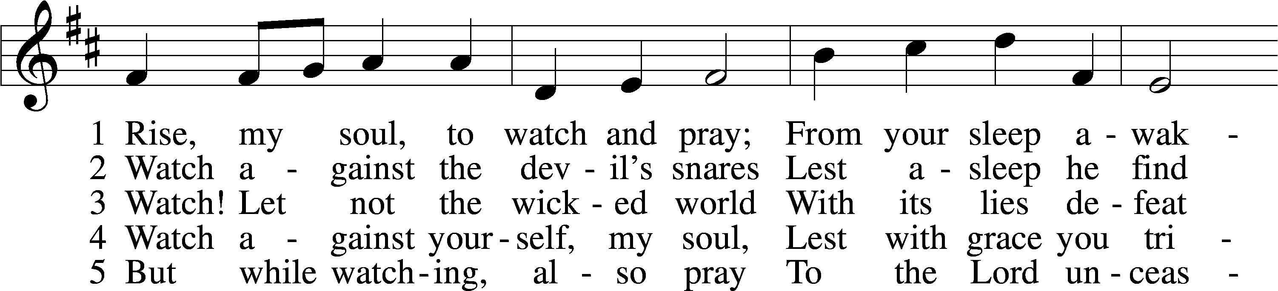

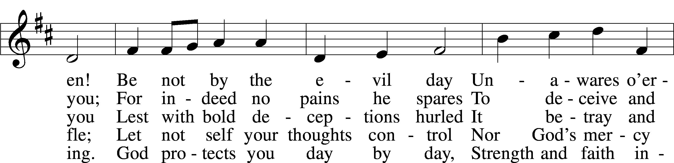

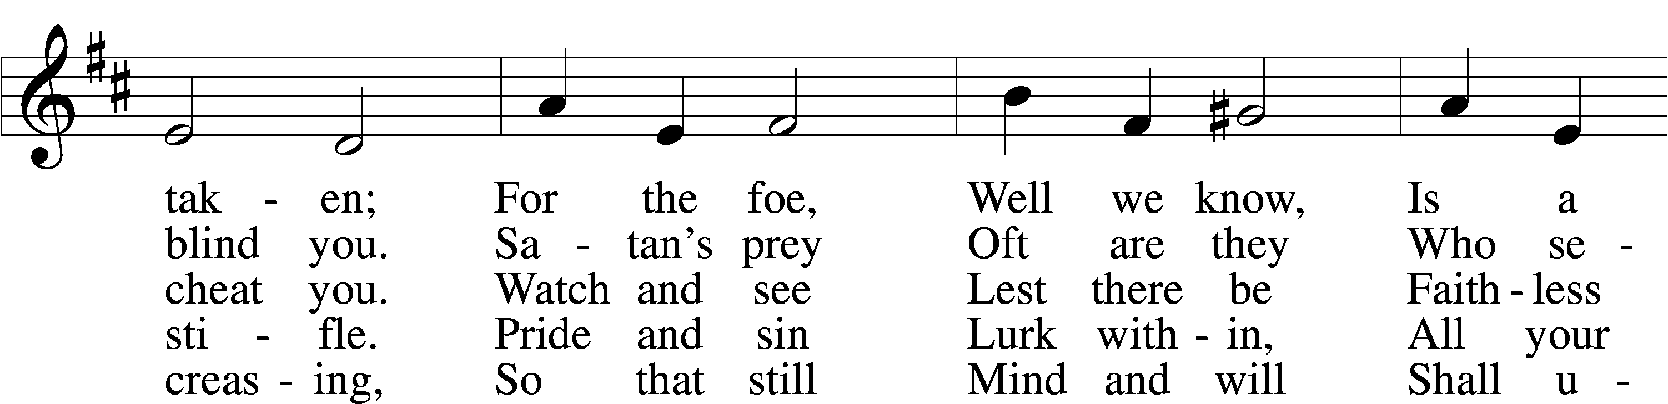

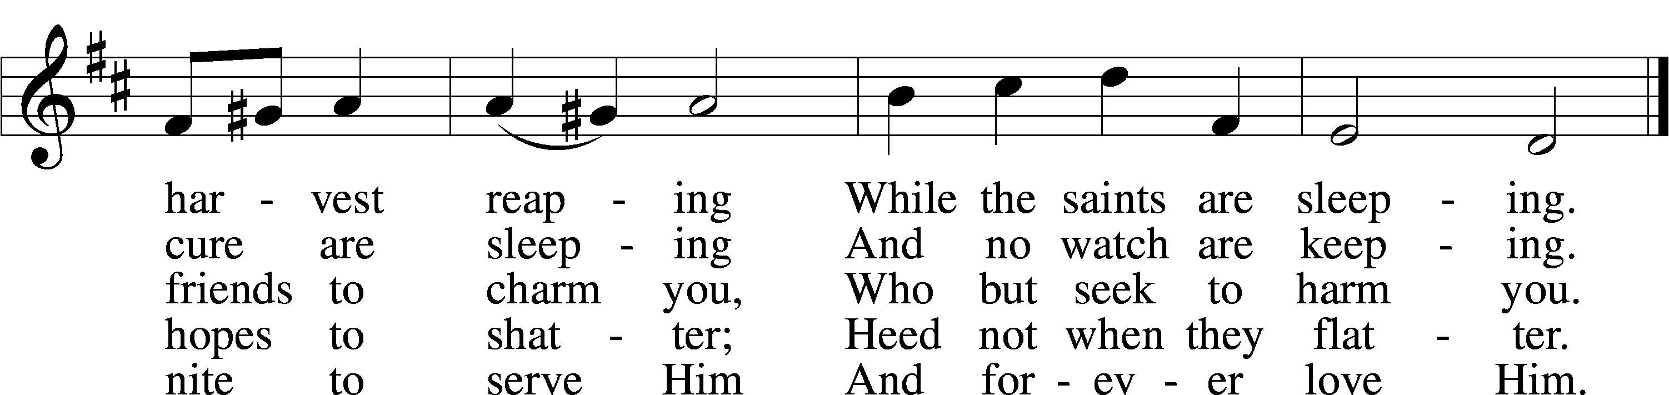

Text: Johann Burkhard Freystein, 1671–1718; tr. Catherine Winkworth, 1827–78, alt.  
Tune: Hundert . . . geistlicher Arien, 1694, Dresden, alt.  
Text and tune: Public domain

# Confession and Absolution

The sign of the cross may be made by all in remembrance of their Baptism.

Invocation Matthew 28:19b; 18:20

P In the name of the Father and of the T Son and of the Holy Spirit.

C **Amen.**

Exhortation Hebrews 10:22; Psalm 124:8; Psalm 32:5

P Beloved in the Lord! Let us draw near with a true heart and confess our sins unto God our Father, beseeching Him in the name of our Lord Jesus Christ to grant us forgiveness.

P Our help is in the name of the Lord,

C **who made heaven and earth.**

P I said, I will confess my transgressions unto the Lord,

C **and You forgave the iniquity of my sin.**

Silence for reflection on God’s Word and for self-examination.

Confession of Sins

P Almighty God, our maker and redeemer, we poor sinners confess unto You that we are by nature sinful and unclean and that we have sinned against You by thought, word, and deed. Wherefore we flee for refuge to Your infinite mercy, seeking and imploring Your grace for the sake of our Lord Jesus Christ.

C **O most merciful God, who has given Your only-begotten Son to die for us, have mercy upon us and for His sake grant us remission of all our sins; and by Your Holy Spirit increase in us true knowledge of You and of Your will and true obedience to Your Word, to the end that by Your grace we may come to everlasting life; through Jesus Christ, our Lord. Amen.**

Declaration of Grace Mark 16:16; John 1:12

P Almighty God, our heavenly Father, has had mercy upon us and has given His only Son to die for us and for His sake forgives us all our sins. To those who believe on His name He gives power to become the children of God and has promised them His Holy Spirit. He that believes and is baptized shall be saved.  
  
Grant this, Lord, unto us all.

C **Amen.**

# Service of the Word

Introit Psalm 39:4–5a, 7–8, 12a; antiphon: 2 Peter 3:13b NIV

We are looking forward to a new heaven and a new earth,  
 the home of righteousness.  
**O Lord, make me know my end and what is the measure of my days;  
 let me know how fleeting I am!**Behold, you have made my days a few handbreadths,  
 and my lifetime is as nothing before you.  
**And now, O Lord, for what do I wait?  
 My hope is in you.**Deliver me from all my transgressions.  
 Do not make me the scorn of the fool!  
**Hear my prayer, O Lord, and give ear to my cry;  
 hold not your peace at my tears!**

Gloria Patri

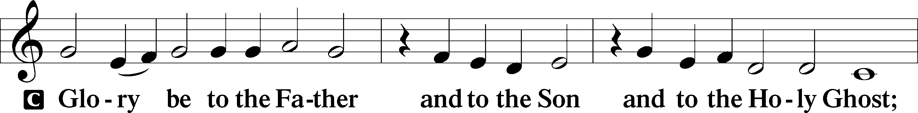

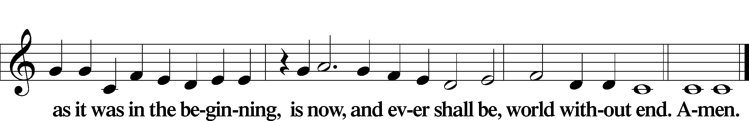

Kyrie Mark 10:47

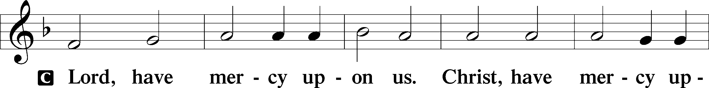

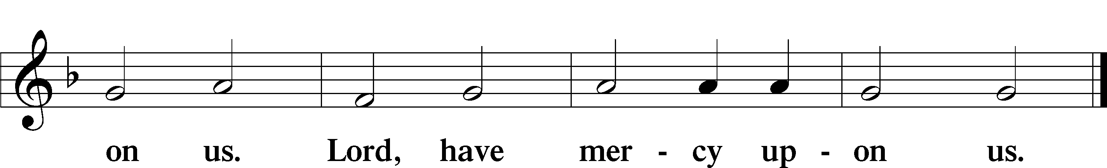

Gloria in Excelsis Luke 2:14; John 1:29

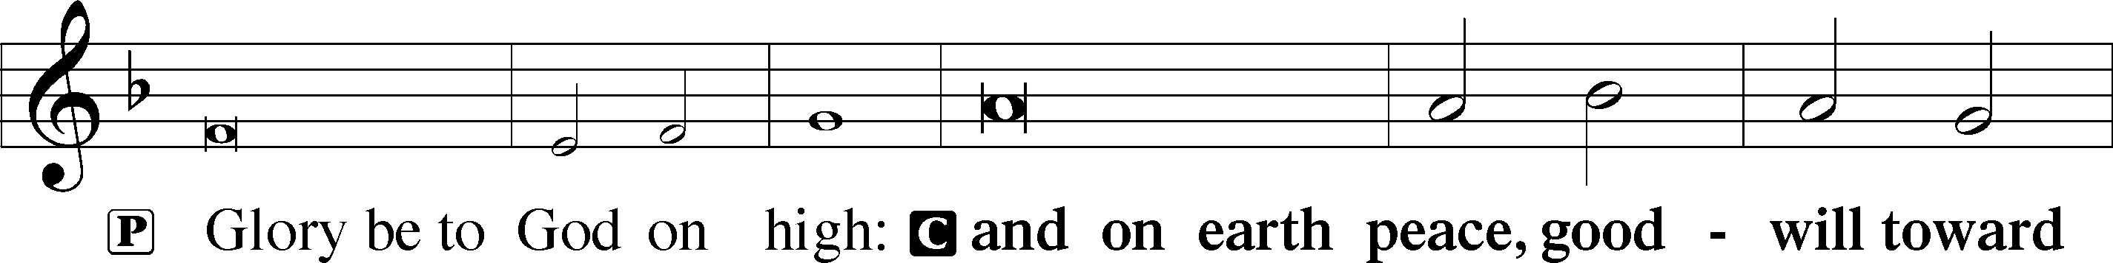

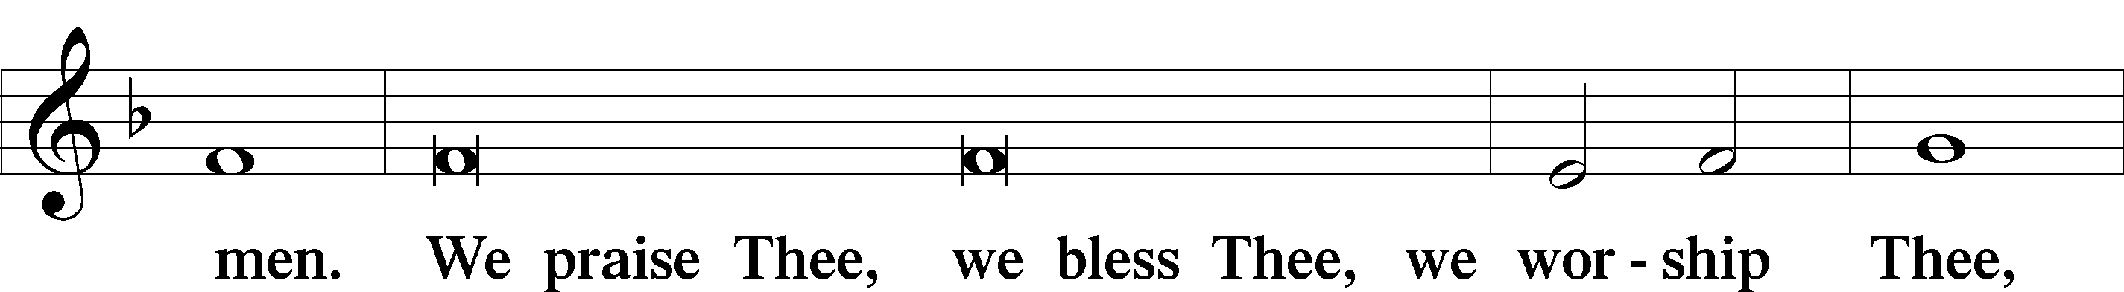

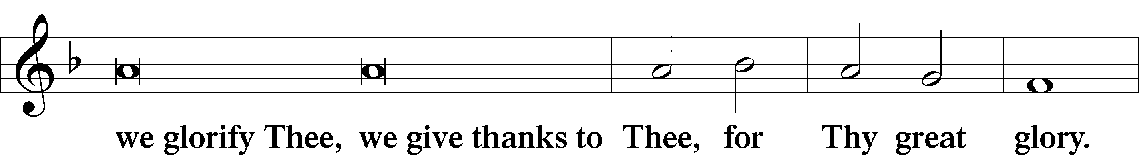

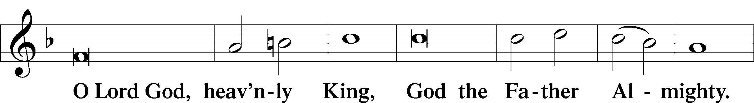

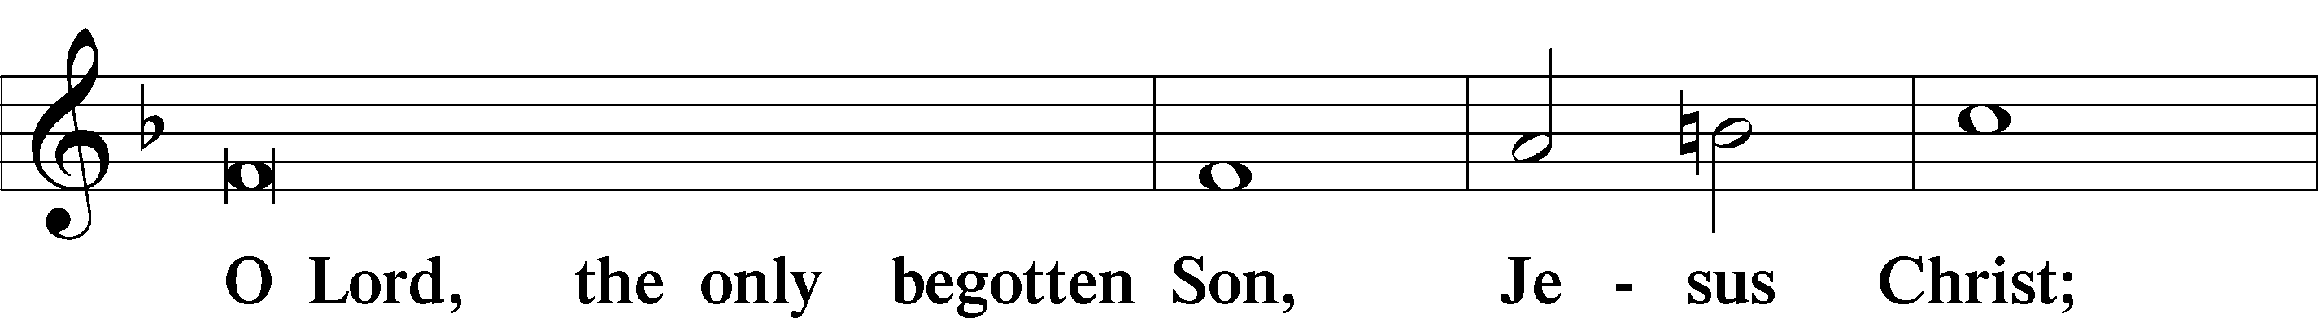

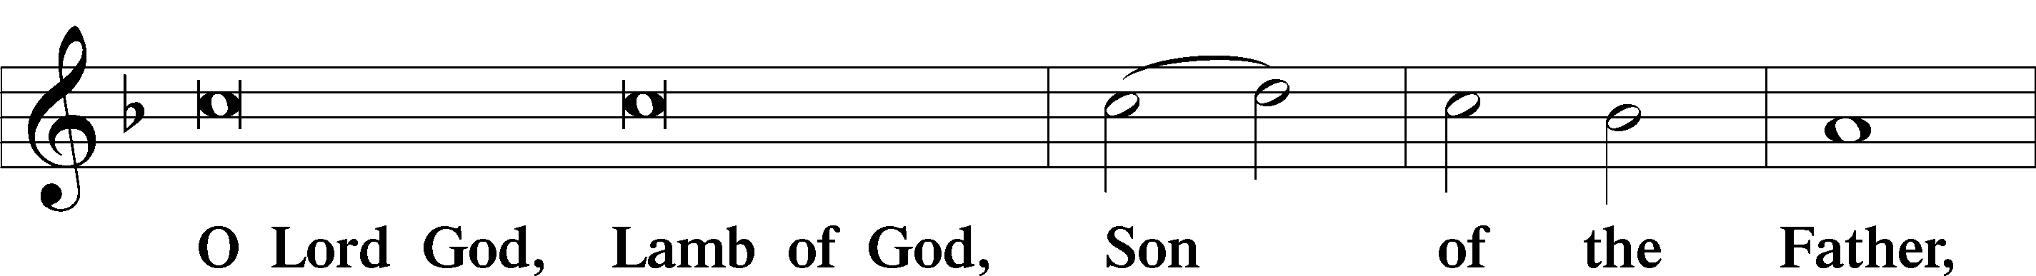

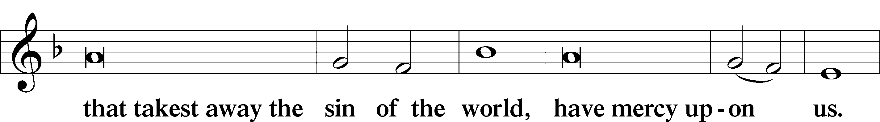

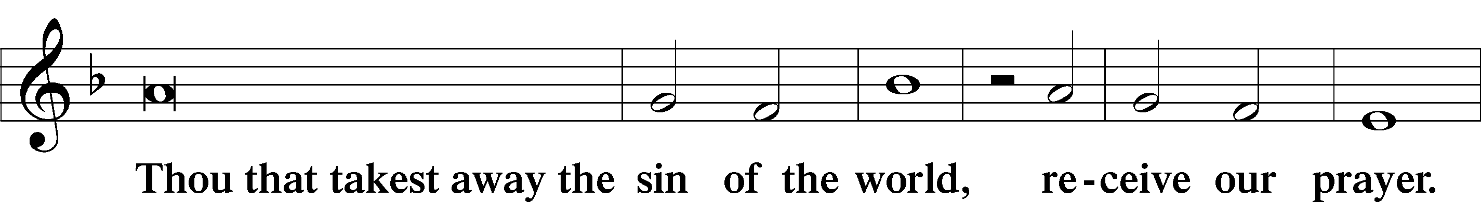

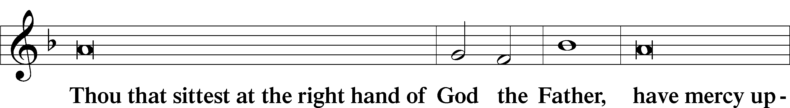

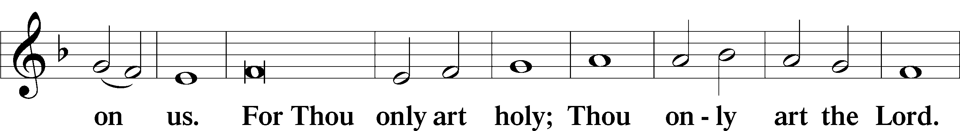

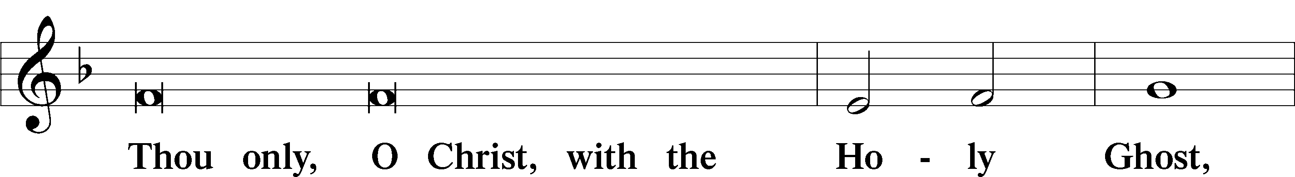

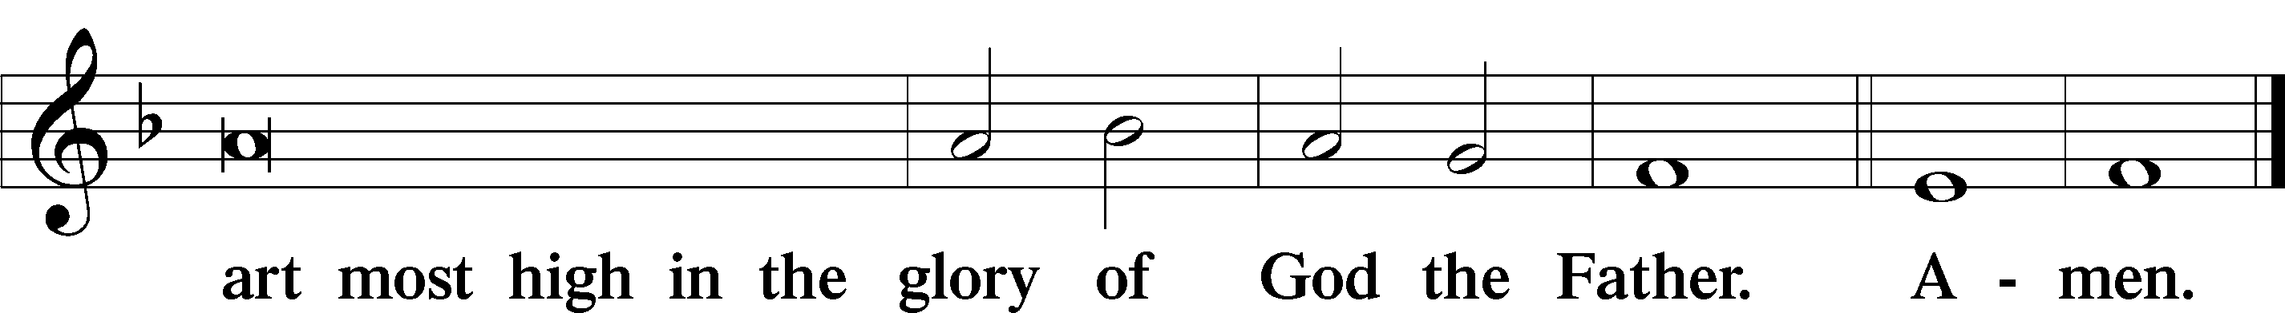

Salutation and Collect of the Day

P The Lord be with you.

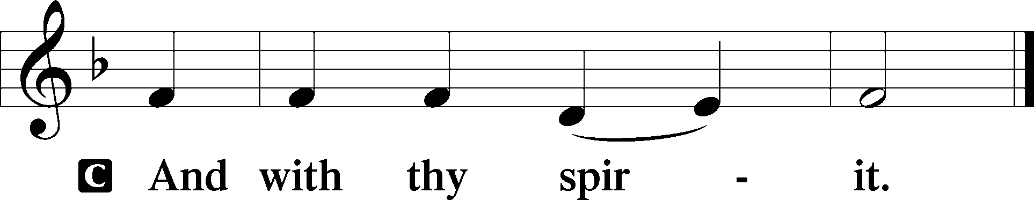

P Let us pray.

Lord Jesus Christ, so govern our hearts and minds by Your Holy Spirit that, ever mindful of Your glorious return, we may persevere in both faith and holiness of living; for You live and reign with the Father and the Holy Spirit, one God, now and forever.

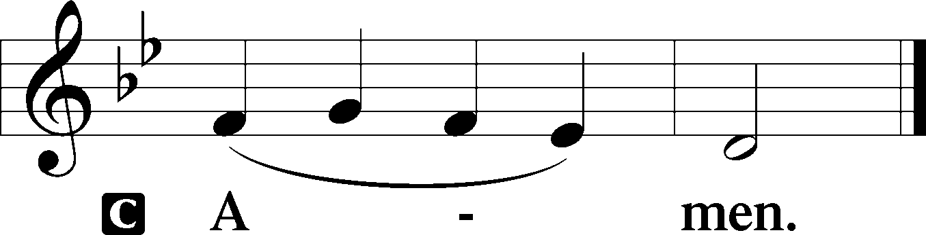

Sit

Old Testament Reading Isaiah 51:4–6

4“Give attention to me, my people,  
 and give ear to me, my nation;  
for a law will go out from me,  
 and I will set my justice for a light to the peoples.  
5My righteousness draws near,  
 my salvation has gone out,  
 and my arms will judge the peoples;  
the coastlands hope for me,  
 and for my arm they wait.  
6Lift up your eyes to the heavens,  
 and look at the earth beneath;  
for the heavens vanish like smoke,  
 the earth will wear out like a garment,  
 and they who dwell in it will die in like manner;  
but my salvation will be forever,  
 and my righteousness will never be dismayed.”

A This is the Word of the Lord.

C **Thanks be to God.**

Gradual Revelation 7:14b; Psalm 84:5

These are the ones coming out of the great tribulation.  
 They have washed their robes and made them white in the blood of the Lamb.  
**Blessèd are those whose strength is in you,  
 in whose heart are the highways to Zion.**

Epistle Jude 20–25

20But you, beloved, build yourselves up in your most holy faith; pray in the Holy Spirit; 21keep yourselves in the love of God, waiting for the mercy of our Lord Jesus Christ that leads to eternal life. 22And have mercy on those who doubt; 23save others by snatching them out of the fire; to others show mercy with fear, hating even the garment stained by the flesh.

24Now to him who is able to keep you from stumbling and to present you blameless before the presence of his glory with great joy, 25to the only God, our Savior, through Jesus Christ our Lord, be glory, majesty, dominion, and authority, before all time and now and forever. Amen.

Stand

Alleluia

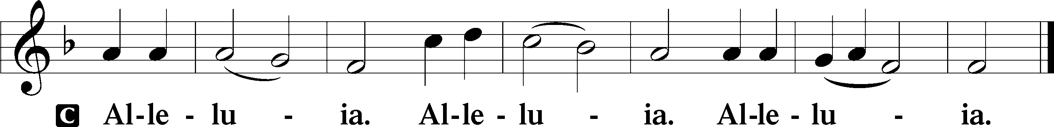

Holy Gospel Mark 13:24–37

P The Holy Gospel according to St. Mark, the thirteenth chapter.

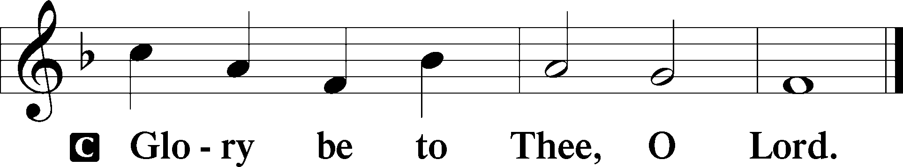

24[Jesus said:] “In those days, after that tribulation, the sun will be darkened, and the moon will not give its light, 25and the stars will be falling from heaven, and the powers in the heavens will be shaken. 26And then they will see the Son of Man coming in clouds with great power and glory. 27And then he will send out the angels and gather his elect from the four winds, from the ends of the earth to the ends of heaven.

28“From the fig tree learn its lesson: as soon as its branch becomes tender and puts out its leaves, you know that summer is near. 29So also, when you see these things taking place, you know that he is near, at the very gates. 30Truly, I say to you, this generation will not pass away until all these things take place. 31Heaven and earth will pass away, but my words will not pass away.

32“But concerning that day or that hour, no one knows, not even the angels in heaven, nor the Son, but only the Father. 33Be on guard, keep awake. For you do not know when the time will come. 34It is like a man going on a journey, when he leaves home and puts his servants in charge, each with his work, and commands the doorkeeper to stay awake. 35Therefore stay awake—for you do not know when the master of the house will come, in the evening, or at midnight, or when the cock crows, or in the morning— 36lest he come suddenly and find you asleep. 37And what I say to you I say to all: Stay awake.”

P This is the Gospel of the Lord.

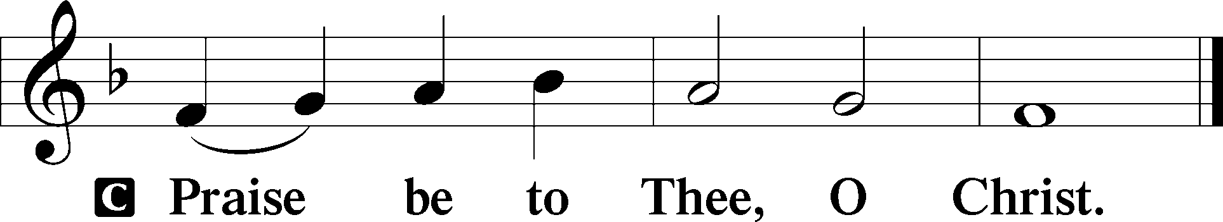

Apostles’ Creed

C **I believe in God, the Father Almighty,**

**maker of heaven and earth.**

**And in Jesus Christ, His only Son, our Lord,**

**who was conceived by the Holy Spirit,**

**born of the virgin Mary,**

**suffered under Pontius Pilate,**

**was crucified, died and was buried.**

**He descended into hell.**

**The third day He rose again from the dead.**

**He ascended into heaven**

**and sits at the right hand of God the Father Almighty.**

**From thence He will come to judge the living and the dead.**

**I believe in the Holy Spirit,**

**the holy Christian Church,**

**the communion of saints,**

**the forgiveness of sins,**

**the resurrection of the body,**

**and the life** T **everlasting. Amen.**

Sit

Children's Sermon

668 Rise! To Arms! With Prayer Employ You

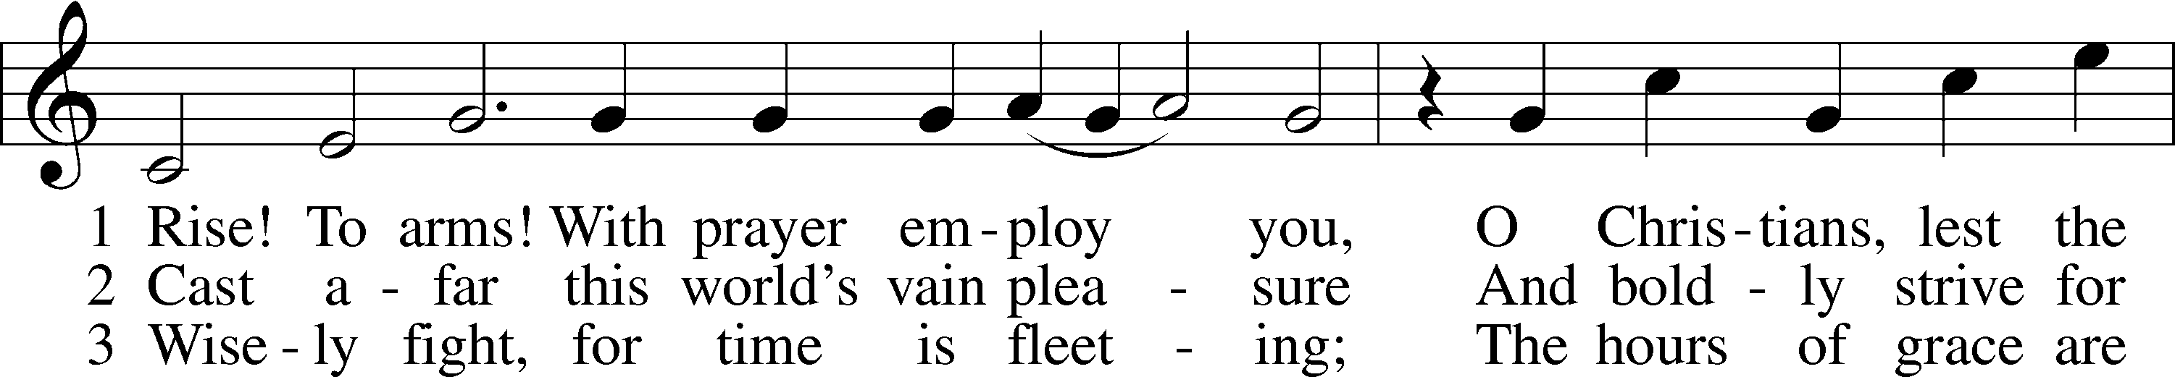

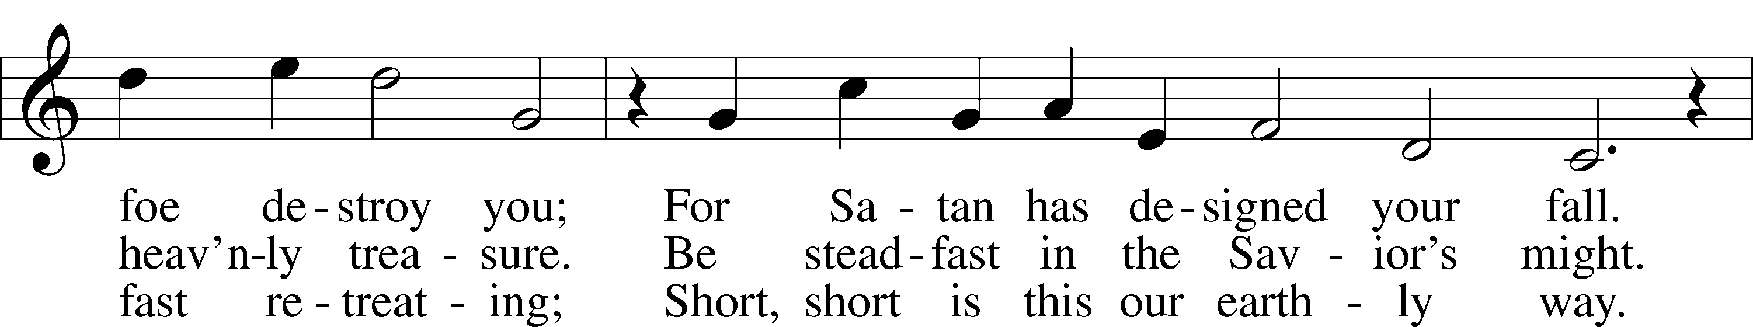

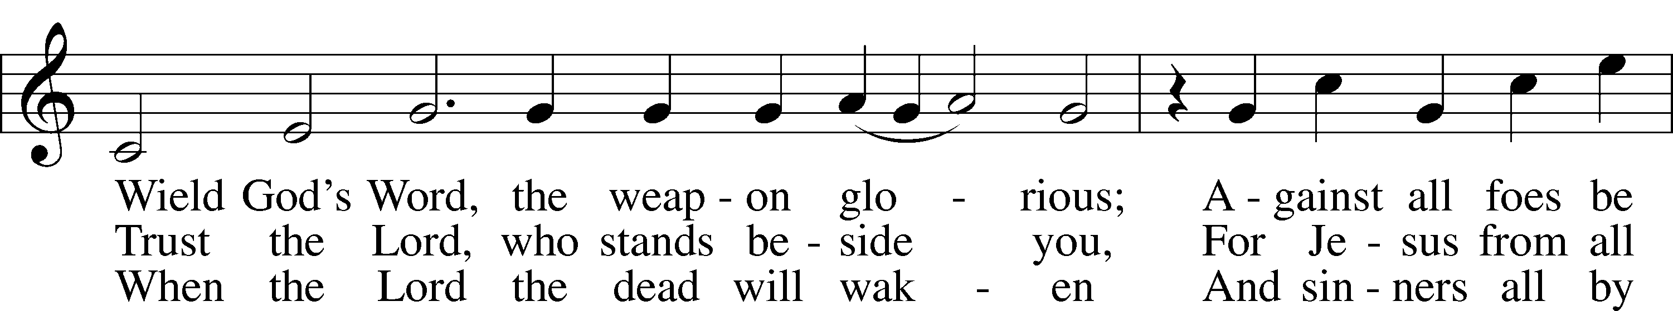

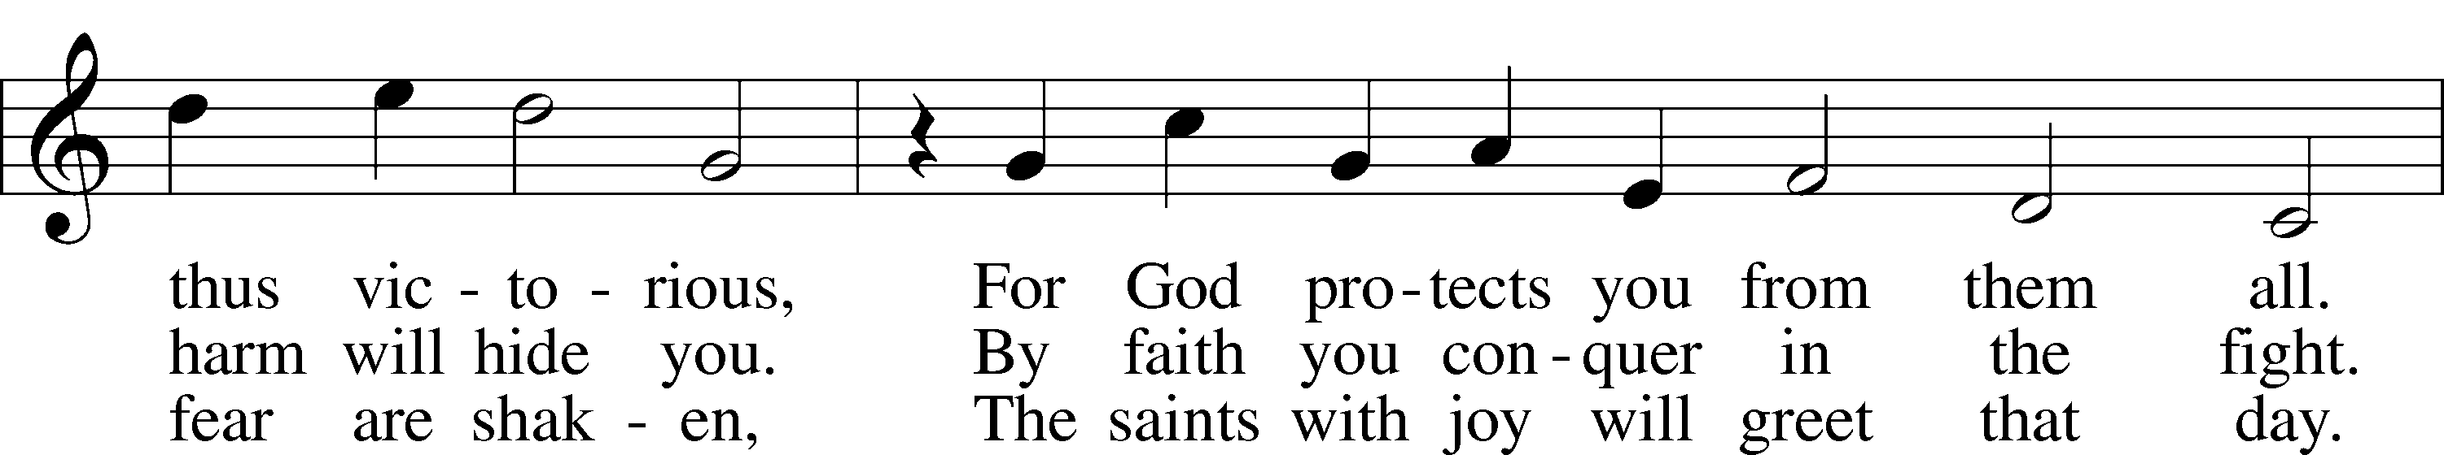

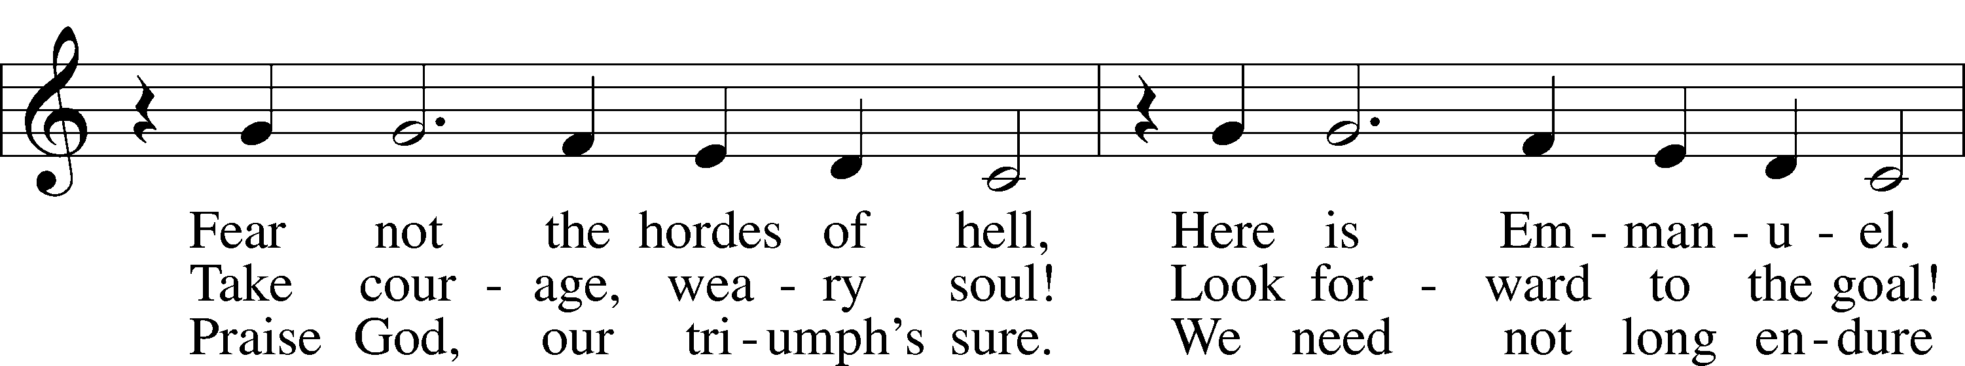

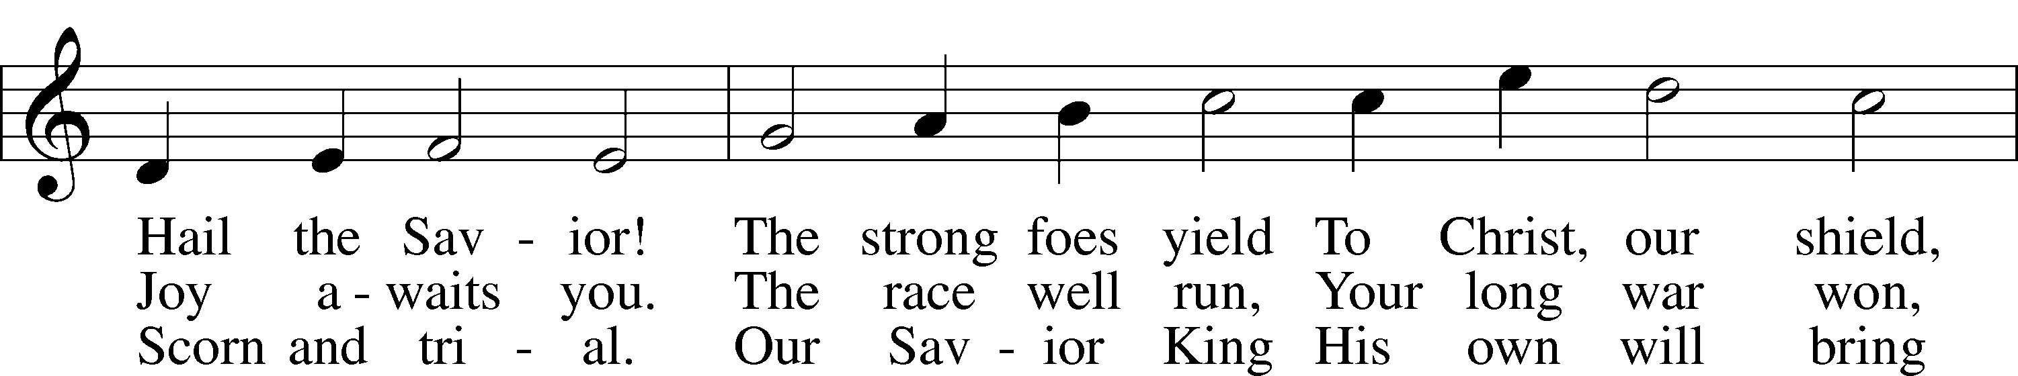

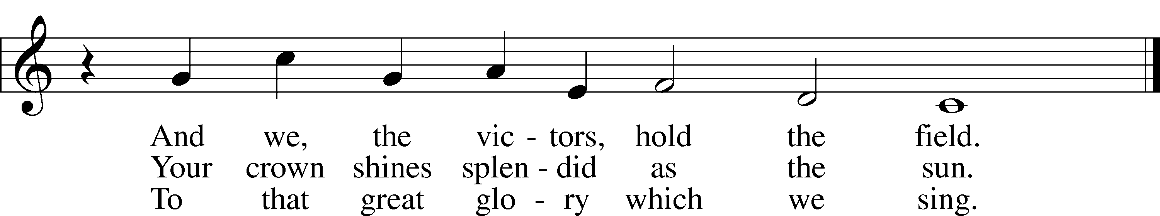

Text: Wilhelm Erasmus Arends, 1677–1721; tr. John M. Sloan, 1835–after 1890, alt.  
Tune: Philipp Nicolai, 1556–1608  
Text and tune: Public domain

Sermon

Votum

P The peace of God, which passes all understanding, keep your hearts and minds in Christ Jesus.

C **Amen.**

Stand

Offertory Psalm 51:10–12

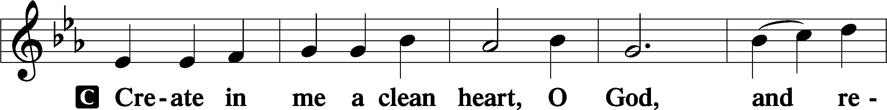

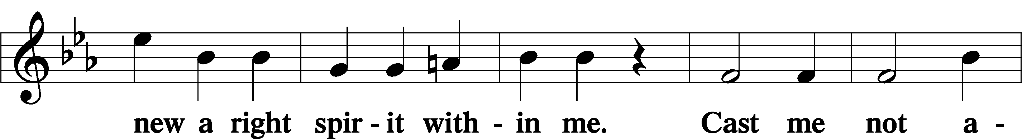

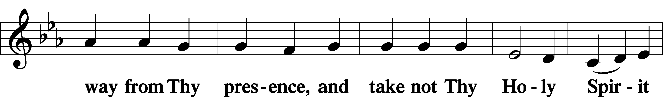

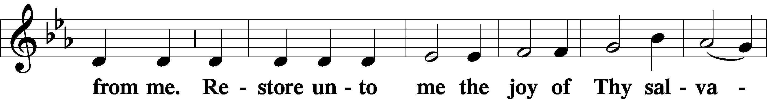

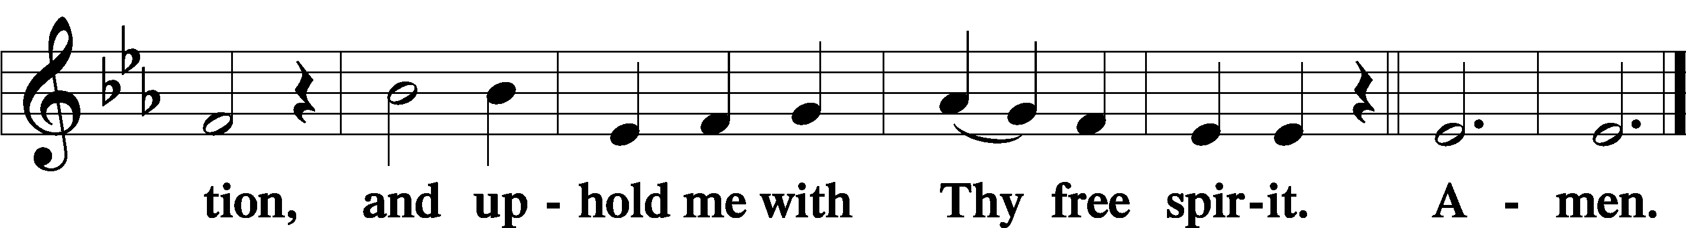

Offering

805 Praise God, from Whom All Blessings Flow

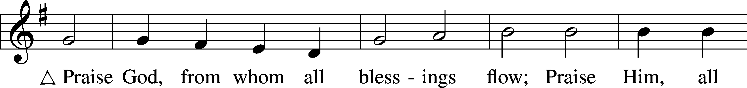

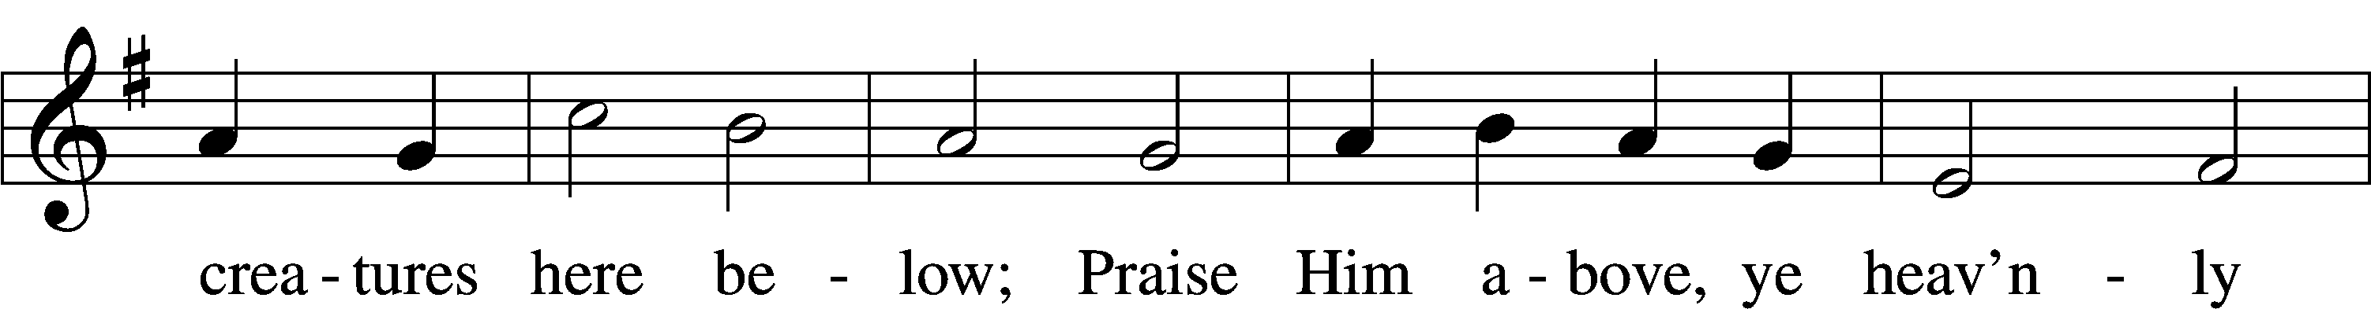

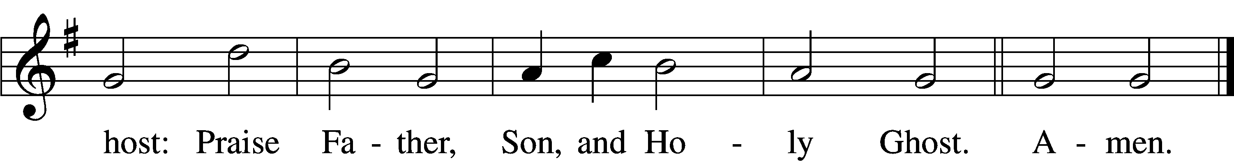

Text: Thomas Ken, 1637–1711  
Tune: Trente quatre Pseaumes de David, 1551, Geneva, ed. Louis Bourgeois  
Text and tune: Public domain

Prayer of the Church

Lord’s Prayer Matthew 6:9–13

P Lord, remember us in Your kingdom and teach us to pray:

C **Our Father who art in heaven,**

**hallowed be Thy name,**

**Thy kingdom come,**

**Thy will be done on earth**

**as it is in heaven;**

**give us this day our daily bread;**

**and forgive us our trespasses**

**as we forgive those**

**who trespass against us;**

**and lead us not into temptation,**

**but deliver us from evil.**

**For Thine is the kingdom**

**and the power and the glory**

**forever and ever. Amen.**

Collect for the Word

Blessed Lord, You have caused all Holy Scriptures to be written for our learning. Grant that we may so hear them, read, mark, learn, and inwardly digest them that, by the patience and comfort of Your holy Word, we may embrace and ever hold fast the blessed hope of everlasting life; through Jesus Christ, Your Son, our Lord, who lives and reigns with You and the Holy Spirit, one God, now and forever.

Benediction

P The Lord bless you and keep you.

The Lord make His face shine on you and be gracious to you.

The Lord look upon you with favor and T give you peace.

C **Amen.**

578 Thy Strong Word

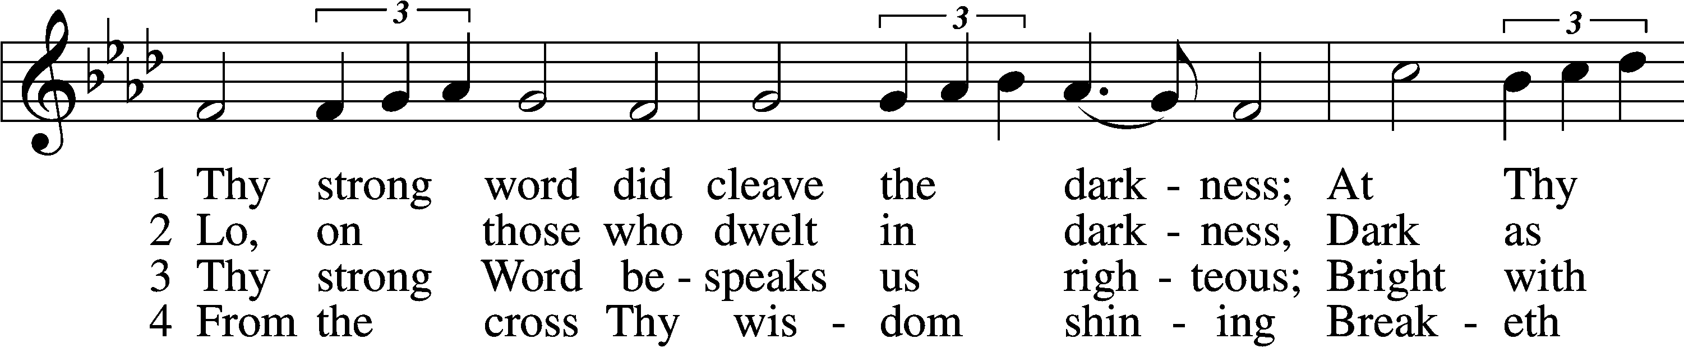

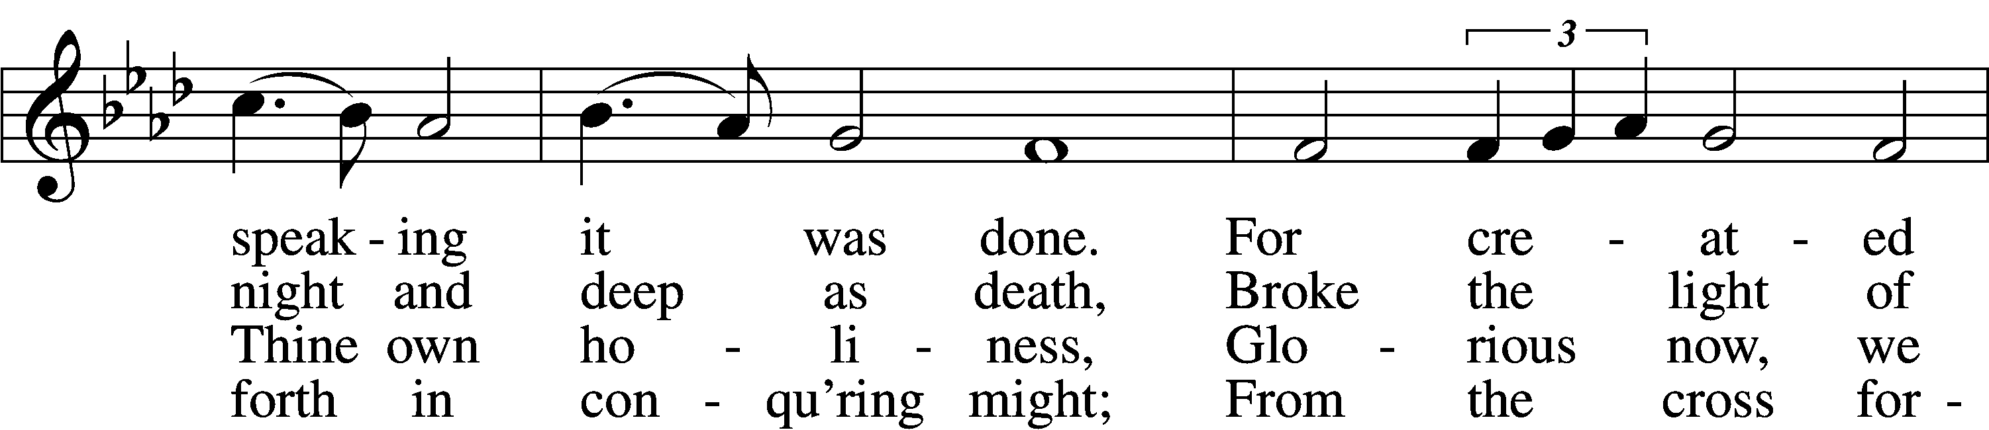

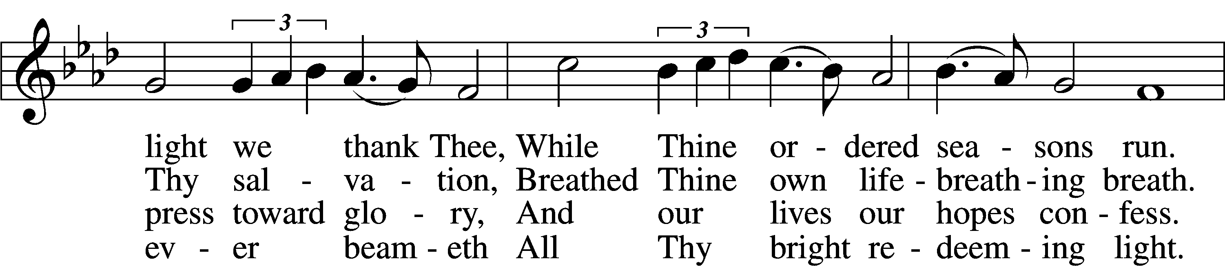

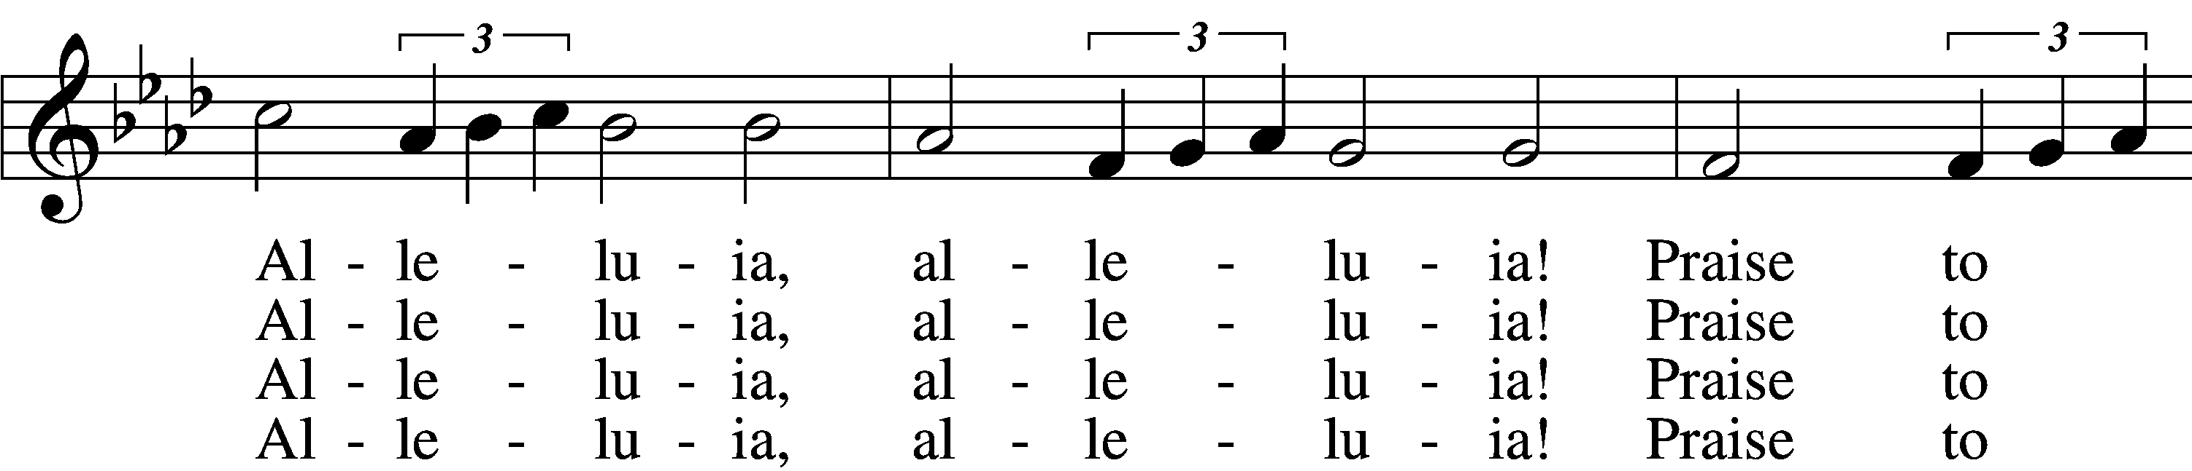

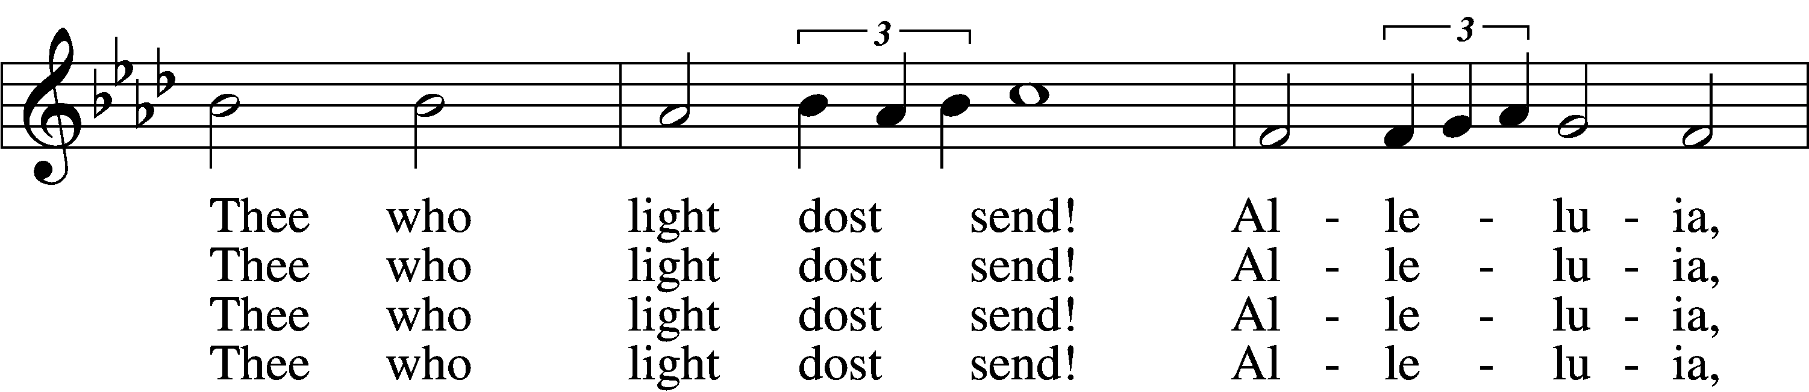

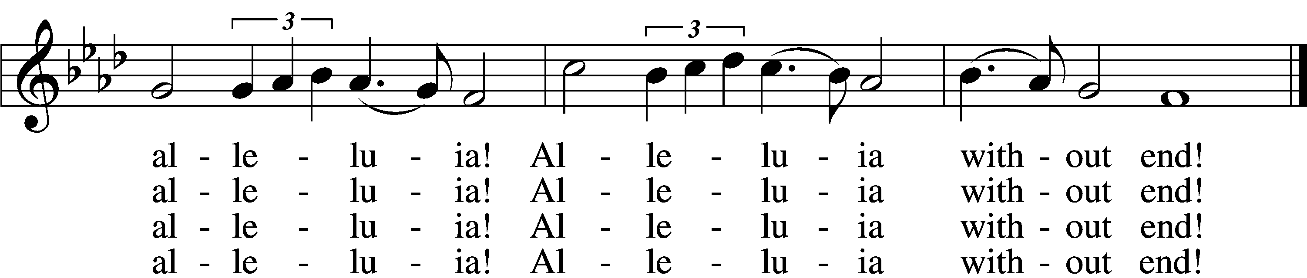

5 Give us lips to sing Thy glory,  
 Tongues Thy mercy to proclaim,  
Throats that shout the hope that fills us,  
 Mouths to speak Thy holy name.  
Alleluia, alleluia!  
 May the light which Thou dost send  
Fill our songs with alleluias,  
 Alleluias without end!

D 6 God the Father, light-creator,  
 To Thee laud and honor be.  
To Thee, Light of Light begotten,  
 Praise be sung eternally.  
Holy Spirit, light-revealer,  
 Glory, glory be to Thee.  
Mortals, angels, now and ever  
 Praise the holy Trinity!

Text: Martin H. Franzmann, 1907–76  
Tune: Thomas J. Williams, 1869–1944  
Text: © 1969 Concordia Publishing House. Used by permission: LSB Hymn License no. 110005011  
Tune: Public domain

Acknowledgments

Unless otherwise indicated, Scripture quotations are from the ESV® Bible (The Holy Bible, English Standard Version®), copyright © 2001 by Crossway, a publishing ministry of Good News Publishers. Used by permission. All rights reserved.

Created by Lutheran Service Builder © 2024 Concordia Publishing House.