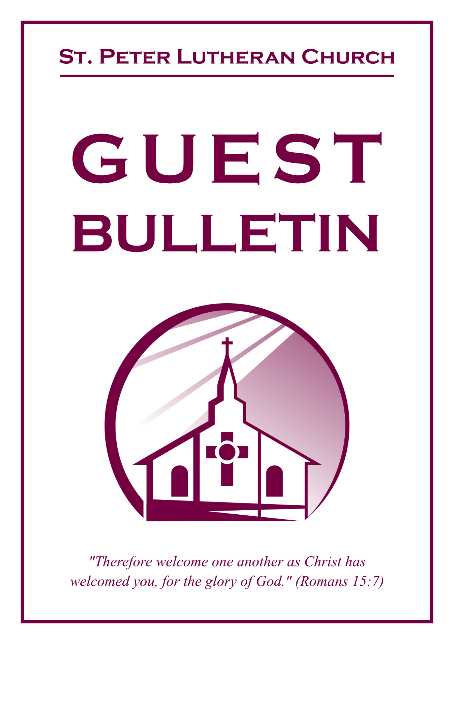

July 5, 2026

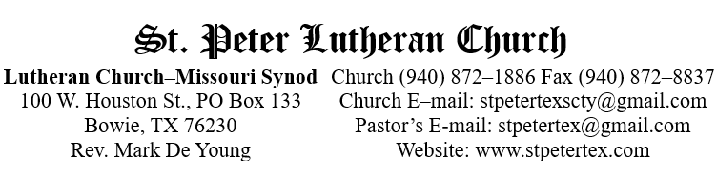
Who Receives the Sacrament of the Altar Worthily?
Fasting and bodily preparation are certainly fine outward training. But that person is truly worthy and well prepared who has faith in these words: “Given and shed for you for the forgiveness of sins.”
But anyone who does not believe these words or doubts them is unworthy and unprepared; for the words “for you” require all hearts to believe.
How May I Prepare?
See Dr. Luther’s self–examination questions and answers in the
LSB Hymnal on page 329
To Our Guests and Visitors:

We welcome all our friends in Christ who have come to worship with us. If you are a guest, please feel at home with us, sign our guest register, and worship with us whenever you are able. If you do not have a church home, we invite you to
consider becoming a part of our church family.

Communion Statement:

The Lord’s Supper is celebrated at this congregation in the confession and glad confidence that, as He says, our Lord gives into our mouths not only bread and wine but His very Body and Blood to eat and drink for the forgiveness of sins and to strengthen our union with Him and one another.

Our Lord invites to His table those who trust in His words, repent of all sin, and set aside any refusal to forgive and love as He forgives and loves us, that they may show forth His death until He comes.

Because those who eat and drink our Lord’s Body and Blood unworthily do so to their great harm, and because Holy Communion is a confession of the faith, which is confessed at this altar, guests who are not confirmed members of an LCMS congregation and have not previously communed at this altar, are asked to first speak with our pastor.

If you are unable to do so before the service, it is out of Christian love and care for your souls that we ask you to refrain from communing this morning.

For further study, please see Matthew 5:23ff, 10:32ff, 18:15–35, 26:26–29; 1 Corinthians 11:17–34.

If you desire to receive a blessing for yourself or your children, please approach during
communion, cross your arms over your chest and bow your head as you kneel at the
altar rail.

Upon entering the Sanctuary. please turn off cell phones, pagers. etc. Use the time as a quiet time for personal reflection and meditation in preparation for worship. This is a time for anyone to join in praying for the service, and for the church in general.
717 Eternal Father, Strong to Save
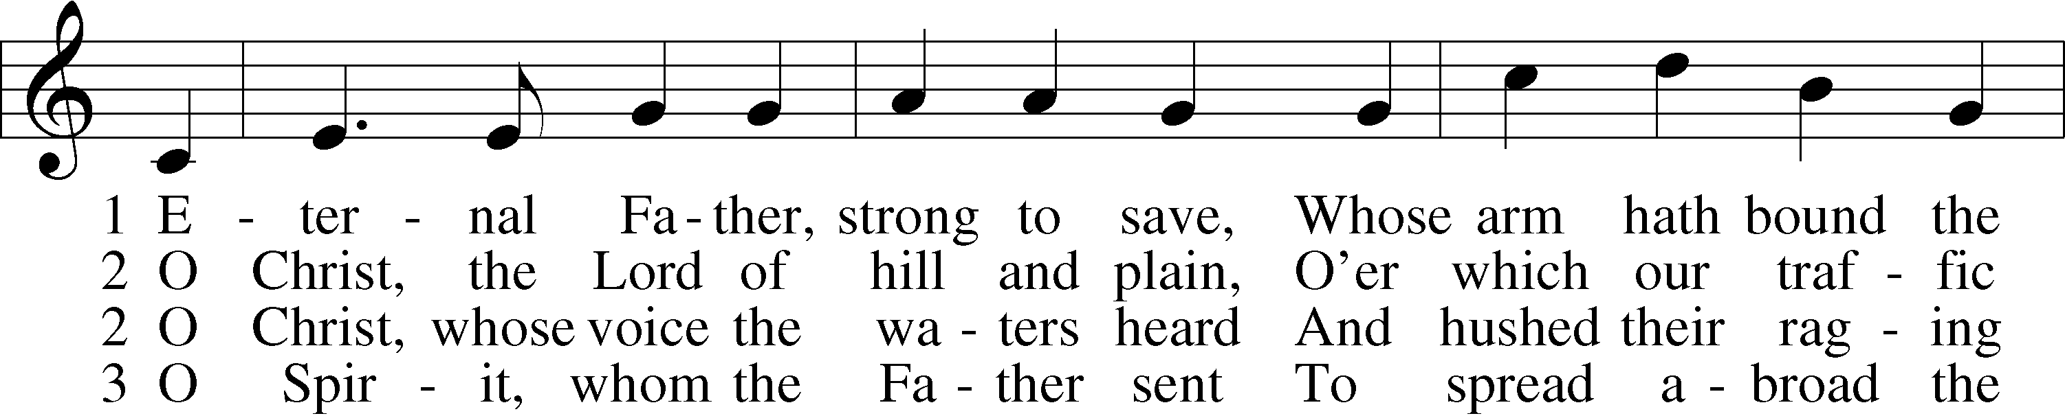
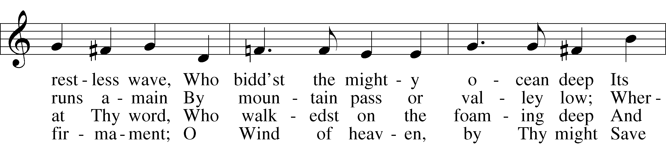
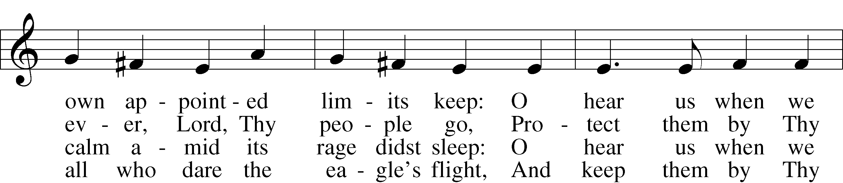
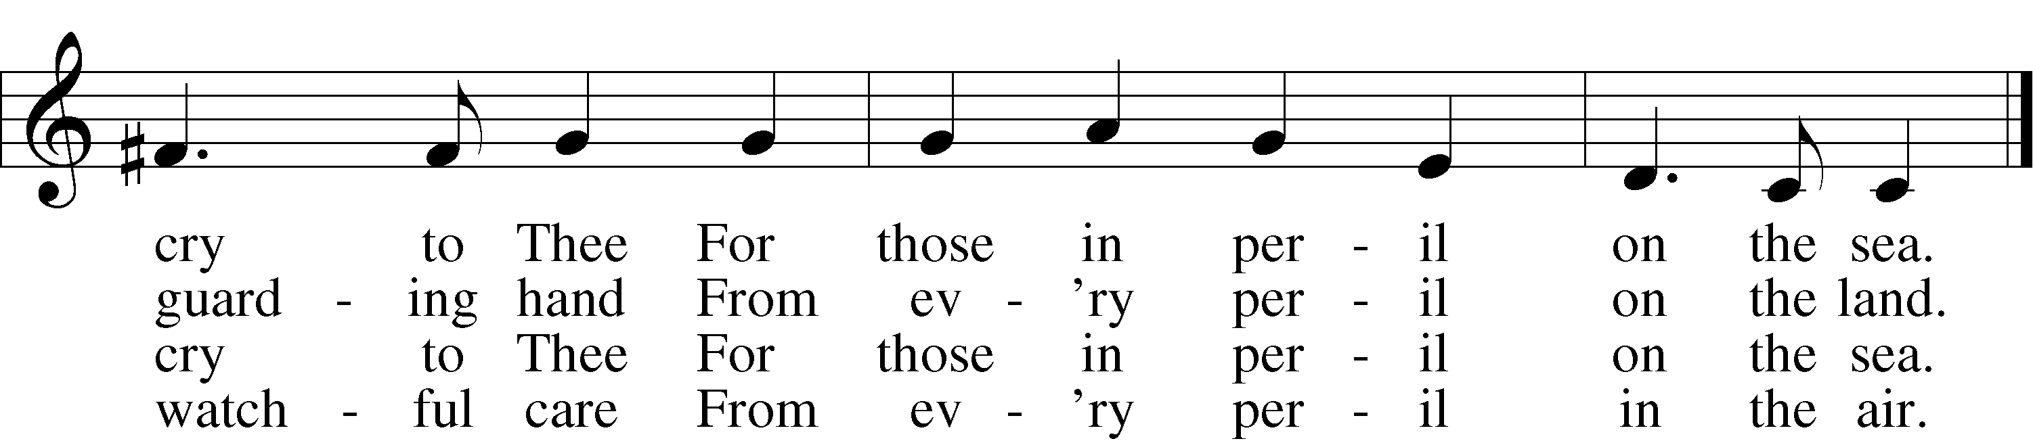

3a Most Holy Spirit, who didst brood
Upon the chaos dark and rude,
And bid its angry tumult cease,
And give, for wild confusion, peace:
O hear us when we cry to Thee
For those in peril on the sea.

4 O Trinity of love and pow’r,
Our people shield in danger’s hour;
From rock and tempest, fire and foe,
Protect them wheresoe’er they go;
Thus evermore shall rise to Thee
Glad praise from air and land and sea.
Text (sts. 1–4): William Whiting, 1825–78, alt.; (sts. 2a–3a): Robert N. Spencer, 1877–1961, alt.
Tune: John B. Dykes, 1823–76
Text (sts. 2–3): © The Church Pension Fund. Used by permission: LSB Hymn License no. 110005011
Text (sts. 1–4) and tune: Public domain
Confession and Absolution
Stand

The sign of the cross may be made by all in remembrance of their Baptism.

Invocation Matthew 28:19b; 18:20
P In the name of the Father and of the T Son and of the Holy Spirit.
C Amen.

Exhortation Hebrews 10:22; Psalm 124:8; Psalm 32:5
P Beloved in the Lord! Let us draw near with a true heart and confess our sins unto God our Father, beseeching Him in the name of our Lord Jesus Christ to grant us forgiveness.
P Our help is in the name of the Lord,
C who made heaven and earth.
P I said, I will confess my transgressions unto the Lord,
C and You forgave the iniquity of my sin.

Kneel/Stand

Silence for reflection on God’s Word and for self-examination.

Confession of Sins
P O almighty God, merciful Father,
C I, a poor, miserable sinner, confess unto You all my sins and iniquities with which I have ever offended You and justly deserved Your temporal and eternal punishment. But I am heartily sorry for them and sincerely repent of them, and I pray You of Your boundless mercy and for the sake of the holy, innocent, bitter sufferings and death of Your beloved Son, Jesus Christ, to be gracious and merciful to me, a poor, sinful being.

Absolution [John 20:19–23]
P Upon this your confession, I, by virtue of my office, as a called and ordained servant of the Word, announce the grace of God unto all of you, and in the stead and by the command of my Lord Jesus Christ I forgive you all your sins in the name of the Father and of the T Son and of the Holy Spirit.
C Amen.

Stand
Service of the Word
Introit Psalm 91:2, 9–10; antiphon: v. 1
He who dwells in the shelter of the Most High
will abide in the shadow of the Almighty.
I will say to the Lord, “My refuge and my fortress,
my God, in whom I trust.”
Because you have made the Lord your dwelling place—
the Most High, who is my refuge—
no evil shall be allowed to befall you,
no plague come near your tent.

Gloria Patri
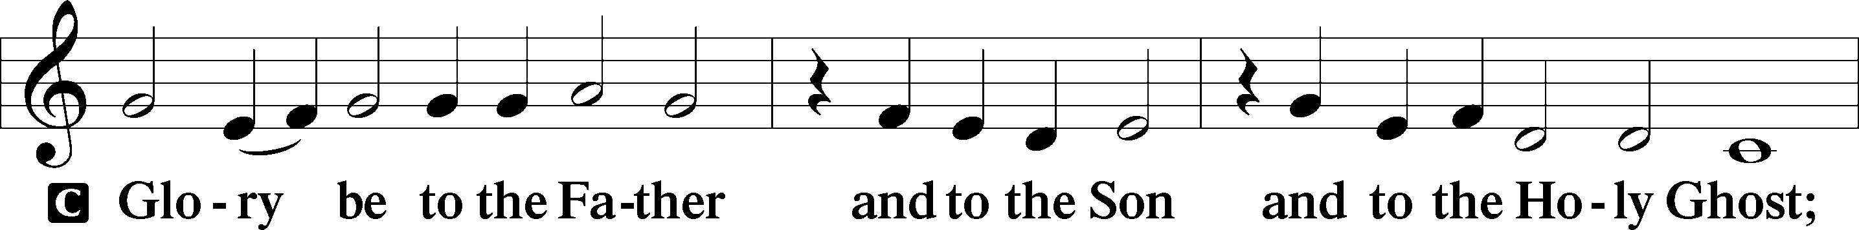
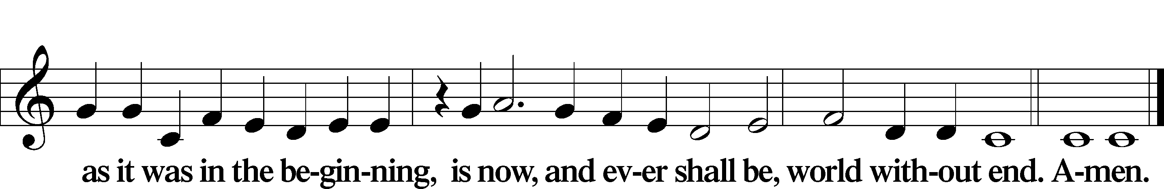

Kyrie Mark 10:47
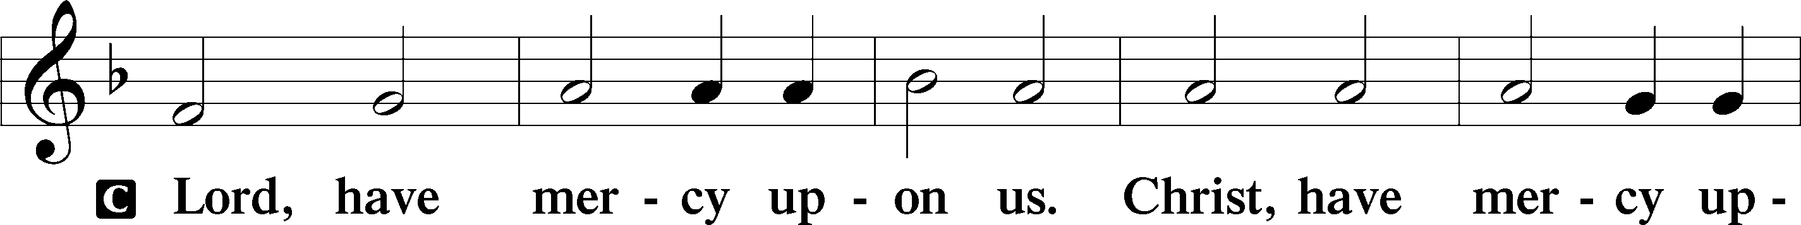
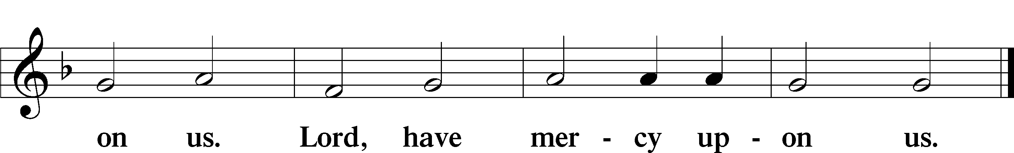

Gloria in Excelsis Luke 2:14; John 1:29
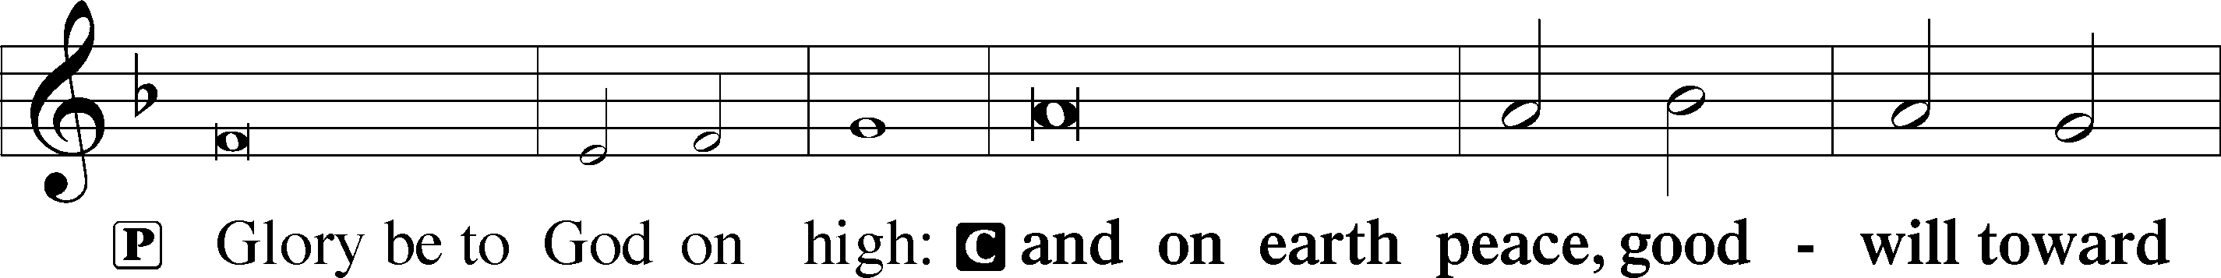
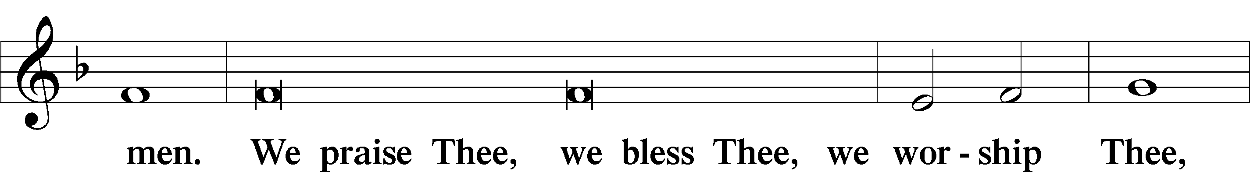
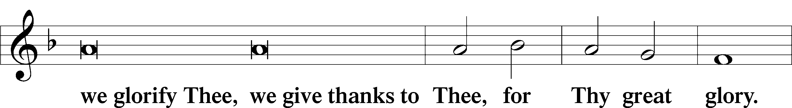
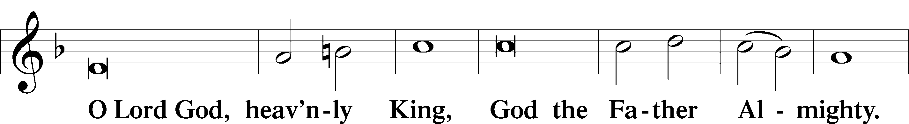
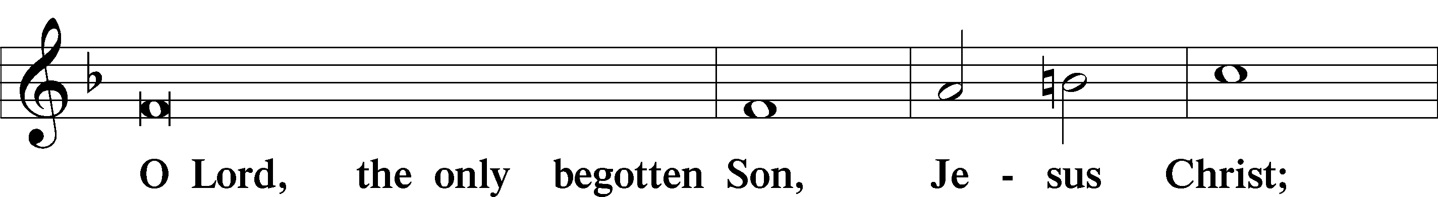
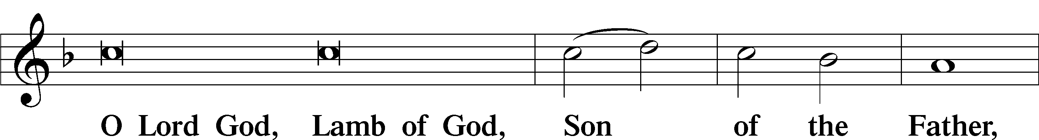
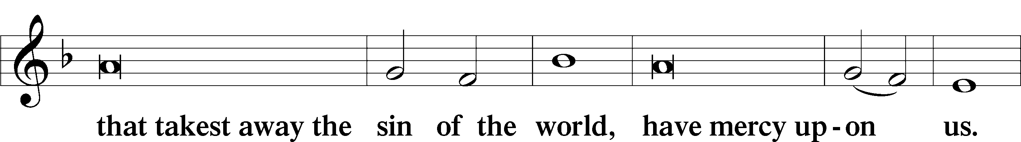
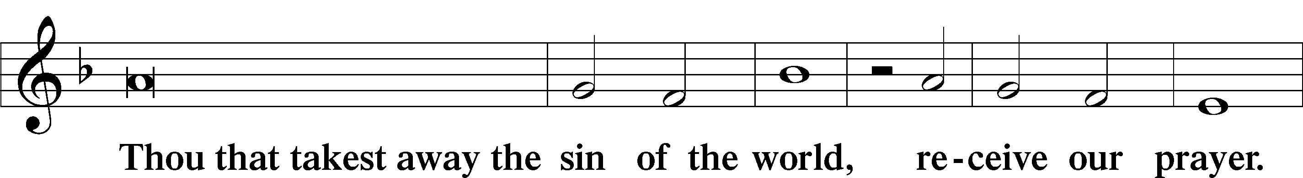
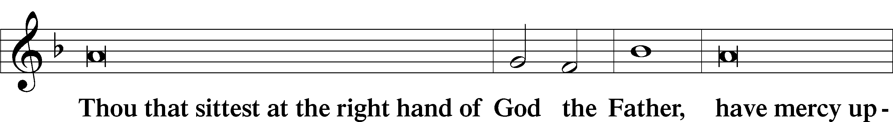
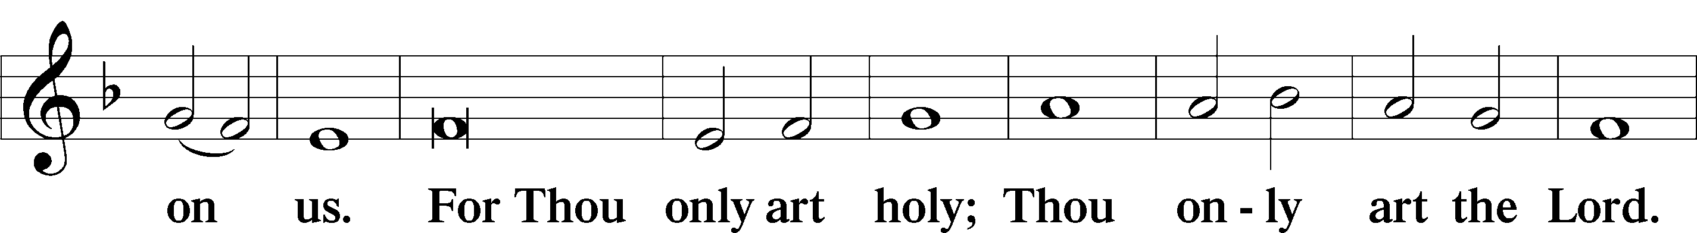
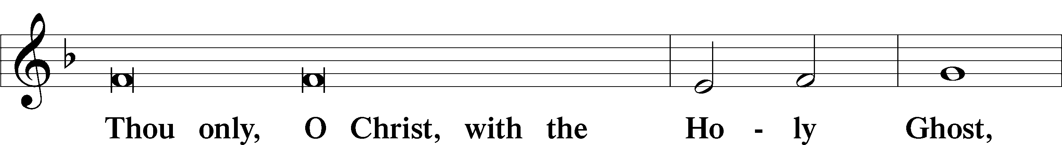
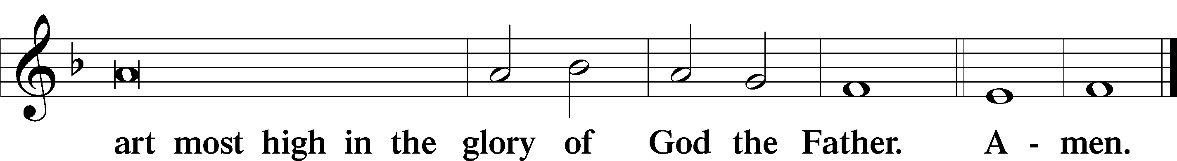

Salutation and Collect of the Day
P The Lord be with you.
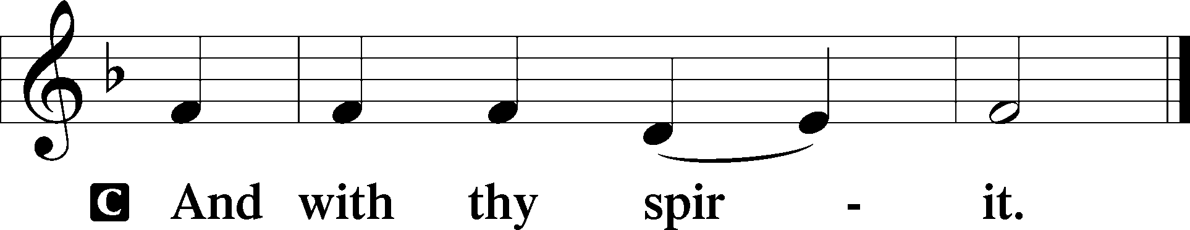

P Let us pray.

Gracious God, our heavenly Father, Your mercy attends us all our days. Be our strength and support amid the wearisome changes of this world, and at life’s end grant us Your promised rest and the full joys of Your salvation; through Jesus Christ, Your Son, our Lord, who lives and reigns with You and the Holy Spirit, one God, now and forever.

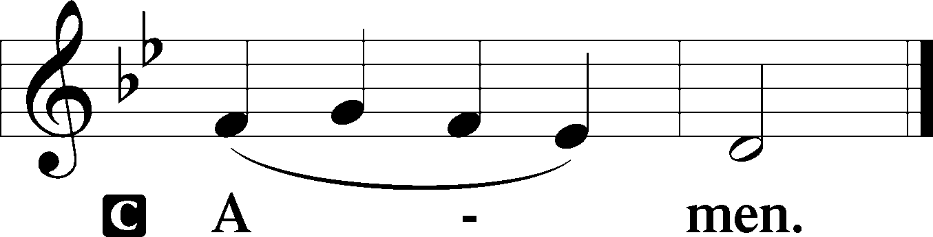

Sit

Old Testament Reading Zechariah 9:9–12
9Rejoice greatly, O daughter of Zion! Shout aloud, O daughter of Jerusalem! behold, your king is coming to you; righteous and having salvation is he, humble and mounted on a donkey, on a colt, the foal of a donkey. 10I will cut off the chariot from Ephraim and the war horse from Jerusalem; and the battle bow shall be cut off, and he shall speak peace to the nations; his rule shall be from sea to sea, and from the River to the ends of the earth. 11As for you also, because of the blood of my covenant with you, I will set your prisoners free from the waterless pit. 12Return to your stronghold, O prisoners of hope; today I declare that I will restore to you double.
A This is the Word of the Lord.
C Thanks be to God.

Gradual Romans 11:33, 36
Oh, the depth of the riches and wisdom and knowledge of God!
How unsearchable are his judgments and how inscrutable his ways!
For from him and through him and to him are all things.
To him be glory forever. Amen.

Epistle Romans 7:14–25a
14We know that the law is spiritual, but I am of the flesh, sold under sin. 15I do not understand my own actions. For I do not do what I want, but I do the very thing I hate. 16Now if I do what I do not want, I agree with the law, that it is good. 17So now it is no longer I who do it, but sin that dwells within me. 18For I know that nothing good dwells in me, that is, in my flesh. For I have the desire to do what is right, but not the ability to carry it out. 19For I do not do the good I want, but the evil I do not want is what I keep on doing. 20Now if I do what I do not want, it is no longer I who do it, but sin that dwells within me. 21So I find it to be a law that when I want to do right, evil lies close at hand. 22For I delight in the law of God, in my inner being, 23but I see in my members another law waging war against the law of my mind and making me captive to the law of sin that dwells in my members. 24Wretched man that I am! Who will deliver me from this body of death? 25Thanks be to God through Jesus Christ our Lord!
A This is the Word of the Lord.
C Thanks be to God.

Stand

Alleluia
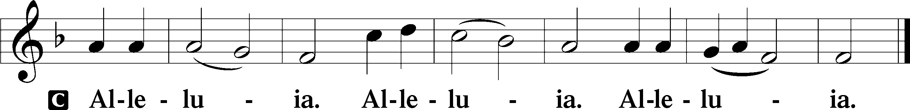

Holy Gospel Matthew 11:25–30
P The Holy Gospel according to St. Matthew, the eleventh chapter.

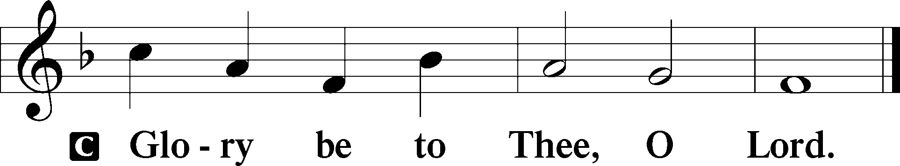

25At that time Jesus declared, “I thank you, Father, Lord of heaven and earth, that you have hidden these things from the wise and understanding and revealed them to little children; 26yes, Father, for such was your gracious will. 27All things have been handed over to me by my Father, and no one knows the Son except the Father, and no one knows the Father except the Son and anyone to whom the Son chooses to reveal him. 28Come to me, all who labor and are heavy laden, and I will give you rest. 29Take my yoke upon you, and learn from me, for I am gentle and lowly in heart, and you will find rest for your souls. 30For my yoke is easy, and my burden is light.”

P This is the Gospel of the Lord.

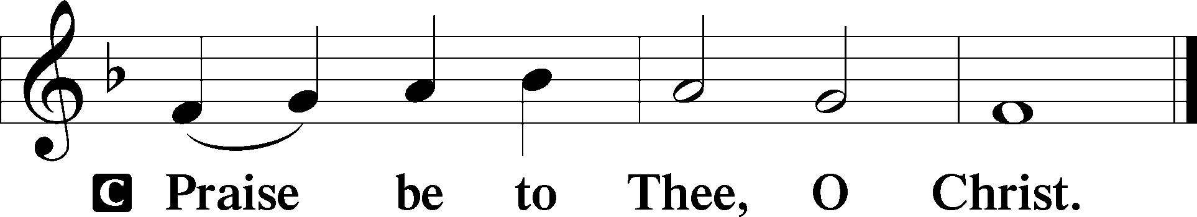

Nicene Creed
C I believe in one God,
the Father Almighty,
maker of heaven and earth
and of all things visible and invisible.

And in one Lord Jesus Christ,
the only-begotten Son of God,
begotten of His Father before all worlds,
God of God, Light of Light,
very God of very God,
begotten, not made,
being of one substance with the Father,
by whom all things were made;
who for us men and for our salvation came down from heaven
and was incarnate by the Holy Spirit of the virgin Mary
and was made man;
and was crucified also for us under Pontius Pilate.
He suffered and was buried.
And the third day He rose again according to the Scriptures
and ascended into heaven
and sits at the right hand of the Father.
And He will come again with glory to judge both the living and the dead,
whose kingdom will have no end.

And I believe in the Holy Spirit,
the Lord and giver of life,
who proceeds from the Father and the Son,
who with the Father and the Son together is worshiped and glorified,
who spoke by the prophets.
And I believe in one holy Christian and apostolic Church,
I acknowledge one Baptism for the remission of sins,
and I look for the resurrection of the dead
and the life T of the world to come. Amen.
Sit

Children's Sermon

I pledge allegiance to the flag of the United States of America; and to the republic for which it stands, one nation under God, indivisible, with liberty and justice for all.

I pledge allegiance to the cross of my Lord Jesus Christ, and to the faith for which it stands, one Savior, eternal, with mercy and grace for all.

606 I Lay My Sins on Jesus
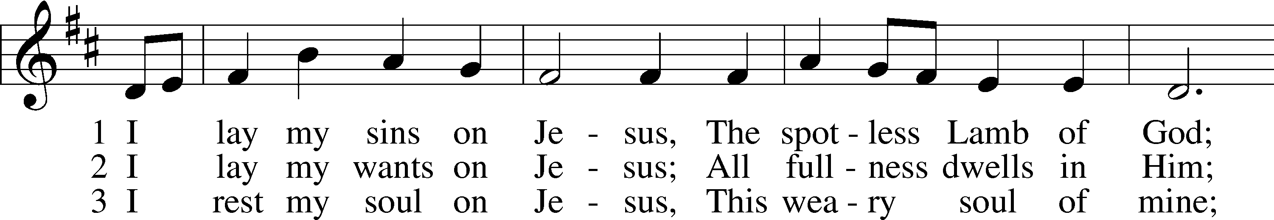
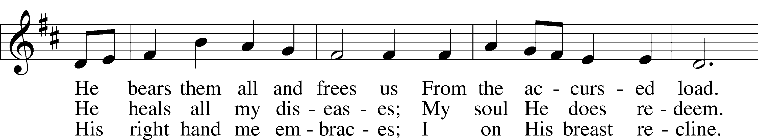
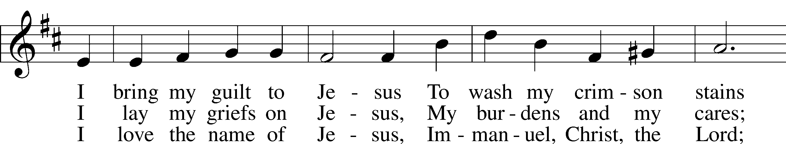
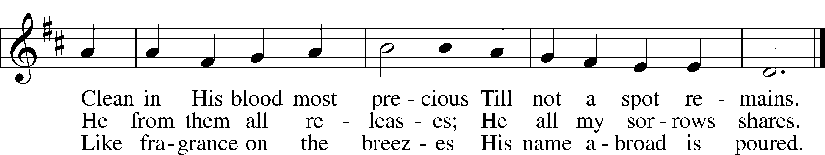
Text: Horatius Bonar, 1808–89
Tune: Neu-vermehrtes . . . Gesangbuch, 1693, 3rd ed., Meiningen
Text and tune: Public domain

Sermon "Nobody's Perfect"

Votum
P The peace of God, which passes all understanding, keep your hearts and minds in Christ Jesus.
C Amen.

Stand

Offertory Psalm 51:10–12
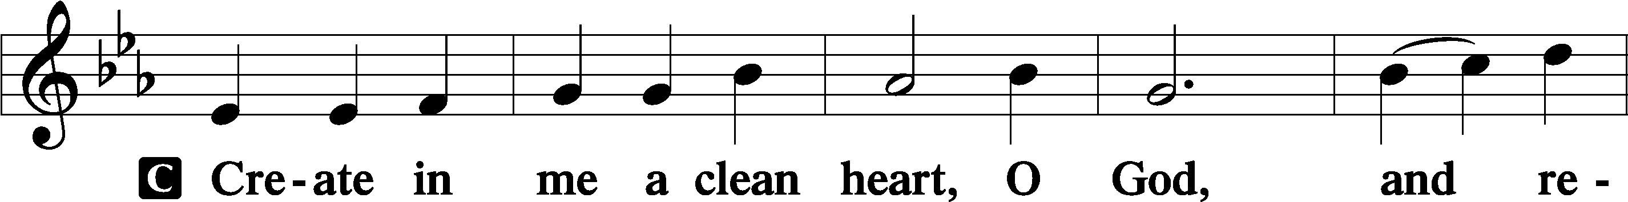
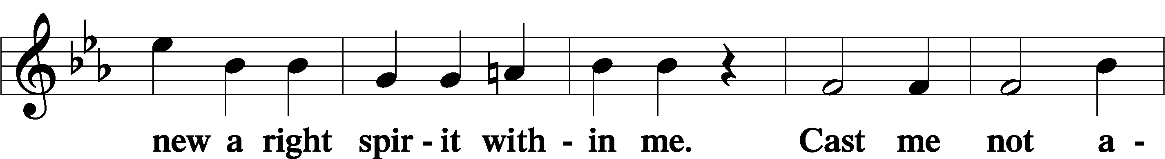
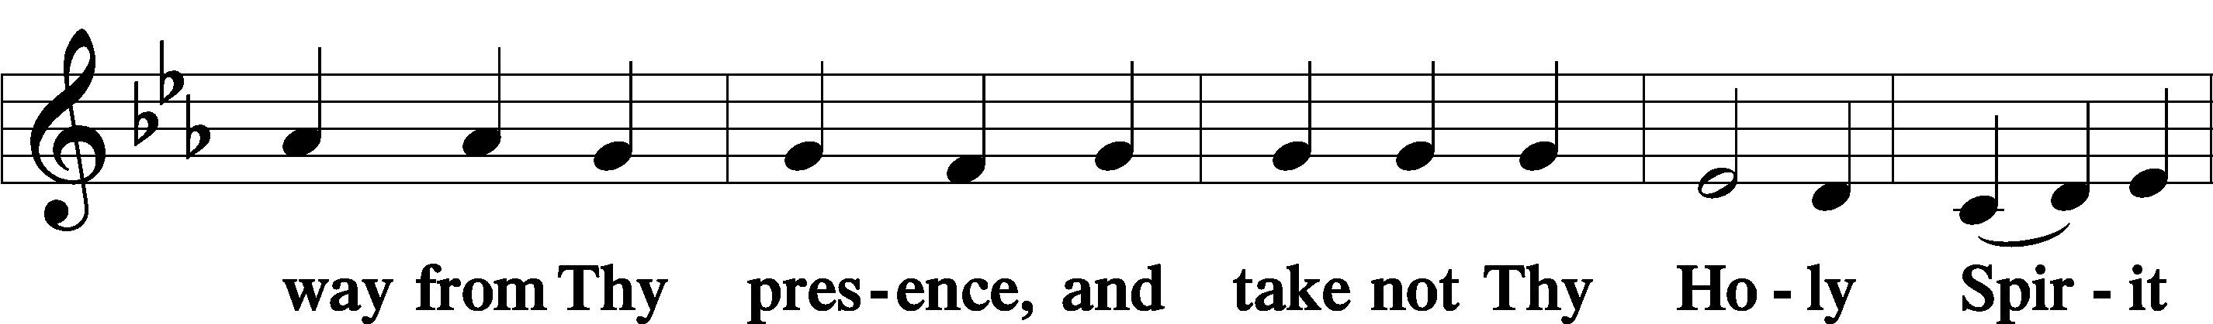
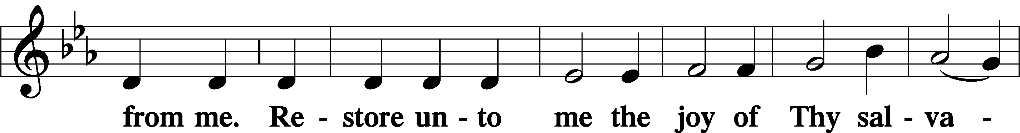
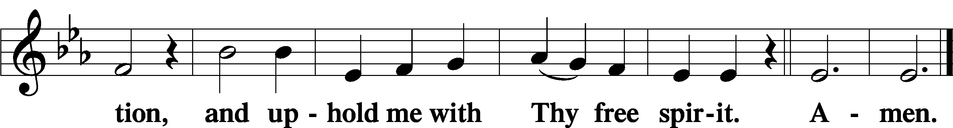

Sit

Offering

Hymn
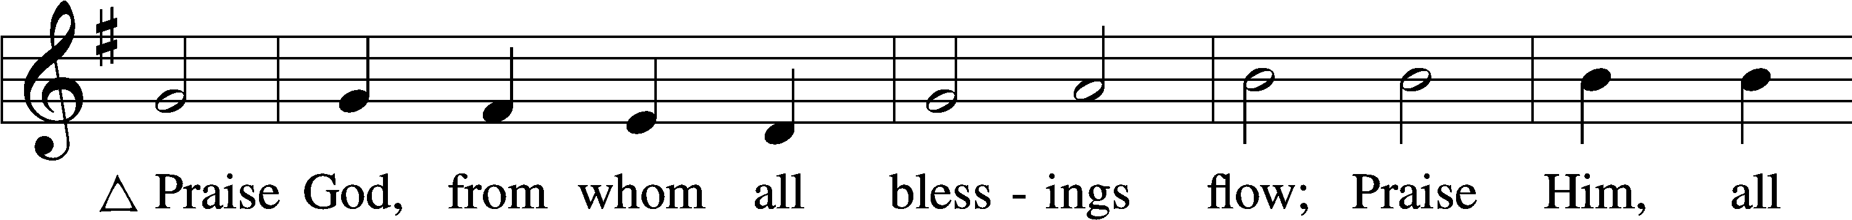
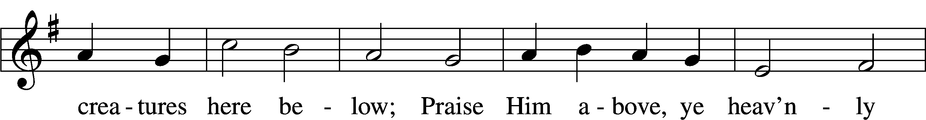
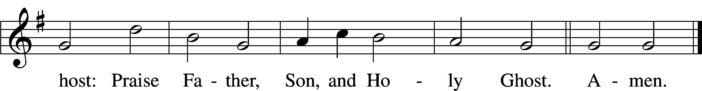
Text: Thomas Ken, 1637–1711
Tune: Trente quatre Pseaumes de David, 1551, Geneva, ed. Louis Bourgeois
Text and tune: Public domain

Stand

Prayer of the Church

Service of the Sacrament

Preface 2 Timothy 4:22; [Colossians 3:1]; [Psalm 136]
P The Lord be with you.
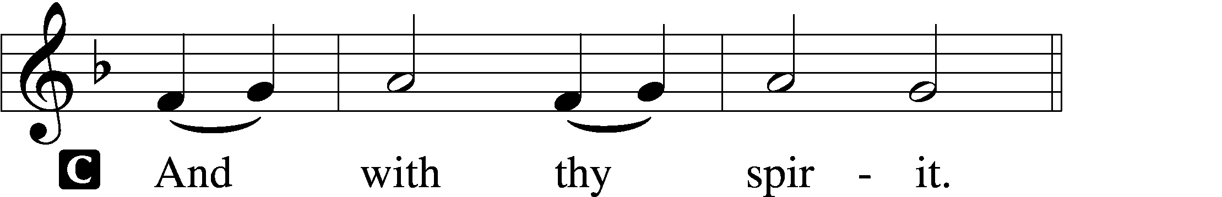

P Lift up your hearts.
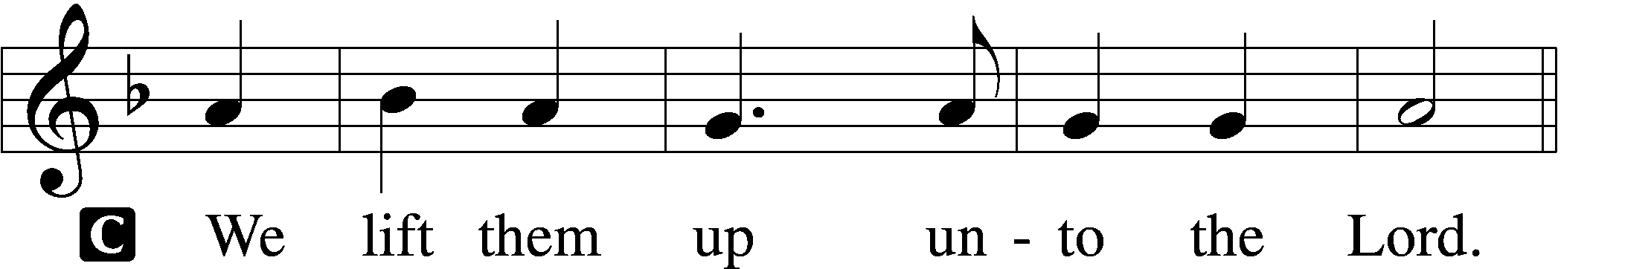

P Let us give thanks unto the Lord, our God.
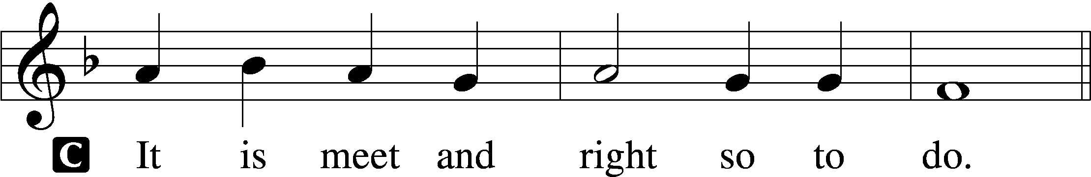

Proper Preface (Full)
P It is truly meet, right, and salutary that we should at all times and in all places give thanks to You, holy Lord, almighty Father, everlasting God, through Jesus Christ, our Lord, who, out of love for His fallen creation, humbled Himself by taking on the form of a servant, becoming obedient unto death, even death upon a cross. Risen from the dead, He has freed us from eternal death and given us life everlasting. Therefore with angels and archangels and with all the company of heaven we laud and magnify Your glorious name, evermore praising You and saying:

Sanctus Isaiah 6:3; Matthew 21:9
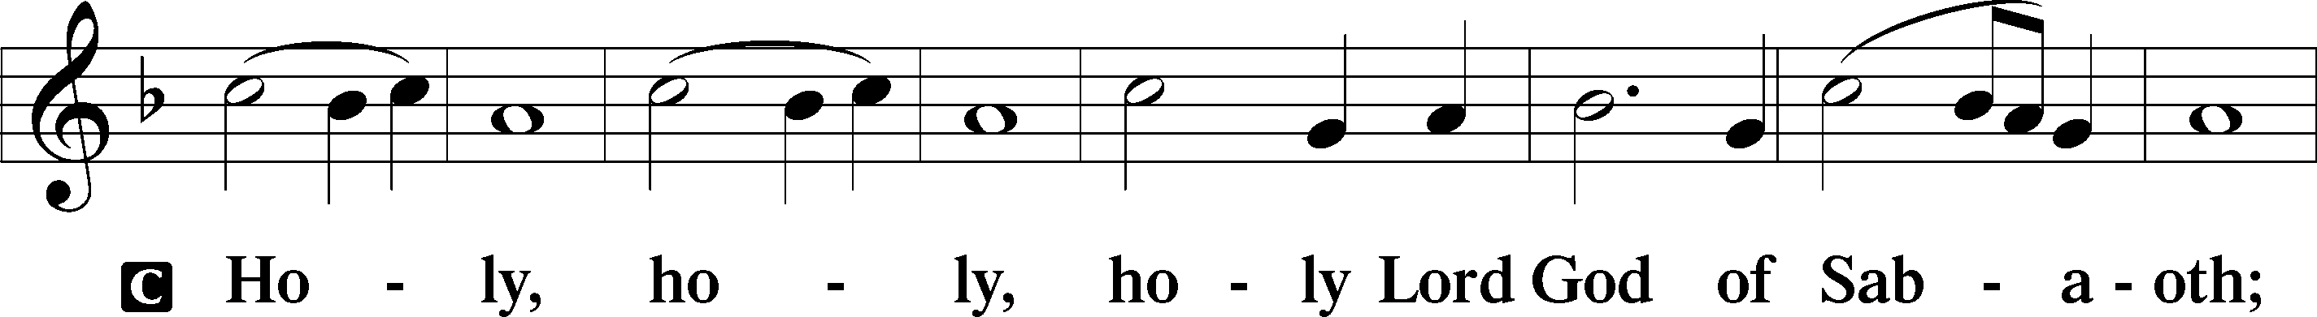
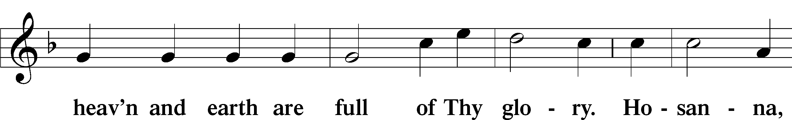
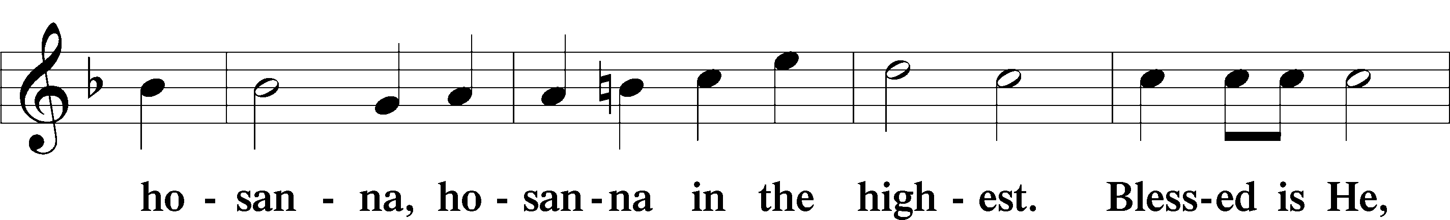
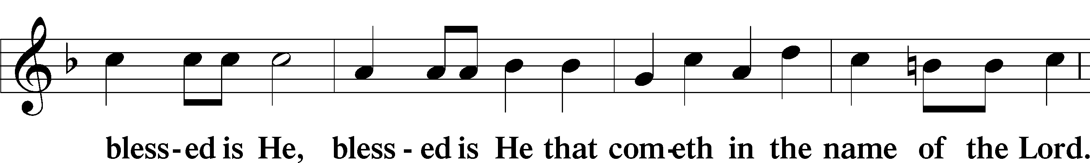
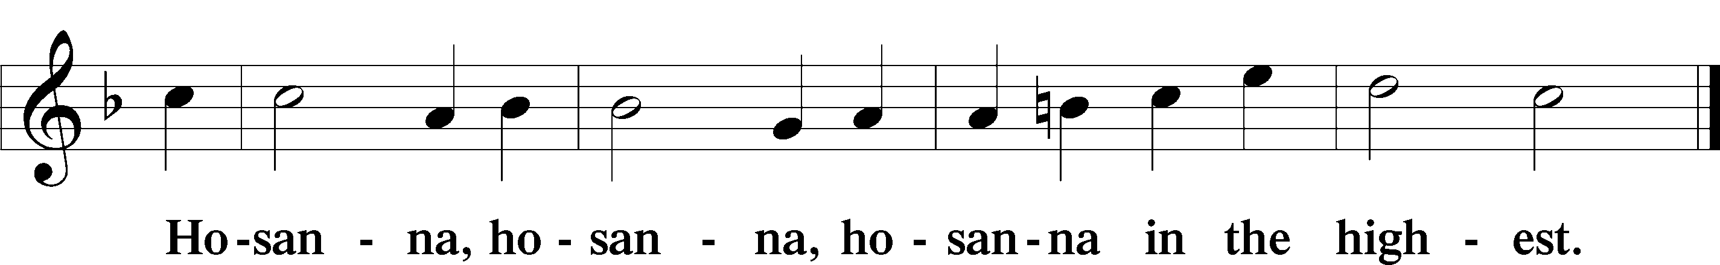

Lord’s Prayer Matthew 6:9–13
P Our Father who art in heaven,
hallowed be Thy name,
Thy kingdom come,
Thy will be done on earth as it is in heaven;
give us this day our daily bread;
and forgive us our trespasses as we forgive those who trespass against us;
and lead us not into temptation,
but deliver us from evil.
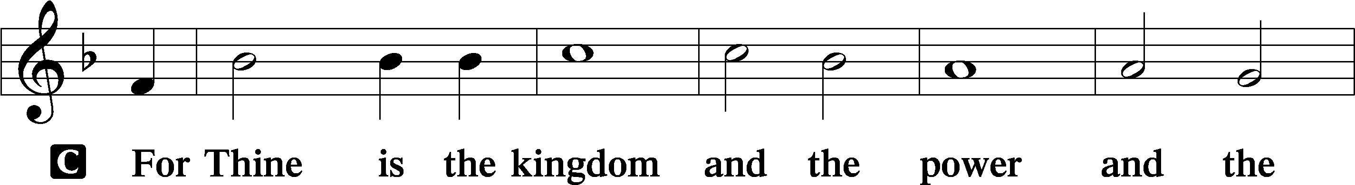
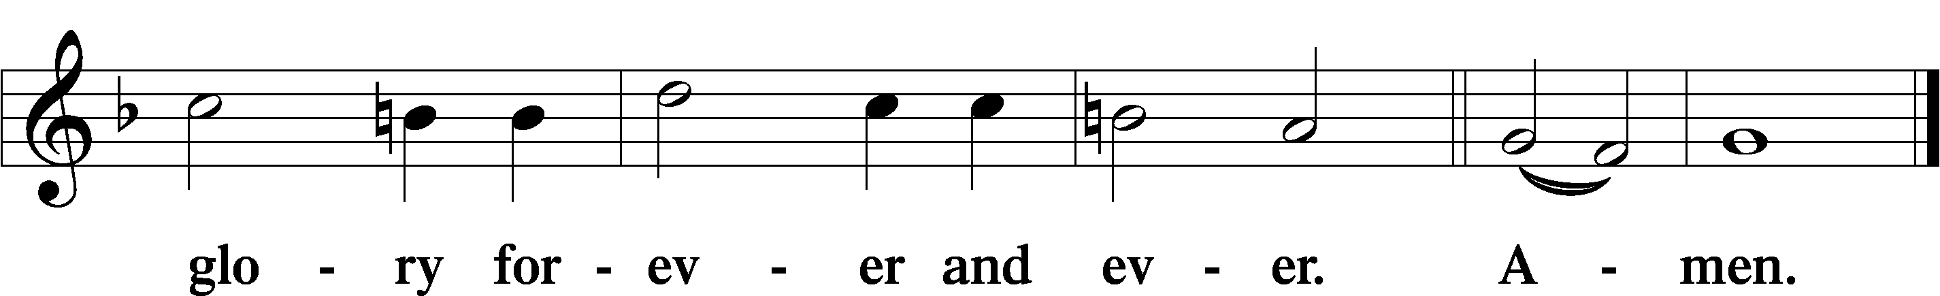

The Words of Our Lord Matthew 26:26–28; Mark 14:22–24; Luke 22:19–20; 1 Corinthians 11:23–25
P Our Lord Jesus Christ, on the night when He was betrayed, took bread, and when He had given thanks, He broke it and gave it to the disciples and said: “Take, eat; this is My T body, which is given for you. This do in remembrance of Me.”

In the same way also He took the cup after supper, and when He had given thanks, He gave it to them, saying: “Drink of it, all of you; this cup is the new testament in My T blood, which is shed for you for the forgiveness of sins. This do, as often as you drink it, in remembrance of Me.”

Pax Domini John 20:19
P The peace of the Lord be with you always.

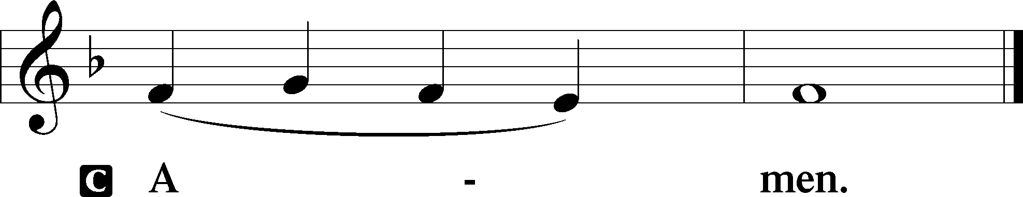

Agnus Dei John 1:29
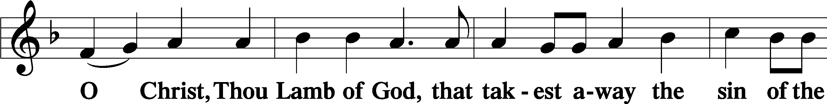
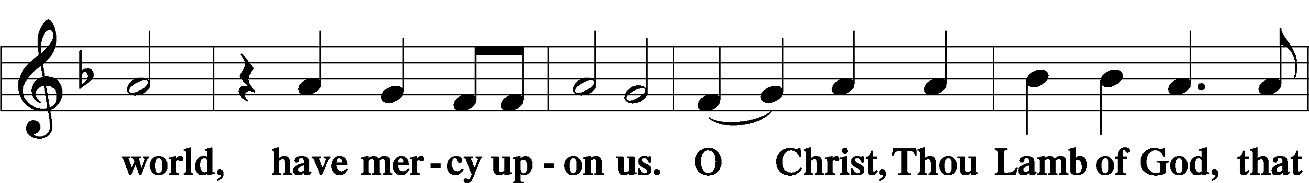
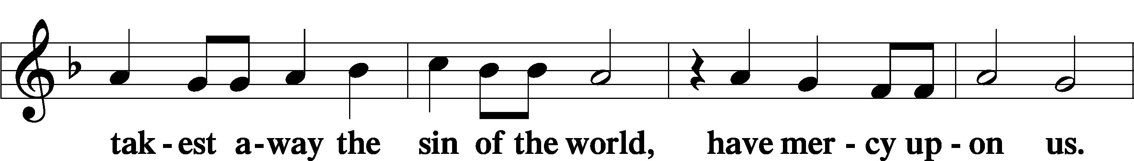
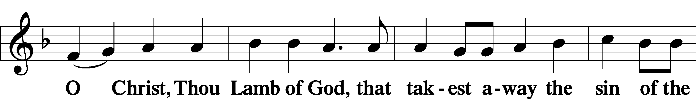
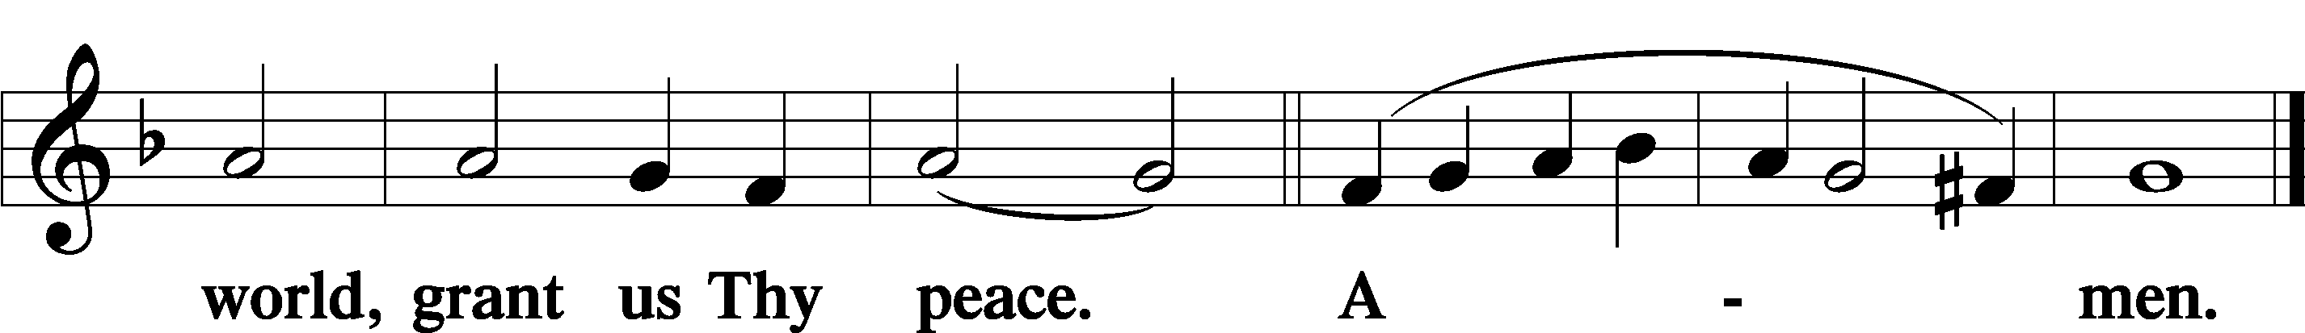

Sit

Distribution

The pastor and those who assist him receive the body and blood of Christ first and then distribute them to those who come to receive, saying:

Take, eat; this is the true body of our Lord and Savior Jesus Christ, given into death for your sins.
Amen.

Take, drink; this is the true blood of our Lord and Savior Jesus Christ, shed for the forgiveness of your sins.
Amen.

In dismissing the communicants, the following is said:

The Dismissal
P The body and blood of our Lord Jesus Christ strengthen and preserve you in body and soul to life everlasting. Depart T in peace.
C Amen.

680 Thine the Amen, Thine the Praise
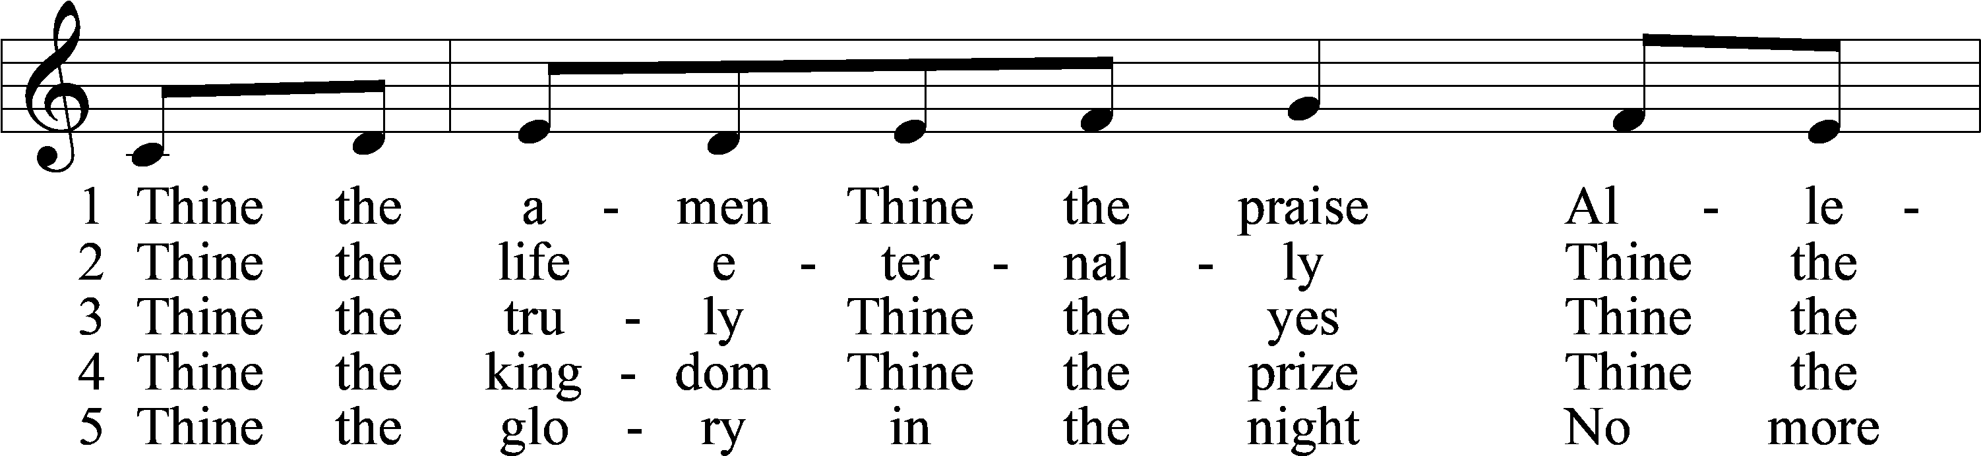
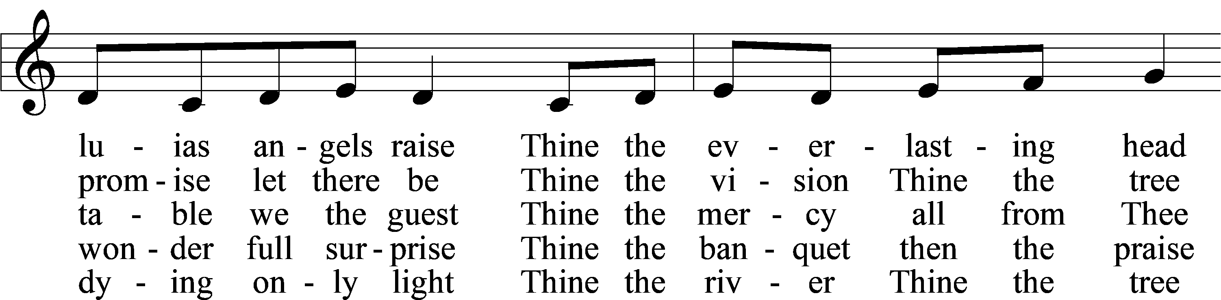
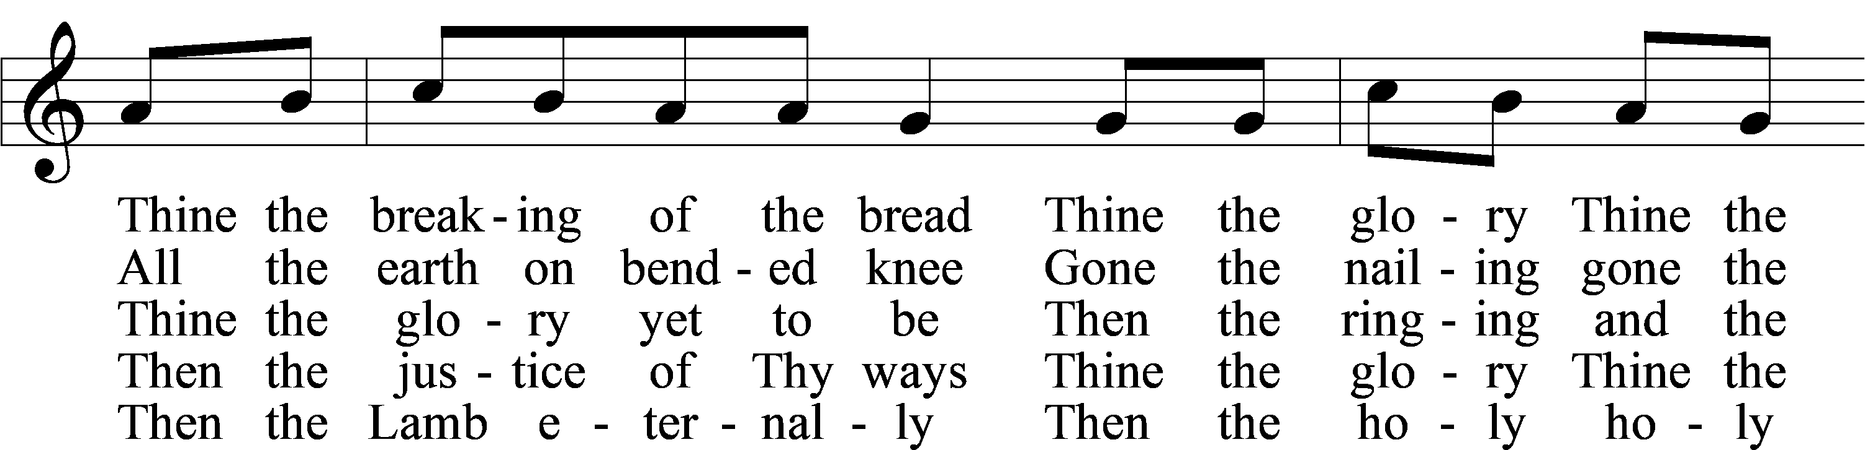
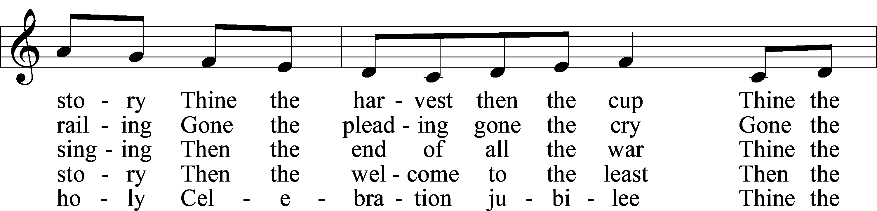
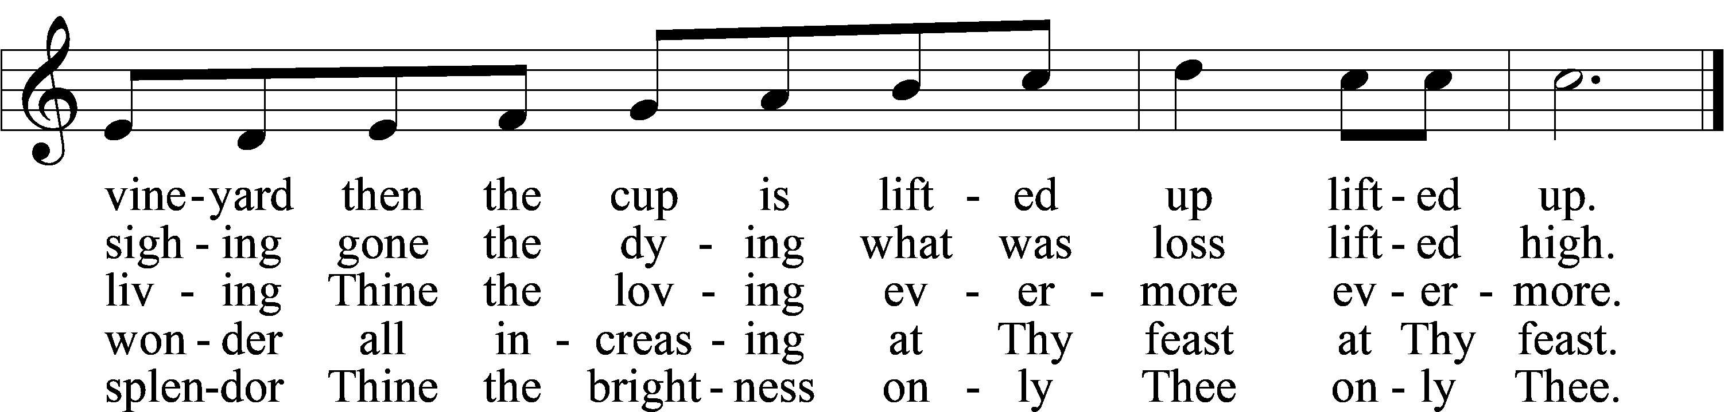
Text: Herbert F. Brokering, 1926–2009
Tune: Carl F. Schalk, 1929–2021
Text and tune: © 1983 Augsburg Publishing House. Used by permission: LSB Hymn License no. 110005011

658 Preserve Your Word, O Savior
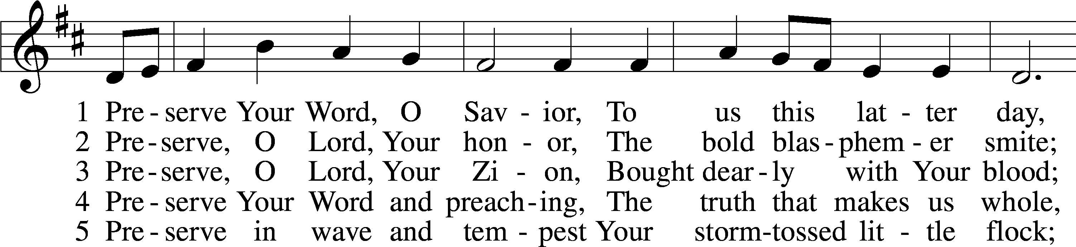
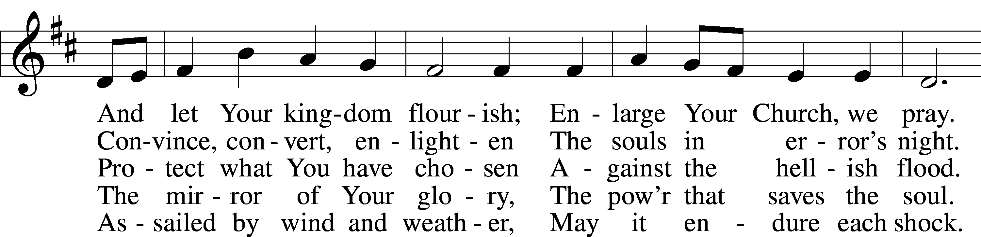
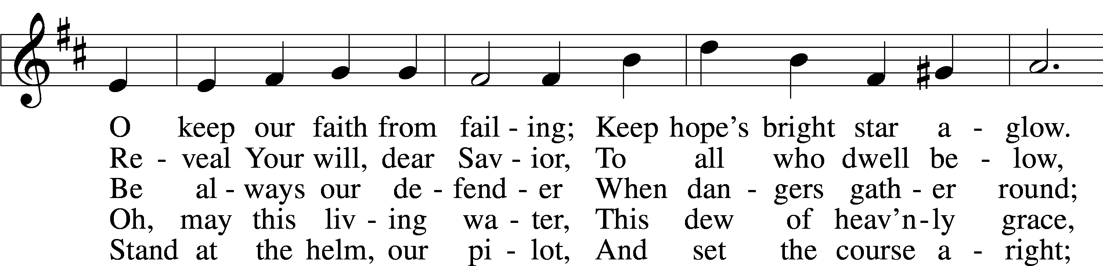
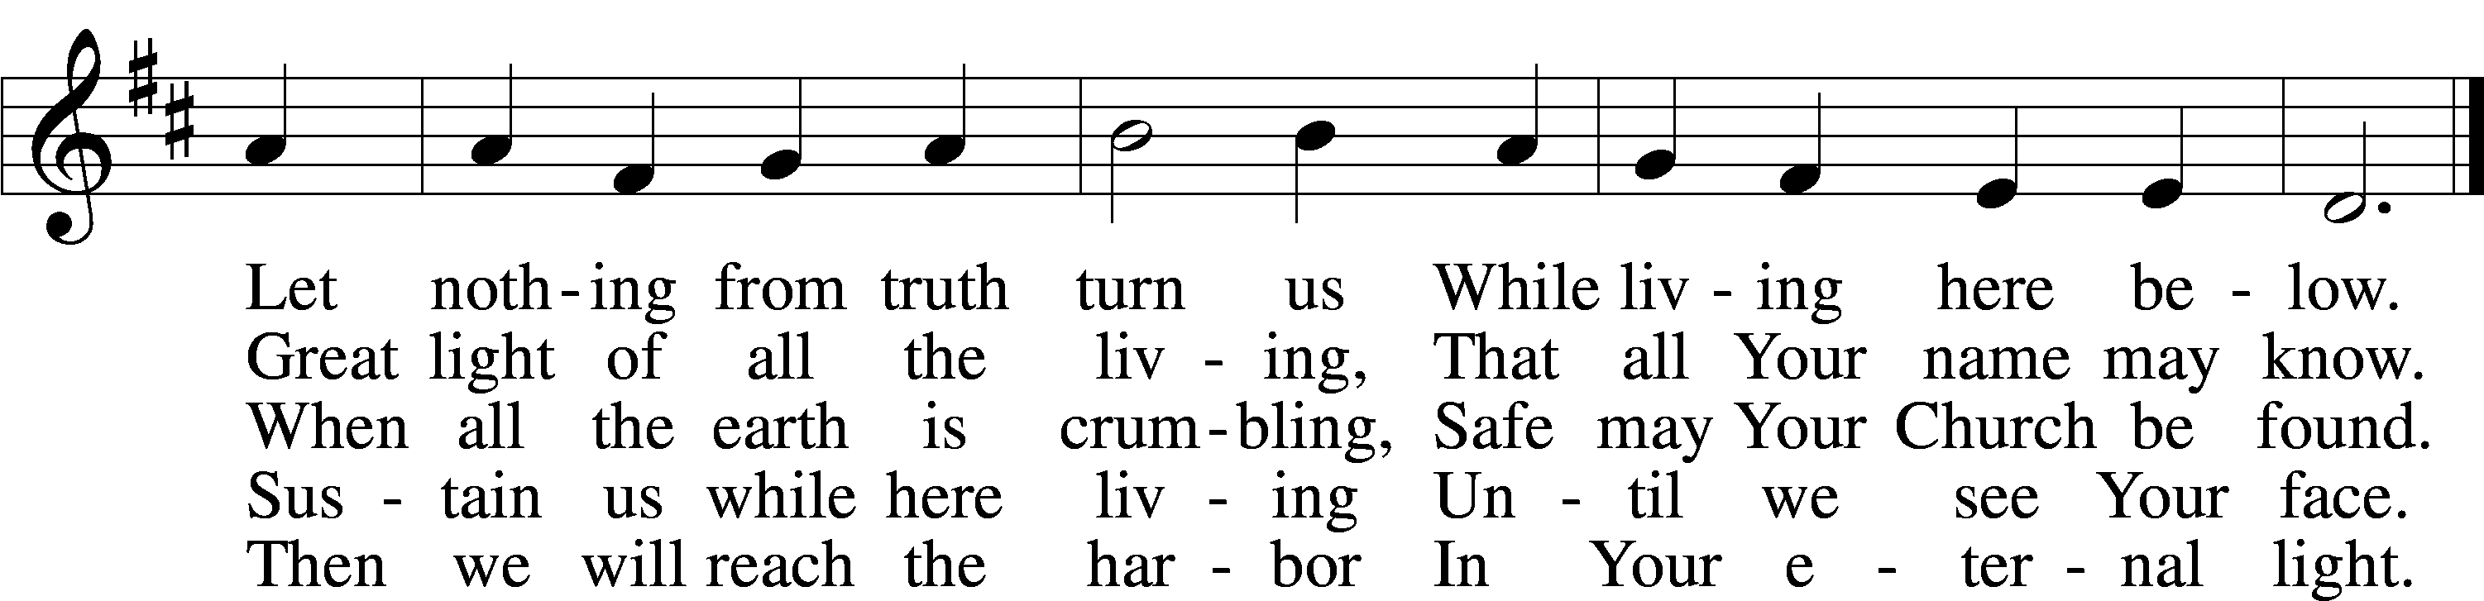
Text: Andreas Gryphius, 1616–64; tr. William J. Schaefer, 1891–1976, alt.
Tune: Neu-vermehrtes . . . Gesangbuch, 1693, 3rd ed., Meiningen
Text: © 1941 Concordia Publishing House. Used by permission: LSB Hymn License no. 110005011
Tune: Public domain

566 By Grace I’m Saved
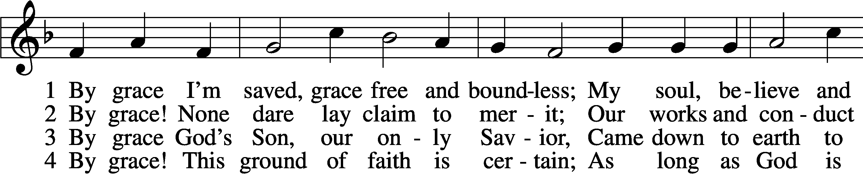
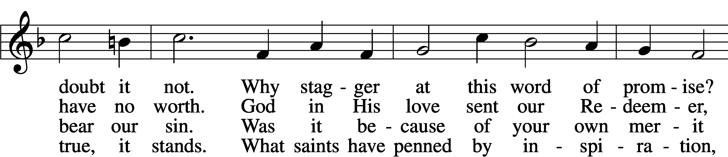
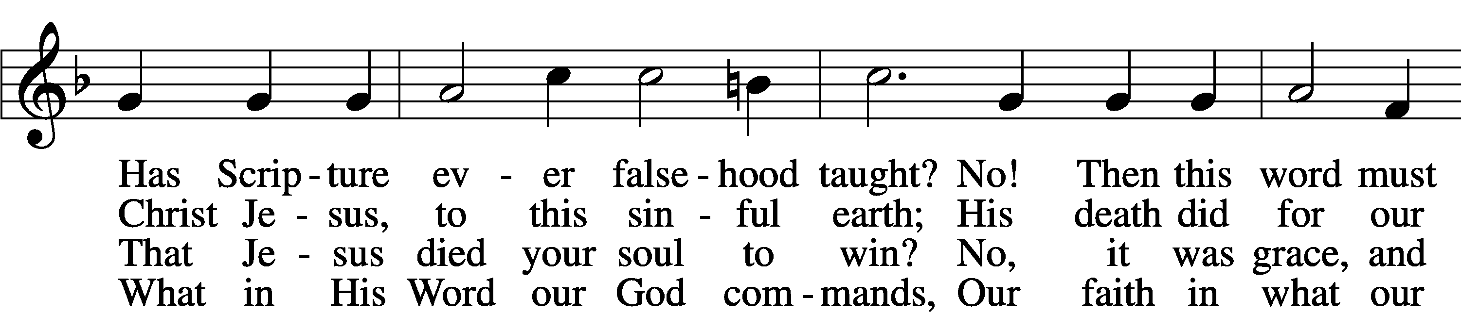
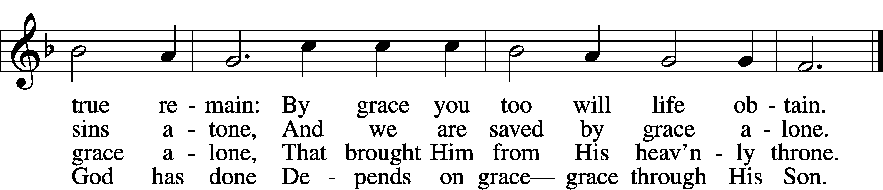

5 By grace to timid hearts that tremble,
In tribulation’s furnace tried,
By grace, in spite of fear and trouble,
The Father’s heart is open wide.
Where could I help and strength secure
If grace were not my anchor sure?

6 By grace! On this I’ll rest when dying;
In Jesus’ promise I rejoice;
For though I know my heart’s condition,
I also know my Savior’s voice.
My heart is glad, all grief has flown
Since I am saved by grace alone.
Text: Christian Ludwig Scheidt, 1709–61; tr. The Lutheran Hymnal, 1941, alt.
Tune: Cornelius Heinrich Dretzel, 1697–1775
Text and tune: Public domain

580 The Gospel Shows the Father’s Grace
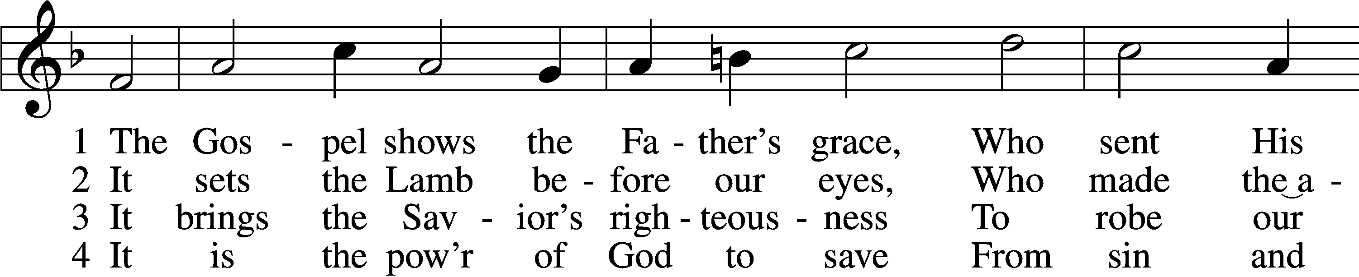
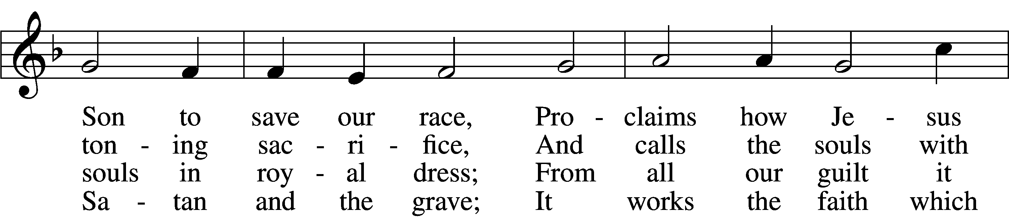
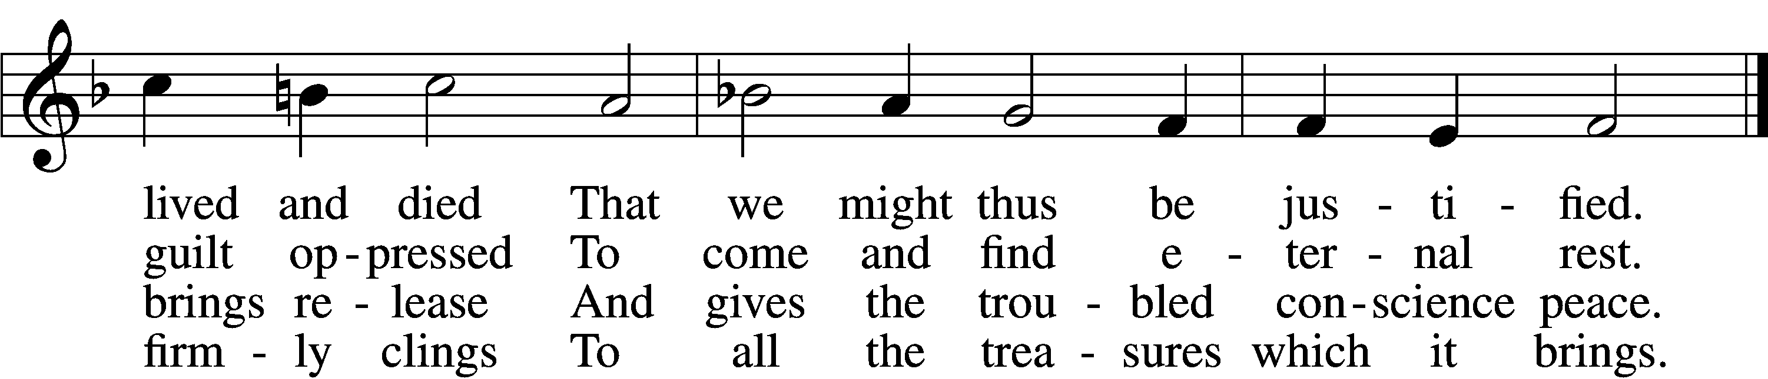

5 It bears to all the tidings glad
And bids their hearts no more be sad;
The weary, burdened souls it cheers
And banishes their guilty fears.

6 May we in faith its message learn
Nor thanklessly its blessings spurn;
May we in faith its truth confess
And praise the Lord, our righteousness.
Text: Matthias Loy, 1828–1915, alt.
Tune: Cantionale Germanicum, 1628, Gochsheim
Text and tune: Public domain

Stand

Nunc Dimittis Luke 2:29–32
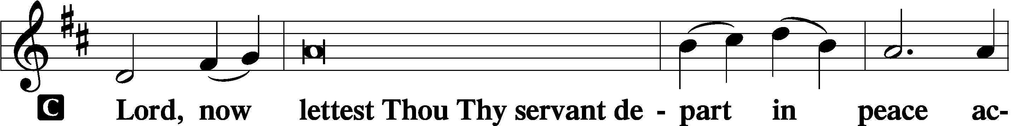

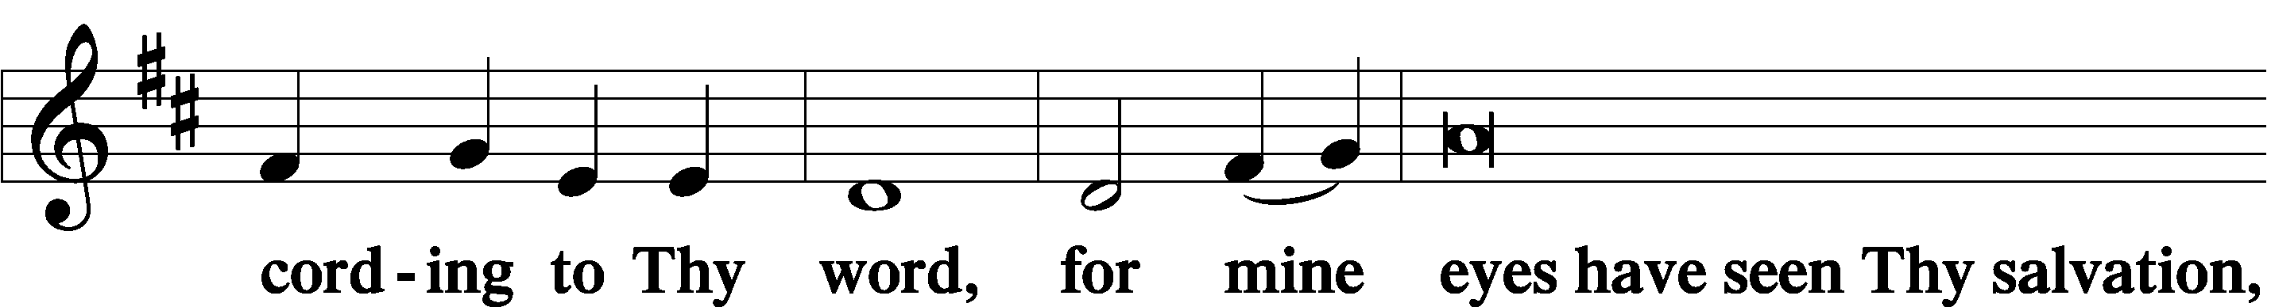

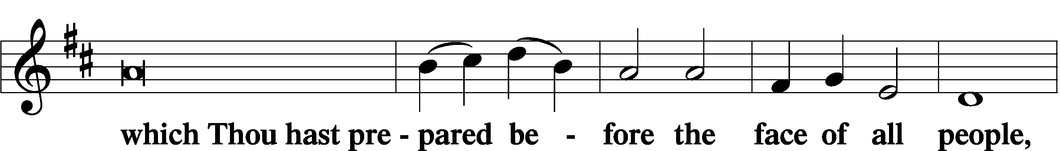

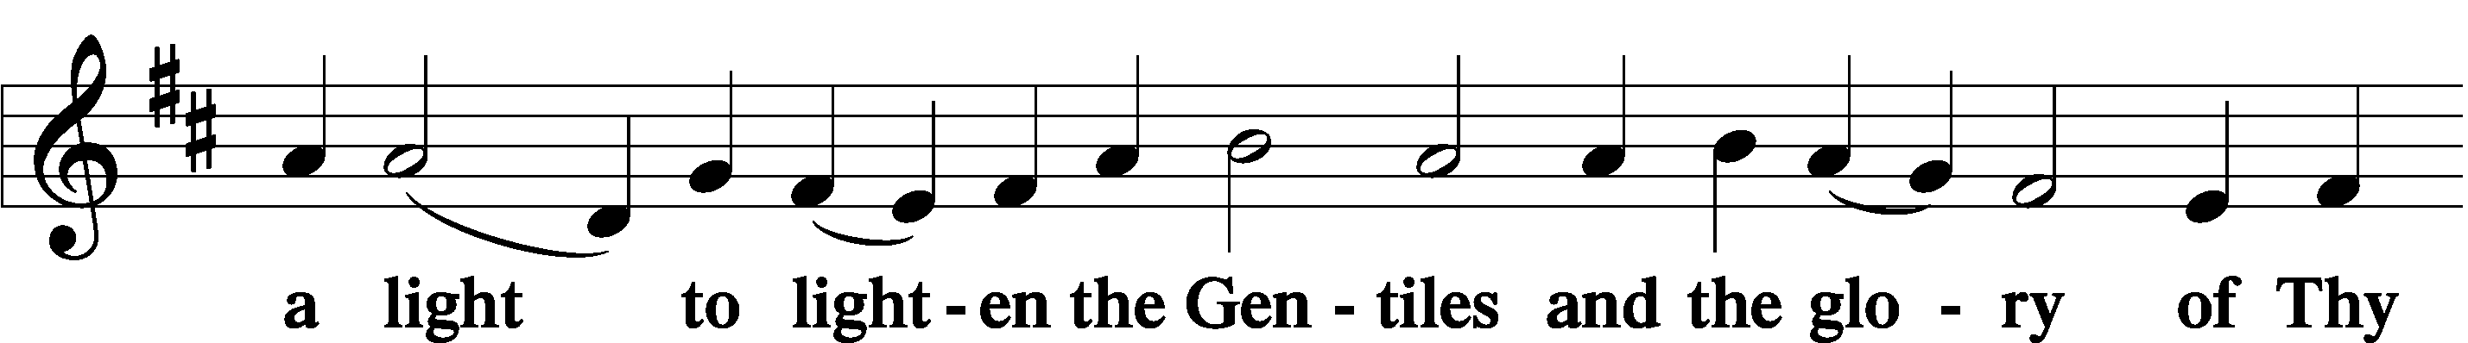

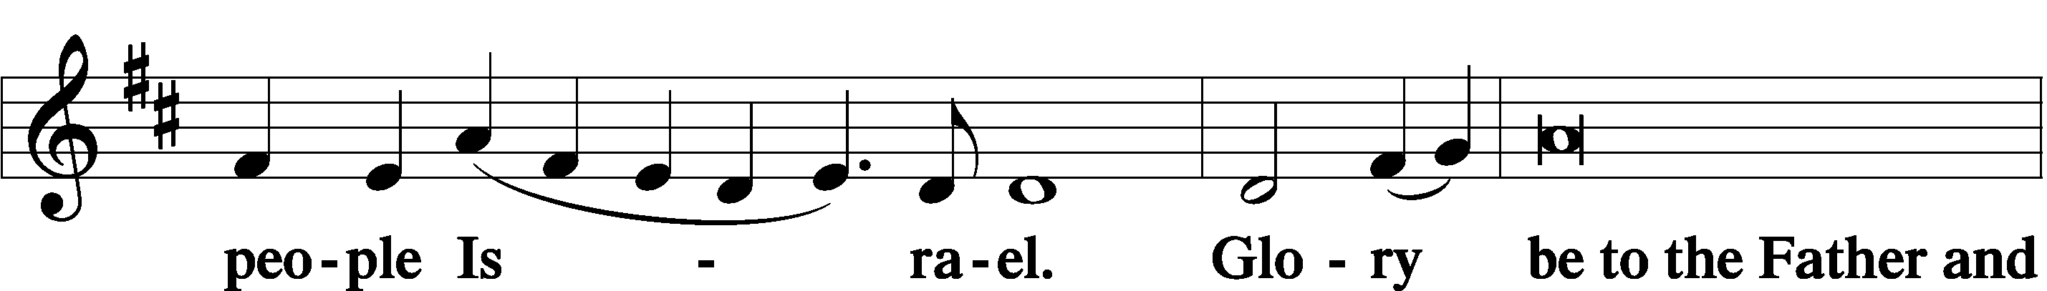

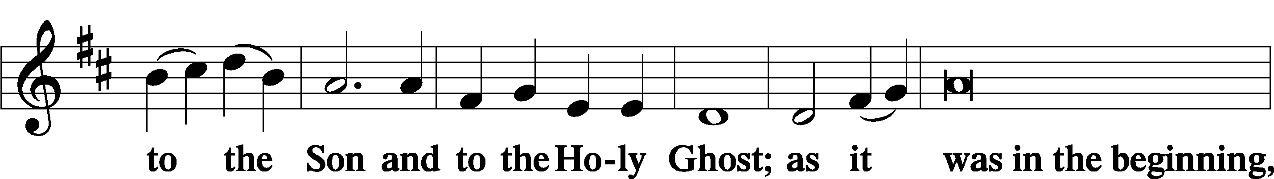

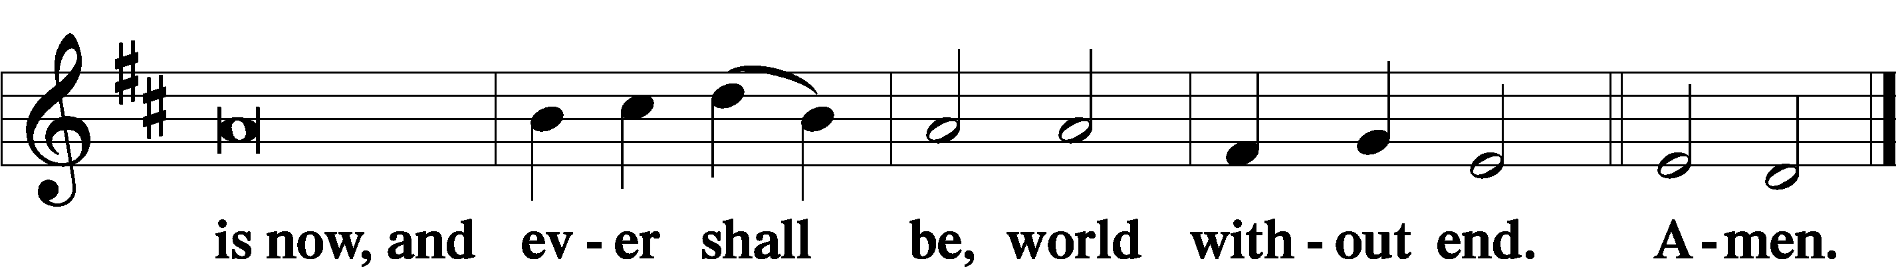

Thanksgiving Psalm 107:1
A O give thanks unto the Lord, for He is good,

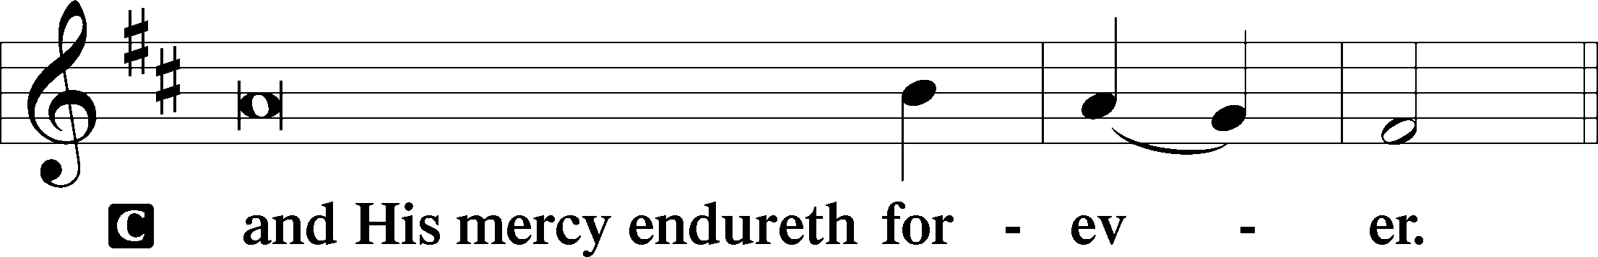

Post-Communion Collect
A Let us pray.
We give thanks to You, almighty God, that You have refreshed us through this salutary gift, and we implore You that of Your mercy You would strengthen us through the same in faith toward You and in fervent love toward one another; through Jesus Christ, Your Son, our Lord, who lives and reigns with You and the Holy Spirit, one God, now and forever.

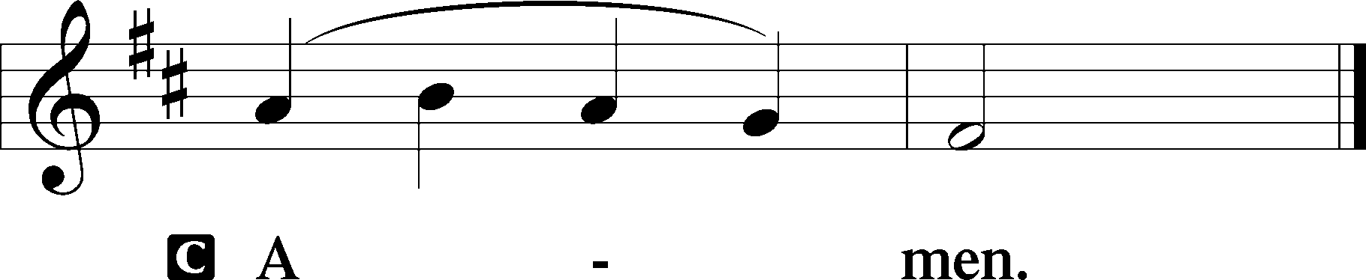

Salutation 2 Timothy 4:22
P The Lord be with you.

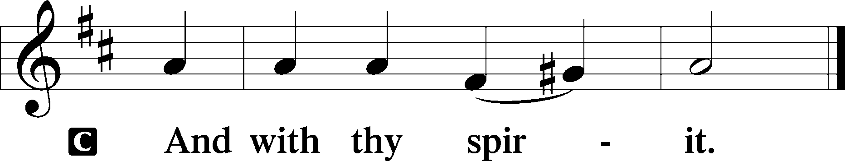

Benedicamus Psalm 103:1
A Bless we the Lord.

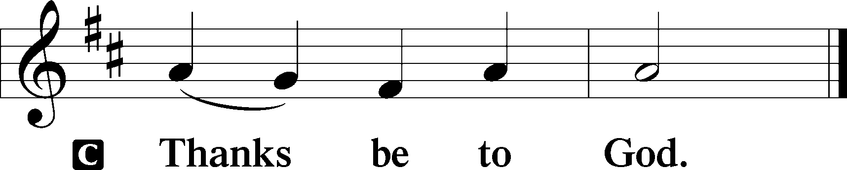

Benediction Numbers 6:24–26
P The Lord bless you and keep you.
The Lord make His face shine upon you and be gracious unto you.
The Lord lift up His countenance upon you and T give you peace.
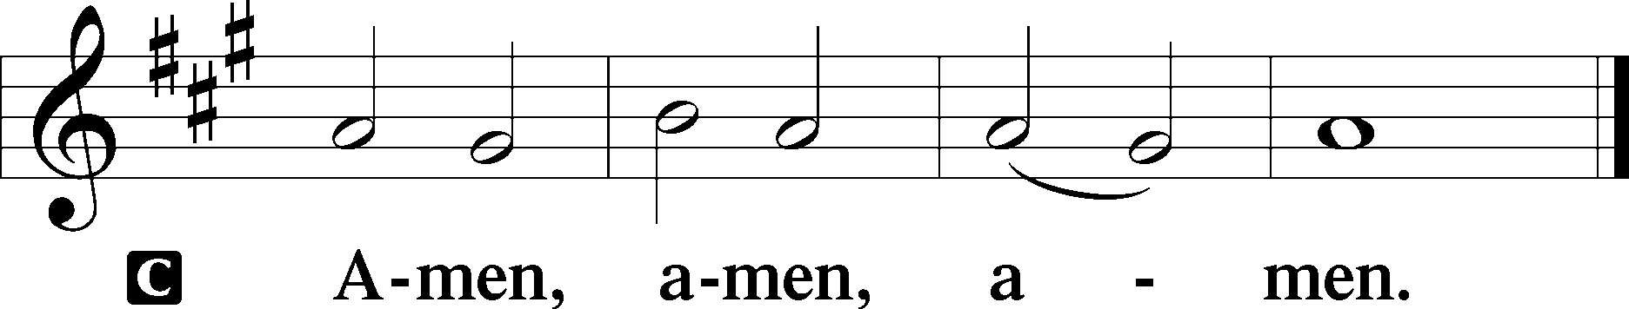

966 Before You, Lord, We Bow
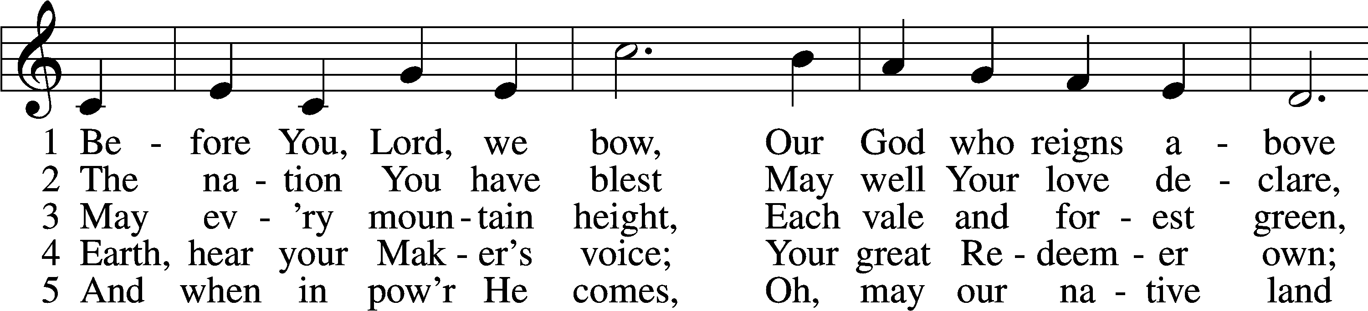
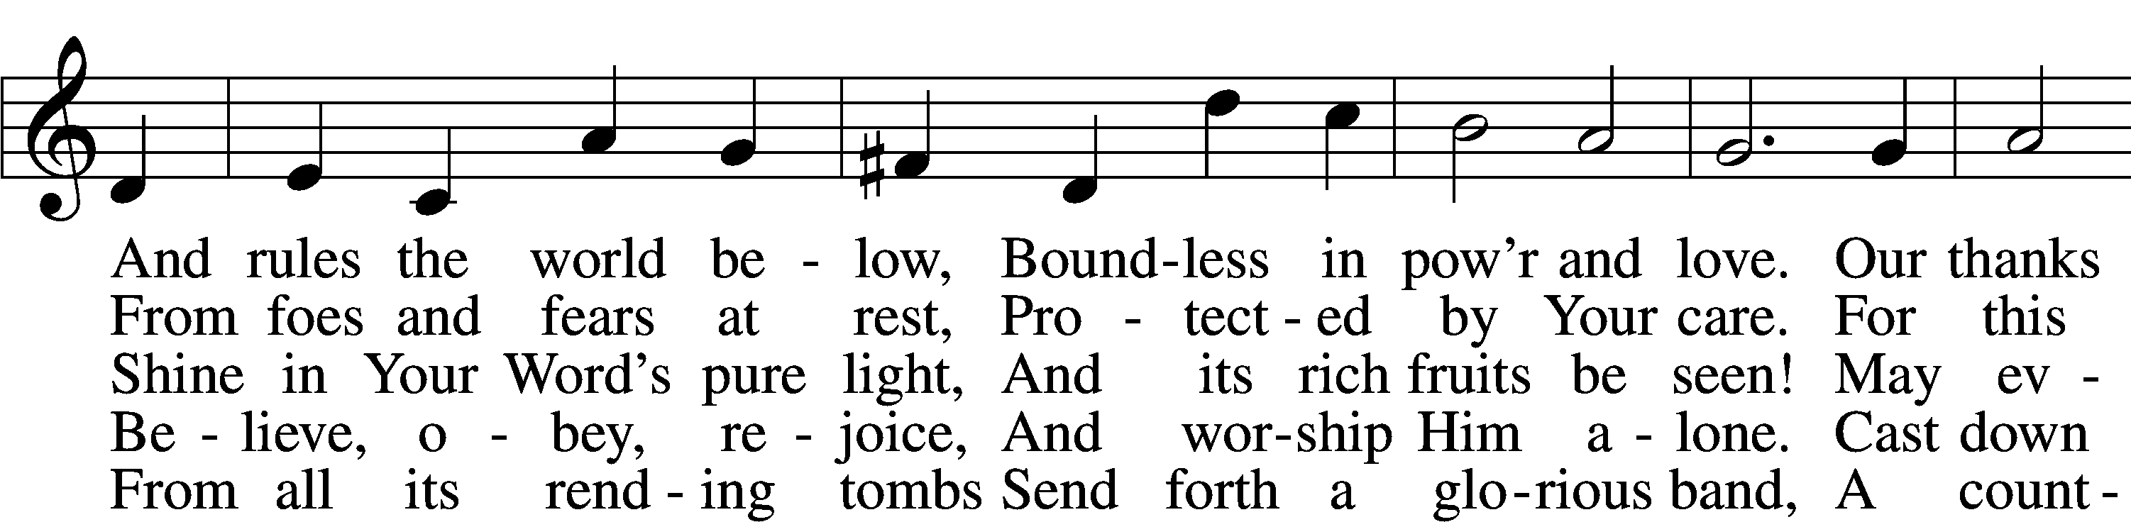
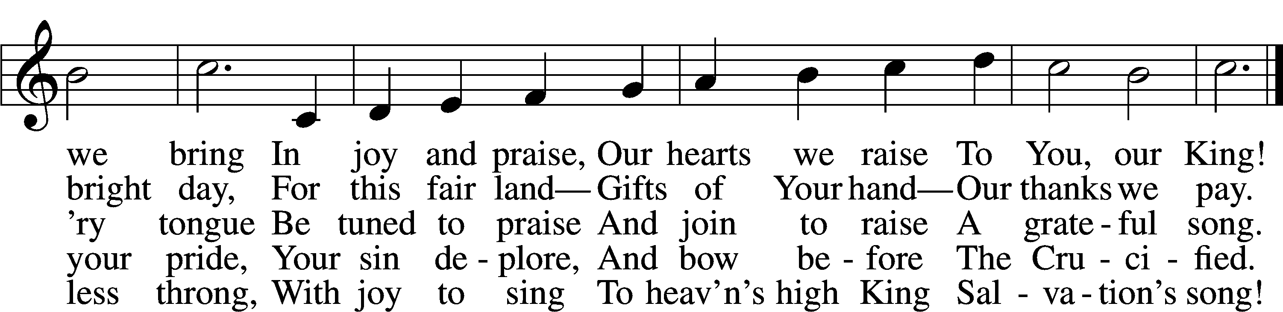
Text: Francis Scott Key, 1779–1843, alt.
Tune: John Darwall, 1731–89
Text and tune: Public domain
Acknowledgments
Divine Service, Setting Three from Lutheran Service Book
Unless otherwise indicated, Scripture quotations are from the ESV® Bible (The Holy Bible, English Standard Version®), copyright © 2001 by Crossway, a publishing ministry of Good News Publishers. Used by permission. All rights reserved.
Created by Lutheran Service Builder © 2026 Concordia Publishing House.

Thank you for joining us, and we hope to see you again soon!
For any questions, feel free to ask another congregation member, our Pastor, or just visit our website at: www.stpetertex.com
You can also find the links to our socials on our website.
Follow our Instagram or Facebook for important updates, verse-of-the-week posts, and more!

