709 The King of Love My Shepherd Is
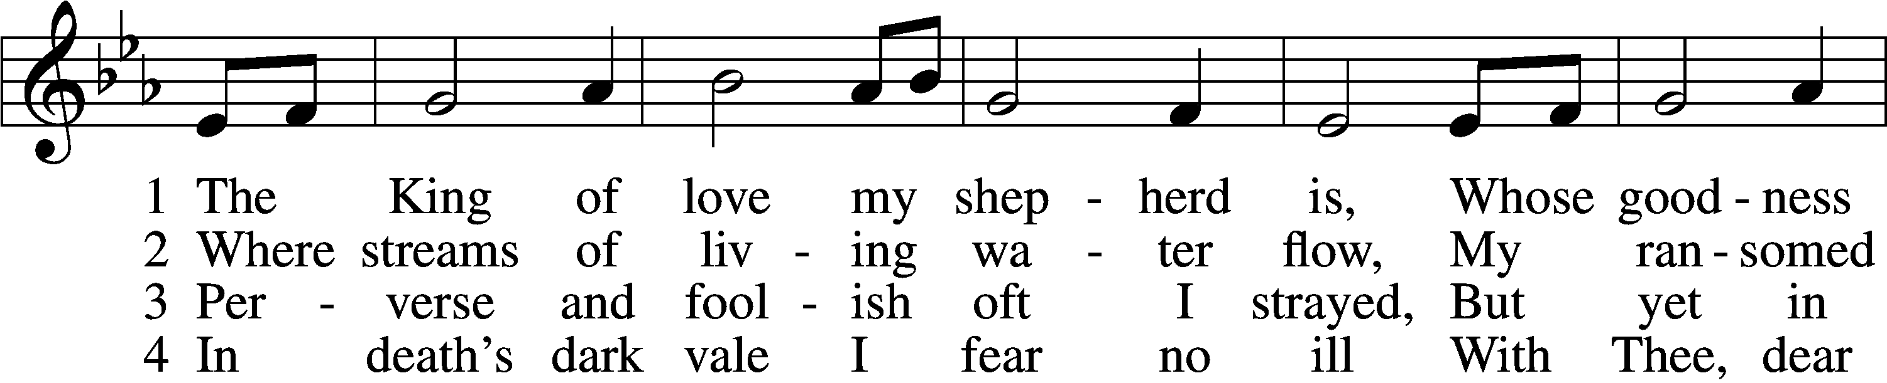
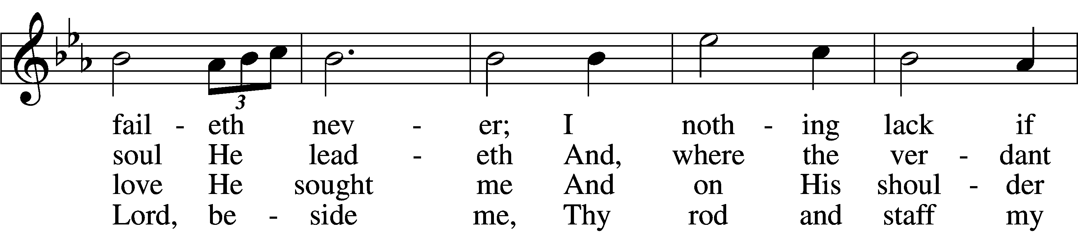
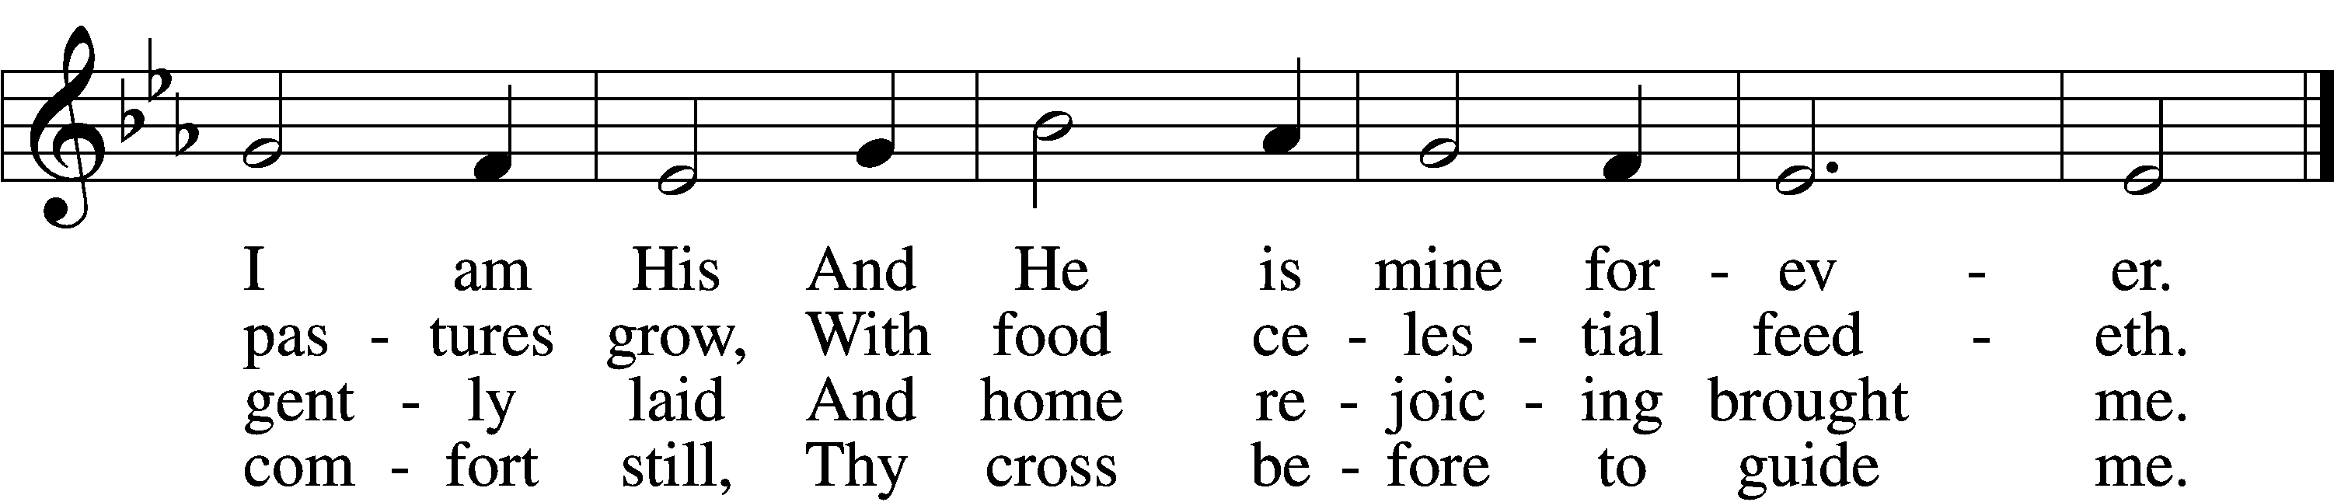

5 Thou spreadst a table in my sight;
Thine unction grace bestoweth;
And, oh, what transport of delight
From Thy pure chalice floweth!

6 And so through all the length of days
Thy goodness faileth never;
Good Shepherd, may I sing Thy praise
Within Thy house forever!
Text: Henry W. Baker, 1821–77
Tune: Irish, c. 18th cent.
Text and tune: Public domain

Confession and Absolution

The sign of the cross may be made by all in remembrance of their Baptism.

Invocation Matthew 28:19b; 18:20
P In the name of the Father and of the T Son and of the Holy Spirit.
C Amen.

Exhortation Hebrews 10:22; Psalm 124:8; Psalm 32:5
P Beloved in the Lord! Let us draw near with a true heart and confess our sins unto God our Father, beseeching Him in the name of our Lord Jesus Christ to grant us forgiveness.

P Our help is in the name of the Lord,
C who made heaven and earth.
P I said, I will confess my transgressions unto the Lord,
C and You forgave the iniquity of my sin.

Silence for reflection on God’s Word and for self-examination.

Confession of Sins
P Almighty God, our maker and redeemer, we poor sinners confess unto You that we are by nature sinful and unclean and that we have sinned against You by thought, word, and deed. Wherefore we flee for refuge to Your infinite mercy, seeking and imploring Your grace for the sake of our Lord Jesus Christ.
C O most merciful God, who has given Your only-begotten Son to die for us, have mercy upon us and for His sake grant us remission of all our sins; and by Your Holy Spirit increase in us true knowledge of You and of Your will and true obedience to Your Word, to the end that by Your grace we may come to everlasting life; through Jesus Christ, our Lord. Amen.

Declaration of Grace Mark 16:16; John 1:12
P Almighty God, our heavenly Father, has had mercy upon us and has given His only Son to die for us and for His sake forgives us all our sins. To those who believe on His name He gives power to become the children of God and has promised them His Holy Spirit. He that believes and is baptized shall be saved.
Grant this, Lord, unto us all.
C Amen.

Service of the Word

Introit Psalm 23
1The Lord is my shepherd;
I shall not want.
2He makes me lie down in green pastures.
He leads me beside still waters.
3He restores my soul.
He leads me in paths of righteousness for his name’s sake.
4Even though I walk through the valley of the shadow of death, I will fear no evil, for you are with me;
your rod and your staff, they comfort me.
5You prepare a table before me
in the presence of my enemies;
you anoint my head with oil;
my cup overflows.
6Surely goodness and mercy shall follow me
all the days of my life,
and I shall dwell in the house of the Lord forever.

Gloria Patri
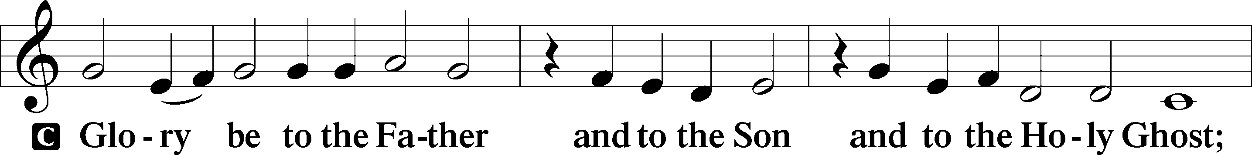
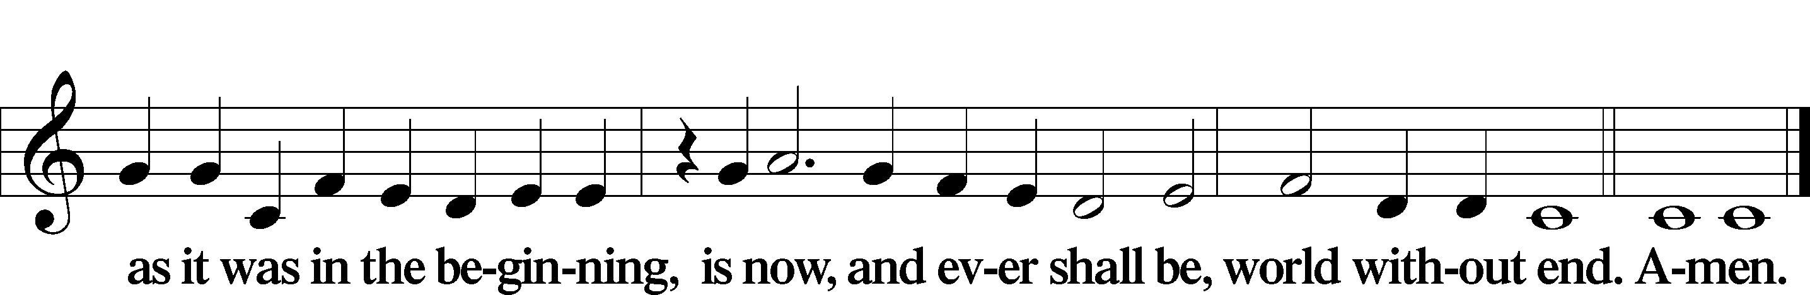

Kyrie Mark 10:47
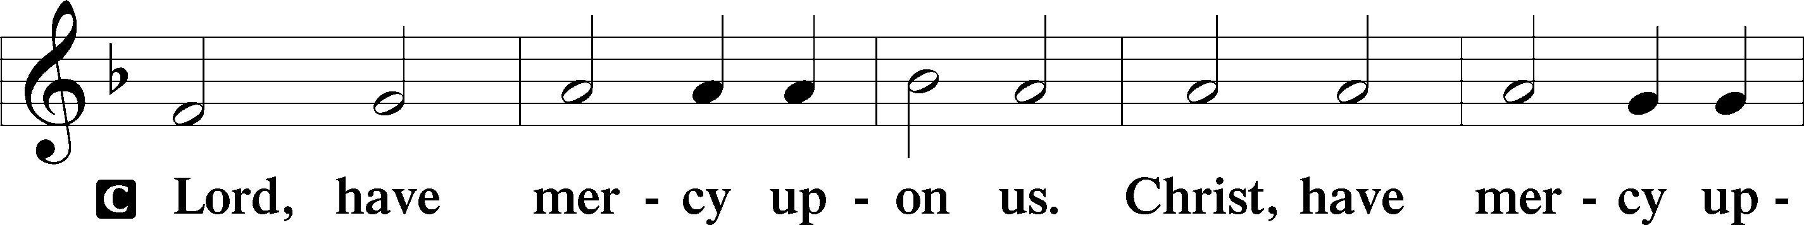
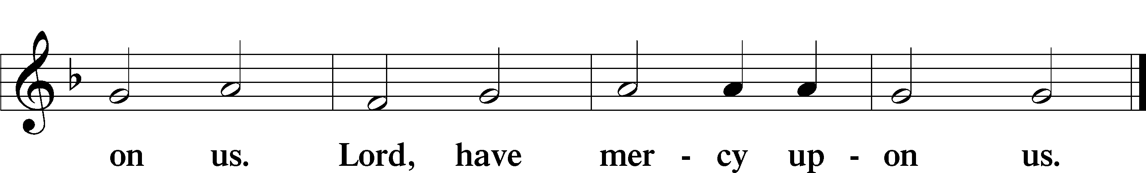

Gloria in Excelsis Luke 2:14; John 1:29
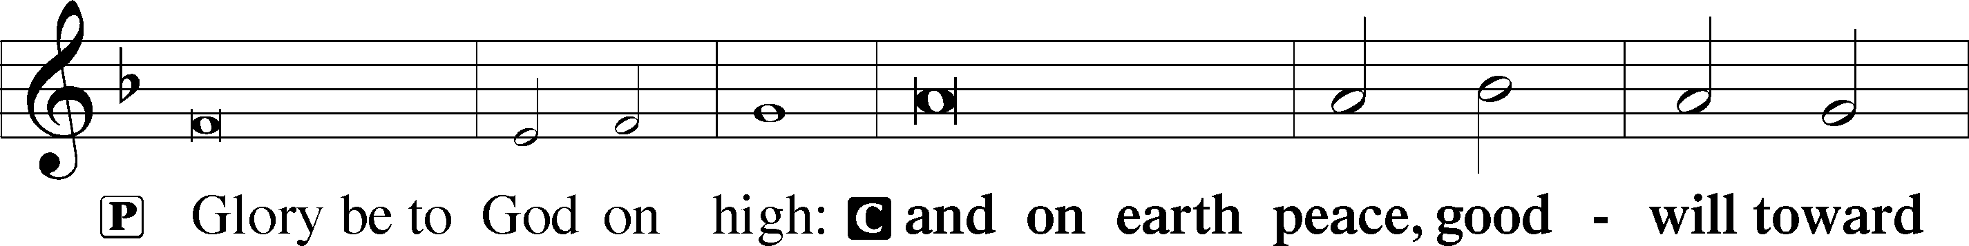
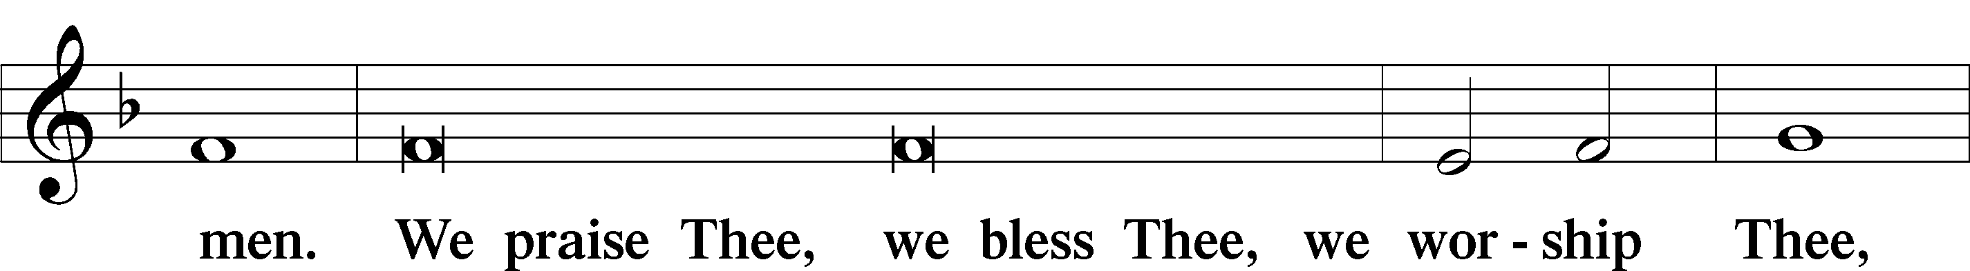
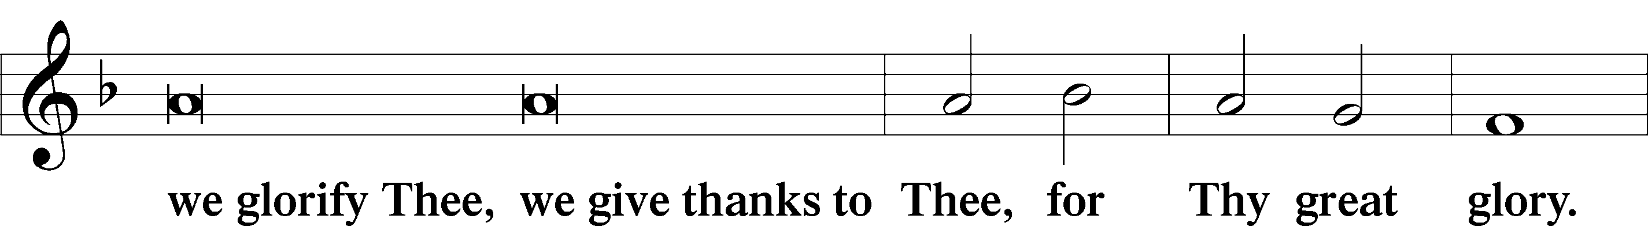
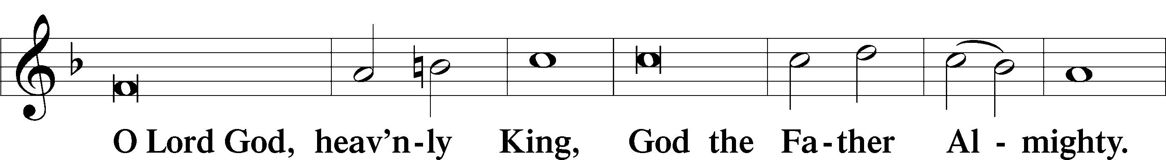
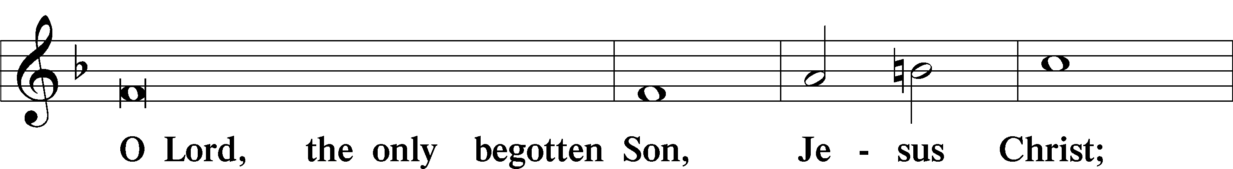
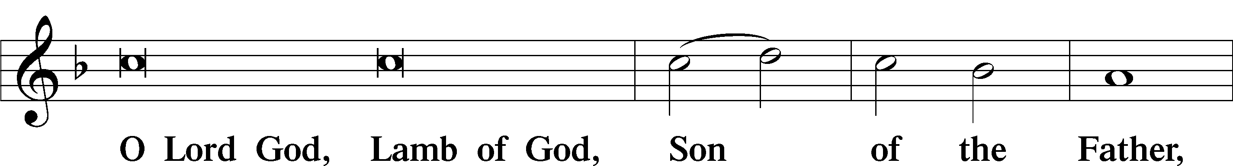
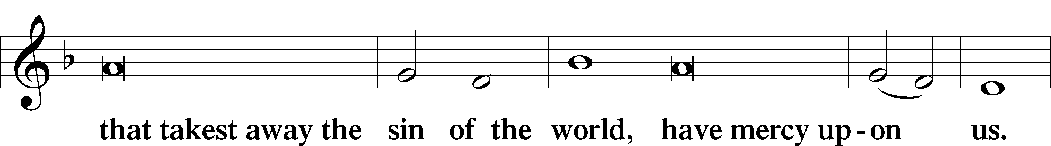
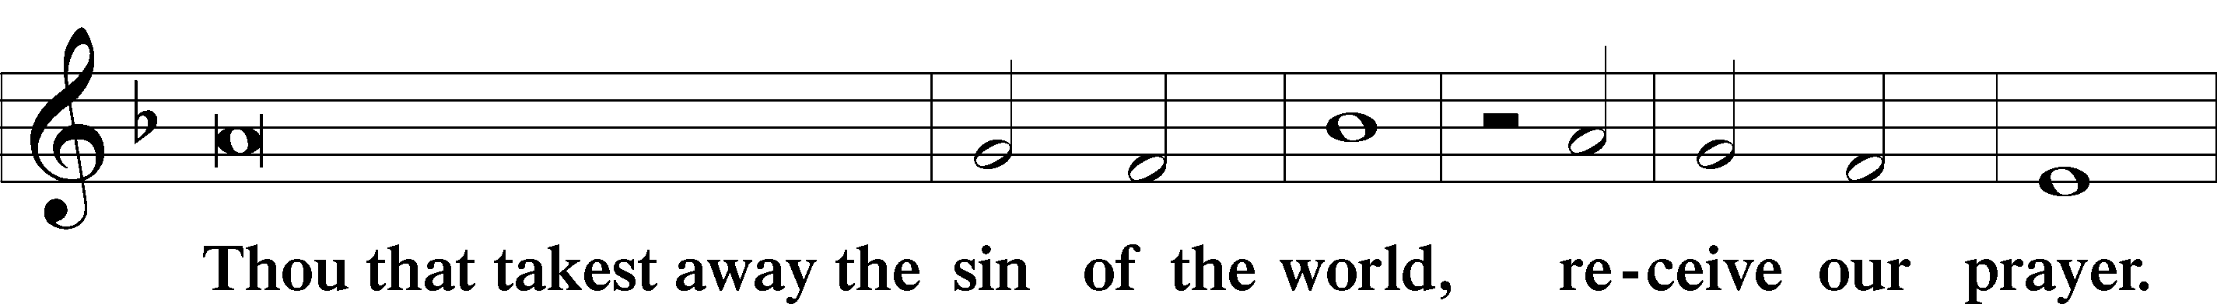
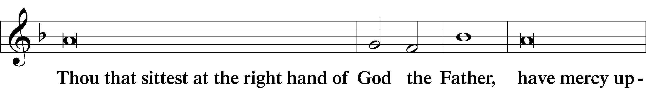
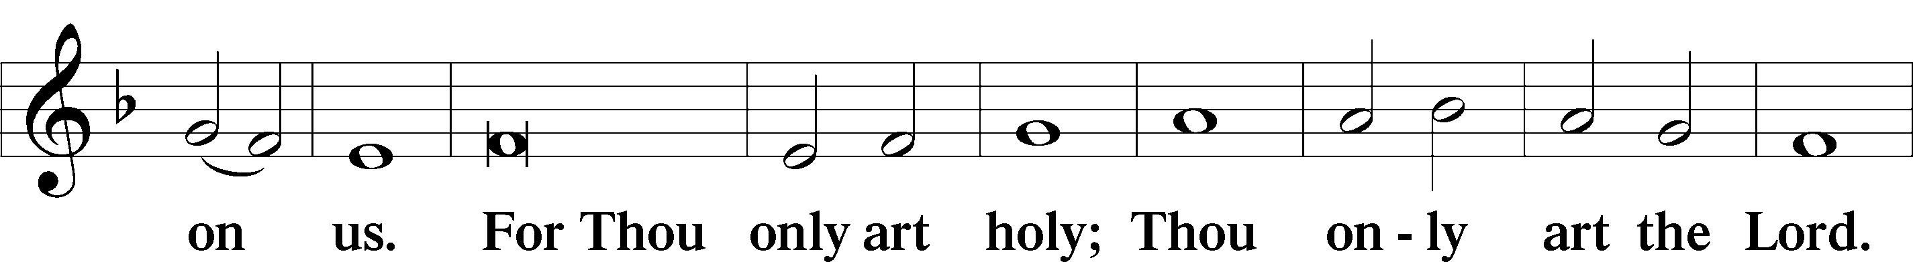
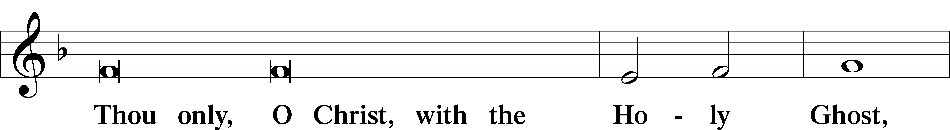
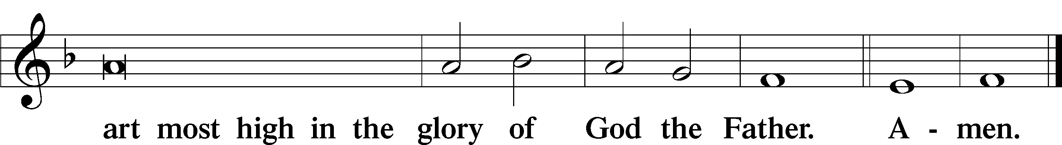

Salutation and Collect of the Day
P The Lord be with you.
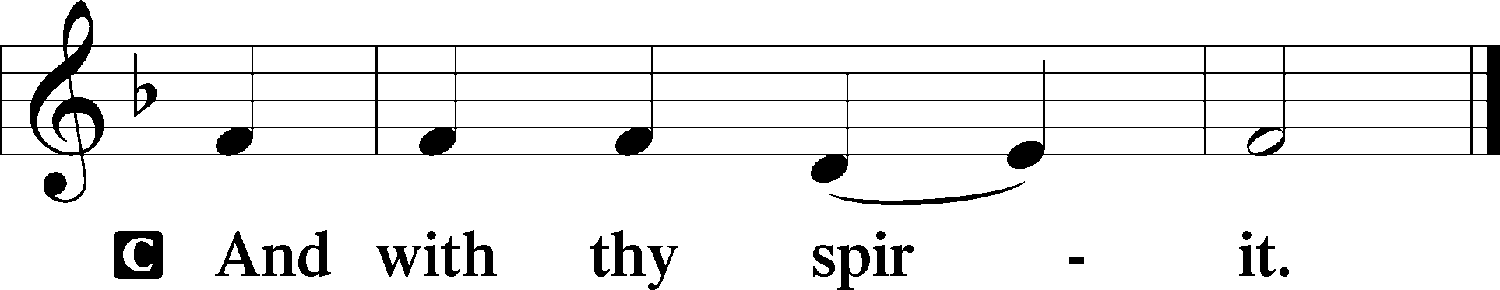

P Let us pray.
Almighty God, merciful Father, since You have wakened from death the Shepherd of Your sheep, grant us Your Holy Spirit that when we hear the voice of our Shepherd we may know Him who calls us each by name and follow where He leads; through the same Jesus Christ, Your Son, our Lord, who lives and reigns with You and the Holy Spirit, one God, now and forever.

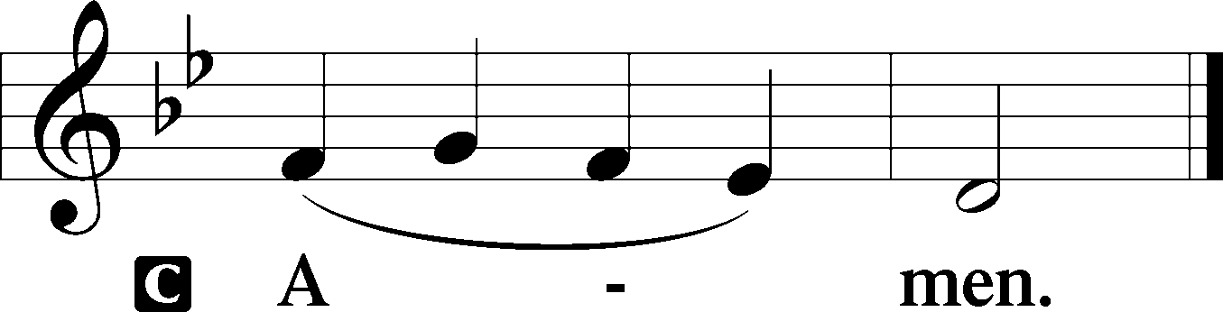

Sit

Old Testament Acts 2:42–47
42They devoted themselves to the apostles’ teaching and fellowship, to the breaking of bread and the prayers. 43And awe came upon every soul, and many wonders and signs were being done through the apostles. 44And all who believed were together and had all things in common. 45And they were selling their possessions and belongings and distributing the proceeds to all, as any had need. 46And day by day, attending the temple together and breaking bread in their homes, they received their food with glad and generous hearts, 47praising God and having favor with all the people. And the Lord added to their number day by day those who were being saved.

A This is the Word of the Lord.
C Thanks be to God.

Gradual adapt. from Matthew 28:7; Hebrews 2:7; Psalm 8:6
Christ has risen from the dead.
[God the Father] has crowned him with glory and honor.
He has given him dominion over the works of his hands;
he has put all things under his feet.

Epistle 1 Peter 2:19–25
¹⁹This is a gracious thing, when, mindful of God, one endures sorrows while suffering unjustly. ²⁰For what credit is it if, when you sin and are beaten for it, you endure? But if when you do good and suffer for it you endure, this is a gracious thing in the sight of God. ²¹For to this you have been called, because Christ also suffered for you, leaving you an example, so that you might follow in his steps. ²²He committed no sin, neither was deceit found in his mouth. ²³When he was reviled, he did not revile in return; when he suffered, he did not threaten, but continued entrusting himself to him who judges justly. ²⁴He himself bore our sins in his body on the tree, that we might die to sin and live to righteousness. By his wounds you have been healed. ²⁵For you were straying like sheep, but have now returned to the Shepherd and Overseer of your souls.

Stand

Alleluia
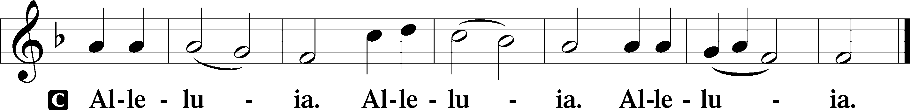

Holy Gospel John 10:1–10
P The Holy Gospel according to St. John, the tenth chapter.

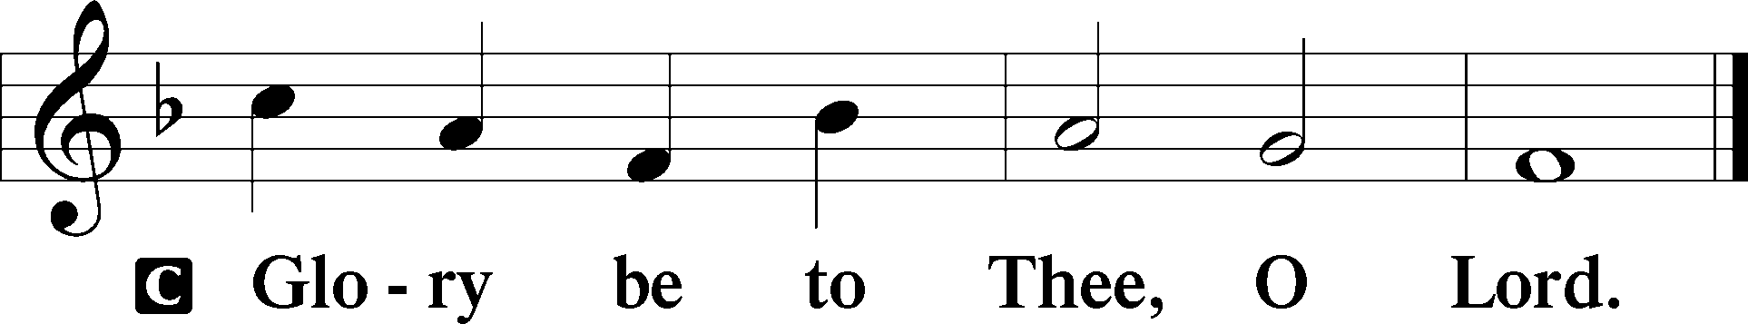

1[Jesus said:] “Truly, truly, I say to you, he who does not enter the sheepfold by the door but climbs in by another way, that man is a thief and a robber. 2But he who enters by the door is the shepherd of the sheep. 3To him the gatekeeper opens. The sheep hear his voice, and he calls his own sheep by name and leads them out. 4When he has brought out all his own, he goes before them, and the sheep follow him, for they know his voice. 5A stranger they will not follow, but they will flee from him, for they do not know the voice of strangers.” 6This figure of speech Jesus used with them, but they did not understand what he was saying to them.
7So Jesus again said to them, “Truly, truly, I say to you, I am the door of the sheep. 8All who came before me are thieves and robbers, but the sheep did not listen to them. 9I am the door. If anyone enters by me, he will be saved and will go in and out and find pasture. 10The thief comes only to steal and kill and destroy. I came that they may have life and have it abundantly.”

P This is the Gospel of the Lord.

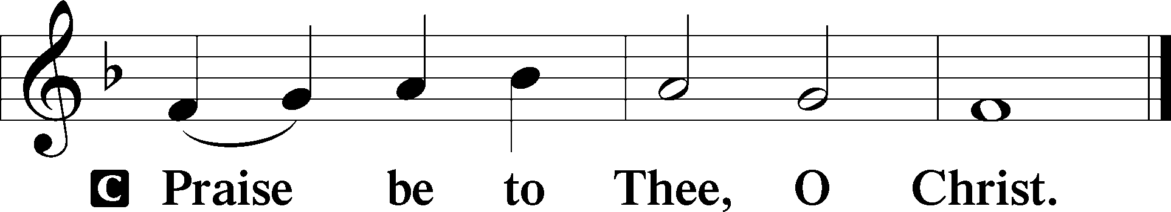

Apostles’ Creed
C I believe in God, the Father Almighty,
maker of heaven and earth.

And in Jesus Christ, His only Son, our Lord,
who was conceived by the Holy Spirit,
born of the virgin Mary,
suffered under Pontius Pilate,
was crucified, died and was buried.
He descended into hell.
The third day He rose again from the dead.
He ascended into heaven
and sits at the right hand of God the Father Almighty.
From thence He will come to judge the living and the dead.

I believe in the Holy Spirit,
the holy Christian Church,
the communion of saints,
the forgiveness of sins,
the resurrection of the body,
and the life T everlasting. Amen.

Sit

Children's Sermon

556 Dear Christians, One and All, Rejoice
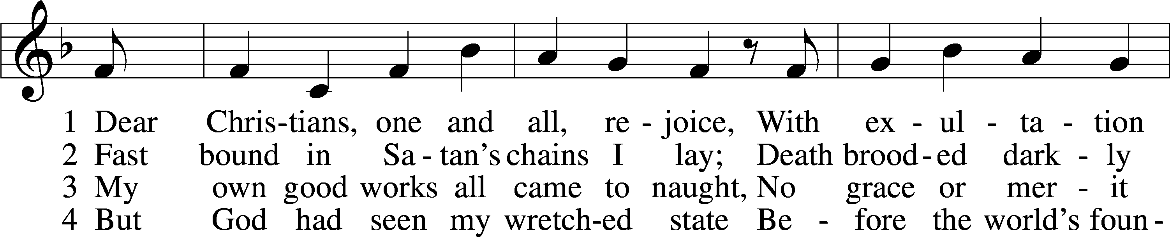
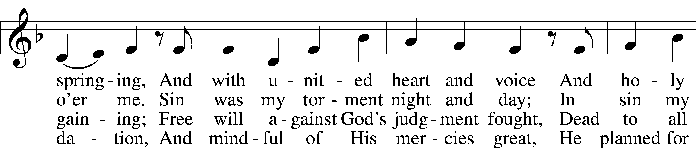
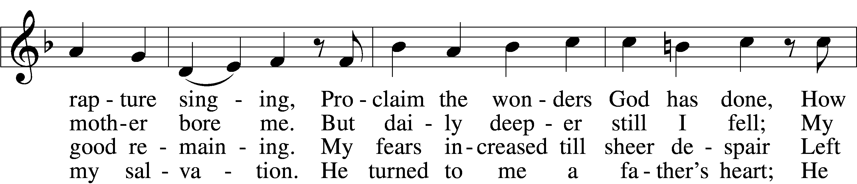
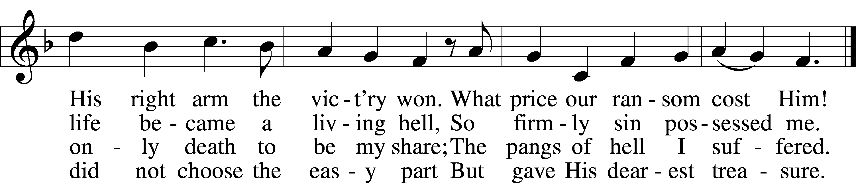

5 God said to His belovèd Son:
“It’s time to have compassion.
Then go, bright jewel of My crown,
And bring to all salvation.
From sin and sorrow set them free;
Slay bitter death for them that they
May live with You forever.”

6 The Son obeyed His Father’s will,
Was born of virgin mother;
And God’s good pleasure to fulfill,
He came to be my brother.
His royal pow’r disguised He bore;
A servant’s form, like mine, He wore
To lead the devil captive.

7 To me He said: “Stay close to Me,
I am your rock and castle.
Your ransom I Myself will be;
For you I strive and wrestle.
For I am yours, and you are Mine,
And where I am you may remain;
The foe shall not divide us.

8 “Though he will shed My precious blood,
Me of My life bereaving,
All this I suffer for your good;
Be steadfast and believing.
Life will from death the vict’ry win;
My innocence shall bear your sin,
And you are blest forever.

9 “Now to My Father I depart,
From earth to heav’n ascending,
And, heav’nly wisdom to impart,
The Holy Spirit sending;
In trouble He will comfort you
And teach you always to be true
And into truth shall guide you.

10 “What I on earth have done and taught
Guide all your life and teaching;
So shall the kingdom’s work be wrought
And honored in your preaching.
But watch lest foes with base alloy
The heav’nly treasure should destroy;
This final word I leave you.”
Text: Martin Luther, 1483–1546; tr. Richard Massie, 1800–87, alt.
Tune: Etlich Cristlich lider, 1524, Wittenberg
Text and tune: Public domain

Sermon

Votum
P The peace of God, which passes all understanding, keep your hearts and minds in Christ Jesus.
C Amen.

Stand

Offertory Psalm 51:10–12
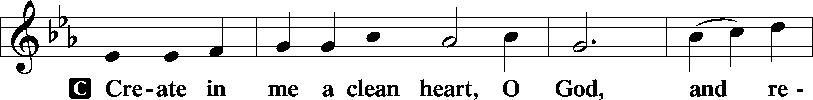
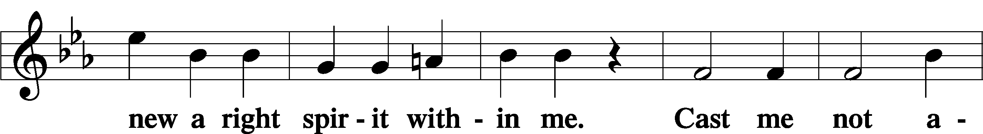
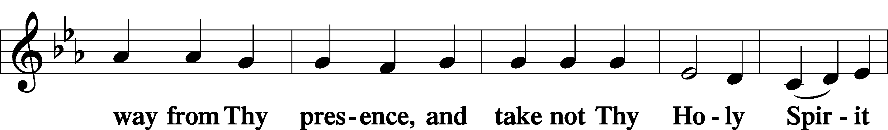
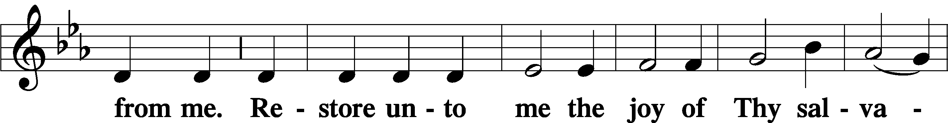
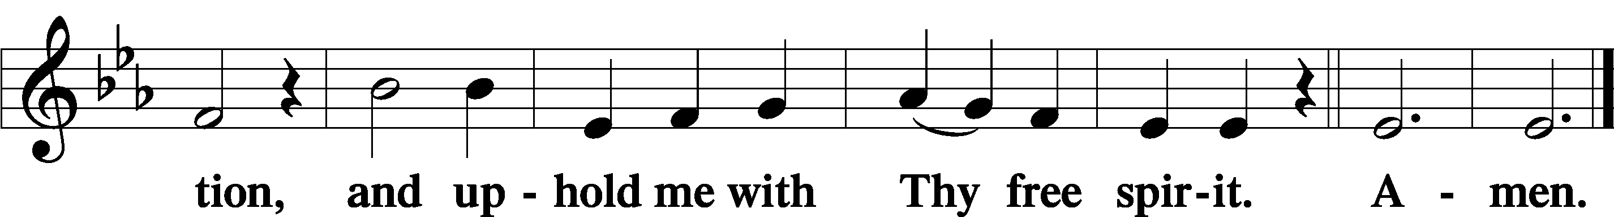

Offering

735 Have No Fear, Little Flock
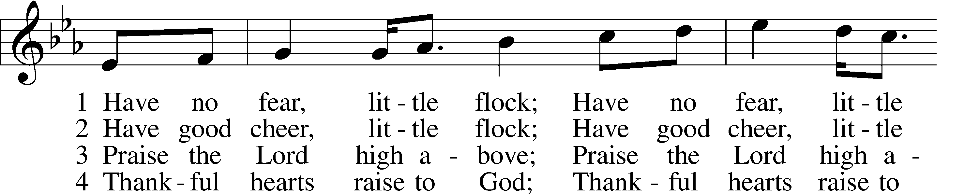
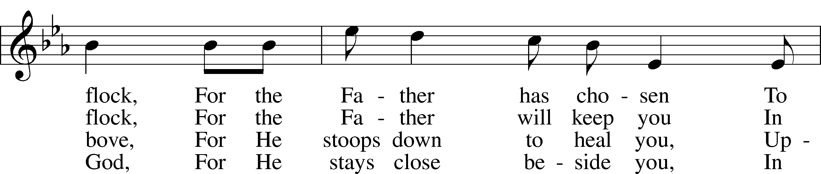
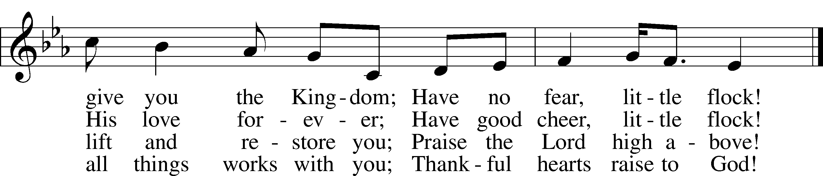
Text (sts. 2–4): Marjorie A. Jillson, 1931–2010
Text (st. 1) and tune: Heinz Werner Zimmermann, 1930–2022
Text and tune: © 1973 Concordia Publishing House. Used by permission: LSB Hymn License no. 110005011

Prayer of the Church

Lord’s Prayer Matthew 6:9–13
P Lord, remember us in Your kingdom and teach us to pray:
C Our Father who art in heaven,
hallowed be Thy name,
Thy kingdom come,
Thy will be done on earth
as it is in heaven;
give us this day our daily bread;
and forgive us our trespasses
as we forgive those
who trespass against us;
and lead us not into temptation,
but deliver us from evil.
For Thine is the kingdom
and the power and the glory
forever and ever. Amen.

Collect for the Word

Blessed Lord, You have caused all Holy Scriptures to be written for our learning. Grant that we may so hear them, read, mark, learn, and inwardly digest them that, by the patience and comfort of Your holy Word, we may embrace and ever hold fast the blessed hope of everlasting life; through Jesus Christ, Your Son, our Lord, who lives and reigns with You and the Holy Spirit, one God, now and forever.

Benediction
P The Lord bless you and keep you.
The Lord make His face shine on you and be gracious to you.
The Lord look upon you with favor and T give you peace.
C Amen.

664 Fight the Good Fight
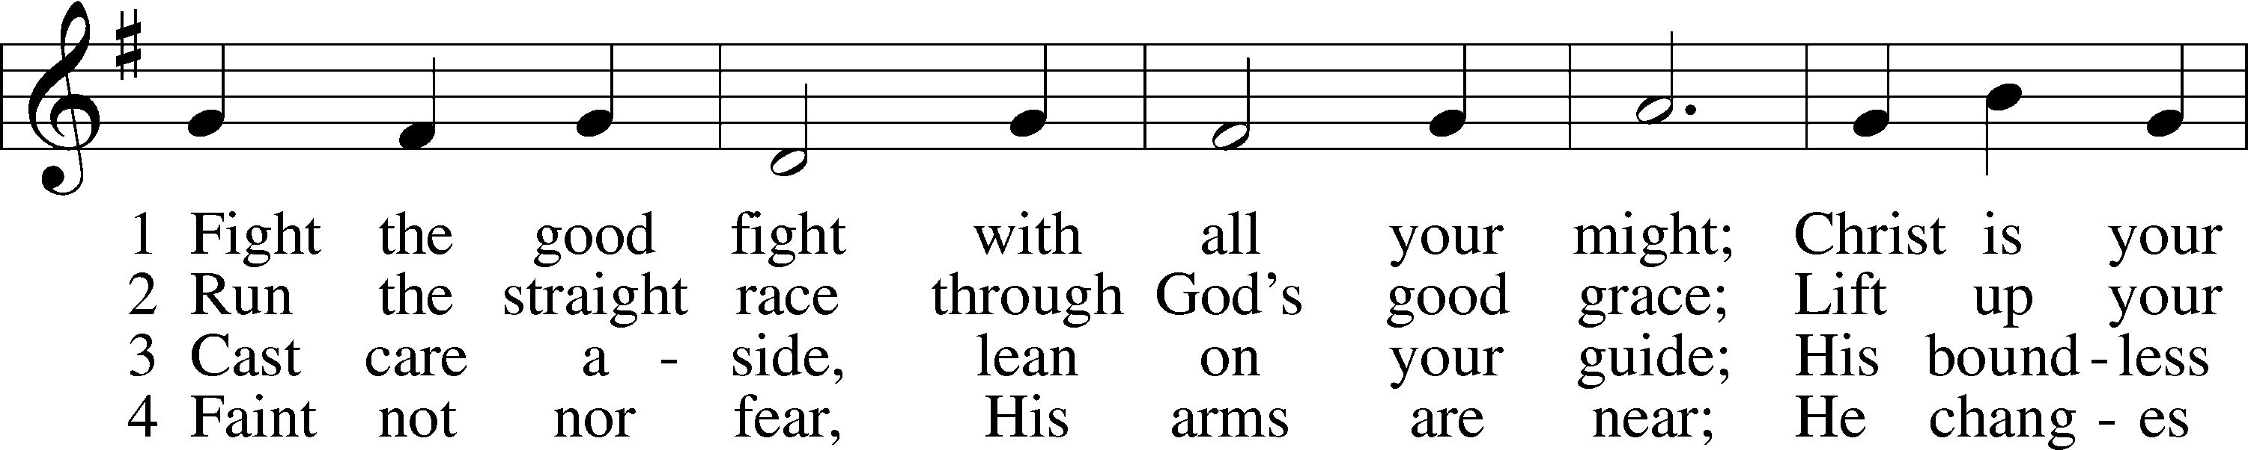
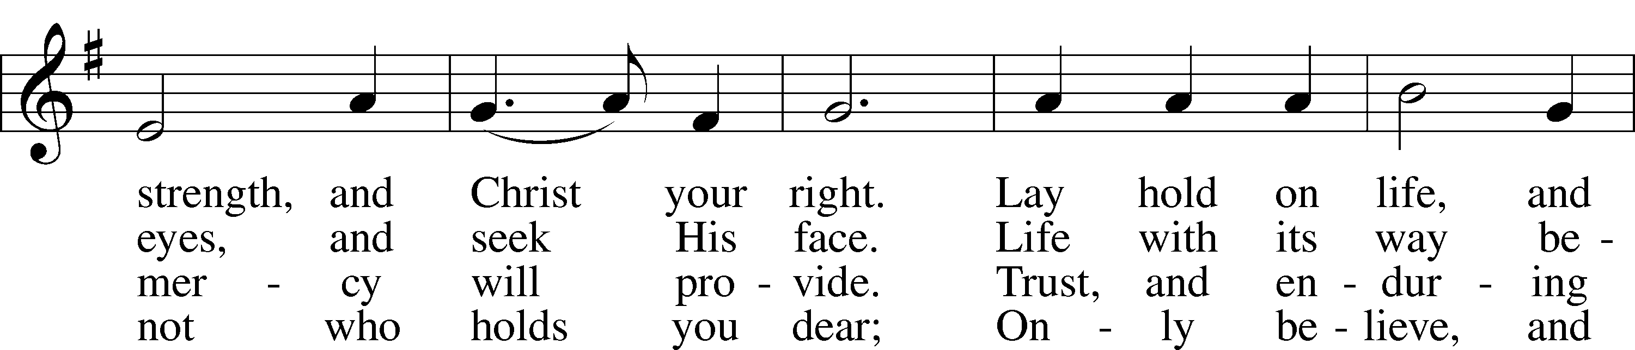
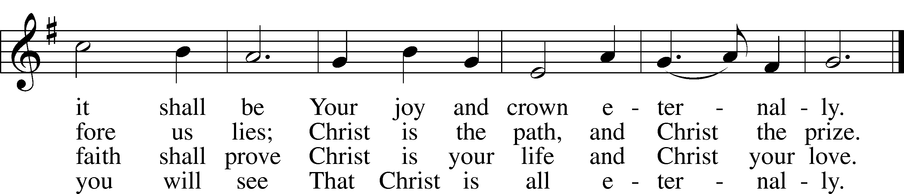
Text: John S. B. Monsell, 1811–75, alt.
Tune: The Methodist Harmonist, 1821, New York
Text and tune: Public domain
Acknowledgments
Unless otherwise indicated, Scripture quotations are from the ESV® Bible (The Holy Bible, English Standard Version®), copyright © 2001 by Crossway, a publishing ministry of Good News Publishers. Used by permission. All rights reserved.
Created by Lutheran Service Builder © 2026 Concordia Publishing House.

