

November 2025
As I sit down to write this article, we are approaching the Reformation Sunday service. Reformation day is the day that Martin Luther nailed the 95 theses to the door of the Castle Church in Wittenberg, Germany. That day was October 31st, 1517. We remember that event; Martin Luther, taking a stand against what he saw as abuses by the church and its leadership.
It wasn’t until many years later that Martin Luther had a deep understanding of saved by grace through faith (Ephesians 2:8–9). The Lutheran Church—Missouri Synod still embraces this teaching.
The heart of the Lutheran Church’s beliefs is the doctrine of justification, the teaching of how we are declared righteous in God’s sight. For years the Lutheran Church has used watchwords to articulate this doctrine:
A sinner is justified by grace alone (sola gratia) through faith alone (sola fide) for the sake of Christ alone (solus Christus), a truth revealed to us in Scripture alone (sola Scriptura).
When we speak of grace we must first ask the question: What is grace? Grace is God’s undeserved favor (favor Dei) toward sinners. Grace is God’s unmerited good intention, His loving disposition toward those who have gone astray and are “dead” in sin and “by nature children of wrath” (Ephesians 2:1, 3). Grace, then, is something in God, not in man. So we hear that “Noah found favor [grace] in the eyes of the Lord” (Genesis 6:8).
In addition, this grace of God extends to everyone. Grace is universal. Scripture teaches that “in Christ God was reconciling the world to himself, not imputing their trespasses against them” (2 Corinthians 5:19). And on Jordan’s banks John the Baptist cried of Jesus: “Behold, the Lamb of God, who takes away the sin of the world!” (John 1:29) No one is excluded from God’s grace in Christ.
God shows Himself to be gracious to us through specific means, namely His Word and Sacraments. Martin Luther sums up what instruments God uses to reveal His grace:
God is superabundantly generous in His grace: First, through the spoken Word, by which the forgiveness of sins is preaching in the whole world. This is the particular office of the Gospel. Second, through Baptism. Third through the holy Sacrament of the Altar. Fourth, through the Power of the Keys. Also through the mutual conversation and consolation of brethren.

From the beginning, in the middle, and to the end, you are justified by God’s grace alone. To be justified by God’s grace alone is a great comfort to the Christian conscience, comfort centered in God’s love for us in Christ Jesus, our Lord. A watchword conveys the heart of one’s beliefs. God grant that this watchword be proclaimed for all to hear, printed for all to see, and take deep root in our hearts as we celebrate the Reformation.
— Pastor De Young
Excerpts from: https://resources.lcms.org/reading-study/sola-gratia-grace-alone/
Christian living in a nutshell:

Witness (martyria), Mercy (Diakonia), and Life Together (Koinonia).

Back in 2011, President Harrison launched a new program in the LCMS. The three parts of this program were: Witness (martyria), Mercy (Diakonia), and Life Together (Koinonia).

In the past two newsletters, I covered Witness and Mercy. This month I will be covering Life Together.

The Church’s life together is life under the cross of Jesus. Like the images for Witness and Mercy, the cross is at the center. To the upper left, the Greek word koinonia appears. Koinonia is usually translated as “fellowship.” The word fellowship is familiar to the Church.
However, due to various uses of the word such as church fellowship, communion fellowship, right hand of fellowship, fellowship hall, and so on, this word might not be the best to describe the church’s life together under the cross. Life Together includes many aspects of the Church’s life: worship, church fellowship, Holy Communion, schools, universities, seminaries and more. The lower right side of the image has a chalice with grapes, recalling to mind that in the Lord’s Supper Jesus not only gives us His body and blood along with the forgiveness of sins, He also gives us a collective life together. Individual grains become one loaf. Individual members become one body with Christ as the head, guiding our Life Together.
The word for Life Together occurs less in the New Testament than either the word for Witness or Mercy. Life Together (koinonia) is somewhat abstract in Greek. In fact, the term is so broad that at times it can be challenging for us to pin it down. The word means “fellowship” or “participation.” The Christian has fellowship, participation, or Life Together with Jesus because of Jesus’ work on the cross.
“God is faithful, by whom you were called into the fellowship of His Son, Jesus Christ, our Lord” (1 Cor. 1:9). The Christian has fellowship, participation, or Life Together in Communion fellowship, that is, in receiving the true body and blood of Christ in the Lord’s Supper. The Church has fellowship or a Life Together with herself and with individual members who have been made one body in Christ. Christians have fellowship, partnership, or Life Together in carrying out the Witness (martyria) and Mercy (diakonia) of the Church. As the Church lives her Life Together under the cross, opportunities for Witness and Mercy abound.

The work and life of the Church engages in Witness (martyria), Mercy (diakonia), and Life Together (koinonia) with the cross of Jesus at the center. These aspects flow into one another. One begins with Jesus, and each aspect complements and flows into the others. Jesus bore witness to His Father by going to the cross. Jesus served and showed mercy to those in need. And Jesus has called us into a Life Together with Him. As the Church lives in Christ, the Church also follows this pattern, this threefold emphasis of Witness, Mercy, and Life Together—for the Church and for the world.
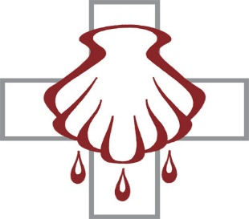

Celebrate November’s Baptism Birthdays
& their years as heirs of God’s kingdom!

Date | Name | Years
1st | Karen George | 43
 | Clara Noack | 90
4th | LeAnn Hoover | 13
 | Logan Hoover | 13
5th | Joanne Little | 81
7th | Lindsey Bohn | 32
8th | Aubrey Gill | 27
9th | Alexandra Keyes | 11
15th | Cooper Hammer | 20
17th | Carrie Aune | 35
18th | Jaylen McComack | 4
23rd | Becky Geis | 39
24th | Rhett Lewis | 6
25th | Doris Long | 80
29th | Paul Lasch | 55
29th | Blakely Thomlinson | 5

Serving in God’s House this month

Elder of the Month | Travis Dyson
Counters | Bryan Roth / Arn Anderson
Altar Guild | D’Ann Hammett / Sharon Rainwater
Altar Care | Debbit Jones / Karen Lee
Guest Monitor | Sherry Hammer & Jeanine Yowell

Week | Acolytes | Reader
November 02 | Avery Henry & Karlee Hughes | William Pickett
November 09 | Wyatt Lawson & Parker Lawson | Lee Hughes
November 16 | Kiley McDonald & Stevi McDonald | Arn Anderson
November 23 | Molly Gilmore & Max Gilmore | Bryan Roth
November 30 | Davin George & Annallee Osbon | William Pickett









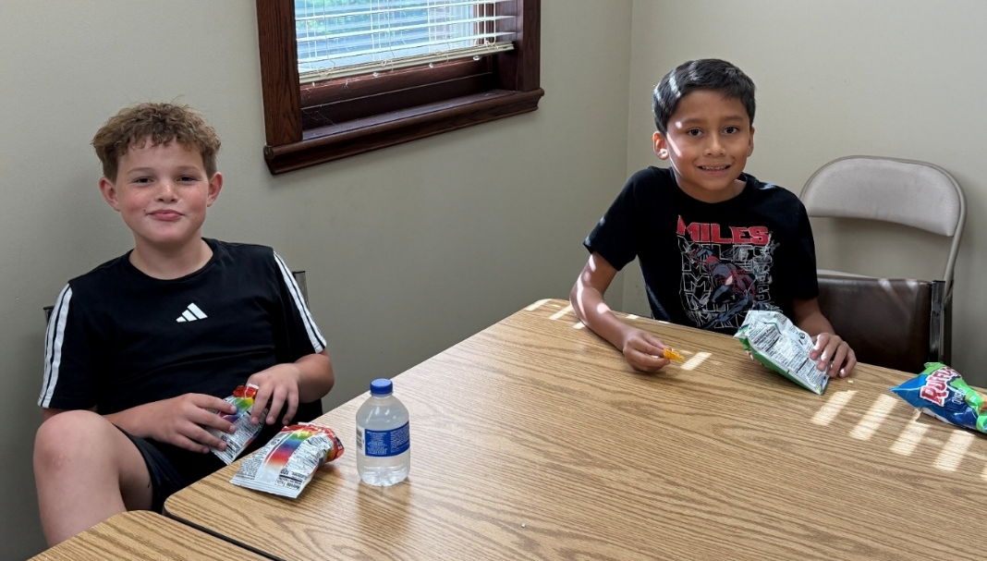




b










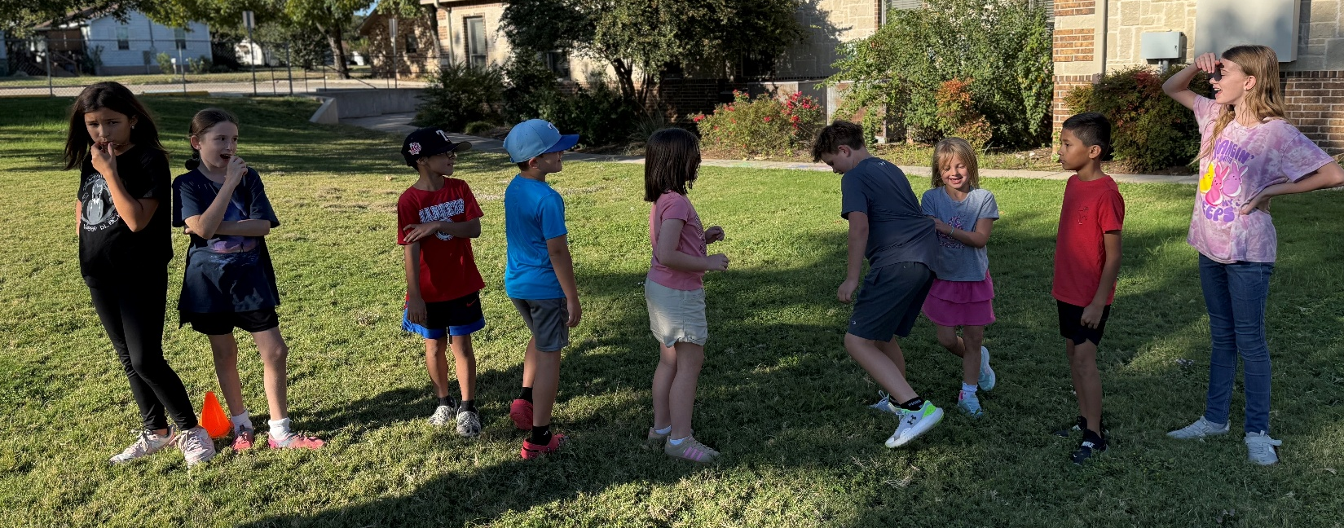


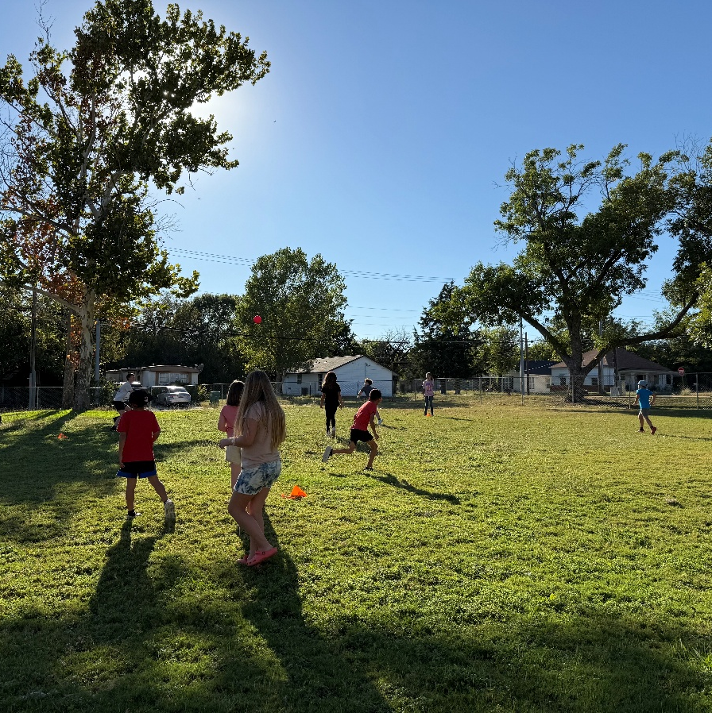
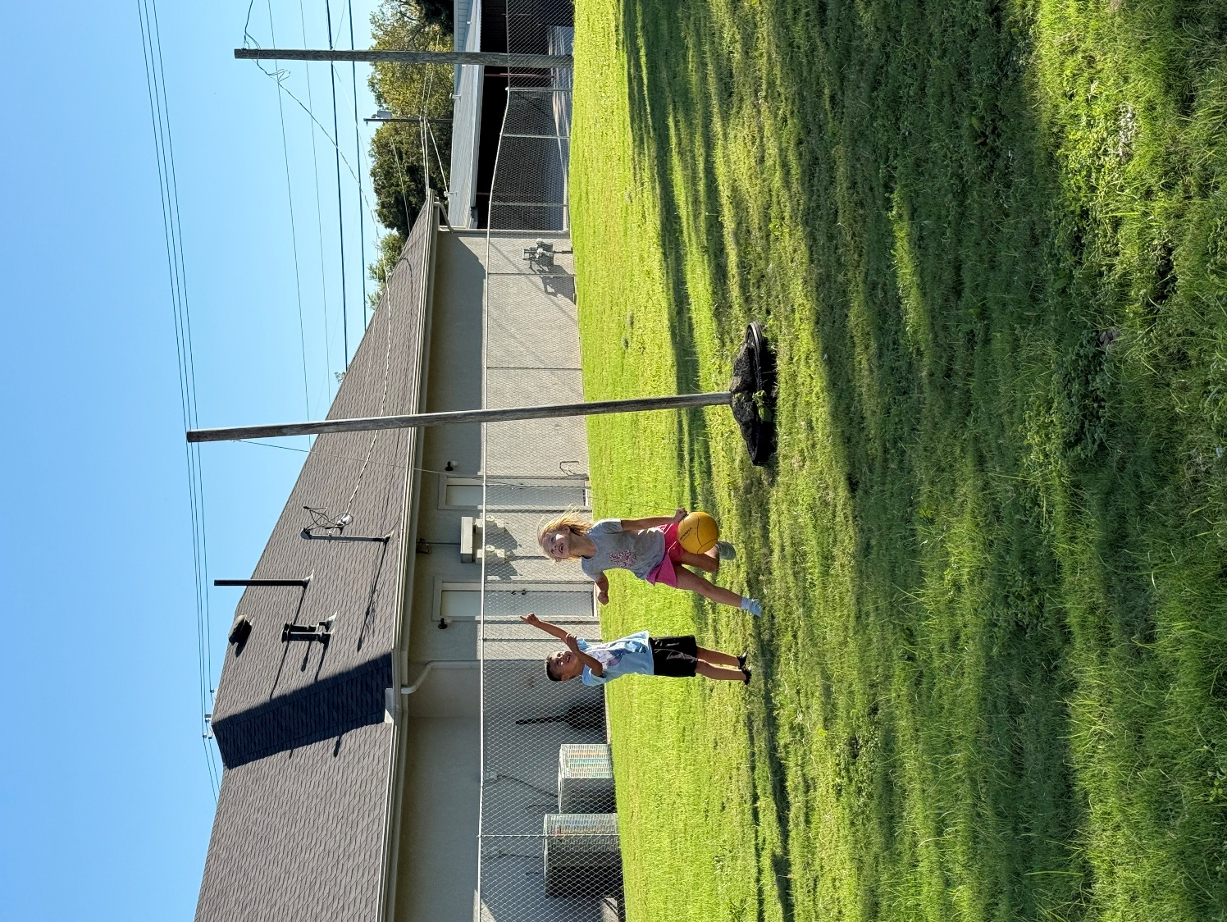






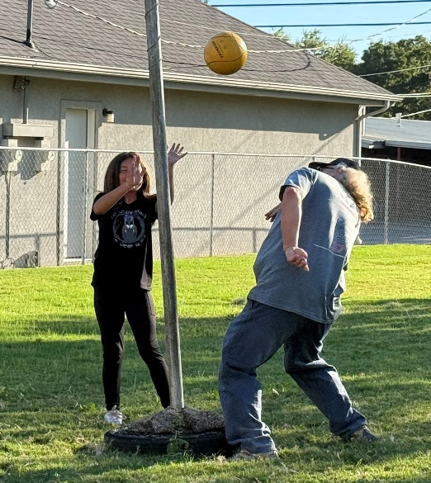






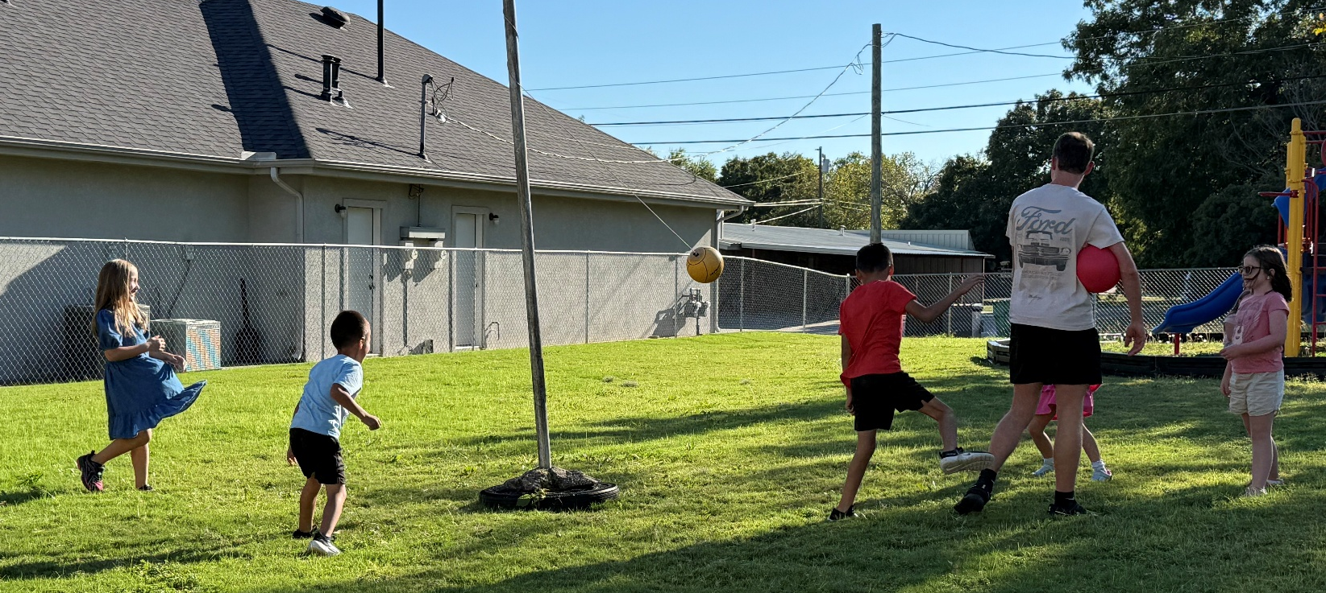

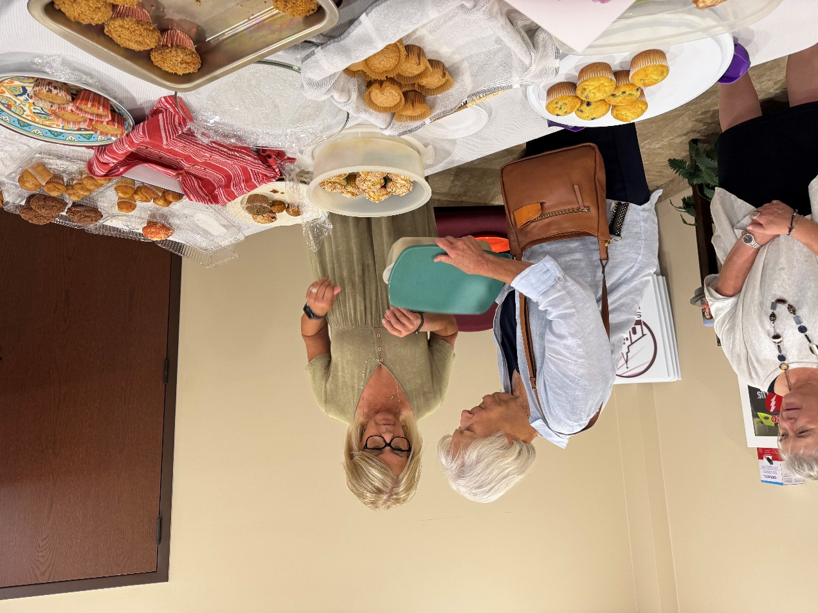
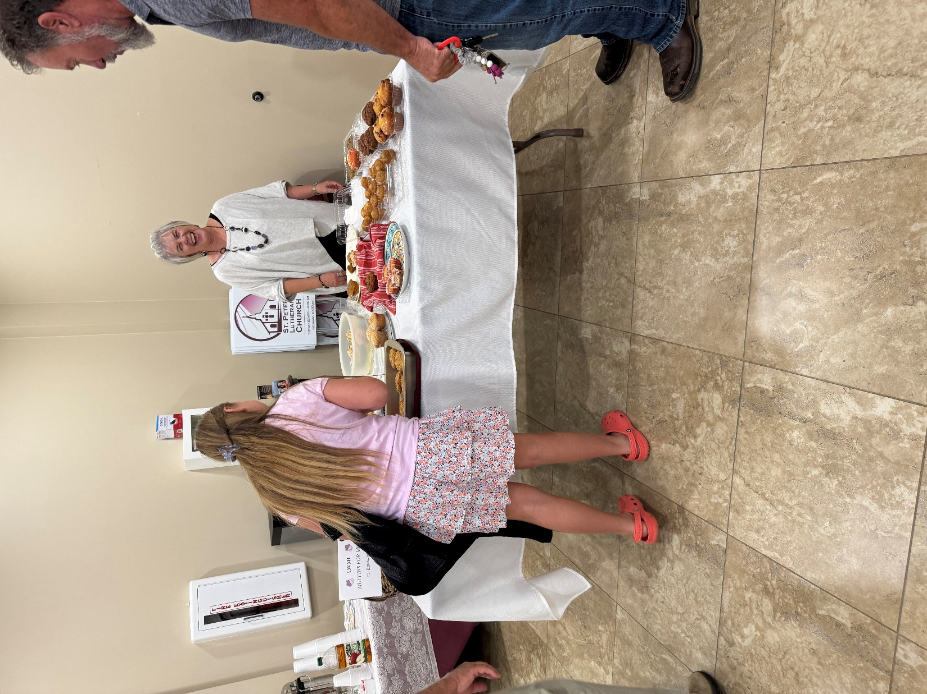

LWML Muffins for Mites










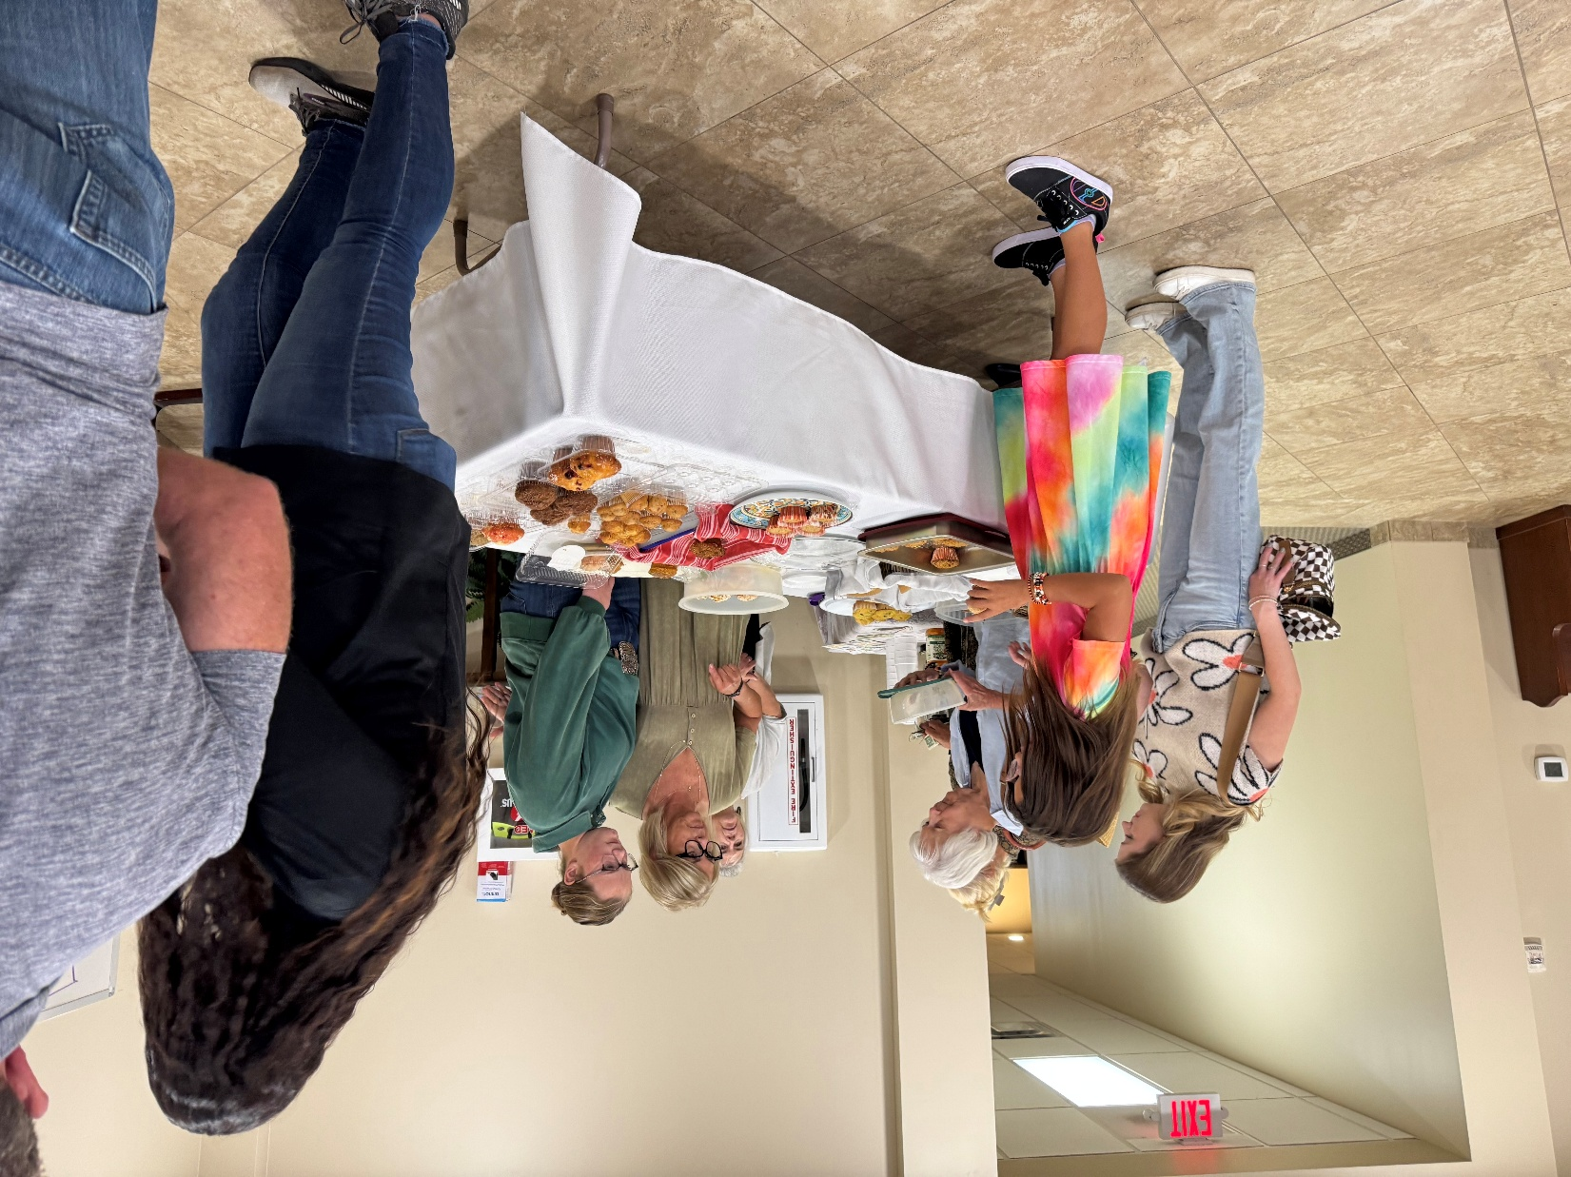


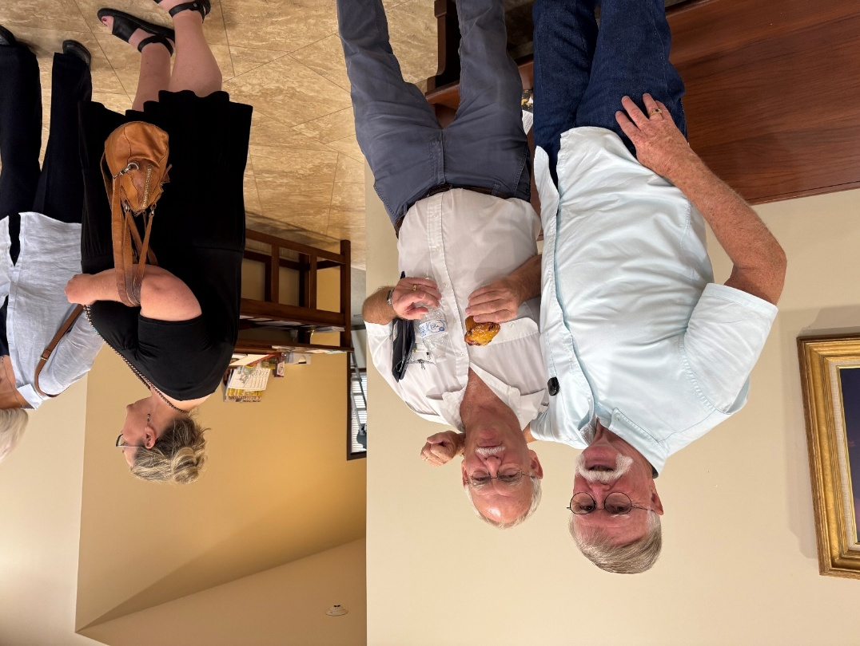




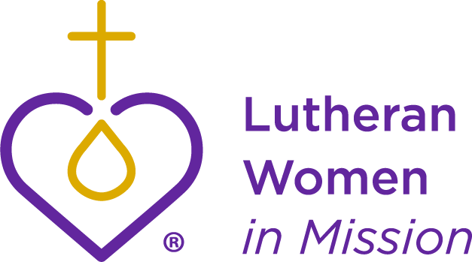







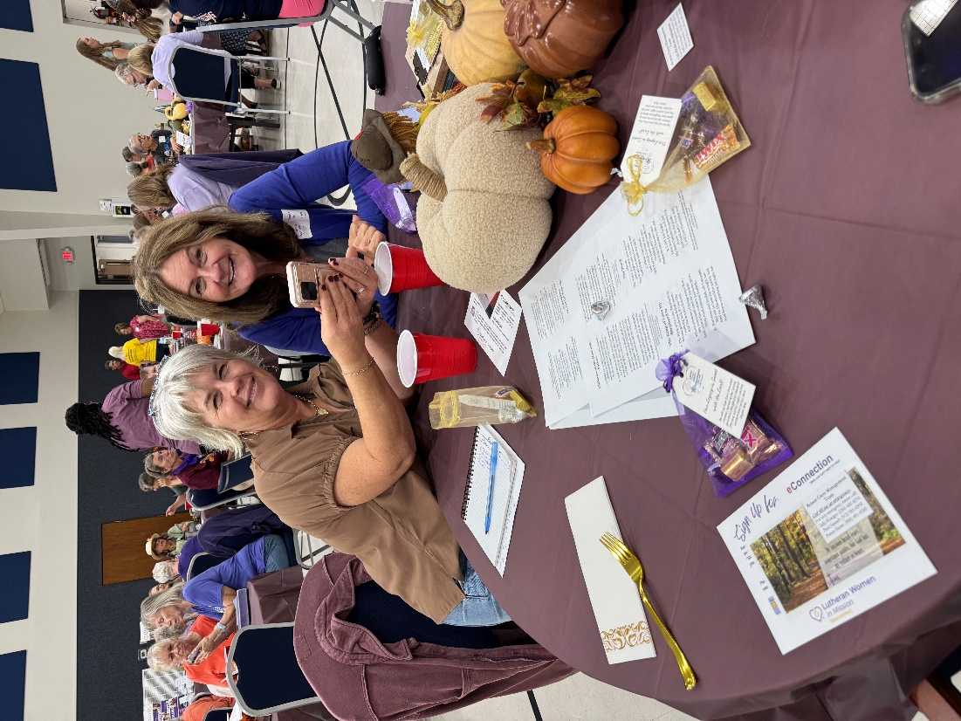
LWML 2025 District Retreat



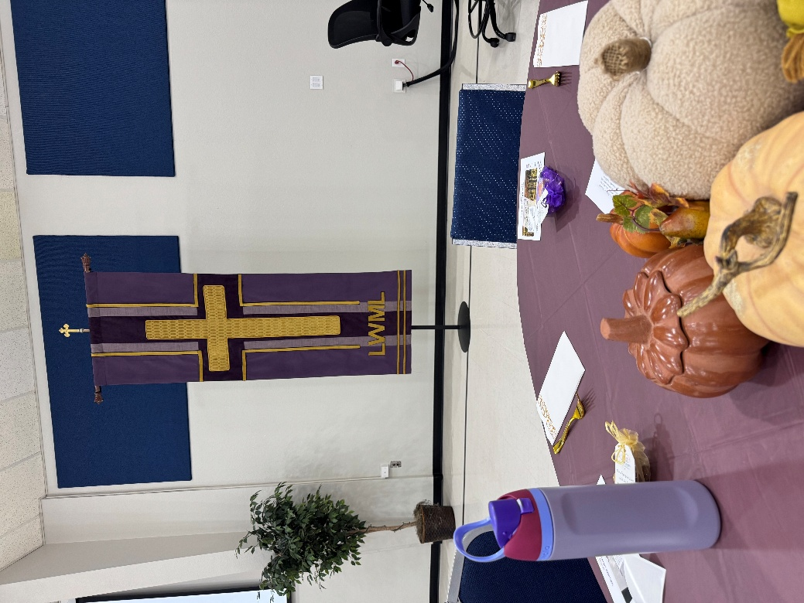
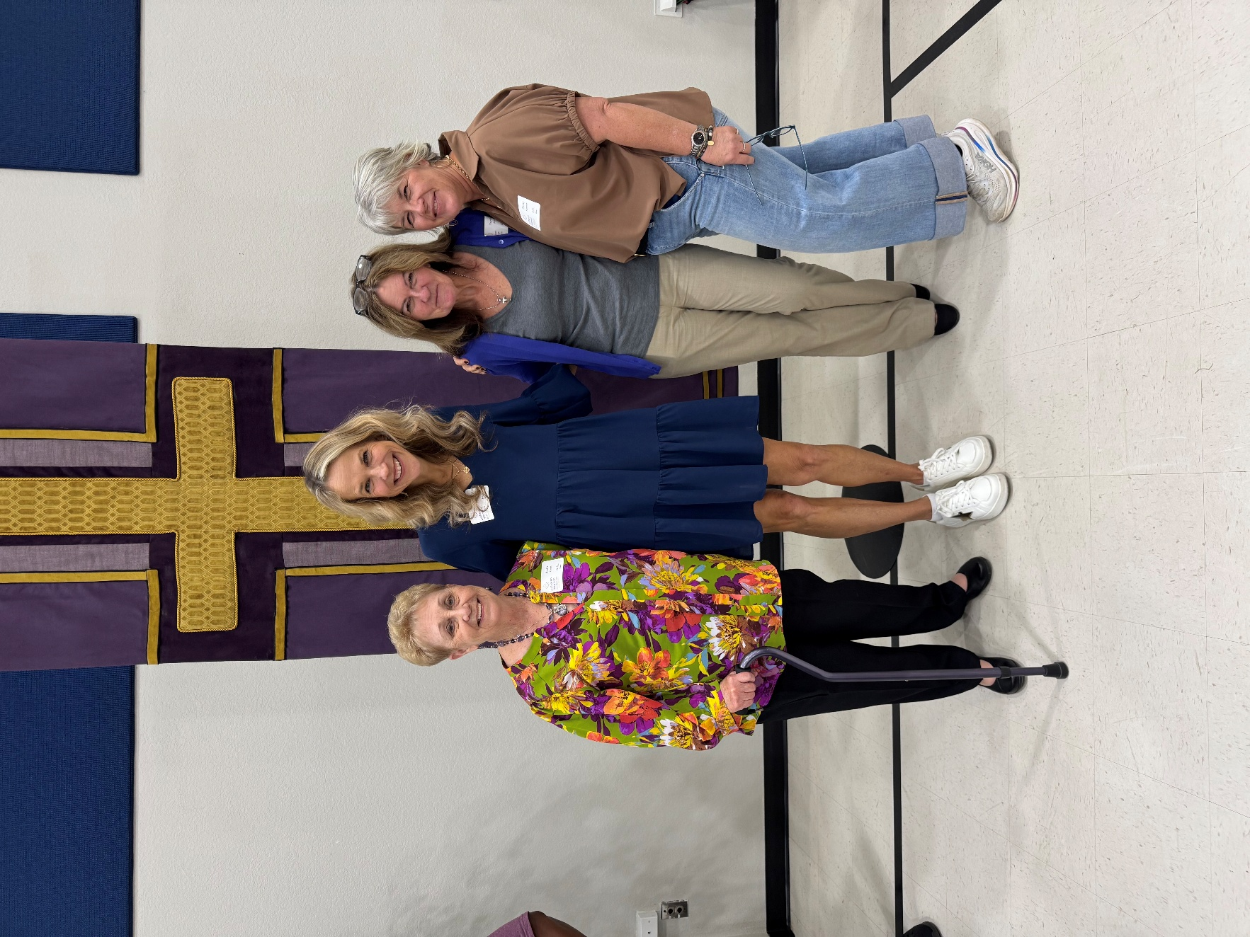
















OKTOBERFEST!







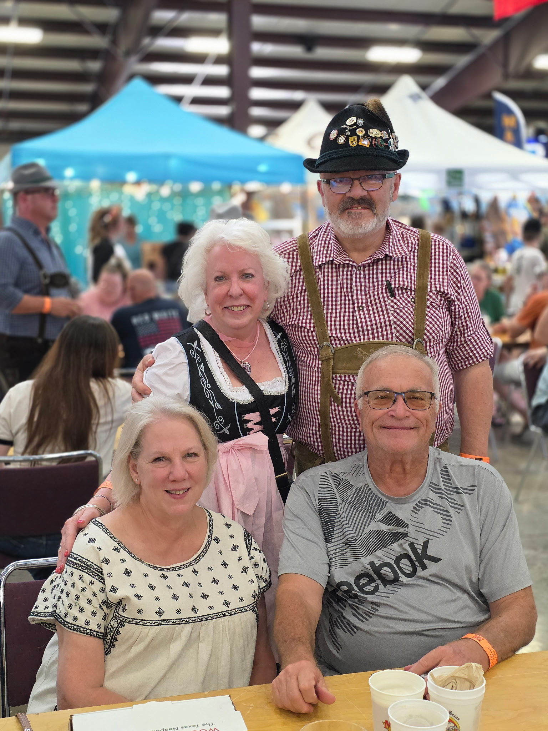









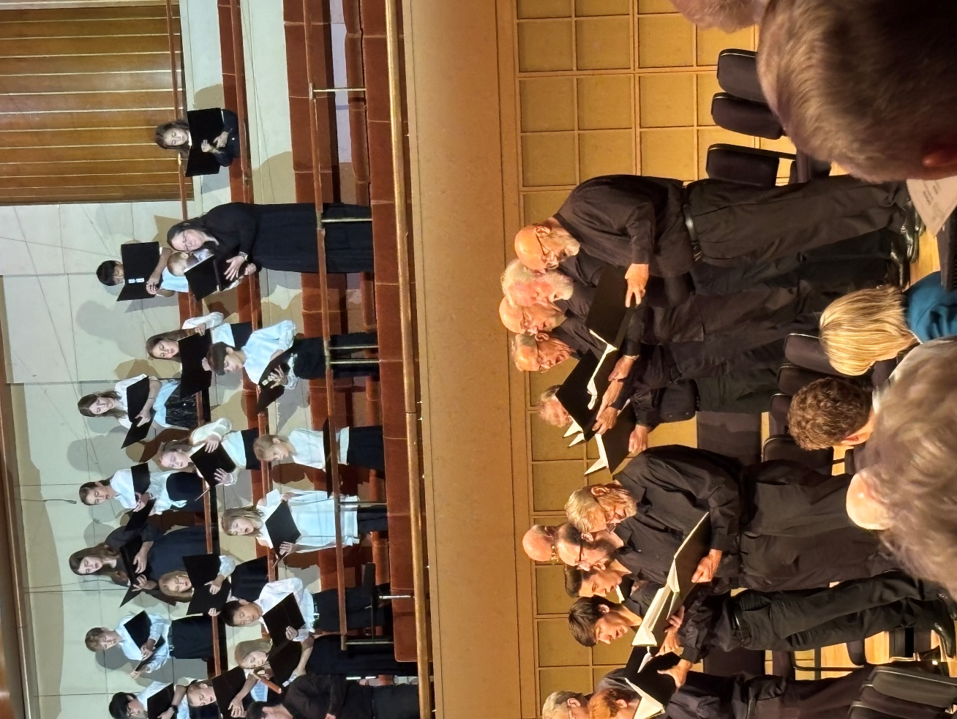





The Lutheran Hymn Festival



