
February 2026

Knowing what to do, and doing it, sometimes are two completely different things. St. Paul wrote about this in Romans 7:18 – 20 ¹⁸ For I know that nothing good dwells in me, that is, in my flesh. For I have the desire to do what is right, but not the ability to carry it out. ¹⁹ For I do not do the good I want, but the evil I do not want is what I keep on doing. ²⁰ Now if I do what I do not want, it is no longer I who do it, but sin that dwells within me.

We know that God wants us to worship Him. We intend to gather and worship Him, then life happens. We have a deadline at work that is pressing. I need to do this work; I can attend church next week. Or, the children have a game on Sunday morning; I will attend church next week. While these may seem like isolated incidents at first; without an effort to correct the issue, these incidents may soon become the norm.

We treat God and church as an inconvenience. Other events in our lives seem to become more important that gathering to hear God’s Word. This may even trickle down to our devotion life. How many times, in the last week, did you stop what you are doing in order to read the Bible? Do you have a dedicated time for devotion with your family? Do you keep with that habit of reading devotions as a family?

I have heard it stated before that it takes 21 days to create a new habit. I am not sure that there is a minimum number of days necessary to create that habit. Instead, I would say: It takes commitment and perseverance to create a new habit. Commitment – set a time and place that you will sit down and read the Bible and pray. Perseverance – you will not allow any other activity to stop you from reading the Bible and praying.

The world (sin, death, and the devil) would like nothing more than for you to take God for granted. The world (and some church bodies) might tell you: “once saved – always saved”. This false doctrine believes that there is nothing that you can do to disinherit heaven. This “sin freely, because God forgives freely” theology is not only dangerous, it is also straight from the devil. The devil told Eve: “You will not surely die. For God knows that when you eat of it your eyes will be opened, and you will be like God, knowing good and evil.” The devil speaks to us in the same way: “Sin cannot keep you from God’s promise, go ahead.”

As a tool to assist you in your Lenten devotional life, I have included an article from President Harrison’s Lutheran Witness archives.

— Pastor De Young

March 2012

After about a year and a half in this position, I’ve discovered that, if nothing else, being Synod president does tend to improve one’s prayer life. A prayer Luther often prayed at night says it all: “My dear God, now I lie down and turn Your affairs back to You; You may do better with them. If You can do no better than I, You will ruin them entirely. When I awake, I will gladly try again.’

Because of a feisty barber named Peter Beskendorf, we not only know exactly how Martin Luther prayed, but we have what is probably the greatest and most practical little pamphlet ever written on how regular folks can pray: “A Simple Way to Pray” (Luther’s Works, v. 43, pp. 189-211). While Luther was getting lathered in the barber’s chair, Peter asked the Reformer how he went about praying. Luther gave Peter the lowdown in the chair and then sat down and peeled off his little book shortly thereafter. Because there are so many unbiblical things said and written about prayer all about us, every Lutheran should have “A Simple Way to Pray” and read it. Luther’s little book on prayer will revolutionize your prayer life.

The genius of Luther’s approach is that it anchors prayer in the biblical or biblically based text so that it doesn’t float off into self-absorbed drivel, quite disconnected from God’s mandates and promises in the Bible. Luther’s approach balances the issue of order and freedom, written prayer and ex corde prayer–but in such a way that the biblical text determines the content and inspires the mind to pray freely as the Spirit moves.
Luther followed a simple, fourfold pattern:

- Instruction
- Thanksgiving
- Confession
- Prayer

I call it I.T.C.P. This is how Luther prayed the Small Catechism–something I’d long heard about but had not the slightest idea what it meant. Virtually any text of the Bible can be prayed this way, or for that matter, any biblically based prayer.

It’s Lent. I invite you to pray daily with me the greatest prayer ever written (aside from those in the Bible): The Litany (LSB 288–89). This 1500-year-old prayer, which Luther loved, covers the extent of real spiritual and physical need for the Church and the world. And it’s all right out of the Bible. When you come to the following text, let Luther’s I.T.C.P. mode kick in. Here’s an example: We poor sinners implore you . . . to preserve all pastors and ministers of Your Church in the true knowledge and understanding of Your wholesome Word and to sustain them in holy living.

Lord, You INSTRUCT us that it is Your deepest desire that pastors love and stick to Your Word, for themselves and for others. It’s horrible when a pastor forsakes the Word and falls into error or gross sin and does untold damage in the Church. We also know that it is Your deepest desire, Lord, that we pray for our pastors.

Lord, I give You THANKS for my pastor and all pastors of the Church. In this crazy day and age, it’s a miracle that I have a pastor who believes the Bible, preaches Law and Gospel, loves his people and serves me and my family.

Lord, I CONFESS that I fail to pray for my pastor. I don’t even think about our seminaries until we have a vacancy. I’ve been stingy in supporting my pastor. I have not always put the best construction on his actions and have failed to follow Matthew 18 when I’ve had a concern. I have disregarded the fact that You have placed this man to dole out your previous gifts of the Gospel to me.

Lord, I PRAY, enlighten me by Your Word and Spirit. Be with my pastor, and strengthen him today. Cause him to love your wholesome Word. Protect him and his wife and family from the evil one. Sustain him in holy living, and give him joy in his vocation. Cause me to be a source of joy in his ministry, and give me a generous heart that I may support the ministry of the Gospel in this place in every way. Amen.

Blessed Lent,
Rev. Matthew C. Harrison



Celebrate February’s Baptism Birthdays
& their years as heirs of God’s kingdom!

Date | Name | Years
1st | Norma Sheppmann | 76
10th | Monte Mayfield | 18
14th | Lisa Lawson | 66
23th | Heather Lawson | 40

Serving in God’s House this month

Elder of the Month | David Geis
Counters | Bryan Roth / Arn Anderson
Altar Guild | D’Ann Hammett / Sharon Rainwater
Altar Care | Melissa Stephens / Teresa Johnston
Guest Monitor | D’Ann Hammett

Week | Acolytes | Reader
February 01 | Avery Henry & Bella Caswell | Lee Hughes
February 08 | Molly Gilmore & Max Gilmore | Arn Anderson
February 15 | Parker Lawson & Annallee Osbon | Bryan Roth
February 22 | Karlee Hughes & Emily Keyes | William Pickett


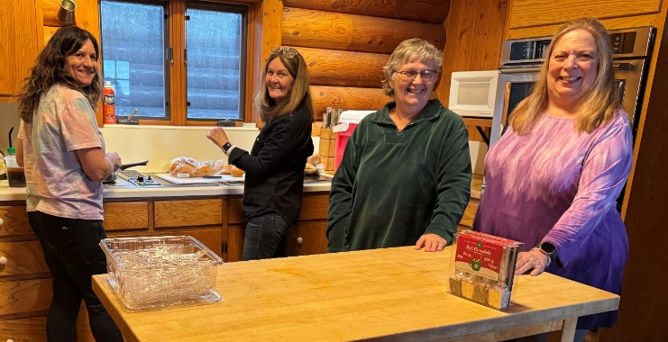
Annual Women’s Retreat

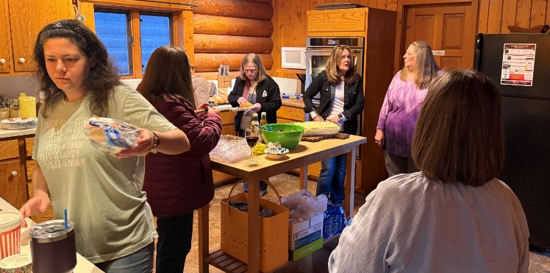













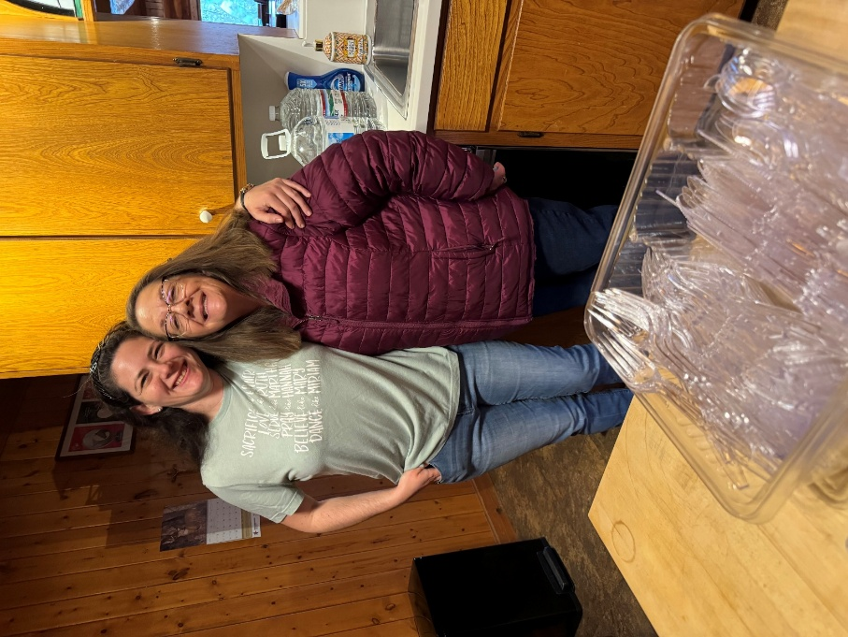









































Did you know we have a Facebook & Instagram?

You can find the links to our socials on our website at: www.stpetertex.com

Follow us for important updates, verse-of-the-week posts, and more!
In case you missed January’s weekly verse posts:





