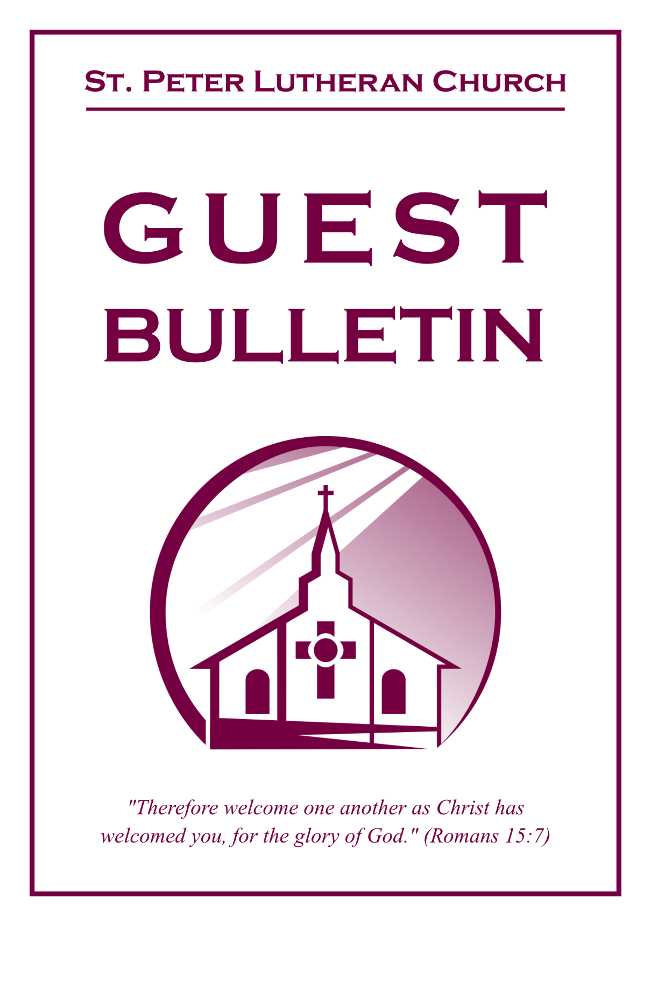

August 2, 2026



St. Peter Lutheran Church
Missouri Synod
906 Highway 59N, P.O. Box 133

Bowie, Texas 76230

Church (940) 872-1886 Fax ((940) 872-8837

Church E-mail: stpetertexscty@gmail.com
To Our Guests and Visitors:

We welcome all our friends in Christ who have come to worship with us. If you are a guest, please feel at home with us, sign our guest register, and worship with us whenever you are able. If you do not have a church home, we invite you to
consider becoming a part of our church family.

Website: www.stpetertex.com
Communion Statement:

The Lord’s Supper is celebrated at this congregation in the confession and glad confidence that, as He says, our Lord gives into our mouths not only bread and wine but His very Body and Blood to eat and drink for the forgiveness of sins and to strengthen our union with Him and one another.

Our Lord invites to His table those who trust in His words, repent of all sin, and set aside any refusal to forgive and love as He forgives and loves us, that they may show forth His death until He comes.

Because those who eat and drink our Lord’s Body and Blood unworthily do so to their great harm, and because Holy Communion is a confession of the faith, which is confessed at this altar, guests who are not confirmed members of an LCMS congregation and have not previously communed at this altar, are asked to first speak with our pastor.

If you are unable to do so before the service, it is out of Christian love and care for your souls that we ask you to refrain from communing this morning.

For further study, please see Matthew 5:23ff, 10:32ff, 18:15–35, 26:26–29; 1 Corinthians 11:17–34.

If you desire to receive a blessing for yourself or your children, please approach during
communion, cross your arms over your chest and bow your head as you kneel at the
altar rail.

Who Receives the Sacrament of the Altar Worthily?
Fasting and bodily preparation are certainly fine outward training. But that person is truly worthy and well prepared who has faith in these words: “Given and shed for you for the forgiveness of sins.” But anyone who does not believe these words or doubts them is unworthy and unprepared; for the words “for you” require all hearts to believe.
How May I Prepare?
See Dr. Luther’s self–examination questions and answers in the
LSB Hymnal on page 329

Upon entering the Sanctuary. please turn off cell phones, pagers. etc. Use the time as a quiet time for personal reflection and meditation in preparation for worship. This is a time for anyone to join in praying for the service, and for the church in general.
907 God Himself Is Present
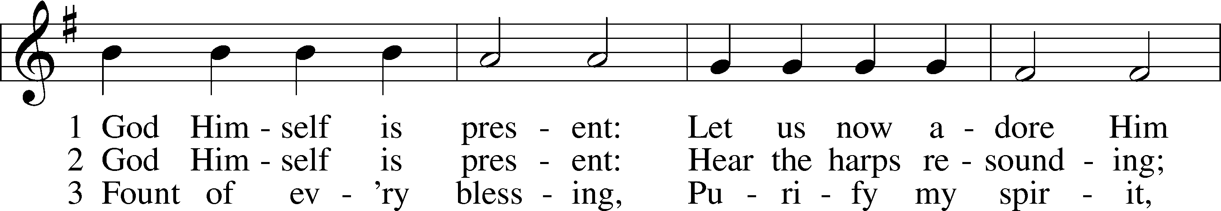
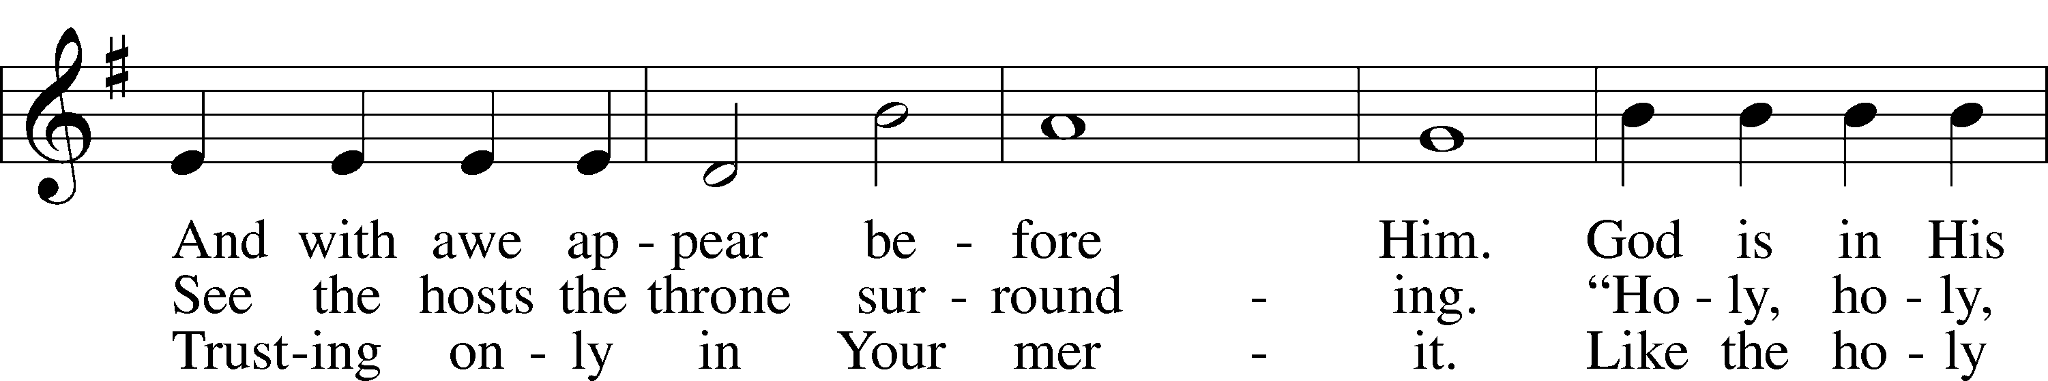
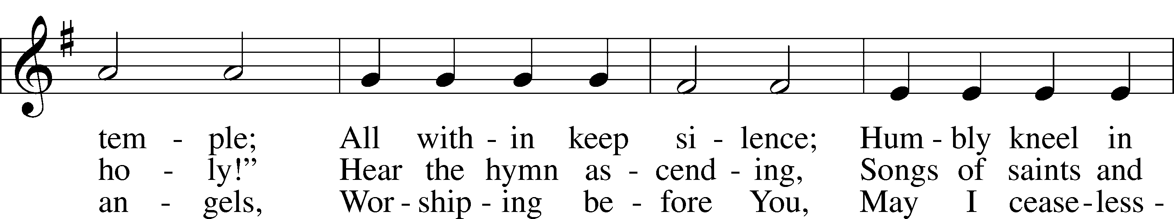
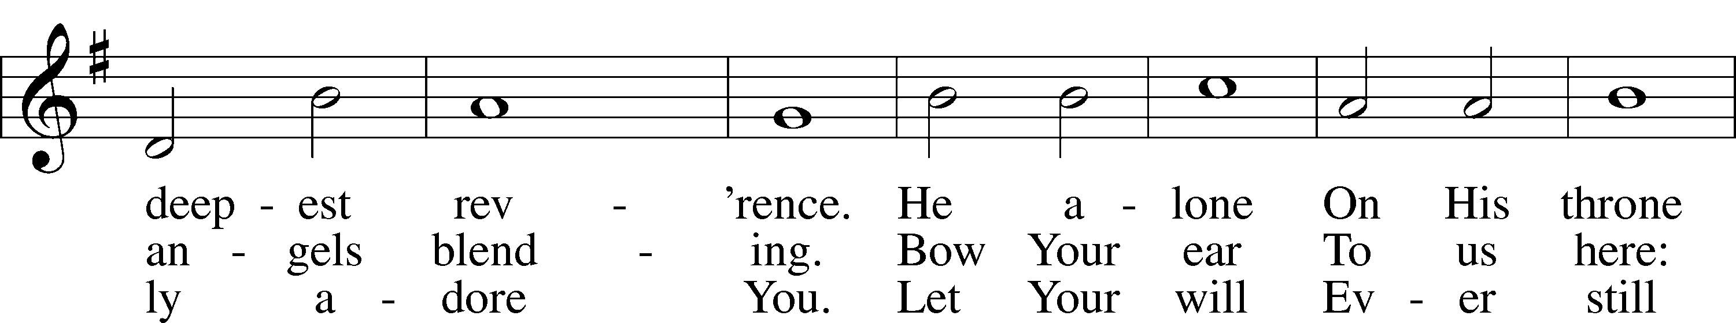
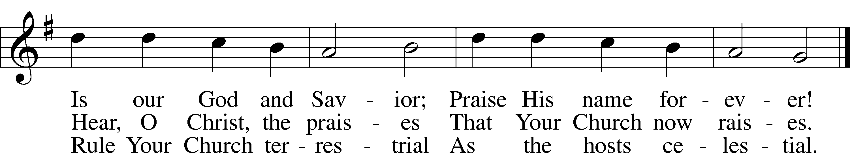
Text: Gerhard Tersteegen, 1697–1769, abr.; tr. Frederick W. Foster, 1760–1835, alt.; tr. John Miller, 1756–90, alt.
Tune: Joachim Neander, 1650–80
Text and tune: Public domain

Confession and Absolution

Stand

The sign of the cross may be made by all in remembrance of their Baptism.

Invocation Matthew 28:19b; 18:20
P In the name of the Father and of the T Son and of the Holy Spirit.
C Amen.

Exhortation Hebrews 10:22; Psalm 124:8; Psalm 32:5
P Beloved in the Lord! Let us draw near with a true heart and confess our sins unto God our Father, beseeching Him in the name of our Lord Jesus Christ to grant us forgiveness.
P Our help is in the name of the Lord,
C who made heaven and earth.
P I said, I will confess my transgressions unto the Lord,
C and You forgave the iniquity of my sin.
Kneel/Stand

Silence for reflection on God’s Word and for self-examination.

Confession of Sins
P O almighty God, merciful Father,
C I, a poor, miserable sinner, confess unto You all my sins and iniquities with which I have ever offended You and justly deserved Your temporal and eternal punishment. But I am heartily sorry for them and sincerely repent of them, and I pray You of Your boundless mercy and for the sake of the holy, innocent, bitter sufferings and death of Your beloved Son, Jesus Christ, to be gracious and merciful to me, a poor, sinful being.

Absolution [John 20:19–23]
P Upon this your confession, I, by virtue of my office, as a called and ordained servant of the Word, announce the grace of God unto all of you, and in the stead and by the command of my Lord Jesus Christ I forgive you all your sins in the name of the Father and of the T Son and of the Holy Spirit.
C Amen.

Stand

Service of the Word

Introit Psalm 136:1–9, 23–26
1Give thanks to the Lord, for he is good,
for his steadfast love endures forever.
2Give thanks to the God of gods,
for his steadfast love endures forever.
3Give thanks to the Lord of lords,
for his steadfast love endures forever;
4to him who alone does great wonders,
for his steadfast love endures forever;
5to him who by understanding made the heavens,
for his steadfast love endures forever;
6to him who spread out the earth above the waters,
for his steadfast love endures forever;
7to him who made the great lights,
for his steadfast love endures forever;
8the sun to rule over the day,
for his steadfast love endures forever;
9the moon and stars to rule over the night,
for his steadfast love endures forever;
23It is he who remembered us in our low estate,
for his steadfast love endures forever;
24and rescued us from our foes,
for his steadfast love endures forever;
25he who gives food to all flesh,
for his steadfast love endures forever.
26Give thanks to the God of heaven,
for his steadfast love endures forever.

Gloria Patri
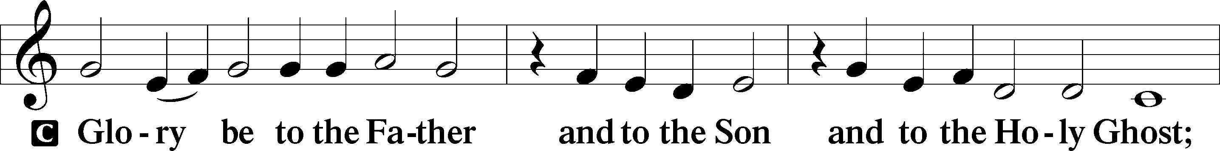
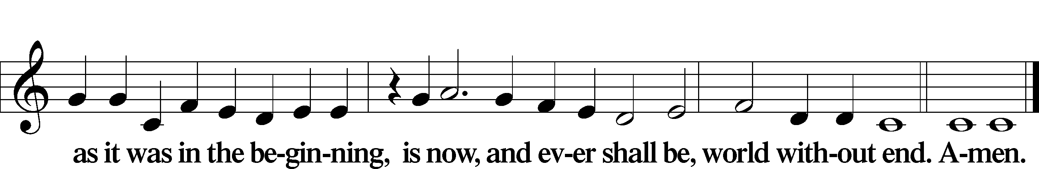

Kyrie Mark 10:47
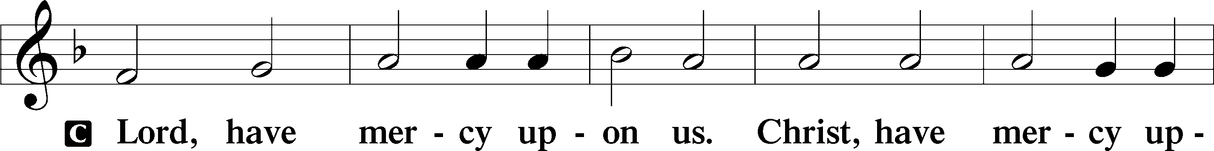
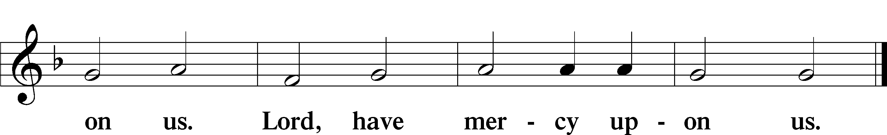
Gloria in Excelsis Luke 2:14; John 1:29
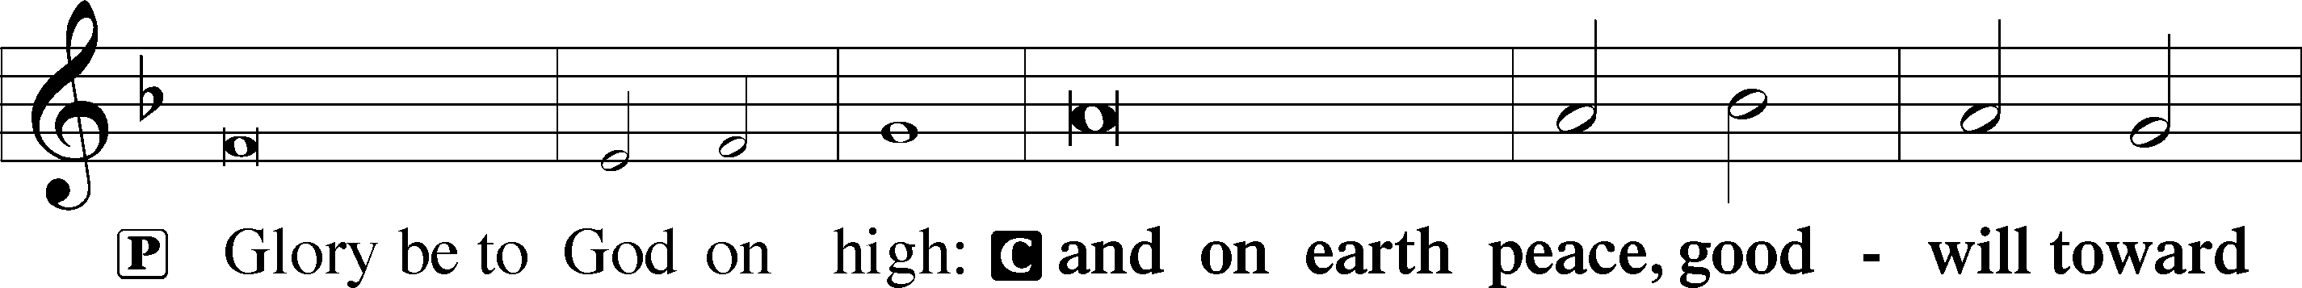
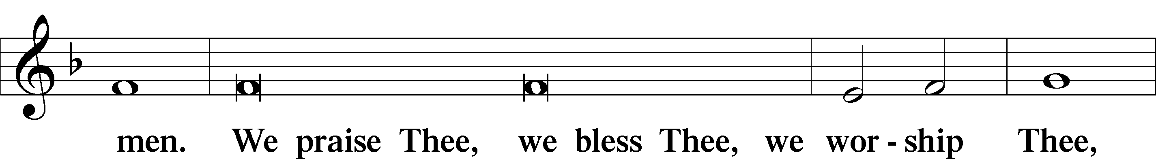
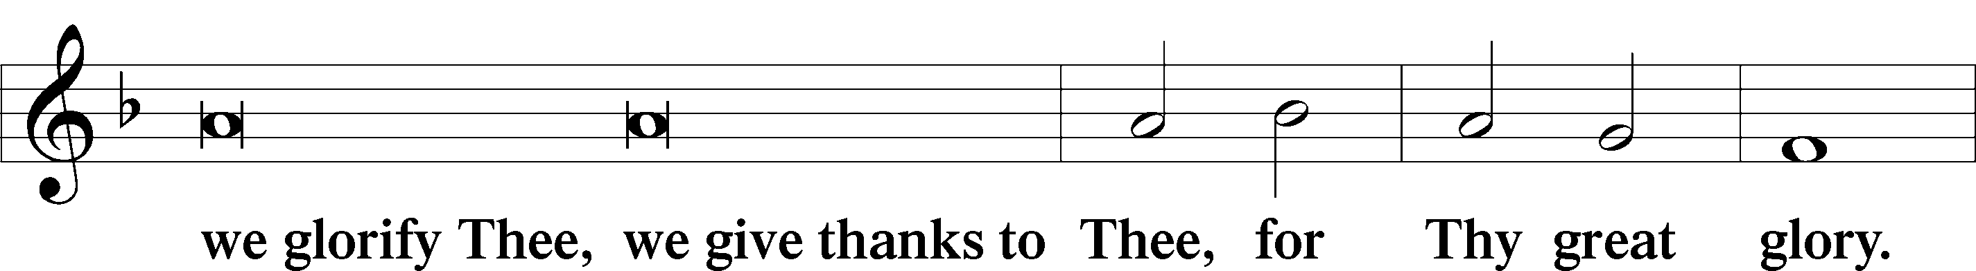
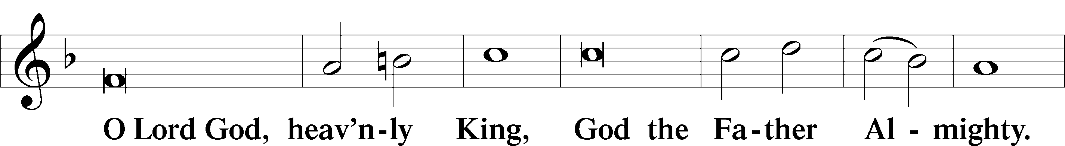
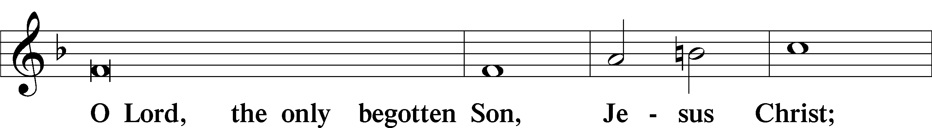
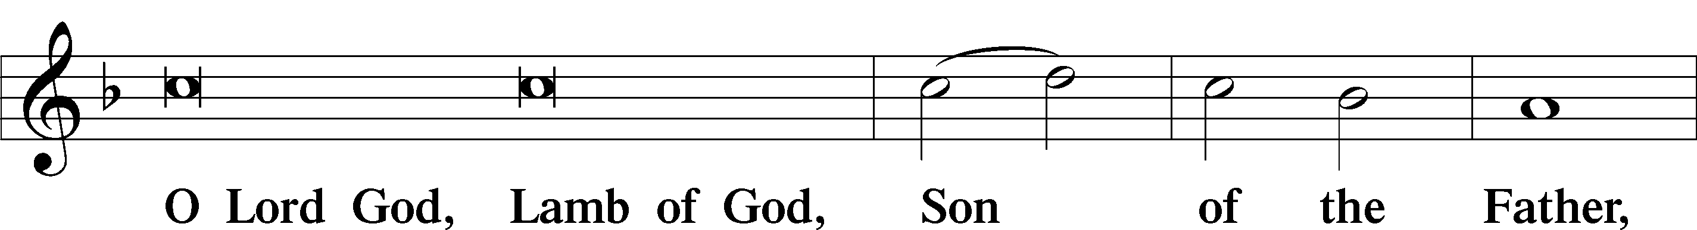
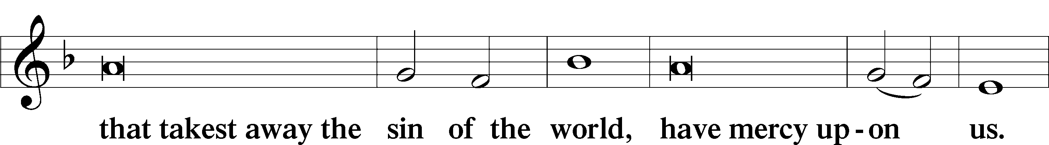
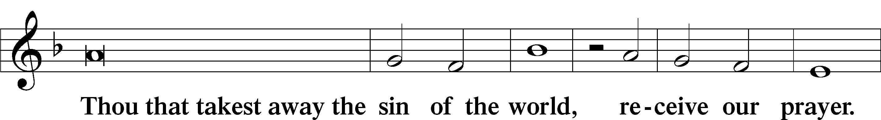
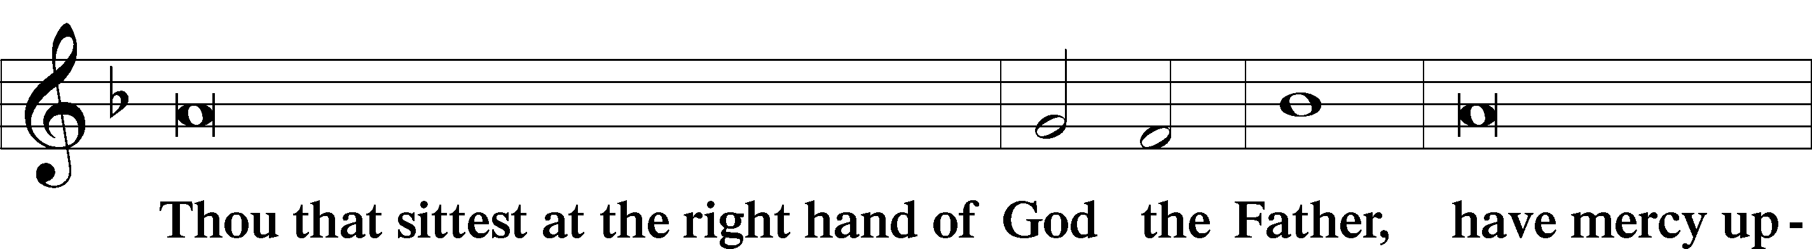
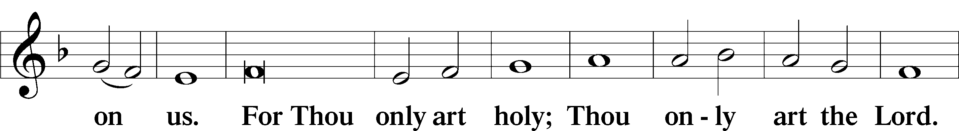
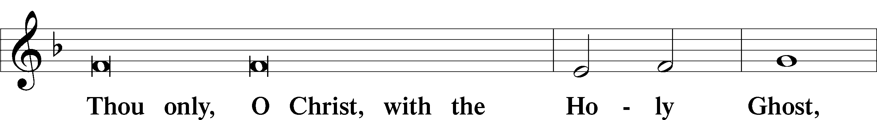
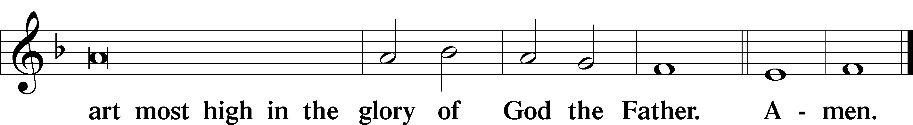

Salutation and Collect of the Day
P The Lord be with you.
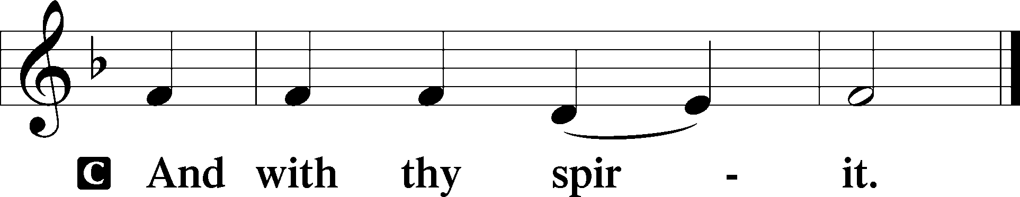

P Let us pray.
Heavenly Father, though we do not deserve Your goodness, still You provide for all our needs of body and soul. Grant us Your Holy Spirit that we may acknowledge Your gifts, give thanks for all Your benefits, and serve You in willing obedience; through Jesus Christ, Your Son, our Lord, who lives and reigns with You and the Holy Spirit, one God, now and forever.

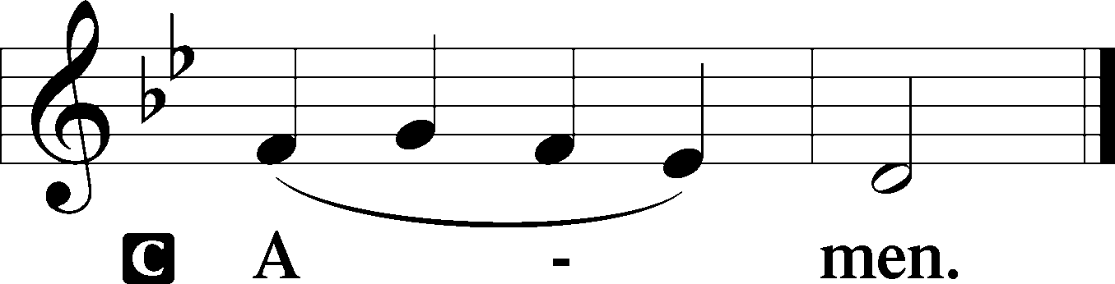

Sit

Old Testament Reading Isaiah 55:1–5
1“Come, everyone who thirsts, come to the waters;
and he who has no money, come, buy and eat! Come, buy wine and milk without money and without price. 2Why do you spend your money for that which is not bread, and your labor for that which does not satisfy? Listen diligently to me, and eat what is good, and delight yourselves in rich food. 3Incline your ear, and come to me; hear, that your soul may live; and I will make with you an everlasting covenant, my steadfast, sure love for David. 4Behold, I made him a witness to the peoples, a leader and commander for the peoples. 5Behold, you shall call a nation that you do not know, and a nation that did not know you shall run to you, because of the Lord your God, and of the Holy One of Israel,
for he has glorified you.”

A This is the Word of the Lord.
C Thanks be to God.

Gradual Romans 11:33, 36
Oh, the depth of the riches and wisdom and knowledge of God!
How unsearchable are his judgments and how inscrutable his ways!
For from him and through him and to him are all things.
To him be glory forever. Amen.

Epistle Romans 9:1–13
1I am speaking the truth in Christ—I am not lying; my conscience bears me witness in the Holy Spirit— 2that I have great sorrow and unceasing anguish in my heart. 3For I could wish that I myself were accursed and cut off from Christ for the sake of my brothers, my kinsmen according to the flesh. 4They are Israelites, and to them belong the adoption, the glory, the covenants, the giving of the law, the worship, and the promises. 5To them belong the patriarchs, and from their race, according to the flesh, is the Christ who is God over all, blessed forever. Amen. 6But it is not as though the word of God has failed. For not all who are descended from Israel belong to Israel, 7and not all are children of Abraham because they are his offspring, but “Through Isaac shall your offspring be named.” 8This means that it is not the children of the flesh who are the children of God, but the children of the promise are counted as offspring. 9For this is what the promise said: “About this time next year I will return and Sarah shall have a son.” 10And not only so, but also when Rebecca had conceived children by one man, our forefather Isaac, 11though they were not yet born and had done nothing either good or bad—in order that God’s purpose of election might continue, not because of works but because of his call— 12she was told, “The older will serve the younger.” 13As it is written, “Jacob I loved, but Esau I hated.”

A This is the Word of the Lord.
C Thanks be to God.

Stand

Alleluia
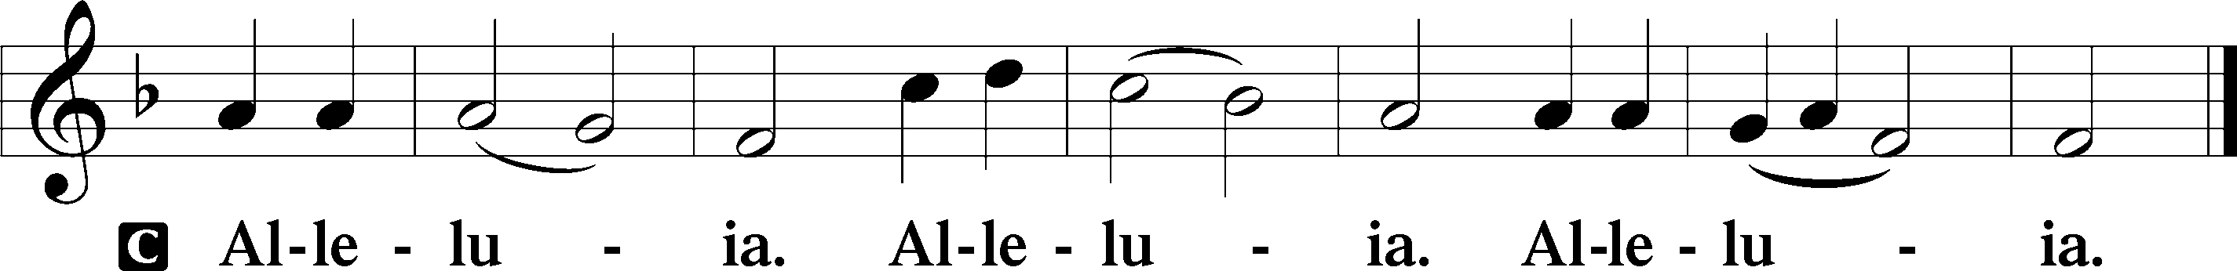

Holy Gospel Matthew 14:13–21
P The Holy Gospel according to St. Matthew, the fourteenth chapter.

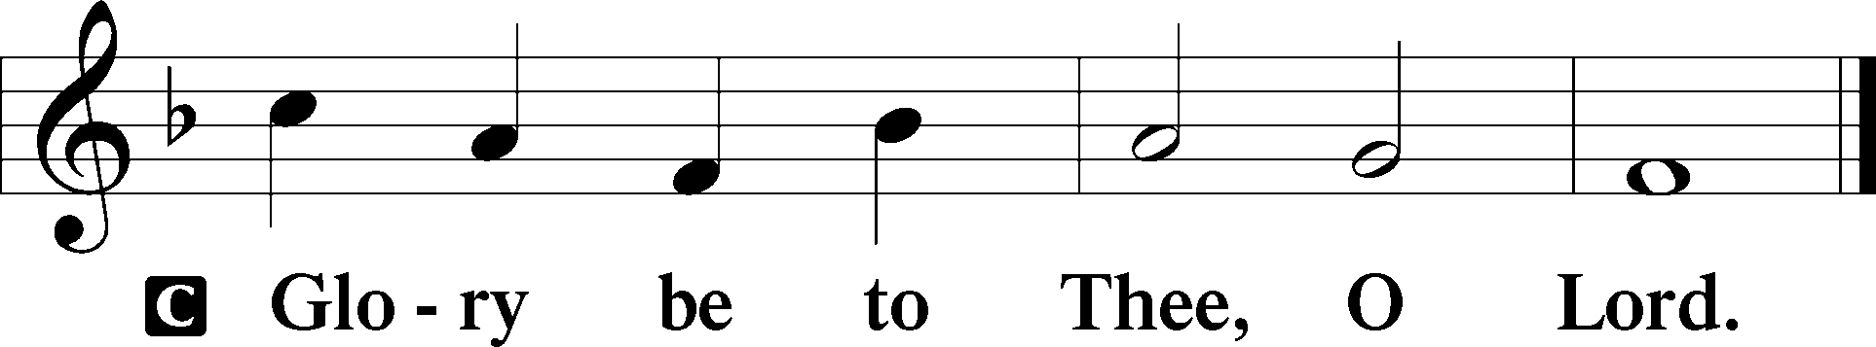

13Now when Jesus heard [about the death of John], he withdrew from there in a boat to a desolate place by himself. But when the crowds heard it, they followed him on foot from the towns. 14When he went ashore he saw a great crowd, and he had compassion on them and healed their sick. 15Now when it was evening, the disciples came to him and said, “This is a desolate place, and the day is now over; send the crowds away to go into the villages and buy food for themselves.” 16But Jesus said, “They need not go away; you give them something to eat.” 17They said to him, “We have only five loaves here and two fish.” 18And he said, “Bring them here to me.” 19Then he ordered the crowds to sit down on the grass, and taking the five loaves and the two fish, he looked up to heaven and said a blessing. Then he broke the loaves and gave them to the disciples, and the disciples gave them to the crowds. 20And they all ate and were satisfied. And they took up twelve baskets full of the broken pieces left over. 21And those who ate were about five thousand men, besides women and children.

P This is the Gospel of the Lord.

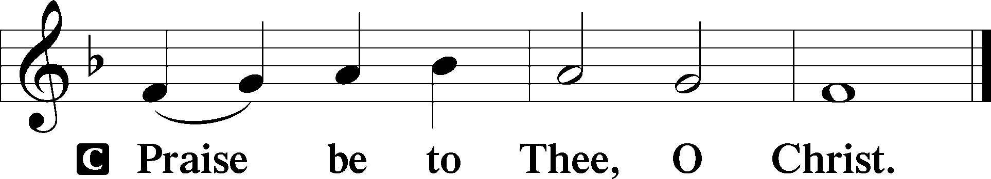

Nicene Creed
C I believe in one God,
the Father Almighty,
maker of heaven and earth
and of all things visible and invisible.

And in one Lord Jesus Christ,
the only-begotten Son of God,
begotten of His Father before all worlds,
God of God, Light of Light,
very God of very God,
begotten, not made,
being of one substance with the Father,
by whom all things were made;
who for us men and for our salvation came down from heaven
and was incarnate by the Holy Spirit of the virgin Mary
and was made man;
and was crucified also for us under Pontius Pilate.
He suffered and was buried.
And the third day He rose again according to the Scriptures
and ascended into heaven
and sits at the right hand of the Father.
And He will come again with glory to judge both the living and the dead,
whose kingdom will have no end.

And I believe in the Holy Spirit,
the Lord and giver of life,
who proceeds from the Father and the Son,
who with the Father and the Son together is worshiped and glorified,
who spoke by the prophets.
And I believe in one holy Christian and apostolic Church,
I acknowledge one Baptism for the remission of sins,
and I look for the resurrection of the dead
and the life T of the world to come. Amen.

Sit

Children's Sermon

770 What a Friend We Have in Jesus
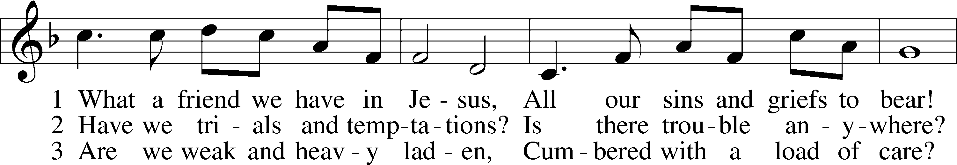
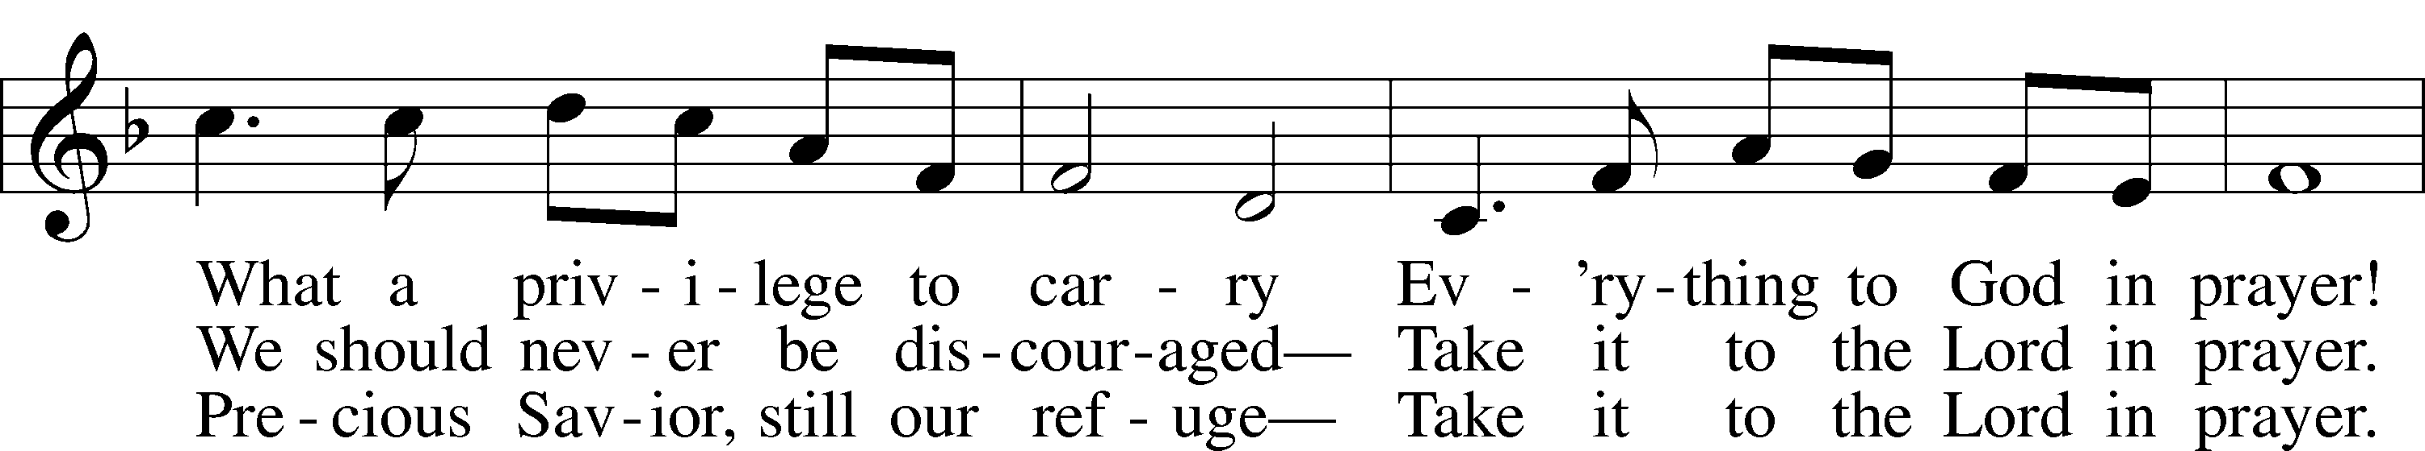
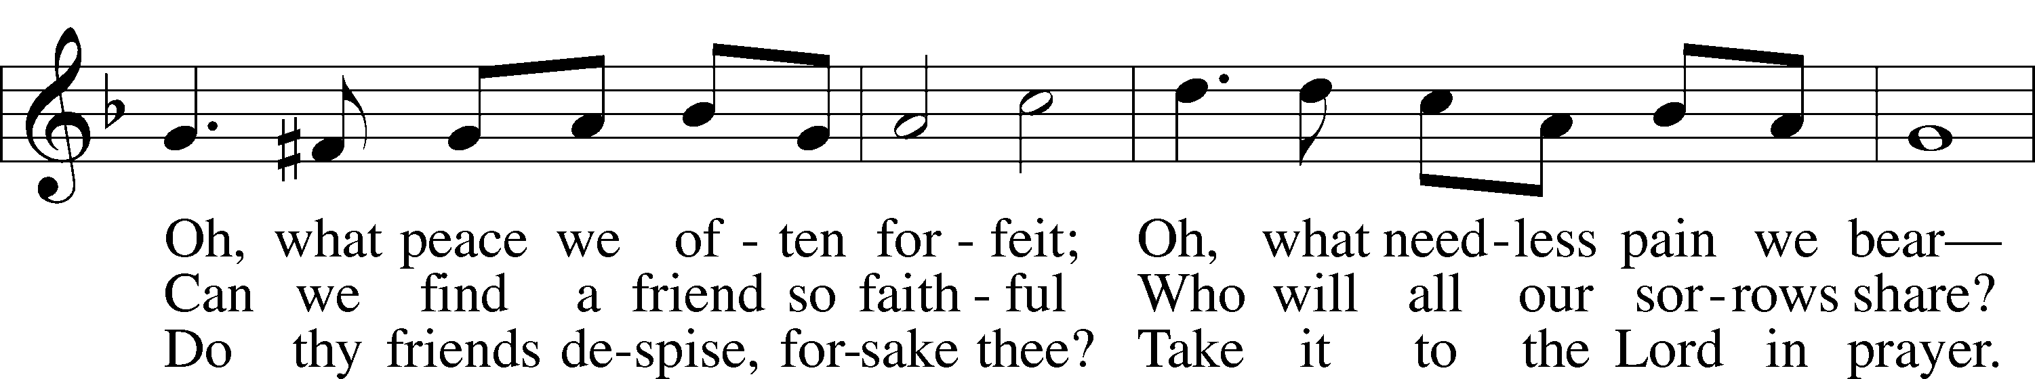
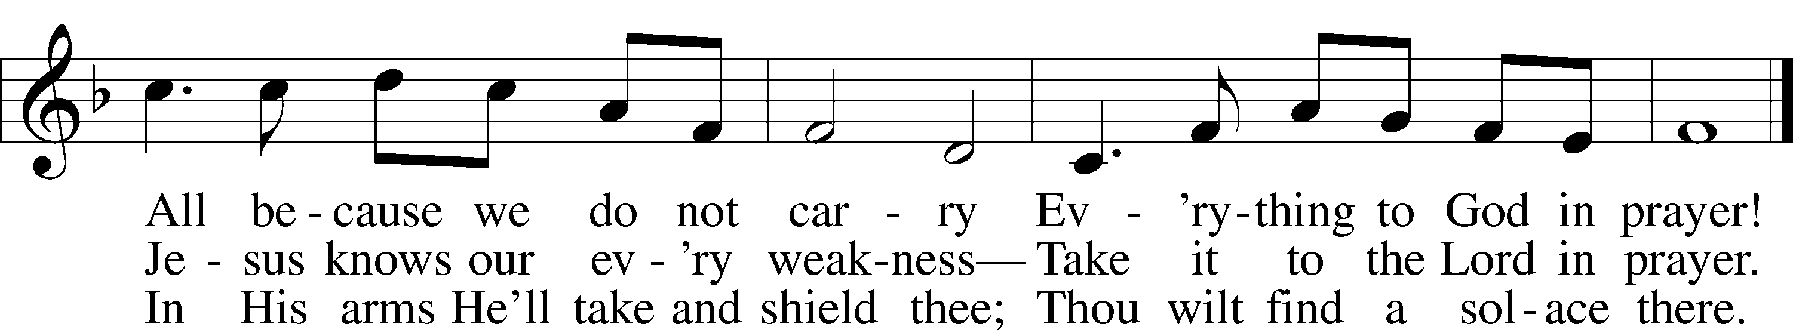
Text: Joseph M. Scriven, 1819–86
Tune: Charles C. Converse, 1832–1918
Text and tune: Public domain

Sermon

Votum
P The peace of God, which passes all understanding, keep your hearts and minds in Christ Jesus.
C Amen.

Stand

Offertory Psalm 51:10–12
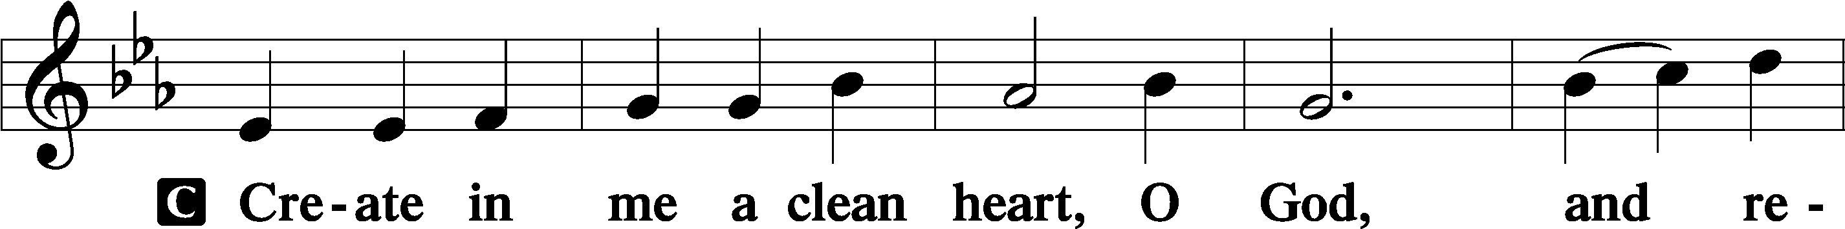
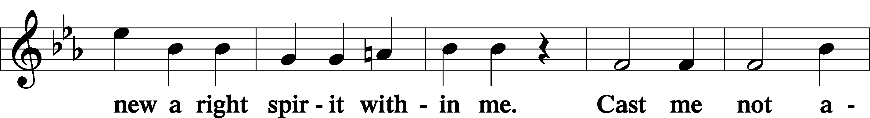
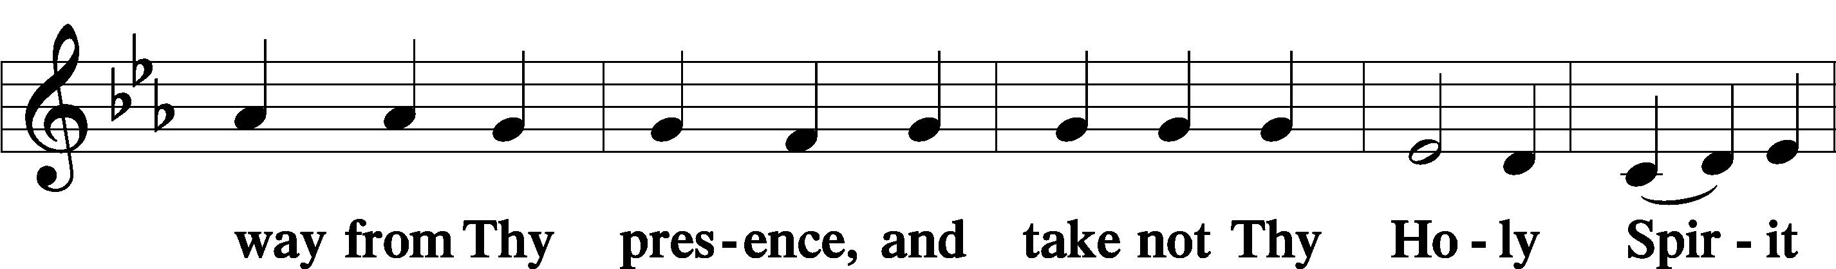
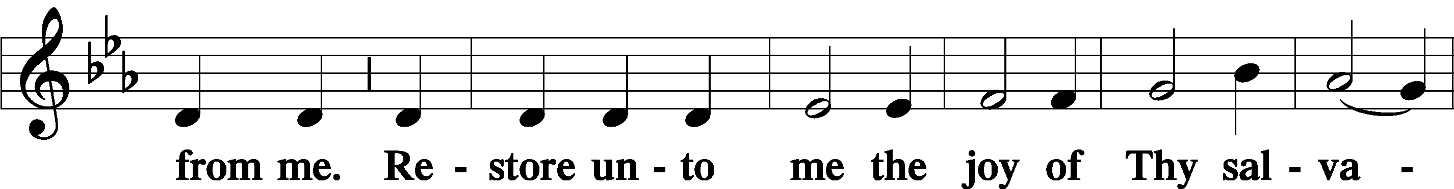
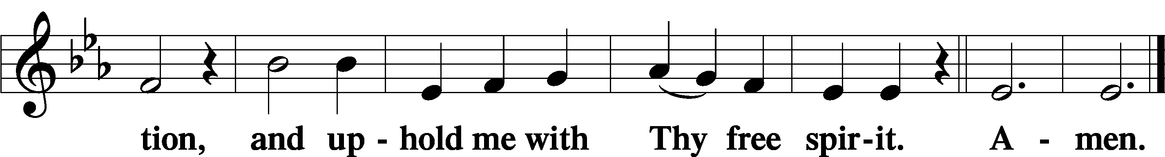

Sit

Offering

805 Praise God, from Whom All Blessings Flow
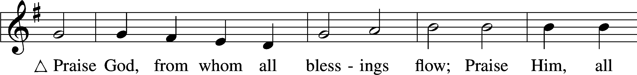
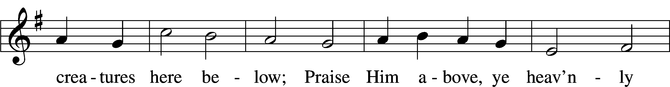
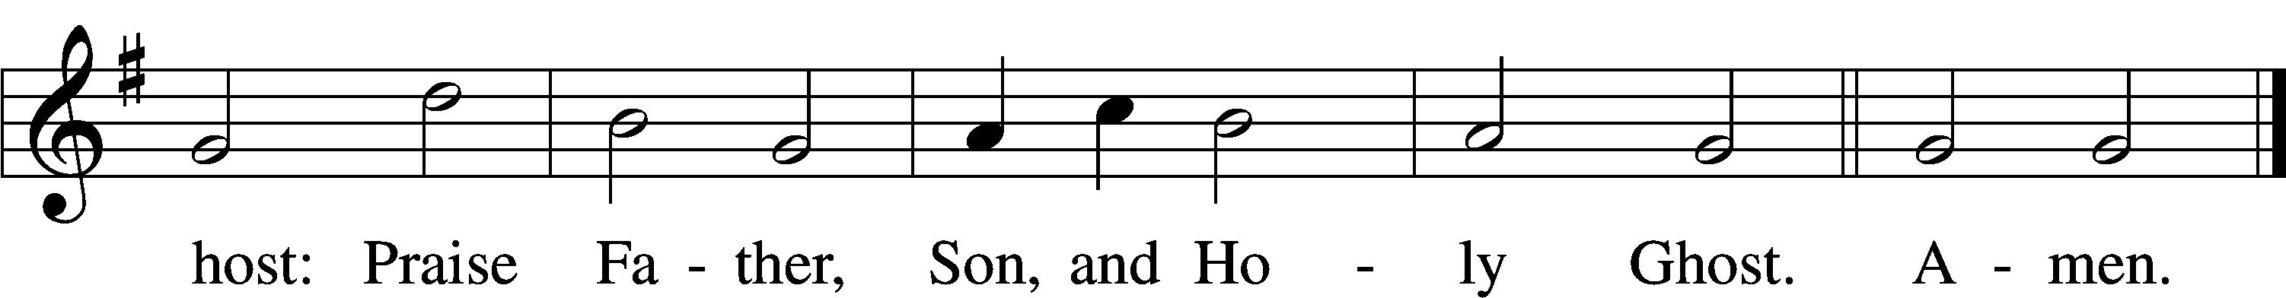
Text: Thomas Ken, 1637–1711
Tune: Trente quatre Pseaumes de David, 1551, Geneva, ed. Louis Bourgeois
Text and tune: Public domain

Stand

Prayer of the Church

Service of the Sacrament

Preface 2 Timothy 4:22; [Colossians 3:1]; [Psalm 136]
P The Lord be with you.
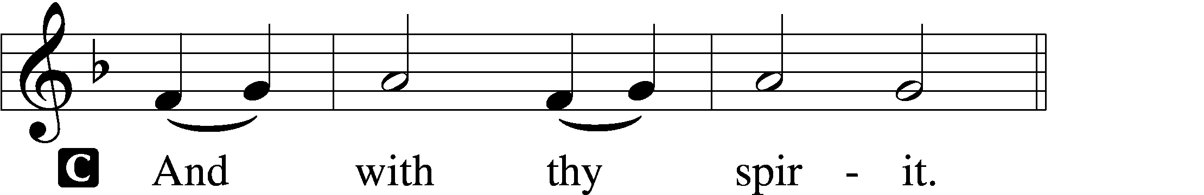

P Lift up your hearts.
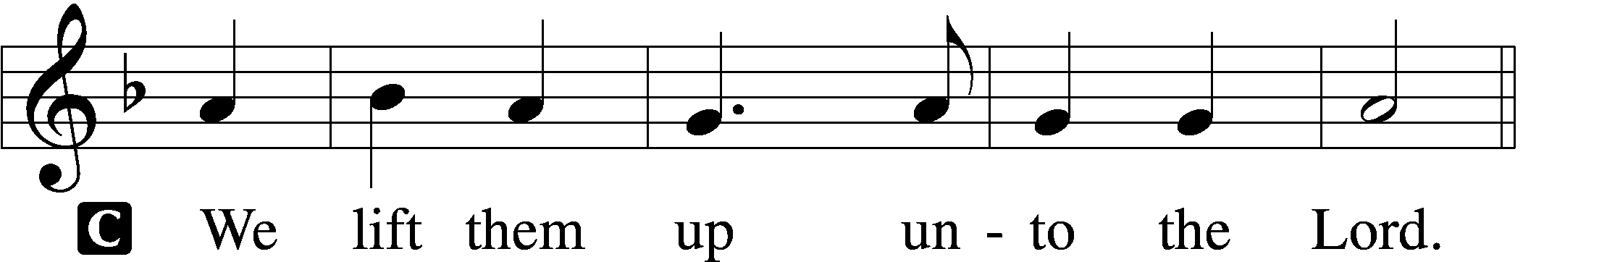

P Let us give thanks unto the Lord, our God.
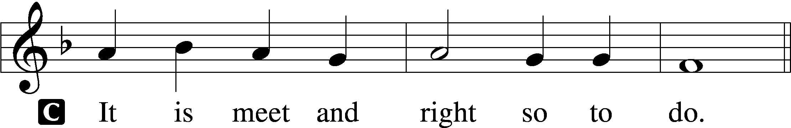

Proper Preface (Full)
P It is truly meet, right, and salutary that we should at all times and in all places give thanks to You, holy Lord, almighty Father, everlasting God, through Jesus Christ, our Lord. Therefore with angels and archangels and with all the company of heaven we laud and magnify Your glorious name, evermore praising You and saying:

Sanctus Isaiah 6:3; Matthew 21:9
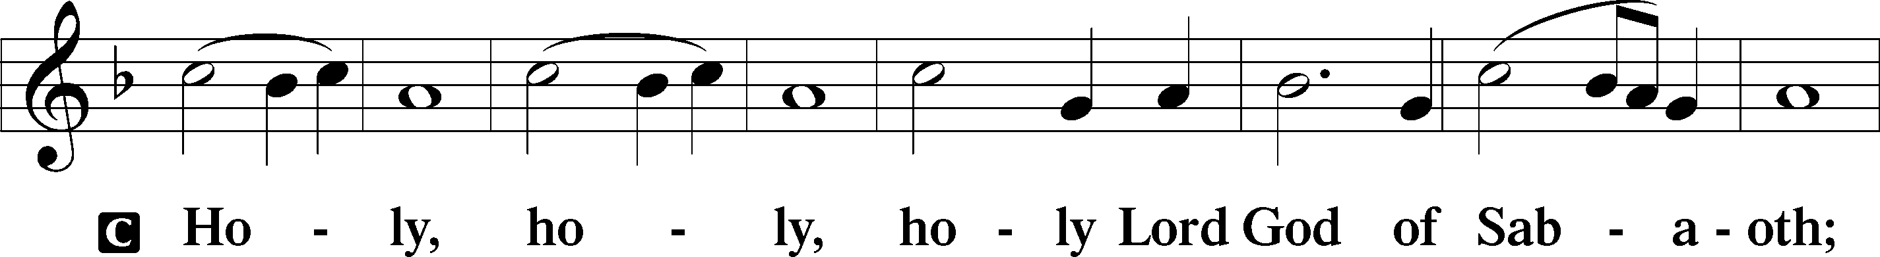
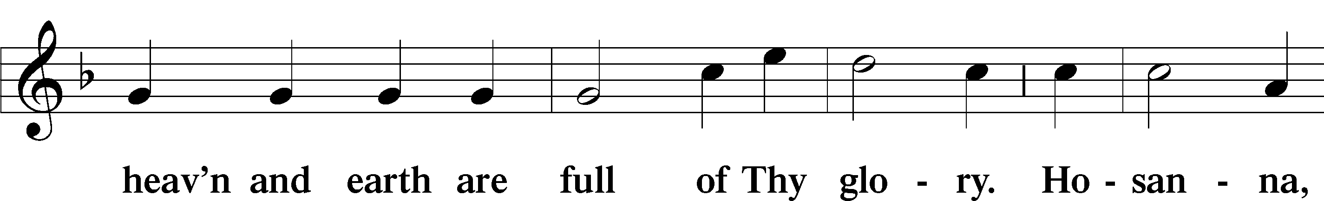
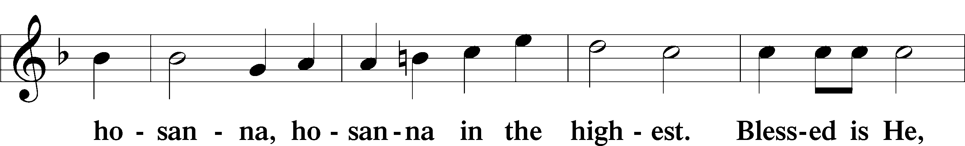
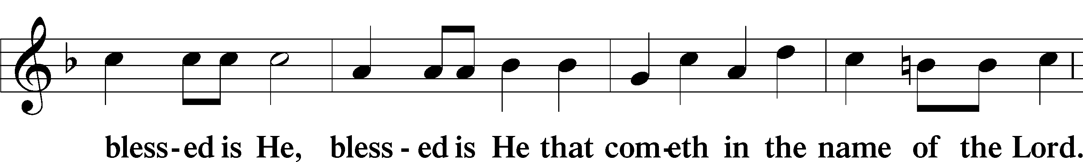
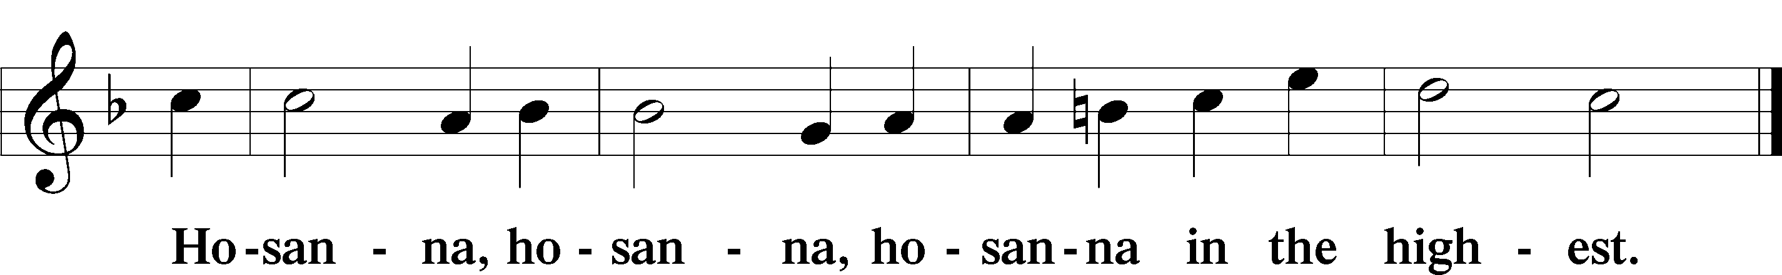

Lord’s Prayer Matthew 6:9–13
P Our Father who art in heaven,
hallowed be Thy name,
Thy kingdom come,
Thy will be done on earth as it is in heaven;
give us this day our daily bread;
and forgive us our trespasses as we forgive those who trespass against us;
and lead us not into temptation,
but deliver us from evil.
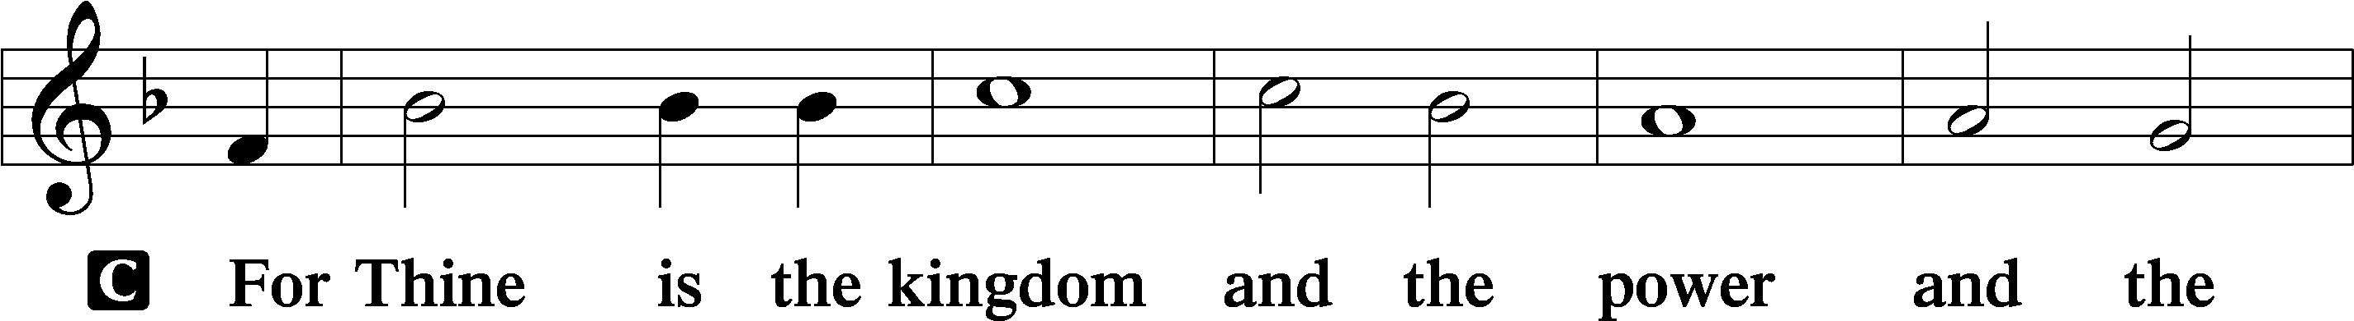
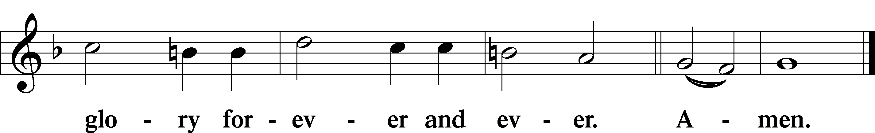

The Words of Our Lord Matthew 26:26–28; Mark 14:22–24; Luke 22:19–20; 1 Corinthians 11:23–25
P Our Lord Jesus Christ, on the night when He was betrayed, took bread, and when He had given thanks, He broke it and gave it to the disciples and said: “Take, eat; this is My T body, which is given for you. This do in remembrance of Me.”

In the same way also He took the cup after supper, and when He had given thanks, He gave it to them, saying: “Drink of it, all of you; this cup is the new testament in My T blood, which is shed for you for the forgiveness of sins. This do, as often as you drink it, in remembrance of Me.”

Pax Domini John 20:19
P The peace of the Lord be with you always.

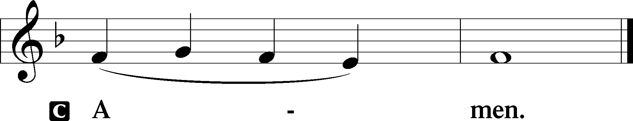

Agnus Dei John 1:29
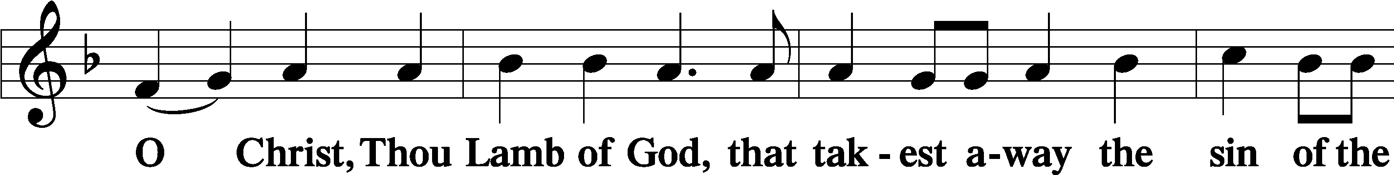
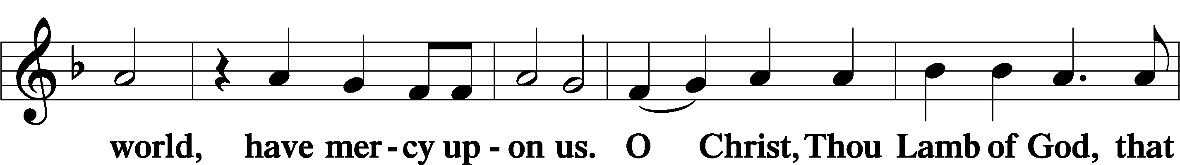
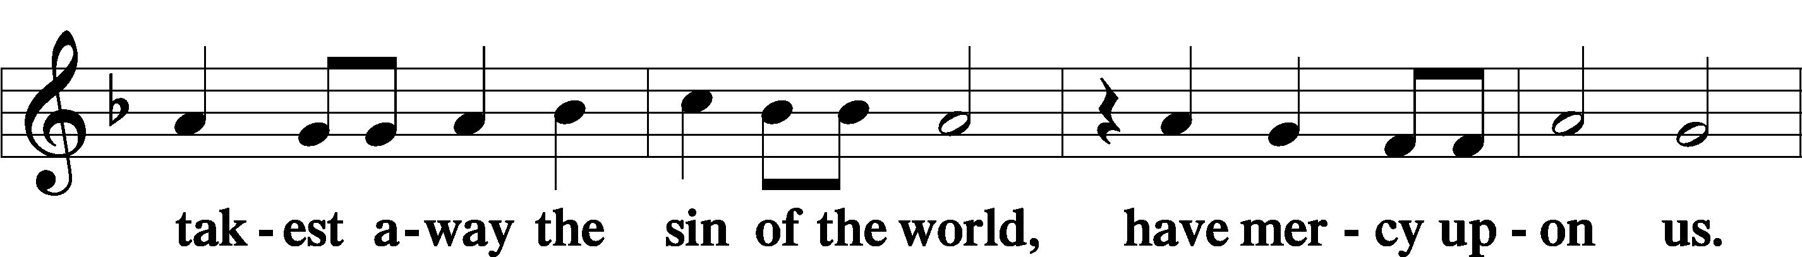
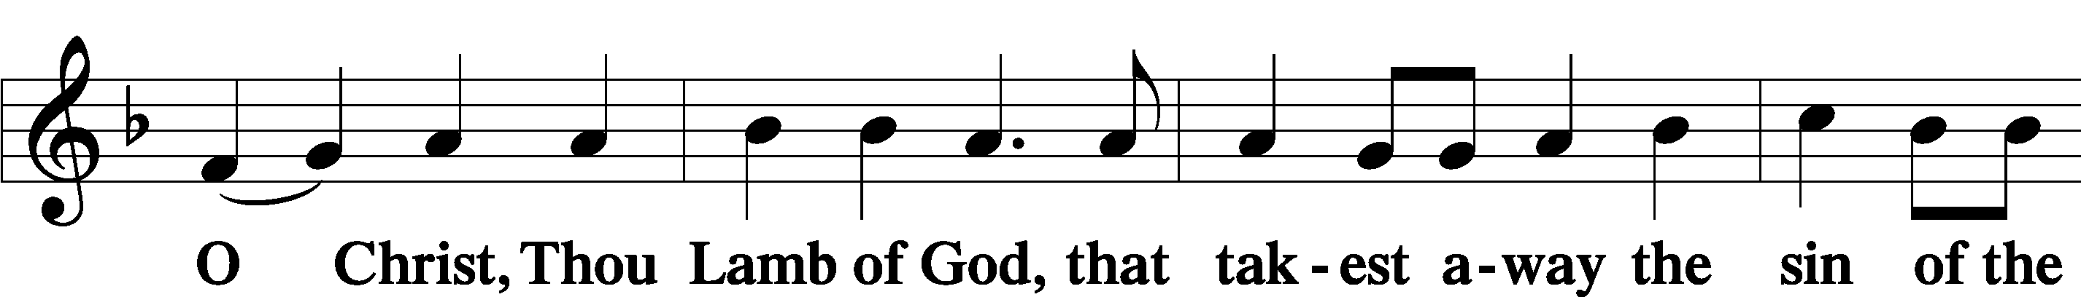
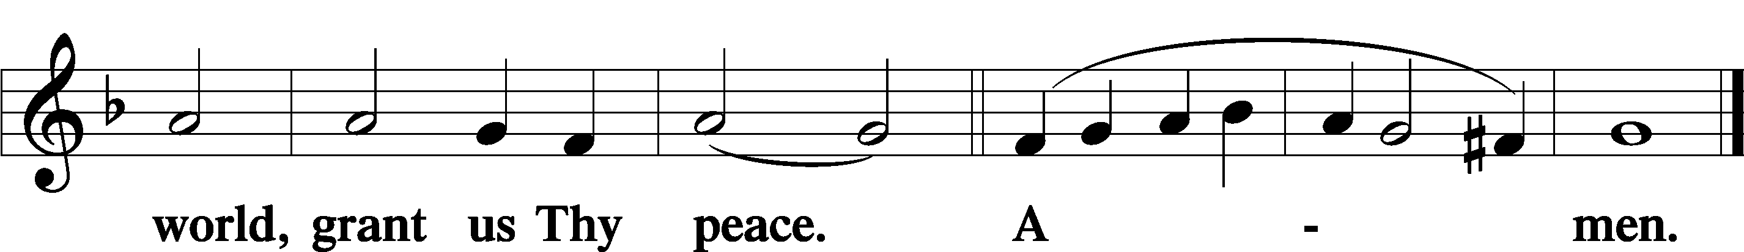

Sit

Distribution

The pastor and those who assist him receive the body and blood of Christ first and then distribute them to those who come to receive, saying:

Take, eat; this is the true body of our Lord and Savior Jesus Christ, given into death for your sins.
Amen.

Take, drink; this is the true blood of our Lord and Savior Jesus Christ, shed for the forgiveness of your sins.
Amen.

In dismissing the communicants, the following is said:

The Dismissal
P The body and blood of our Lord Jesus Christ strengthen and preserve you in body and soul to life everlasting. Depart T in peace.
C Amen.

633 At the Lamb’s High Feast We Sing
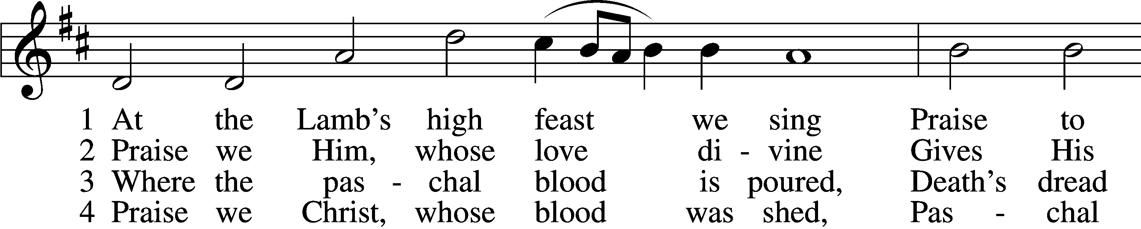
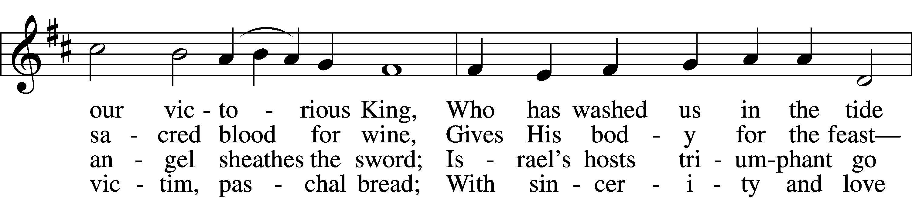
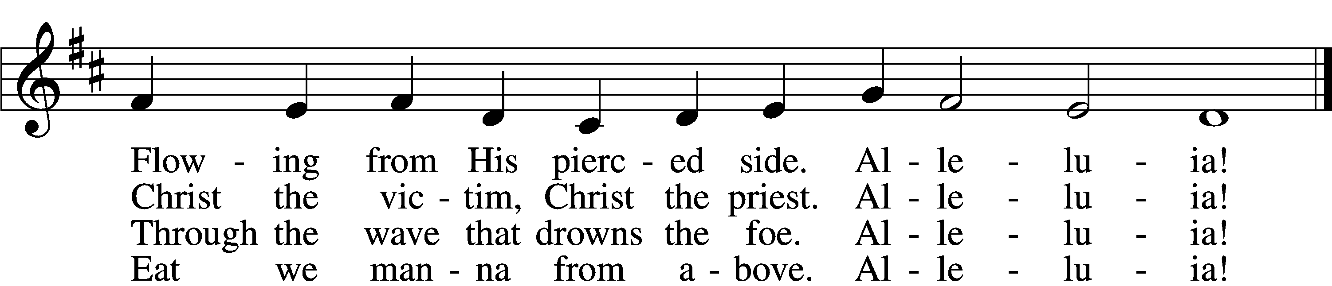

5 Mighty Victim from the sky,
Hell’s fierce pow’rs beneath You lie;
You have conquered in the fight,
You have brought us life and light.
Alleluia!

6 Now no more can death appall,
Now no more the grave enthrall;
You have opened paradise,
And Your saints in You shall rise.
Alleluia!

7 Easter triumph, Easter joy!
This alone can sin destroy;
From sin’s pow’r, Lord, set us free,
Newborn souls in You to be.
Alleluia!

D 8 Father, who the crown shall give,
Savior, by whose death we live,
Spirit, guide through all our days:
Three in One, Your name we praise.
Alleluia!
Text: Latin, c. 5th–10th cent.; tr. Robert Campbell, 1814–68, alt.
Tune: Kirchengeseng, 1566, Ivancice
Text and tune: Public domain

637 Draw Near and Take the Body of the Lord
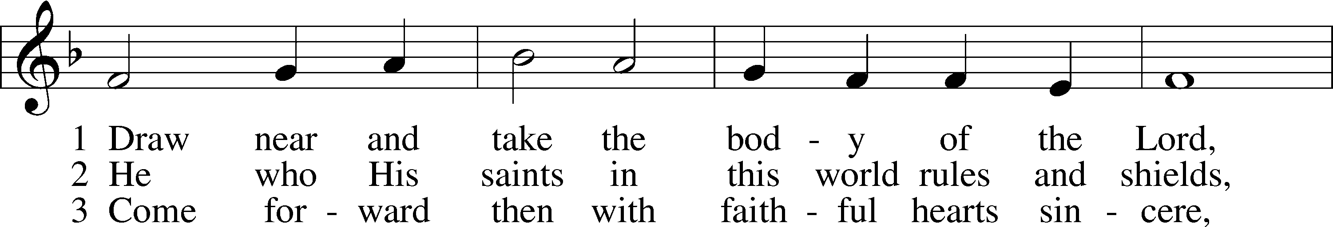
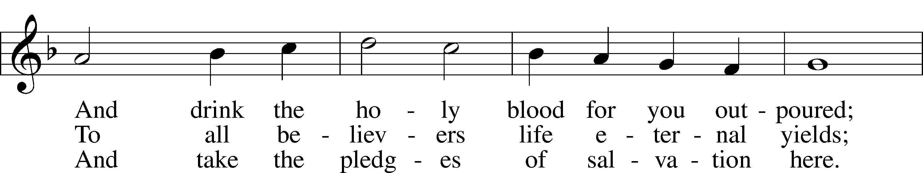
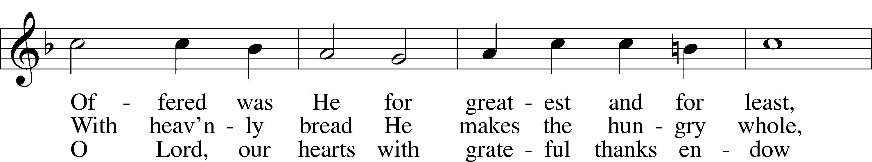
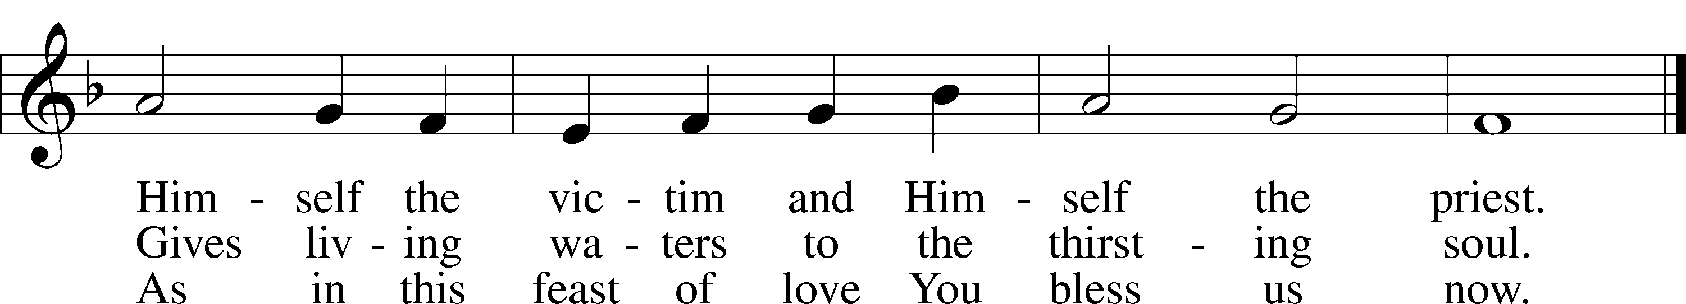
Text: Latin, 7th cent.; tr. John Mason Neale, 1818–66, alt.
Tune: Trente quatre Pseaumes de David, 1551, Geneva, ed. Louis Bourgeois
Text and tune: Public domain

752 Be Still, My Soul
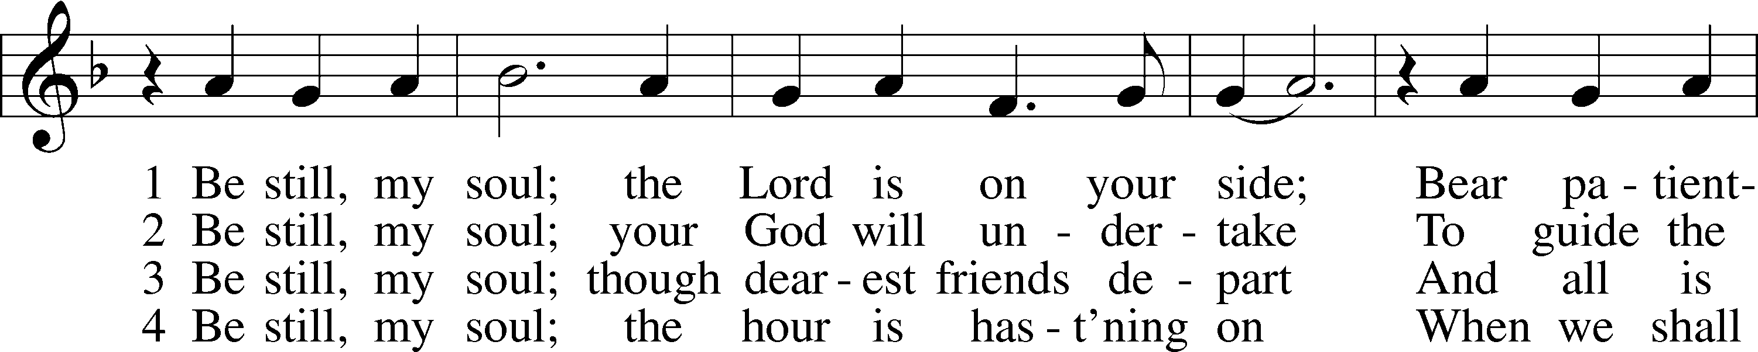
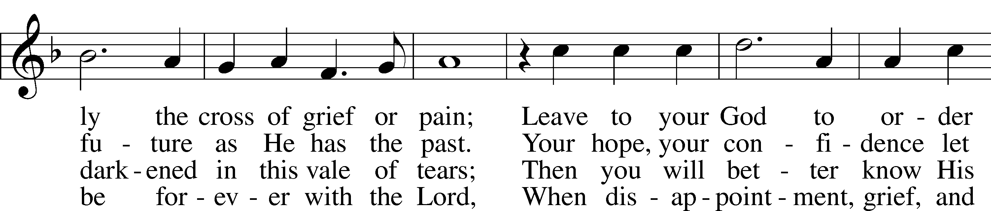
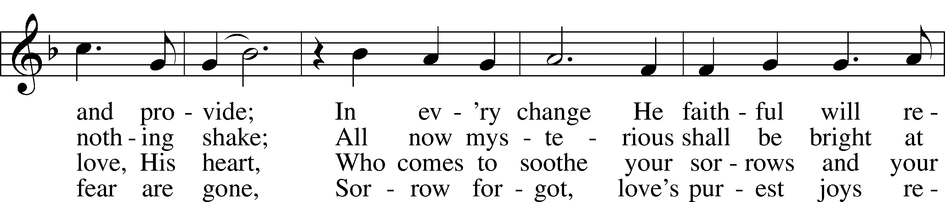
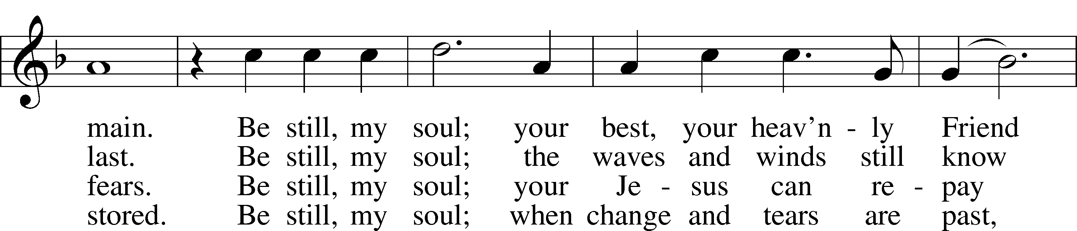
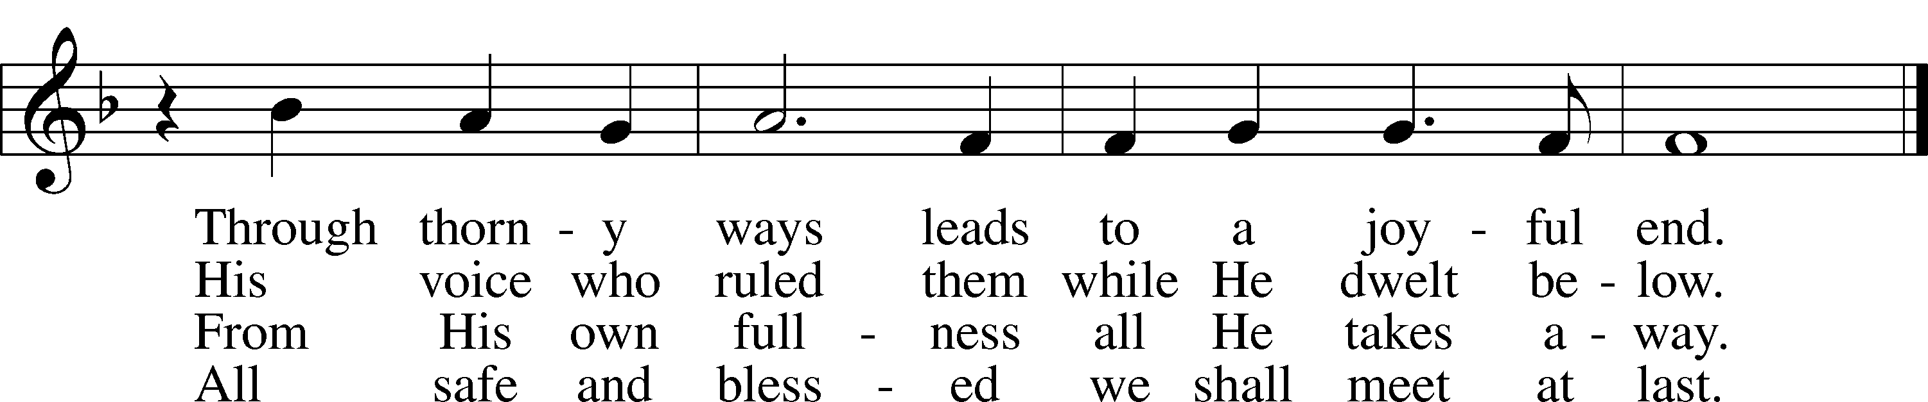
Text: Catharina Amalia Dorothea von Schlegel, 1697–1752; tr. Jane L. Borthwick, 1813–97, alt.
Tune: Jean Sibelius, 1865–1957, adapt.
Text and tune: Public domain

606 I Lay My Sins on Jesus
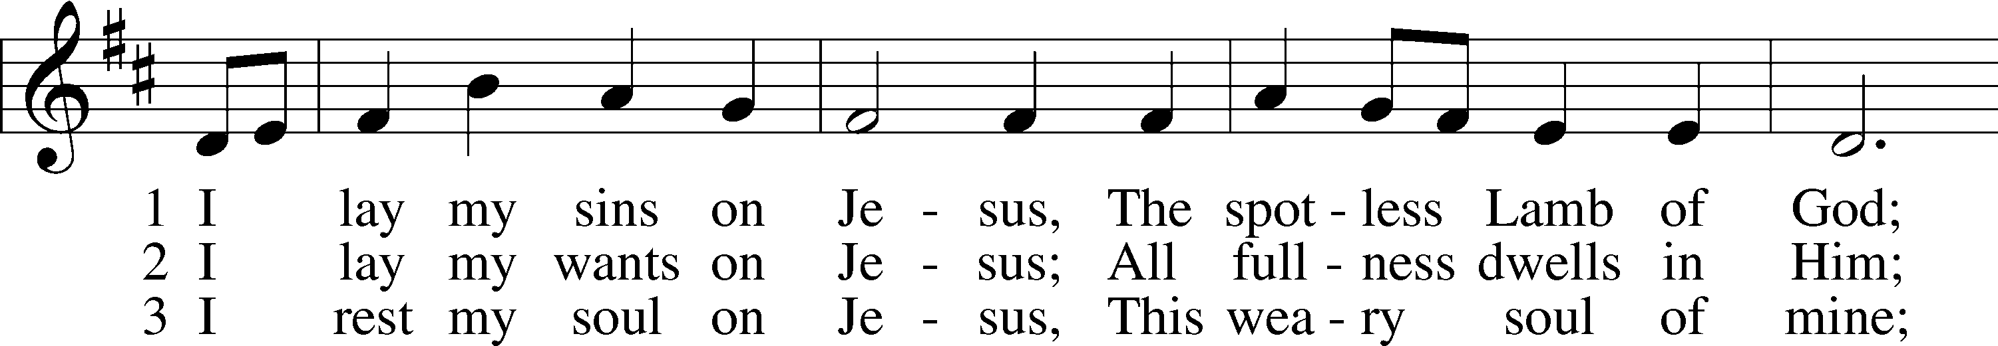
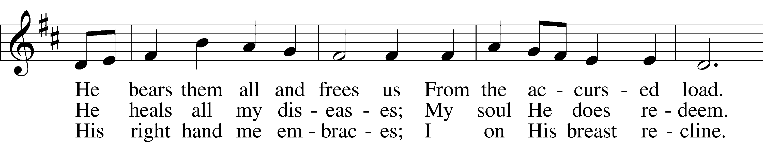
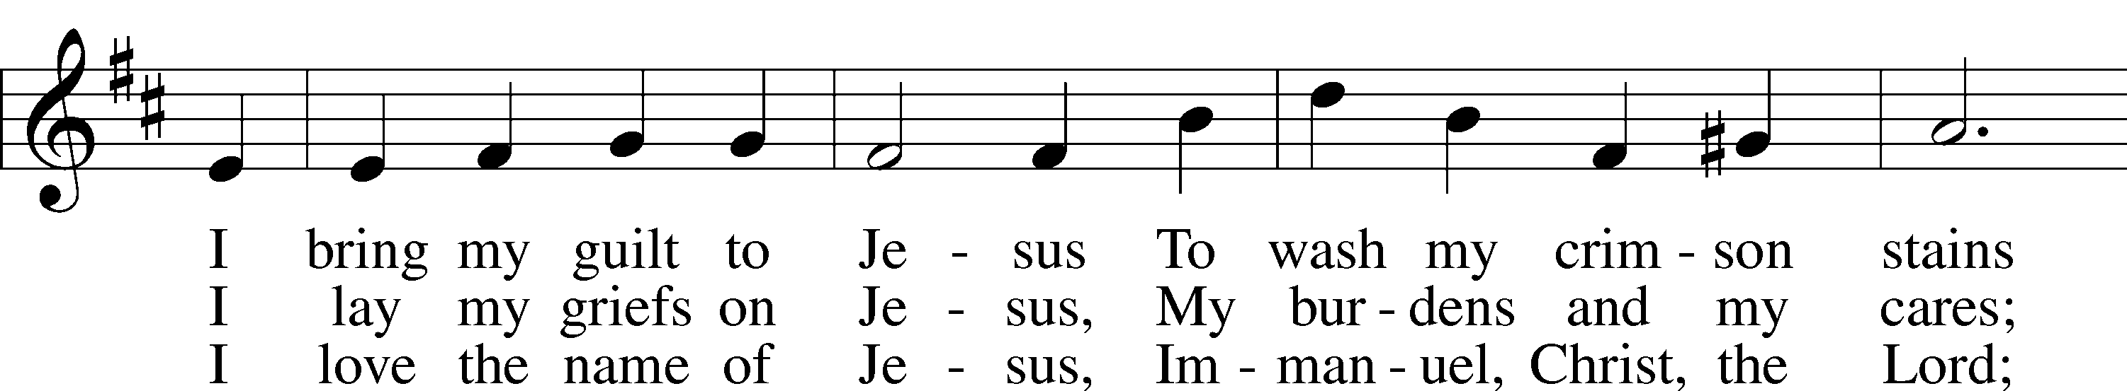
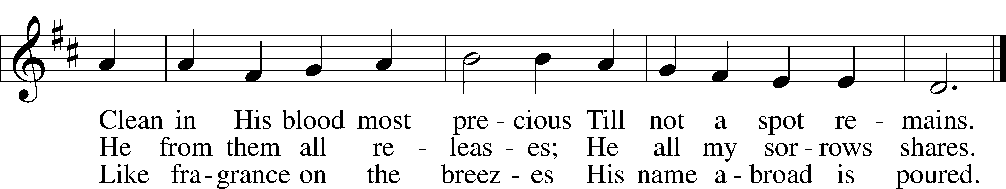
Text: Horatius Bonar, 1808–89
Tune: Neu-vermehrtes . . . Gesangbuch, 1693, 3rd ed., Meiningen
Text and tune: Public domain

Stand

Nunc Dimittis Luke 2:29–32
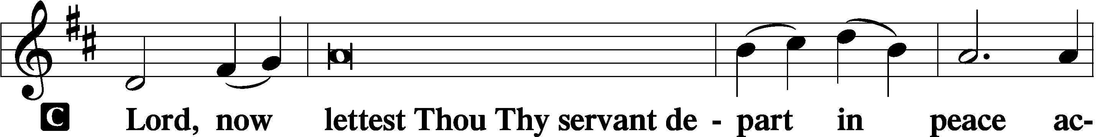

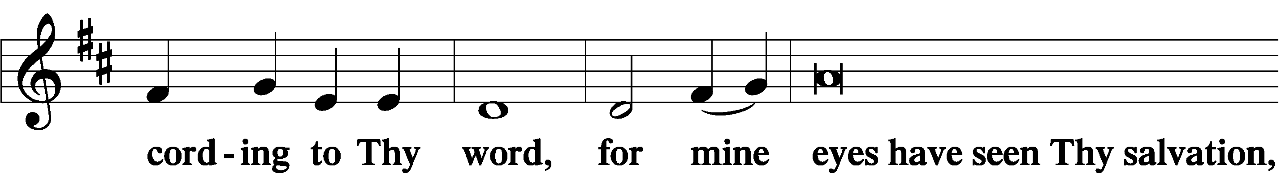

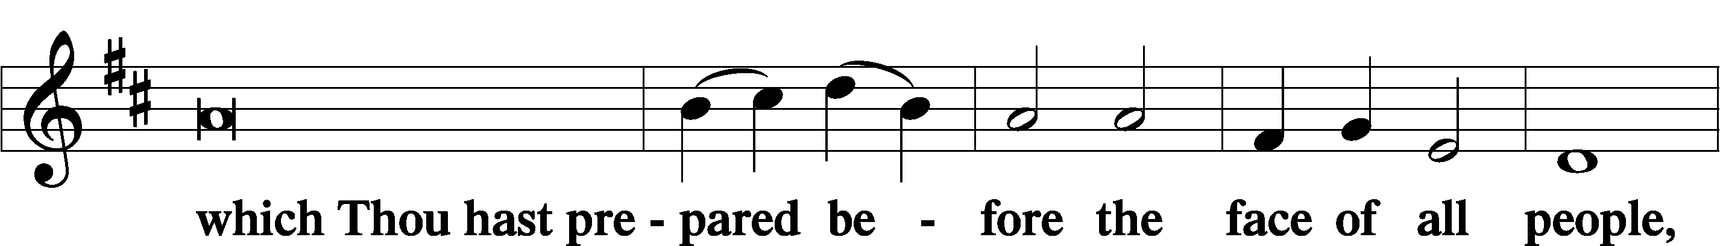

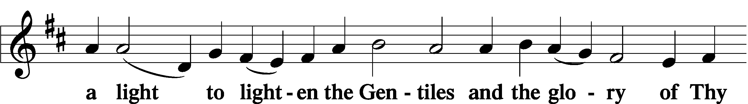

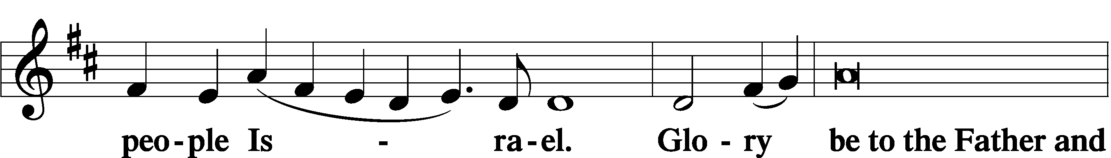

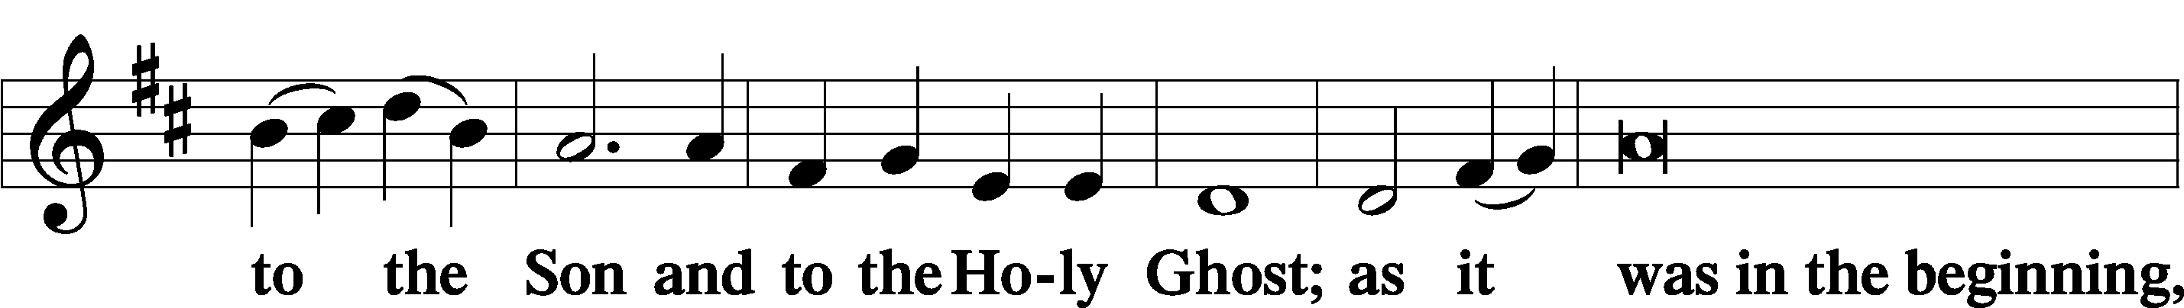

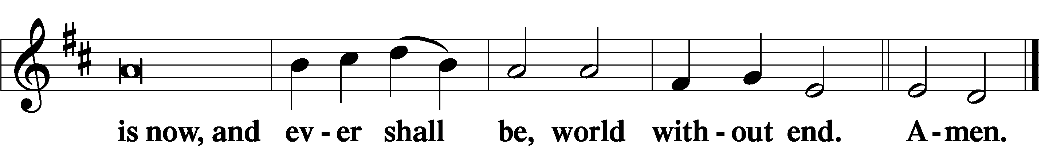

Thanksgiving Psalm 107:1
A O give thanks unto the Lord, for He is good,

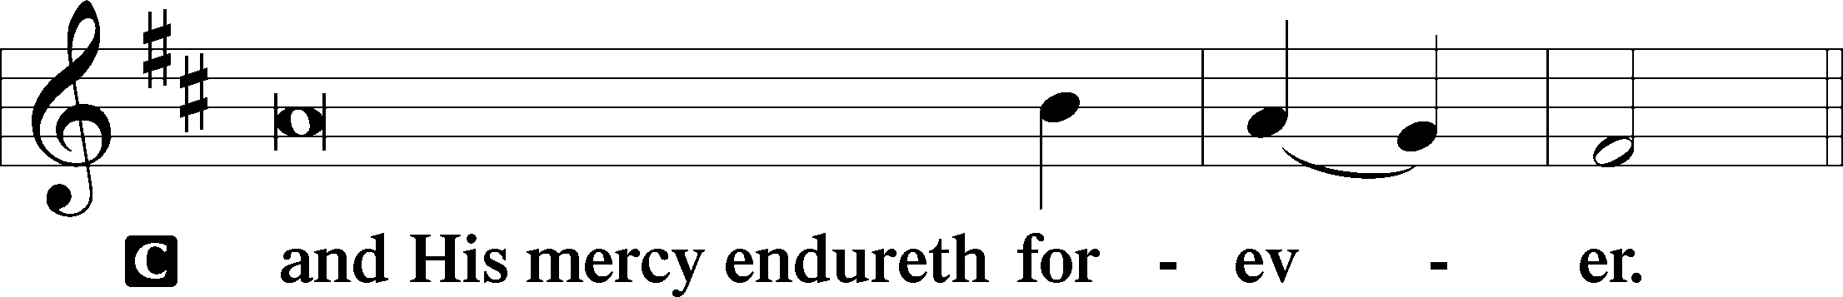

Post-Communion Collect
A Let us pray.
We give thanks to You, almighty God, that You have refreshed us through this salutary gift, and we implore You that of Your mercy You would strengthen us through the same in faith toward You and in fervent love toward one another; through Jesus Christ, Your Son, our Lord, who lives and reigns with You and the Holy Spirit, one God, now and forever.

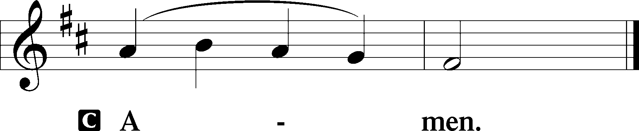

Salutation 2 Timothy 4:22
P The Lord be with you.

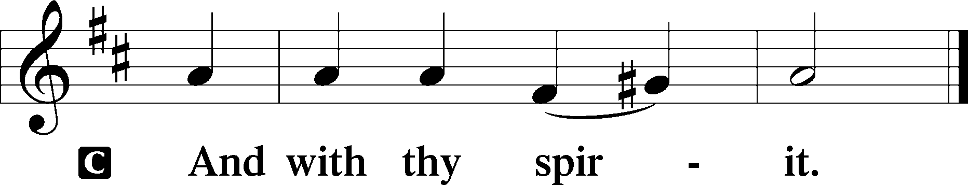

Benedicamus Psalm 103:1
A Bless we the Lord.

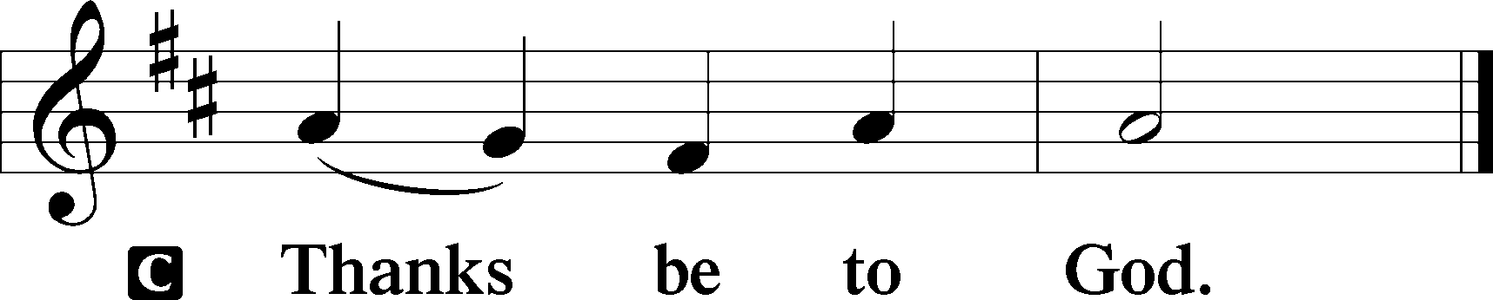

Benediction Numbers 6:24–26
P The Lord bless you and keep you.
The Lord make His face shine upon you and be gracious unto you.
The Lord lift up His countenance upon you and T give you peace.
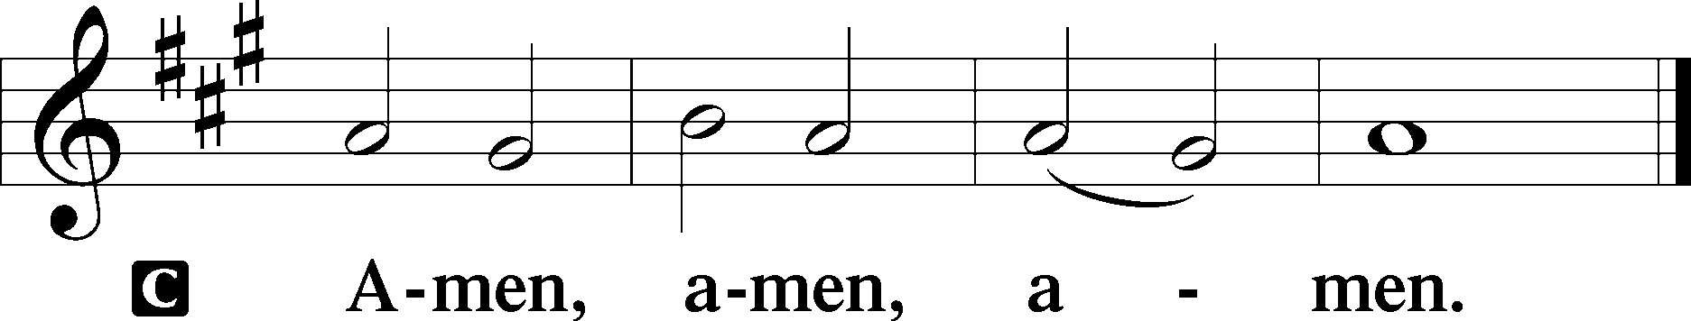

794 The Lord, My God, Be Praised
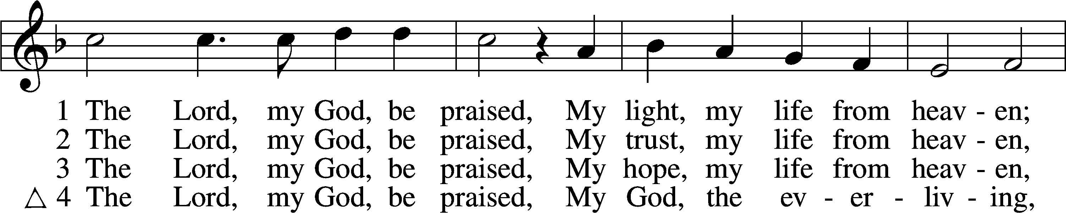
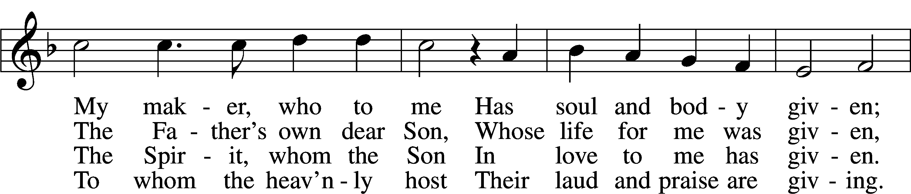
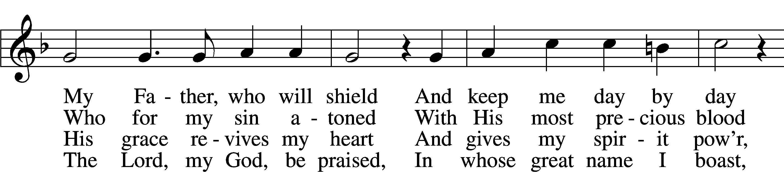
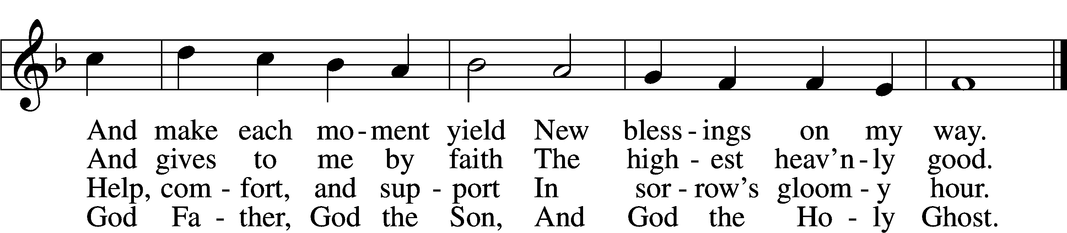
Text: Johann Olearius, 1611–84; tr. August Crull, 1845–1923, alt.
Tune: Johann Crüger, 1598–1662
Text and tune: Public domain
Acknowledgments
Divine Service, Setting Three from Lutheran Service Book. Unless otherwise indicated, Scripture quotations are from the ESV® Bible (The Holy Bible, English Standard Version®), copyright © 2001 by Crossway, a publishing ministry of Good News Publishers. Used by permission. All rights reserved. Created by Lutheran Service Builder © 2026 Concordia Publishing House.

