908 Lord, Open Now My Heart to Hear
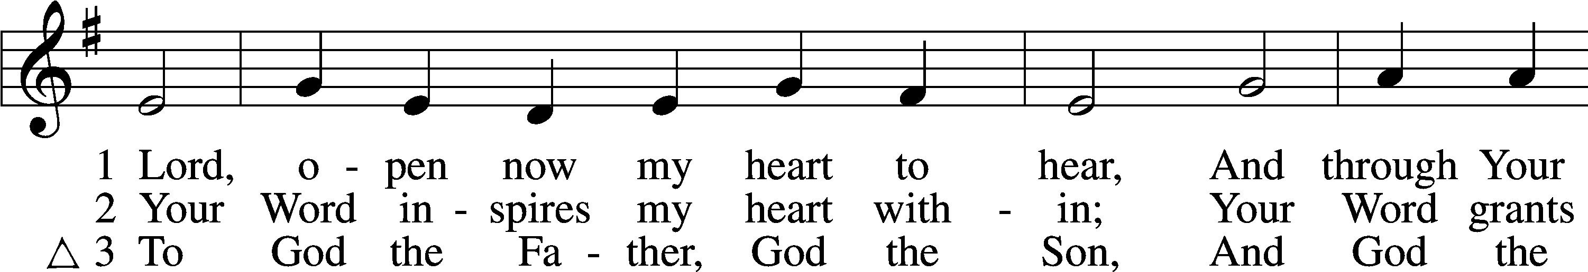
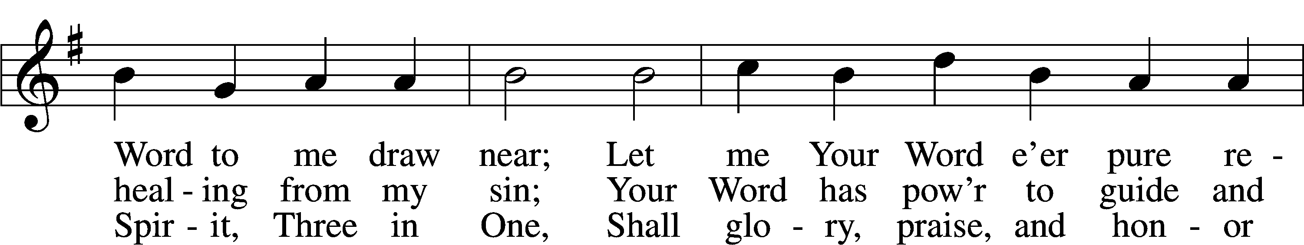
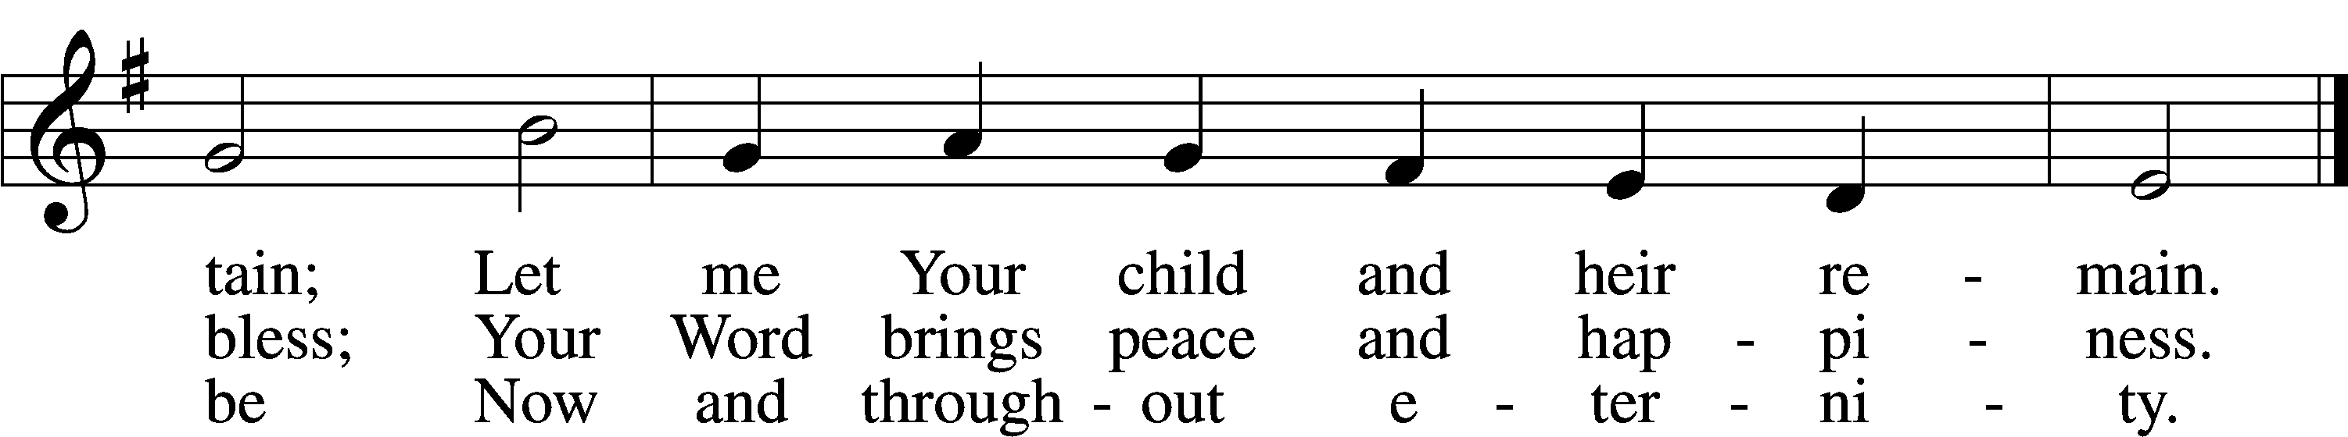
Text: Johann Olearius, 1611–84; (sts. 1, 3): tr. Matthias Loy, 1828–1915, alt.; (st. 2): tr. Mark A. Jeske, 1952
Tune: Geistliche Lieder auffs new gebessert, 1543, Wittenberg, ed. Joseph Klug
Text (st. 2): © 1993 Mark A. Jeske. Used by permission: LSB Hymn License no. 110005011
Text (sts. 1, 3) and tune: Public domain

Confession and Absolution

Stand

The sign of the cross may be made by all in remembrance of their Baptism.

Invocation Matthew 28:19b; 18:20
P In the name of the Father and of the T Son and of the Holy Spirit.
C Amen.

Exhortation Hebrews 10:22; Psalm 124:8; Psalm 32:5
P Beloved in the Lord! Let us draw near with a true heart and confess our sins unto God our Father, beseeching Him in the name of our Lord Jesus Christ to grant us forgiveness.

P Our help is in the name of the Lord,
C who made heaven and earth.
P I said, I will confess my transgressions unto the Lord,
C and You forgave the iniquity of my sin.

Kneel/Stand

Silence for reflection on God’s Word and for self-examination.

Confession of Sins
P O almighty God, merciful Father,
C I, a poor, miserable sinner, confess unto You all my sins and iniquities with which I have ever offended You and justly deserved Your temporal and eternal punishment. But I am heartily sorry for them and sincerely repent of them, and I pray You of Your boundless mercy and for the sake of the holy, innocent, bitter sufferings and death of Your beloved Son, Jesus Christ, to be gracious and merciful to me, a poor, sinful being.

Absolution [John 20:19–23]
P Upon this your confession, I, by virtue of my office, as a called and ordained servant of the Word, announce the grace of God unto all of you, and in the stead and by the command of my Lord Jesus Christ I forgive you all your sins in the name of the Father and of the T Son and of the Holy Spirit.
C Amen.

Stand

Service of the Word

Introit Psalm 133; antiphon: v. 1
Behold, how good and pleasant it is
when brothers dwell in unity!
It is like the precious oil on the head, running down on the beard, on the beard of Aaron,
running down on the collar of his robes!
It is like the dew of Hermon, which falls on the mountains of Zion!
For there the Lord has commanded the blessing, life forevermore.
Glory be to the Father and to the Son
and to the Holy Spirit;
as it was in the beginning,
is now, and will be forever. Amen.
Behold, how good and pleasant it is
when brothers dwell in unity!

Gloria Patri
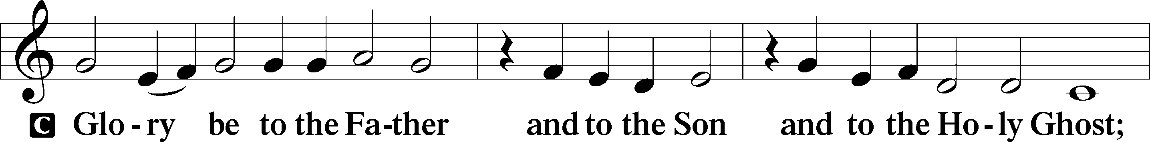
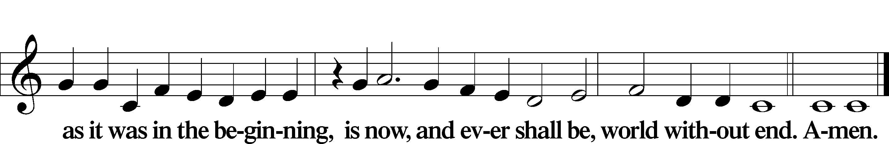

Kyrie Mark 10:47
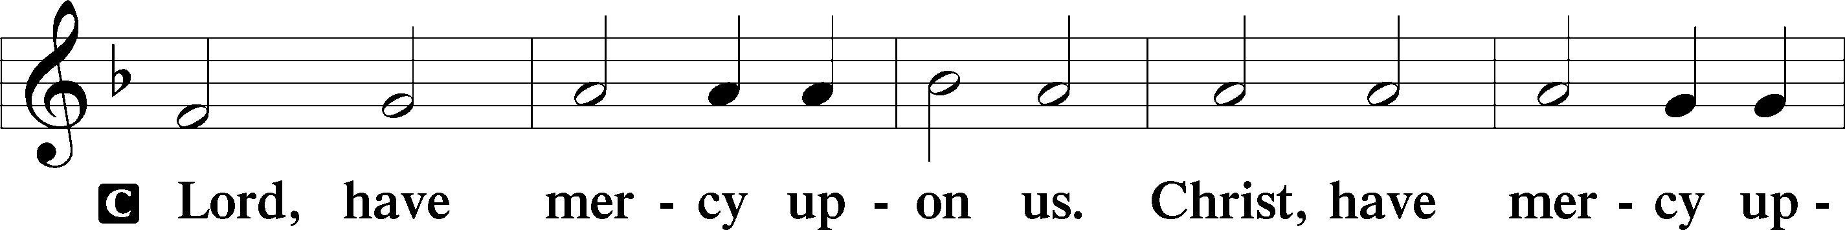
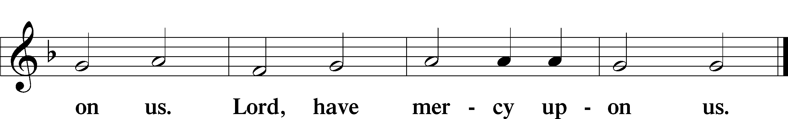

Gloria in Excelsis Luke 2:14; John 1:29
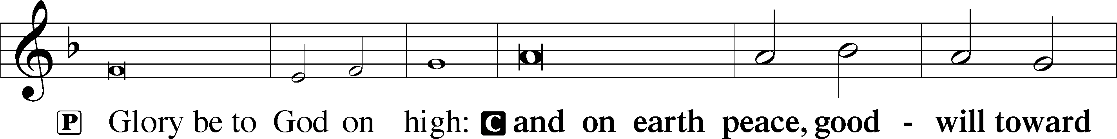
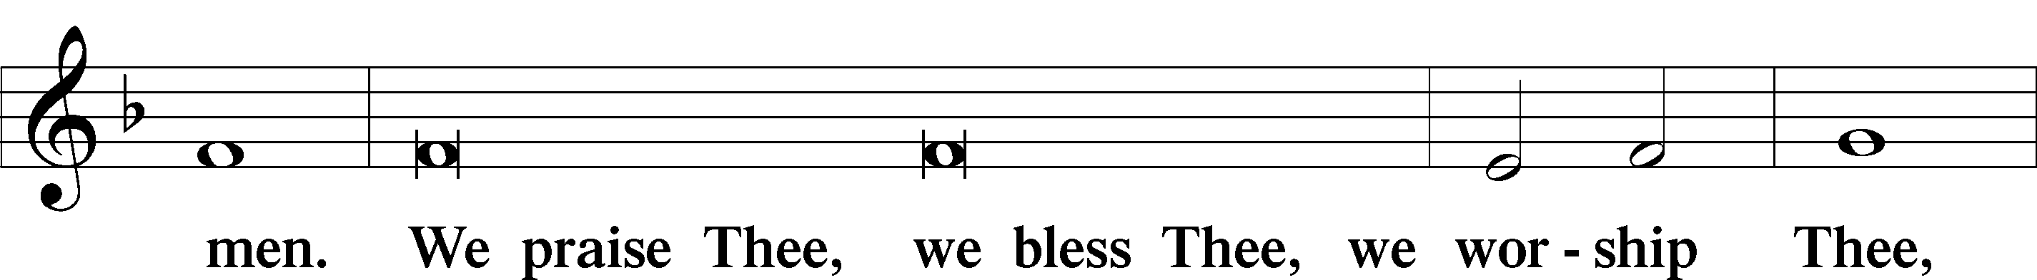
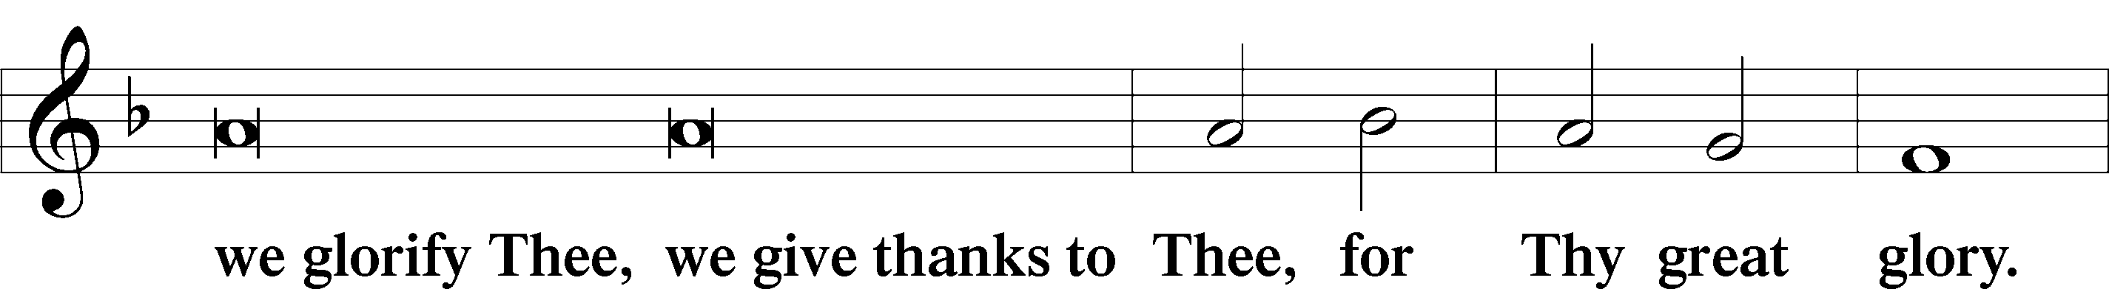
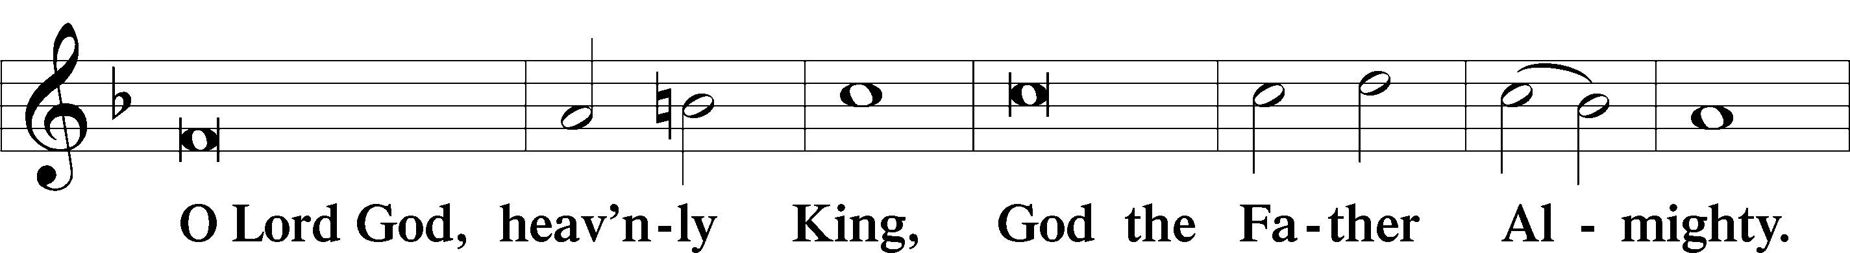
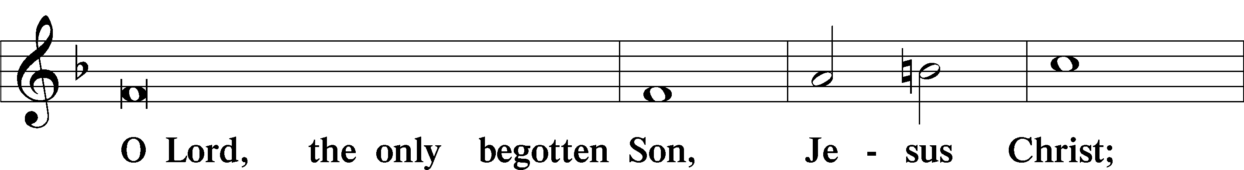
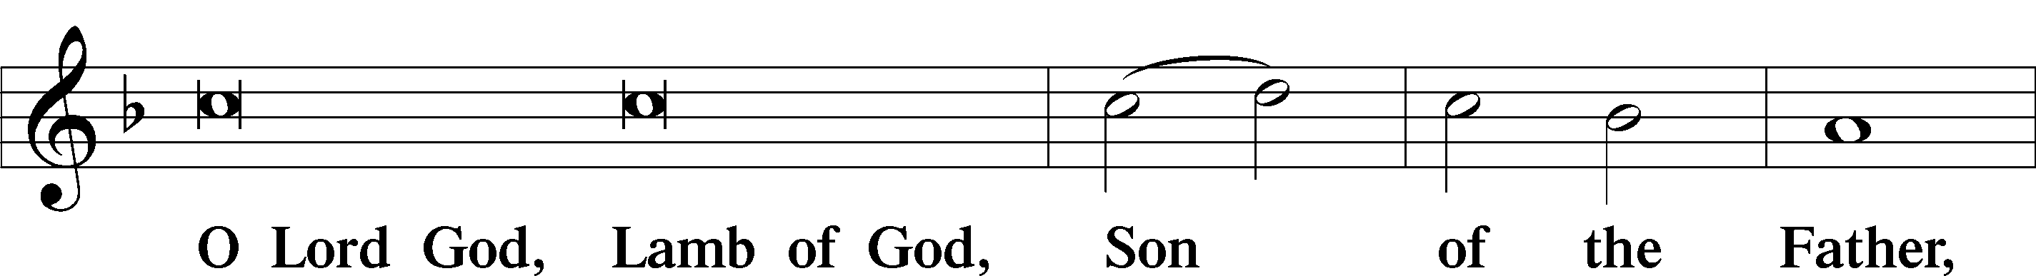
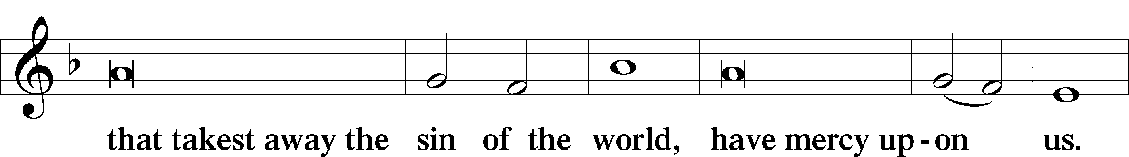
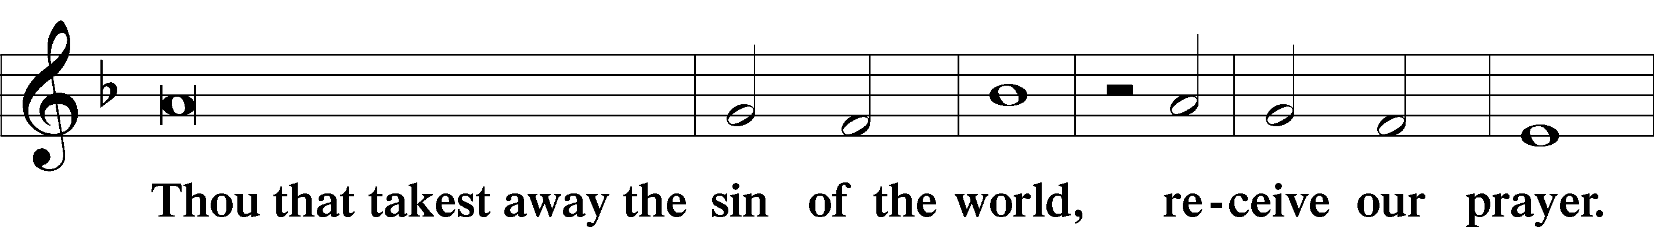
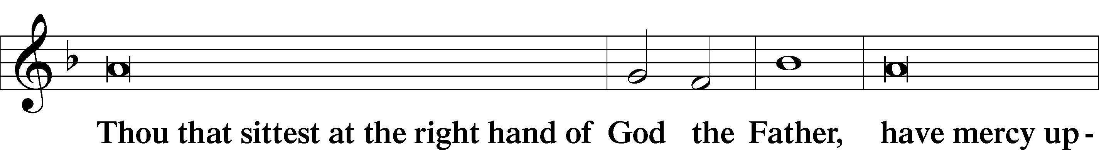
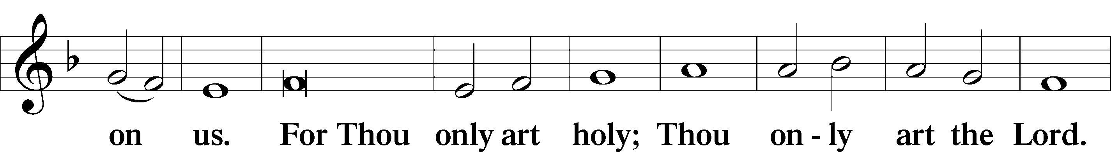
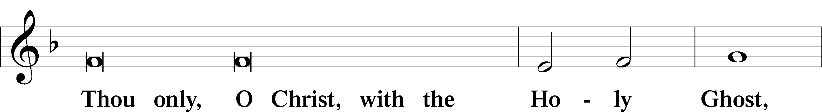
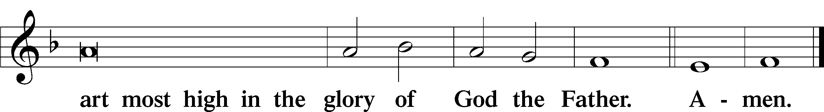

Salutation and Collect of the Day
P The Lord be with you.
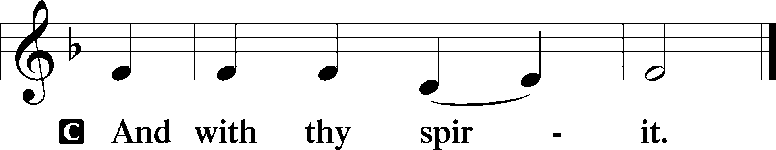

P Let us pray.
O God, through the humiliation of Your Son You raised up the fallen world. Grant to Your faithful people, rescued from the peril of everlasting death, perpetual gladness and eternal joys; through Jesus Christ, our Lord, who lives and reigns with You and the Holy Spirit, one God, now and forever.

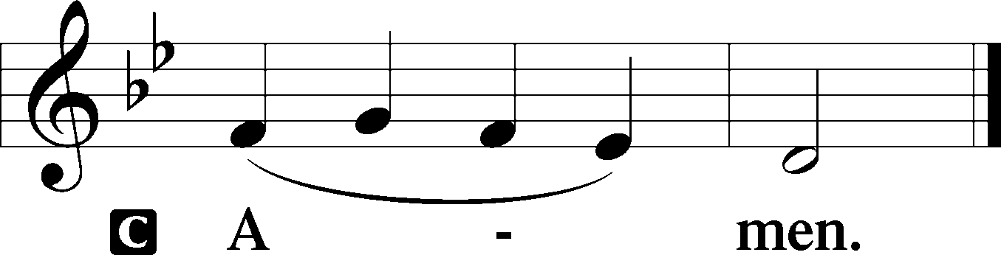

Sit

Old Testament Acts 2:14a, 36–41
14Peter, standing with the eleven, lifted up his voice and addressed them, . . .
36Let all the house of Israel therefore know for certain that God has made him both Lord and Christ, this Jesus whom you crucified.”
37Now when they heard this they were cut to the heart, and said to Peter and the rest of the apostles, “Brothers, what shall we do?” 38And Peter said to them, “Repent and be baptized every one of you in the name of Jesus Christ for the forgiveness of your sins, and you will receive the gift of the Holy Spirit. 39For the promise is for you and for your children and for all who are far off, everyone whom the Lord our God calls to himself.” 40And with many other words he bore witness and continued to exhort them, saying, “Save yourselves from this crooked generation.” 41So those who received his word were baptized, and there were added that day about three thousand souls.

A This is the Word of the Lord.
C Thanks be to God.

Gradual adapt. from Matthew 28:7; Hebrews 2:7; Psalm 8:6
Christ has risen from the dead.
[God the Father] has crowned him with glory and honor.
He has given him dominion over the works of his hands;
he has put all things under his feet.

Epistle 1 Peter 1:17–25
17If you call on him as Father who judges impartially according to each one’s deeds, conduct yourselves with fear throughout the time of your exile, 18knowing that you were ransomed from the futile ways inherited from your forefathers, not with perishable things such as silver or gold, 19but with the precious blood of Christ, like that of a lamb without blemish or spot. 20He was foreknown before the foundation of the world but was made manifest in the last times for your sake, 21who through him are believers in God, who raised him from the dead and gave him glory, so that your faith and hope are in God.
22Having purified your souls by your obedience to the truth for a sincere brotherly love, love one another earnestly from a pure heart, 23since you have been born again, not of perishable seed but of imperishable, through the living and abiding word of God; 24for
“All flesh is like grass
and all its glory like the flower of grass.
The grass withers,
and the flower falls,
25but the word of the Lord remains forever.”
And this word is the good news that was preached to you.

A This is the Word of the Lord.
C Thanks be to God.

Stand

Alleluia
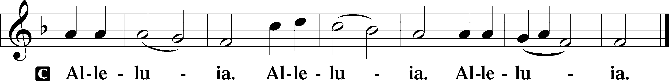

Holy Gospel Luke 24:13–35
P The Holy Gospel according to St. Luke, the twenty-fourth chapter.

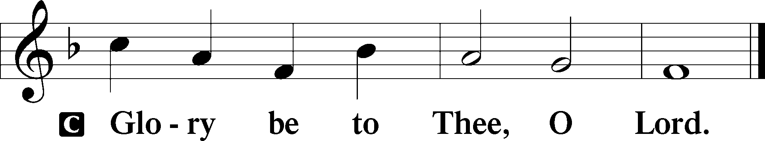

13That very day two of them were going to a village named Emmaus, about seven miles from Jerusalem, 14and they were talking with each other about all these things that had happened. 15While they were talking and discussing together, Jesus himself drew near and went with them. 16But their eyes were kept from recognizing him. 17And he said to them, “What is this conversation that you are holding with each other as you walk?” And they stood still, looking sad. 18Then one of them, named Cleopas, answered him, “Are you the only visitor to Jerusalem who does not know the things that have happened there in these days?” 19And he said to them, “What things?” And they said to him, “Concerning Jesus of Nazareth, a man who was a prophet mighty in deed and word before God and all the people, 20and how our chief priests and rulers delivered him up to be condemned to death, and crucified him. 21But we had hoped that he was the one to redeem Israel. Yes, and besides all this, it is now the third day since these things happened. 22Moreover, some women of our company amazed us. They were at the tomb early in the morning, 23and when they did not find his body, they came back saying that they had even seen a vision of angels, who said that he was alive. 24Some of those who were with us went to the tomb and found it just as the women had said, but him they did not see.” 25And he said to them, “O foolish ones, and slow of heart to believe all that the prophets have spoken! 26Was it not necessary that the Christ should suffer these things and enter into his glory?” 27And beginning with Moses and all the Prophets, he interpreted to them in all the Scriptures the things concerning himself.
28So they drew near to the village to which they were going. He acted as if he were going farther, 29but they urged him strongly, saying, “Stay with us, for it is toward evening and the day is now far spent.” So he went in to stay with them. 30When he was at table with them, he took the bread and blessed and broke it and gave it to them. 31And their eyes were opened, and they recognized him. And he vanished from their sight. 32They said to each other, “Did not our hearts burn within us while he talked to us on the road, while he opened to us the Scriptures?” 33And they rose that same hour and returned to Jerusalem. And they found the eleven and those who were with them gathered together, 34saying, “The Lord has risen indeed, and has appeared to Simon!” 35Then they told what had happened on the road, and how he was known to them in the breaking of the bread.

P This is the Gospel of the Lord.

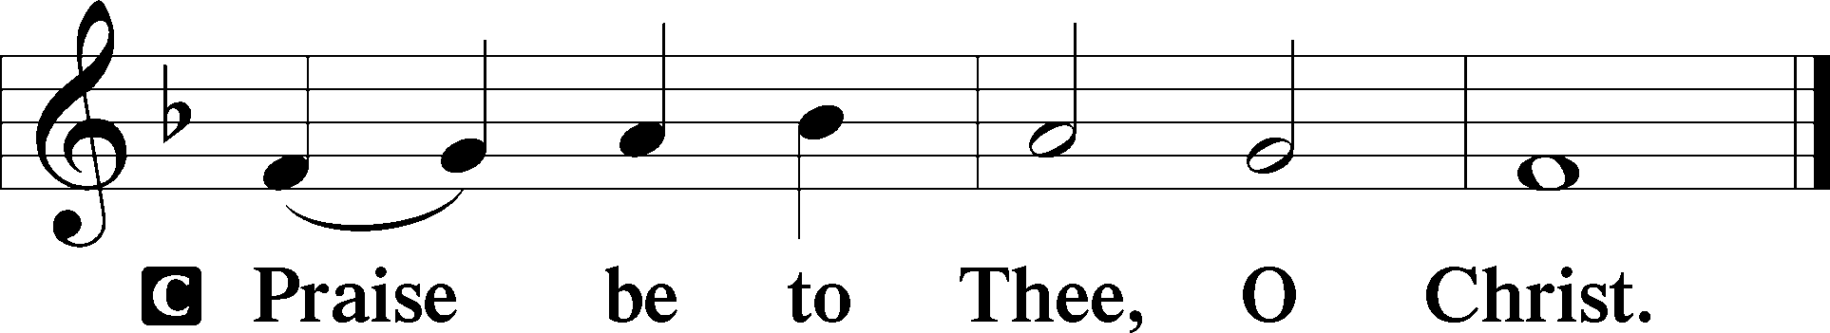

Nicene Creed
C I believe in one God,
the Father Almighty,
maker of heaven and earth
and of all things visible and invisible.

And in one Lord Jesus Christ,
the only-begotten Son of God,
begotten of His Father before all worlds,
God of God, Light of Light,
very God of very God,
begotten, not made,
being of one substance with the Father,
by whom all things were made;
who for us men and for our salvation came down from heaven
and was incarnate by the Holy Spirit of the virgin Mary
and was made man;
and was crucified also for us under Pontius Pilate.
He suffered and was buried.
And the third day He rose again according to the Scriptures
and ascended into heaven
and sits at the right hand of the Father.
And He will come again with glory to judge both the living and the dead,
whose kingdom will have no end.

And I believe in the Holy Spirit,
the Lord and giver of life,
who proceeds from the Father and the Son,
who with the Father and the Son together is worshiped and glorified,
who spoke by the prophets.
And I believe in one holy Christian and apostolic Church,
I acknowledge one Baptism for the remission of sins,
and I look for the resurrection of the dead
and the life T of the world to come. Amen.

Sit

Children's Sermon

655 Lord, Keep Us Steadfast in Your Word
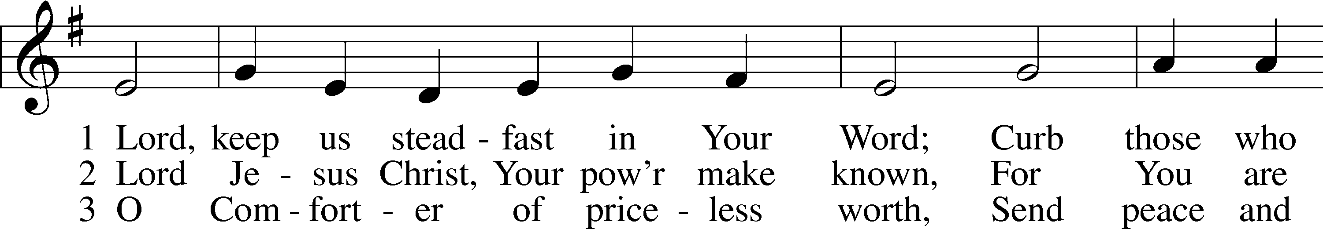
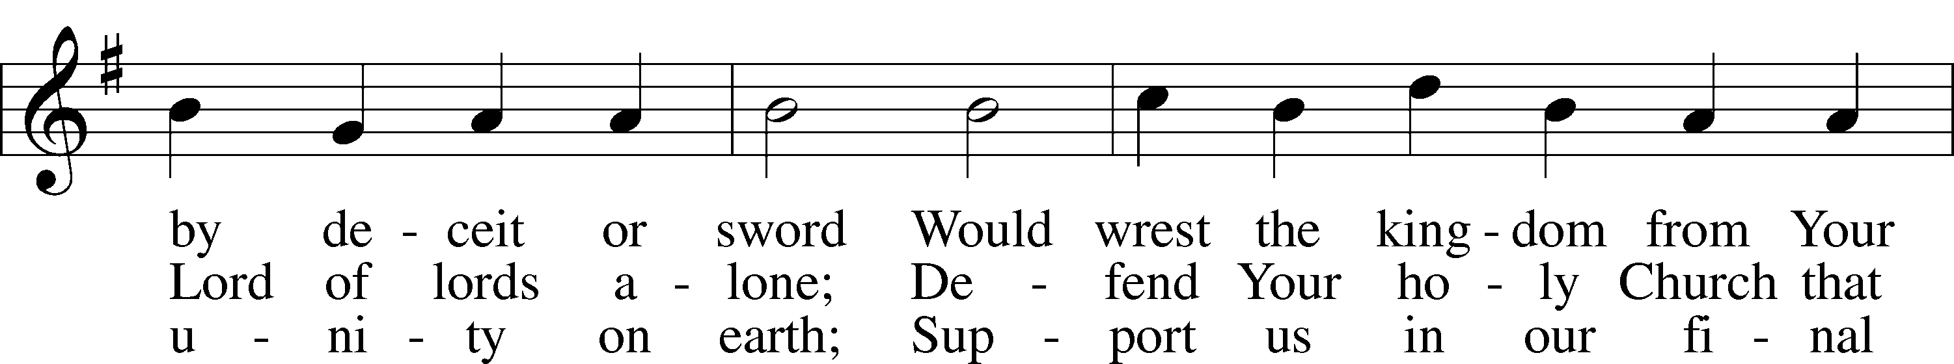
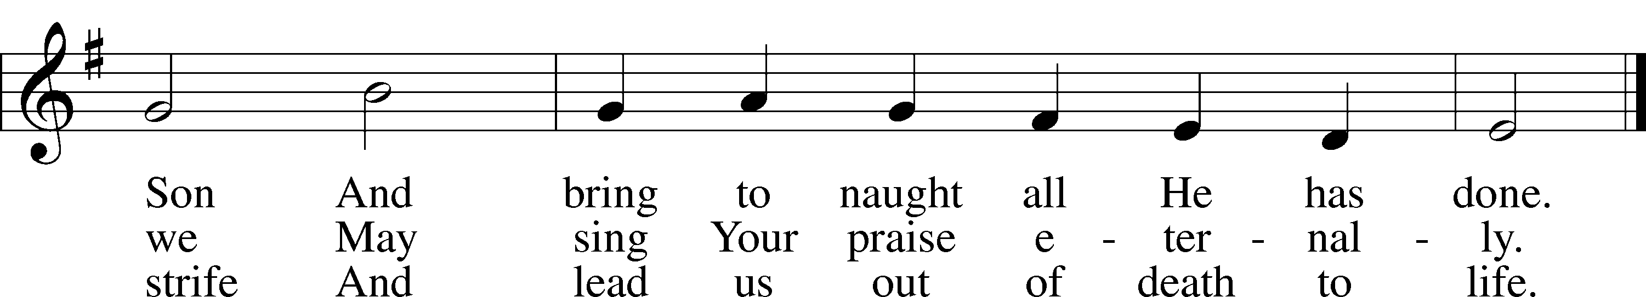
Text: Martin Luther, 1483–1546; tr. Catherine Winkworth, 1827–78, alt.
Tune: Geistliche Lieder auffs new gebessert, 1543, Wittenberg, ed. Joseph Klug
Text and tune: Public domain

Sermon

Votum
P The peace of God, which passes all understanding, keep your hearts and minds in Christ Jesus.
C Amen.

Stand

Offertory Psalm 51:10–12
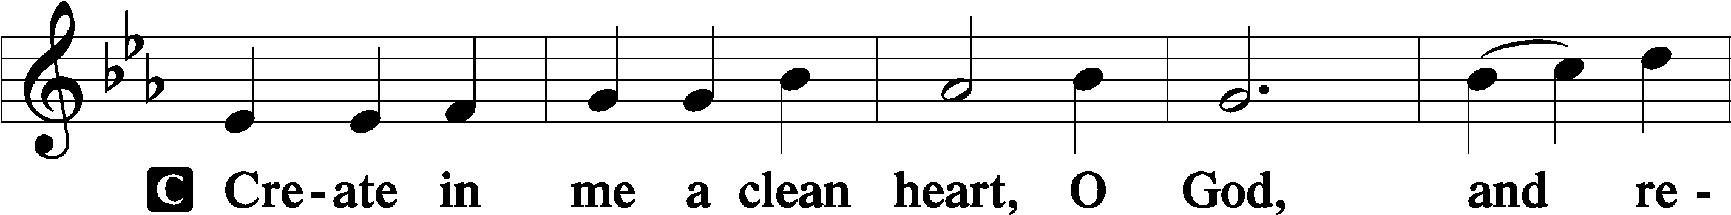
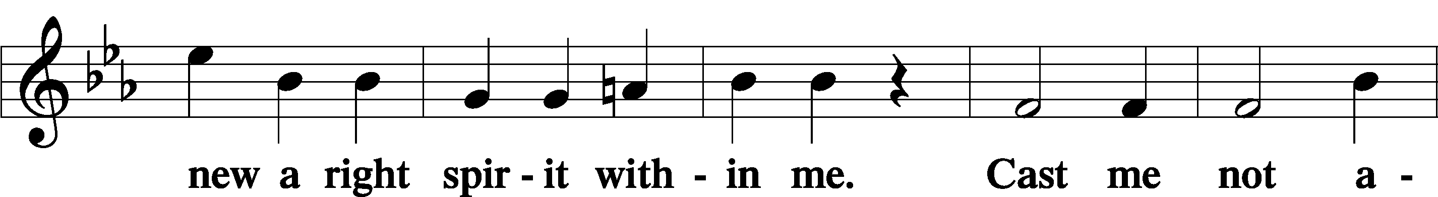
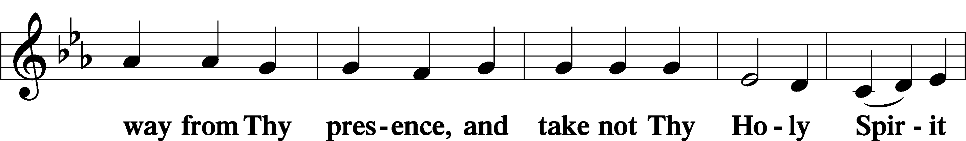
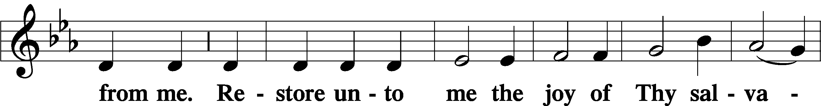
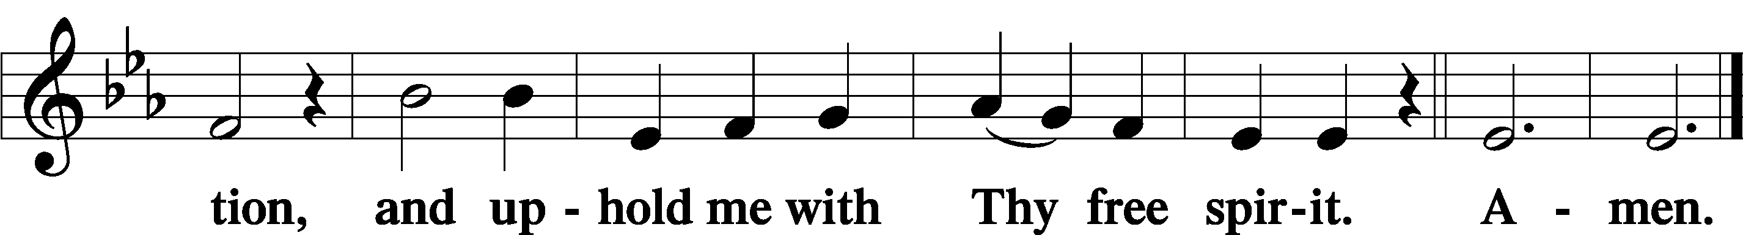

Sit

Offering

Hymn
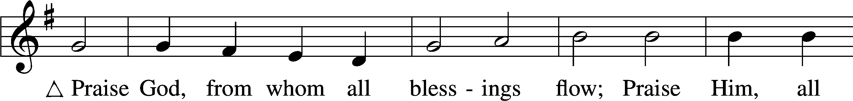
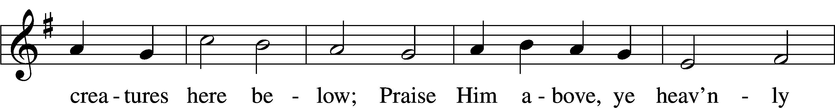
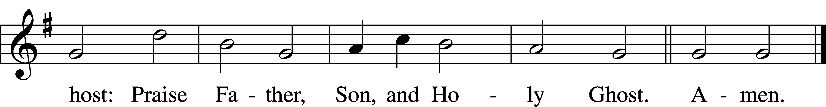
Text: Thomas Ken, 1637–1711
Tune: Trente quatre Pseaumes de David, 1551, Geneva, ed. Louis Bourgeois
Text and tune: Public domain

Stand

Prayer of the Church

Service of the Sacrament

Preface 2 Timothy 4:22; [Colossians 3:1]; [Psalm 136]
P The Lord be with you.
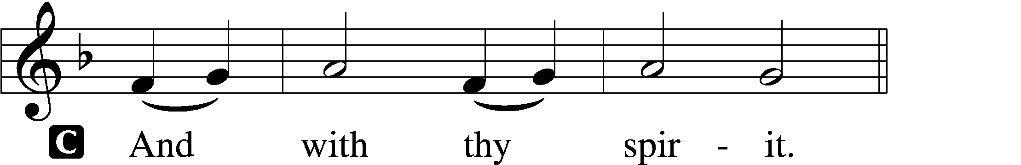

P Lift up your hearts.
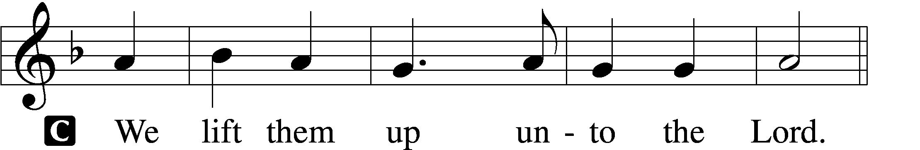

P Let us give thanks unto the Lord, our God.
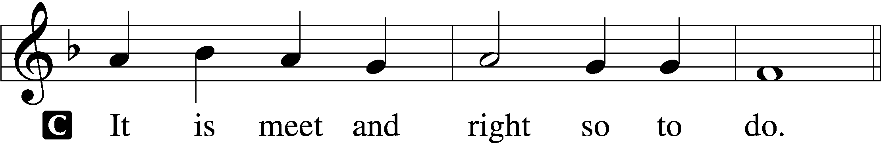

Proper Preface (Full)
P It is truly meet, right, and salutary that we should at all times and in all places give thanks to You, holy Lord, almighty Father, everlasting God. And most especially are we bound to praise You on this day for the glorious resurrection of Your Son, Jesus Christ, the very Paschal Lamb, who was sacrificed for us and bore the sins of the world. By His dying He has destroyed death, and by His rising again He has restored to us everlasting life. Therefore with Mary Magdalene, Peter and John, and with all the witnesses of the resurrection, with angels and archangels, and with all the company of heaven we laud and magnify Your glorious name, evermore praising You and saying:

Sanctus Isaiah 6:3; Matthew 21:9
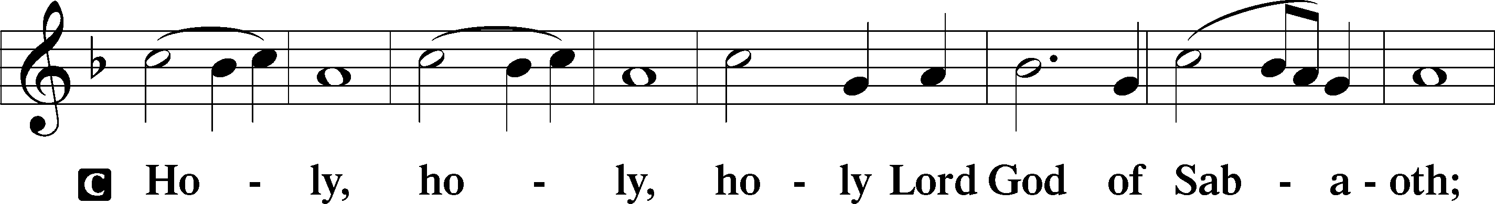
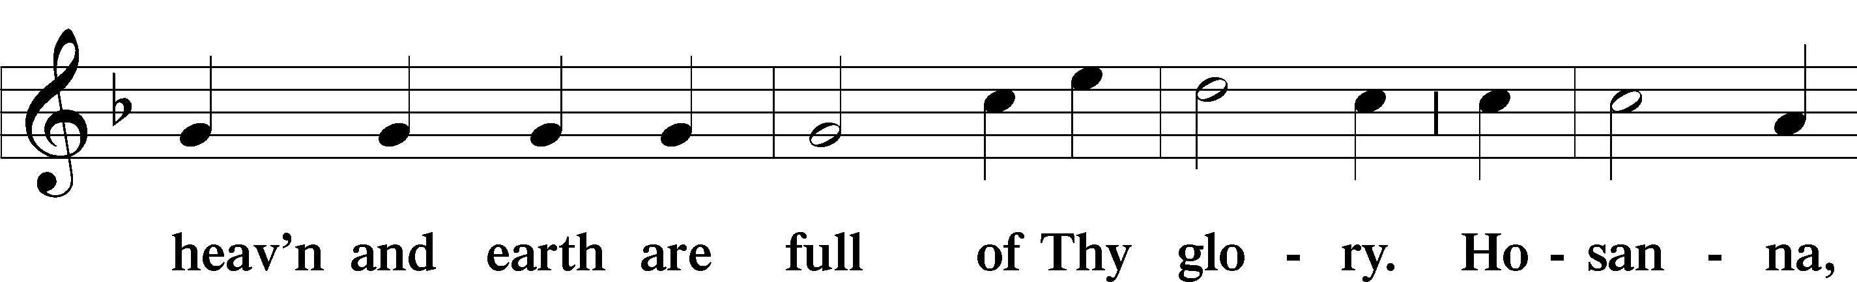
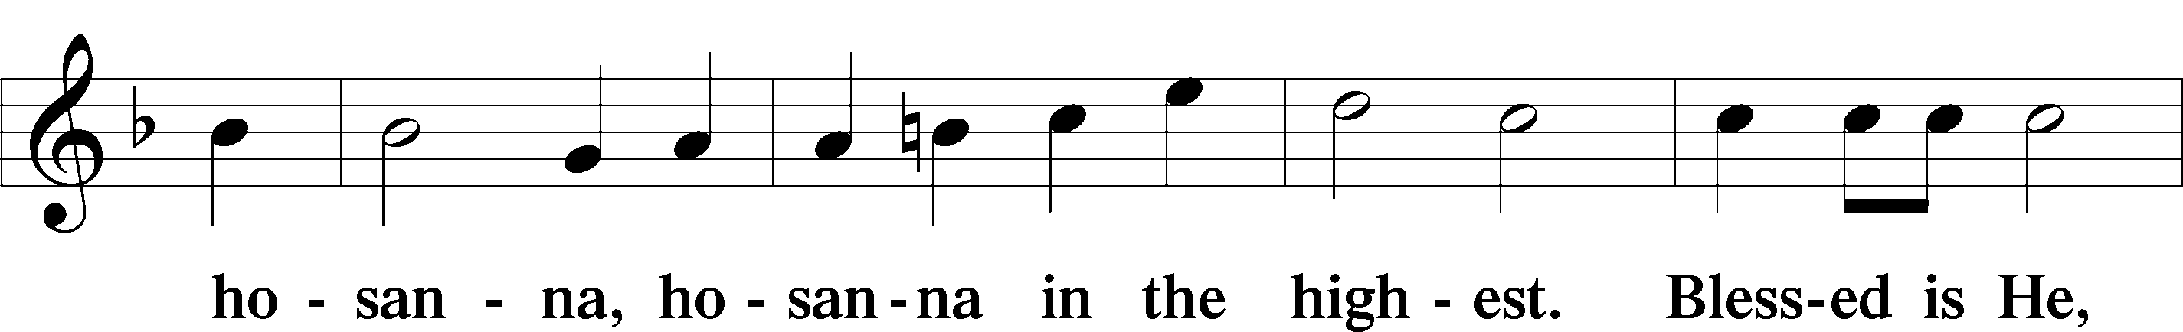
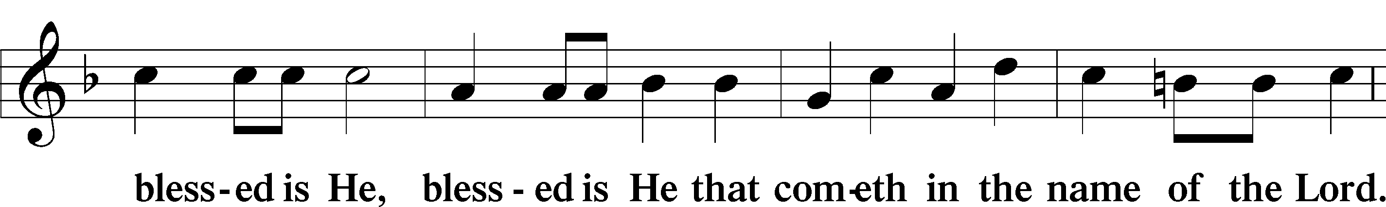
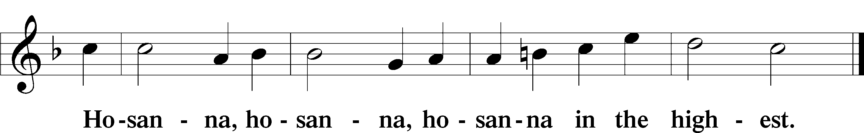

Lord’s Prayer Matthew 6:9–13
P Our Father who art in heaven,
hallowed be Thy name,
Thy kingdom come,
Thy will be done on earth as it is in heaven;
give us this day our daily bread;
and forgive us our trespasses as we forgive those who trespass against us;
and lead us not into temptation,
but deliver us from evil.
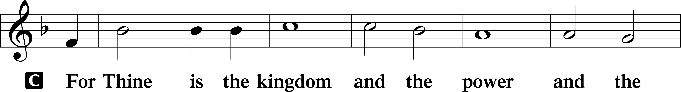
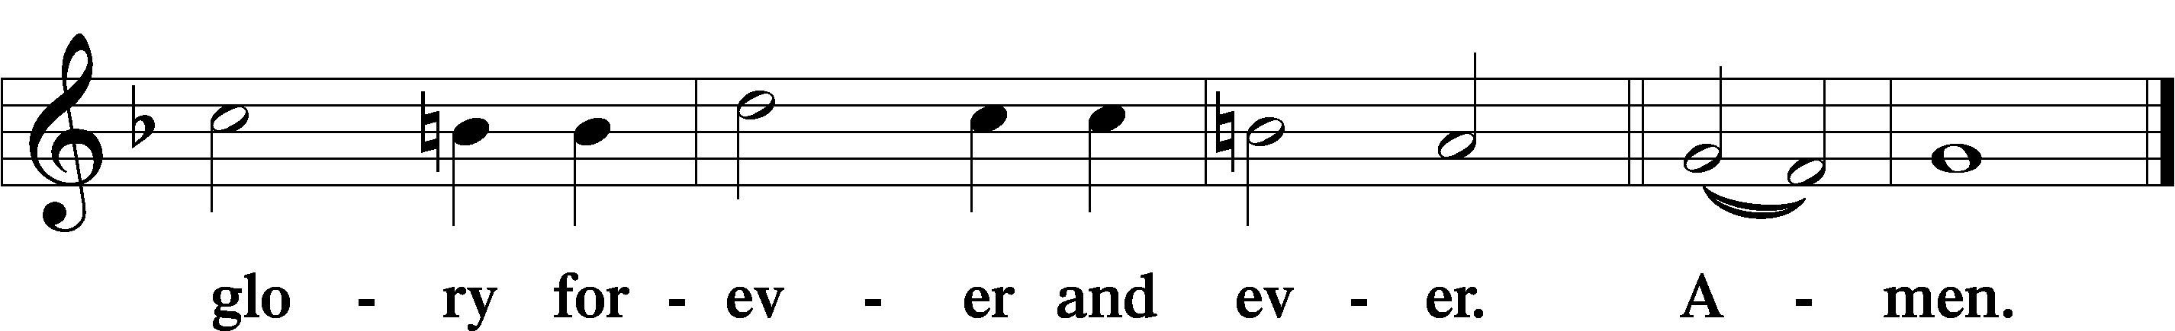

The Words of Our Lord Matthew 26:26–28; Mark 14:22–24; Luke 22:19–20; 1 Corinthians 11:23–25
P Our Lord Jesus Christ, on the night when He was betrayed, took bread, and when He had given thanks, He broke it and gave it to the disciples and said: “Take, eat; this is My T body, which is given for you. This do in remembrance of Me.”

In the same way also He took the cup after supper, and when He had given thanks, He gave it to them, saying: “Drink of it, all of you; this cup is the new testament in My T blood, which is shed for you for the forgiveness of sins. This do, as often as you drink it, in remembrance of Me.”

Pax Domini John 20:19
P The peace of the Lord be with you always.

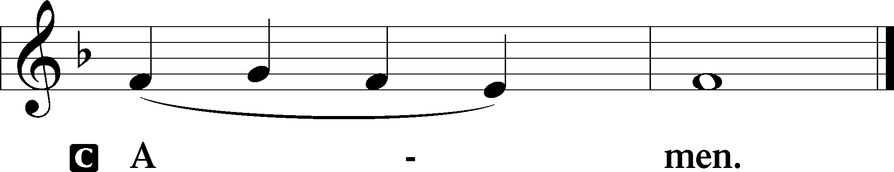

Agnus Dei John 1:29
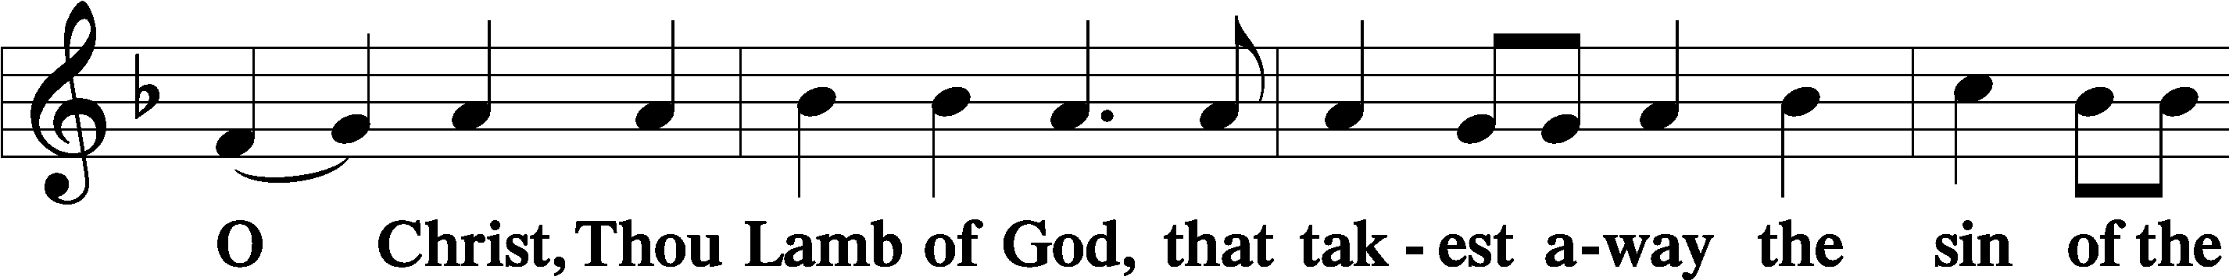
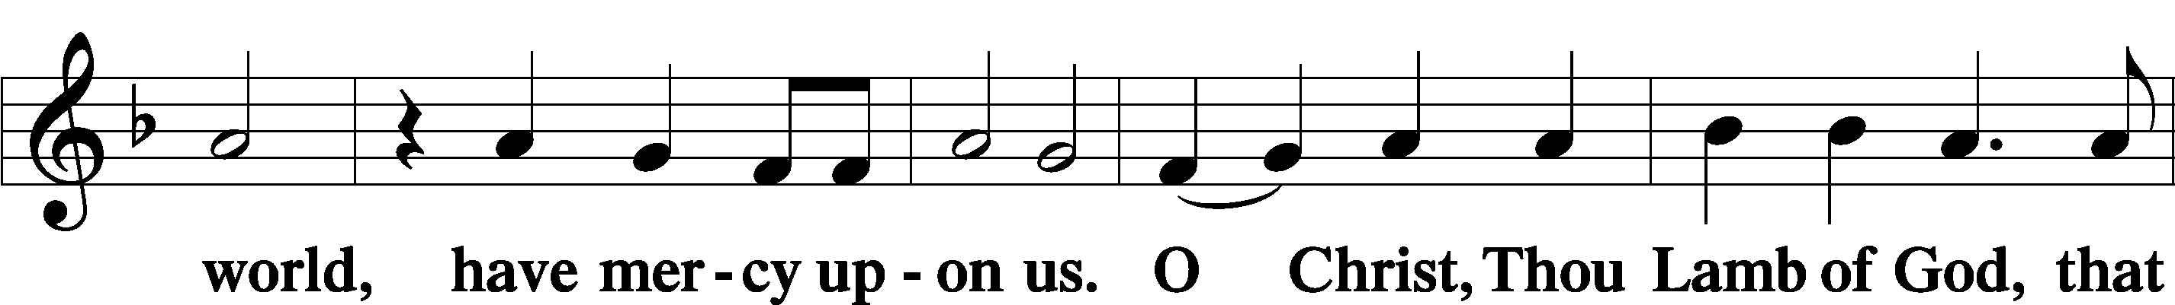
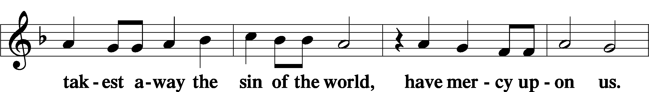
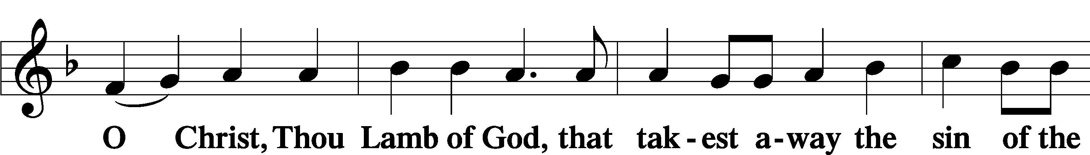
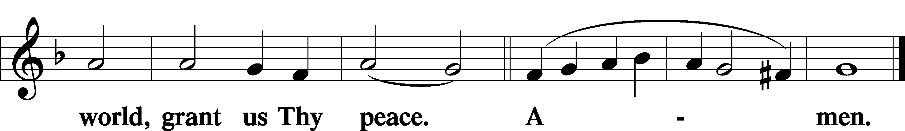

Sit

Distribution

The pastor and those who assist him receive the body and blood of Christ first and then distribute them to those who come to receive, saying:

Take, eat; this is the true body of our Lord and Savior Jesus Christ, given into death for your sins.
Amen.

Take, drink; this is the true blood of our Lord and Savior Jesus Christ, shed for the forgiveness of your sins.
Amen.

In dismissing the communicants, the following is said:

The Dismissal
P The body and blood of our Lord Jesus Christ strengthen and preserve you in body and soul to life everlasting. Depart T in peace.
C Amen.

633 At the Lamb’s High Feast We Sing
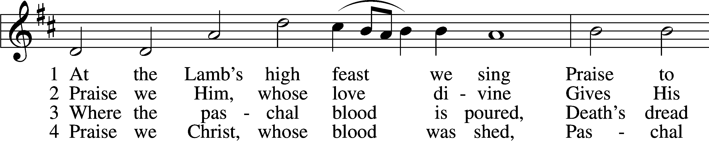
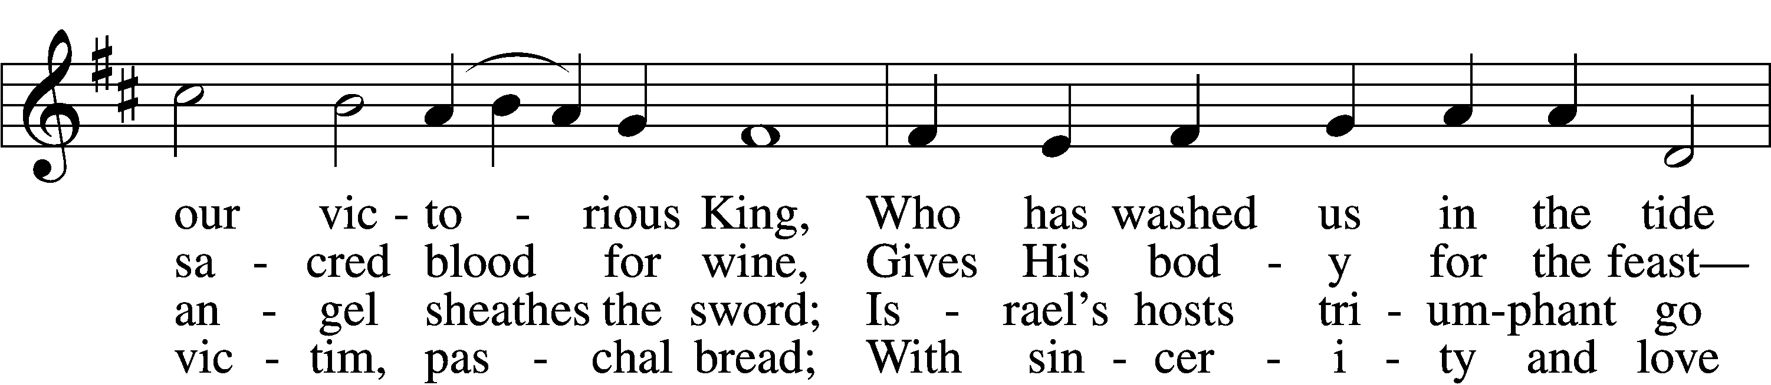
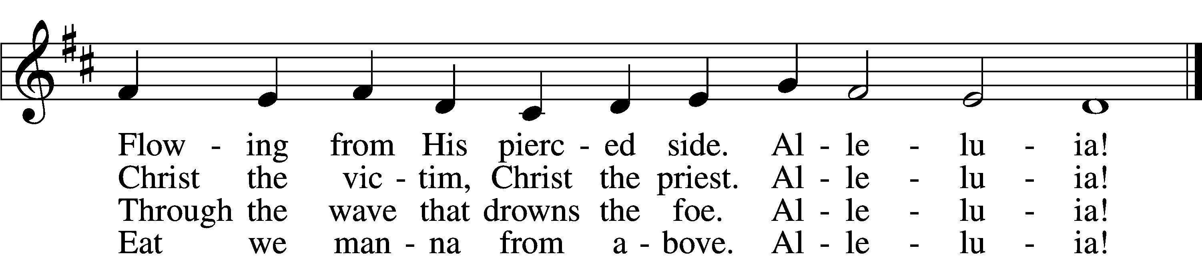

5 Mighty Victim from the sky,
Hell’s fierce pow’rs beneath You lie;
You have conquered in the fight,
You have brought us life and light.
Alleluia!

6 Now no more can death appall,
Now no more the grave enthrall;
You have opened paradise,
And Your saints in You shall rise.
Alleluia!

7 Easter triumph, Easter joy!
This alone can sin destroy;
From sin’s pow’r, Lord, set us free,
Newborn souls in You to be.
Alleluia!

D 8 Father, who the crown shall give,
Savior, by whose death we live,
Spirit, guide through all our days:
Three in One, Your name we praise.
Alleluia!
Text: Latin, c. 5th–10th cent.; tr. Robert Campbell, 1814–68, alt.
Tune: Kirchengeseng, 1566, Ivancice
Text and tune: Public domain

578 Thy Strong Word
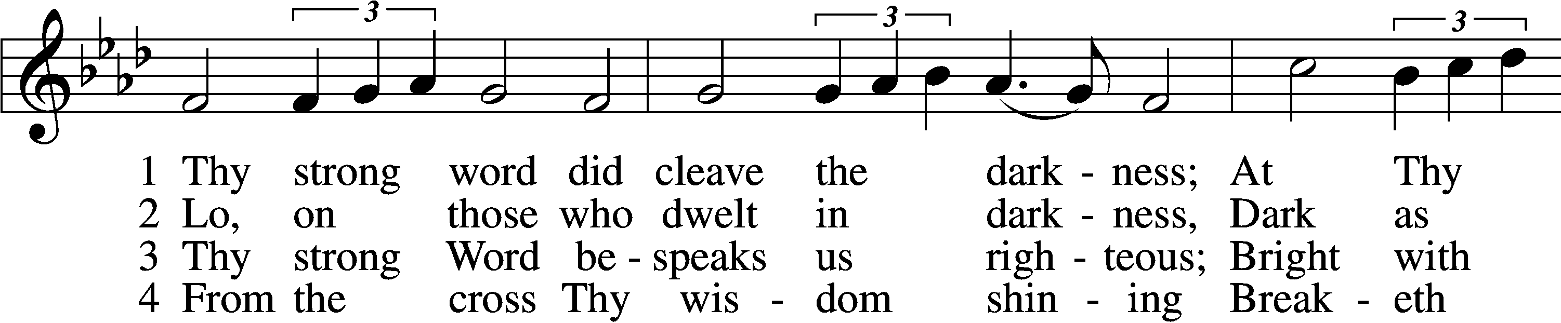
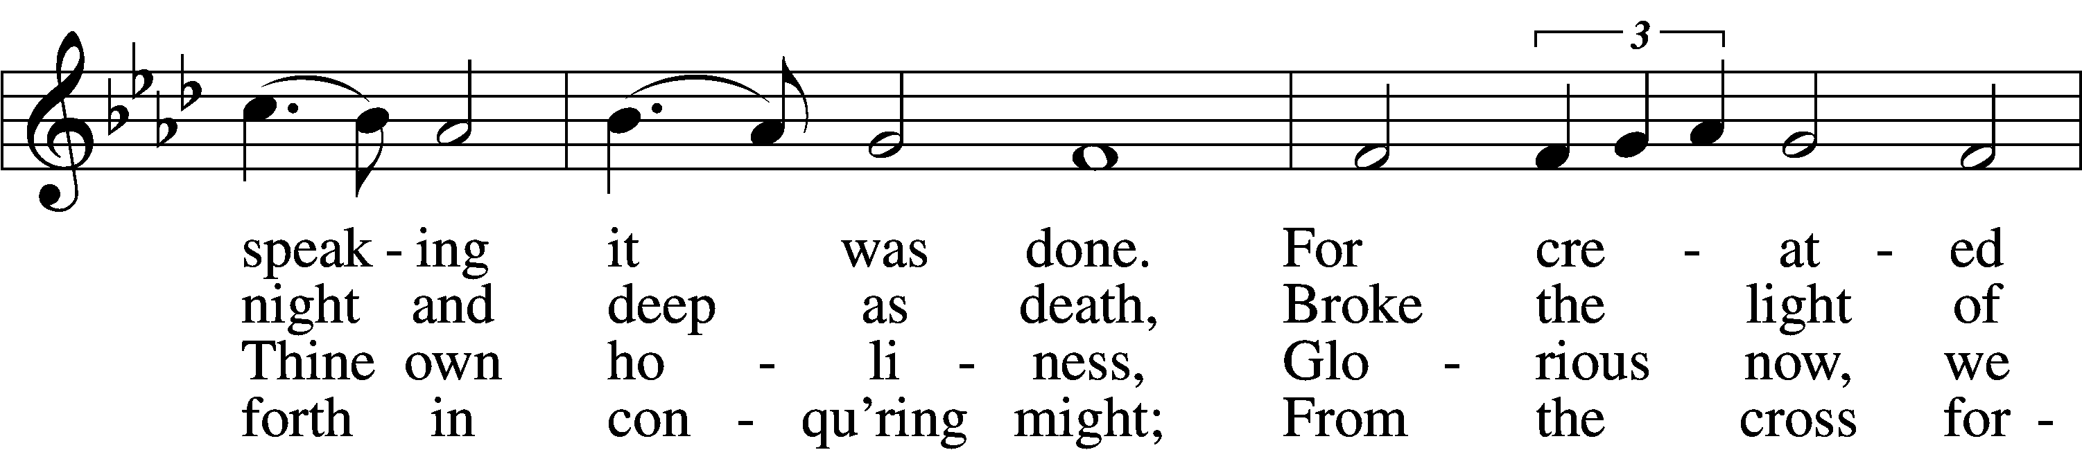
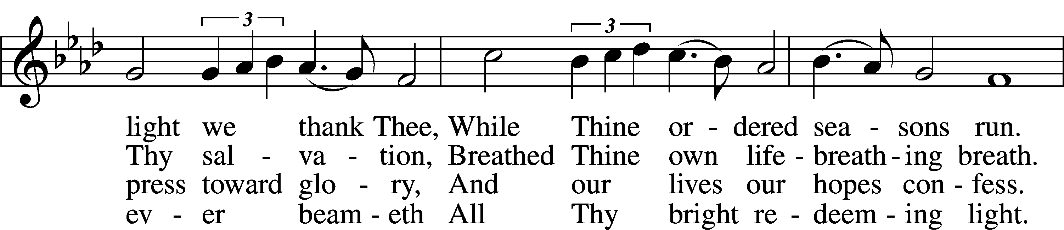
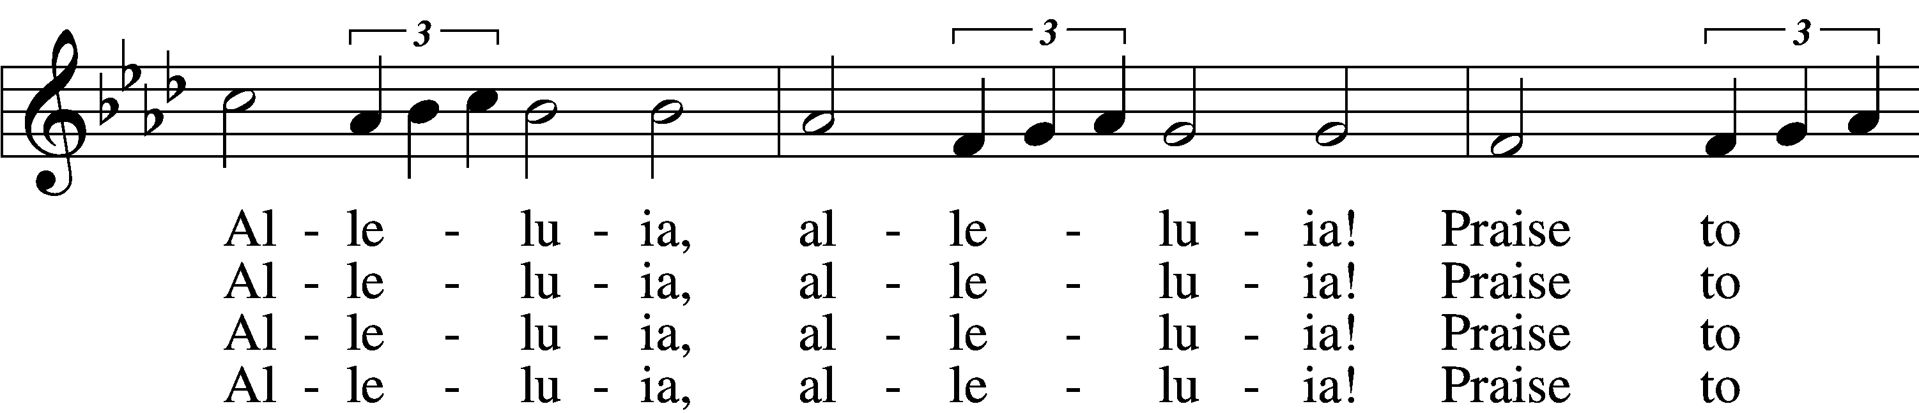
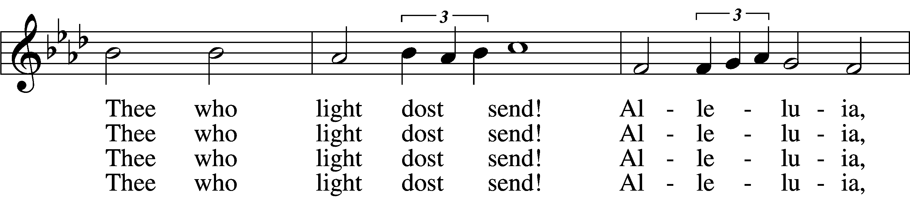
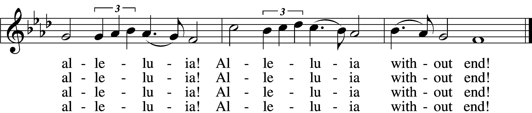

5 Give us lips to sing Thy glory,
Tongues Thy mercy to proclaim,
Throats that shout the hope that fills us,
Mouths to speak Thy holy name.
Alleluia, alleluia!
May the light which Thou dost send
Fill our songs with alleluias,
Alleluias without end!

D 6 God the Father, light-creator,
To Thee laud and honor be.
To Thee, Light of Light begotten,
Praise be sung eternally.
Holy Spirit, light-revealer,
Glory, glory be to Thee.
Mortals, angels, now and ever
Praise the holy Trinity!
Text: Martin H. Franzmann, 1907–76
Tune: Thomas J. Williams, 1869–1944
Text: © 1969 Concordia Publishing House. Used by permission: LSB Hymn License no. 110005011
Tune: Public domain

563 Jesus, Thy Blood and Righteousness
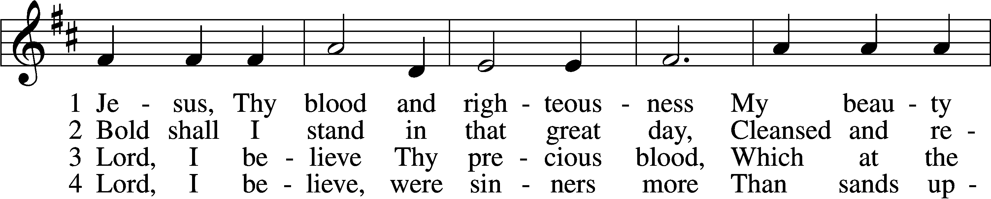
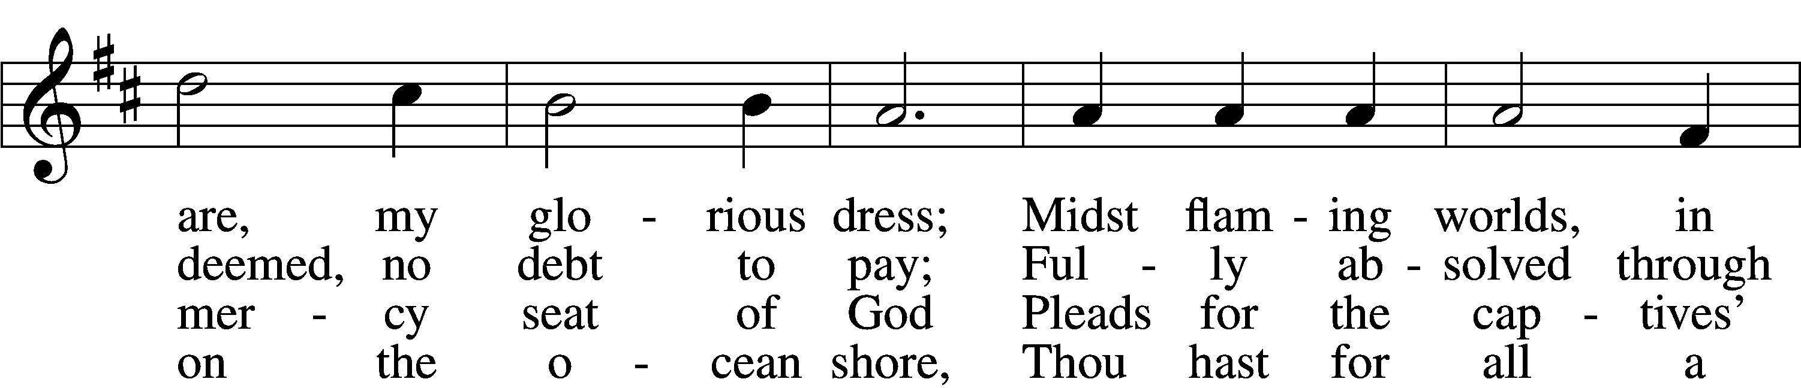
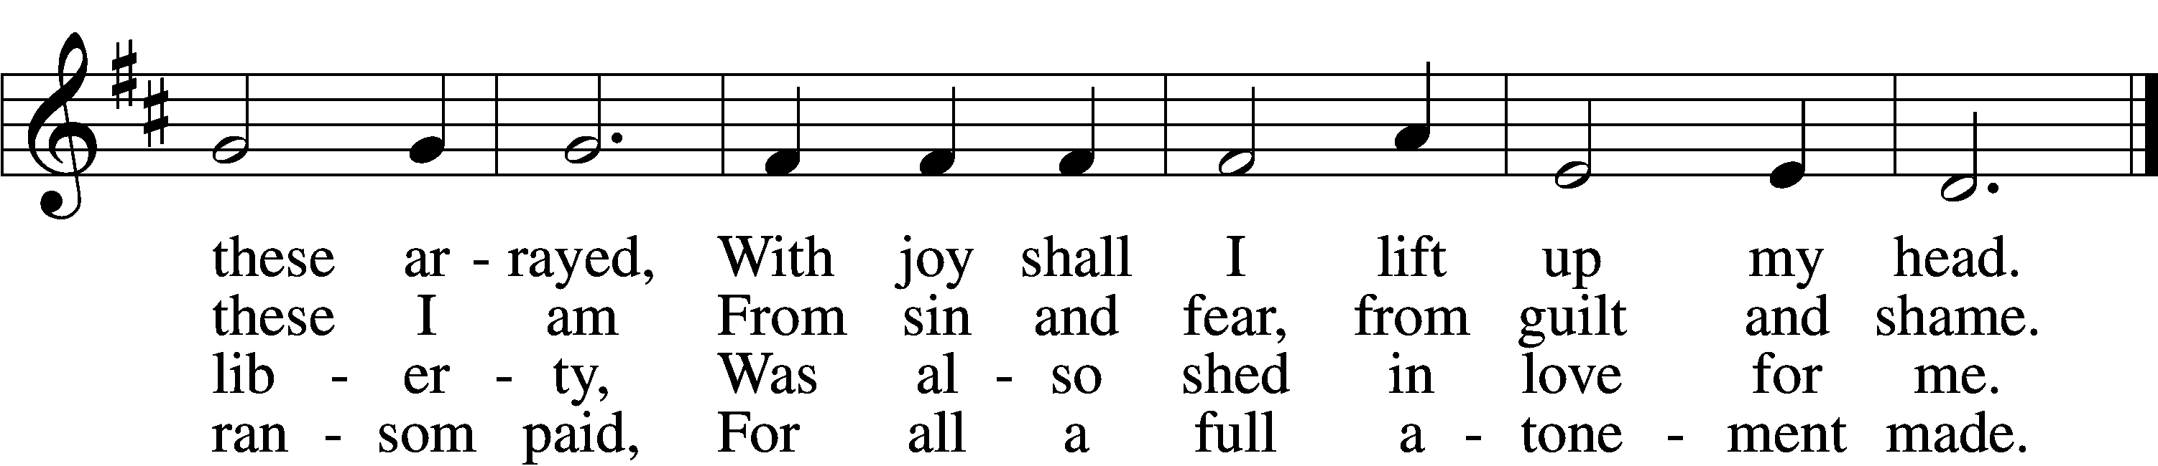

5 When from the dust of death I rise
To claim my mansion in the skies,
This then shall be my only plea:
Jesus hath lived and died for me.

6 Jesus, be endless praise to Thee,
Whose boundless mercy hath for me,
For me, and all Thy hands have made,
An everlasting ransom paid.
Text: Nicolaus Ludwig von Zinzendorf, 1700–60; tr. John B. Wesley, 1703–91, alt.
Tune: George J. Elvey, 1816–93
Text and tune: Public domain

550 Lamb of God
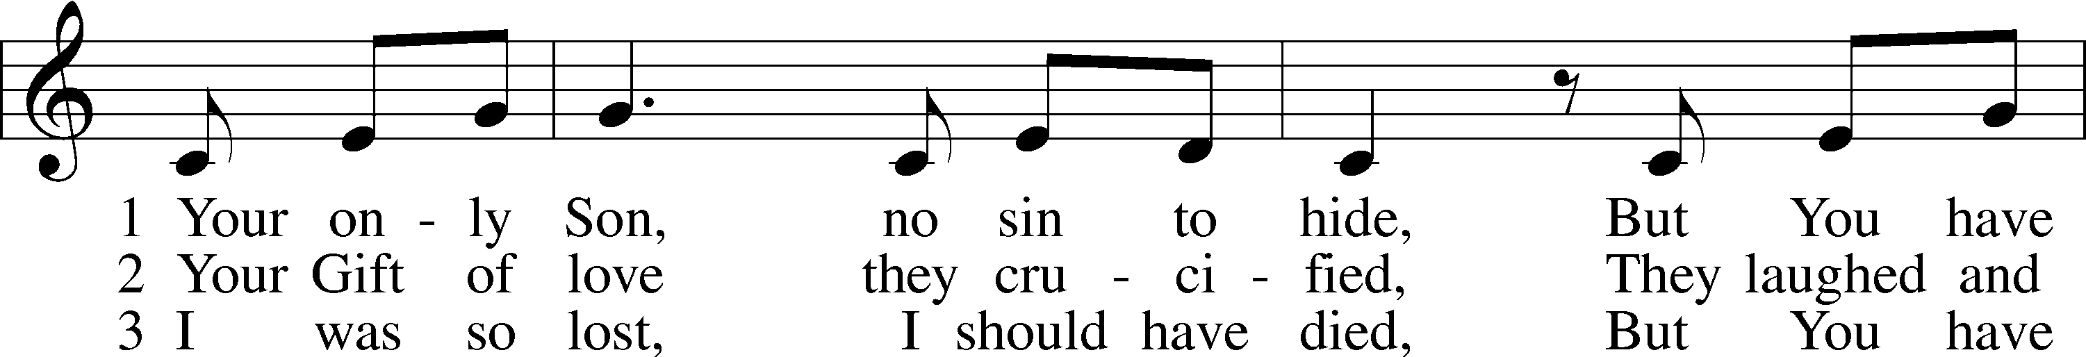
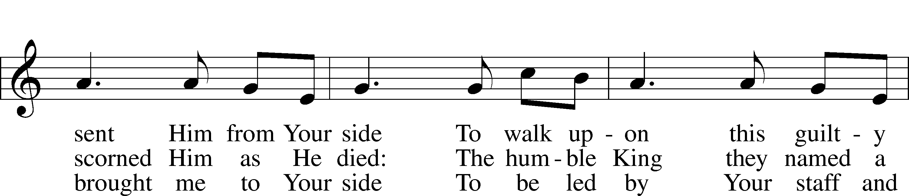
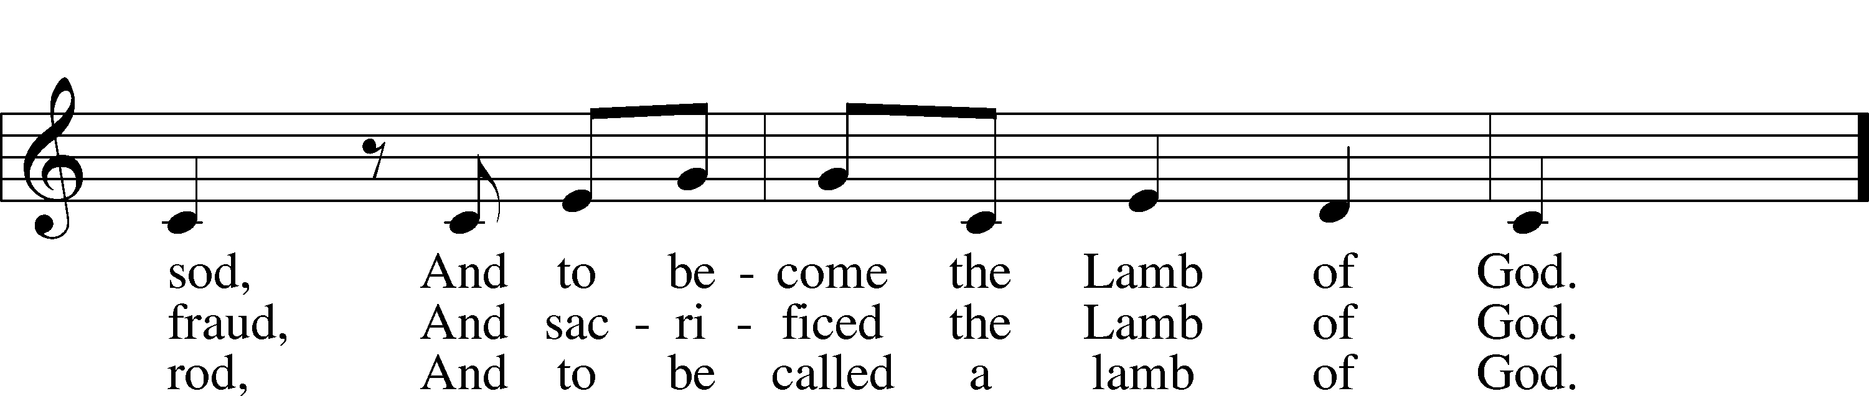
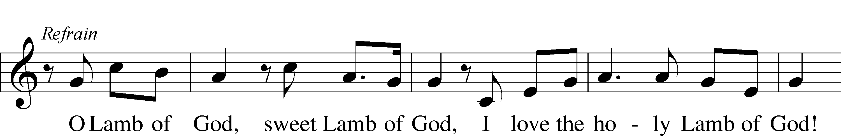
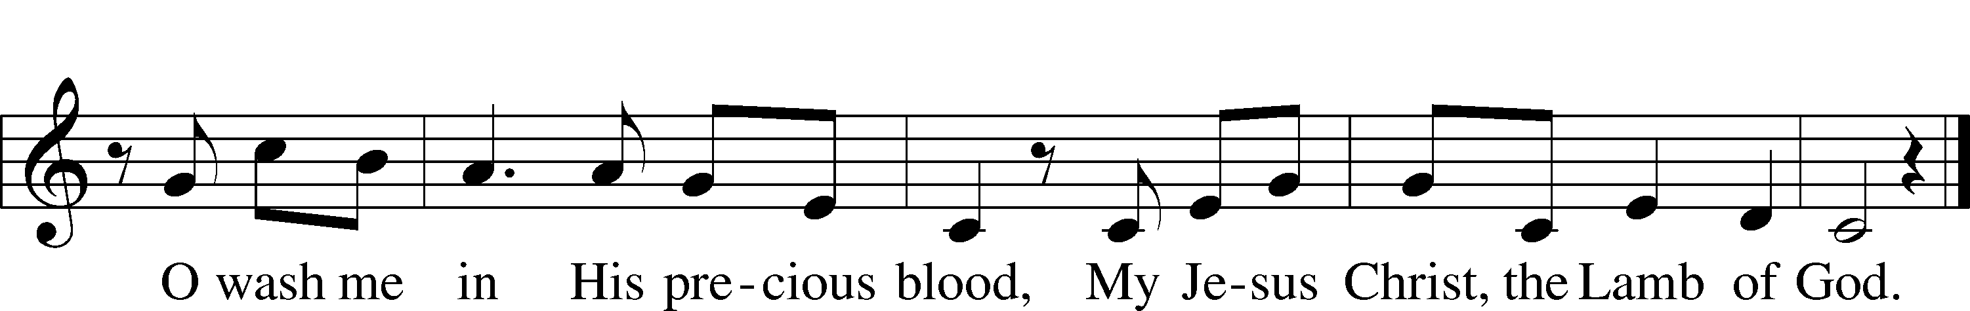
Text and tune: Twila Paris, 1958
Text and tune: © 1985 Straightway Music, admin. EMI. Used by permission: LSB Hymn License no. 110005011

Stand

Nunc Dimittis Luke 2:29–32
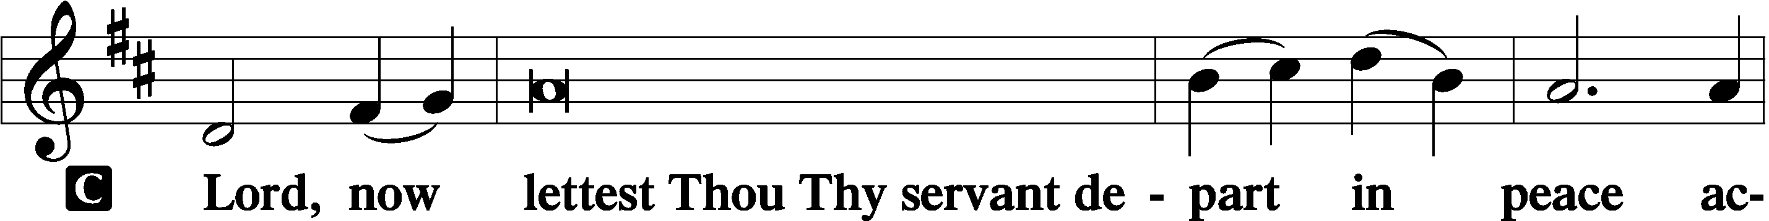

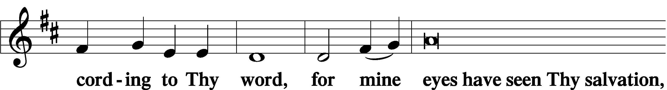

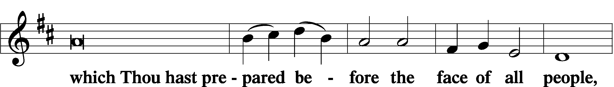

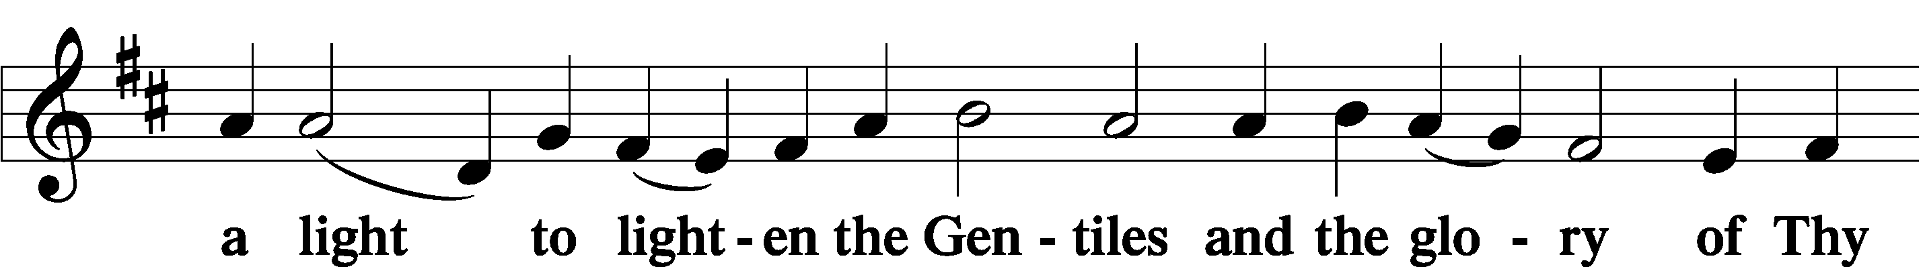

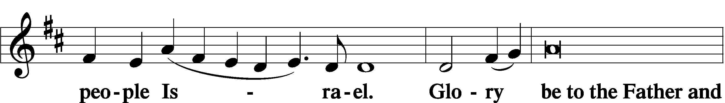

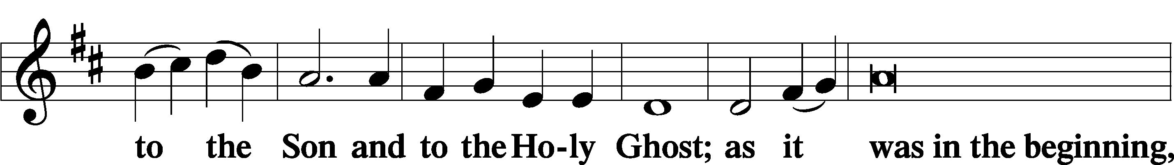

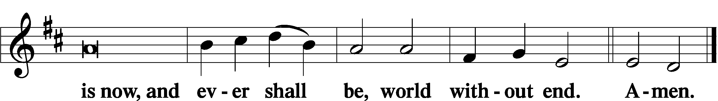

Thanksgiving Psalm 107:1
A O give thanks unto the Lord, for He is good,

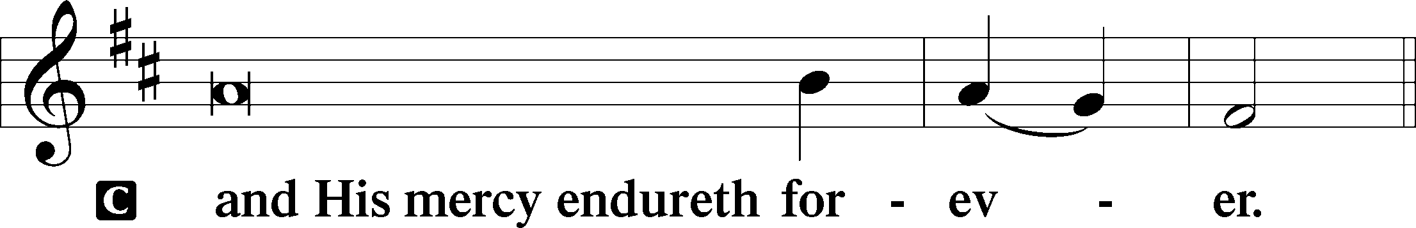

Post-Communion Collect
A Let us pray.
We give thanks to You, almighty God, that You have refreshed us through this salutary gift, and we implore You that of Your mercy You would strengthen us through the same in faith toward You and in fervent love toward one another; through Jesus Christ, Your Son, our Lord, who lives and reigns with You and the Holy Spirit, one God, now and forever.

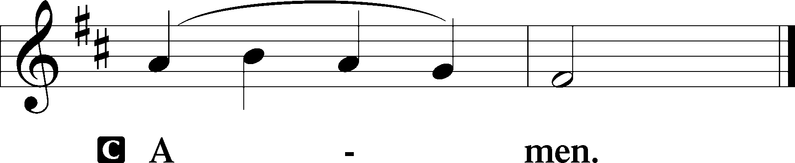

Salutation 2 Timothy 4:22
P The Lord be with you.

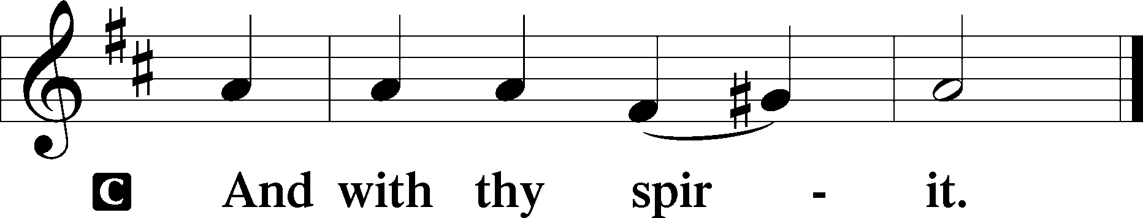

Benedicamus Psalm 103:1
A Bless we the Lord.

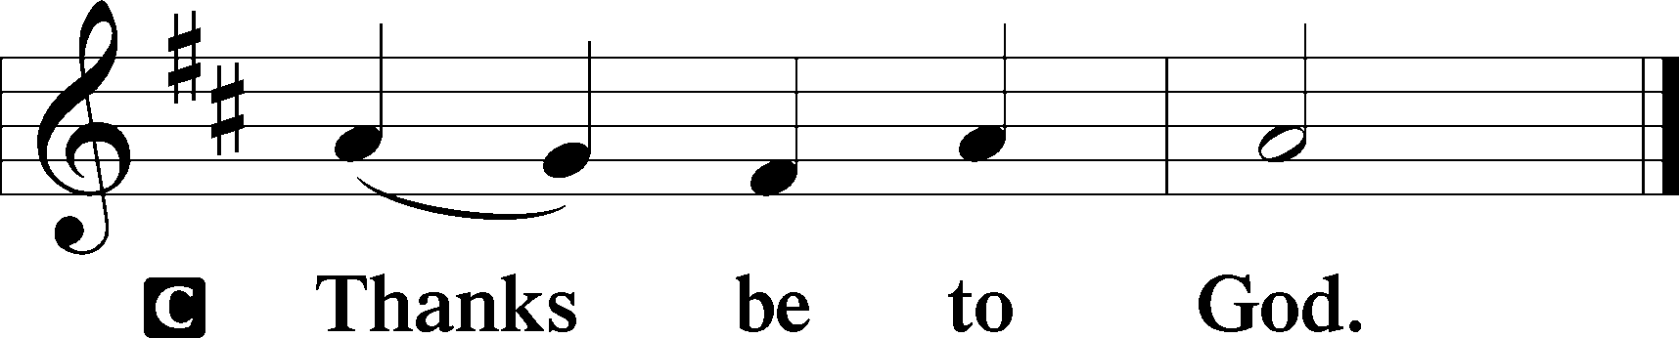

Benediction Numbers 6:24–26
P The Lord bless you and keep you.
The Lord make His face shine upon you and be gracious unto you.
The Lord lift up His countenance upon you and T give you peace.
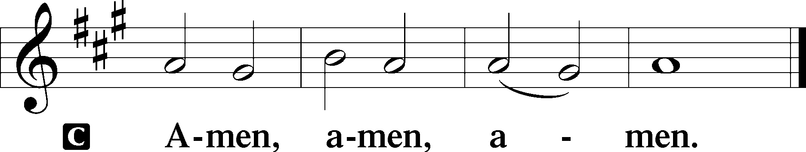

570 Just as I Am, without One Plea
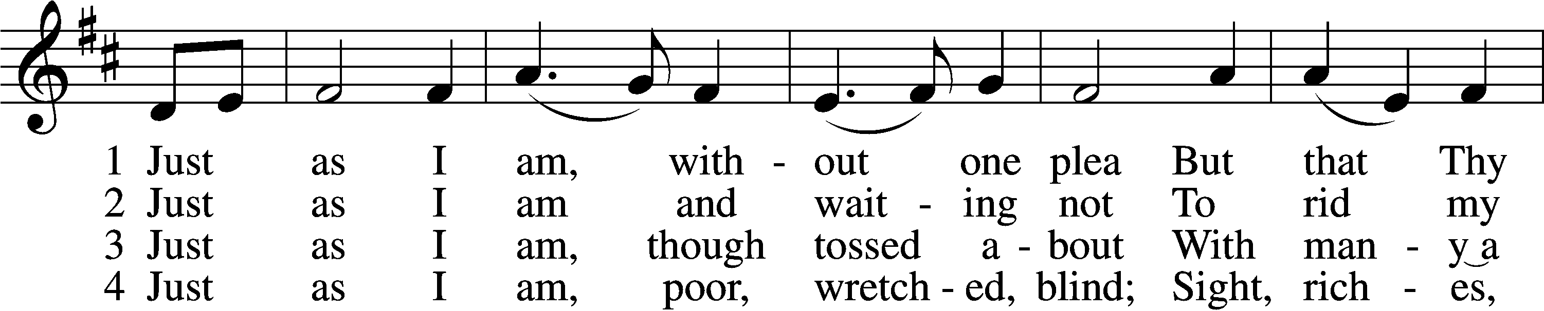
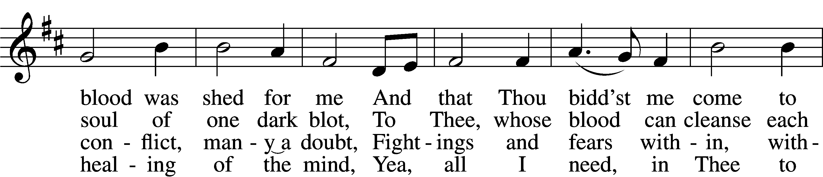
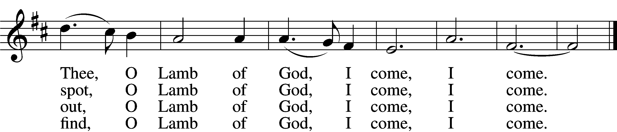

5 Just as I am, Thou wilt receive,
Wilt welcome, pardon, cleanse, relieve;
Because Thy promise I believe,
O Lamb of God, I come, I come.

6 Just as I am; Thy love unknown
Has broken ev’ry barrier down;
Now to be Thine, yea, Thine alone,
O Lamb of God, I come, I come.
Text: Charlotte Elliott, 1789–1871
Tune: William B. Bradbury, 1816–68
Text and tune: Public domain
Acknowledgments
Divine Service, Setting Three from Lutheran Service Book
Unless otherwise indicated, Scripture quotations are from the ESV® Bible (The Holy Bible, English Standard Version®), copyright © 2001 by Crossway, a publishing ministry of Good News Publishers. Used by permission. All rights reserved.
Created by Lutheran Service Builder © 2026 Concordia Publishing House.

