On entering the church

P Lord, I love the habitation of Your house and the place

where Your glory dwells. In the multitude of Your tender

mercies prepare my heart that I may enter Your house to

worship and confess Your holy name; through Jesus Christ,

my God and Lord.

Before worship

C O Lord, our creator, redeemer, and comforter, as we come

together to worship You in spirit and in truth, we humbly

pray that You would open our hearts to the preaching of

Your Word so that we may repent of our sins, believe in

Jesus Christ as our only Savior, and grow in grace and

holiness. Hear us for His sake.

672 Jerusalem the Golden

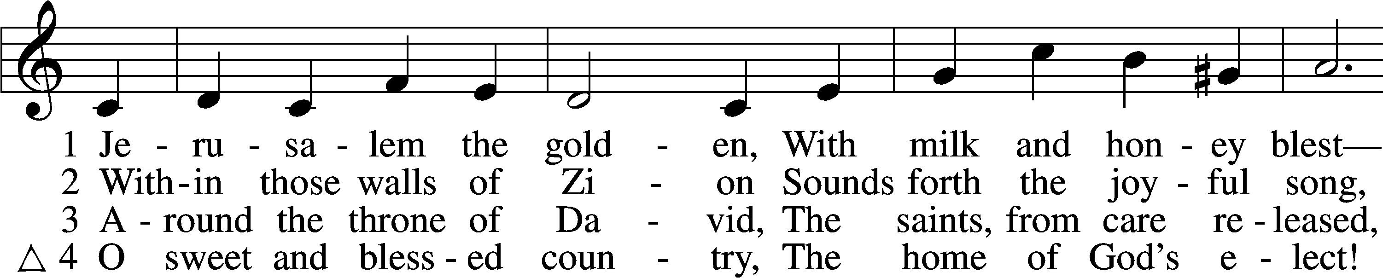

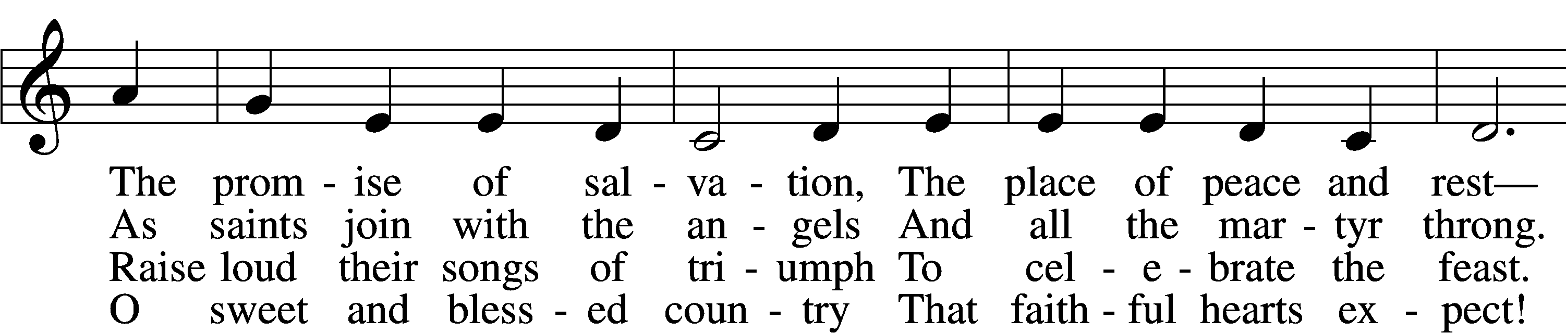

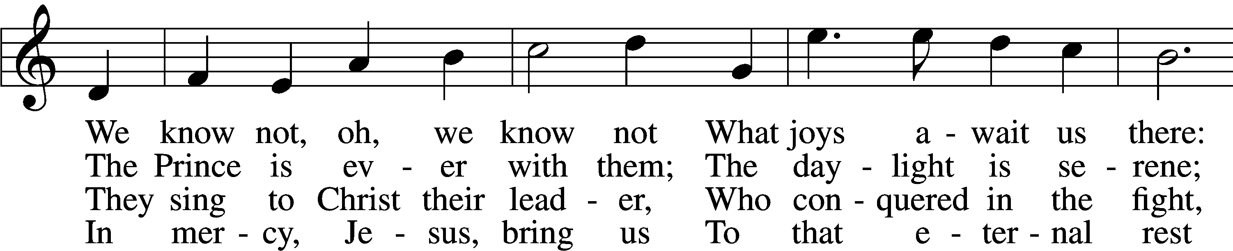

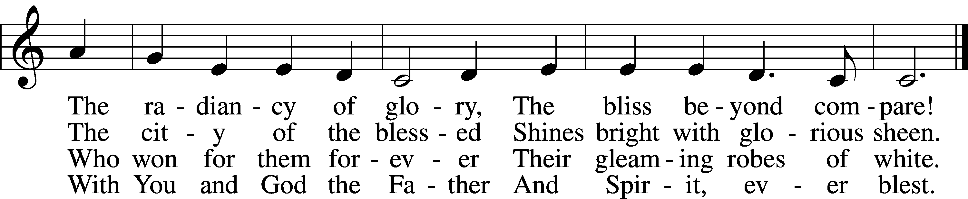

Text: Bernard of Cluny, 12th cent.; tr. John Mason Neale, 1818–66, alt.  
Tune: Alexander C. Ewing, 1830–95, alt.  
Text and tune: Public domain

# Confession and Absolution

The sign of the cross may be made by all in remembrance of their Baptism.

Invocation Matthew 28:19b; 18:20

P In the name of the Father and of the T Son and of the Holy Spirit.

C **Amen.**

Exhortation Hebrews 10:22; Psalm 124:8; Psalm 32:5

P Beloved in the Lord! Let us draw near with a true heart and confess our sins unto God our Father, beseeching Him in the name of our Lord Jesus Christ to grant us forgiveness.

P Our help is in the name of the Lord,

C **who made heaven and earth.**

P I said, I will confess my transgressions unto the Lord,

C **and You forgave the iniquity of my sin.**

Silence for reflection on God’s Word and for self-examination.

Confession of Sins

P Almighty God, our maker and redeemer, we poor sinners confess unto You that we are by nature sinful and unclean and that we have sinned against You by thought, word, and deed. Wherefore we flee for refuge to Your infinite mercy, seeking and imploring Your grace for the sake of our Lord Jesus Christ.

C **O most merciful God, who has given Your only-begotten Son to die for us, have mercy upon us and for His sake grant us remission of all our sins; and by Your Holy Spirit increase in us true knowledge of You and of Your will and true obedience to Your Word, to the end that by Your grace we may come to everlasting life; through Jesus Christ, our Lord. Amen.**

Declaration of Grace Mark 16:16; John 1:12

P Almighty God, our heavenly Father, has had mercy upon us and has given His only Son to die for us and for His sake forgives us all our sins. To those who believe on His name He gives power to become the children of God and has promised them His Holy Spirit. He that believes and is baptized shall be saved.  
  
Grant this, Lord, unto us all.

C **Amen.**

# Service of the Word

Introit Psalm 55:4, 16–18; antiphon: v. 22

Cast your burden on the Lord, and he will sustain you;  
 he will never permit the righteous to be moved.  
**My heart is in anguish within me;  
 the terrors of death have fallen upon me.**But I call to God,  
 and the Lord will save me.  
**Evening and morning and at noon I utter my complaint and moan,  
 and he hears my voice.**He redeems my soul in safety from the battle that I wage,  
 for many are arrayed against me.

Gloria Patri

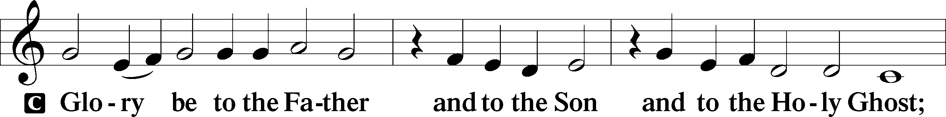

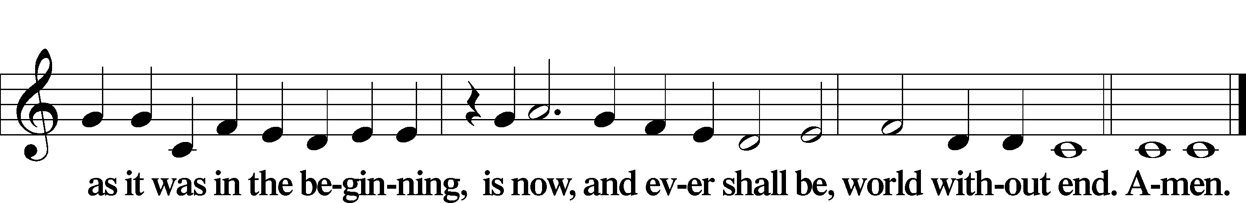

Kyrie Mark 10:47

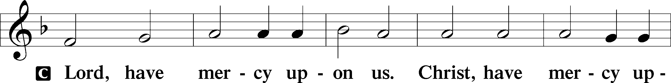

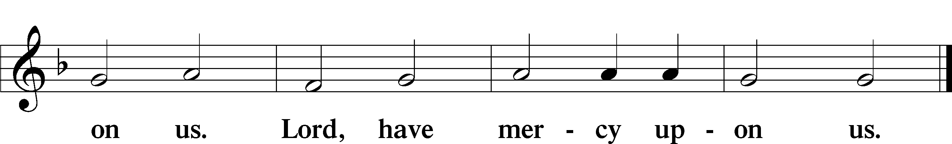

Gloria in Excelsis Luke 2:14; John 1:29

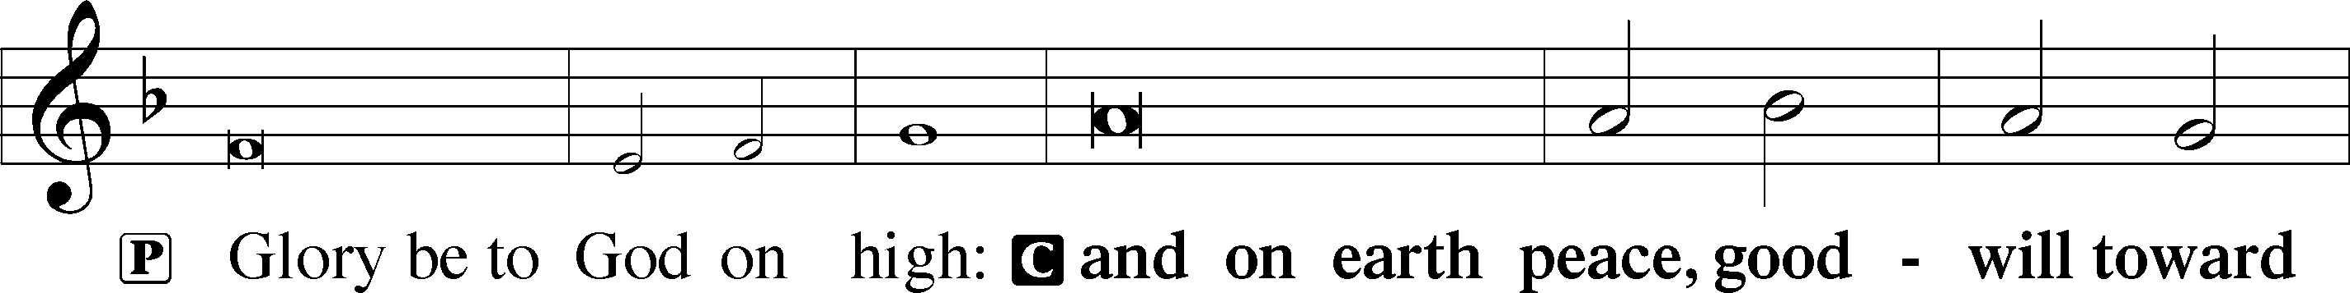

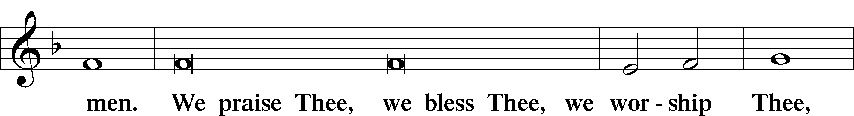

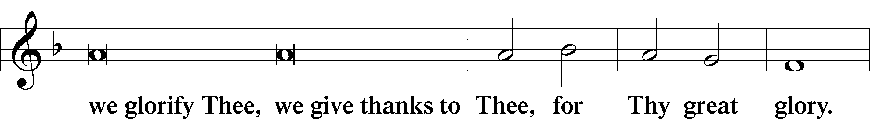

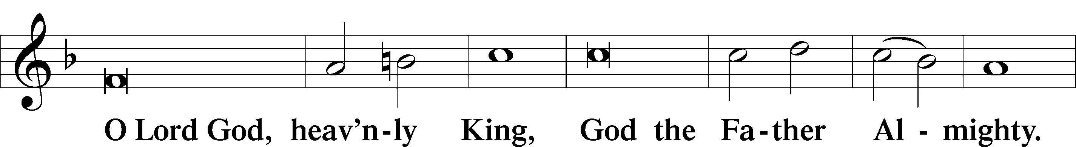

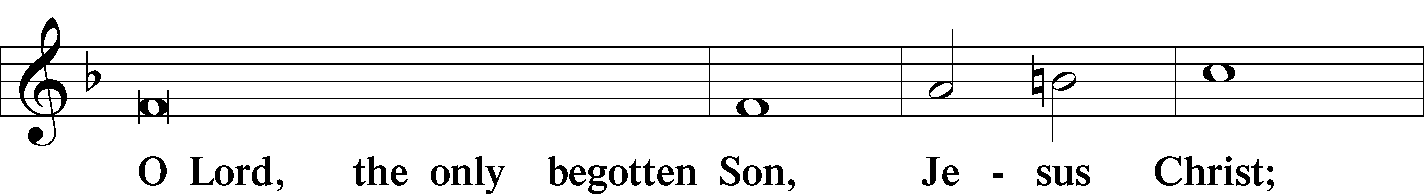

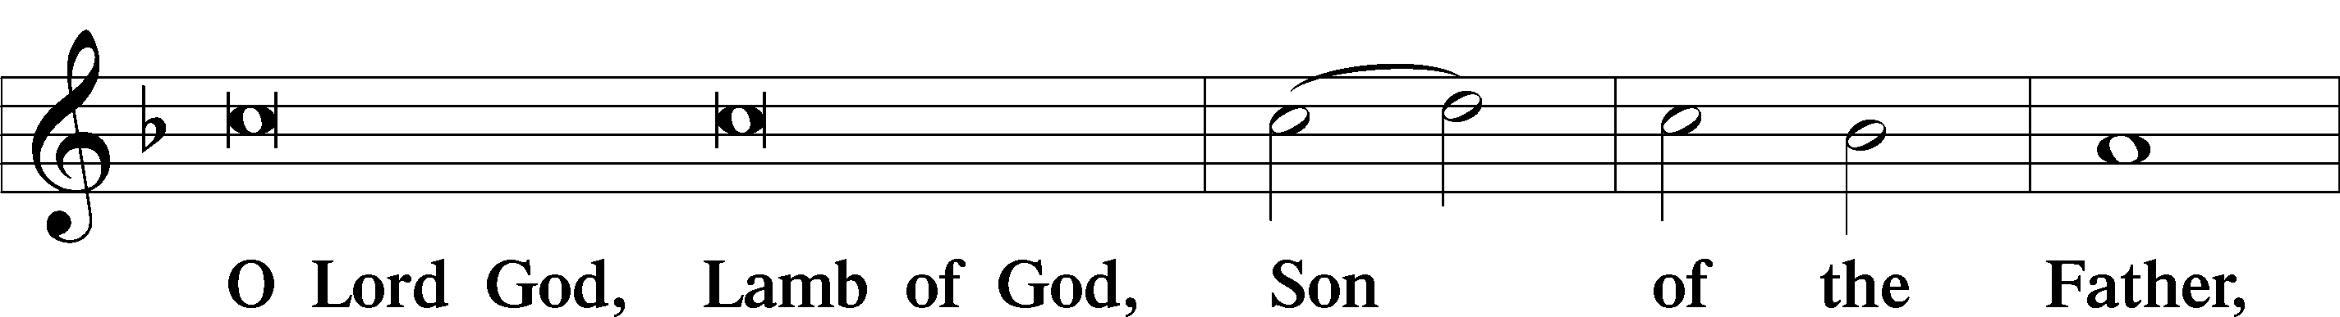

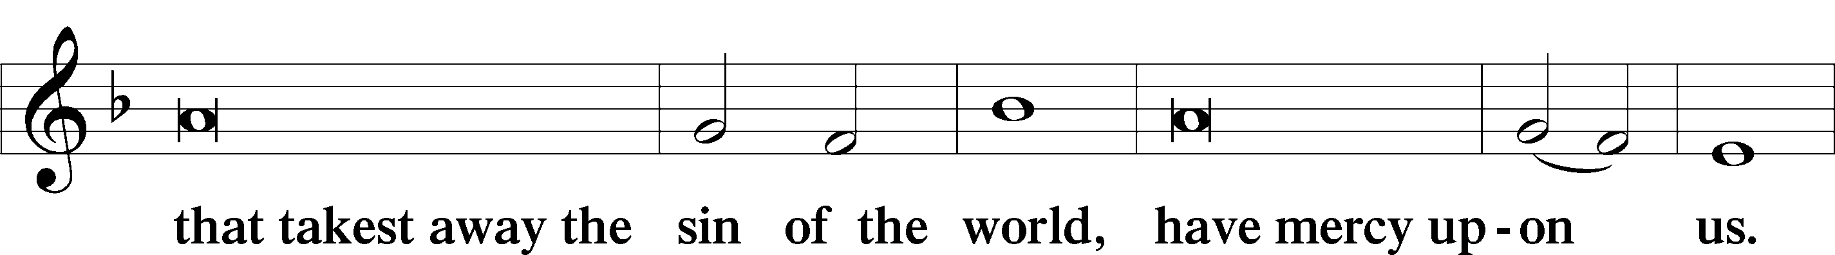

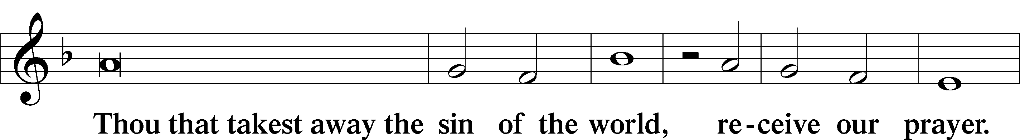

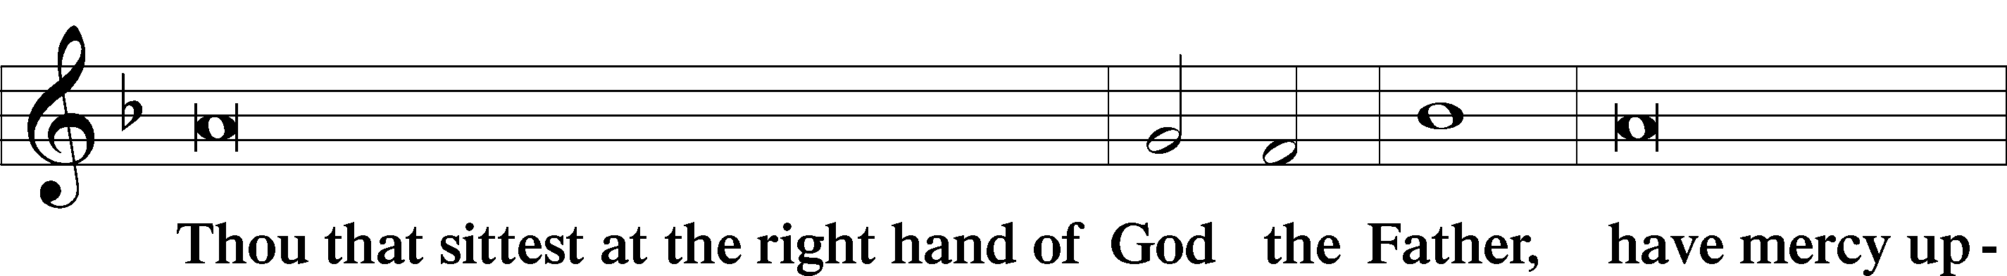

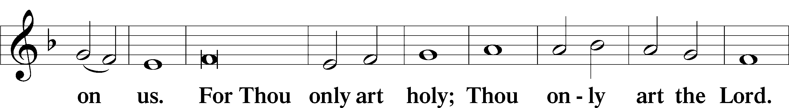

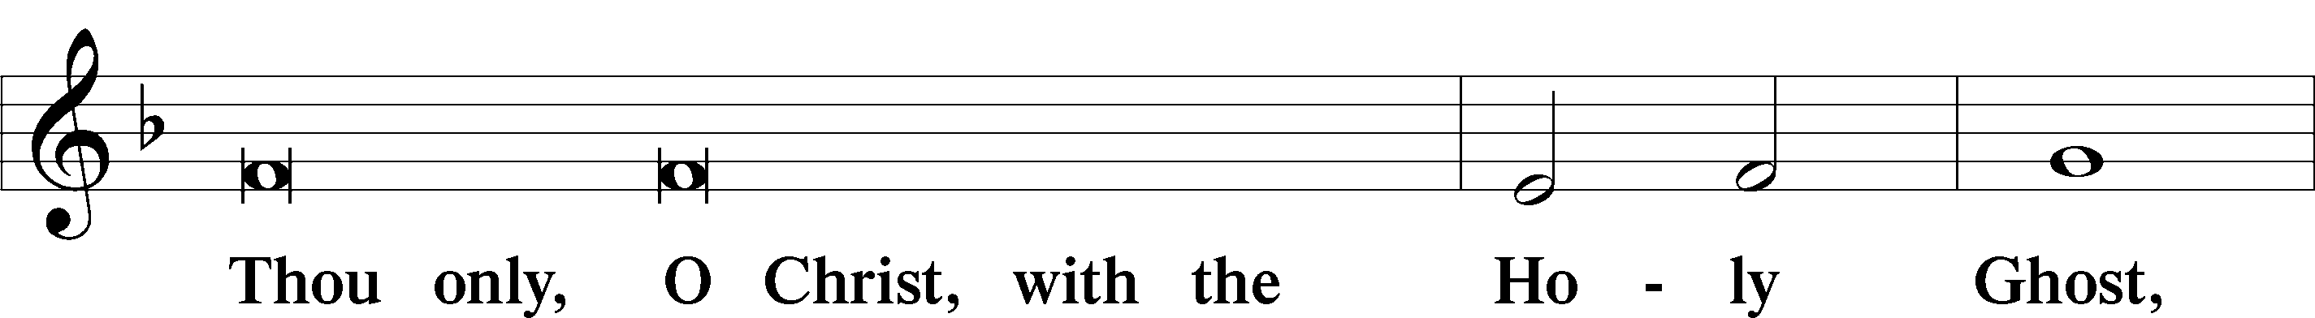

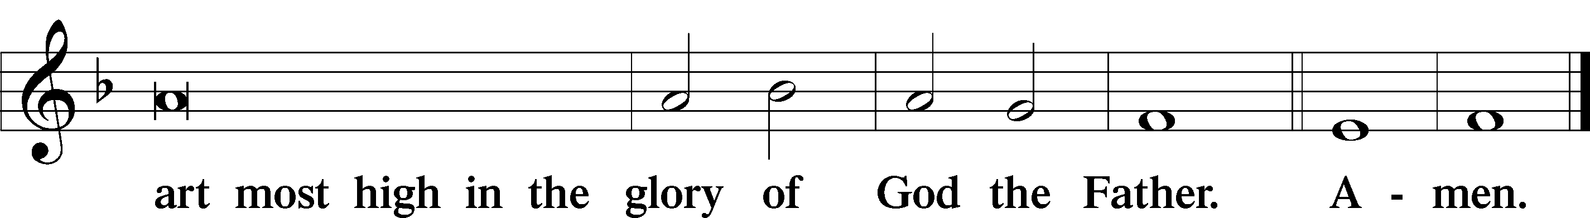

Salutation and Collect of the Day

P The Lord be with you.

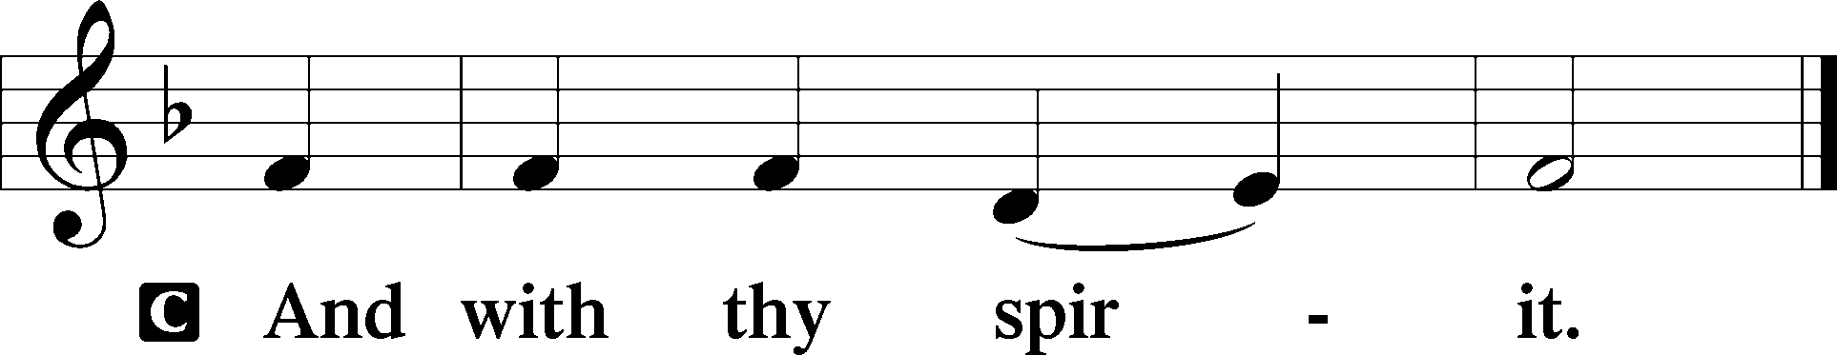

P Let us pray.

O God, the giver of all that is good, by Your holy inspiration grant that we may think those things that are right and by Your merciful guiding accomplish them; through Jesus Christ, Your Son, our Lord, who lives and reigns with You and the Holy Spirit, one God, now and forever.

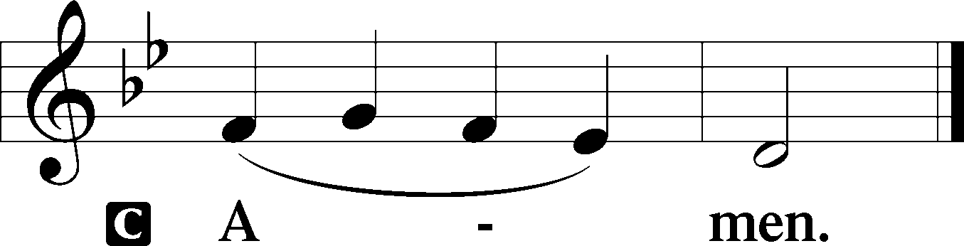

Sit

First Reading Acts 16:9–15

9A vision appeared to Paul in the night: a man of Macedonia was standing there, urging him and saying, “Come over to Macedonia and help us.” 10And when Paul had seen the vision, immediately we sought to go on into Macedonia, concluding that God had called us to preach the gospel to them.

11So, setting sail from Troas, we made a direct voyage to Samothrace, and the following day to Neapolis, 12and from there to Philippi, which is a leading city of the district of Macedonia and a Roman colony. We remained in this city some days. 13And on the Sabbath day we went outside the gate to the riverside, where we supposed there was a place of prayer, and we sat down and spoke to the women who had come together. 14One who heard us was a woman named Lydia, from the city of Thyatira, a seller of purple goods, who was a worshiper of God. The Lord opened her heart to pay attention to what was said by Paul. 15And after she was baptized, and her household as well, she urged us, saying, “If you have judged me to be faithful to the Lord, come to my house and stay.” And she prevailed upon us.

A This is the Word of the Lord.

C **Thanks be to God.**

Gradual adapt. from Matthew 28:7; Hebrews 2:7; Psalm 8:6

Christ has risen from the dead.  
 [God the Father] has crowned him with glory and honor.  
**He has given him dominion over the works of his hands;  
 he has put all things under his feet.**

Epistle Revelation 21:9–14, 21–27

9Then came one of the seven angels who had the seven bowls full of the seven last plagues and spoke to me, saying, “Come, I will show you the Bride, the wife of the Lamb.” 10And he carried me away in the Spirit to a great, high mountain, and showed me the holy city Jerusalem coming down out of heaven from God, 11having the glory of God, its radiance like a most rare jewel, like a jasper, clear as crystal. 12It had a great, high wall, with twelve gates, and at the gates twelve angels, and on the gates the names of the twelve tribes of the sons of Israel were inscribed— 13on the east three gates, on the north three gates, on the south three gates, and on the west three gates. 14And the wall of the city had twelve foundations, and on them were the twelve names of the twelve apostles of the Lamb. . . .

21And the twelve gates were twelve pearls, each of the gates made of a single pearl, and the street of the city was pure gold, transparent as glass.

22And I saw no temple in the city, for its temple is the Lord God the Almighty and the Lamb. 23And the city has no need of sun or moon to shine on it, for the glory of God gives it light, and its lamp is the Lamb. 24By its light will the nations walk, and the kings of the earth will bring their glory into it, 25and its gates will never be shut by day—and there will be no night there. 26They will bring into it the glory and the honor of the nations. 27But nothing unclean will ever enter it, nor anyone who does what is detestable or false, but only those who are written in the Lamb’s book of life.

Stand

Alleluia

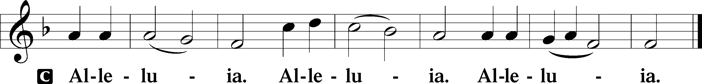

Holy Gospel John 16:23–33

P The Holy Gospel according to St. John, the sixteenth chapter.

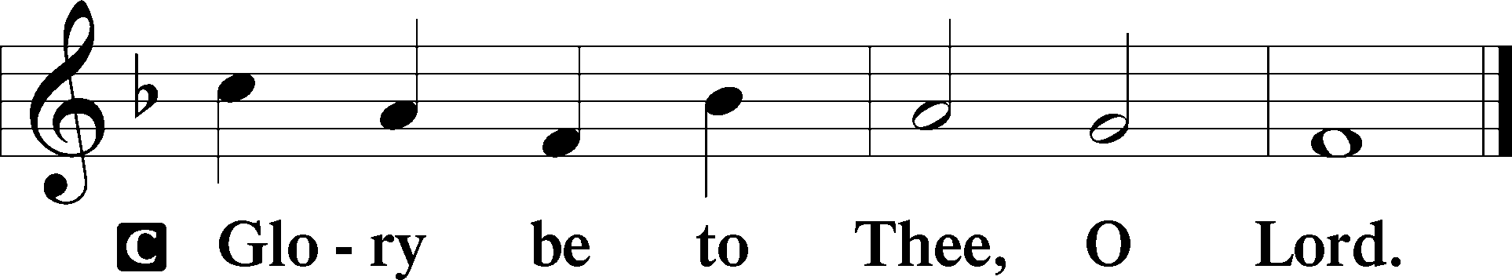

23[Jesus said:] “In that day you will ask nothing of me. Truly, truly, I say to you, whatever you ask of the Father in my name, he will give it to you. 24Until now you have asked nothing in my name. Ask, and you will receive, that your joy may be full.

25“I have said these things to you in figures of speech. The hour is coming when I will no longer speak to you in figures of speech but will tell you plainly about the Father. 26In that day you will ask in my name, and I do not say to you that I will ask the Father on your behalf; 27for the Father himself loves you, because you have loved me and have believed that I came from God. 28I came from the Father and have come into the world, and now I am leaving the world and going to the Father.”

29His disciples said, “Ah, now you are speaking plainly and not using figurative speech! 30Now we know that you know all things and do not need anyone to question you; this is why we believe that you came from God.” 31Jesus answered them, “Do you now believe? 32Behold, the hour is coming, indeed it has come, when you will be scattered, each to his own home, and will leave me alone. Yet I am not alone, for the Father is with me. 33I have said these things to you, that in me you may have peace. In the world you will have tribulation. But take heart; I have overcome the world.”

P This is the Gospel of the Lord.

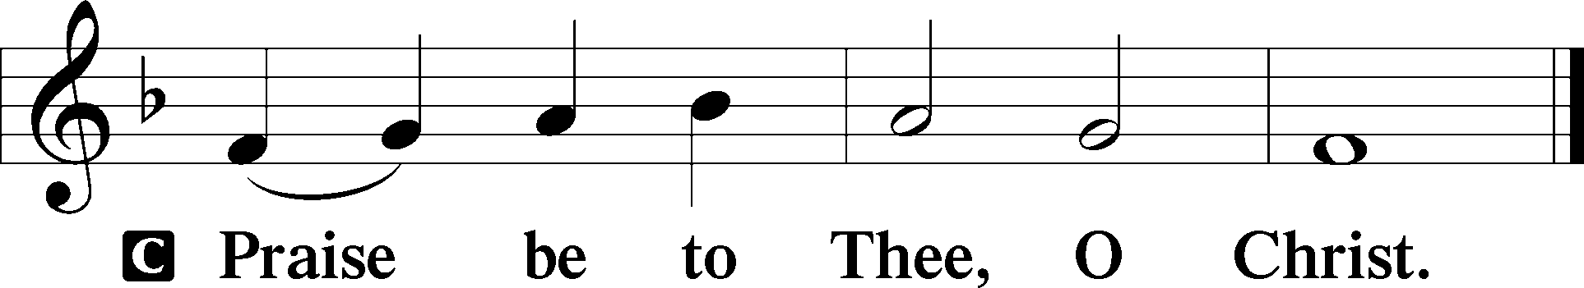

Apostles’ Creed

C **I believe in God, the Father Almighty,**

**maker of heaven and earth.**

**And in Jesus Christ, His only Son, our Lord,**

**who was conceived by the Holy Spirit,**

**born of the virgin Mary,**

**suffered under Pontius Pilate,**

**was crucified, died and was buried.**

**He descended into hell.**

**The third day He rose again from the dead.**

**He ascended into heaven**

**and sits at the right hand of God the Father Almighty.**

**From thence He will come to judge the living and the dead.**

**I believe in the Holy Spirit,**

**the holy Christian Church,**

**the communion of saints,**

**the forgiveness of sins,**

**the resurrection of the body,**

**and the life** T **everlasting. Amen.**

Sit

Children's Sermon

826 Hark, the Voice of Jesus Crying

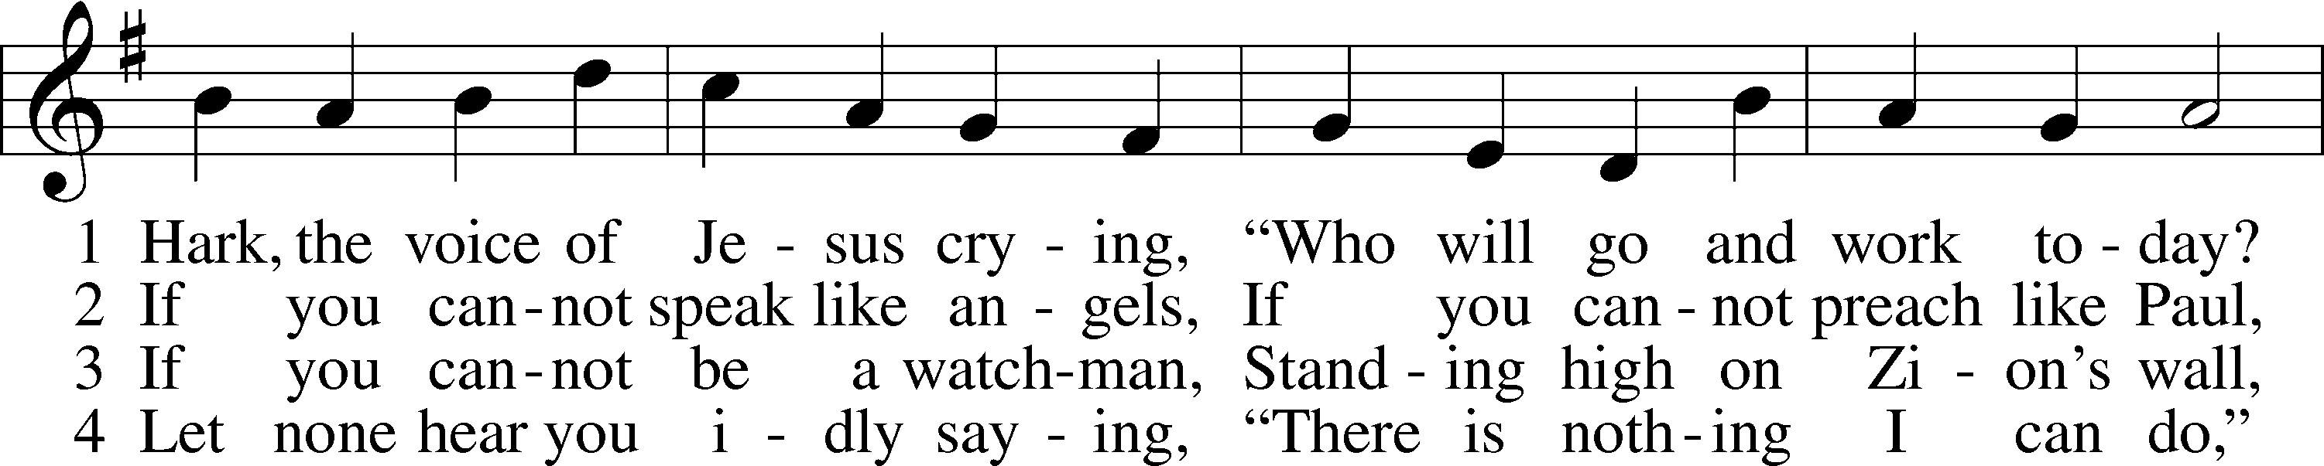

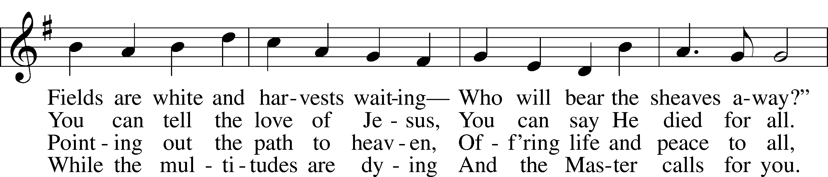

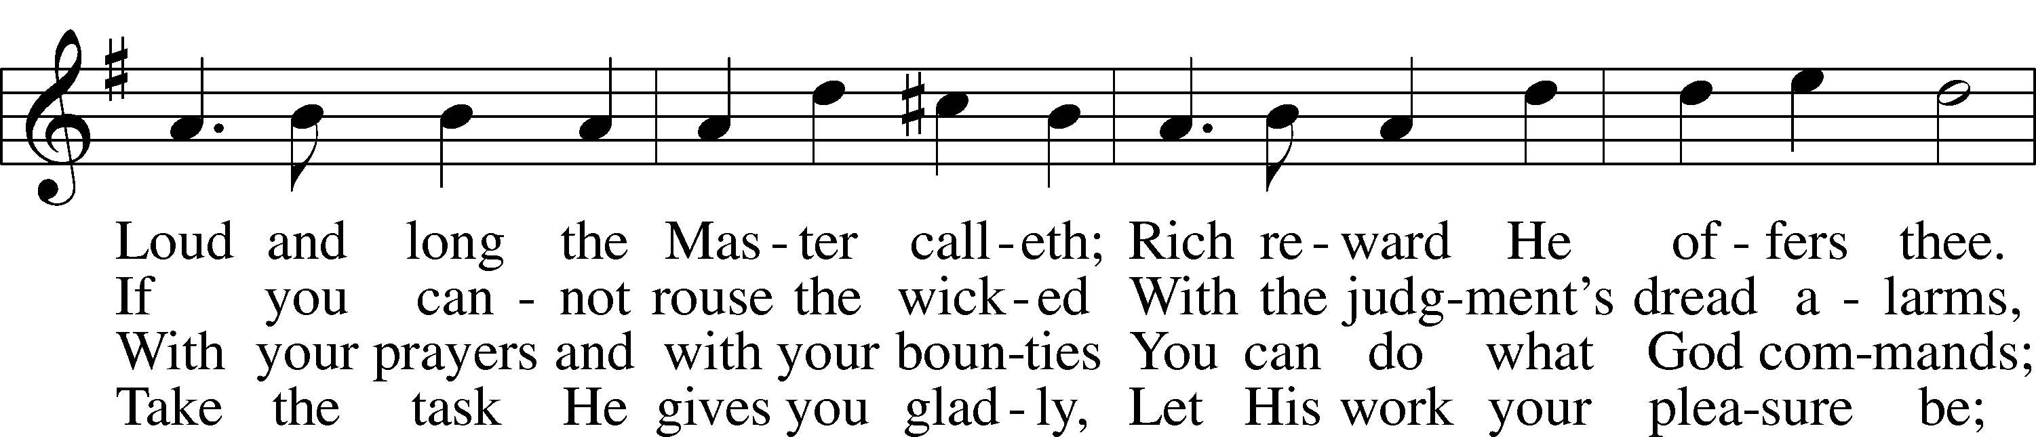

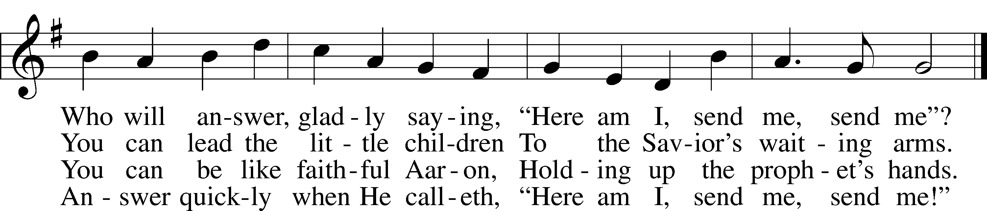

Text (sts. 1–2, 4): Daniel March, 1816–1909, alt.; (st. 3): unknown, alt.  
Tune: Joseph Barnby, 1838–96  
Text and tune: Public domain

Sermon

Votum

P The peace of God, which passes all understanding, keep your hearts and minds in Christ Jesus.

C **Amen.**

Stand

Offertory Psalm 51:10–12

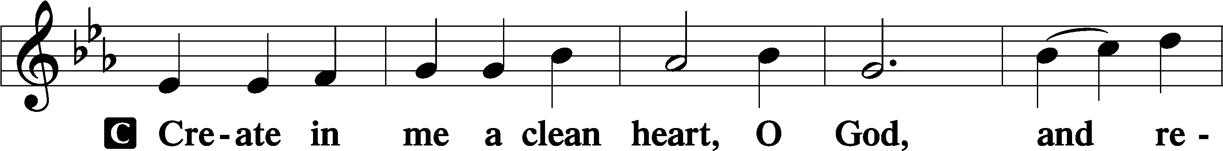

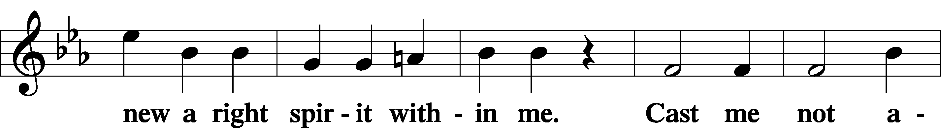

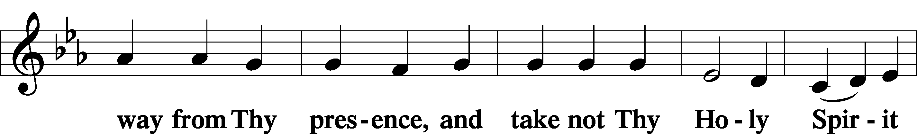

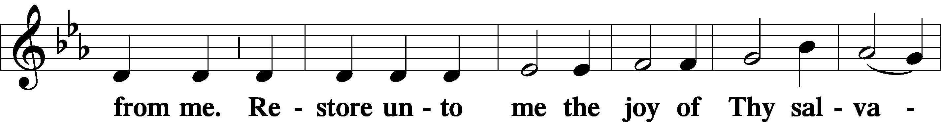

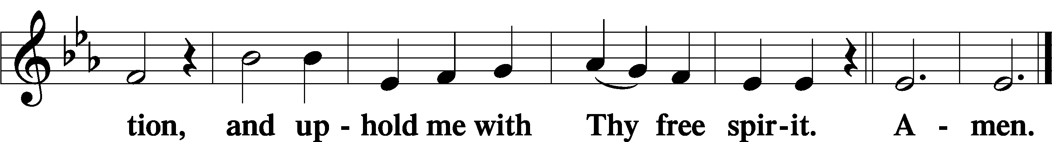

Offering

805 Praise God, from Whom All Blessings Flow

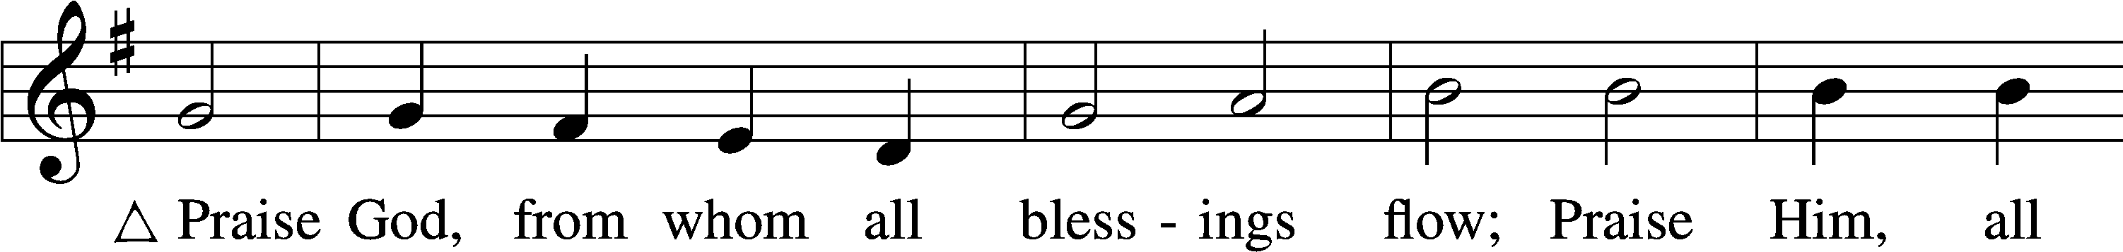

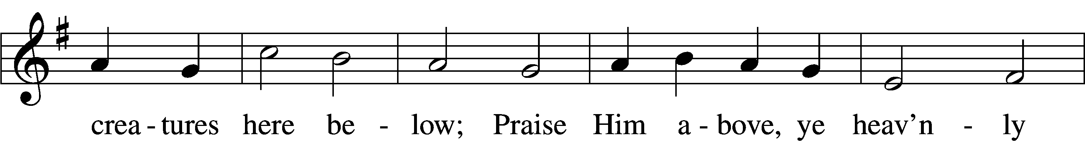

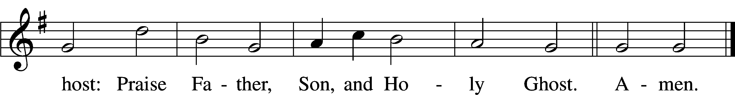

Text: Thomas Ken, 1637–1711  
Tune: Trente quatre Pseaumes de David, 1551, Geneva, ed. Louis Bourgeois  
Text and tune: Public domain

Prayer of the Church

Lord’s Prayer Matthew 6:9–13

P Lord, remember us in Your kingdom and teach us to pray:

C **Our Father who art in heaven,**

**hallowed be Thy name,**

**Thy kingdom come,**

**Thy will be done on earth**

**as it is in heaven;**

**give us this day our daily bread;**

**and forgive us our trespasses**

**as we forgive those**

**who trespass against us;**

**and lead us not into temptation,**

**but deliver us from evil.**

**For Thine is the kingdom**

**and the power and the glory**

**forever and ever. Amen.**

Collect for the Word

Blessed Lord, You have caused all Holy Scriptures to be written for our learning. Grant that we may so hear them, read, mark, learn, and inwardly digest them that, by the patience and comfort of Your holy Word, we may embrace and ever hold fast the blessed hope of everlasting life; through Jesus Christ, Your Son, our Lord, who lives and reigns with You and the Holy Spirit, one God, now and forever.

Benediction

P The Lord bless you and keep you.

The Lord make His face shine on you and be gracious to you.

The Lord look upon you with favor and T give you peace.

C **Amen.**

917 Savior, Again to Thy Dear Name We Raise

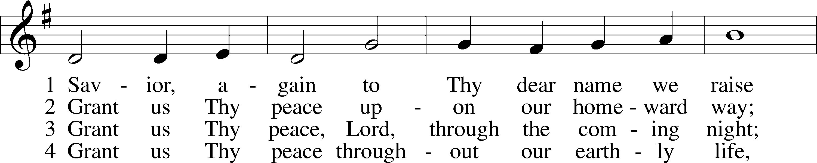

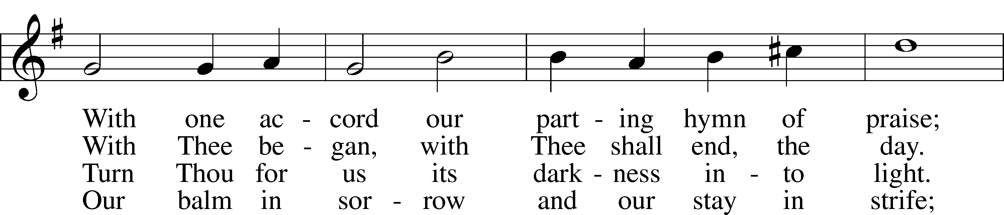

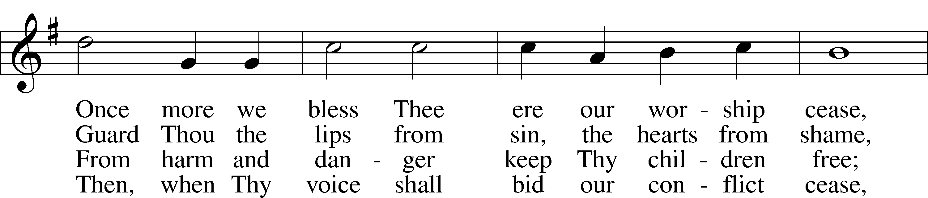

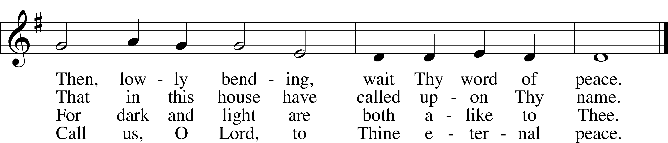

Text: John Ellerton, 1826–93  
Tune: Edward J. Hopkins, 1818–1901  
Text and tune: Public domain

Acknowledgments

Unless otherwise indicated, Scripture quotations are from the ESV® Bible (The Holy Bible, English Standard Version®), copyright © 2001 by Crossway, a publishing ministry of Good News Publishers. Used by permission. All rights reserved.

Created by Lutheran Service Builder © 2025 Concordia Publishing House.