On entering the church

P Lord, I love the habitation of Your house and the place

where Your glory dwells. In the multitude of Your tender

mercies prepare my heart that I may enter Your house to

worship and confess Your holy name; through Jesus Christ,

my God and Lord.

Before worship

C O Lord, our creator, redeemer, and comforter, as we come

together to worship You in spirit and in truth, we humbly

pray that You would open our hearts to the preaching of

Your Word so that we may repent of our sins, believe in

Jesus Christ as our only Savior, and grow in grace and

holiness. Hear us for His sake.

798 The God of Abraham Praise sts. 1–5

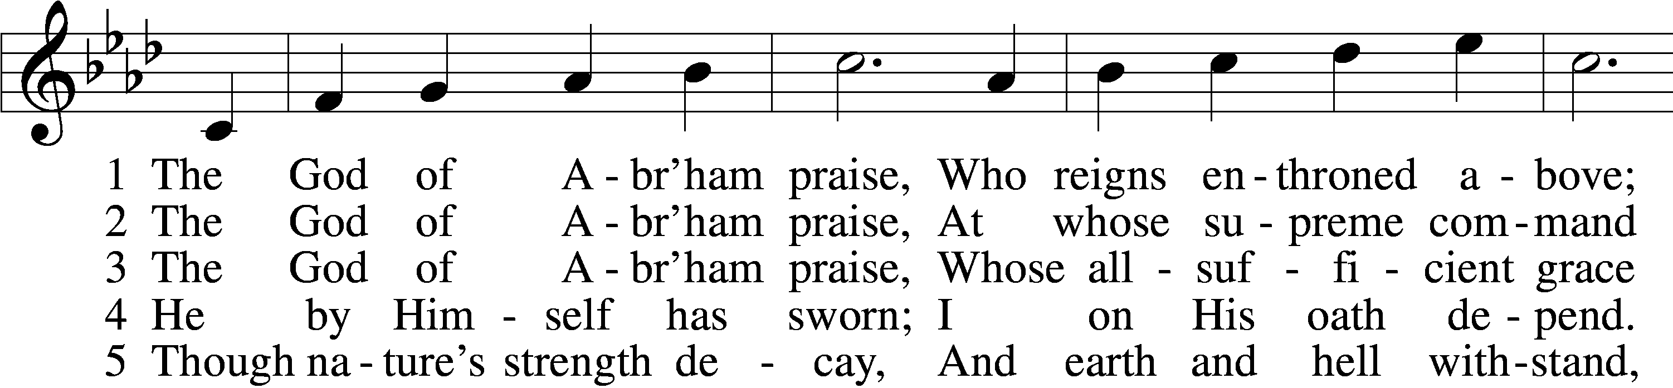

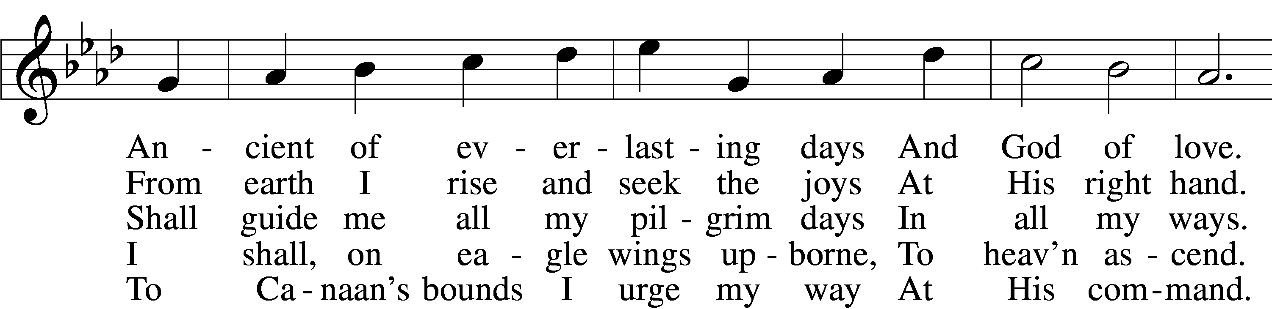

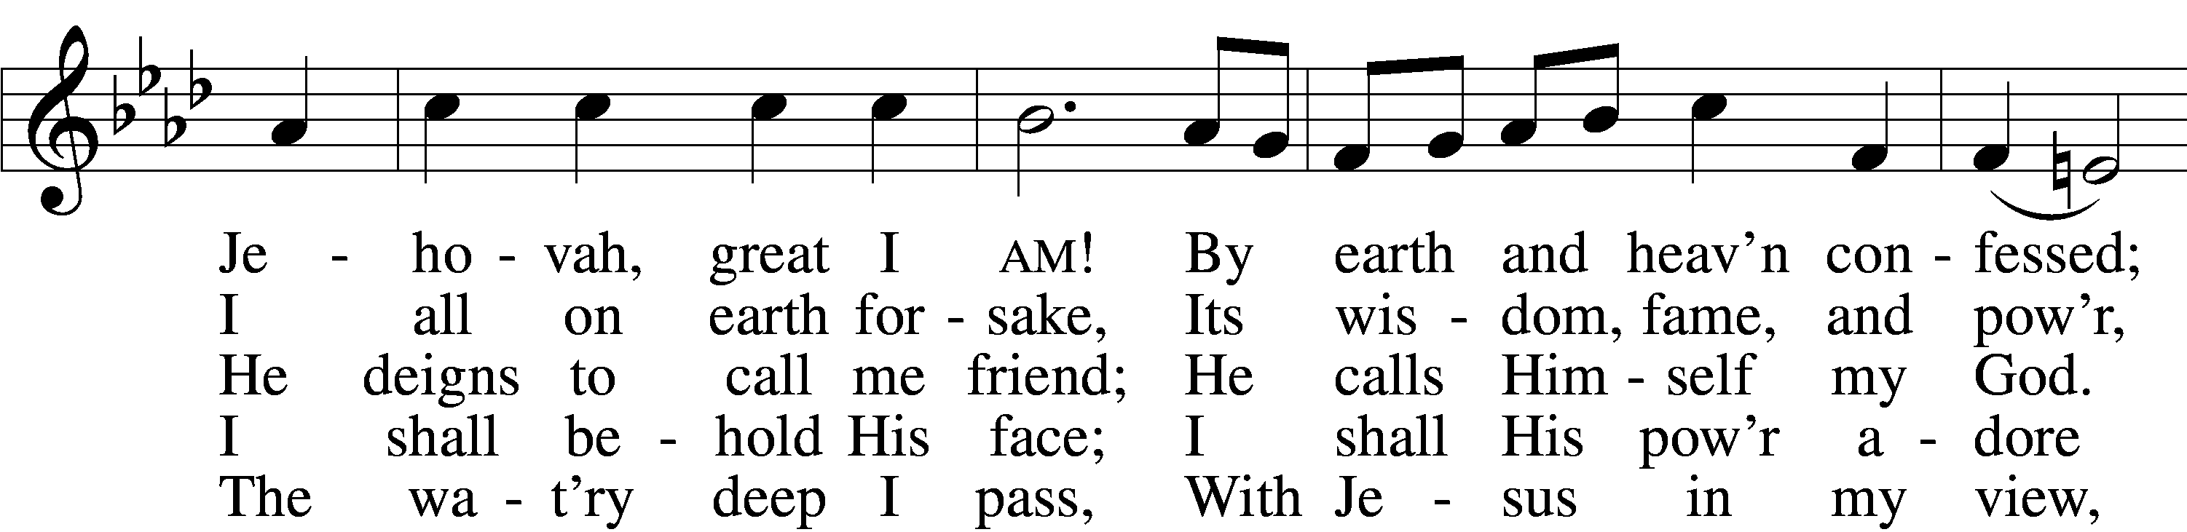

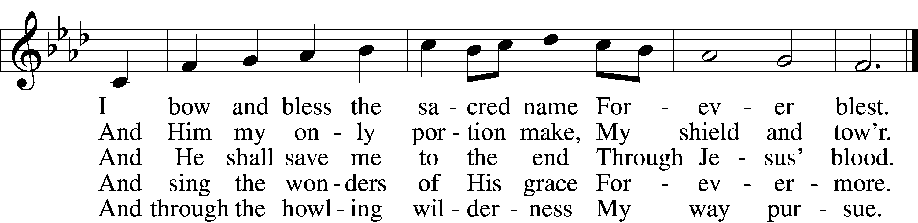

Text: Thomas Olivers, 1725–99, alt.  
Tune: Hebrew  
Text and tune: Public domain

# Confession and Absolution

Stand

The sign of the cross may be made by all in remembrance of their Baptism.

Invocation Matthew 28:19b; 18:20

P In the name of the Father and of the T Son and of the Holy Spirit.

C **Amen.**

Exhortation Hebrews 10:22; Psalm 124:8; Psalm 32:5

P Beloved in the Lord! Let us draw near with a true heart and confess our sins unto God our Father, beseeching Him in the name of our Lord Jesus Christ to grant us forgiveness.

P Our help is in the name of the Lord,

C **who made heaven and earth.**

P I said, I will confess my transgressions unto the Lord,

C **and You forgave the iniquity of my sin.**

Kneel/Stand

Silence for reflection on God’s Word and for self-examination.

Confession of Sins

P O almighty God, merciful Father,

C **I, a poor, miserable sinner, confess unto You all my sins and iniquities with which I have ever offended You and justly deserved Your temporal and eternal punishment. But I am heartily sorry for them and sincerely repent of them, and I pray You of Your boundless mercy and for the sake of the holy, innocent, bitter sufferings and death of Your beloved Son, Jesus Christ, to be gracious and merciful to me, a poor, sinful being.**

Absolution [John 20:19–23]

P Upon this your confession, I, by virtue of my office, as a called and ordained servant of the Word, announce the grace of God unto all of you, and in the stead and by the command of my Lord Jesus Christ I forgive you all your sins in the name of the Father and of the T Son and of the Holy Spirit.

C **Amen.**

Stand

# Service of the Word

Introit Psalm 84:1–2, 9, 11; antiphon: v. 4

Blessèd are those who dwell in your house,  
 ever singing your praise!  
**How lovely is your dwelling place,  
 O Lord of hosts!**My soul longs, yes, faints for the courts of the Lord;  
 my heart and flesh sing for joy to the living God.  
**Behold our shield, O God;  
 look on the face of your anointed!**For the Lord God is a sun and shield; the Lord bestows favor and honor.  
 No good thing does he withhold from those who walk uprightly.

Gloria Patri

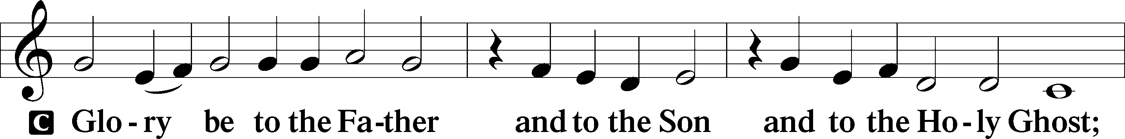

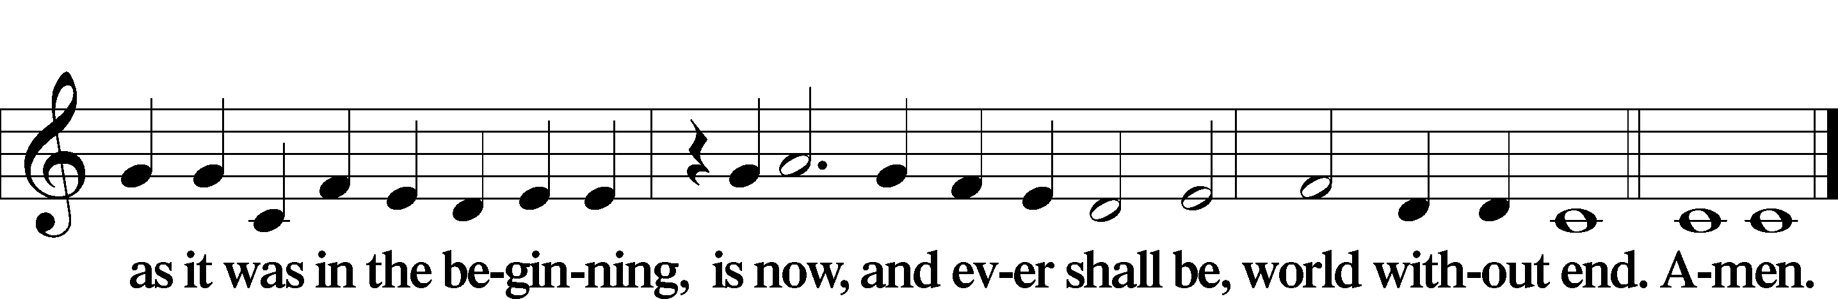

Kyrie Mark 10:47

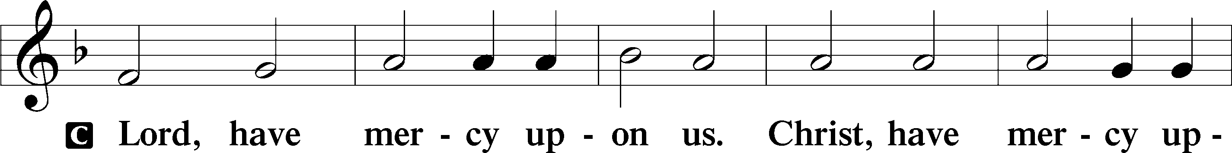

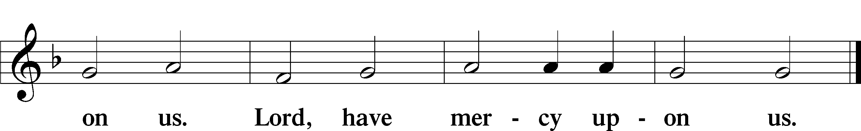

Gloria in Excelsis Luke 2:14; John 1:29

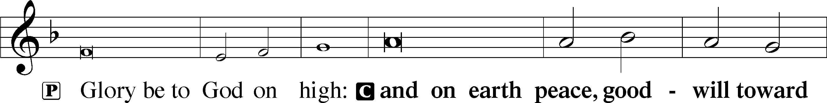

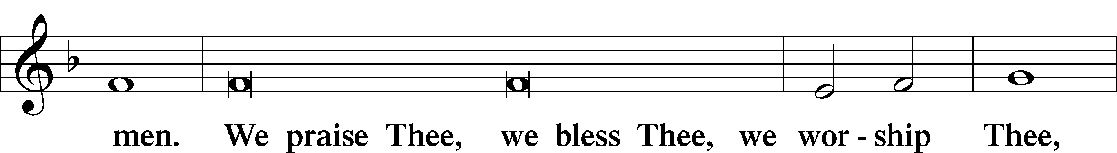

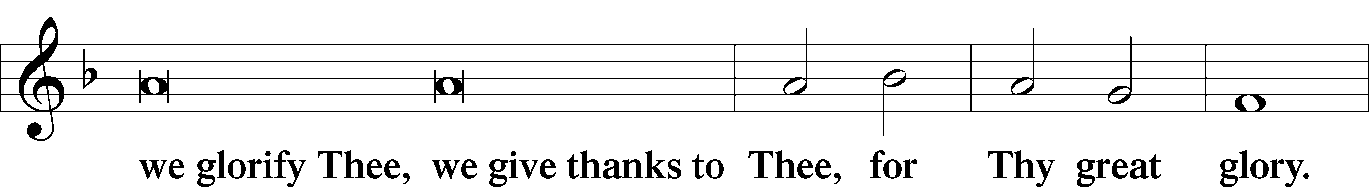

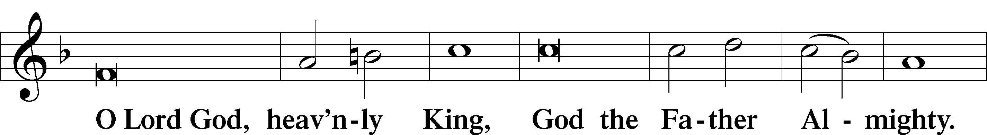

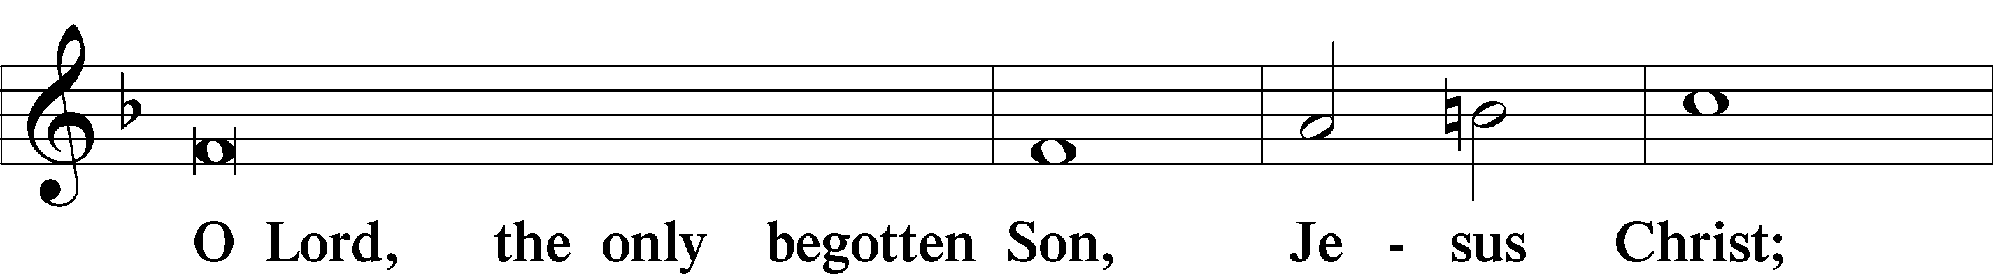

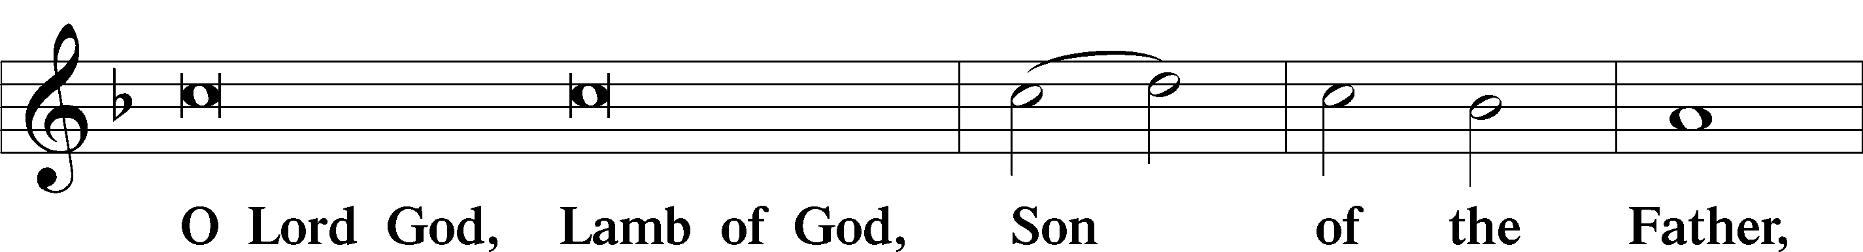

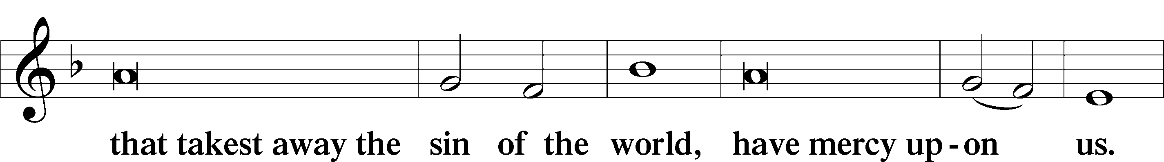

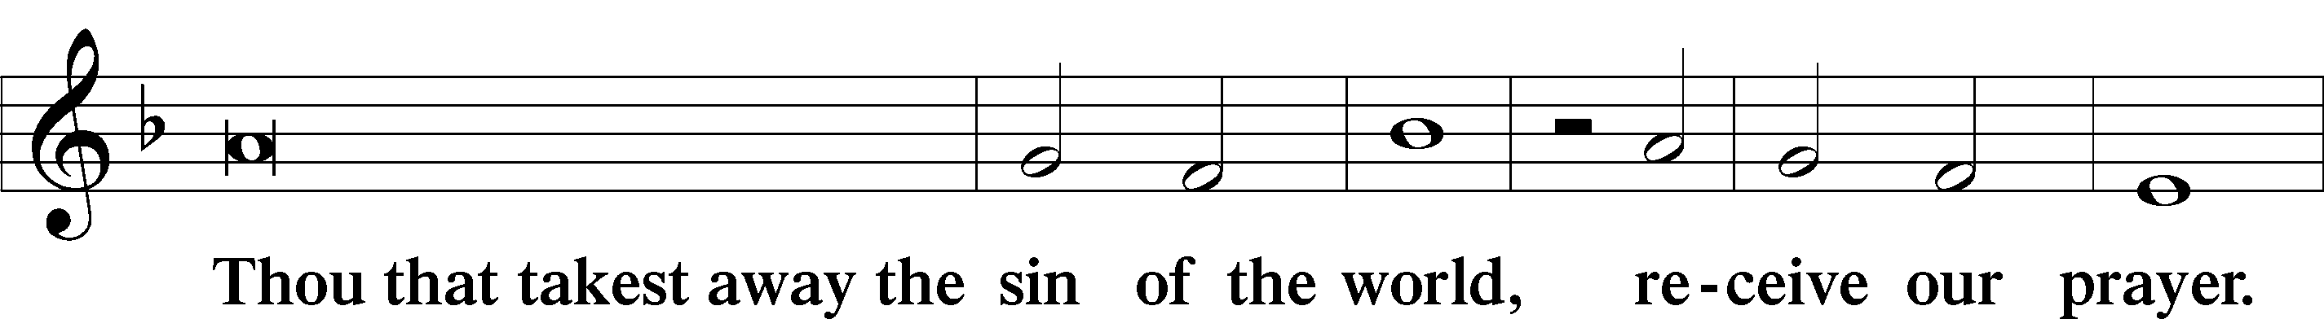

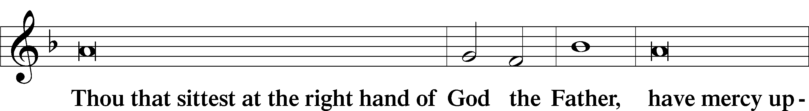

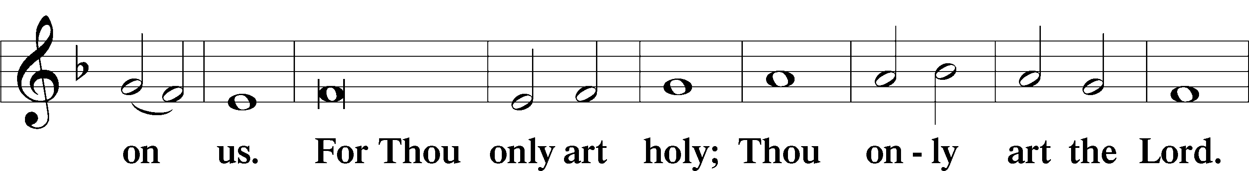

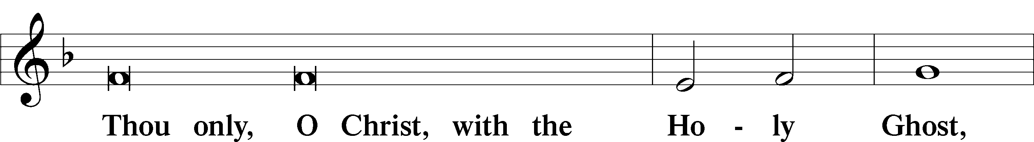

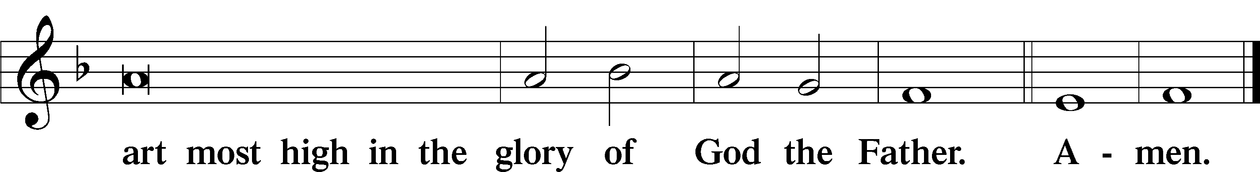

Salutation and Collect of the Day

P The Lord be with you.

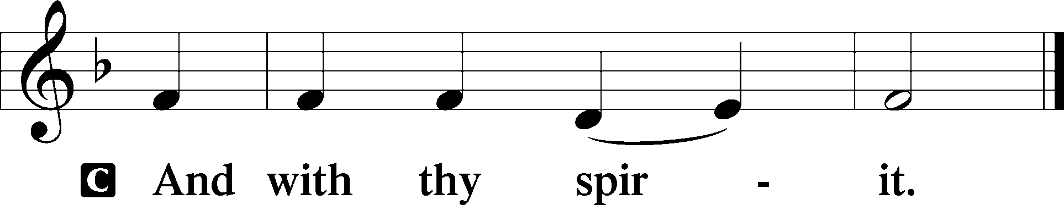

P Let us pray.

O God, in the glorious transfiguration of Your beloved Son You confirmed the mysteries of the faith by the testimony of Moses and Elijah. In the voice that came from the bright cloud You wonderfully foreshowed our adoption by grace. Mercifully make us co-heirs with the King in His glory and bring us to the fullness of our inheritance in heaven; through the same Jesus Christ, our Lord, who lives and reigns with You and the Holy Spirit, one God, now and forever.

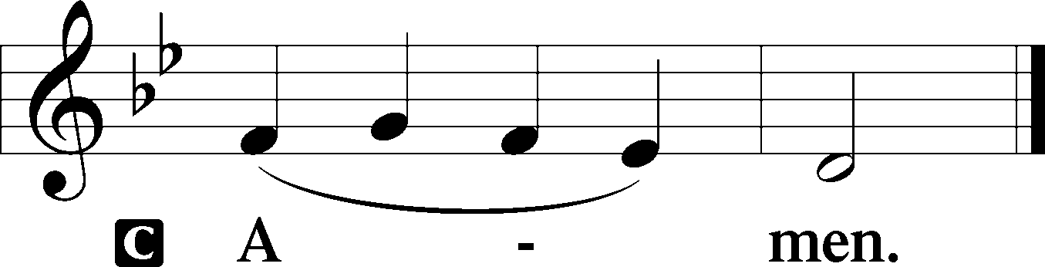

Sit

Old Testament Reading Deuteronomy 34:1–12

1Then Moses went up from the plains of Moab to Mount Nebo, to the top of Pisgah, which is opposite Jericho. And the Lord showed him all the land, Gilead as far as Dan, 2all Naphtali, the land of Ephraim and Manasseh, all the land of Judah as far as the western sea, 3the Negeb, and the Plain, that is, the Valley of Jericho the city of palm trees, as far as Zoar. 4And the Lord said to him, “This is the land of which I swore to Abraham, to Isaac, and to Jacob, ‘I will give it to your offspring.’ I have let you see it with your eyes, but you shall not go over there.” 5So Moses the servant of the Lord died there in the land of Moab, according to the word of the Lord, 6and he buried him in the valley in the land of Moab opposite Beth-peor; but no one knows the place of his burial to this day. 7Moses was 120 years old when he died. His eye was undimmed, and his vigor unabated. 8And the people of Israel wept for Moses in the plains of Moab thirty days. Then the days of weeping and mourning for Moses were ended.

9And Joshua the son of Nun was full of the spirit of wisdom, for Moses had laid his hands on him. So the people of Israel obeyed him and did as the Lord had commanded Moses. 10And there has not arisen a prophet since in Israel like Moses, whom the Lord knew face to face, 11none like him for all the signs and the wonders that the Lord sent him to do in the land of Egypt, to Pharaoh and to all his servants and to all his land, 12and for all the mighty power and all the great deeds of terror that Moses did in the sight of all Israel.

A This is the Word of the Lord.

C **Thanks be to God.**

Gradual Psalm 117:1–2a; 96:8

Praise the Lord, all nations!  
 Extol him, all peoples!  
**For great is his steadfast love toward us,  
 and the faithfulness of the Lord endures forever.**Ascribe to the Lord the glory due his name;  
 bring an offering, and come into his courts!

Epistle Hebrews 3:1–6

1Therefore, holy brothers, you who share in a heavenly calling, consider Jesus, the apostle and high priest of our confession, 2who was faithful to him who appointed him, just as Moses also was faithful in all God’s house. 3For Jesus has been counted worthy of more glory than Moses—as much more glory as the builder of a house has more honor than the house itself. 4(For every house is built by someone, but the builder of all things is God.) 5Now Moses was faithful in all God’s house as a servant, to testify to the things that were to be spoken later, 6but Christ is faithful over God’s house as a son. And we are his house if indeed we hold fast our confidence and our boasting in our hope.

A This is the Word of the Lord.

C **Thanks be to God.**

Stand

Alleluia

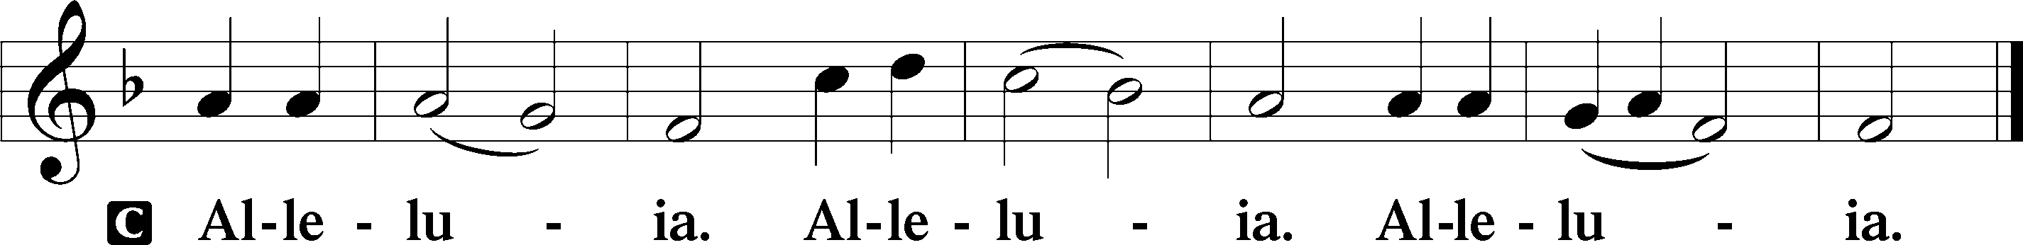

Holy Gospel Luke 9:28–36

P The Holy Gospel according to St. Luke, the ninth chapter.

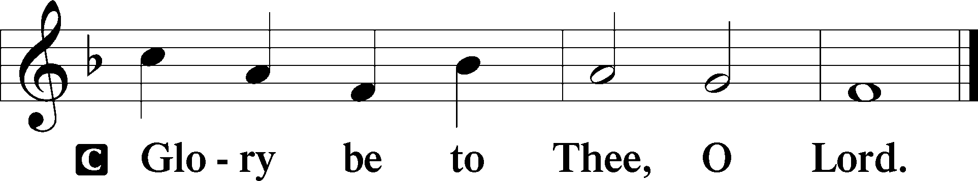

28Now about eight days after these sayings [Jesus] took with him Peter and John and James and went up on the mountain to pray. 29And as he was praying, the appearance of his face was altered, and his clothing became dazzling white. 30And behold, two men were talking with him, Moses and Elijah, 31who appeared in glory and spoke of his departure, which he was about to accomplish at Jerusalem. 32Now Peter and those who were with him were heavy with sleep, but when they became fully awake they saw his glory and the two men who stood with him. 33And as the men were parting from him, Peter said to Jesus, “Master, it is good that we are here. Let us make three tents, one for you and one for Moses and one for Elijah”—not knowing what he said. 34As he was saying these things, a cloud came and overshadowed them, and they were afraid as they entered the cloud. 35And a voice came out of the cloud, saying, “This is my Son, my Chosen One; listen to him!” 36And when the voice had spoken, Jesus was found alone. And they kept silent and told no one in those days anything of what they had seen.

P This is the Gospel of the Lord.

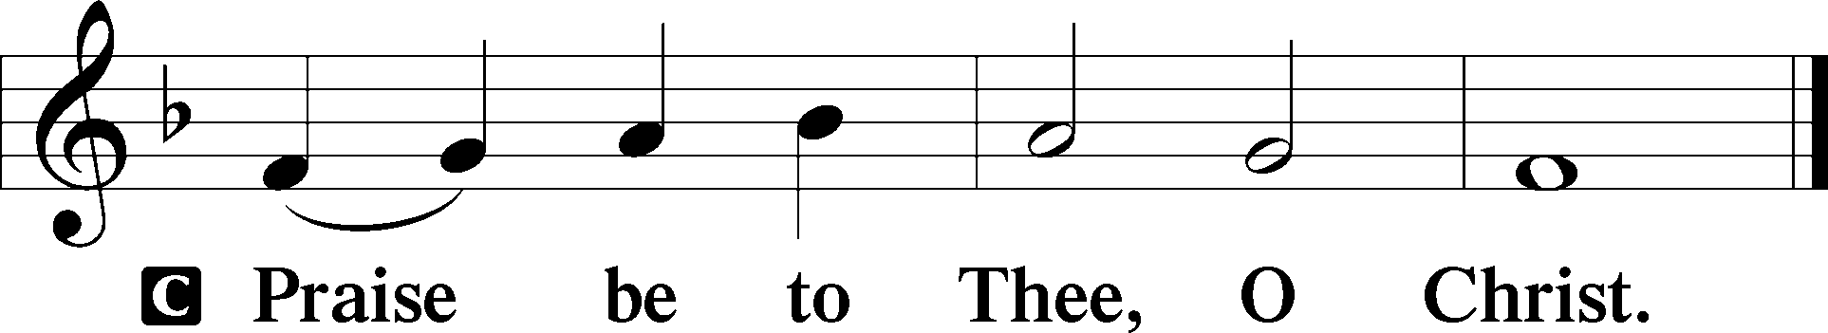

Nicene Creed

C **I believe in one God,**

**the Father Almighty,**

**maker of heaven and earth**

**and of all things visible and invisible.**

**And in one Lord Jesus Christ,**

**the only-begotten Son of God,**

**begotten of His Father before all worlds,**

**God of God, Light of Light,**

**very God of very God,**

**begotten, not made,**

**being of one substance with the Father,**

**by whom all things were made;**

**who for us men and for our salvation came down from heaven**

**and was incarnate by the Holy Spirit of the virgin Mary**

**and was made man;**

**and was crucified also for us under Pontius Pilate.**

**He suffered and was buried.**

**And the third day He rose again according to the Scriptures**

**and ascended into heaven**

**and sits at the right hand of the Father.**

**And He will come again with glory to judge both the living and the dead,**

**whose kingdom will have no end.**

**And I believe in the Holy Spirit,**

**the Lord and giver of life,**

**who proceeds from the Father and the Son,**

**who with the Father and the Son together is worshiped and glorified,**

**who spoke by the prophets.**

**And I believe in one holy Christian and apostolic Church,**

**I acknowledge one Baptism for the remission of sins,**

**and I look for the resurrection of the dead**

**and the life** T **of the world to come. Amen.**

Sit

Children's Sermon

585 Lord Jesus Christ, with Us Abide

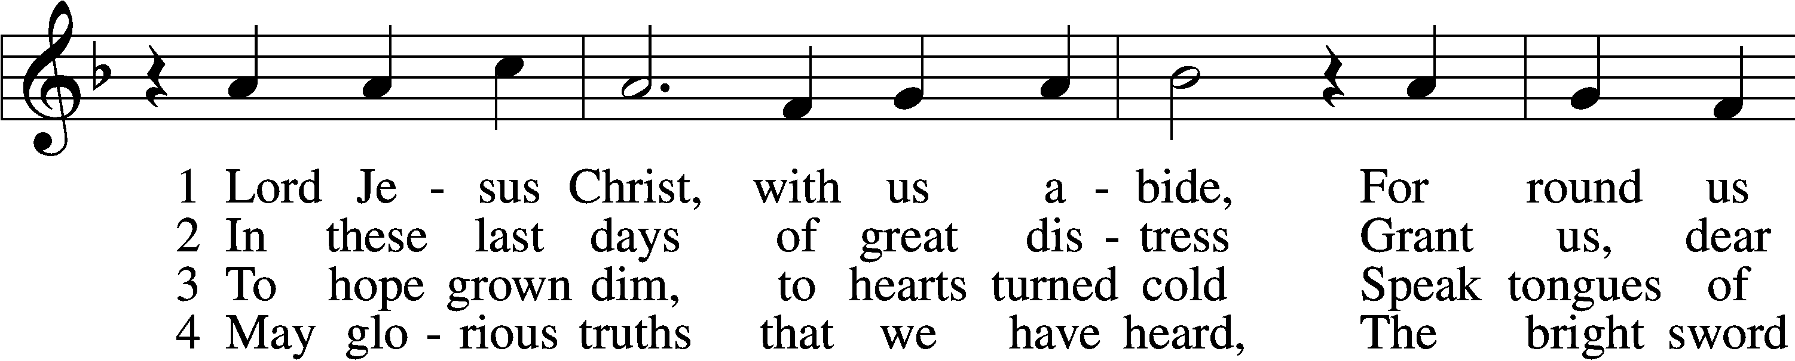

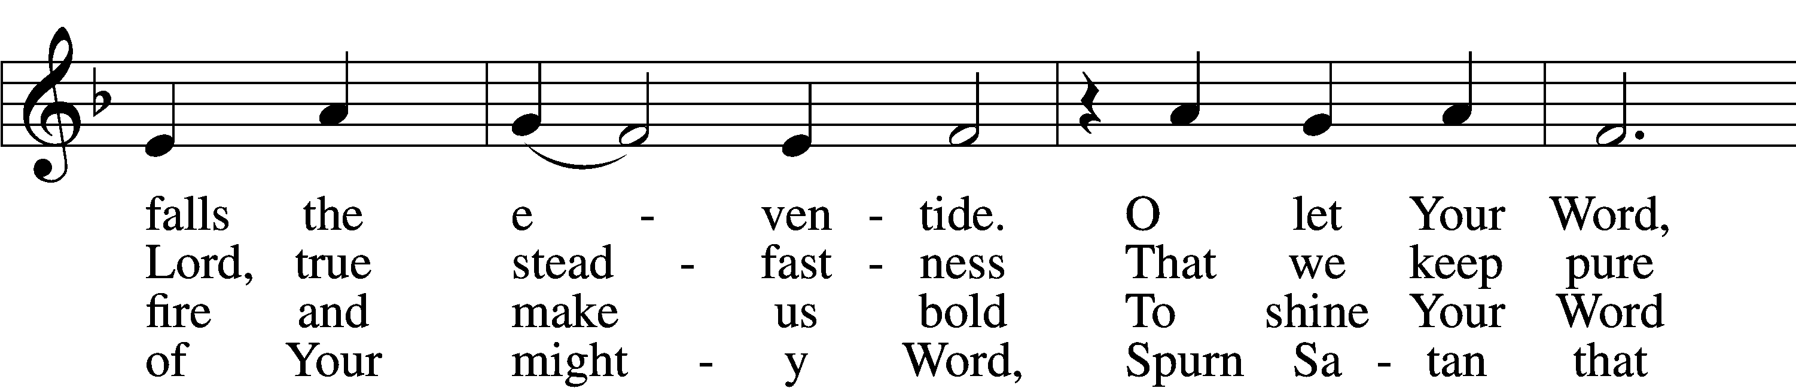

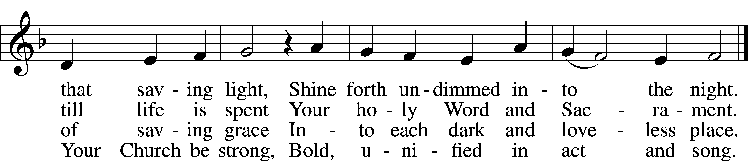

5 Restrain, O Lord, the human pride  
That seeks to thrust Your truth aside  
Or with some man-made thoughts or things  
Would dim the words Your Spirit sings.

6 Stay with us, Lord, and keep us true;  
Preserve our faith our whole life through—  
Your Word alone our heart’s defense,  
The Church’s glorious confidence.

Text: tr. F. Samuel Janzow, 1913–2001, alt.; (st. 1): Philipp Melanchthon, 1497–1560; (st. 1): German version Geistliche Psalmen, 1611, Nuremberg; (sts. 2–6): Nicolaus Selnecker, 1532–92  
Tune: Geistliche Lieder D. Martini Lutheri, 1589, Leipzig  
Text: © 1982 Concordia Publishing House. Used by permission: LSB Hymn License no. 110005011  
Tune: Public domain

Sermon

Votum

P The peace of God, which passes all understanding, keep your hearts and minds in Christ Jesus.

C **Amen.**

Stand

Offertory Psalm 51:10–12

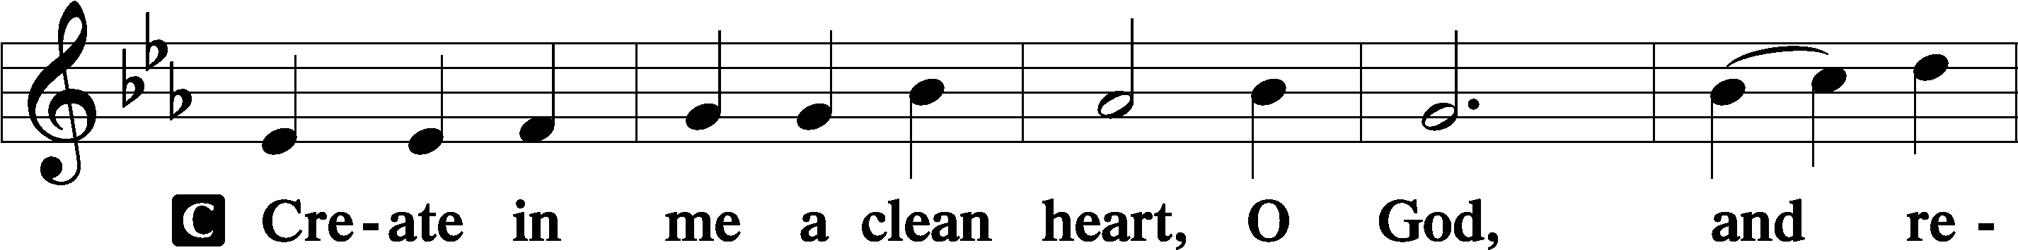

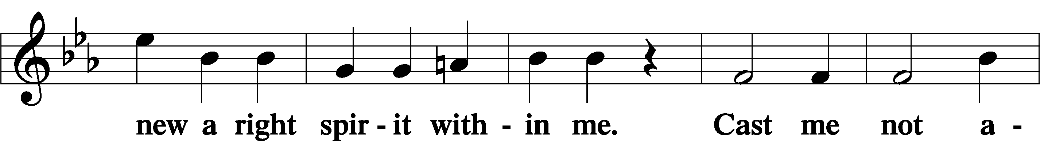

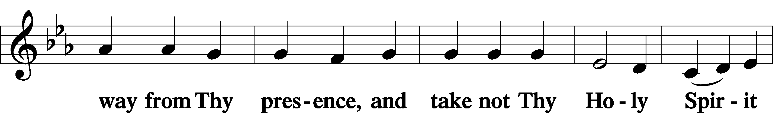

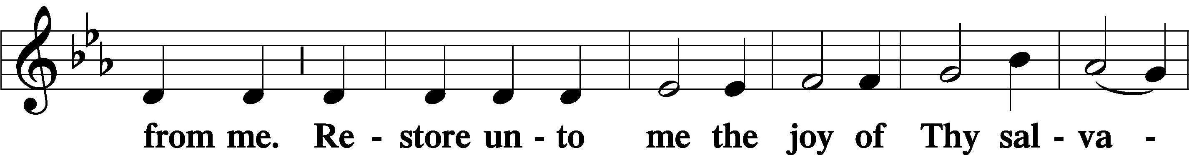

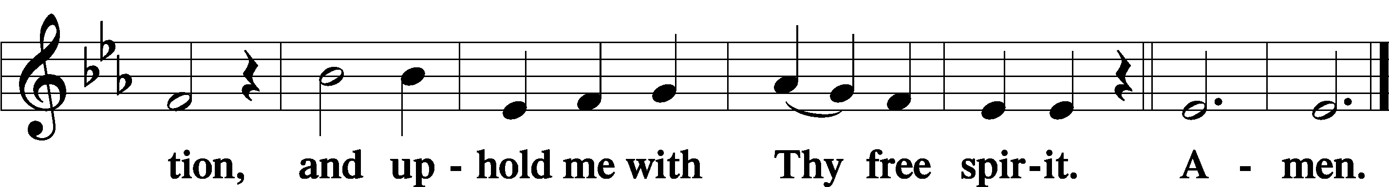

Sit

Offering

805 Praise God, from Whom All Blessings Flow

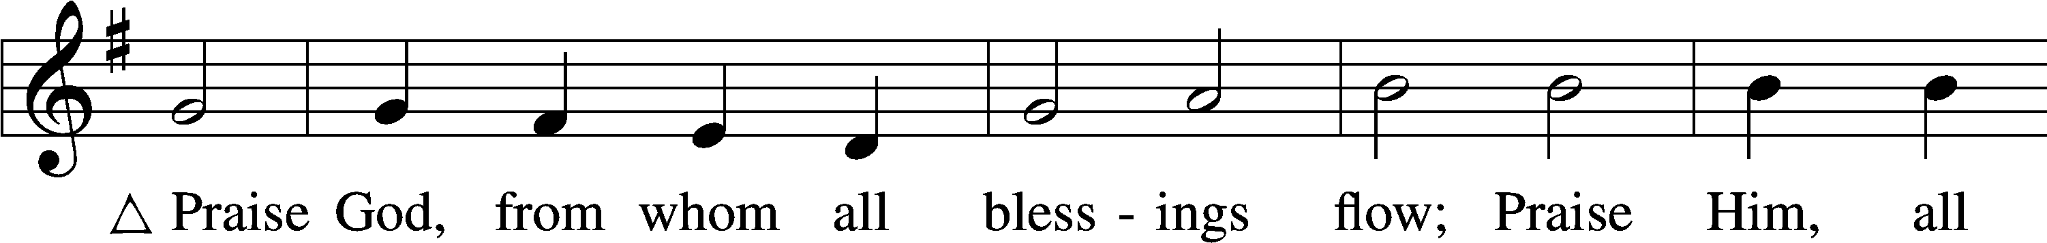

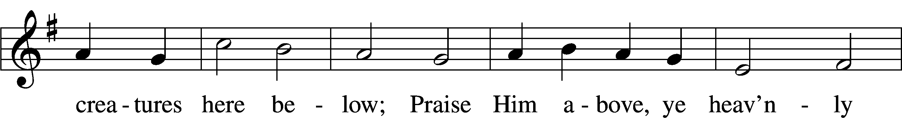

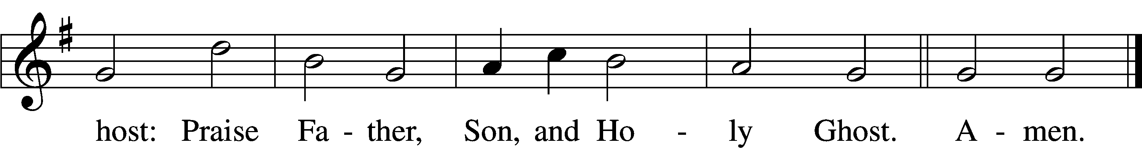

Text: Thomas Ken, 1637–1711  
Tune: Trente quatre Pseaumes de David, 1551, Geneva, ed. Louis Bourgeois  
Text and tune: Public domain

Stand

Prayer of the Church

# Service of the Sacrament

Preface 2 Timothy 4:22; [Colossians 3:1]; [Psalm 136]

P The Lord be with you.

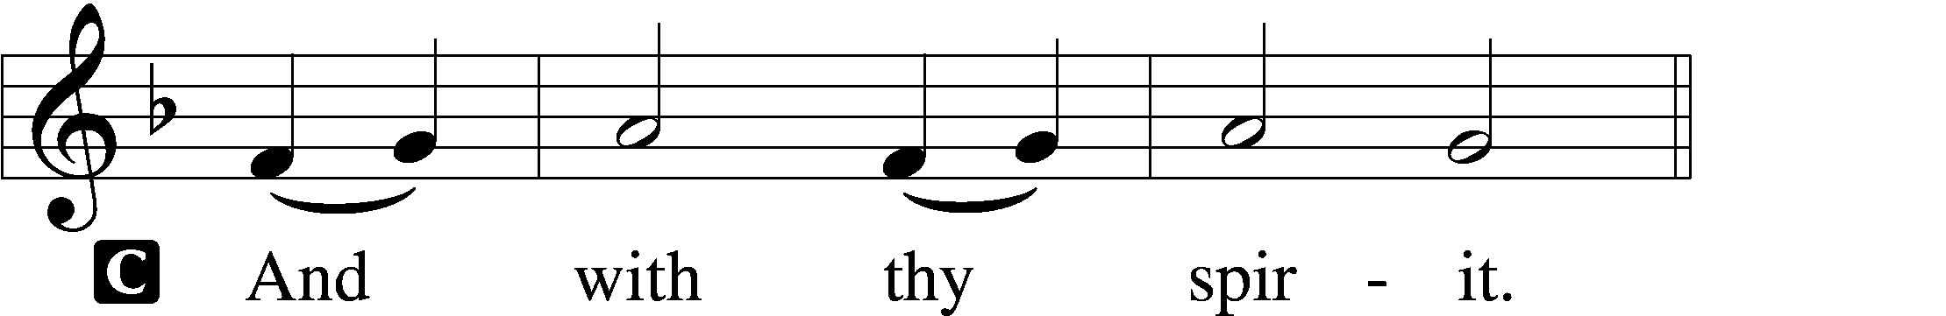

P Lift up your hearts.

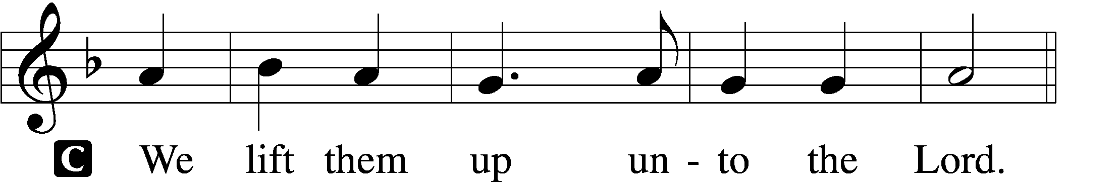

P Let us give thanks unto the Lord, our God.

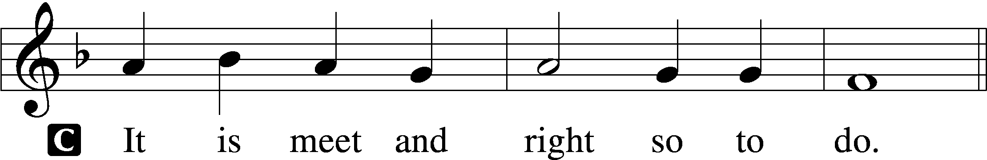

Proper Preface (Full)

P It is truly meet, right, and salutary that we should at all times and in all places give thanks to You, holy Lord, almighty Father, everlasting God, through Jesus Christ, our Lord, who at His transfiguration revealed His glory to His disciples that they might be strengthened to proclaim His cross and resurrection and with all the faithful look forward to the glory of life everlasting. Therefore with angels and archangels and with all the company of heaven we laud and magnify Your glorious name, evermore praising You and saying:

Sanctus Isaiah 6:3; Matthew 21:9

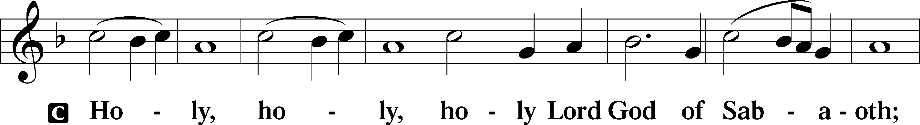

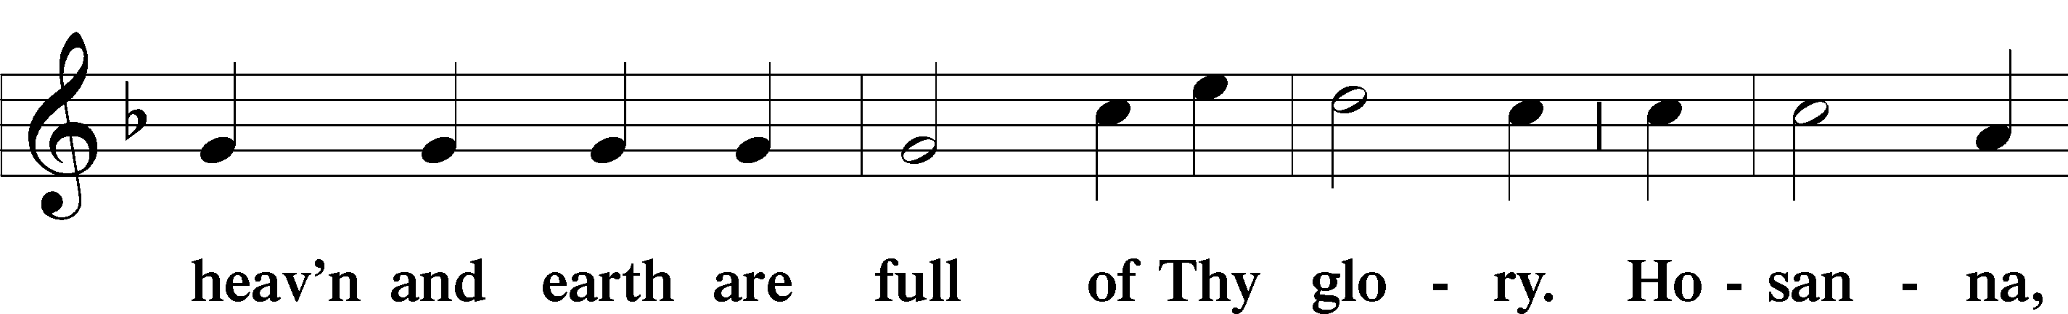

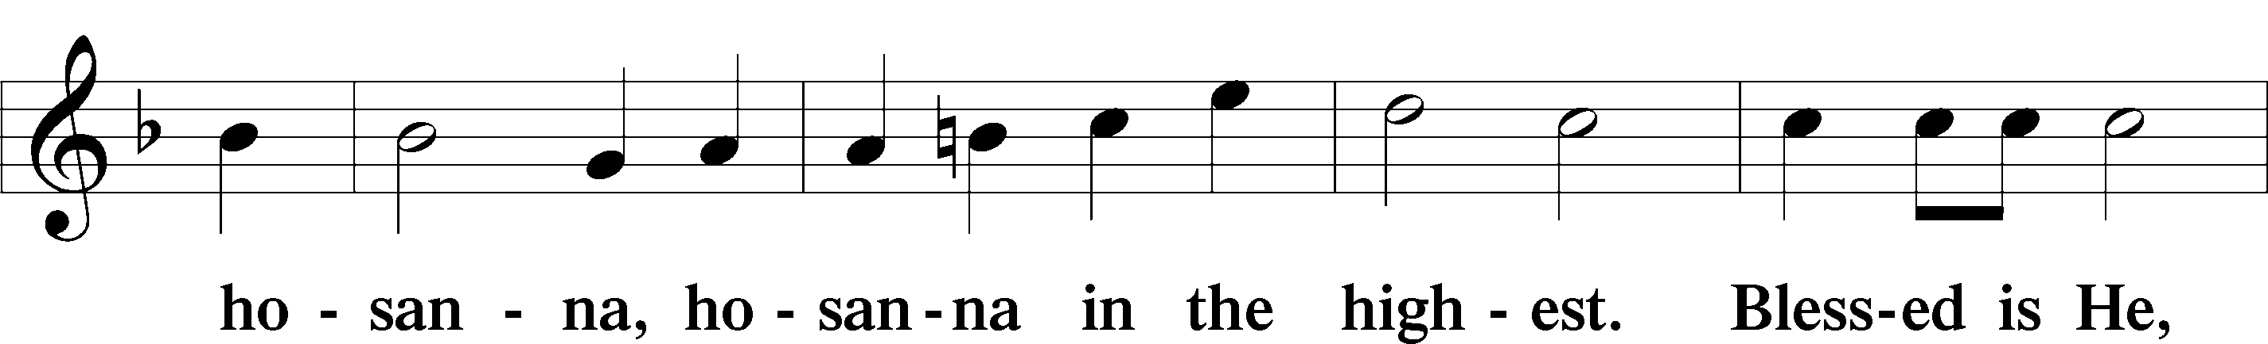

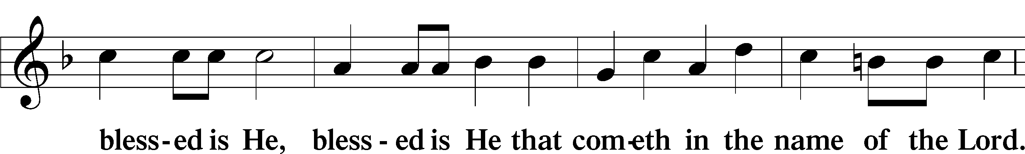

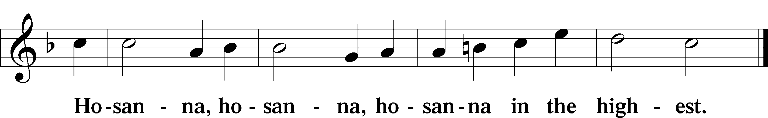

Lord’s Prayer Matthew 6:9–13

P Our Father who art in heaven,

hallowed be Thy name,

Thy kingdom come,

Thy will be done on earth as it is in heaven;

give us this day our daily bread;

and forgive us our trespasses as we forgive those who trespass against us;

and lead us not into temptation,

but deliver us from evil.

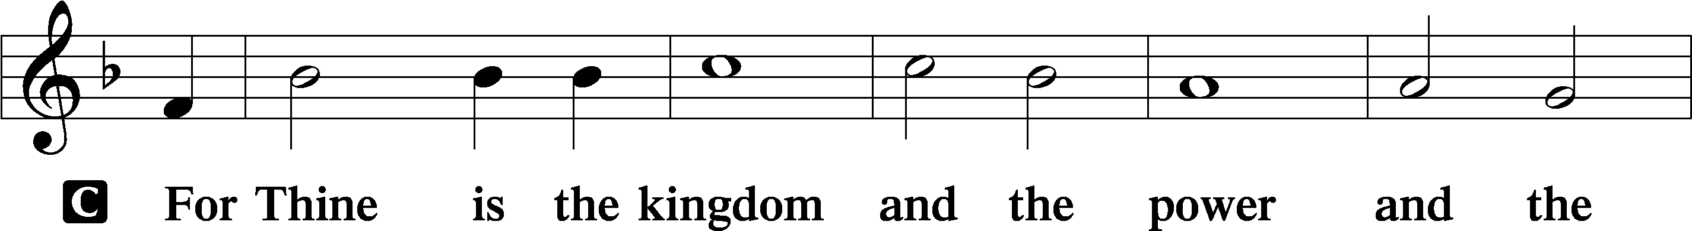

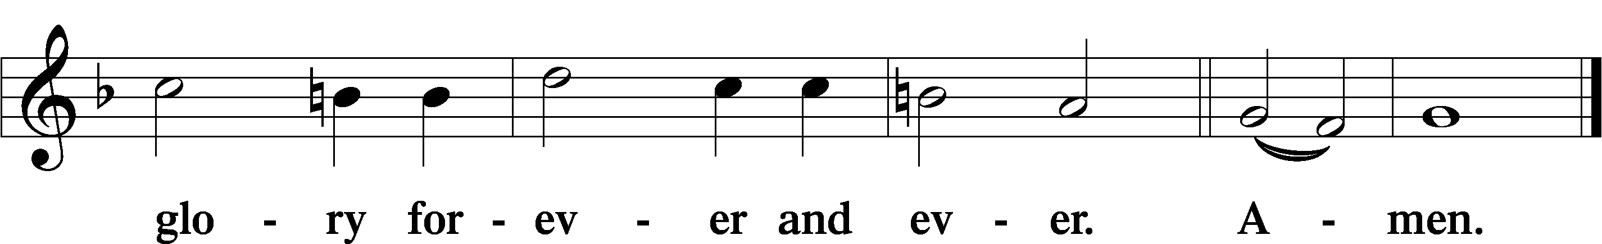

The Words of Our Lord Matthew 26:26–28; Mark 14:22–24; Luke 22:19–20; 1 Corinthians 11:23–25

P Our Lord Jesus Christ, on the night when He was betrayed, took bread, and when He had given thanks, He broke it and gave it to the disciples and said: “Take, eat; this is My T body, which is given for you. This do in remembrance of Me.”

In the same way also He took the cup after supper, and when He had given thanks, He gave it to them, saying: “Drink of it, all of you; this cup is the new testament in My T blood, which is shed for you for the forgiveness of sins. This do, as often as you drink it, in remembrance of Me.”

Pax Domini John 20:19

P The peace of the Lord be with you always.

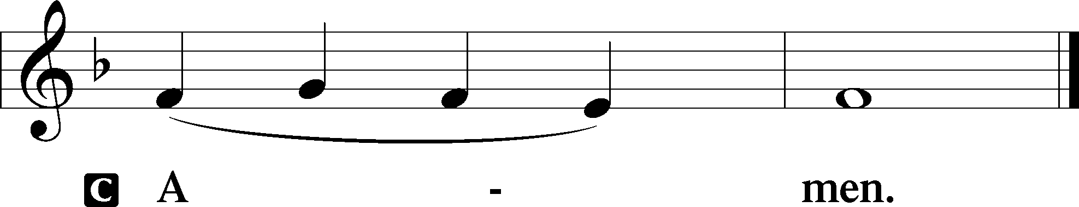

Agnus Dei John 1:29

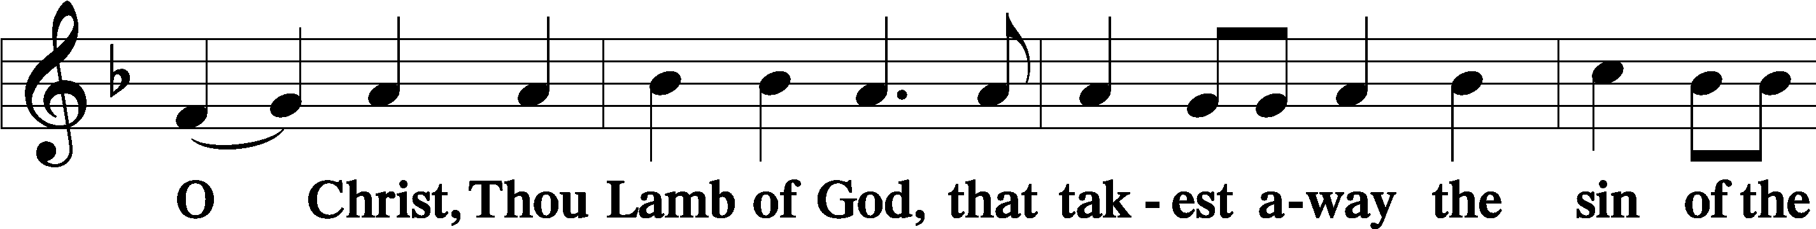

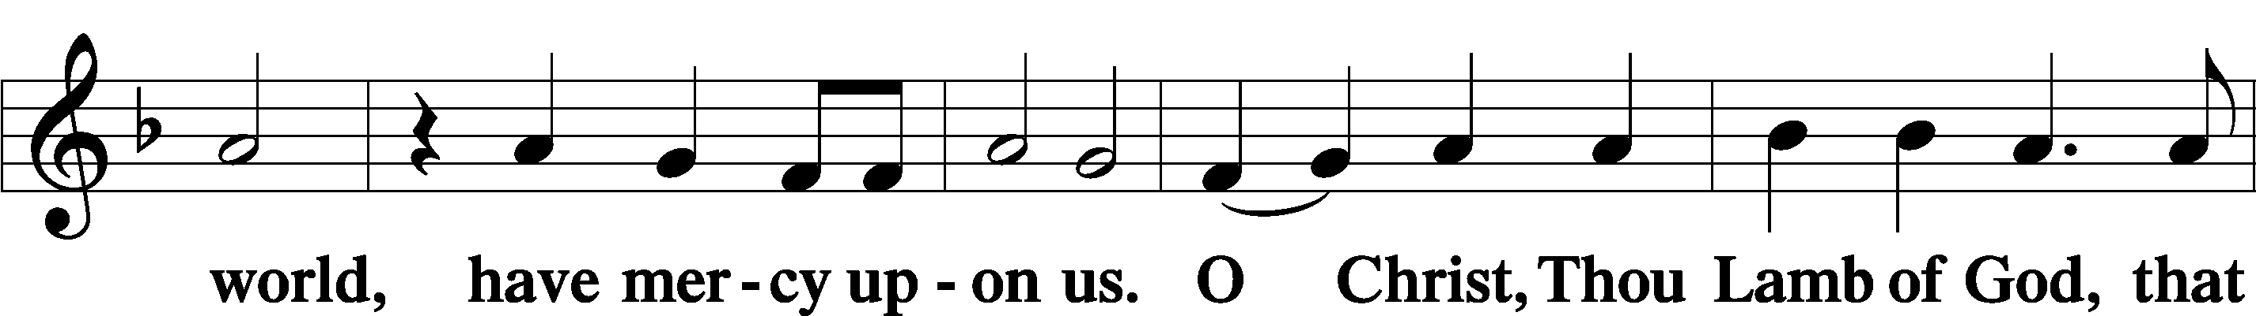

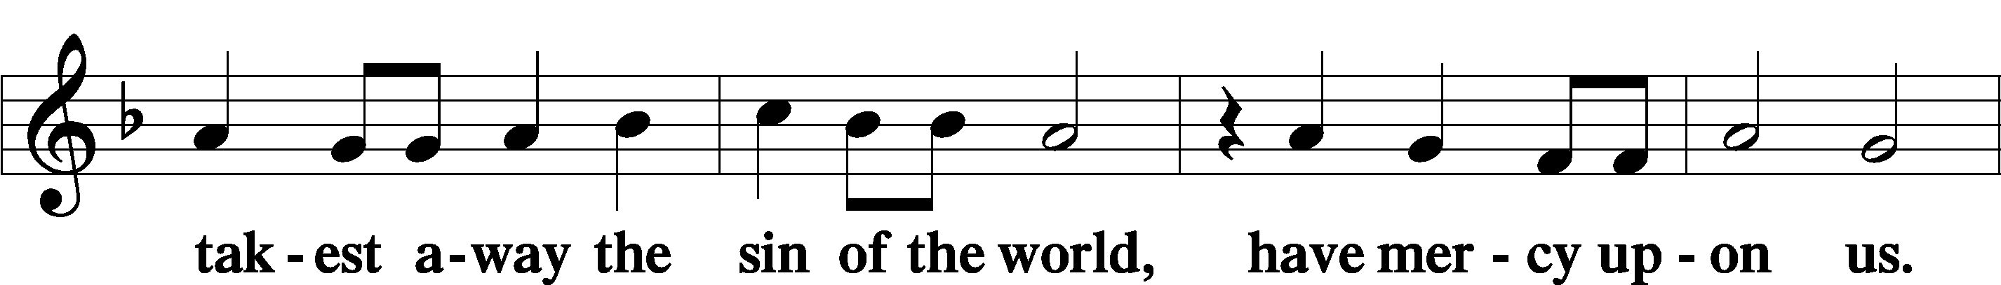

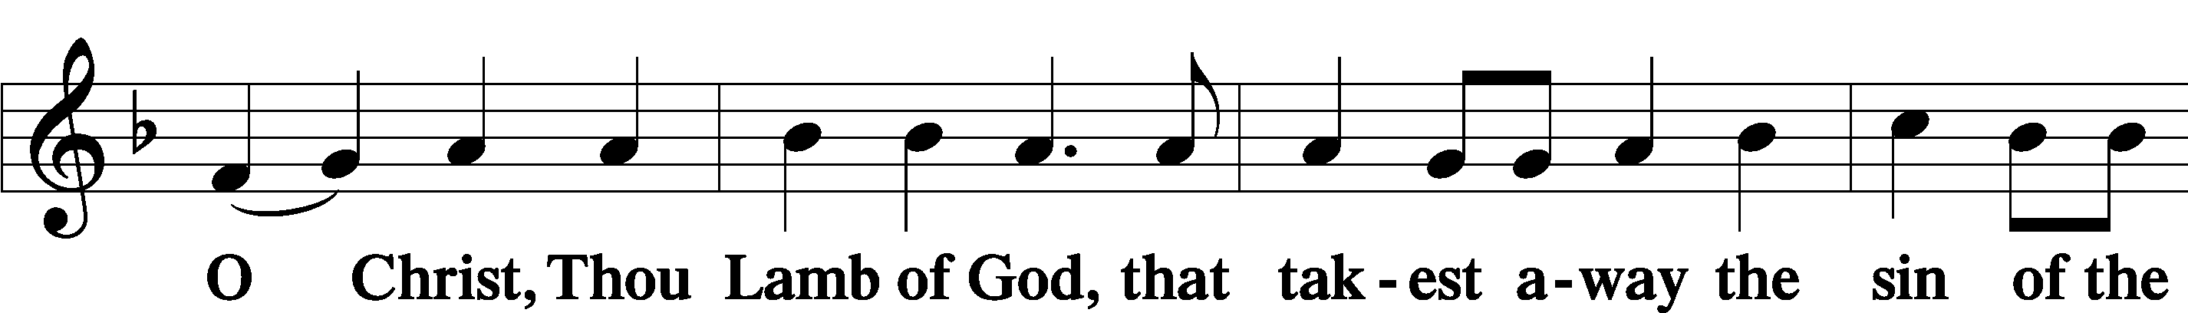

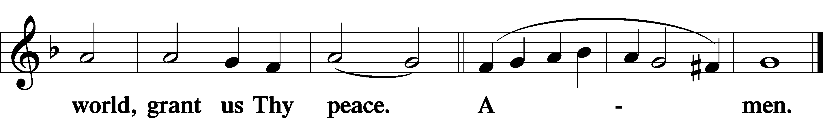

Sit

Distribution

The pastor and those who assist him receive the body and blood of Christ first and then distribute them to those who come to receive, saying:

Take, eat; this is the true body of our Lord and Savior Jesus Christ, given into death for your sins.

**Amen.**

Take, drink; this is the true blood of our Lord and Savior Jesus Christ, shed for the forgiveness of your sins.

**Amen.**

In dismissing the communicants, the following is said:

The Dismissal

P The body and blood of our Lord Jesus Christ strengthen and preserve you in body and soul to life everlasting. Depart T in peace.

C **Amen.**

414 ’Tis Good, Lord, to Be Here

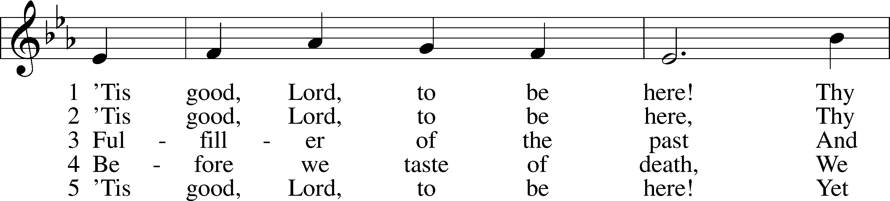

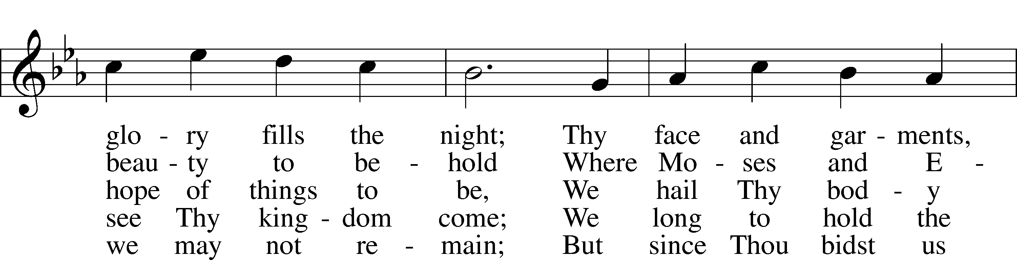

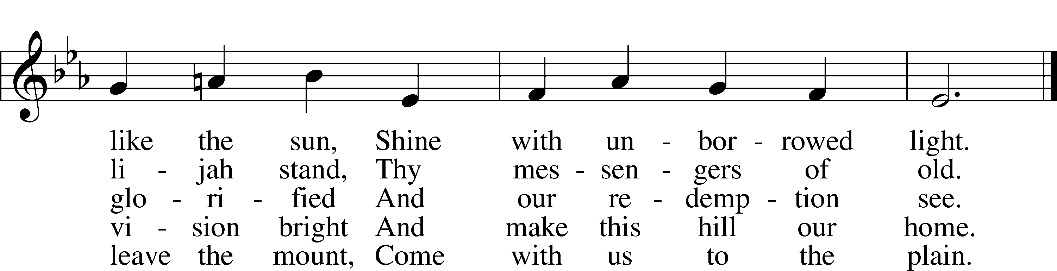

Text: Joseph A. Robinson, 1858–1933, alt.  
Tune: Johann Sebastian Bach, 1685–1750, adapt.  
Text and tune: Public domain

389 Let All Together Praise Our God

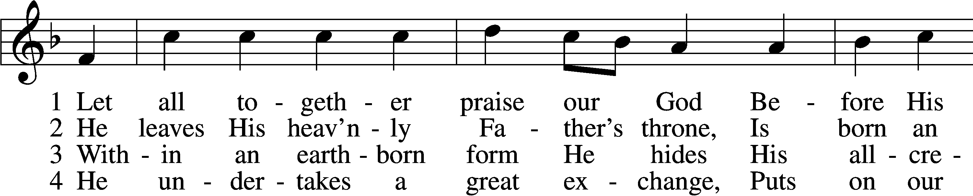

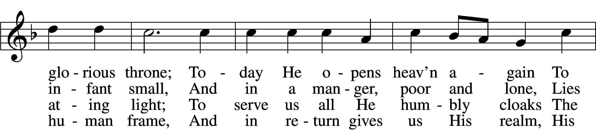

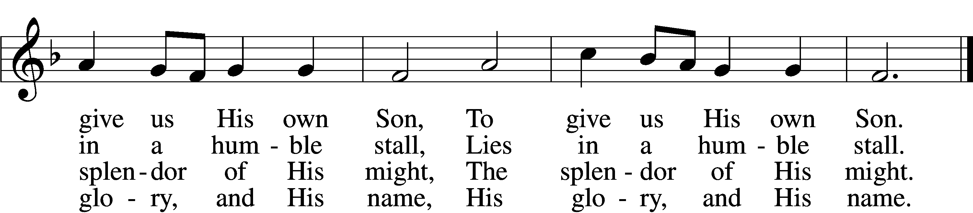

5 He is a servant, I a lord:  
 How great a mystery!  
How strong the tender Christ Child’s love!  
 No truer friend than He,  
 No truer friend than He.

6 He is the key and He the door  
 To blessèd paradise;  
The angel bars the way no more.  
 To God our praises rise,  
 To God our praises rise.

D 7 Your grace in lowliness revealed,  
 Lord Jesus, we adore  
And praise to God the Father yield  
 And Spirit evermore;  
 We praise You evermore.

Text (sts. 1, 3–7): tr. F. Samuel Janzow, 1913–2001; (st. 2): tr. August Crull, 1845–1923, alt.  
Text and tune: Nicolaus Herman, c. 1480–1561  
Text (sts. 1, 3–7): © 1969 Concordia Publishing House. Used by permission: LSB Hymn License no. 110005011  
Text (st. 2) and tune: Public domain

821 Alleluia! Sing to Jesus

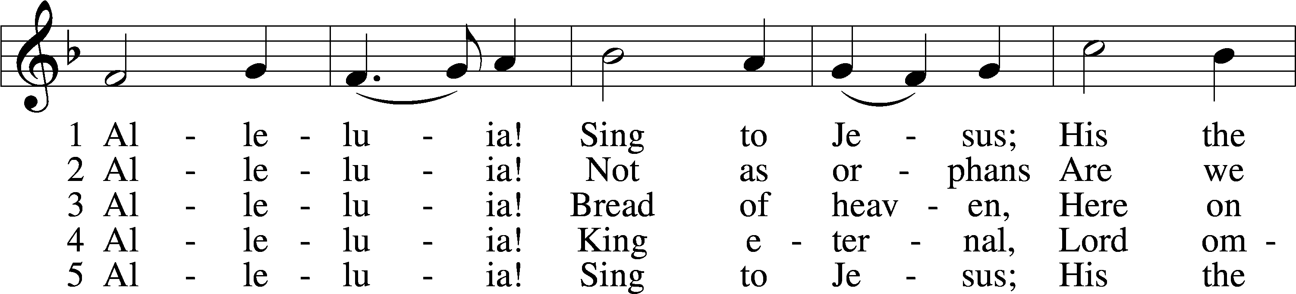

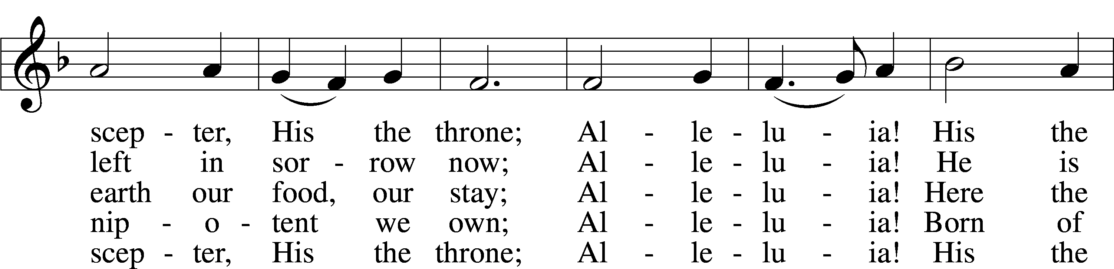

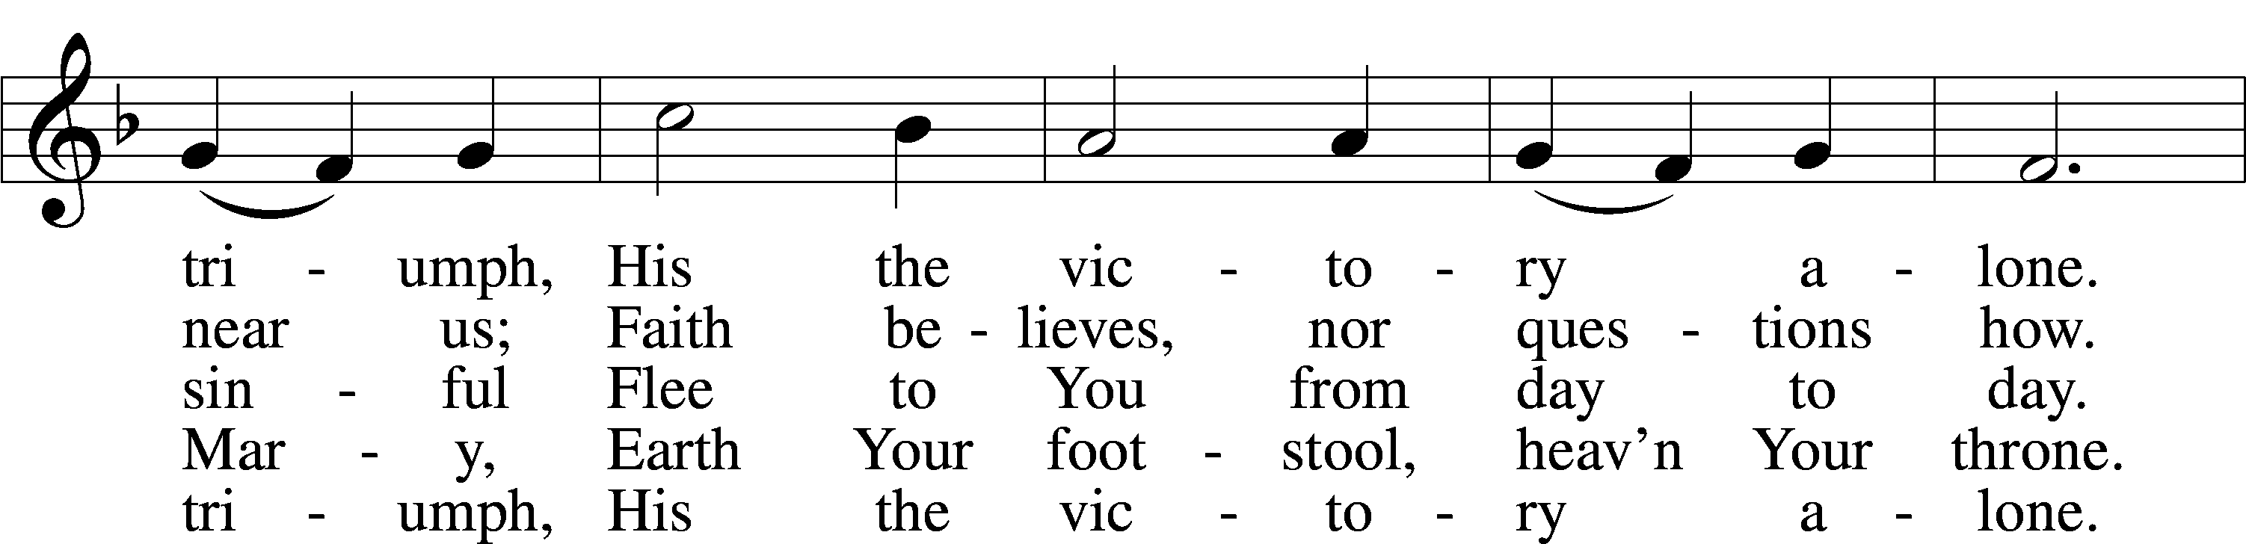

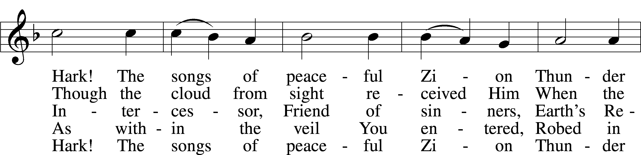

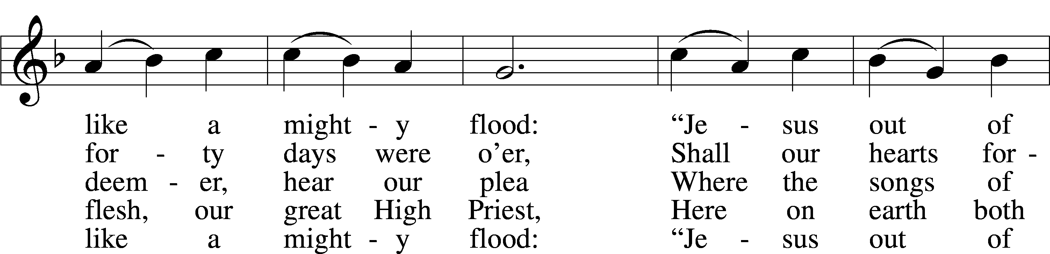

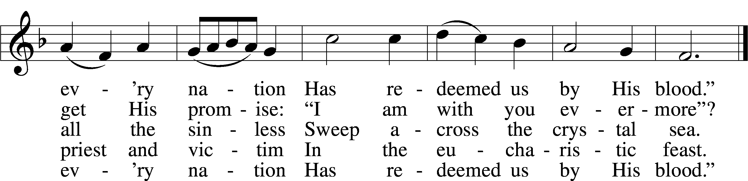

Text: William C. Dix, 1837–98, alt.  
Tune: Rowland H. Prichard, 1811–87  
Text and tune: Public domain

617 O Lord, We Praise Thee

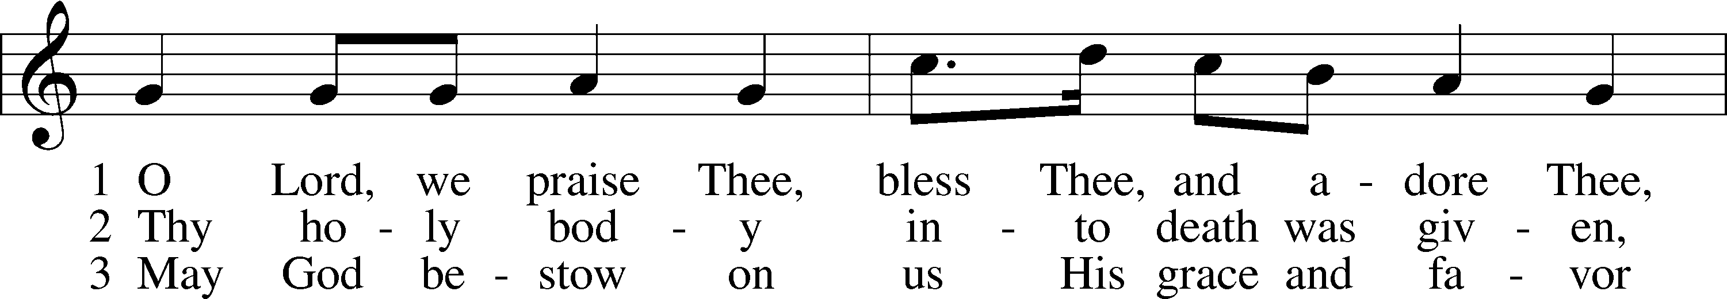

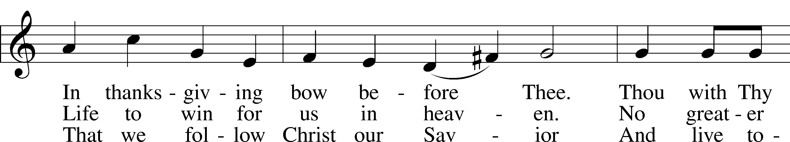

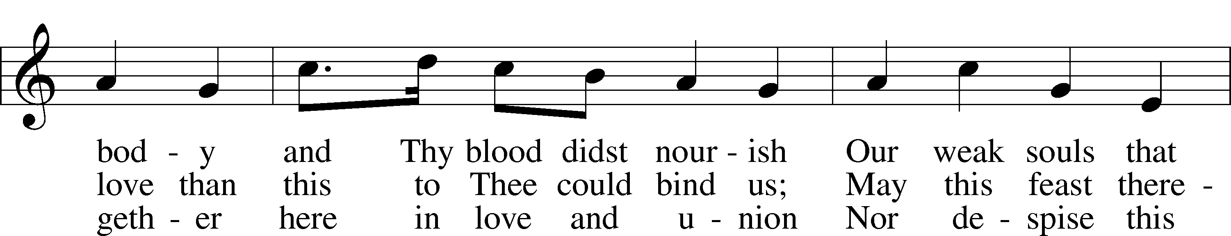

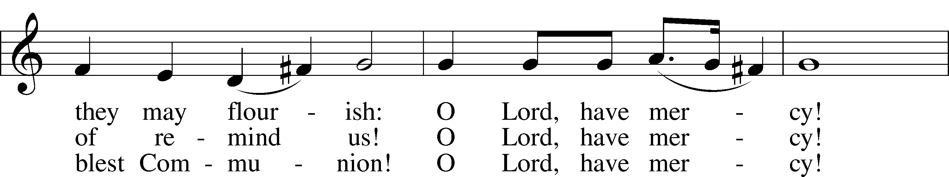

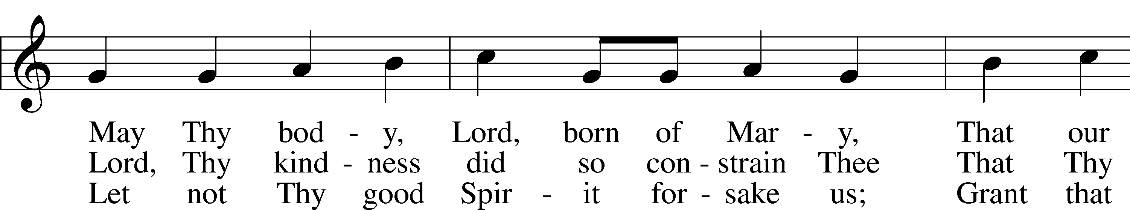

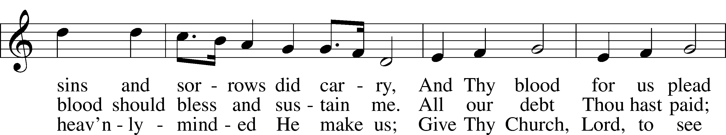

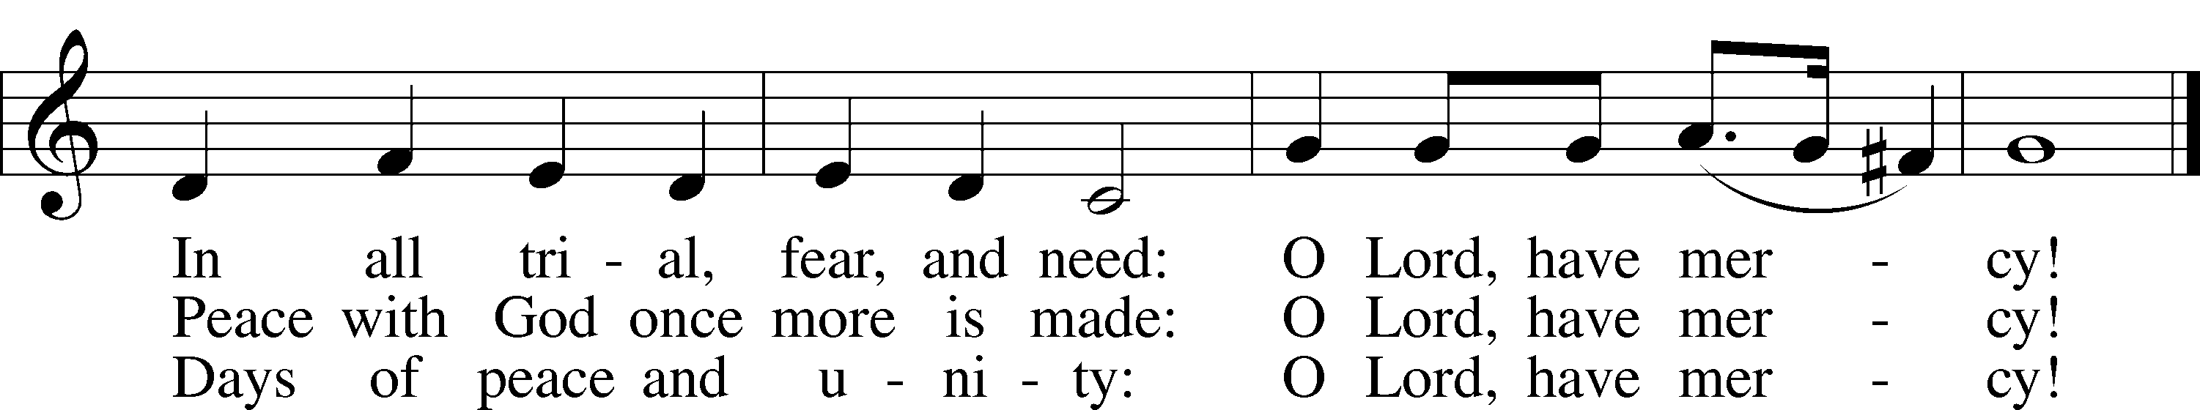

Text: tr. The Lutheran Hymnal, 1941, alt.; (st. 1): German, 14th cent.; (sts. 2–3): Martin Luther, 1483–1546  
Tune: Geystliche gesangk Buchleyn, 1524, Wittenberg, ed. Johann Walter  
Text: © 1941 Concordia Publishing House. Used by permission: LSB Hymn License no. 110005011  
Tune: Public domain

Stand

Nunc Dimittis Luke 2:29–32

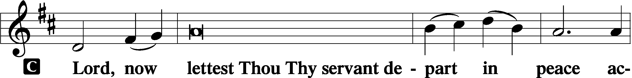

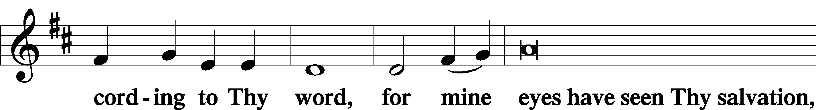

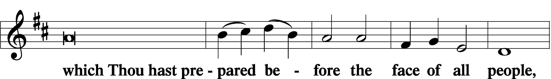

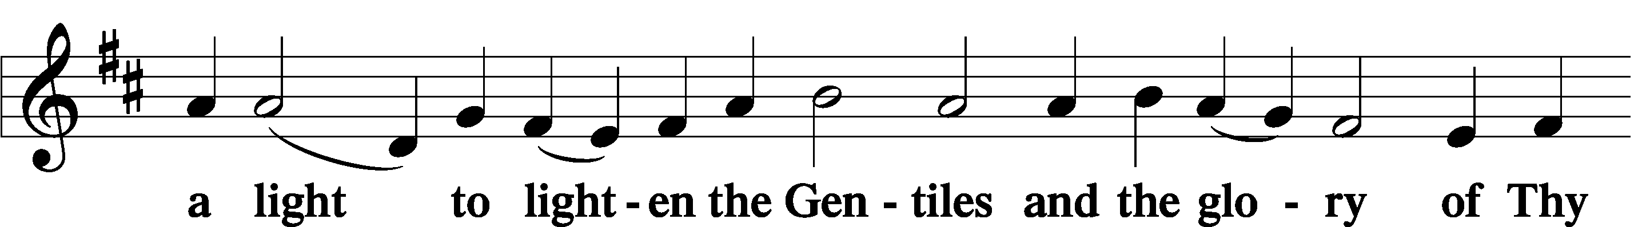

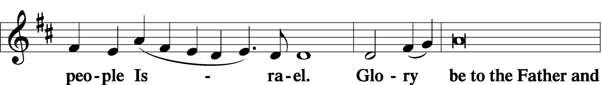

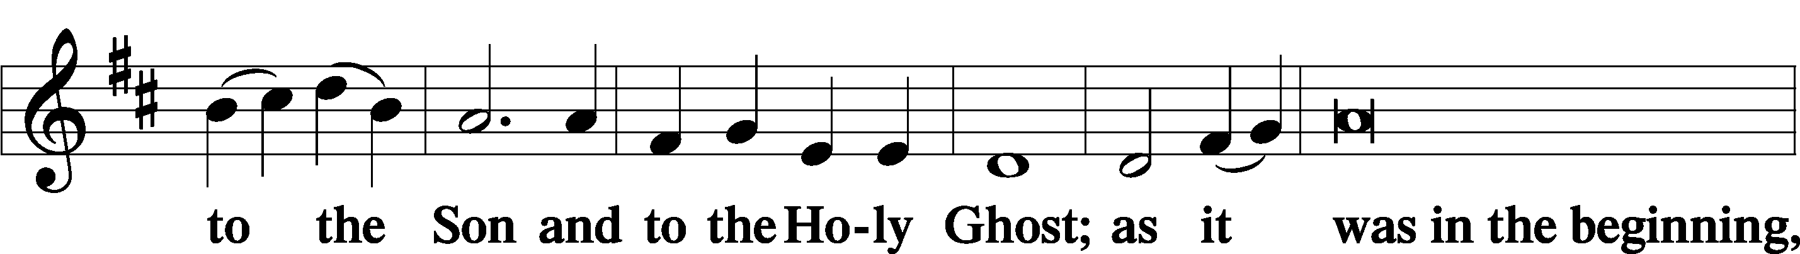

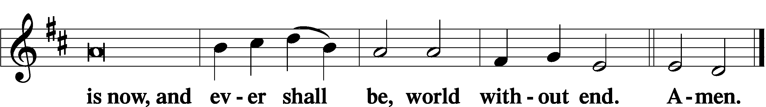

Thanksgiving Psalm 107:1

A O give thanks unto the Lord, for He is good,

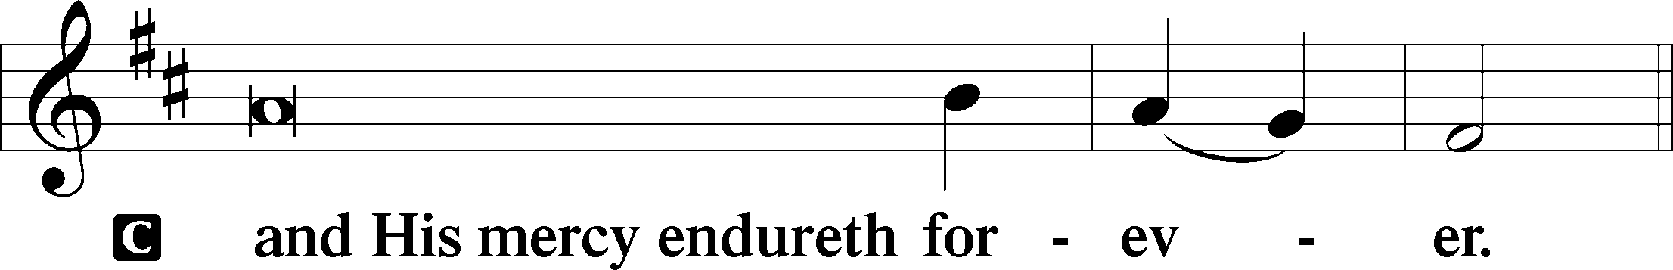

Post-Communion Collect

A Let us pray.

We give thanks to You, almighty God, that You have refreshed us through this salutary gift, and we implore You that of Your mercy You would strengthen us through the same in faith toward You and in fervent love toward one another; through Jesus Christ, Your Son, our Lord, who lives and reigns with You and the Holy Spirit, one God, now and forever.

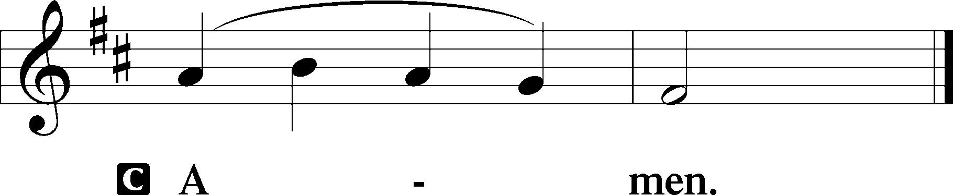

Salutation 2 Timothy 4:22

P The Lord be with you.

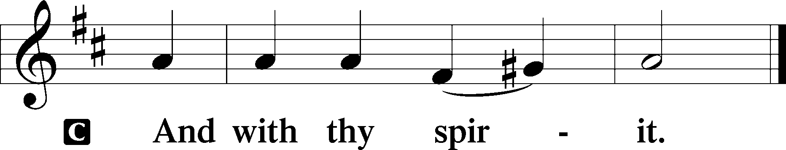

Benedicamus Psalm 103:1

A Bless we the Lord.

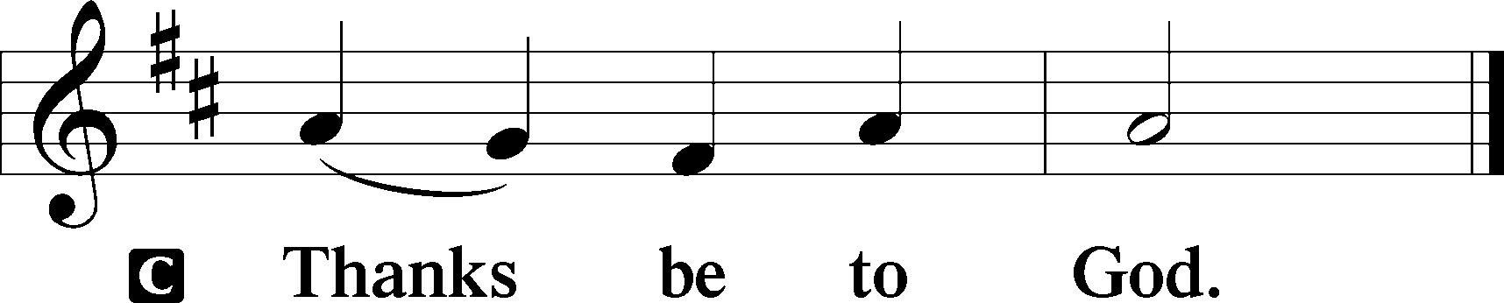

Benediction Numbers 6:24–26

P The Lord bless you and keep you.

The Lord make His face shine upon you and be gracious unto you.

The Lord lift up His countenance upon you and T give you peace.

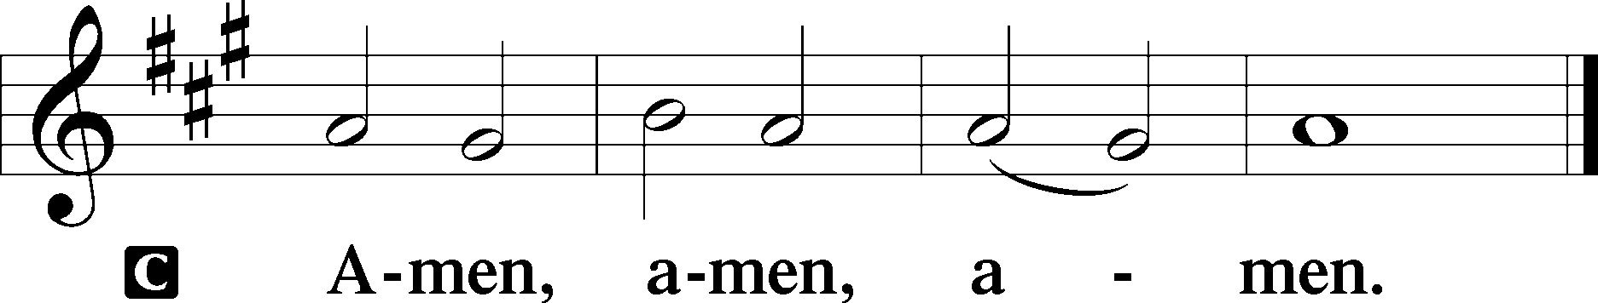

798 The God of Abraham Praise sts. 6–9

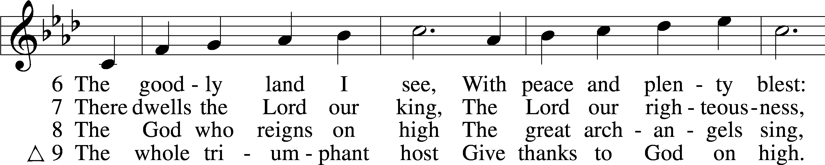

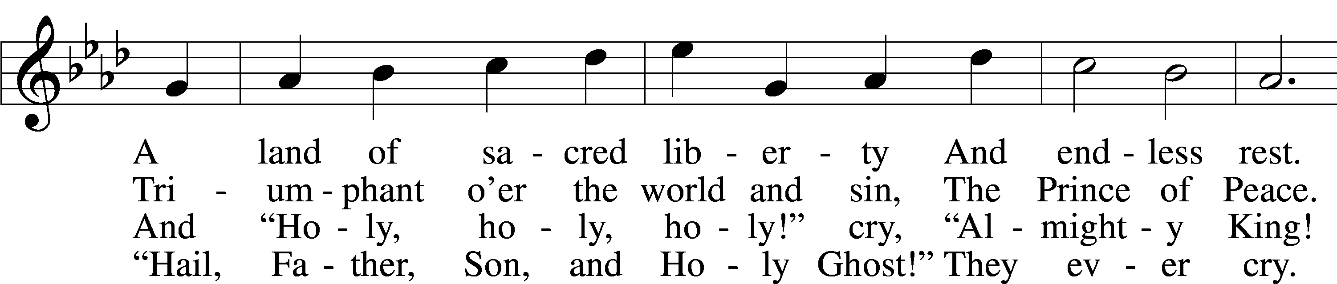

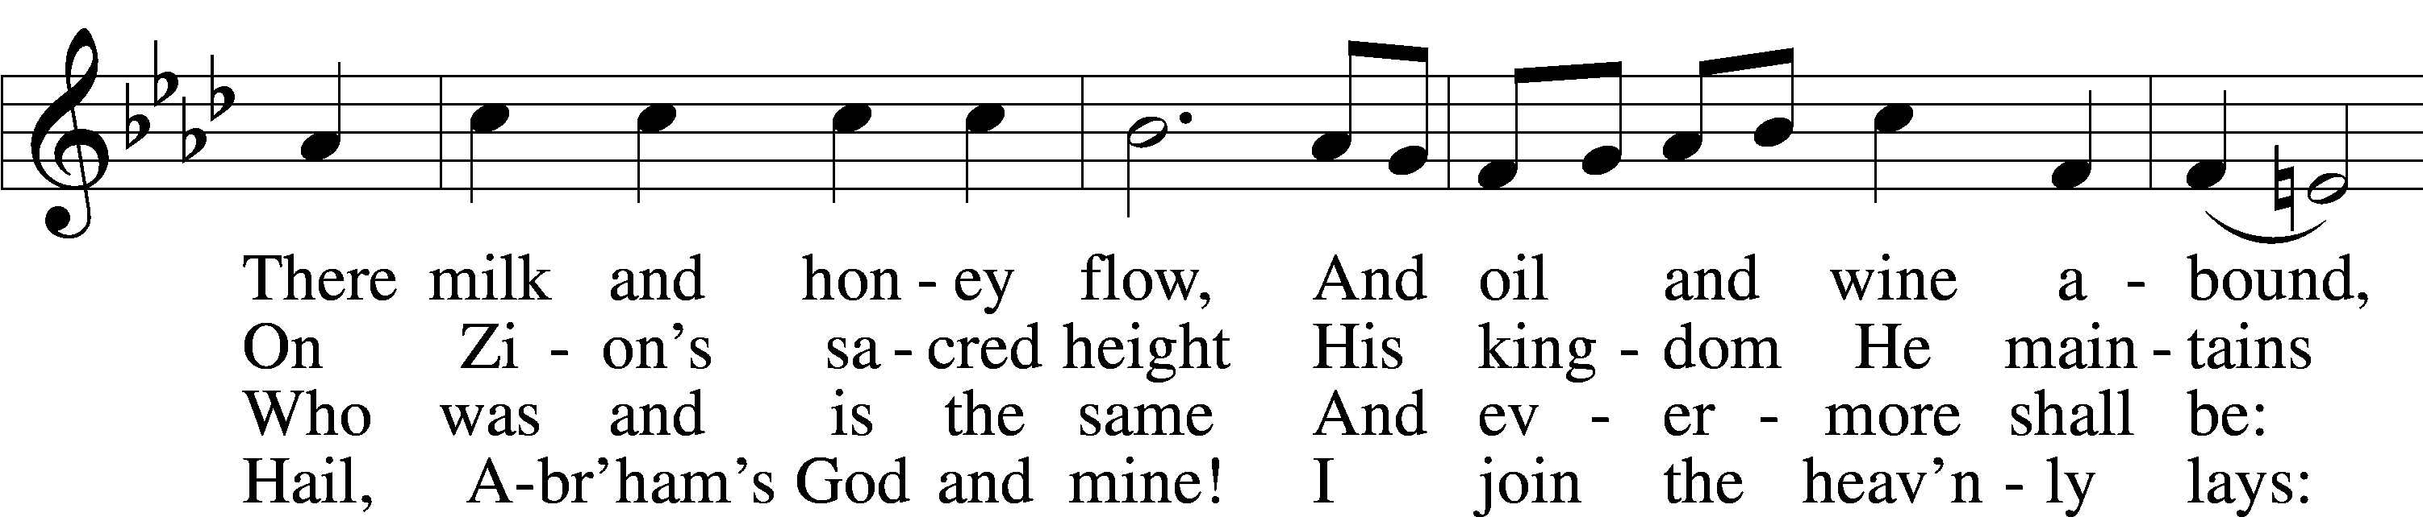

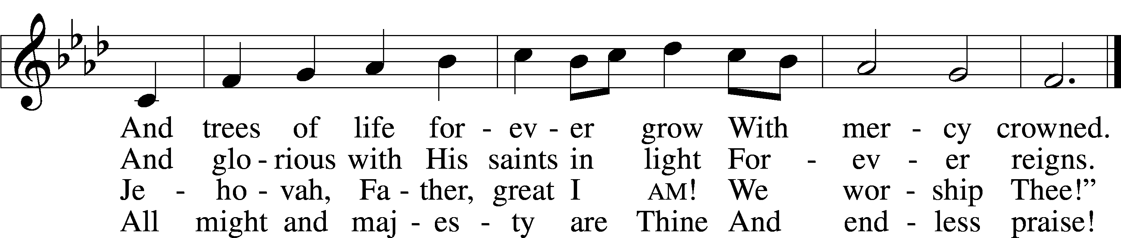

Text: Thomas Olivers, 1725–99, alt.  
Tune: Hebrew  
Text and tune: Public domain

Acknowledgments

Divine Service, Setting Three from Lutheran Service Book

Unless otherwise indicated, Scripture quotations are from the ESV® Bible (The Holy Bible, English Standard Version®), copyright © 2001 by Crossway, a publishing ministry of Good News Publishers. Used by permission. All rights reserved.

Created by Lutheran Service Builder © 2025 Concordia Publishing House.