On entering the church

P Lord, I love the habitation of Your house and the place
where Your glory dwells. In the multitude of Your tender
mercies prepare my heart that I may enter Your house to
worship and confess Your holy name; through Jesus Christ,
my God and Lord.

Before worship

C O Lord, our creator, redeemer, and comforter, as we come
together to worship You in spirit and in truth, we humbly
pray that You would open our hearts to the preaching of
Your Word so that we may repent of our sins, believe in
Jesus Christ as our only Savior, and grow in grace and
holiness. Hear us for His sake.

370 What Child Is This
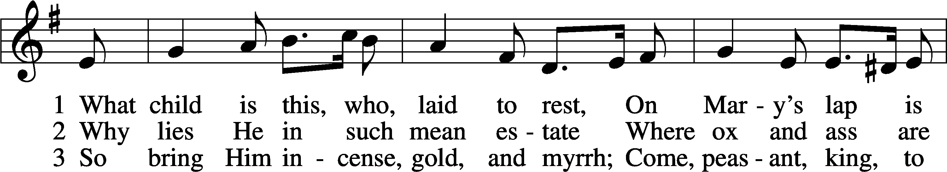
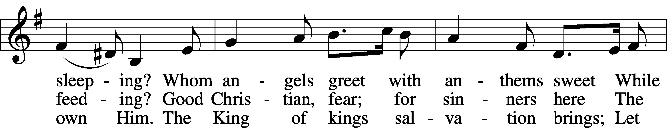
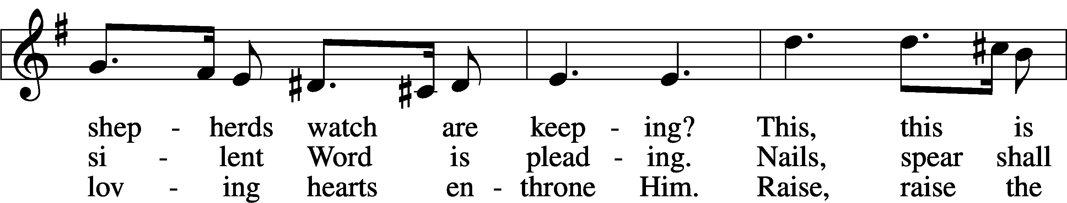
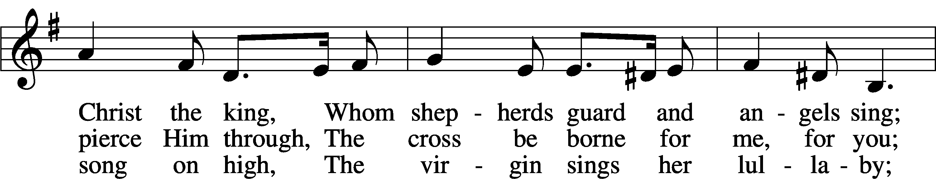
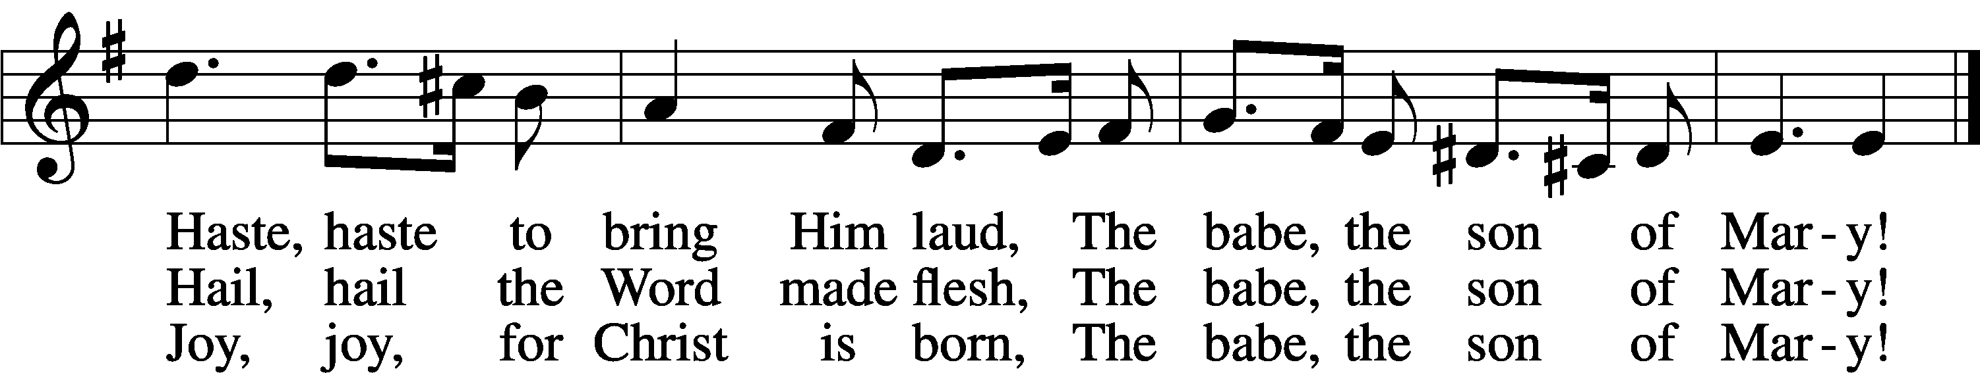
Text: William C. Dix, 1837–98
Tune: English, 16th cent.
Text and tune: Public domain

Confession and Absolution

The sign of the cross may be made by all in remembrance of their Baptism.

Invocation Matthew 28:19b; 18:20
P In the name of the Father and of the T Son and of the Holy Spirit.
C Amen.

Exhortation Hebrews 10:22; Psalm 124:8; Psalm 32:5
P Beloved in the Lord! Let us draw near with a true heart and confess our sins unto God our Father, beseeching Him in the name of our Lord Jesus Christ to grant us forgiveness.

P Our help is in the name of the Lord,
C who made heaven and earth.
P I said, I will confess my transgressions unto the Lord,
C and You forgave the iniquity of my sin.

Silence for reflection on God’s Word and for self-examination.

Confession of Sins
P Almighty God, our maker and redeemer, we poor sinners confess unto You that we are by nature sinful and unclean and that we have sinned against You by thought, word, and deed. Wherefore we flee for refuge to Your infinite mercy, seeking and imploring Your grace for the sake of our Lord Jesus Christ.
C O most merciful God, who has given Your only-begotten Son to die for us, have mercy upon us and for His sake grant us remission of all our sins; and by Your Holy Spirit increase in us true knowledge of You and of Your will and true obedience to Your Word, to the end that by Your grace we may come to everlasting life; through Jesus Christ, our Lord. Amen.

Declaration of Grace Mark 16:16; John 1:12
P Almighty God, our heavenly Father, has had mercy upon us and has given His only Son to die for us and for His sake forgives us all our sins. To those who believe on His name He gives power to become the children of God and has promised them His Holy Spirit. He that believes and is baptized shall be saved.
Grant this, Lord, unto us all.
C Amen.

Service of the Word

Introit Psalm 31:1, 3, 5; antiphon: Revelation 7:14b
These are the ones coming out of the great tribulation.
They have washed their robes and made them white in the blood of the Lamb.
In you, O Lord, do I take refuge; let me never be put to shame;
in your righteousness deliver me.
For you are my rock and my fortress;
and for your name’s sake you lead me and guide me.
Into your hand I commit my spirit;
you have redeemed me, O Lord, faithful God.

Gloria Patri
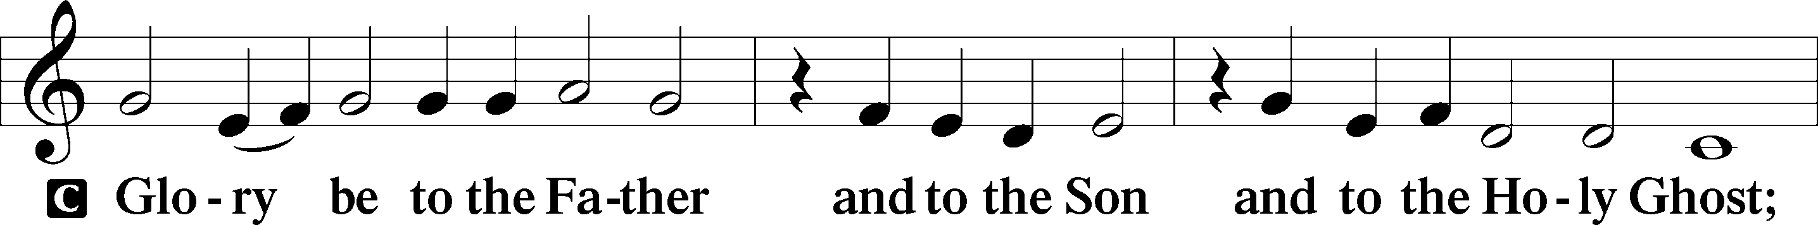
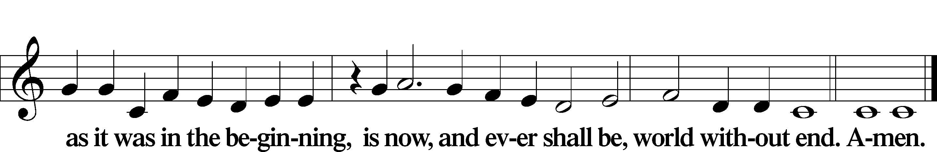

Kyrie Mark 10:47
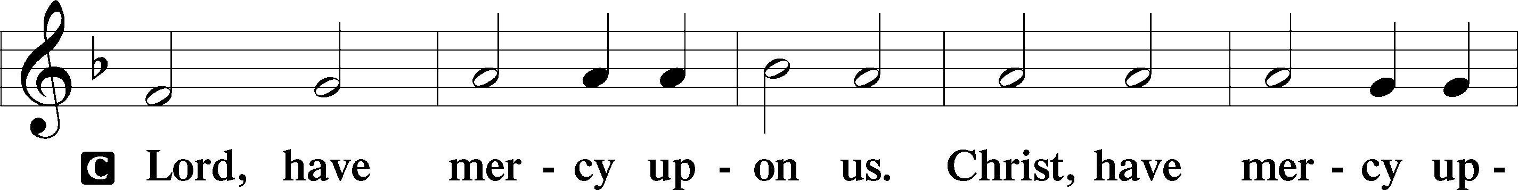
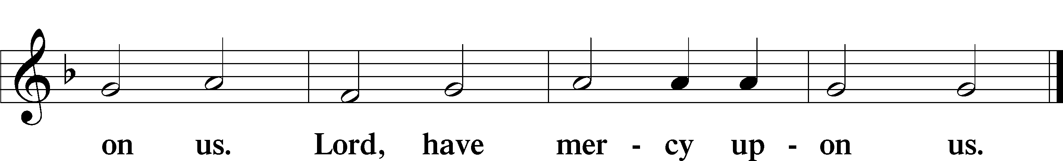

Gloria in Excelsis Luke 2:14; John 1:29
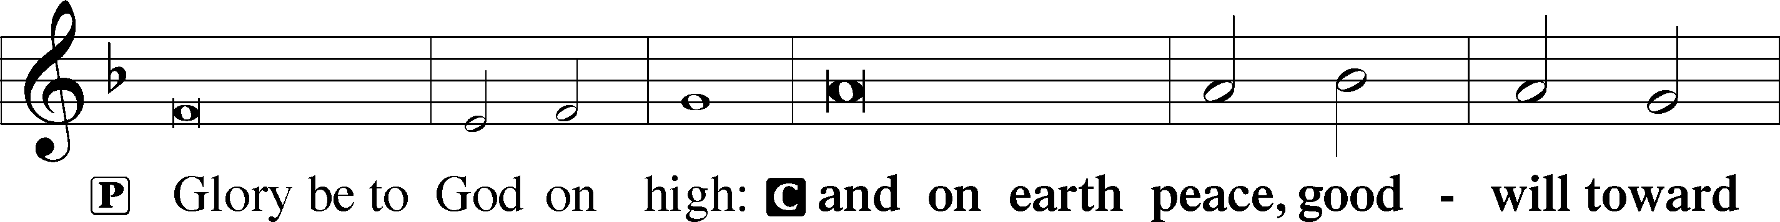
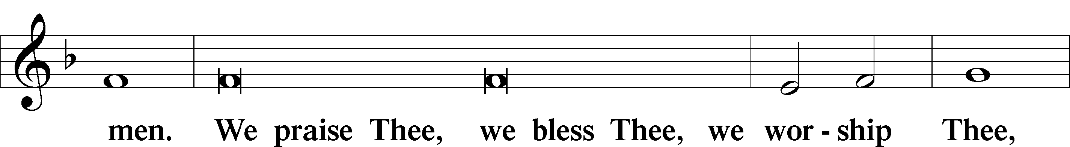
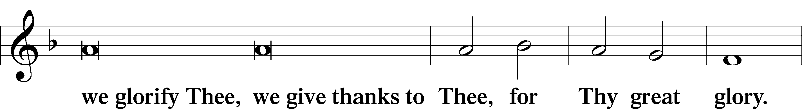
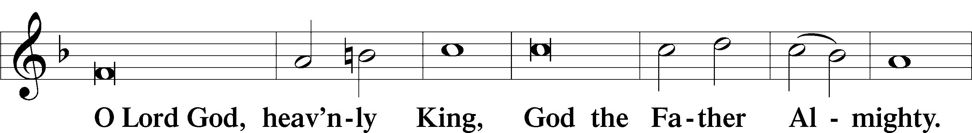
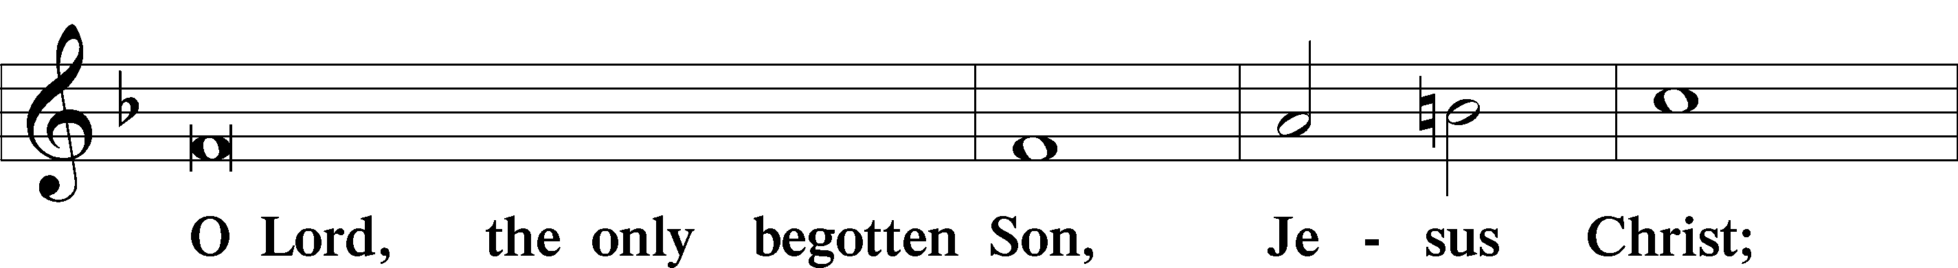
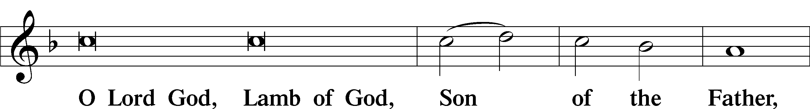
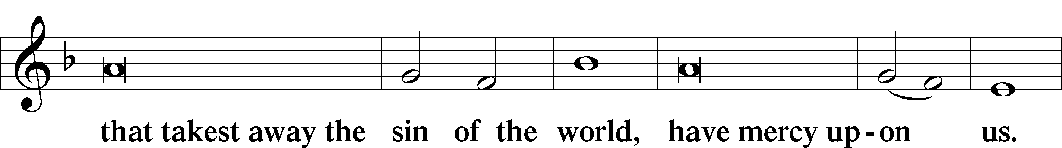
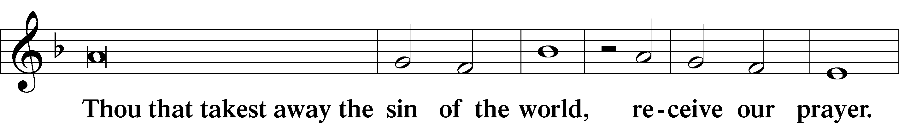
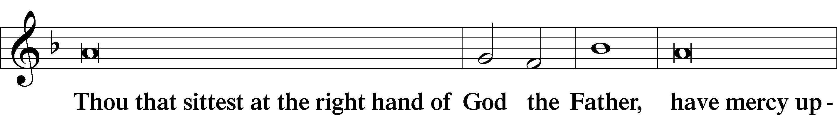
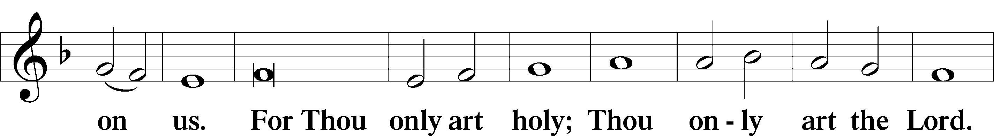
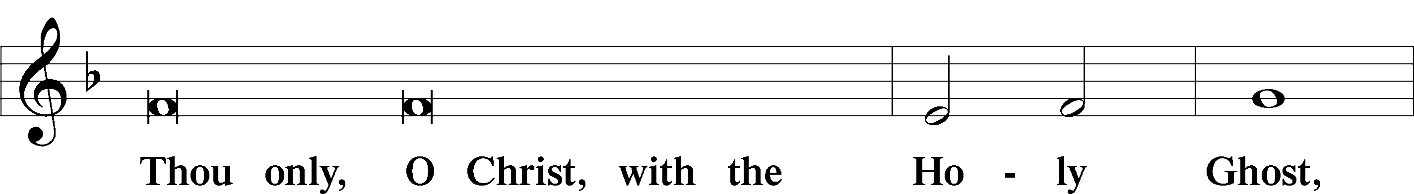
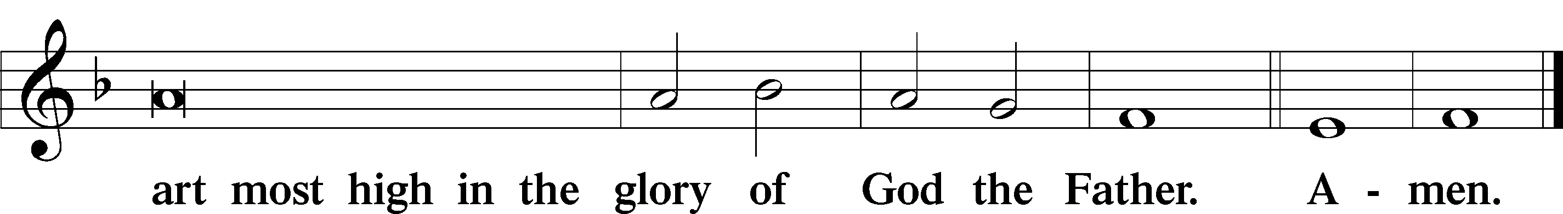

Salutation and Collect of the Day
P The Lord be with you.
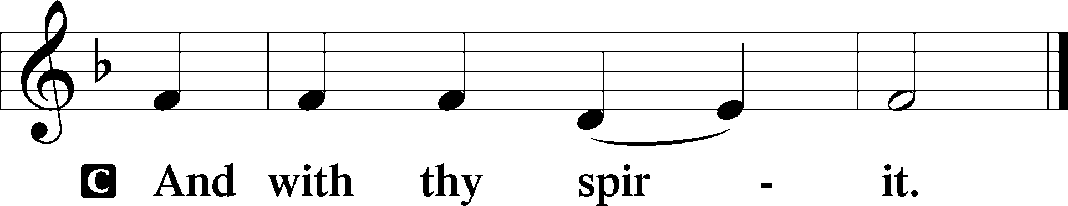

P Let us pray.
Almighty God, the martyred innocents of Bethlehem showed forth Your praise not by speaking but by dying. Put to death in us all that is in conflict with Your will that our lives may bear witness to the faith we profess with our lips; through Jesus Christ, our Lord, who lives and reigns with You and the Holy Spirit, one God, now and forever.

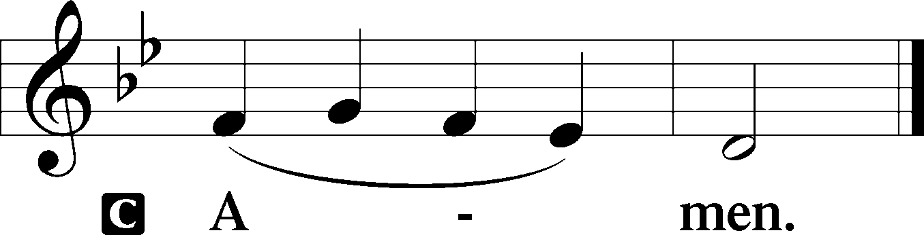

Sit

Old Testament Reading Jeremiah 31:15–17
15Thus says the Lord:
“A voice is heard in Ramah,
lamentation and bitter weeping.
Rachel is weeping for her children;
she refuses to be comforted for her children,
because they are no more.”
16Thus says the Lord:
“Keep your voice from weeping,
and your eyes from tears,
for there is a reward for your work,
declares the Lord,
and they shall come back from the land of the enemy.
17There is hope for your future,
declares the Lord,
and your children shall come back to their own country.”

A This is the Word of the Lord.
C Thanks be to God.

Gradual Psalm 71:4a, 5a, 6a, b, 8
Rescue me, O my God, from the hand of the wicked.
For you, O Lord, are my hope.
Upon you have I leaned from before my birth;
you are he who took me from my mother’s womb.
My mouth is filled with your praise,
and with your glory all the day.

Epistle Revelation 14:1–5
1Then I looked, and behold, on Mount Zion stood the Lamb, and with him 144,000 who had his name and his Father’s name written on their foreheads. 2And I heard a voice from heaven like the roar of many waters and like the sound of loud thunder. The voice I heard was like the sound of harpists playing on their harps, 3and they were singing a new song before the throne and before the four living creatures and before the elders. No one could learn that song except the 144,000 who had been redeemed from the earth. 4It is these who have not defiled themselves with women, for they are virgins. It is these who follow the Lamb wherever he goes. These have been redeemed from mankind as firstfruits for God and the Lamb, 5and in their mouth no lie was found, for they are blameless.

Stand

Alleluia
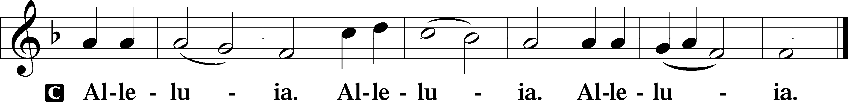

Holy Gospel Matthew 2:13–18
P The Holy Gospel according to St. Matthew, the second chapter.

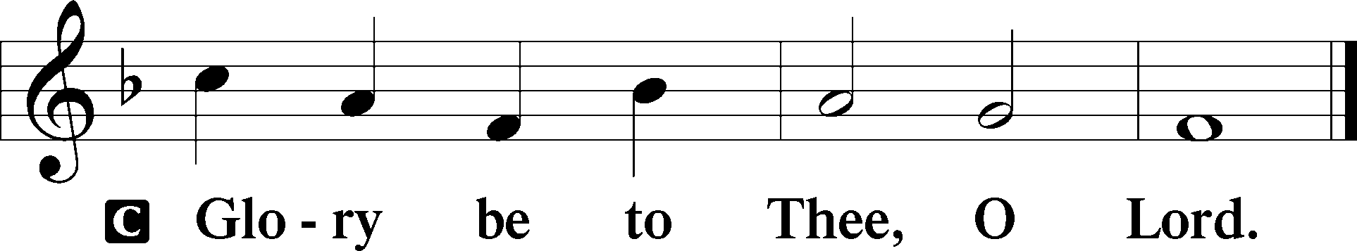

13When [the wise men] had departed, behold, an angel of the Lord appeared to Joseph in a dream and said, “Rise, take the child and his mother, and flee to Egypt, and remain there until I tell you, for Herod is about to search for the child, to destroy him.” 14And he rose and took the child and his mother by night and departed to Egypt 15and remained there until the death of Herod. This was to fulfill what the Lord had spoken by the prophet, “Out of Egypt I called my son.”
16Then Herod, when he saw that he had been tricked by the wise men, became furious, and he sent and killed all the male children in Bethlehem and in all that region who were two years old or under, according to the time that he had ascertained from the wise men. 17Then was fulfilled what was spoken by the prophet Jeremiah:
18“A voice was heard in Ramah,
weeping and loud lamentation,
Rachel weeping for her children;
she refused to be comforted, because they are no more.”

P This is the Gospel of the Lord.

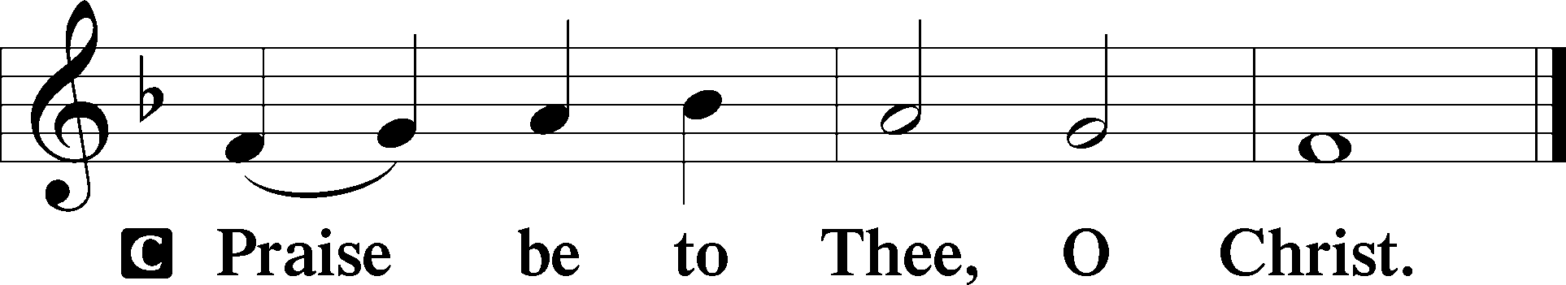

Apostles’ Creed
C I believe in God, the Father Almighty,
maker of heaven and earth.

And in Jesus Christ, His only Son, our Lord,
who was conceived by the Holy Spirit,
born of the virgin Mary,
suffered under Pontius Pilate,
was crucified, died and was buried.
He descended into hell.
The third day He rose again from the dead.
He ascended into heaven
and sits at the right hand of God the Father Almighty.
From thence He will come to judge the living and the dead.

I believe in the Holy Spirit,
the holy Christian Church,
the communion of saints,
the forgiveness of sins,
the resurrection of the body,
and the life T everlasting. Amen.

Sit

Children's Sermon

725 Children of the Heavenly Father
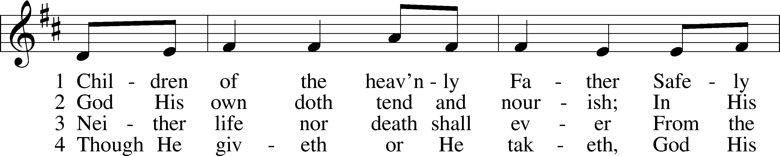
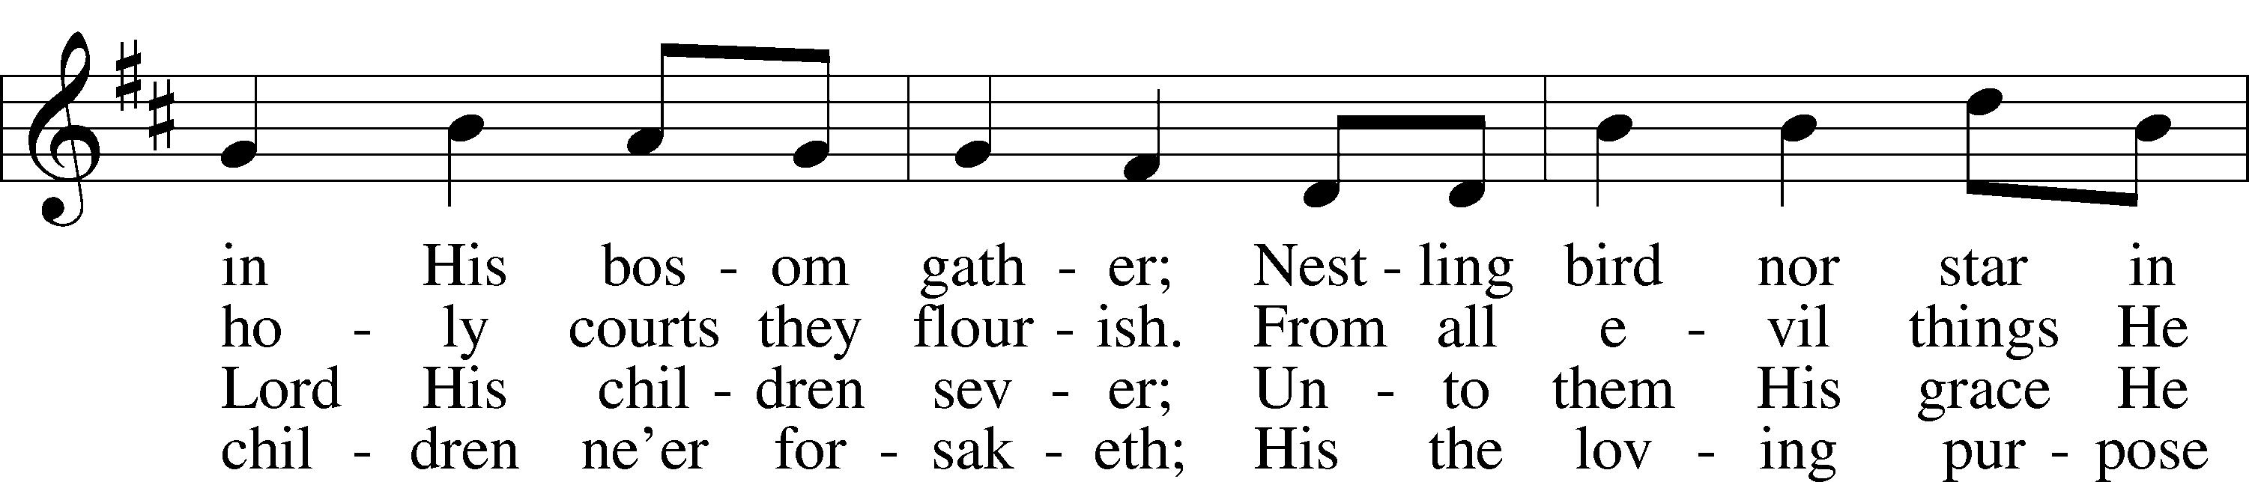
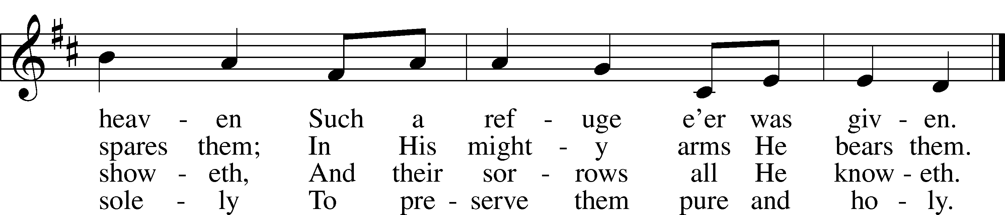
Text: Carolina Sandell Berg, 1832–1903; tr. Ernst W. Olson, 1870–1958
Tune: Lofsånger och andeliga wisor, 1873, Sweden
Text: Public domain
Tune: Public domain

Sermon

Votum
P The peace of God, which passes all understanding, keep your hearts and minds in Christ Jesus.
C Amen.

Stand

Offertory Psalm 51:10–12
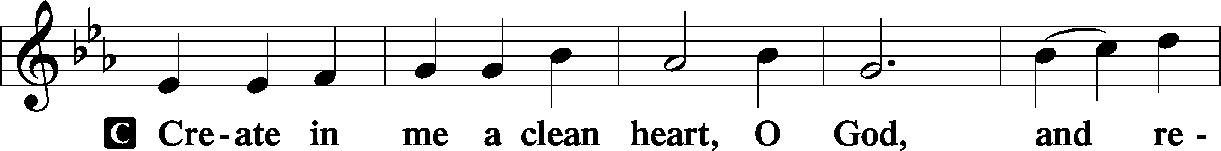
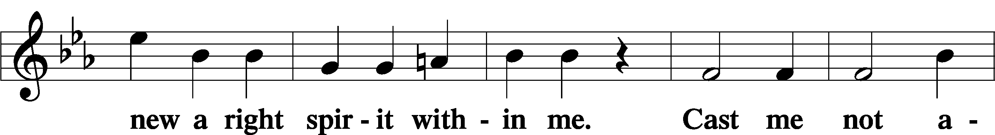
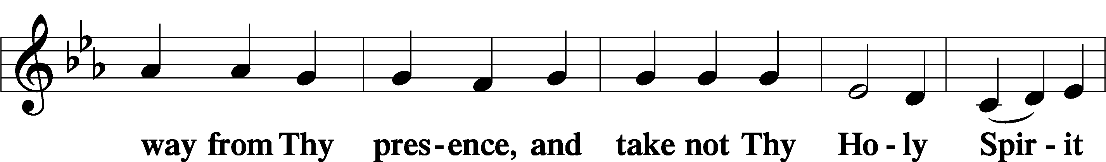
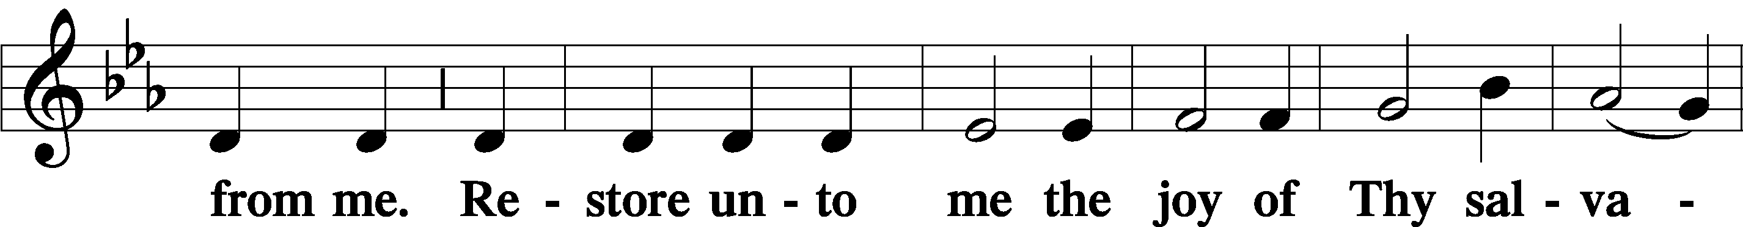
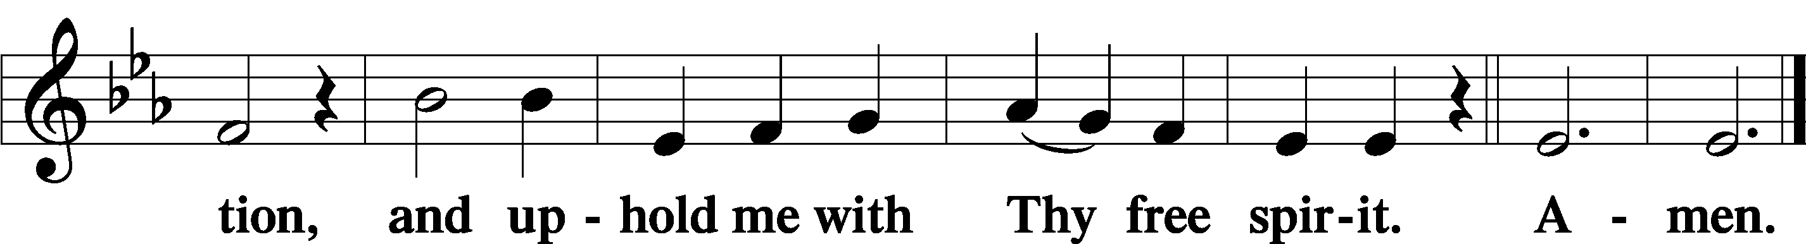

Offering

805 Praise God, from Whom All Blessings Flow
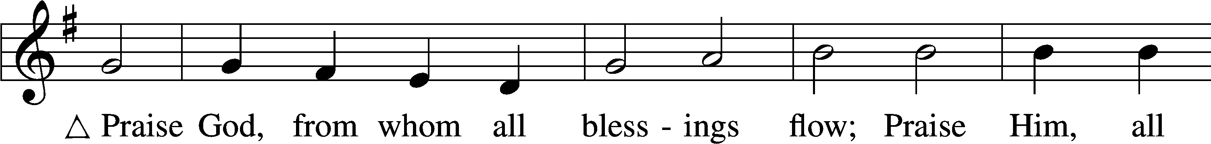
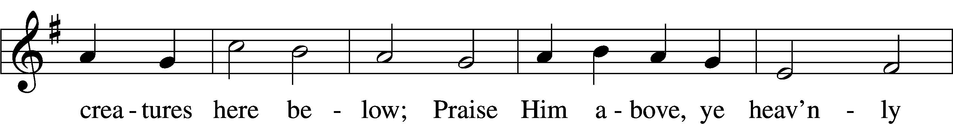
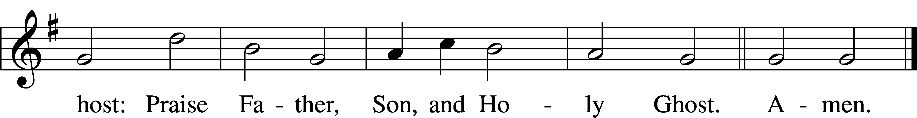
Text: Thomas Ken, 1637–1711
Tune: Trente quatre Pseaumes de David, 1551, Geneva, ed. Louis Bourgeois
Text and tune: Public domain

Prayer of the Church

Lord’s Prayer Matthew 6:9–13
P Lord, remember us in Your kingdom and teach us to pray:
C Our Father who art in heaven,
hallowed be Thy name,
Thy kingdom come,
Thy will be done on earth
as it is in heaven;
give us this day our daily bread;
and forgive us our trespasses
as we forgive those
who trespass against us;
and lead us not into temptation,
but deliver us from evil.
For Thine is the kingdom
and the power and the glory
forever and ever. Amen.

Collect for the Word

Blessed Lord, You have caused all Holy Scriptures to be written for our learning. Grant that we may so hear them, read, mark, learn, and inwardly digest them that, by the patience and comfort of Your holy Word, we may embrace and ever hold fast the blessed hope of everlasting life; through Jesus Christ, Your Son, our Lord, who lives and reigns with You and the Holy Spirit, one God, now and forever.

Benediction
P The Lord bless you and keep you.
The Lord make His face shine on you and be gracious to you.
The Lord look upon you with favor and T give you peace.
C Amen.

399 The Star Proclaims the King Is Here
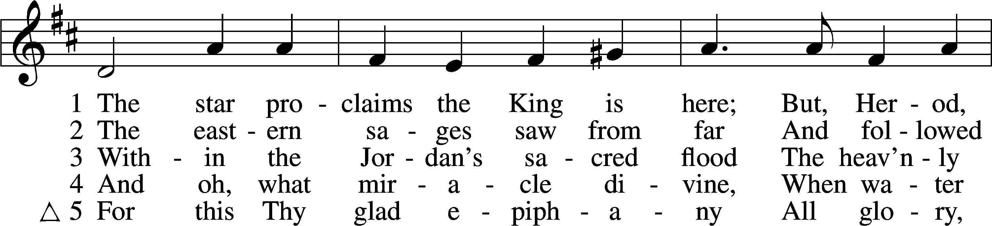
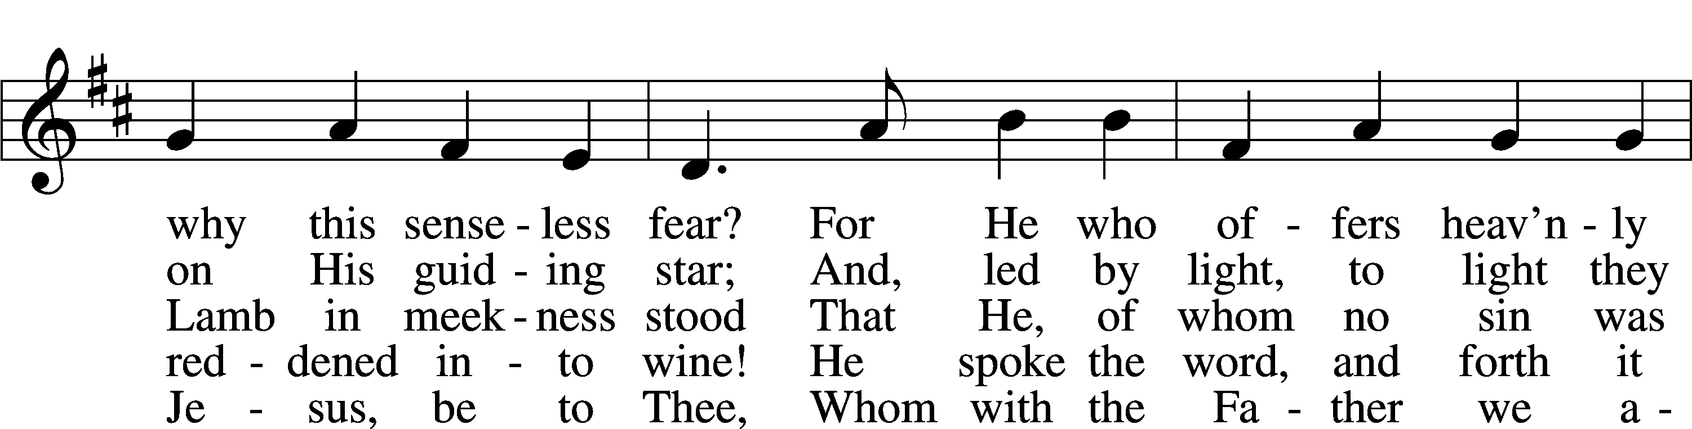
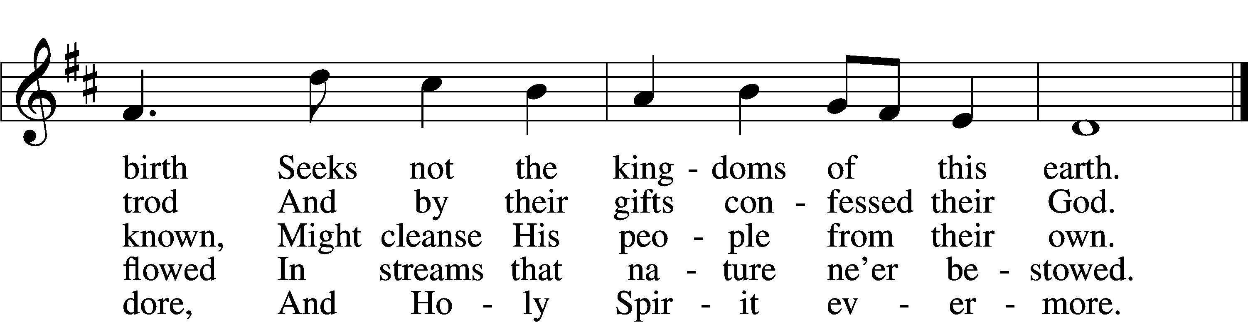
Text: Coelius Sedulius, 5th cent.; tr. John Mason Neale, 1818–66, alt.
Tune: Geistliche Lieder auffs new gebessert, 1535, Wittenberg, ed. Joseph Klug
Text and tune: Public domain

Acknowledgments
Unless otherwise indicated, Scripture quotations are from the ESV® Bible (The Holy Bible, English Standard Version®), copyright © 2001 by Crossway, a publishing ministry of Good News Publishers. Used by permission. All rights reserved.
Created by Lutheran Service Builder © 2025 Concordia Publishing House.

