On entering the church

P Lord, I love the habitation of Your house and the place

where Your glory dwells. In the multitude of Your tender

mercies prepare my heart that I may enter Your house to

worship and confess Your holy name; through Jesus Christ,

my God and Lord.

Before worship

C O Lord, our creator, redeemer, and comforter, as we come

together to worship You in spirit and in truth, we humbly

pray that You would open our hearts to the preaching of

Your Word so that we may repent of our sins, believe in

Jesus Christ as our only Savior, and grow in grace and

holiness. Hear us for His sake.

596 All Christians Who Have Been Baptized

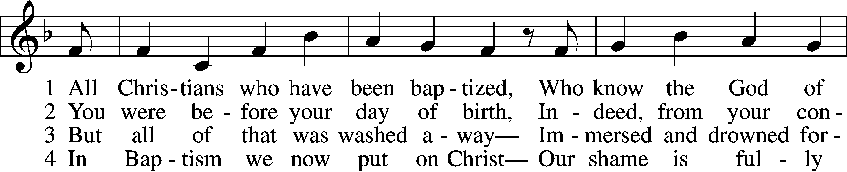

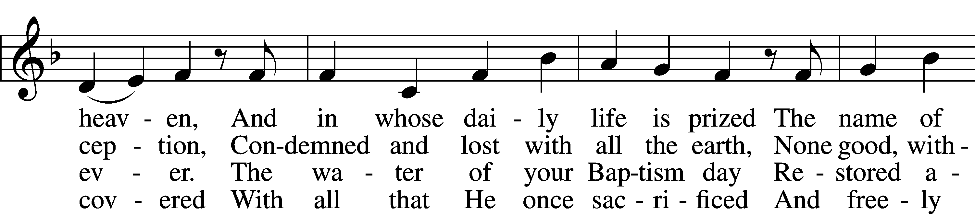

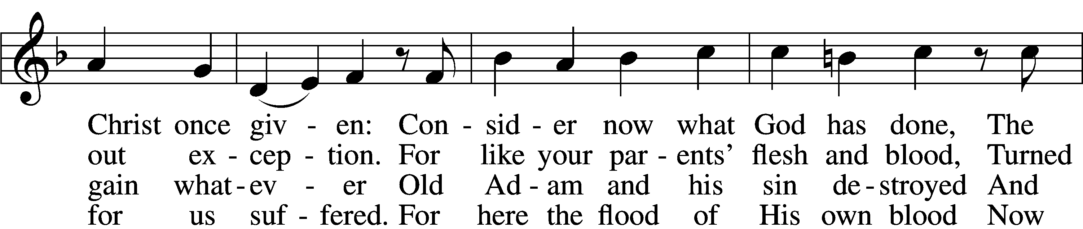

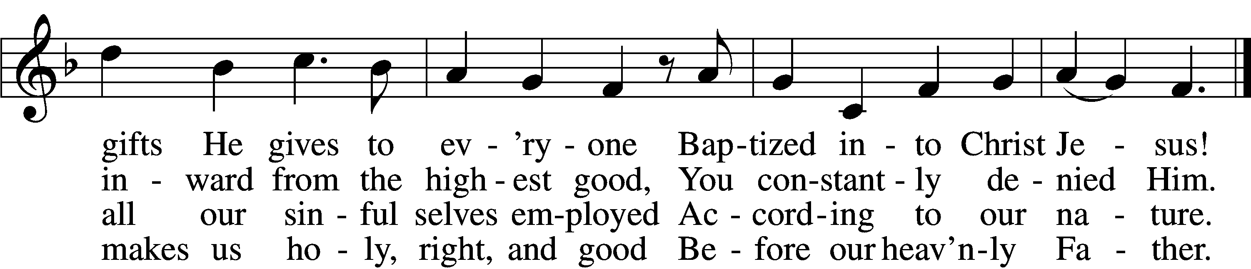

5 O Christian, firmly hold this gift  
 And give God thanks forever!  
It gives the power to uplift  
 In all that you endeavor.  
When nothing else revives your soul,  
Your Baptism stands and makes you whole  
 And then in death completes you.

6 So use it well! You are made new—  
 In Christ a new creation!  
As faithful Christians, live and do  
 Within your own vocation,  
Until that day when you possess  
His glorious robe of righteousness  
 Bestowed on you forever!

Text: Paul Gerhardt, 1607–76; tr. Jon D. Vieker, 1961  
Tune: Etlich Cristlich lider, 1524, Wittenberg  
Text: © 2004 Concordia Publishing House. Used by permission: LSB Hymn License no. 110005011  
Tune: Public domain

# Confession and Absolution

Stand

The sign of the cross may be made by all in remembrance of their Baptism.

Invocation Matthew 28:19b; 18:20

P In the name of the Father and of the T Son and of the Holy Spirit.

C **Amen.**

Exhortation Hebrews 10:22; Psalm 124:8; Psalm 32:5

P Beloved in the Lord! Let us draw near with a true heart and confess our sins unto God our Father, beseeching Him in the name of our Lord Jesus Christ to grant us forgiveness.

P Our help is in the name of the Lord,

C **who made heaven and earth.**

P I said, I will confess my transgressions unto the Lord,

C **and You forgave the iniquity of my sin.**

Kneel/Stand

Silence for reflection on God’s Word and for self-examination.

Confession of Sins

P O almighty God, merciful Father,

C **I, a poor, miserable sinner, confess unto You all my sins and iniquities with which I have ever offended You and justly deserved Your temporal and eternal punishment. But I am heartily sorry for them and sincerely repent of them, and I pray You of Your boundless mercy and for the sake of the holy, innocent, bitter sufferings and death of Your beloved Son, Jesus Christ, to be gracious and merciful to me, a poor, sinful being.**

Absolution [John 20:19–23]

P Upon this your confession, I, by virtue of my office, as a called and ordained servant of the Word, announce the grace of God unto all of you, and in the stead and by the command of my Lord Jesus Christ I forgive you all your sins in the name of the Father and of the T Son and of the Holy Spirit.

C **Amen.**

Stand

# Service of the Word

Introit Psalm 119:28–32; antiphon: v. 27

Make me understand the way of your precepts,  
 and I will meditate on your wondrous works.  
**My soul melts away for sorrow;  
 strengthen me according to your word!**Put false ways far from me  
 and graciously teach me your law!  
**I have chosen the way of faithfulness;  
 I set your just decrees before me.**I cling to your testimonies, O Lord;  
 let me not be put to shame!  
**I will run in the way of your commandments  
 when you enlarge my heart!**

Gloria Patri

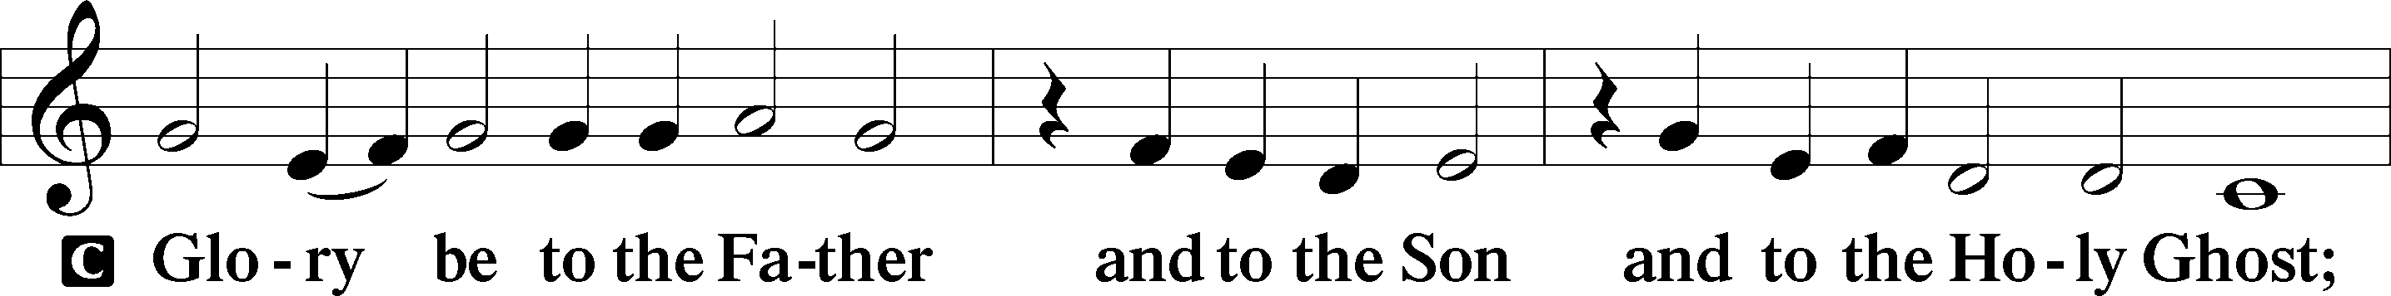

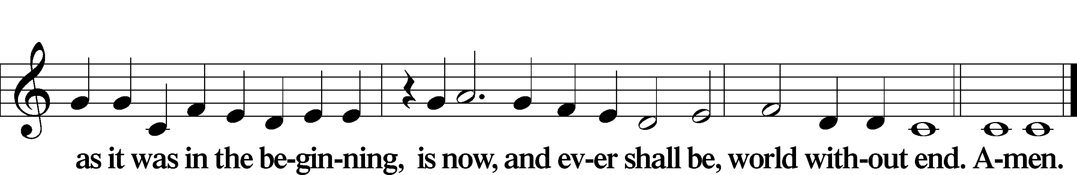

Kyrie Mark 10:47

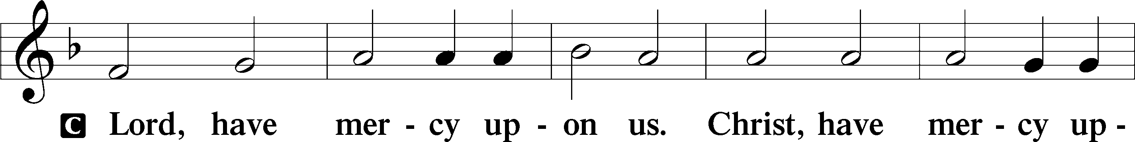

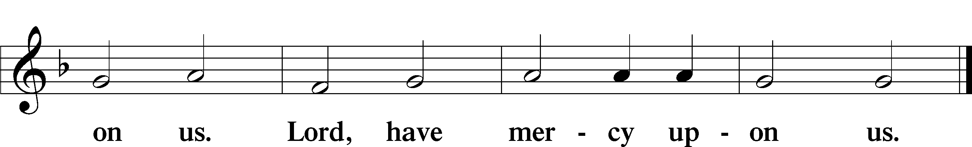

Gloria in Excelsis Luke 2:14; John 1:29

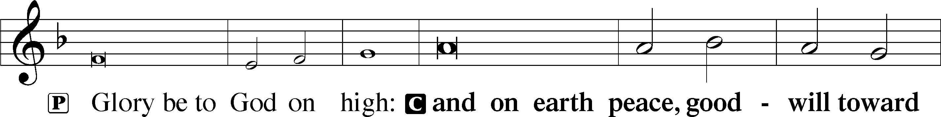

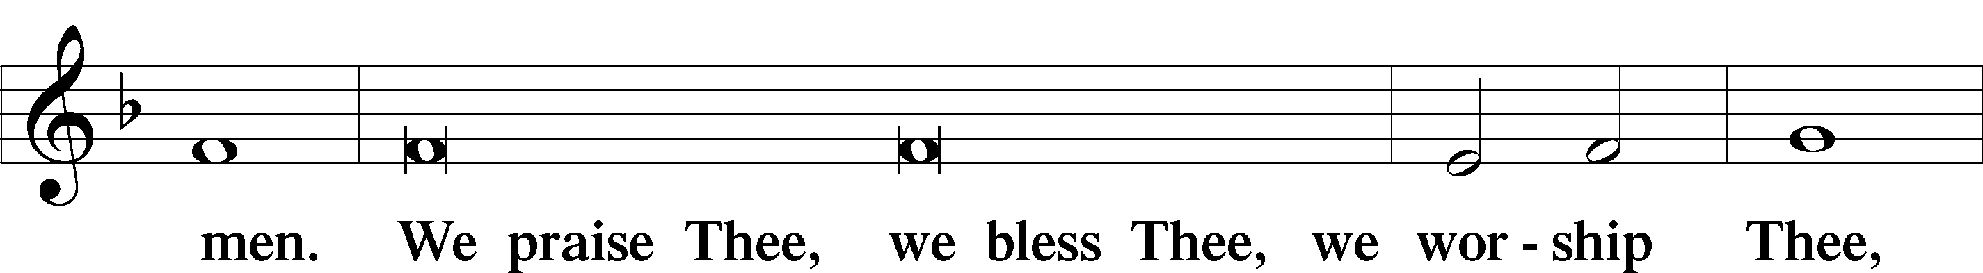

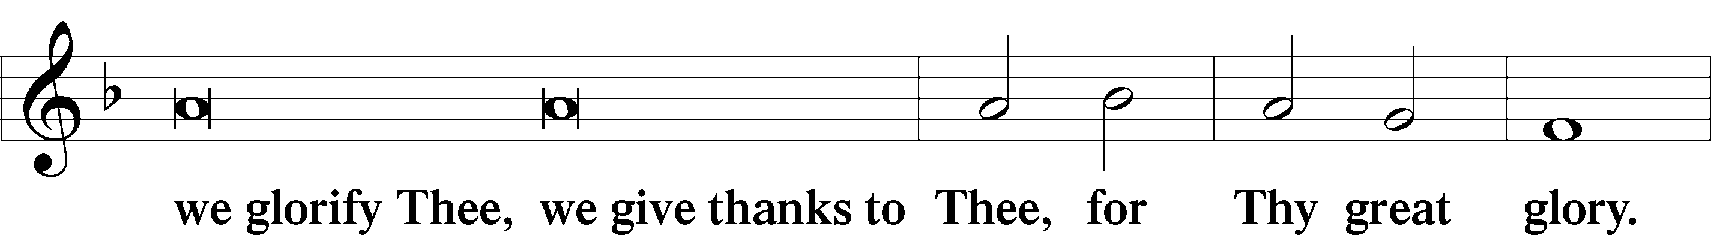

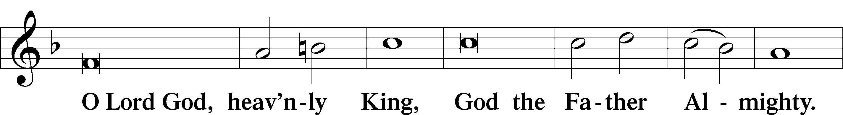

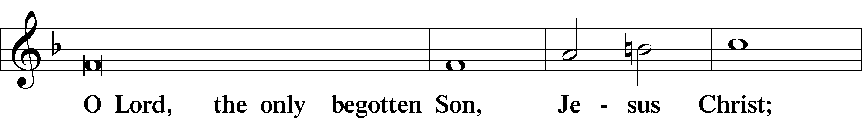

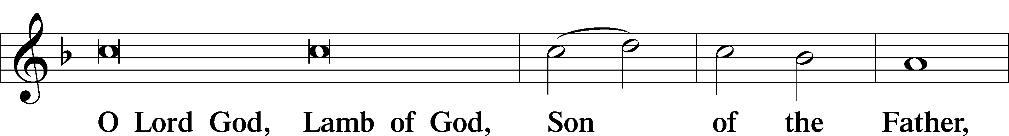

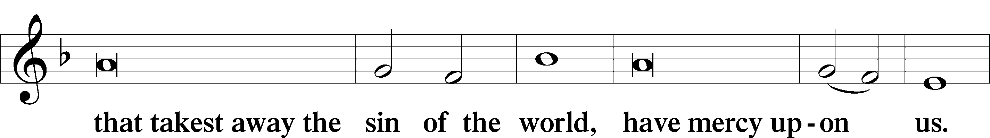

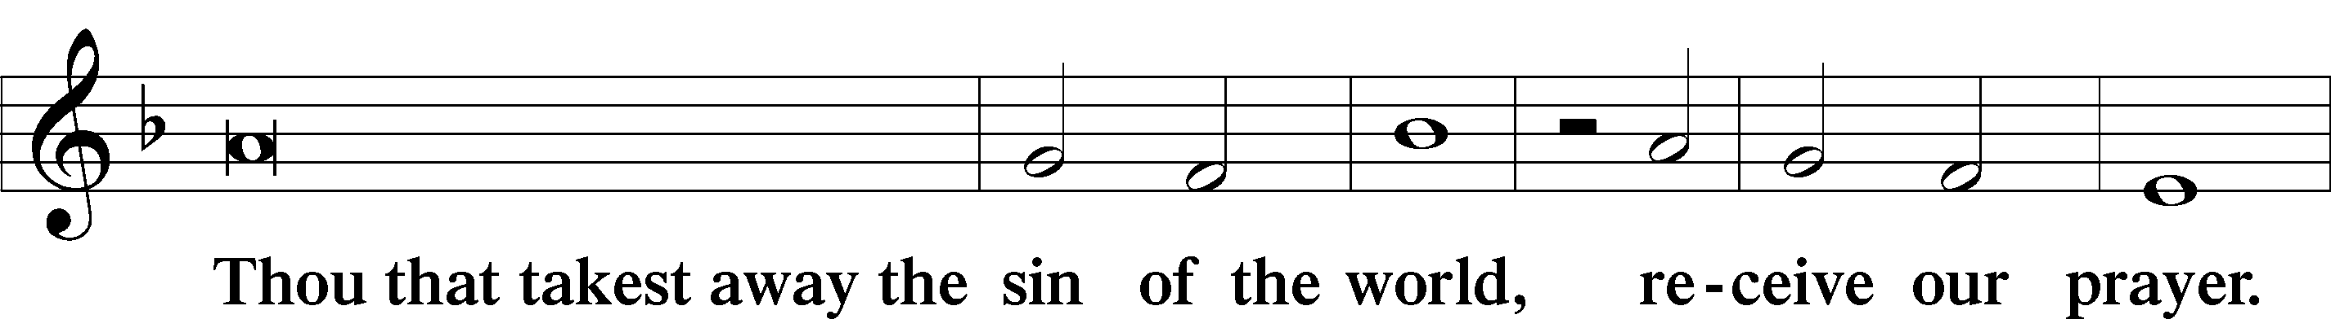

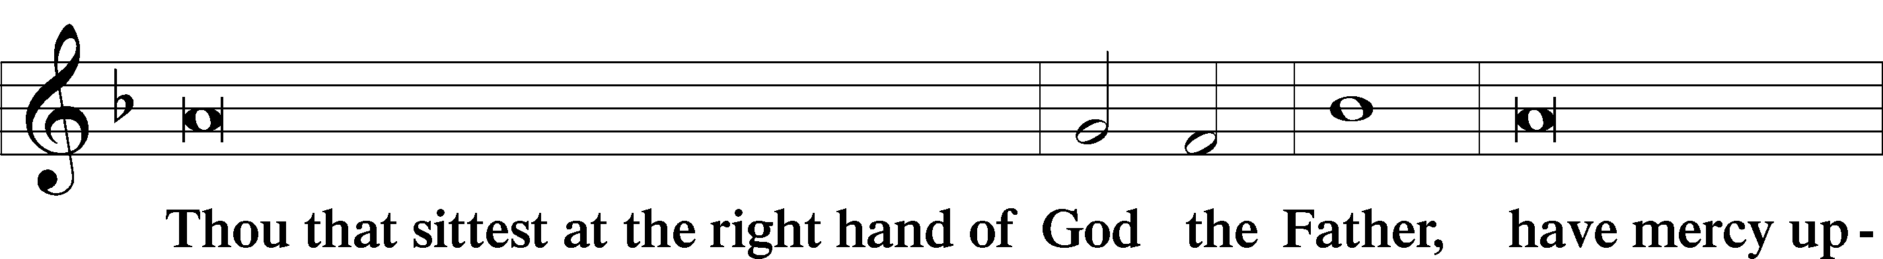

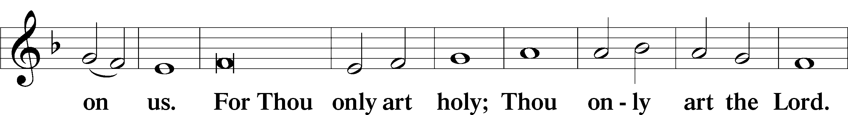

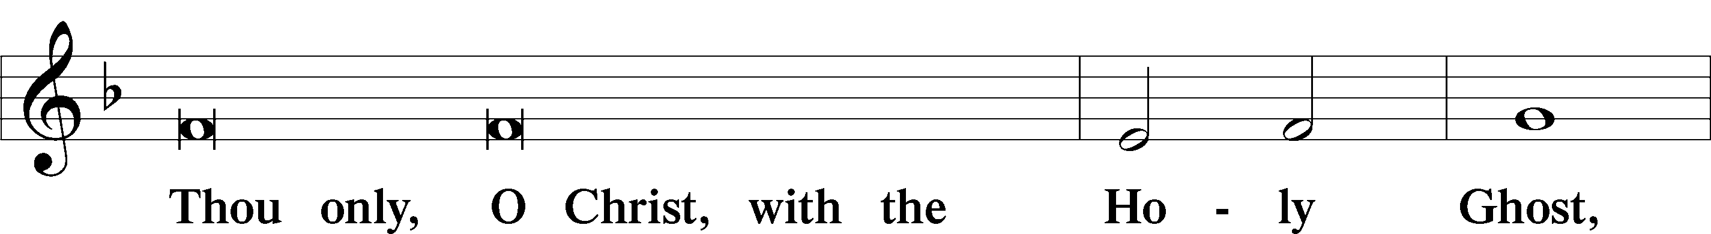

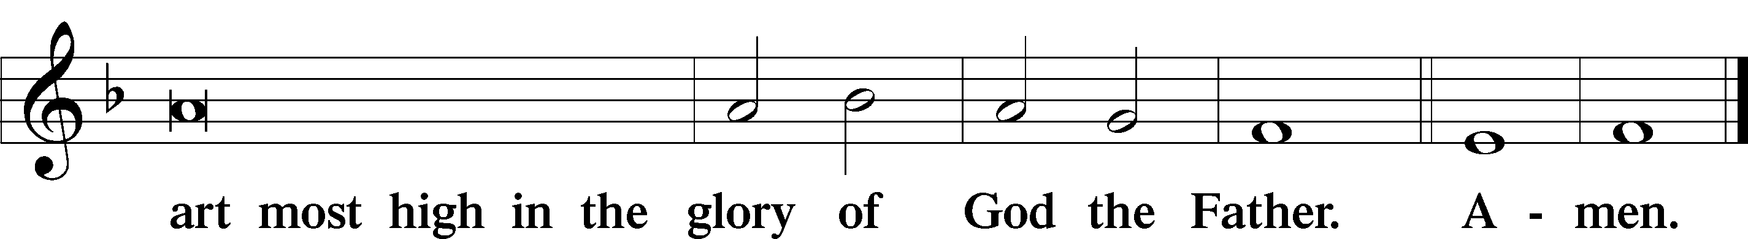

Salutation and Collect of the Day

P The Lord be with you.

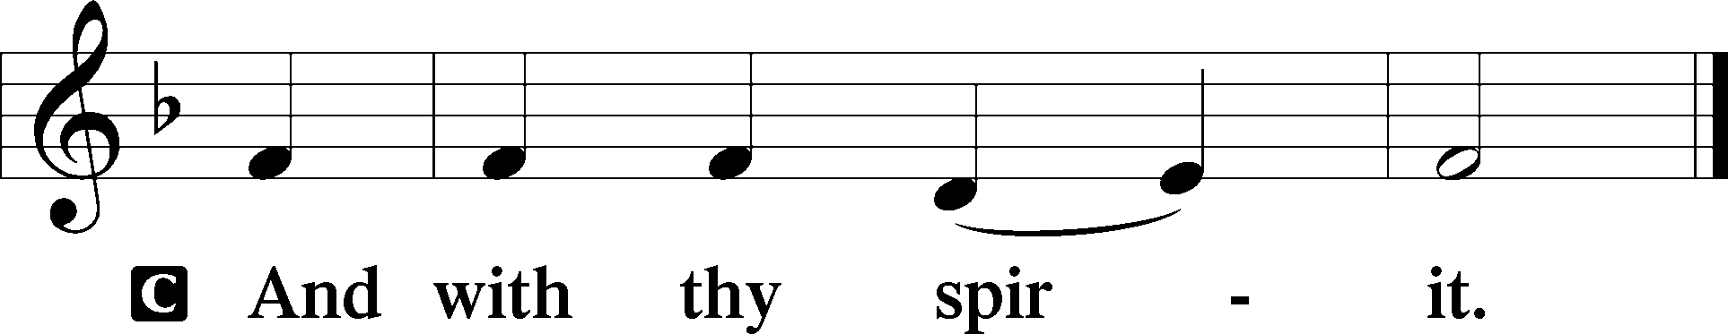

P Let us pray.

O merciful Lord, You did not spare Your only Son but delivered Him up for us all. Grant us courage and strength to take up the cross and follow Him, who lives and reigns with You and the Holy Spirit, one God, now and forever.

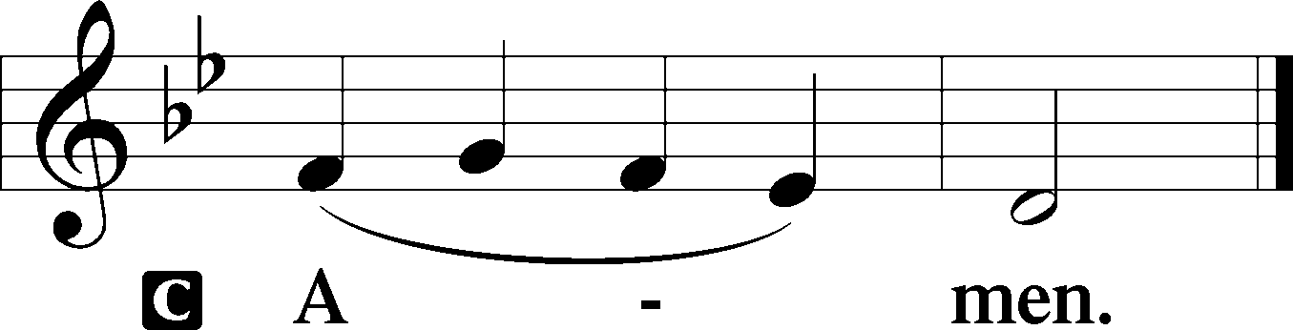

Sit

Old Testament Reading Deuteronomy 30:15–20

15“See, I have set before you today life and good, death and evil. 16If you obey the commandments of the Lord your God that I command you today, by loving the Lord your God, by walking in his ways, and by keeping his commandments and his statutes and his rules, then you shall live and multiply, and the Lord your God will bless you in the land that you are entering to take possession of it. 17But if your heart turns away, and you will not hear, but are drawn away to worship other gods and serve them, 18I declare to you today, that you shall surely perish. You shall not live long in the land that you are going over the Jordan to enter and possess. 19I call heaven and earth to witness against you today, that I have set before you life and death, blessing and curse. Therefore choose life, that you and your offspring may live, 20loving the Lord your God, obeying his voice and holding fast to him, for he is your life and length of days, that you may dwell in the land that the Lord swore to your fathers, to Abraham, to Isaac, and to Jacob, to give them.”

A This is the Word of the Lord.

C **Thanks be to God.**

Gradual Psalm 34:9, 19, alt.

Fear the Lord, you his saints,  
 for those who fear him lack nothing!  
**Many are the afflictions of the righteous,  
 but the Lord delivers him out of them all.**

Epistle Philemon 1–21

1Paul, a prisoner for Christ Jesus, and Timothy our brother,

To Philemon our beloved fellow worker 2and Apphia our sister and Archippus our fellow soldier, and the church in your house:

3Grace to you and peace from God our Father and the Lord Jesus Christ.

4I thank my God always when I remember you in my prayers, 5because I hear of your love and of the faith that you have toward the Lord Jesus and all the saints, 6and I pray that the sharing of your faith may become effective for the full knowledge of every good thing that is in us for the sake of Christ. 7For I have derived much joy and comfort from your love, my brother, because the hearts of the saints have been refreshed through you.

8Accordingly, though I am bold enough in Christ to command you to do what is required, 9yet for love’s sake I prefer to appeal to you—I, Paul, an old man and now a prisoner also for Christ Jesus— 10I appeal to you for my child, Onesimus, whose father I became in my imprisonment. 11(Formerly he was useless to you, but now he is indeed useful to you and to me.) 12I am sending him back to you, sending my very heart. 13I would have been glad to keep him with me, in order that he might serve me on your behalf during my imprisonment for the gospel, 14but I preferred to do nothing without your consent in order that your goodness might not be by compulsion but of your own free will. 15For this perhaps is why he was parted from you for a while, that you might have him back forever, 16no longer as a slave but more than a slave, as a beloved brother—especially to me, but how much more to you, both in the flesh and in the Lord.

17So if you consider me your partner, receive him as you would receive me. 18If he has wronged you at all, or owes you anything, charge that to my account. 19I, Paul, write this with my own hand: I will repay it—to say nothing of your owing me even your own self. 20Yes, brother, I want some benefit from you in the Lord. Refresh my heart in Christ.

21Confident of your obedience, I write to you, knowing that you will do even more than I say.

A This is the Word of the Lord.

C **Thanks be to God.**

Stand

Alleluia

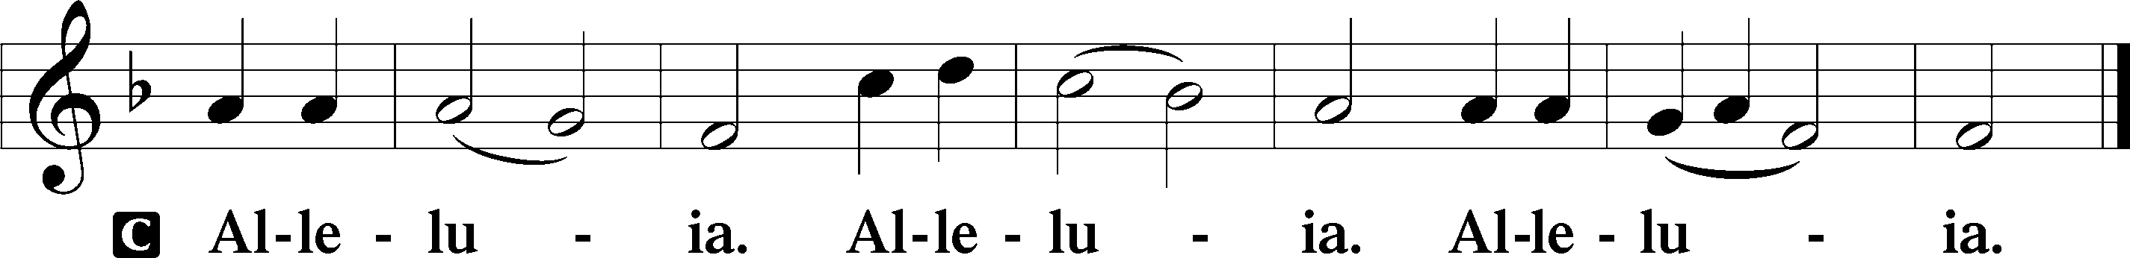

Holy Gospel Luke 14:25–35

P The Holy Gospel according to St. Luke, the fourteenth chapter.

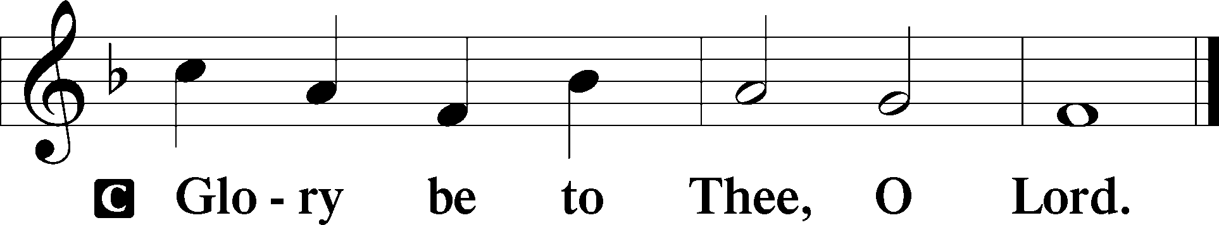

25Now great crowds accompanied [Jesus], and he turned and said to them, 26“If anyone comes to me and does not hate his own father and mother and wife and children and brothers and sisters, yes, and even his own life, he cannot be my disciple. 27Whoever does not bear his own cross and come after me cannot be my disciple. 28For which of you, desiring to build a tower, does not first sit down and count the cost, whether he has enough to complete it? 29Otherwise, when he has laid a foundation and is not able to finish, all who see it begin to mock him, 30saying, ‘This man began to build and was not able to finish.’ 31Or what king, going out to encounter another king in war, will not sit down first and deliberate whether he is able with ten thousand to meet him who comes against him with twenty thousand? 32And if not, while the other is yet a great way off, he sends a delegation and asks for terms of peace. 33So therefore, any one of you who does not renounce all that he has cannot be my disciple.

34“Salt is good, but if salt has lost its taste, how shall its saltiness be restored? 35It is of no use either for the soil or for the manure pile. It is thrown away. He who has ears to hear, let him hear.”

P This is the Gospel of the Lord.

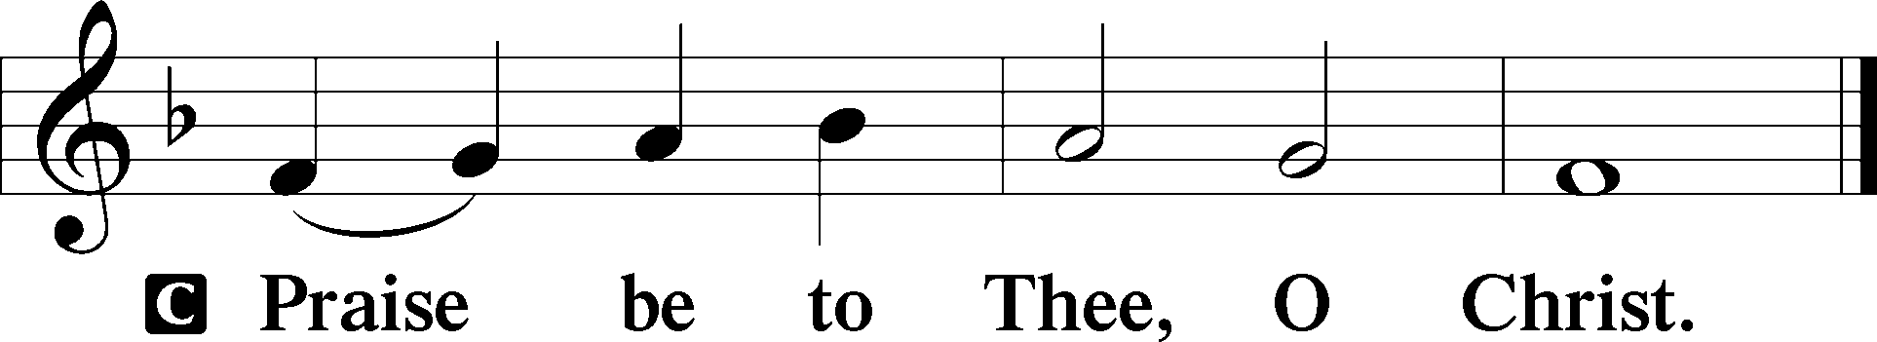

Nicene Creed

C **I believe in one God,**

**the Father Almighty,**

**maker of heaven and earth**

**and of all things visible and invisible.**

**And in one Lord Jesus Christ,**

**the only-begotten Son of God,**

**begotten of His Father before all worlds,**

**God of God, Light of Light,**

**very God of very God,**

**begotten, not made,**

**being of one substance with the Father,**

**by whom all things were made;**

**who for us men and for our salvation came down from heaven**

**and was incarnate by the Holy Spirit of the virgin Mary**

**and was made man;**

**and was crucified also for us under Pontius Pilate.**

**He suffered and was buried.**

**And the third day He rose again according to the Scriptures**

**and ascended into heaven**

**and sits at the right hand of the Father.**

**And He will come again with glory to judge both the living and the dead,**

**whose kingdom will have no end.**

**And I believe in the Holy Spirit,**

**the Lord and giver of life,**

**who proceeds from the Father and the Son,**

**who with the Father and the Son together is worshiped and glorified,**

**who spoke by the prophets.**

**And I believe in one holy Christian and apostolic Church,**

**I acknowledge one Baptism for the remission of sins,**

**and I look for the resurrection of the dead**

**and the life** T **of the world to come. Amen.**

Sit

Children's Sermon

594 God’s Own Child, I Gladly Say It

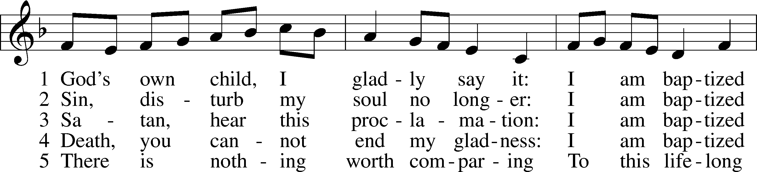

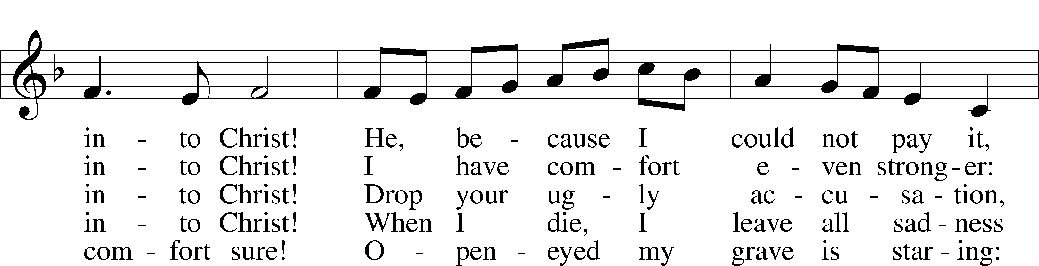

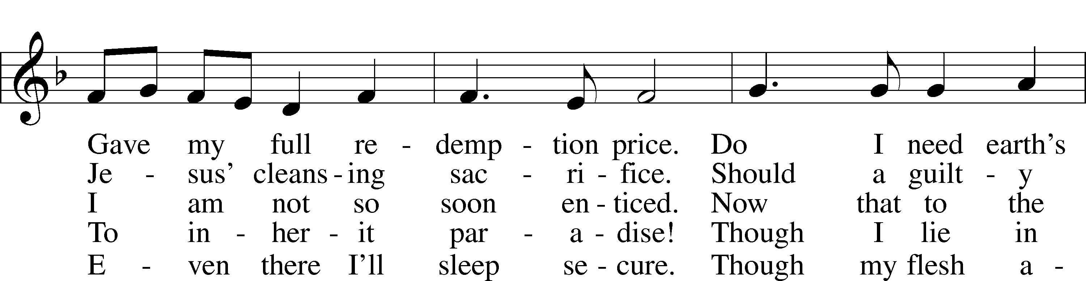

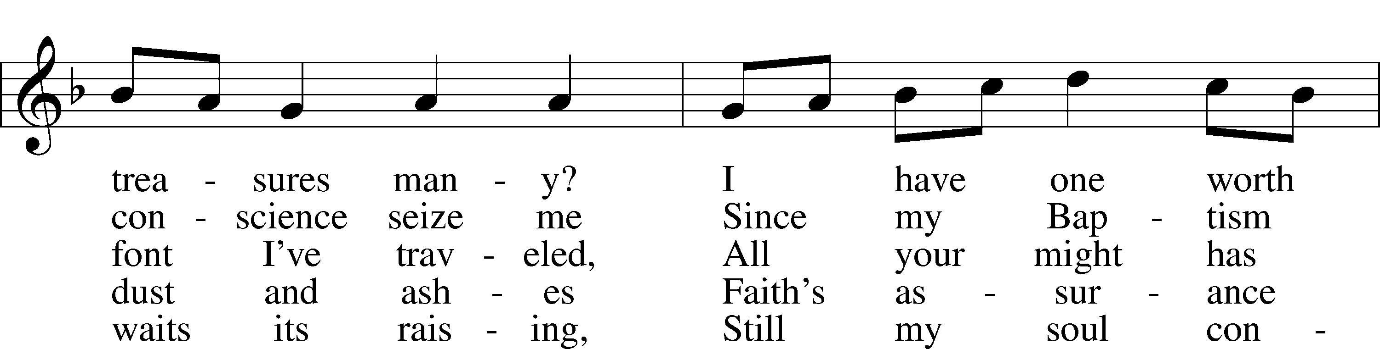

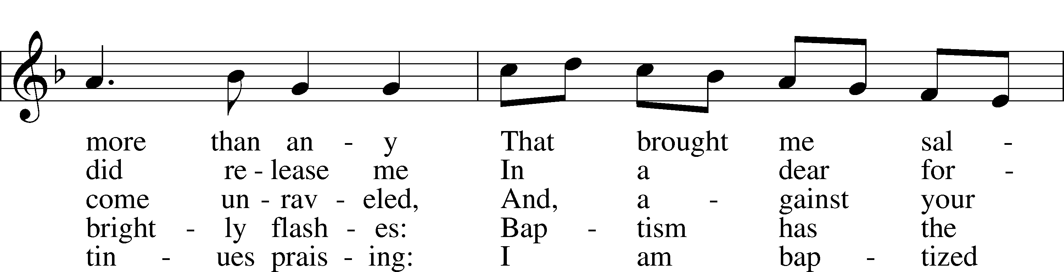

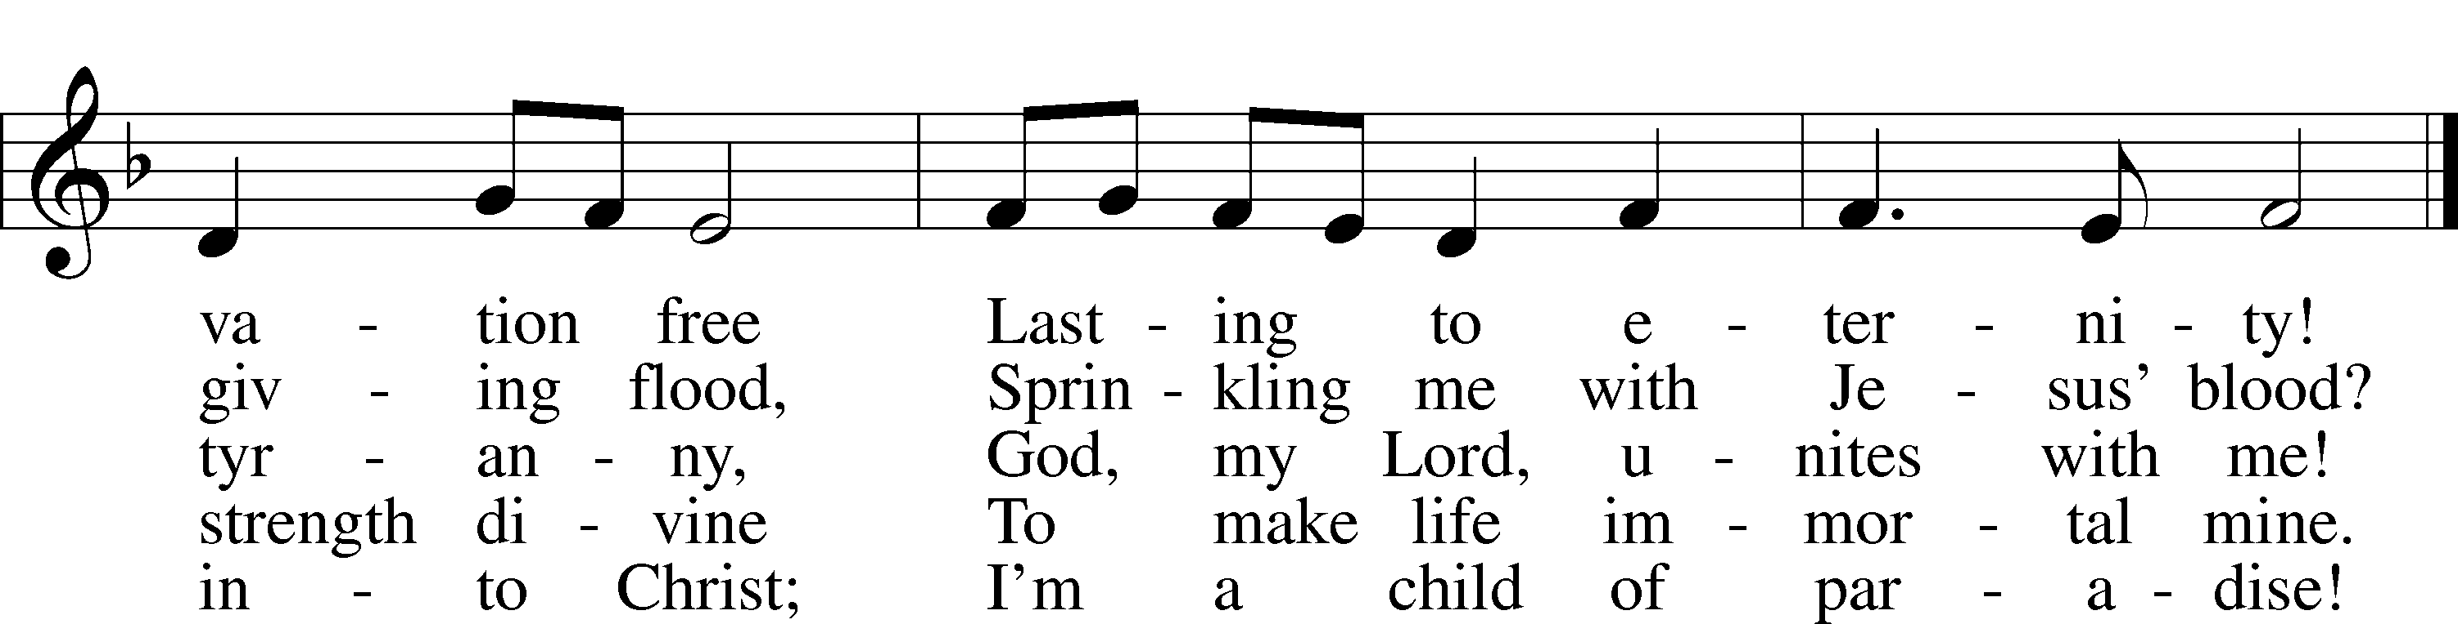

Text: Erdmann Neumeister, 1671–1756; tr. Robert E. Voelker, 1957  
Tune: Johann Caspar Bachofen, 1695–1755, alt.  
Text: © 1991 Robert E. Voelker. Used by permission: LSB Hymn License no. 110005011  
Tune: Public domain

Sermon

Holy Baptism, Adult Confirmation, & Profession of Faith

Votum

P The peace of God, which passes all understanding, keep your hearts and minds in Christ Jesus.

C **Amen.**

Stand

Offertory Psalm 51:10–12

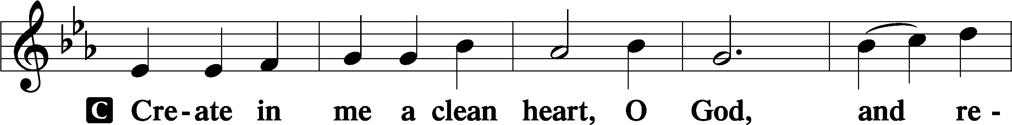

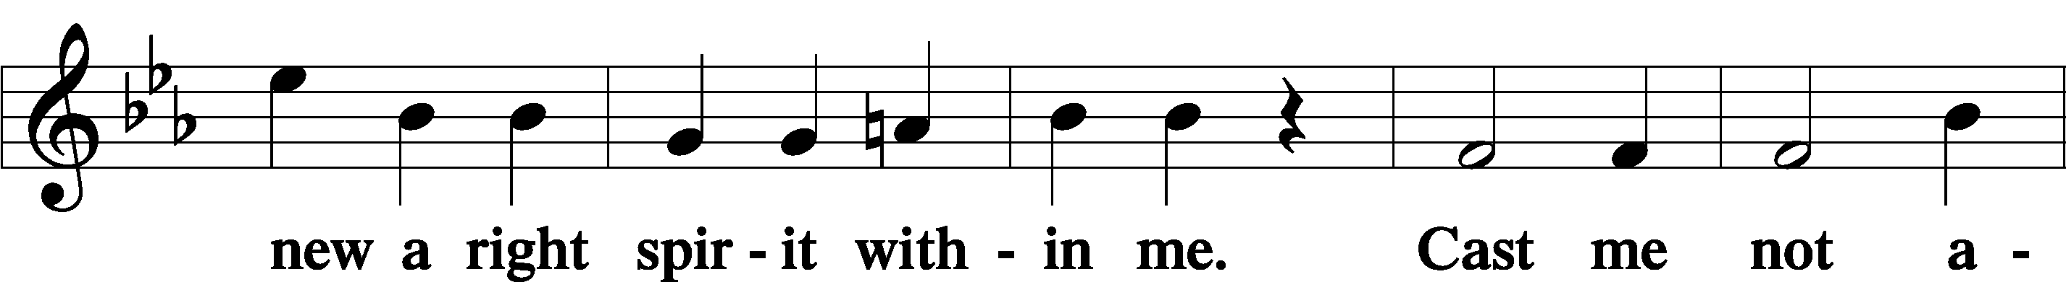

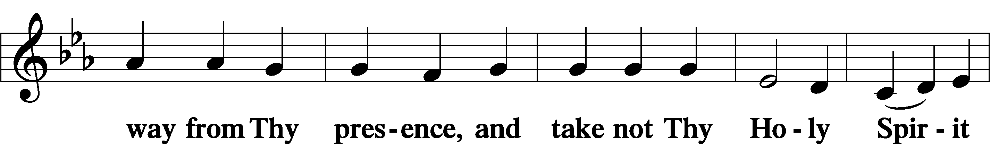

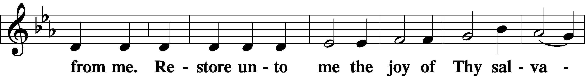

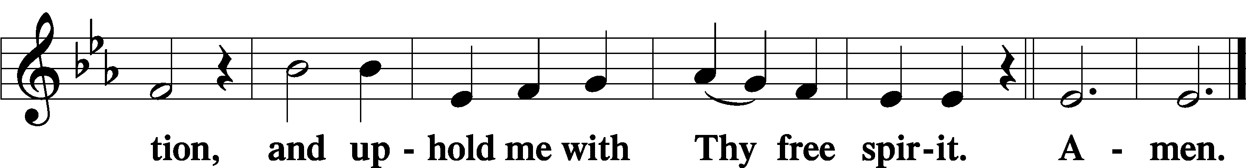

Sit

Offering

Hymn

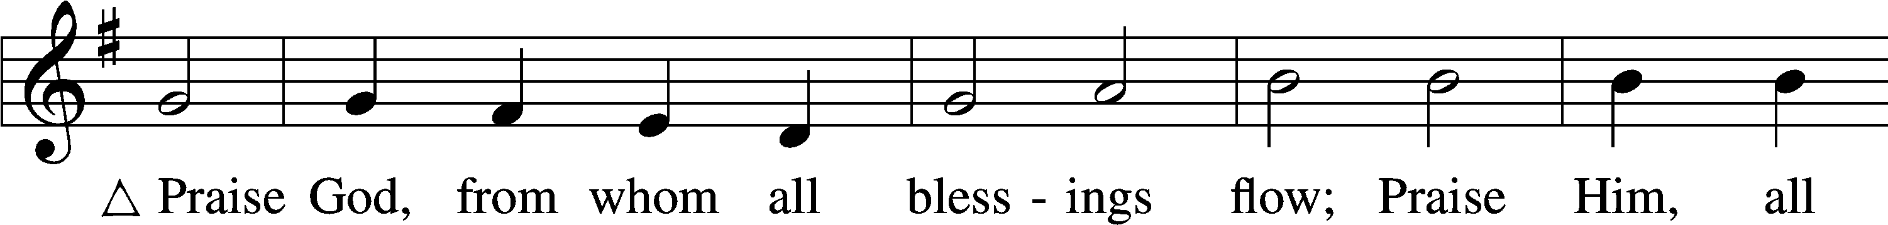

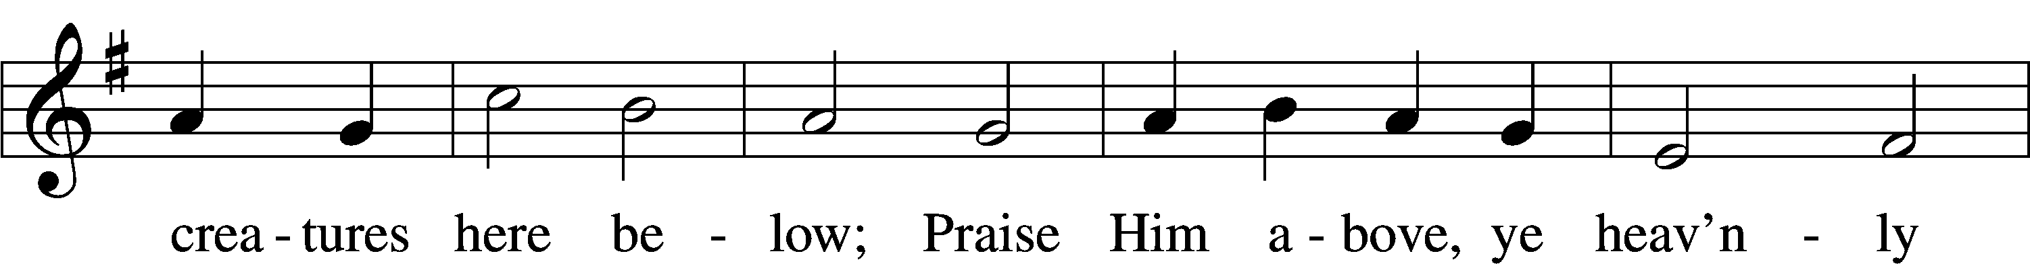

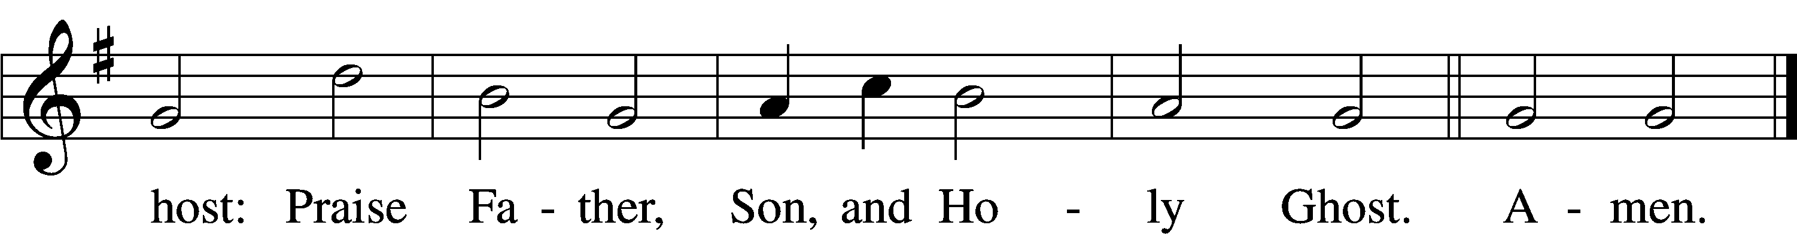

Text: Thomas Ken, 1637–1711  
Tune: Trente quatre Pseaumes de David, 1551, Geneva, ed. Louis Bourgeois  
Text and tune: Public domain

Stand

Prayer of the Church

# Service of the Sacrament

Preface 2 Timothy 4:22; [Colossians 3:1]; [Psalm 136]

P The Lord be with you.

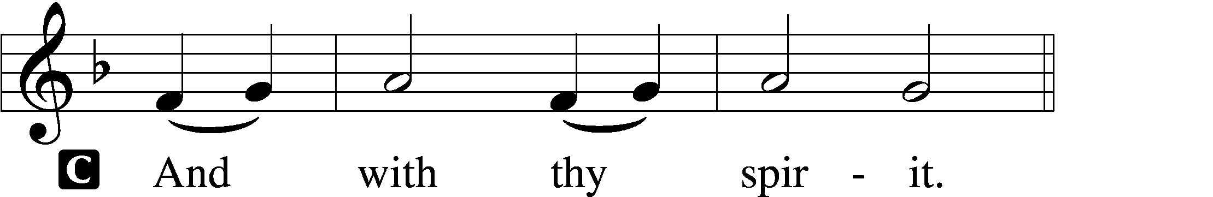

P Lift up your hearts.

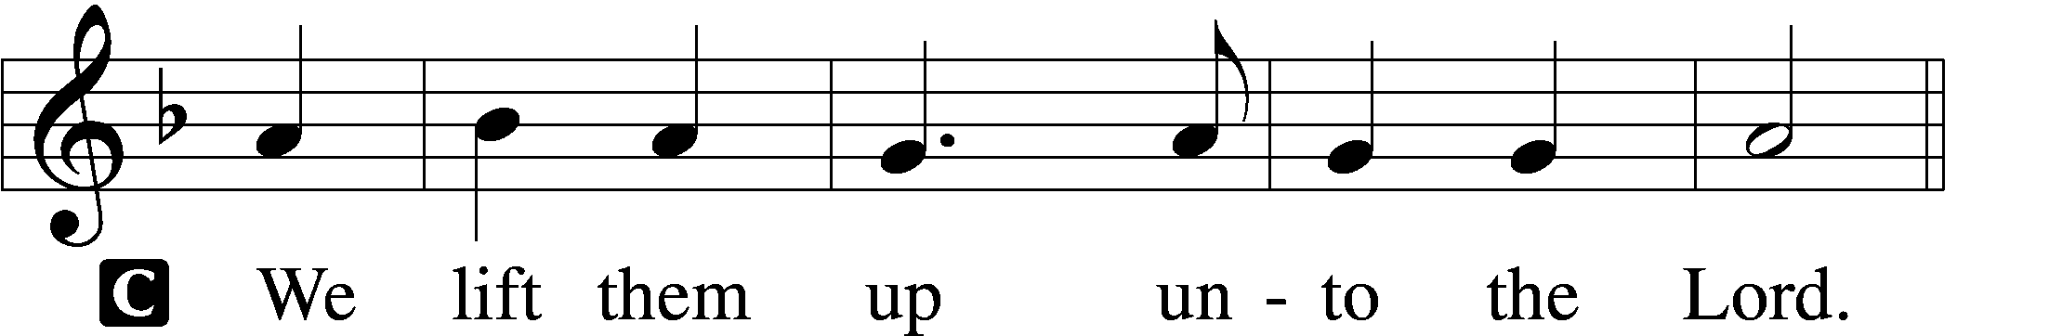

P Let us give thanks unto the Lord, our God.

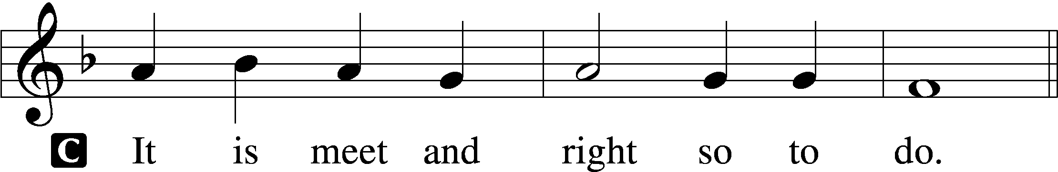

Proper Preface (Full)

P It is truly meet, right, and salutary that we should at all times and in all places give thanks to You, holy Lord, almighty Father, everlasting God, through Jesus Christ, our Lord. Therefore with angels and archangels and with all the company of heaven we laud and magnify Your glorious name, evermore praising You and saying:

Sanctus Isaiah 6:3; Matthew 21:9

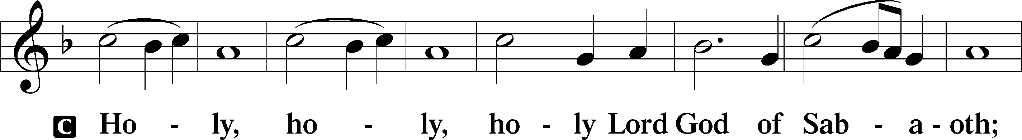

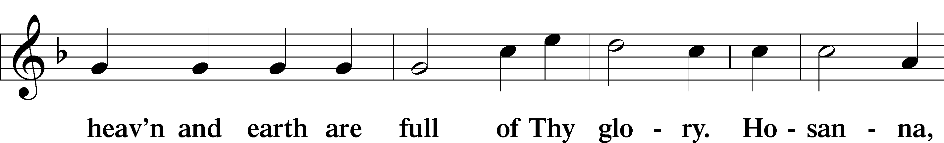

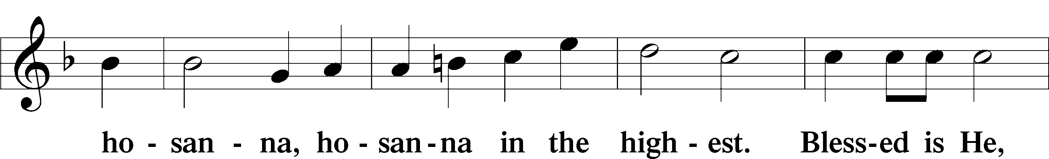

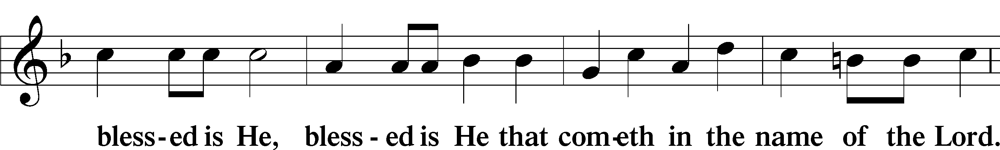

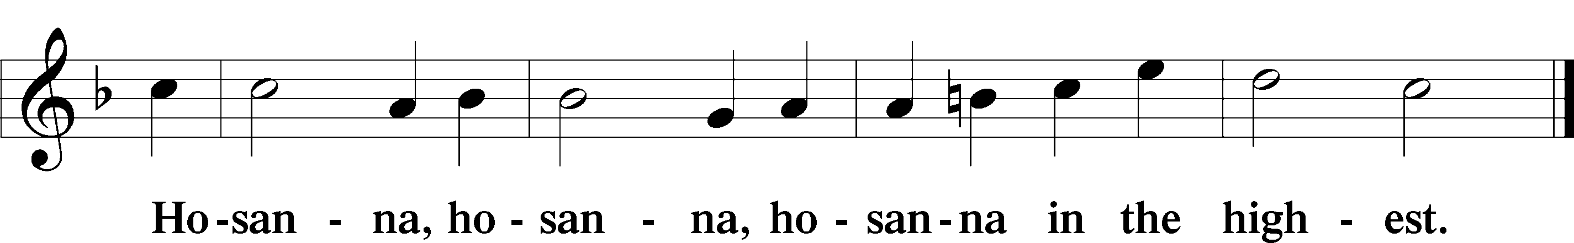

Lord’s Prayer Matthew 6:9–13

P Our Father who art in heaven,

hallowed be Thy name,

Thy kingdom come,

Thy will be done on earth as it is in heaven;

give us this day our daily bread;

and forgive us our trespasses as we forgive those who trespass against us;

and lead us not into temptation,

but deliver us from evil.

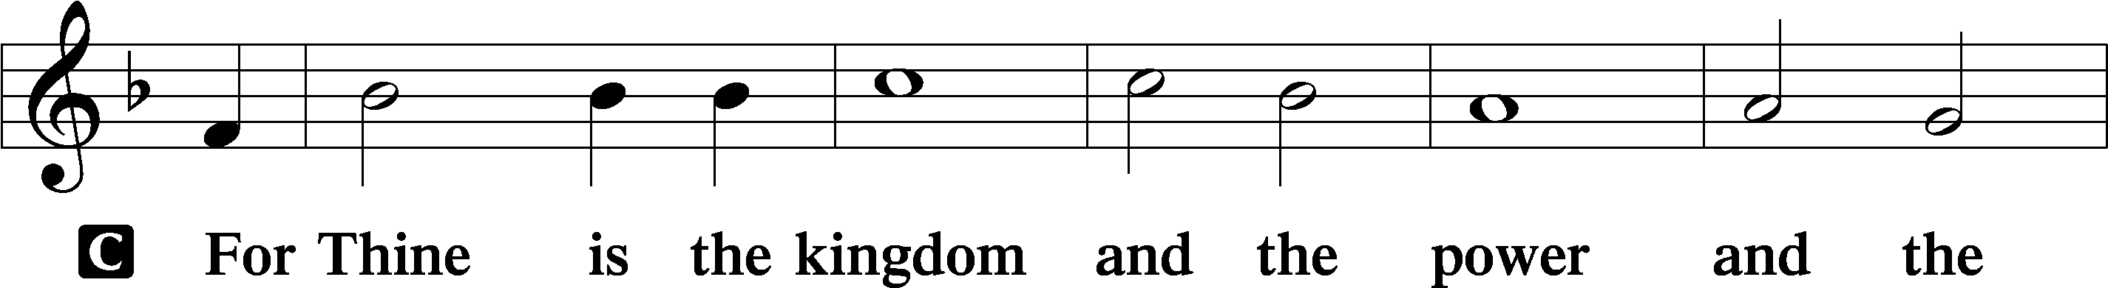

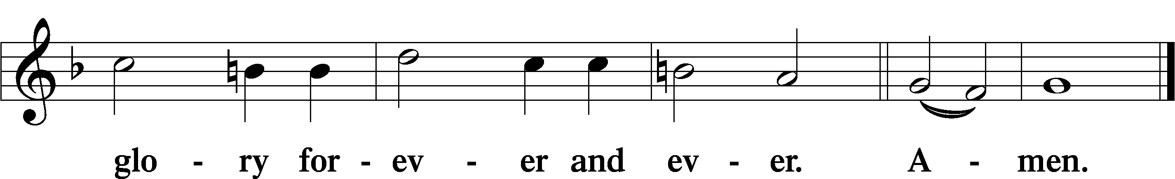

The Words of Our Lord Matthew 26:26–28; Mark 14:22–24; Luke 22:19–20; 1 Corinthians 11:23–25

P Our Lord Jesus Christ, on the night when He was betrayed, took bread, and when He had given thanks, He broke it and gave it to the disciples and said: “Take, eat; this is My T body, which is given for you. This do in remembrance of Me.”

In the same way also He took the cup after supper, and when He had given thanks, He gave it to them, saying: “Drink of it, all of you; this cup is the new testament in My T blood, which is shed for you for the forgiveness of sins. This do, as often as you drink it, in remembrance of Me.”

Pax Domini John 20:19

P The peace of the Lord be with you always.

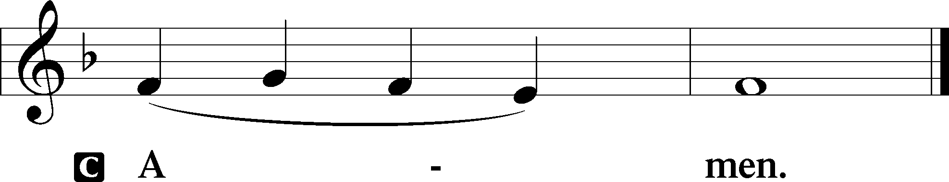

Agnus Dei John 1:29

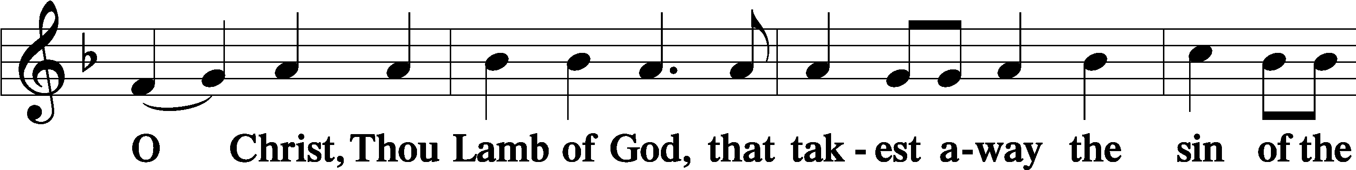

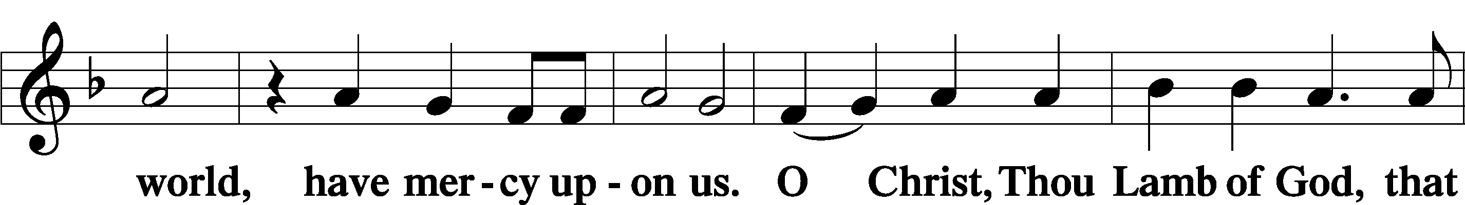

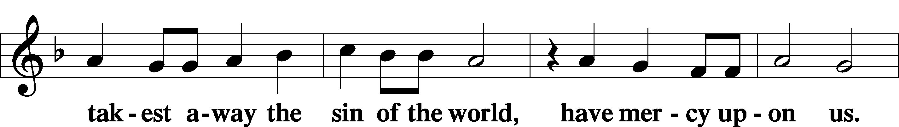

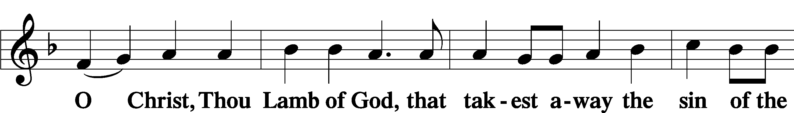

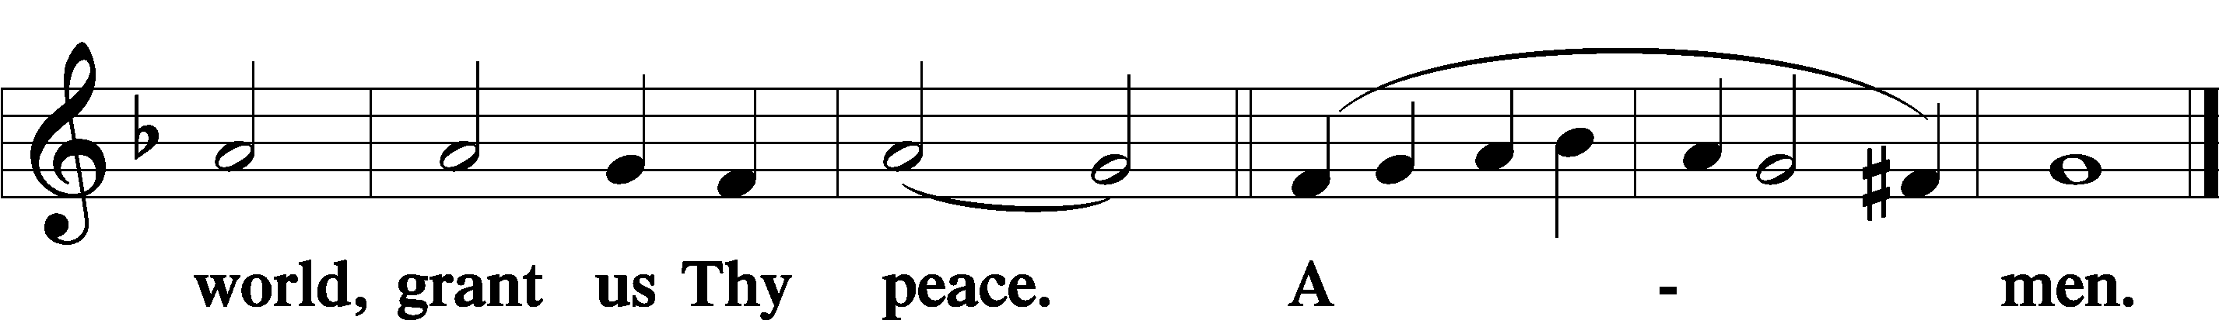

Sit

Distribution

The pastor and those who assist him receive the body and blood of Christ first and then distribute them to those who come to receive, saying:

Take, eat; this is the true body of our Lord and Savior Jesus Christ, given into death for your sins.

**Amen.**

Take, drink; this is the true blood of our Lord and Savior Jesus Christ, shed for the forgiveness of your sins.

**Amen.**

In dismissing the communicants, the following is said:

The Dismissal

P The body and blood of our Lord Jesus Christ strengthen and preserve you in body and soul to life everlasting. Depart T in peace.

C **Amen.**

633 At the Lamb’s High Feast We Sing

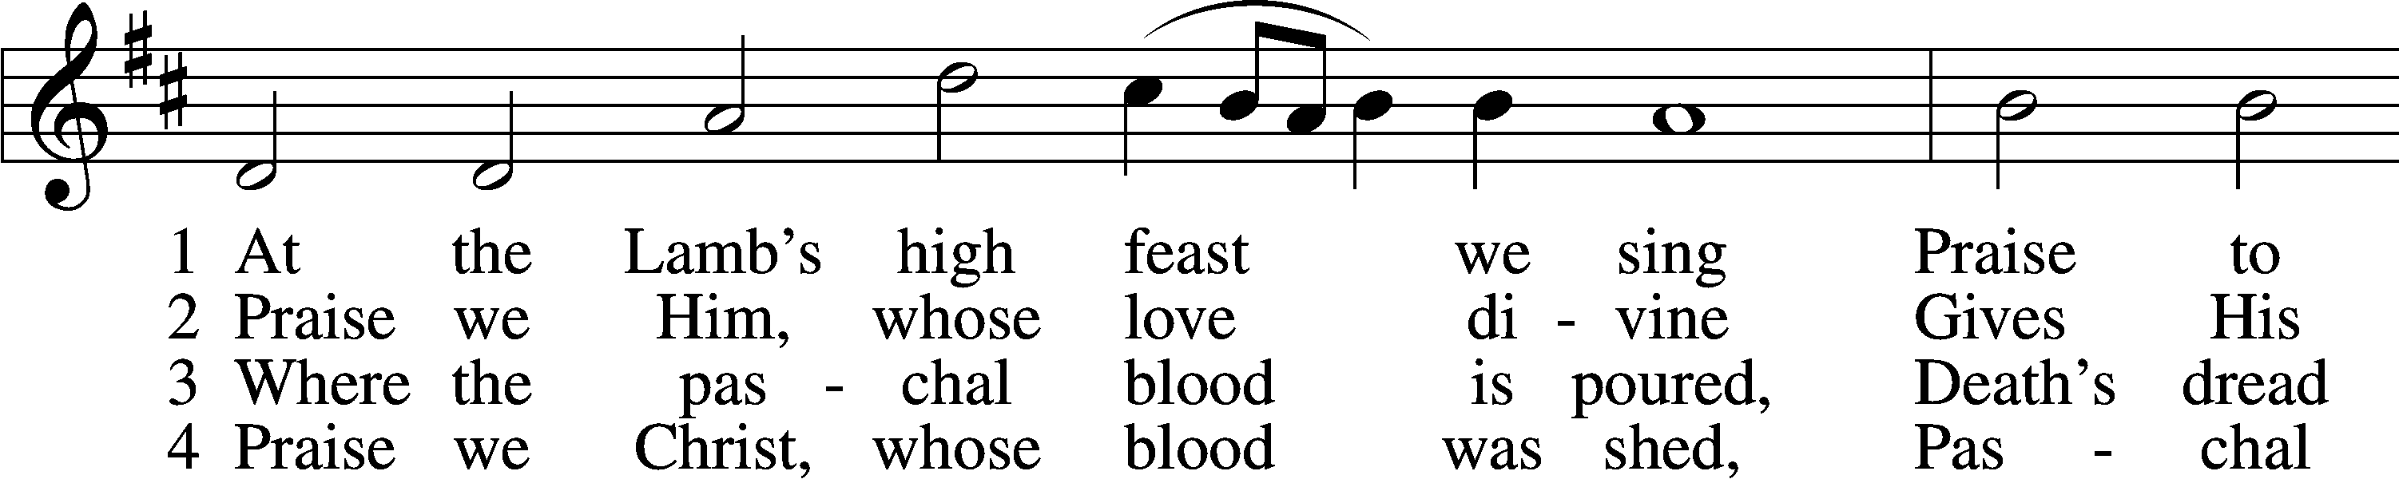

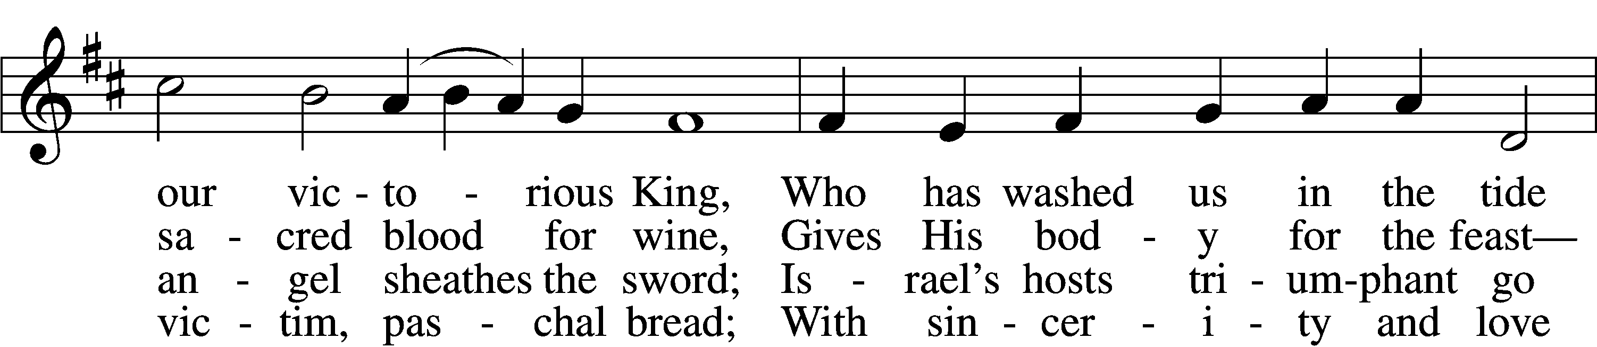

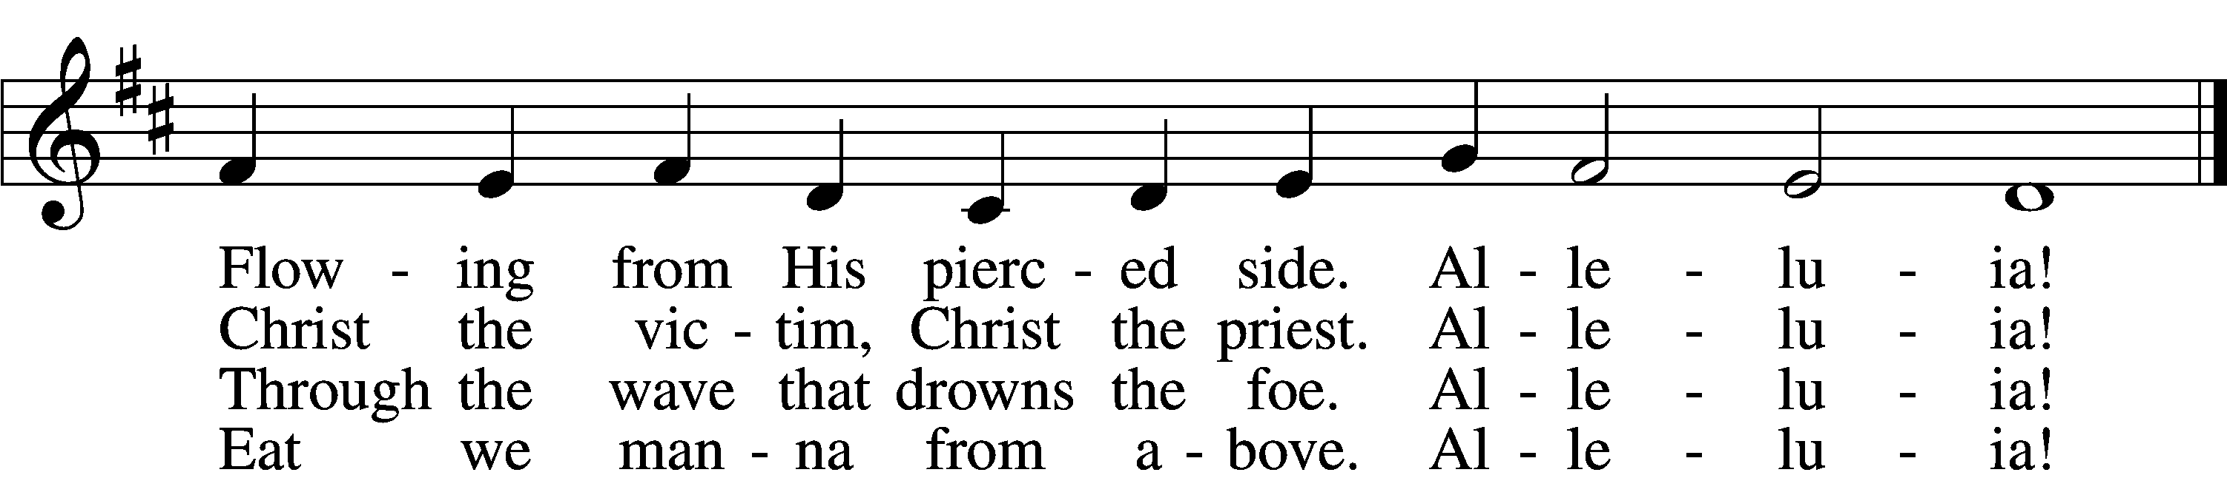

5 Mighty Victim from the sky,  
Hell’s fierce pow’rs beneath You lie;  
You have conquered in the fight,  
You have brought us life and light.  
 Alleluia!

6 Now no more can death appall,  
Now no more the grave enthrall;  
You have opened paradise,  
And Your saints in You shall rise.  
 Alleluia!

7 Easter triumph, Easter joy!  
This alone can sin destroy;  
From sin’s pow’r, Lord, set us free,  
Newborn souls in You to be.  
 Alleluia!

D 8 Father, who the crown shall give,  
Savior, by whose death we live,  
Spirit, guide through all our days:  
Three in One, Your name we praise.  
 Alleluia!

Text: Latin, c. 5th–10th cent.; tr. Robert Campbell, 1814–68, alt.  
Tune: Kirchengeseng, 1566, Ivancice  
Text and tune: Public domain

845 Where Charity and Love Prevail

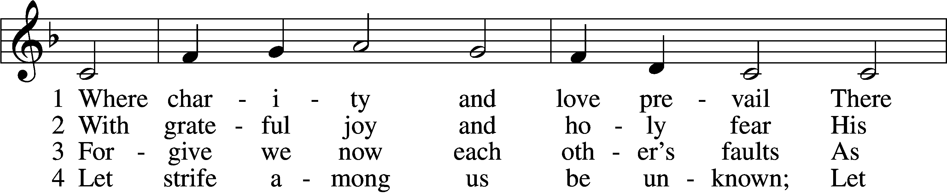

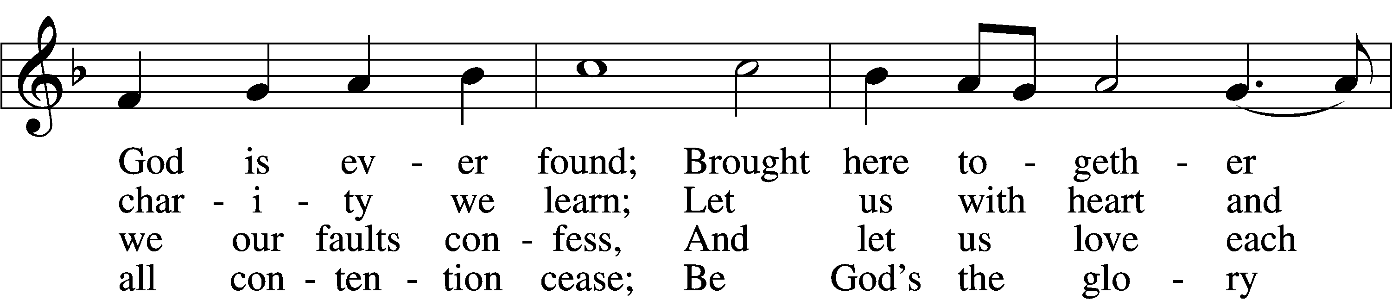

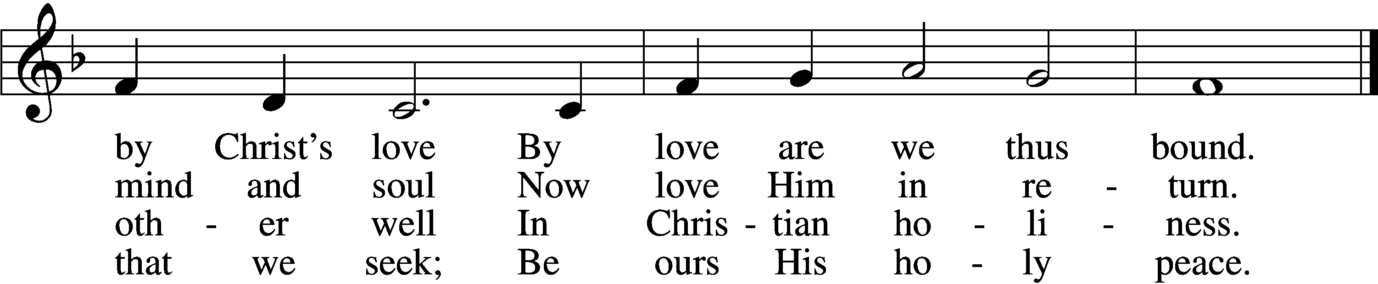

5 Let us recall that in our midst  
 Dwells Christ, His only Son;  
As members of His body joined  
 We are in Him made one.

6 For love excludes no race or clan  
 That names the Savior’s name;  
His family embraces all  
 Whose Father is the same.

Text: Latin, c. 9th cent.; tr. Omer E. Westendorf, 1916–97, alt.  
Tune: Lucius Chapin, 1760–1842  
Text: © 1960 World Library Publications. Used by permission: LSB Hymn License no. 110005011  
Tune: Public domain

797 Praise the Almighty

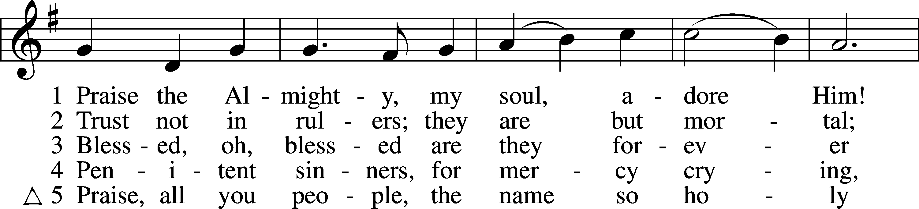

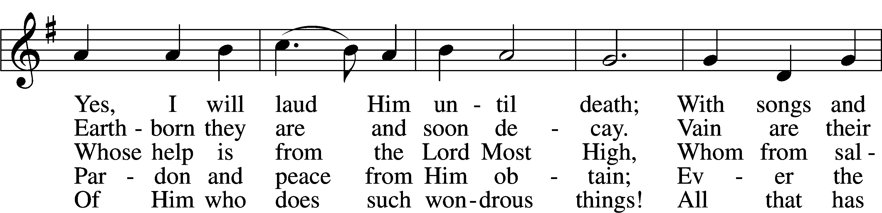

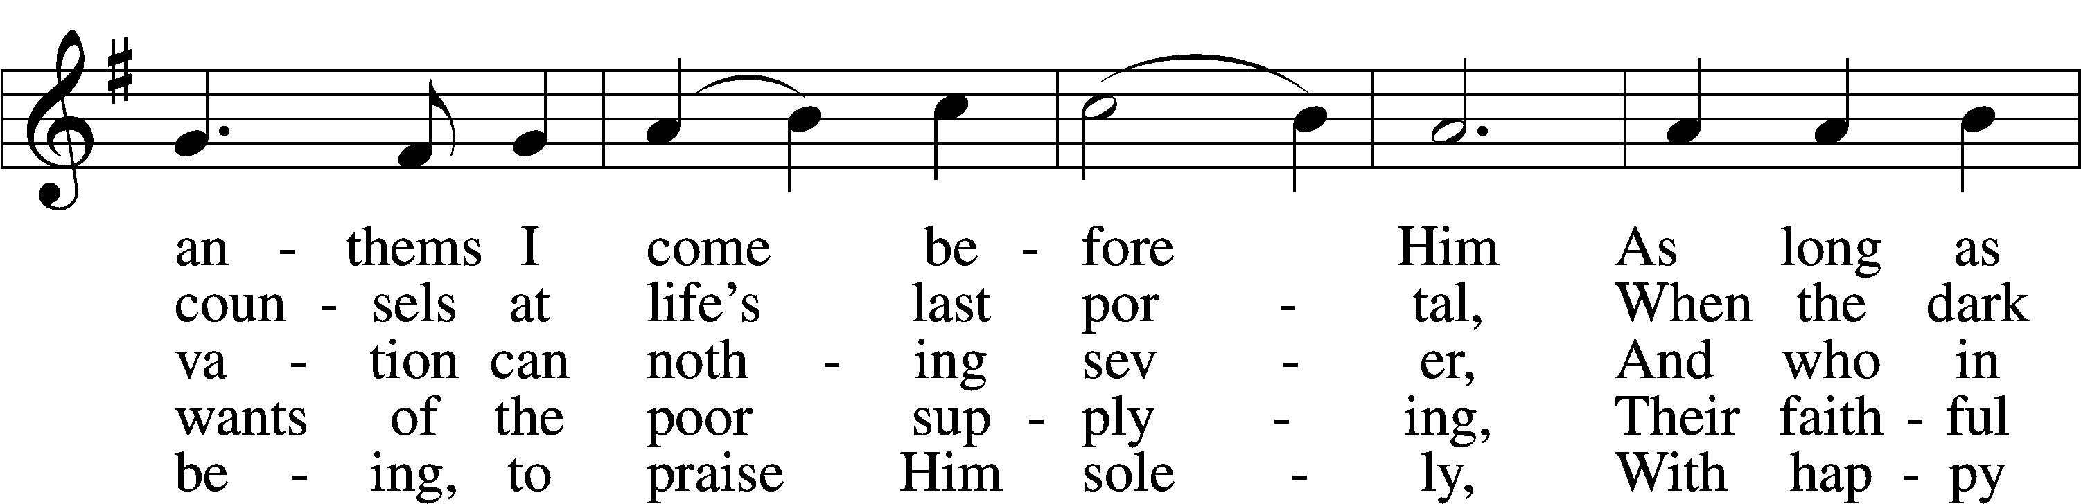

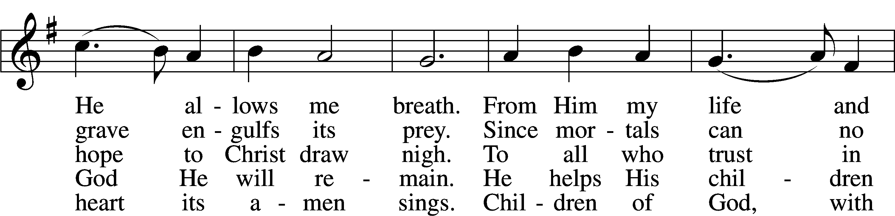

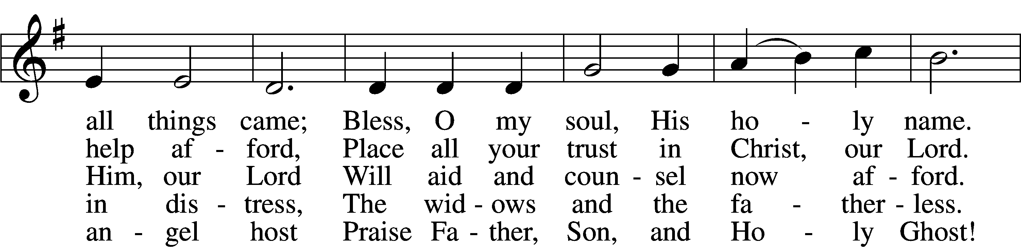

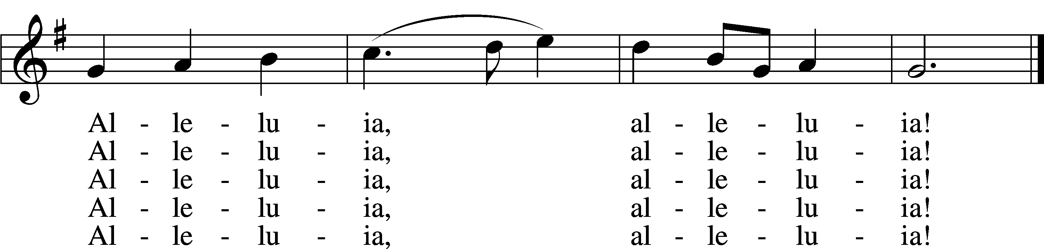

Text: Johann Daniel Herrnschmidt, 1675–1723; tr. Alfred E. R. Brauer, 1866–1949, alt.  
Tune: New-vermehrte Christliche Seelenharpf, 1665, Ansbach  
Text and tune: Public domain

685 Let Us Ever Walk with Jesus

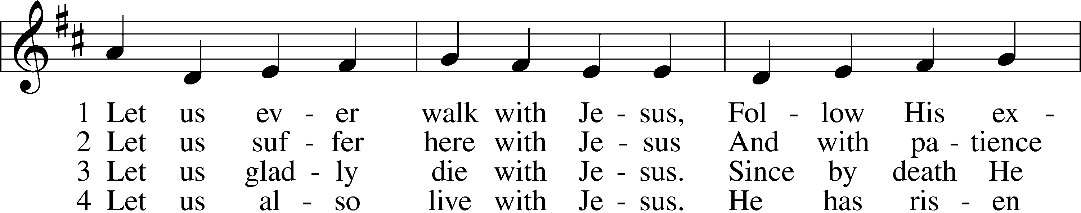

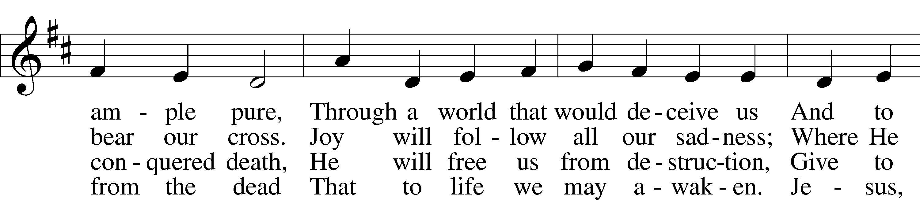

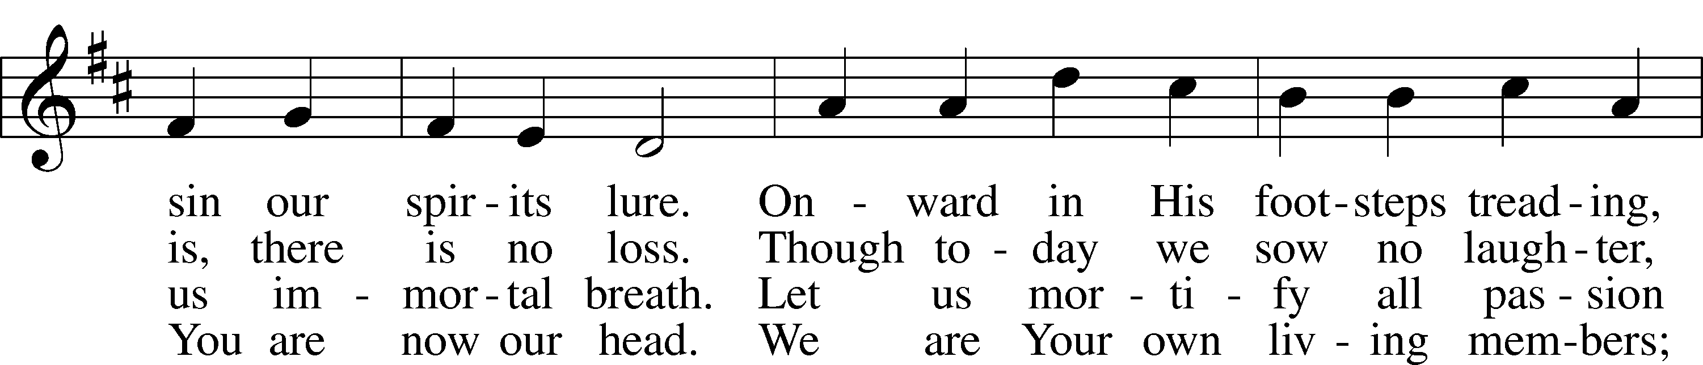

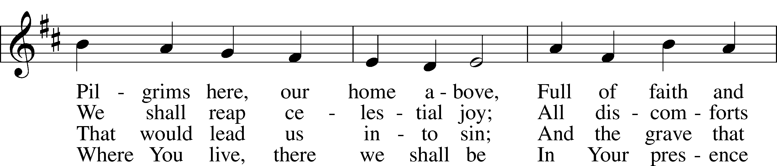

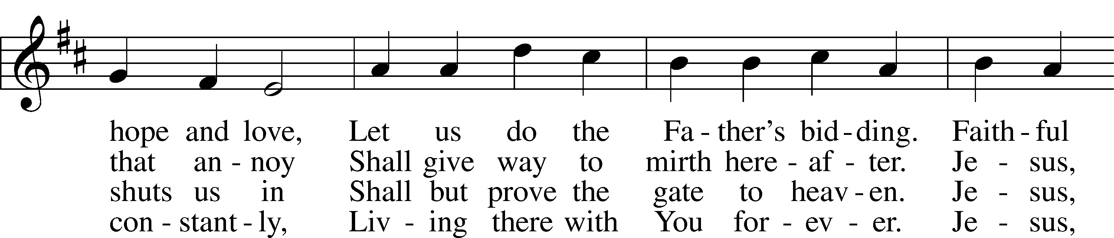

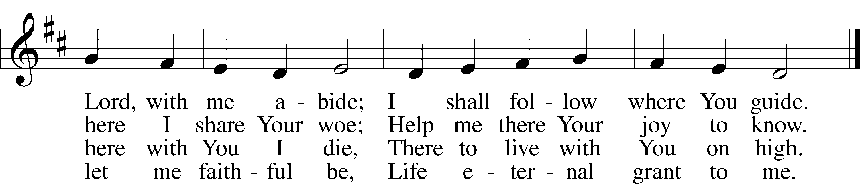

Text: Sigismund von Birken, 1626–81; tr. Lutheran Book of Worship, 1978, alt.  
Tune: Georg G. Boltze, 18th cent.  
Text: © 1978 Lutheran Book of Worship. Used by permission: LSB Hymn License no. 110005011  
Tune: Public domain

Stand

Nunc Dimittis Luke 2:29–32

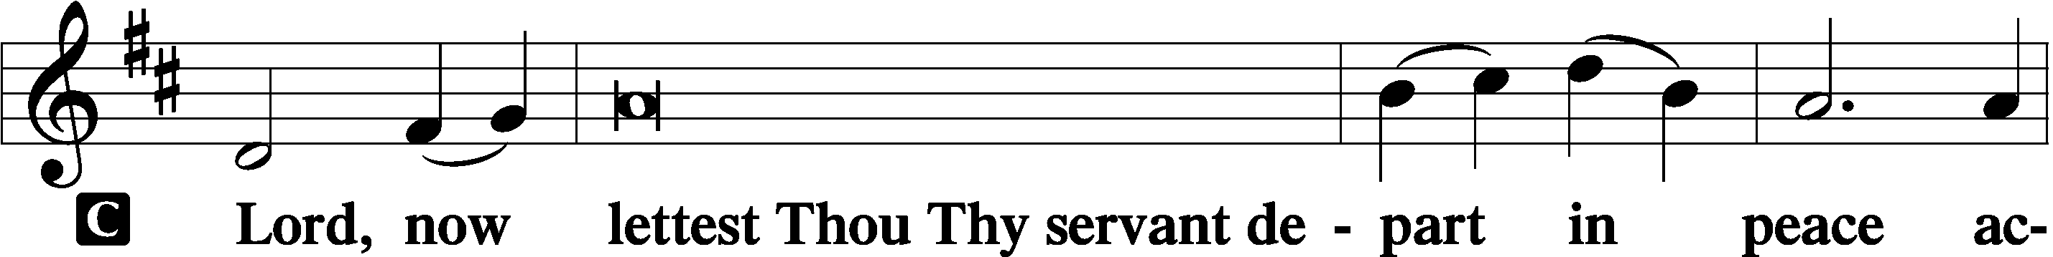

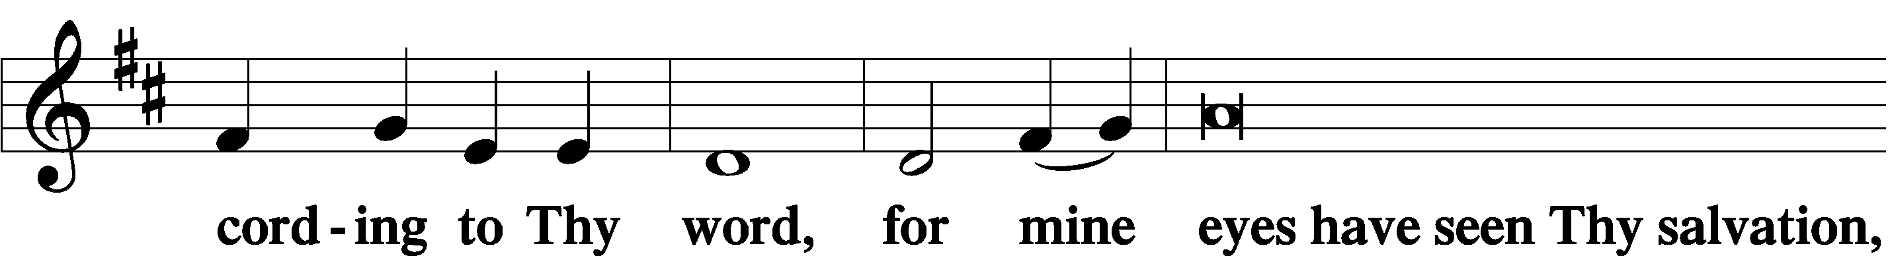

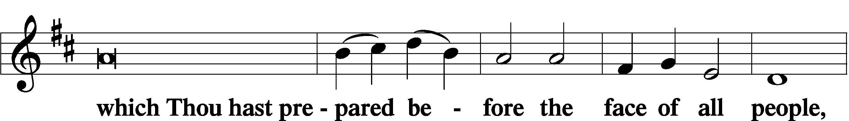

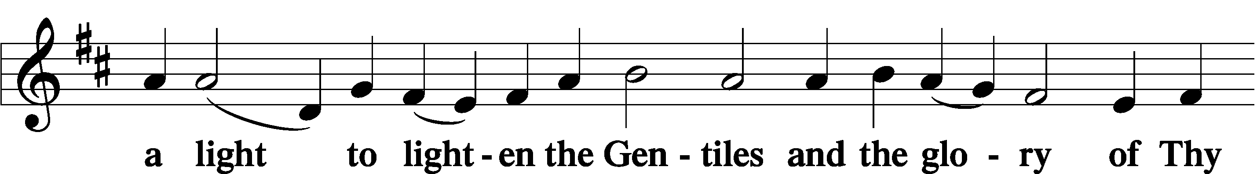

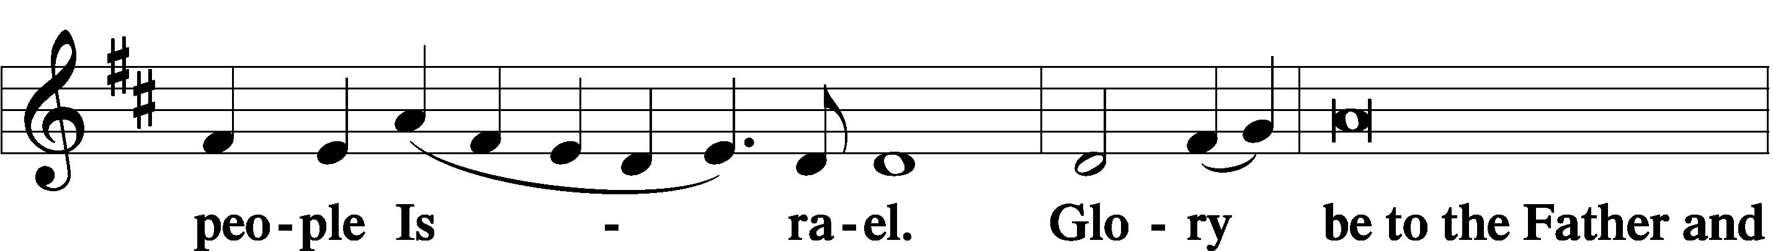

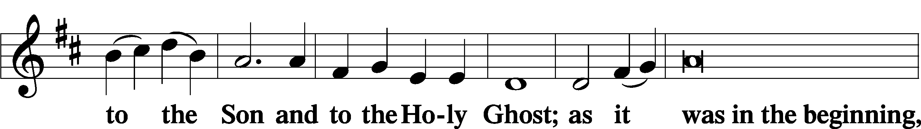

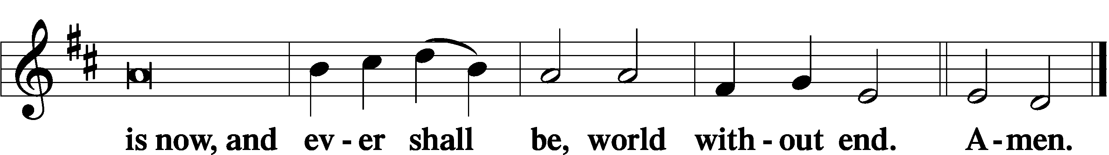

Thanksgiving Psalm 107:1

A O give thanks unto the Lord, for He is good,

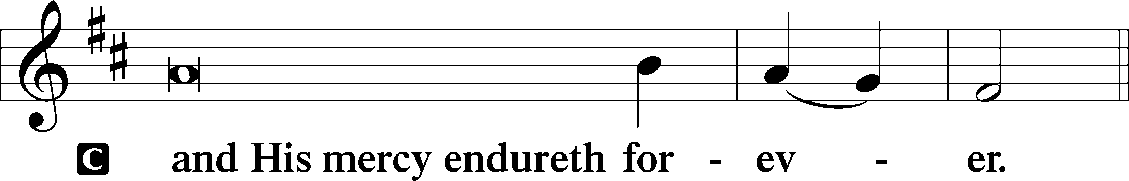

Post-Communion Collect

A Let us pray.

We give thanks to You, almighty God, that You have refreshed us through this salutary gift, and we implore You that of Your mercy You would strengthen us through the same in faith toward You and in fervent love toward one another; through Jesus Christ, Your Son, our Lord, who lives and reigns with You and the Holy Spirit, one God, now and forever.

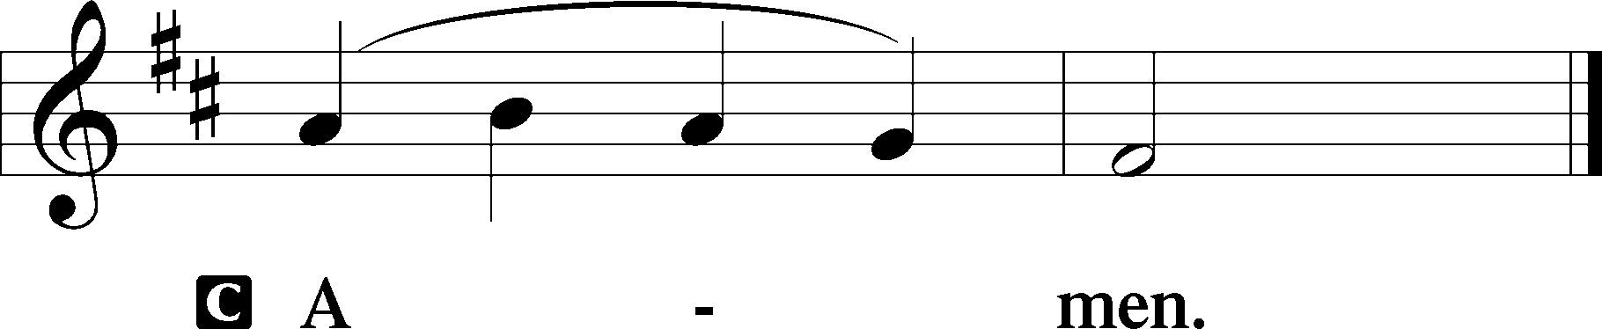

Salutation 2 Timothy 4:22

P The Lord be with you.

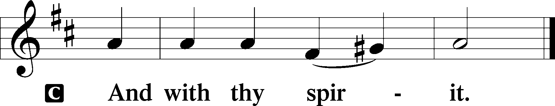

Benedicamus Psalm 103:1

A Bless we the Lord.

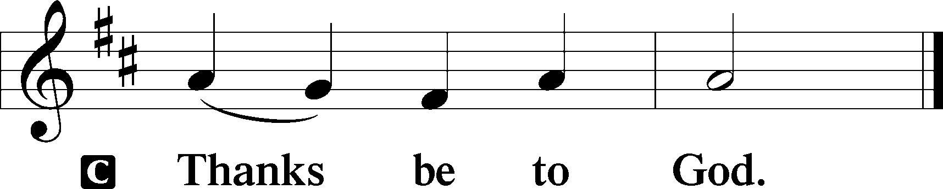

Benediction Numbers 6:24–26

P The Lord bless you and keep you.

The Lord make His face shine upon you and be gracious unto you.

The Lord lift up His countenance upon you and T give you peace.

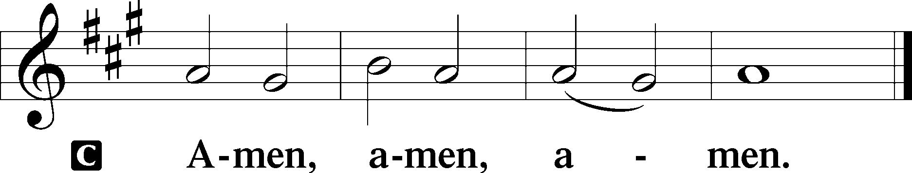

851 Lord of Glory, You Have Bought Us

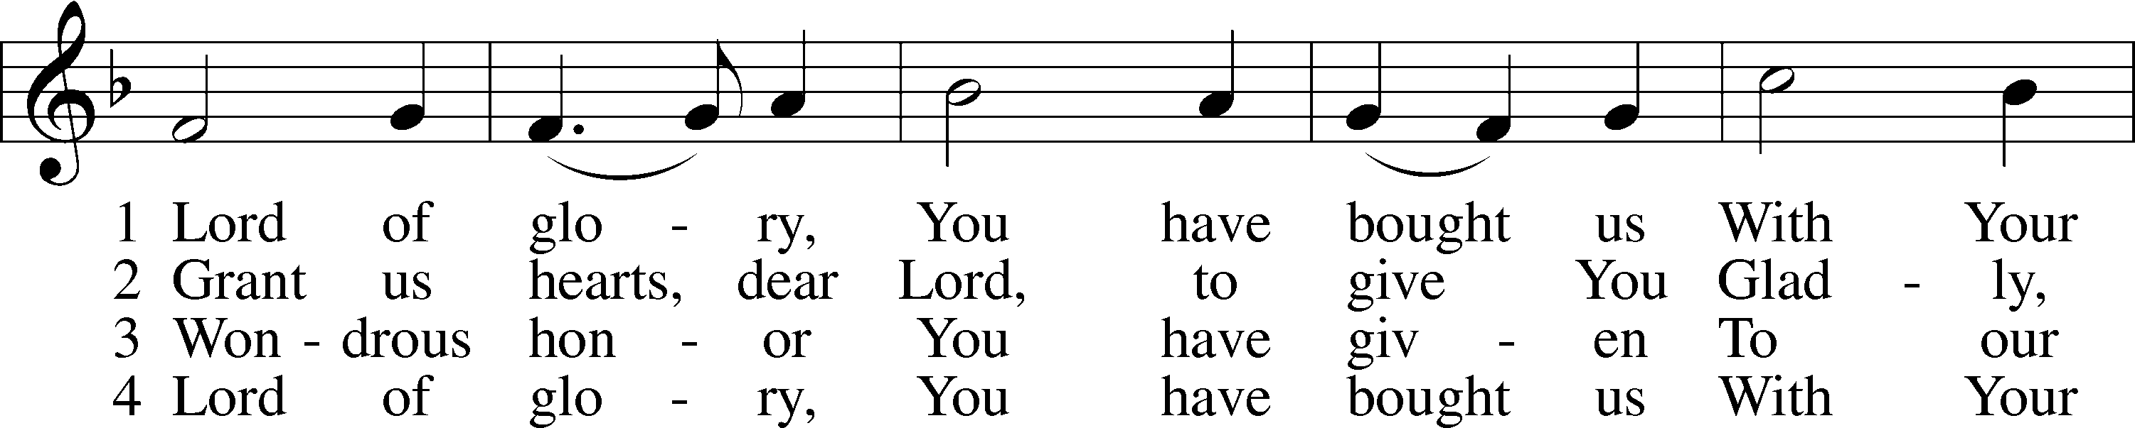

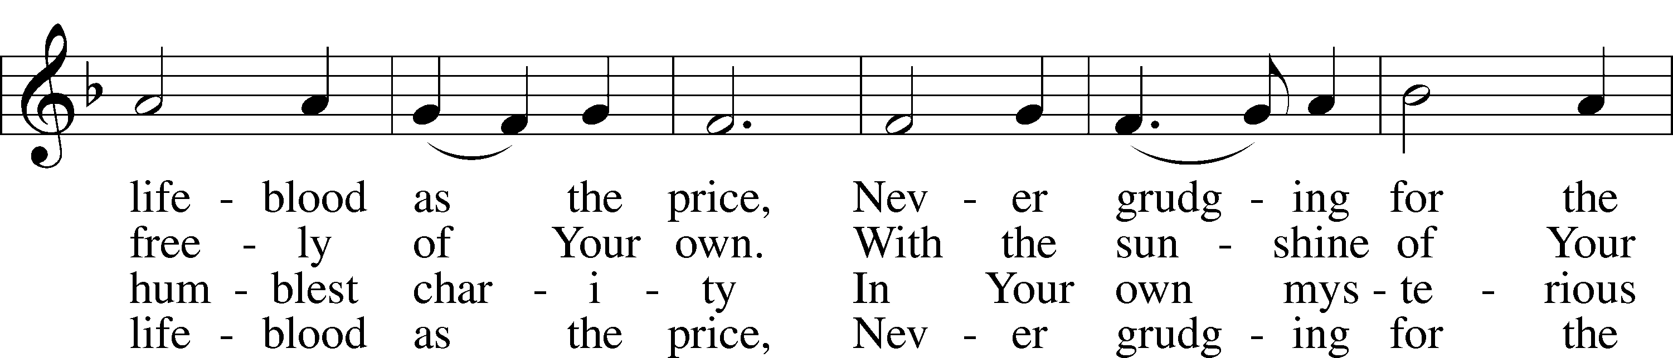

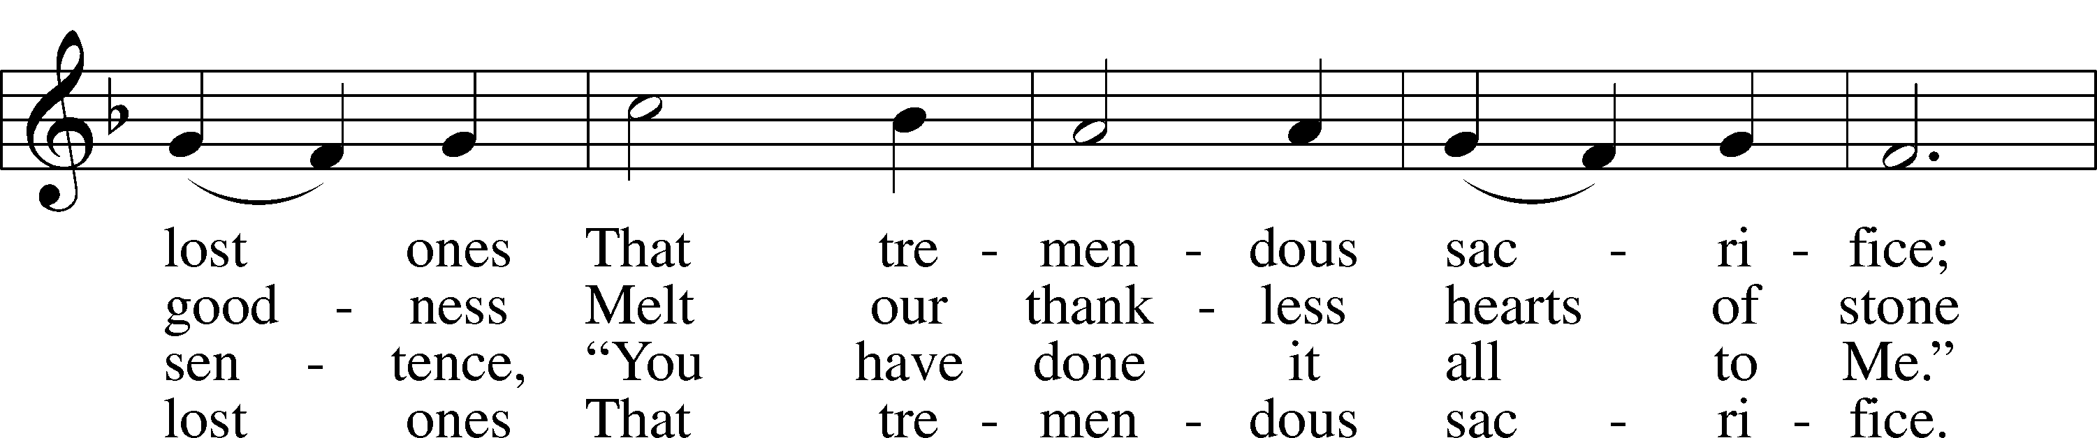

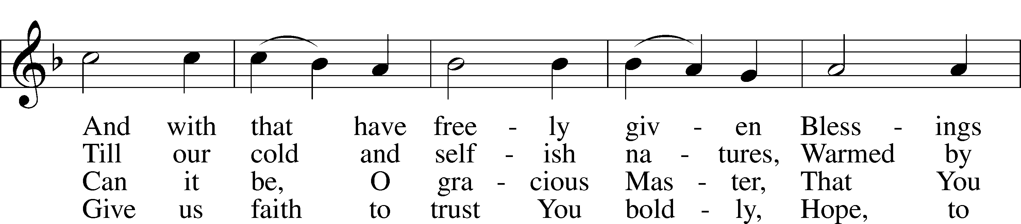

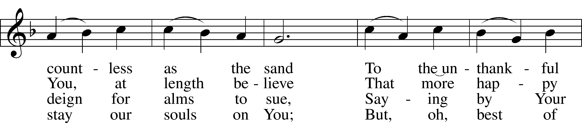

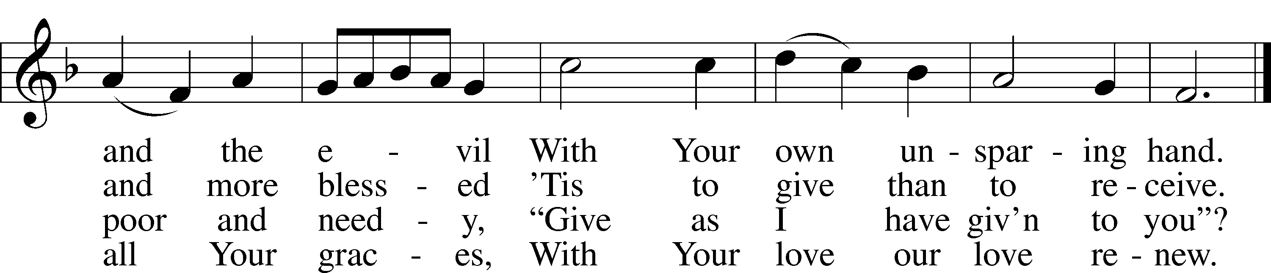

Text: Eliza S. Alderson, 1818–89, alt.  
Tune: Rowland H. Prichard, 1811–87  
Text and tune: Public domain

Acknowledgments

Divine Service, Setting Three from Lutheran Service Book

Unless otherwise indicated, Scripture quotations are from the ESV® Bible (The Holy Bible, English Standard Version®), copyright © 2001 by Crossway, a publishing ministry of Good News Publishers. Used by permission. All rights reserved.

Created by Lutheran Service Builder © 2025 Concordia Publishing House.