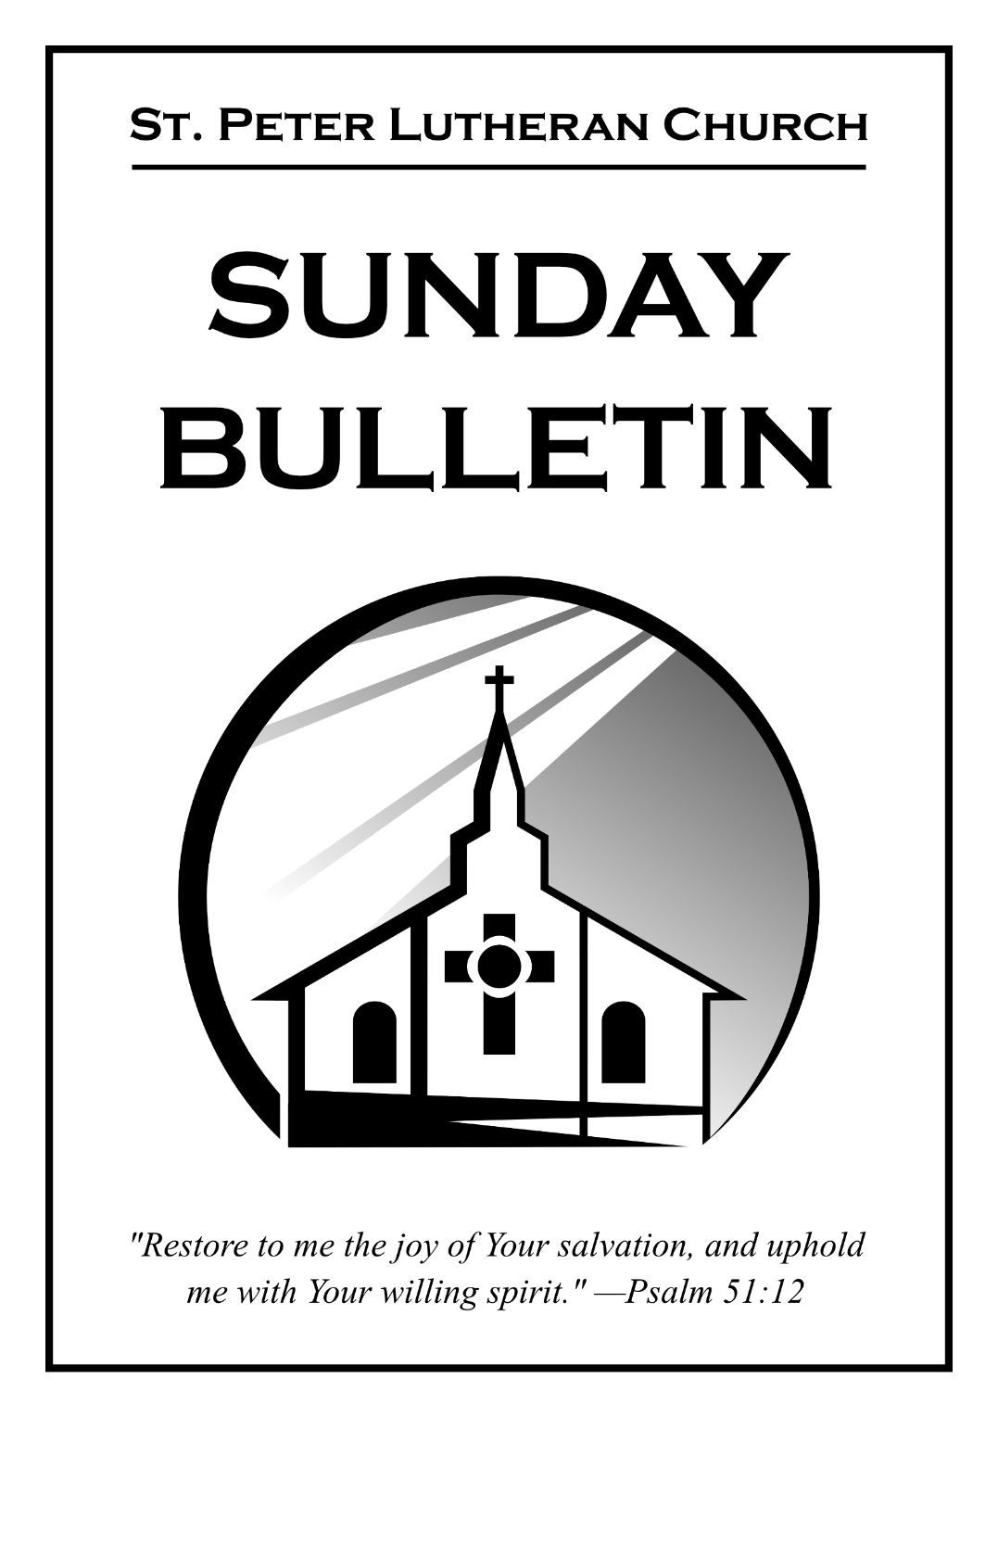
June 28, 2026
Fifth Sunday after Pentecost

June 28, 2026 Fifth Sunday after Pentecost

Not Peace but a Sword!

As We Gather
God’s Holy Law binds, condemns, and kills! Those under the Law are terrorized by sin. Prophets recount the transgressions of people that have provoked wars, famines, pestilence, and death. Only peace produces life. But the Lord unsheathes the sword of division between those who vehemently deny and those who humbly confess Christ as Lord. Nothing dismisses the authority of the Law, but thanks be to God that Christ fulfilled its every letter—so we shall inherit eternal peace!

Opening Hymn “O Word of God Incarnate” (LSB 523; all vs.)
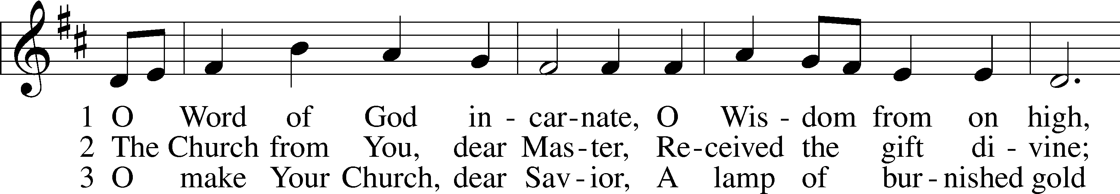
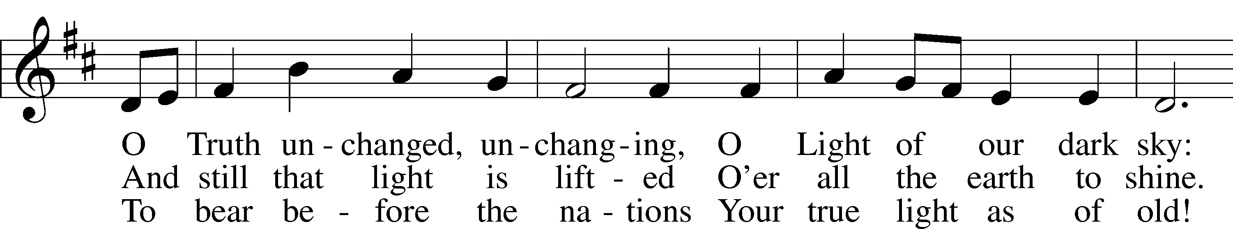
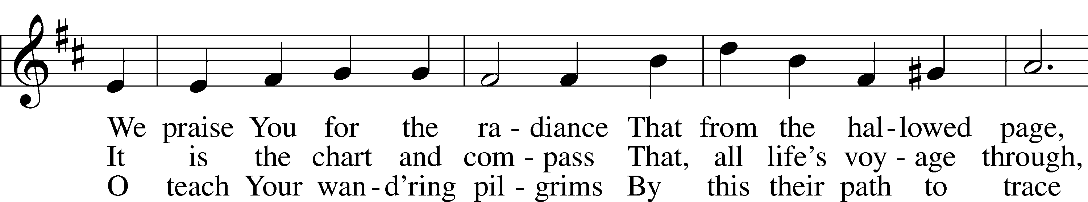
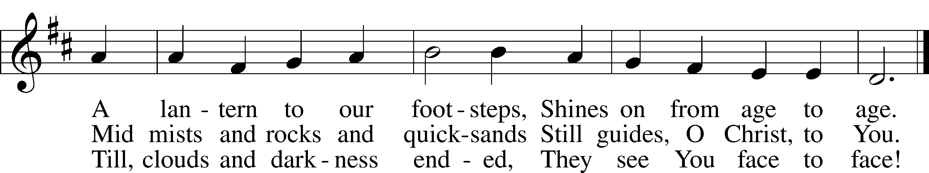

We Call on the Name of Our Triune God
P We worship the Father,
C Who is our strength and shield;
P We worship the Son,
C Who is our refuge and salvation;
P We worship the Holy Spirit,
C Who gives us life and faith.
P Our God has called us out of darkness into His marvelous light, and has made us His children. His Spirit works through His Word, and we are made His with the water and the words of our baptism:
C In the name of the Father, and of the T Son, and of the Holy Spirit. Amen.
P The Lord is my strength and my song;
C He has become my salvation. He is my God, and I will praise Him.
P God is our refuge and strength,
C An ever-present help in trouble.
P My flesh and my heart may fail,
C But God is the strength of my heart and my portion forever.
P It is good to recognize the Lord as our strength and salvation. But before we can appreciate what this truly means, we first must recognize how weak we are and how much we are in need of His strength. We sin daily because we are not strong enough to resist the temptations of Satan. Therefore, our God, our refuge and strength, calls us to admit our failures, and seek renewal according to His unfailing love. Let us therefore pause and consider our sin, and then sing to the One through whom we find forgiveness and strength.
(We silently confess the sins we have committed
over the past week)
P God in His mercy has heard your confession, and by the blood of Jesus forgives you all your sins. We therefore rejoice and sing for joy, for in your weakness, you are made strong!
C Amen. Thanks be to God!

Hymn of Praise “Oh, That I Had a Thousand Voices ” (811; v. 1,4)
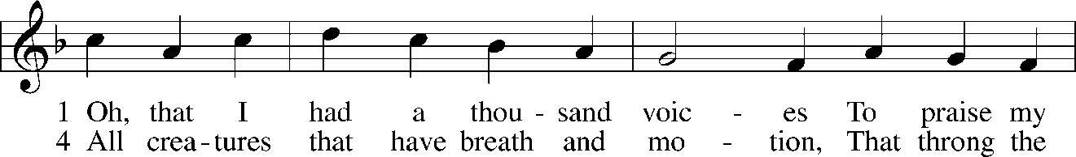
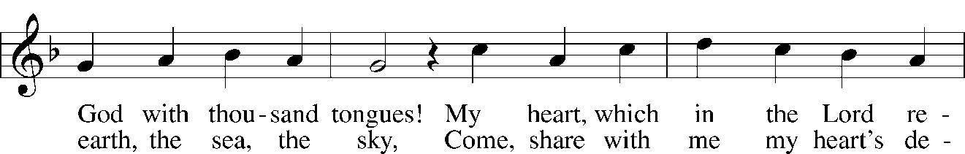
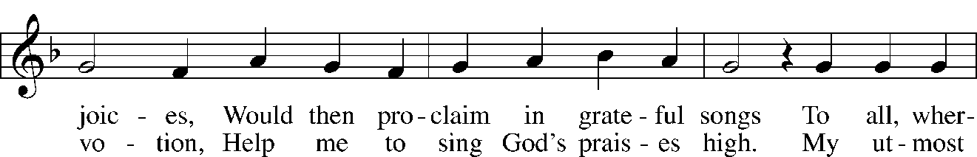
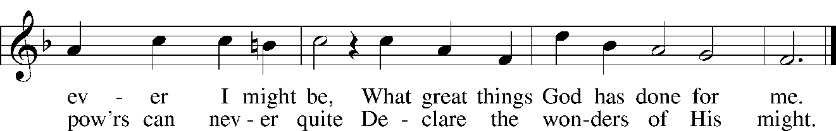

Salutation and Collect of the Day
P The Lord be with you.
C And also with you.
P Almighty God, by the working of Your Holy Spirit, grant that we would hear Your Word proclaimed among us with great joy and follow its directing; through Jesus Christ, Your Son, our Lord, who lives and reigns with You and the Holy Spirit, one God, now and forever.
C Amen.

Please be seated.

Old Testament Reading Jeremiah 28:1-9
¹In that same year, at the beginning of the reign of Zedekiah king of Judah, in the fifth month of the fourth year, Hananiah the son of Azzur, the prophet from Gibeon, spoke to me in the house of the Lord, in the presence of the priests and all the people, saying, ²“Thus says the Lord of hosts, the God of Israel: I have broken the yoke of the king of Babylon. ³Within two years I will bring back to this place all the vessels of the Lord’s house, which Nebuchadnezzar king of Babylon took away from this place and carried to Babylon. ⁴I will also bring back to this place Jeconiah the son of Jehoiakim, king of Judah, and all the exiles from Judah who went to Babylon, declares the Lord, for I will break the yoke of the king of Babylon.”
⁵Then the prophet Jeremiah spoke to Hananiah the prophet in the presence of the priests and all the people who were standing in the house of the Lord, ⁶and the prophet Jeremiah said, “Amen! May the Lord do so; may the Lord make the words that you have prophesied come true, and bring back to this place from Babylon the vessels of the house of the Lord, and all the exiles. ⁷Yet hear now this word that I speak in your hearing and in the hearing of all the people. ⁸The prophets who preceded you and me from ancient times prophesied war, famine, and pestilence against many countries and great kingdoms. ⁹As for the prophet who prophesies peace, when the word of that prophet comes to pass, then it will be known that the Lord has truly sent the prophet.”
P This is the Word of the Lord.
C Thanks be to God.

Gradual (Spoken responsively.) Romans 11:33, 36
L Oh, the depth of the riches and wisdom and knowledge of God!
How unsearchable are his judgments and how inscrutable his ways!
C For from him and through him and to him are all things.
To him be glory forever. Amen.

Epistle Romans 7:1-13
¹Do you not know, brothers—for I am speaking to those who know the law—that the law is binding on a person only as long as he lives? ²Thus a married woman is bound by law to her husband while he lives, but if her husband dies she is released from the law of marriage. ³Accordingly, she will be called an adulteress if she lives with another man while her husband is alive. But if her husband dies, she is free from that law, and if she marries another man she is not an adulteress.
⁴Likewise, my brothers, you also have died to the law through the body of Christ, so that you may belong to another, to him who has been raised from the dead, in order that we may bear fruit for God. ⁵For while we were living in the flesh, our sinful passions, aroused by the law, were at work in our members to bear fruit for death. ⁶But now we are released from the law, having died to that which held us captive, so that we serve not under the old written code but in the new life of the Spirit.
⁷What then shall we say? That the law is sin? By no means! Yet if it had not been for the law, I would not have known sin. I would not have known what it is to covet if the law had not said, “You shall not covet.” ⁸But sin, seizing an opportunity through the commandment, produced in me all kinds of covetousness. Apart from the law, sin lies dead. ⁹I was once alive apart from the law, but when the commandment came, sin came alive and I died. ¹⁰The very commandment that promised life proved to be death to me. ¹¹For sin, seizing an opportunity through the commandment, deceived me and through it killed me. ¹²So the law is holy, and the commandment is holy and righteous and good.
¹³Did that which is good, then, bring death to me? By no means! It was sin, producing death in me through what is good, in order that sin might be shown to be sin, and through the commandment might become sinful beyond measure.
P This is the Word of the Lord.
C Thanks be to God.

We stand to sing.

Hymn “God’s Word is Our Great Heritage” (LSB 582)
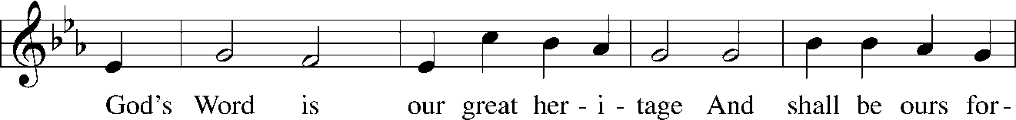
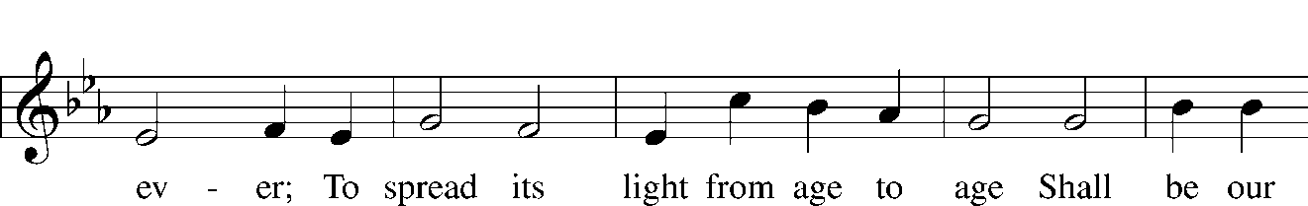
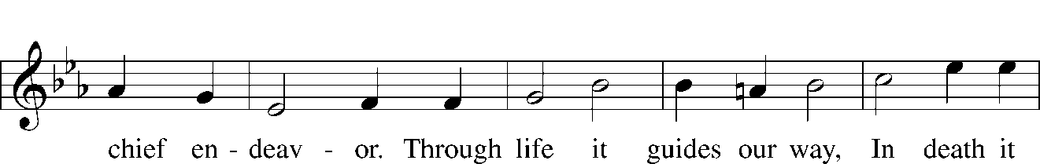
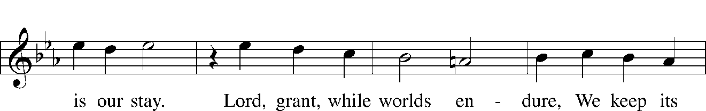
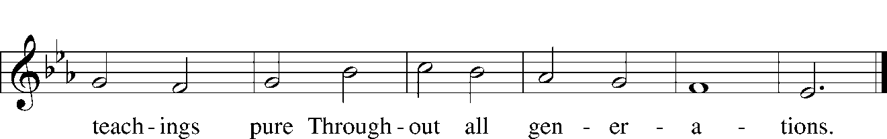

Holy Gospel Matthew 10:34-42
³⁴[Jesus said:] “Do not think that I have come to bring peace to the earth. I have not come to bring peace, but a sword. ³⁵For I have come to set a man against his father, and a daughter against her mother, and a daughter-in-law against her mother-in-law. ³⁶And a person’s enemies will be those of his own household. ³⁷Whoever loves father or mother more than me is not worthy of me, and whoever loves son or daughter more than me is not worthy of me. ³⁸And whoever does not take his cross and follow me is not worthy of me. ³⁹Whoever finds his life will lose it, and whoever loses his life for my sake will find it.
⁴⁰“Whoever receives you receives me, and whoever receives me receives him who sent me. ⁴¹The one who receives a prophet because he is a prophet will receive a prophet’s reward, and the one who receives a righteous person because he is a righteous person will receive a righteous person’s reward. ⁴²And whoever gives one of these little ones even a cup of cold water because he is a disciple, truly, I say to you, he will by no means lose his reward.”
P This is the Gospel of the Lord!
C Thanks be to God!

Baptismal Remembrance and the Apostles' Creed
P In his letter to the Ephesians, chapter 4, St. Paul tells us, “There is one body and one Spirit.
C One Lord, one faith, one baptism,
P One God and Father of us all,
C Who is over all and through all and in all.”
P In the words of the Apostles' Creed we confess with confidence and joy the faith into which we are baptized:
C I believe in God, the Father Almighty,
maker of heaven and earth.
And in Jesus Christ, His only Son, our Lord,
who was conceived by the Holy Spirit,
born of the virgin Mary,
suffered under Pontius Pilate,
was crucified, died and was buried.
He descended into hell.
The third day He rose again from the dead.
He ascended into heaven and sits at the right hand of God the Father Almighty.
From thence He will come to judge the living and the dead.
I believe in the Holy Spirit,
the holy Christian Church,
the communion of saints,
the forgiveness of sins,
the resurrection of the body,
and the life T everlasting. Amen.

Children’s Message

Hymn of the Day "Praise to the Lord, the Almighty" (LSB 790)
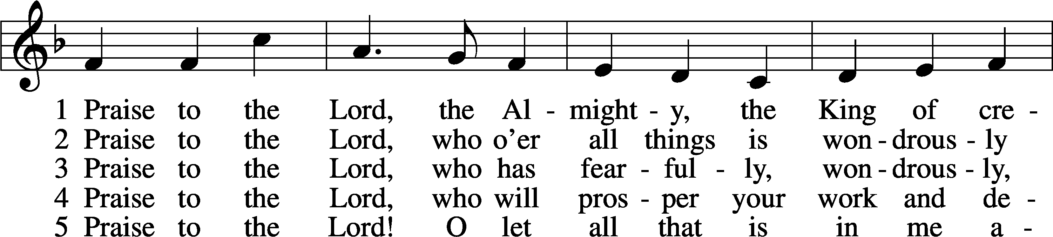
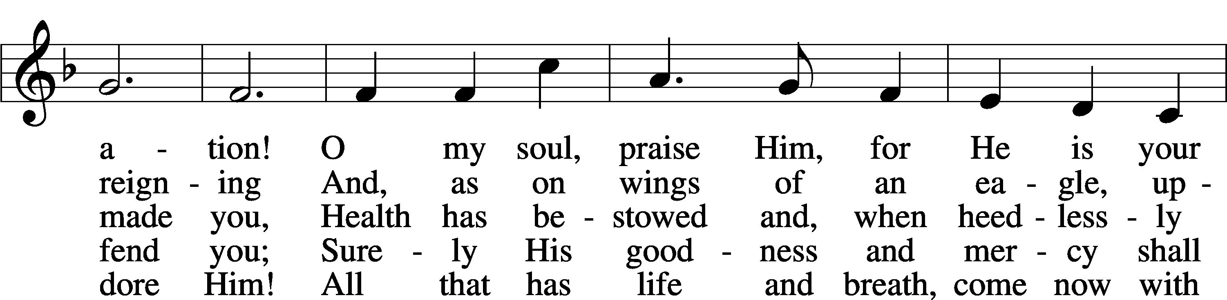
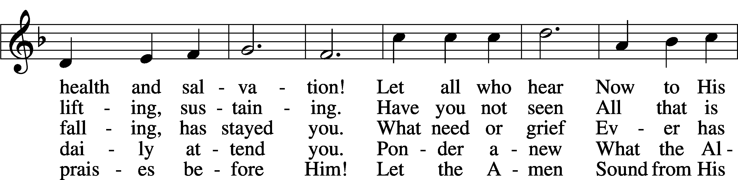
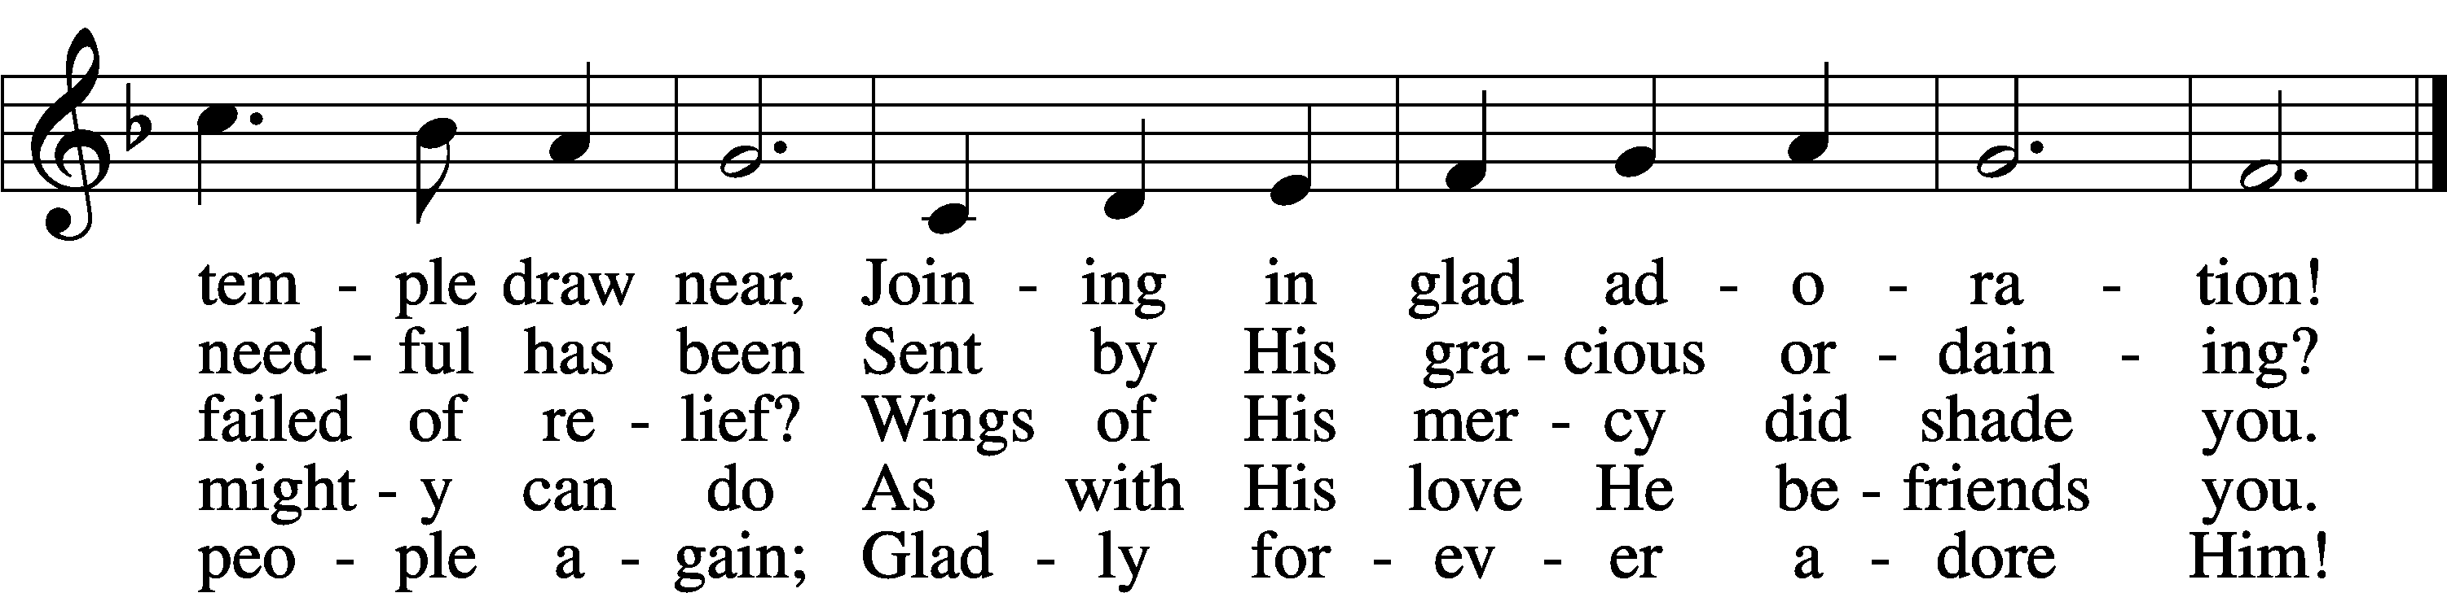

Text: Joachim Neander, 1650–80; tr. Catherine Winkworth, 1827–78, alt.
Tune: Ander Theil Des Erneuerten Gesang-Buchs, 1665, Stralsund. Text and tune: Public domain
Sermon “Peace for Our Time? NOT!” Matthew 10:34-42

Receiving of Tithes and Special Offerings (LSB 805)
As the Offerings are brought forward, we stand to sing the Doxology.

Praise God, from whom all blessings flow;
Praise Him, all creatures here below;
Praise Him above, ye heav’nly host;
Praise Father, Son, and Holy Ghost. Amen.

Prayer of the Church
P Let us pray for the whole Church of God in Christ Jesus and for all people according to their needs:
(A brief silence is kept to center our hearts and minds on prayer.)
Father, we thank You that You have released us from the Law and that we now belong to Christ. Help us always to serve You in the new life of the Spirit and bear fruit for You. Lord, in Your mercy,
C Hear our prayer.
P Father, we thank You for all You do to provide us with our daily bread. Be with all who work to grow the fruits of the earth that You have given us for food. Give them favorable weather and a successful harvest. Bless also all involved in the commerce and industry of our land. Allow the fruits of their labor to provide for the material needs of the many who rely on them. Lord, in Your mercy,
C Hear our prayer.
P Father, we thank You for our own nation and the many freedoms that You have provided for us here. Guide our elected and appointed leaders to serve us with integrity. Be with those who defend our freedoms in the Armed Forces, as well as the police, firefighters, first responders, and all who provide care and protect our freedoms closer to home. Lord, in Your mercy,
C Hear our prayer.
P Father, we thank You for the freedom from sin, sickness and death that will come with the full manifestation of Your Son’s Kingdom. Give comfort, healing, patience, and endurance to all who suffer from illness, injury, or chronic affliction. Strengthen their faith so that they know that despite their suffering, they have not lost their reward. Lord, in Your mercy,
C Hear our prayer.
P Father, we thank You for the great cloud of witnesses that surrounds us. Join our praise with theirs and bring us at last with them into the full freedom of Your Kingdom. All this we pray through Jesus Christ, who Himself gave us these words to pray:
C Our Father who art in heaven,
hallowed be Thy name,
Thy kingdom come,
Thy will be done on earth as it is in heaven;
give us this day our daily bread;
and forgive us our trespasses
as we forgive those who trespass against us;
and lead us not into temptation,
but deliver us from evil.
For Thine is the kingdom and the power and the glory forever and ever. Amen.

Benedicamus and Benediction
P Let us bless the Lord.
C Thanks be to God!
P The grace of the Lord T Jesus Christ and the love of God and the fellowship of the Holy Spirit be with you all.
C Amen.


Closing Hymn “Praise and Thanksgiving” (LSB 789; all vs.)
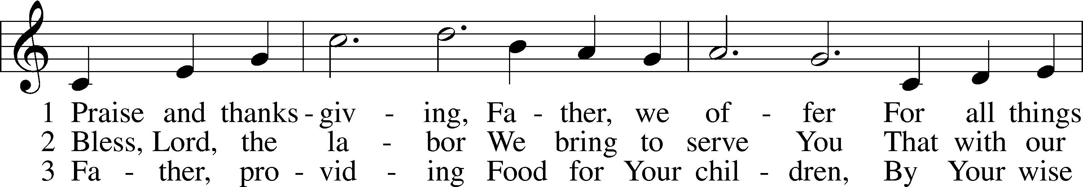
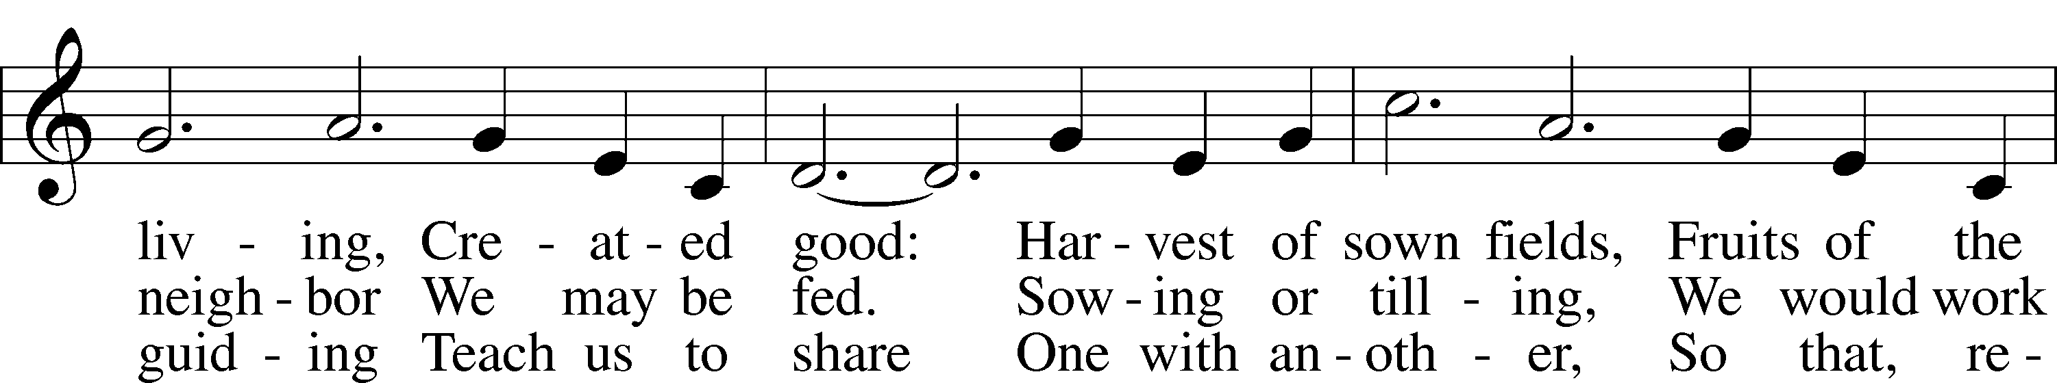
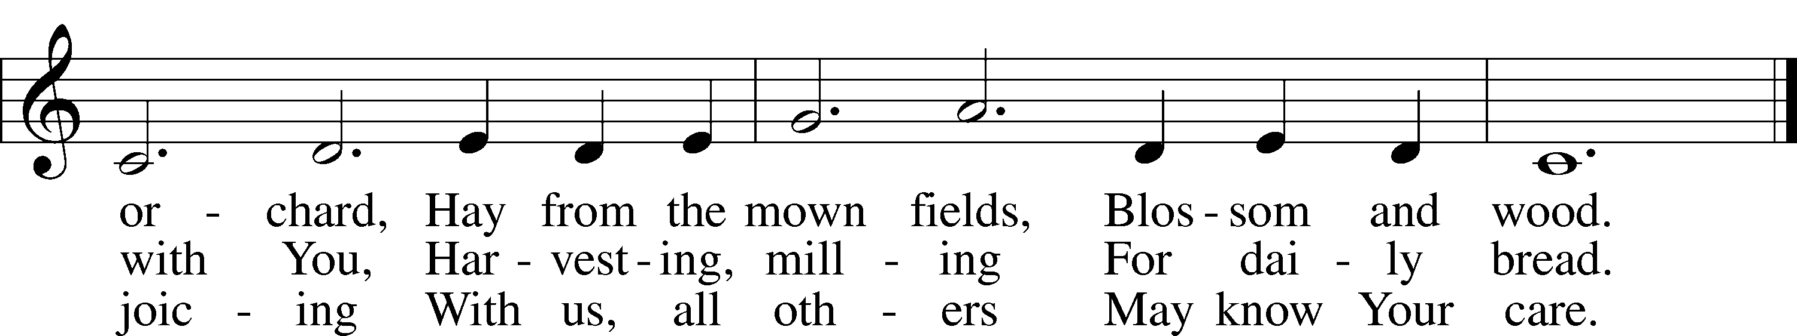

Text: Albert F. Bayly, 1901–84
Tune: Gaelic, 19th cent.
Text: © 1987 Oxford University Press. Used by permission: LSB Hymn License no. 110005011
Tune: Public domain

SERVING IN GODS HOUSE TODAY

Officiant | Rev. Dale Snyder
Elder | David Geis
Reader | William Pickett
Acolytes | Emily Keyes & Parker Lawson
Counters | Lee Hughes / David Geis
Altar Guild | Lisa Lawson / Rebecca Horton
Altar Care | Maleisa Belcher / Becky Geis
Guest Monitor | Kelly Roth

THIS WEEK AT ST PETER

Sunday | Sunday School | 9:30 a.m.
 | Worship w/Holy Communion after Worship | 10:30 a.m.
Wednesday | Adult Bible Study | 7:00 p.m.
Thursday | Elders Meeting | 6:00 p.m.

Sunday | Sunday School/Bible Classes | 9:30 a.m.
 | Worship w/Holy Communion | 10:30 a.m.
Wednesday | Adult Bible Study | 7:00 p.m.
Thursday | Voter’s Meeting | 7:00 p.m.
NEXT WEEK AT ST PETER

SERVING IN JULY

Elder of the Month | Travis Dyson
Counters | Bryan Roth / Arn Anderson
Altar Guild | Sherry Hammer / Jeannine Yowell
Altar Care | Vonita Drager / Darlene Geis
Guest Monitor | Lisa Lawson

Birthdays: June 28 Sally Morgan
July 01 Jimmy Atkinson
02 Archer Ferguson

Anniversaries: June 29 Bryan & Kelly Roth

News & Other Information

Pastor Holiday, Interim Pastor — To listen to Pastor Holiday’s Sermons and help us decide whether or not he will be our church’s interim pastor, go to Peace Lutheran Church Hewitt TX’s Facebook Page: https://www.facebook.com/share/1BfE3ZojDh/?mibextid=wwXIfr

Upcoming Voter’s Meeting Topics — If you have things concerning the church you would like to bring up and vote on, there are blank sheets on the table near the classroom you can leave notes on.

Volunteer Call — Altar Guild very short on members and needs help. Please prayerfully consider serving in our church. To discuss becoming an Altar Guild member, please contact Rebecca Horton.

Hearing Assistance — A wireless communication system is available to assist those with hearing issues to better hear the sermon. You may request a receiving unit from Pastor or William Pickett.

To all members: if you need to speak to a Pastor at this time, Pastor Brummett is available to take calls at (940) 886-7468. For anything else, please contact the church elders or other church leaders.

Mary Atkinson, Graphic Designer and Secretary
- Email: stpetertexscty@gmail.com
- Office Phone: (940) 872-1886
- Personal Phone: (940) 634-3032
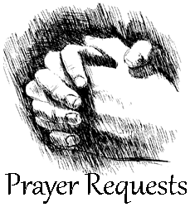
Please fill out a “Cares and Concerns” card located in the Narthex for prayer requests.
Bonnie Brisco – Diagnosed with Lymphoma in her face and is starting treatments (mother of a co-worker to Lisa Lawson).
Gary Burkhart – Diagnosed with kidney cancer (Art Noack’s Brother-in-Law).
Mike Dunn – Diagnosed with prostate cancer (Debra Keyes’s Stepfather).
Debbie Garrett – Diagnosed with breasts cancer (Glenda Roth’s Sibling).
Bryleigh Gresham – In remission for her acute lymphoblastic leukemia (student in Maci Ferguson’s class).
Beth Hiatt – Diagnosed with stage 4 breast cancer (friend of Ashley Keyes).
Michelle McCaniless – Undergoing chemotherapy treatment, they are unable to operate on lung tumors (friend of Malley Underwood).
Jessica Miller – Ovarian cancer terminal. Still on meds and treatments but has surpassed timeline the Drs. initially gave her, 24 months (friend of Chanda Lee).
Bill Miller – Recovering from surgery to remove colon cancer tumor (friend of Terry Henry).
Chris Mitchell – Has been put on several ‘trial options’ for Esophageal/tongue cancer; some seem to be working, still struggles with strength and side effects of treatments, not able to work. (friend of Chanda Lee).
Melissa Taylor – Breast Cancer has returned. Taking radiation treatments now (friend of Chanda Lee).
Rick Baker – Compound Fracture to his leg. Had second surgery, all went well and will be non-weight bearing for 3 months possibly. The recovery will be longer (father-in-law of Reisha Baker).
Kevin Cox – Received a heart transplant (friend of Terisa Johnston).
Carol English – Fell and broke her hip. To have surgery (friend of Bettie Hines).
Jennifer H. – Diagnosed with stage 1 breast cancer (friend of Gillis and D’Ann Hammett).
Robert Johnston – Recovering at home.
Rhonda Pyle – Recovering from back surgery.
David Rhyne – health issues (father of Camerin Rhyne Dyson).
Thelma Roth – Recovering from Respiratory Distress in Sanger with her daughter.
Norma Scheppmann – Several medical issues.
Brooklynn Schissbauer – Her baby was diagnosed with Turner Syndrome in her last sonogram (granddaughter of Debbie Herriage).
Josh Smith – On dialysis for heart and kidneys (friend of Levi Yowell).
Billy Don Smith – At home and under hospice care.
Caden & Lucas Wolsey
Juliana & Katie Falbo

IN THE MILITARY SHUT -INS

Sid Mayfield – US Navy Edwin Kleinhans Charles Roth
Connor Ogrodnick – US Navy Cholly Hargrove

Our Stewardship 06/21/2026

General Fund | $ 3,611.00 | 71
Cemetery Fund | $ 90.00

Did you know we have a Facebook & Instagram?

You can find the links to our socials on our website at: www.stpetertex.com

Follow us for important updates, verse-of-the-week posts, and more!

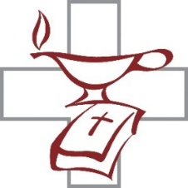


Why do we worship on Sunday?
Do you remember on which day of the week Jesus rose from the dead? If you guessed “Sunday,” then you are right! Sunday is called “the Lord’s Day” because it directs our attention to Jesus’ resurrection from the dead, not to mention the many other miraculous events in the early Christian Church that took place on Sunday. For example, the Holy Spirit was sent to the disciples on a Sunday at Pentecost.

For how long have Christians worshiped on Sundays?
We know from the Bible that the very first Christians met on Sundays to hear God's Word and celebrate Holy Communion (Acts 20:7; 1 Corinthians 16:2). Though Christians in different regions of the world would sometimes worship on days other than Sunday, by A.D. 325 most Christians set Sunday aside for worship because they considered it “the Lord's Day.” So every time you go to church on Sunday, you are doing the same thing that Christians did all the way back in the beginning of Christianity! Wow! What a great tradition we share with our Christian ancestors!
For Parents
Direct your children to the significance and importance found in having a special day—the Lord's Day—set aside for receiving God's wonderful gifts through Word and Sacrament.

