On entering the church

P Lord, I love the habitation of Your house and the place
where Your glory dwells. In the multitude of Your tender
mercies prepare my heart that I may enter Your house to
worship and confess Your holy name; through Jesus Christ,
my God and Lord.

Before worship

C O Lord, our creator, redeemer, and comforter, as we come
together to worship You in spirit and in truth, we humbly
pray that You would open our hearts to the preaching of
Your Word so that we may repent of our sins, believe in
Jesus Christ as our only Savior, and grow in grace and
holiness. Hear us for His sake.

594 God’s Own Child, I Gladly Say It
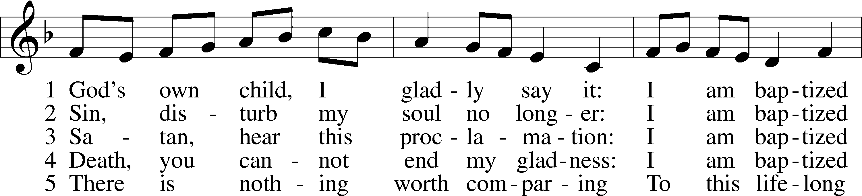
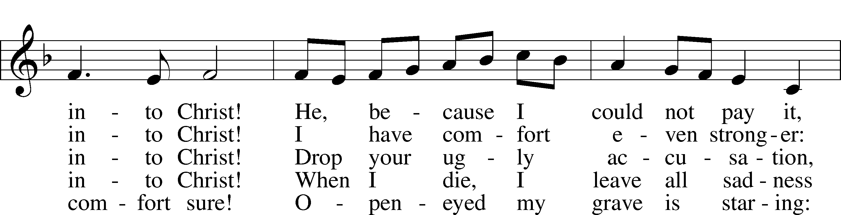
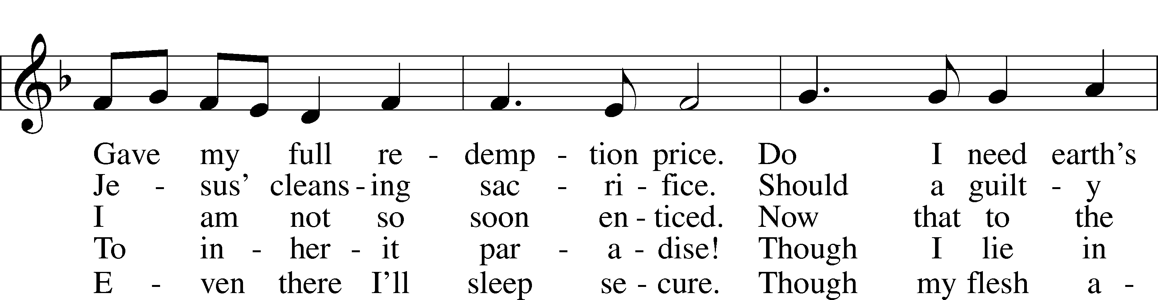
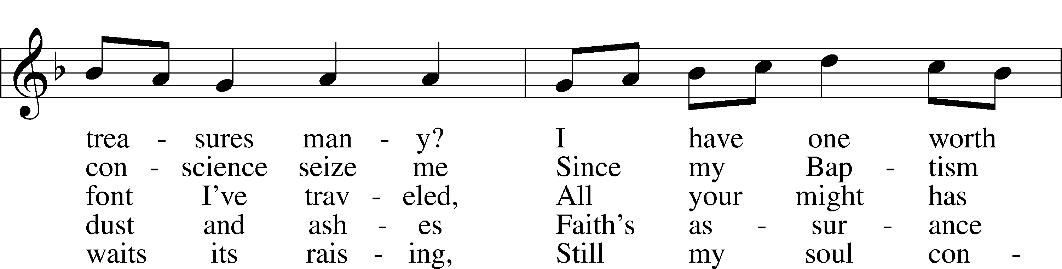
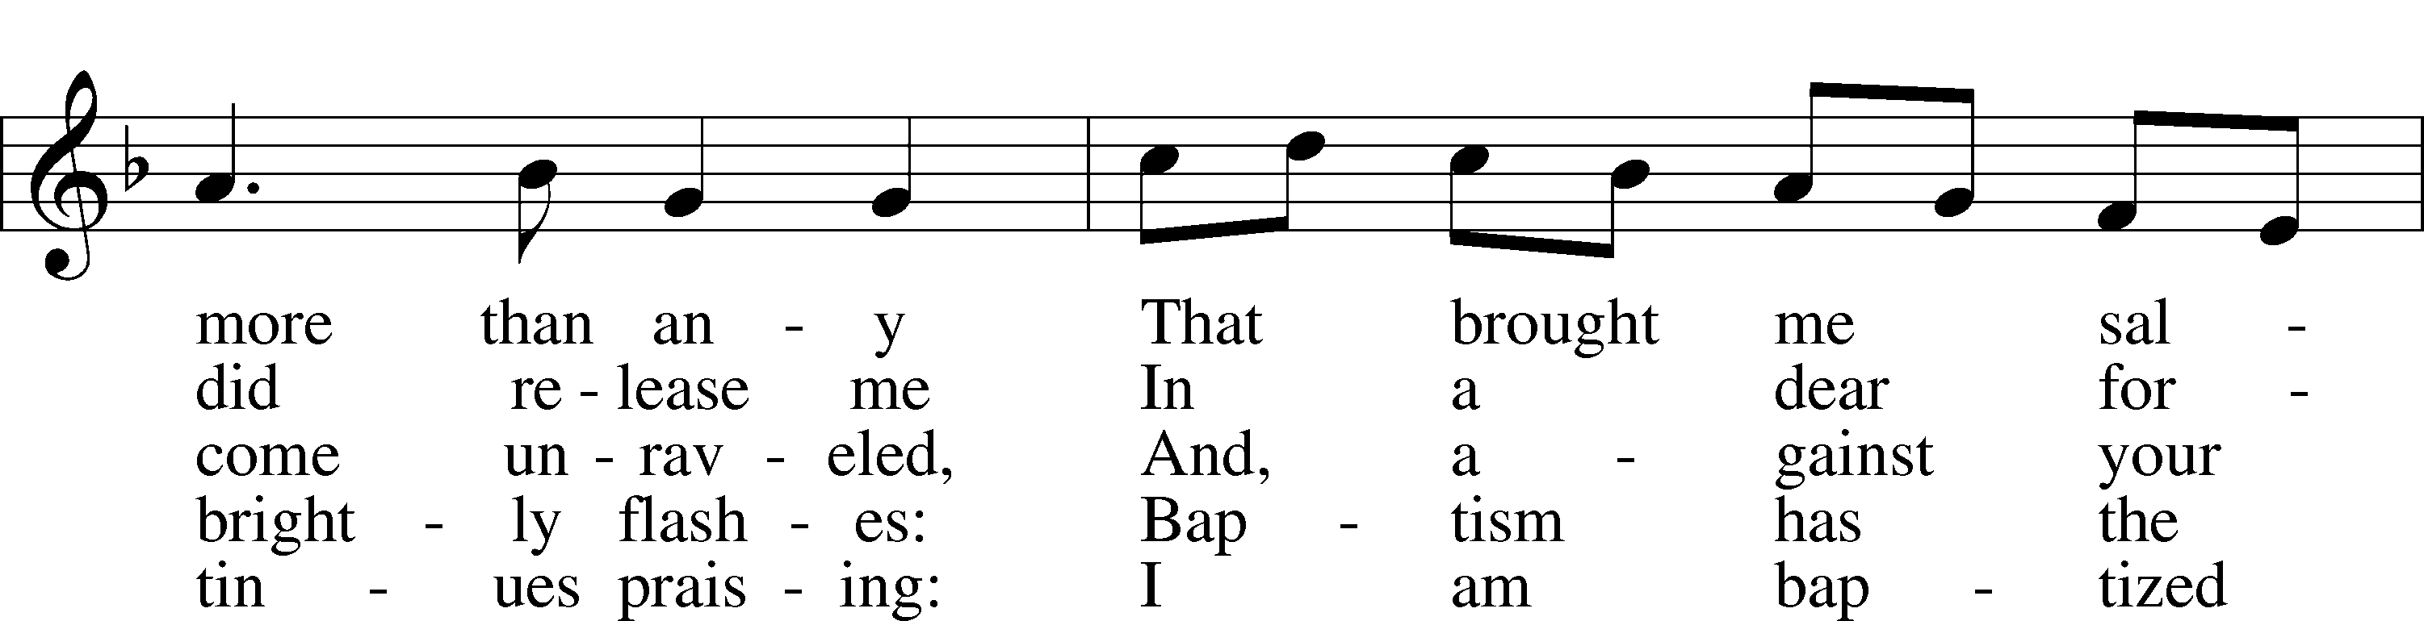
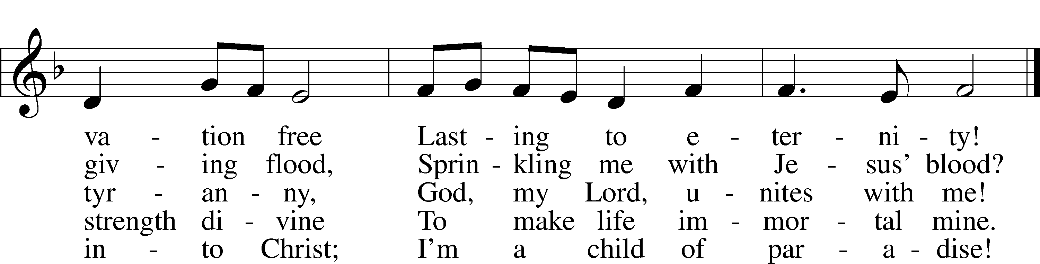
Text: Erdmann Neumeister, 1671–1756; tr. Robert E. Voelker, 1957
Tune: Johann Caspar Bachofen, 1695–1755, alt.
Text: © 1991 Robert E. Voelker. Used by permission: LSB Hymn License no. 110005011
Tune: Public domain

Confession and Absolution

The sign of the cross may be made by all in remembrance of their Baptism.

Invocation Matthew 28:19b; 18:20
P In the name of the Father and of the T Son and of the Holy Spirit.
C Amen.

Exhortation Hebrews 10:22; Psalm 124:8; Psalm 32:5
P Beloved in the Lord! Let us draw near with a true heart and confess our sins unto God our Father, beseeching Him in the name of our Lord Jesus Christ to grant us forgiveness.

P Our help is in the name of the Lord,
C who made heaven and earth.
P I said, I will confess my transgressions unto the Lord,
C and You forgave the iniquity of my sin.

Silence for reflection on God’s Word and for self-examination.

Confession of Sins
P Almighty God, our maker and redeemer, we poor sinners confess unto You that we are by nature sinful and unclean and that we have sinned against You by thought, word, and deed. Wherefore we flee for refuge to Your infinite mercy, seeking and imploring Your grace for the sake of our Lord Jesus Christ.
C O most merciful God, who has given Your only-begotten Son to die for us, have mercy upon us and for His sake grant us remission of all our sins; and by Your Holy Spirit increase in us true knowledge of You and of Your will and true obedience to Your Word, to the end that by Your grace we may come to everlasting life; through Jesus Christ, our Lord. Amen.

Declaration of Grace Mark 16:16; John 1:12
P Almighty God, our heavenly Father, has had mercy upon us and has given His only Son to die for us and for His sake forgives us all our sins. To those who believe on His name He gives power to become the children of God and has promised them His Holy Spirit. He that believes and is baptized shall be saved.
Grant this, Lord, unto us all.
C Amen.

Service of the Word

Introit Psalm 84:1–2a, 4, 10–11; antiphon: Psalm 77:18b
Your lightnings lighted up the world;
the earth trembled and shook.
How lovely is your dwelling place, O Lord of hosts!
My soul longs, yes, faints for the courts of the Lord.
Blessèd are those who dwell in your house,
ever singing your praise!
For a day in your courts is better than a thousand elsewhere.
I would rather be a doorkeeper in the house of my God than dwell in the tents of wickedness.
For the Lord God is a sun and shield; the Lord bestows favor and honor.
No good thing does he withhold from those who walk uprightly.

Gloria Patri
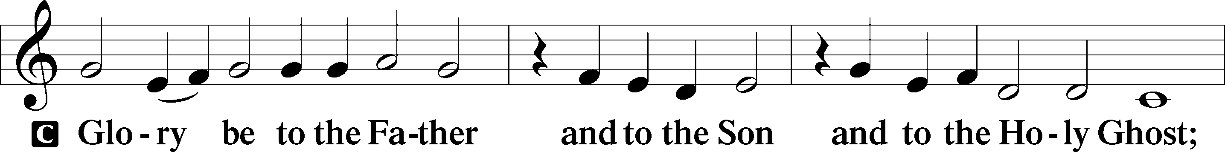
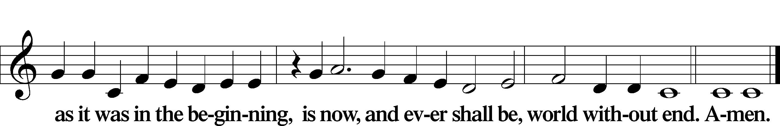

Kyrie Mark 10:47
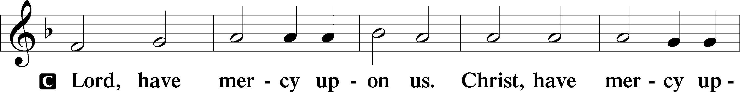
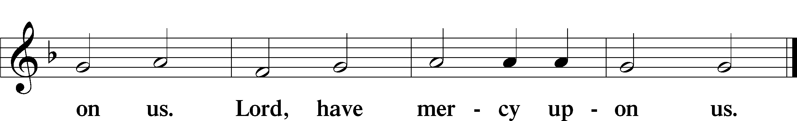

Gloria in Excelsis Luke 2:14; John 1:29
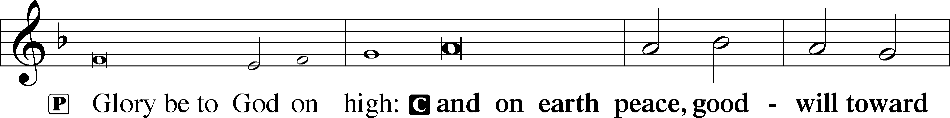
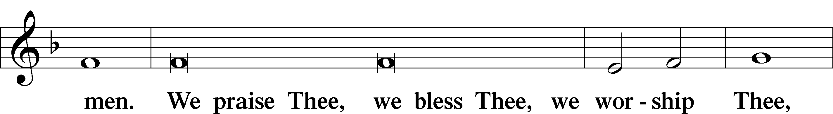
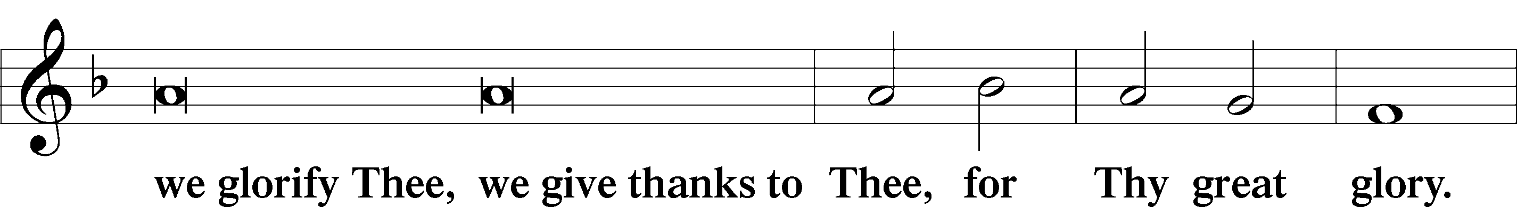
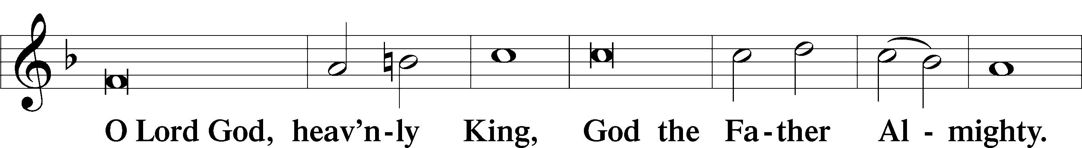
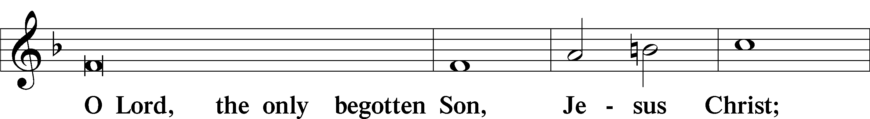
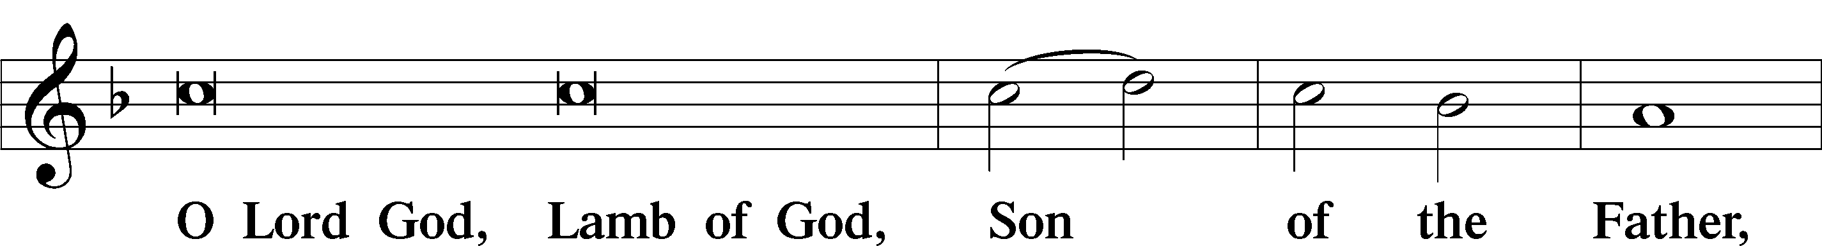
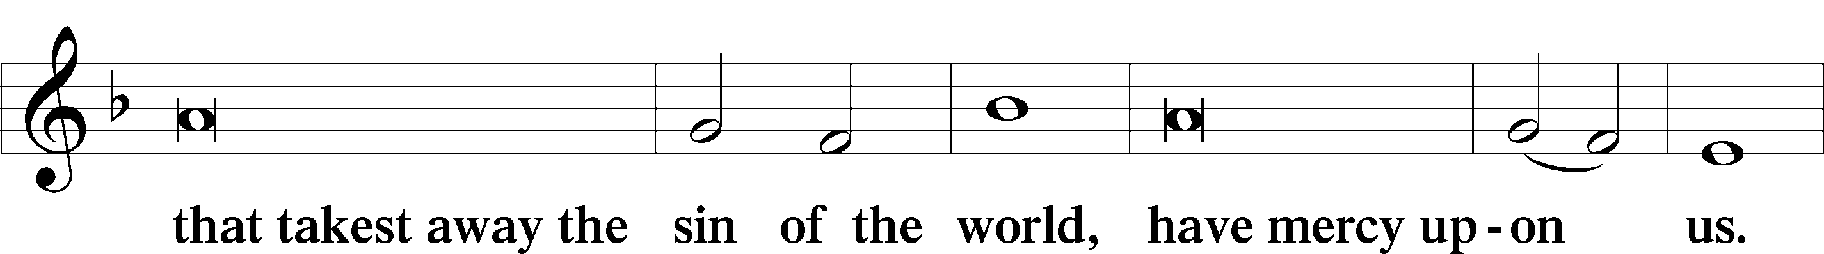
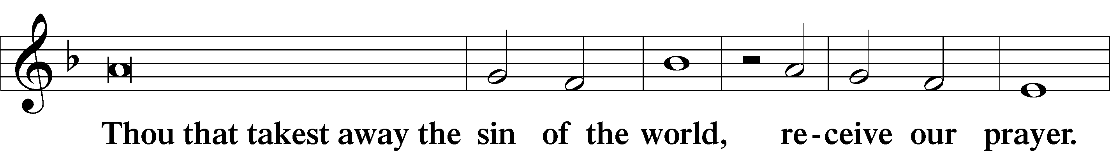
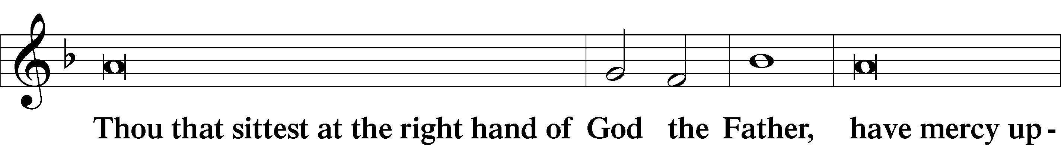
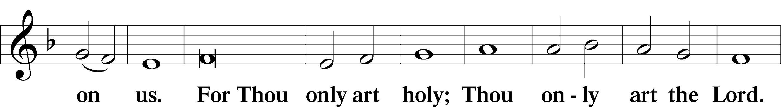
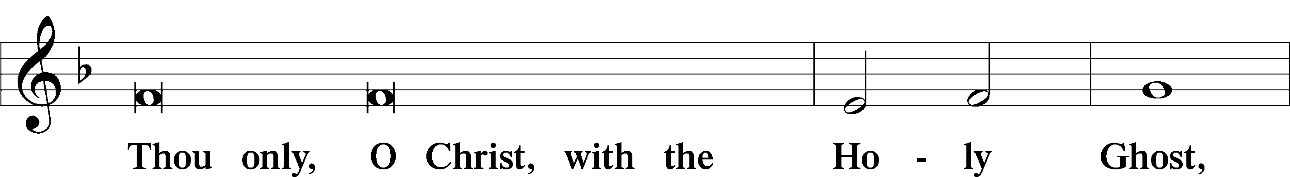
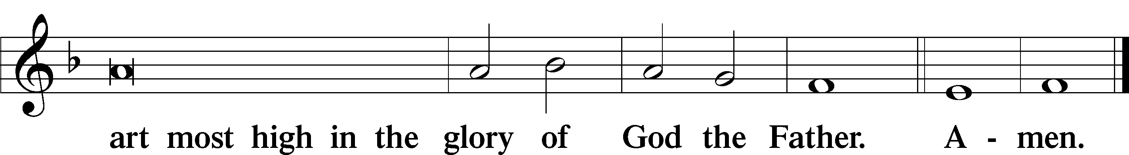

Salutation and Collect of the Day
P The Lord be with you.
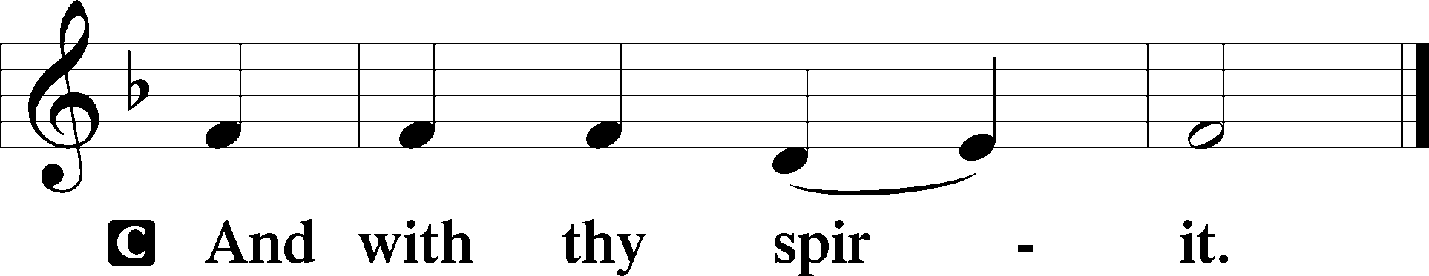

P Let us pray.
O God, in the glorious transfiguration of Your beloved Son You confirmed the mysteries of the faith by the testimony of Moses and Elijah. In the voice that came from the bright cloud You wonderfully foreshowed our adoption by grace. Mercifully make us co-heirs with the King in His glory and bring us to the fullness of our inheritance in heaven; through the same Jesus Christ, our Lord, who lives and reigns with You and the Holy Spirit, one God, now and forever.

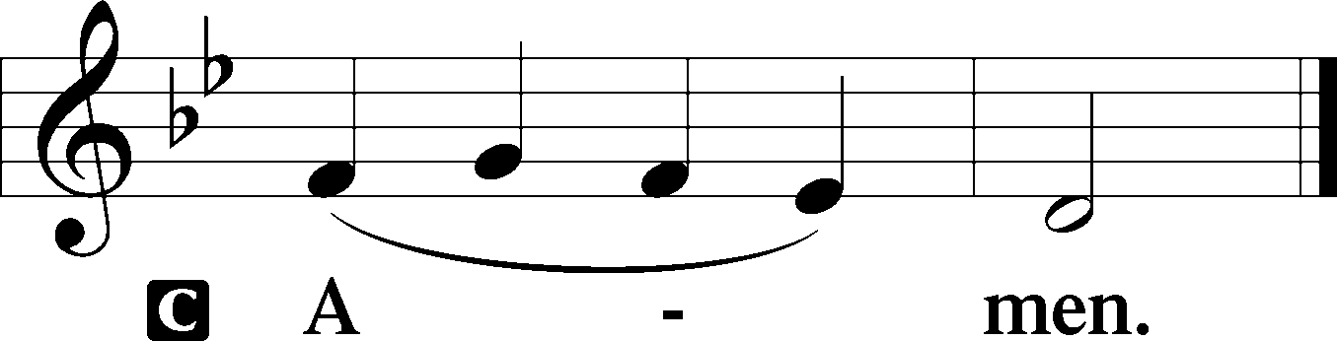

Sit

Old Testament Reading Exodus 34:29–35
29When Moses came down from Mount Sinai, with the two tablets of the testimony in his hand as he came down from the mountain, Moses did not know that the skin of his face shone because he had been talking with God. 30Aaron and all the people of Israel saw Moses, and behold, the skin of his face shone, and they were afraid to come near him. 31But Moses called to them, and Aaron and all the leaders of the congregation returned to him, and Moses talked with them. 32Afterward all the people of Israel came near, and he commanded them all that the Lord had spoken with him in Mount Sinai. 33And when Moses had finished speaking with them, he put a veil over his face.
34Whenever Moses went in before the Lord to speak with him, he would remove the veil, until he came out. And when he came out and told the people of Israel what he was commanded, 35the people of Israel would see the face of Moses, that the skin of Moses’ face was shining. And Moses would put the veil over his face again, until he went in to speak with him.

A This is the Word of the Lord.
C Thanks be to God.

Gradual Psalm 45:2a; 110:1
You are the most handsome of the sons of men;
grace is poured upon your lips.
The Lord says to my Lord: “Sit at my right hand,
until I make your enemies your footstool.”

Epistle 2 Peter 1:16–21
16For we did not follow cleverly devised myths when we made known to you the power and coming of our Lord Jesus Christ, but we were eyewitnesses of his majesty. 17For when he received honor and glory from God the Father, and the voice was borne to him by the Majestic Glory, “This is my beloved Son, with whom I am well pleased,” 18we ourselves heard this very voice borne from heaven, for we were with him on the holy mountain. 19And we have something more sure, the prophetic word, to which you will do well to pay attention as to a lamp shining in a dark place, until the day dawns and the morning star rises in your hearts, 20knowing this first of all, that no prophecy of Scripture comes from someone’s own interpretation. 21For no prophecy was ever produced by the will of man, but men spoke from God as they were carried along by the Holy Spirit.

Stand

Alleluia
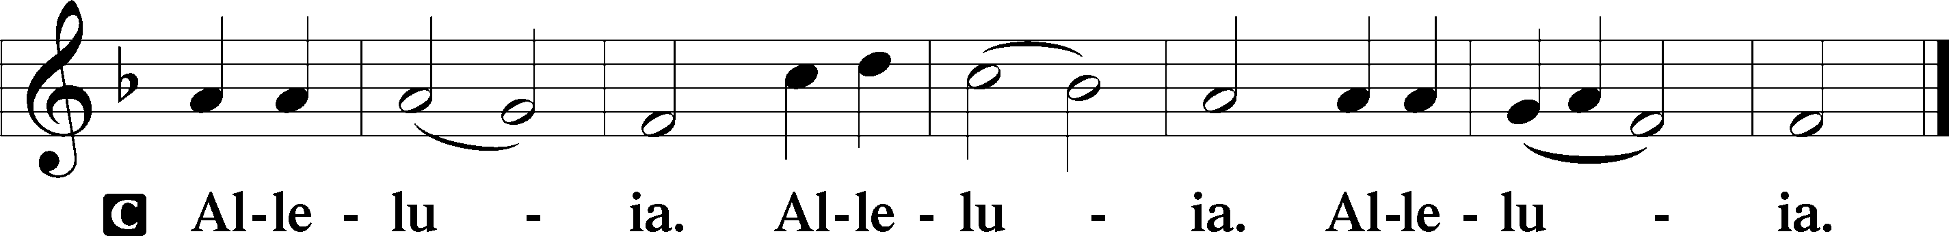

Holy Gospel Matthew 17:1–9
P The Holy Gospel according to St. Matthew, the seventeenth chapter.

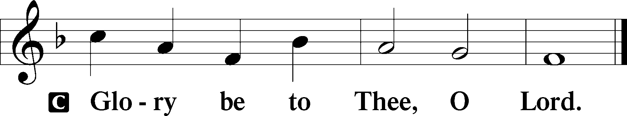

1After six days Jesus took with him Peter and James, and John his brother, and led them up a high mountain by themselves. 2And he was transfigured before them, and his face shone like the sun, and his clothes became white as light. 3And behold, there appeared to them Moses and Elijah, talking with him. 4And Peter said to Jesus, “Lord, it is good that we are here. If you wish, I will make three tents here, one for you and one for Moses and one for Elijah.” 5He was still speaking when, behold, a bright cloud overshadowed them, and a voice from the cloud said, “This is my beloved Son, with whom I am well pleased; listen to him.” 6When the disciples heard this, they fell on their faces and were terrified. 7But Jesus came and touched them, saying, “Rise, and have no fear.” 8And when they lifted up their eyes, they saw no one but Jesus only.
9And as they were coming down the mountain, Jesus commanded them, “Tell no one the vision, until the Son of Man is raised from the dead.”

P This is the Gospel of the Lord.

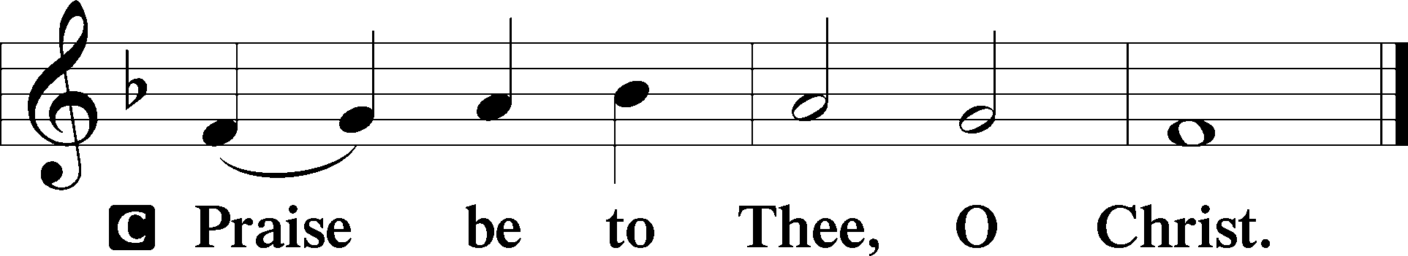

Apostles’ Creed
C I believe in God, the Father Almighty,
maker of heaven and earth.

And in Jesus Christ, His only Son, our Lord,
who was conceived by the Holy Spirit,
born of the virgin Mary,
suffered under Pontius Pilate,
was crucified, died and was buried.
He descended into hell.
The third day He rose again from the dead.
He ascended into heaven
and sits at the right hand of God the Father Almighty.
From thence He will come to judge the living and the dead.

I believe in the Holy Spirit,
the holy Christian Church,
the communion of saints,
the forgiveness of sins,
the resurrection of the body,
and the life T everlasting. Amen.

Sit

Children's Sermon

413 O Wondrous Type! O Vision Fair
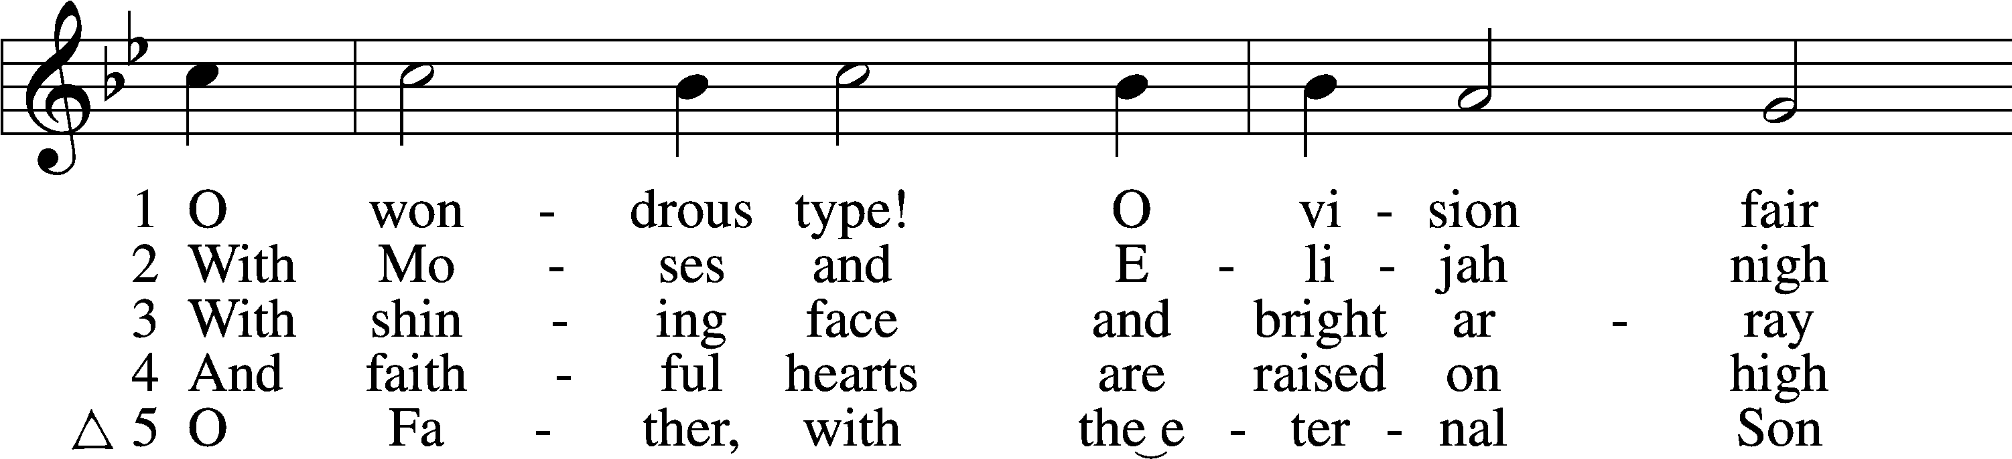
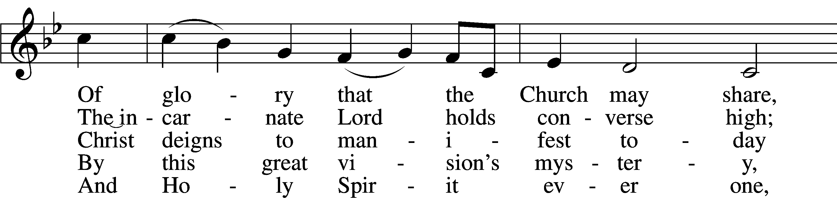
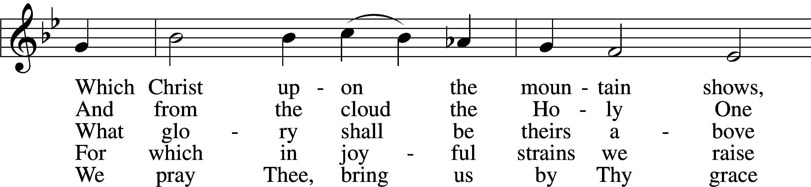
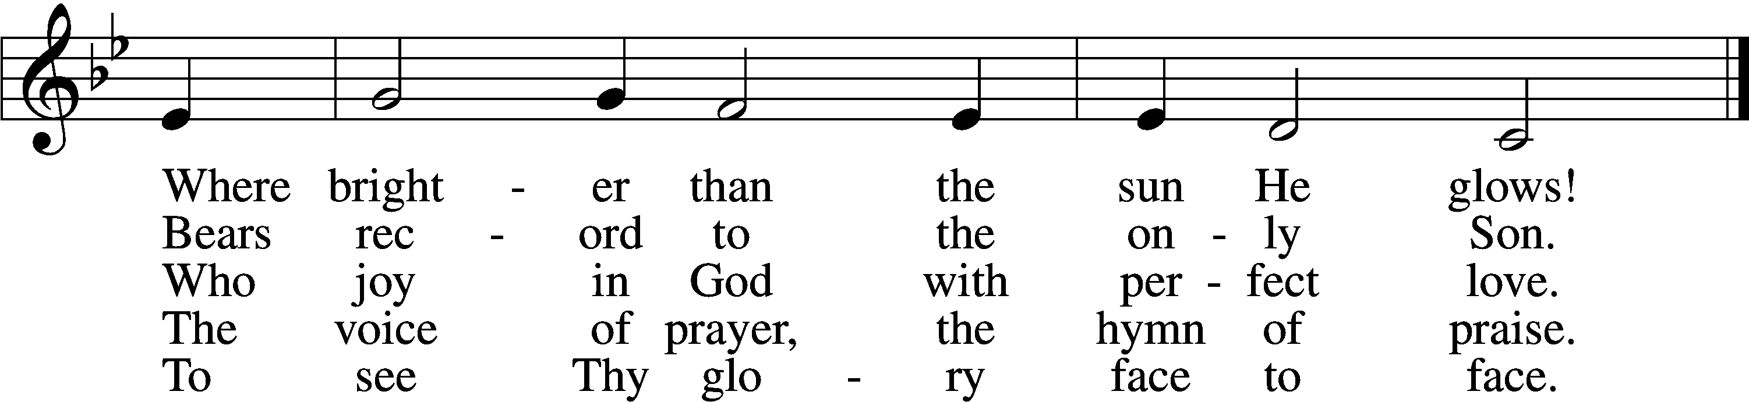
Text: Sarum Breviary, 1495, Salisbury; tr. John Mason Neale, 1818–66, alt.
Tune: English, 15th cent.
Text and tune: Public domain

Sermon

Votum
P The peace of God, which passes all understanding, keep your hearts and minds in Christ Jesus.
C Amen.

Stand

Offertory Psalm 51:10–12
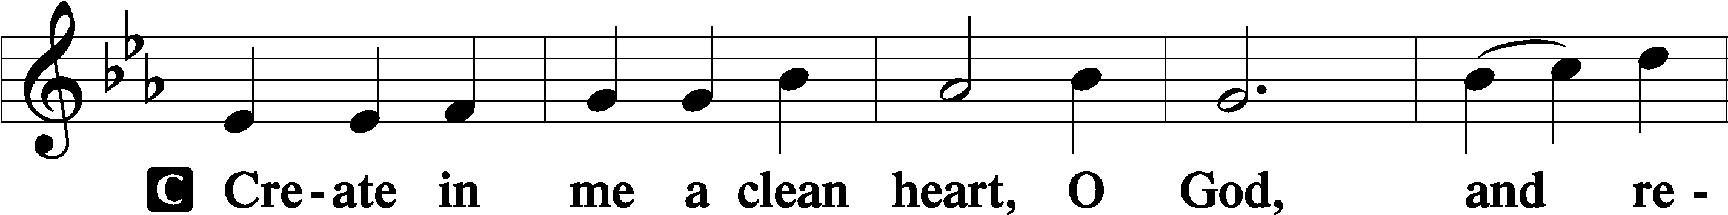
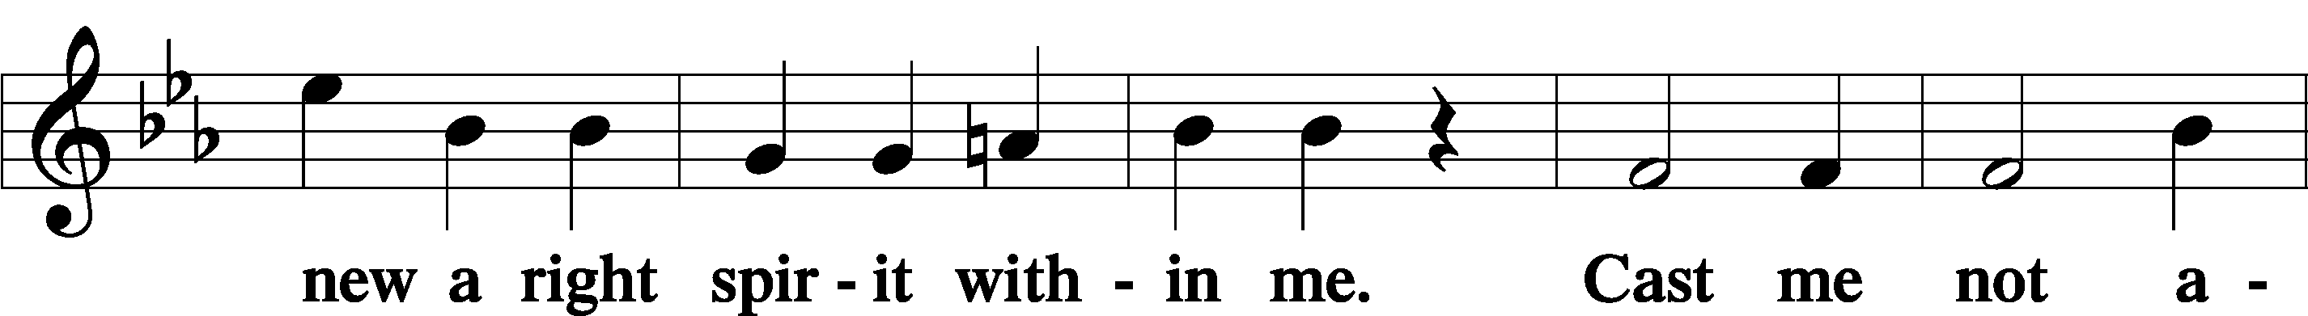
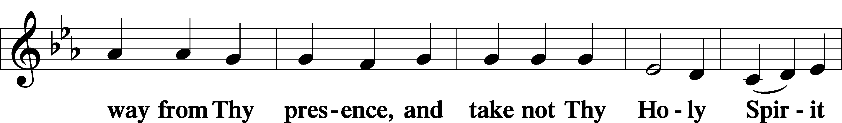
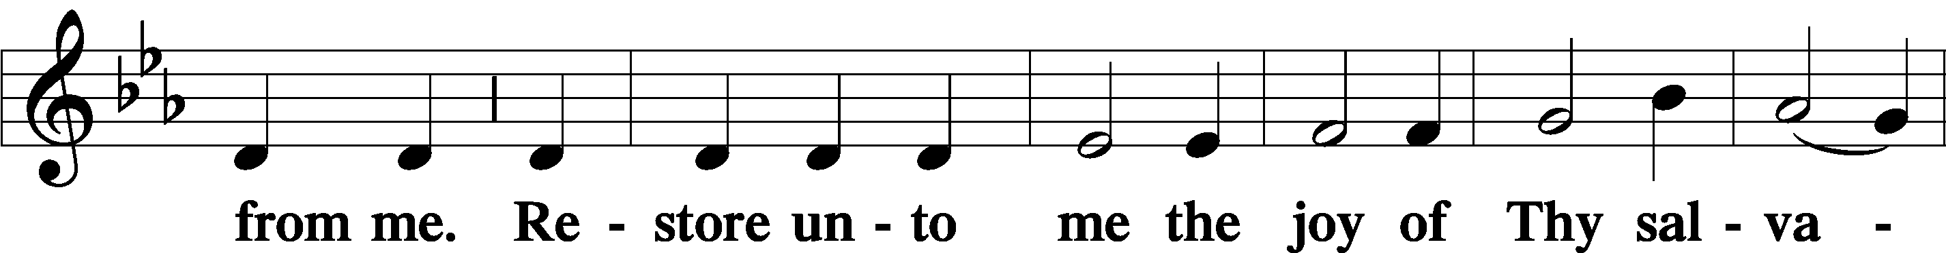
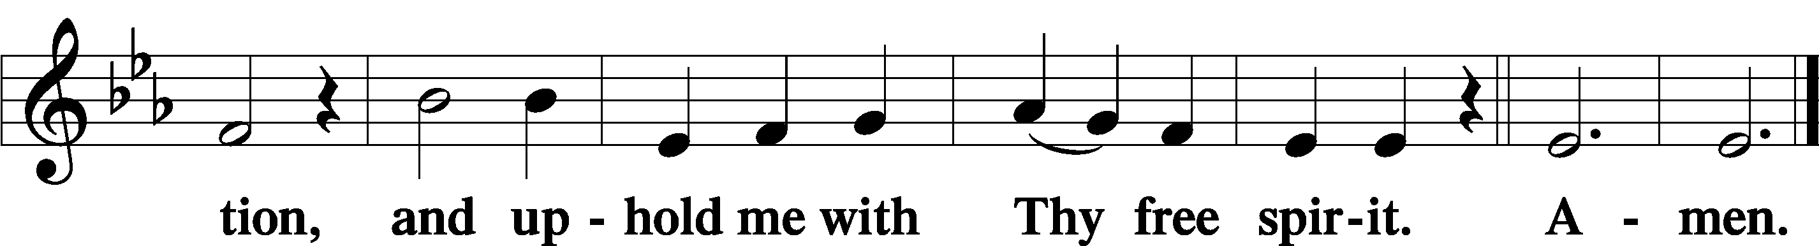

Offering

805 Praise God, from Whom All Blessings Flow
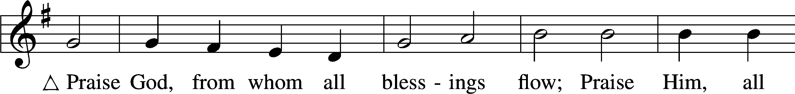
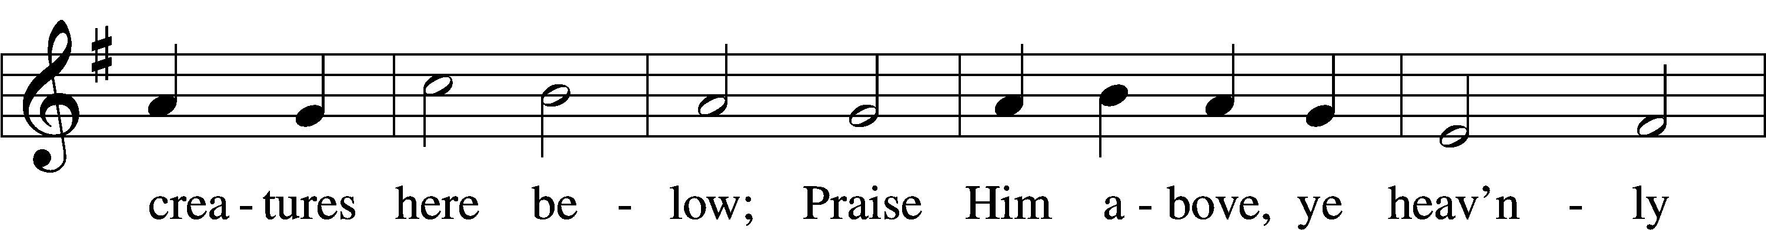
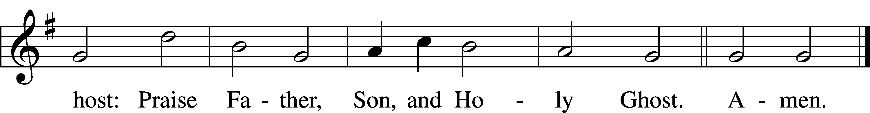
Text: Thomas Ken, 1637–1711
Tune: Trente quatre Pseaumes de David, 1551, Geneva, ed. Louis Bourgeois
Text and tune: Public domain

Prayer of the Church

Lord’s Prayer Matthew 6:9–13
P Lord, remember us in Your kingdom and teach us to pray:
C Our Father who art in heaven,
hallowed be Thy name,
Thy kingdom come,
Thy will be done on earth
as it is in heaven;
give us this day our daily bread;
and forgive us our trespasses
as we forgive those
who trespass against us;
and lead us not into temptation,
but deliver us from evil.
For Thine is the kingdom
and the power and the glory
forever and ever. Amen.

Collect for the Word

Blessed Lord, You have caused all Holy Scriptures to be written for our learning. Grant that we may so hear them, read, mark, learn, and inwardly digest them that, by the patience and comfort of Your holy Word, we may embrace and ever hold fast the blessed hope of everlasting life; through Jesus Christ, Your Son, our Lord, who lives and reigns with You and the Holy Spirit, one God, now and forever.

Benediction
P The Lord bless you and keep you.
The Lord make His face shine on you and be gracious to you.
The Lord look upon you with favor and T give you peace.
C Amen.

414 ’Tis Good, Lord, to Be Here
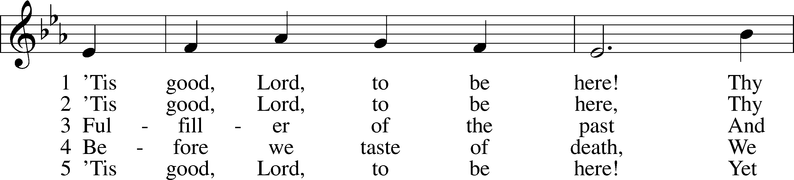
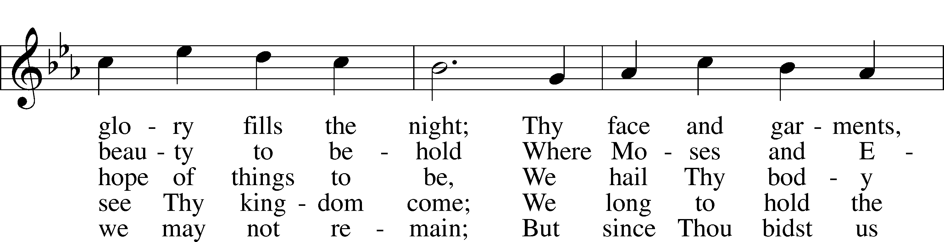
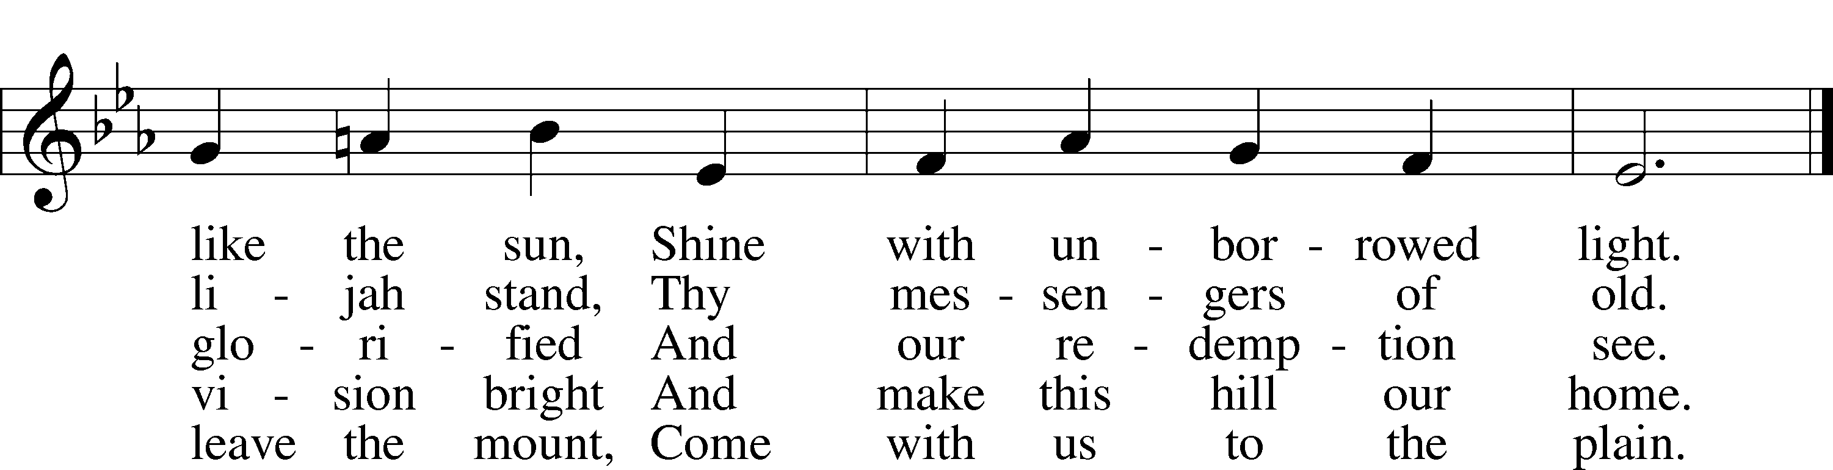
Text: Joseph A. Robinson, 1858–1933, alt.
Tune: Johann Sebastian Bach, 1685–1750, adapt.
Text and tune: Public domain
Acknowledgments
Unless otherwise indicated, Scripture quotations are from the ESV® Bible (The Holy Bible, English Standard Version®), copyright © 2001 by Crossway, a publishing ministry of Good News Publishers. Used by permission. All rights reserved.
Created by Lutheran Service Builder © 2026 Concordia Publishing House.

