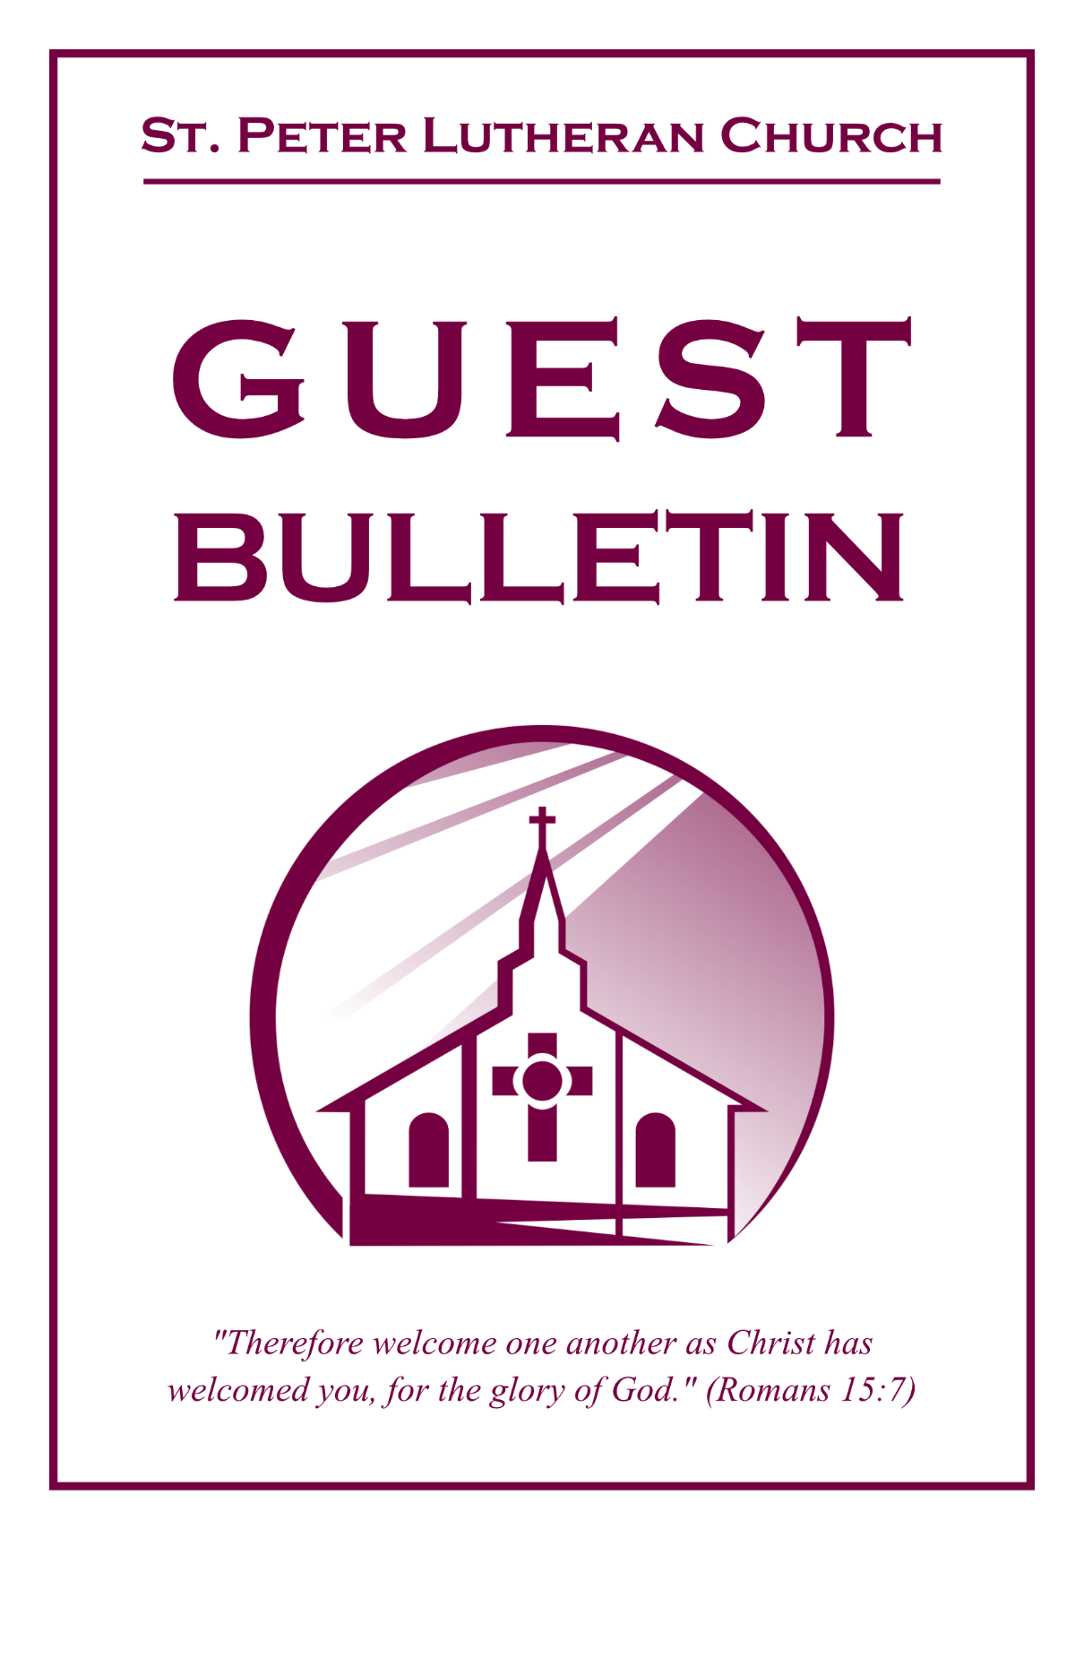

September 27, 2026



St. Peter Lutheran Church
Missouri Synod
906 Highway 59N, P.O. Box 133

Bowie, Texas 76230

Church (940) 872-1886 Fax ((940) 872-8837

Church E-mail: stpetertexscty@gmail.com
To Our Guests and Visitors:

We welcome all our friends in Christ who have come to worship with us. If you are a guest, please feel at home with us, sign our guest register, and worship with us whenever you are able. If you do not have a church home, we invite you to
consider becoming a part of our church family.

Website: www.stpetertex.com
Communion Statement:

The Lord’s Supper is celebrated at this congregation in the confession and glad confidence that, as He says, our Lord gives into our mouths not only bread and wine but His very Body and Blood to eat and drink for the forgiveness of sins and to strengthen our union with Him and one another.

Our Lord invites to His table those who trust in His words, repent of all sin, and set aside any refusal to forgive and love as He forgives and loves us, that they may show forth His death until He comes.

Because those who eat and drink our Lord’s Body and Blood unworthily do so to their great harm, and because Holy Communion is a confession of the faith, which is confessed at this altar, guests who are not confirmed members of an LCMS congregation and have not previously communed at this altar, are asked to first speak with our pastor.

If you are unable to do so before the service, it is out of Christian love and care for your souls that we ask you to refrain from communing this morning.

For further study, please see Matthew 5:23ff, 10:32ff, 18:15–35, 26:26–29; 1 Corinthians 11:17–34.

If you desire to receive a blessing for yourself or your children, please approach during
communion, cross your arms over your chest and bow your head as you kneel at the
altar rail.

Who Receives the Sacrament of the Altar Worthily?
Fasting and bodily preparation are certainly fine outward training. But that person is truly worthy and well prepared who has faith in these words: “Given and shed for you for the forgiveness of sins.” But anyone who does not believe these words or doubts them is unworthy and unprepared; for the words “for you” require all hearts to believe.
How May I Prepare?
See Dr. Luther’s self–examination questions and answers in the
LSB Hymnal on page 329

Upon entering the Sanctuary. please turn off cell phones, pagers. etc. Use the time as a quiet time for personal reflection and meditation in preparation for worship. This is a time for anyone to join in praying for the service, and for the church in general.

549 All Hail the Power of Jesus’ Name
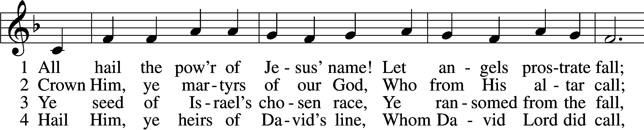
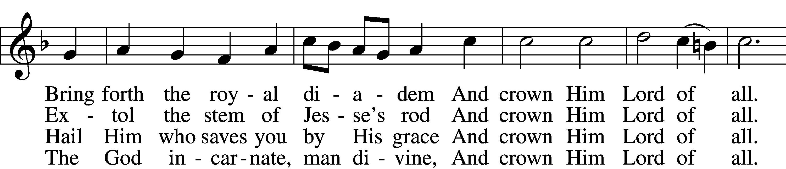
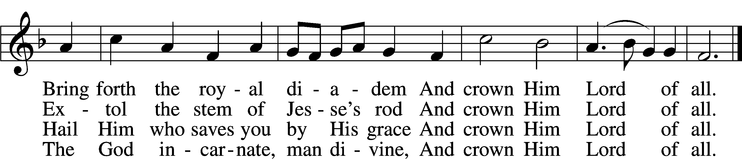

5 Sinners, whose love can ne’er forget
The wormwood and the gall,
Go, spread your trophies at His feet
And crown Him Lord of all.
Go, spread your trophies at His feet
And crown Him Lord of all.

6 Let ev’ry kindred, ev’ry tribe,
On this terrestrial ball
To Him all majesty ascribe
And crown Him Lord of all.
To Him all majesty ascribe
And crown Him Lord of all.

7 Oh, that with yonder sacred throng
We at His feet may fall!
We’ll join the everlasting song
And crown Him Lord of all.
We’ll join the everlasting song
And crown Him Lord of all.
Text (sts. 1–5): Edward Perronet, 1726–92, alt.; (sts. 6–7): A Selection of Hymns, 1787, London, alt.
Tune: Oliver Holden, 1765–1844
Text and tune: Public domain

Confession and Absolution

The sign of the cross may be made by all in remembrance of their Baptism.

Invocation Matthew 28:19b; 18:20
P In the name of the Father and of the T Son and of the Holy Spirit.
C Amen.

Exhortation Hebrews 10:22; Psalm 124:8; Psalm 32:5
P Beloved in the Lord! Let us draw near with a true heart and confess our sins unto God our Father, beseeching Him in the name of our Lord Jesus Christ to grant us forgiveness.
P Our help is in the name of the Lord,
C who made heaven and earth.
P I said, I will confess my transgressions unto the Lord,
C and You forgave the iniquity of my sin.

Silence for reflection on God’s Word and for self-examination.

Confession of Sins
P Almighty God, our maker and redeemer, we poor sinners confess unto You that we are by nature sinful and unclean and that we have sinned against You by thought, word, and deed. Wherefore we flee for refuge to Your infinite mercy, seeking and imploring Your grace for the sake of our Lord Jesus Christ.
C O most merciful God, who has given Your only-begotten Son to die for us, have mercy upon us and for His sake grant us remission of all our sins; and by Your Holy Spirit increase in us true knowledge of You and of Your will and true obedience to Your Word, to the end that by Your grace we may come to everlasting life; through Jesus Christ, our Lord. Amen.

Declaration of Grace Mark 16:16; John 1:12
P Almighty God, our heavenly Father, has had mercy upon us and has given His only Son to die for us and for His sake forgives us all our sins. To those who believe on His name He gives power to become the children of God and has promised them His Holy Spirit. He that believes and is baptized shall be saved.
Grant this, Lord, unto us all.
C Amen.
Service of the Word

Introit Psalm 147:1–5; antiphon: v. 6
The Lord lifts up the humble;
he casts the wicked to the ground.
Praise the Lord! For it is good to sing praises to our God;
for it is pleasant, and a song of praise is fitting.
The Lord builds up Jerusalem;
he gathers the outcasts of Israel.
He heals the brokenhearted
and binds up their wounds.
He determines the number of the stars;
he gives to all of them their names.
Great is our Lord, and abundant in power;
his understanding is beyond measure.

Gloria Patri
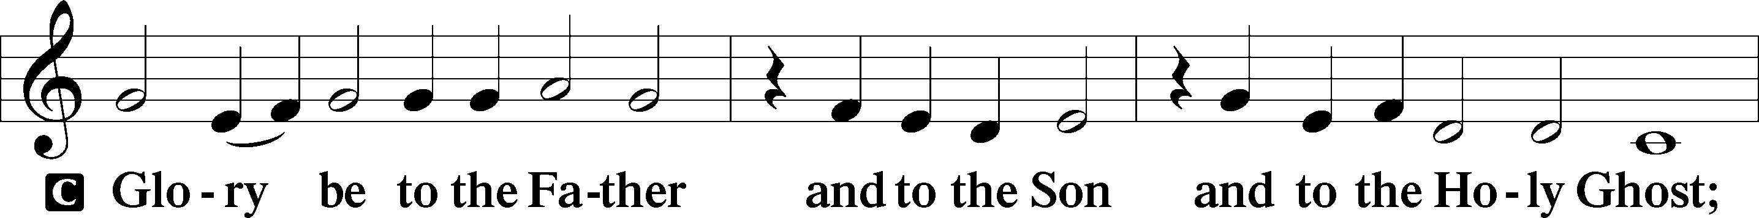
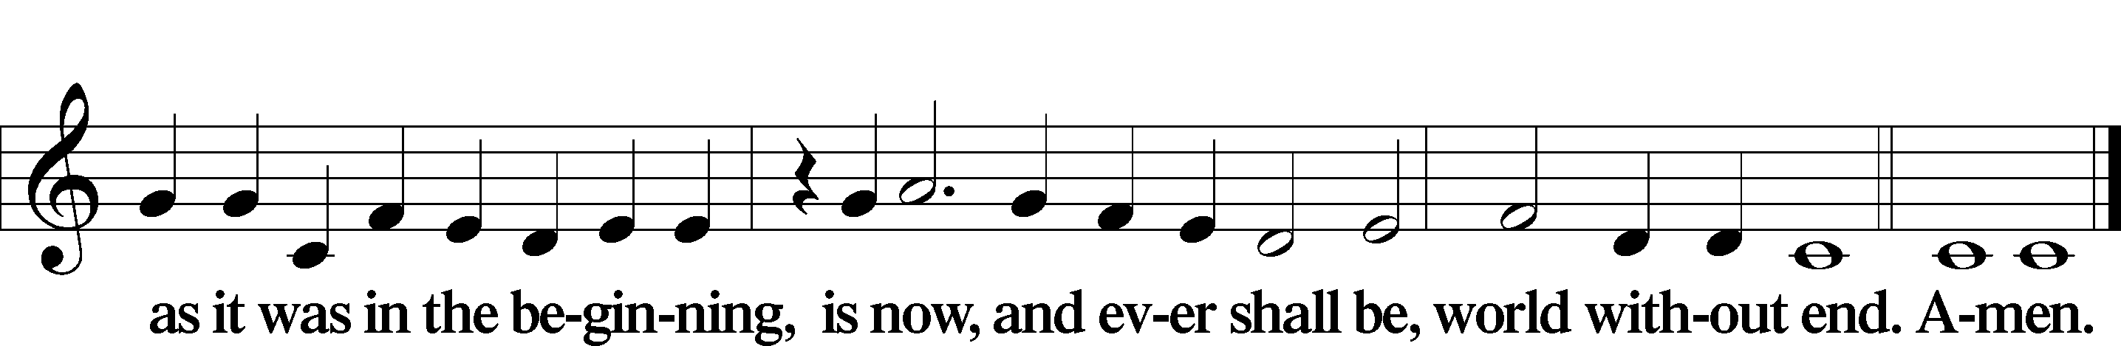

Kyrie Mark 10:47
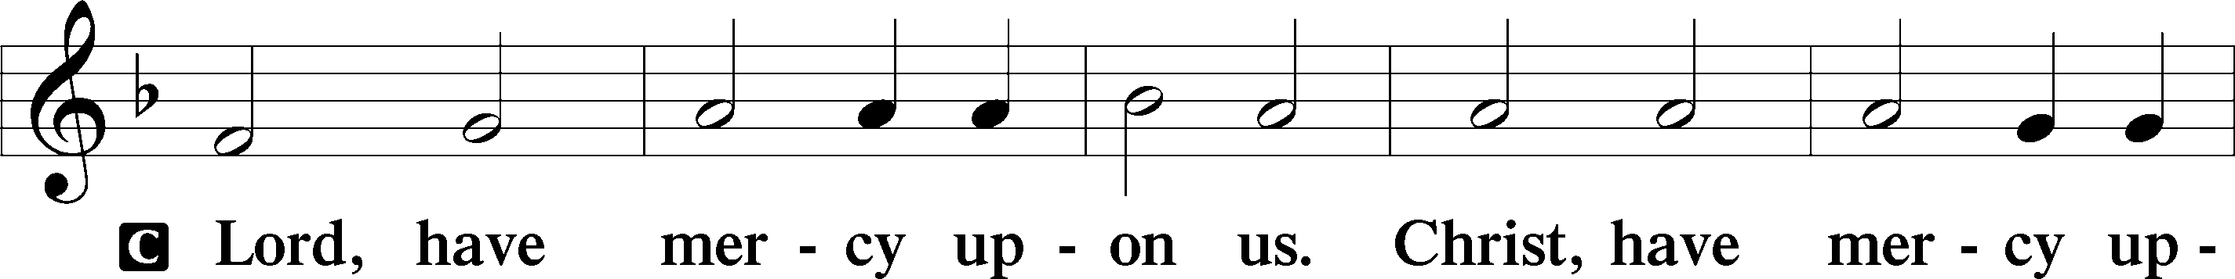
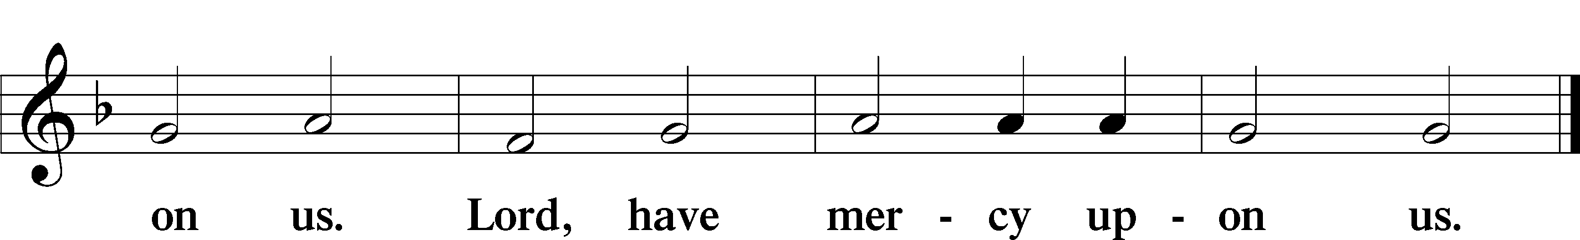

Gloria in Excelsis Luke 2:14; John 1:29
P Glory be to God on high:
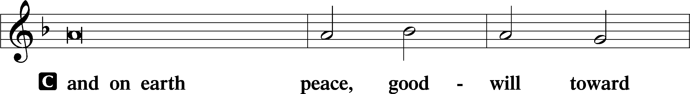
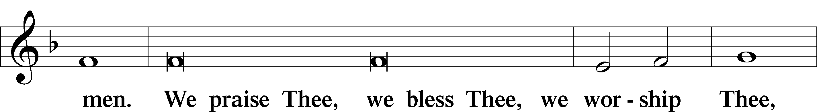
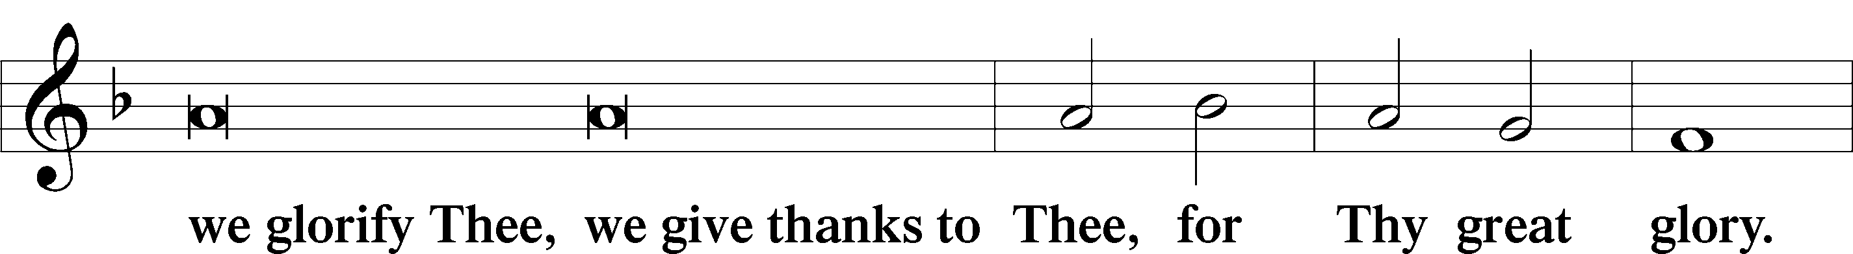
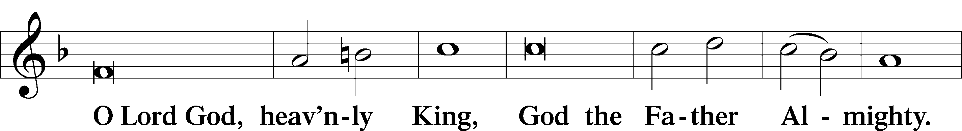
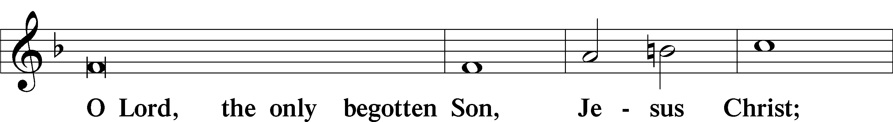
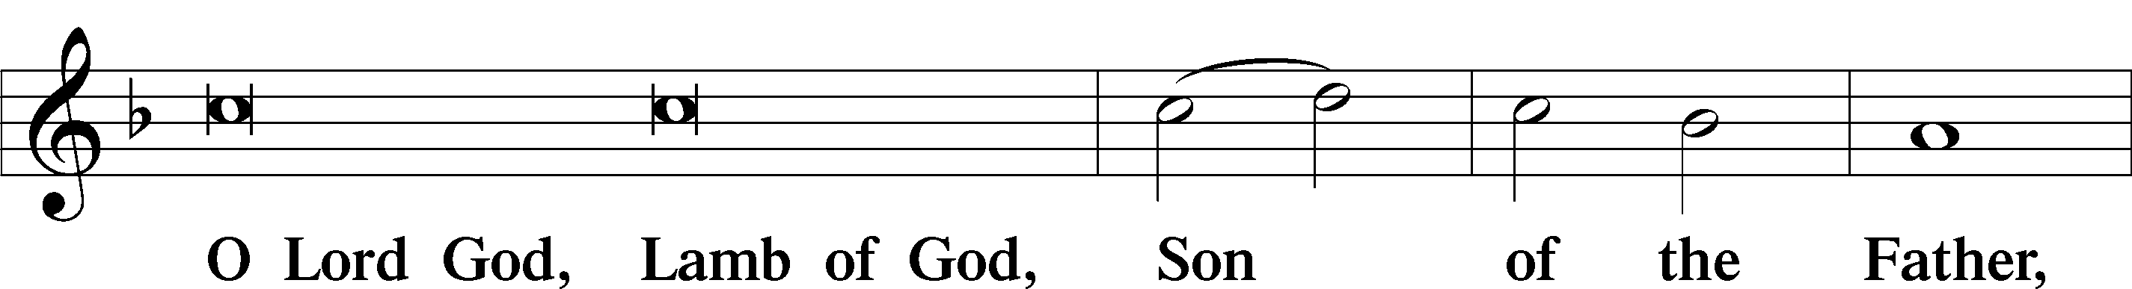
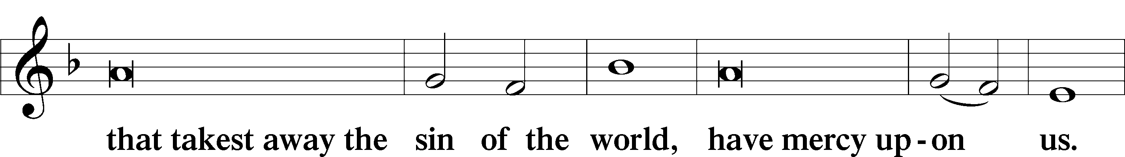
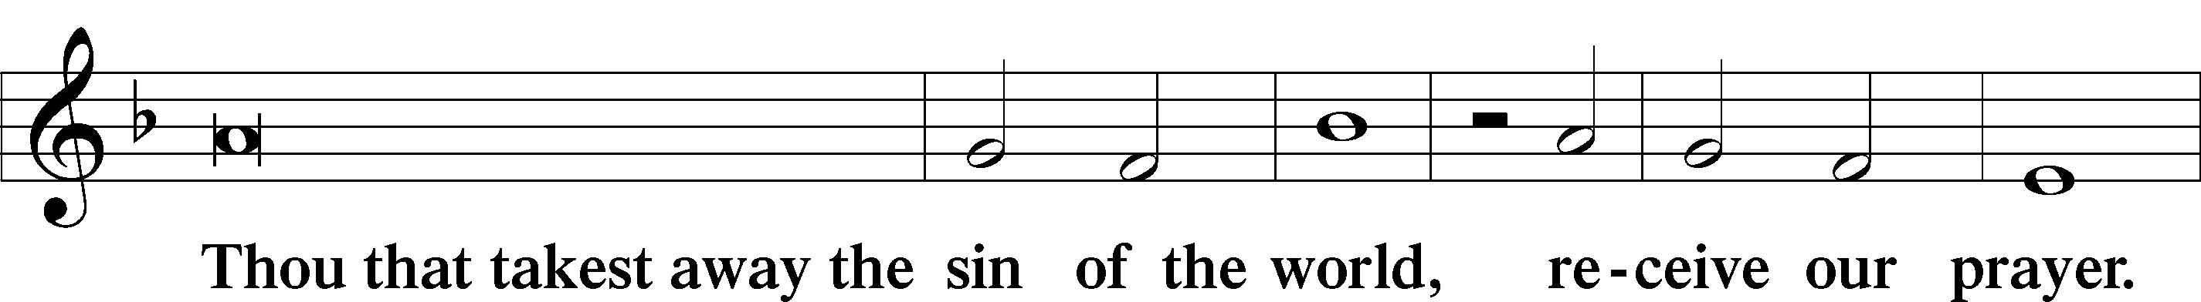
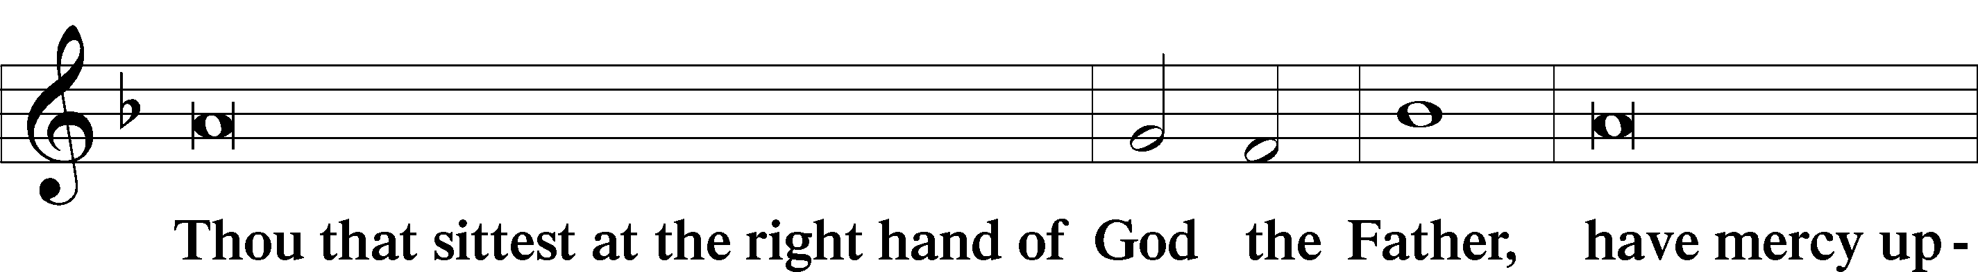
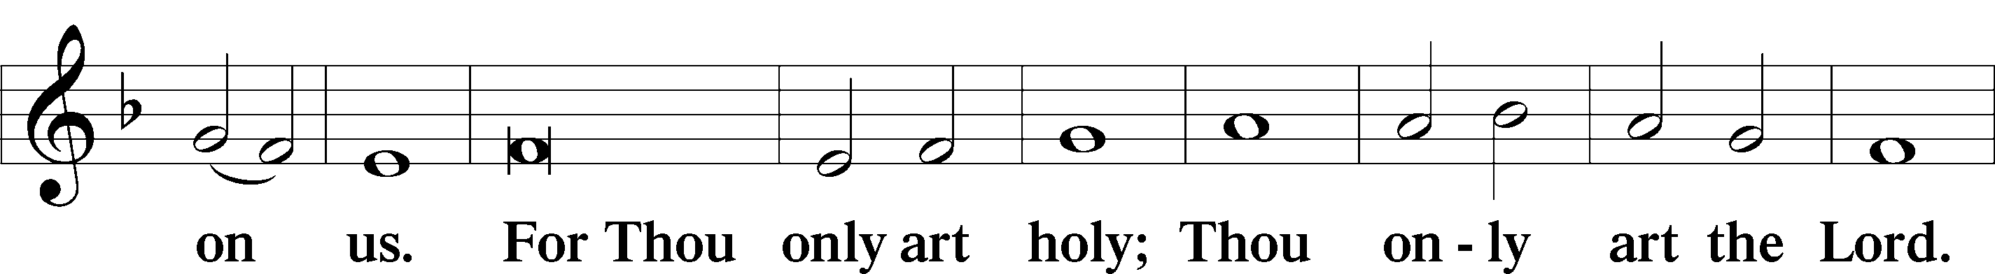
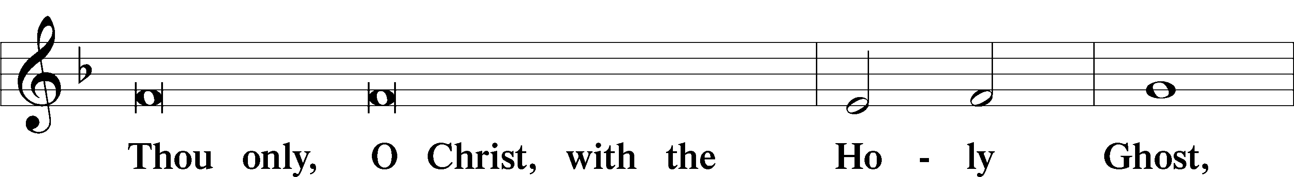
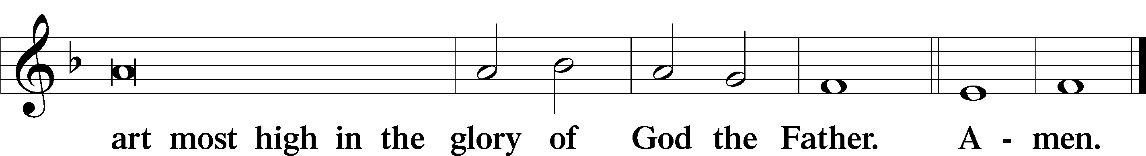

Salutation and Collect of the Day
P The Lord be with you.
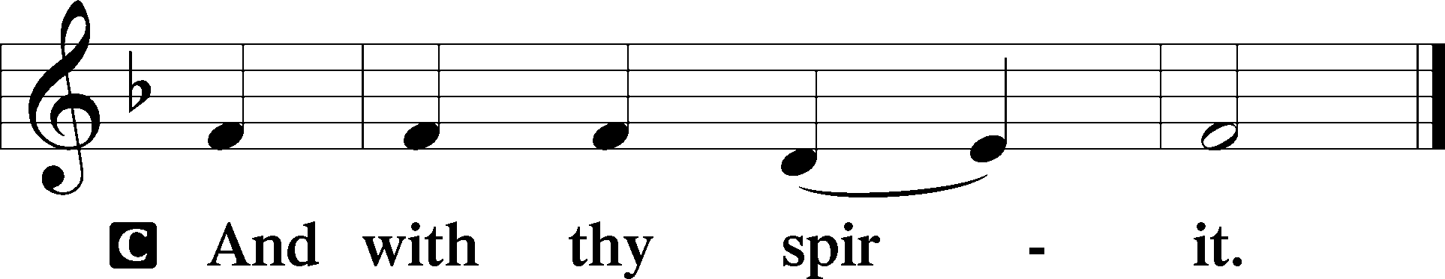

P Let us pray.
Almighty God, You exalted Your Son to the place of all honor and authority. Enlighten our minds by Your Holy Spirit that, confessing Jesus as Lord, we may be led into all truth; through the same Jesus Christ, our Lord, who lives and reigns with You and the Holy Spirit, one God, now and forever.

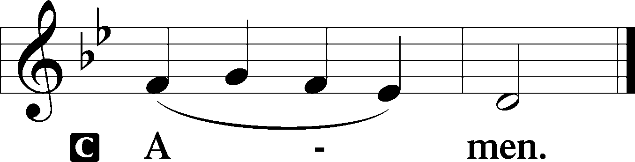

Sit

Old Testament Reading Ezekiel 18:1–4, 25–32
1The word of the Lord came to me: 2“What do you mean by repeating this proverb concerning the land of Israel, ‘The fathers have eaten sour grapes, and the children’s teeth are set on edge’? 3As I live, declares the Lord God, this proverb shall no more be used by you in Israel. 4Behold, all souls are mine; the soul of the father as well as the soul of the son is mine: the soul who sins shall die. . . . 25“Yet you say, ‘The way of the Lord is not just.’ Hear now, O house of Israel: Is my way not just? Is it not your ways that are not just? 26When a righteous person turns away from his righteousness and does injustice, he shall die for it; for the injustice that he has done he shall die. 27Again, when a wicked person turns away from the wickedness he has committed and does what is just and right, he shall save his life. 28Because he considered and turned away from all the transgressions that he had committed, he shall surely live; he shall not die. 29Yet the house of Israel says, ‘The way of the Lord is not just.’ O house of Israel, are my ways not just? Is it not your ways that are not just? 30“Therefore I will judge you, O house of Israel, every one according to his ways, declares the Lord God. Repent and turn from all your transgressions, lest iniquity be your ruin. 31Cast away from you all the transgressions that you have committed, and make yourselves a new heart and a new spirit! Why will you die, O house of Israel? 32For I have no pleasure in the death of anyone, declares the Lord God; so turn, and live.”

A This is the Word of the Lord.
C Thanks be to God.
Gradual Psalm 91:11; 103:1
He will command his angels concerning you
to guard you in all your ways.
Bless the Lord, O my soul,
and all that is within me, bless his holy name!

Epistle Philippians 2:1–4, 14–18
1If there is any encouragement in Christ, any comfort from love, any participation in the Spirit, any affection and sympathy, 2complete my joy by being of the same mind, having the same love, being in full accord and of one mind. 3Do nothing from rivalry or conceit, but in humility count others more significant than yourselves. 4Let each of you look not only to his own interests, but also to the interests of others. . . .14Do all things without grumbling or questioning, 15that you may be blameless and innocent, children of God without blemish in the midst of a crooked and twisted generation, among whom you shine as lights in the world, 16holding fast to the word of life, so that in the day of Christ I may be proud that I did not run in vain or labor in vain. 17Even if I am to be poured out as a drink offering upon the sacrificial offering of your faith, I am glad and rejoice with you all. 18Likewise you also should be glad and rejoice with me.

Stand

Alleluia
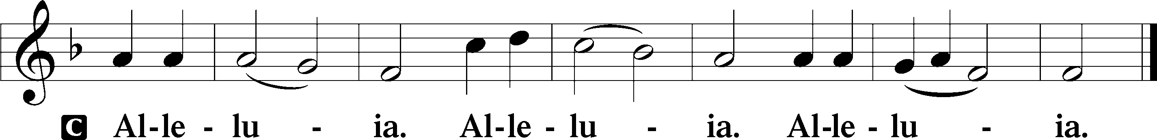

Holy Gospel Matthew 21:23–27
P The Holy Gospel according to St. Matthew, the twenty-first chapter.
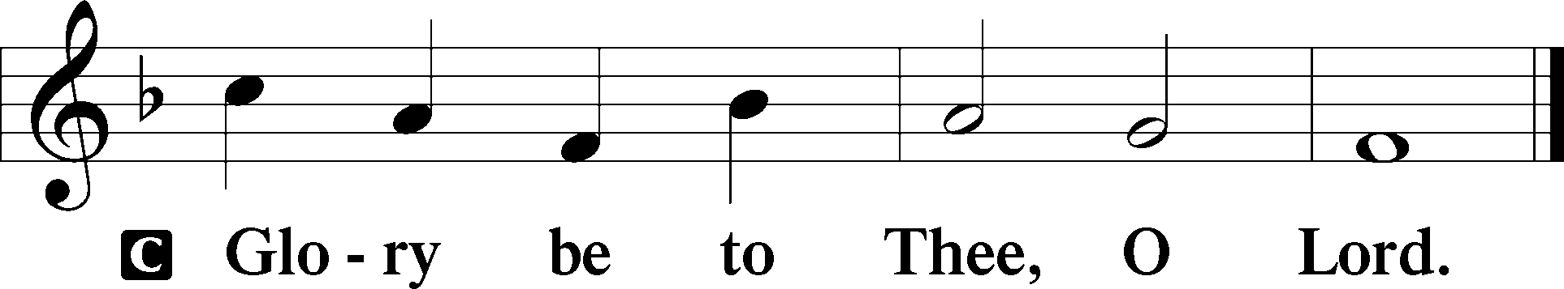

23When [Jesus] entered the temple, the chief priests and the elders of the people came up to him as he was teaching, and said, “By what authority are you doing these things, and who gave you this authority?” 24Jesus answered them, “I also will ask you one question, and if you tell me the answer, then I also will tell you by what authority I do these things. 25The baptism of John, from where did it come? From heaven or from man?” And they discussed it among themselves, saying, “If we say, ‘From heaven,’ he will say to us, ‘Why then did you not believe him?’ 26But if we say, ‘From man,’ we are afraid of the crowd, for they all hold that John was a prophet.” 27So they answered Jesus, “We do not know.” And he said to them, “Neither will I tell you by what authority I do these things.”

P This is the Gospel of the Lord.

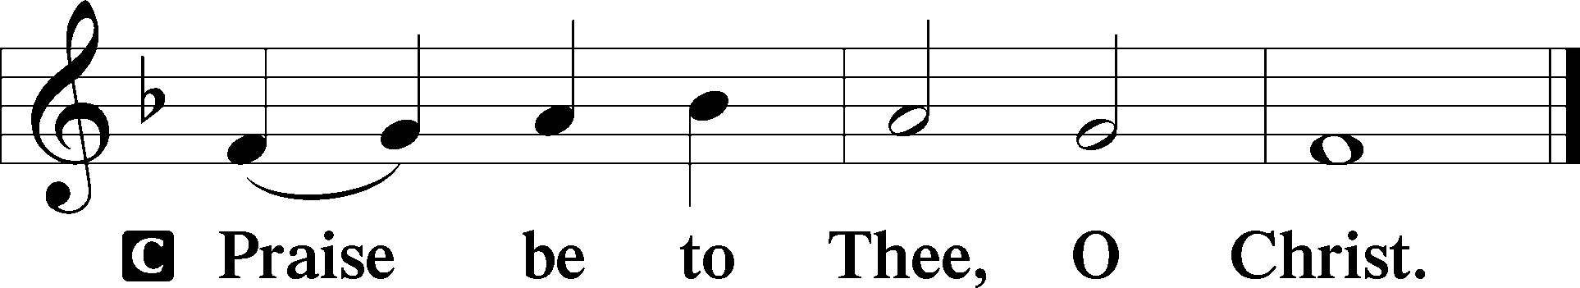

Apostles’ Creed
C I believe in God, the Father Almighty,
maker of heaven and earth.

And in Jesus Christ, His only Son, our Lord,
who was conceived by the Holy Spirit,
born of the virgin Mary,
suffered under Pontius Pilate,
was crucified, died and was buried.
He descended into hell.
The third day He rose again from the dead.
He ascended into heaven
and sits at the right hand of God the Father Almighty.
From thence He will come to judge the living and the dead.

I believe in the Holy Spirit,
the holy Christian Church,
the communion of saints,
the forgiveness of sins,
the resurrection of the body,
and the life T everlasting. Amen.

Sit

Children's Sermon

655 Lord, Keep Us Steadfast in Your Word
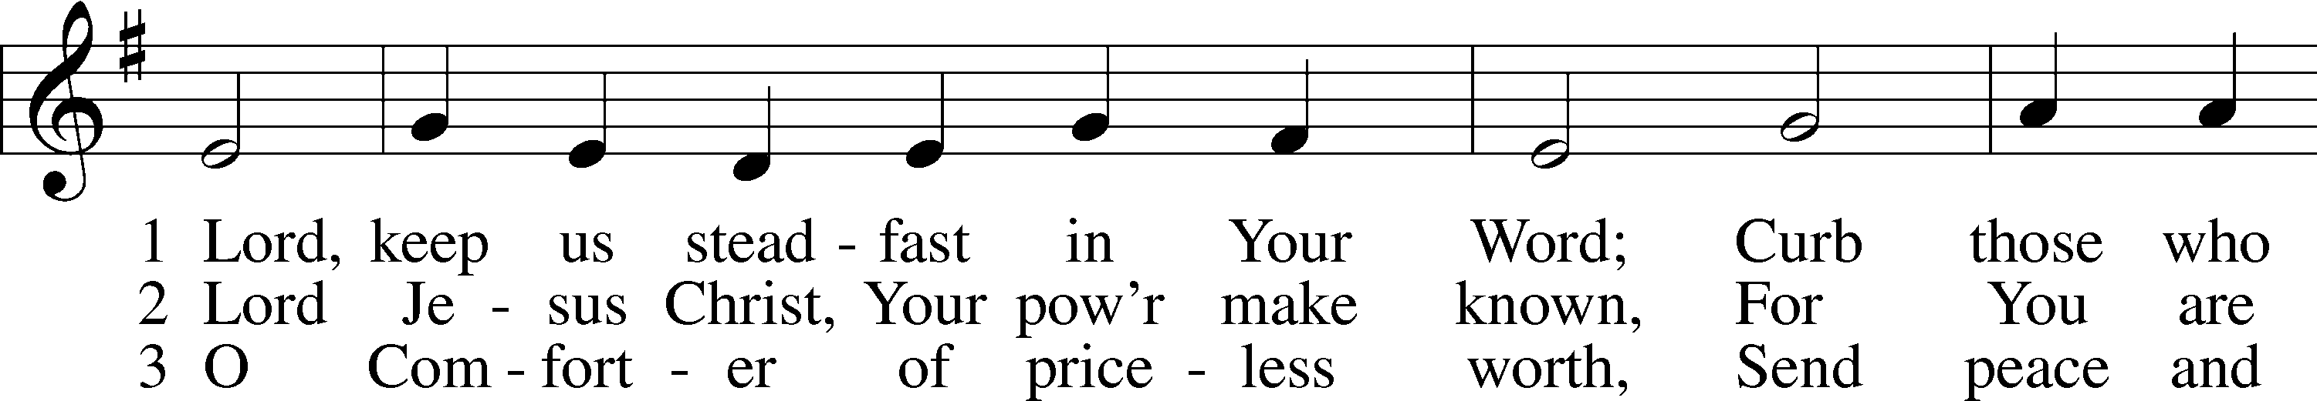
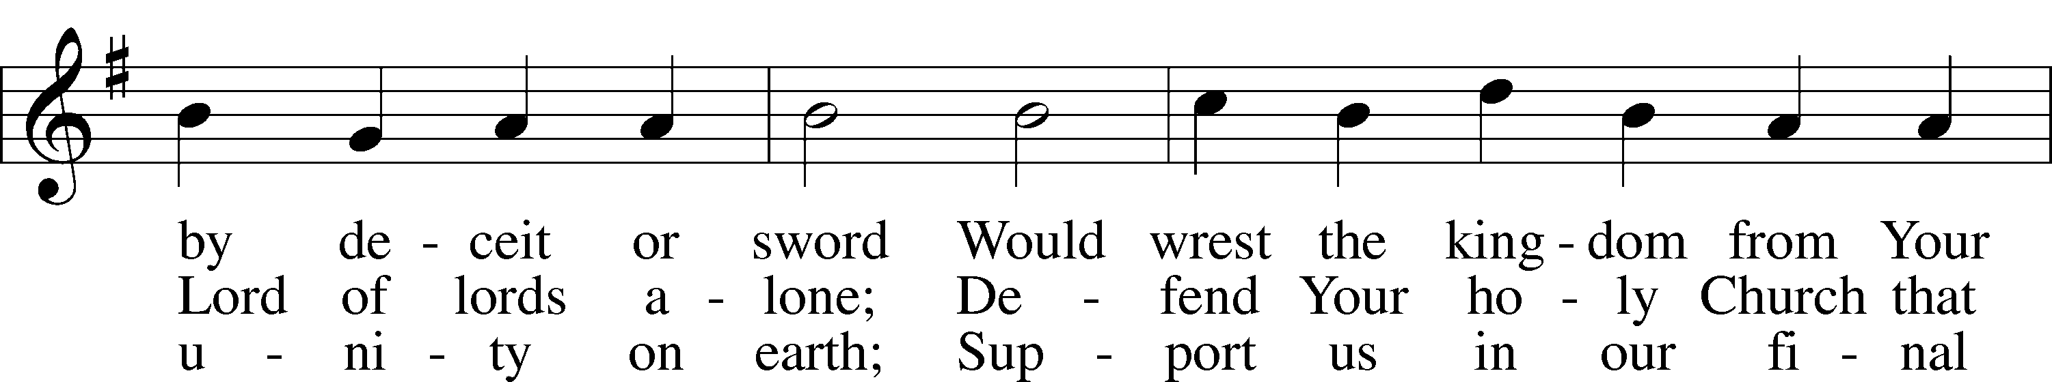
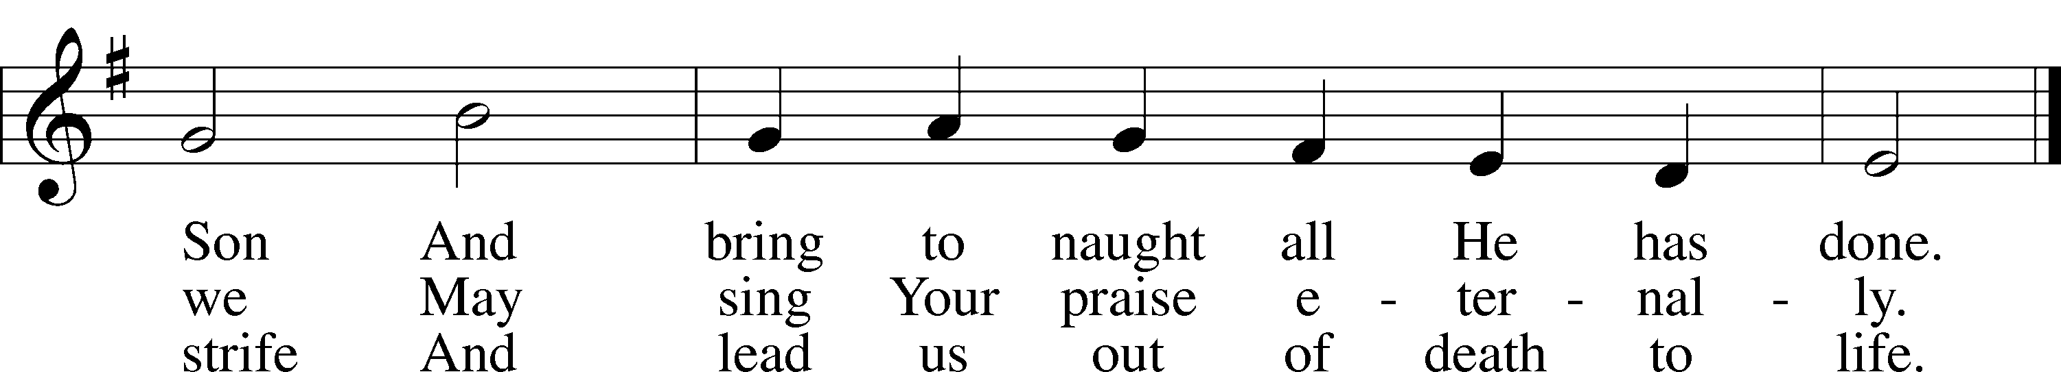
Text: Martin Luther, 1483–1546; tr. Catherine Winkworth, 1827–78, alt.
Tune: Geistliche Lieder auffs new gebessert, 1543, Wittenberg, ed. Joseph Klug
Text and tune: Public domain

Sermon “Questions.”

Votum
P The peace of God, which passes all understanding, keep your hearts and minds in Christ Jesus.
C Amen.

Stand

Offertory Psalm 51:10–12
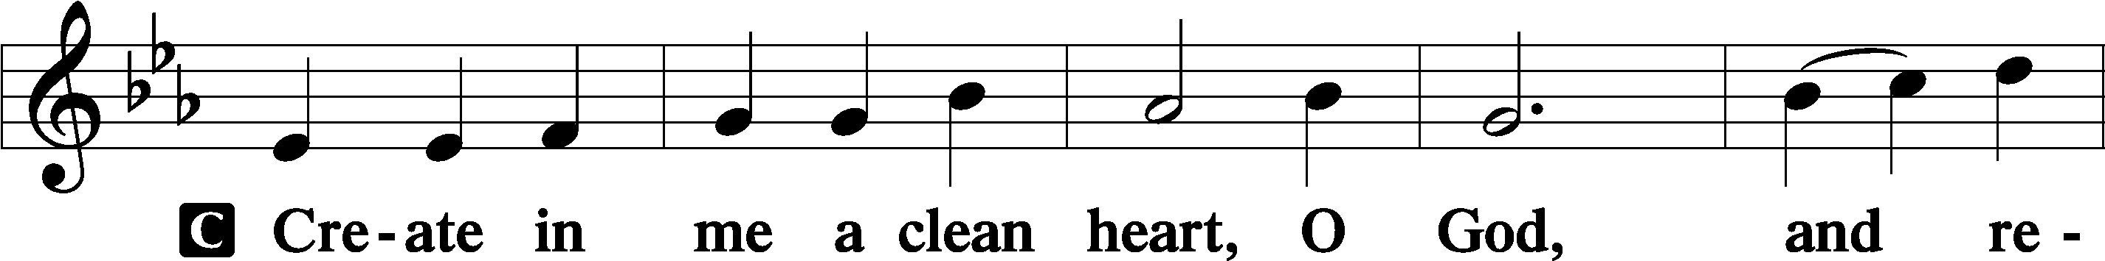
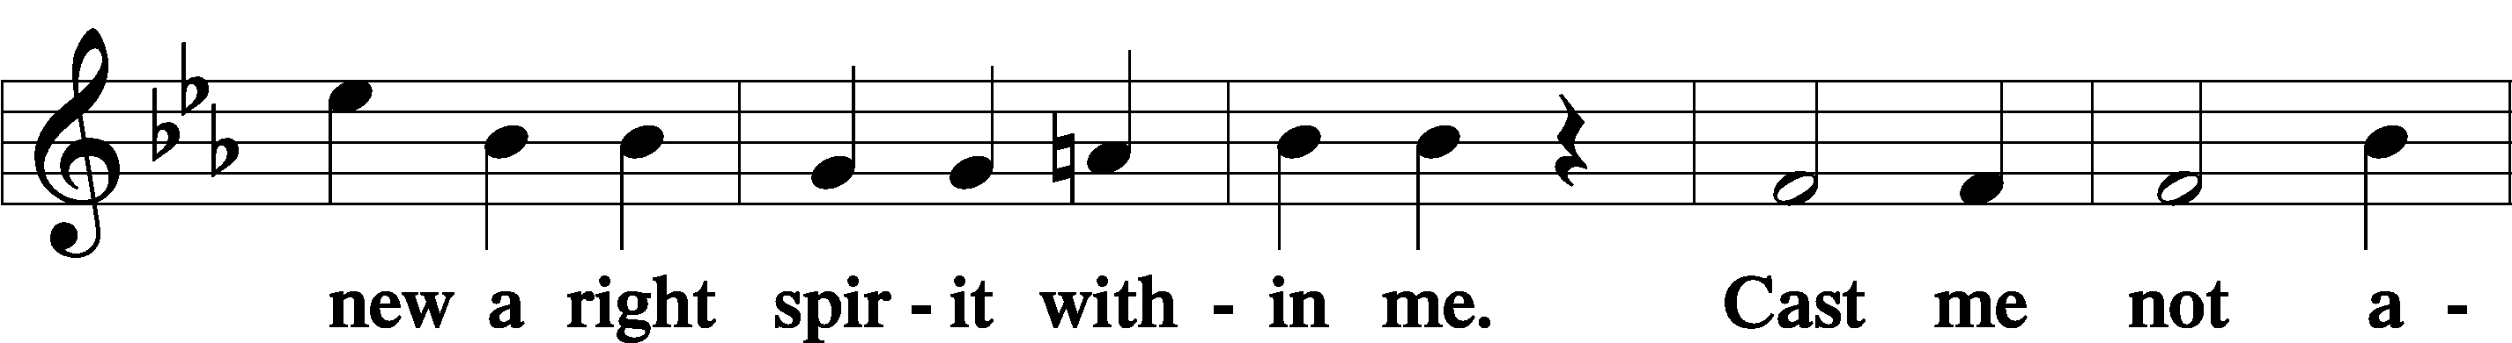
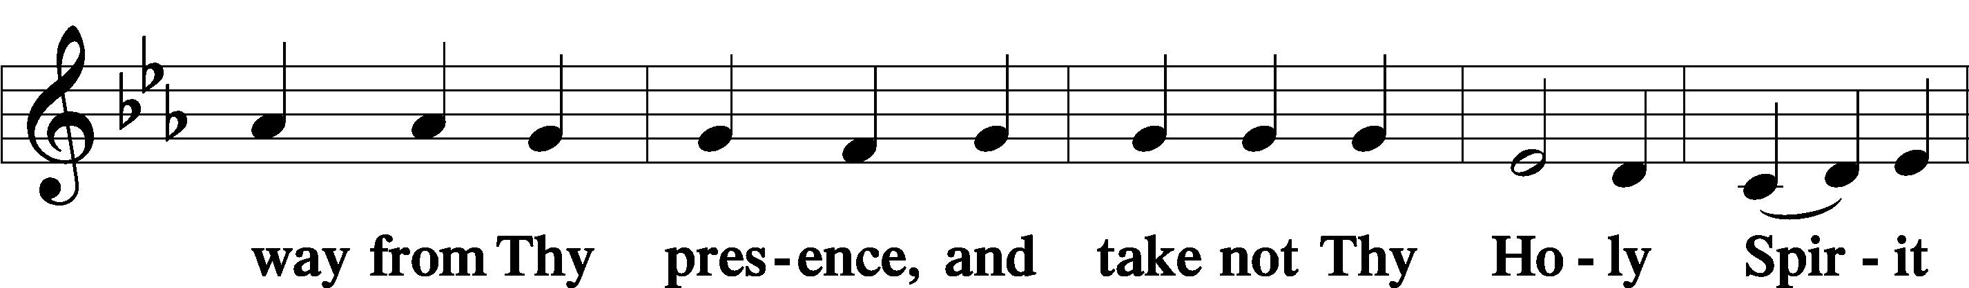
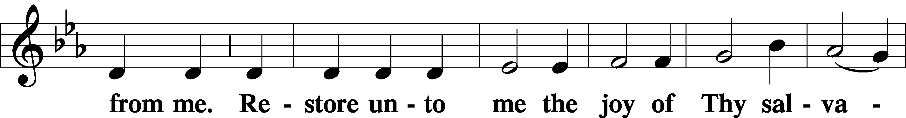
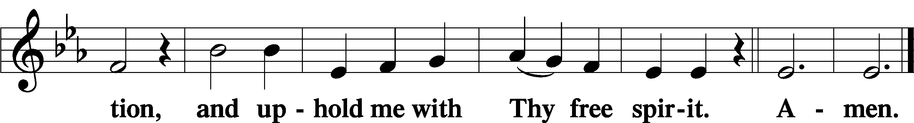
Offering

805 Praise God, from Whom All Blessings Flow
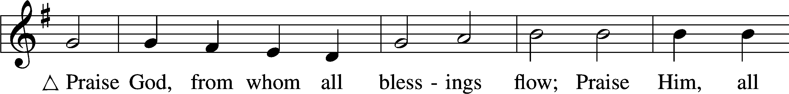
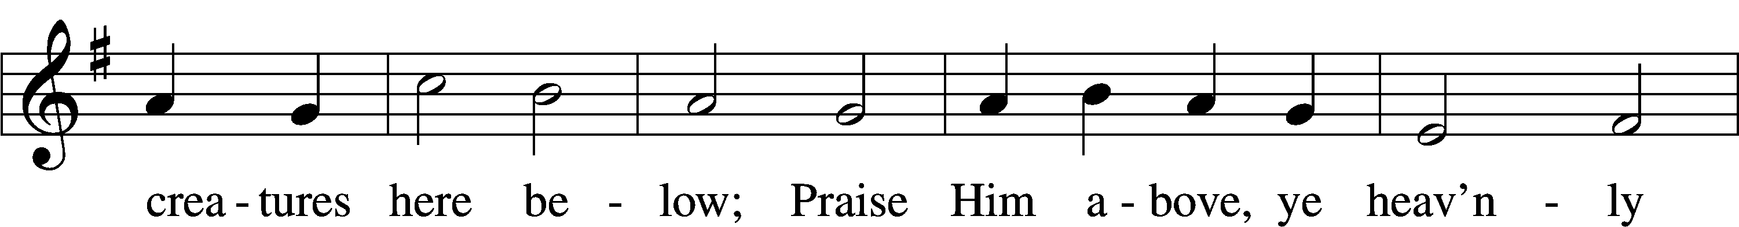
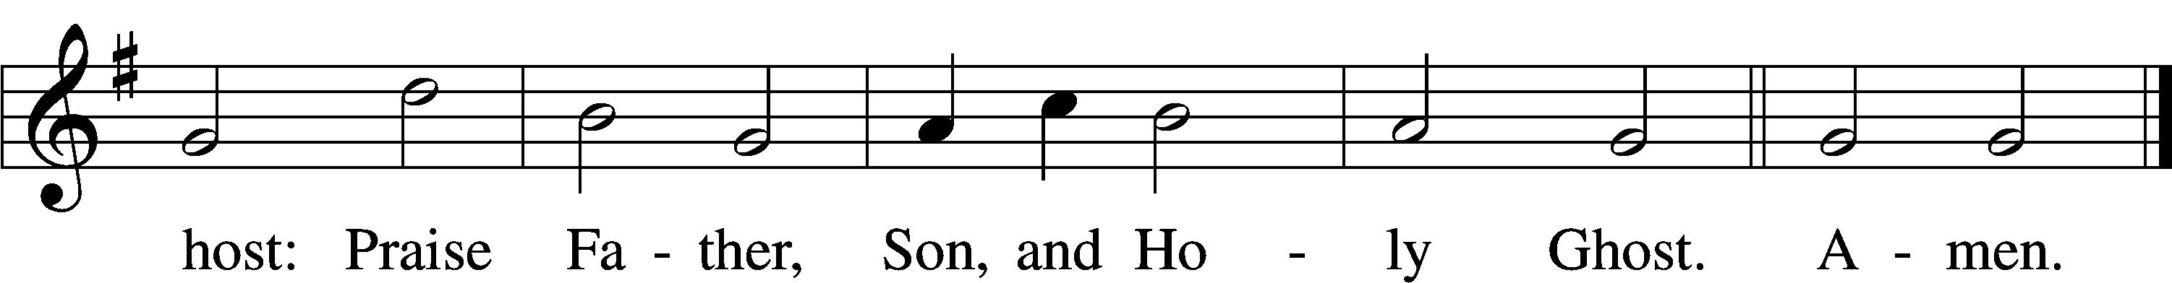
Text: Thomas Ken, 1637–1711
Tune: Trente quatre Pseaumes de David, 1551, Geneva, ed. Louis Bourgeois
Text and tune: Public domain

Prayer of the Church

Lord’s Prayer Matthew 6:9–13
P Lord, remember us in Your kingdom and teach us to pray:
C Our Father who art in heaven,
hallowed be Thy name,
Thy kingdom come,
Thy will be done on earth
as it is in heaven;
give us this day our daily bread;
and forgive us our trespasses
as we forgive those
who trespass against us;
and lead us not into temptation,
but deliver us from evil.
For Thine is the kingdom
and the power and the glory
forever and ever. Amen.

Collect for the Word

Blessed Lord, You have caused all Holy Scriptures to be written for our learning. Grant that we may so hear them, read, mark, learn, and inwardly digest them that, by the patience and comfort of Your holy Word, we may embrace and ever hold fast the blessed hope of everlasting life; through Jesus Christ, Your Son, our Lord, who lives and reigns with You and the Holy Spirit, one God, now and forever.

Benediction
P The Lord bless you and keep you.
The Lord make His face shine on you and be gracious to you.
The Lord look upon you with favor and T give you peace.
C Amen.

857 Lord, Help Us Walk Your Servant Way
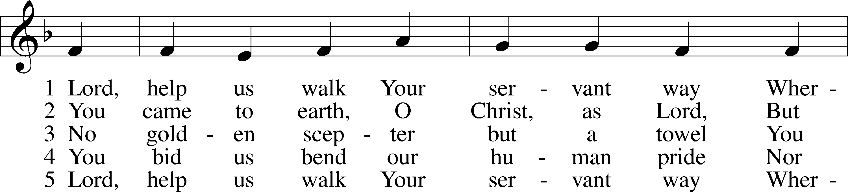
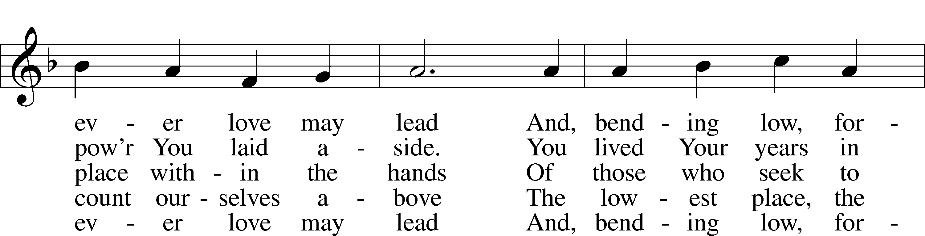
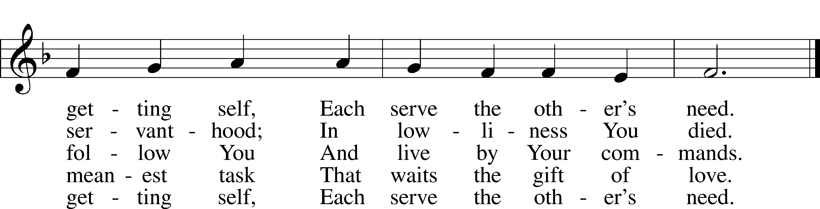
Text: Herman G. Stuempfle, Jr., 1923–2007
Tune: The Whole Booke of Psalmes, 1562, London
Text: © 1997 GIA Publications, Inc. Used by permission: LSB Hymn License no. 110005011
Tune: Public domain
Acknowledgments
Unless otherwise indicated, Scripture quotations are from the ESV® Bible (The Holy Bible, English Standard Version®), copyright © 2001 by Crossway, a publishing ministry of Good News Publishers. Used by permission. All rights reserved.
Created by Lutheran Service Builder © 2026 Concordia Publishing House.

