On entering the church

P Lord, I love the habitation of Your house and the place
where Your glory dwells. In the multitude of Your tender
mercies prepare my heart that I may enter Your house to
worship and confess Your holy name; through Jesus Christ,
my God and Lord.

Before worship

C O Lord, our creator, redeemer, and comforter, as we come
together to worship You in spirit and in truth, we humbly
pray that You would open our hearts to the preaching of
Your Word so that we may repent of our sins, believe in
Jesus Christ as our only Savior, and grow in grace and
holiness. Hear us for His sake.

398 Hail to the Lord’s Anointed
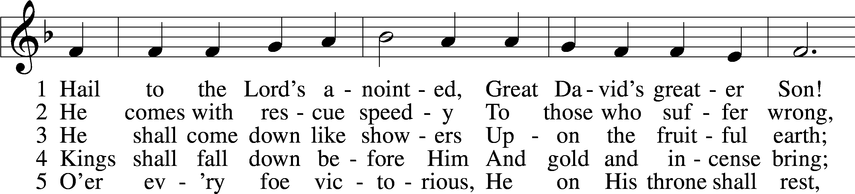
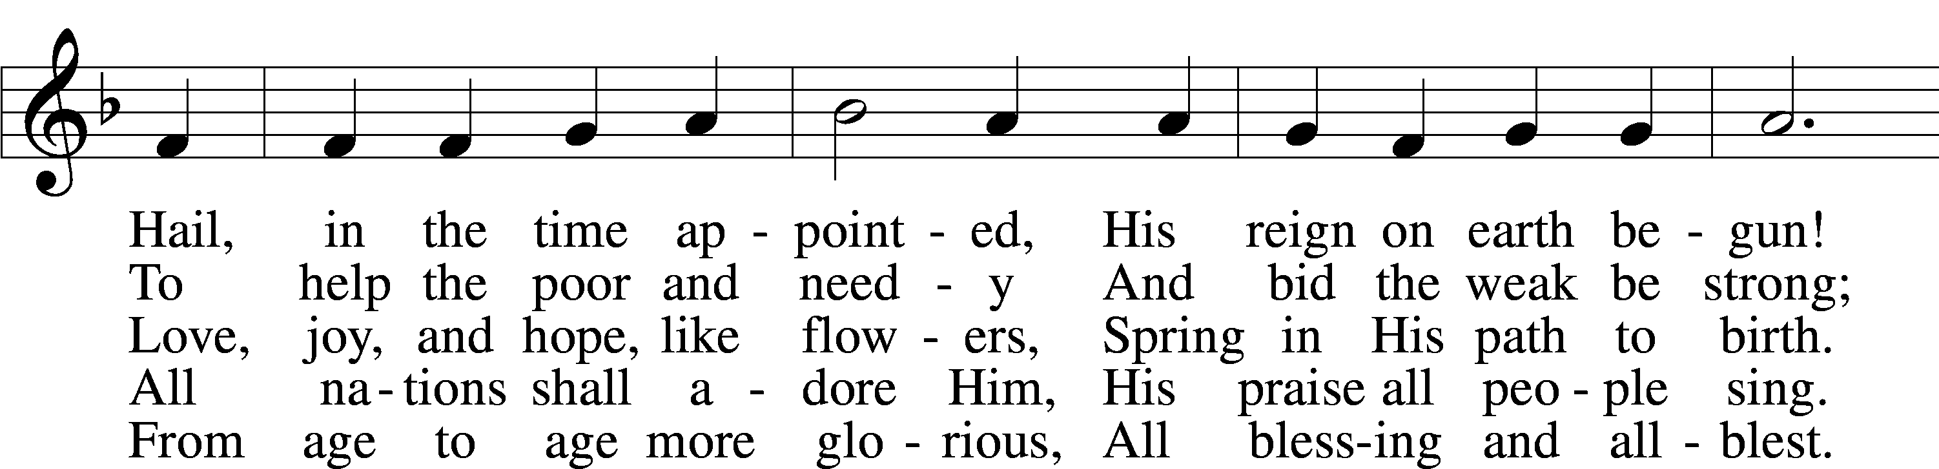
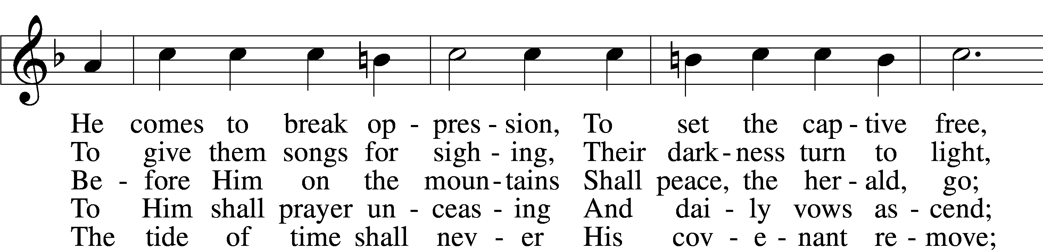
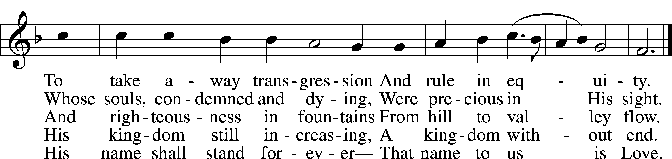
Text: James Montgomery, 1771–1854, alt.
Tune: Leonhart Schröter, c. 1532–c. 1601
Text and tune: Public domain
Confession and Absolution
Stand

The sign of the cross may be made by all in remembrance of their Baptism.

Invocation Matthew 28:19b; 18:20
P In the name of the Father and of the T Son and of the Holy Spirit.
C Amen.

Exhortation Psalm 124:8; Psalm 130:3–4; Luke 18:13
P Our help is in the name of the Lord,
C who made heaven and earth.

P If You, O Lord, kept a record of sins, O Lord, who could stand?
C But with You there is forgiveness; therefore You are feared.

P Since we are gathered to hear God’s Word, call upon Him in prayer and praise, and receive the body and blood of our Lord Jesus Christ in the fellowship of this altar, let us first consider our unworthiness and confess before God and one another that we have sinned in thought, word, and deed, and that we cannot free ourselves from our sinful condition. Together as His people let us take refuge in the infinite mercy of God, our heavenly Father, seeking His grace for the sake of Christ, and saying: God, be merciful to me, a sinner.

Kneel/Stand

Confession of Sins
C Almighty God, have mercy upon us, forgive us our sins, and lead us to everlasting life. Amen.

Absolution [John 20:19–23]
P Almighty God in His mercy has given His Son to die for you and for His sake forgives you all your sins. As a called and ordained servant of Christ, and by His authority, I therefore forgive you all your sins in the name of the Father and of the T Son and of the Holy Spirit.
C Amen.

Stand
Service of the Word
Introit Psalm 66:1–5, 20; antiphon: v. 4; 92:1
All the earth worships you and sings praises to you;
they sing praises to your name.
It is good to give thanks to the Lord,
to sing praises to your name, O Most High.
Shout for joy to God, all the earth;
sing the glory of his name; give to him glorious praise!
Say to God, “How awesome are your deeds!
So great is your power that your enemies come cringing to you.
All the earth worships you and sings praises to you;
they sing praises to your name.”
Come and see what God has done:
he is awesome in his deeds toward the children of man.
Blessèd be God,
because he has not rejected my prayer or removed his steadfast love from me!
Glory be to the Father and to the Son
and to the Holy Spirit;
as it was in the beginning,
is now, and will be forever. Amen.
All the earth worships you and sings praises to you;
they sing praises to your name.
It is good to give thanks to the Lord,
to sing praises to your name, O Most High.

Kyrie Mark 10:47
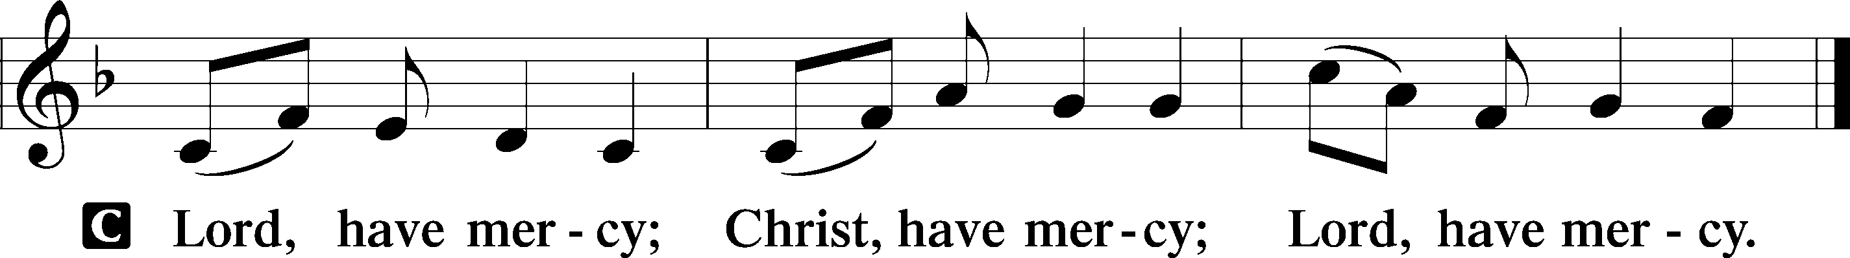

Gloria in Excelsis Luke 2:14; John 1:29
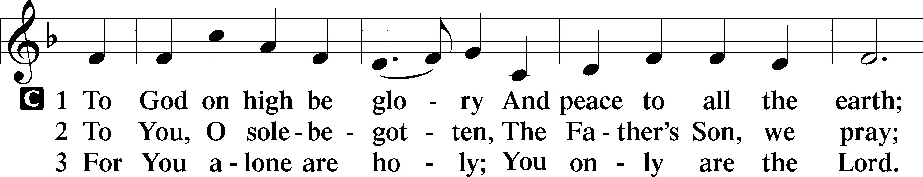
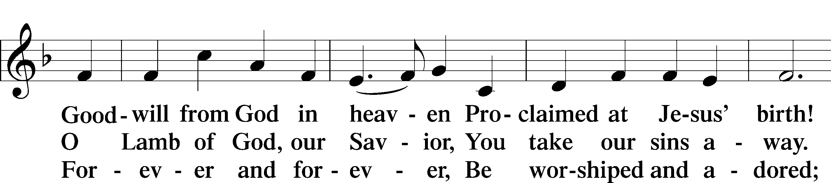
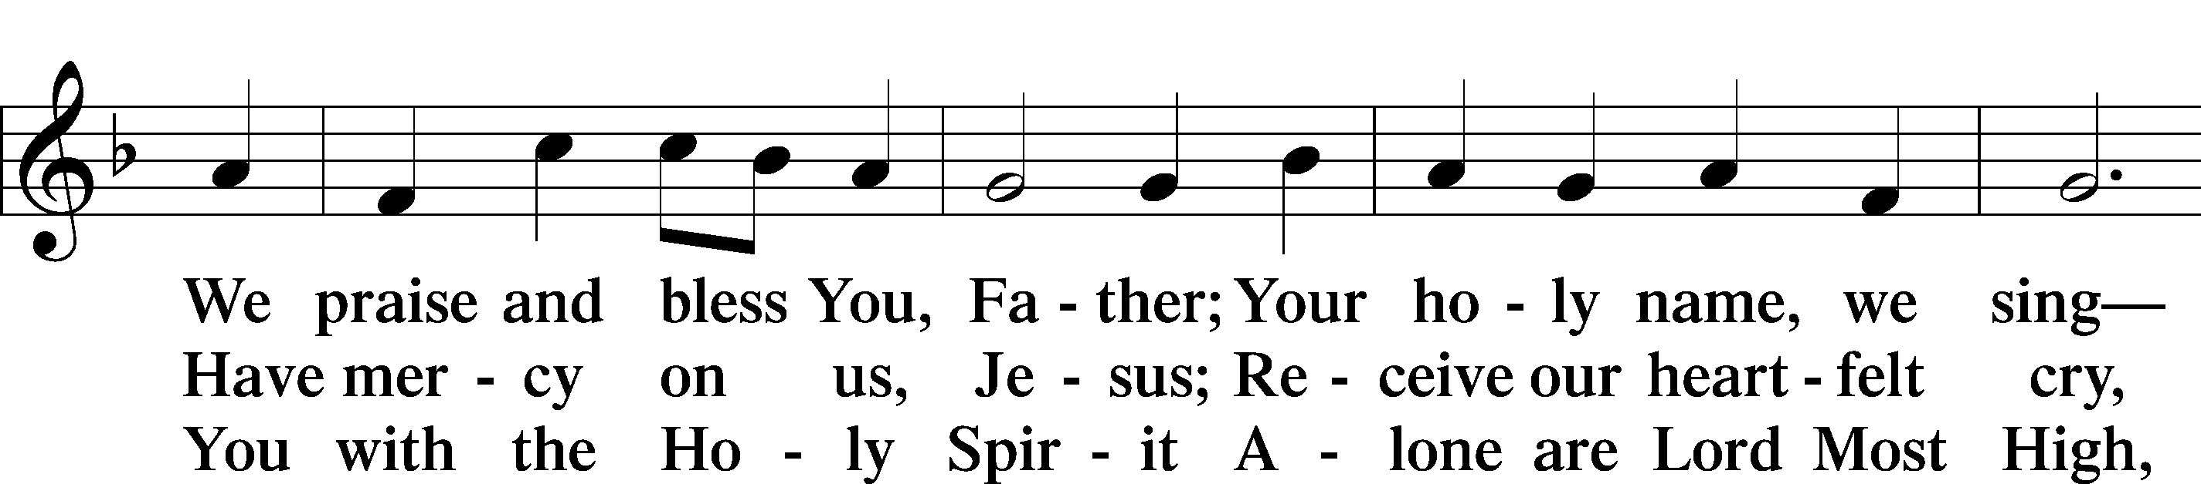
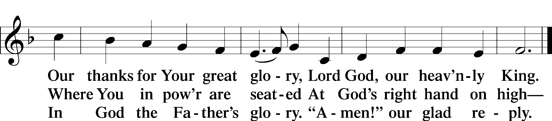
Text: Stephen P. Starke

Salutation and Collect of the Day
P The Lord be with you.
C And also with you.

P Let us pray.
Almighty and everlasting God, who governs all things in heaven and on earth, mercifully hear the prayers of Your people and grant us Your peace through all our days; through Jesus Christ, Your Son, our Lord, who lives and reigns with You and the Holy Spirit, one God, now and forever.

C Amen.

Sit

Old Testament Reading Amos 9:11–15
11“In that day I will raise up
the booth of David that is fallen
and repair its breaches,
and raise up its ruins
and rebuild it as in the days of old,
12that they may possess the remnant of Edom
and all the nations who are called by my name,”
declares the Lord who does this.
13“Behold, the days are coming,” declares the Lord,
“when the plowman shall overtake the reaper
and the treader of grapes him who sows the seed;
the mountains shall drip sweet wine,
and all the hills shall flow with it.
14I will restore the fortunes of my people Israel,
and they shall rebuild the ruined cities and inhabit them;
they shall plant vineyards and drink their wine,
and they shall make gardens and eat their fruit.
15I will plant them on their land,
and they shall never again be uprooted
out of the land that I have given them,”
says the Lord your God.

P This is the Word of the Lord.
C Thanks be to God.

Gradual Psalm 107:20–21
He sent out his word and healed them,
and delivered them from their destruction.
Let them thank the Lord for his steadfast love,
for his wondrous works to the children of men!

Epistle Romans 12:6–16
6Having gifts that differ according to the grace given to us, let us use them: if prophecy, in proportion to our faith; 7if service, in our serving; the one who teaches, in his teaching; 8the one who exhorts, in his exhortation; the one who contributes, in generosity; the one who leads, with zeal; the one who does acts of mercy, with cheerfulness.
9Let love be genuine. Abhor what is evil; hold fast to what is good. 10Love one another with brotherly affection. Outdo one another in showing honor. 11Do not be slothful in zeal, be fervent in spirit, serve the Lord. 12Rejoice in hope, be patient in tribulation, be constant in prayer. 13Contribute to the needs of the saints and seek to show hospitality.
14Bless those who persecute you; bless and do not curse them. 15Rejoice with those who rejoice, weep with those who weep. 16Live in harmony with one another. Do not be haughty, but associate with the lowly. Never be conceited.

A This is the Word of the Lord.
C Thanks be to God.

Stand

Alleluia and Verse

Alleluia
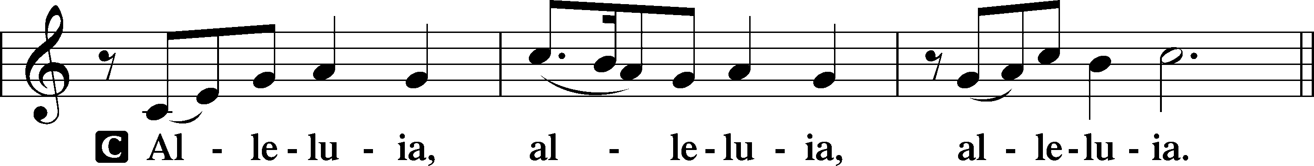

Verse John 20:31
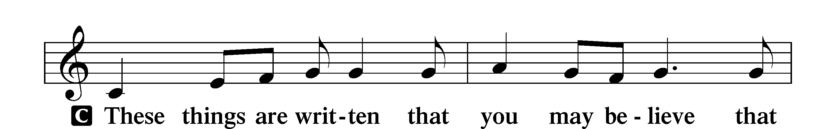
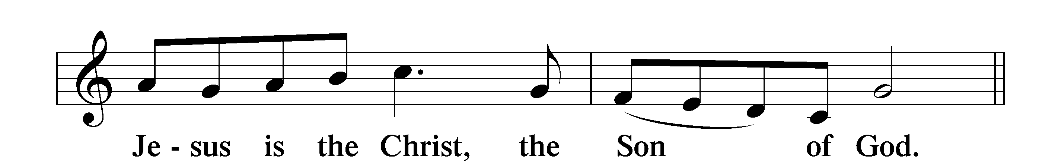

Alleluia
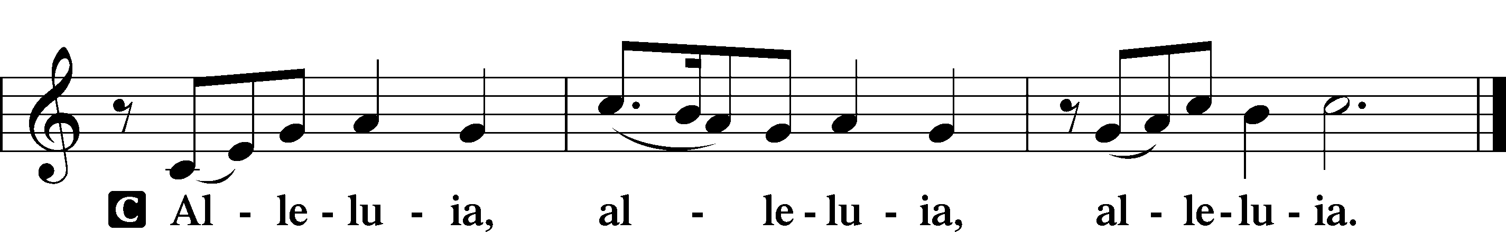

Holy Gospel John 2:1–11
P The Holy Gospel according to St. John, the second chapter.
C Glory to You, O Lord.
1On the third day there was a wedding at Cana in Galilee, and the mother of Jesus was there. 2Jesus also was invited to the wedding with his disciples. 3When the wine ran out, the mother of Jesus said to him, “They have no wine.” 4And Jesus said to her, “Woman, what does this have to do with me? My hour has not yet come.” 5His mother said to the servants, “Do whatever he tells you.”
6Now there were six stone water jars there for the Jewish rites of purification, each holding twenty or thirty gallons. 7Jesus said to the servants, “Fill the jars with water.” And they filled them up to the brim. 8And he said to them, “Now draw some out and take it to the master of the feast.” So they took it. 9When the master of the feast tasted the water now become wine, and did not know where it came from (though the servants who had drawn the water knew), the master of the feast called the bridegroom 10and said to him, “Everyone serves the good wine first, and when people have drunk freely, then the poor wine. But you have kept the good wine until now.” 11This, the first of his signs, Jesus did at Cana in Galilee, and manifested his glory. And his disciples believed in him.

P This is the Gospel of the Lord.
C Praise to You, O Christ.

Nicene Creed
C I believe in one God,
the Father Almighty,
maker of heaven and earth
and of all things visible and invisible.
And in one Lord Jesus Christ,
the only-begotten Son of God,
begotten of His Father before all worlds,
God of God, Light of Light,
very God of very God,
begotten, not made,
being of one substance with the Father,
by whom all things were made;
who for us men and for our salvation came down from heaven
and was incarnate by the Holy Spirit of the virgin Mary
and was made man;
and was crucified also for us under Pontius Pilate.
He suffered and was buried.
And the third day He rose again according to the Scriptures
and ascended into heaven
and sits at the right hand of the Father.
And He will come again with glory to judge both the living and the dead,
whose kingdom will have no end.
And I believe in the Holy Spirit,
the Lord and giver of life,
who proceeds from the Father and the Son,
who with the Father and the Son together is worshiped and glorified,
who spoke by the prophets.
And I believe in one holy Christian and apostolic Church,
I acknowledge one Baptism for the remission of sins,
and I look for the resurrection of the dead
and the life T of the world to come. Amen.

Sit

Children's Sermon

402 The Only Son from Heaven
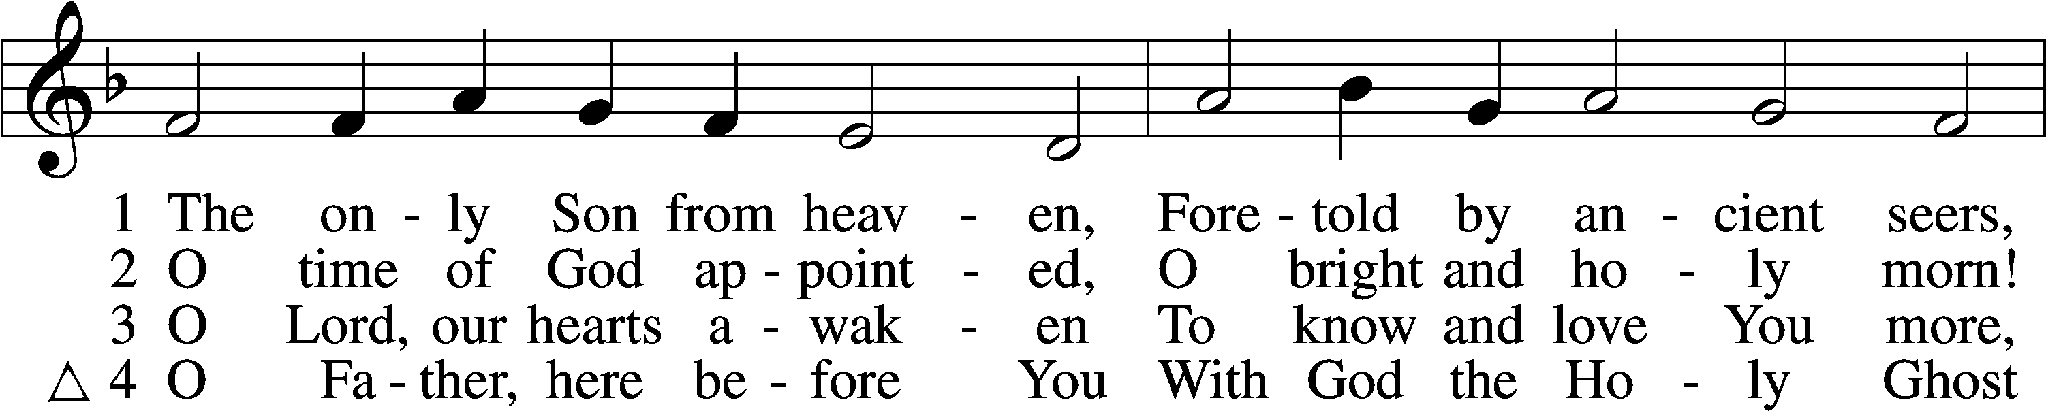
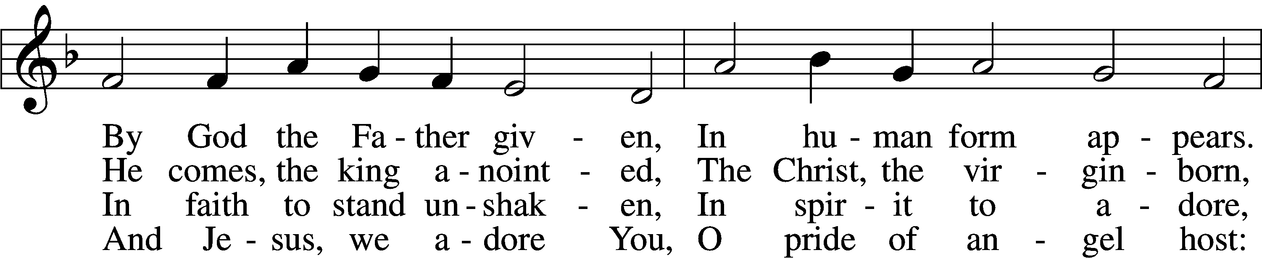
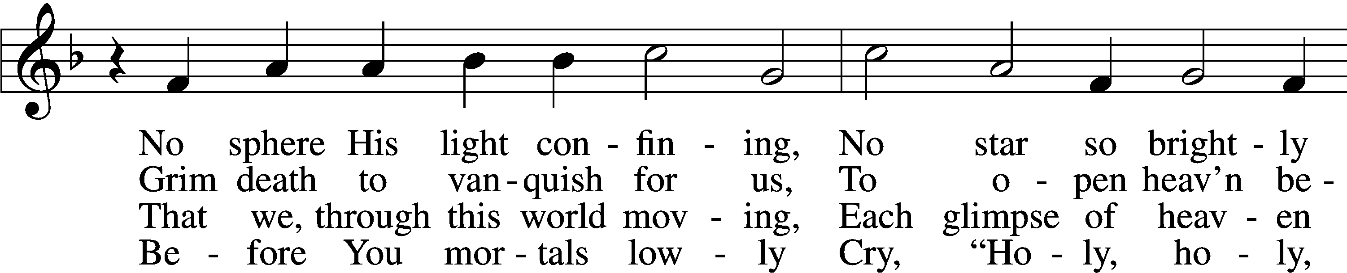
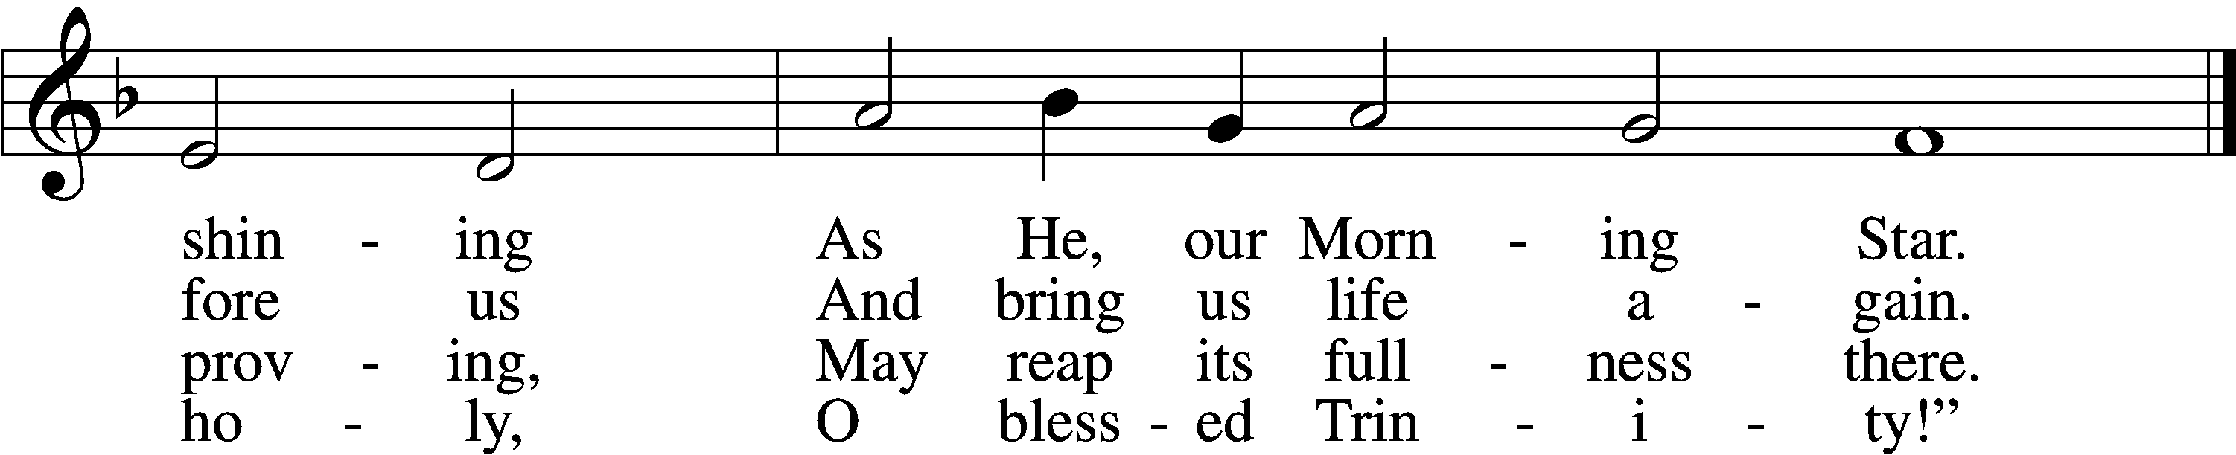
Text (sts. 1–3): Elisabeth Cruciger, c. 1500–1535; (sts. 1–3): tr. Arthur T. Russell, 1806–74, alt.; (st. 4): Lutheran Book of Worship, 1978
Tune: Eyn Enchiridion oder Handbüchlein, 1524, Erfurt
Text and tune: Public domain

Sermon

Stand

Prayer of the Church

Following the prayers, the people may greet one another in the name of the Lord, saying, “Peace be with you,” as a sign of reconciliation and of the unity of the Spirit in the bond of peace (Matt. 5:22–24; Eph. 4:1–3).

Sit

Offering

805 Praise God, from Whom All Blessings Flow
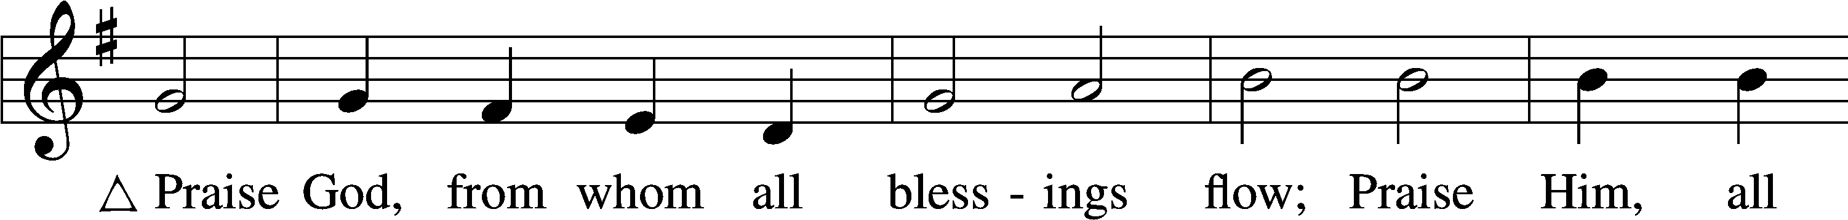
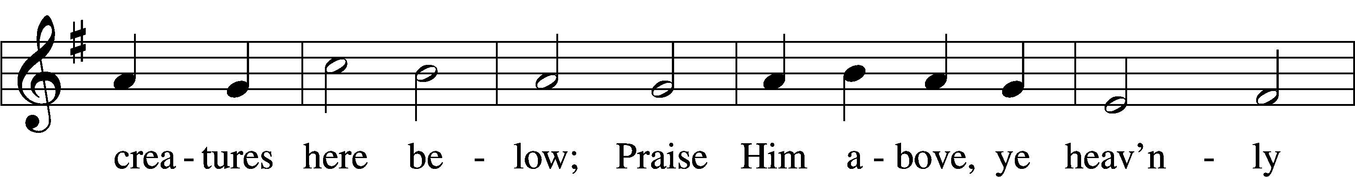
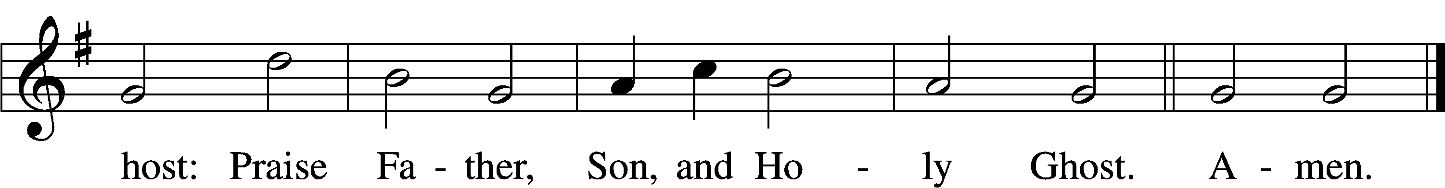
Text: Thomas Ken, 1637–1711
Tune: Trente quatre Pseaumes de David, 1551, Geneva, ed. Louis Bourgeois
Text and tune: Public domain

Service of the Sacrament
Stand

Preface 2 Timothy 4:22; [Colossians 3:1]; [Psalm 136]
P The Lord be with you.
C And also with you.
P Lift up your hearts.
C We lift them to the Lord.
P Let us give thanks to the Lord our God.
C It is right to give Him thanks and praise.
P It is truly good, right, and salutary that we should at all times and in all places give thanks to You, O Lord, holy Father, almighty and everlasting God, for the countless blessings You so freely bestow on us and all creation. Above all, we give thanks for Your boundless love shown to us when You sent Your only-begotten Son, Jesus Christ, into our flesh and laid on Him our sin, giving Him into death that we might not die eternally. Because He is now risen from the dead and lives and reigns to all eternity, all who believe in Him will overcome sin and death and will rise again to new life. Therefore with angels and archangels and with all the company of heaven we laud and magnify Your glorious name, evermore praising You and saying:

Sanctus Isaiah 6:3; Matthew 21:9
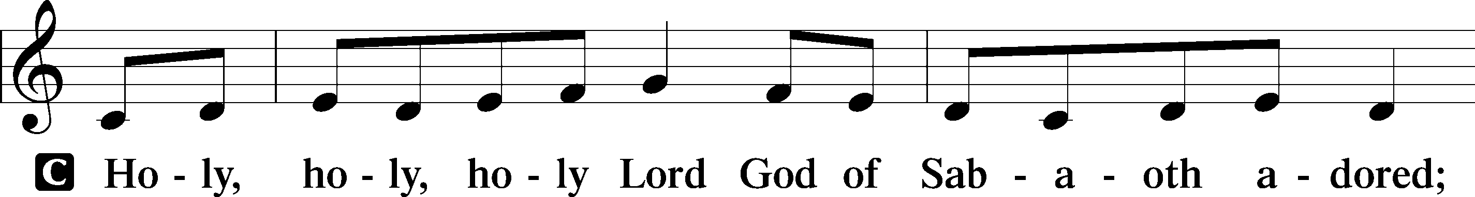
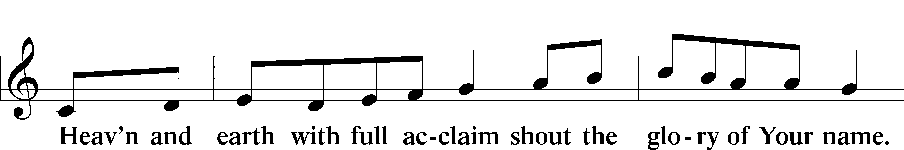
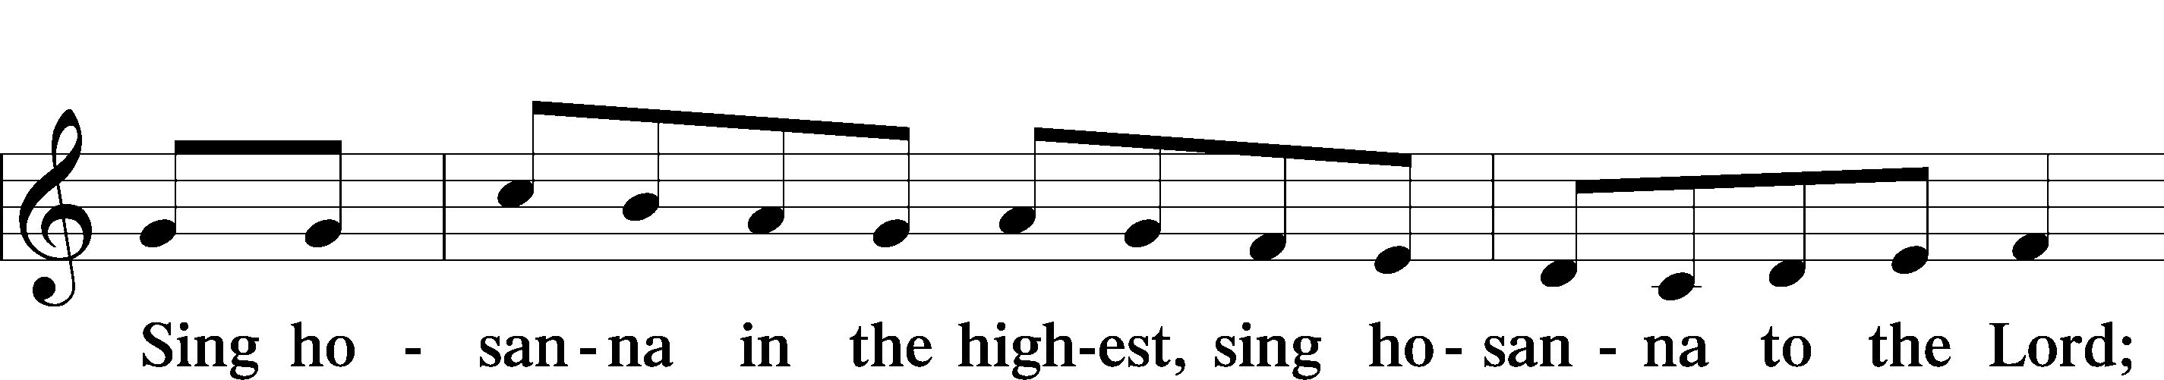
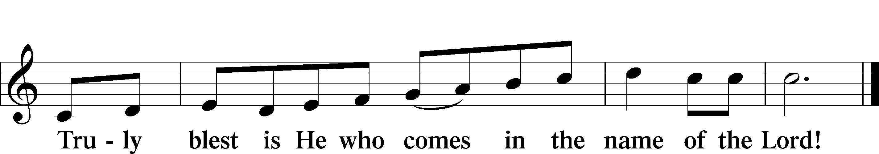
Text: Stephen P. Starke

Prayer of Thanksgiving
P Blessed are You, O Lord our God, king of all creation, for You have had mercy on us and given Your only-begotten Son that whoever believes in Him should not perish but have eternal life.
As the glory of Your presence once filled Your ancient temple, so in the incarnation of Your Son, Jesus Christ, You manifested the fullness of Your glory in human flesh.
We give You thanks that in His most Holy Supper You reveal Your glory to us. Grant us faithfully to eat His body and drink His blood so that we may one day behold Your glory face to face.
Hear us as we pray in His name and as He has taught us:

Lord’s Prayer
C Our Father who art in heaven,
hallowed be Thy name,
Thy kingdom come,
Thy will be done on earth
as it is in heaven;
give us this day our daily bread;
and forgive us our trespasses
as we forgive those
who trespass against us;
and lead us not into temptation,
but deliver us from evil.
For Thine is the kingdom
and the power and the glory
forever and ever. Amen.

The Words of Our Lord
P Our Lord Jesus Christ, on the night when He was betrayed, took bread, and when He had given thanks, He broke it and gave it to the disciples and said: “Take, eat; this is My T body, which is given for you. This do in remembrance of Me.”
In the same way also He took the cup after supper, and when He had given thanks, He gave it to them, saying: “Drink of it, all of you; this cup is the new testament in My T blood, which is shed for you for the forgiveness of sins. This do, as often as you drink it, in remembrance of Me.”

Pax Domini
P The peace of the Lord be with you always.
C Amen.

Agnus Dei John 1:29
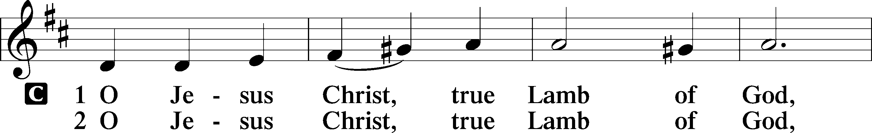
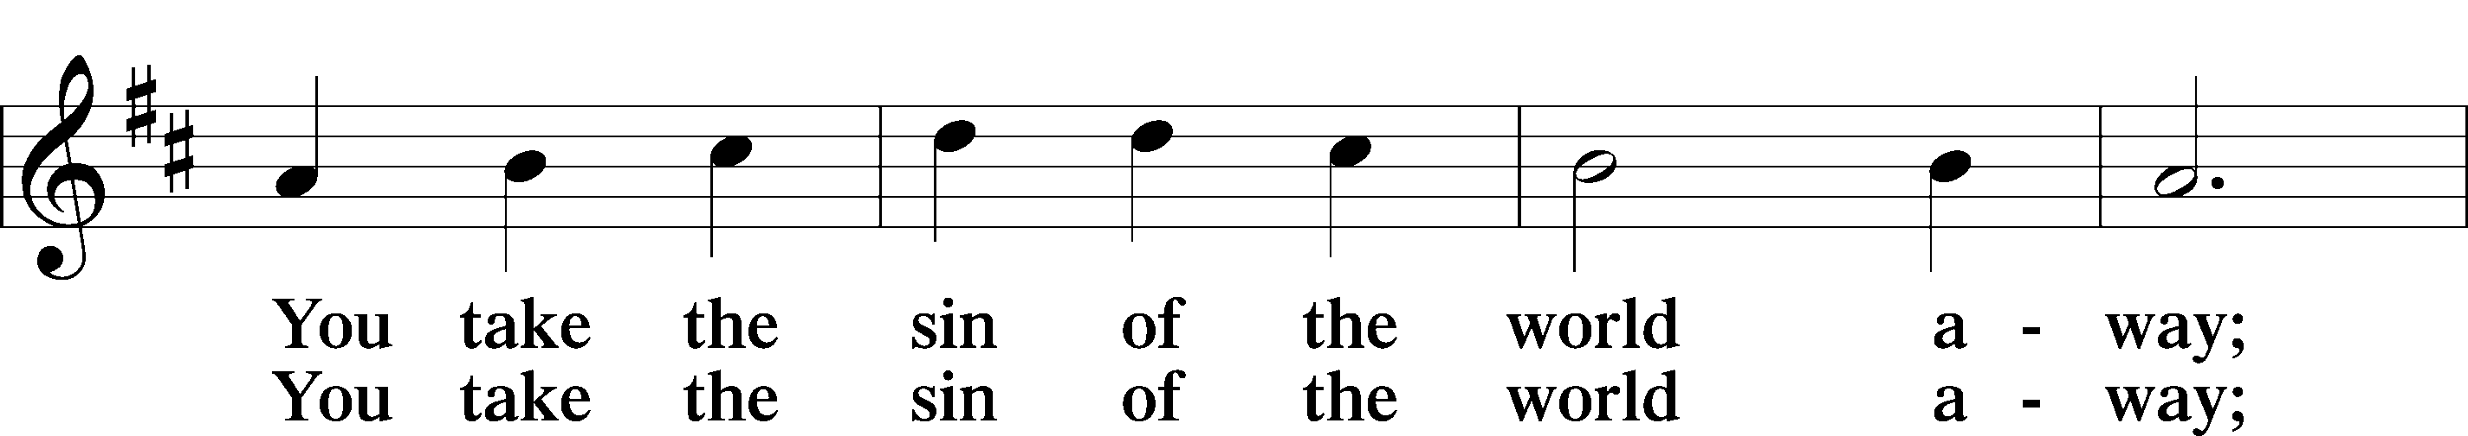
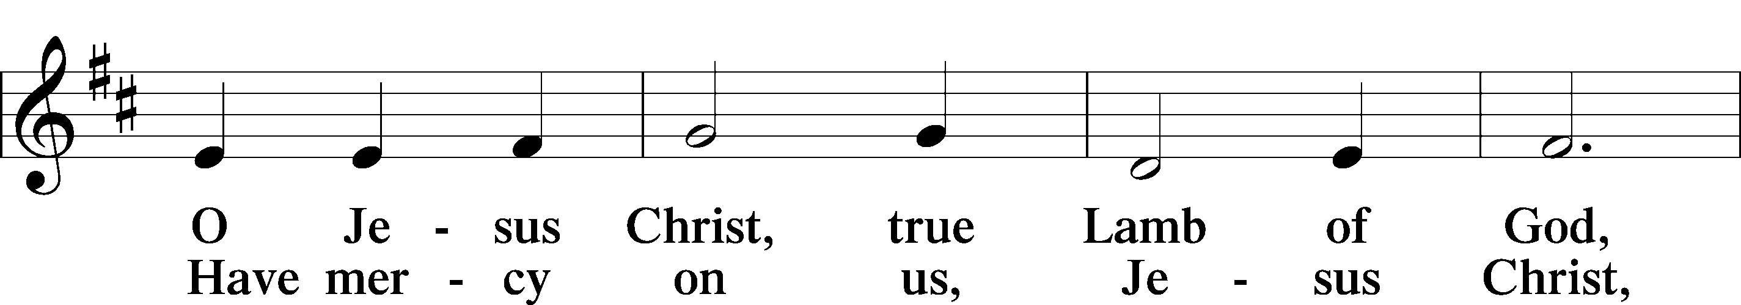
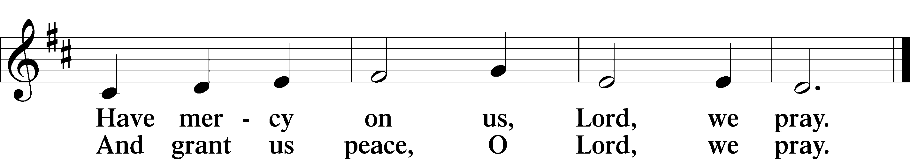
Text: Stephen P. Starke

Sit

Distribution

The pastor and those who assist him receive the body and blood of Christ first and then distribute them to those who come to receive, saying:

Take, eat; this is the true body of our Lord and Savior Jesus Christ, given into death for your sins.
Amen.

Take, drink; this is the true blood of our Lord and Savior Jesus Christ, shed for the forgiveness of your sins.
Amen.

In dismissing the communicants, the following is said:

The Dismissal
P The body and blood of our Lord Jesus Christ strengthen and preserve you in body and soul to life everlasting. Depart T in peace.
C Amen.

822 Alleluia! Let Praises Ring
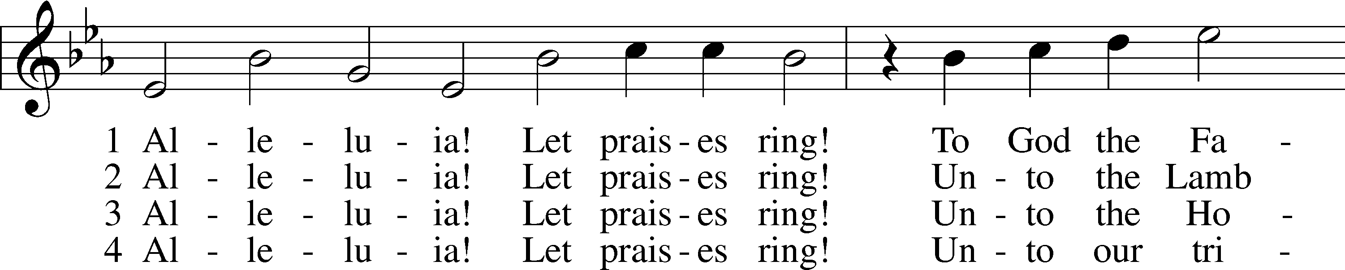
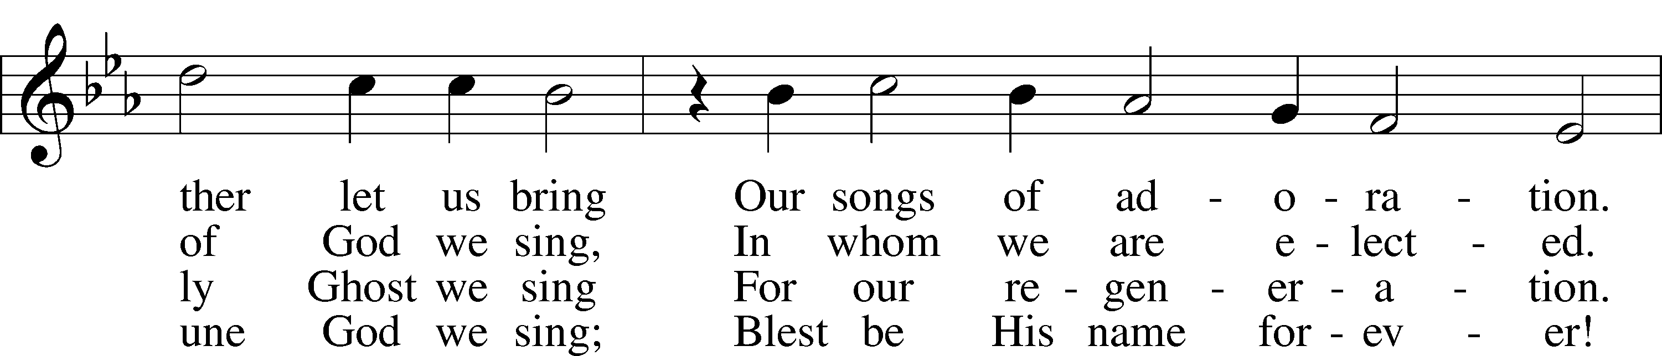
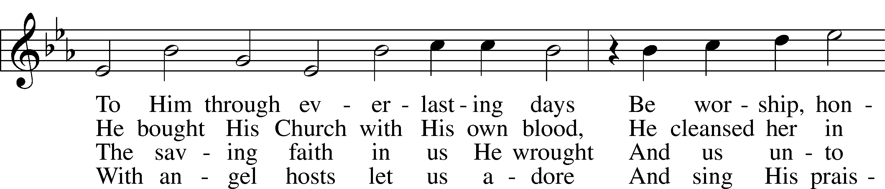
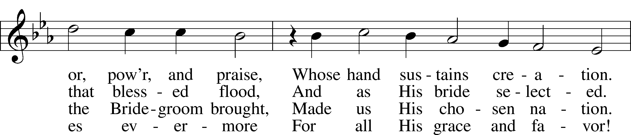
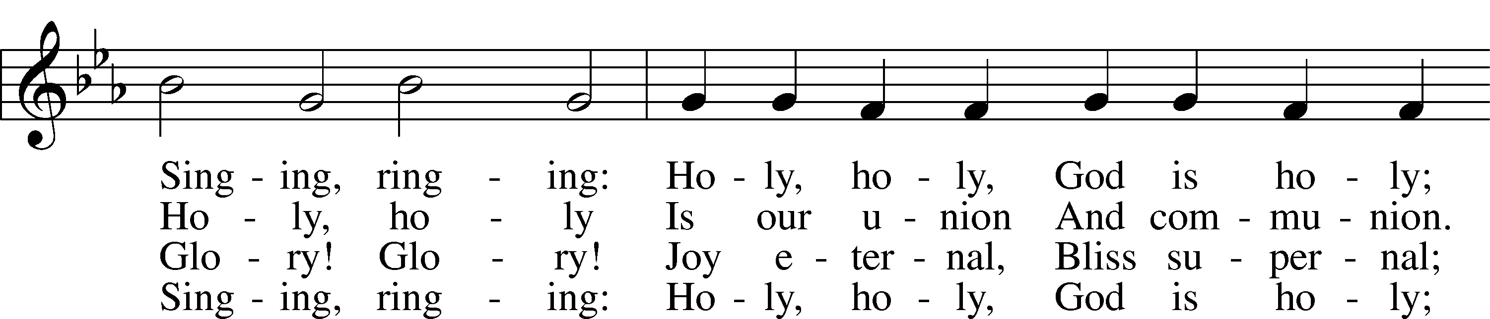
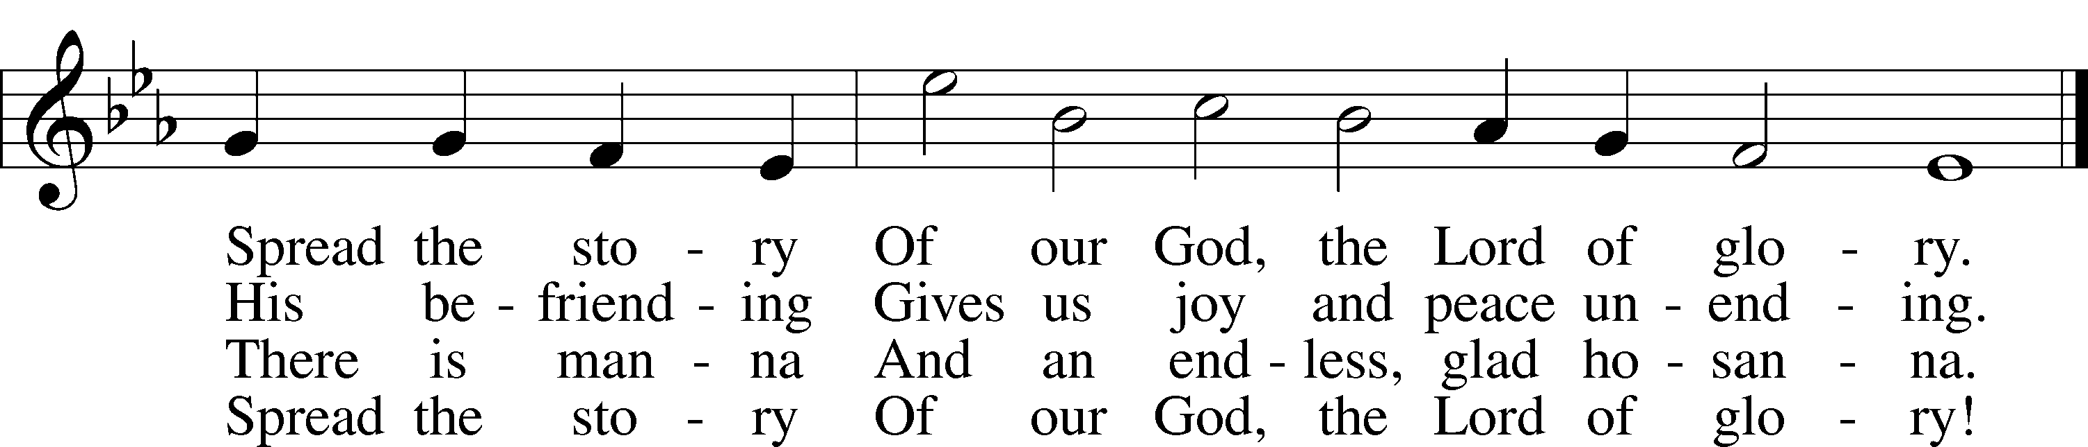
Text: Geistreiches Gesang-Buch, 1698, Darmstadt; tr. The Lutheran Hymnal, 1941, alt.
Tune: Philipp Nicolai, 1556–1608
Text and tune: Public domain

397 As with Gladness Men of Old
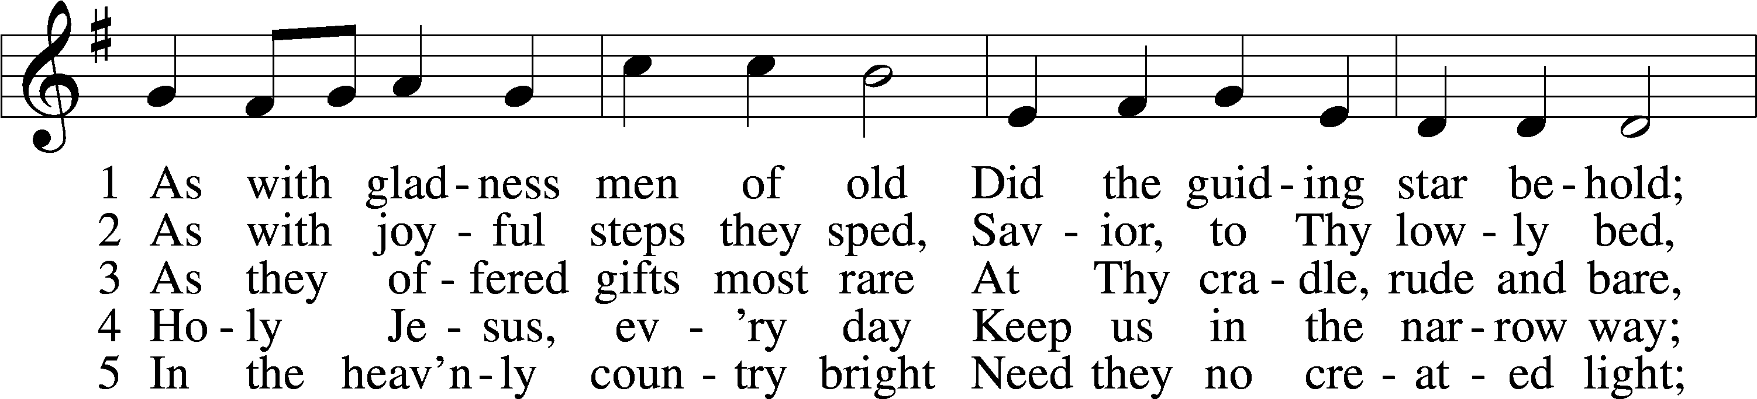
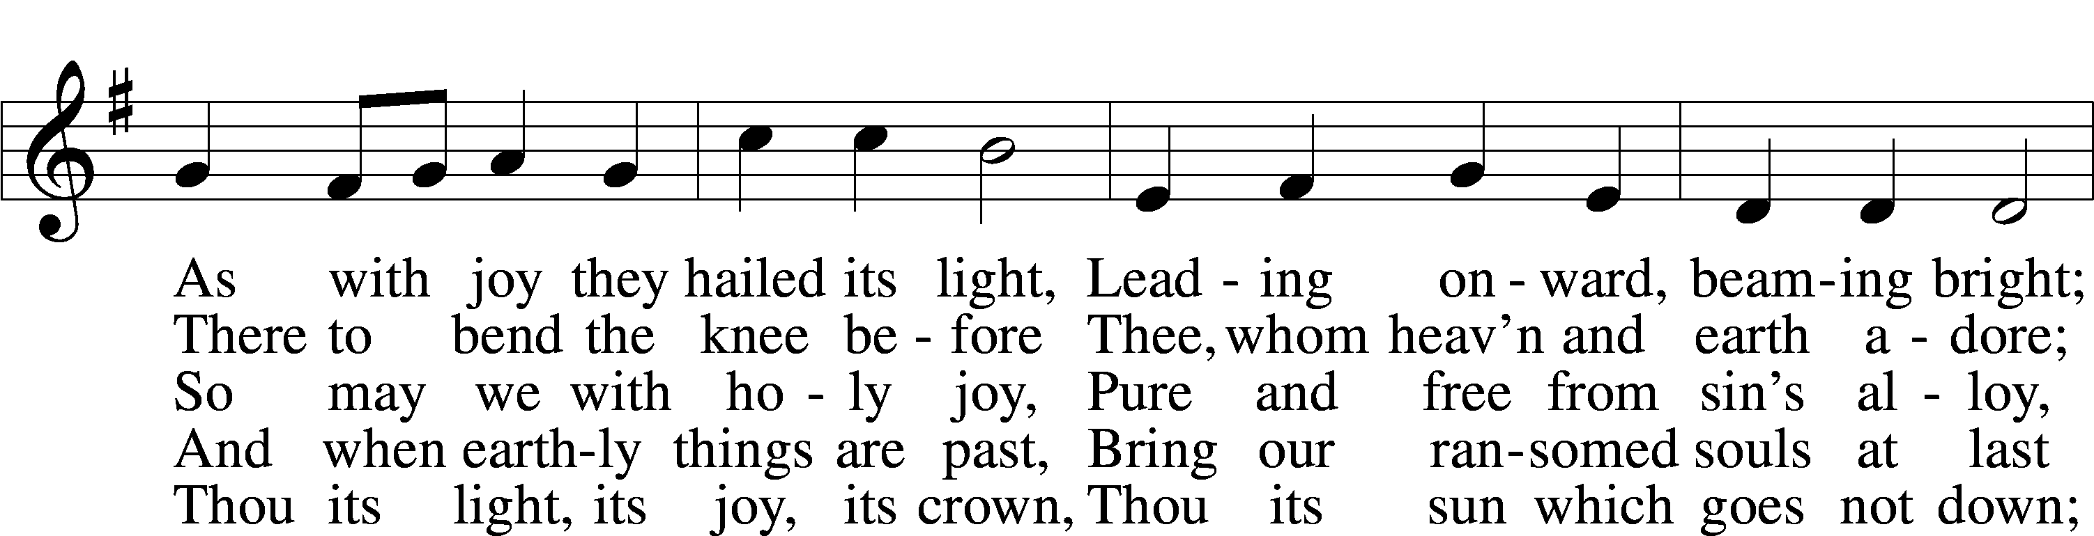
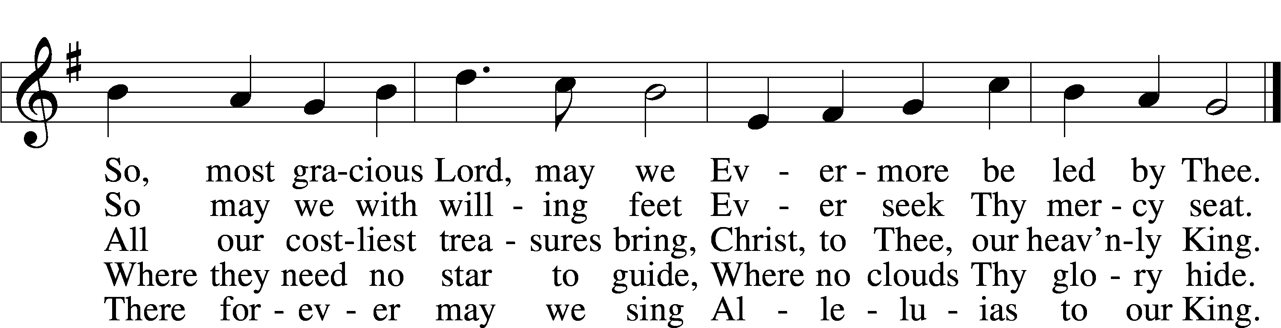
Text: William C. Dix, 1837–98, alt.
Tune: Conrad Kocher, 1786–1872
Text and tune: Public domain

394 Songs of Thankfulness and Praise
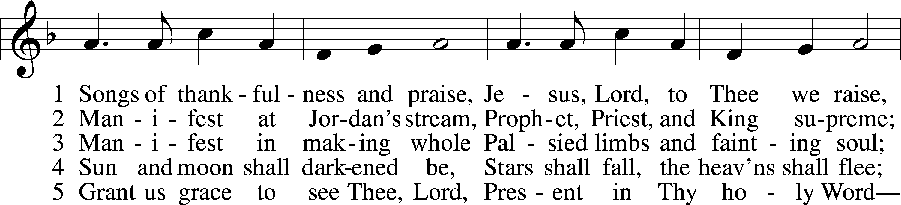
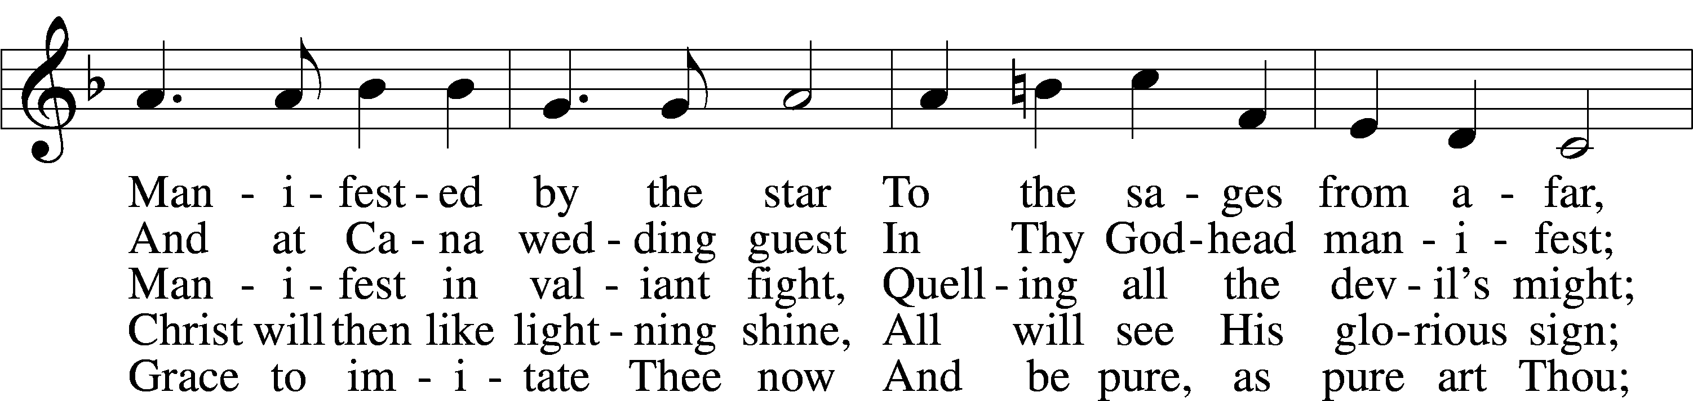
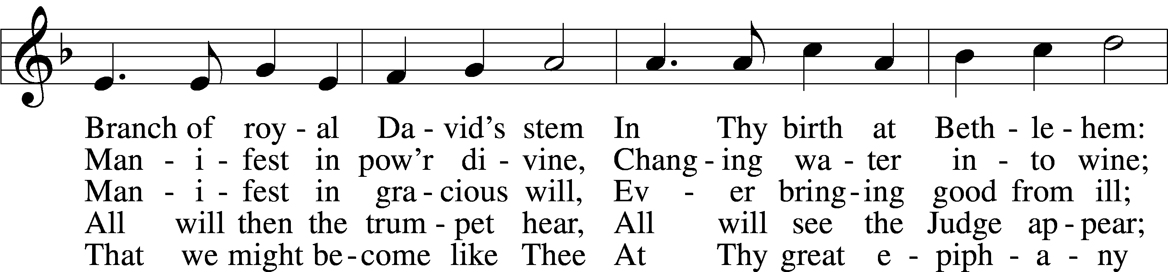
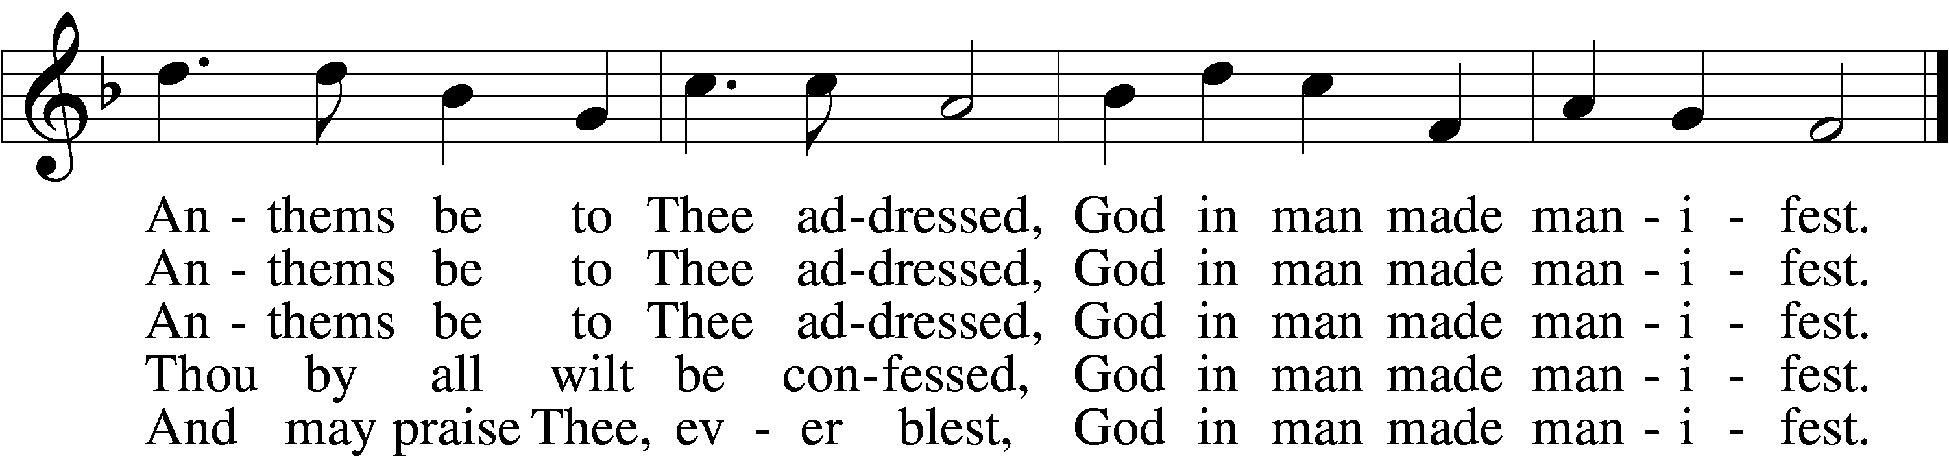
Text: Christopher Wordsworth, 1807–85, alt.
Tune: George J. Elvey, 1816–93
Text and tune: Public domain

400 Brightest and Best of the Stars of the Morning
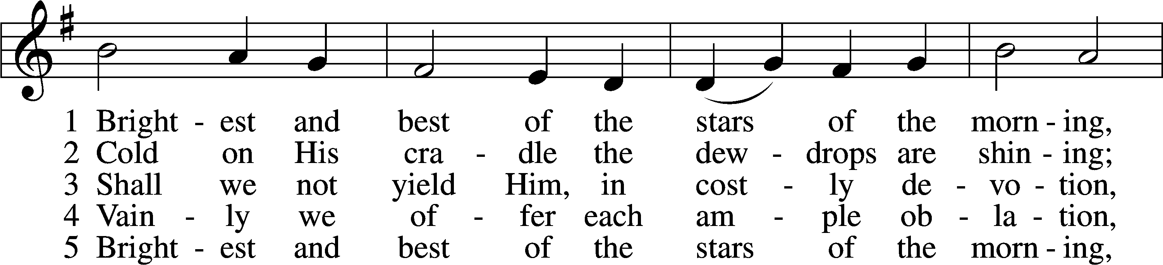
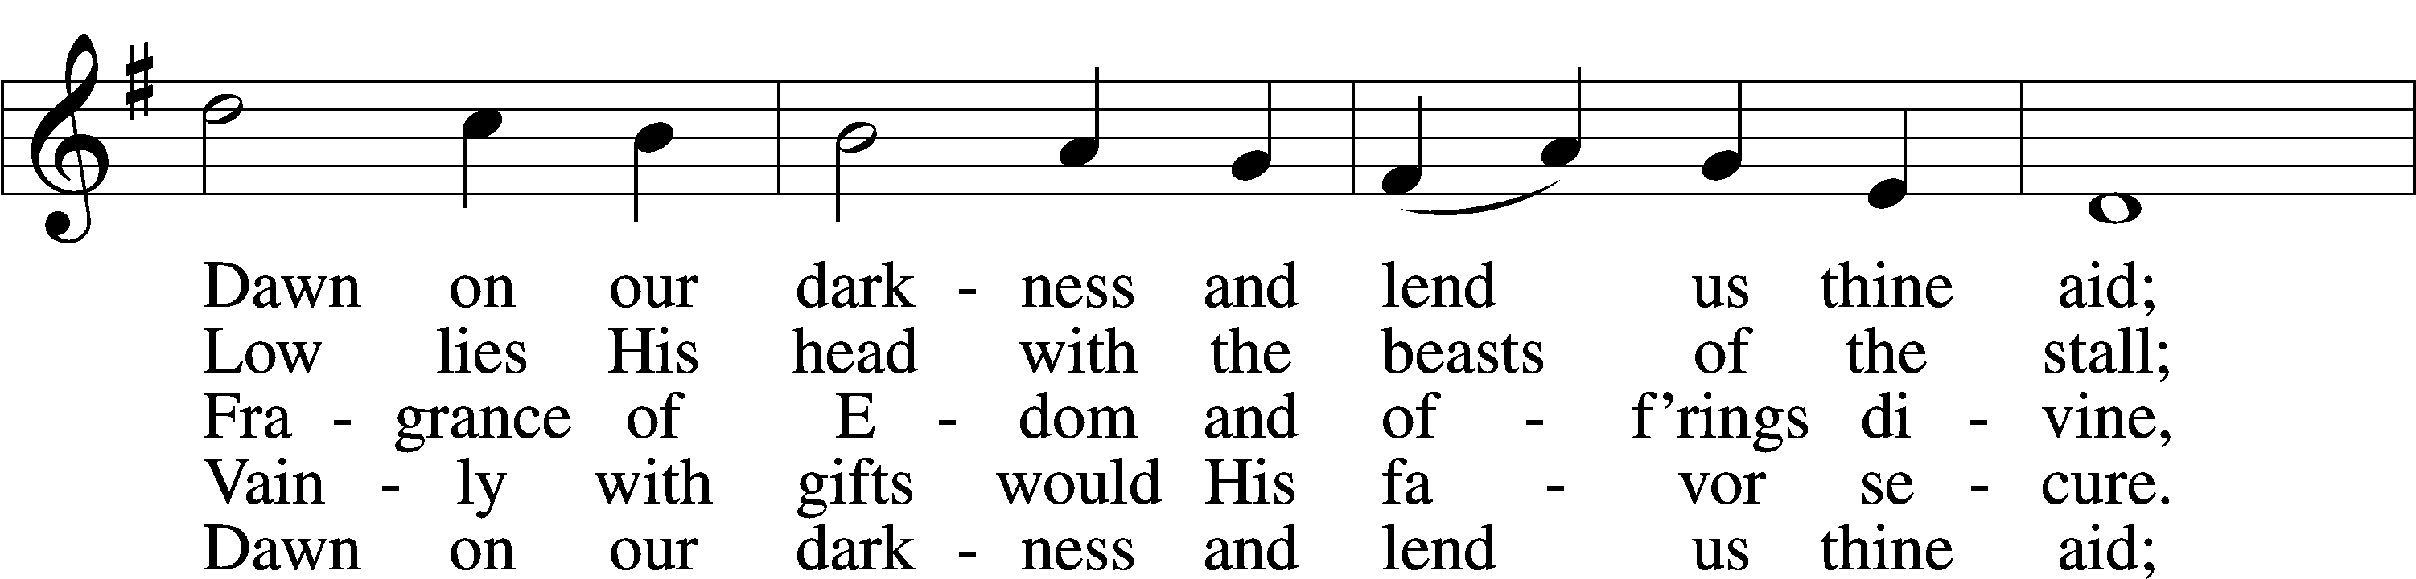
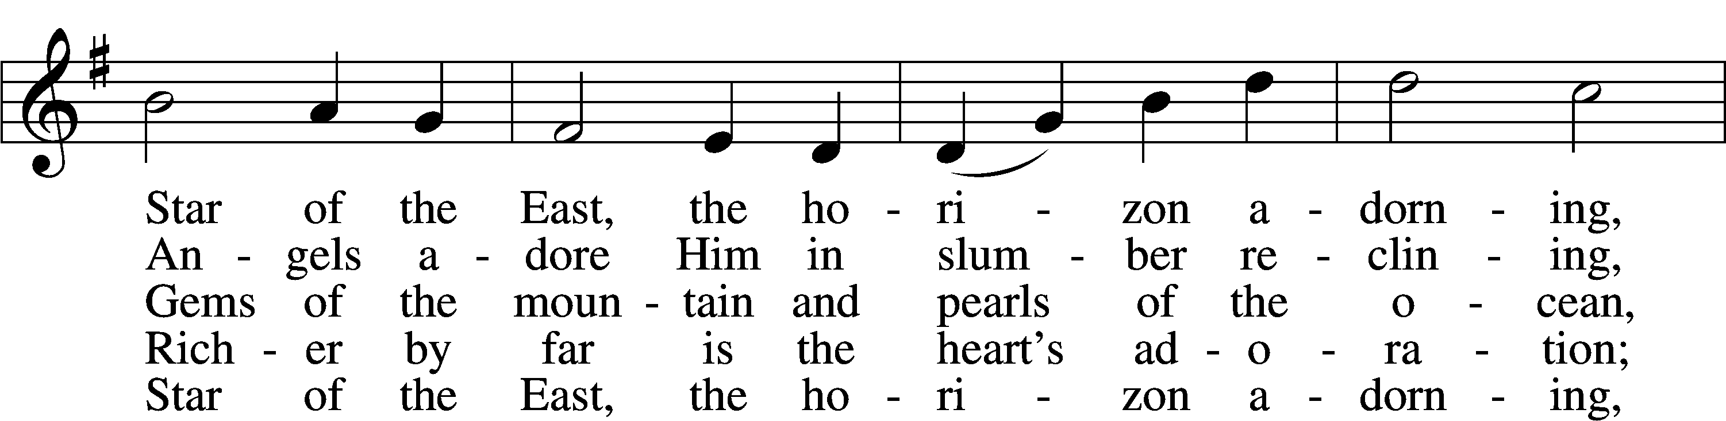
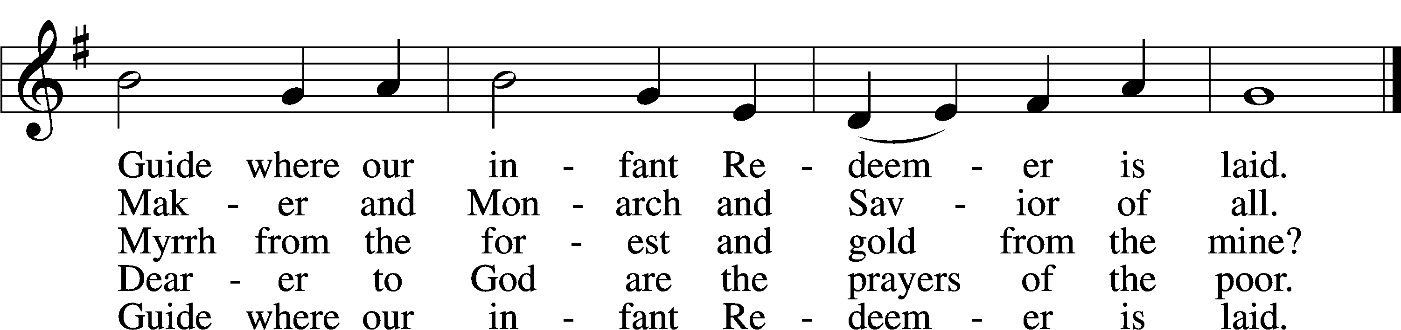
Text: Reginald Heber, 1783–1826, alt.
Tune: James P. Harding, 1850–1911, adapt.
Text and tune: Public domain

Stand

Nunc Dimittis Luke 2:29–32
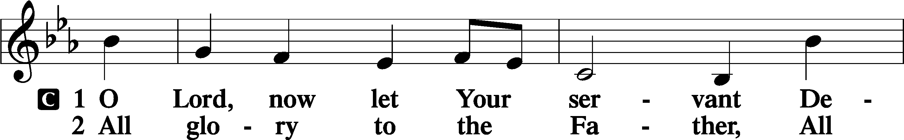
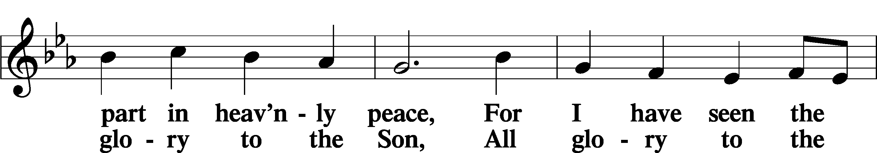
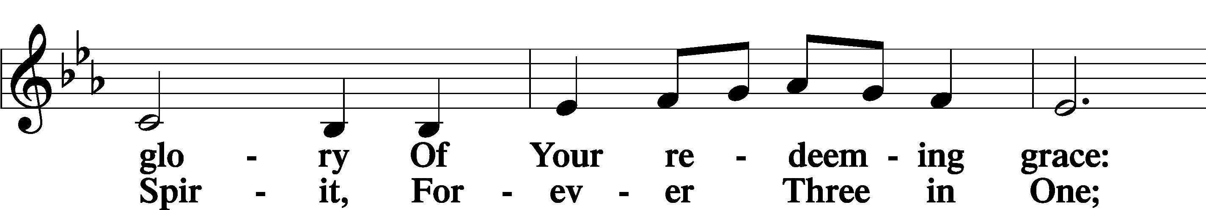
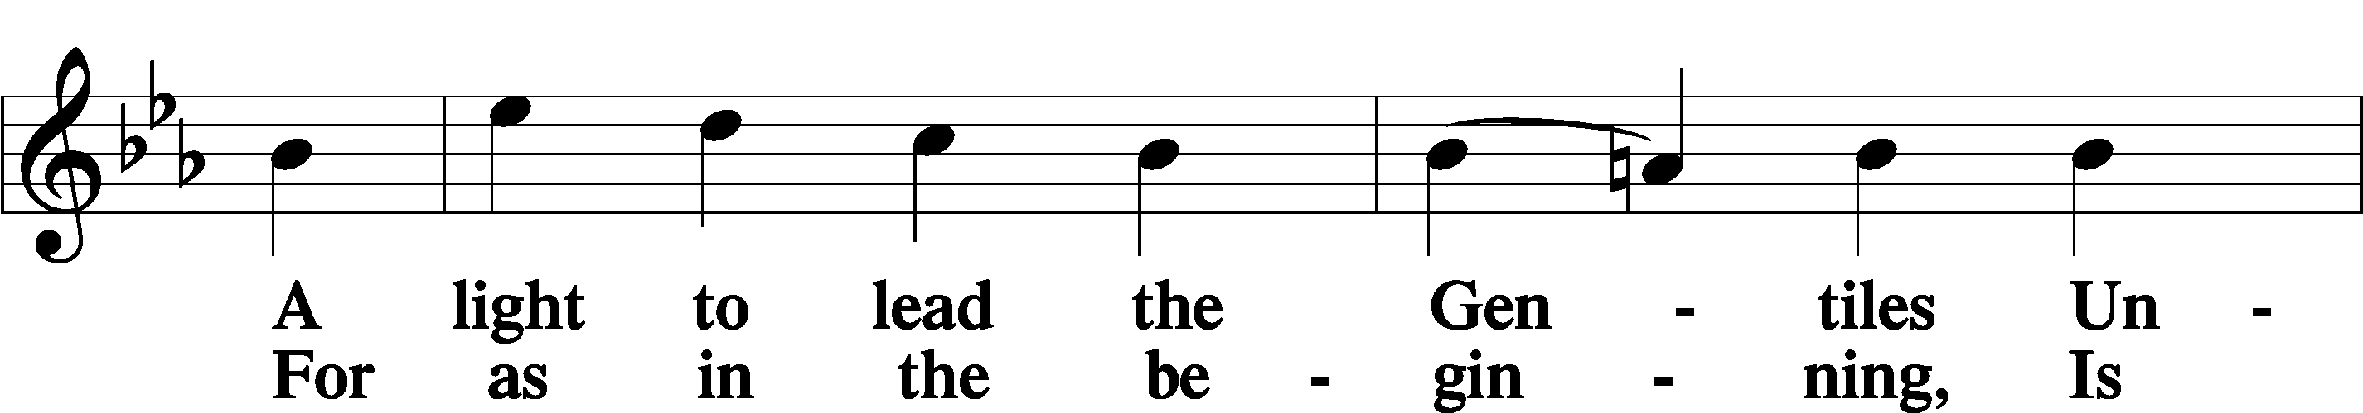
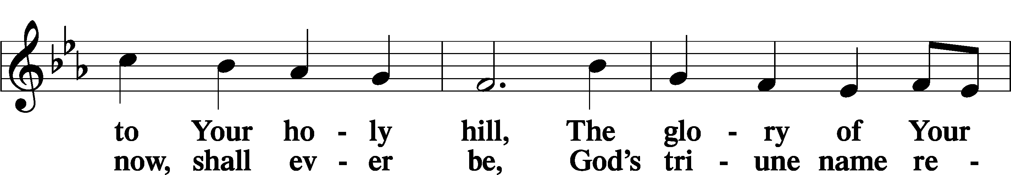
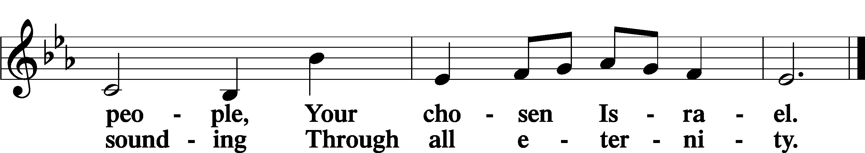

Post-Communion Collect
P Let us pray.
We give thanks to You, almighty God, that You have refreshed us through this salutary gift, and we implore You that of Your mercy You would strengthen us through the same in faith toward You and in fervent love toward one another; through Jesus Christ, Your Son, our Lord, who lives and reigns with You and the Holy Spirit, one God, now and forever.
C Amen.

Benedicamus Psalm 103:1
P Let us bless the Lord.
C Thanks be to God.

Benediction
P The Lord bless you and keep you.
The Lord make His face shine on you and be gracious to you.
The Lord look upon you with favor and T give you peace.
C Amen.

644 The Church’s One Foundation sts. 1–5
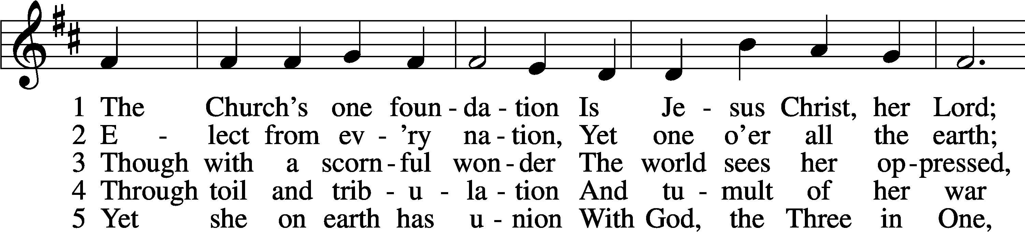
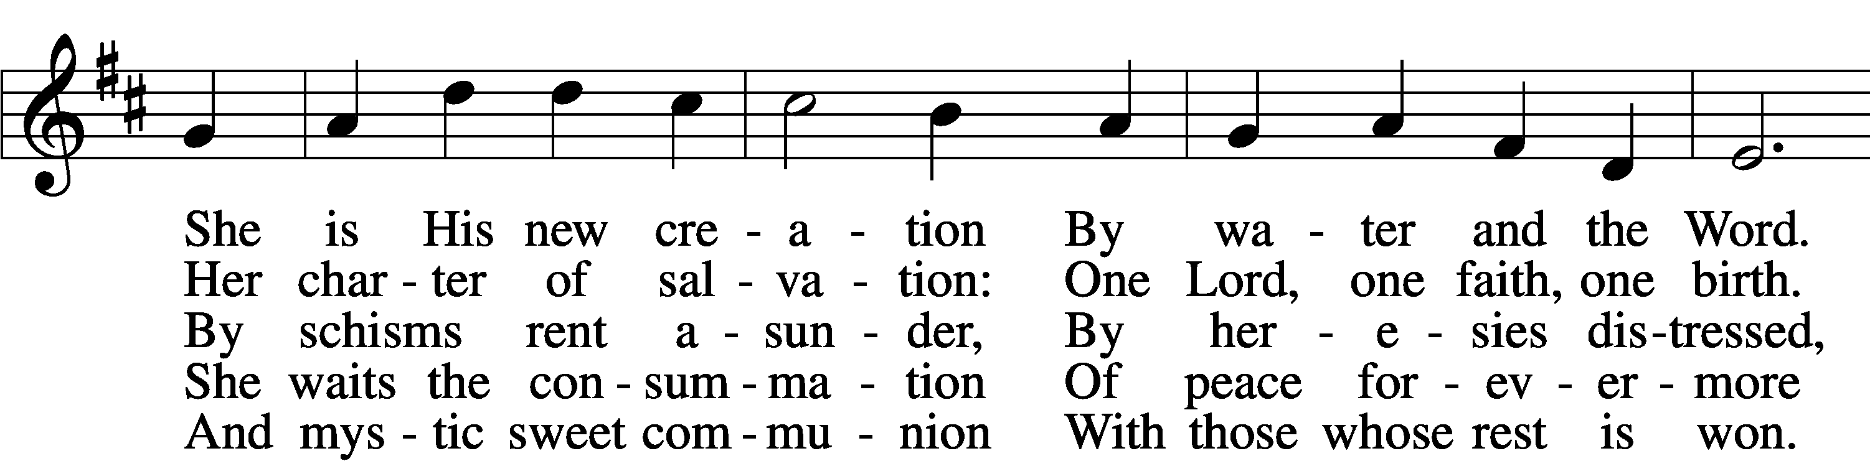
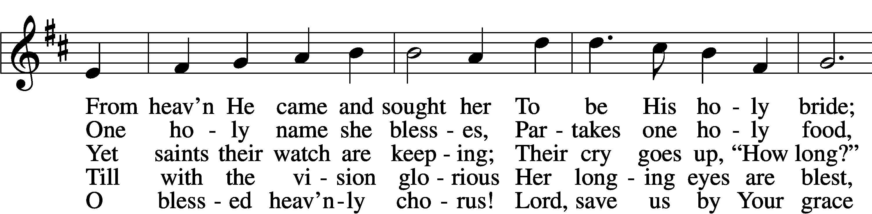
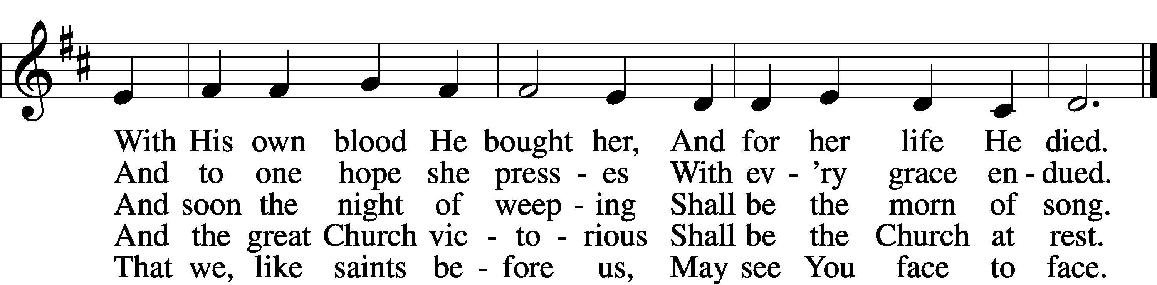
Text: Samuel J. Stone, 1839–1900, alt.
Tune: Samuel S. Wesley, 1810–76
Text and tune: Public domain
Acknowledgments
Divine Service, Setting Four from Lutheran Service Book
Unless otherwise indicated, Scripture quotations are from the ESV® Bible (The Holy Bible, English Standard Version®), copyright © 2001 by Crossway, a publishing ministry of Good News Publishers. Used by permission. All rights reserved.
Created by Lutheran Service Builder © 2026 Concordia Publishing House.

