On entering the church

P Lord, I love the habitation of Your house and the place

where Your glory dwells. In the multitude of Your tender

mercies prepare my heart that I may enter Your house to

worship and confess Your holy name; through Jesus Christ,

my God and Lord.

Before worship

C O Lord, our creator, redeemer, and comforter, as we come

together to worship You in spirit and in truth, we humbly

pray that You would open our hearts to the preaching of

Your Word so that we may repent of our sins, believe in

Jesus Christ as our only Savior, and grow in grace and

holiness. Hear us for His sake.

673 Jerusalem, My Happy Home

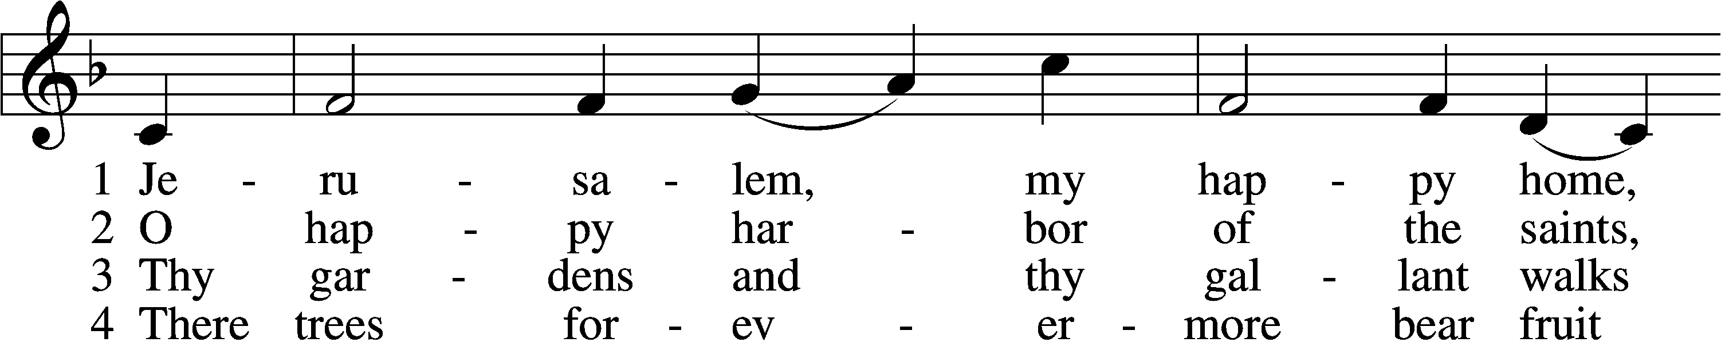

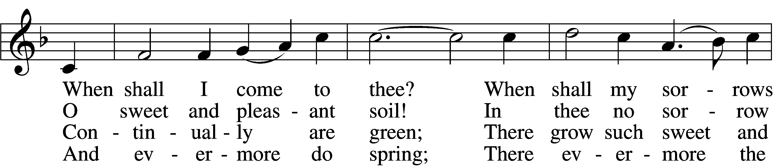

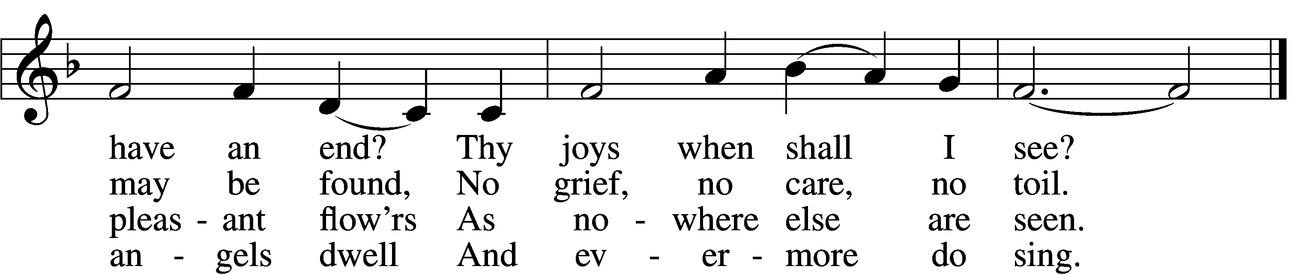

5 Apostles, martyrs, prophets, there  
 Around my Savior stand;  
And soon my friends in Christ below  
 Will join the glorious band.

6 O Christ, do Thou my soul prepare  
 For that bright home of love  
That I may see Thee and adore  
 With all Thy saints above.

Text: F. B. P., 16th cent., alt.  
Tune: American  
Text and tune: Public domain

# Confession and Absolution

Stand

The sign of the cross may be made by all in remembrance of their Baptism.

Invocation Matthew 28:19b; 18:20

P In the name of the Father and of the T Son and of the Holy Spirit.

C **Amen.**

Exhortation Hebrews 10:22; Psalm 124:8; Psalm 32:5

P Beloved in the Lord! Let us draw near with a true heart and confess our sins unto God our Father, beseeching Him in the name of our Lord Jesus Christ to grant us forgiveness.

P Our help is in the name of the Lord,

C **who made heaven and earth.**

P I said, I will confess my transgressions unto the Lord,

C **and You forgave the iniquity of my sin.**

Kneel/Stand

Silence for reflection on God’s Word and for self-examination.

Confession of Sins

P Almighty God, our maker and redeemer, we poor sinners confess unto You that we are by nature sinful and unclean and that we have sinned against You by thought, word, and deed. Wherefore we flee for refuge to Your infinite mercy, seeking and imploring Your grace for the sake of our Lord Jesus Christ.

C **O most merciful God, who has given Your only-begotten Son to die for us, have mercy upon us and for His sake grant us remission of all our sins; and by Your Holy Spirit increase in us true knowledge of You and of Your will and true obedience to Your Word, to the end that by Your grace we may come to everlasting life; through Jesus Christ, our Lord. Amen.**

Declaration of Grace Mark 16:16; John 1:12

P Almighty God, our heavenly Father, has had mercy upon us and has given His only Son to die for us and for His sake forgives us all our sins. To those who believe on His name He gives power to become the children of God and has promised them His Holy Spirit. He that believes and is baptized shall be saved.  
  
Grant this, Lord, unto us all.

C **Amen.**

Stand

# Service of the Word

Introit Psalm 119:73–75, 77; antiphon: v. 76

Let your steadfast love comfort me  
 according to your promise to your servant.  
**Your hands have made and fashioned me;  
 give me understanding that I may learn your commandments.**Those who fear you shall see me and rejoice,  
 because I have hoped in your word.  
**I know, O Lord, that your just decrees are righteous,  
 and that in faithfulness you have afflicted me.**Let your mercy come to me, that I may live;  
 for your law is my delight.

Gloria Patri

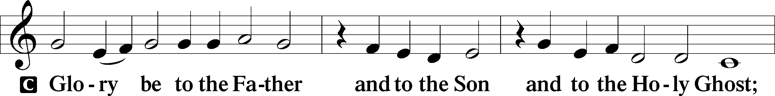

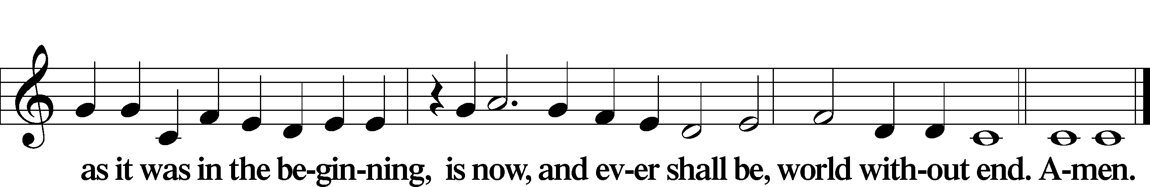

Kyrie Mark 10:47

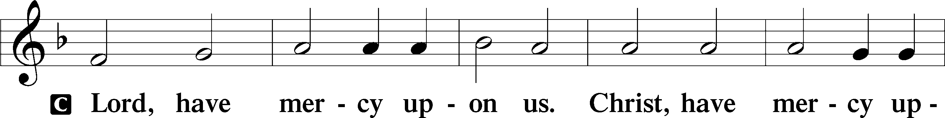

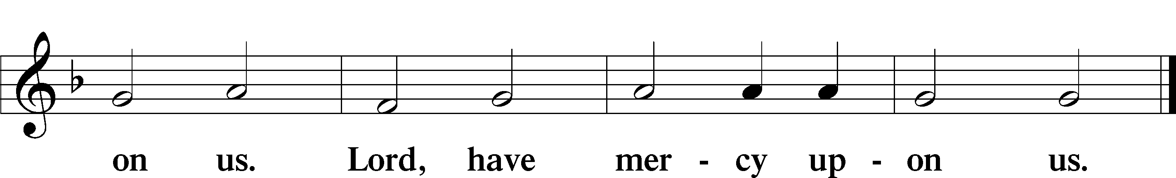

Gloria in Excelsis Luke 2:14; John 1:29

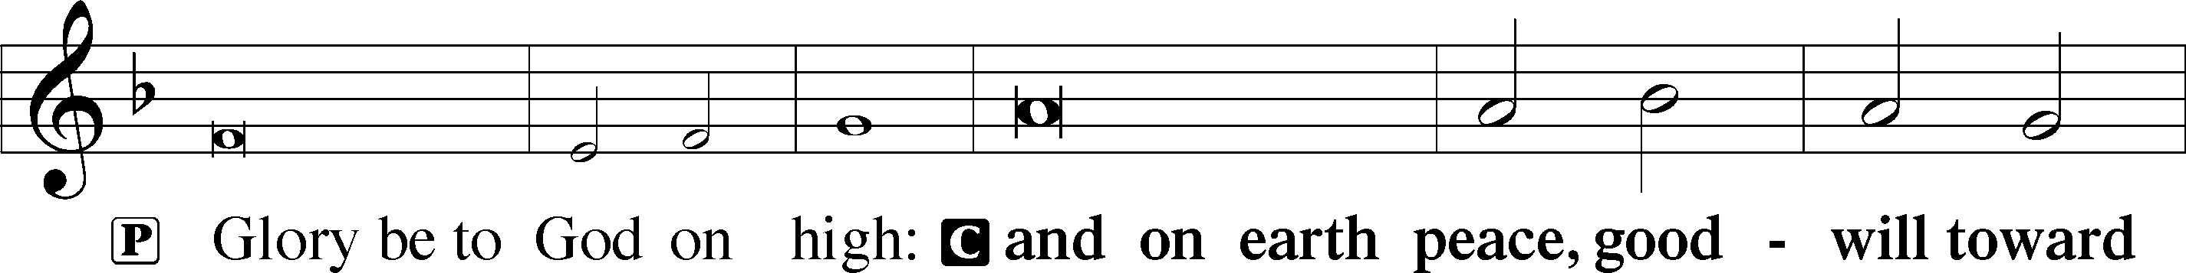

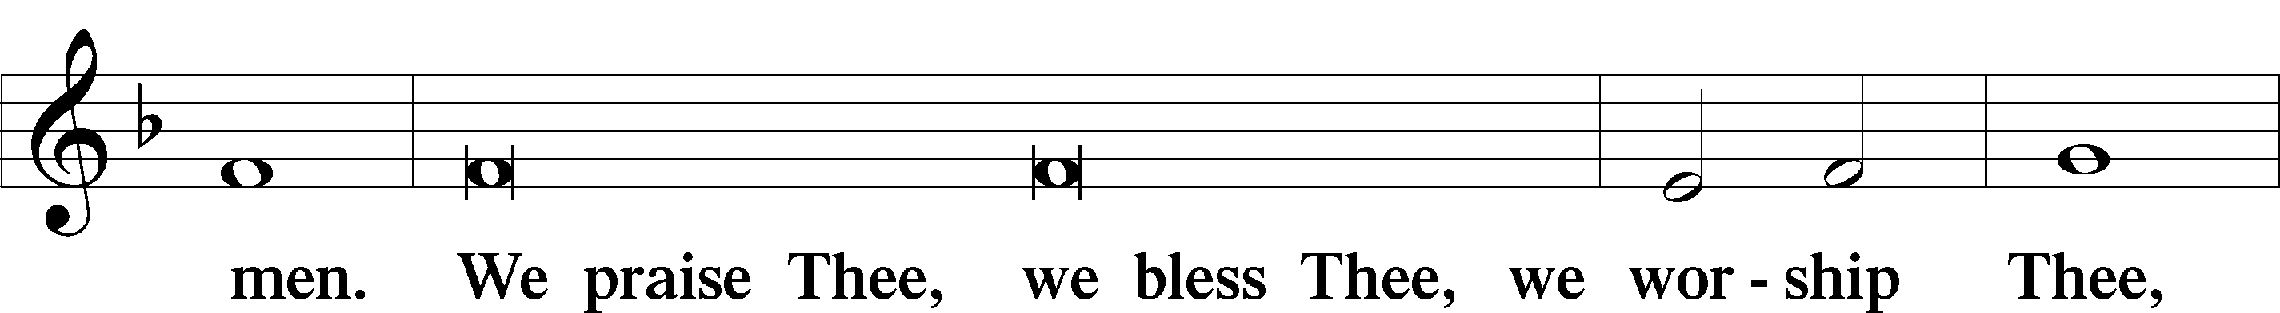

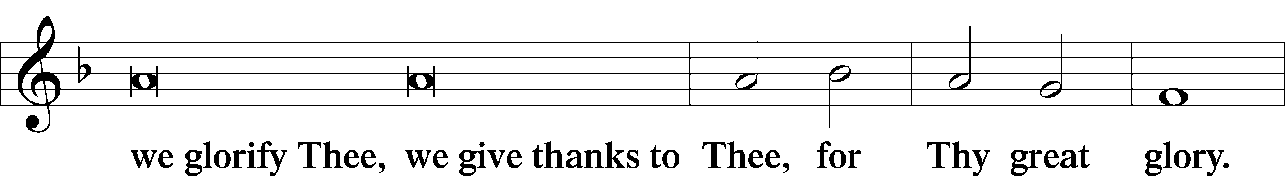

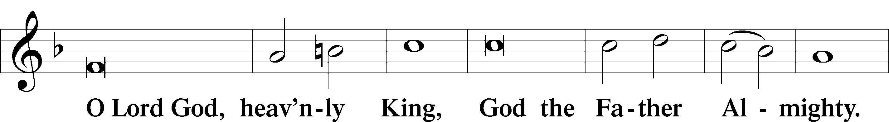

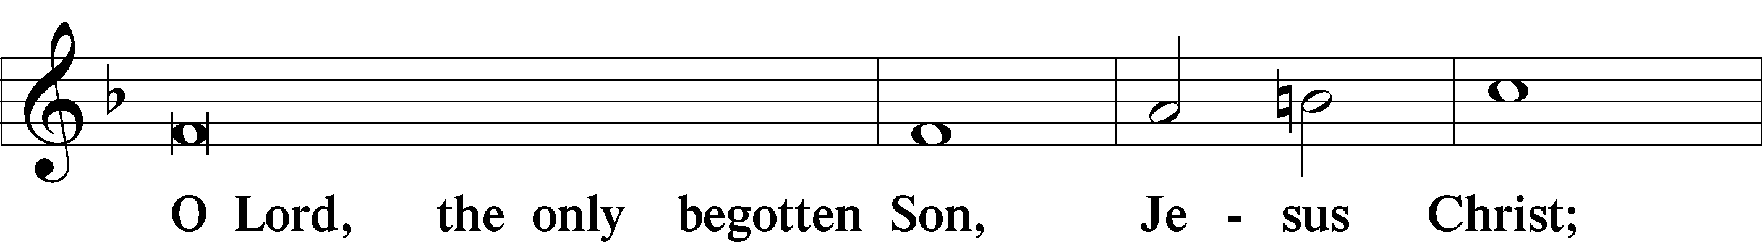

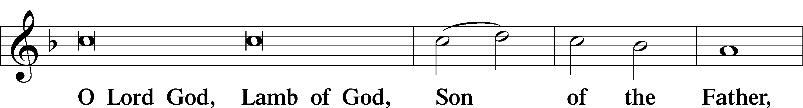

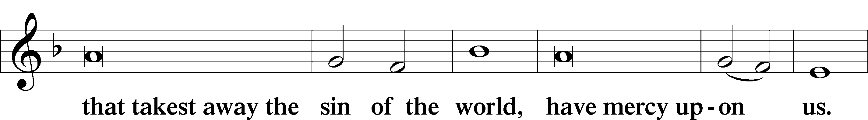

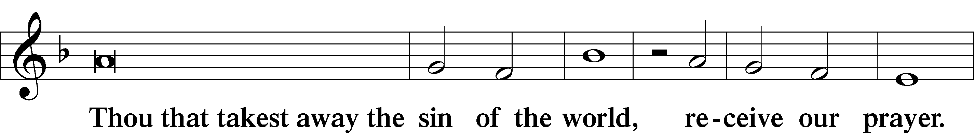

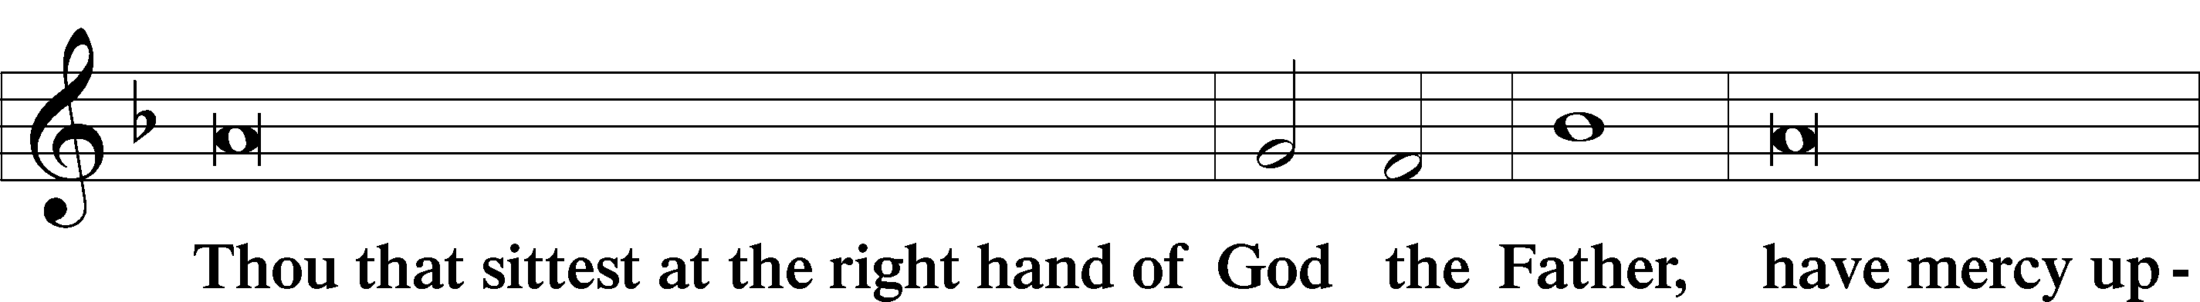

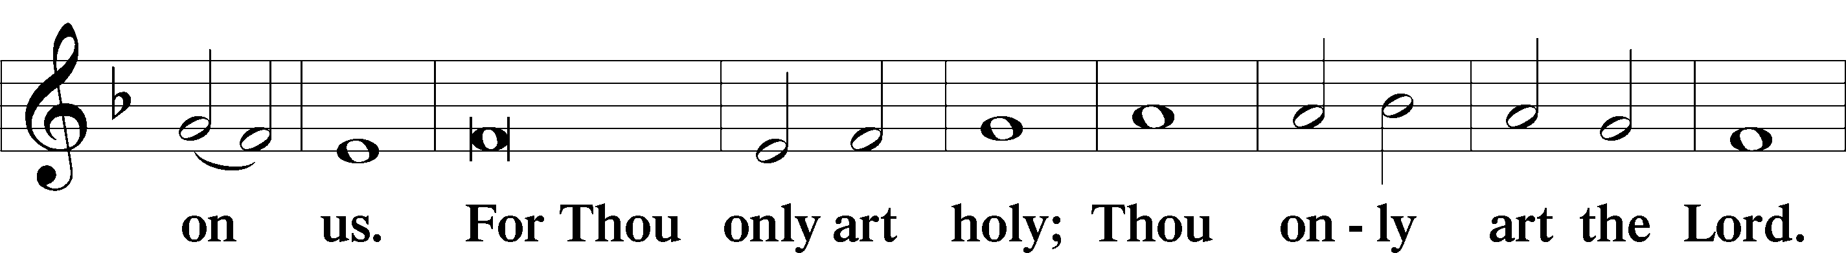

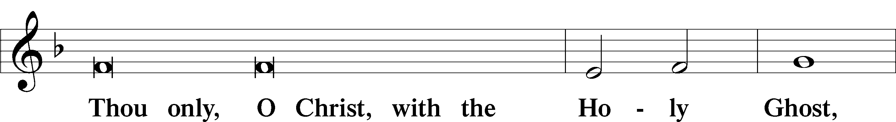

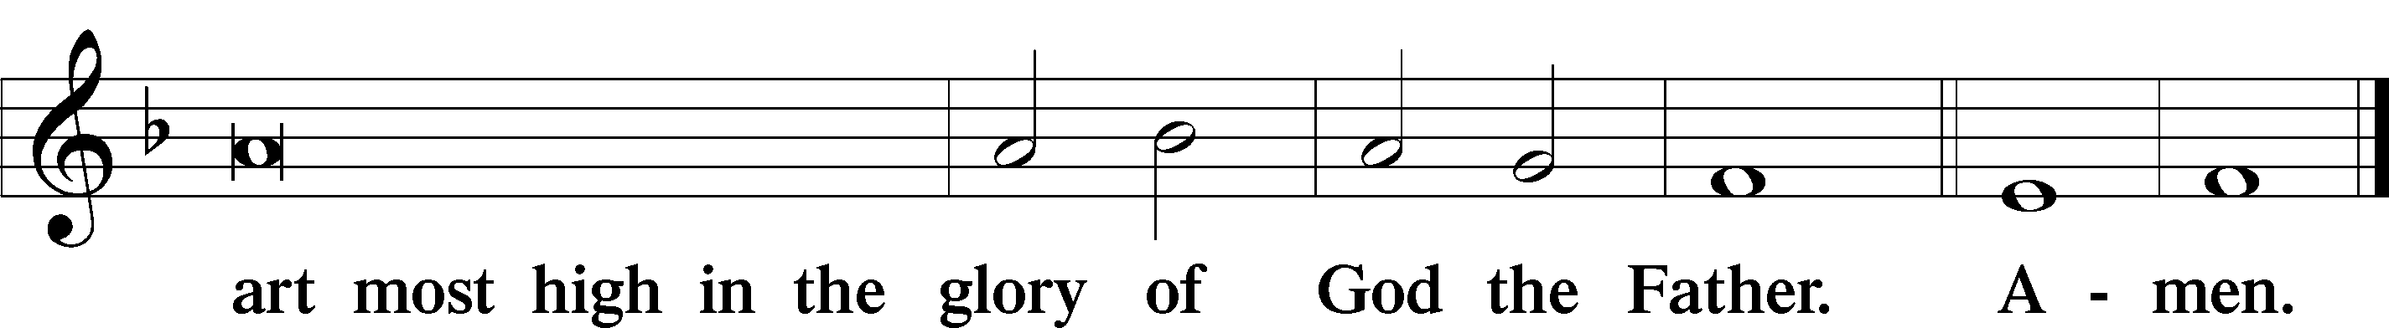

Salutation and Collect of the Day

P The Lord be with you.

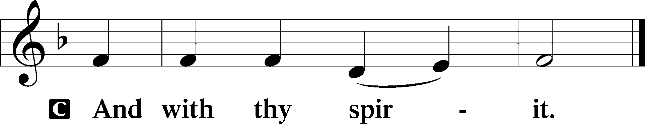

P Let us pray.

O God, You are the strength of all who trust in You, and without Your aid we can do no good thing. Grant us the help of Your grace that we may please You in both will and deed; through Jesus Christ, Your Son, our Lord, who lives and reigns with You and the Holy Spirit, one God, now and forever.

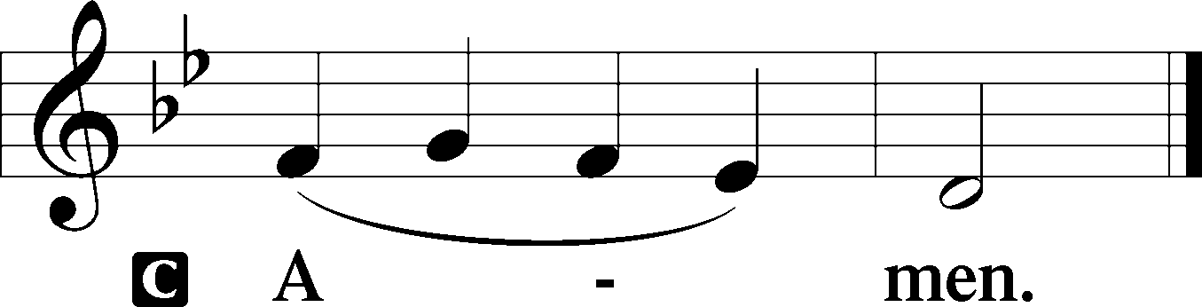

Sit

Old Testament Reading Amos 6:1–7

1“Woe to those who are at ease in Zion,  
 and to those who feel secure on the mountain of Samaria,  
the notable men of the first of the nations,  
 to whom the house of Israel comes!  
2Pass over to Calneh, and see,  
 and from there go to Hamath the great;  
 then go down to Gath of the Philistines.  
Are you better than these kingdoms?  
 Or is their territory greater than your territory,  
3O you who put far away the day of disaster  
 and bring near the seat of violence?  
4“Woe to those who lie on beds of ivory  
 and stretch themselves out on their couches,  
and eat lambs from the flock  
 and calves from the midst of the stall,  
5who sing idle songs to the sound of the harp  
 and like David invent for themselves instruments of music,  
6who drink wine in bowls  
 and anoint themselves with the finest oils,  
 but are not grieved over the ruin of Joseph!  
7Therefore they shall now be the first of those who go into exile,  
 and the revelry of those who stretch themselves out shall pass away.”

A This is the Word of the Lord.

C **Thanks be to God.**

Gradual Psalm 91:11; 103:1

He will command his angels concerning you  
 to guard you in all your ways.  
**Bless the Lord, O my soul,  
 and all that is within me, bless his holy name!**

Epistle 1 Timothy 3:1–13

1The saying is trustworthy: If anyone aspires to the office of overseer, he desires a noble task. 2Therefore an overseer must be above reproach, the husband of one wife, sober-minded, self-controlled, respectable, hospitable, able to teach, 3not a drunkard, not violent but gentle, not quarrelsome, not a lover of money. 4He must manage his own household well, with all dignity keeping his children submissive, 5for if someone does not know how to manage his own household, how will he care for God’s church? 6He must not be a recent convert, or he may become puffed up with conceit and fall into the condemnation of the devil. 7Moreover, he must be well thought of by outsiders, so that he may not fall into disgrace, into a snare of the devil.

8Deacons likewise must be dignified, not double-tongued, not addicted to much wine, not greedy for dishonest gain. 9They must hold the mystery of the faith with a clear conscience. 10And let them also be tested first; then let them serve as deacons if they prove themselves blameless. 11Their wives likewise must be dignified, not slanderers, but sober-minded, faithful in all things. 12Let deacons each be the husband of one wife, managing their children and their own households well. 13For those who serve well as deacons gain a good standing for themselves and also great confidence in the faith that is in Christ Jesus.

A This is the Word of the Lord.

C **Thanks be to God.**

Stand

Alleluia

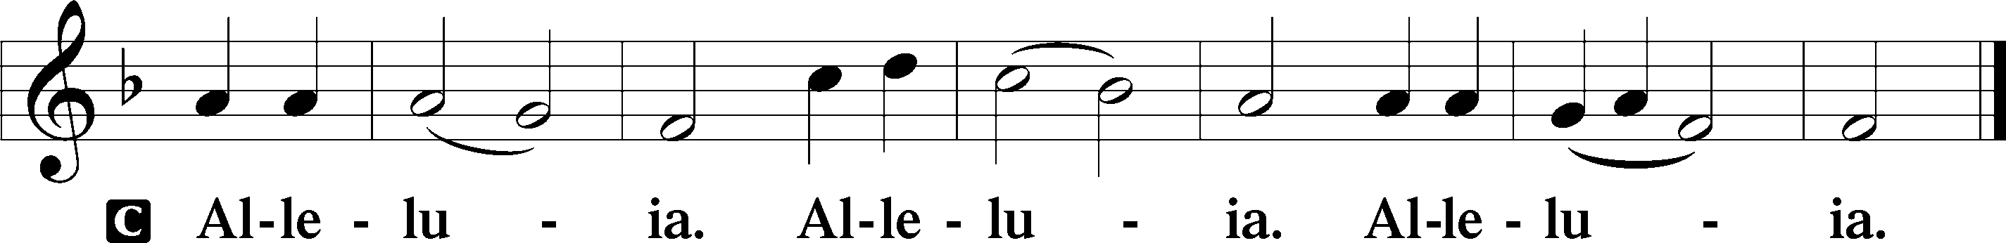

Holy Gospel Luke 16:19–31

P The Holy Gospel according to St. Luke, the sixteenth chapter.

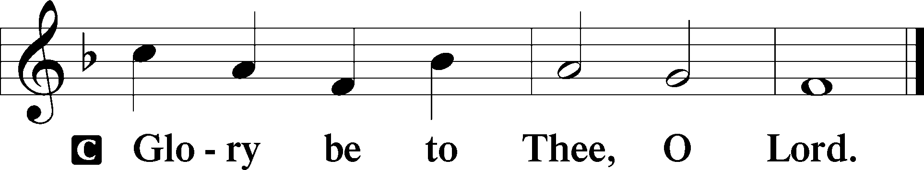

19[Jesus said:] “There was a rich man who was clothed in purple and fine linen and who feasted sumptuously every day. 20And at his gate was laid a poor man named Lazarus, covered with sores, 21who desired to be fed with what fell from the rich man’s table. Moreover, even the dogs came and licked his sores. 22The poor man died and was carried by the angels to Abraham’s side. The rich man also died and was buried, 23and in Hades, being in torment, he lifted up his eyes and saw Abraham far off and Lazarus at his side. 24And he called out, ‘Father Abraham, have mercy on me, and send Lazarus to dip the end of his finger in water and cool my tongue, for I am in anguish in this flame.’ 25But Abraham said, ‘Child, remember that you in your lifetime received your good things, and Lazarus in like manner bad things; but now he is comforted here, and you are in anguish. 26And besides all this, between us and you a great chasm has been fixed, in order that those who would pass from here to you may not be able, and none may cross from there to us.’ 27And he said, ‘Then I beg you, father, to send him to my father’s house— 28for I have five brothers—so that he may warn them, lest they also come into this place of torment.’ 29But Abraham said, ‘They have Moses and the Prophets; let them hear them.’ 30And he said, ‘No, father Abraham, but if someone goes to them from the dead, they will repent.’ 31He said to him, ‘If they do not hear Moses and the Prophets, neither will they be convinced if someone should rise from the dead.’”

P This is the Gospel of the Lord.

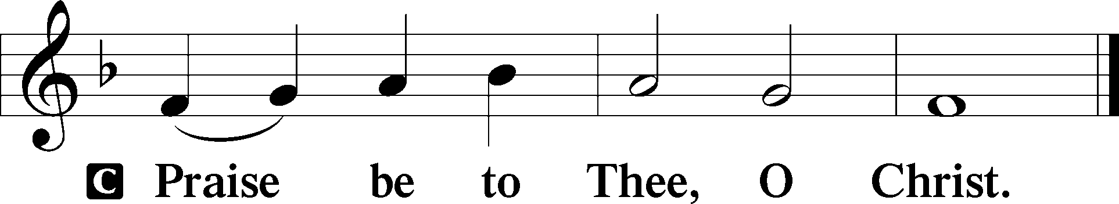

Apostles’ Creed

C **I believe in God, the Father Almighty,**

**maker of heaven and earth.**

**And in Jesus Christ, His only Son, our Lord,**

**who was conceived by the Holy Spirit,**

**born of the virgin Mary,**

**suffered under Pontius Pilate,**

**was crucified, died and was buried.**

**He descended into hell.**

**The third day He rose again from the dead.**

**He ascended into heaven**

**and sits at the right hand of God the Father Almighty.**

**From thence He will come to judge the living and the dead.**

**I believe in the Holy Spirit,**

**the holy Christian Church,**

**the communion of saints,**

**the forgiveness of sins,**

**the resurrection of the body,**

**and the life** T **everlasting. Amen.**

Sit

Children's Sermon

798 The God of Abraham Praise sts. 1–5

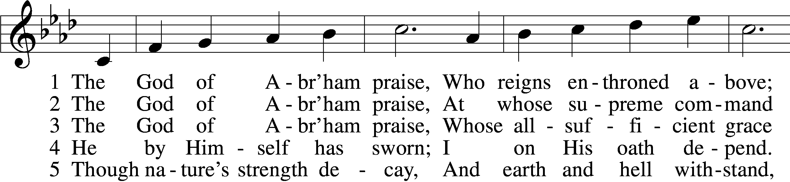

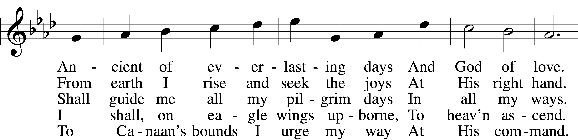

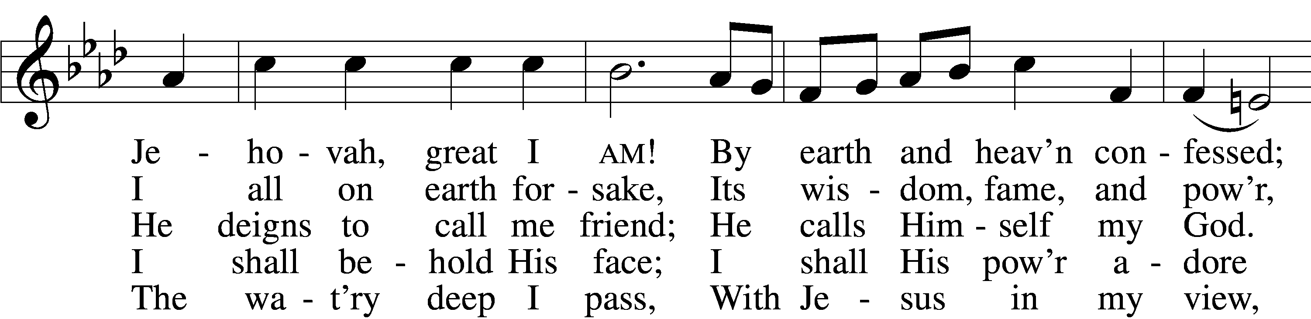

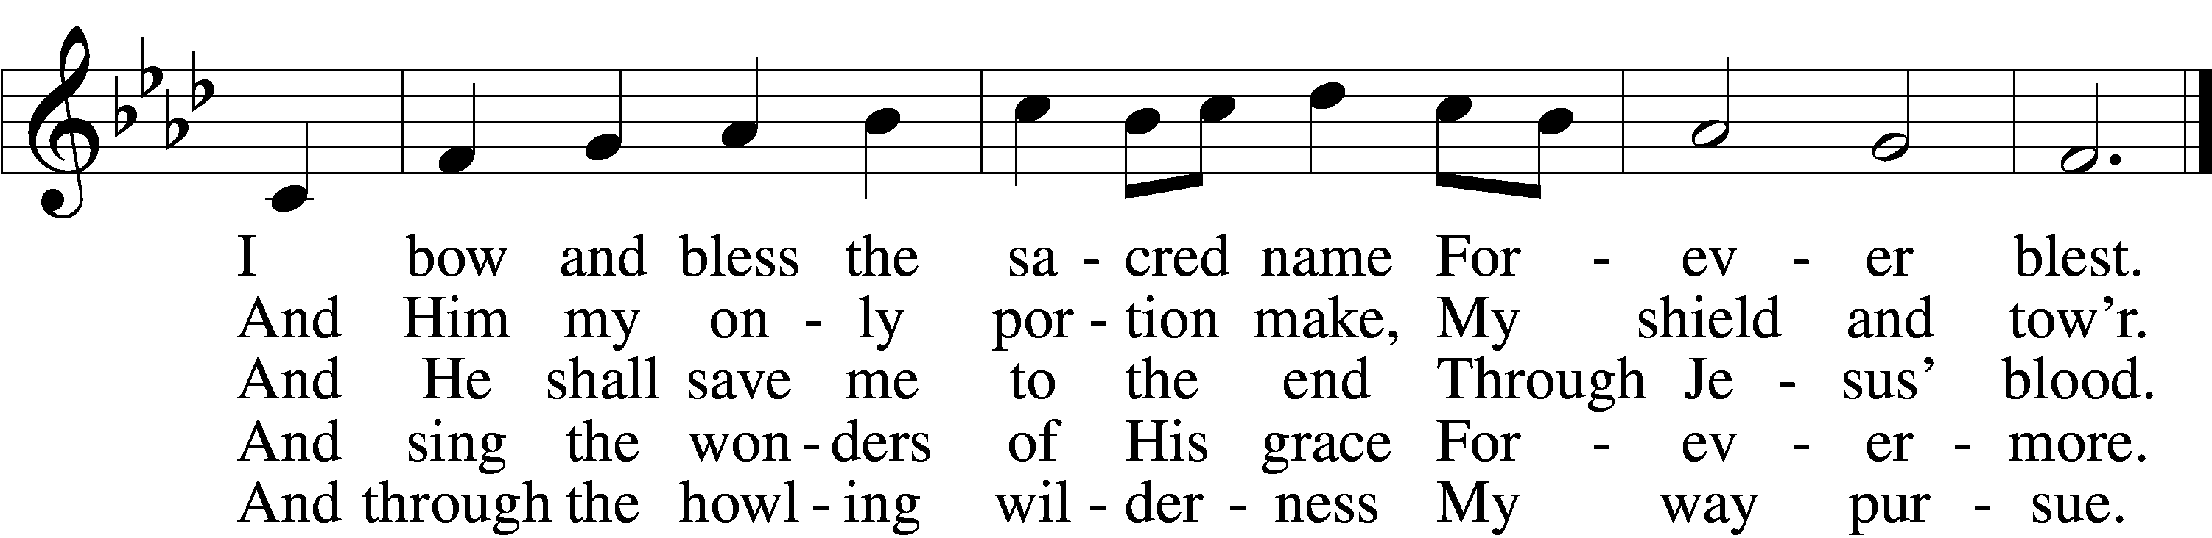

Text: Thomas Olivers, 1725–99, alt.  
Tune: Hebrew  
Text and tune: Public domain

Sermon

798 The God of Abraham Praise sts. 6–9

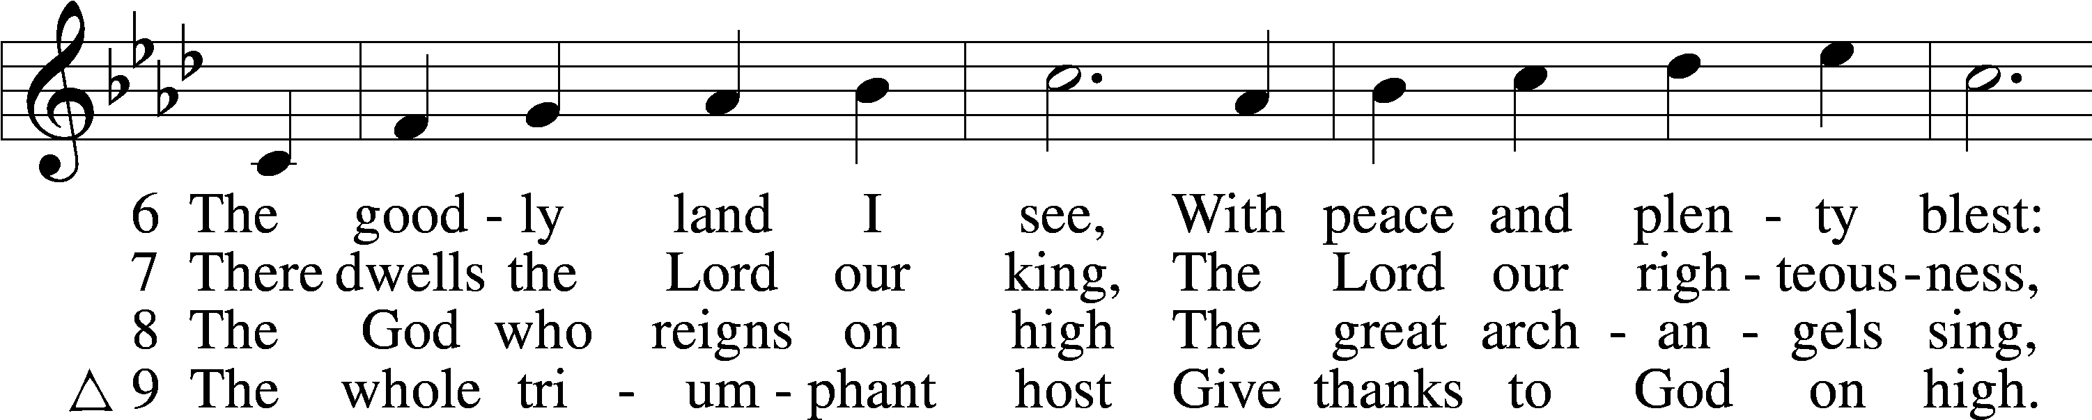

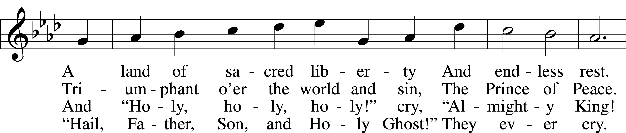

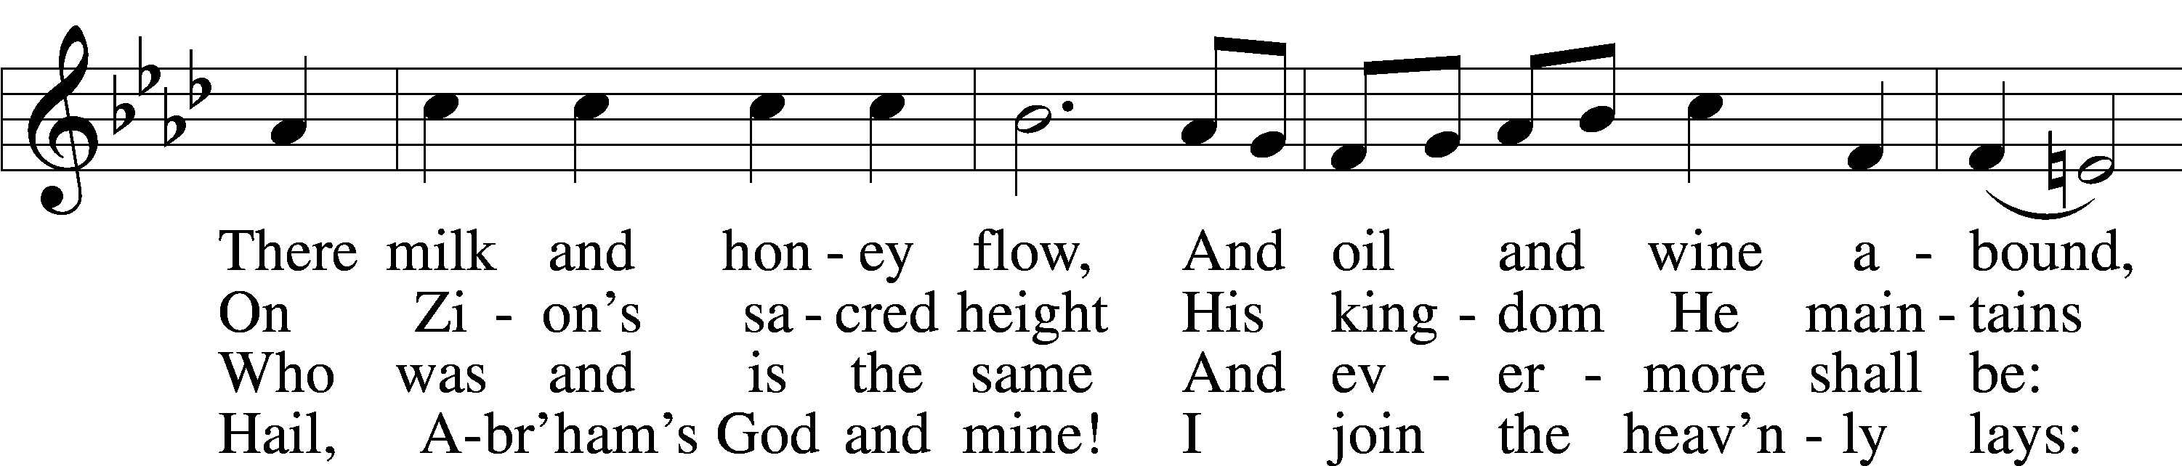

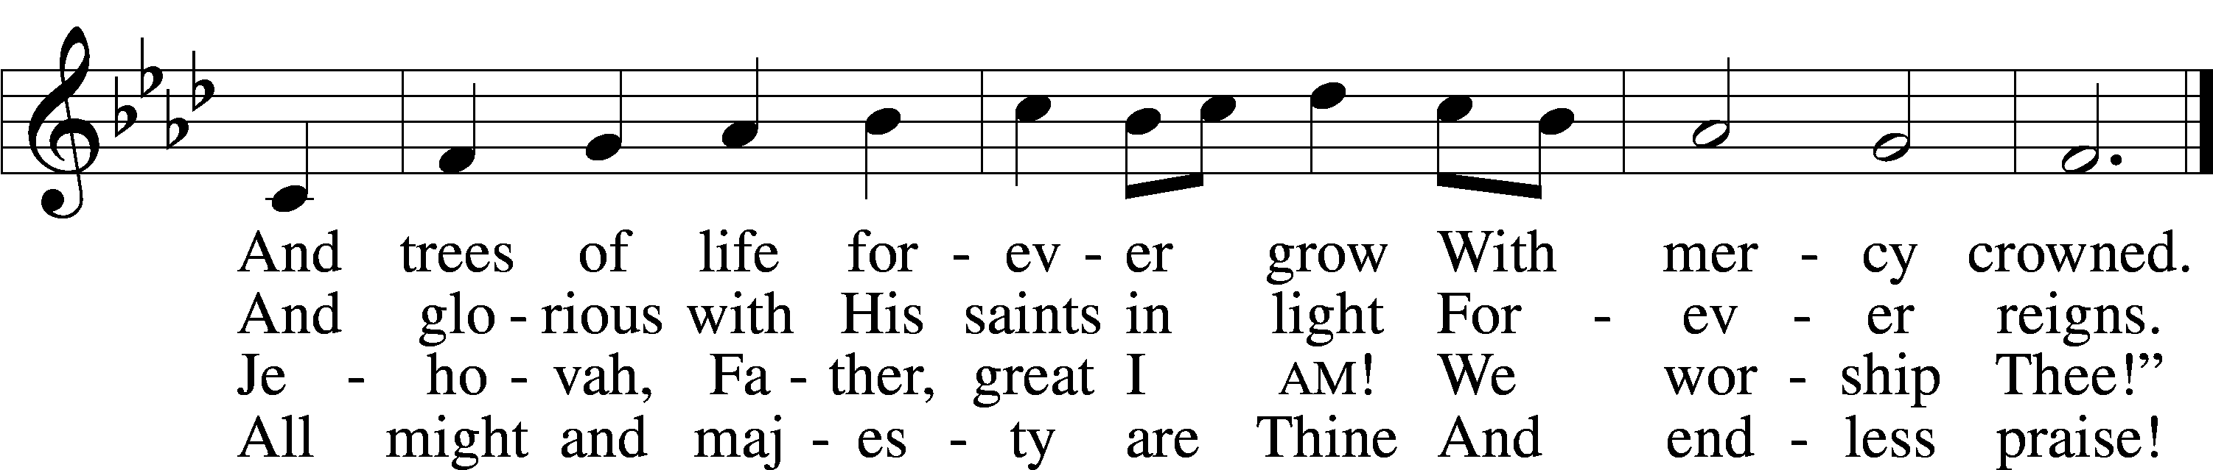

Text: Thomas Olivers, 1725–99, alt.  
Tune: Hebrew  
Text and tune: Public domain

Votum

P The peace of God, which passes all understanding, keep your hearts and minds in Christ Jesus.

C **Amen.**

Stand

Offertory Psalm 51:10–12

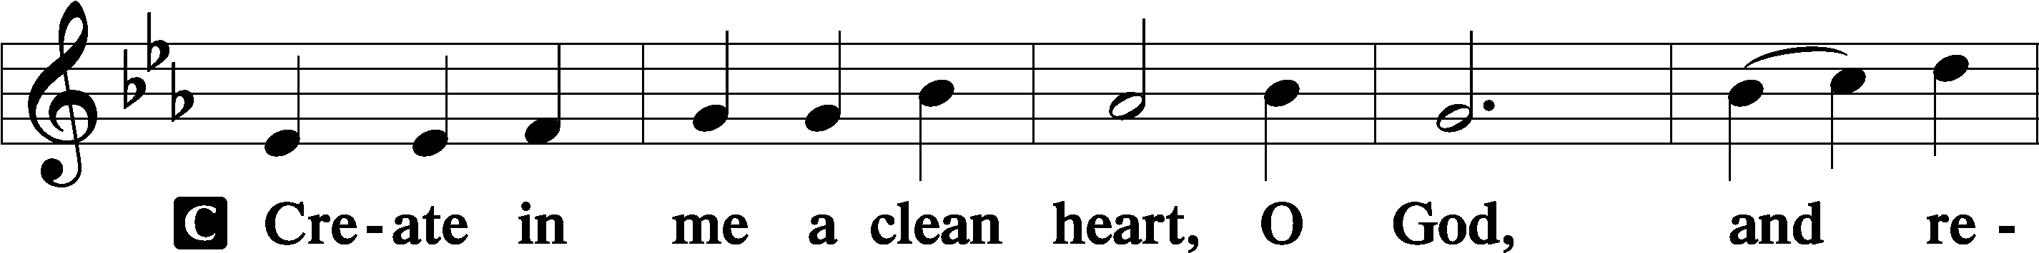

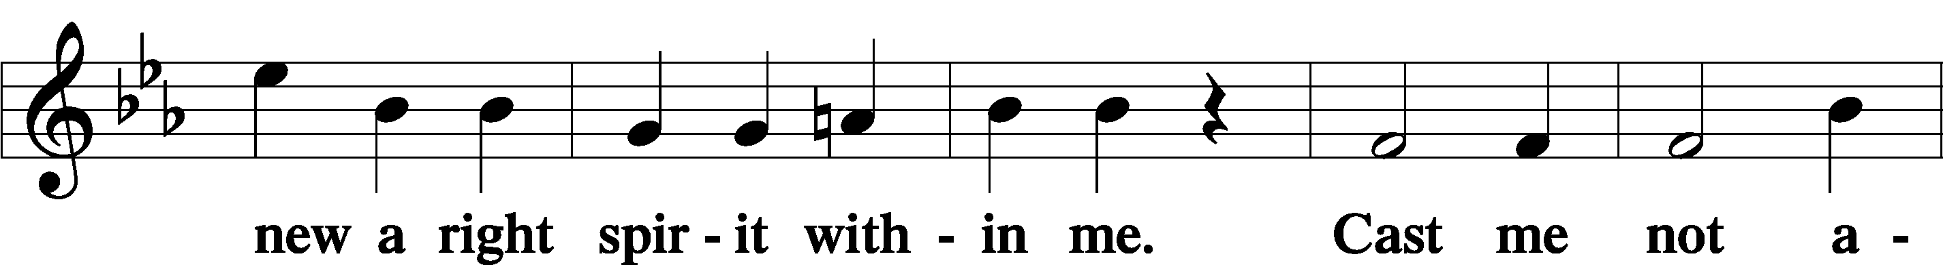

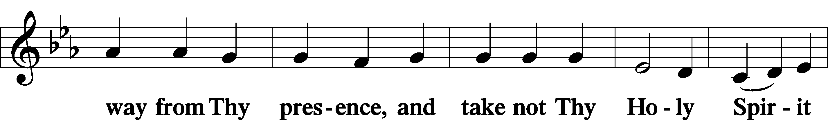

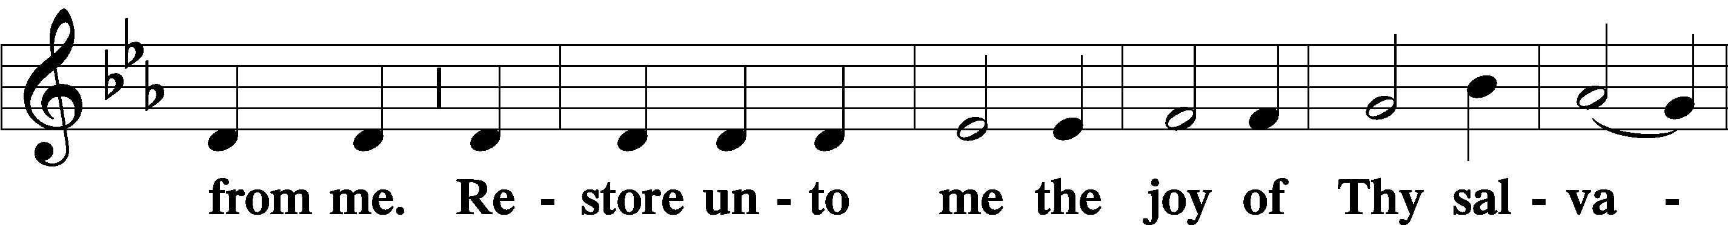

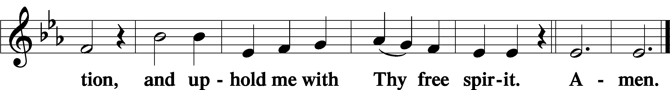

Sit

Offering

Stand

Prayer of the Church

Lord’s Prayer Matthew 6:9–13

P Lord, remember us in Your kingdom and teach us to pray:

C **Our Father who art in heaven,**

**hallowed be Thy name,**

**Thy kingdom come,**

**Thy will be done on earth**

**as it is in heaven;**

**give us this day our daily bread;**

**and forgive us our trespasses**

**as we forgive those**

**who trespass against us;**

**and lead us not into temptation,**

**but deliver us from evil.**

**For Thine is the kingdom**

**and the power and the glory**

**forever and ever. Amen.**

Collect for the Word

Blessed Lord, You have caused all Holy Scriptures to be written for our learning. Grant that we may so hear them, read, mark, learn, and inwardly digest them that, by the patience and comfort of Your holy Word, we may embrace and ever hold fast the blessed hope of everlasting life; through Jesus Christ, Your Son, our Lord, who lives and reigns with You and the Holy Spirit, one God, now and forever.

Benediction

L The almighty and merciful Lord, the Father, the Son, and the Holy Spirit, bless us and keep us.

C **Amen.**

850 God of Grace and God of Glory

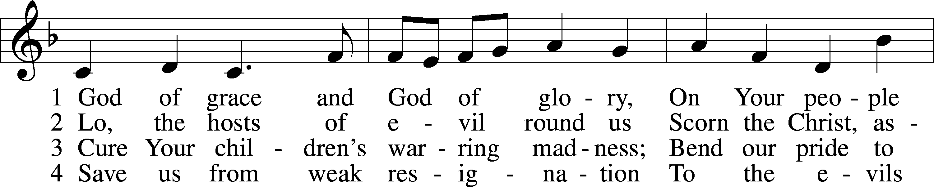

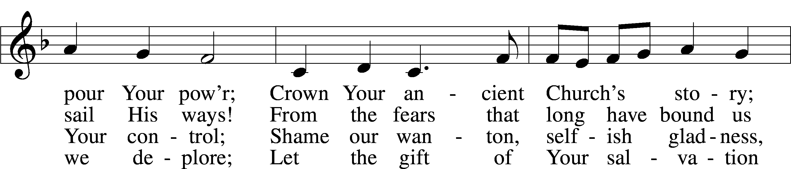

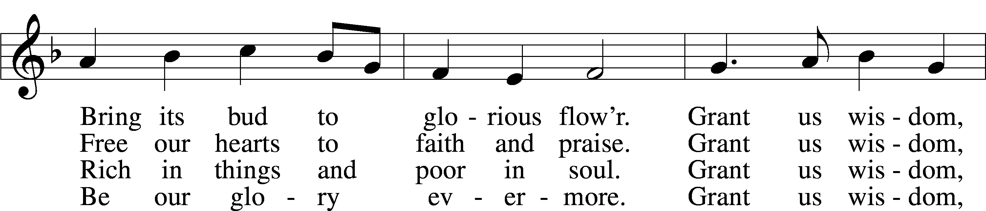

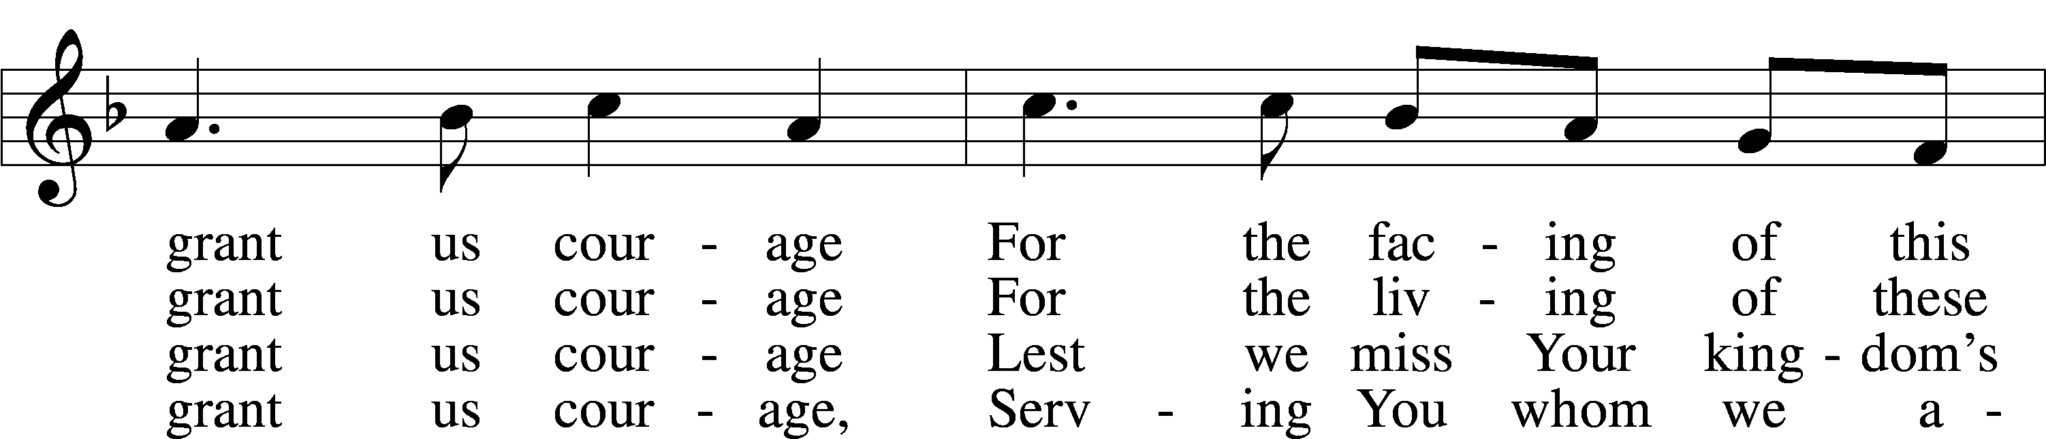

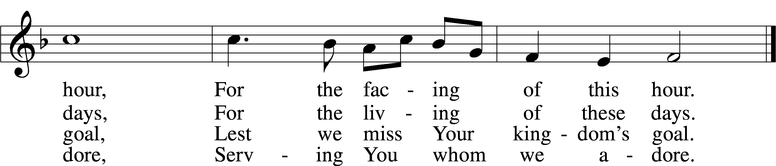

Text: Harry Emerson Fosdick, 1878–1969  
Tune: John Hughes, 1873–1932  
Text and tune: Public domain

Acknowledgments

Divine Service, Setting Three from Lutheran Service Book

Unless otherwise indicated, Scripture quotations are from the ESV® Bible (The Holy Bible, English Standard Version®), copyright © 2001 by Crossway, a publishing ministry of Good News Publishers. Used by permission. All rights reserved.

Created by Lutheran Service Builder © 2025 Concordia Publishing House.