427 In the Cross of Christ I Glory
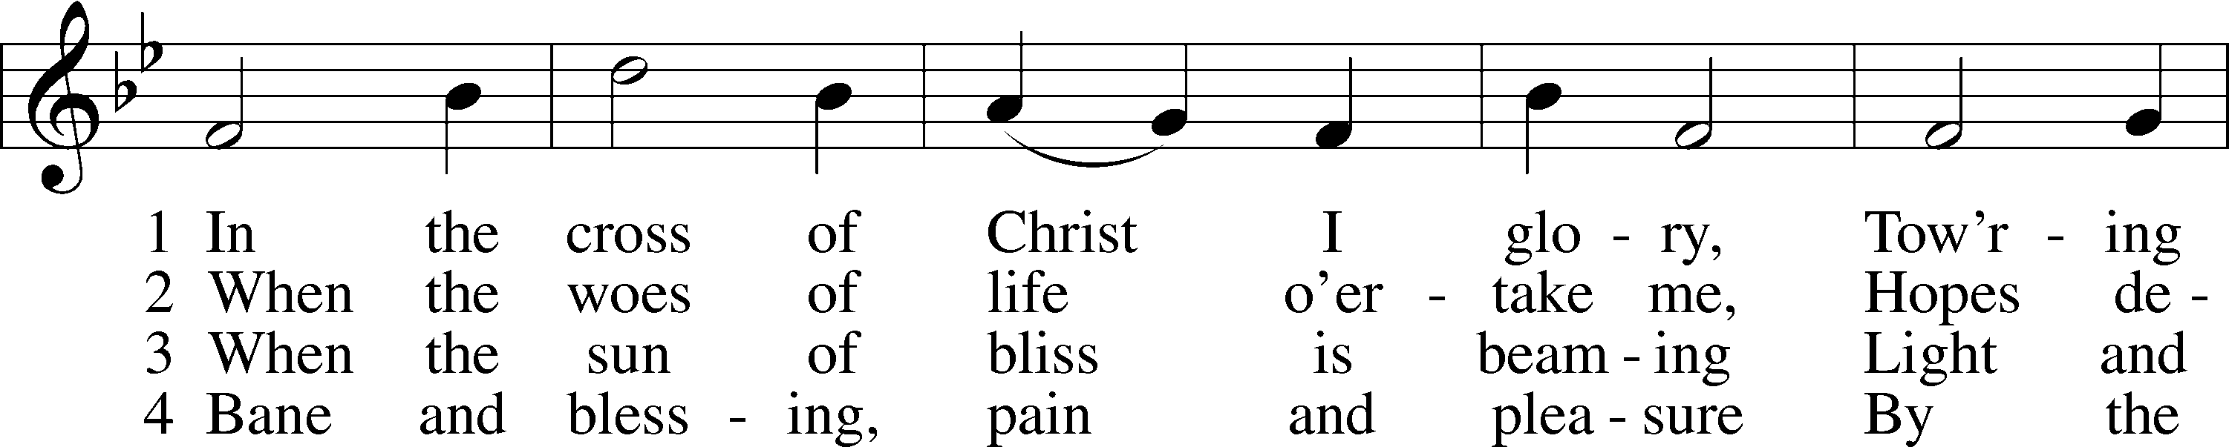
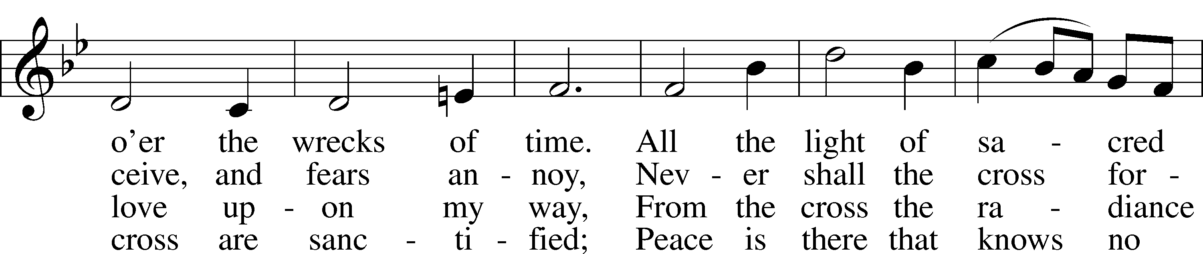
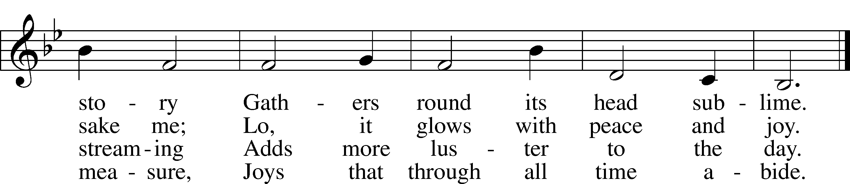
Text: John Bowring, 1792–1872
Tune: Ithamar Conkey, 1815–67
Text and tune: Public domain

Confession and Absolution

Stand

The sign of the cross may be made by all in remembrance of their Baptism.

Invocation Matthew 28:19b; 18:20
P In the name of the Father and of the T Son and of the Holy Spirit.
C Amen.

Exhortation Hebrews 10:22; Psalm 124:8; Psalm 32:5
P Beloved in the Lord! Let us draw near with a true heart and confess our sins unto God our Father, beseeching Him in the name of our Lord Jesus Christ to grant us forgiveness.

P Our help is in the name of the Lord,
C who made heaven and earth.
P I said, I will confess my transgressions unto the Lord,
C and You forgave the iniquity of my sin.

Kneel/Stand

Silence for reflection on God’s Word and for self-examination.

Confession of Sins
P O almighty God, merciful Father,
C I, a poor, miserable sinner, confess unto You all my sins and iniquities with which I have ever offended You and justly deserved Your temporal and eternal punishment. But I am heartily sorry for them and sincerely repent of them, and I pray You of Your boundless mercy and for the sake of the holy, innocent, bitter sufferings and death of Your beloved Son, Jesus Christ, to be gracious and merciful to me, a poor, sinful being.

Absolution [John 20:19–23]
P Upon this your confession, I, by virtue of my office, as a called and ordained servant of the Word, announce the grace of God unto all of you, and in the stead and by the command of my Lord Jesus Christ I forgive you all your sins in the name of the Father and of the T Son and of the Holy Spirit.
C Amen.

Stand

Service of the Word

Introit Psalm 27:4–6; antiphon: Psalm 25:15
My eyes are ever toward the Lord,
for he will pluck my feet out of the net.
One thing have I asked of the Lord, that will I seek after:
that I may dwell in the house of the Lord all the days of my life, to gaze upon the beauty of the Lord and to inquire in his temple.
For he will hide me in his shelter in the day of trouble;
he will conceal me under the cover of his tent; he will lift me high upon a rock.
And now my head shall be lifted up above my enemies all around me, and I will offer in his tent sacrifices with shouts of joy;
I will sing and make melody to the Lord.
Glory be to the Father and to the Son
and to the Holy Spirit;
as it was in the beginning,
is now, and will be forever. Amen.
My eyes are ever toward the Lord,
for he will pluck my feet out of the net.

Gloria Patri
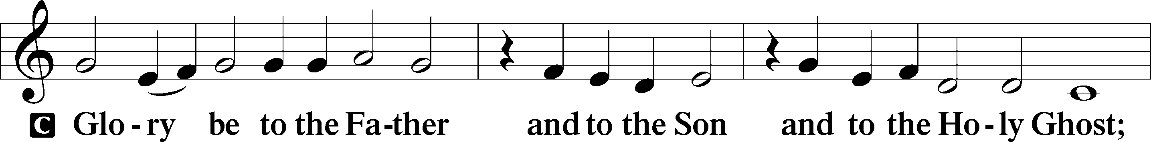
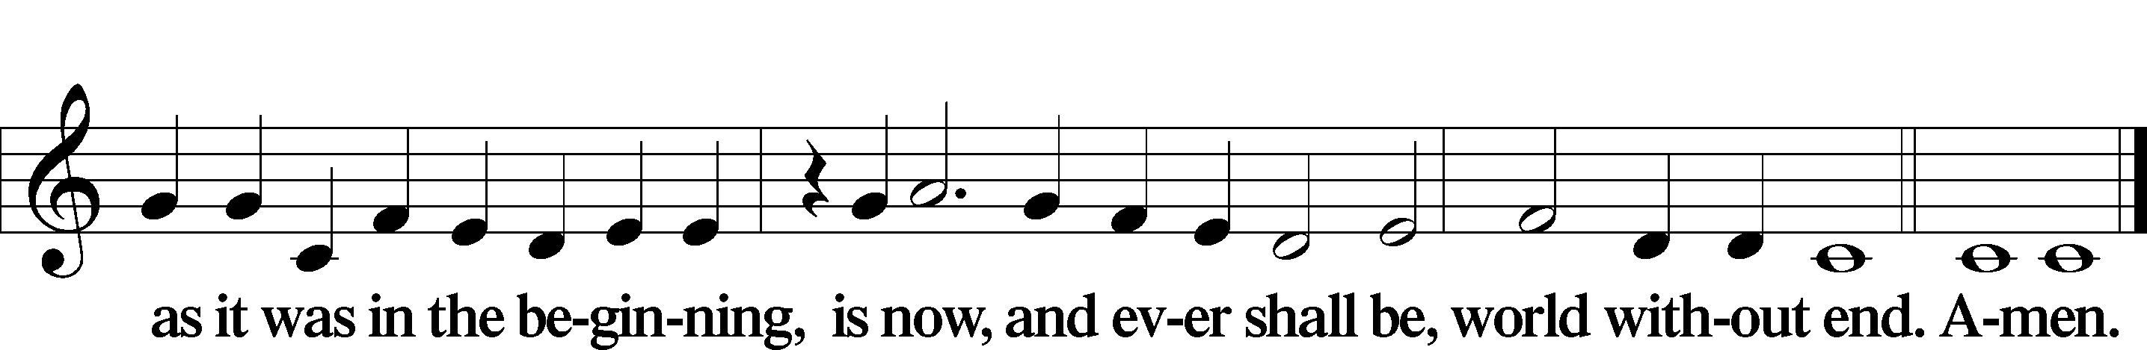

Kyrie Mark 10:47
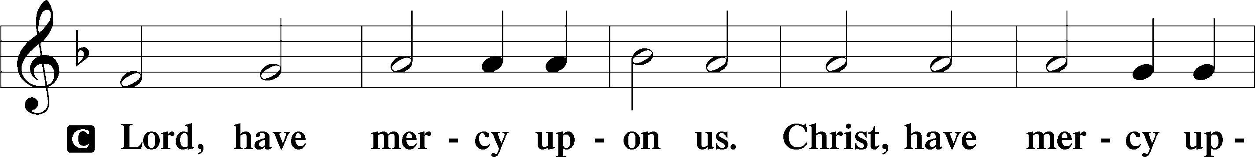
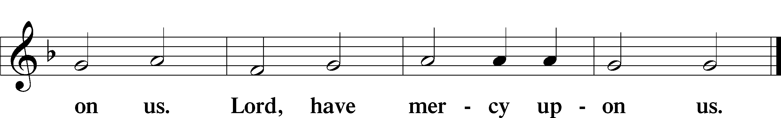

Salutation and Collect of the Day
P The Lord be with you.
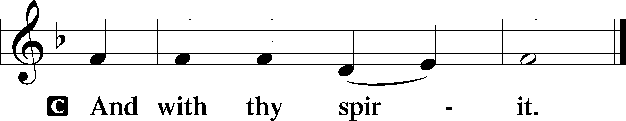

P Let us pray.
Almighty God, our heavenly Father, Your mercies are new every morning; and though we deserve only punishment, You receive us as Your children and provide for all our needs of body and soul. Grant that we may heartily acknowledge Your merciful goodness, give thanks for all Your benefits, and serve You in willing obedience; through Jesus Christ, Your Son, our Lord, who lives and reigns with You and the Holy Spirit, one God, now and forever.

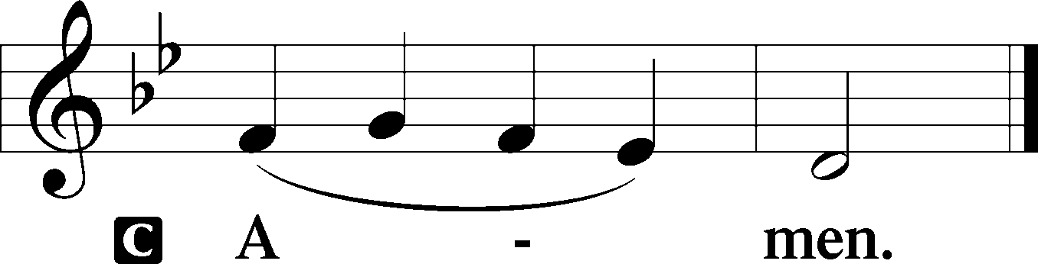

Sit

Old Testament Reading Isaiah 42:14–21
14For a long time I have held my peace;
I have kept still and restrained myself;
now I will cry out like a woman in labor;
I will gasp and pant.
15I will lay waste mountains and hills,
and dry up all their vegetation;
I will turn the rivers into islands,
and dry up the pools.
16And I will lead the blind
in a way that they do not know,
in paths that they have not known
I will guide them.
I will turn the darkness before them into light,
the rough places into level ground.
These are the things I do,
and I do not forsake them.
17They are turned back and utterly put to shame,
who trust in carved idols,
who say to metal images,
“You are our gods.”
18Hear, you deaf,
and look, you blind, that you may see!
19Who is blind but my servant,
or deaf as my messenger whom I send?
Who is blind as my dedicated one,
or blind as the servant of the Lord?
20He sees many things, but does not observe them;
his ears are open, but he does not hear.
21The Lord was pleased, for his righteousness’ sake,
to magnify his law and make it glorious.

A This is the Word of the Lord.
C Thanks be to God.

Gradual Hebrews 12:2
[O come, let us fix our eyes on] Jesus,
the founder and perfecter of our faith,
who for the joy that was set before him endured the cross, despising the shame,
and is seated at the right hand of the throne of God.

Epistle Ephesians 5:8–14
8For at one time you were darkness, but now you are light in the Lord. Walk as children of light 9(for the fruit of light is found in all that is good and right and true), 10and try to discern what is pleasing to the Lord. 11Take no part in the unfruitful works of darkness, but instead expose them. 12For it is shameful even to speak of the things that they do in secret. 13But when anything is exposed by the light, it becomes visible, 14for anything that becomes visible is light. Therefore it says,
“Awake, O sleeper,
and arise from the dead,
and Christ will shine on you.”

A This is the Word of the Lord.
C Thanks be to God.

Stand

Holy Gospel John 9:1–41
P The Holy Gospel according to St. John, the ninth chapter.

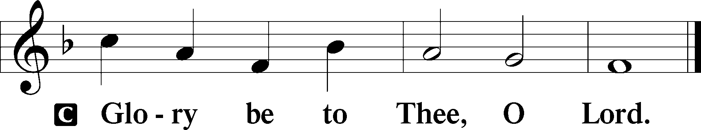

1As [Jesus] passed by, he saw a man blind from birth. 2And his disciples asked him, “Rabbi, who sinned, this man or his parents, that he was born blind?” 3Jesus answered, “It was not that this man sinned, or his parents, but that the works of God might be displayed in him. 4We must work the works of him who sent me while it is day; night is coming, when no one can work. 5As long as I am in the world, I am the light of the world.” 6Having said these things, he spat on the ground and made mud with the saliva. Then he anointed the man’s eyes with the mud 7and said to him, “Go, wash in the pool of Siloam” (which means Sent). So he went and washed and came back seeing.
8The neighbors and those who had seen him before as a beggar were saying, “Is this not the man who used to sit and beg?” 9Some said, “It is he.” Others said, “No, but he is like him.” He kept saying, “I am the man.” 10So they said to him, “Then how were your eyes opened?” 11He answered, “The man called Jesus made mud and anointed my eyes and said to me, ‘Go to Siloam and wash.’ So I went and washed and received my sight.” 12They said to him, “Where is he?” He said, “I do not know.”
13They brought to the Pharisees the man who had formerly been blind. 14Now it was a Sabbath day when Jesus made the mud and opened his eyes. 15So the Pharisees again asked him how he had received his sight. And he said to them, “He put mud on my eyes, and I washed, and I see.” 16Some of the Pharisees said, “This man is not from God, for he does not keep the Sabbath.” But others said, “How can a man who is a sinner do such signs?” And there was a division among them. 17So they said again to the blind man, “What do you say about him, since he has opened your eyes?” He said, “He is a prophet.”
18The Jews did not believe that he had been blind and had received his sight, until they called the parents of the man who had received his sight 19and asked them, “Is this your son, who you say was born blind? How then does he now see?” 20His parents answered, “We know that this is our son and that he was born blind. 21But how he now sees we do not know, nor do we know who opened his eyes. Ask him; he is of age. He will speak for himself.” 22(His parents said these things because they feared the Jews, for the Jews had already agreed that if anyone should confess Jesus to be Christ, he was to be put out of the synagogue.) 23Therefore his parents said, “He is of age; ask him.”
24So for the second time they called the man who had been blind and said to him, “Give glory to God. We know that this man is a sinner.” 25He answered, “Whether he is a sinner I do not know. One thing I do know, that though I was blind, now I see.” 26They said to him, “What did he do to you? How did he open your eyes?” 27He answered them, “I have told you already, and you would not listen. Why do you want to hear it again? Do you also want to become his disciples?” 28And they reviled him, saying, “You are his disciple, but we are disciples of Moses. 29We know that God has spoken to Moses, but as for this man, we do not know where he comes from.” 30The man answered, “Why, this is an amazing thing! You do not know where he comes from, and yet he opened my eyes. 31We know that God does not listen to sinners, but if anyone is a worshiper of God and does his will, God listens to him. 32Never since the world began has it been heard that anyone opened the eyes of a man born blind. 33If this man were not from God, he could do nothing.” 34They answered him, “You were born in utter sin, and would you teach us?” And they cast him out.
35Jesus heard that they had cast him out, and having found him he said, “Do you believe in the Son of Man?” 36He answered, “And who is he, sir, that I may believe in him?” 37Jesus said to him, “You have seen him, and it is he who is speaking to you.” 38He said, “Lord, I believe,” and he worshiped him. 39Jesus said, “For judgment I came into this world, that those who do not see may see, and those who see may become blind.” 40Some of the Pharisees near him heard these things, and said to him, “Are we also blind?” 41Jesus said to them, “If you were blind, you would have no guilt; but now that you say, ‘We see,’ your guilt remains.”

P This is the Gospel of the Lord.

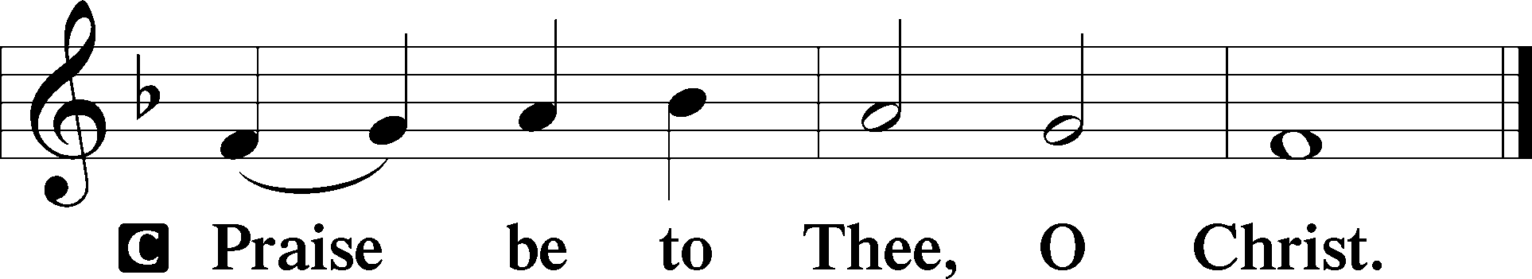

Nicene Creed
C I believe in one God,
the Father Almighty,
maker of heaven and earth
and of all things visible and invisible.

And in one Lord Jesus Christ,
the only-begotten Son of God,
begotten of His Father before all worlds,
God of God, Light of Light,
very God of very God,
begotten, not made,
being of one substance with the Father,
by whom all things were made;
who for us men and for our salvation came down from heaven
and was incarnate by the Holy Spirit of the virgin Mary
and was made man;
and was crucified also for us under Pontius Pilate.
He suffered and was buried.
And the third day He rose again according to the Scriptures
and ascended into heaven
and sits at the right hand of the Father.
And He will come again with glory to judge both the living and the dead,
whose kingdom will have no end.

And I believe in the Holy Spirit,
the Lord and giver of life,
who proceeds from the Father and the Son,
who with the Father and the Son together is worshiped and glorified,
who spoke by the prophets.
And I believe in one holy Christian and apostolic Church,
I acknowledge one Baptism for the remission of sins,
and I look for the resurrection of the dead
and the life T of the world to come. Amen.

Sit

Children's Sermon

849 Praise the One Who Breaks the Darkness
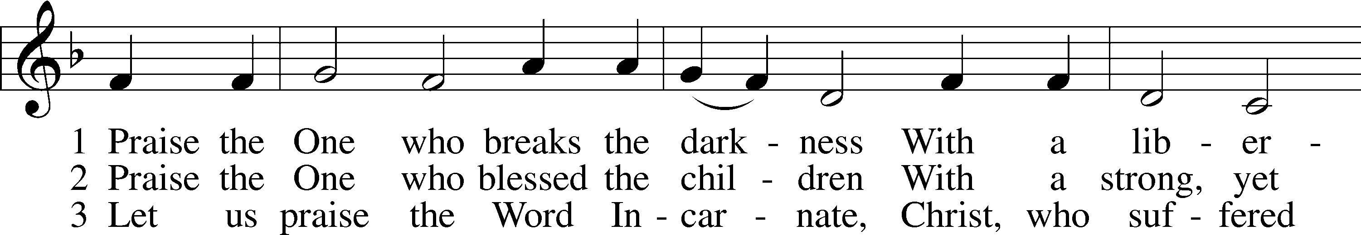
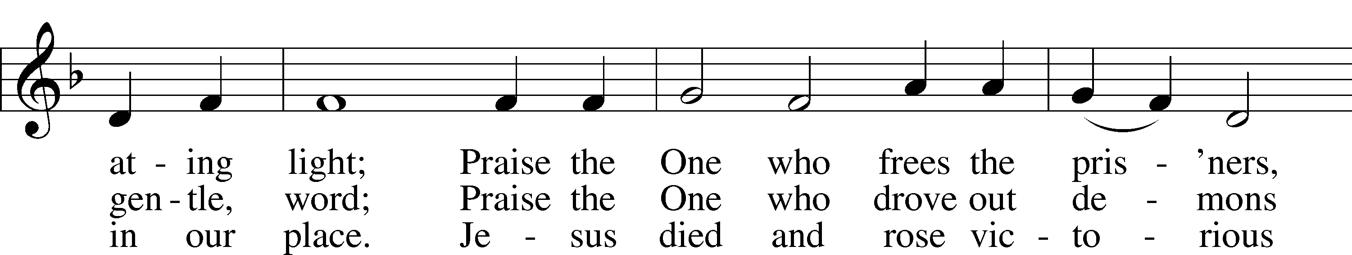
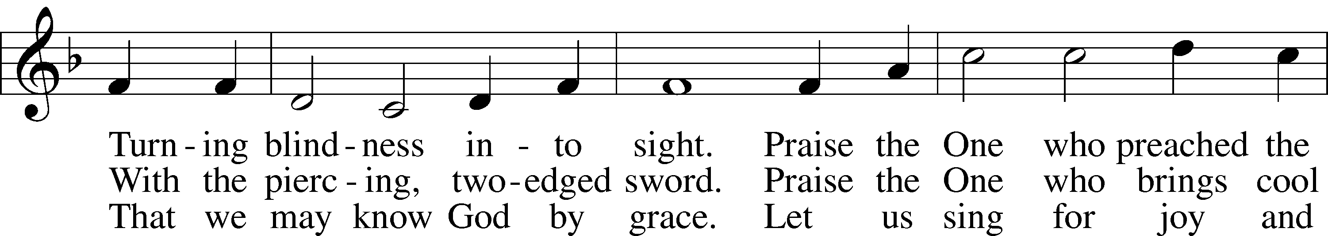
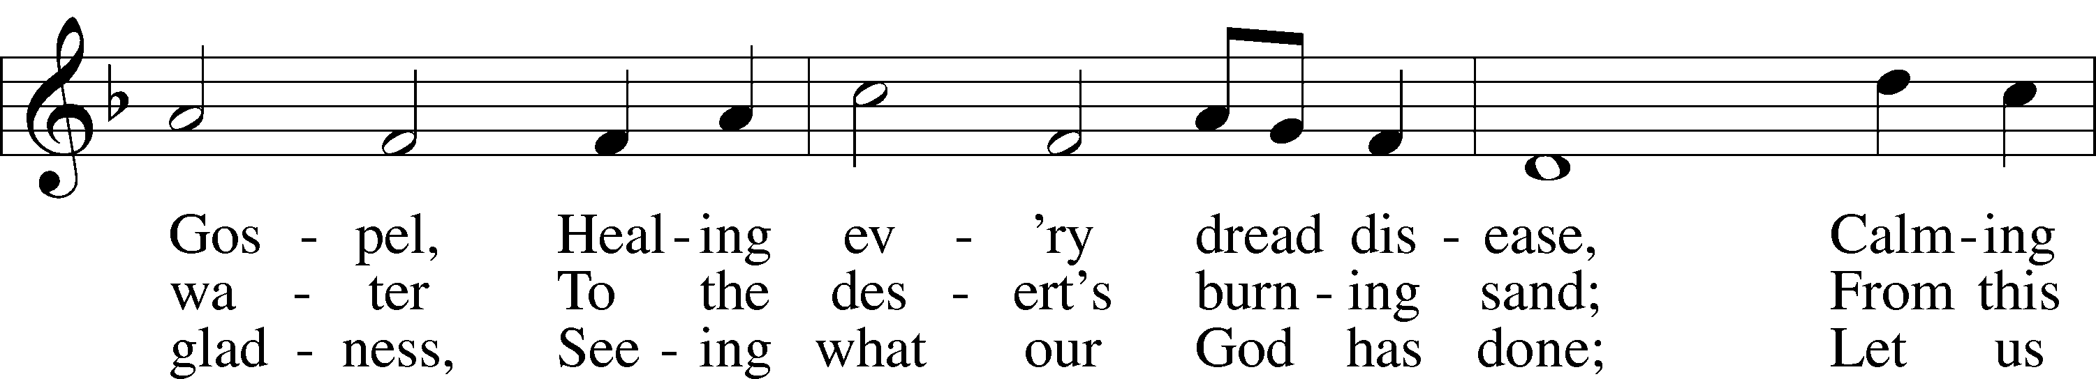
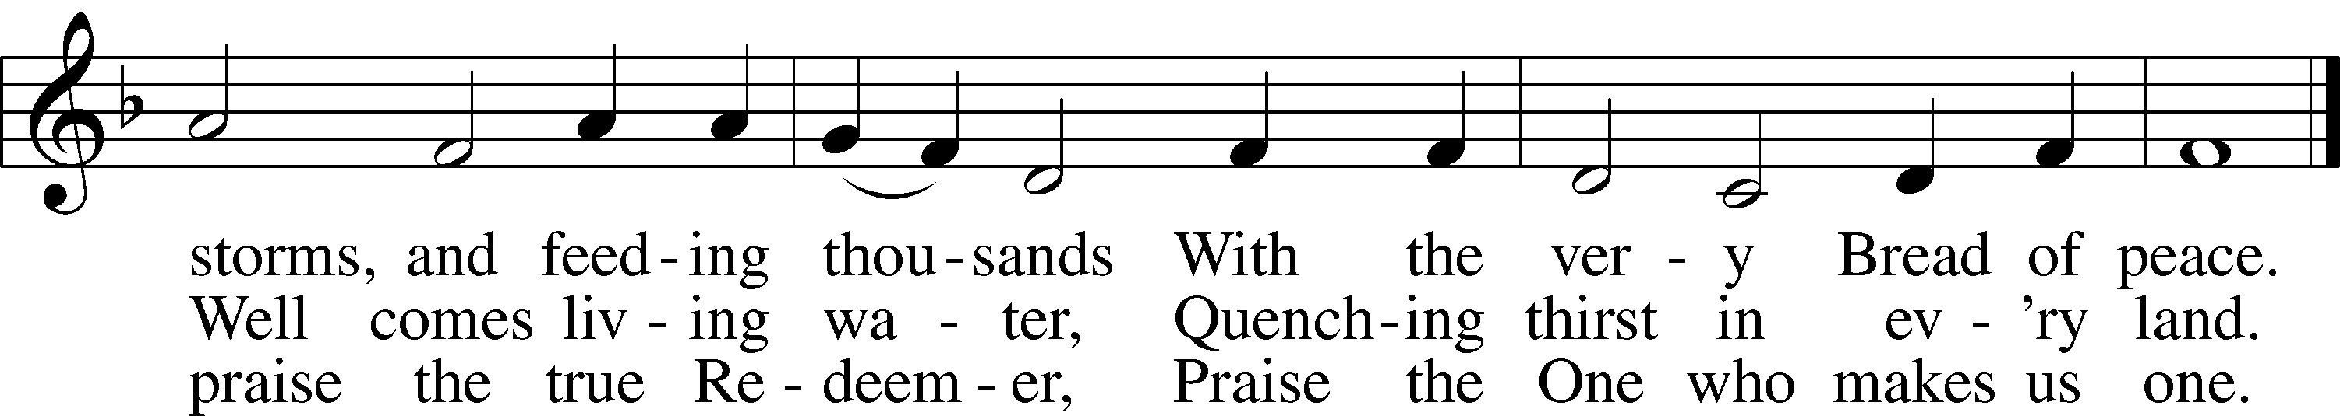
Text: Rusty Edwards, 1955
Tune: The Sacred Harp, 1844, Philadelphia
Text: © 1987 Hope Publishing Co. Used by permission: LSB Hymn License no. 110005011
Tune: Public domain

Sermon

Votum
P The peace of God, which passes all understanding, keep your hearts and minds in Christ Jesus.
C Amen.

Stand

Offertory Psalm 51:10–12
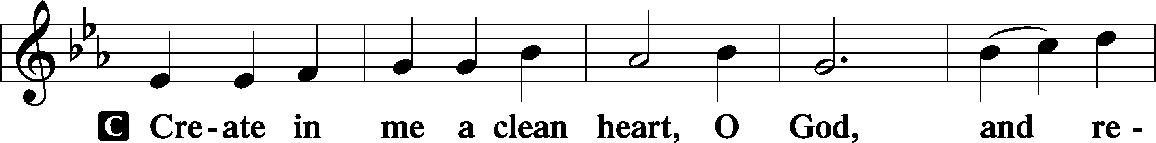
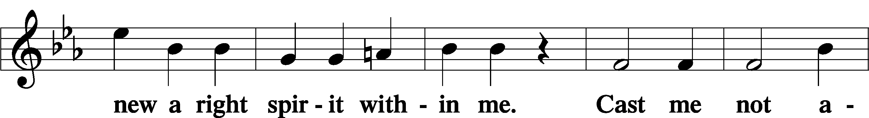
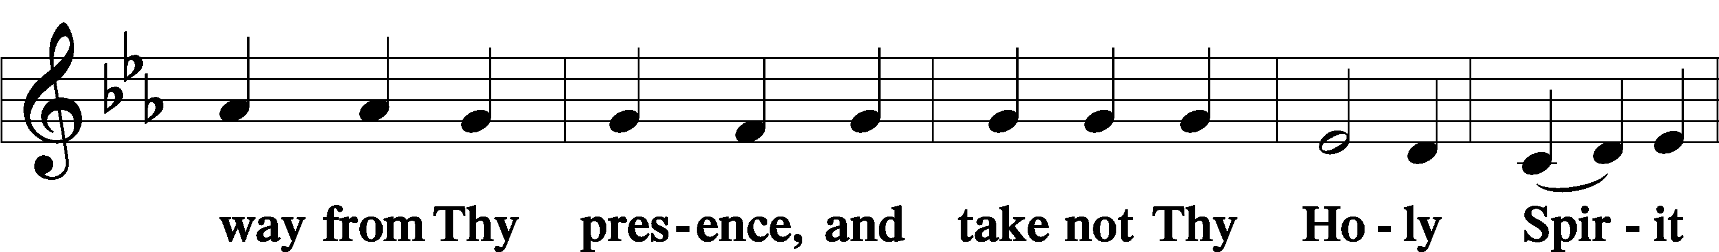
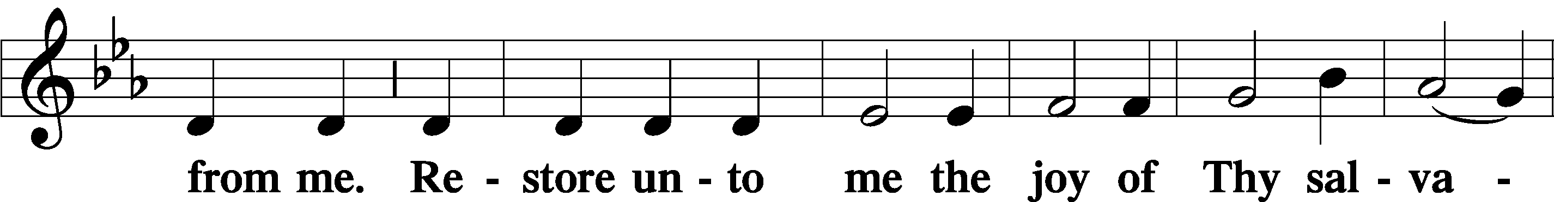
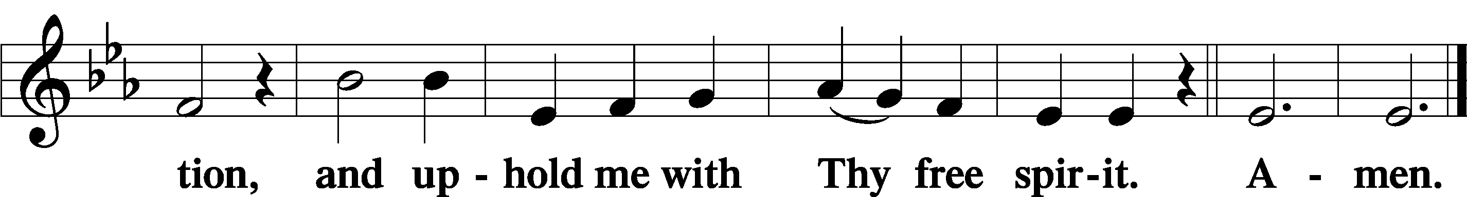

Sit

Offering

805 Praise God, from Whom All Blessings Flow
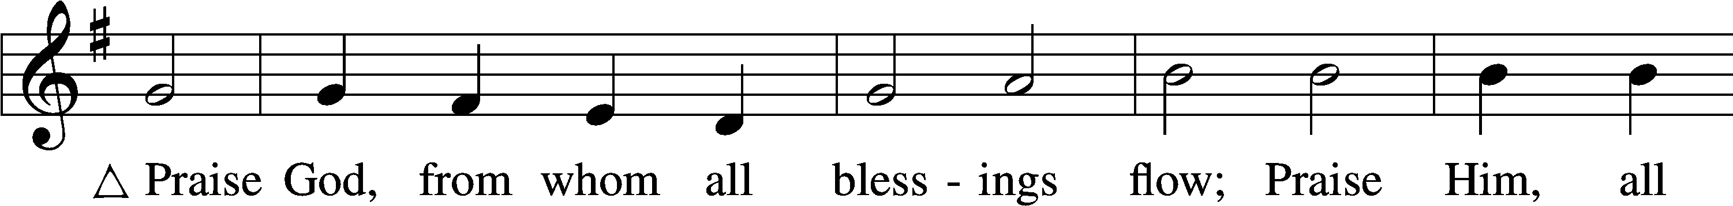
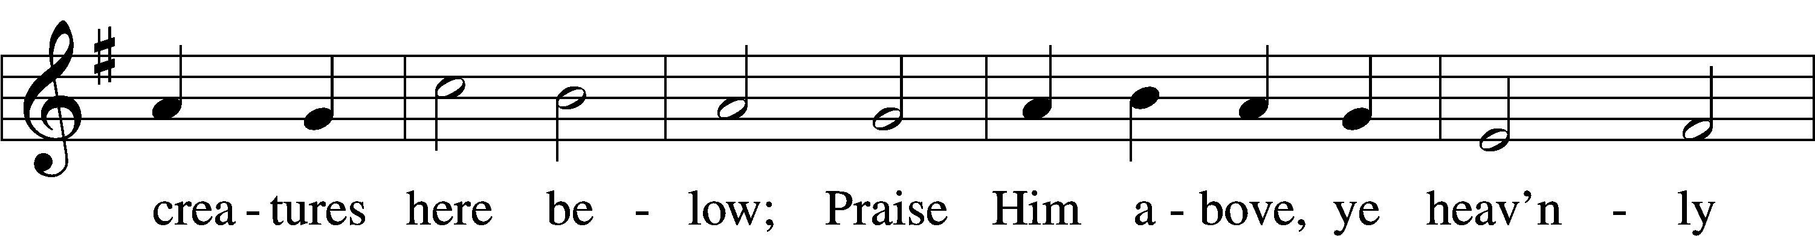
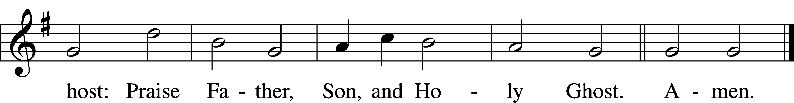
Text: Thomas Ken, 1637–1711
Tune: Trente quatre Pseaumes de David, 1551, Geneva, ed. Louis Bourgeois
Text and tune: Public domain

Stand

Prayer of the Church

Service of the Sacrament

Preface 2 Timothy 4:22; [Colossians 3:1]; [Psalm 136]
P The Lord be with you.
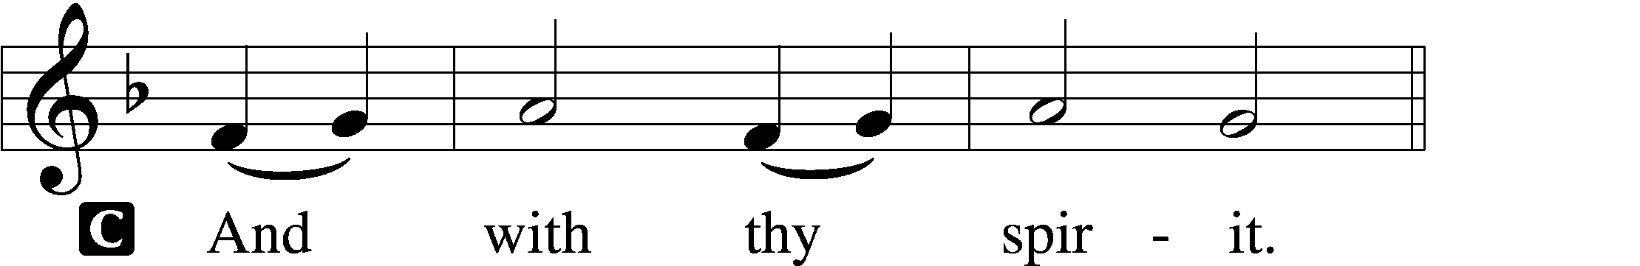

P Lift up your hearts.
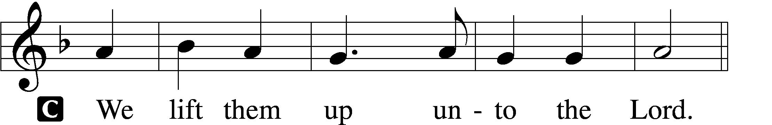

P Let us give thanks unto the Lord, our God.
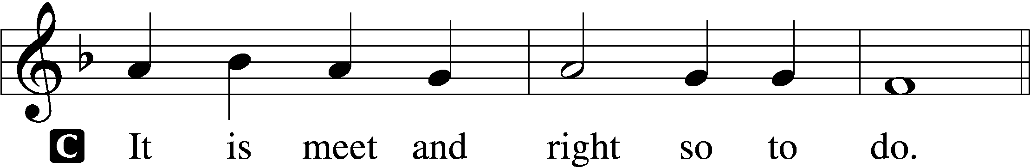

Proper Preface (Full)
P It is truly meet, right, and salutary that we should at all times and in all places give thanks to You, holy Lord, almighty Father, everlasting God, through Jesus Christ, our Lord, who overcame the assaults of the devil and gave His life as a ransom for many that with cleansed hearts we might be prepared joyfully to celebrate the paschal feast in sincerity and truth. Therefore with angels and archangels and with all the company of heaven we laud and magnify Your glorious name, evermore praising You and saying:

Sanctus Isaiah 6:3; Matthew 21:9
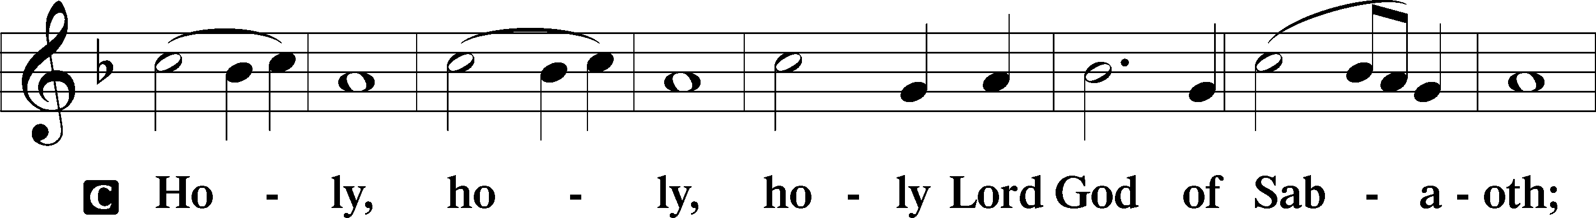
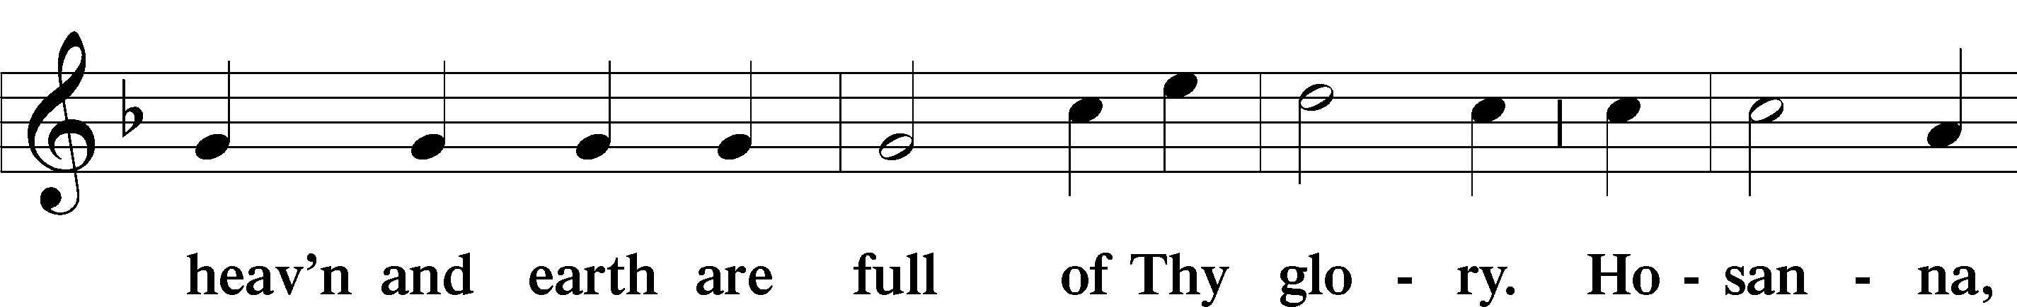
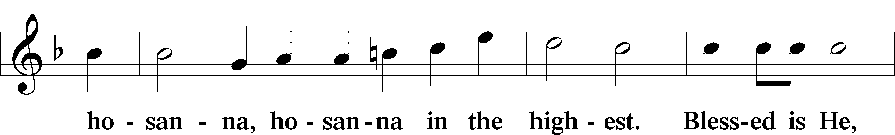
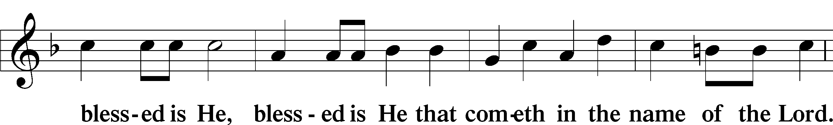
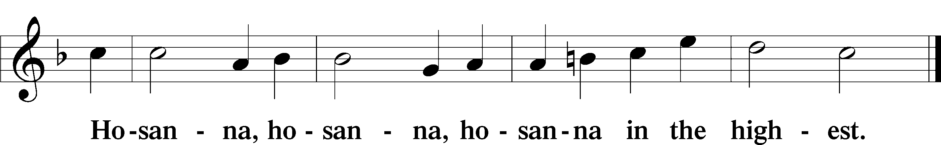

Lord’s Prayer Matthew 6:9–13
P Our Father who art in heaven,
hallowed be Thy name,
Thy kingdom come,
Thy will be done on earth as it is in heaven;
give us this day our daily bread;
and forgive us our trespasses as we forgive those who trespass against us;
and lead us not into temptation,
but deliver us from evil.
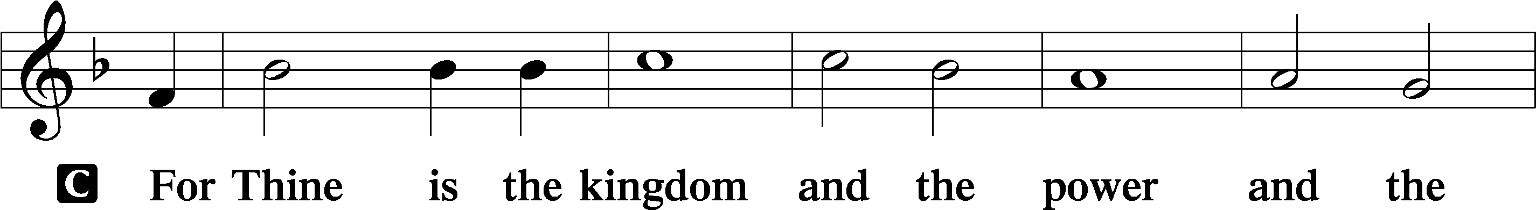
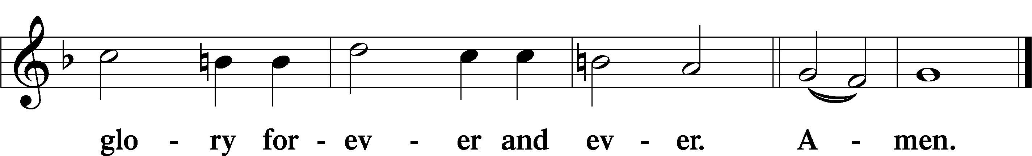

The Words of Our Lord Matthew 26:26–28; Mark 14:22–24; Luke 22:19–20; 1 Corinthians 11:23–25
P Our Lord Jesus Christ, on the night when He was betrayed, took bread, and when He had given thanks, He broke it and gave it to the disciples and said: “Take, eat; this is My T body, which is given for you. This do in remembrance of Me.”

In the same way also He took the cup after supper, and when He had given thanks, He gave it to them, saying: “Drink of it, all of you; this cup is the new testament in My T blood, which is shed for you for the forgiveness of sins. This do, as often as you drink it, in remembrance of Me.”

Pax Domini John 20:19
P The peace of the Lord be with you always.

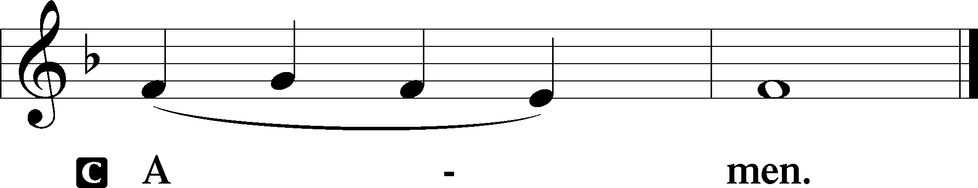

Agnus Dei John 1:29
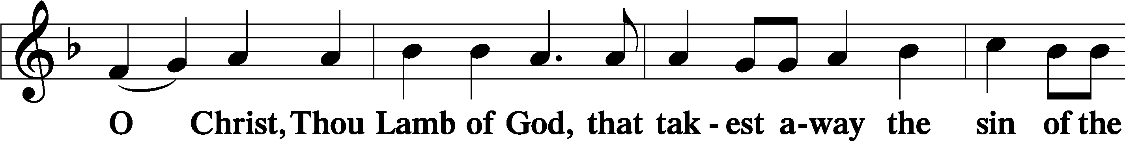
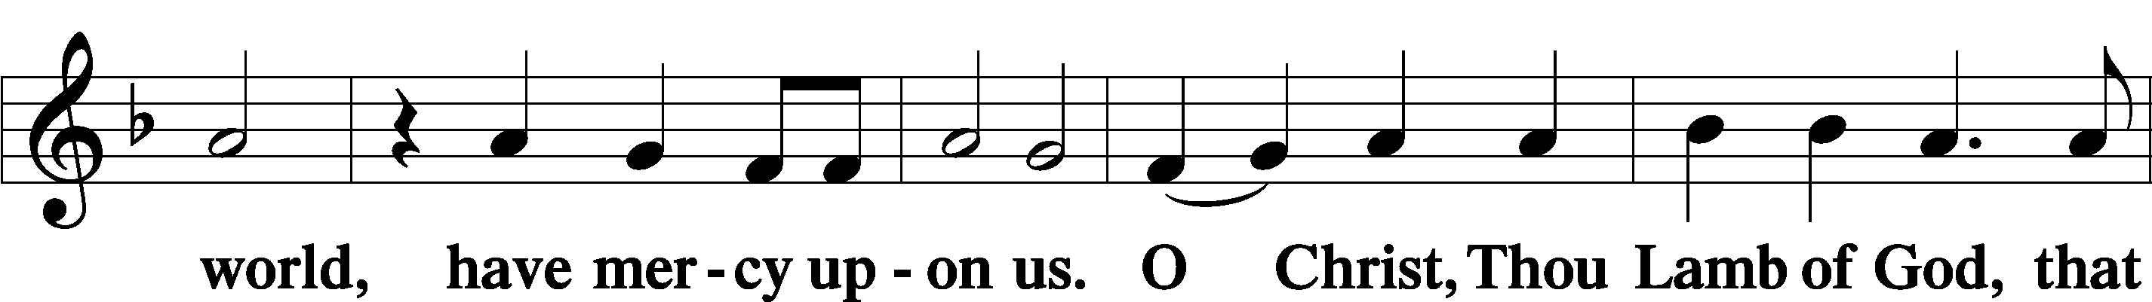
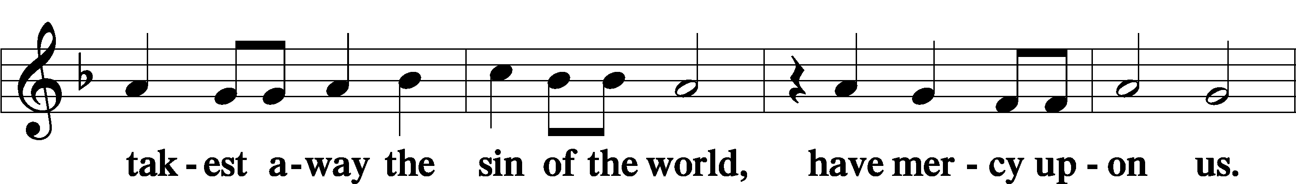
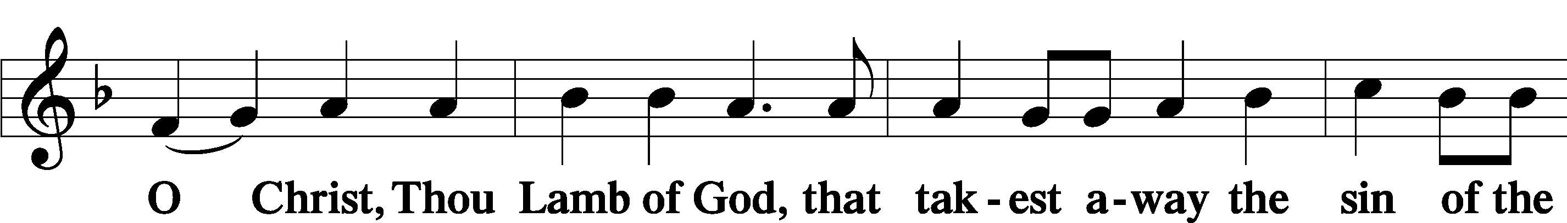
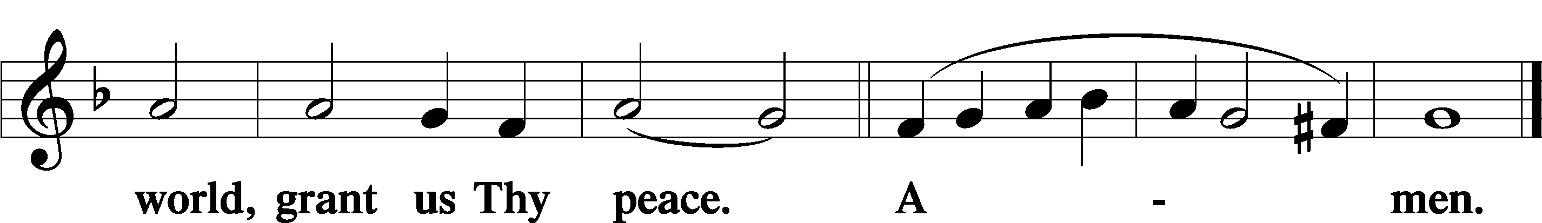

Sit

Distribution

The pastor and those who assist him receive the body and blood of Christ first and then distribute them to those who come to receive, saying:

Take, eat; this is the true body of our Lord and Savior Jesus Christ, given into death for your sins.
Amen.

Take, drink; this is the true blood of our Lord and Savior Jesus Christ, shed for the forgiveness of your sins.
Amen.

In dismissing the communicants, the following is said:

The Dismissal
P The body and blood of our Lord Jesus Christ strengthen and preserve you in body and soul to life everlasting. Depart T in peace.
C Amen.

623 Lord Jesus Christ, We Humbly Pray
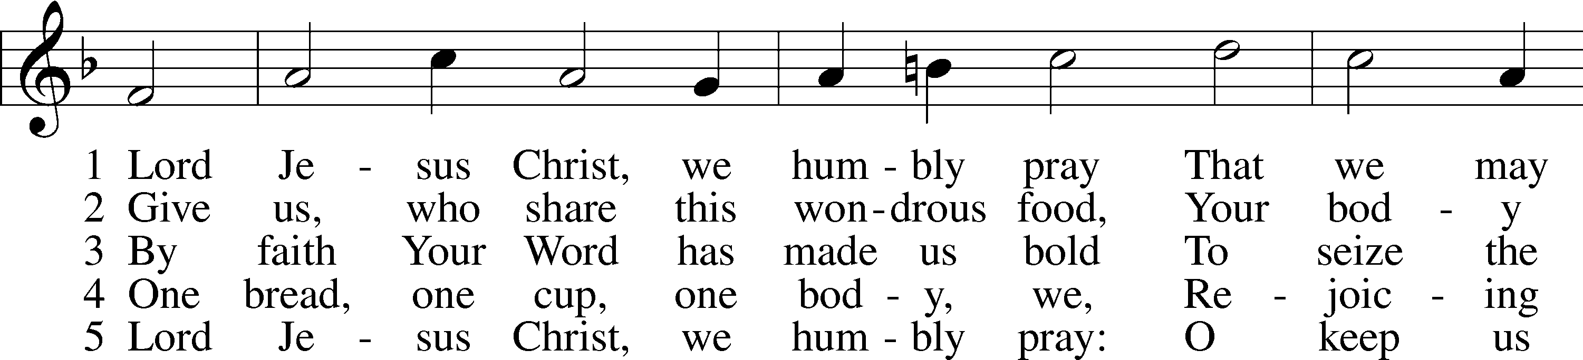
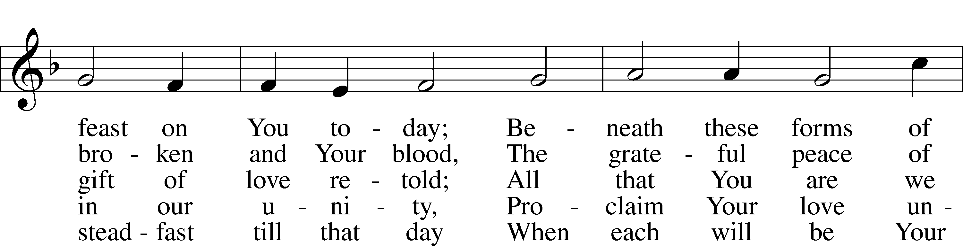
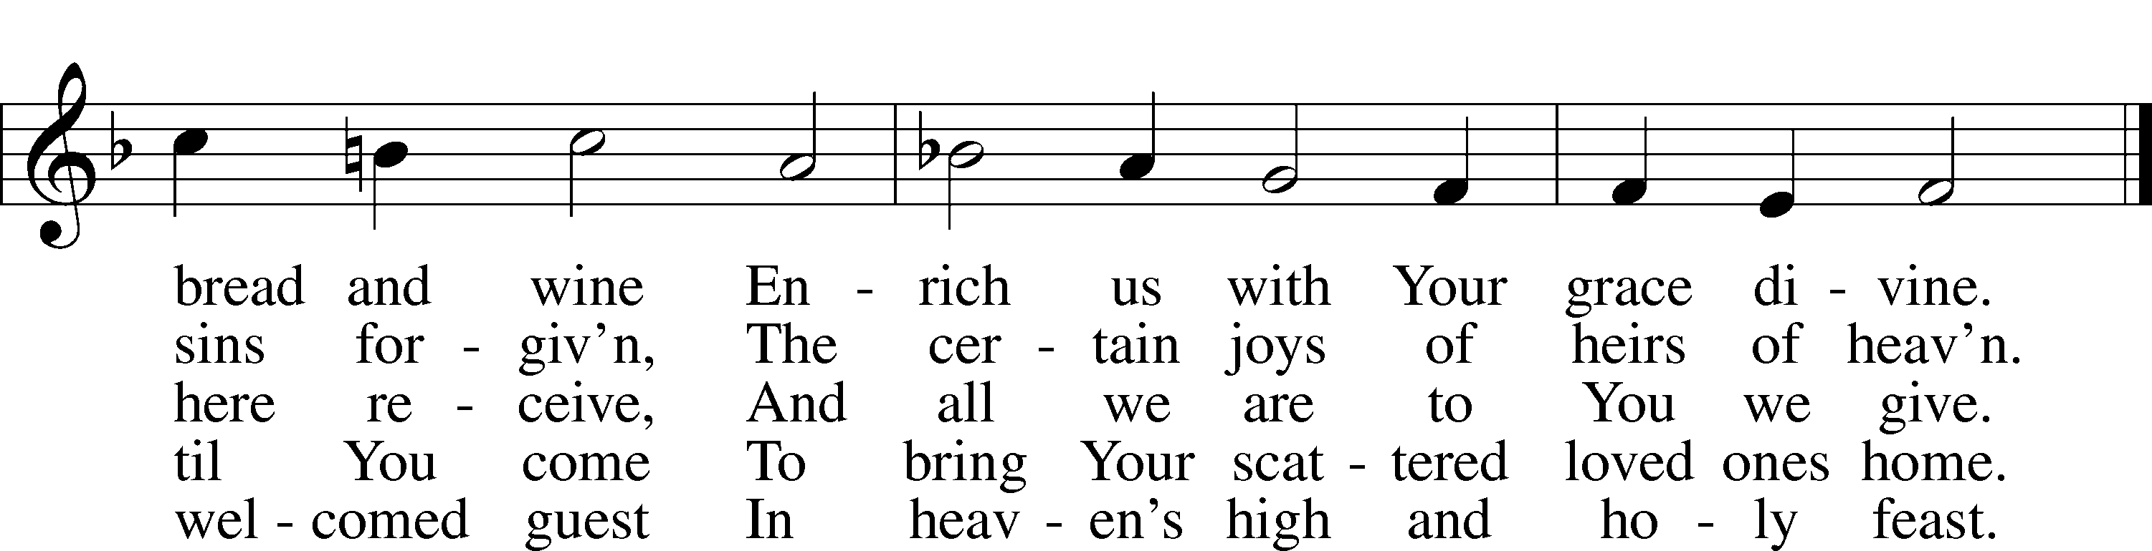
Text: Henry E. Jacobs, 1844–1932, alt.
Tune: Cantionale Germanicum, 1628, Gochsheim
Text and tune: Public domain

633 At the Lamb’s High Feast We Sing
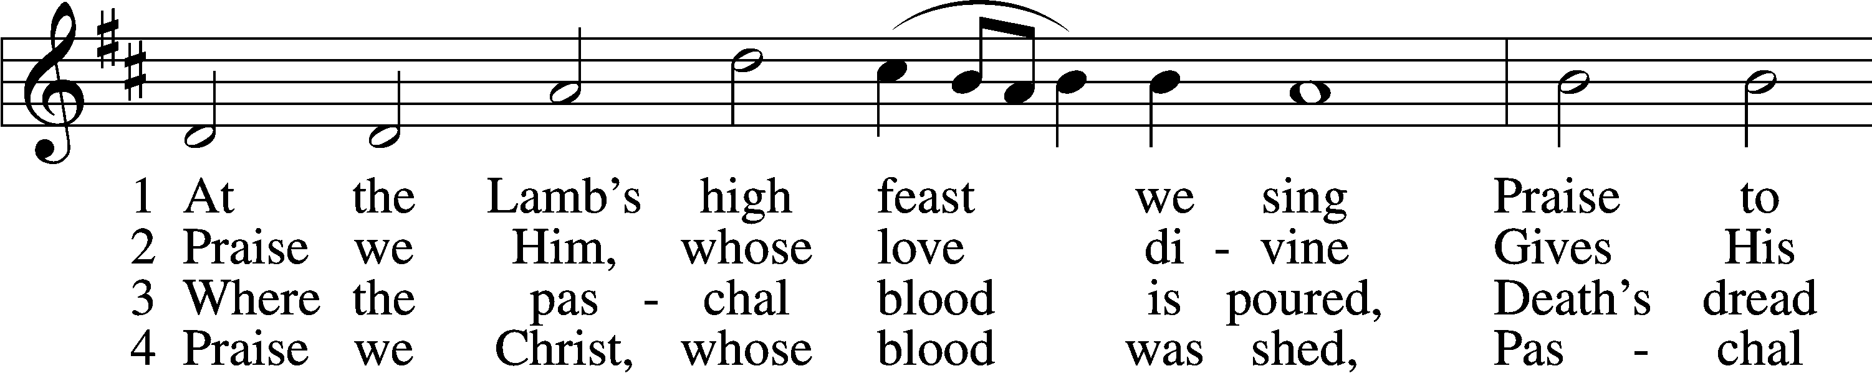
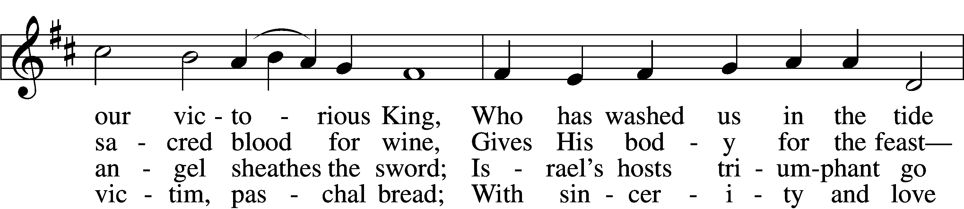
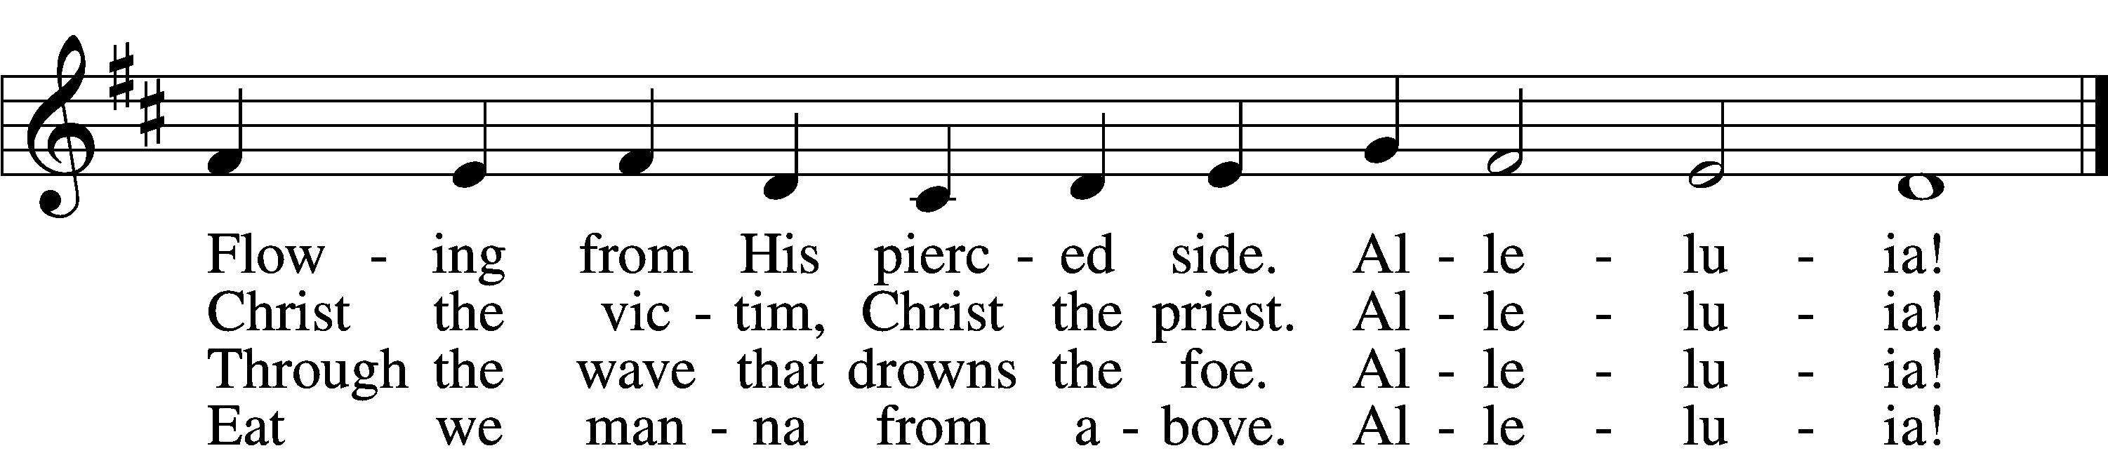

5 Mighty Victim from the sky,
Hell’s fierce pow’rs beneath You lie;
You have conquered in the fight,
You have brought us life and light.
Alleluia!

6 Now no more can death appall,
Now no more the grave enthrall;
You have opened paradise,
And Your saints in You shall rise.
Alleluia!

7 Easter triumph, Easter joy!
This alone can sin destroy;
From sin’s pow’r, Lord, set us free,
Newborn souls in You to be.
Alleluia!

D 8 Father, who the crown shall give,
Savior, by whose death we live,
Spirit, guide through all our days:
Three in One, Your name we praise.
Alleluia!
Text: Latin, c. 5th–10th cent.; tr. Robert Campbell, 1814–68, alt.
Tune: Kirchengeseng, 1566, Ivancice
Text and tune: Public domain

637 Draw Near and Take the Body of the Lord
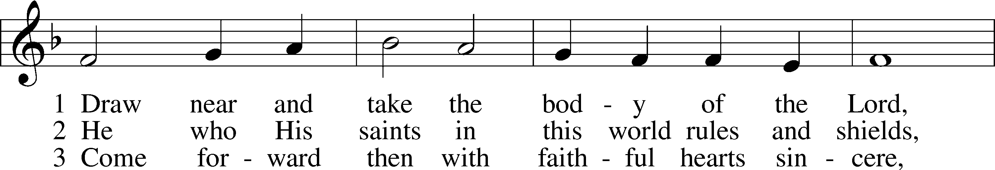
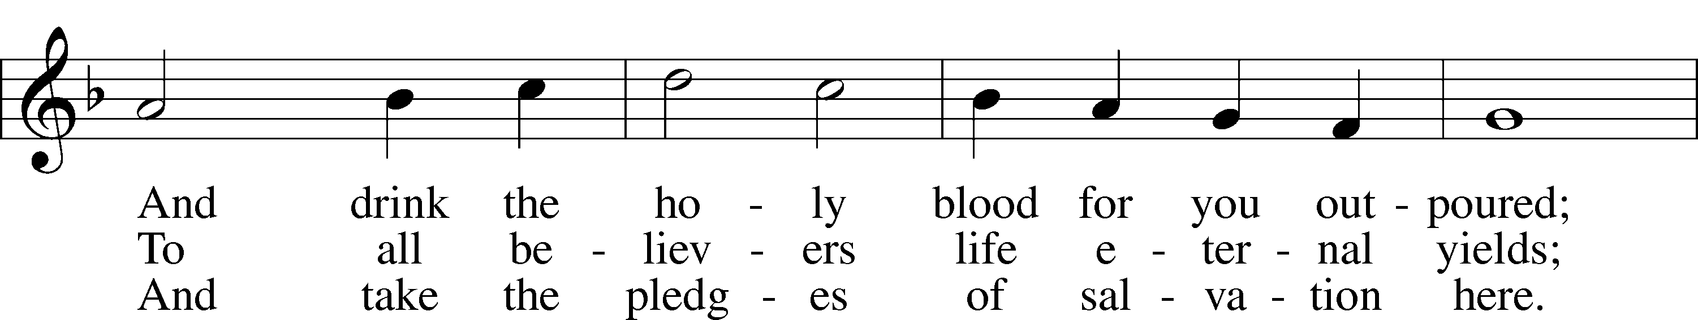
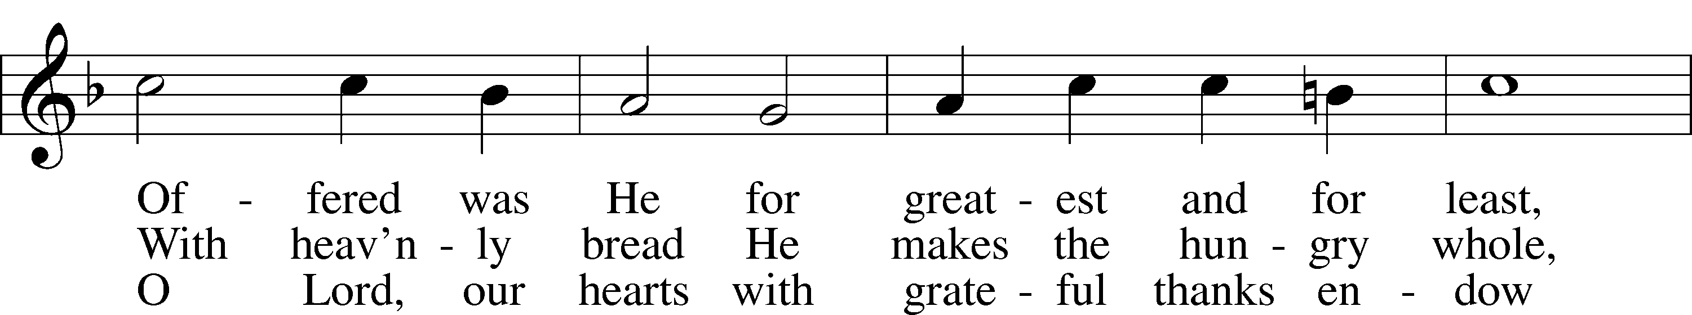
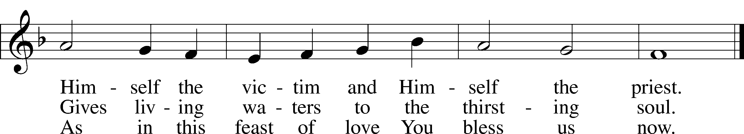
Text: Latin, 7th cent.; tr. John Mason Neale, 1818–66, alt.
Tune: Trente quatre Pseaumes de David, 1551, Geneva, ed. Louis Bourgeois
Text and tune: Public domain

643 Sent Forth by God’s Blessing
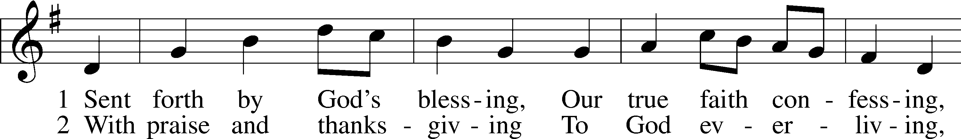
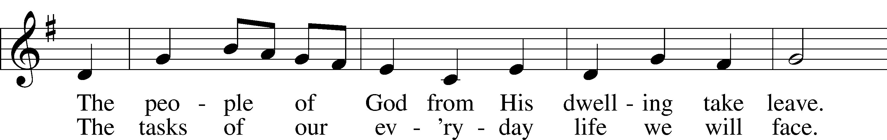
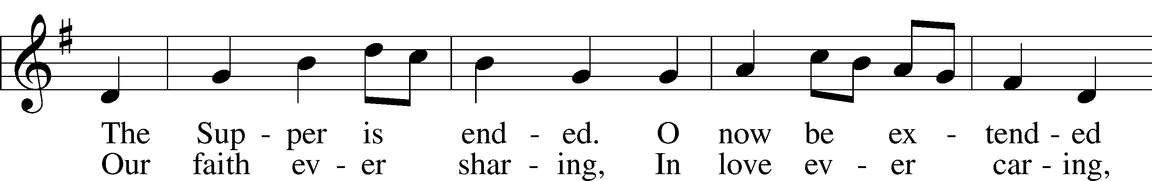
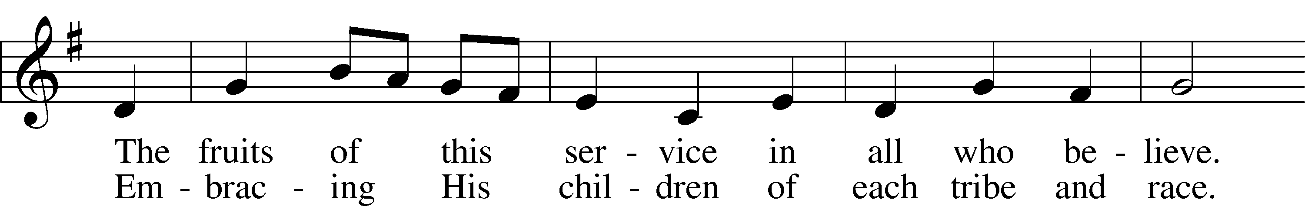
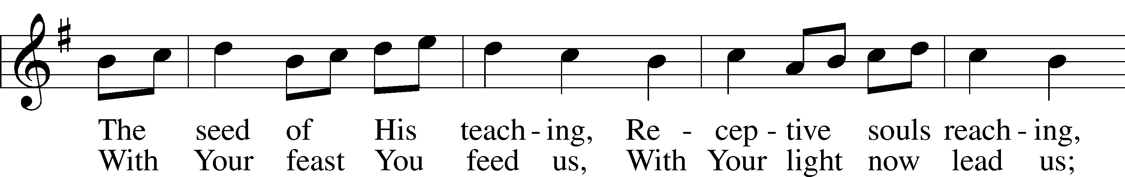
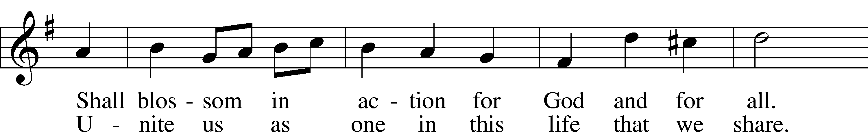
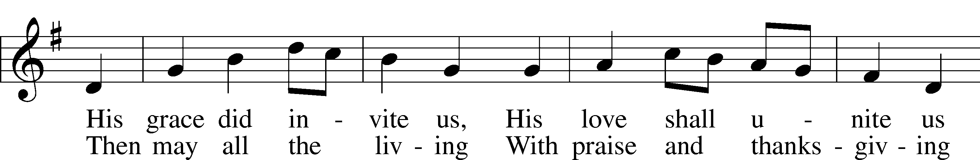
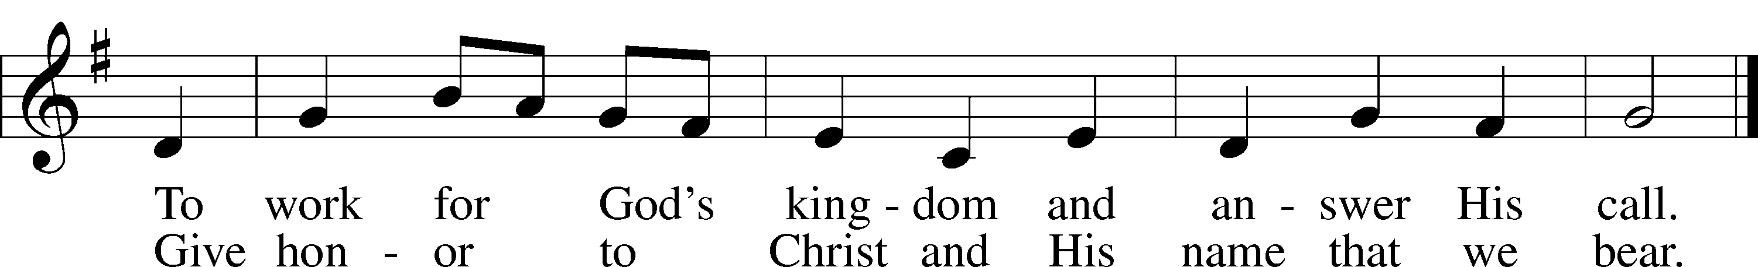
Text: Omer E. Westendorf, 1916–97, alt.
Tune: Welsh
Text: © 1964 World Library Publications. Used by permission: LSB Hymn License no. 110005011
Tune: Public domain

Stand

Nunc Dimittis Luke 2:29–32
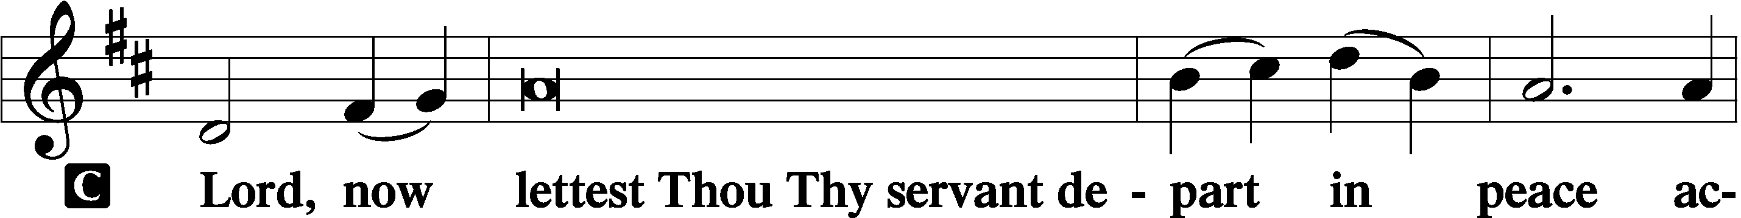

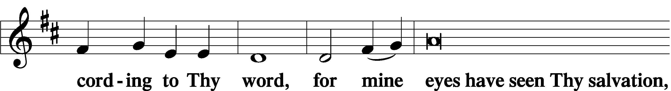

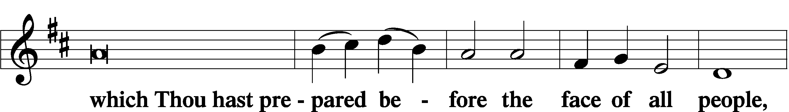

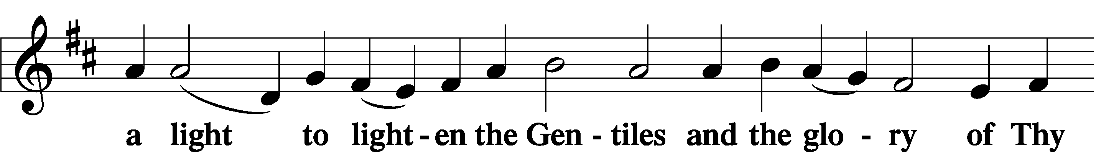

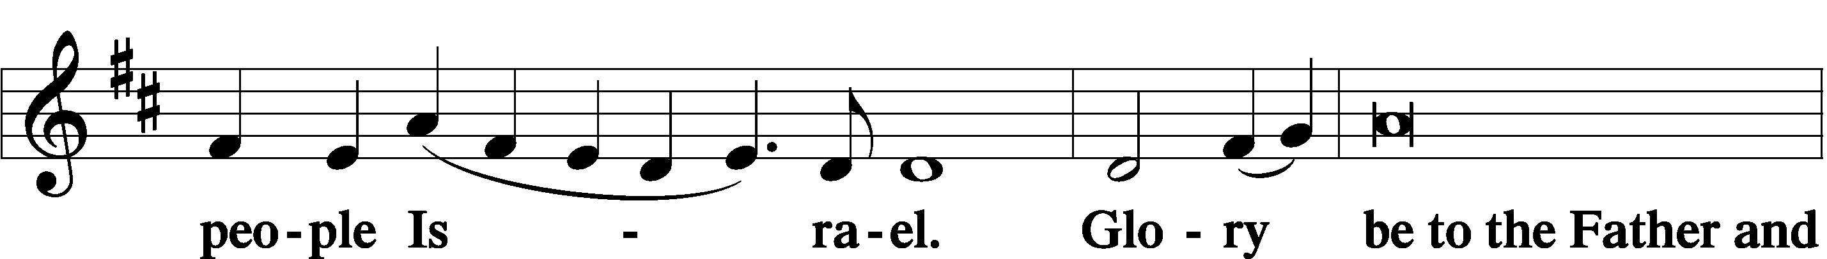

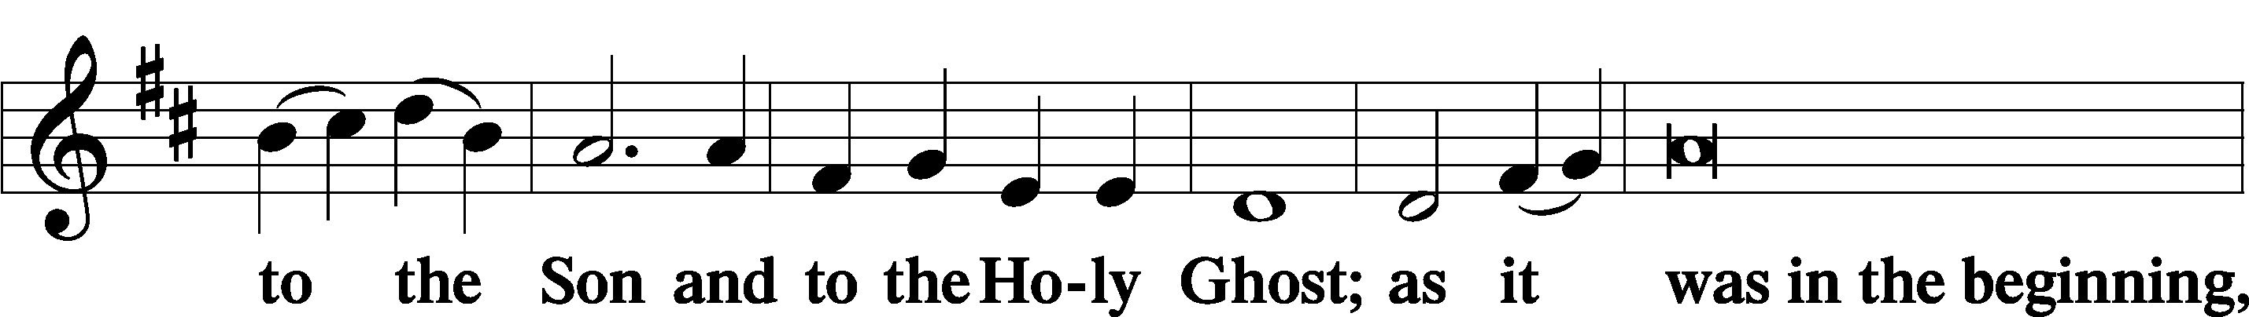

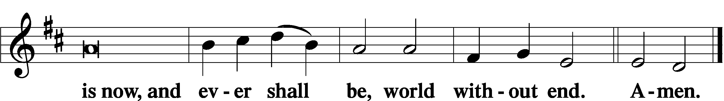

Thanksgiving Psalm 107:1
A O give thanks unto the Lord, for He is good,

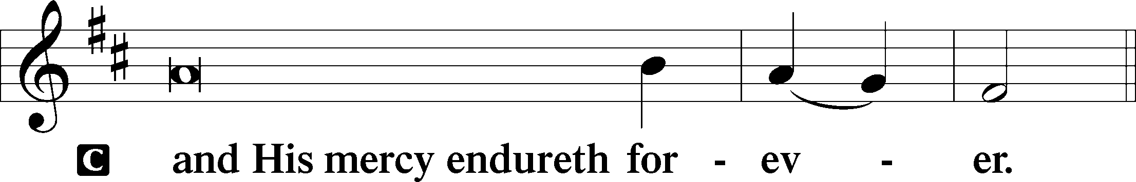

Post-Communion Collect
A Let us pray.
We give thanks to You, almighty God, that You have refreshed us through this salutary gift, and we implore You that of Your mercy You would strengthen us through the same in faith toward You and in fervent love toward one another; through Jesus Christ, Your Son, our Lord, who lives and reigns with You and the Holy Spirit, one God, now and forever.

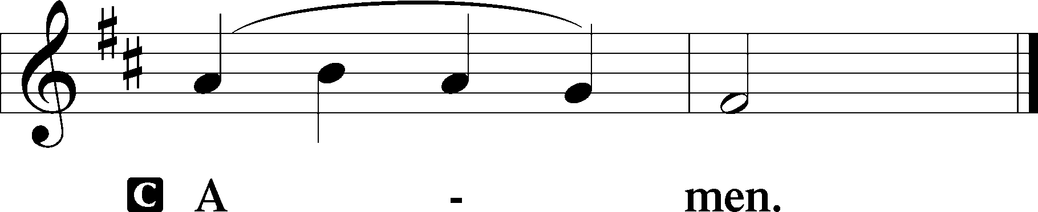

Salutation 2 Timothy 4:22
P The Lord be with you.

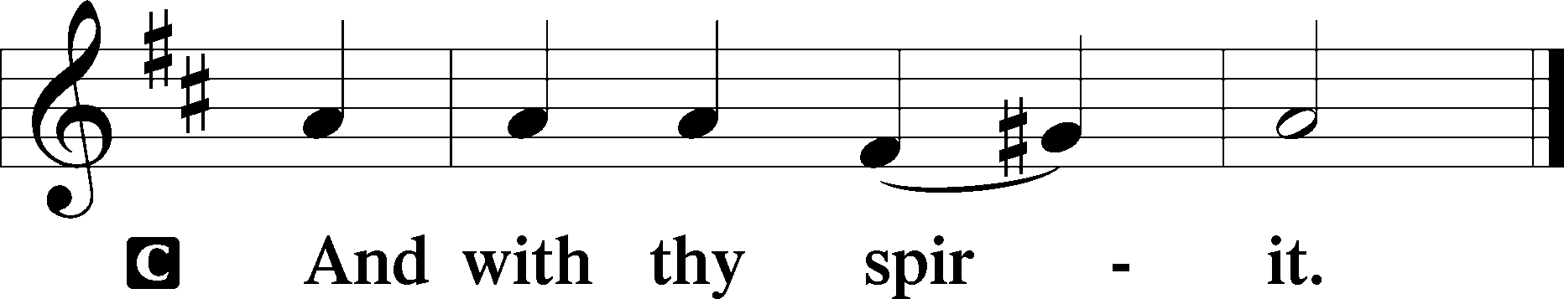

Benedicamus Psalm 103:1
A Bless we the Lord.

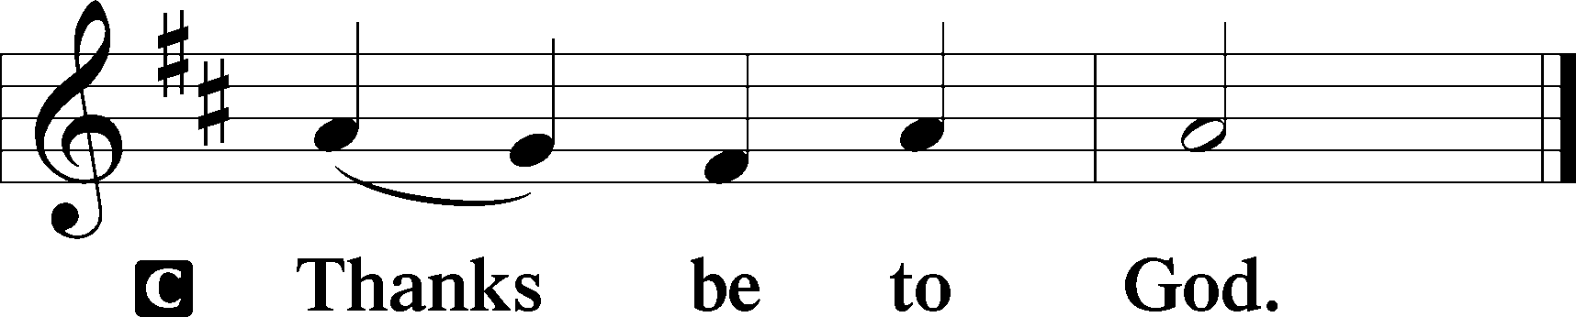

Benediction Numbers 6:24–26
P The Lord bless you and keep you.
The Lord make His face shine upon you and be gracious unto you.
The Lord lift up His countenance upon you and T give you peace.
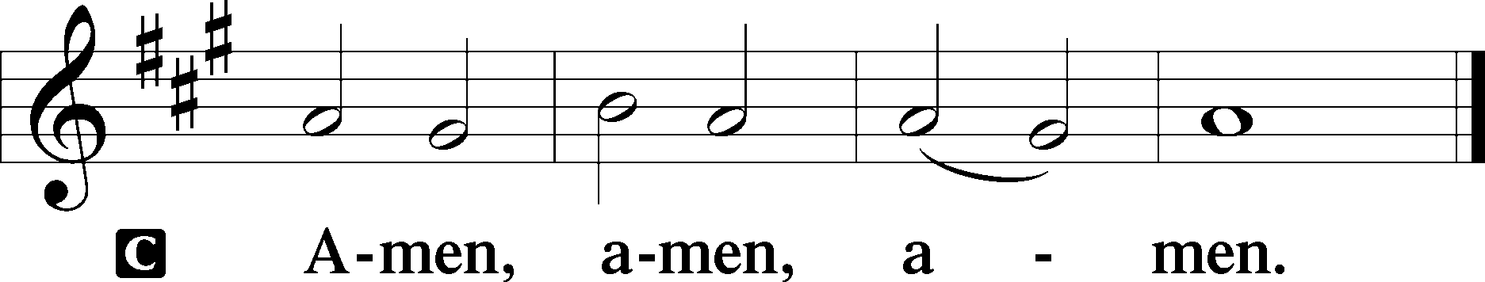

744 Amazing Grace sts. 1–5
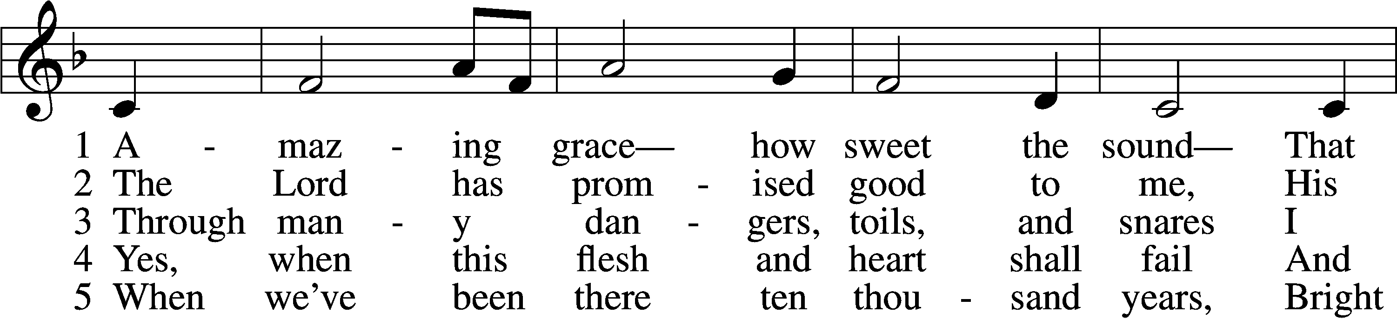
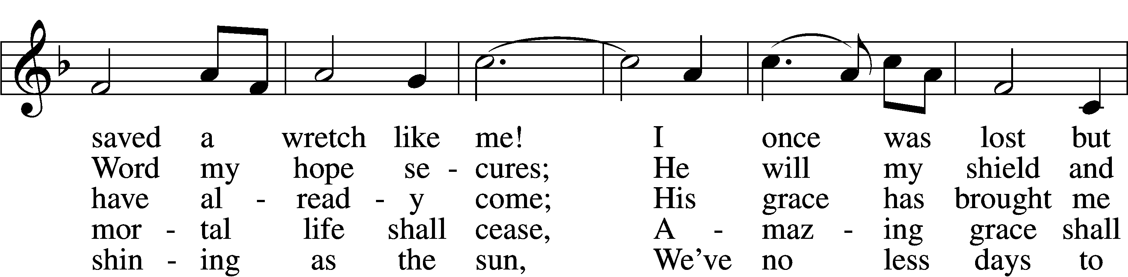
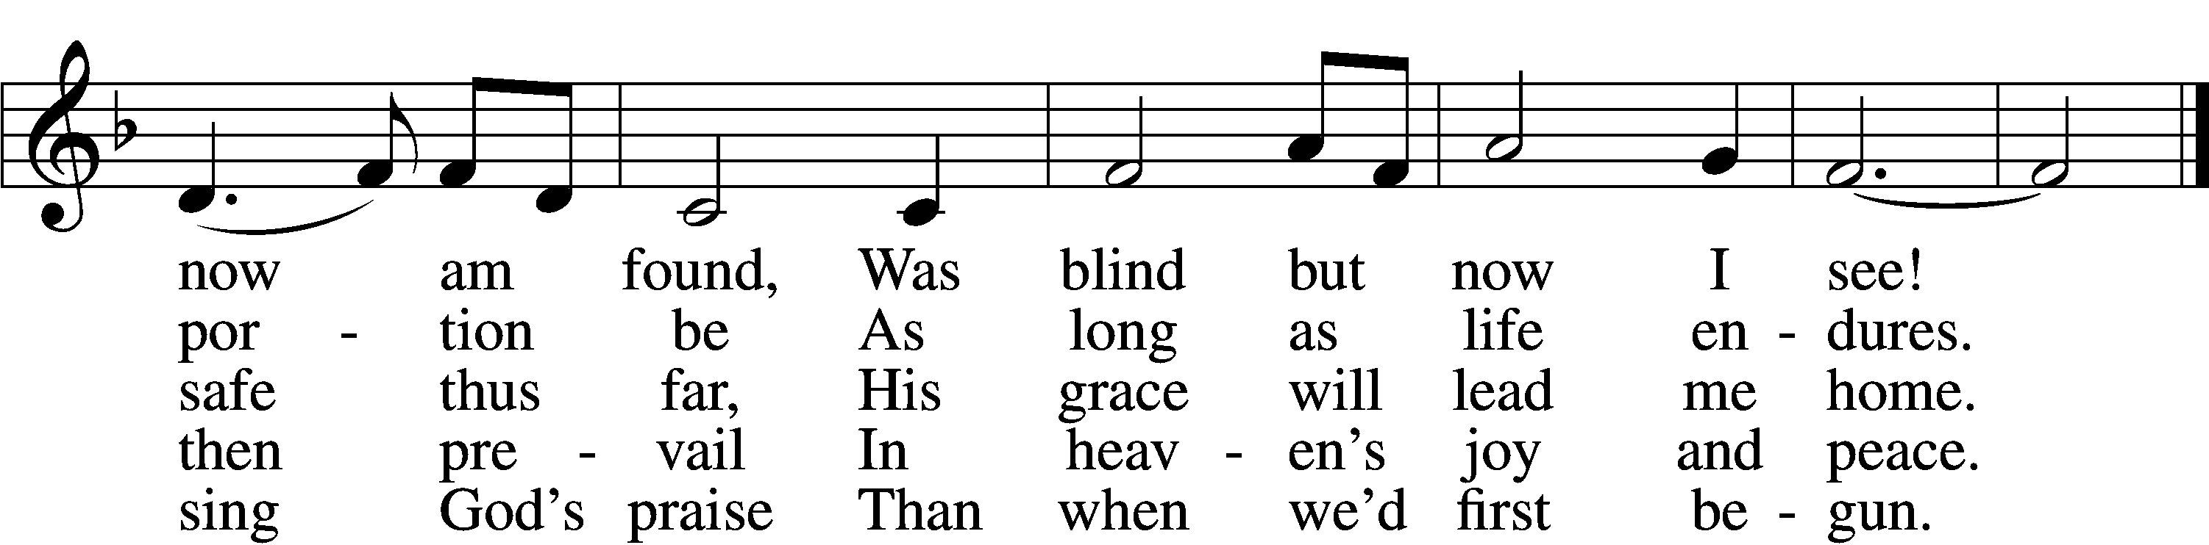
Text (sts. 1–4): John Newton, 1725–1807, alt.; (st. 5): A Collection of Sacred Ballads, 1790, Richmond
Tune: Columbian Harmony, 1829, Cincinnati
Text and tune: Public domain

Acknowledgments
Divine Service, Setting Three from Lutheran Service Book
Unless otherwise indicated, Scripture quotations are from the ESV® Bible (The Holy Bible, English Standard Version®), copyright © 2001 by Crossway, a publishing ministry of Good News Publishers. Used by permission. All rights reserved.
Created by Lutheran Service Builder © 2026 Concordia Publishing House.

