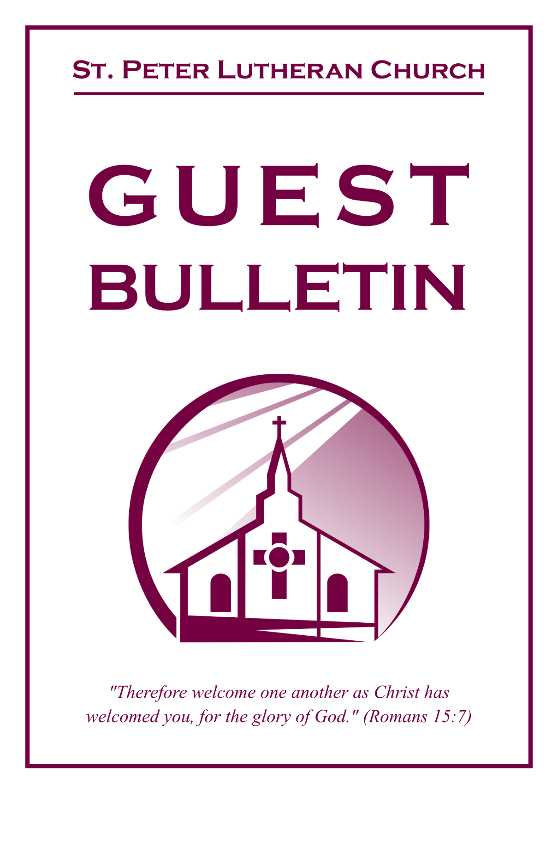

September 20, 2026



St. Peter Lutheran Church
Missouri Synod
906 Highway 59N, P.O. Box 133

Bowie, Texas 76230

Church (940) 872-1886 Fax ((940) 872-8837

Church E-mail: stpetertexscty@gmail.com
To Our Guests and Visitors:

We welcome all our friends in Christ who have come to worship with us. If you are a guest, please feel at home with us, sign our guest register, and worship with us whenever you are able. If you do not have a church home, we invite you to
consider becoming a part of our church family.

Website: www.stpetertex.com
Communion Statement:

The Lord’s Supper is celebrated at this congregation in the confession and glad confidence that, as He says, our Lord gives into our mouths not only bread and wine but His very Body and Blood to eat and drink for the forgiveness of sins and to strengthen our union with Him and one another.

Our Lord invites to His table those who trust in His words, repent of all sin, and set aside any refusal to forgive and love as He forgives and loves us, that they may show forth His death until He comes.

Because those who eat and drink our Lord’s Body and Blood unworthily do so to their great harm, and because Holy Communion is a confession of the faith, which is confessed at this altar, guests who are not confirmed members of an LCMS congregation and have not previously communed at this altar, are asked to first speak with our pastor.

If you are unable to do so before the service, it is out of Christian love and care for your souls that we ask you to refrain from communing this morning.

For further study, please see Matthew 5:23ff, 10:32ff, 18:15–35, 26:26–29; 1 Corinthians 11:17–34.

If you desire to receive a blessing for yourself or your children, please approach during
communion, cross your arms over your chest and bow your head as you kneel at the
altar rail.

Who Receives the Sacrament of the Altar Worthily?
Fasting and bodily preparation are certainly fine outward training. But that person is truly worthy and well prepared who has faith in these words: “Given and shed for you for the forgiveness of sins.” But anyone who does not believe these words or doubts them is unworthy and unprepared; for the words “for you” require all hearts to believe.
How May I Prepare?
See Dr. Luther’s self–examination questions and answers in the
LSB Hymnal on page 329

Upon entering the Sanctuary. please turn off cell phones, pagers. etc. Use the time as a quiet time for personal reflection and meditation in preparation for worship. This is a time for anyone to join in praying for the service, and for the church in general.
711 Savior, like a Shepherd Lead Us
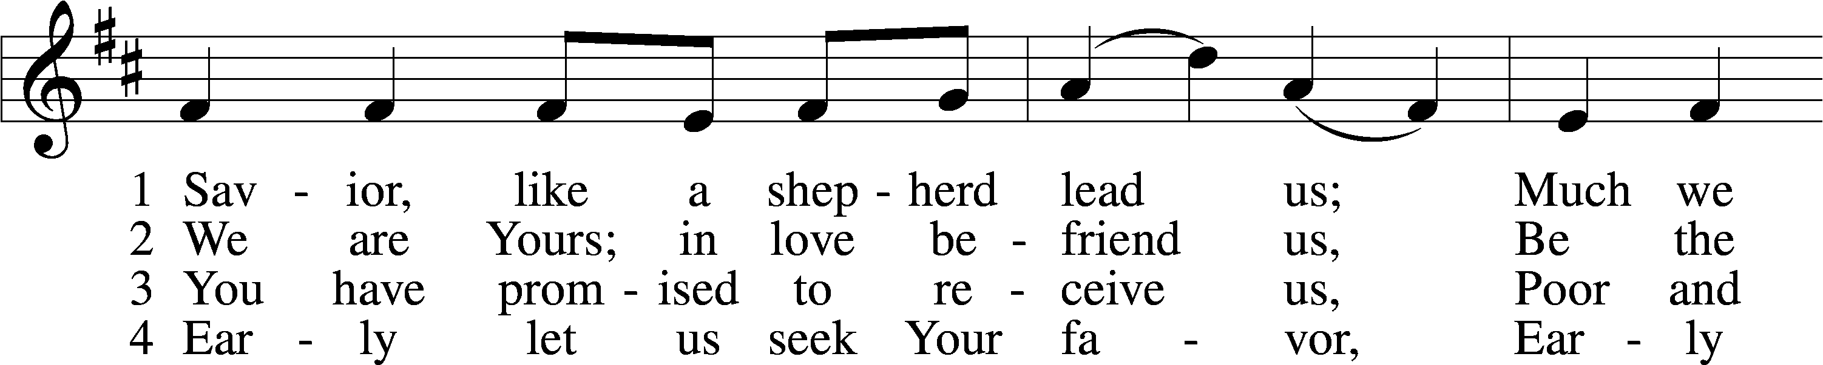
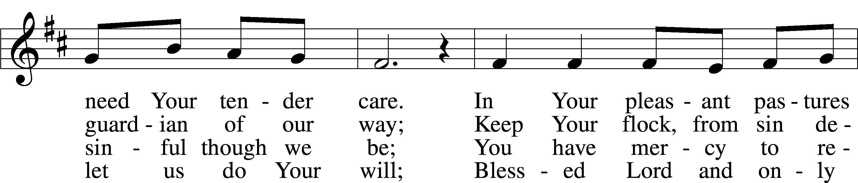
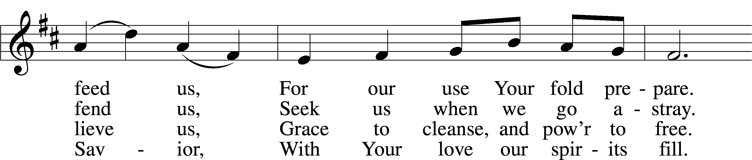
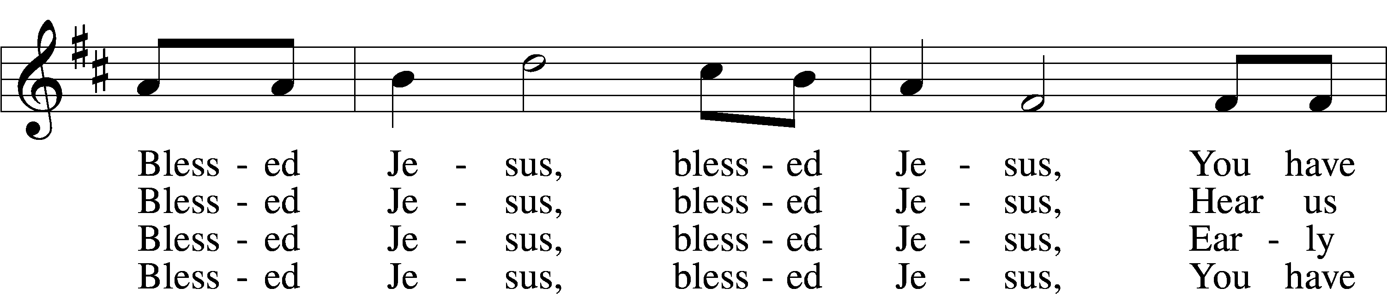
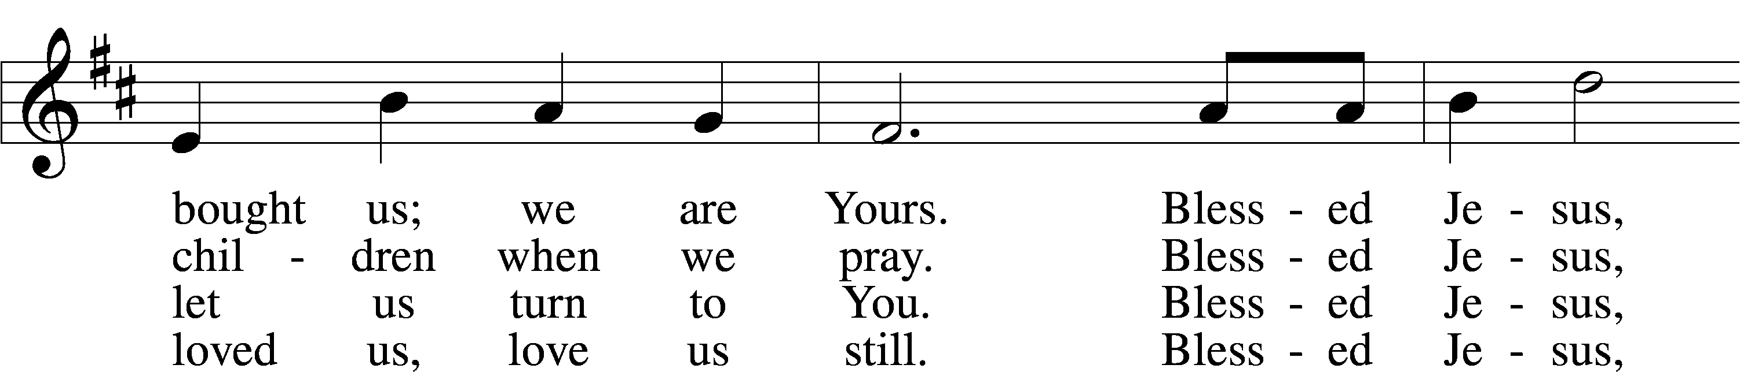
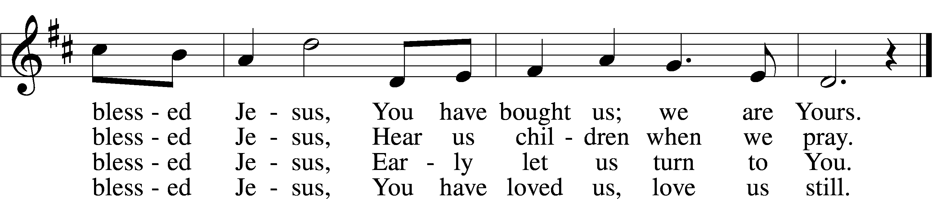
Text: Hymns for the Young, 1836, 4th ed., London, alt.
Tune: William B. Bradbury, 1816–68
Text and tune: Public domain
Confession and Absolution

Stand

The sign of the cross may be made by all in remembrance of their Baptism.

Invocation Matthew 28:19b; 18:20
P In the name of the Father and of the T Son and of the Holy Spirit.
C Amen.
Exhortation Hebrews 10:22; Psalm 124:8; Psalm 32:5
P Beloved in the Lord! Let us draw near with a true heart and confess our sins unto God our Father, beseeching Him in the name of our Lord Jesus Christ to grant us forgiveness.

P Our help is in the name of the Lord,
C who made heaven and earth.
P I said, I will confess my transgressions unto the Lord,
C and You forgave the iniquity of my sin.

Kneel/Stand

Silence for reflection on God’s Word and for self-examination.

Confession of Sins
P O almighty God, merciful Father,
C I, a poor, miserable sinner, confess unto You all my sins and iniquities with which I have ever offended You and justly deserved Your temporal and eternal punishment. But I am heartily sorry for them and sincerely repent of them, and I pray You of Your boundless mercy and for the sake of the holy, innocent, bitter sufferings and death of Your beloved Son, Jesus Christ, to be gracious and merciful to me, a poor, sinful being.

Absolution [John 20:19–23]
P Upon this your confession, I, by virtue of my office, as a called and ordained servant of the Word, announce the grace of God unto all of you, and in the stead and by the command of my Lord Jesus Christ I forgive you all your sins in the name of the Father and of the T Son and of the Holy Spirit.
C Amen.

Stand

Service of the Word
Introit Psalm 116:12–13, 15–16; antiphon: v. 17
I will offer to you the sacrifice of thanksgiving
and call on the name of the Lord.
What shall I render to the Lord
for all his benefits to me?
I will lift up the cup of salvation
and call on the name of the Lord.
Precious in the sight of the Lord
is the death of his saints.
O Lord, I am your servant;
I am your servant, the son of your maidservant. You have loosed my bonds.
Glory be to the Father and to the Son
and to the Holy Spirit;
as it was in the beginning,
is now, and will be forever. Amen.
I will offer to you the sacrifice of thanksgiving
and call on the name of the Lord.

Gloria Patri
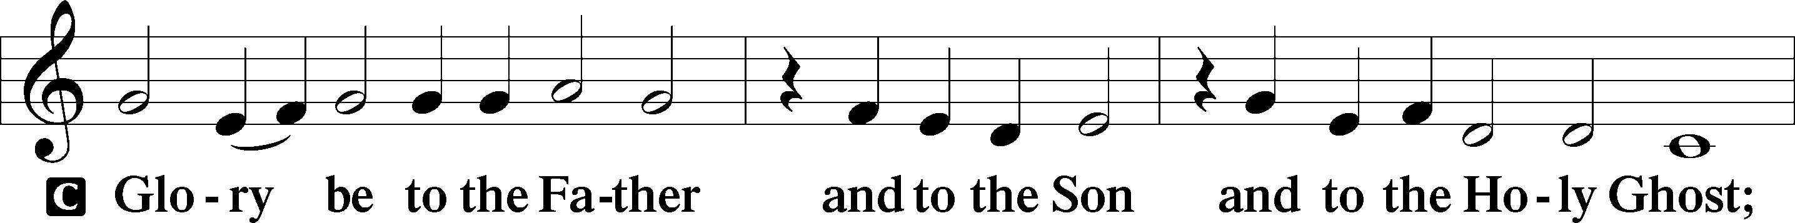
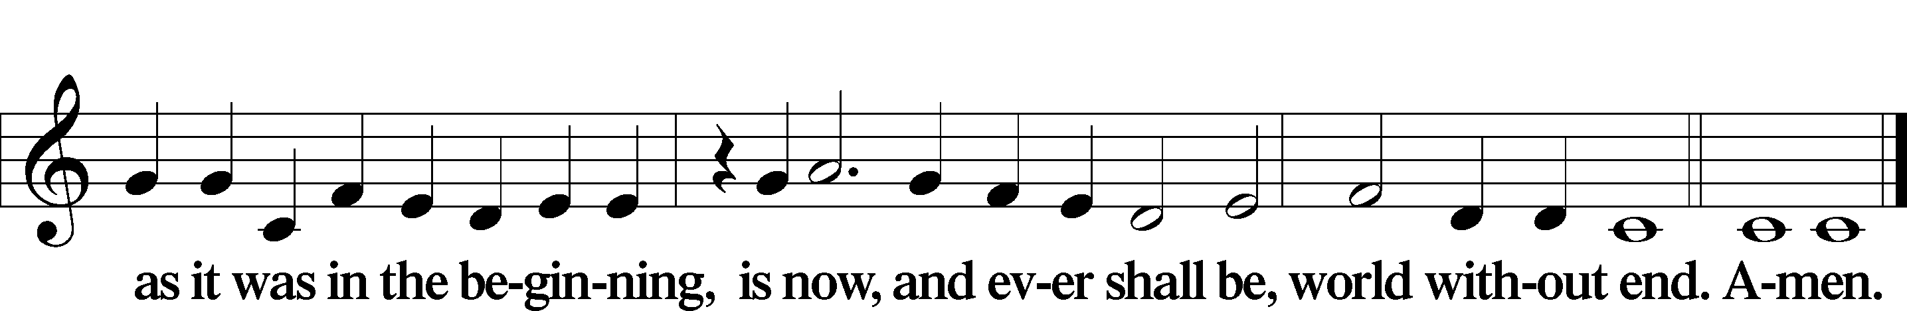

Kyrie Mark 10:47
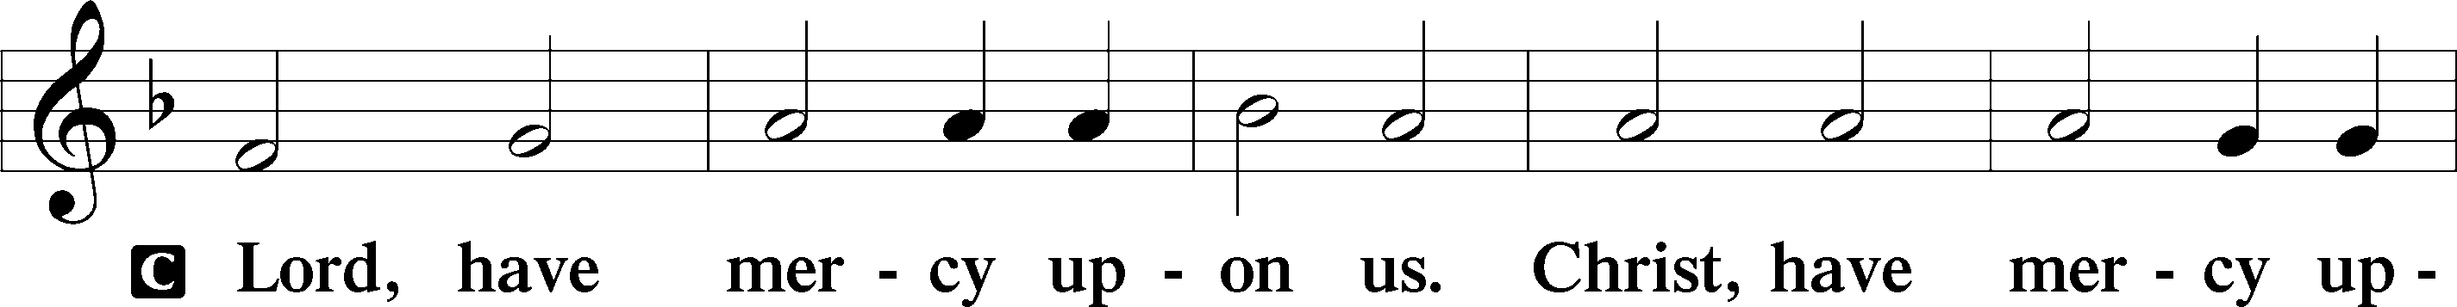
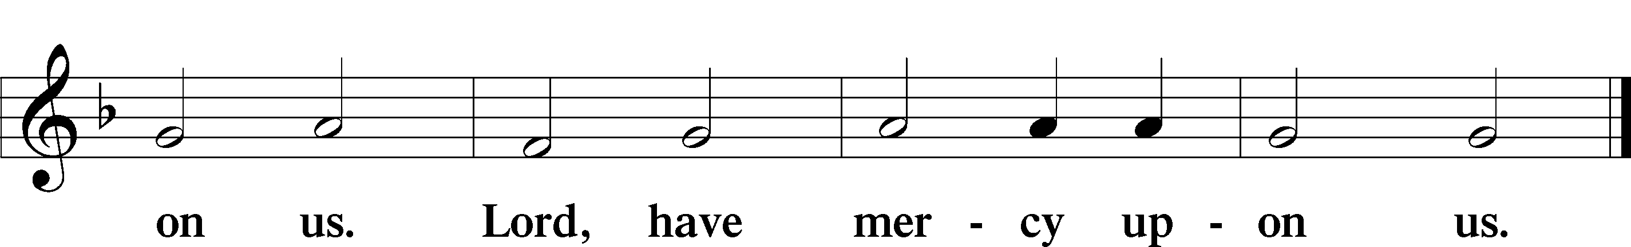

Gloria in Excelsis Luke 2:14; John 1:29
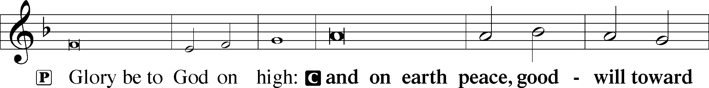
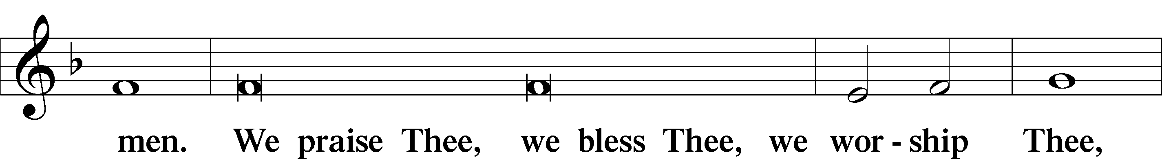
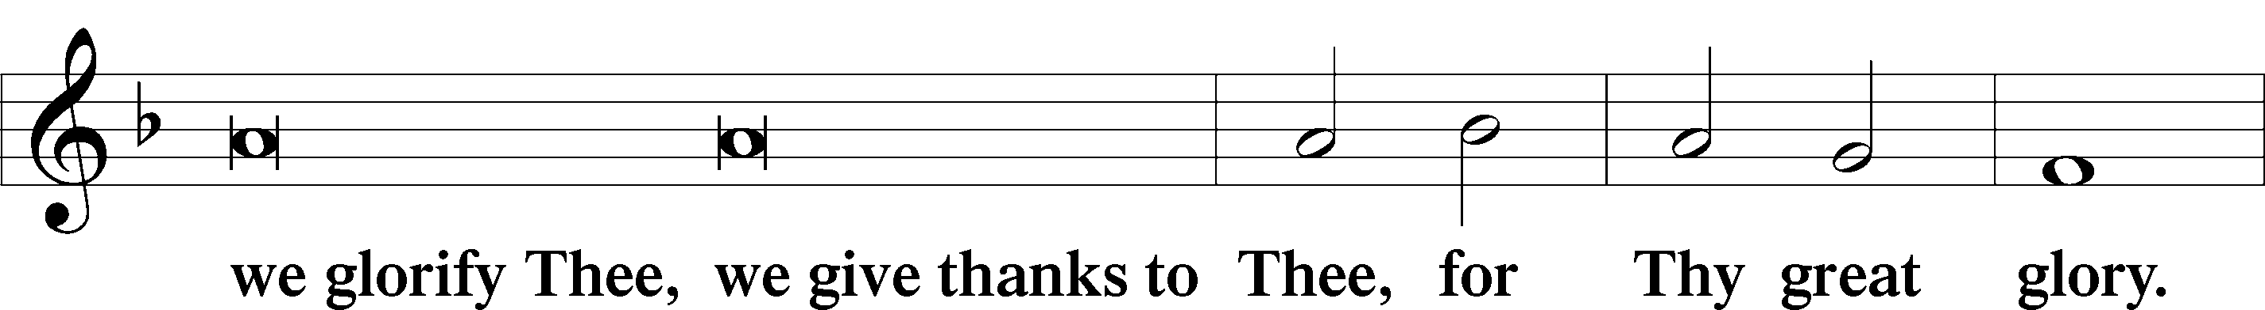
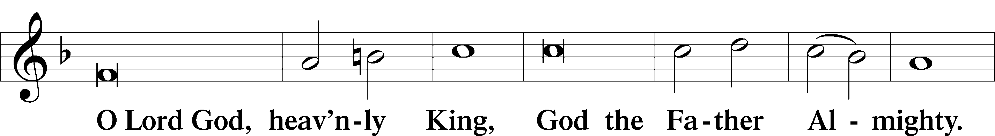
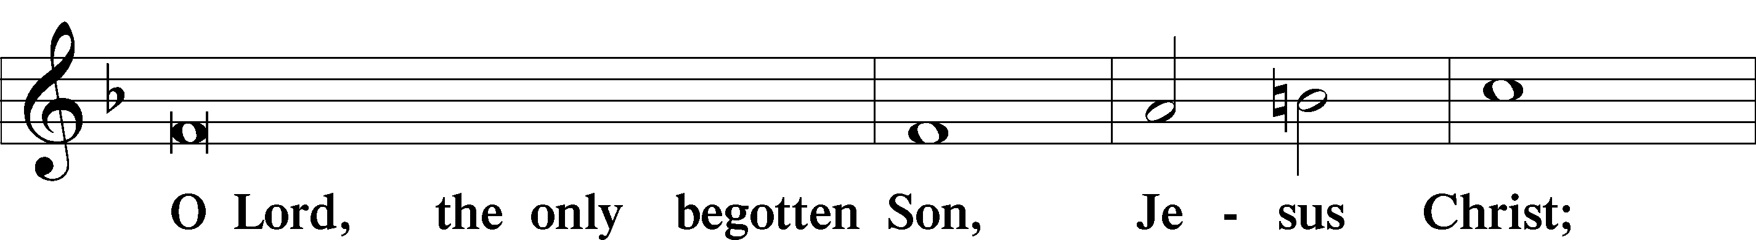
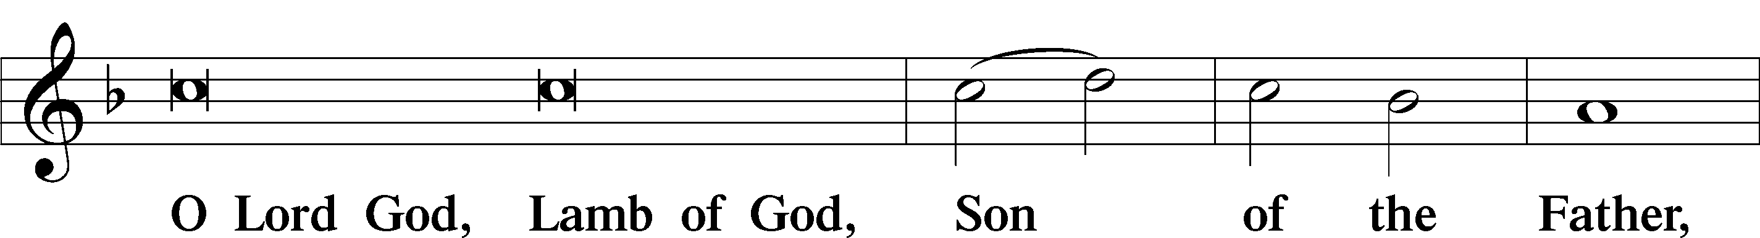
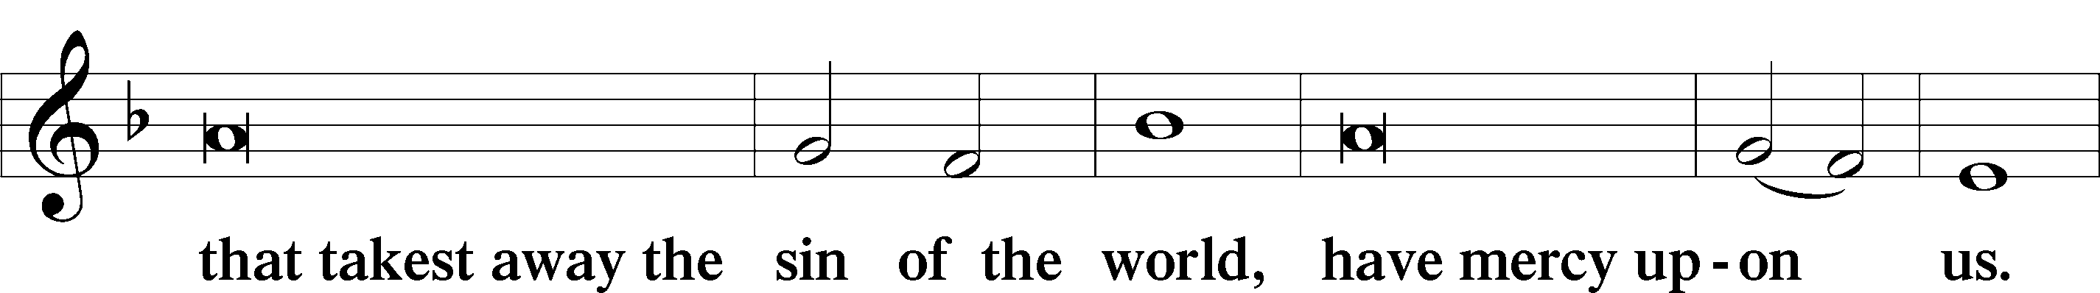
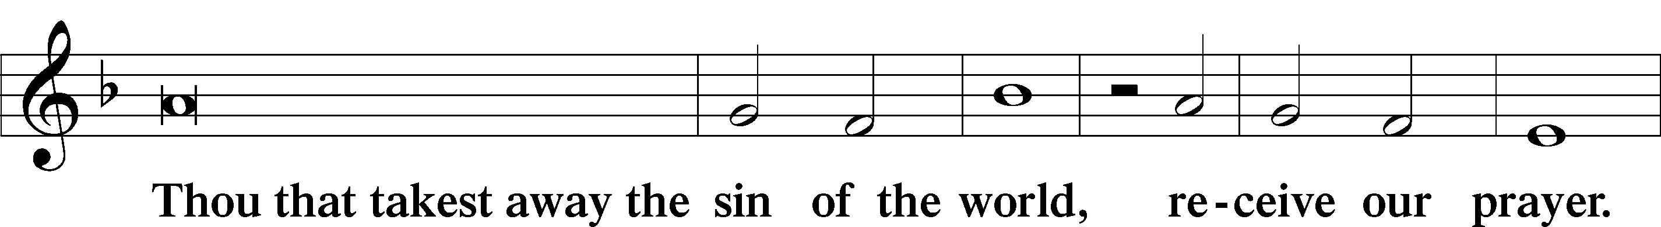
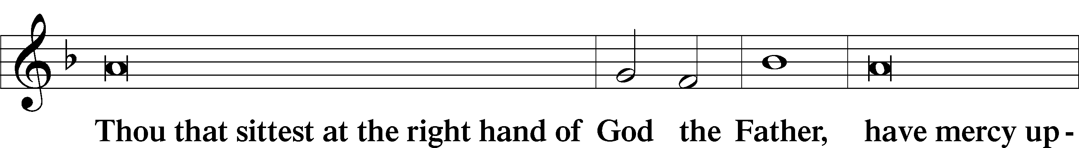
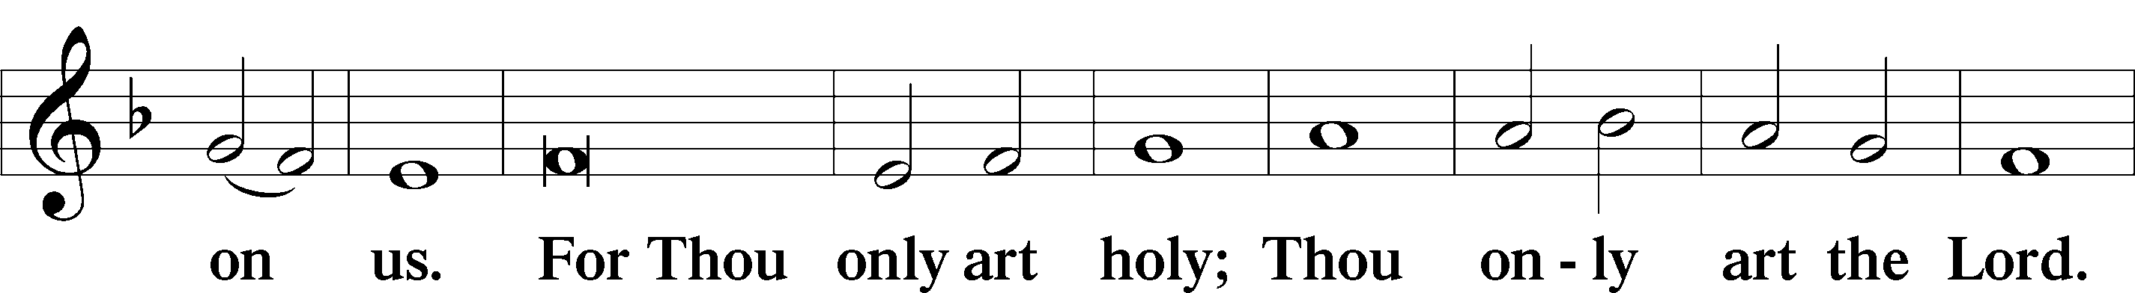
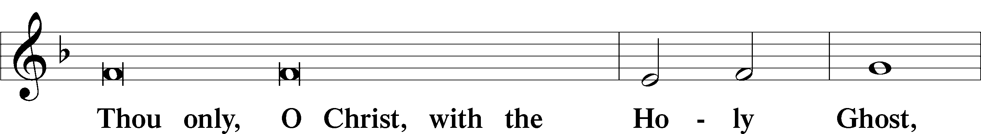
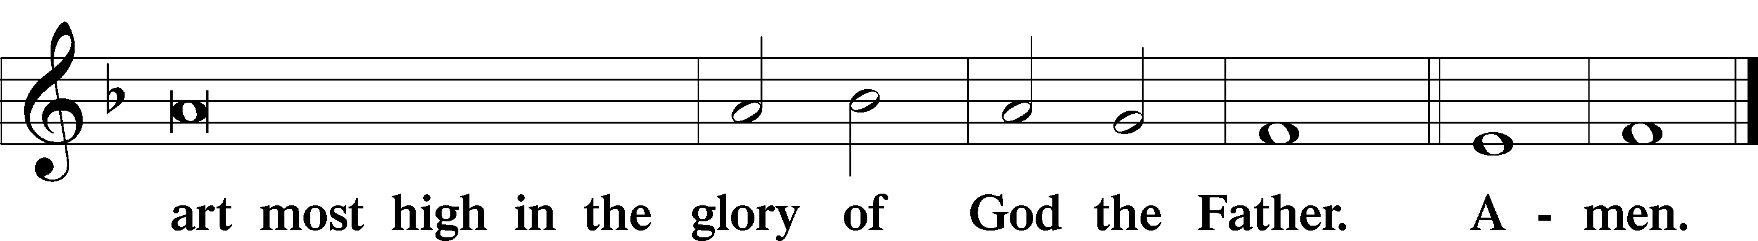

Salutation and Collect of the Day
P The Lord be with you.
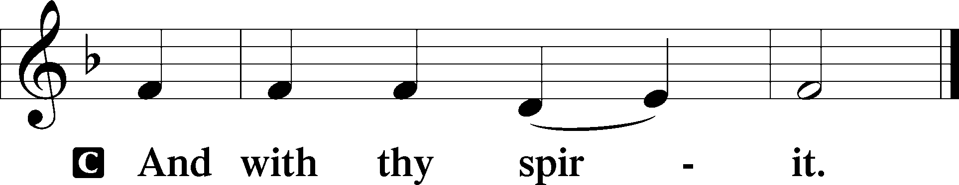

P Let us pray.
Lord God, heavenly Father, since we cannot stand before You relying on anything we have done, help us trust in Your abiding grace and live according to Your Word; through Jesus Christ, Your Son, our Lord, who lives and reigns with You and the Holy Spirit, one God, now and forever.

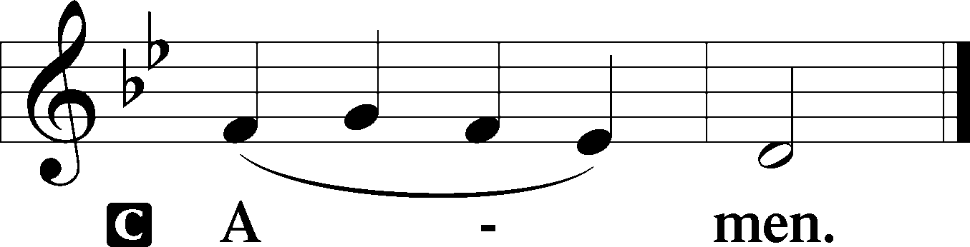

Sit

Old Testament Reading Isaiah 55:6–9
6“Seek the Lord while he may be found; call upon him while he is near; 7let the wicked forsake his way, and the unrighteous man his thoughts; let him return to the Lord, that he may have compassion on him, and to our God, for he will abundantly pardon. 8For my thoughts are not your thoughts, neither are your ways my ways, declares the Lord. 9For as the heavens are higher than the earth, so are my ways higher than your ways and my thoughts than your thoughts.”
A This is the Word of the Lord.
C Thanks be to God.

Gradual Psalm 34:9, 19, alt.
Fear the Lord, you his saints,
for those who fear him lack nothing!
Many are the afflictions of the righteous,
but the Lord delivers him out of them all.

Epistle Philippians 1:12–14, 19–30
12I want you to know, brothers, that what has happened to me has really served to advance the gospel, 13so that it has become known throughout the whole imperial guard and to all the rest that my imprisonment is for Christ. 14And most of the brothers, having become confident in the Lord by my imprisonment, are much more bold to speak the word without fear. . . . 19for I know that through your prayers and the help of the Spirit of Jesus Christ this will turn out for my deliverance, 20as it is my eager expectation and hope that I will not be at all ashamed, but that with full courage now as always Christ will be honored in my body, whether by life or by death. 21For to me to live is Christ, and to die is gain. 22If I am to live in the flesh, that means fruitful labor for me. Yet which I shall choose I cannot tell. 23I am hard pressed between the two. My desire is to depart and be with Christ, for that is far better. 24But to remain in the flesh is more necessary on your account. 25Convinced of this, I know that I will remain and continue with you all, for your progress and joy in the faith, 26so that in me you may have ample cause to glory in Christ Jesus, because of my coming to you again. 27Only let your manner of life be worthy of the gospel of Christ, so that whether I come and see you or am absent, I may hear of you that you are standing firm in one spirit, with one mind striving side by side for the faith of the gospel, 28and not frightened in anything by your opponents. This is a clear sign to them of their destruction, but of your salvation, and that from God. 29For it has been granted to you that for the sake of Christ you should not only believe in him but also suffer for his sake, 30engaged in the same conflict that you saw I had and now hear that I still have.

A This is the Word of the Lord.
C Thanks be to God.

Stand

Alleluia
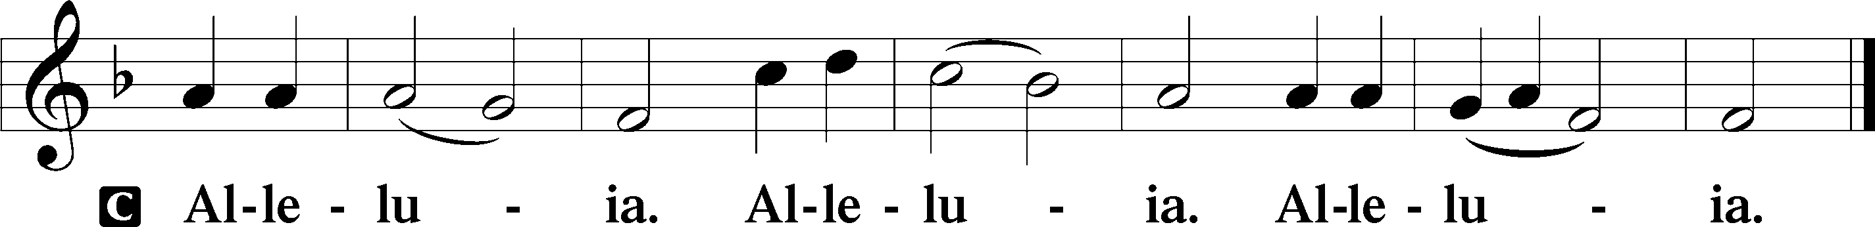

Holy Gospel Matthew 20:1–16
P The Holy Gospel according to St. Matthew, the twentieth chapter.
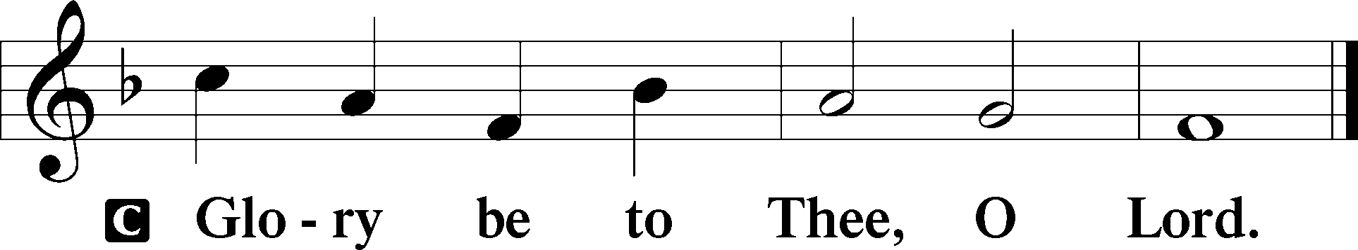

1[Jesus said:] “The kingdom of heaven is like a master of a house who went out early in the morning to hire laborers for his vineyard. 2After agreeing with the laborers for a denarius a day, he sent them into his vineyard. 3And going out about the third hour he saw others standing idle in the marketplace, 4and to them he said, ‘You go into the vineyard too, and whatever is right I will give you.’ 5So they went. Going out again about the sixth hour and the ninth hour, he did the same. 6And about the eleventh hour he went out and found others standing. And he said to them, ‘Why do you stand here idle all day?’ 7They said to him, ‘Because no one has hired us.’ He said to them, ‘You go into the vineyard too.’ 8And when evening came, the owner of the vineyard said to his foreman, ‘Call the laborers and pay them their wages, beginning with the last, up to the first.’ 9And when those hired about the eleventh hour came, each of them received a denarius. 10Now when those hired first came, they thought they would receive more, but each of them also received a denarius. 11And on receiving it they grumbled at the master of the house, 12saying, ‘These last worked only one hour, and you have made them equal to us who have borne the burden of the day and the scorching heat.’ 13But he replied to one of them, ‘Friend, I am doing you no wrong. Did you not agree with me for a denarius? 14Take what belongs to you and go. I choose to give to this last worker as I give to you. 15Am I not allowed to do what I choose with what belongs to me? Or do you begrudge my generosity?’ 16So the last will be first, and the first last.”

P This is the Gospel of the Lord.

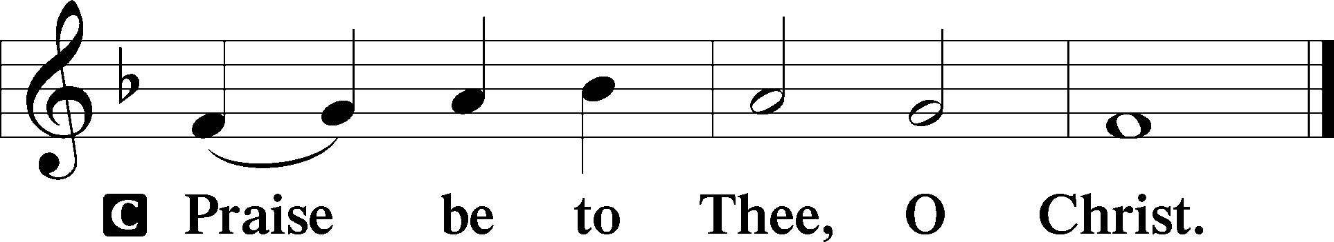

Nicene Creed
C I believe in one God,
the Father Almighty,
maker of heaven and earth
and of all things visible and invisible.

And in one Lord Jesus Christ,
the only-begotten Son of God,
begotten of His Father before all worlds,
God of God, Light of Light,
very God of very God,
begotten, not made,
being of one substance with the Father,
by whom all things were made;
who for us men and for our salvation came down from heaven
and was incarnate by the Holy Spirit of the virgin Mary
and was made man;
and was crucified also for us under Pontius Pilate.
He suffered and was buried.
And the third day He rose again according to the Scriptures
and ascended into heaven
and sits at the right hand of the Father.
And He will come again with glory to judge both the living and the dead,
whose kingdom will have no end.

And I believe in the Holy Spirit,
the Lord and giver of life,
who proceeds from the Father and the Son,
who with the Father and the Son together is worshiped and glorified,
who spoke by the prophets.
And I believe in one holy Christian and apostolic Church,
I acknowledge one Baptism for the remission of sins,
and I look for the resurrection of the dead
and the life T of the world to come. Amen.

Sit

Children's Sermon

827 Hark, the Voice of Jesus Calling
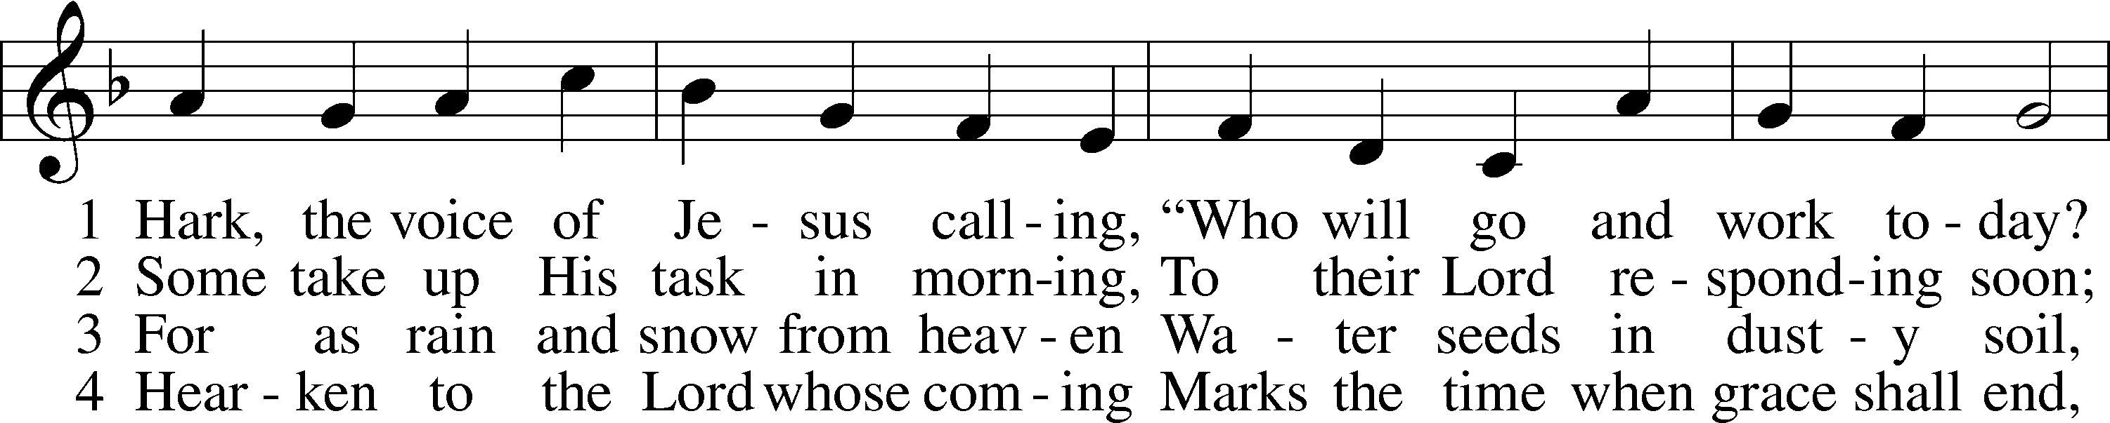
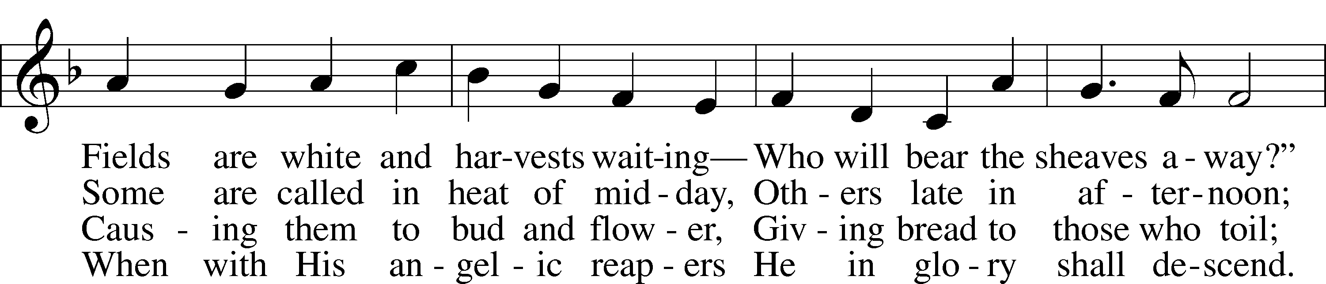
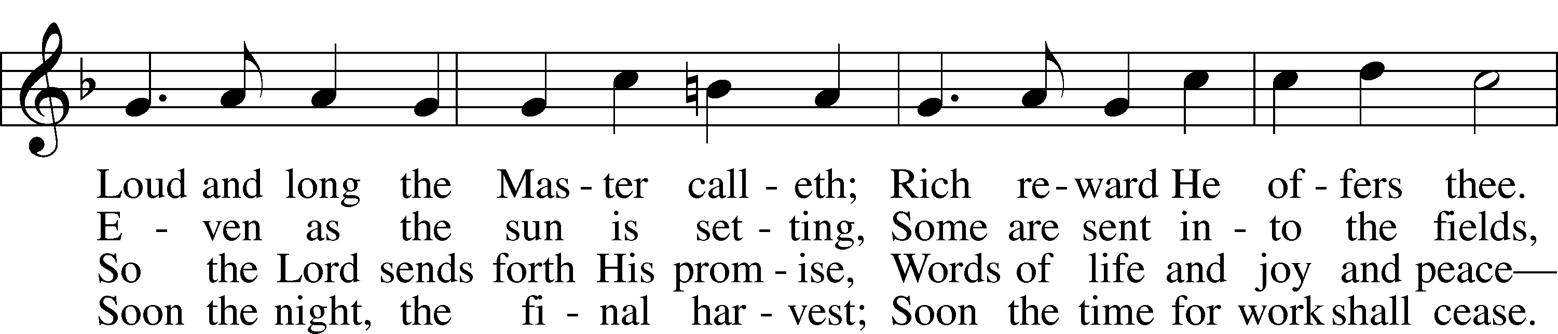
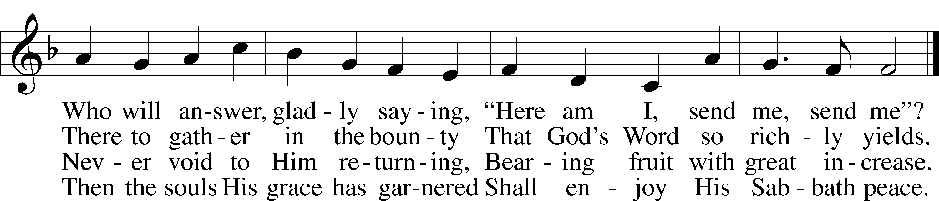
Text (st. 1): Daniel March, 1816–1909, alt.; (sts. 2–4): Stephen P. Starke, 1955
Tune: Joseph Barnby, 1838–96
Text (sts. 2–4): © 2001 Stephen P. Starke, admin. Concordia Publishing House. Used by permission: LSB Hymn License no. 110005011
Text (st. 1) and tune: Public domain

Sermon

Votum
P The peace of God, which passes all understanding, keep your hearts and minds in Christ Jesus.
C Amen.

Stand

Offertory Psalm 51:10–12
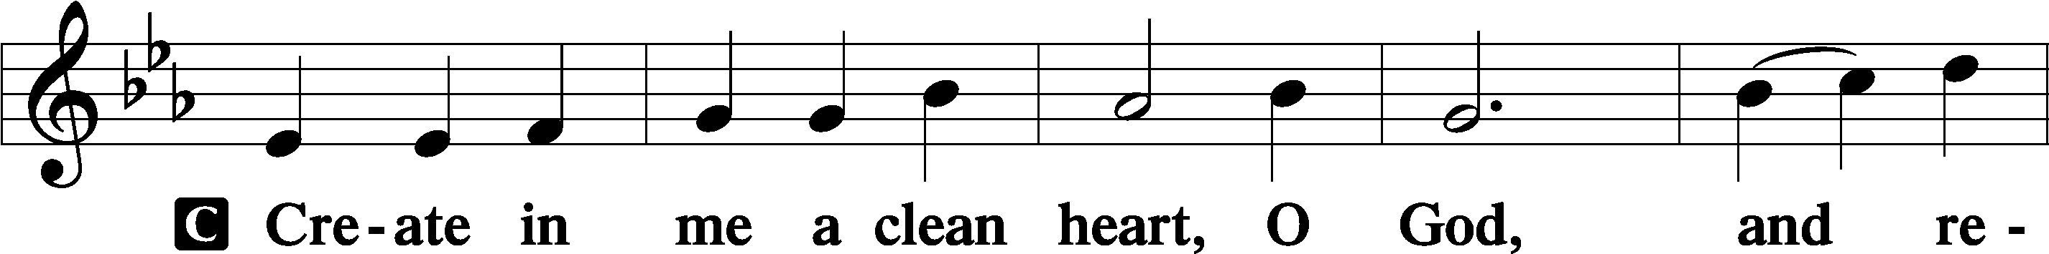
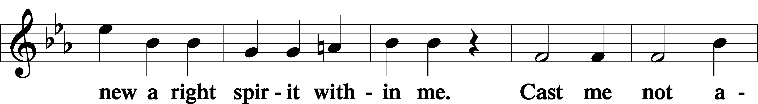
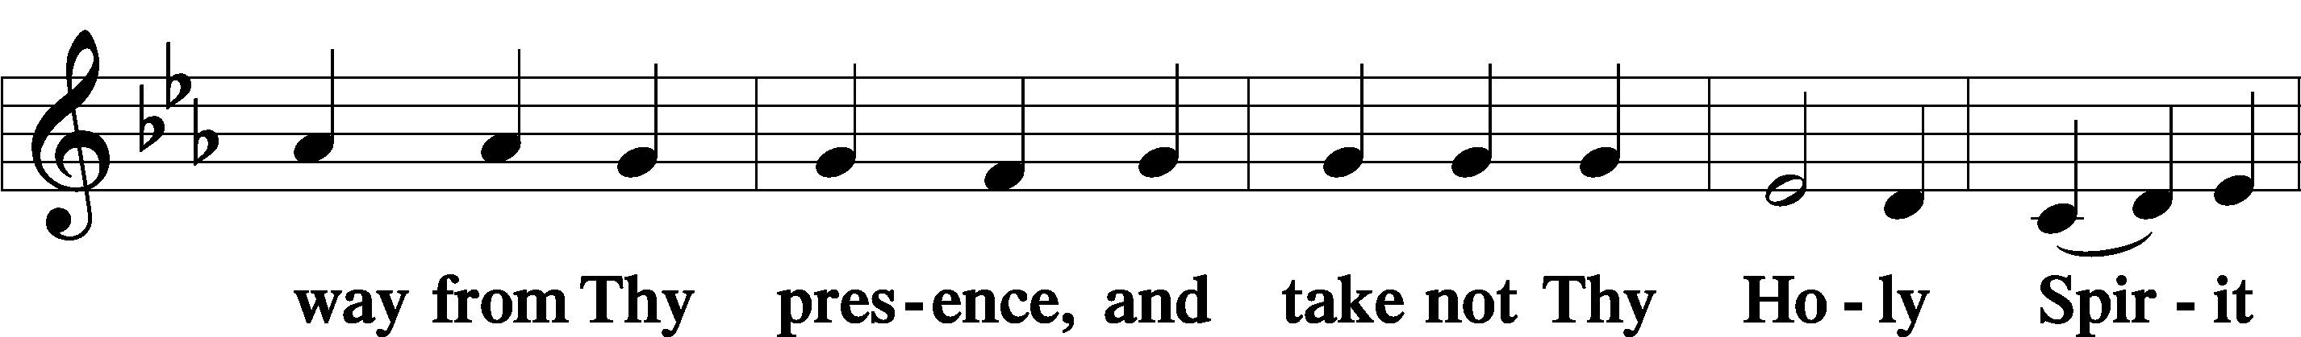
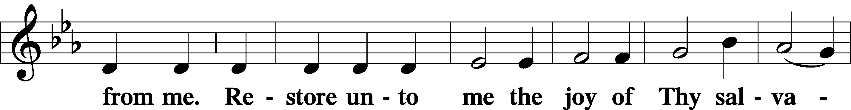
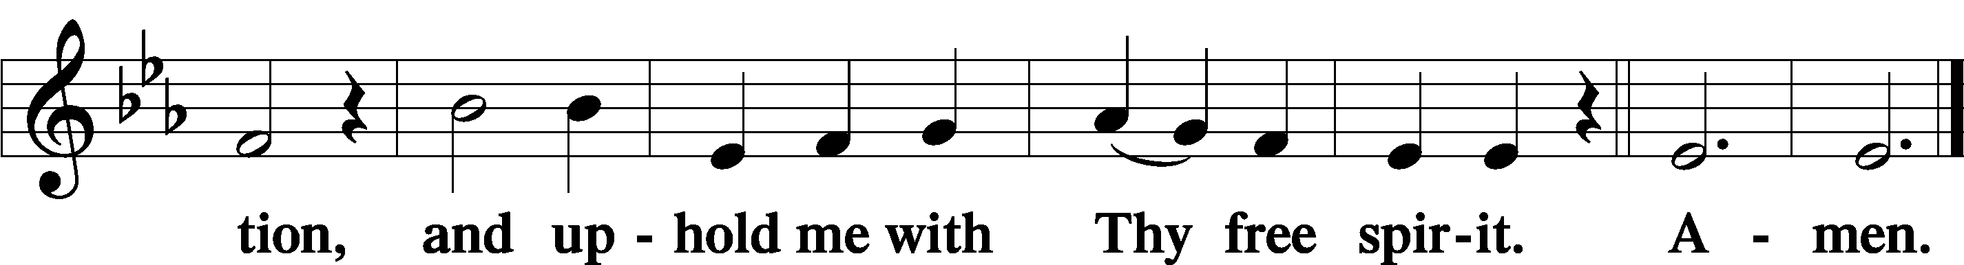

Sit

Offering

805 Praise God, from Whom All Blessings Flow
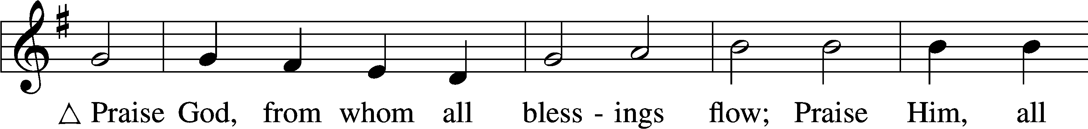
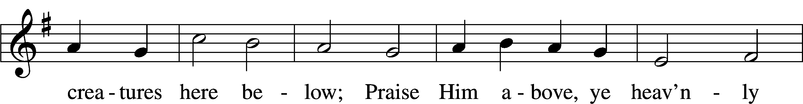
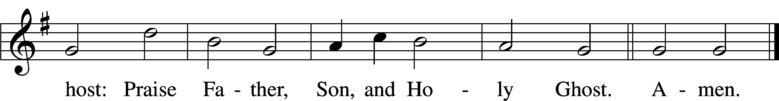
Text: Thomas Ken, 1637–1711
Tune: Trente quatre Pseaumes de David, 1551, Geneva, ed. Louis Bourgeois
Text and tune: Public domain

Stand

Prayer of the Church

Service of the Sacrament

Preface 2 Timothy 4:22; [Colossians 3:1]; [Psalm 136]
P The Lord be with you.
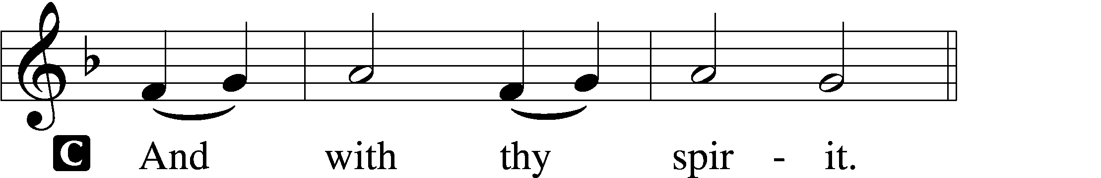

P Lift up your hearts.
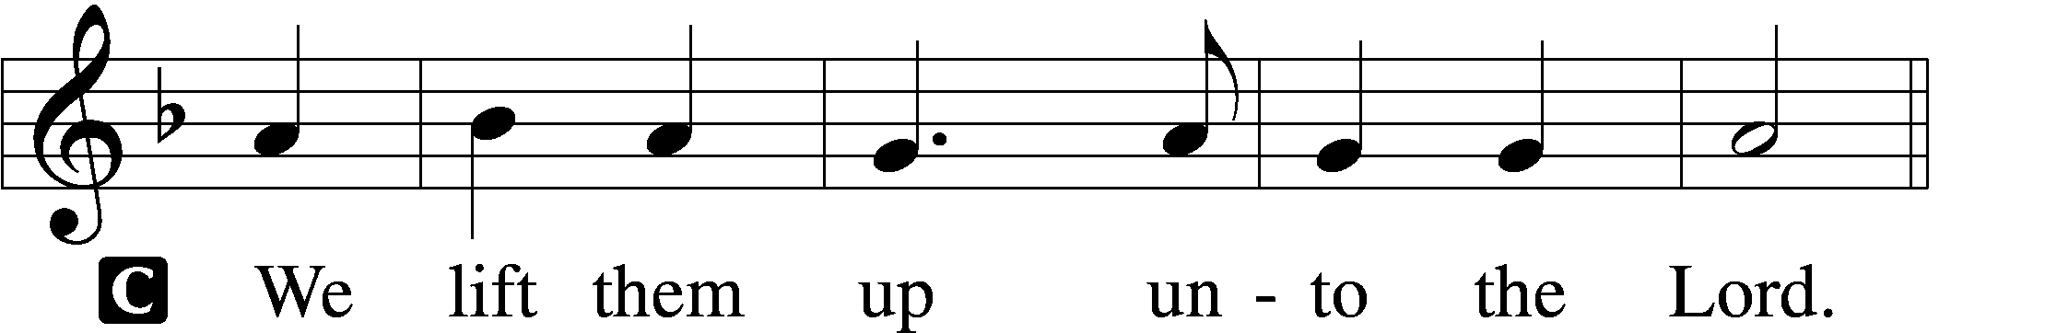

P Let us give thanks unto the Lord, our God.
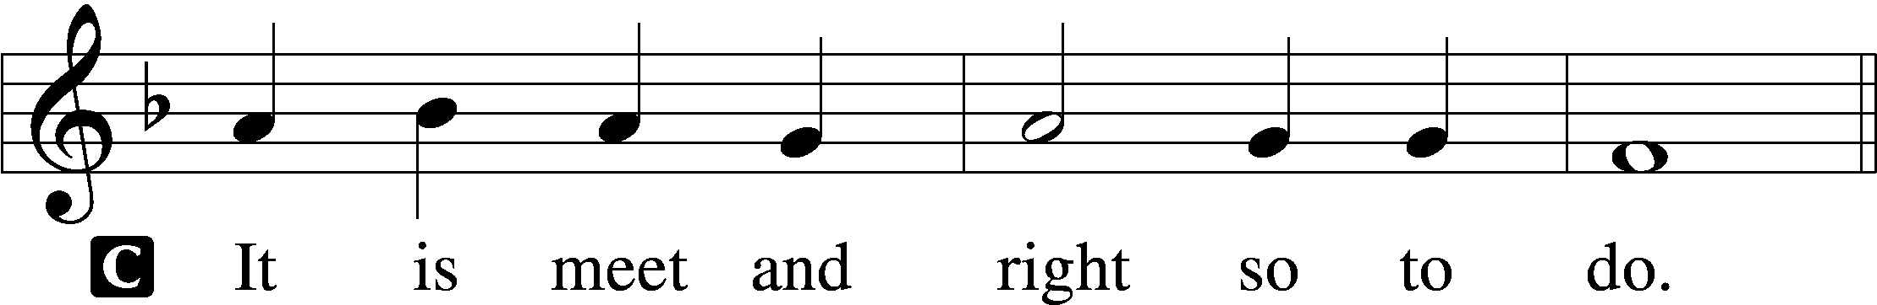

Proper Preface (Full)
P It is truly meet, right, and salutary that we should at all times and in all places give thanks to You, holy Lord, almighty Father, everlasting God, through Jesus Christ, our Lord, who on this day overcame death and the grave and by His glorious resurrection opened to us the way of everlasting life. Therefore with angels and archangels and with all the company of heaven we laud and magnify Your glorious name, evermore praising You and saying:

Sanctus Isaiah 6:3; Matthew 21:9
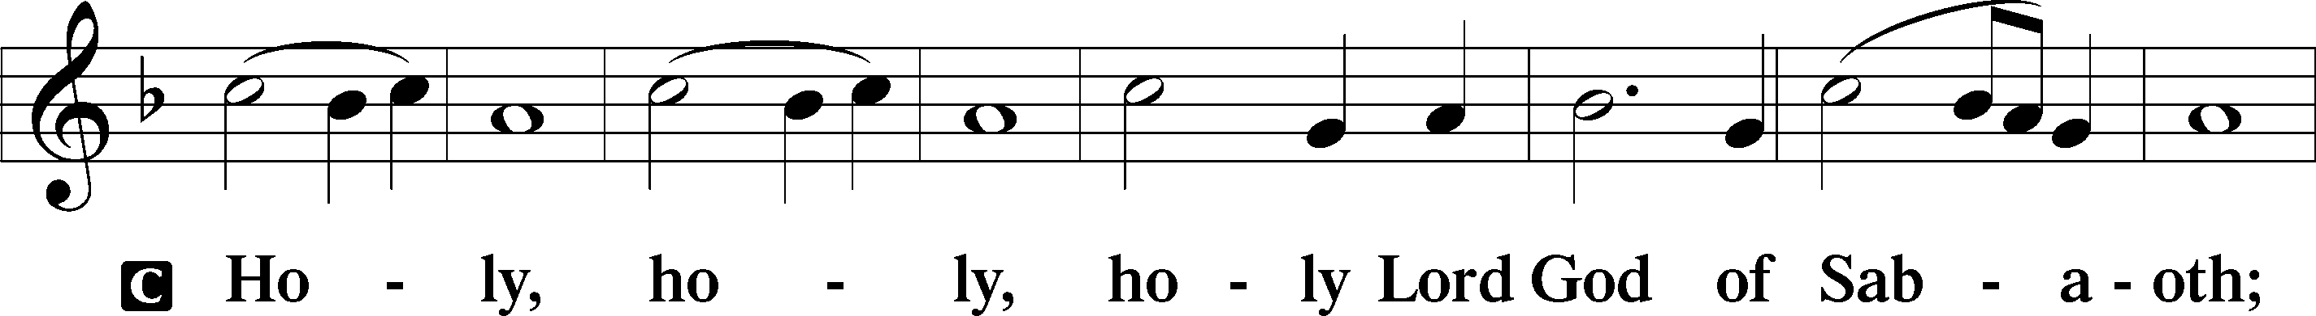
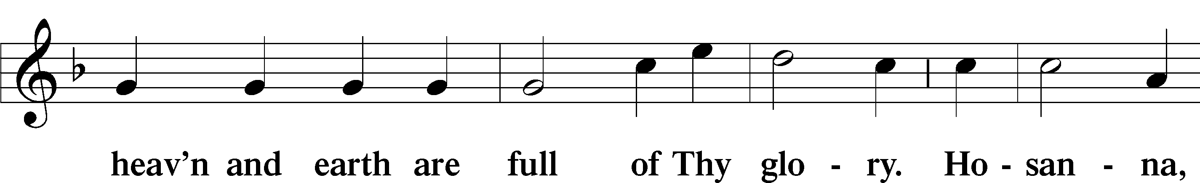
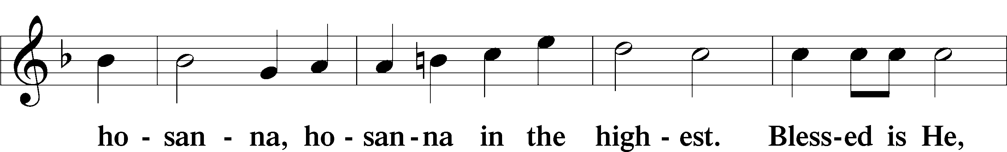
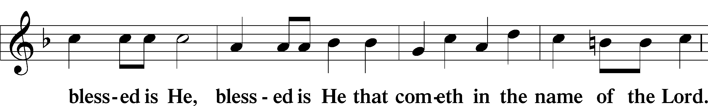
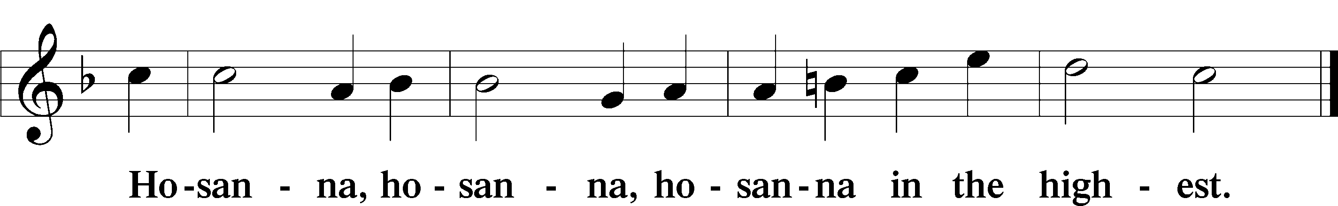

Lord’s Prayer Matthew 6:9–13
P Our Father who art in heaven,
hallowed be Thy name,
Thy kingdom come,
Thy will be done on earth as it is in heaven;
give us this day our daily bread;
and forgive us our trespasses as we forgive those who trespass against us;
and lead us not into temptation,
but deliver us from evil.
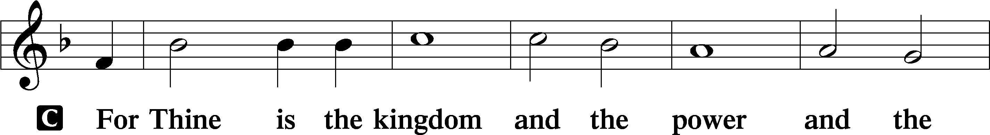
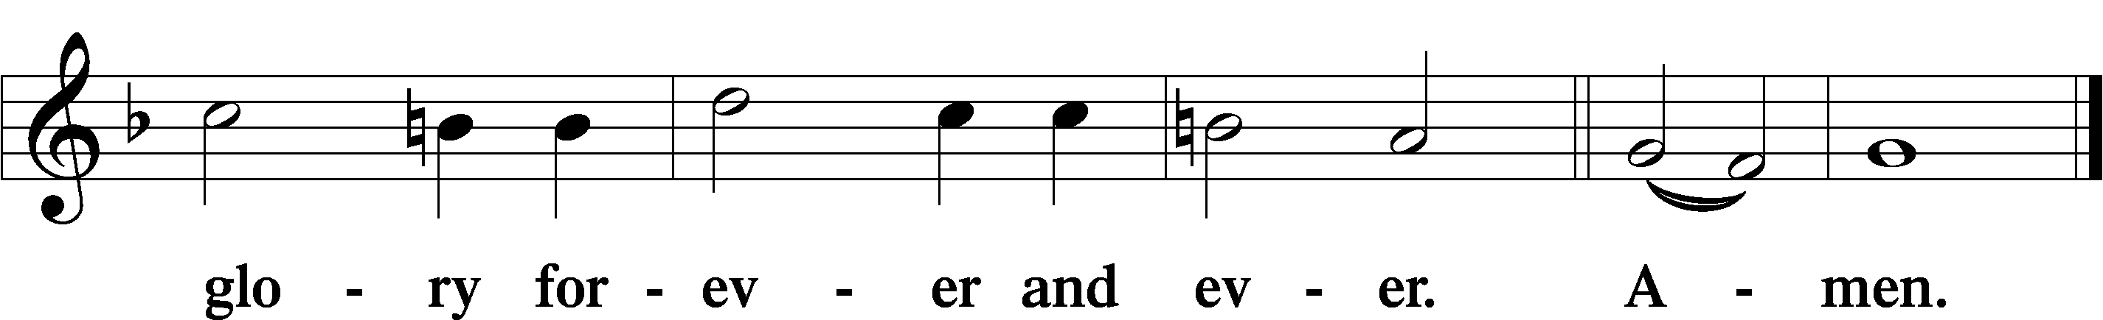

The Words of Our Lord Matthew 26:26–28; Mark 14:22–24; Luke 22:19–20; 1 Corinthians 11:23–25
P Our Lord Jesus Christ, on the night when He was betrayed, took bread, and when He had given thanks, He broke it and gave it to the disciples and said: “Take, eat; this is My T body, which is given for you. This do in remembrance of Me.”

In the same way also He took the cup after supper, and when He had given thanks, He gave it to them, saying: “Drink of it, all of you; this cup is the new testament in My T blood, which is shed for you for the forgiveness of sins. This do, as often as you drink it, in remembrance of Me.”

Pax Domini John 20:19
P The peace of the Lord be with you always.
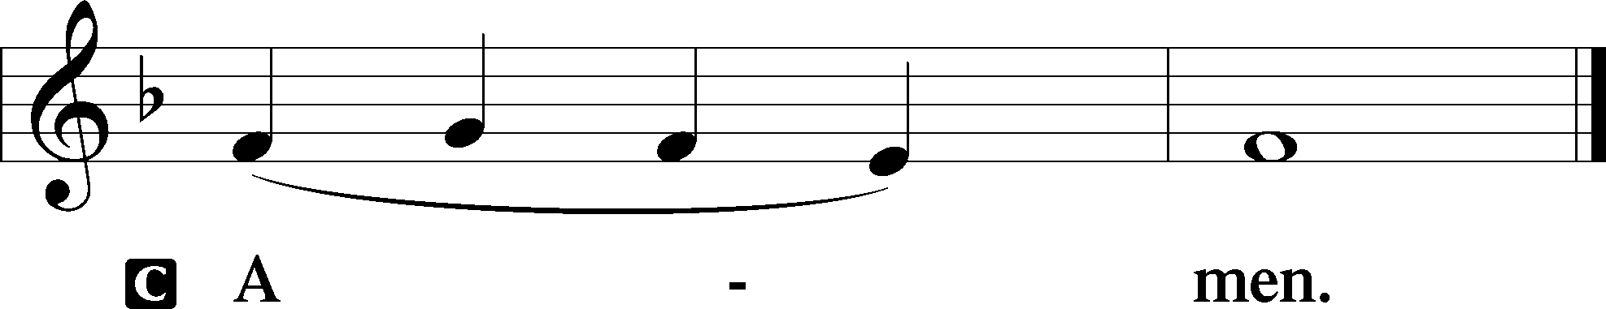

Agnus Dei John 1:29
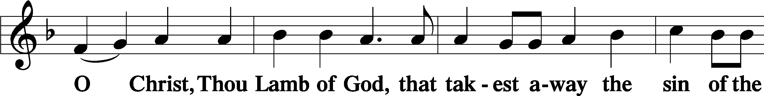
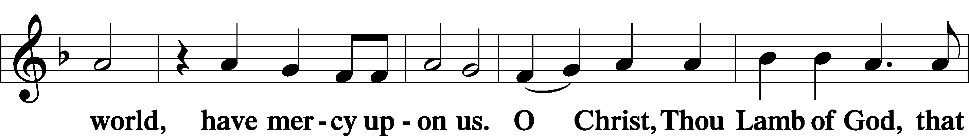
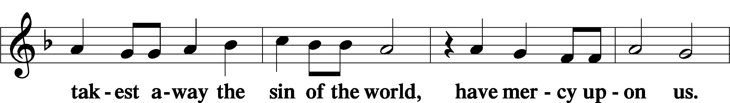
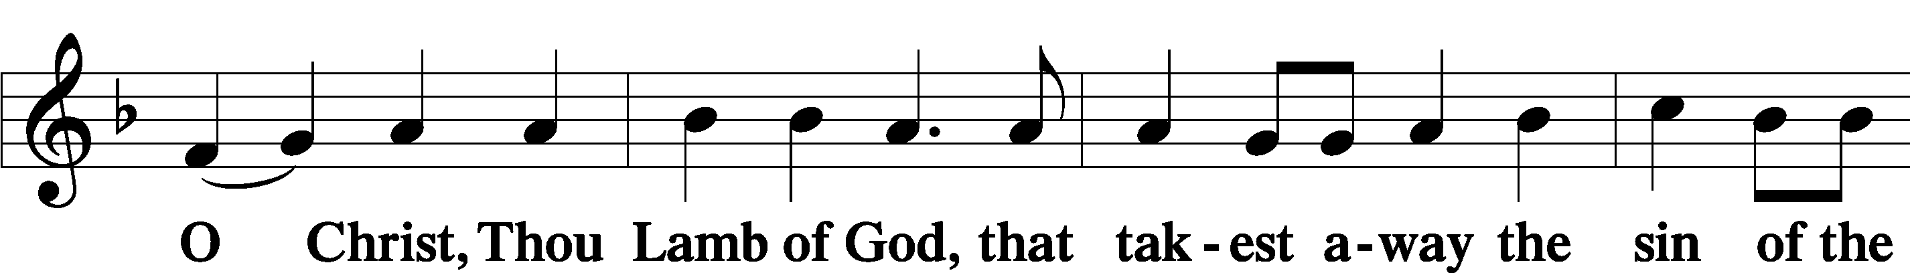
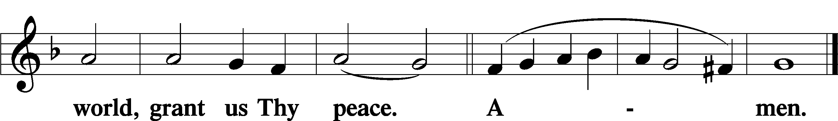

Sit

Distribution

The pastor and those who assist him receive the body and blood of Christ first and then distribute them to those who come to receive, saying:

Take, eat; this is the true body of our Lord and Savior Jesus Christ, given into death for your sins.
Amen.

Take, drink; this is the true blood of our Lord and Savior Jesus Christ, shed for the forgiveness of your sins.
Amen.

In dismissing the communicants, the following is said:

The Dismissal
P The body and blood of our Lord Jesus Christ strengthen and preserve you in body and soul to life everlasting. Depart T in peace.
C Amen.

656 A Mighty Fortress Is Our God
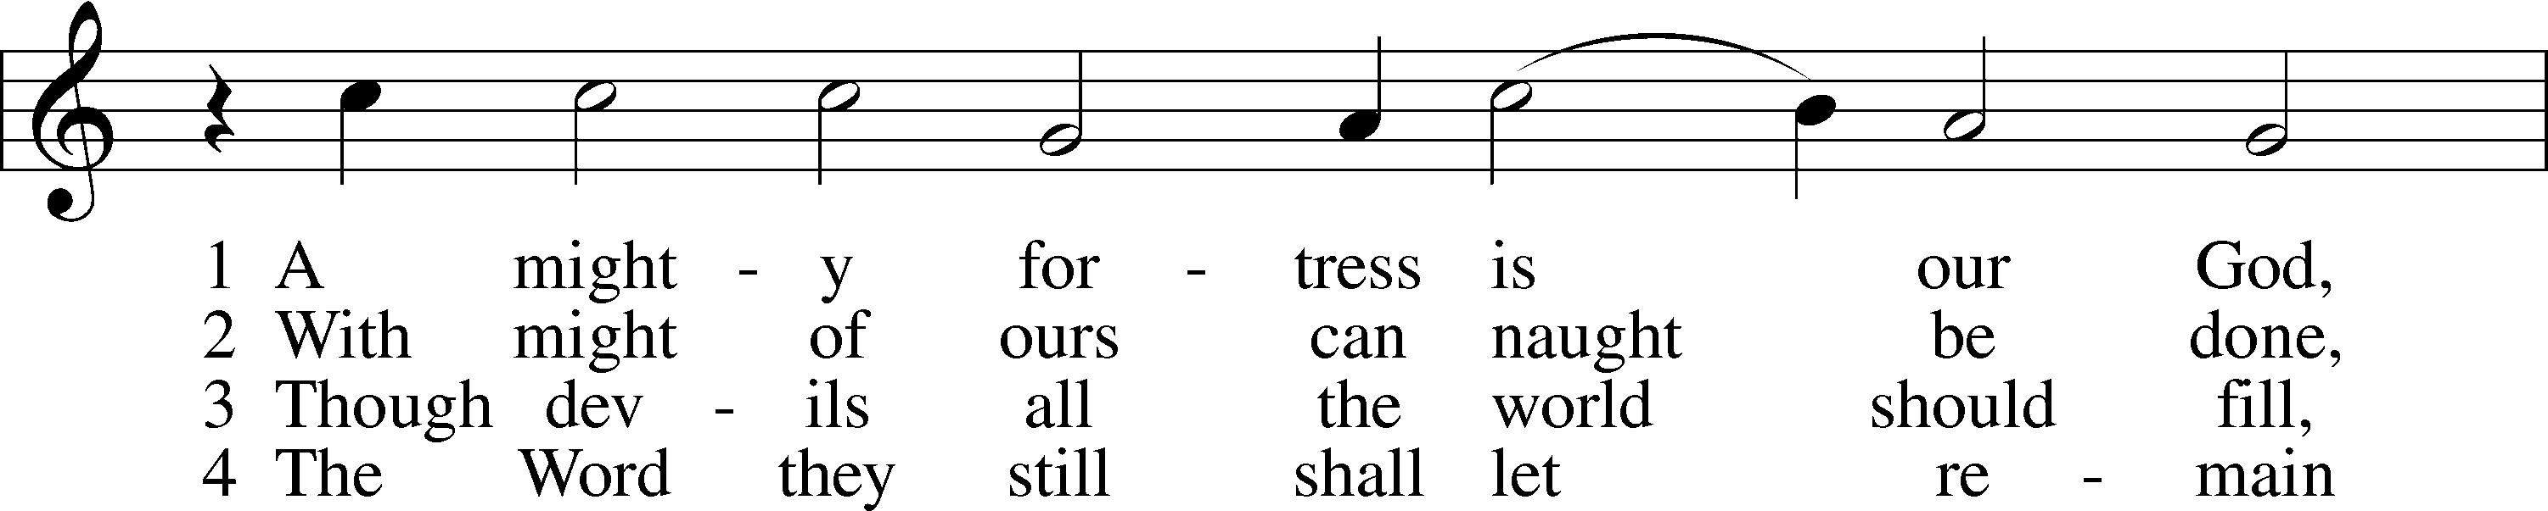
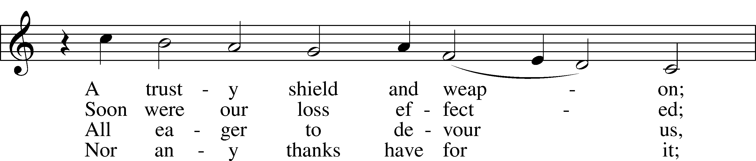
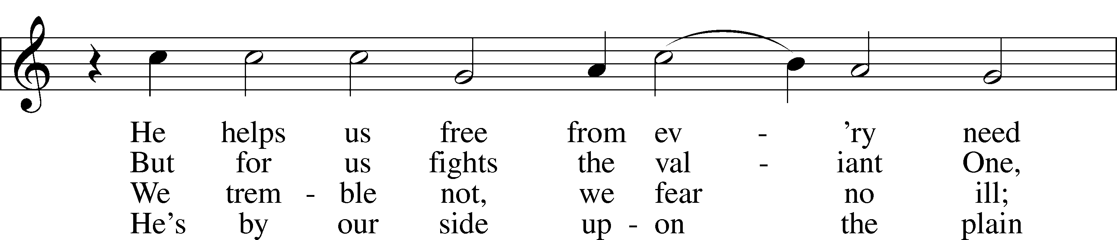
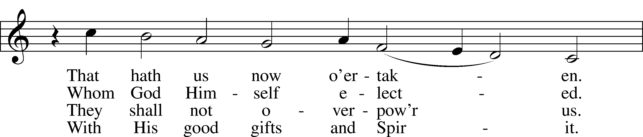
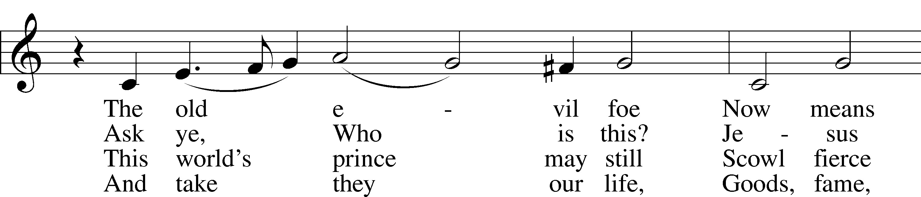
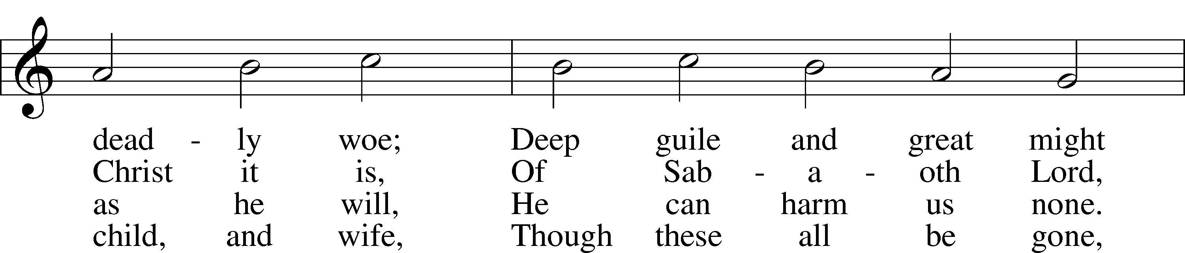
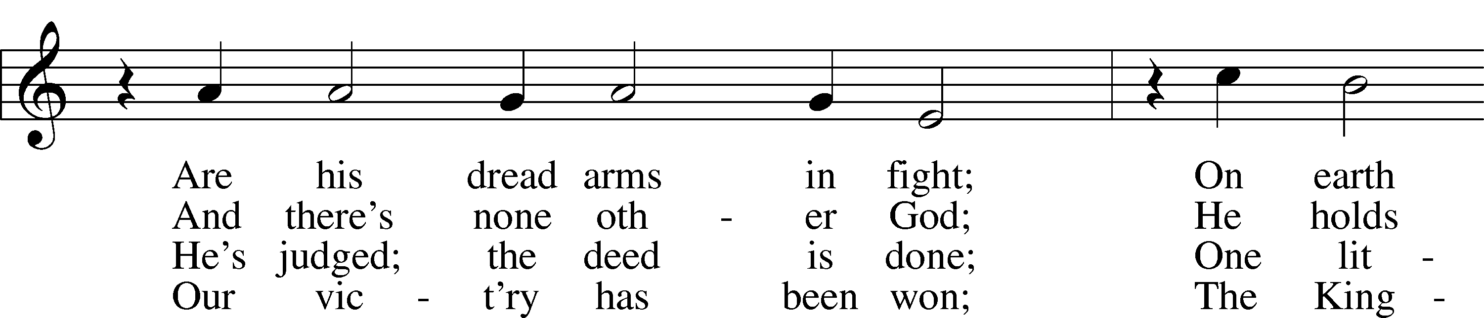
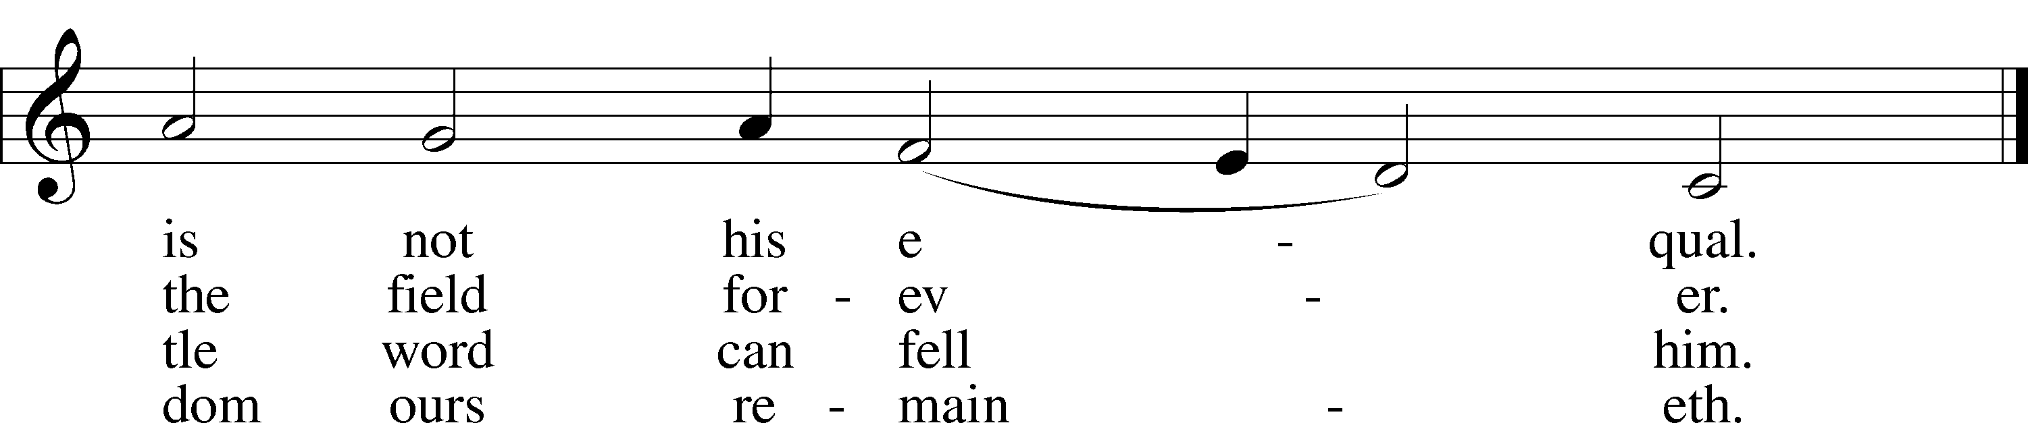
Text: tr. composite
Text and tune: Martin Luther, 1483–1546
Text and tune: Public domain

555 Salvation unto Us Has Come
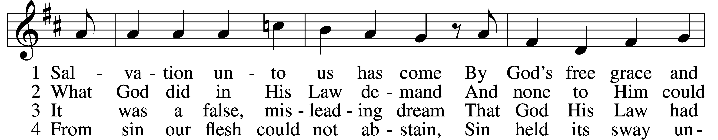
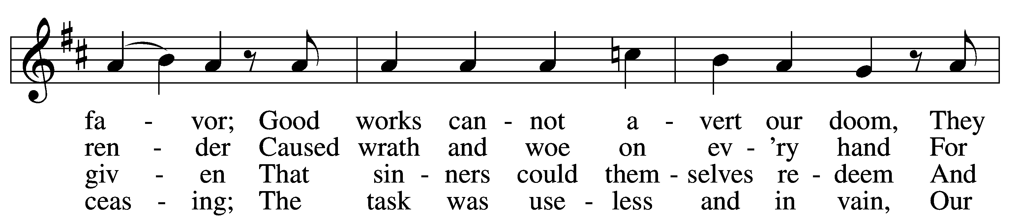
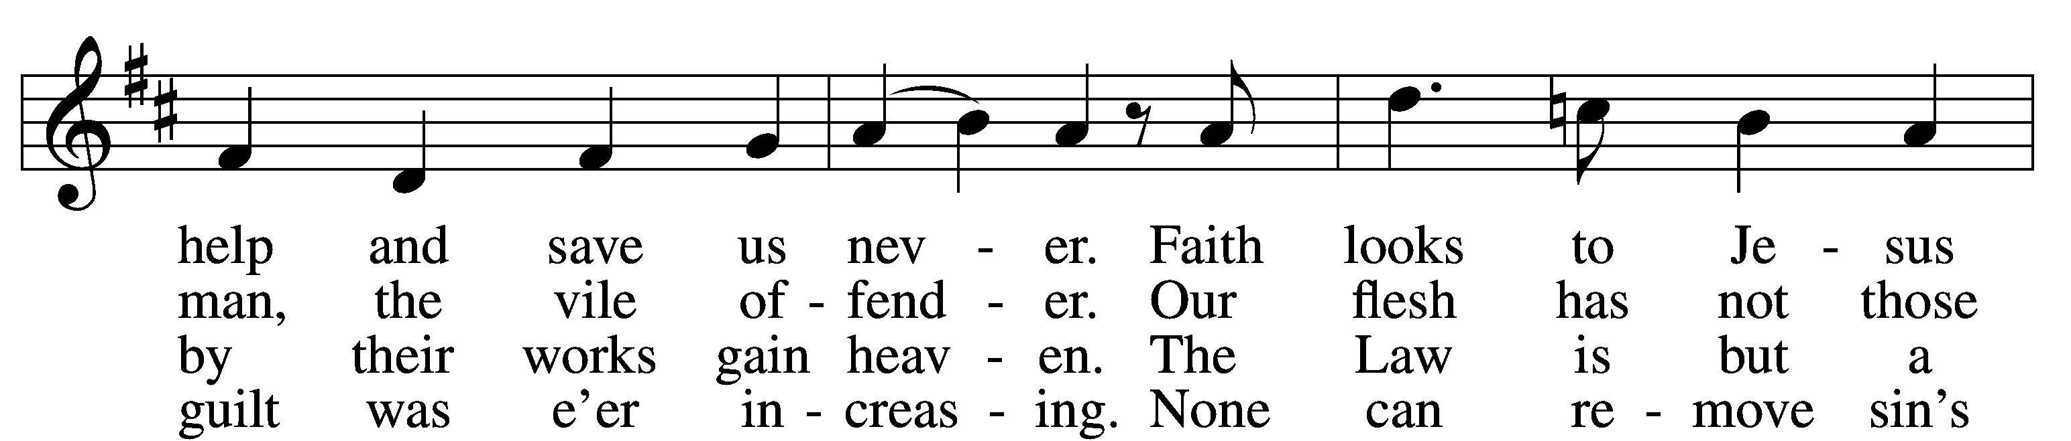
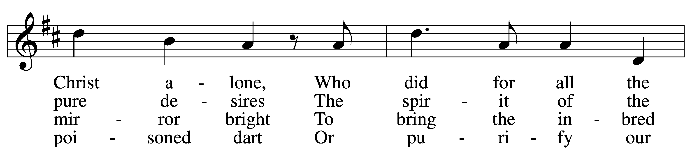
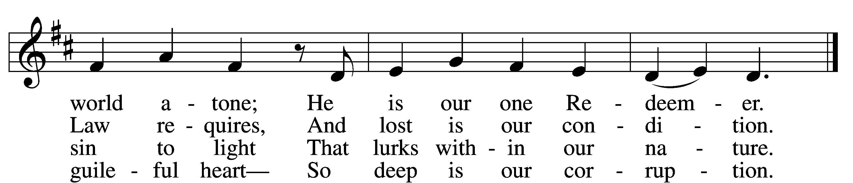

5 Yet as the Law must be fulfilled
Or we must die despairing,
Christ came and has God’s anger stilled,
Our human nature sharing.
He has for us the Law obeyed
And thus the Father’s vengeance stayed
Which over us impended.

6 Since Christ has full atonement made
And brought to us salvation,
Each Christian therefore may be glad
And build on this foundation.
Your grace alone, dear Lord, I plead,
Your death is now my life indeed,
For You have paid my ransom.

7 Let me not doubt, but truly see
Your Word cannot be broken;
Your call rings out, “Come unto Me!”
No falsehood have You spoken.
Baptized into Your precious name,
My faith cannot be put to shame,
And I shall never perish.

8 The Law reveals the guilt of sin
And makes us conscience-stricken;
But then the Gospel enters in
The sinful soul to quicken.
Come to the cross, trust Christ, and live;
The Law no peace can ever give,
No comfort and no blessing.

9 Faith clings to Jesus’ cross alone
And rests in Him unceasing;
And by its fruits true faith is known,
With love and hope increasing.
For faith alone can justify;
Works serve our neighbor and supply
The proof that faith is living.

D 10 All blessing, honor, thanks, and praise
To Father, Son, and Spirit,
The God who saved us by His grace;
All glory to His merit.
O triune God in heav’n above,
You have revealed Your saving love;
Your blessèd name we hallow.
Text: Paul Speratus, 1484–1551; tr. The Lutheran Hymnal, 1941, alt.
Tune: Etlich Cristlich lider, 1524, Wittenberg
Text and tune: Public domain

Stand

Nunc Dimittis Luke 2:29–32
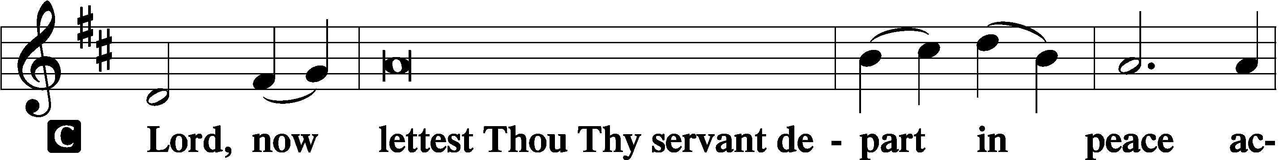
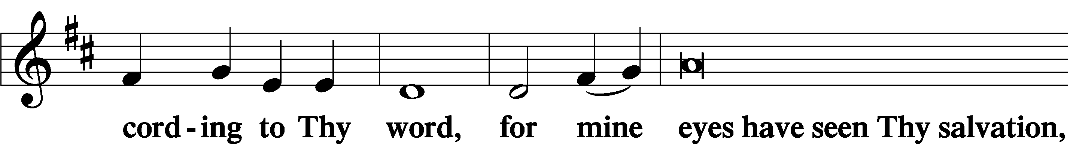
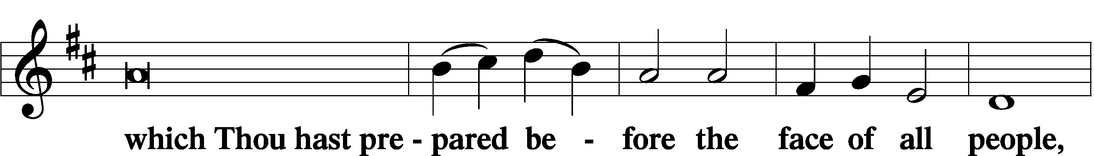
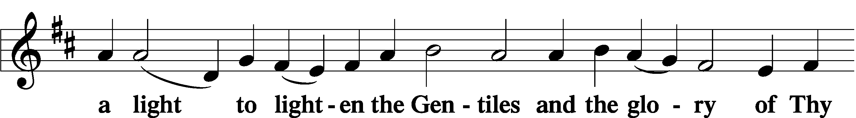
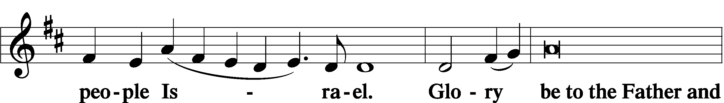
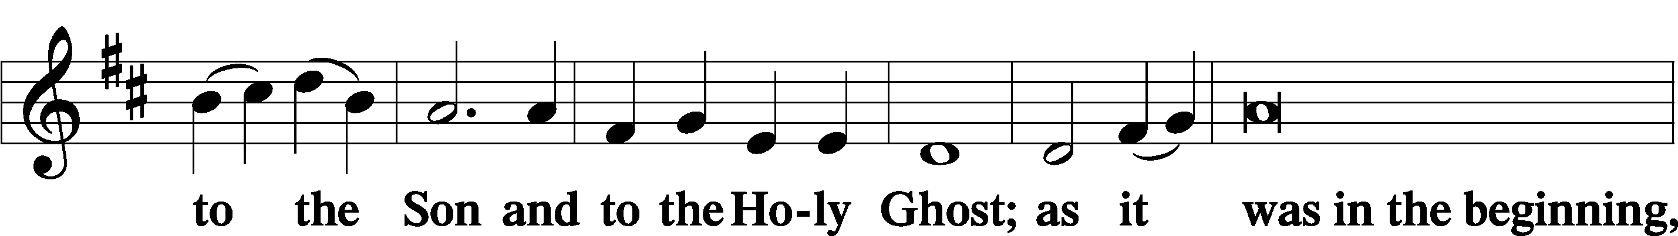
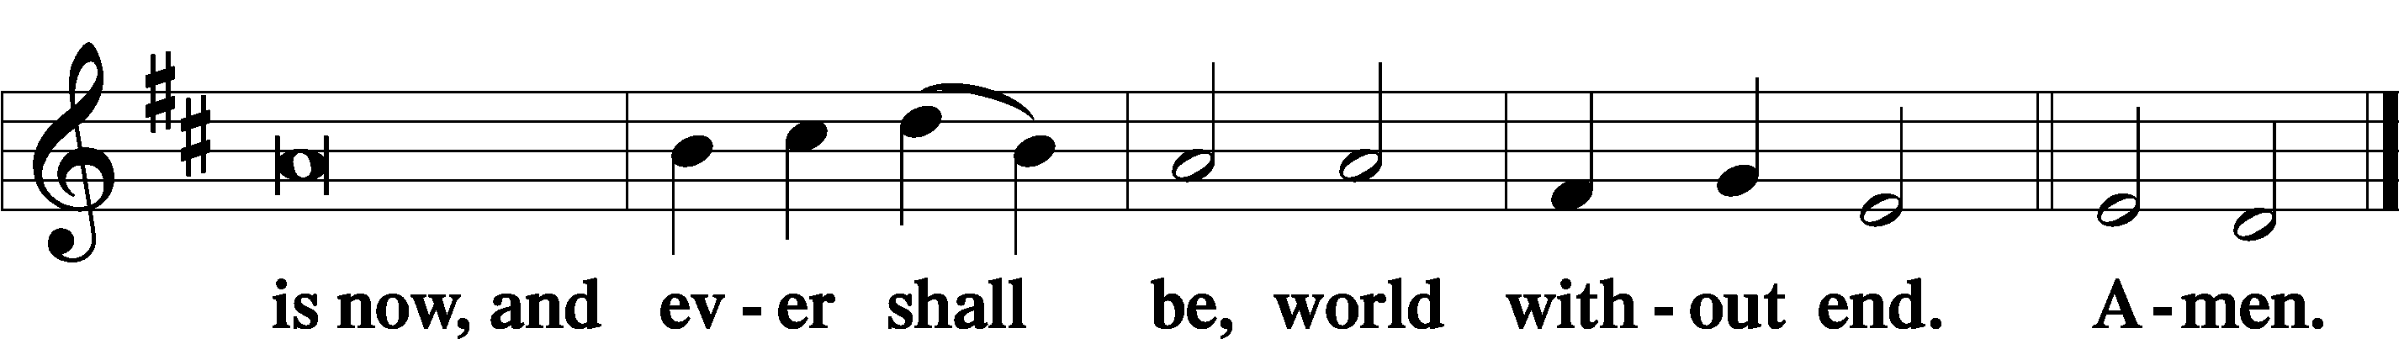

Thanksgiving Psalm 107:1
A O give thanks unto the Lord, for He is good,

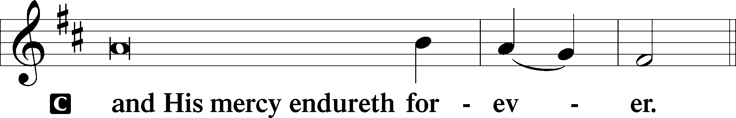

Post-Communion Collect
A Let us pray.
We give thanks to You, almighty God, that You have refreshed us through this salutary gift, and we implore You that of Your mercy You would strengthen us through the same in faith toward You and in fervent love toward one another; through Jesus Christ, Your Son, our Lord, who lives and reigns with You and the Holy Spirit, one God, now and forever.

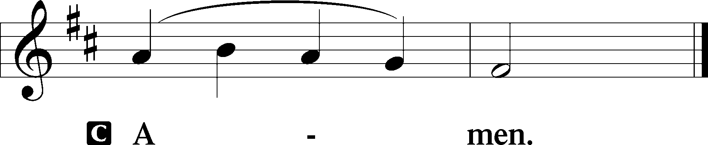

Salutation 2 Timothy 4:22
P The Lord be with you.
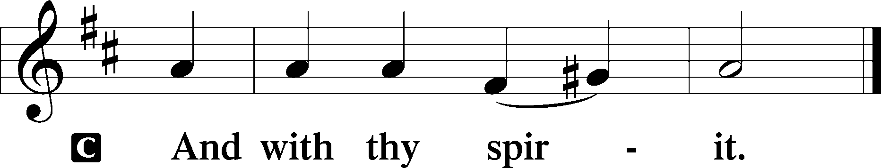

Benedicamus Psalm 103:1
A Bless we the Lord.
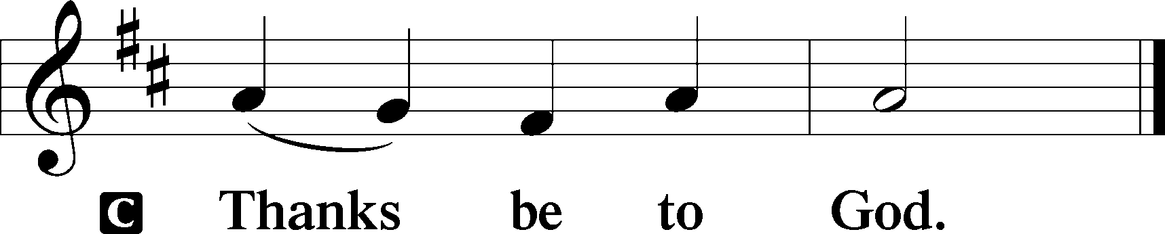

Benediction Numbers 6:24–26
P The Lord bless you and keep you.
The Lord make His face shine upon you and be gracious unto you.
The Lord lift up His countenance upon you and T give you peace.
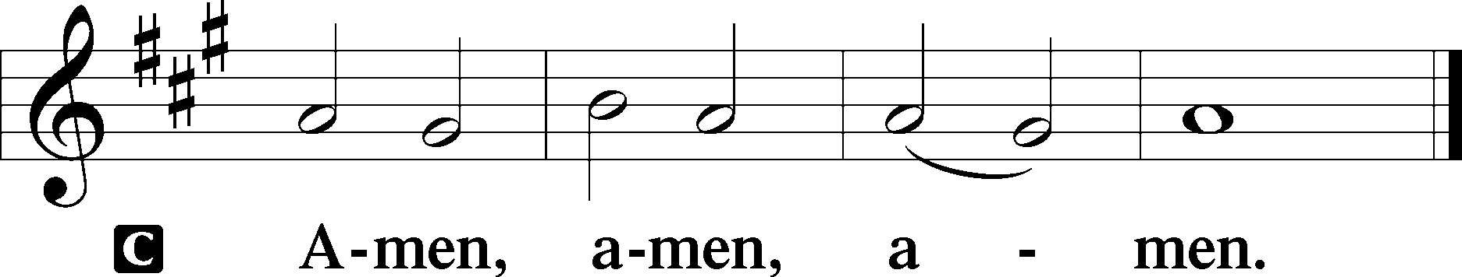

851 Lord of Glory, You Have Bought Us
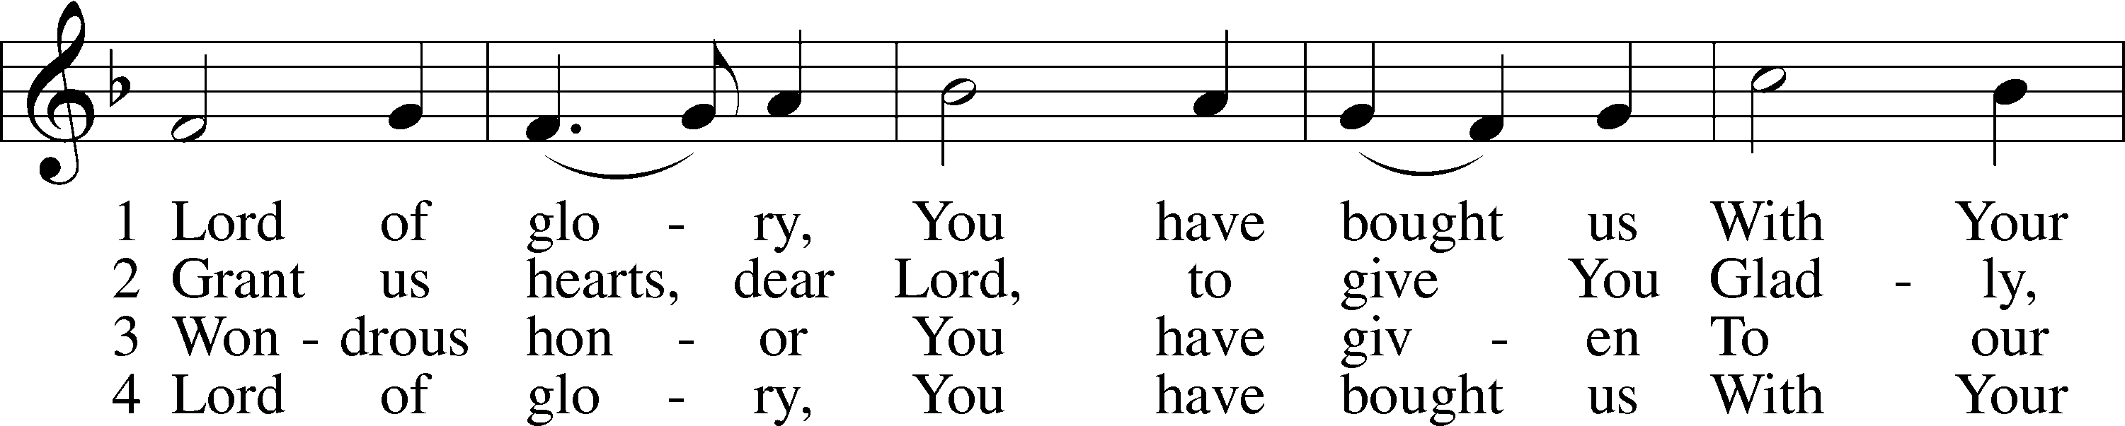
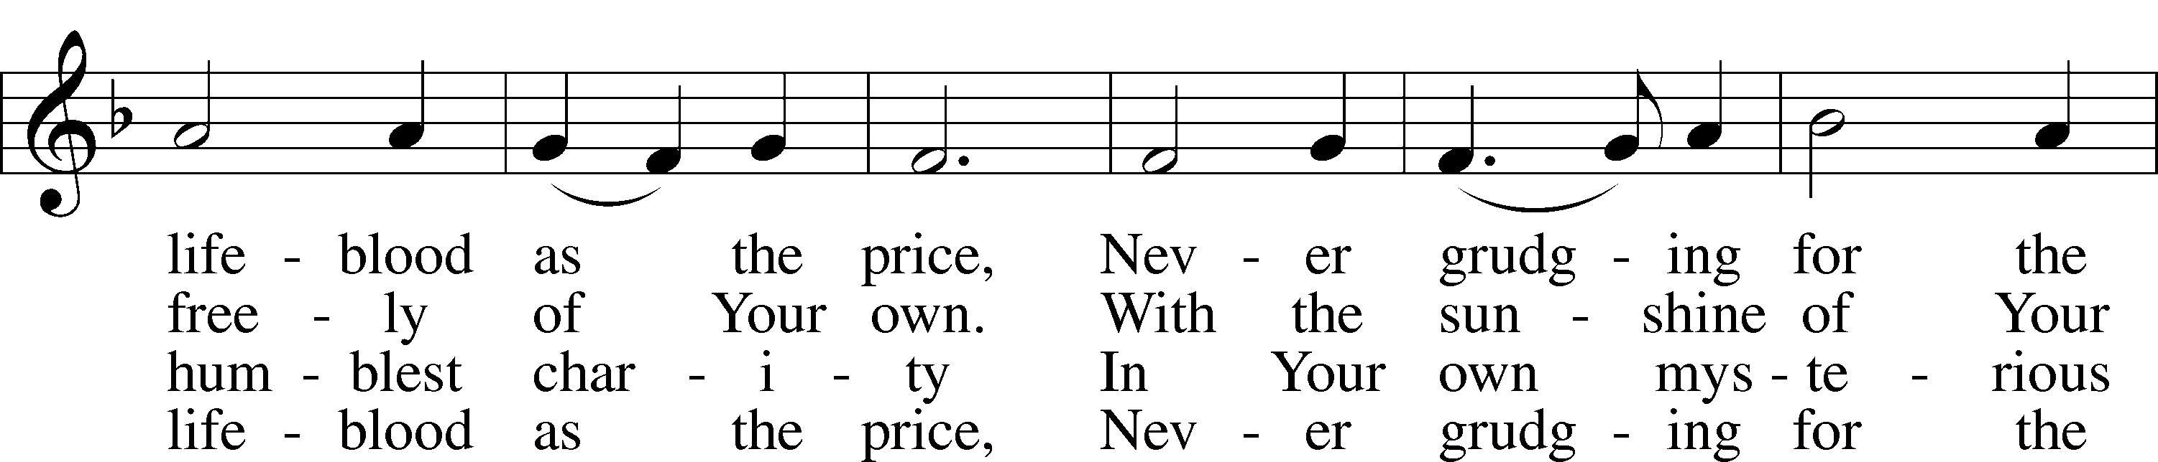
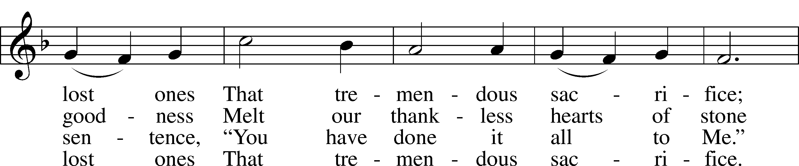
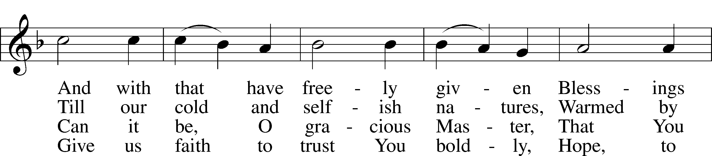
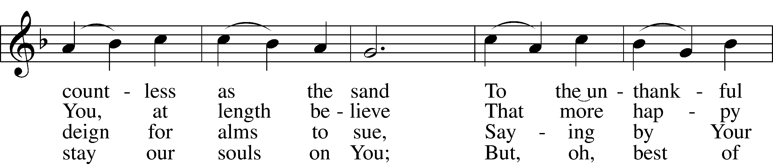
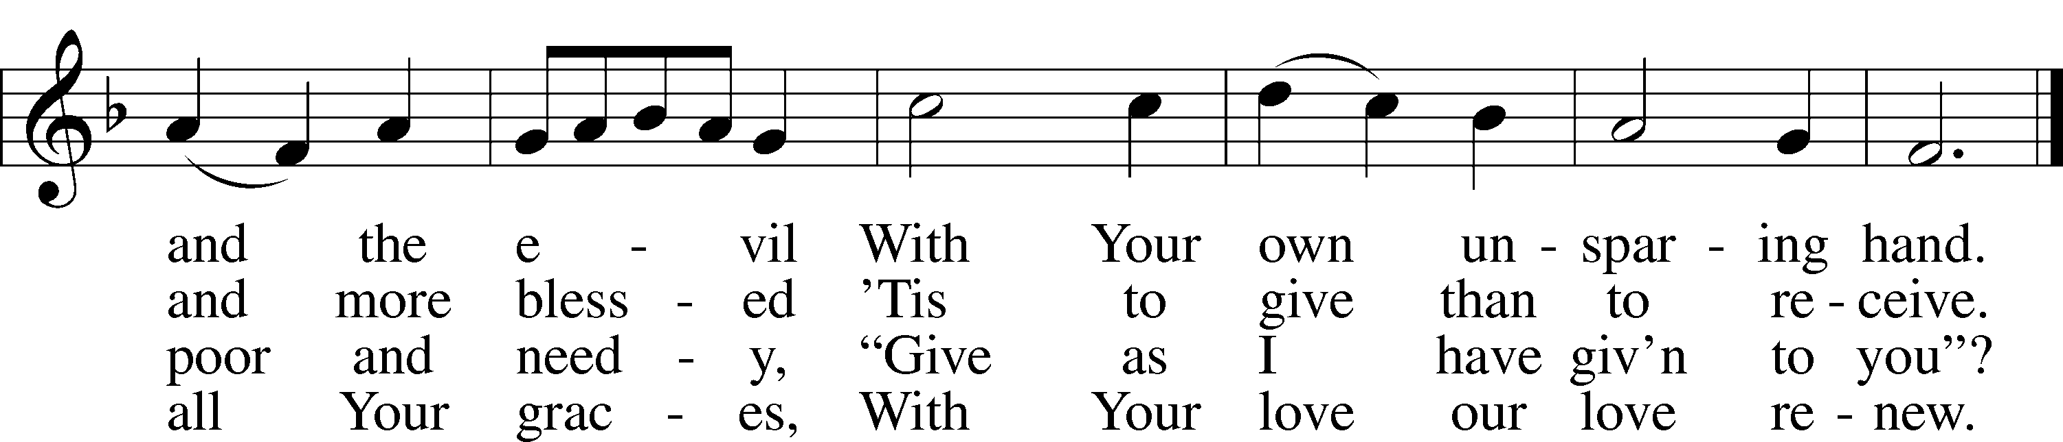
Text: Eliza S. Alderson, 1818–89, alt.
Tune: Rowland H. Prichard, 1811–87
Text and tune: Public domain
Acknowledgments
Divine Service, Setting Three from Lutheran Service Book
Unless otherwise indicated, Scripture quotations are from the ESV® Bible (The Holy Bible, English Standard Version®), copyright © 2001 by Crossway, a publishing ministry of Good News Publishers. Used by permission. All rights reserved.
Created by Lutheran Service Builder © 2026 Concordia Publishing House.

