On entering the church

P Lord, I love the habitation of Your house and the place
where Your glory dwells. In the multitude of Your tender
mercies prepare my heart that I may enter Your house to
worship and confess Your holy name; through Jesus Christ,
my God and Lord.

Before worship

C O Lord, our creator, redeemer, and comforter, as we come
together to worship You in spirit and in truth, we humbly
pray that You would open our hearts to the preaching of
Your Word so that we may repent of our sins, believe in
Jesus Christ as our only Savior, and grow in grace and
holiness. Hear us for His sake.

410 Within the Father’s House
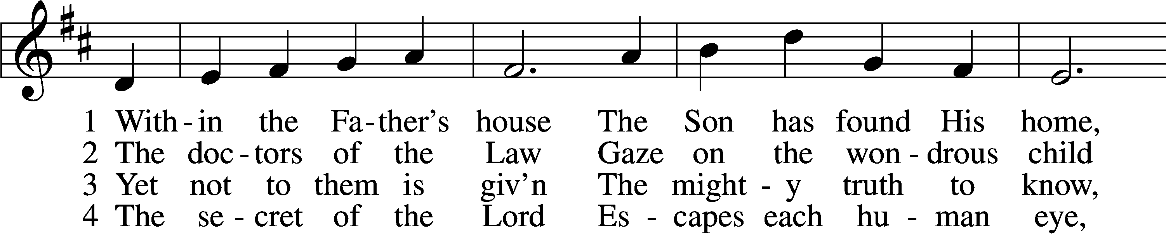
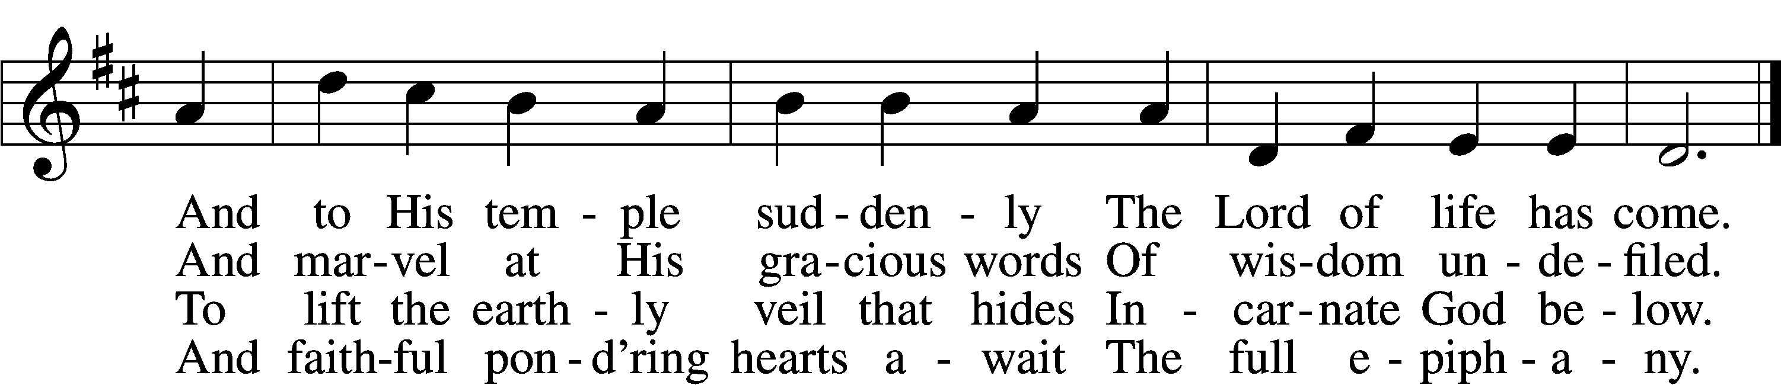

5 Lord, visit Thou our souls
And teach us by Thy grace
Each dim revealing of Thyself
With loving awe to trace

D 6 Till we behold Thy face
And know as we are known
Thee, Father, Son, and Holy Ghost,
Coequal Three in One.
Text: James R. Woodford, 1820–85, alt.
Tune: Johann Balthasar König, 1691–1758; adapt. William H. Havergal, 1793–1870
Text and tune: Public domain

Confession and Absolution

The sign of the cross may be made by all in remembrance of their Baptism.

Invocation Matthew 28:19b; 18:20
P In the name of the Father and of the T Son and of the Holy Spirit.
C Amen.

Exhortation Hebrews 10:22; Psalm 124:8; Psalm 32:5
P Beloved in the Lord! Let us draw near with a true heart and confess our sins unto God our Father, beseeching Him in the name of our Lord Jesus Christ to grant us forgiveness.

P Our help is in the name of the Lord,
C who made heaven and earth.
P I said, I will confess my transgressions unto the Lord,
C and You forgave the iniquity of my sin.

Silence for reflection on God’s Word and for self-examination.

Confession of Sins
P Almighty God, our maker and redeemer, we poor sinners confess unto You that we are by nature sinful and unclean and that we have sinned against You by thought, word, and deed. Wherefore we flee for refuge to Your infinite mercy, seeking and imploring Your grace for the sake of our Lord Jesus Christ.
C O most merciful God, who has given Your only-begotten Son to die for us, have mercy upon us and for His sake grant us remission of all our sins; and by Your Holy Spirit increase in us true knowledge of You and of Your will and true obedience to Your Word, to the end that by Your grace we may come to everlasting life; through Jesus Christ, our Lord. Amen.

Declaration of Grace Mark 16:16; John 1:12
P Almighty God, our heavenly Father, has had mercy upon us and has given His only Son to die for us and for His sake forgives us all our sins. To those who believe on His name He gives power to become the children of God and has promised them His Holy Spirit. He that believes and is baptized shall be saved.
Grant this, Lord, unto us all.
C Amen.

Service of the Word

Introit Psalm 100; antiphon: Isaiah 6:1; Revelation 19:6
I saw the Lord sitting upon a throne, high and lifted up;
and the train of his robe filled the temple.
Then I heard the voice of a great multitude, crying out,
“Hallelujah! For the Lord our God the Almighty reigns.”
Make a joyful noise to the Lord, all the earth!
Serve the Lord with gladness! Come into his presence with singing!
Know that the Lord, he is God!
It is he who made us, and we are his; we are his people, and the sheep of his pasture.
Enter his gates with thanksgiving, and his courts with praise!
Give thanks to him; bless his name!
For the Lord is good; his steadfast love endures forever,
and his faithfulness to all generations.

Gloria Patri
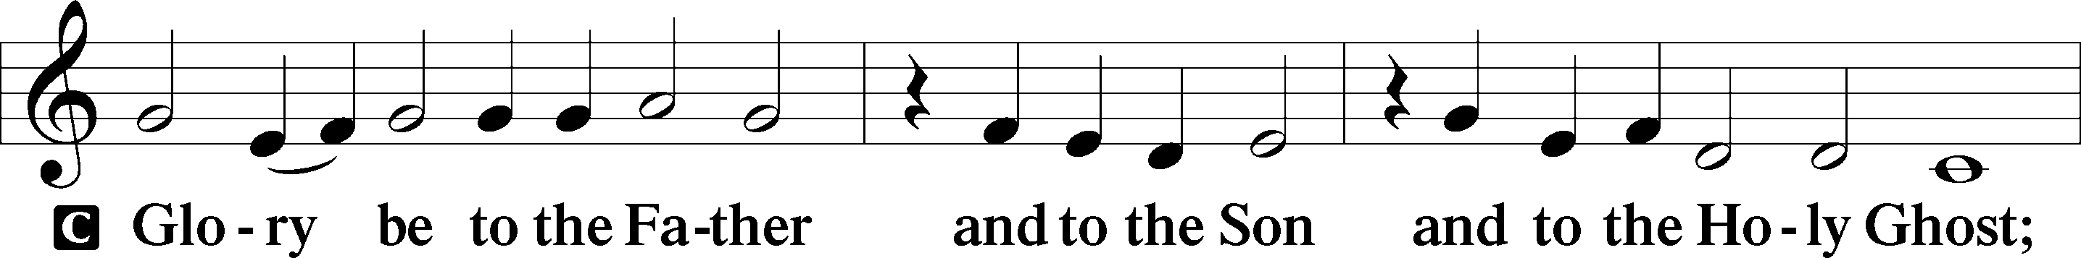
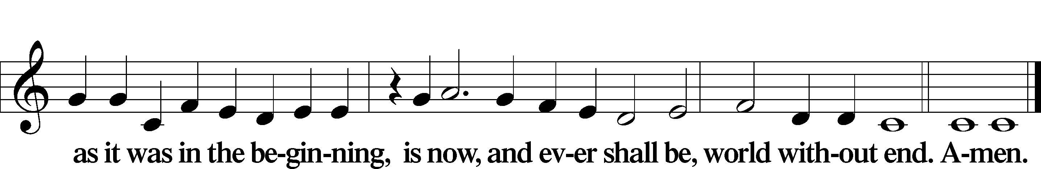

Kyrie Mark 10:47
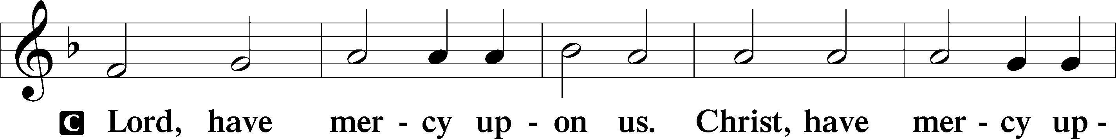
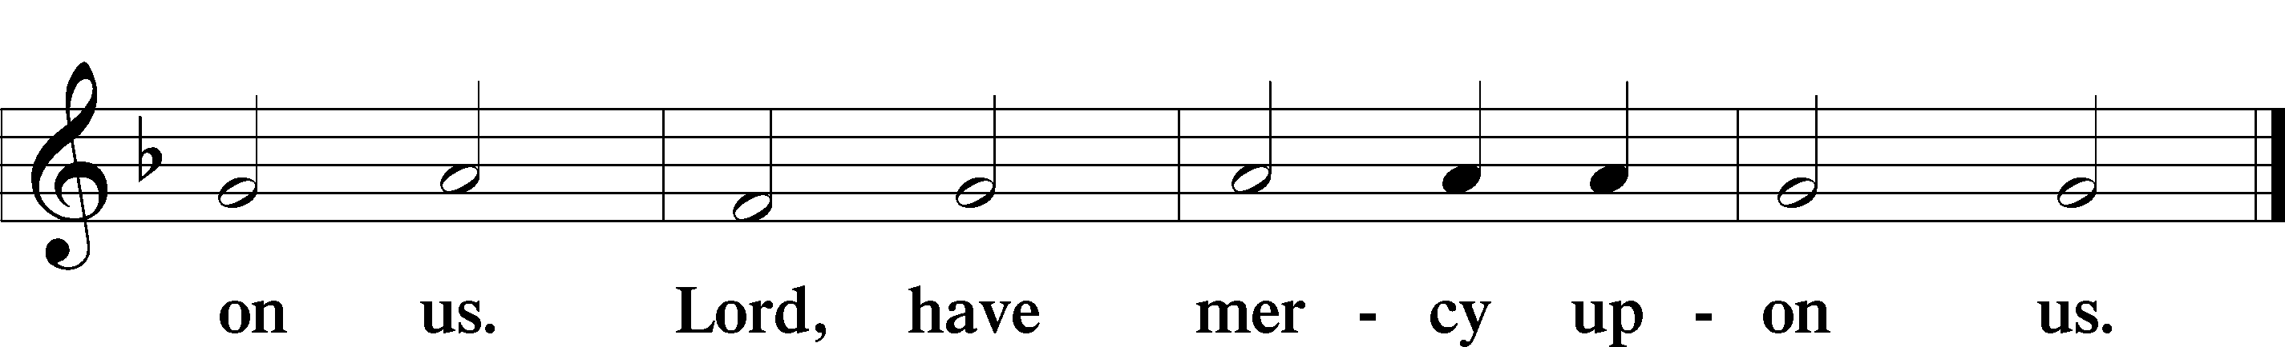

Gloria in Excelsis Luke 2:14; John 1:29
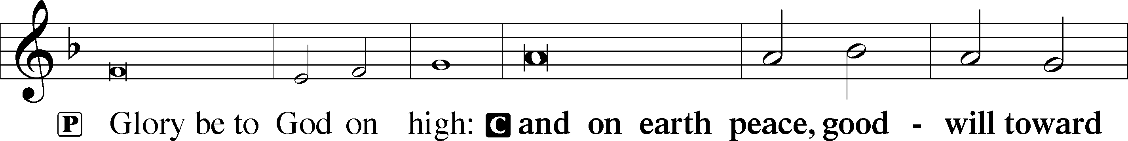
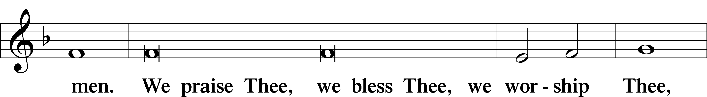
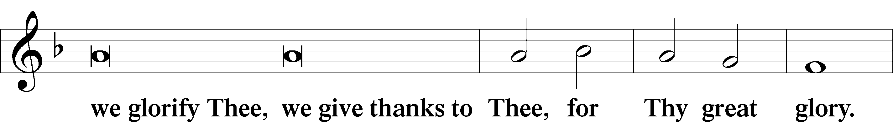
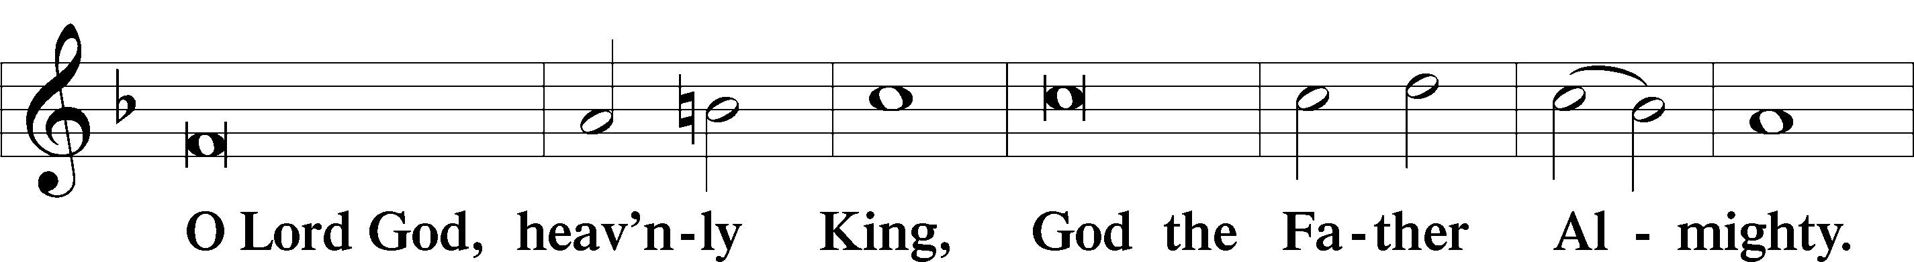
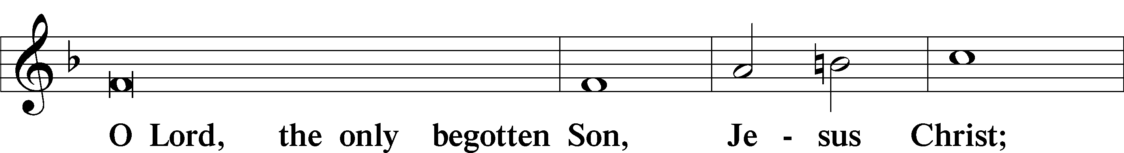
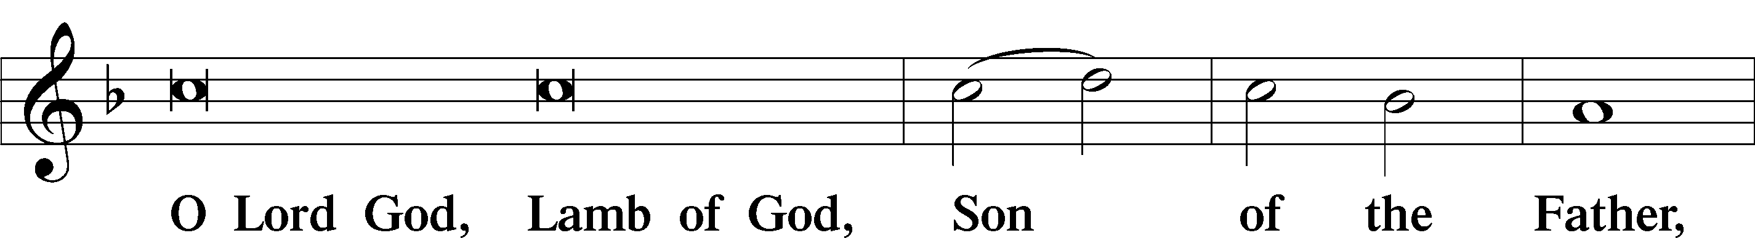
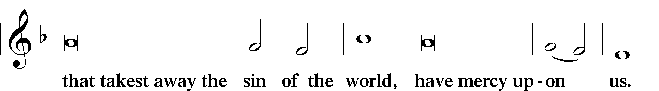
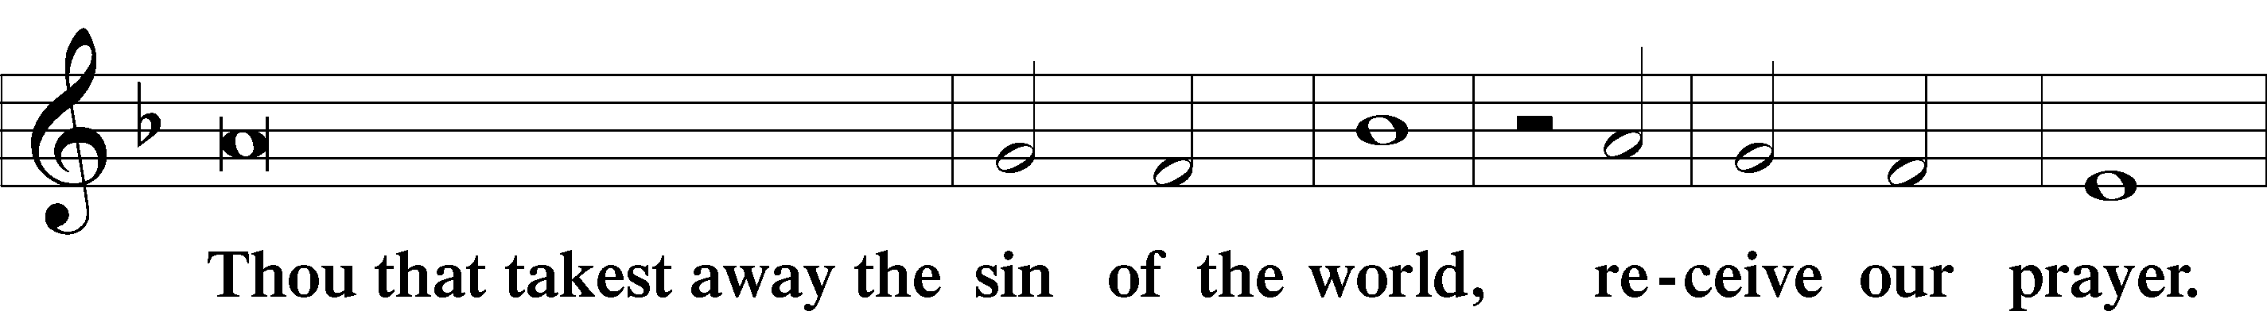
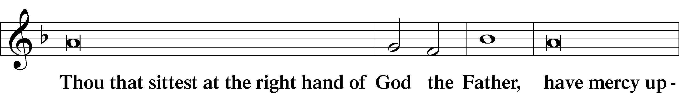
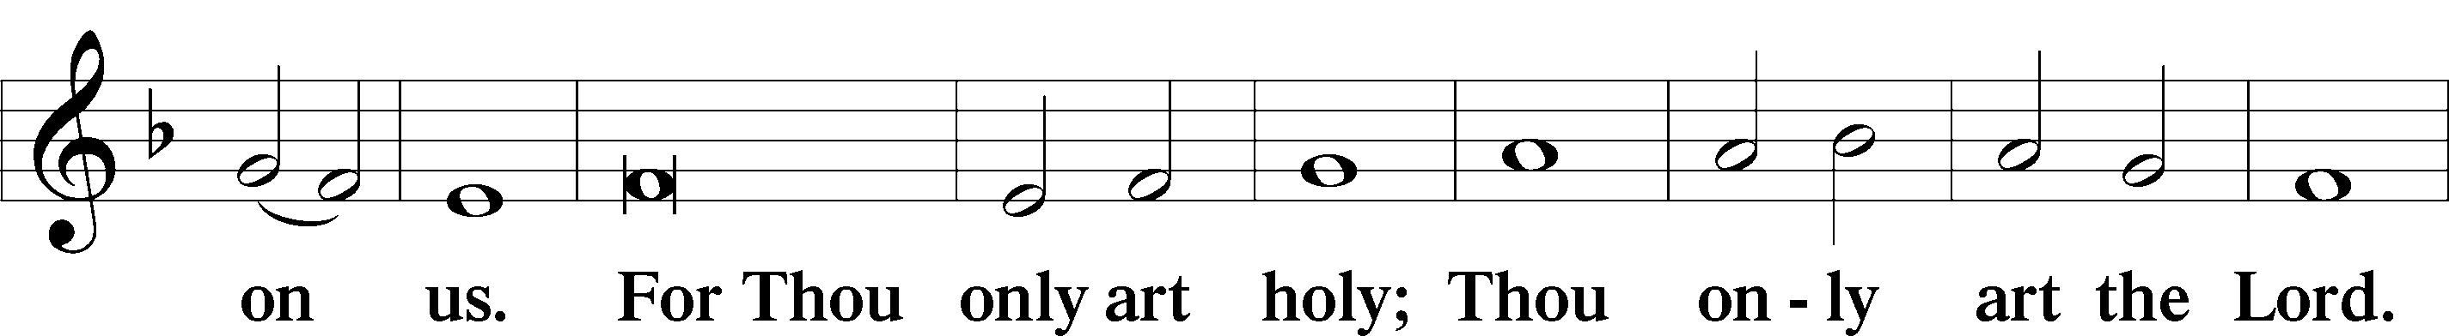
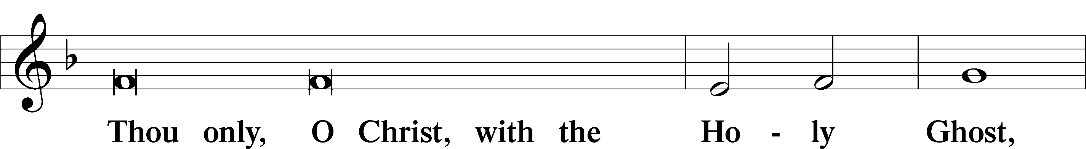
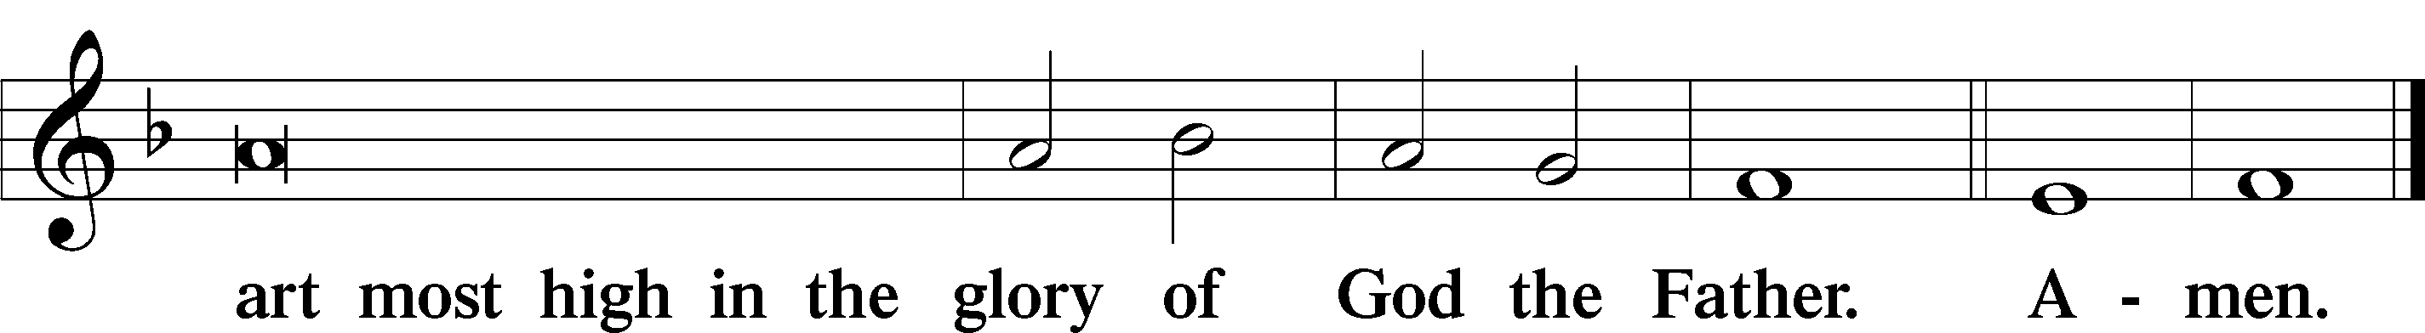

Salutation and Collect of the Day
P The Lord be with you.
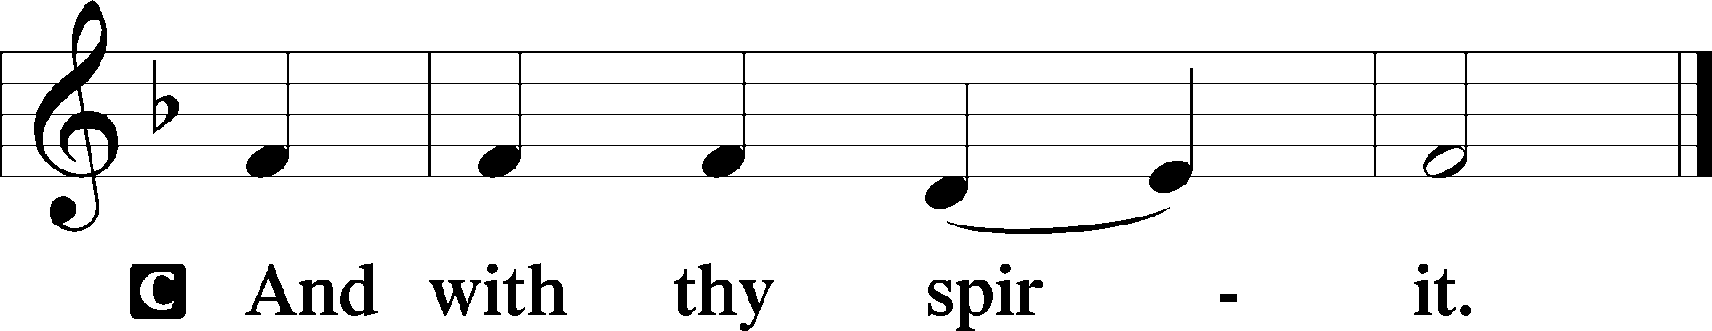

P Let us pray.
O Lord, mercifully receive the prayers of Your people who call upon You and grant that they both perceive and know what things they ought to do and also may have grace and power faithfully to fulfill the same; through Jesus Christ, Your Son, our Lord, who lives and reigns with You and the Holy Spirit, one God, now and forever.

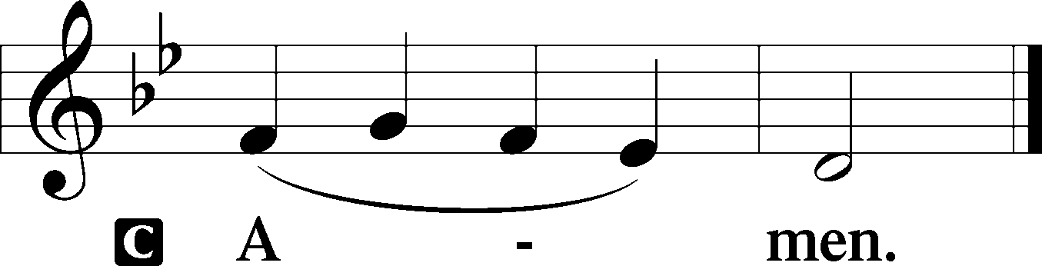

Sit

Old Testament Reading Isaiah 42:1–7
1Behold my servant, whom I uphold,
my chosen, in whom my soul delights;
I have put my Spirit upon him;
he will bring forth justice to the nations.
2He will not cry aloud or lift up his voice,
or make it heard in the street;
3a bruised reed he will not break,
and a faintly burning wick he will not quench;
he will faithfully bring forth justice.
4He will not grow faint or be discouraged
till he has established justice in the earth;
and the coastlands wait for his law.
5Thus says God, the Lord,
who created the heavens and stretched them out,
who spread out the earth and what comes from it,
who gives breath to the people on it
and spirit to those who walk in it:
6“I am the Lord; I have called you in righteousness;
I will take you by the hand and keep you;
I will give you as a covenant for the people,
a light for the nations,
7to open the eyes that are blind,
to bring out the prisoners from the dungeon,
from the prison those who sit in darkness.

A This is the Word of the Lord.
C Thanks be to God.

Gradual Psalm 72:18, 3
Blessèd be the Lord, the God of Israel,
who alone does wondrous things.
Let the mountains bear prosperity for the people,
and the hills, in righteousness!

Epistle Romans 12:1–5
1I appeal to you therefore, brothers, by the mercies of God, to present your bodies as a living sacrifice, holy and acceptable to God, which is your spiritual worship. 2Do not be conformed to this world, but be transformed by the renewal of your mind, that by testing you may discern what is the will of God, what is good and acceptable and perfect.
3For by the grace given to me I say to everyone among you not to think of himself more highly than he ought to think, but to think with sober judgment, each according to the measure of faith that God has assigned. 4For as in one body we have many members, and the members do not all have the same function, 5so we, though many, are one body in Christ, and individually members one of another.

Stand

Alleluia
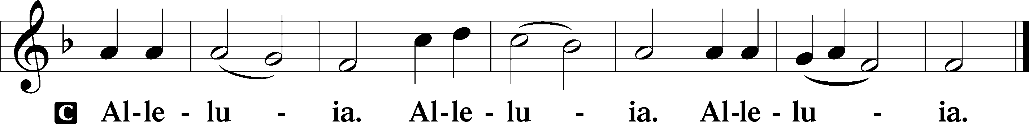

Holy Gospel Luke 2:41–52
P The Holy Gospel according to St. Luke, the second chapter.

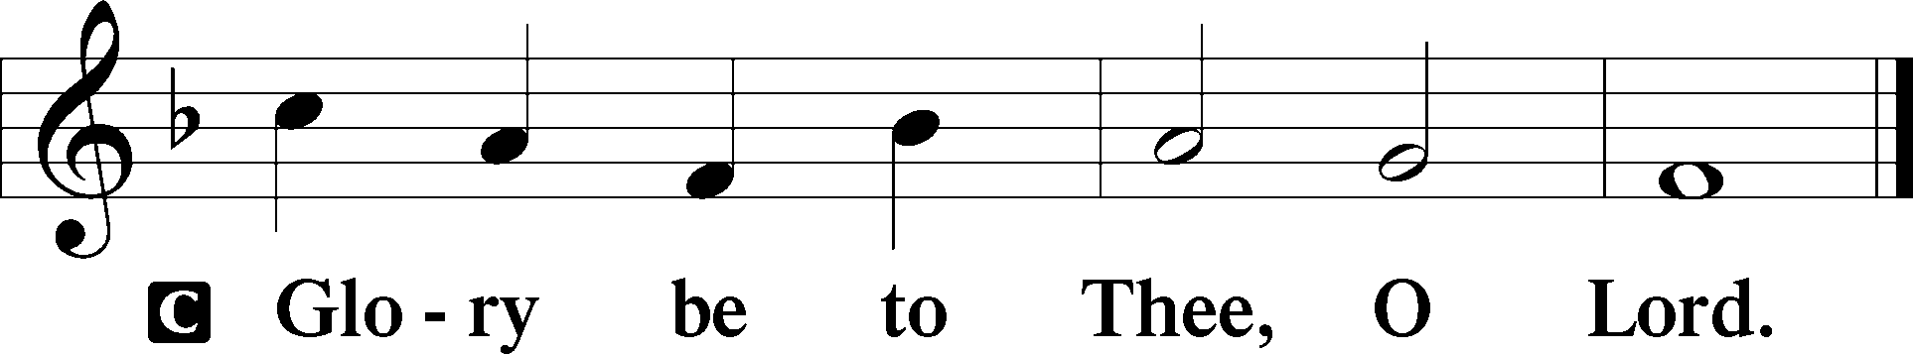

41Now [Jesus’] parents went to Jerusalem every year at the Feast of the Passover. 42And when he was twelve years old, they went up according to custom. 43And when the feast was ended, as they were returning, the boy Jesus stayed behind in Jerusalem. His parents did not know it, 44but supposing him to be in the group they went a day’s journey, but then they began to search for him among their relatives and acquaintances, 45and when they did not find him, they returned to Jerusalem, searching for him. 46After three days they found him in the temple, sitting among the teachers, listening to them and asking them questions. 47And all who heard him were amazed at his understanding and his answers. 48And when his parents saw him, they were astonished. And his mother said to him, “Son, why have you treated us so? Behold, your father and I have been searching for you in great distress.” 49And he said to them, “Why were you looking for me? Did you not know that I must be in my Father’s house?” 50And they did not understand the saying that he spoke to them. 51And he went down with them and came to Nazareth and was submissive to them. And his mother treasured up all these things in her heart.
52And Jesus increased in wisdom and in stature and in favor with God and man.

P This is the Gospel of the Lord.

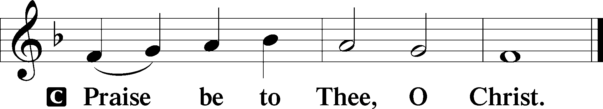

Apostles’ Creed
C I believe in God, the Father Almighty,
maker of heaven and earth.

And in Jesus Christ, His only Son, our Lord,
who was conceived by the Holy Spirit,
born of the virgin Mary,
suffered under Pontius Pilate,
was crucified, died and was buried.
He descended into hell.
The third day He rose again from the dead.
He ascended into heaven
and sits at the right hand of God the Father Almighty.
From thence He will come to judge the living and the dead.

I believe in the Holy Spirit,
the holy Christian Church,
the communion of saints,
the forgiveness of sins,
the resurrection of the body,
and the life T everlasting. Amen.

Sit

Children's Sermon

624 The Infant Priest Was Holy Born
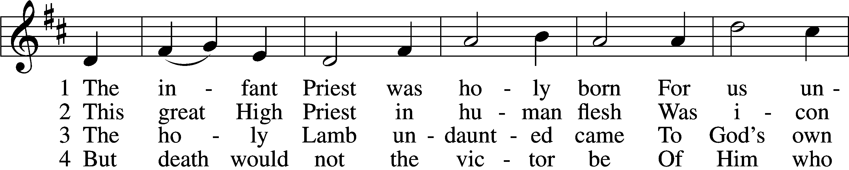
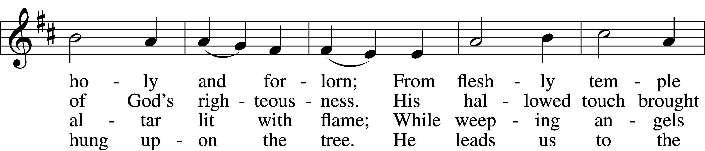
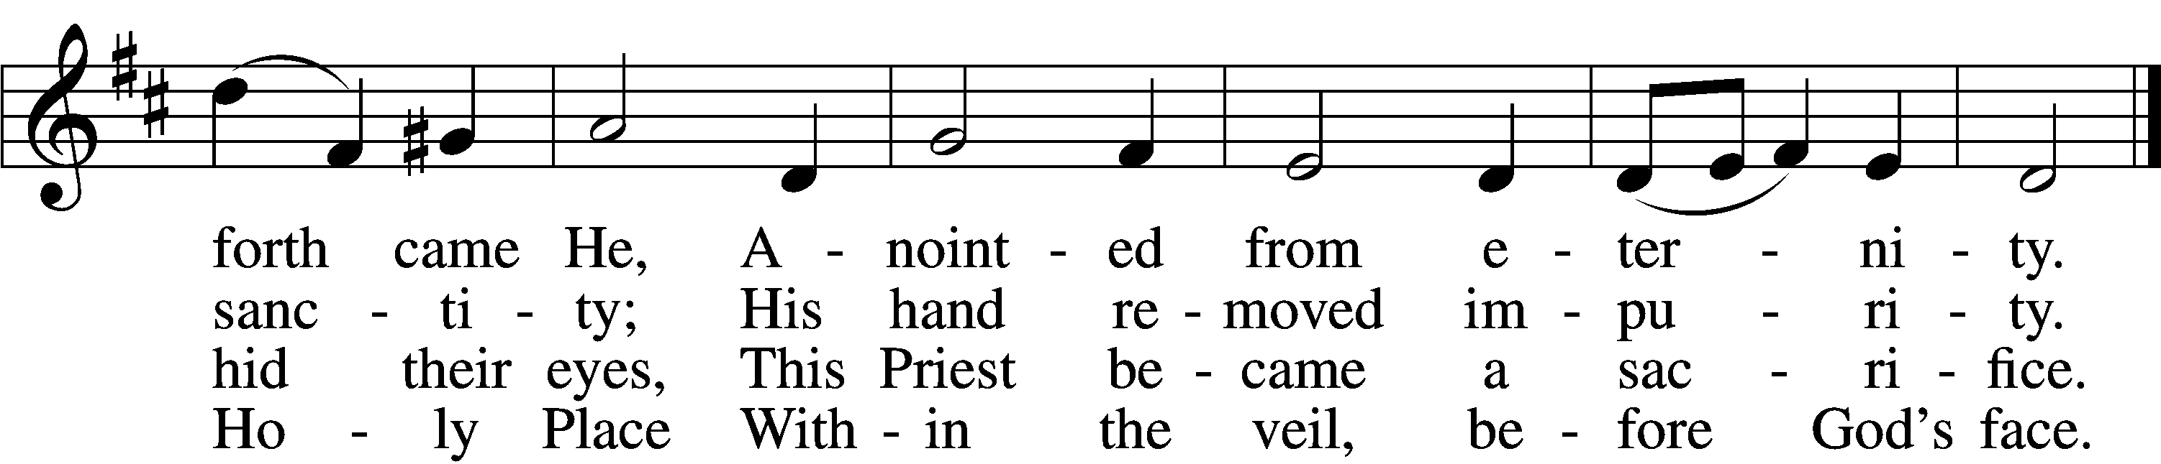

5 The veil is torn, our Priest we see,
As at the rail on bended knee
Our hungry mouths from Him receive
The bread of immortality.

6 The body of God’s Lamb we eat,
A priestly food and priestly meat;
On sin-parched lips the chalice pours
His quenching blood that life restores.

7 With cherubim and seraphim
Our voices join the endless hymn,
And “Holy, holy, holy” sing
To Christ, God’s Lamb, our Priest and King.
Text: Chad L. Bird, 1970
Tune: Second Supplement to Psalmody in Miniature, 1778, London; adapt. Edward Miller, 1731–1807
Text: © 1997, 2003 Chad L. Bird. Used by permission: LSB Hymn License no. 110005011
Tune: Public domain

Sermon

Votum
P The peace of God, which passes all understanding, keep your hearts and minds in Christ Jesus.
C Amen.

Stand

Offertory Psalm 51:10–12
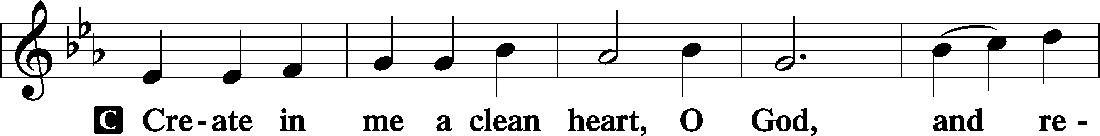
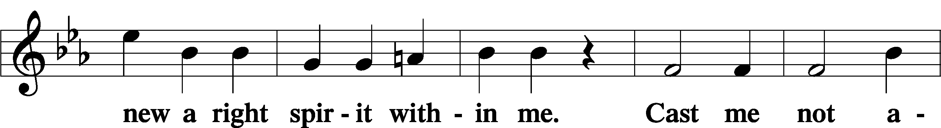
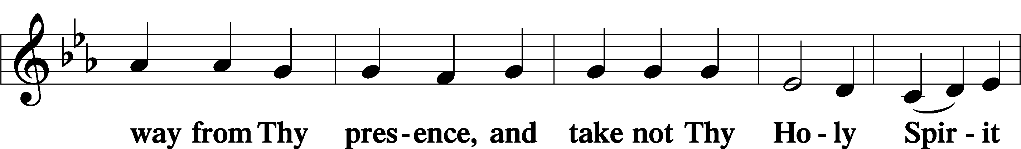
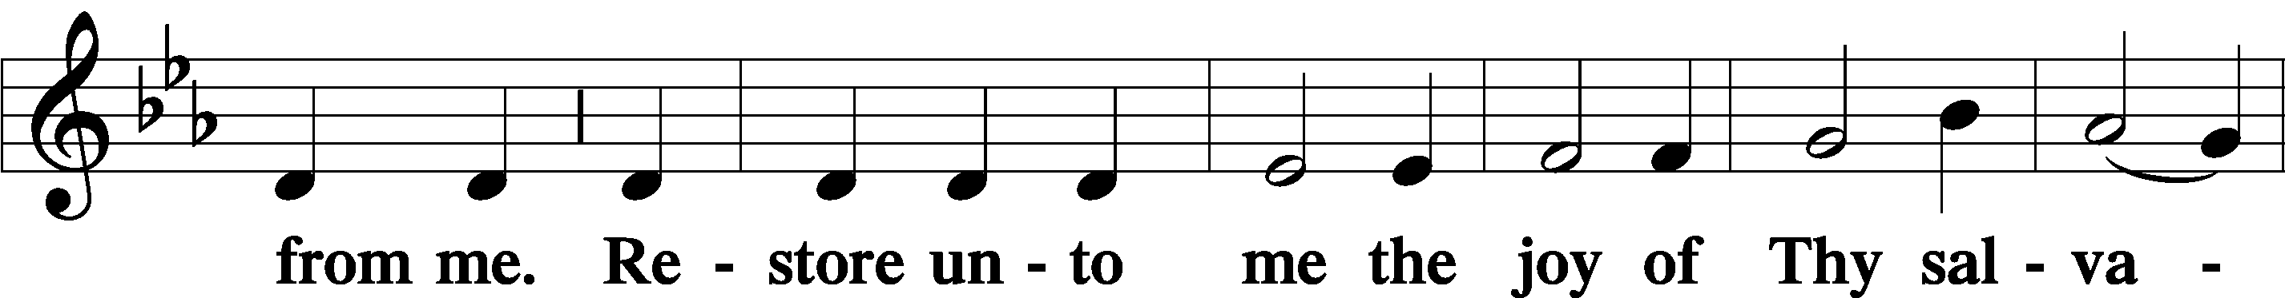
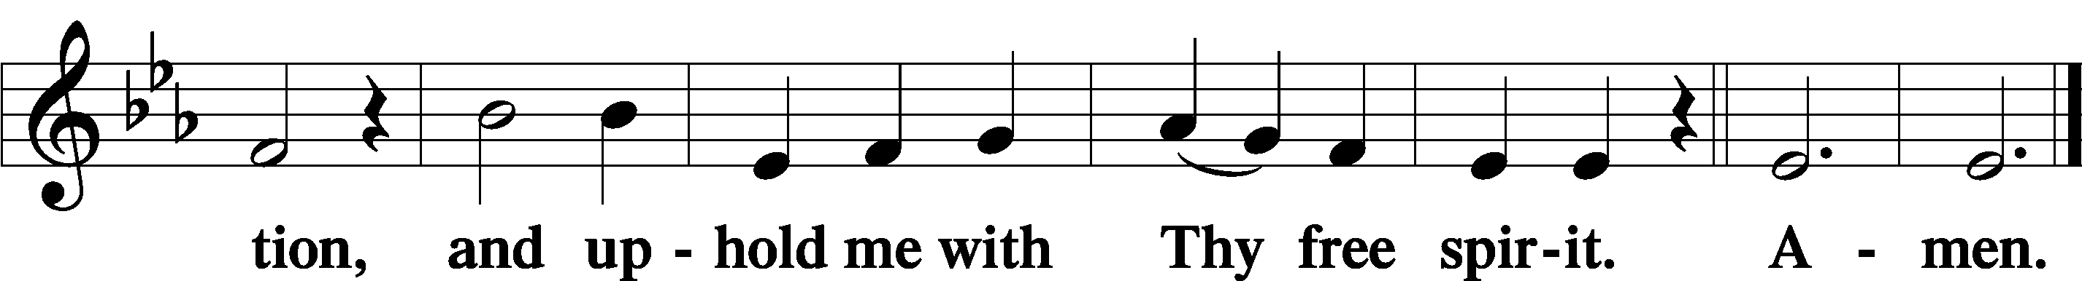

Offering

805 Praise God, from Whom All Blessings Flow
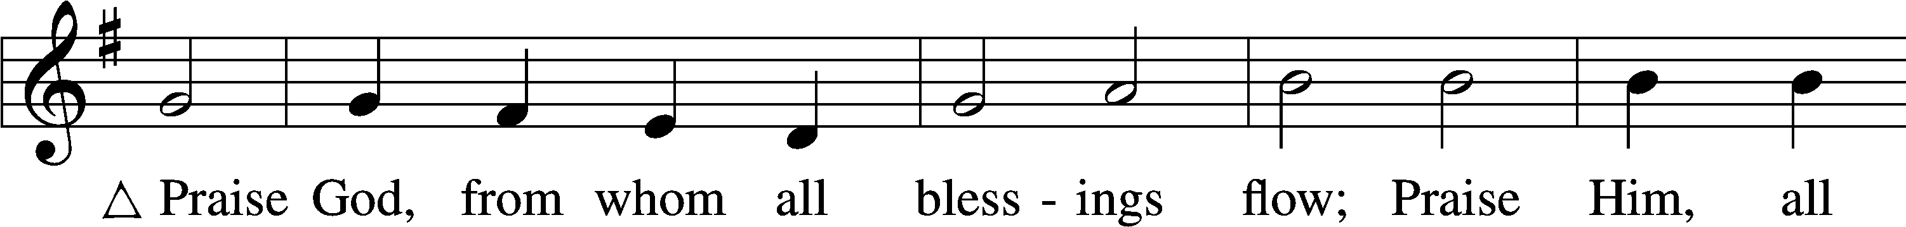
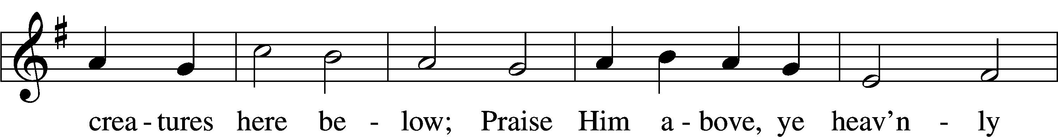
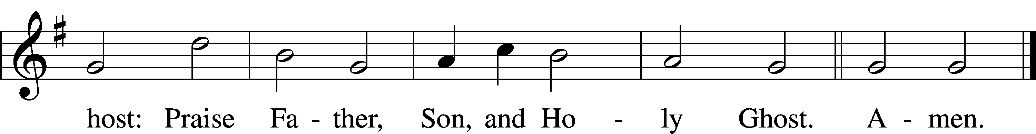
Text: Thomas Ken, 1637–1711
Tune: Trente quatre Pseaumes de David, 1551, Geneva, ed. Louis Bourgeois
Text and tune: Public domain

Prayer of the Church

Lord’s Prayer Matthew 6:9–13
P Lord, remember us in Your kingdom and teach us to pray:
C Our Father who art in heaven,
hallowed be Thy name,
Thy kingdom come,
Thy will be done on earth
as it is in heaven;
give us this day our daily bread;
and forgive us our trespasses
as we forgive those
who trespass against us;
and lead us not into temptation,
but deliver us from evil.
For Thine is the kingdom
and the power and the glory
forever and ever. Amen.

Collect for the Word

Blessed Lord, You have caused all Holy Scriptures to be written for our learning. Grant that we may so hear them, read, mark, learn, and inwardly digest them that, by the patience and comfort of Your holy Word, we may embrace and ever hold fast the blessed hope of everlasting life; through Jesus Christ, Your Son, our Lord, who lives and reigns with You and the Holy Spirit, one God, now and forever.

Benediction
P The Lord bless you and keep you.
The Lord make His face shine on you and be gracious to you.
The Lord look upon you with favor and T give you peace.
C Amen.
730 What Is the World to Me
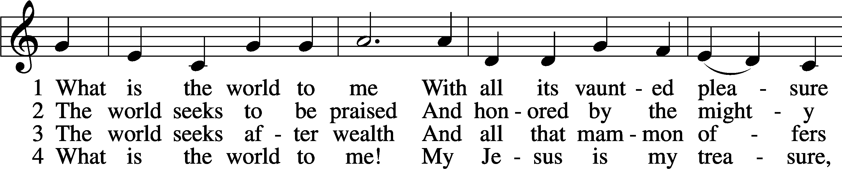
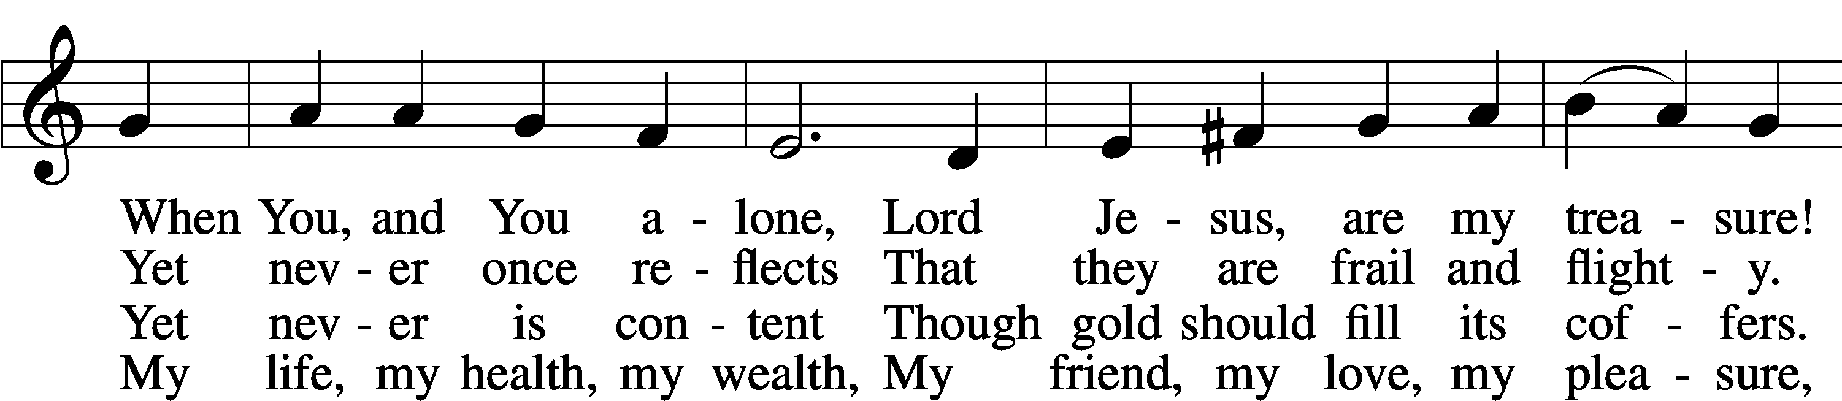
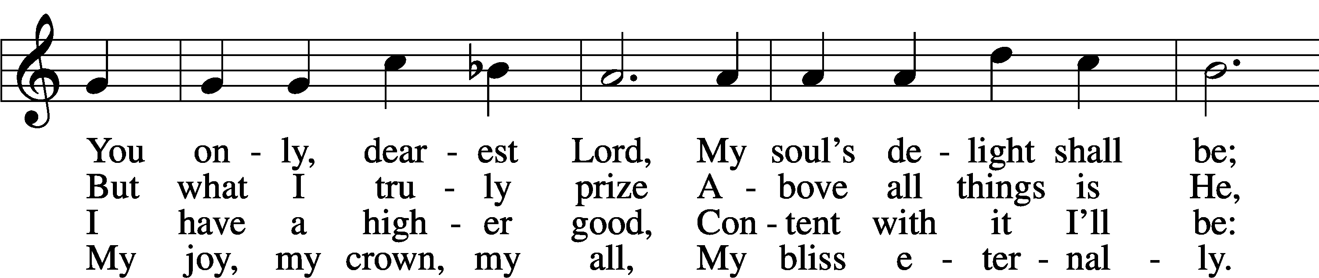
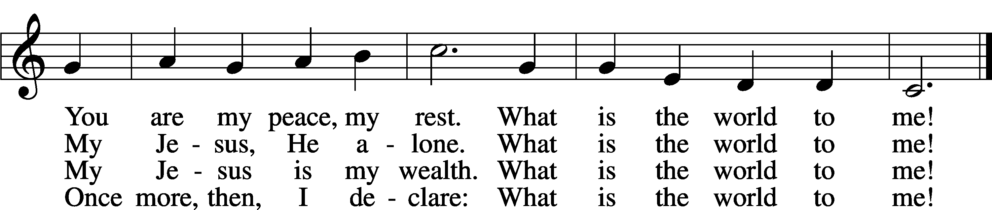
Text: Georg Michael Pfefferkorn, 1645–1732; tr. August Crull, 1845–1923, alt.
Tune: Ahasverus Fritsch, 1629–1701
Text and tune: Public domain

Acknowledgments
Unless otherwise indicated, Scripture quotations are from the ESV® Bible (The Holy Bible, English Standard Version®), copyright © 2001 by Crossway, a publishing ministry of Good News Publishers. Used by permission. All rights reserved.
Created by Lutheran Service Builder © 2026 Concordia Publishing House.

