On entering the church

P Lord, I love the habitation of Your house and the place

where Your glory dwells. In the multitude of Your tender

mercies prepare my heart that I may enter Your house to

worship and confess Your holy name; through Jesus Christ,

my God and Lord.

Before worship

C O Lord, our creator, redeemer, and comforter, as we come

together to worship You in spirit and in truth, we humbly

pray that You would open our hearts to the preaching of

Your Word so that we may repent of our sins, believe in

Jesus Christ as our only Savior, and grow in grace and

holiness. Hear us for His sake.

837 Lift High the Cross sts. ref–6

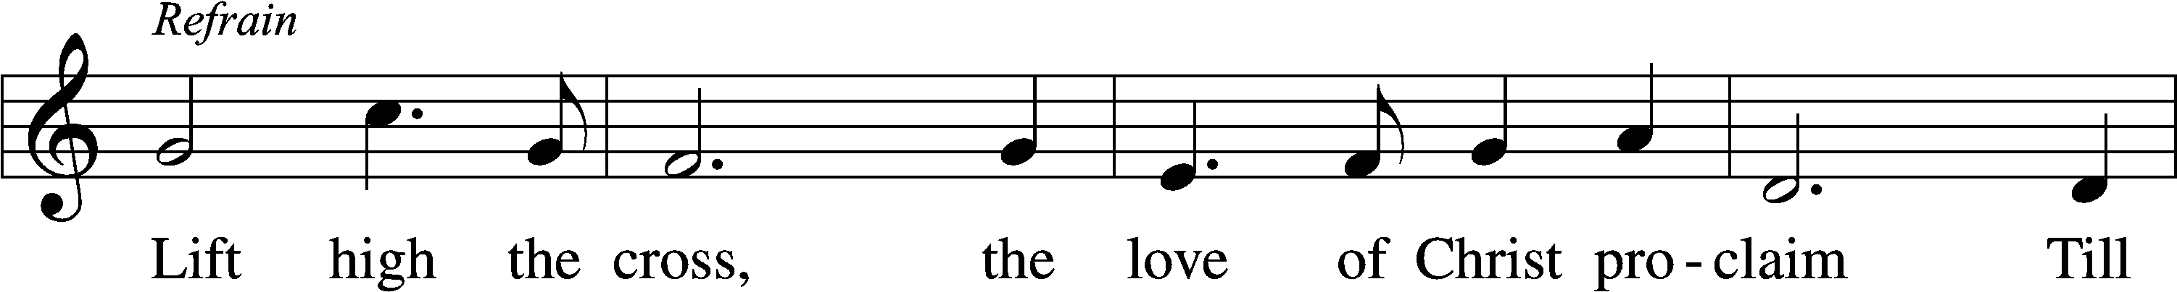

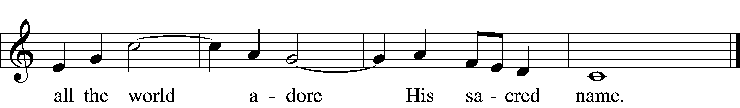

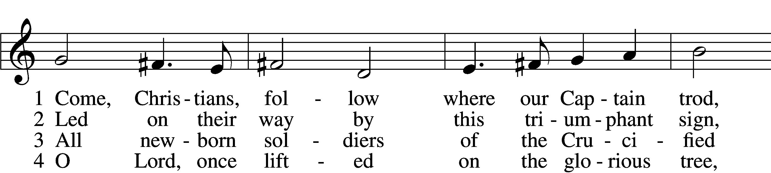

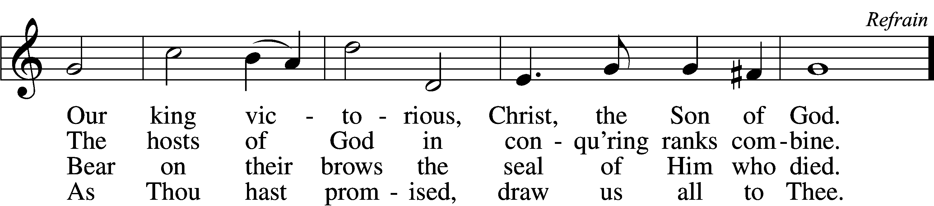

5 Let ev’ry race and ev’ry language tell  
Of Him who saves our lives from death and hell. Refrain

6 So shall our song of triumph ever be:  
Praise to the Crucified for victory! Refrain

Text: George W. Kitchin, 1827–1912; rev. Michael R. Newbolt, 1874–1956, alt.  
Tune: Sydney H. Nicholson, 1875–1947  
Text and tune: © 1974 Hope Publishing Co. Used by permission: LSB Hymn License no. 110005011

# Confession and Absolution

Stand

The sign of the cross may be made by all in remembrance of their Baptism.

Invocation Matthew 28:19b; 18:20

P In the name of the Father and of the T Son and of the Holy Spirit.

C **Amen.**

Exhortation Psalm 124:8; Psalm 130:3–4; Luke 18:13

P Our help is in the name of the Lord,

C **who made heaven and earth.**

P If You, O Lord, kept a record of sins, O Lord, who could stand?

C **But with You there is forgiveness; therefore You are feared.**

P Since we are gathered to hear God’s Word, call upon Him in prayer and praise, and receive the body and blood of our Lord Jesus Christ in the fellowship of this altar, let us first consider our unworthiness and confess before God and one another that we have sinned in thought, word, and deed, and that we cannot free ourselves from our sinful condition. Together as His people let us take refuge in the infinite mercy of God, our heavenly Father, seeking His grace for the sake of Christ, and saying: God, be merciful to me, a sinner.

Kneel/Stand

Confession of Sins

C **Almighty God, have mercy upon us, forgive us our sins, and lead us to everlasting life. Amen.**

Absolution [John 20:19–23]

P Almighty God in His mercy has given His Son to die for you and for His sake forgives you all your sins. As a called and ordained servant of Christ, and by His authority, I therefore forgive you all your sins in the name of the Father and of the T Son and of the Holy Spirit.

C **Amen.**

Stand

# Service of the Word

Introit Psalm 98:2–6; antiphon: v. 1

Oh sing to the Lord a new song, for he has done marvelous things!  
 His right hand and his holy arm have worked salvation for him.  
**The Lord has made known his salvation;  
 he has revealed his righteousness in the sight of the nations.**  
He has remembered his steadfast love and faithfulness to the house of Israel.  
 All the ends of the earth have seen the salvation of our God.  
**Make a joyful noise to the Lord, all the earth;  
 break forth into joyous song and sing praises!**Sing praises to the Lord with the lyre,  
 with the lyre and the sound of melody!  
**With trumpets and the sound of the horn  
 make a joyful noise before the King, the Lord!  
Glory be to the Father and to the Son**  
 **and to the Holy Spirit;**  
**as it was in the beginning,**  
 **is now, and will be forever. Amen.**  
Oh sing to the Lord a new song, for he has done marvelous things!  
 His right hand and his holy arm have worked salvation for him.

Kyrie Mark 10:47

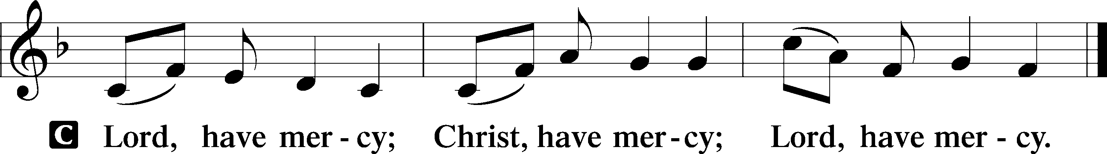

Gloria in Excelsis Luke 2:14; John 1:29

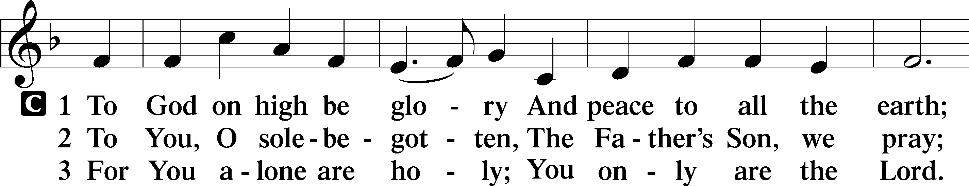

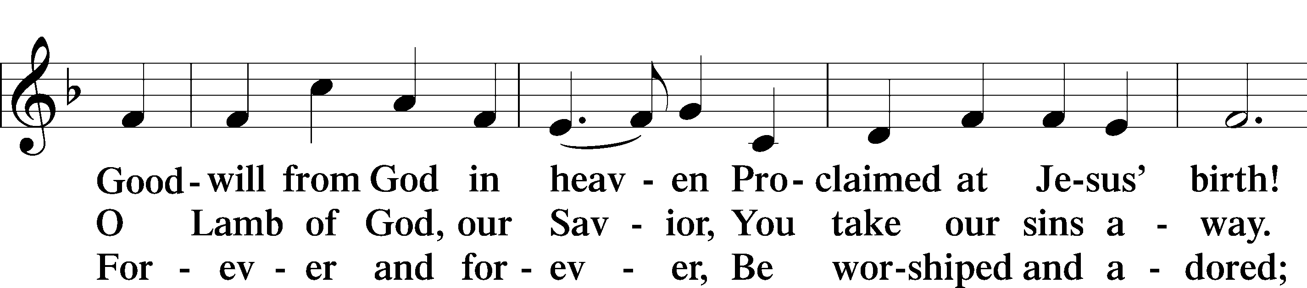

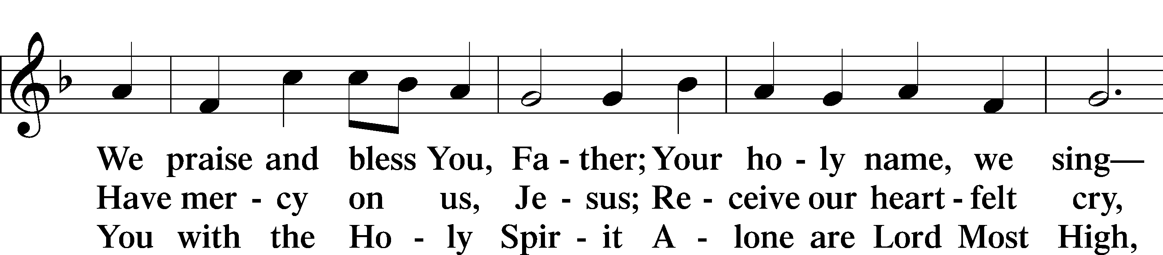

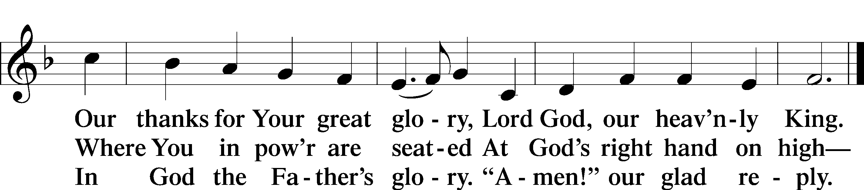

Text: Stephen P. Starke

Salutation and Collect of the Day

P The Lord be with you.

C **And also with you.**

P Let us pray.

O God, You make the minds of Your faithful to be of one will. Grant that we may love what You have commanded and desire what You promise, that among the many changes of this world our hearts may be fixed where true joys are found; through Jesus Christ, Your Son, our Lord, who lives and reigns with You and the Holy Spirit, one God, now and forever.

C **Amen.**

Sit

First Reading Acts 11:1–18

1Now the apostles and the brothers who were throughout Judea heard that the Gentiles also had received the word of God. 2So when Peter went up to Jerusalem, the circumcision party criticized him, saying, 3“You went to uncircumcised men and ate with them.” 4But Peter began and explained it to them in order: 5“I was in the city of Joppa praying, and in a trance I saw a vision, something like a great sheet descending, being let down from heaven by its four corners, and it came down to me. 6Looking at it closely, I observed animals and beasts of prey and reptiles and birds of the air. 7And I heard a voice saying to me, ‘Rise, Peter; kill and eat.’ 8But I said, ‘By no means, Lord; for nothing common or unclean has ever entered my mouth.’ 9But the voice answered a second time from heaven, ‘What God has made clean, do not call common.’ 10This happened three times, and all was drawn up again into heaven. 11And behold, at that very moment three men arrived at the house in which we were, sent to me from Caesarea. 12And the Spirit told me to go with them, making no distinction. These six brothers also accompanied me, and we entered the man’s house. 13And he told us how he had seen the angel stand in his house and say, ‘Send to Joppa and bring Simon who is called Peter; 14he will declare to you a message by which you will be saved, you and all your household.’ 15As I began to speak, the Holy Spirit fell on them just as on us at the beginning. 16And I remembered the word of the Lord, how he said, ‘John baptized with water, but you will be baptized with the Holy Spirit.’ 17If then God gave the same gift to them as he gave to us when we believed in the Lord Jesus Christ, who was I that I could stand in God’s way?” 18When they heard these things they fell silent. And they glorified God, saying, “Then to the Gentiles also God has granted repentance that leads to life.”

A This is the Word of the Lord.

C **Thanks be to God.**

Gradual adapt. from Matthew 28:7; Hebrews 2:7; Psalm 8:6

Christ has risen from the dead.  
 [God the Father] has crowned him with glory and honor.  
**He has given him dominion over the works of his hands;  
 he has put all things under his feet.**

Epistle Revelation 21:1–7

1Then I saw a new heaven and a new earth, for the first heaven and the first earth had passed away, and the sea was no more. 2And I saw the holy city, new Jerusalem, coming down out of heaven from God, prepared as a bride adorned for her husband. 3And I heard a loud voice from the throne saying, “Behold, the dwelling place of God is with man. He will dwell with them, and they will be his people, and God himself will be with them as their God. 4He will wipe away every tear from their eyes, and death shall be no more, neither shall there be mourning nor crying nor pain anymore, for the former things have passed away.”

5And he who was seated on the throne said, “Behold, I am making all things new.” Also he said, “Write this down, for these words are trustworthy and true.” 6And he said to me, “It is done! I am the Alpha and the Omega, the beginning and the end. To the thirsty I will give from the spring of the water of life without payment. 7The one who conquers will have this heritage, and I will be his God and he will be my son.”

A This is the Word of the Lord.

C **Thanks be to God.**

Stand

Alleluia and Verse

Alleluia

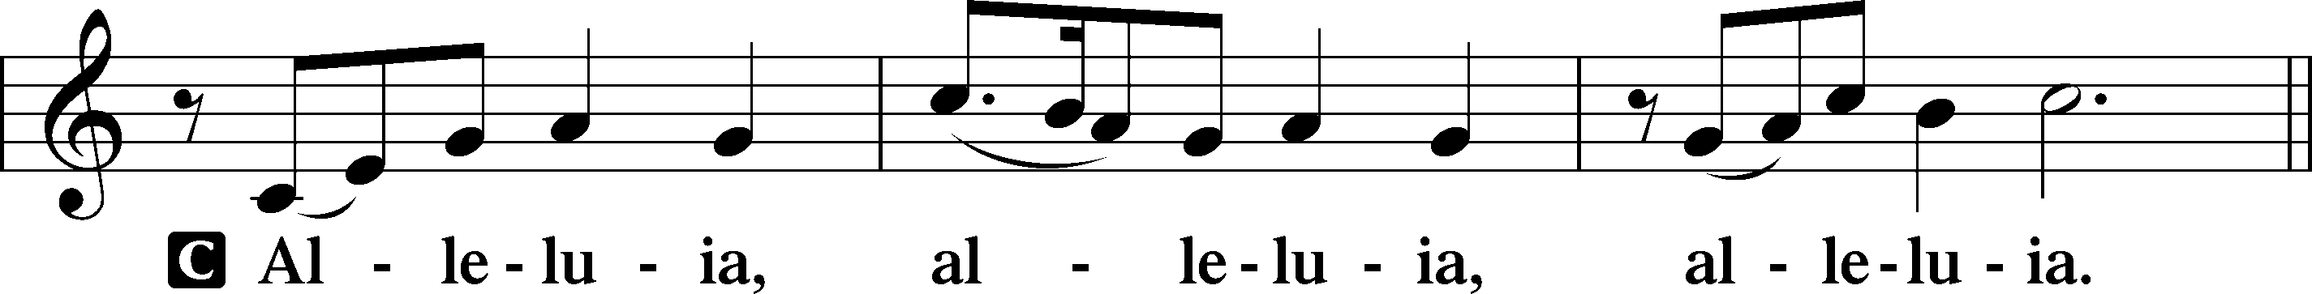

Verse John 20:31

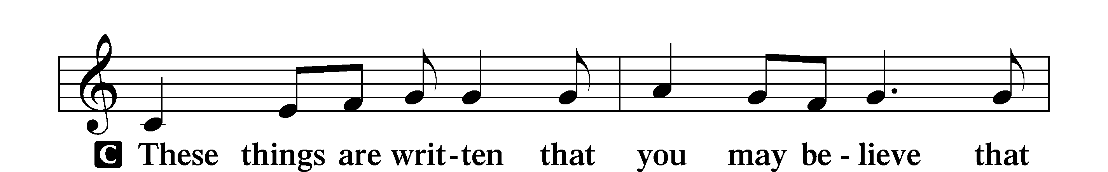

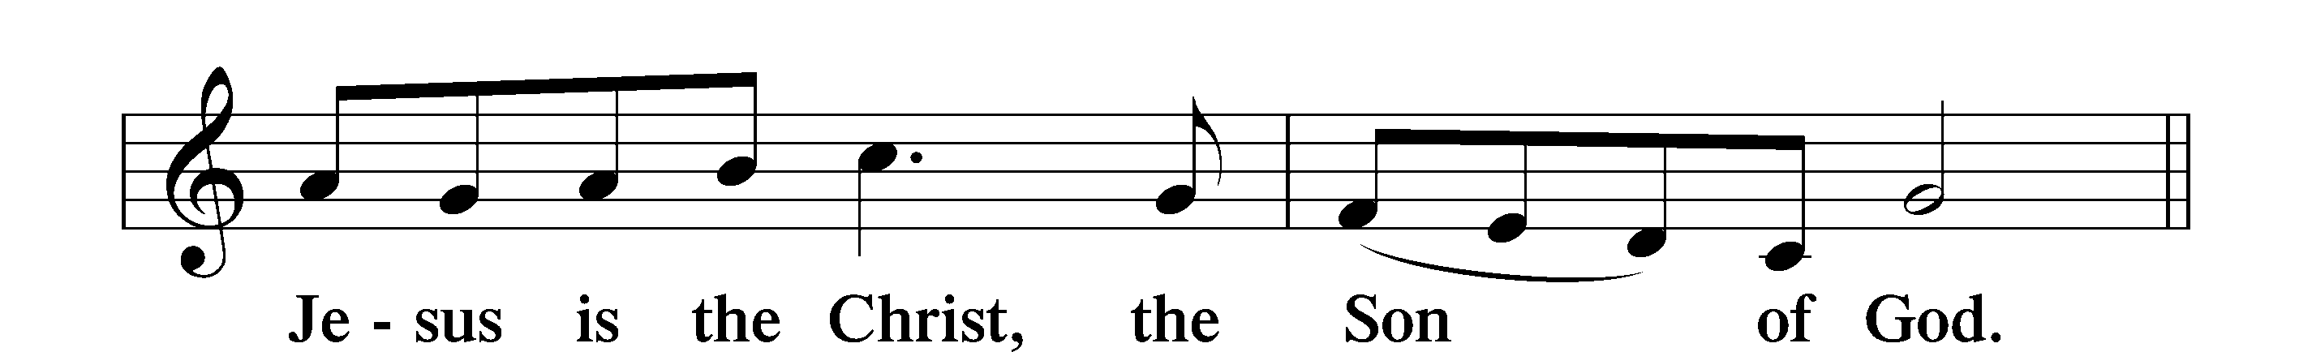

Alleluia

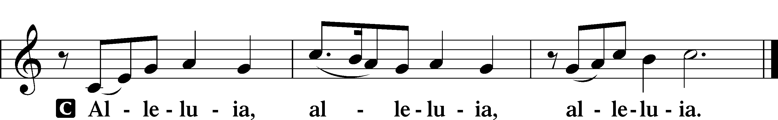

Holy Gospel John 16:12–22

P The Holy Gospel according to St. John, the sixteenth chapter.

C **Glory to You, O Lord.**

12[Jesus said:] “I still have many things to say to you, but you cannot bear them now. 13When the Spirit of truth comes, he will guide you into all the truth, for he will not speak on his own authority, but whatever he hears he will speak, and he will declare to you the things that are to come. 14He will glorify me, for he will take what is mine and declare it to you. 15All that the Father has is mine; therefore I said that he will take what is mine and declare it to you.

16“A little while, and you will see me no longer; and again a little while, and you will see me.” 17So some of his disciples said to one another, “What is this that he says to us, ‘A little while, and you will not see me, and again a little while, and you will see me’; and, ‘because I am going to the Father’?” 18So they were saying, “What does he mean by ‘a little while’? We do not know what he is talking about.” 19Jesus knew that they wanted to ask him, so he said to them, “Is this what you are asking yourselves, what I meant by saying, ‘A little while and you will not see me, and again a little while and you will see me’? 20Truly, truly, I say to you, you will weep and lament, but the world will rejoice. You will be sorrowful, but your sorrow will turn into joy. 21When a woman is giving birth, she has sorrow because her hour has come, but when she has delivered the baby, she no longer remembers the anguish, for joy that a human being has been born into the world. 22So also you have sorrow now, but I will see you again and your hearts will rejoice, and no one will take your joy from you.”

P This is the Gospel of the Lord.

C **Praise to You, O Christ.**

Nicene Creed

C **I believe in one God,**

**the Father Almighty,**

**maker of heaven and earth**

**and of all things visible and invisible.**

**And in one Lord Jesus Christ,**

**the only-begotten Son of God,**

**begotten of His Father before all worlds,**

**God of God, Light of Light,**

**very God of very God,**

**begotten, not made,**

**being of one substance with the Father,**

**by whom all things were made;**

**who for us men and for our salvation came down from heaven**

**and was incarnate by the Holy Spirit of the virgin Mary**

**and was made man;**

**and was crucified also for us under Pontius Pilate.**

**He suffered and was buried.**

**And the third day He rose again according to the Scriptures**

**and ascended into heaven**

**and sits at the right hand of the Father.**

**And He will come again with glory to judge both the living and the dead,**

**whose kingdom will have no end.**

**And I believe in the Holy Spirit,**

**the Lord and giver of life,**

**who proceeds from the Father and the Son,**

**who with the Father and the Son together is worshiped and glorified,**

**who spoke by the prophets.**

**And I believe in one holy Christian and apostolic Church,**

**I acknowledge one Baptism for the remission of sins,**

**and I look for the resurrection of the dead**

**and the life** T **of the world to come. Amen.**

Sit

Children's Sermon

633 At the Lamb’s High Feast We Sing

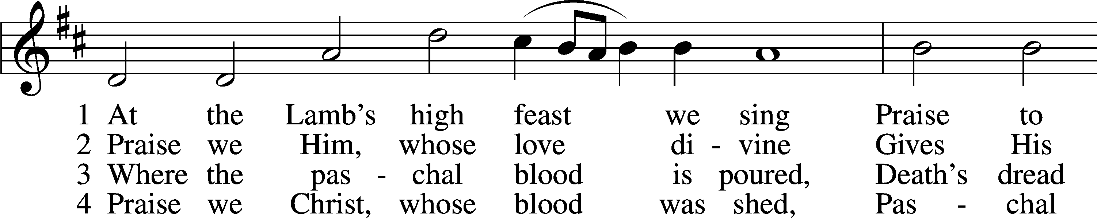

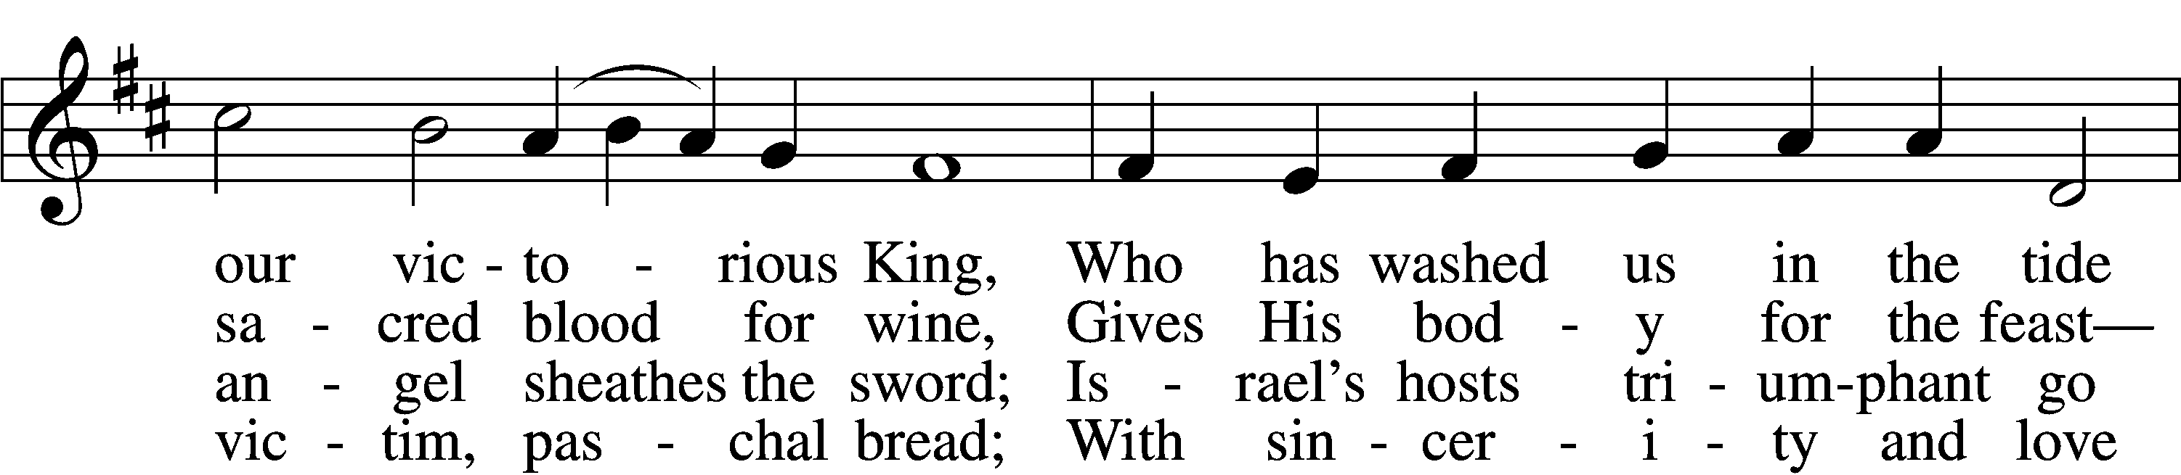

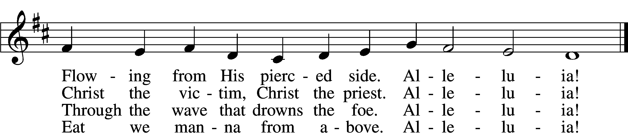

5 Mighty Victim from the sky,  
Hell’s fierce pow’rs beneath You lie;  
You have conquered in the fight,  
You have brought us life and light.  
 Alleluia!

6 Now no more can death appall,  
Now no more the grave enthrall;  
You have opened paradise,  
And Your saints in You shall rise.  
 Alleluia!

7 Easter triumph, Easter joy!  
This alone can sin destroy;  
From sin’s pow’r, Lord, set us free,  
Newborn souls in You to be.  
 Alleluia!

D 8 Father, who the crown shall give,  
Savior, by whose death we live,  
Spirit, guide through all our days:  
Three in One, Your name we praise.  
 Alleluia!

Text: Latin, c. 5th–10th cent.; tr. Robert Campbell, 1814–68, alt.  
Tune: Kirchengeseng, 1566, Ivancice  
Text and tune: Public domain

Sermon

Stand

Prayer of the Church

Following the prayers, the people may greet one another in the name of the Lord, saying, “Peace be with you,” as a sign of reconciliation and of the unity of the Spirit in the bond of peace (Matt. 5:22–24; Eph. 4:1–3).

Sit

Offering

Hymn

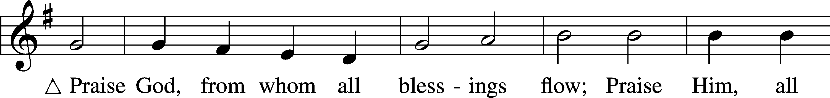

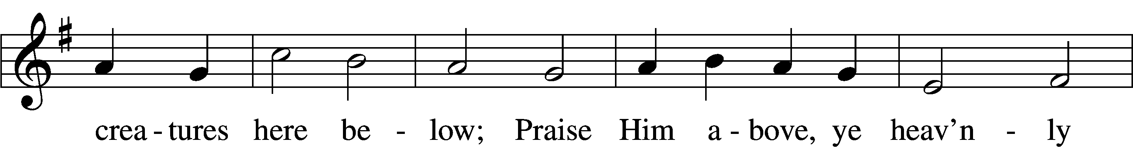

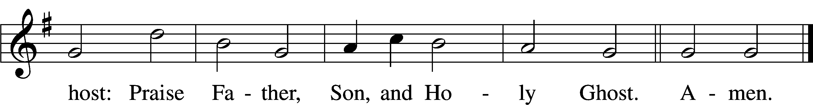

Text: Thomas Ken, 1637–1711  
Tune: Trente quatre Pseaumes de David, 1551, Geneva, ed. Louis Bourgeois  
Text and tune: Public domain

# Service of the Sacrament

Stand

Preface 2 Timothy 4:22; [Colossians 3:1]; [Psalm 136]

P The Lord be with you.

C **And also with you.**

P Lift up your hearts.

C **We lift them to the Lord.**

P Let us give thanks to the Lord our God.

C **It is right to give Him thanks and praise.**

P It is truly good, right, and salutary that we should at all times and in all places give thanks to You, O Lord, holy Father, almighty and everlasting God, for the countless blessings You so freely bestow on us and all creation. Above all, we give thanks for Your boundless love shown to us when You sent Your only-begotten Son, Jesus Christ, into our flesh and laid on Him our sin, giving Him into death that we might not die eternally. Because He is now risen from the dead and lives and reigns to all eternity, all who believe in Him will overcome sin and death and will rise again to new life. Therefore with angels and archangels and with all the company of heaven we laud and magnify Your glorious name, evermore praising You and saying:

Sanctus Isaiah 6:3; Matthew 21:9

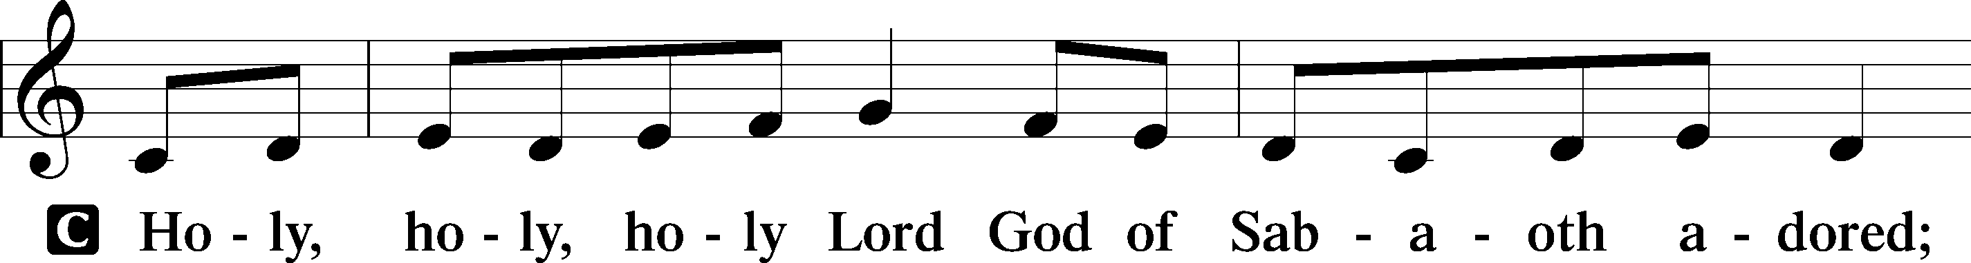

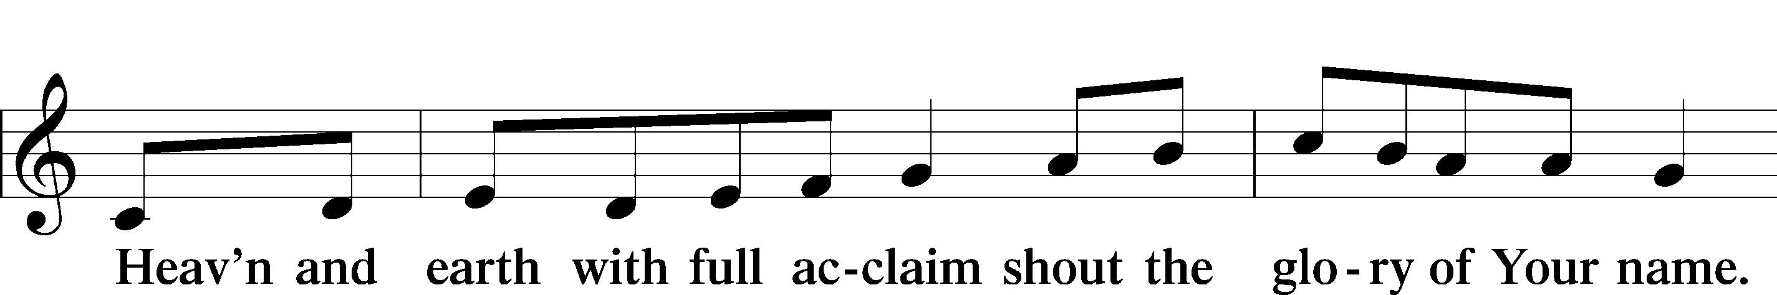

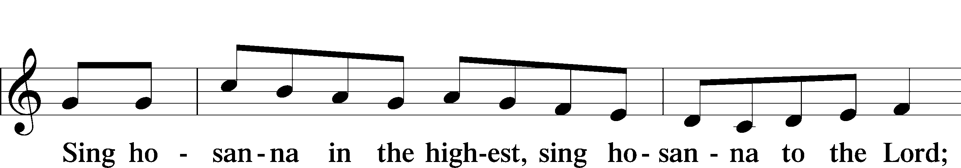

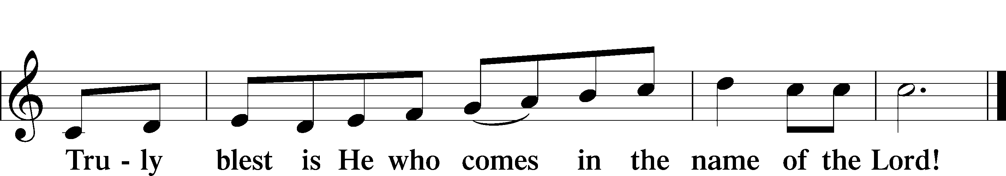

Text: Stephen P. Starke

Prayer of Thanksgiving

P Blessed are You, O Lord our God, king of all creation, for You have had mercy on us and given Your only-begotten Son that whoever believes in Him should not perish but have eternal life.

For Christ, our Passover Lamb, has been sacrificed. By His death, He has redeemed us from bondage to sin and death, and by His resurrection, He has delivered us into new life in Him.

Grant us to keep the Feast in sincerity and truth, faithfully eating His body given into death and drinking His life’s blood poured out for our salvation until we pass through death to the promised land of life eternal.

Hear us as we pray in His name and as He has taught us:

Lord’s Prayer

C **Our Father who art in heaven,**

**hallowed be Thy name,**

**Thy kingdom come,**

**Thy will be done on earth**

**as it is in heaven;**

**give us this day our daily bread;**

**and forgive us our trespasses**

**as we forgive those**

**who trespass against us;**

**and lead us not into temptation,**

**but deliver us from evil.**

**For Thine is the kingdom**

**and the power and the glory**

**forever and ever. Amen.**

The Words of Our Lord

P Our Lord Jesus Christ, on the night when He was betrayed, took bread, and when He had given thanks, He broke it and gave it to the disciples and said: “Take, eat; this is My T body, which is given for you. This do in remembrance of Me.”

In the same way also He took the cup after supper, and when He had given thanks, He gave it to them, saying: “Drink of it, all of you; this cup is the new testament in My T blood, which is shed for you for the forgiveness of sins. This do, as often as you drink it, in remembrance of Me.”

Pax Domini

P The peace of the Lord be with you always.

C **Amen.**

Agnus Dei John 1:29

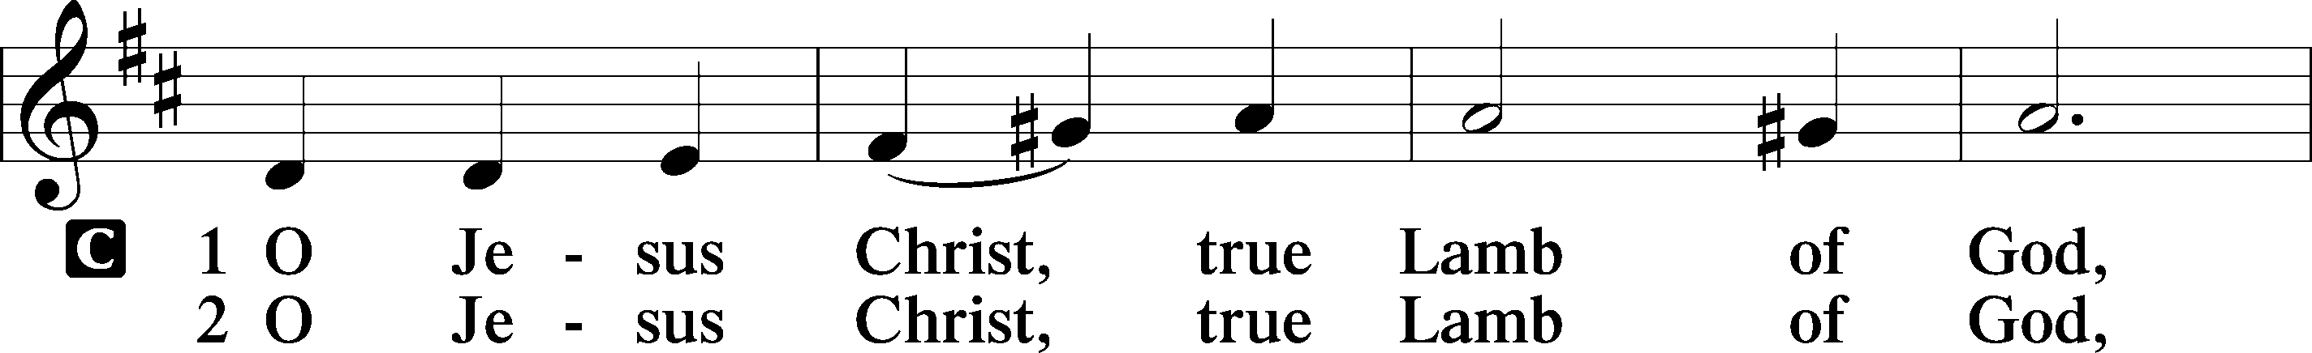

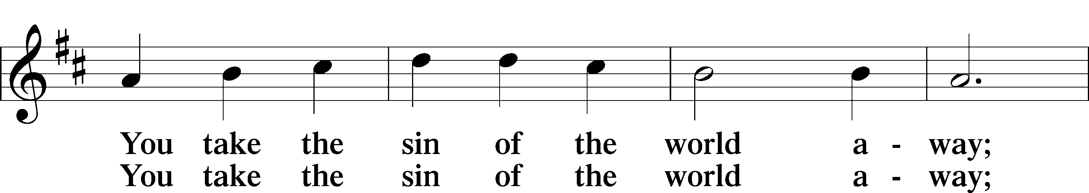

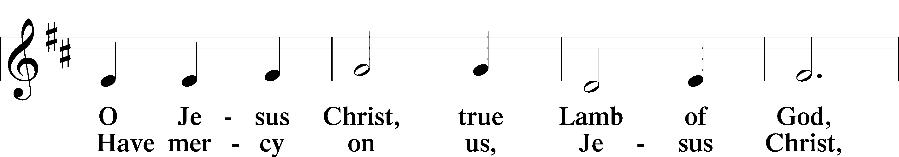

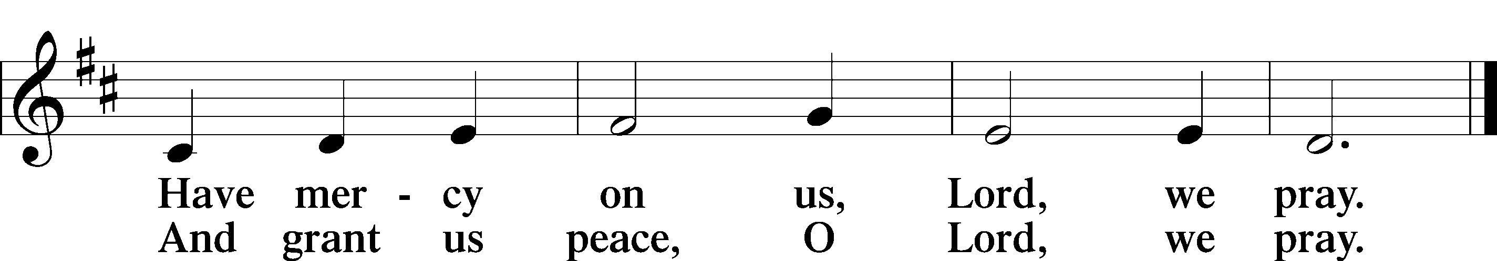

Text: Stephen P. Starke

Sit

Distribution

The pastor and those who assist him receive the body and blood of Christ first and then distribute them to those who come to receive, saying:

Take, eat; this is the true body of our Lord and Savior Jesus Christ, given into death for your sins.

**Amen.**

Take, drink; this is the true blood of our Lord and Savior Jesus Christ, shed for the forgiveness of your sins.

**Amen.**

In dismissing the communicants, the following is said:

The Dismissal

P The body and blood of our Lord Jesus Christ strengthen and preserve you in body and soul to life everlasting. Depart T in peace.

C **Amen.**

628 Your Table I Approach

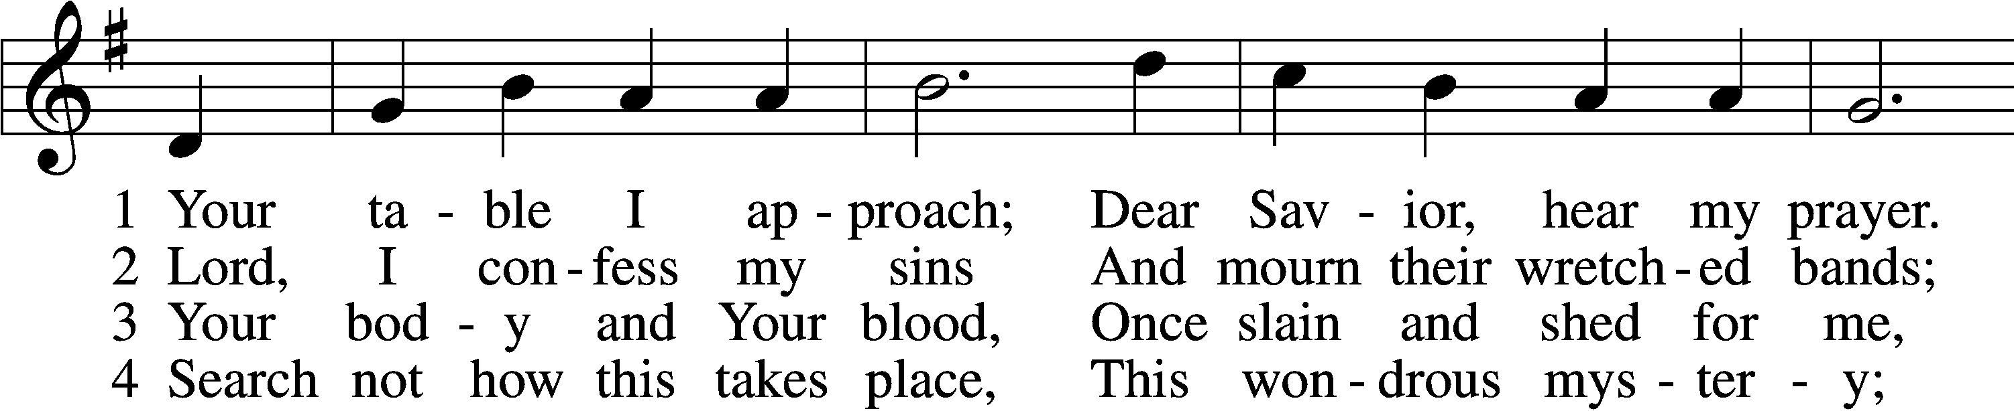

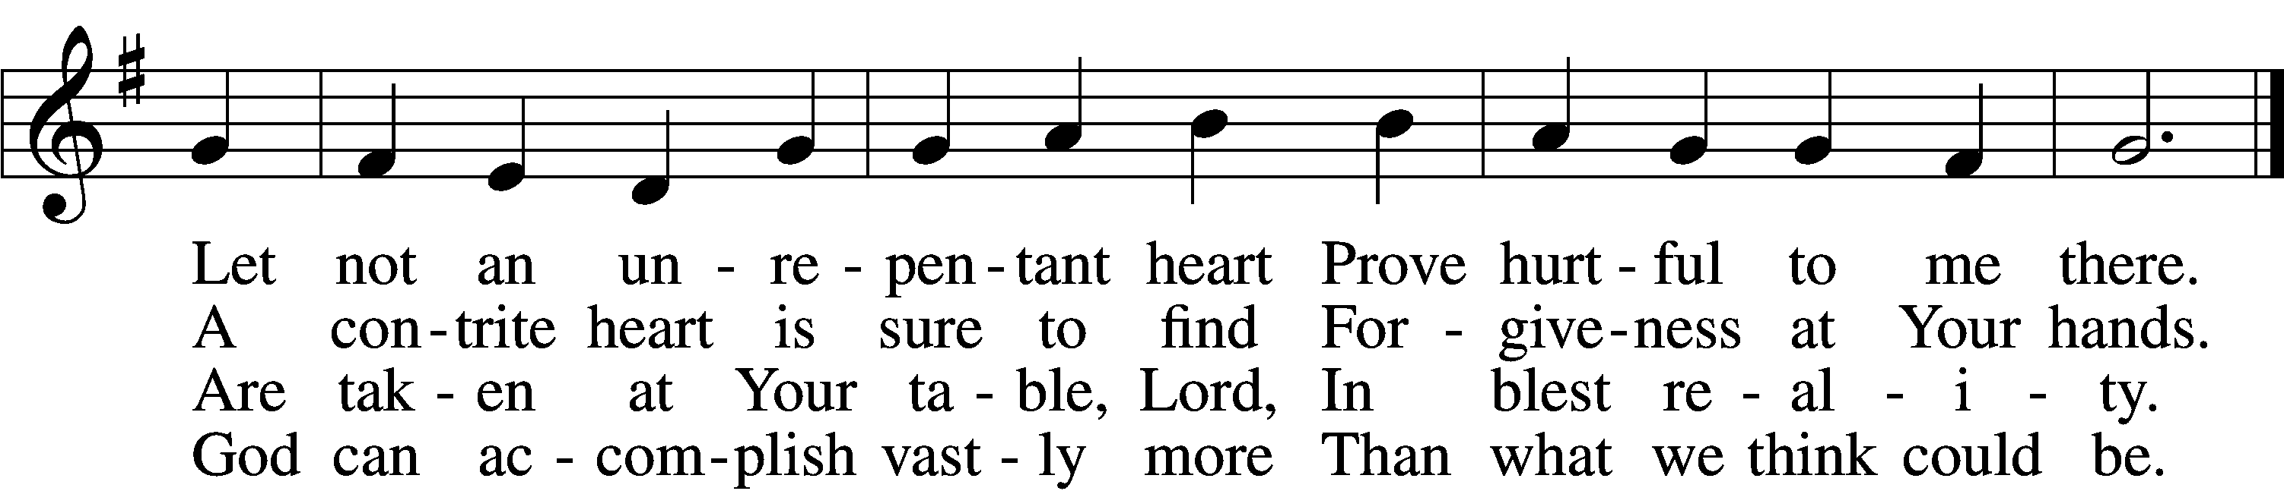

5 O grant, most blessèd Lord,  
 That earth and hell combined  
May not about this sacrament  
 Raise doubt within my mind.

6 Oh, may I never fail  
 To thank You day and night  
For Your true body and true blood,  
 O God, my peace and light.

Text: Gerhard Wolter Molanus, 1633–1722; tr. Matthias Loy, 1828–1915, alt.  
Tune: Trente quatre Pseaumes de David, 1551, Geneva, ed. Louis Bourgeois  
Text and tune: Public domain

618 I Come, O Savior, to Thy Table

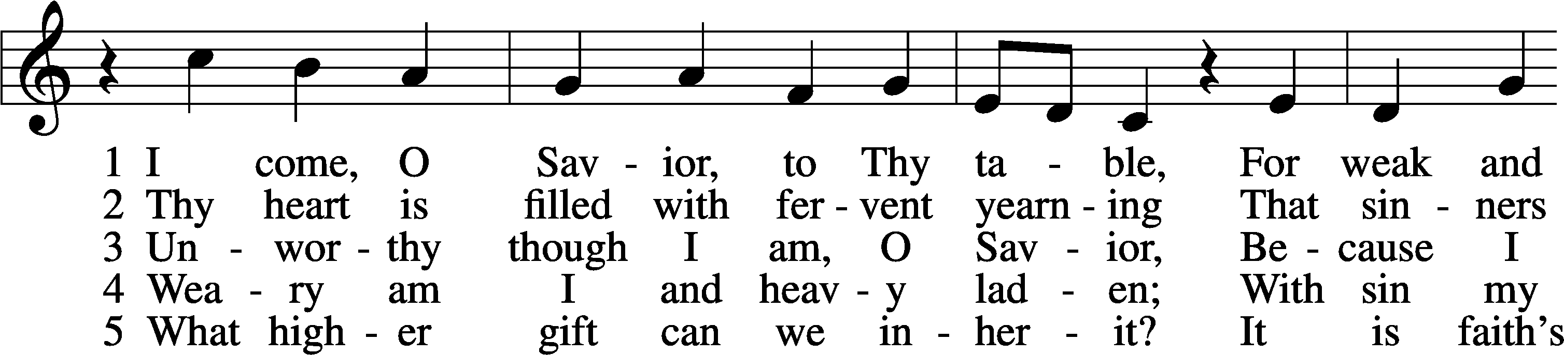

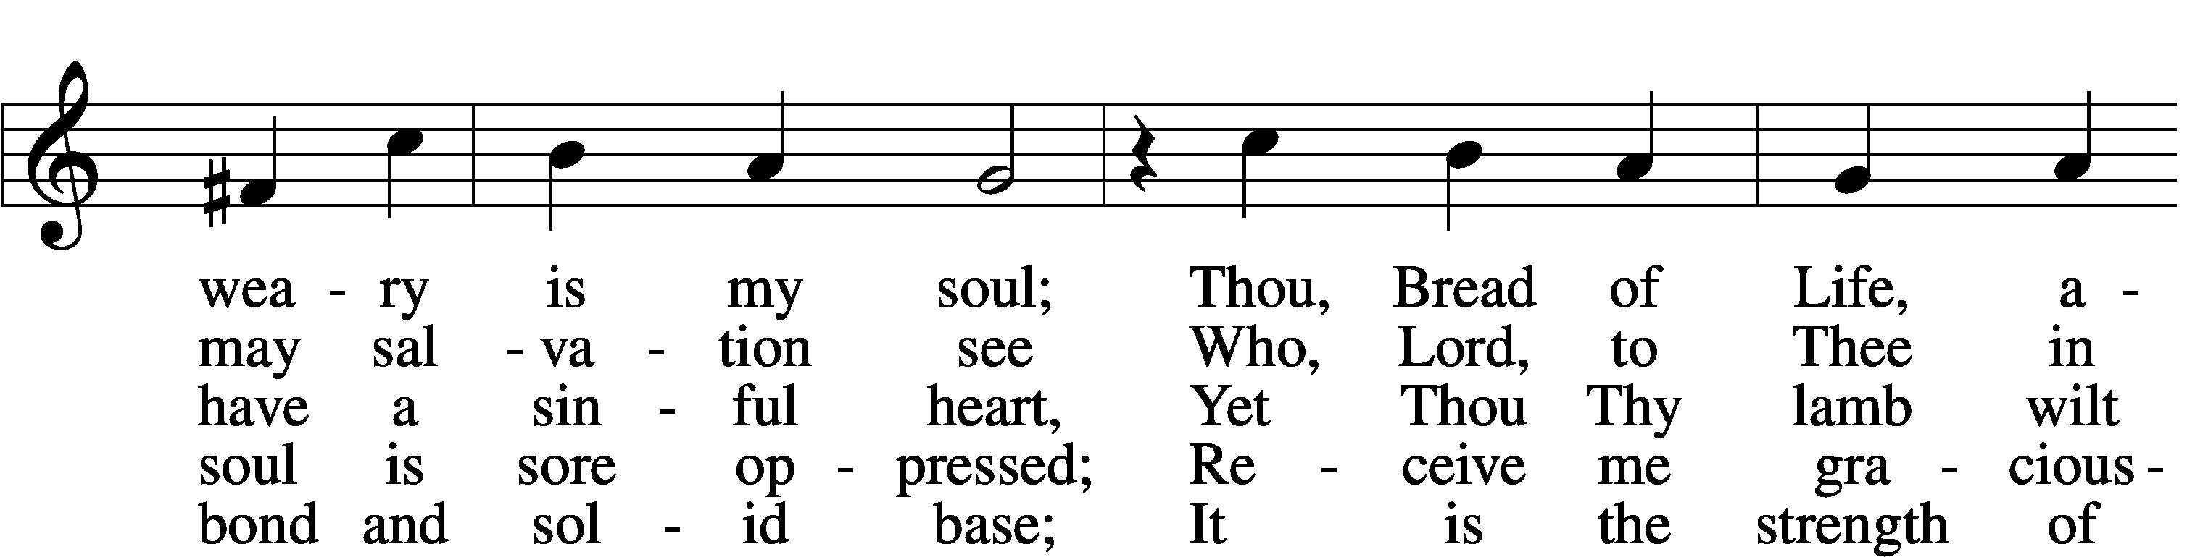

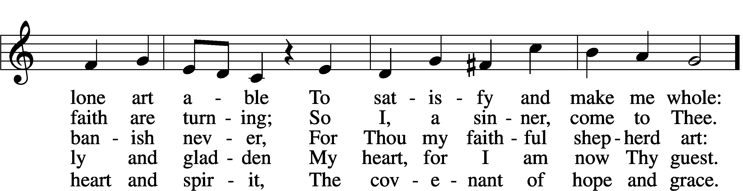

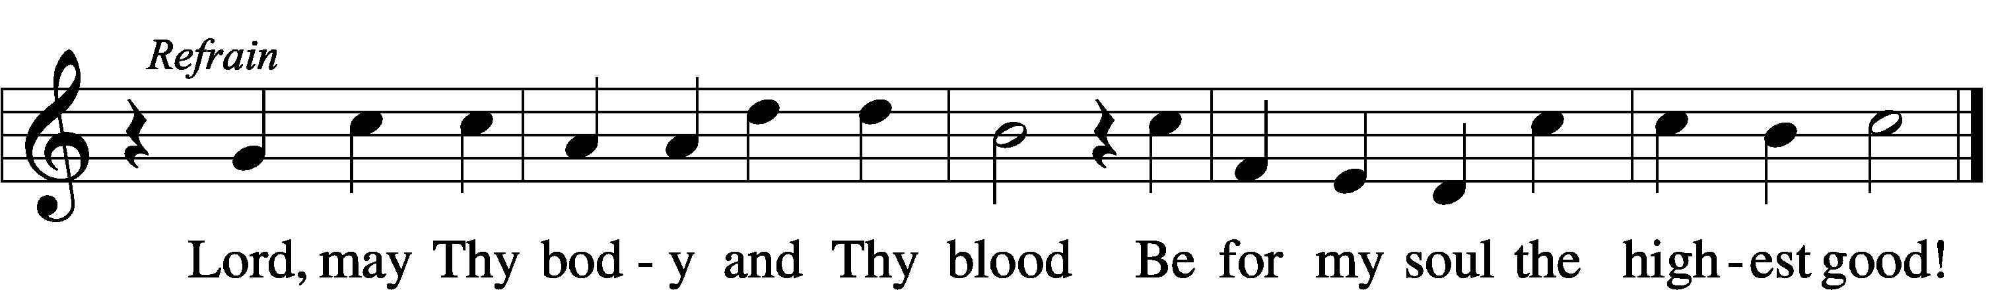

Text: Friedrich Christian Heyder, 1677–1754; tr. The Lutheran Hymnal, 1941, abr.  
Tune: Emskirchner Choral-Buch, 1756, Leipzig  
Text: © 1941 Concordia Publishing House. Used by permission: LSB Hymn License no. 110005011  
Tune: Public domain

655 Lord, Keep Us Steadfast in Your Word

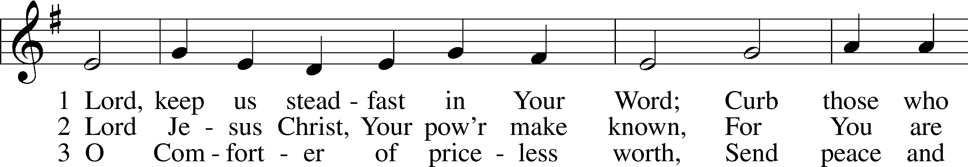

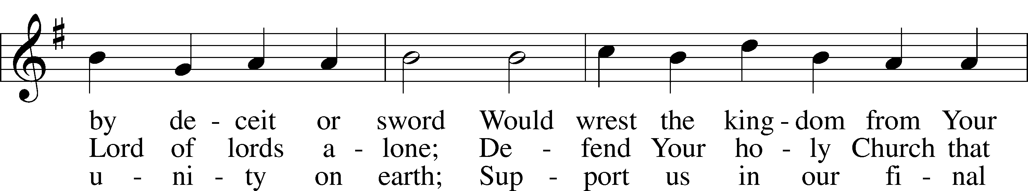

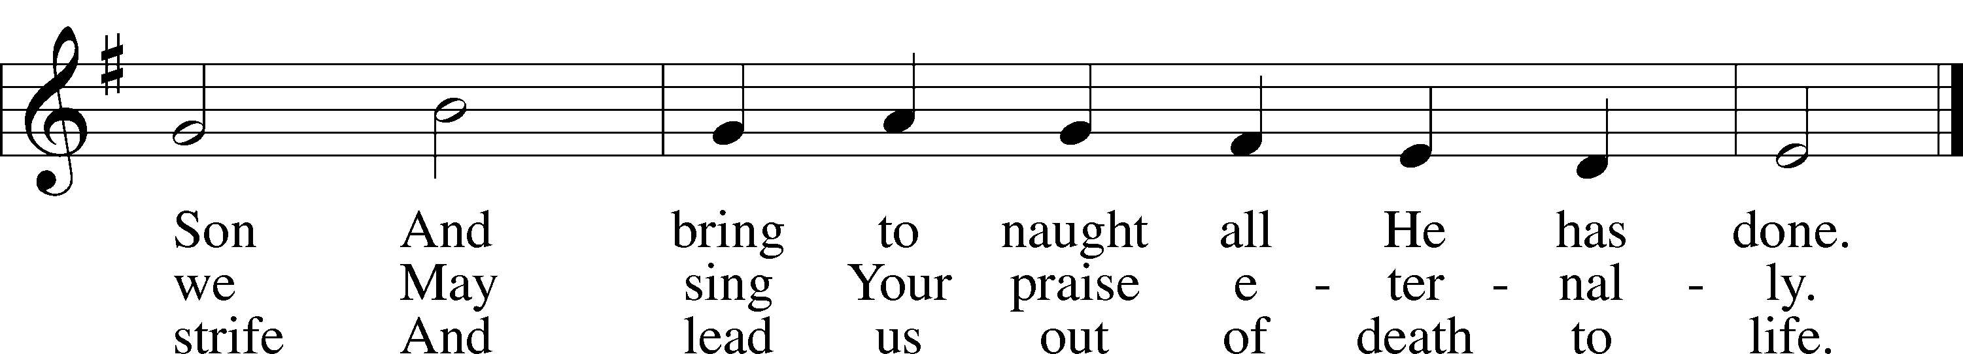

Text: Martin Luther, 1483–1546; tr. Catherine Winkworth, 1827–78, alt.  
Tune: Geistliche Lieder auffs new gebessert, 1543, Wittenberg, ed. Joseph Klug  
Text and tune: Public domain

686 Come, Thou Fount of Every Blessing

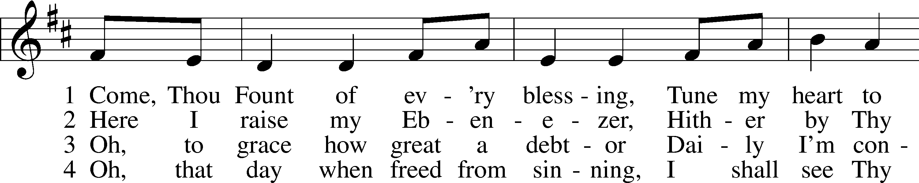

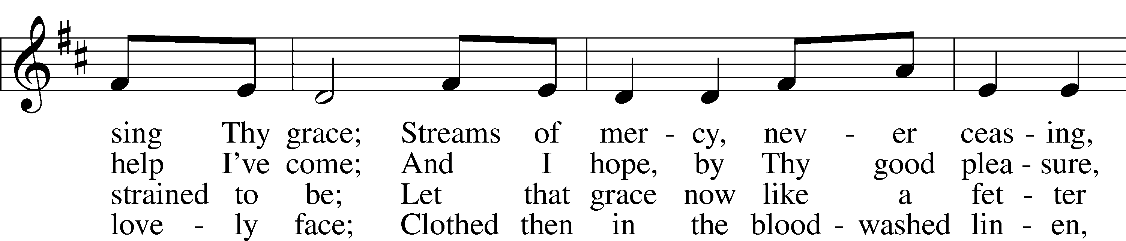

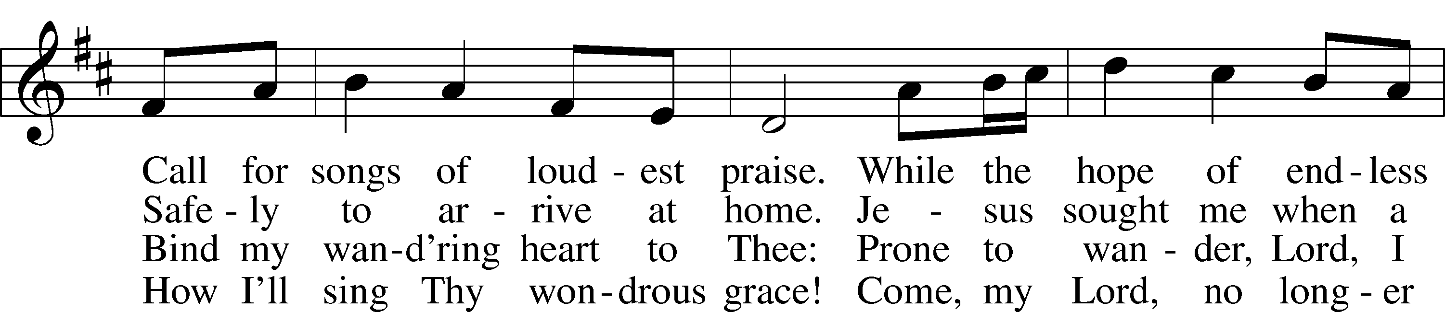

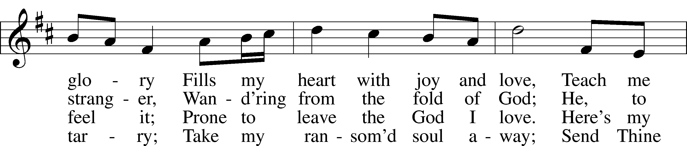

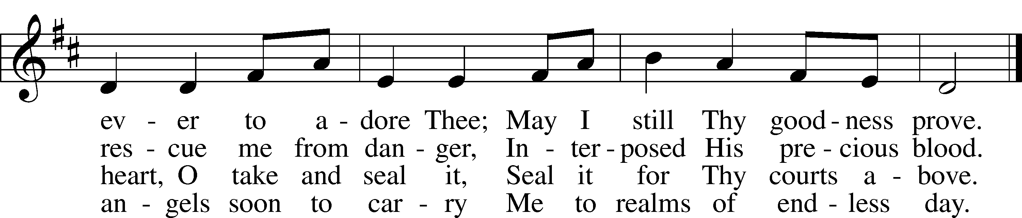

Text: Robert Robinson, 1735–90, alt.  
Tune: Repository of Sacred Music, Part Second, 1813, Harrisburg  
Text and tune: Public domain

Stand

Nunc Dimittis Luke 2:29–32

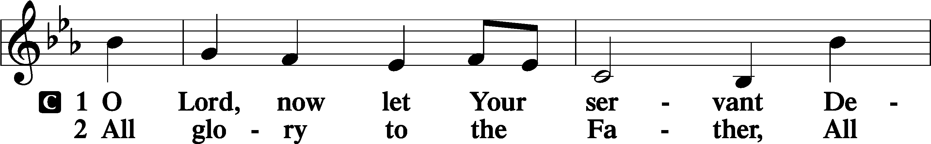

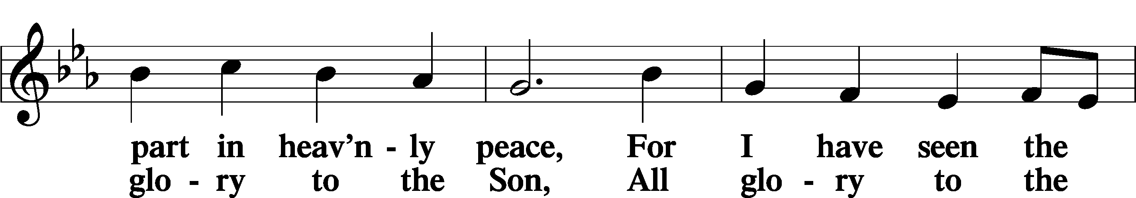

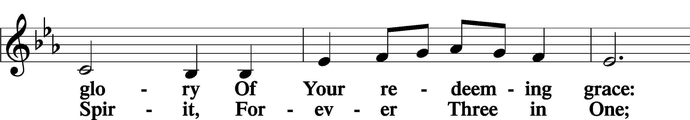

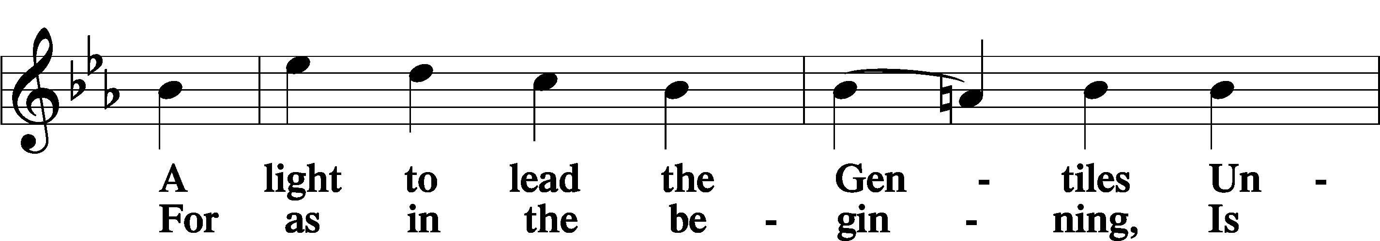

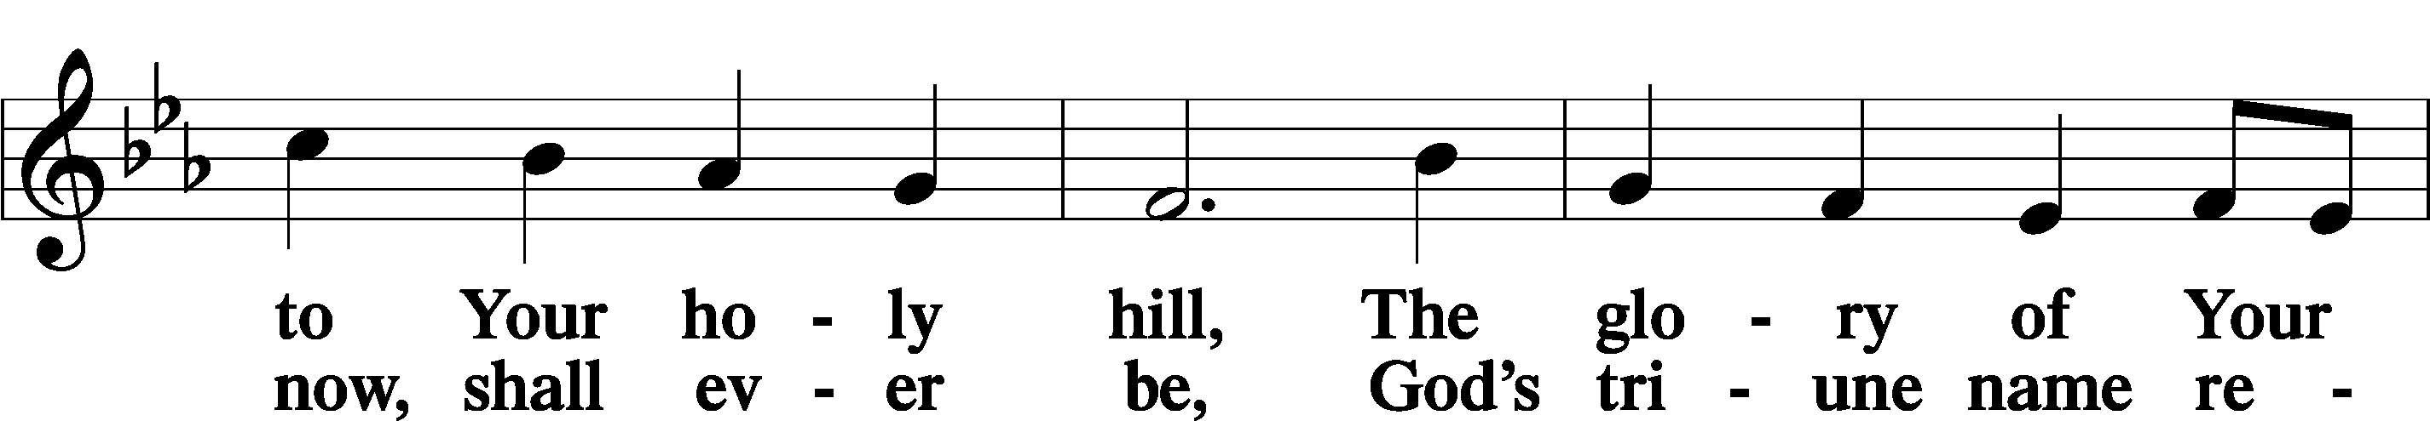

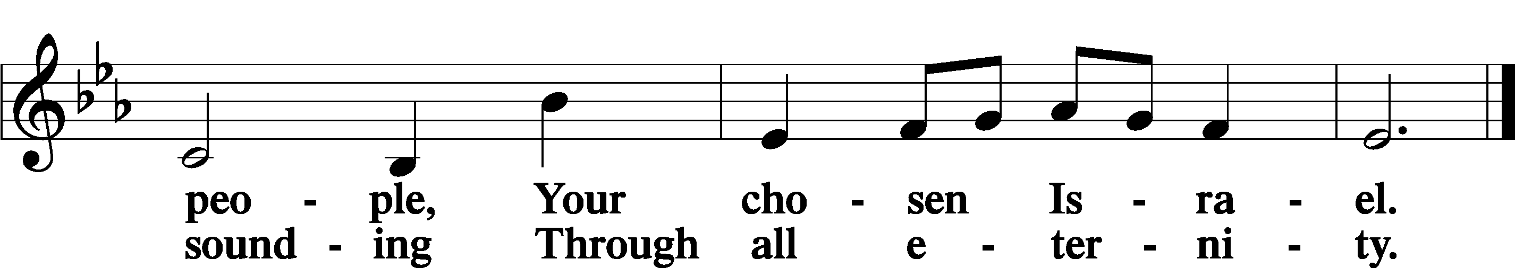

Post-Communion Collect

A Let us pray.

We give thanks to You, almighty God, that You have refreshed us through this salutary gift, and we implore You that of Your mercy You would strengthen us through the same in faith toward You and in fervent love toward one another; through Jesus Christ, Your Son, our Lord, who lives and reigns with You and the Holy Spirit, one God, now and forever.

C **Amen.**

Benedicamus Psalm 103:1

A Let us bless the Lord.

C **Thanks be to God.**

Benediction

P The Lord bless you and keep you.

The Lord make His face shine on you and be gracious to you.

The Lord look upon you with favor and T give you peace.

C **Amen.**

644 The Church’s One Foundation sts. 1–5

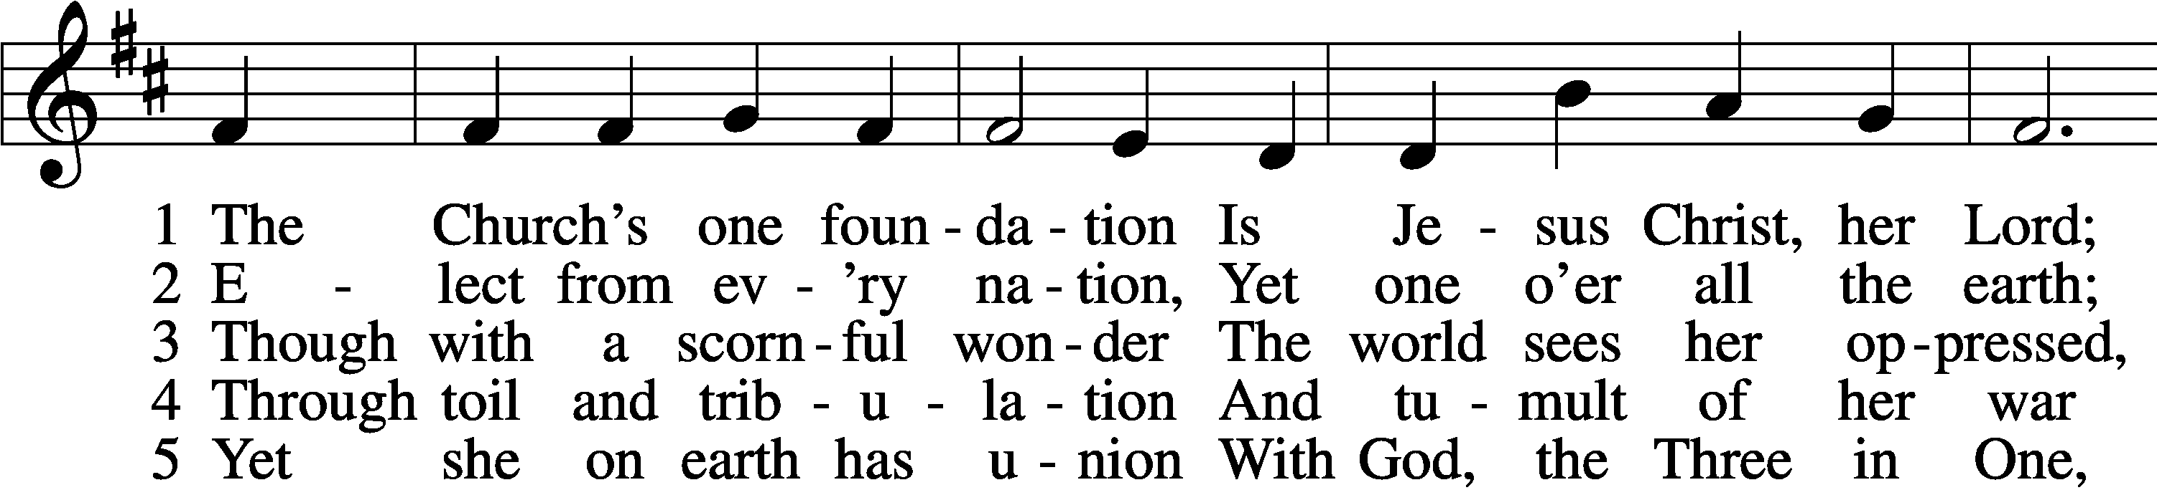

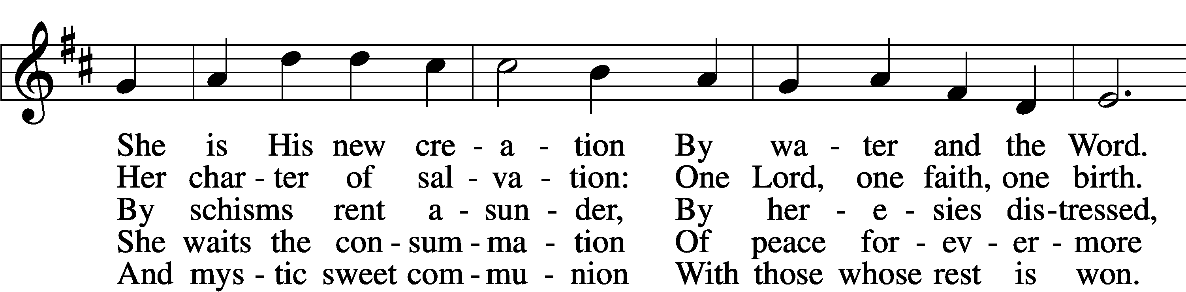

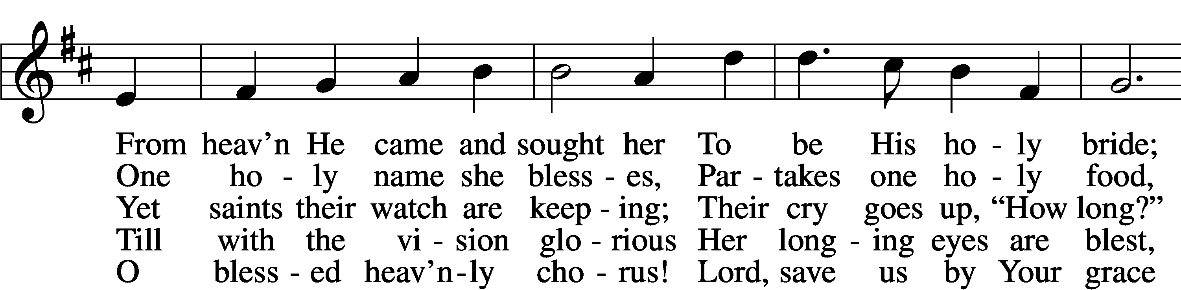

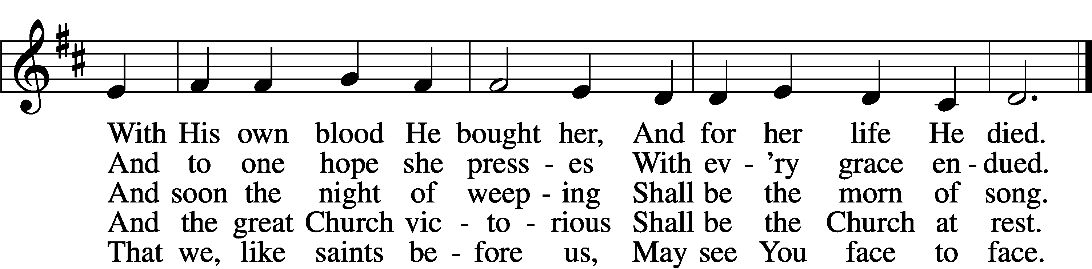

Text: Samuel J. Stone, 1839–1900, alt.  
Tune: Samuel S. Wesley, 1810–76  
Text and tune: Public domain

Acknowledgments

Divine Service, Setting Four from Lutheran Service Book

Unless otherwise indicated, Scripture quotations are from the ESV® Bible (The Holy Bible, English Standard Version®), copyright © 2001 by Crossway, a publishing ministry of Good News Publishers. Used by permission. All rights reserved.

Created by Lutheran Service Builder © 2025 Concordia Publishing House.