On entering the church

P Lord, I love the habitation of Your house and the place

where Your glory dwells. In the multitude of Your tender

mercies prepare my heart that I may enter Your house to

worship and confess Your holy name; through Jesus Christ,

my God and Lord.

Before worship

C O Lord, our creator, redeemer, and comforter, as we come

together to worship You in spirit and in truth, we humbly

pray that You would open our hearts to the preaching of

Your Word so that we may repent of our sins, believe in

Jesus Christ as our only Savior, and grow in grace and

holiness. Hear us for His sake.

516 Wake, Awake, for Night Is Flying

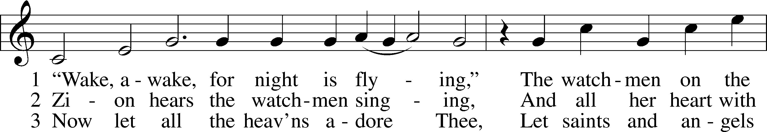

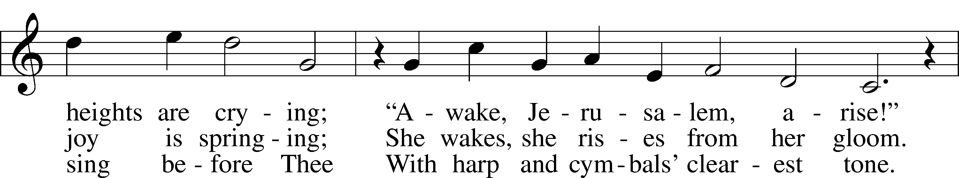

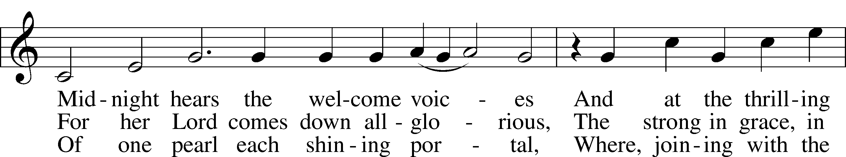

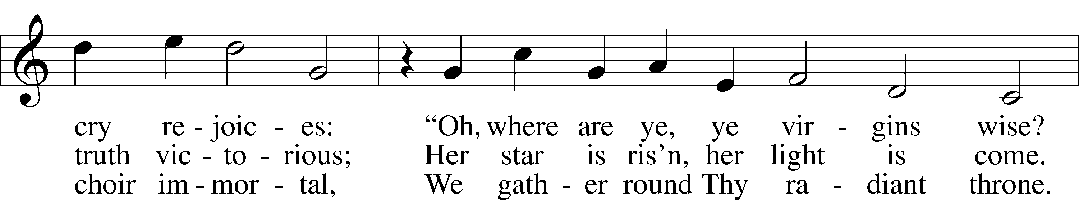

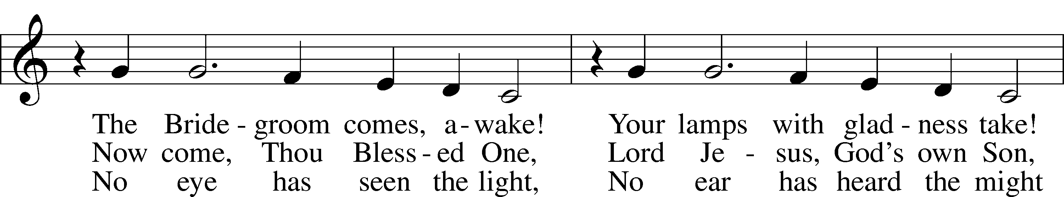

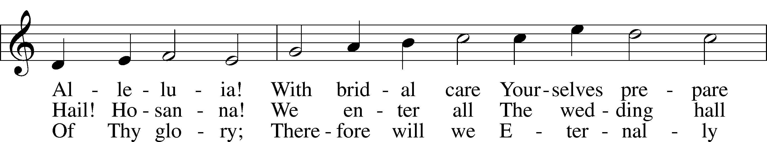

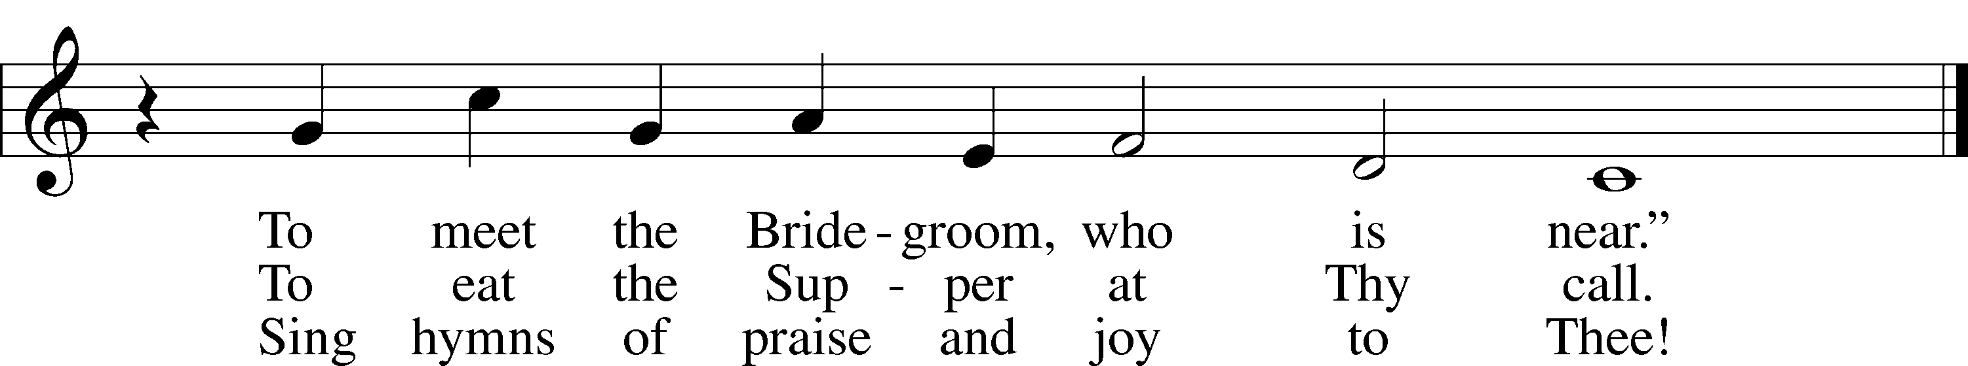

Text: tr. Catherine Winkworth, 1827–78, alt.  
Text and tune: Philipp Nicolai, 1556–1608  
Text and tune: Public domain

# Confession and Absolution

The sign of the cross may be made by all in remembrance of their Baptism.

Invocation Matthew 28:19b; 18:20

P In the name of the Father and of the T Son and of the Holy Spirit.

C **Amen.**

Exhortation Hebrews 10:22; Psalm 124:8; Psalm 32:5

P Beloved in the Lord! Let us draw near with a true heart and confess our sins unto God our Father, beseeching Him in the name of our Lord Jesus Christ to grant us forgiveness.

P Our help is in the name of the Lord,

C **who made heaven and earth.**

P I said, I will confess my transgressions unto the Lord,

C **and You forgave the iniquity of my sin.**

Silence for reflection on God’s Word and for self-examination.

Confession of Sins

P O almighty God, merciful Father,

C **I, a poor, miserable sinner, confess unto You all my sins and iniquities with which I have ever offended You and justly deserved Your temporal and eternal punishment. But I am heartily sorry for them and sincerely repent of them, and I pray You of Your boundless mercy and for the sake of the holy, innocent, bitter sufferings and death of Your beloved Son, Jesus Christ, to be gracious and merciful to me, a poor, sinful being.**

Absolution [John 20:19–23]

P Upon this your confession, I, by virtue of my office, as a called and ordained servant of the Word, announce the grace of God unto all of you, and in the stead and by the command of my Lord Jesus Christ I forgive you all your sins in the name of the Father and of the T Son and of the Holy Spirit.

C **Amen.**

# Service of the Word

Introit Psalm 117; antiphon: Psalm 96:6a; 115:18

Splendor and majesty are before him;  
 we willbless the Lord from this time forth and forevermore. Praise the Lord!  
**Praise the Lord, all nations!  
 Extol him, all peoples!**For great is his steadfast love toward us,  
 and the faithfulness of the Lord endures forever. Praise the Lord!

Gloria Patri

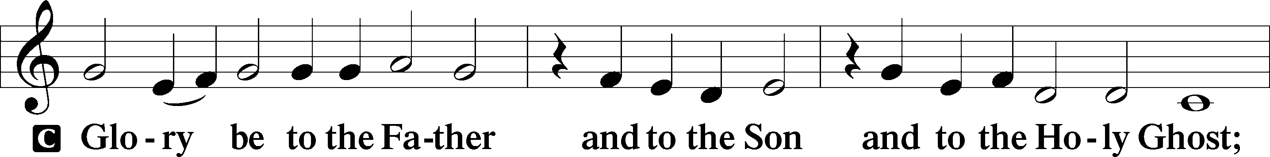

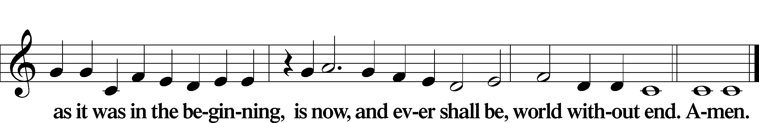

Kyrie Mark 10:47

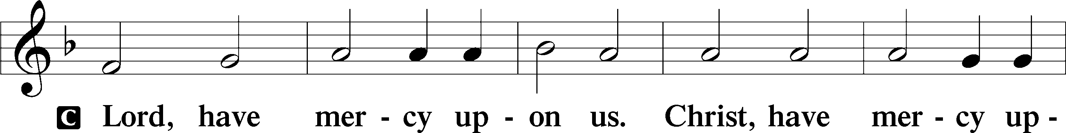

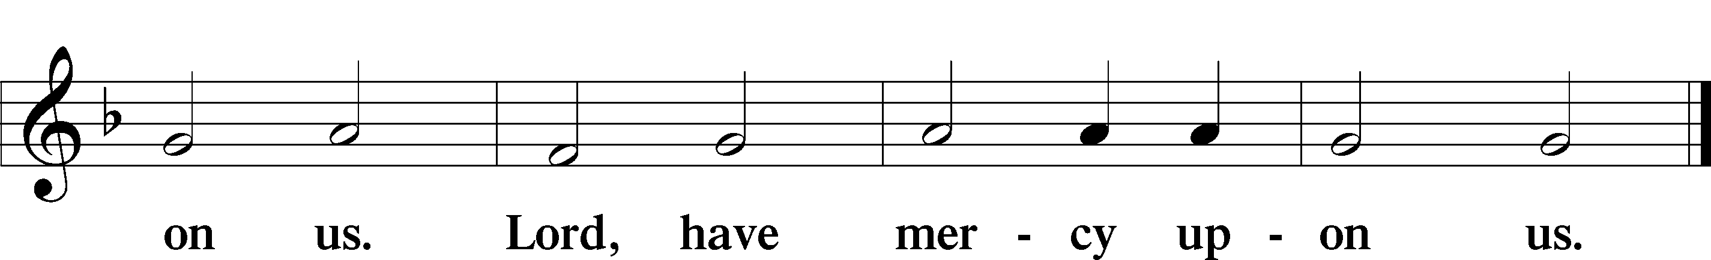

Gloria in Excelsis Luke 2:14; John 1:29

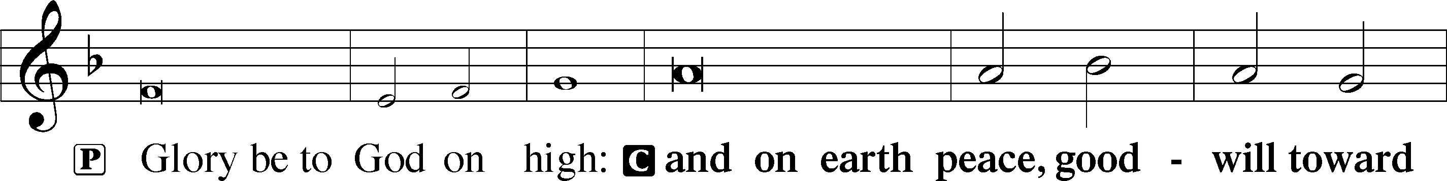

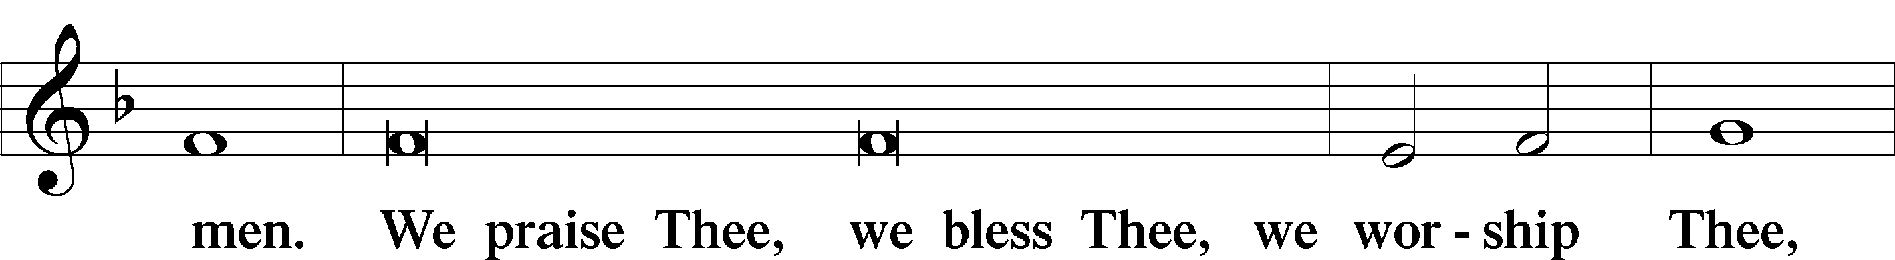

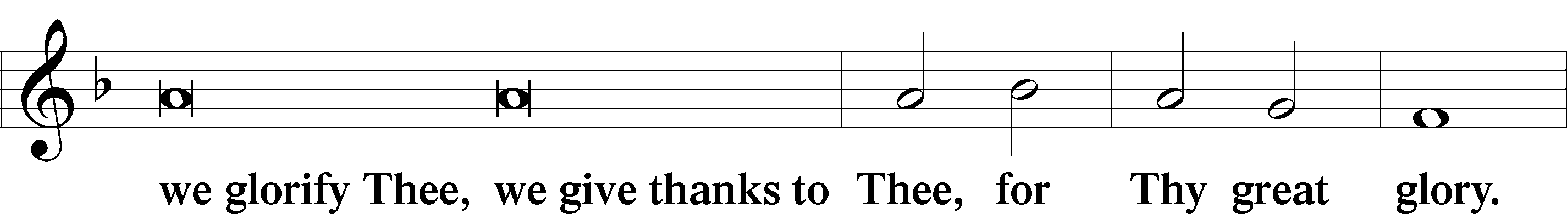

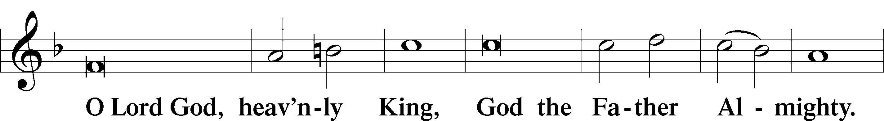

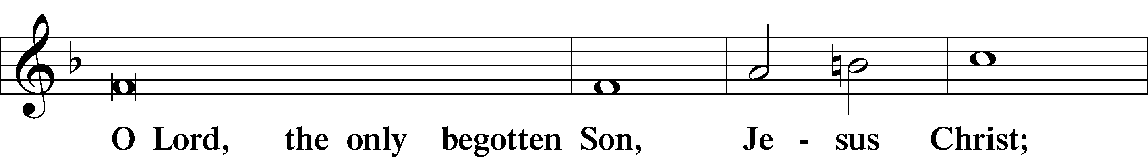

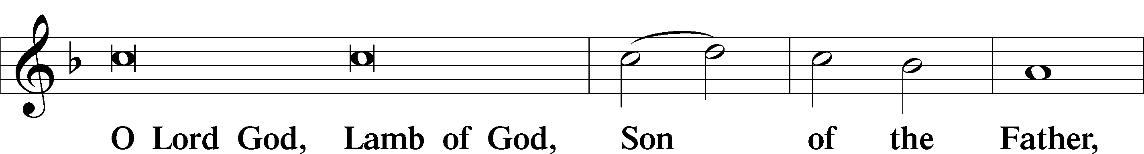

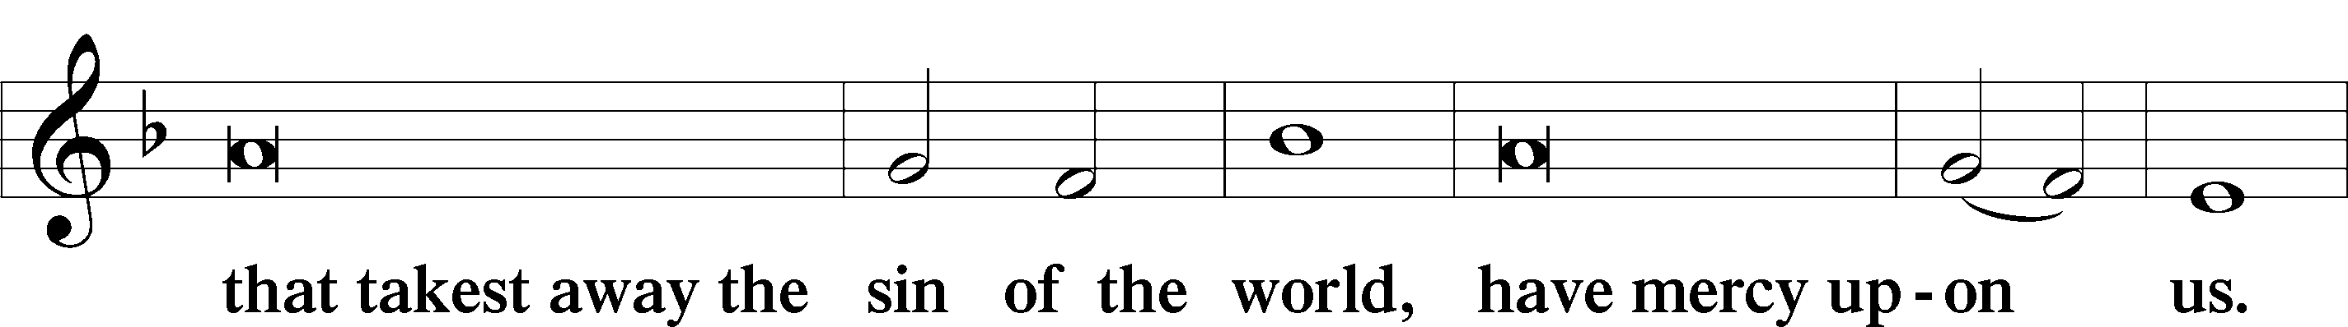

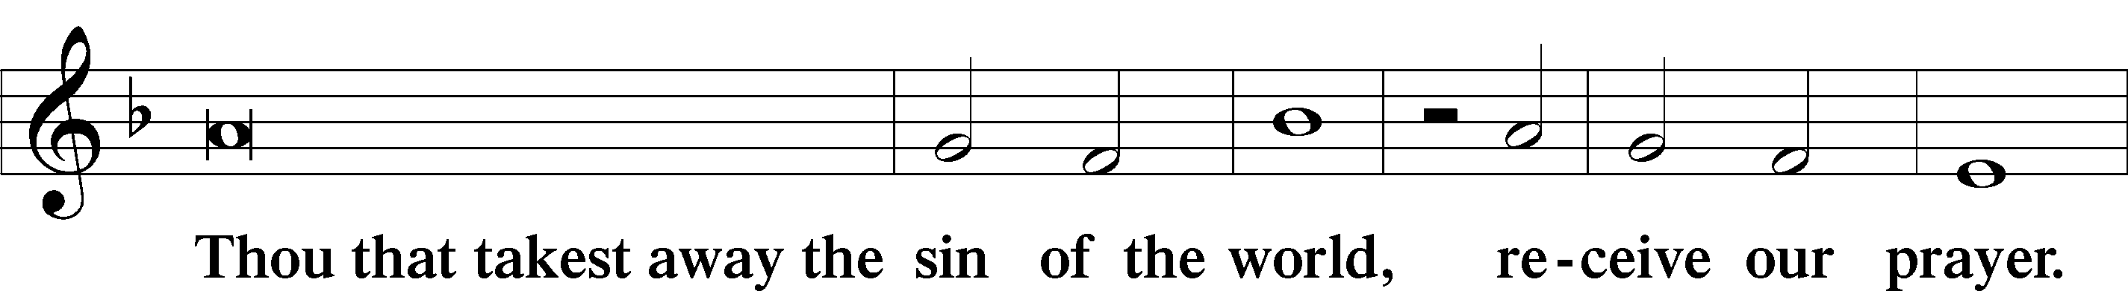

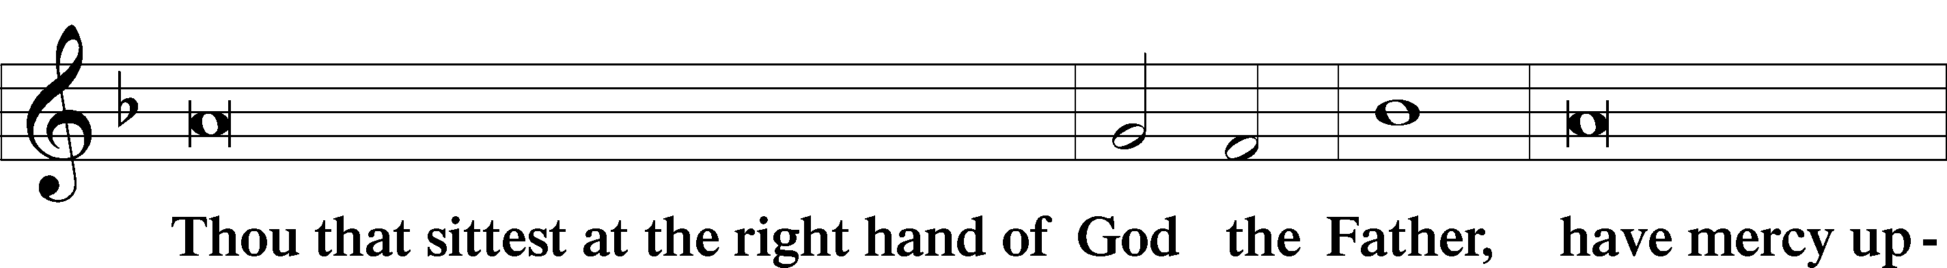

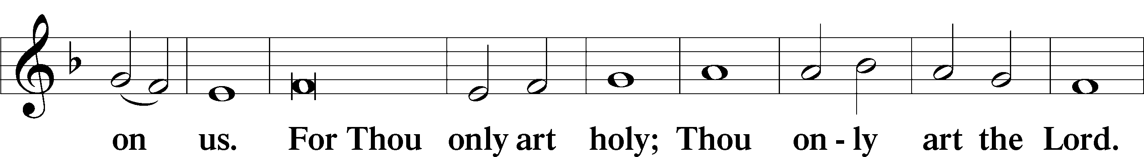

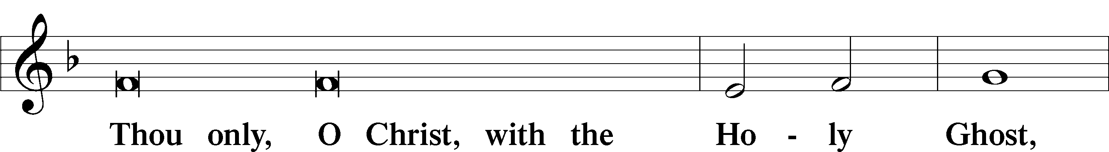

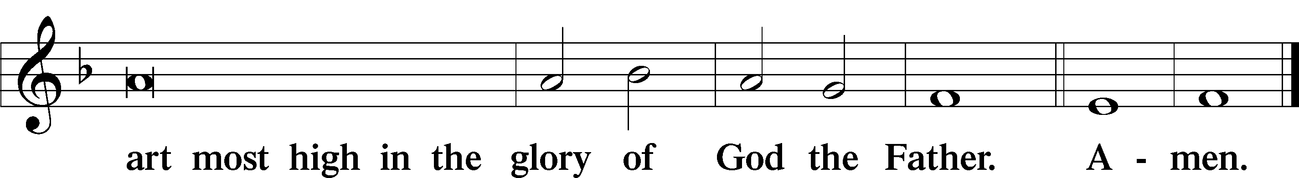

Salutation and Collect of the Day

P The Lord be with you.

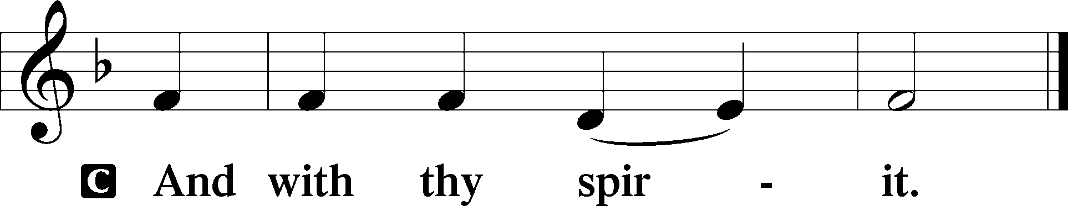

P Let us pray.

O Lord, You have called us to enter Your kingdomthrough the narrow door. Guide us by Your Word and Spirit, and lead us now and always into the feast of Your Son, Jesus Christ, who lives and reigns with You and the Holy Spirit, one God, now and forever.

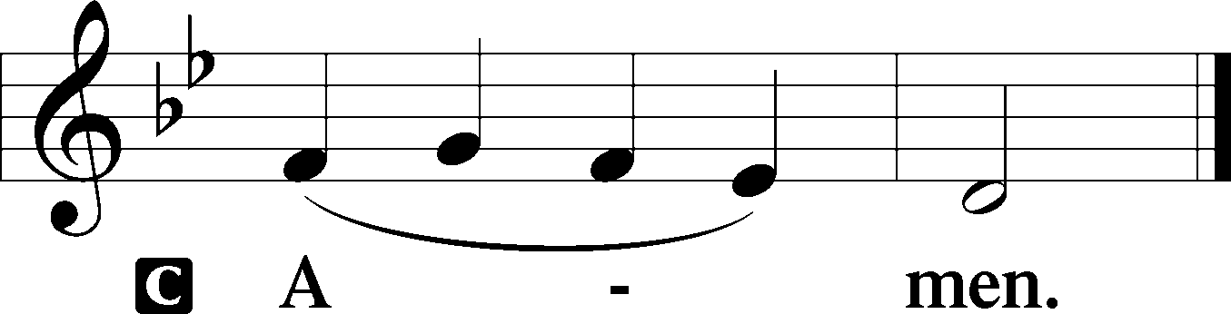

Sit

Old Testament Reading Isaiah 66:18–23

18“For I know their works and their thoughts, and the time is coming to gather all nations and tongues. And they shall come and shall see my glory, 19and I will set a sign among them. And from them I will send survivors to the nations, to Tarshish, Pul, and Lud, who draw the bow, to Tubal and Javan, to the coastlands afar off, that have not heard my fame or seen my glory. And they shall declare my glory among the nations. 20And they shall bring all your brothers from all the nations as an offering to the Lord, on horses and in chariots and in litters and on mules and on dromedaries, to my holy mountain Jerusalem, says the Lord, just as the Israelites bring their grain offering in a clean vessel to the house of the Lord. 21And some of them also I will take for priests and for Levites, says the Lord.

22“For as the new heavens and the new earth  
 that I make  
shall remain before me, says the Lord,  
 so shall your offspring and your name remain.  
23From new moon to new moon,  
 and from Sabbath to Sabbath,  
all flesh shall come to worship before me,  
declares the Lord.”

A This is the Word of the Lord.

C **Thanks be to God.**

Gradual Psalm 34:9, 19, alt.

Fear the Lord, you his saints,  
 for those who fear him lack nothing!  
**Many are the afflictions of the righteous,  
 but the Lord delivers him out of them all.**

Epistle Hebrews 12:4–24

4In your struggle against sin you have not yet resisted to the point of shedding your blood. 5And have you forgotten the exhortation that addresses you as sons?

“My son, do not regard lightly the discipline of the Lord,  
 nor be weary when reproved by him.  
6For the Lord disciplines the one he loves,  
 and chastises every son whom he receives.”

7It is for discipline that you have to endure. God is treating you as sons. For what son is there whom his father does not discipline? 8If you are left without discipline, in which all have participated, then you are illegitimate children and not sons. 9Besides this, we have had earthly fathers who disciplined us and we respected them. Shall we not much more be subject to the Father of spirits and live? 10For they disciplined us for a short time as it seemed best to them, but he disciplines us for our good, that we may share his holiness. 11For the moment all discipline seems painful rather than pleasant, but later it yields the peaceful fruit of righteousness to those who have been trained by it.

12Therefore lift your drooping hands and strengthen your weak knees, 13and make straight paths for your feet, so that what is lame may not be put out of joint but rather be healed. 14Strive for peace with everyone, and for the holiness without which no one will see the Lord. 15See to it that no one fails to obtain the grace of God; that no “root of bitterness” springs up and causes trouble, and by it many become defiled; 16that no one is sexually immoral or unholy like Esau, who sold his birthright for a single meal. 17For you know that afterward, when he desired to inherit the blessing, he was rejected, for he found no chance to repent, though he sought it with tears.

18For you have not come to what may be touched, a blazing fire and darkness and gloom and a tempest 19and the sound of a trumpet and a voice whose words made the hearers beg that no further messages be spoken to them. 20For they could not endure the order that was given, “If even a beast touches the mountain, it shall be stoned.” 21Indeed, so terrifying was the sight that Moses said, “I tremble with fear.” 22But you have come to Mount Zion and to the city of the living God, the heavenly Jerusalem, and to innumerable angels in festal gathering, 23and to the assembly of the firstborn who are enrolled in heaven, and to God, the judge of all, and to the spirits of the righteous made perfect, 24and to Jesus, the mediator of a new covenant, and to the sprinkled blood that speaks a better word than the blood of Abel.

Stand

Alleluia

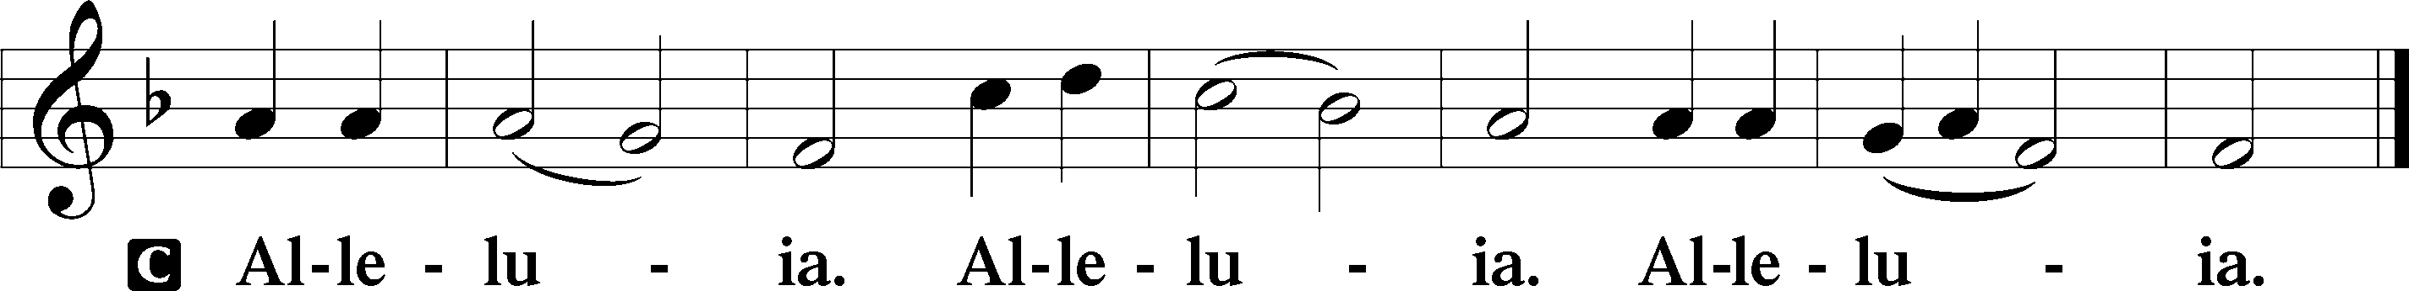

Holy Gospel Luke 13:22–30

P The Holy Gospel according to St. Luke, the thirteenth chapter.

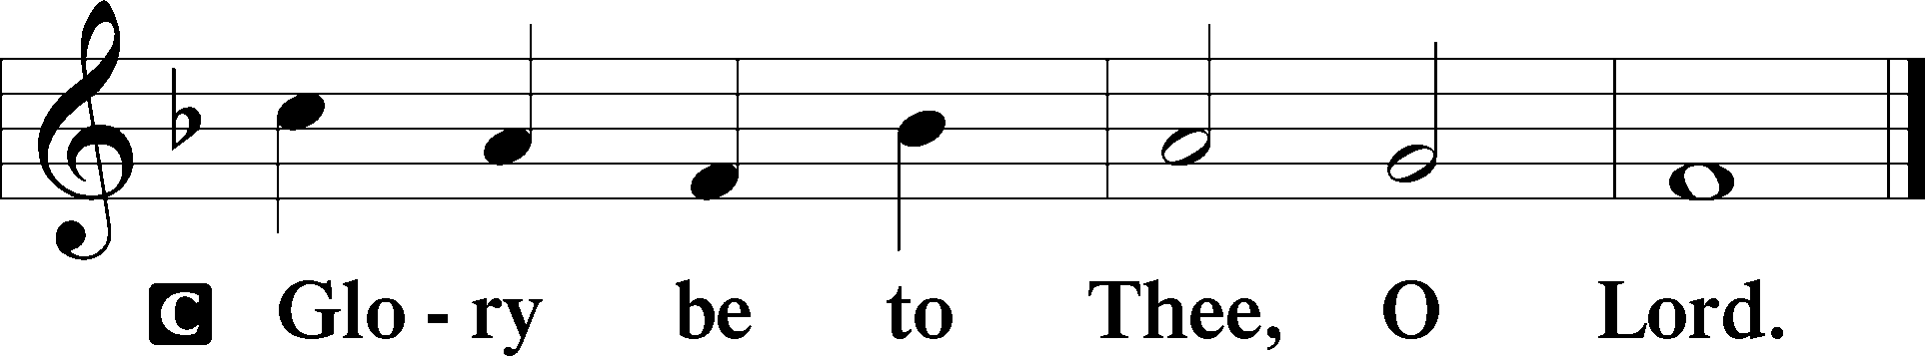

22[Jesus] went on his way through towns and villages, teaching and journeying toward Jerusalem. 23And someone said to him, “Lord, will those who are saved be few?” And he said to them, 24“Strive to enter through the narrow door. For many, I tell you, will seek to enter and will not be able. 25When once the master of the house has risen and shut the door, and you begin to stand outside and to knock at the door, saying, ‘Lord, open to us,’ then he will answer you, ‘I do not know where you come from.’ 26Then you will begin to say, ‘We ate and drank in your presence, and you taught in our streets.’ 27But he will say, ‘I tell you, I do not know where you come from. Depart from me, all you workers of evil!’ 28In that place there will be weeping and gnashing of teeth, when you see Abraham and Isaac and Jacob and all the prophets in the kingdom of God but you yourselves cast out. 29And people will come from east and west, and from north and south, and recline at table in the kingdom of God. 30And behold, some are last who will be first, and some are first who will be last.”

P This is the Gospel of the Lord.

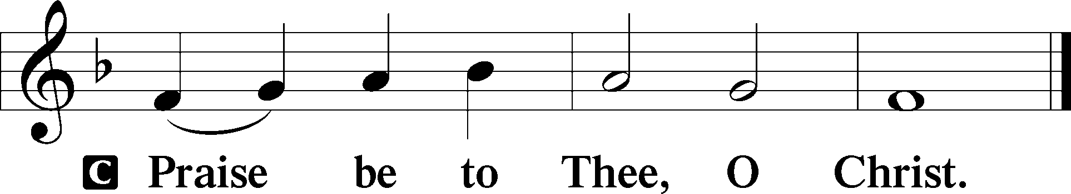

Apostles’ Creed

C **I believe in God, the Father Almighty,**

**maker of heaven and earth.**

**And in Jesus Christ, His only Son, our Lord,**

**who was conceived by the Holy Spirit,**

**born of the virgin Mary,**

**suffered under Pontius Pilate,**

**was crucified, died and was buried.**

**He descended into hell.**

**The third day He rose again from the dead.**

**He ascended into heaven**

**and sits at the right hand of God the Father Almighty.**

**From thence He will come to judge the living and the dead.**

**I believe in the Holy Spirit,**

**the holy Christian Church,**

**the communion of saints,**

**the forgiveness of sins,**

**the resurrection of the body,**

**and the life** T **everlasting. Amen.**

Sit

Children's Sermon

804 O Worship the King

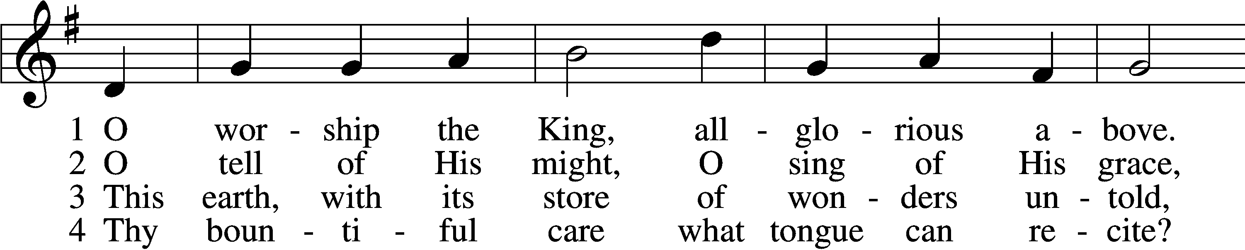

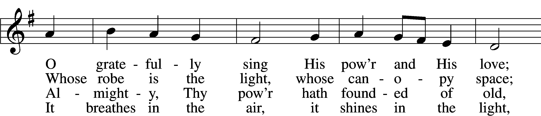

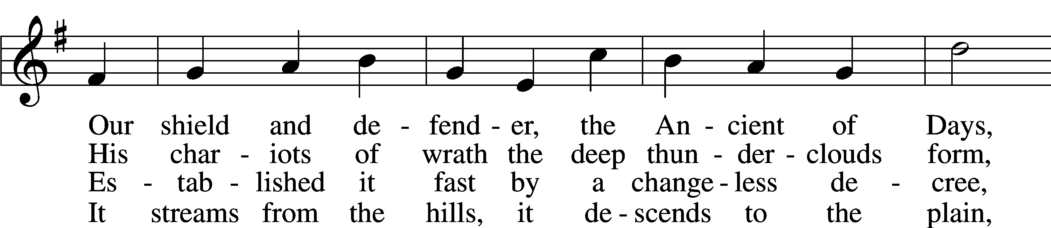

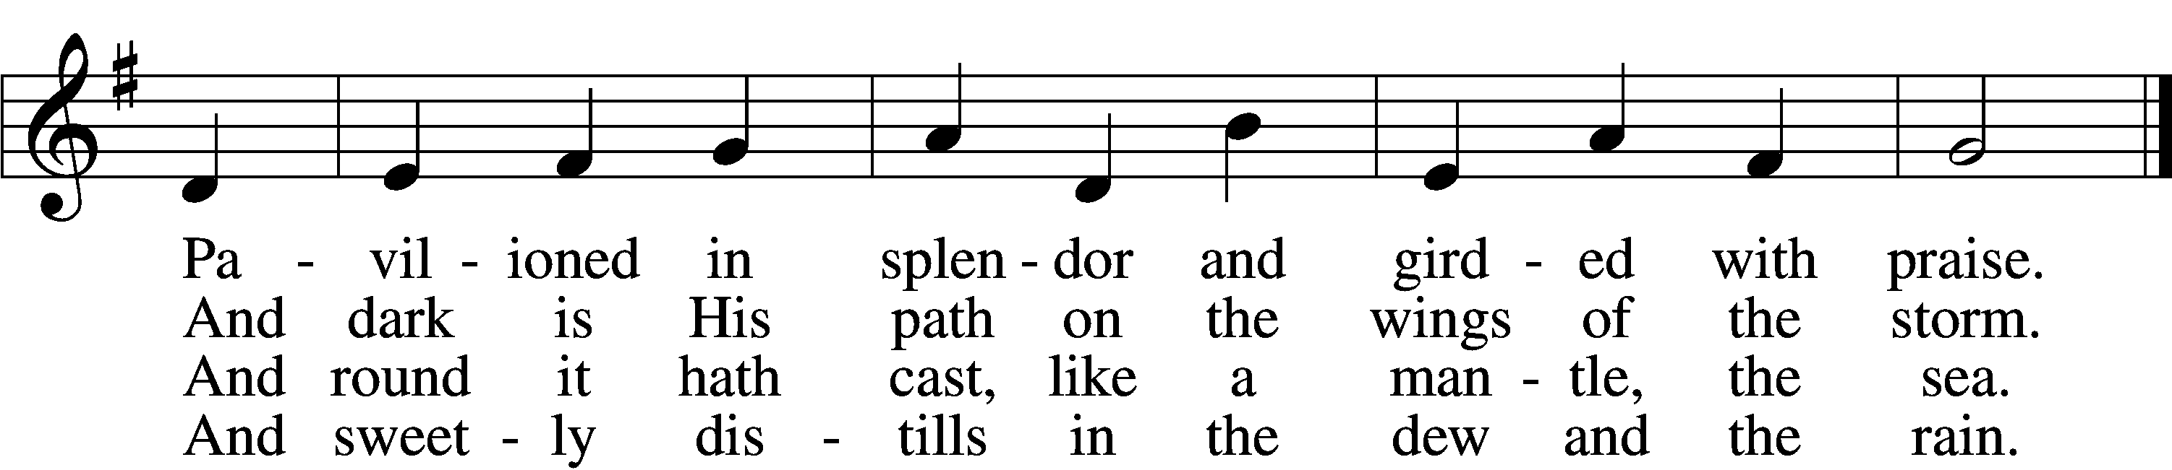

5 Frail children of dust  
 and feeble as frail,  
In Thee do we trust,  
 nor find Thee to fail.  
Thy mercies, how tender,  
 how firm to the end,  
Our maker, defender,  
 redeemer, and friend!

6 O measureless Might,  
 ineffable Love,  
While angels delight  
 to hymn Thee above,  
Thy humbler creation,  
 though feeble their lays,  
With true adoration  
 shall sing to Thy praise.

Text: Robert Grant, 1779–1838, alt.  
Tune: William Croft, 1678–1727  
Text and tune: Public domain

Sermon

Votum

P The peace of God, which passes all understanding, keep your hearts and minds in Christ Jesus.

C **Amen.**

Stand

Offertory Psalm 51:10–12

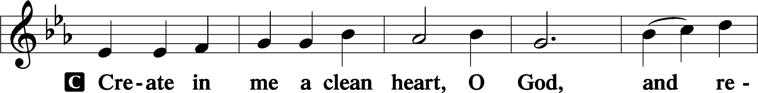

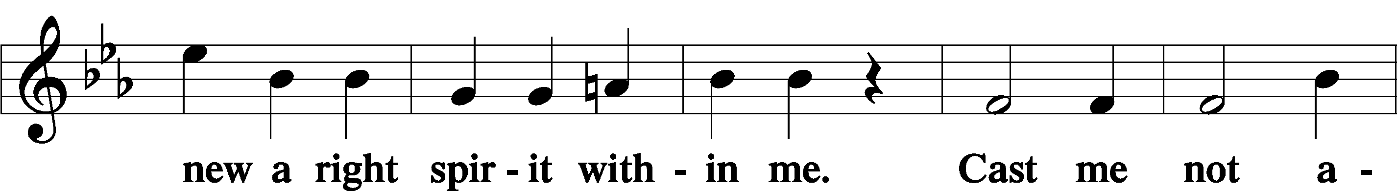

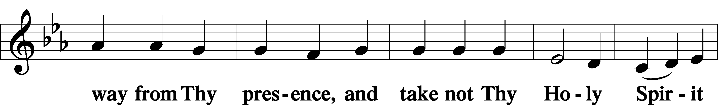

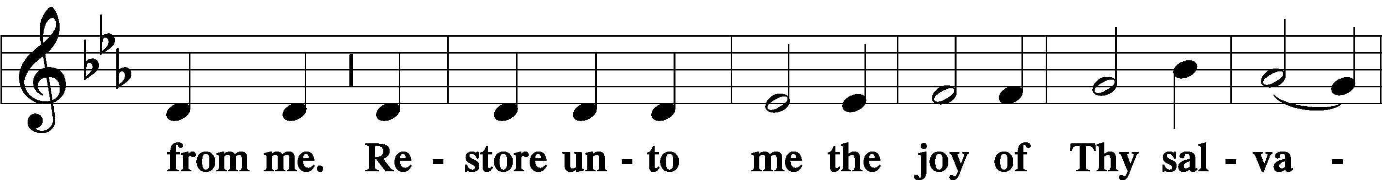

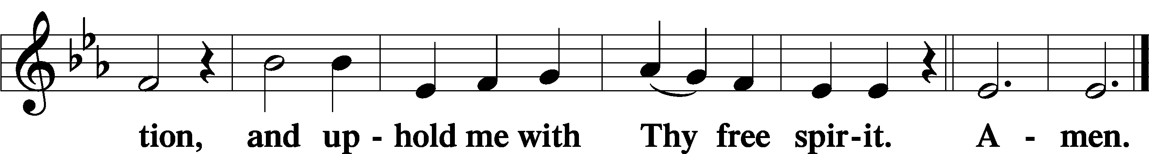

Offering

805 Praise God, from Whom All Blessings Flow

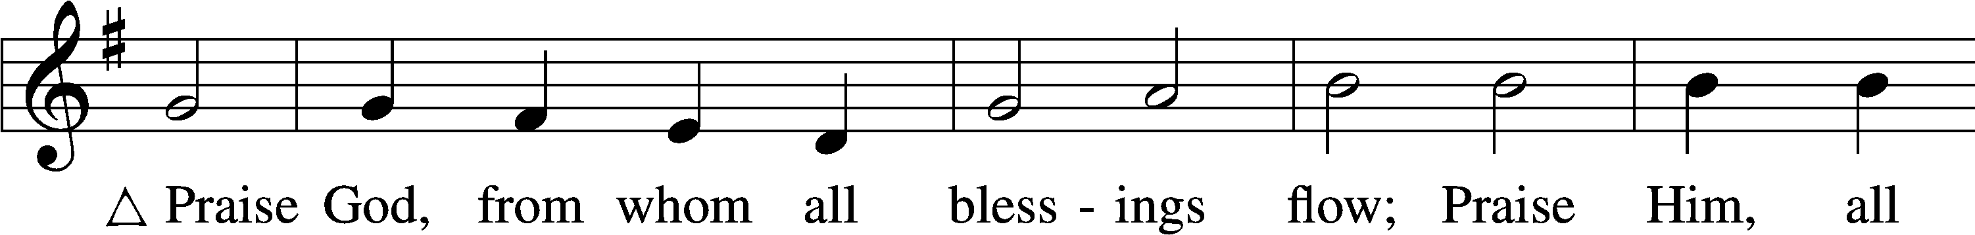

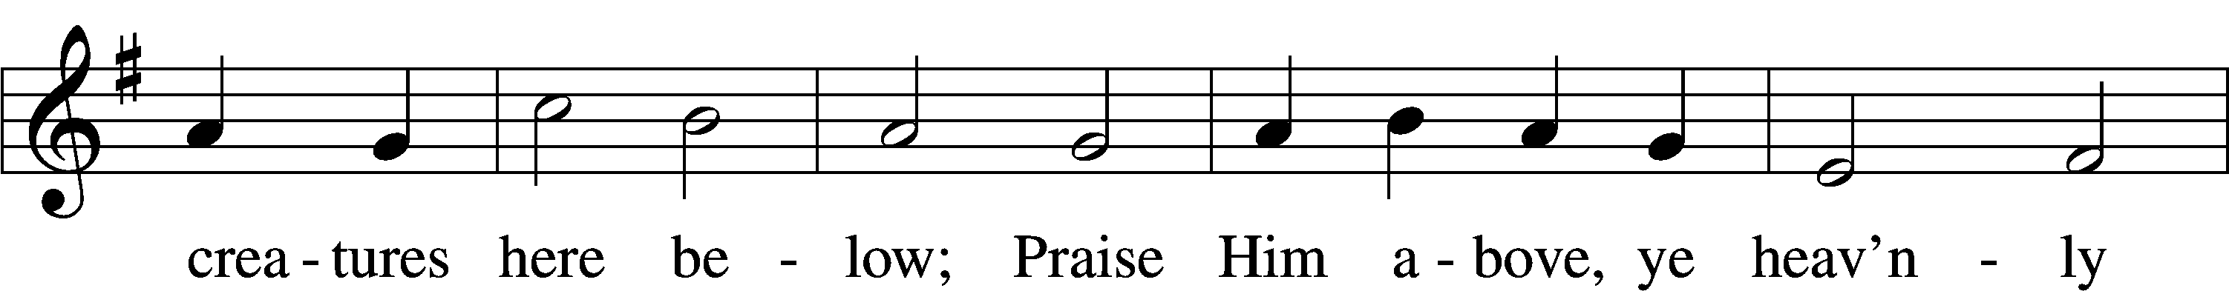

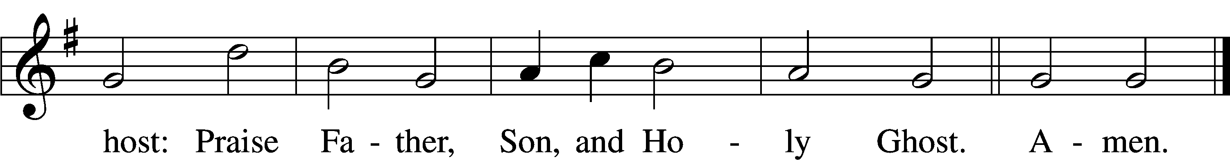

Text: Thomas Ken, 1637–1711  
Tune: Trente quatre Pseaumes de David, 1551, Geneva, ed. Louis Bourgeois  
Text and tune: Public domain

Prayer of the Church

Lord’s Prayer Matthew 6:9–13

P Lord, remember us in Your kingdom and teach us to pray:

C **Our Father who art in heaven,**

**hallowed be Thy name,**

**Thy kingdom come,**

**Thy will be done on earth**

**as it is in heaven;**

**give us this day our daily bread;**

**and forgive us our trespasses**

**as we forgive those**

**who trespass against us;**

**and lead us not into temptation,**

**but deliver us from evil.**

**For Thine is the kingdom**

**and the power and the glory**

**forever and ever. Amen.**

Collect for the Word

Blessed Lord, You have caused all Holy Scriptures to be written for our learning. Grant that we may so hear them, read, mark, learn, and inwardly digest them that, by the patience and comfort of Your holy Word, we may embrace and ever hold fast the blessed hope of everlasting life; through Jesus Christ, Your Son, our Lord, who lives and reigns with You and the Holy Spirit, one God, now and forever.

Benediction

P The Lord bless you and keep you.

The Lord make His face shine on you and be gracious to you.

The Lord look upon you with favor and T give you peace.

C **Amen.**

563 Jesus, Thy Blood and Righteousness

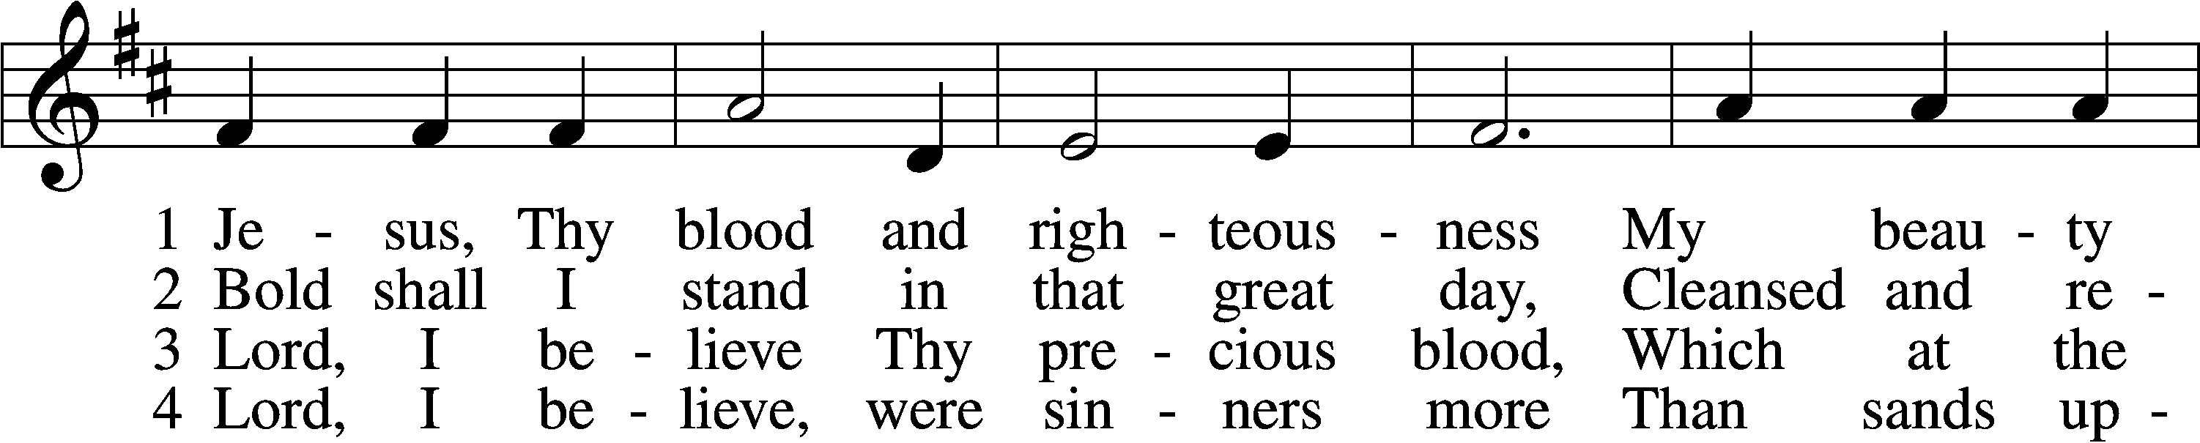

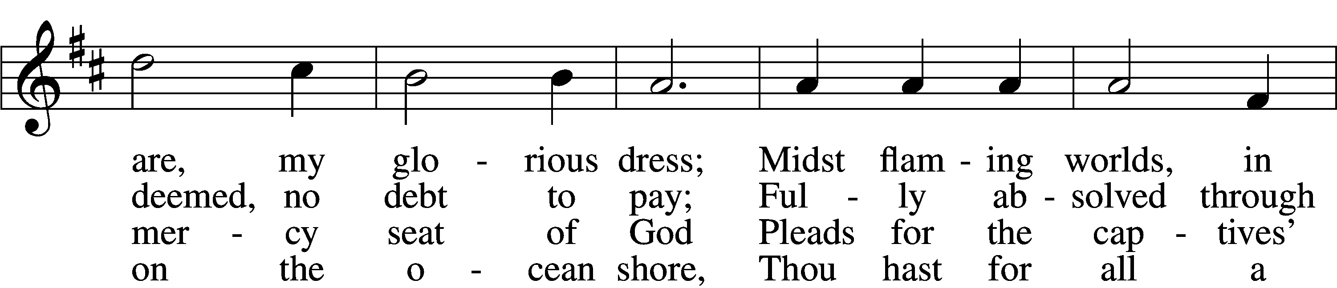

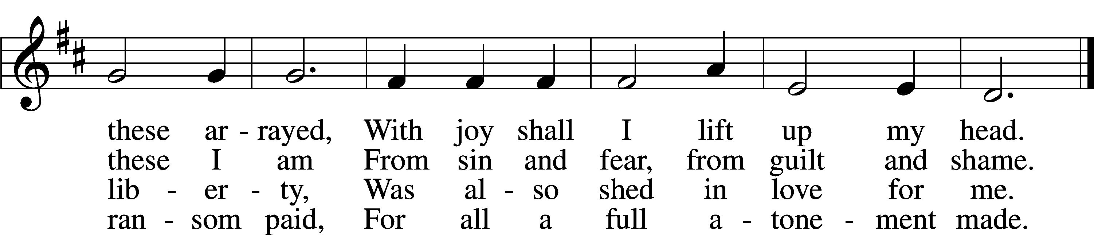

5 When from the dust of death I rise  
To claim my mansion in the skies,  
This then shall be my only plea:  
Jesus hath lived and died for me.

6 Jesus, be endless praise to Thee,  
Whose boundless mercy hath for me,  
For me, and all Thy hands have made,  
An everlasting ransom paid.

Text: Nicolaus Ludwig von Zinzendorf, 1700–60; tr. John B. Wesley, 1703–91, alt.  
Tune: George J. Elvey, 1816–93  
Text and tune: Public domain

Acknowledgments

Unless otherwise indicated, Scripture quotations are from the ESV® Bible (The Holy Bible, English Standard Version®), copyright © 2001 by Crossway, a publishing ministry of Good News Publishers. Used by permission. All rights reserved.

Created by Lutheran Service Builder © 2025 Concordia Publishing House.