On entering the church

P Lord, I love the habitation of Your house and the place

where Your glory dwells. In the multitude of Your tender

mercies prepare my heart that I may enter Your house to

worship and confess Your holy name; through Jesus Christ,

my God and Lord.

Before worship

C O Lord, our creator, redeemer, and comforter, as we come

together to worship You in spirit and in truth, we humbly

pray that You would open our hearts to the preaching of

Your Word so that we may repent of our sins, believe in

Jesus Christ as our only Savior, and grow in grace and

holiness. Hear us for His sake.

685 Let Us Ever Walk with Jesus

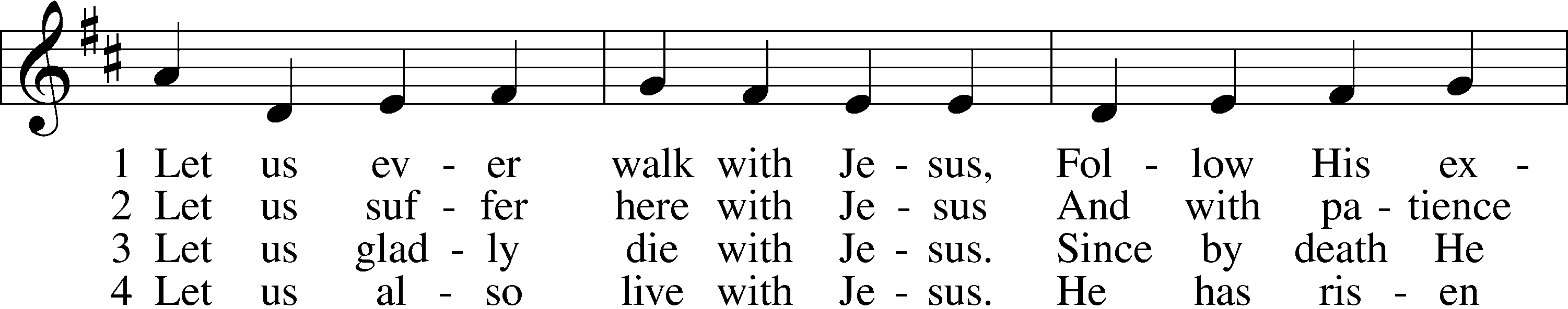

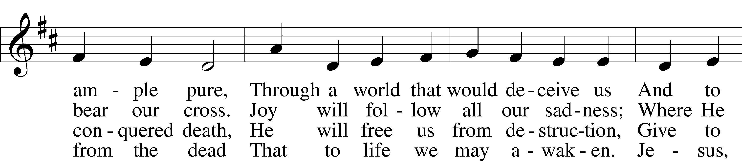

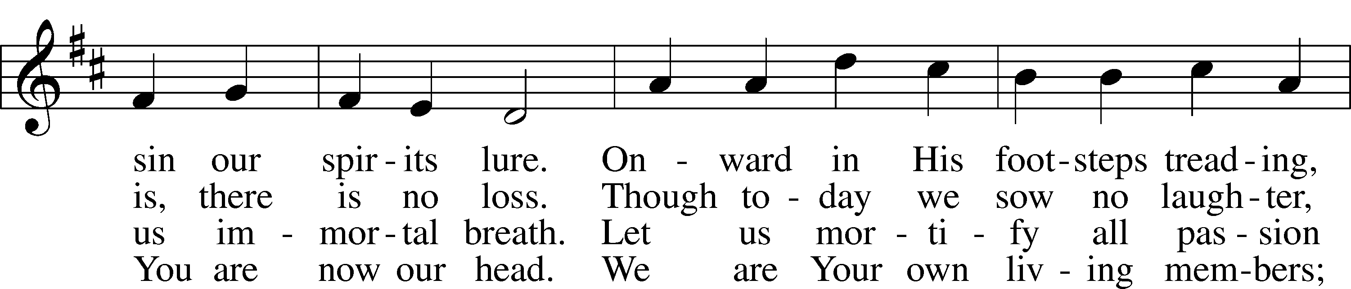

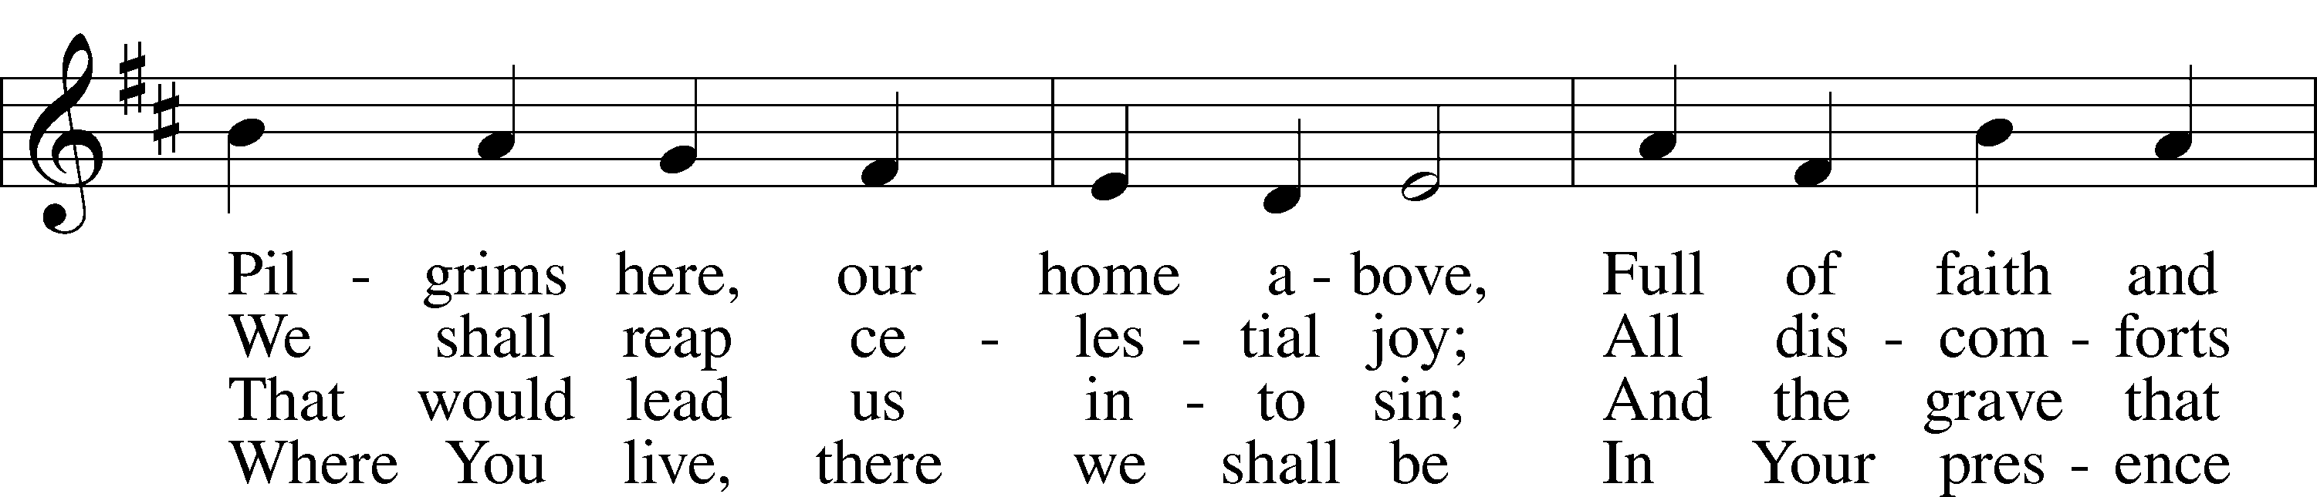

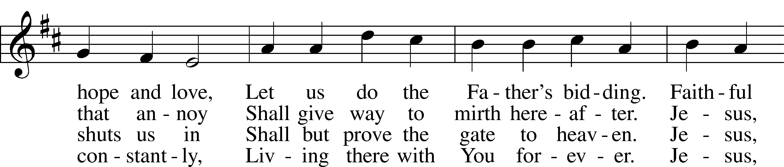

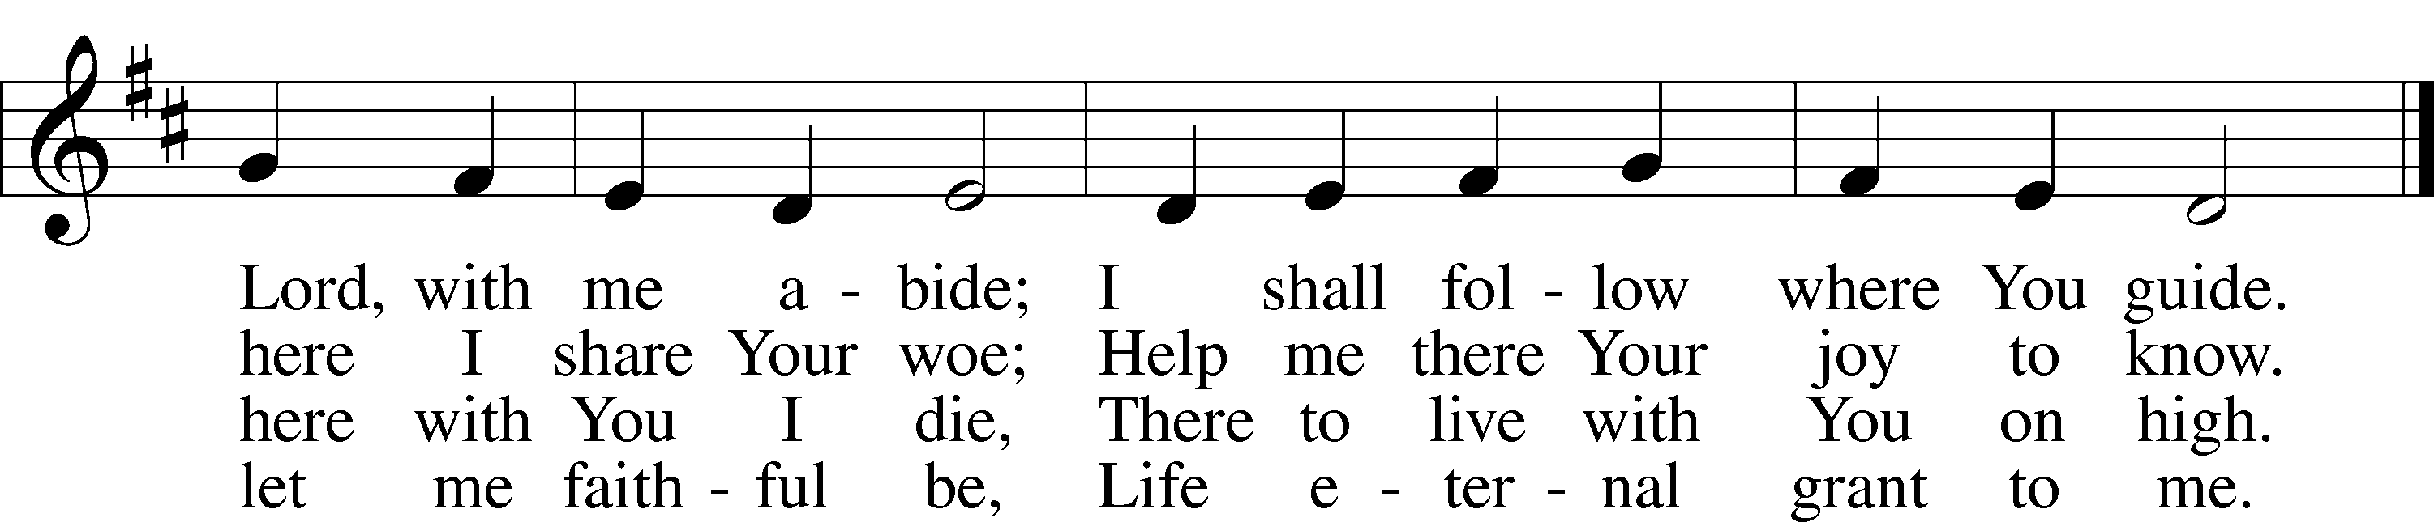

Text: Sigismund von Birken, 1626–81; tr. Lutheran Book of Worship, 1978, alt.  
Tune: Georg G. Boltze, 18th cent.  
Text: © 1978 Lutheran Book of Worship. Used by permission: LSB Hymn License no. 110005011  
Tune: Public domain

# Confession and Absolution

Stand

The sign of the cross may be made by all in remembrance of their Baptism.

Invocation Matthew 28:19b; 18:20

P In the name of the Father and of the T Son and of the Holy Spirit.

C **Amen.**

Exhortation Psalm 124:8; Psalm 130:3–4; Luke 18:13

P Our help is in the name of the Lord,

C **who made heaven and earth.**

P If You, O Lord, kept a record of sins, O Lord, who could stand?

C **But with You there is forgiveness; therefore You are feared.**

P Since we are gathered to hear God’s Word, call upon Him in prayer and praise, and receive the body and blood of our Lord Jesus Christ in the fellowship of this altar, let us first consider our unworthiness and confess before God and one another that we have sinned in thought, word, and deed, and that we cannot free ourselves from our sinful condition. Together as His people let us take refuge in the infinite mercy of God, our heavenly Father, seeking His grace for the sake of Christ, and saying: God, be merciful to me, a sinner.

Kneel/Stand

Confession of Sins

C **Almighty God, have mercy upon us, forgive us our sins, and lead us to everlasting life. Amen.**

Prayer for Forgiveness

P Almighty God, merciful Father, in Holy Baptism You declared us to be Your children and gathered us into Your one, holy Church, in which You daily and richly forgive us our sins and grant us new life through Your Spirit. Be in our midst, enliven our faith, and graciously receive our prayer and praise; through Your Son, Jesus Christ, our Lord.

C **Amen.**

Stand

# Service of the Word

Introit Psalm 119:57–60, 64; antiphon: v. 105

Your word is a lamp to my feet  
 and a light to my path.  
**The Lord is my portion;  
 I promise to keep your words**.  
I entreat your favor with all my heart;  
 be gracious to me according to your promise.  
**When I think on my ways,  
 I turn my feet to your testimonies;**I hasten and do not delay  
 to keep your commandments.  
**The earth, O Lord, is full of your steadfast love;  
 teach me your statutes!  
Glory be to the Father and to the Son**  
 **and to the Holy Spirit;**  
**as it was in the beginning,**  
 **is now, and will be forever. Amen.**  
Your word is a lamp to my feet  
 and a light to my path.

Kyrie Mark 10:47

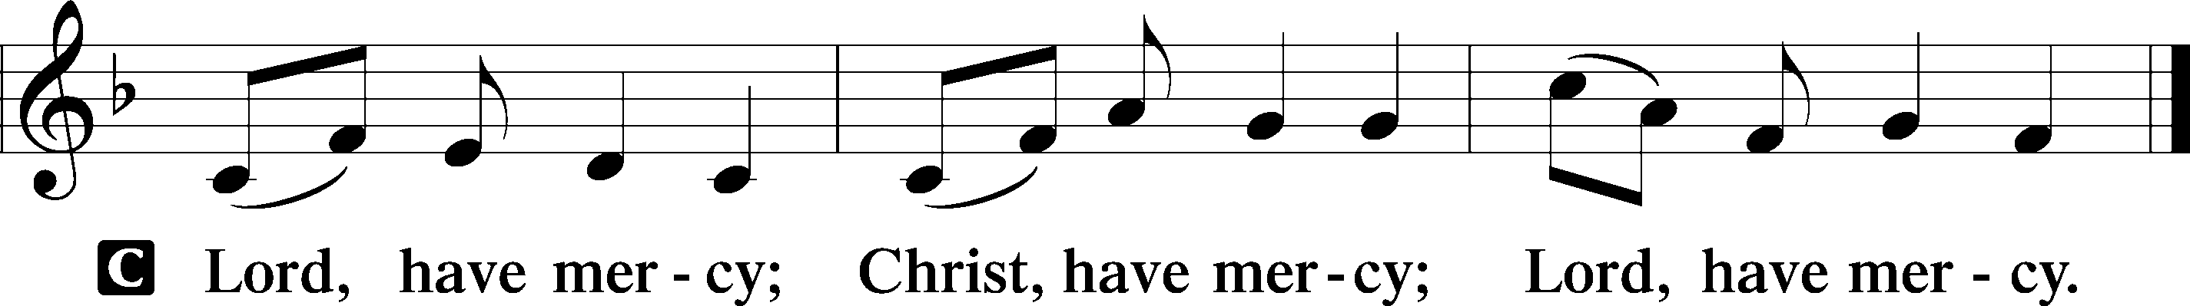

Gloria in Excelsis Luke 2:14; John 1:29

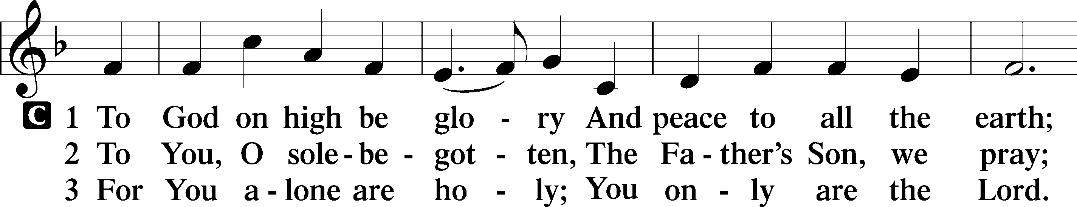

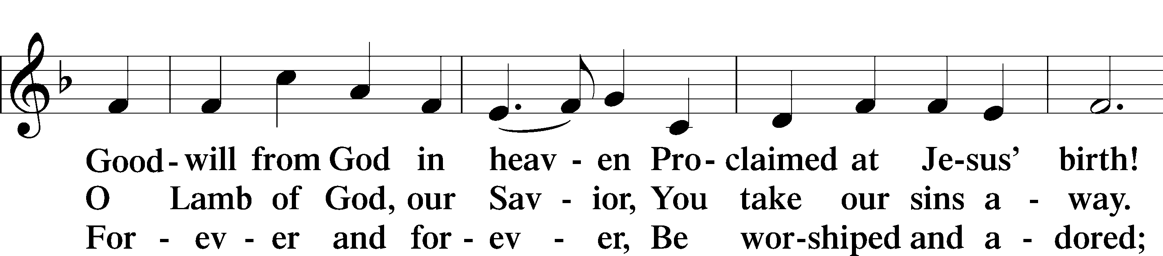

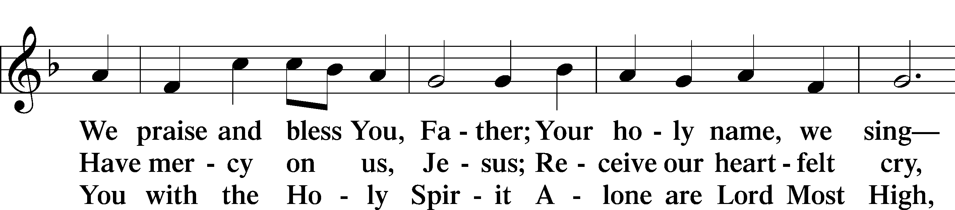

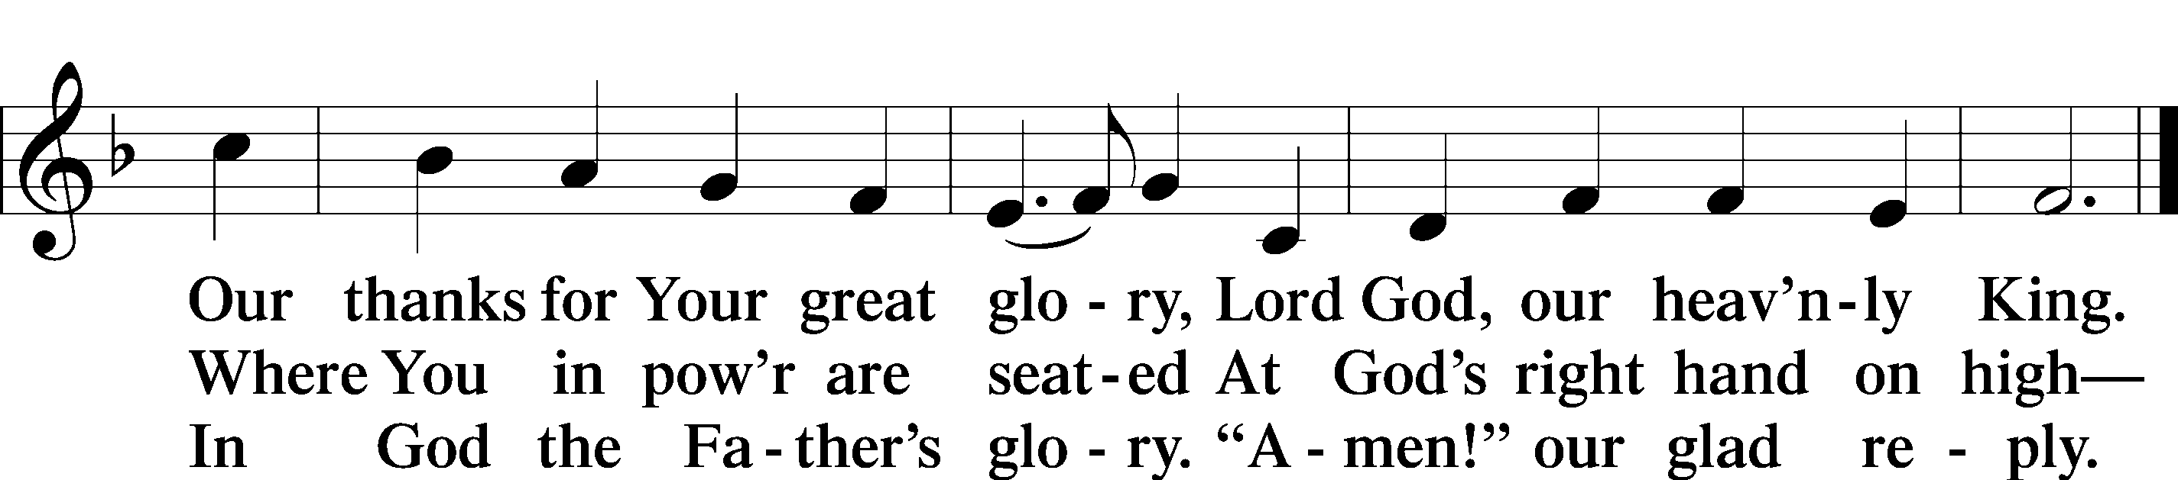

Text: Stephen P. Starke

Salutation and Collect of the Day

P The Lord be with you.

C **And also with you.**

P Let us pray.

O Lord, grant us the Spirit to hear Your Word and know the one thing needful that by Your Word and Spirit we may live according to Your will; through Jesus Christ, Your Son, our Lord, who lives and reigns with You and the Holy Spirit, one God, now and forever.

C **Amen.**

Sit

Old Testament Reading Genesis 18:1–10a

1 The Lord appeared to [Abraham] by the oaks of Mamre, as he sat at the door of his tent in the heat of the day. 2He lifted up his eyes and looked, and behold, three men were standing in front of him. When he saw them, he ran from the tent door to meet them and bowed himself to the earth 3and said, “O Lord, if I have found favor in your sight, do not pass by your servant. 4Let a little water be brought, and wash your feet, and rest yourselves under the tree, 5while I bring a morsel of bread, that you may refresh yourselves, and after that you may pass on—since you have come to your servant.” So they said, “Do as you have said.” 6And Abraham went quickly into the tent to Sarah and said, “Quick! Three seahs of fine flour! Knead it, and make cakes.” 7And Abraham ran to the herd and took a calf, tender and good, and gave it to a young man, who prepared it quickly. 8Then he took curds and milk and the calf that he had prepared, and set it before them. And he stood by them under the tree while they ate.

9They said to him, “Where is Sarah your wife?” And he said, “She is in the tent.” 10The Lord said, “I will surely return to you about this time next year, and Sarah your wife shall have a son.”

A This is the Word of the Lord.

C **Thanks be to God.**

Gradual Romans 10:15b, 18b; Isaiah 52:7b, alt.

How beautiful are the feet of those who preach the good news,  
 who publish peace and bring good news of salvation.  
**Their voice has gone out to all the earth,  
 and their words to the ends of the world.**

Epistle Colossians 1:21–29

21You, who once were alienated and hostile in mind, doing evil deeds, 22he has now reconciled in his body of flesh by his death, in order to present you holy and blameless and above reproach before him, 23if indeed you continue in the faith, stable and steadfast, not shifting from the hope of the gospel that you heard, which has been proclaimed in all creation under heaven, and of which I, Paul, became a minister.

24Now I rejoice in my sufferings for your sake, and in my flesh I am filling up what is lacking in Christ’s afflictions for the sake of his body, that is, the church, 25of which I became a minister according to the stewardship from God that was given to me for you, to make the word of God fully known, 26the mystery hidden for ages and generations but now revealed to his saints. 27To them God chose to make known how great among the Gentiles are the riches of the glory of this mystery, which is Christ in you, the hope of glory. 28Him we proclaim, warning everyone and teaching everyone with all wisdom, that we may present everyone mature in Christ. 29For this I toil, struggling with all his energy that he powerfully works within me.

A This is the Word of the Lord.

C **Thanks be to God.**

Stand

Alleluia and Verse

Alleluia

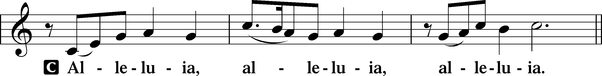

Verse John 20:31

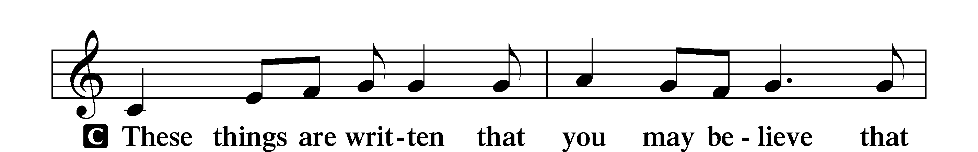

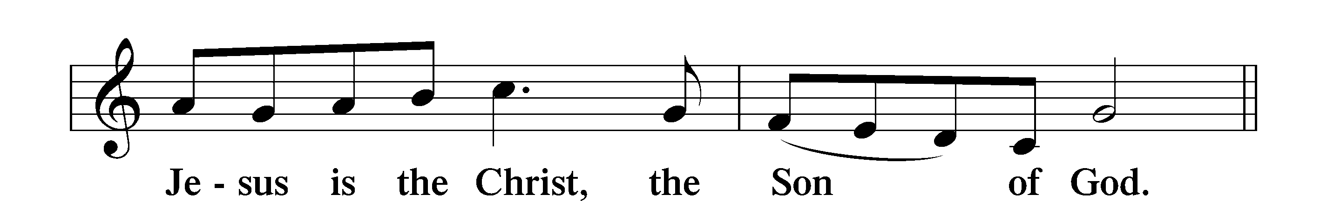

Alleluia

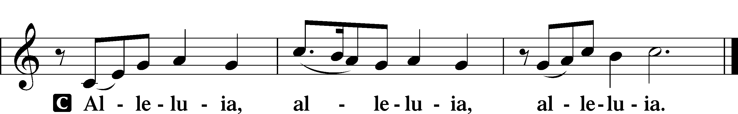

Holy Gospel Luke 10:38–42

P The Holy Gospel according to St. Luke, the tenth chapter.

C **Glory to You, O Lord.**

38Now as they went on their way, Jesus entered a village. And a woman named Martha welcomed him into her house. 39And she had a sister called Mary, who sat at the Lord’s feet and listened to his teaching. 40But Martha was distracted with much serving. And she went up to him and said, “Lord, do you not care that my sister has left me to serve alone? Tell her then to help me.” 41But the Lord answered her, “Martha, Martha, you are anxious and troubled about many things, 42but one thing is necessary. Mary has chosen the good portion, which will not be taken away from her.”

P This is the Gospel of the Lord.

C **Praise to You, O Christ.**

Nicene Creed

C **I believe in one God,**

**the Father Almighty,**

**maker of heaven and earth**

**and of all things visible and invisible.**

**And in one Lord Jesus Christ,**

**the only-begotten Son of God,**

**begotten of His Father before all worlds,**

**God of God, Light of Light,**

**very God of very God,**

**begotten, not made,**

**being of one substance with the Father,**

**by whom all things were made;**

**who for us men and for our salvation came down from heaven**

**and was incarnate by the Holy Spirit of the virgin Mary**

**and was made man;**

**and was crucified also for us under Pontius Pilate.**

**He suffered and was buried.**

**And the third day He rose again according to the Scriptures**

**and ascended into heaven**

**and sits at the right hand of the Father.**

**And He will come again with glory to judge both the living and the dead,**

**whose kingdom will have no end.**

**And I believe in the Holy Spirit,**

**the Lord and giver of life,**

**who proceeds from the Father and the Son,**

**who with the Father and the Son together is worshiped and glorified,**

**who spoke by the prophets.**

**And I believe in one holy Christian and apostolic Church,**

**I acknowledge one Baptism for the remission of sins,**

**and I look for the resurrection of the dead**

**and the life** T **of the world to come. Amen.**

Sit

Children's Sermon

798 The God of Abraham Praise sts. 1–5

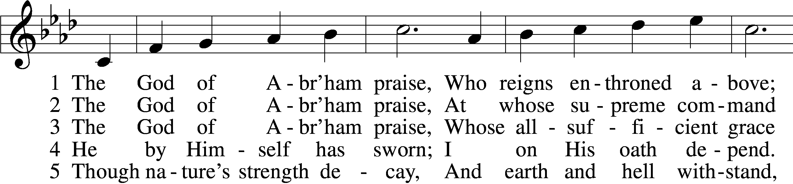

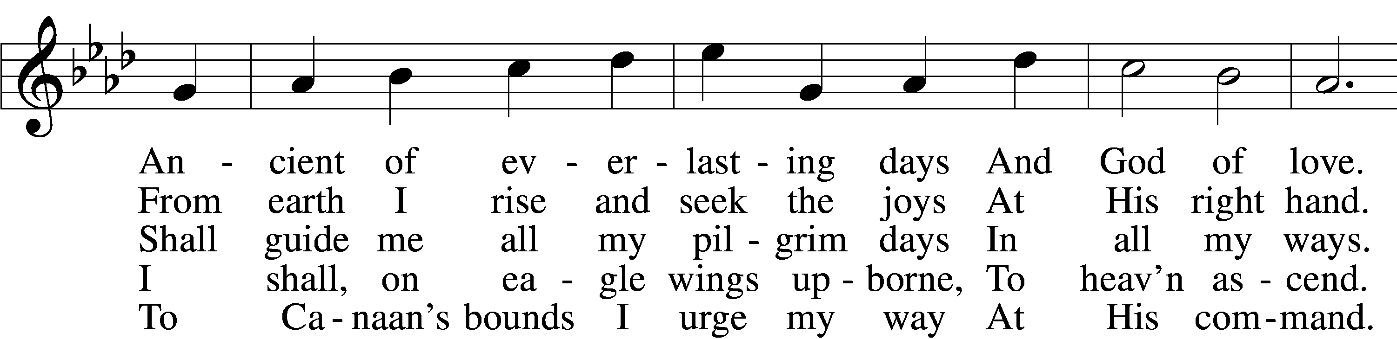

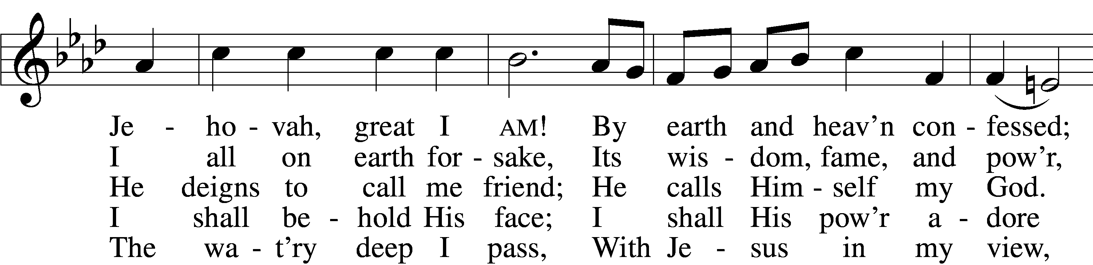

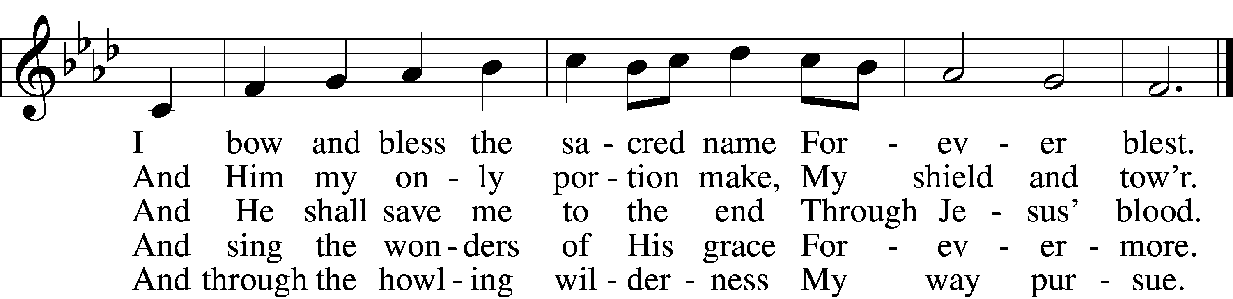

Text: Thomas Olivers, 1725–99, alt.  
Tune: Hebrew  
Text and tune: Public domain

Sermon

798 The God of Abraham Praise sts. 6–9

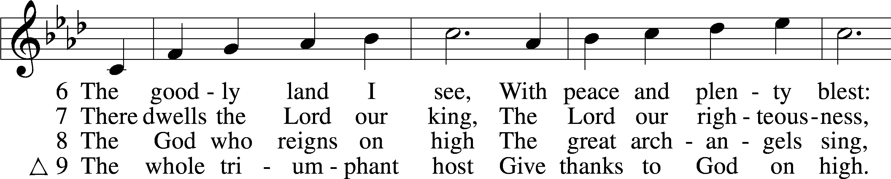

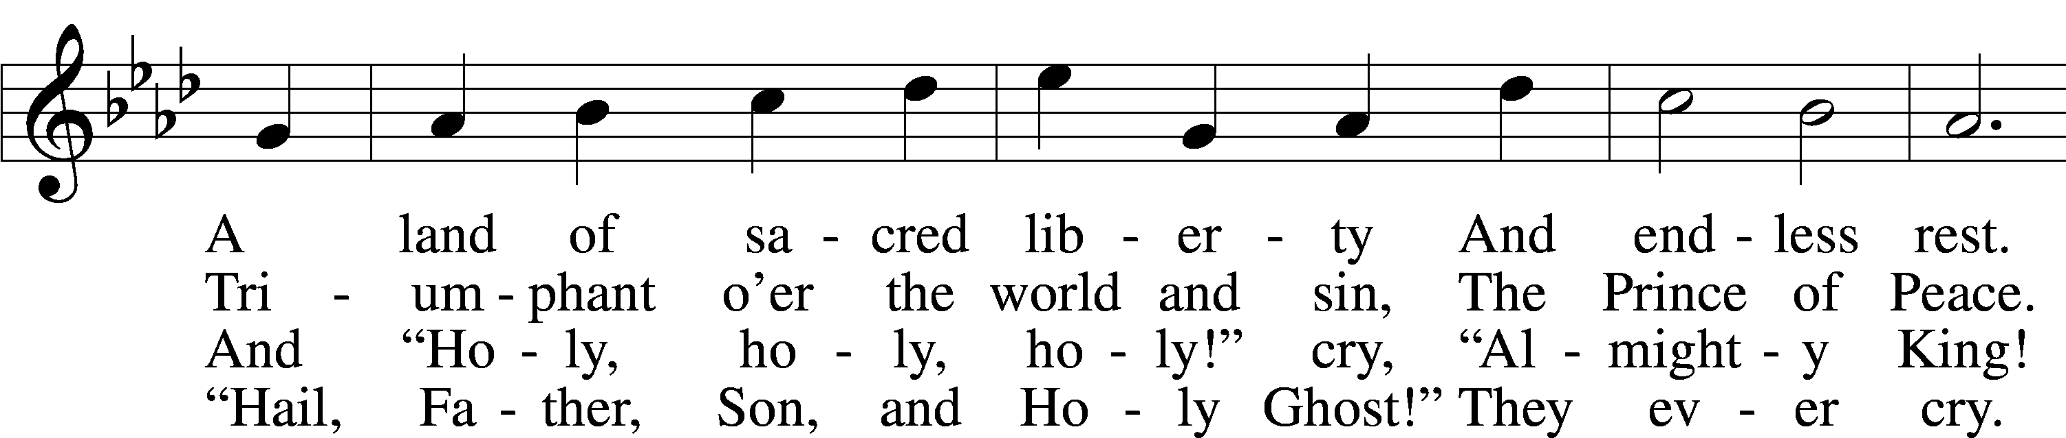

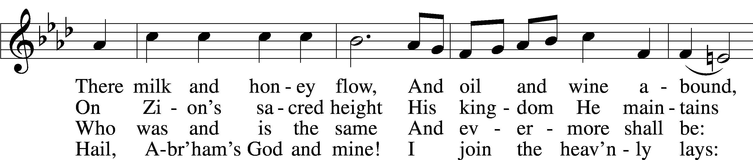

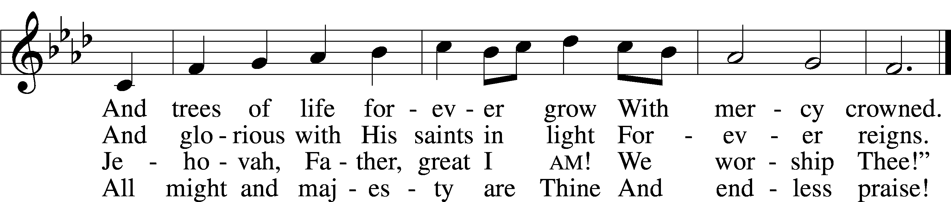

Text: Thomas Olivers, 1725–99, alt.  
Tune: Hebrew  
Text and tune: Public domain

Stand

Prayer of the Church

Following the prayers, the people may greet one another in the name of the Lord, saying, “Peace be with you,” as a sign of reconciliation and of the unity of the Spirit in the bond of peace (Matt. 5:22–24; Eph. 4:1–3).

Sit

Offering

# Service of the Sacrament

Stand

Preface 2 Timothy 4:22; [Colossians 3:1]; [Psalm 136]

P The Lord be with you.

C **And also with you.**

P Lift up your hearts.

C **We lift them to the Lord.**

P Let us give thanks to the Lord our God.

C **It is right to give Him thanks and praise.**

P It is truly good, right, and salutary that we should at all times and in all places give thanks to You, O Lord, holy Father, almighty and everlasting God, for the countless blessings You so freely bestow on us and all creation. Above all, we give thanks for Your boundless love shown to us when You sent Your only-begotten Son, Jesus Christ, into our flesh and laid on Him our sin, giving Him into death that we might not die eternally. Because He is now risen from the dead and lives and reigns to all eternity, all who believe in Him will overcome sin and death and will rise again to new life. Therefore with angels and archangels and with all the company of heaven we laud and magnify Your glorious name, evermore praising You and saying:

Sanctus Isaiah 6:3; Matthew 21:9

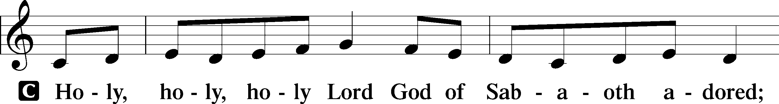

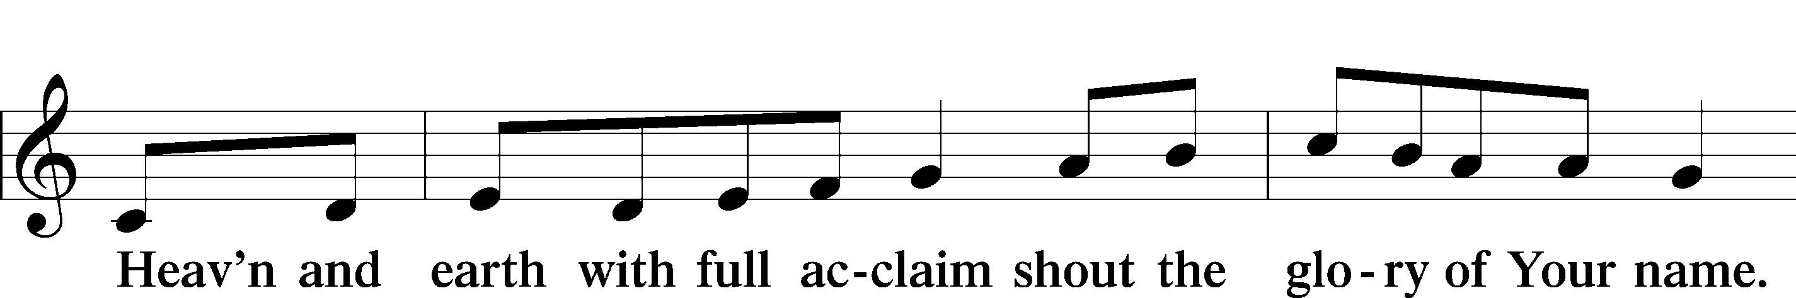

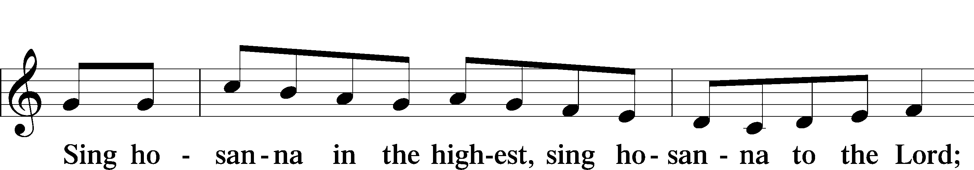

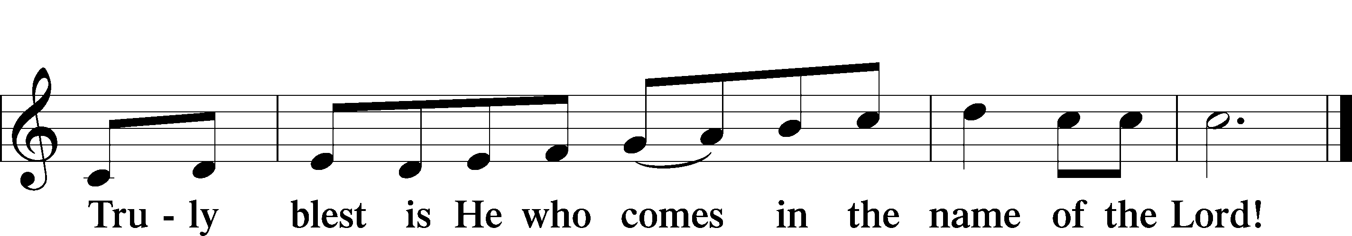

Text: Stephen P. Starke

Prayer of Thanksgiving

P Blessed are You, O Lord our God, king of all creation, for You have had mercy on us and given Your only-begotten Son that whoever believes in Him should not perish but have eternal life.

In Your righteous judgment You condemned the sin of Adam and Eve, who ate the forbidden fruit, and You justly barred them and all their children from the tree of life. Yet, in Your great mercy, You promised salvation by a second Adam, Your Son, Jesus Christ, our Lord, and made His cross a life-giving tree for all who trust in Him.

We give You thanks for the redemption You have prepared for us through Jesus Christ. Grant us Your Holy Spirit that we may faithfully eat and drink of the fruits of His cross and receive the blessings of forgiveness, life, and salvation that come to us in His body and blood.

Hear us as we pray in His name and as He has taught us:

Lord’s Prayer

C **Our Father who art in heaven,**

**hallowed be Thy name,**

**Thy kingdom come,**

**Thy will be done on earth**

**as it is in heaven;**

**give us this day our daily bread;**

**and forgive us our trespasses**

**as we forgive those**

**who trespass against us;**

**and lead us not into temptation,**

**but deliver us from evil.**

**For Thine is the kingdom**

**and the power and the glory**

**forever and ever. Amen.**

The Words of Our Lord

P Our Lord Jesus Christ, on the night when He was betrayed, took bread, and when He had given thanks, He broke it and gave it to the disciples and said: “Take, eat; this is My T body, which is given for you. This do in remembrance of Me.”

In the same way also He took the cup after supper, and when He had given thanks, He gave it to them, saying: “Drink of it, all of you; this cup is the new testament in My T blood, which is shed for you for the forgiveness of sins. This do, as often as you drink it, in remembrance of Me.”

Pax Domini

P The peace of the Lord be with you always.

C **Amen.**

Agnus Dei John 1:29

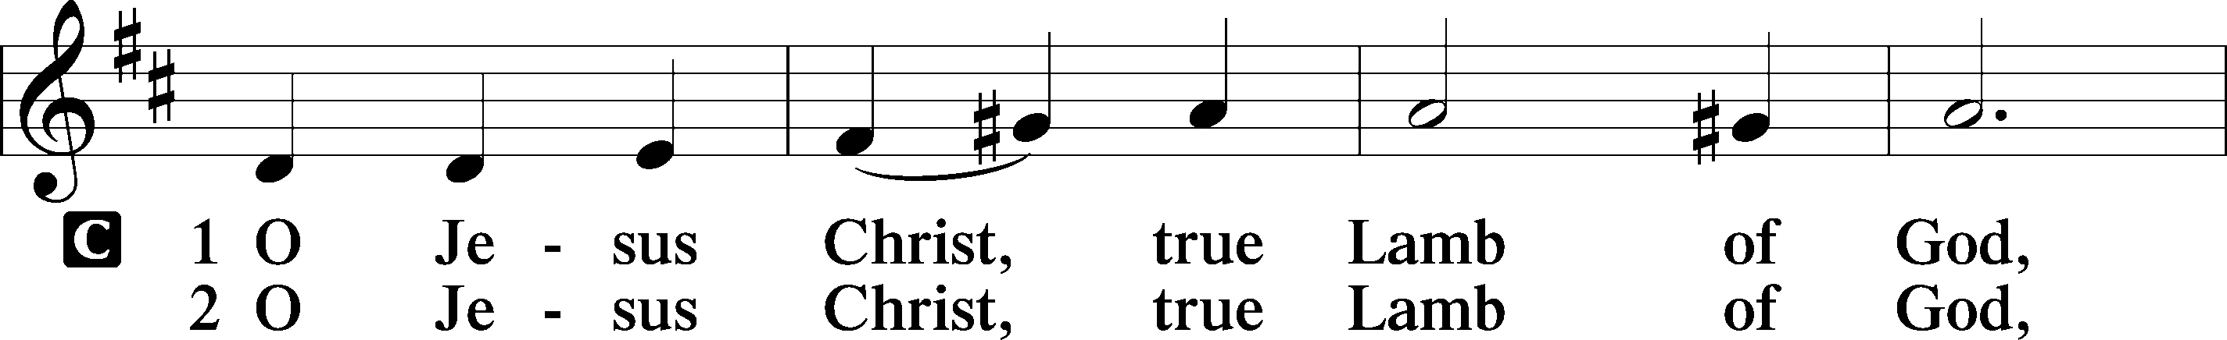

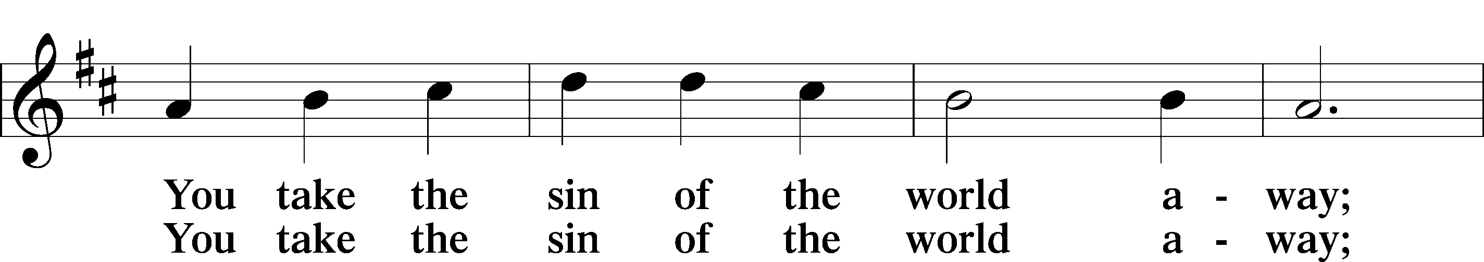

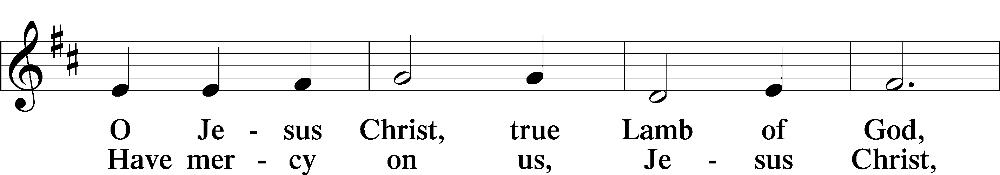

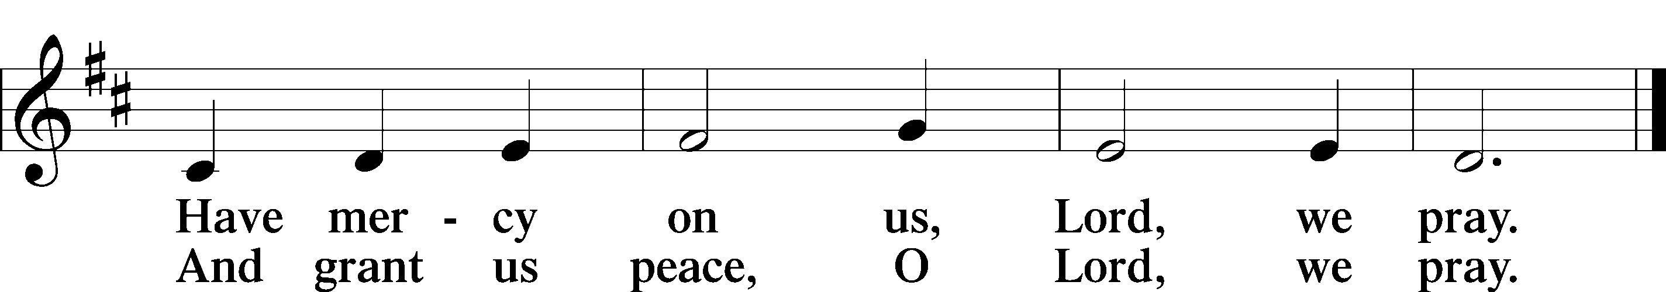

Text: Stephen P. Starke

Sit

Distribution

The pastor and those who assist him receive the body and blood of Christ first and then distribute them to those who come to receive, saying:

Take, eat; this is the true body of our Lord and Savior Jesus Christ, given into death for your sins.

**Amen.**

Take, drink; this is the true blood of our Lord and Savior Jesus Christ, shed for the forgiveness of your sins.

**Amen.**

In dismissing the communicants, the following is said:

The Dismissal

P The body and blood of our Lord Jesus Christ strengthen and preserve you in body and soul to life everlasting. Depart T in peace.

C **Amen.**

This Is the Feast Revelation 5:12–13; 19:5–9

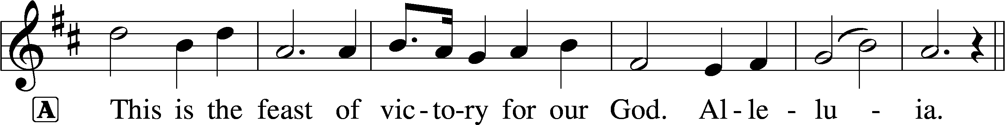

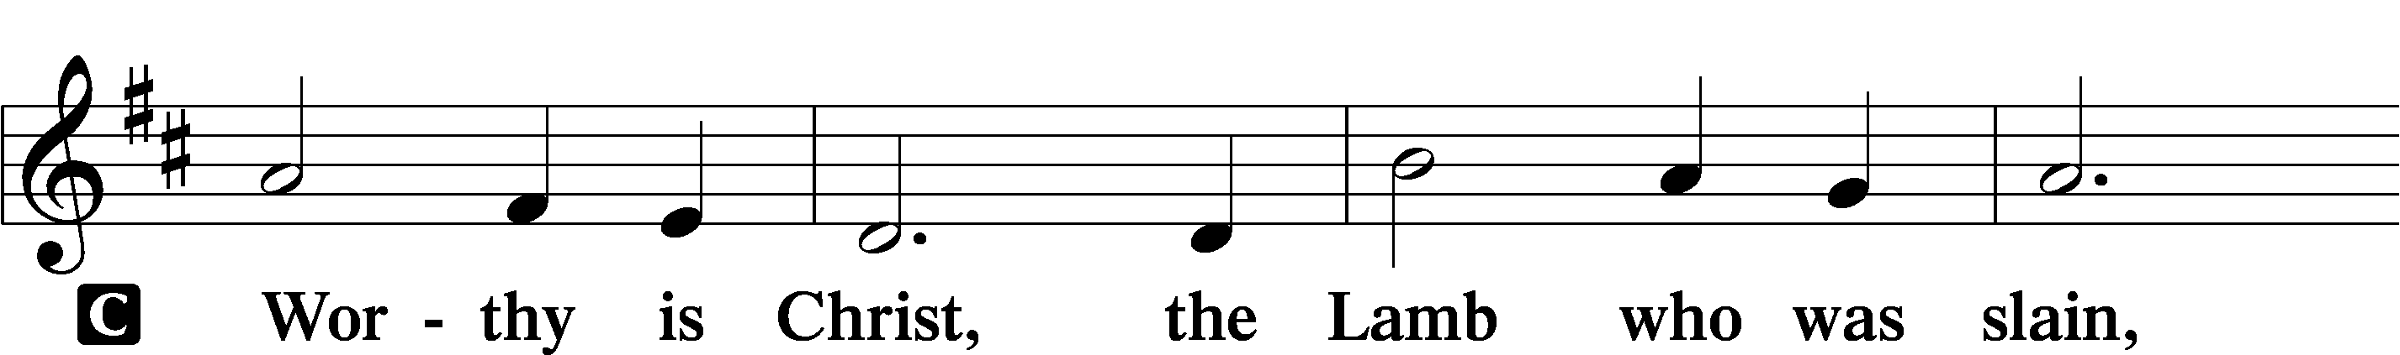

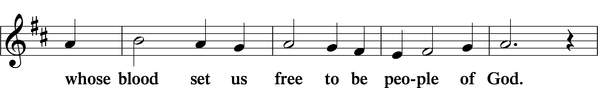

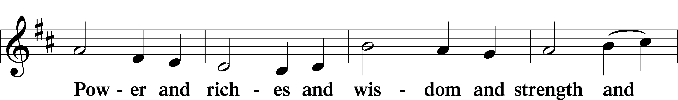

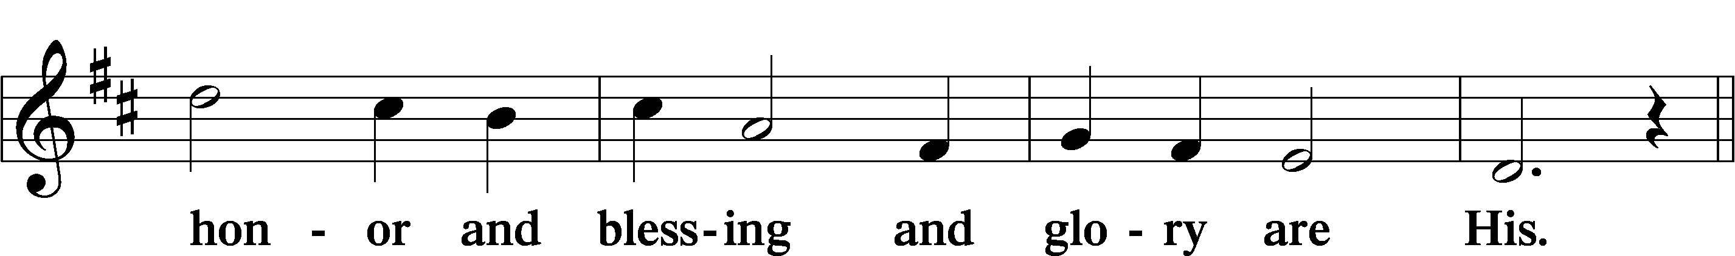

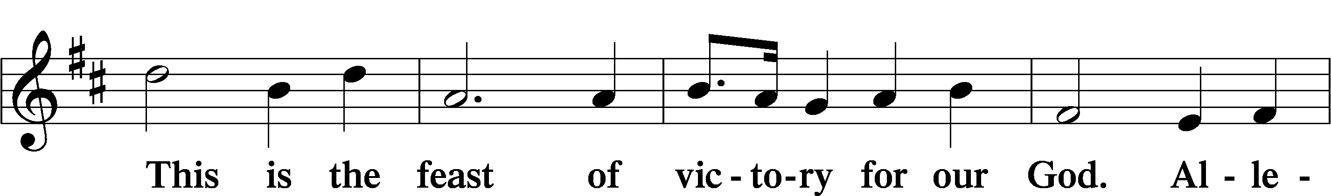

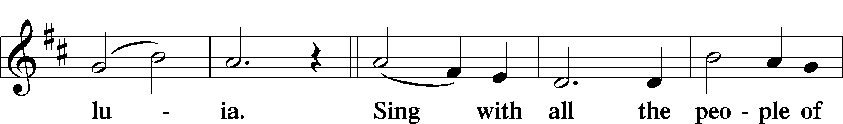

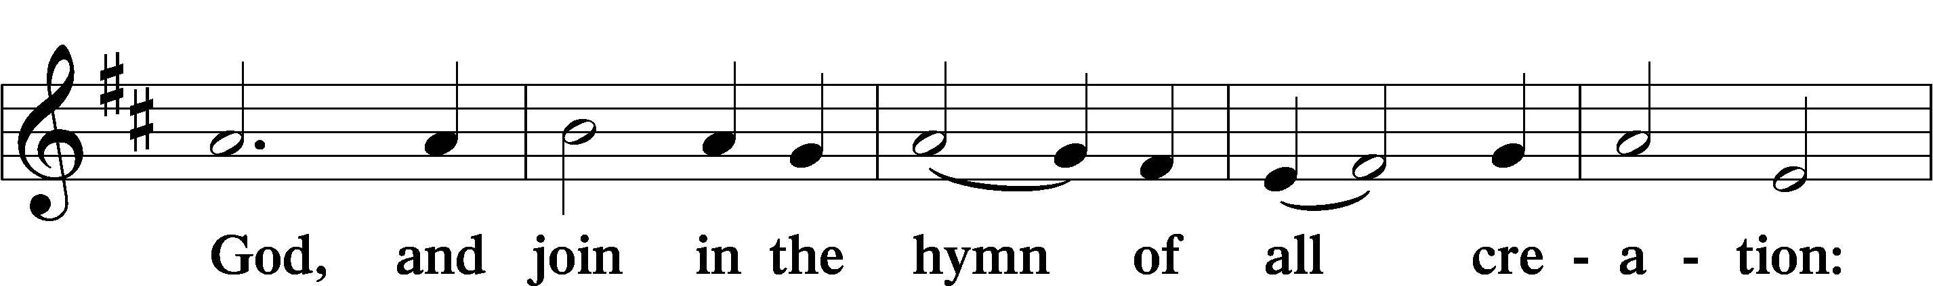

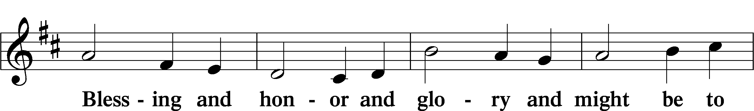

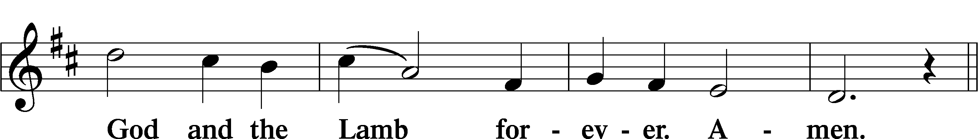

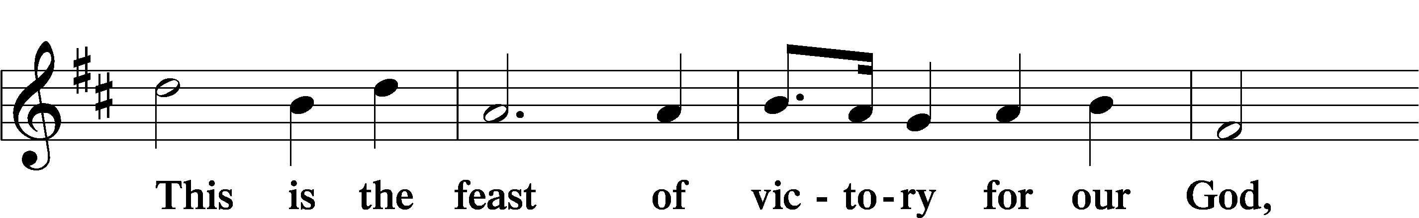

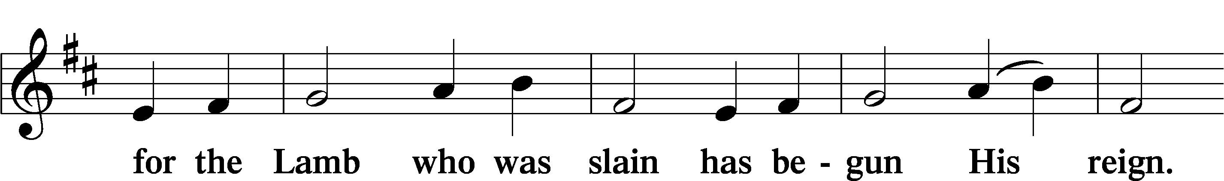

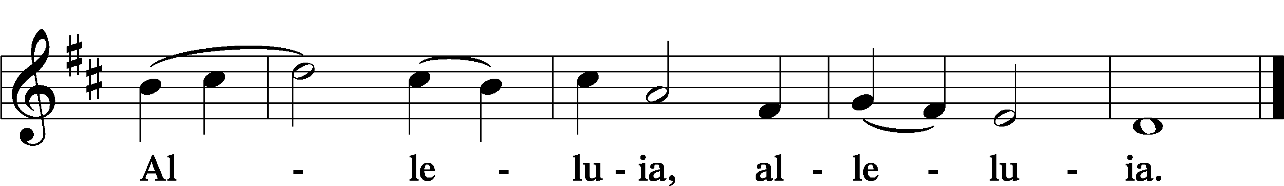

628 Your Table I Approach

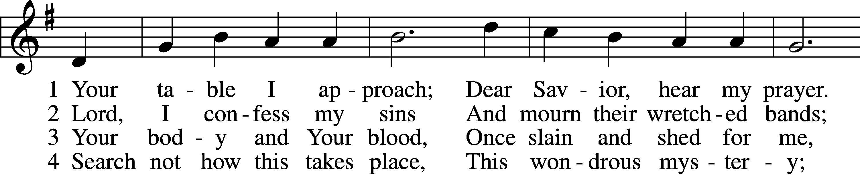

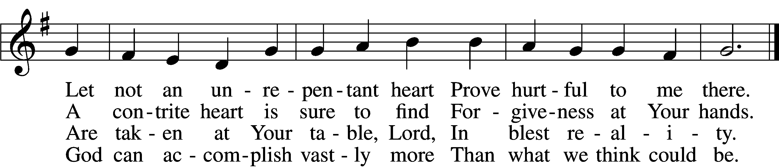

5 O grant, most blessèd Lord,  
 That earth and hell combined  
May not about this sacrament  
 Raise doubt within my mind.

6 Oh, may I never fail  
 To thank You day and night  
For Your true body and true blood,  
 O God, my peace and light.

Text: Gerhard Wolter Molanus, 1633–1722; tr. Matthias Loy, 1828–1915, alt.  
Tune: Trente quatre Pseaumes de David, 1551, Geneva, ed. Louis Bourgeois  
Text and tune: Public domain

575 My Hope Is Built on Nothing Less

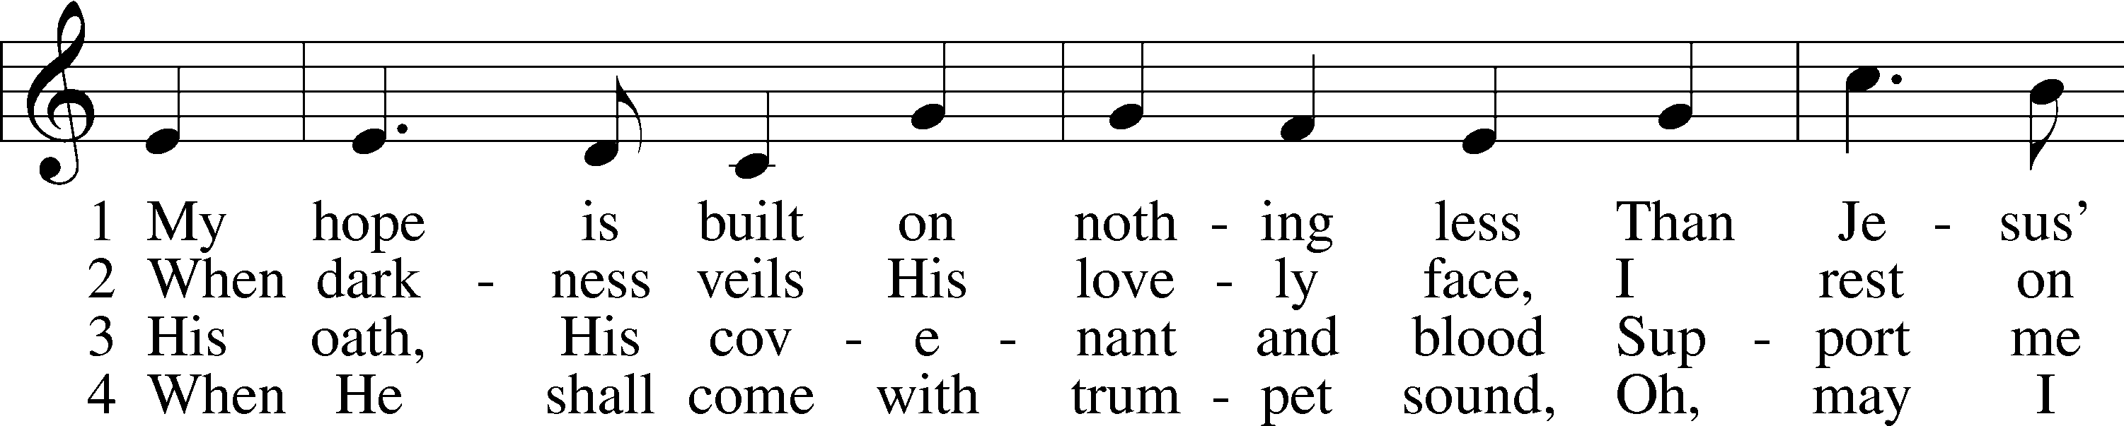

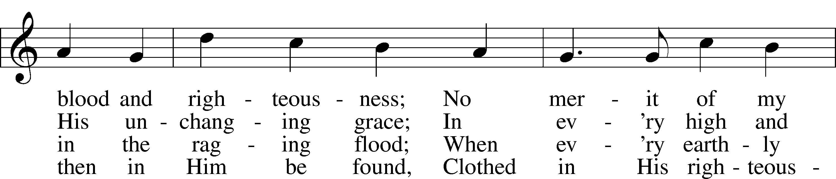

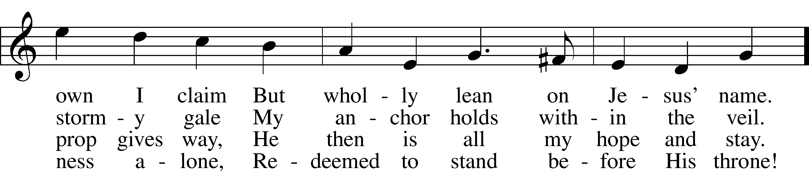

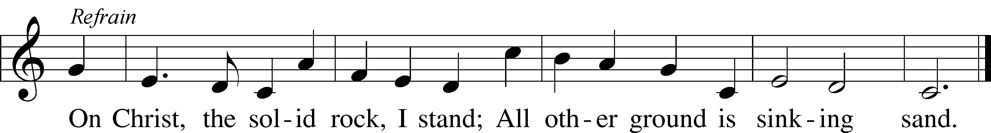

Text: Edward Mote, 1797–1874, alt.  
Tune: John Stainer, 1840–1901  
Text and tune: Public domain

Stand

Nunc Dimittis Luke 2:29–32

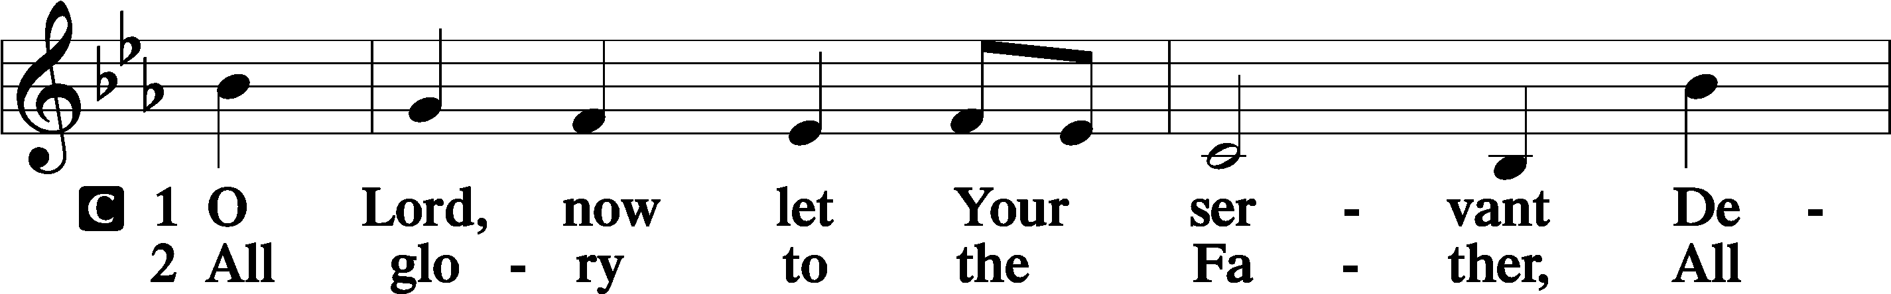

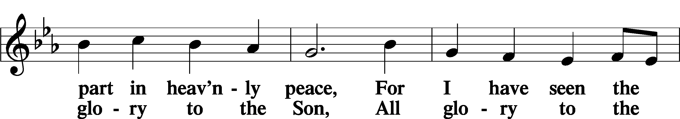

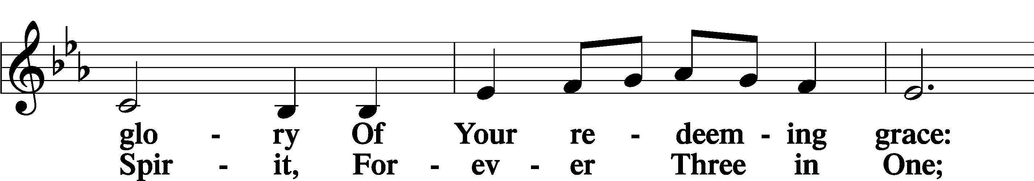

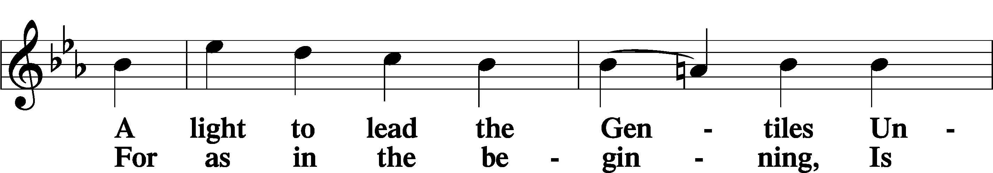

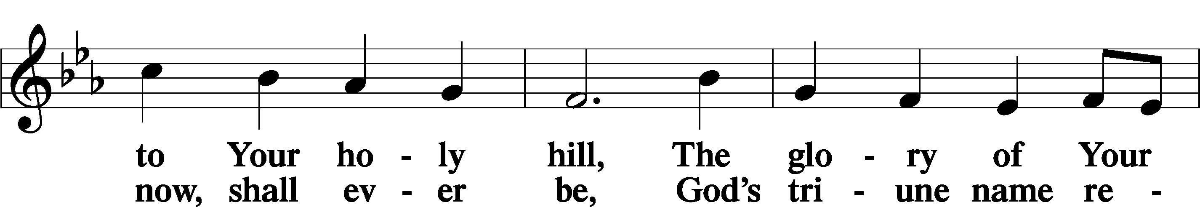

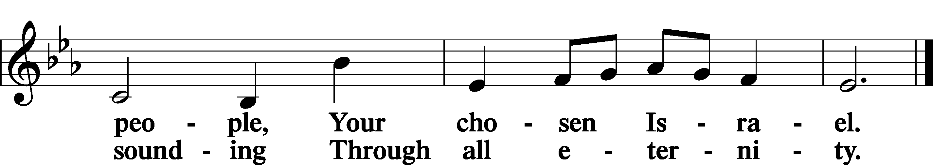

Post-Communion Collect

A Let us pray.

We give thanks to You, almighty God, that You have refreshed us through this salutary gift, and we implore You that of Your mercy You would strengthen us through the same in faith toward You and in fervent love toward one another; through Jesus Christ, Your Son, our Lord, who lives and reigns with You and the Holy Spirit, one God, now and forever.

C **Amen.**

Benedicamus Psalm 103:1

A Let us bless the Lord.

C **Thanks be to God.**

Benediction

P The Lord bless you and keep you.

The Lord make His face shine on you and be gracious to you.

The Lord look upon you with favor and T give you peace.

C **Amen.**

933 My Soul Rejoices

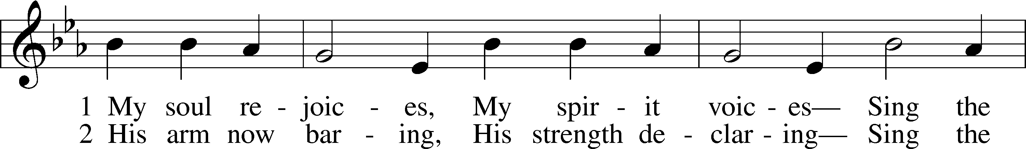

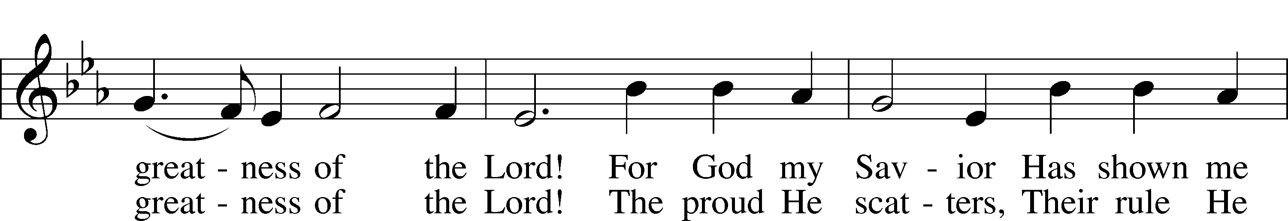

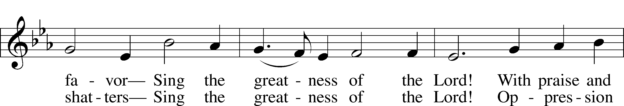

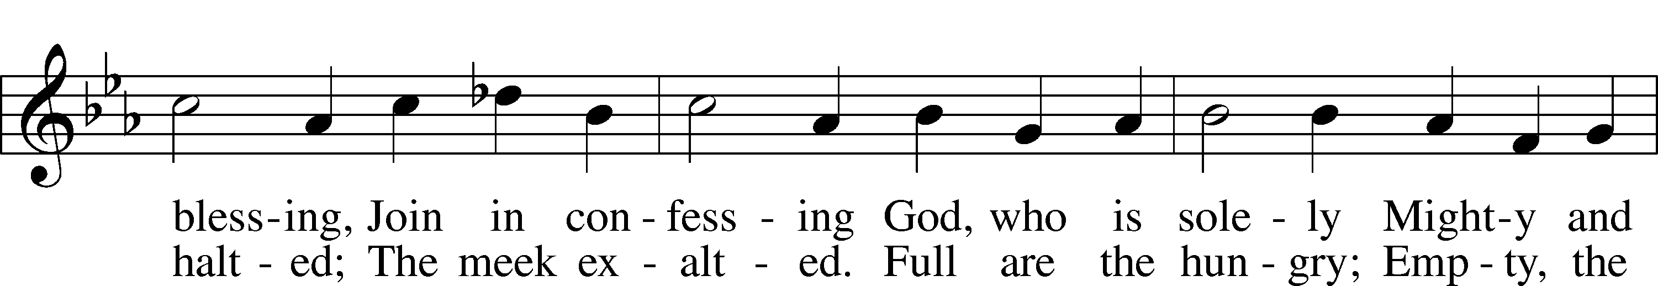

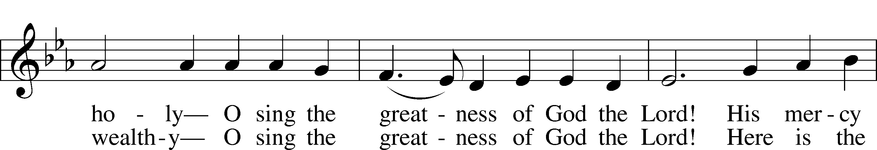

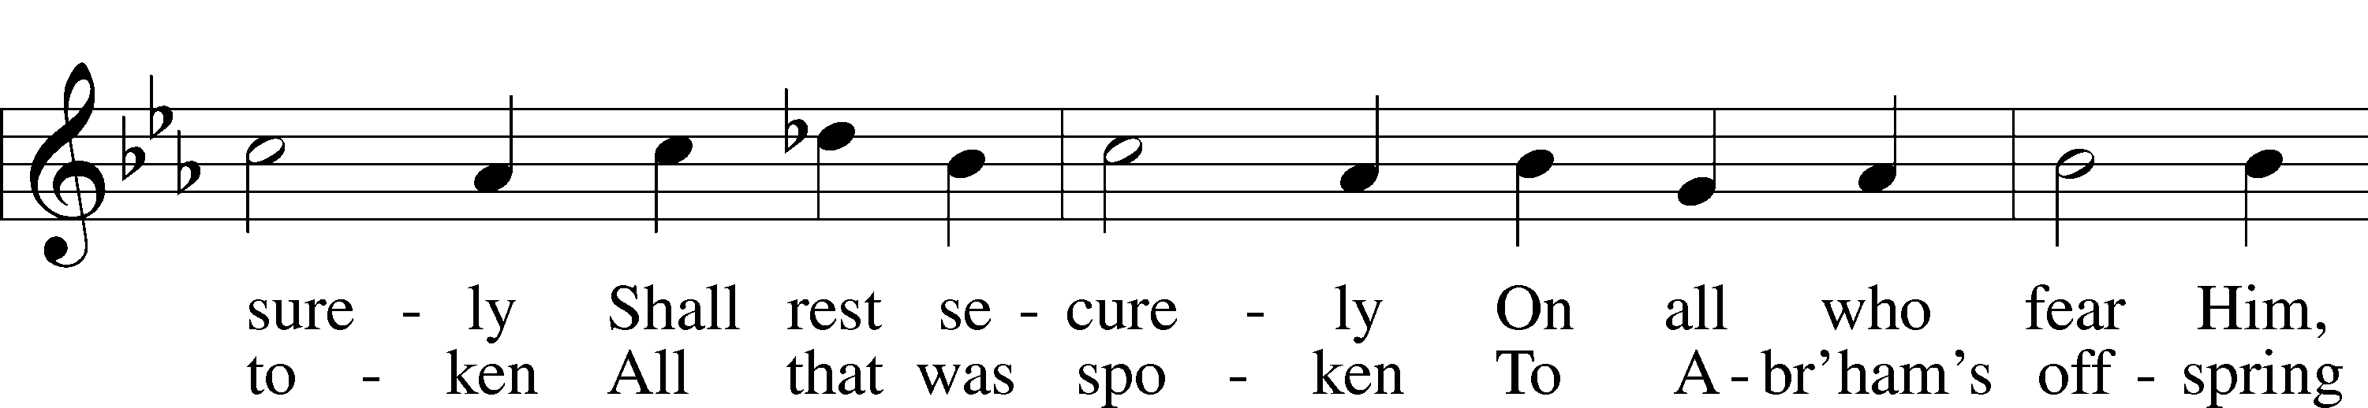

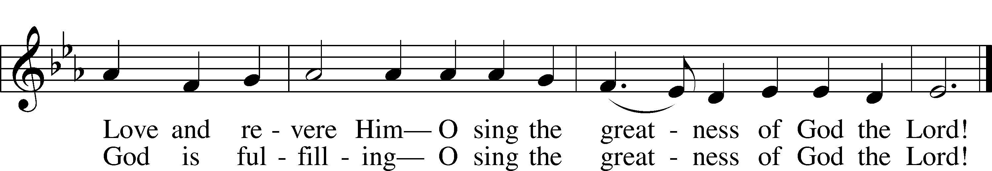

Text: Stephen P. Starke, 1955  
Tune: Giovanni Giacomo Gastoldi, c. 1556–c. 1622  
Text: © 1991 Stephen P. Starke, admin. Concordia Publishing House. Used by permission: LSB Hymn License no. 110005011  
Tune: Public domain

Acknowledgments

Divine Service, Setting Four from Lutheran Service Book

Unless otherwise indicated, Scripture quotations are from the ESV® Bible (The Holy Bible, English Standard Version®), copyright © 2001 by Crossway, a publishing ministry of Good News Publishers. Used by permission. All rights reserved.

Created by Lutheran Service Builder © 2025 Concordia Publishing House.