

May 2025
(Sorry that this is late going to press. We had a lot going on in the last week and a half.)

Christ is risen!
He is risen, indeed!
Alleluia!

This greeting has been used in the church for centuries. This is a statement of fact. Over 500 people witnessed Jesus after his resurrection. The resurrection is written about in all four gospels. The book of Acts also records a resurrected Jesus speaking to his apostles before the Ascension.

In this season of Easter, from Easter to the Ascension (40 days later), what was the first reading (from the Old Testament) will now be from the book of Acts. The readings will concentrate on the times that Jesus appeared to his disciples, and others, after the resurrection.

Each of these accounts involve multiple witnesses to the resurrected Jesus. We will hear about “Doubting” Thomas. The next week, we will read about the calling of Saul of Tarsus. The third week, we learn about Tabitha. We might also hear about Peter being sent by the Holy Spirit to Cornelius’ house.

Paul (used to be named Saul) is directed by the Holy Spirit to head towards Macedonia (modern day Greece) rather than head into Asia.

Each of these stories help us understand how the church grew, even during a time of persecution. They also show us that it is not the work of man, but the guidance of the Holy Spirit, that grew the church.

Please pray for the family of Ed Robinson. He died on Monday the 14th and we held his funeral on Friday the 18th. Viola and her sons have been strong through Eds decline in health. She now needs our prayers even more.

On April 26th, I was in Houston for the committal of Edward Heidenrich (Debbie’s father). Please keep all those who lost their loved ones in the past year in your prayers. The times where life seems to get difficult without our loved ones tends to be at Christmas and Easter.
— Pastor De Young

The Large Catechism has a warning for lazy or prideful Christians:

Such hard heads imagine that God overlooks and allows them to rest in security, or that He is entirely ignorant or cares nothing about such matters. Therefore, God must deal a smashing blow and punish them, so that He cannot forget their sin unto their children’s children. In that way, everyone may take note and see that this is no joke to Him. These are the people He means when He says, “those who hate Me” Exodus 20:5]; i.e., those who persist in their defiance and pride. Whatever is preached or said to them, they will not listen. When they are rebuked in order that they may learn to know themselves and make amends before the punishment begins, they become mad and foolish.
— Large Catechism I 37-40

In the Small Catechism, the Third Commandment, we read: Honor the Sabbath Day by keeping it holy.

What does this mean?
You should fear and love God so that you do not despise preaching and His Word, but hold it sacred and gladly hear and learn it.

Martin Luther preached and prayed regarding “lapsed” Christians. These are the ones that attend infrequently. Attending church services and receiving the Word of God, along with Holy Communion, is the only way to keep your faith strong. The devil works at the edges. “I went to church last week, I do not need to go this week.” soon becomes: “I went to church earlier this month, I should be good.” At some point, the mind quits “keeping score” and the person stops going to church altogether, or they attend only at Christmas and Easter. This is when the devil does his hardest work. Soon, the person forgets about church and his faith.

This may look like a “once saved, always saved” justification for their lives. Nowhere in the Bible does it say, “Because you have been saved, you may freely sin.” We need to stay in God’s Word constantly. Bible studies, church, devotion, prayer; these are all methods to keep the devil at bay.



Celebrate May’s Baptism Birthdays
& their years as heirs of God’s kingdom!

Date | Name | Years
1st | Belinda Anderson | 65
 | Cholly Hargrove | 82
 | Tamie Hoover | 63
16th | Malley Underwood | 60
19th | Isaac Keyes | 12
21st | Hattie Hammer | 25
28th | Darren Gill | 53
29th | Jessi Mayfield | 14

Serving in God’s House this month
Elder of the Month | Arn Anderson
Counters | John Belcher / Terry Henry
Altar Guild | D’Ann Hammett / Sharon Rainwater
Altar Care | Debra Keyes / Cassie Ludtke
Guest Monitor | Tonda Rice
Week | Acolytes | Reader
May 04 | Karlee Hughes & Annellee Osbon | Arn Anderson
May 11 | Avery Henry & Aiden Henry | Bryan Roth
May 18 | Emily Keyes & Parker Lawson | William Pickett
May 25 | Archer Ferguson & Max Gilmore | Lee Hughes






5th Sunday Potluck


Many Soup Suppers were enjoyed this Lent Season


Henry Riker Dyson was Baptised


Doors were donated and replaced in the Fellowship Hall by Our Pastor

The Children’s Sermon on Palm Sunday

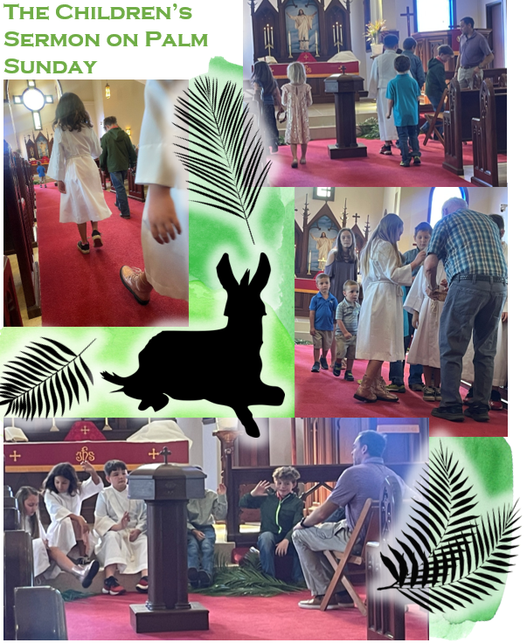


Egg Hunt was a success!




The Youth Group had an Easter Breakfast Fundraiser



