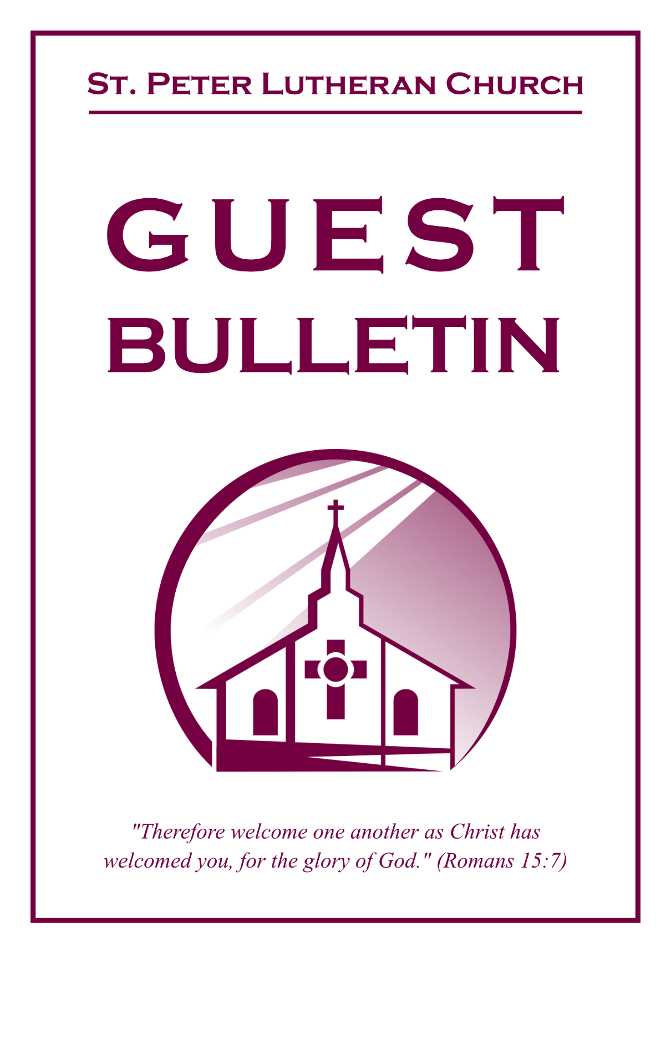

July 12, 2026



St. Peter Lutheran Church
Missouri Synod
906 Highway 59N, P.O. Box 133

Bowie, Texas 76230

Church (940) 872-1886 Fax ((940) 872-8837

Church E-mail: stpetertexscty@gmail.com
To Our Guests and Visitors:

We welcome all our friends in Christ who have come to worship with us. If you are a guest, please feel at home with us, sign our guest register, and worship with us whenever you are able. If you do not have a church home, we invite you to
consider becoming a part of our church family.

Website: www.stpetertex.com
Communion Statement:

The Lord’s Supper is celebrated at this congregation in the confession and glad confidence that, as He says, our Lord gives into our mouths not only bread and wine but His very Body and Blood to eat and drink for the forgiveness of sins and to strengthen our union with Him and one another.

Our Lord invites to His table those who trust in His words, repent of all sin, and set aside any refusal to forgive and love as He forgives and loves us, that they may show forth His death until He comes.

Because those who eat and drink our Lord’s Body and Blood unworthily do so to their great harm, and because Holy Communion is a confession of the faith, which is confessed at this altar, guests who are not confirmed members of an LCMS congregation and have not previously communed at this altar, are asked to first speak with our pastor.

If you are unable to do so before the service, it is out of Christian love and care for your souls that we ask you to refrain from communing this morning.

For further study, please see Matthew 5:23ff, 10:32ff, 18:15–35, 26:26–29; 1 Corinthians 11:17–34.

If you desire to receive a blessing for yourself or your children, please approach during
communion, cross your arms over your chest and bow your head as you kneel at the
altar rail.

Who Receives the Sacrament of the Altar Worthily?
Fasting and bodily preparation are certainly fine outward training. But that person is truly worthy and well prepared who has faith in these words: “Given and shed for you for the forgiveness of sins.” But anyone who does not believe these words or doubts them is unworthy and unprepared; for the words “for you” require all hearts to believe.
How May I Prepare?
See Dr. Luther’s self–examination questions and answers in the
LSB Hymnal on page 329

Upon entering the Sanctuary. please turn off cell phones, pagers. etc. Use the time as a quiet time for personal reflection and meditation in preparation for worship. This is a time for anyone to join in praying for the service, and for the church in general.
904 Blessed Jesus, at Your Word
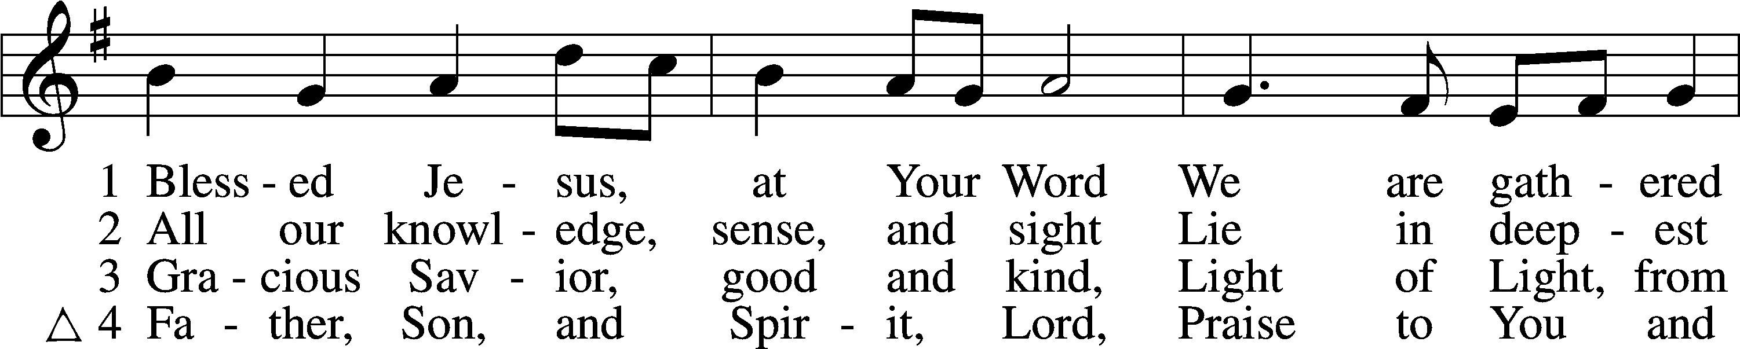
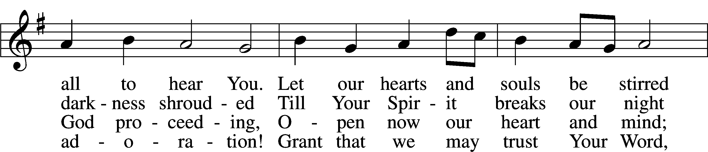
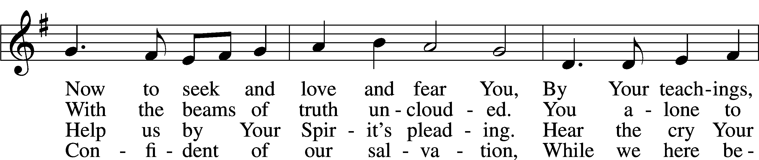
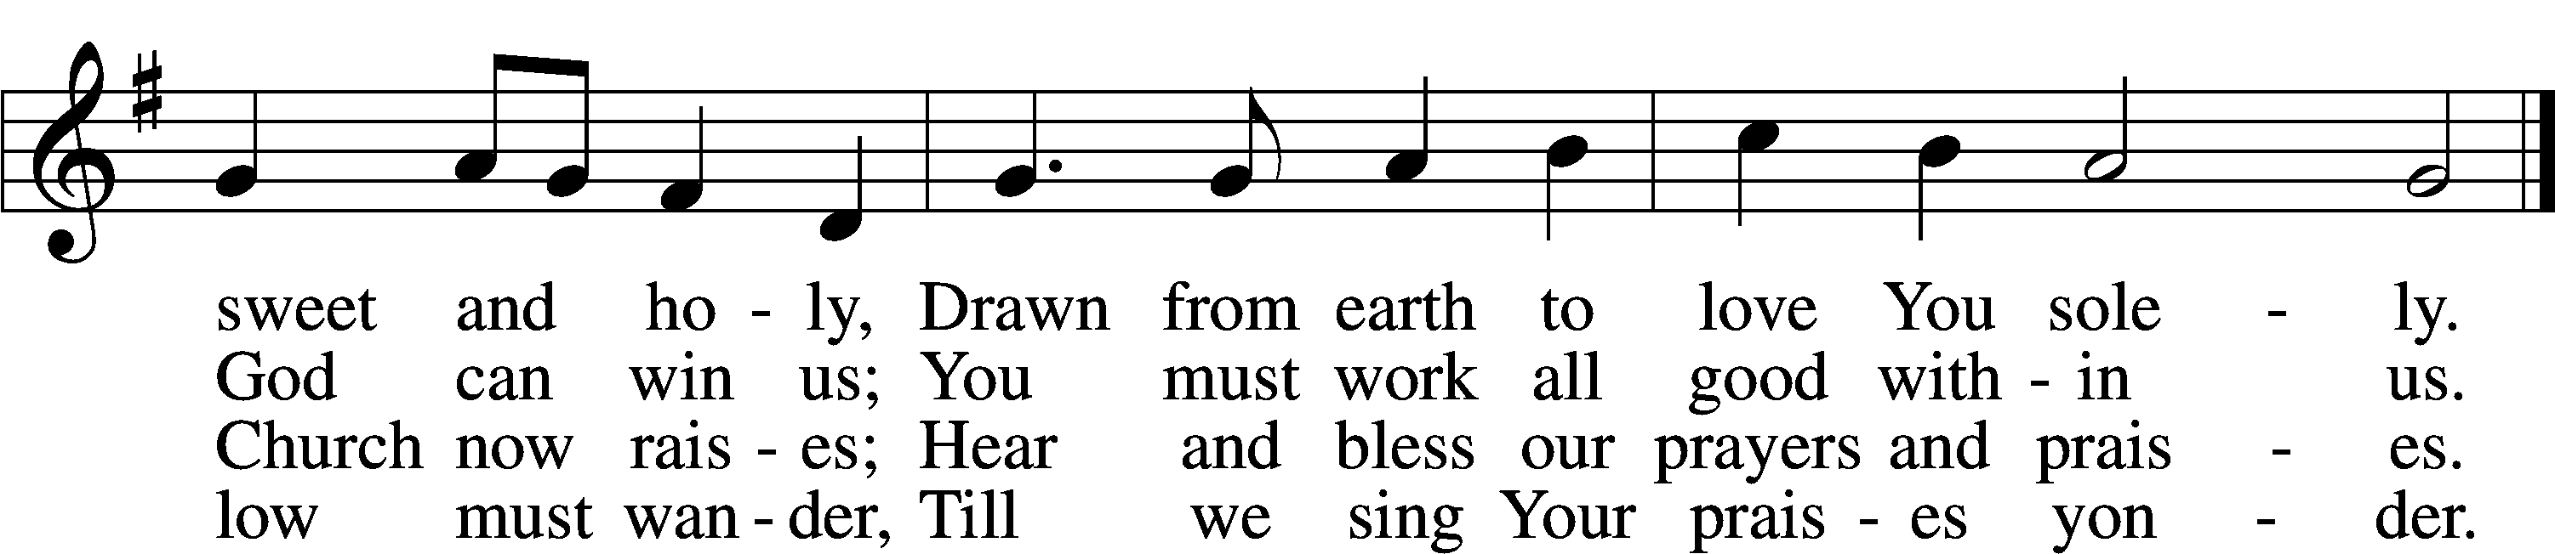
Text (sts. 1–3): Tobias Clausnitzer, 1619–84; (sts. 1–3): tr. Catherine Winkworth, 1827–78, alt.; (st. 4): Geistreiches Gesang-Büchlein, 1707, Berlin; (st. 4): tr. unknown, alt.
Tune: Johann Rudolph Ahle, 1625–73, alt.
Text and tune: Public domain
Confession and Absolution
The sign of the cross may be made by all in remembrance of their Baptism.

Invocation Matthew 28:19b; 18:20
P In the name of the Father and of the T Son and of the Holy Spirit.
C Amen.

Exhortation Hebrews 10:22; Psalm 124:8; Psalm 32:5
P Beloved in the Lord! Let us draw near with a true heart and confess our sins unto God our Father, beseeching Him in the name of our Lord Jesus Christ to grant us forgiveness.

P Our help is in the name of the Lord,
C who made heaven and earth.
P I said, I will confess my transgressions unto the Lord,
C and You forgave the iniquity of my sin.

Silence for reflection on God’s Word and for self-examination.

Confession of Sins
P Almighty God, our maker and redeemer, we poor sinners confess unto You that we are by nature sinful and unclean and that we have sinned against You by thought, word, and deed. Wherefore we flee for refuge to Your infinite mercy, seeking and imploring Your grace for the sake of our Lord Jesus Christ.
C O most merciful God, who has given Your only-begotten Son to die for us, have mercy upon us and for His sake grant us remission of all our sins; and by Your Holy Spirit increase in us true knowledge of You and of Your will and true obedience to Your Word, to the end that by Your grace we may come to everlasting life; through Jesus Christ, our Lord. Amen.

Declaration of Grace Mark 16:16; John 1:12
P Almighty God, our heavenly Father, has had mercy upon us and has given His only Son to die for us and for His sake forgives us all our sins. To those who believe on His name He gives power to become the children of God and has promised them His Holy Spirit. He that believes and is baptized shall be saved.
Grant this, Lord, unto us all.
C Amen.

Service of the Word

Introit Psalm 103:15–19; antiphon: v. 8
The Lord is merciful and gracious,
slow to anger and abounding in steadfast love.
As for man, his days are like grass;
he flourishes like a flower of the field;
for the wind passes over it, and it is gone,
and its place knows it no more.
But the steadfast love of the Lord is from everlasting to everlasting on those who fear him,
and his righteousness to children’s children,
to those who keep his covenant
and remember to do his commandments.
The Lord has established his throne in the heavens,
and his kingdom rules over all.

Gloria Patri
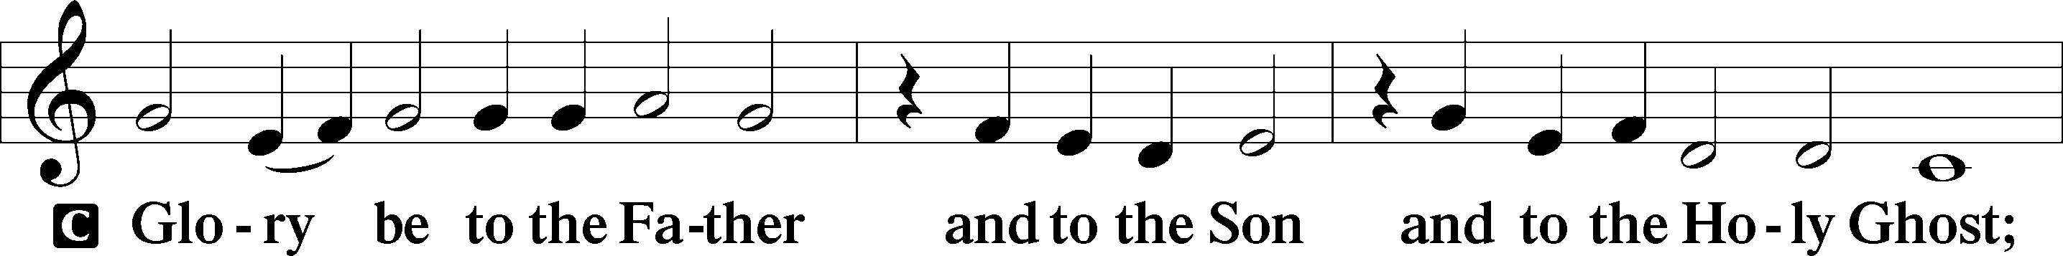
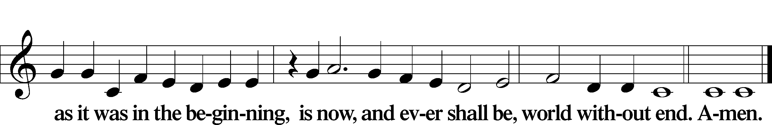

Kyrie Mark 10:47
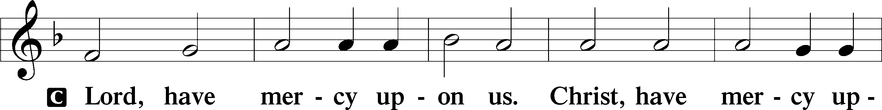
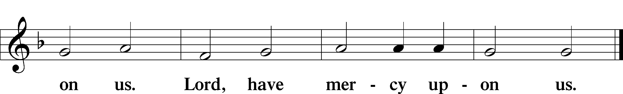

Gloria in Excelsis Luke 2:14; John 1:29
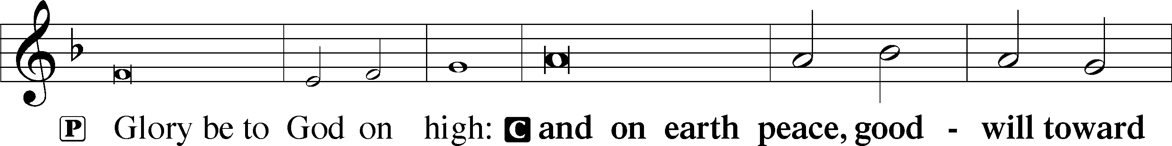
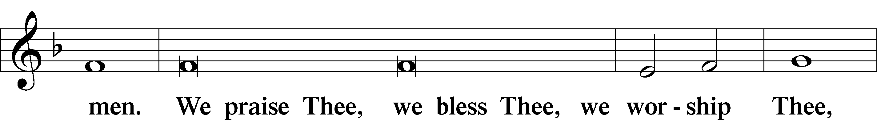
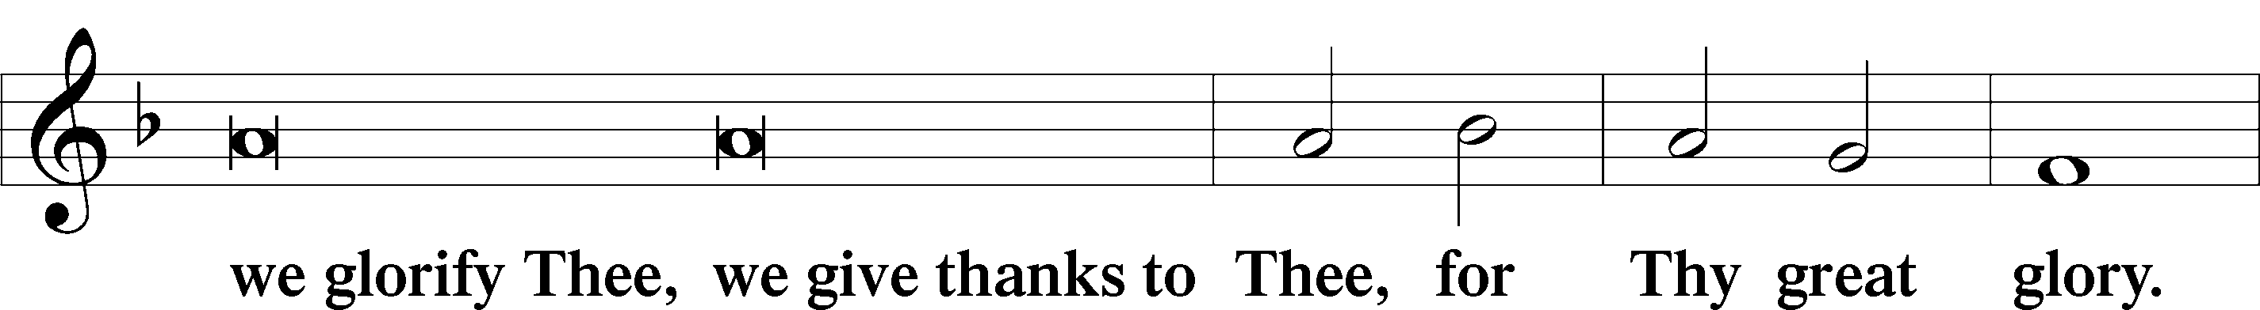
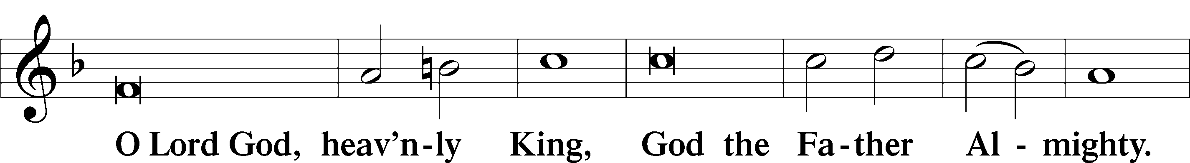
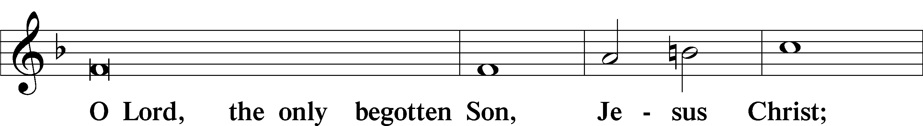
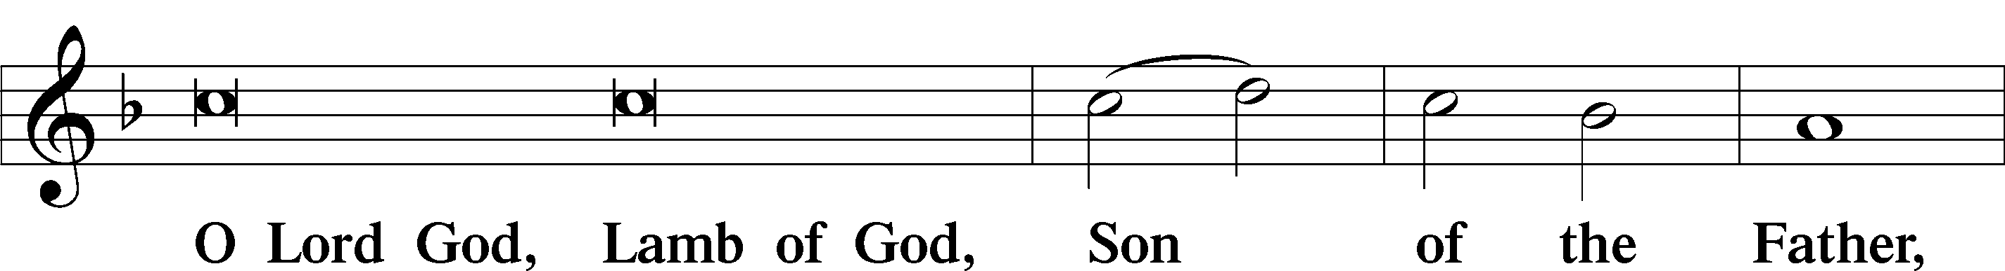
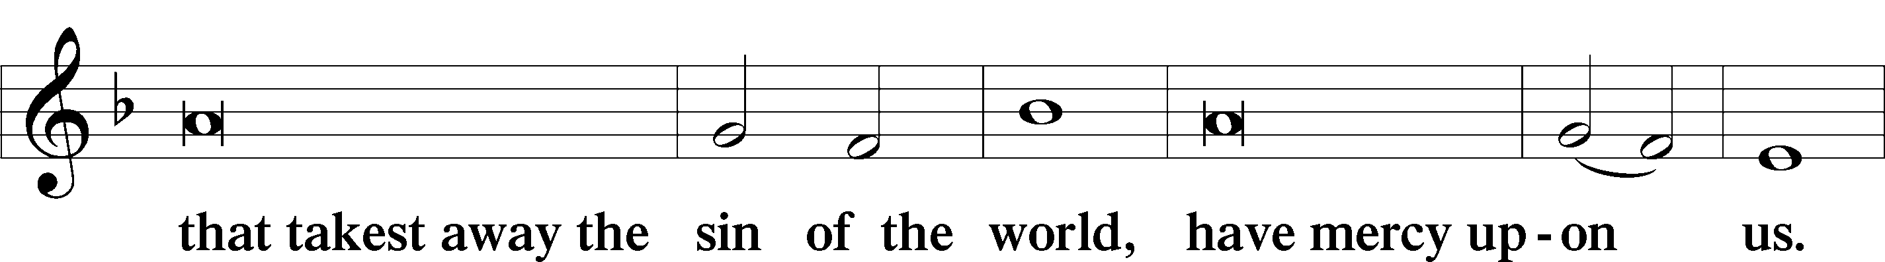
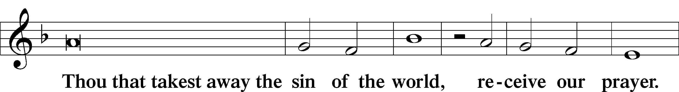
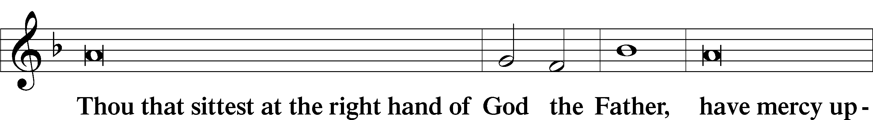
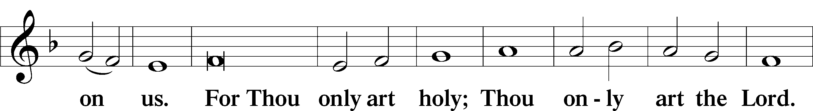
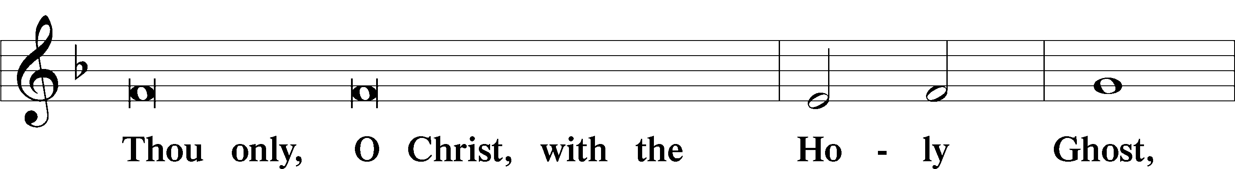
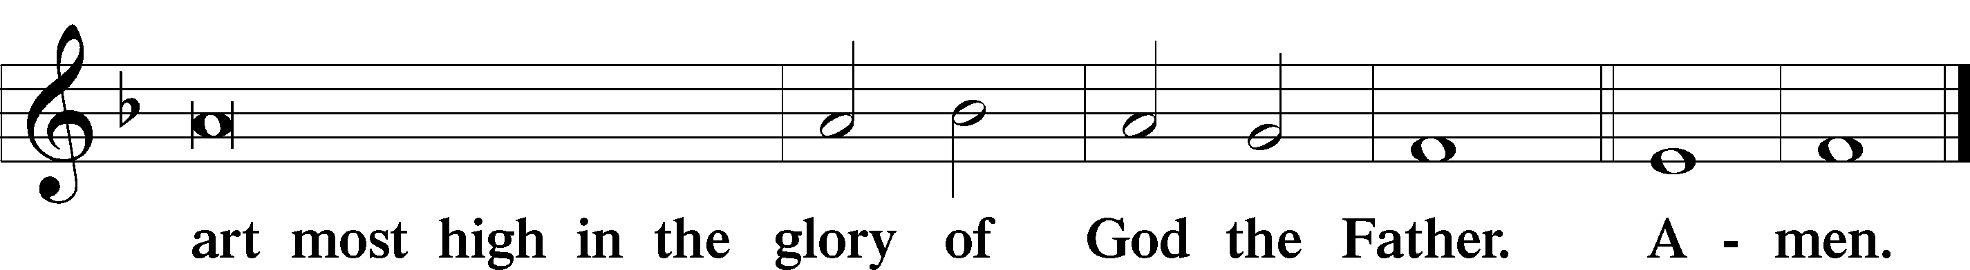

Salutation and Collect of the Day
P The Lord be with you.
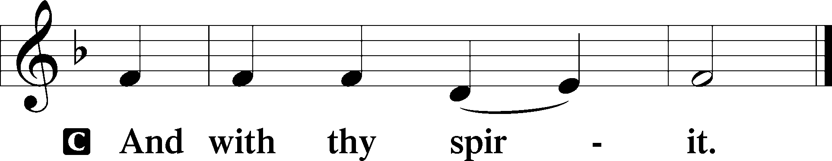

P Let us pray.
Blessed Lord, since You have caused all Holy Scriptures to be written for our learning, grant that we may so hear them, read, mark, learn, and inwardly digest them that we may embrace and ever hold fast the blessed hope of everlasting life; through Jesus Christ, Your Son, our Lord, who lives and reigns with You and the Holy Spirit, one God, now and forever.

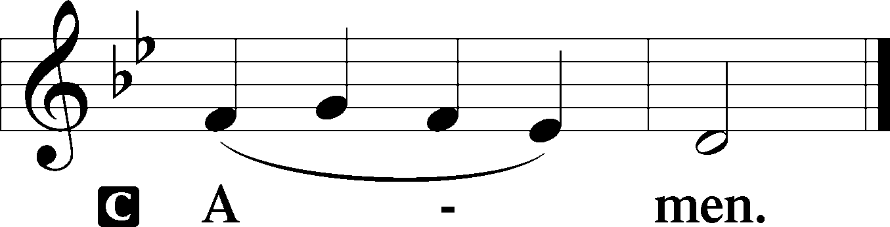

Sit

Old Testament Reading Isaiah 55:10–13
10“For as the rain and the snow come down from heaven and do not return there but water the earth, making it bring forth and sprout, giving seed to the sower and bread to the eater, 11so shall my word be that goes out from my mouth; it shall not return to me empty, but it shall accomplish that which I purpose, and shall succeed in the thing for which I sent it. 12“For you shall go out in joy and be led forth in peace; the mountains and the hills before you shall break forth into singing, and all the trees of the field shall clap their hands. 13Instead of the thorn shall come up the cypress; instead of the brier shall come up the myrtle; and it shall make a name for the Lord, an everlasting sign that shall not be cut off.”

A This is the Word of the Lord.
C Thanks be to God.

Gradual Romans 11:33, 36
Oh, the depth of the riches and wisdom and knowledge of God!
How unsearchable are his judgments and how inscrutable his ways!
For from him and through him and to him are all things.
To him be glory forever. Amen.

Epistle Romans 8:12–17
12So then, brothers, we are debtors, not to the flesh, to live according to the flesh. 13For if you live according to the flesh you will die, but if by the Spirit you put to death the deeds of the body, you will live. 14For all who are led by the Spirit of God are sons of God. 15For you did not receive the spirit of slavery to fall back into fear, but you have received the Spirit of adoption as sons, by whom we cry, “Abba! Father!” 16The Spirit himself bears witness with our spirit that we are children of God, 17and if children, then heirs—heirs of God and fellow heirs with Christ, provided we suffer with him in order that we may also be glorified with him.

Stand

Alleluia
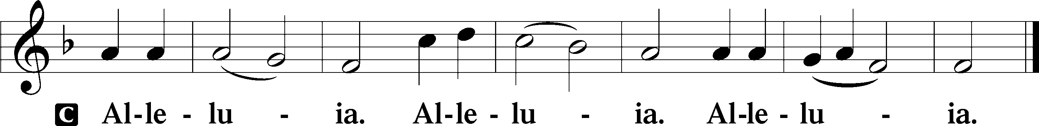

Holy Gospel Matthew 13:1–9, 18–23
P The Holy Gospel according to St. Matthew, the thirteenth chapter.

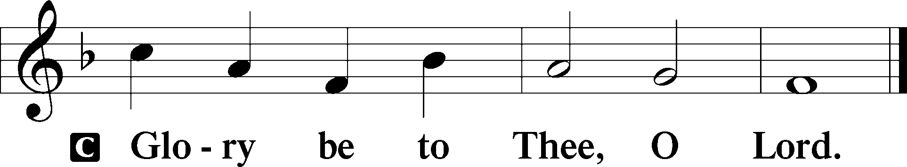

1That same day Jesus went out of the house and sat beside the sea. 2And great crowds gathered about him, so that he got into a boat and sat down. And the whole crowd stood on the beach. 3And he told them many things in parables, saying: “A sower went out to sow. 4And as he sowed, some seeds fell along the path, and the birds came and devoured them. 5Other seeds fell on rocky ground, where they did not have much soil, and immediately they sprang up, since they had no depth of soil, 6but when the sun rose they were scorched. And since they had no root, they withered away. 7Other seeds fell among thorns, and the thorns grew up and choked them. 8Other seeds fell on good soil and produced grain, some a hundredfold, some sixty, some thirty. 9He who has ears, let him hear. . . .18“Hear then the parable of the sower: 19When anyone hears the word of the kingdom and does not understand it, the evil one comes and snatches away what has been sown in his heart. This is what was sown along the path. 20As for what was sown on rocky ground, this is the one who hears the word and immediately receives it with joy, 21yet he has no root in himself, but endures for a while, and when tribulation or persecution arises on account of the word, immediately he falls away. 22As for what was sown among thorns, this is the one who hears the word, but the cares of the world and the deceitfulness of riches choke the word, and it proves unfruitful. 23As for what was sown on good soil, this is the one who hears the word and understands it. He indeed bears fruit and yields, in one case a hundredfold, in another sixty, and in another thirty.”

P This is the Gospel of the Lord.

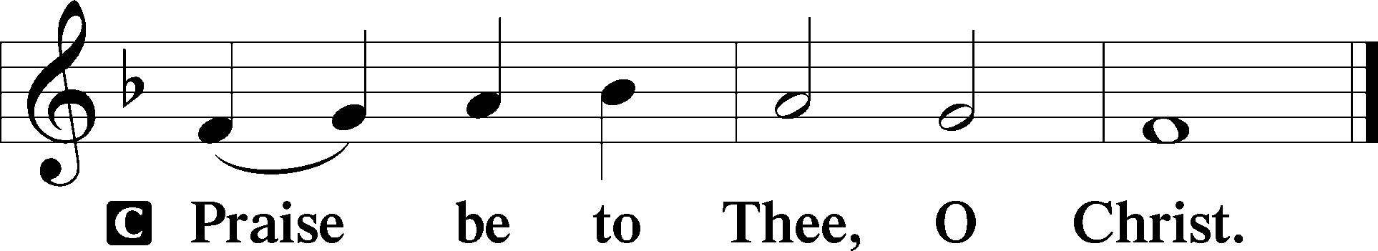

Apostles’ Creed
C I believe in God, the Father Almighty,
maker of heaven and earth.

And in Jesus Christ, His only Son, our Lord,
who was conceived by the Holy Spirit,
born of the virgin Mary,
suffered under Pontius Pilate,
was crucified, died and was buried.
He descended into hell.
The third day He rose again from the dead.
He ascended into heaven
and sits at the right hand of God the Father Almighty.
From thence He will come to judge the living and the dead.

I believe in the Holy Spirit,
the holy Christian Church,
the communion of saints,
the forgiveness of sins,
the resurrection of the body,
and the life T everlasting. Amen.

Sit

Children's Sermon

577 Almighty God, Your Word Is Cast
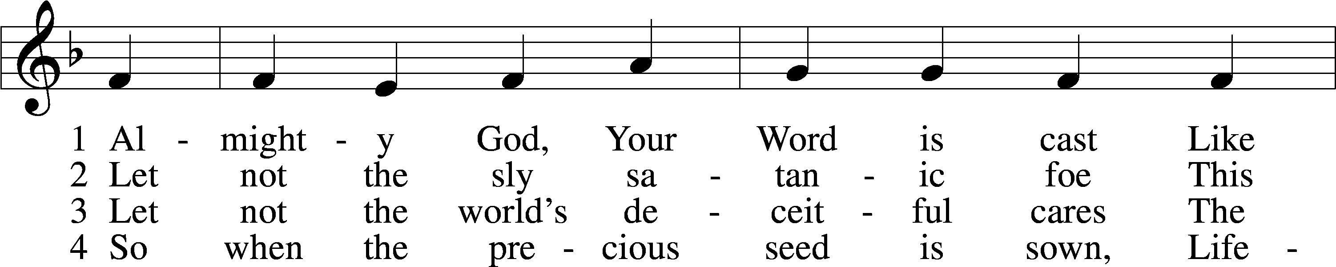
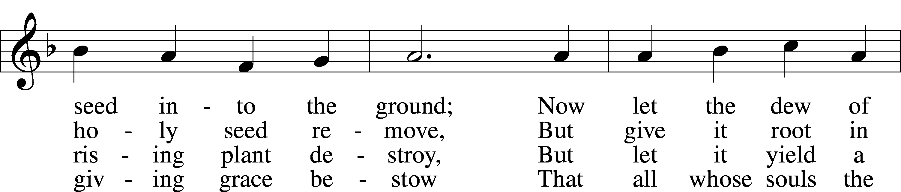
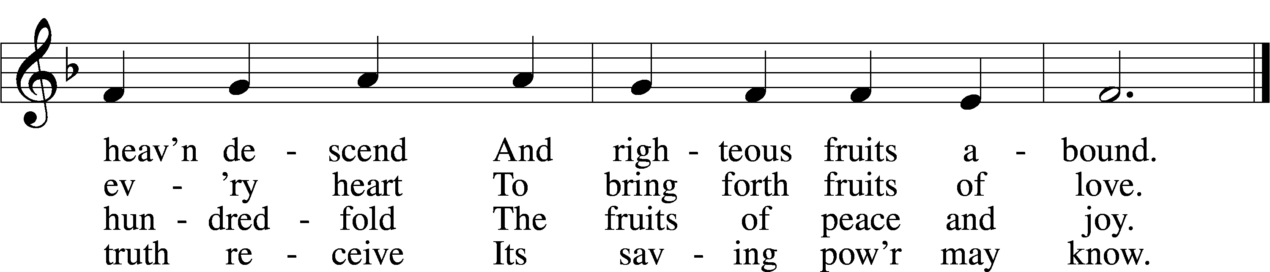
Text: John Cawood, 1775–1852, alt.
Tune: The Whole Booke of Psalmes, 1562, London
Text and tune: Public domain

Sermon “Harvest Time!”

Votum
P The peace of God, which passes all understanding, keep your hearts and minds in Christ Jesus.
C Amen.

Stand

Offertory Psalm 51:10–12
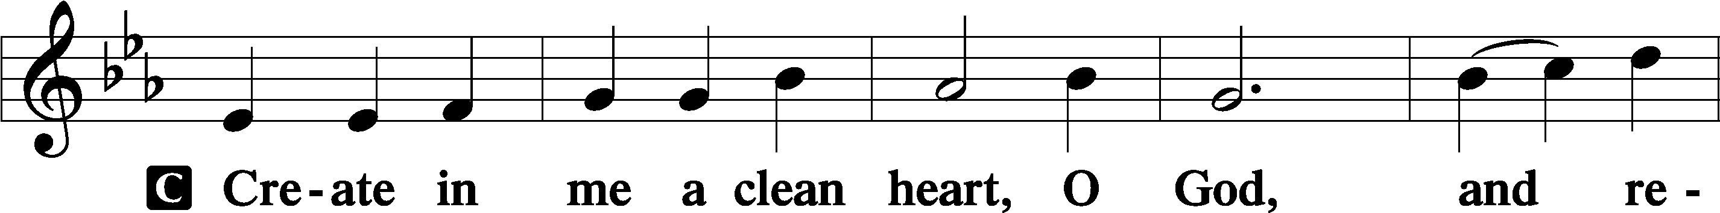
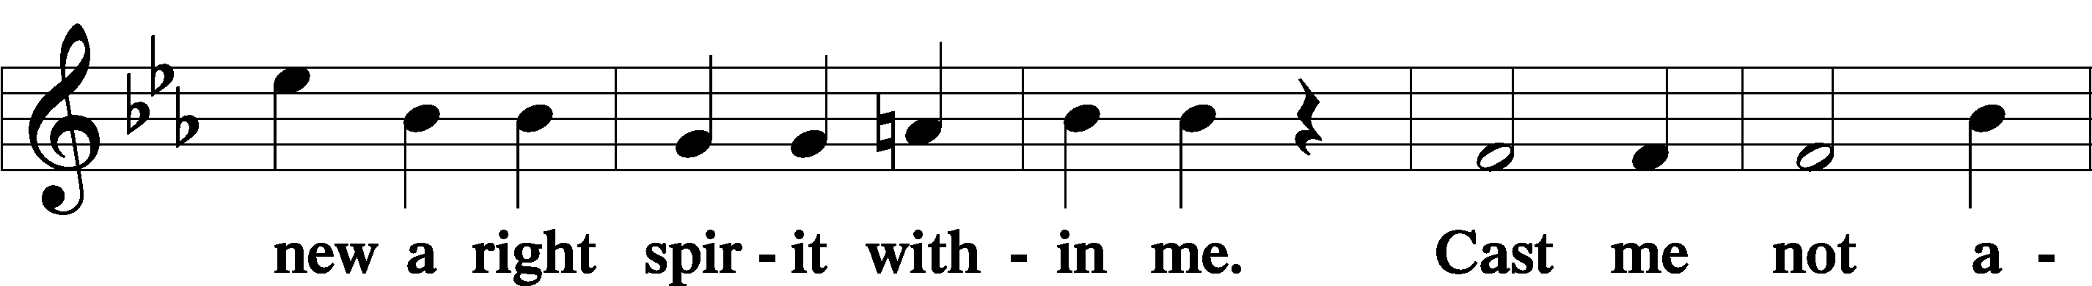
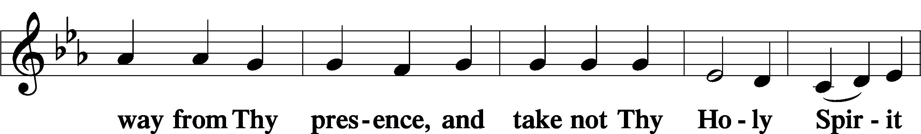
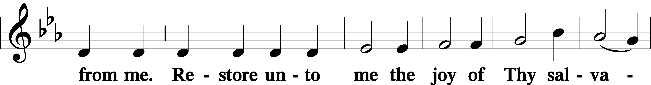
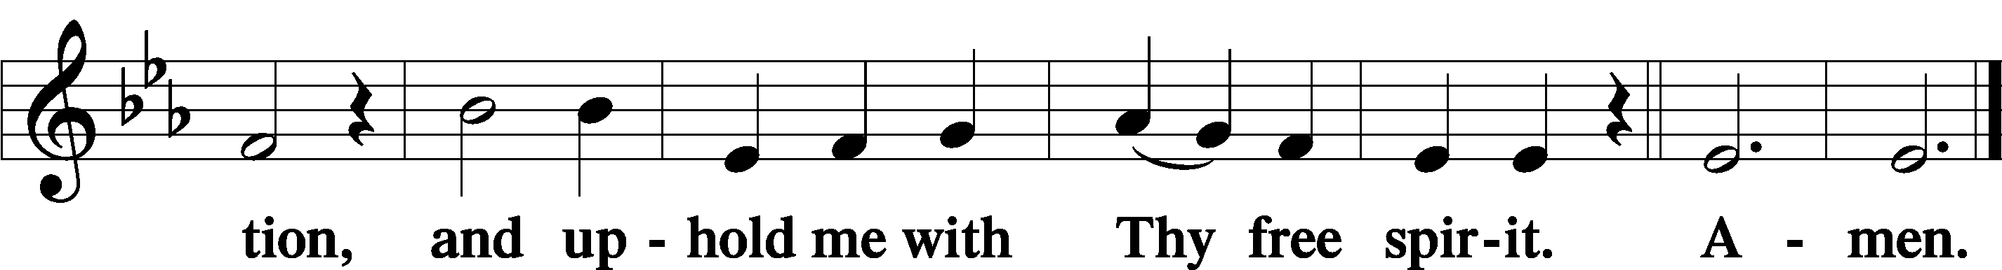

Offering

805 Praise God, from Whom All Blessings Flow
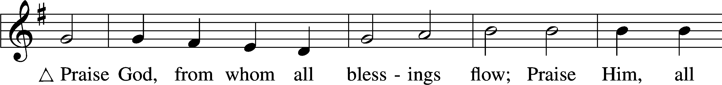
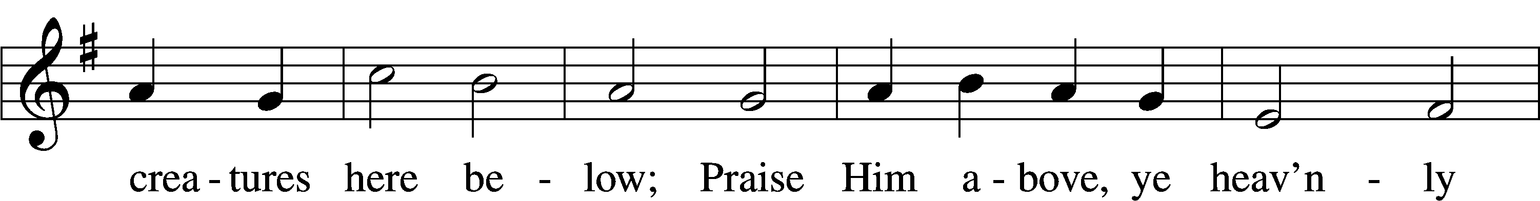
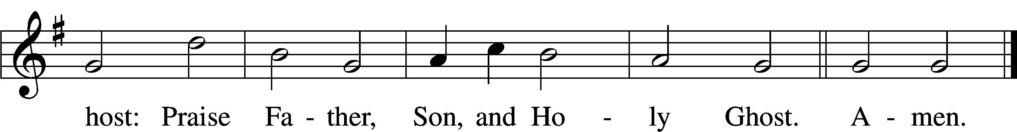
Text: Thomas Ken, 1637–1711
Tune: Trente quatre Pseaumes de David, 1551, Geneva, ed. Louis Bourgeois
Text and tune: Public domain

Prayer of the Church

Lord’s Prayer Matthew 6:9–13
P Lord, remember us in Your kingdom and teach us to pray:
C Our Father who art in heaven,
hallowed be Thy name,
Thy kingdom come,
Thy will be done on earth
as it is in heaven;
give us this day our daily bread;
and forgive us our trespasses
as we forgive those
who trespass against us;
and lead us not into temptation,
but deliver us from evil.
For Thine is the kingdom
and the power and the glory
forever and ever. Amen.

Collect for the Word

Blessed Lord, You have caused all Holy Scriptures to be written for our learning. Grant that we may so hear them, read, mark, learn, and inwardly digest them that, by the patience and comfort of Your holy Word, we may embrace and ever hold fast the blessed hope of everlasting life; through Jesus Christ, Your Son, our Lord, who lives and reigns with You and the Holy Spirit, one God, now and forever.

Benediction
P The Lord bless you and keep you.
The Lord make His face shine on you and be gracious to you.
The Lord look upon you with favor and T give you peace.
C Amen.

917 Savior, Again to Thy Dear Name We Raise
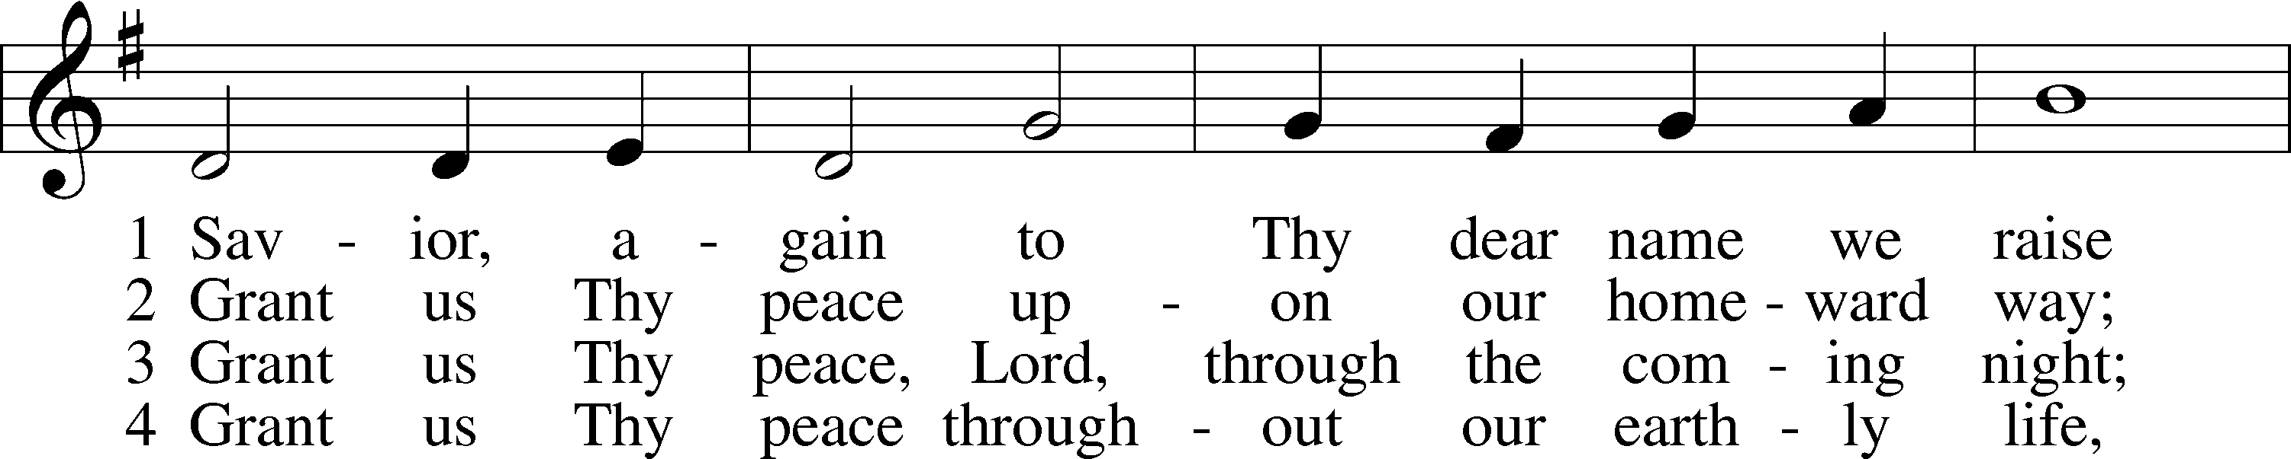
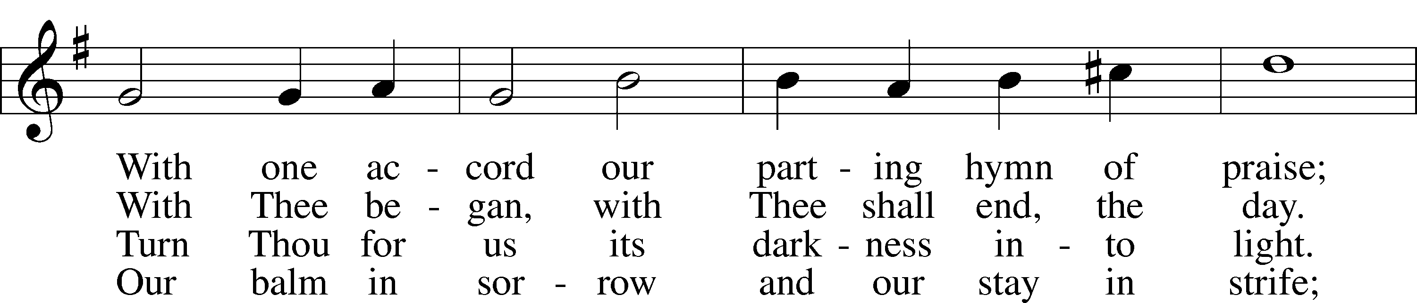
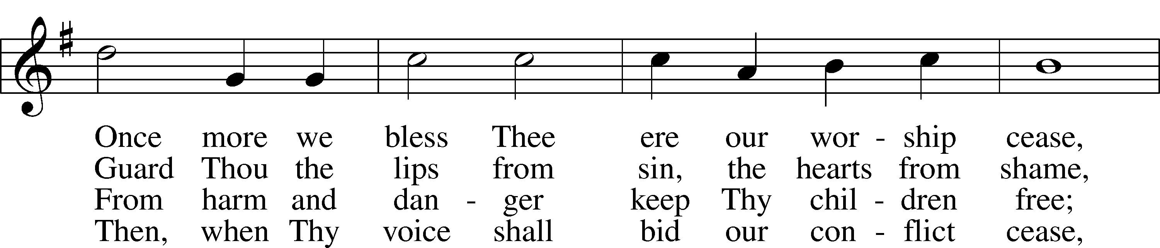
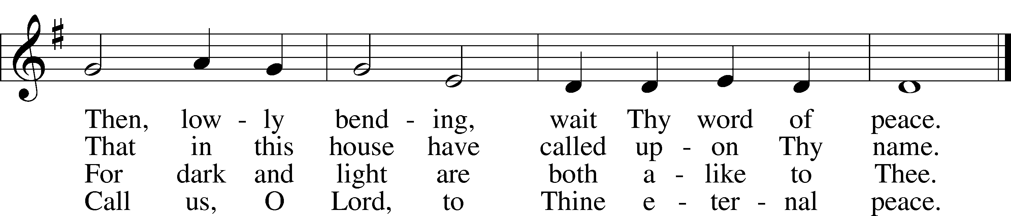
Text: John Ellerton, 1826–93
Tune: Edward J. Hopkins, 1818–1901
Text and tune: Public domain
Acknowledgments
Unless otherwise indicated, Scripture quotations are from the ESV® Bible (The Holy Bible, English Standard Version®), copyright © 2001 by Crossway, a publishing ministry of Good News Publishers. Used by permission. All rights reserved.
Created by Lutheran Service Builder © 2026 Concordia Publishing House.

