On entering the church

P Lord, I love the habitation of Your house and the place

where Your glory dwells. In the multitude of Your tender

mercies prepare my heart that I may enter Your house to

worship and confess Your holy name; through Jesus Christ,

my God and Lord.

Before worship

C O Lord, our creator, redeemer, and comforter, as we come

together to worship You in spirit and in truth, we humbly

pray that You would open our hearts to the preaching of

Your Word so that we may repent of our sins, believe in

Jesus Christ as our only Savior, and grow in grace and

holiness. Hear us for His sake.

457 Jesus Christ Is Risen Today

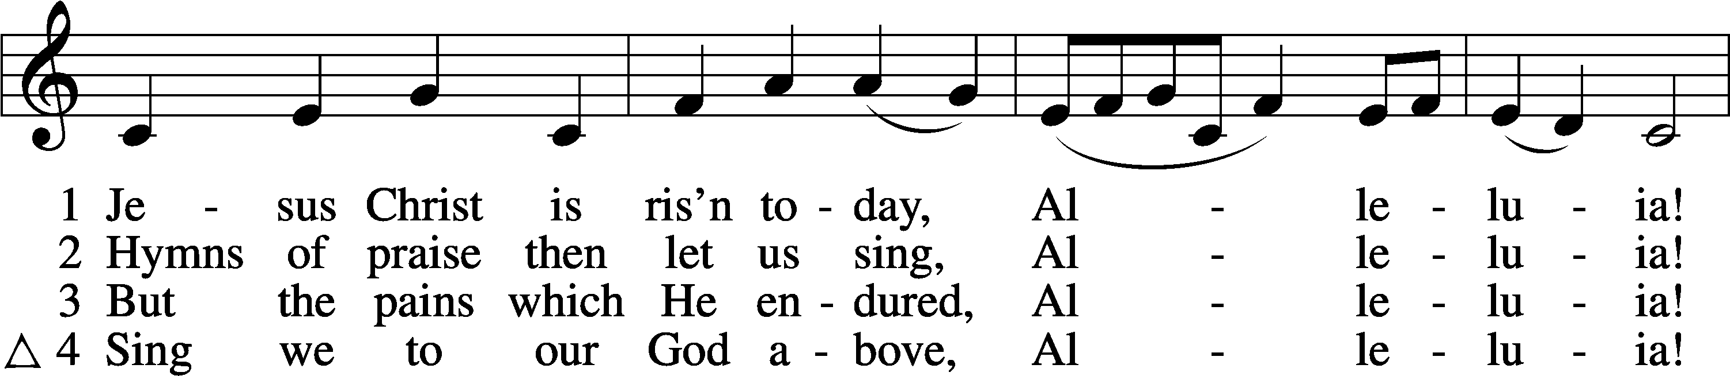

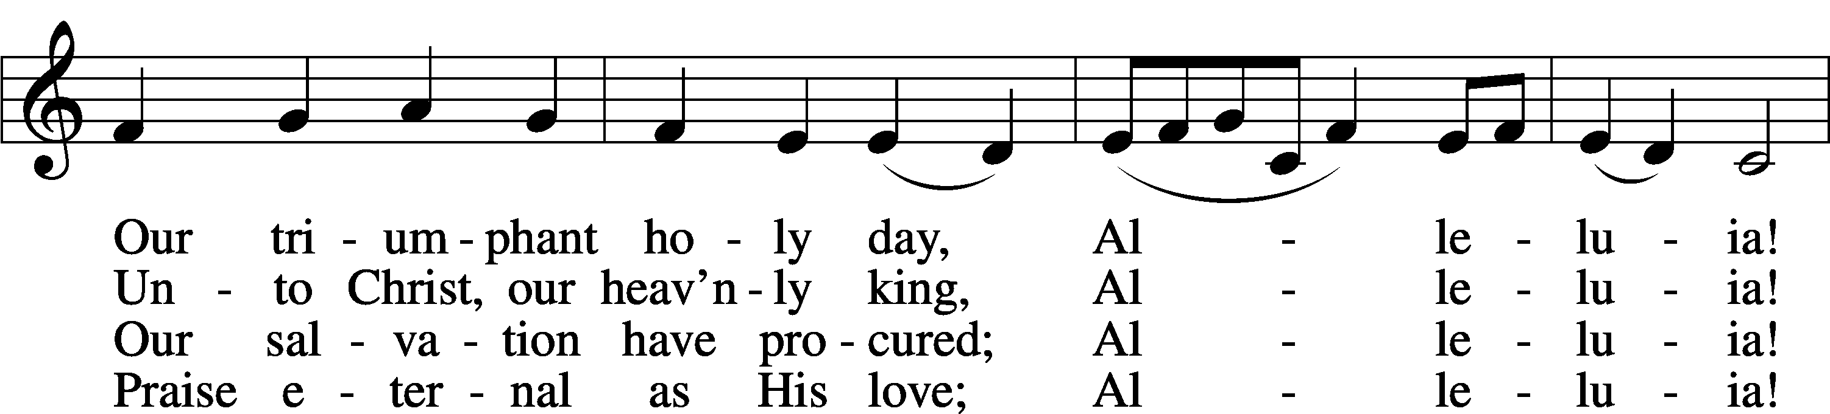

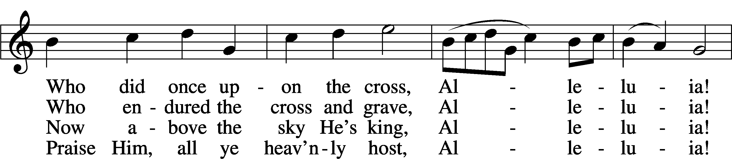

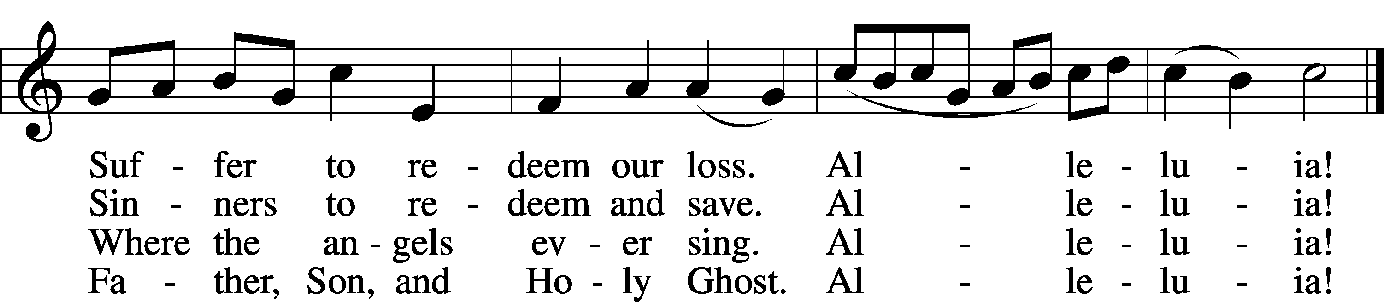

Text: tr. Lyra Davidica, 1708, London, alt.; (sts. 1–3): Latin, 14th cent.; (st. 4): Charles Wesley, 1707–88  
Tune: Lyra Davidica, 1708, London  
Text and tune: Public domain

# Confession and Absolution

Stand

The sign of the cross may be made by all in remembrance of their Baptism.

Invocation Matthew 28:19b; 18:20

P In the name of the Father and of the T Son and of the Holy Spirit.

C **Amen.**

Exhortation Psalm 124:8; Psalm 130:3–4; Luke 18:13

P Our help is in the name of the Lord,

C **who made heaven and earth.**

P If You, O Lord, kept a record of sins, O Lord, who could stand?

C **But with You there is forgiveness; therefore You are feared.**

P Since we are gathered to hear God’s Word, call upon Him in prayer and praise, and receive the body and blood of our Lord Jesus Christ in the fellowship of this altar, let us first consider our unworthiness and confess before God and one another that we have sinned in thought, word, and deed, and that we cannot free ourselves from our sinful condition. Together as His people let us take refuge in the infinite mercy of God, our heavenly Father, seeking His grace for the sake of Christ, and saying: God, be merciful to me, a sinner.

Kneel/Stand

Confession of Sins

C **Almighty God, have mercy upon us, forgive us our sins, and lead us to everlasting life. Amen.**

Absolution [John 20:19–23]

P Almighty God in His mercy has given His Son to die for you and for His sake forgives you all your sins. As a called and ordained servant of Christ, and by His authority, I therefore forgive you all your sins in the name of the Father and of the T Son and of the Holy Spirit.

C **Amen.**

Stand

# Service of the Word

Introit Exodus 15:2a, 6, 13, 17–18; antiphon: v. 1b

I will sing to the Lord, for he has triumphed gloriously;  
 the horse and his rider he has thrown into the sea.  
**The Lord is my strength and my song,  
 and he has become my salvation.**Your right hand, O Lord, glorious in power,  
 your right hand, O Lord, shatters the enemy.  
**You have led in your steadfast love the people whom you have redeemed;  
 you have guided them by your strength to your holy abode.**You will bring them in and plant them on your own mountain,  
 the place, O Lord, which you have made for your abode,  
**the sanctuary, O Lord, which your hands have established.**  
 **The Lord will reign forever and ever.  
Glory be to the Father and to the Son**  
 **and to the Holy Spirit;**  
**as it was in the beginning,**  
 **is now, and will be forever. Amen.**  
I will sing to the Lord, for he has triumphed gloriously;  
 the horse and his rider he has thrown into the sea.

Kyrie Mark 10:47

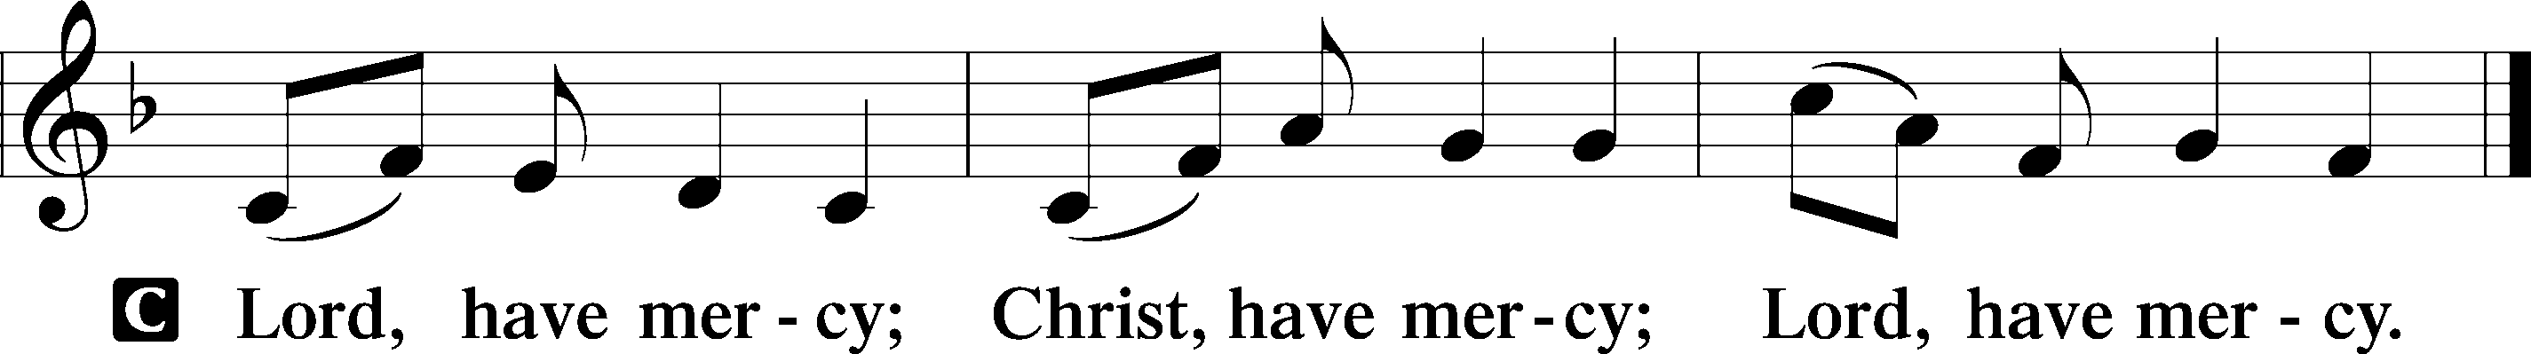

Gloria in Excelsis Luke 2:14; John 1:29

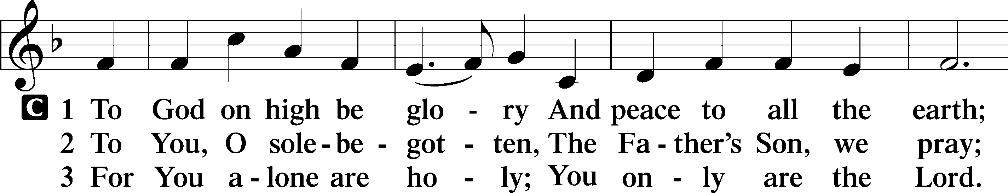

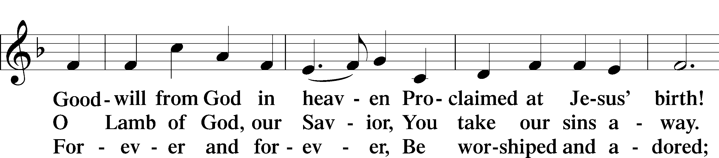

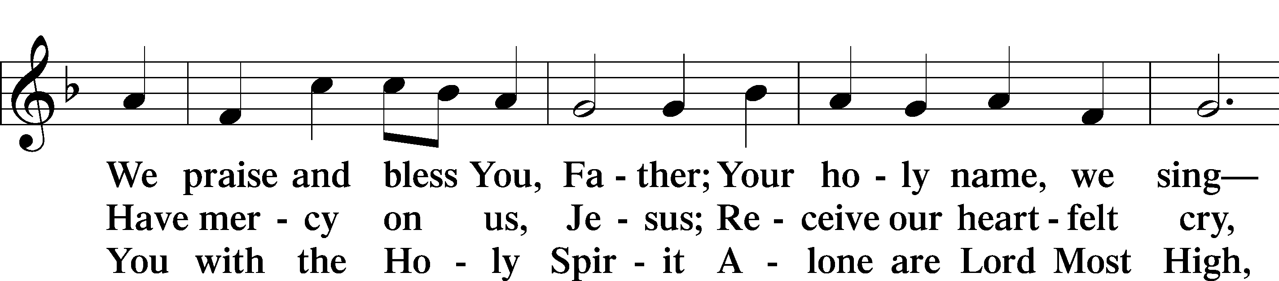

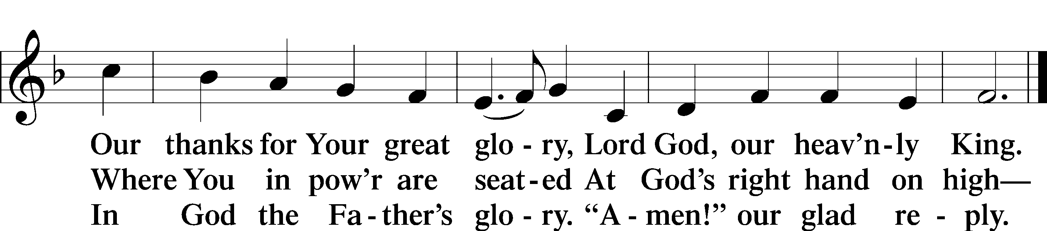

Text: Stephen P. Starke

Salutation and Collect of the Day

P The Lord be with you.

C **And also with you.**

P Let us pray.

O God, for our redemption You gave Your only-begotten Son to the death of the cross and by His glorious resurrection delivered us from the power of the enemy. Grant that all our sin may be drowned through daily repentance and that day by day we may arise to live before You in righteousness and purity forever; through Jesus Christ, our Lord, who lives and reigns with You and the Holy Spirit, one God, now and forever.

C **Amen.**

Sit

Old Testament Reading Isaiah 65:17–25

17“Behold, I create new heavens  
 and a new earth,  
and the former things shall not be remembered  
 or come into mind.  
18But be glad and rejoice forever  
 in that which I create;  
for behold, I create Jerusalem to be a joy,  
 and her people to be a gladness.  
19I will rejoice in Jerusalem  
 and be glad in my people;  
no more shall be heard in it the sound of weeping  
 and the cry of distress.  
20No more shall there be in it  
 an infant who lives but a few days,  
 or an old man who does not fill out his days,  
for the young man shall die a hundred years old,  
 and the sinner a hundred years old shall be accursed.  
21They shall build houses and inhabit them;  
 they shall plant vineyards and eat their fruit.  
22They shall not build and another inhabit;  
 they shall not plant and another eat;  
for like the days of a tree shall the days of my people be,  
 and my chosen shall long enjoy the work of their hands.  
23They shall not labor in vain  
 or bear children for calamity,  
for they shall be the offspring of the blessed of the Lord,  
 and their descendants with them.  
24Before they call I will answer;  
 while they are yet speaking I will hear.  
25The wolf and the lamb shall graze together;  
 the lion shall eat straw like the ox,  
 and dust shall be the serpent’s food.  
They shall not hurt or destroy  
 in all my holy mountain,”  
says the Lord.

A This is the Word of the Lord.

C **Thanks be to God.**

Gradual adapt. from Matthew 28:7; Hebrews 2:7; Psalm 8:6

Christ has risen from the dead.  
 [God the Father] has crowned him with glory and honor.  
**He has given him dominion over the works of his hands;  
 he has put all things under his feet.**

Epistle 1 Corinthians 15:19–26

19If in this life only we have hoped in Christ, we are of all people most to be pitied.

20But in fact Christ has been raised from the dead, the firstfruits of those who have fallen asleep. 21For as by a man came death, by a man has come also the resurrection of the dead. 22For as in Adam all die, so also in Christ shall all be made alive. 23But each in his own order: Christ the firstfruits, then at his coming those who belong to Christ. 24Then comes the end, when he delivers the kingdom to God the Father after destroying every rule and every authority and power. 25For he must reign until he has put all his enemies under his feet. 26The last enemy to be destroyed is death.

A This is the Word of the Lord.

C **Thanks be to God.**

Stand

Alleluia and Verse

Alleluia

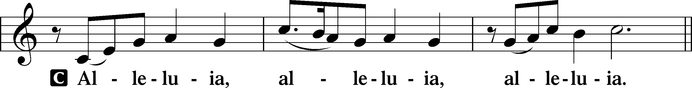

Verse John 20:31

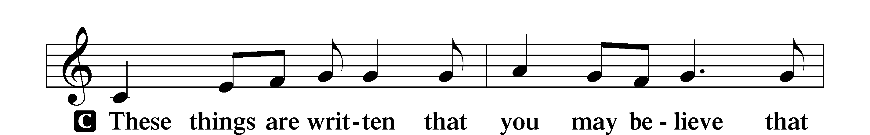

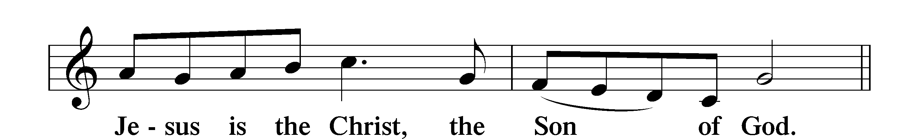

Alleluia

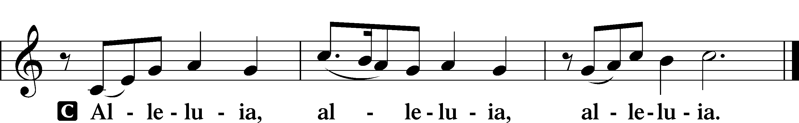

Holy Gospel Luke 24:1–12

P The Holy Gospel according to St. Luke, the twenty-fourth chapter.

C **Glory to You, O Lord.**

1On the first day of the week, at early dawn, they went to the tomb, taking the spices they had prepared. 2And they found the stone rolled away from the tomb, 3but when they went in they did not find the body of the Lord Jesus. 4While they were perplexed about this, behold, two men stood by them in dazzling apparel. 5And as they were frightened and bowed their faces to the ground, the men said to them, “Why do you seek the living among the dead? 6He is not here, but has risen. Remember how he told you, while he was still in Galilee, 7that the Son of Man must be delivered into the hands of sinful men and be crucified and on the third day rise.” 8And they remembered his words, 9and returning from the tomb they told all these things to the eleven and to all the rest. 10Now it was Mary Magdalene and Joanna and Mary the mother of James and the other women with them who told these things to the apostles, 11but these words seemed to them an idle tale, and they did not believe them. 12But Peter rose and ran to the tomb; stooping and looking in, he saw the linen cloths by themselves; and he went home marveling at what had happened.

P This is the Gospel of the Lord.

C **Praise to You, O Christ.**

Nicene Creed

C **I believe in one God,**

**the Father Almighty,**

**maker of heaven and earth**

**and of all things visible and invisible.**

**And in one Lord Jesus Christ,**

**the only-begotten Son of God,**

**begotten of His Father before all worlds,**

**God of God, Light of Light,**

**very God of very God,**

**begotten, not made,**

**being of one substance with the Father,**

**by whom all things were made;**

**who for us men and for our salvation came down from heaven**

**and was incarnate by the Holy Spirit of the virgin Mary**

**and was made man;**

**and was crucified also for us under Pontius Pilate.**

**He suffered and was buried.**

**And the third day He rose again according to the Scriptures**

**and ascended into heaven**

**and sits at the right hand of the Father.**

**And He will come again with glory to judge both the living and the dead,**

**whose kingdom will have no end.**

**And I believe in the Holy Spirit,**

**the Lord and giver of life,**

**who proceeds from the Father and the Son,**

**who with the Father and the Son together is worshiped and glorified,**

**who spoke by the prophets.**

**And I believe in one holy Christian and apostolic Church,**

**I acknowledge one Baptism for the remission of sins,**

**and I look for the resurrection of the dead**

**and the life** T **of the world to come. Amen.**

Sit

Children's Sermon

475 Good Christian Friends, Rejoice and Sing

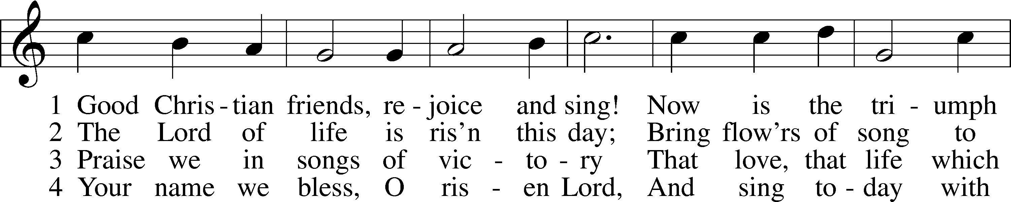

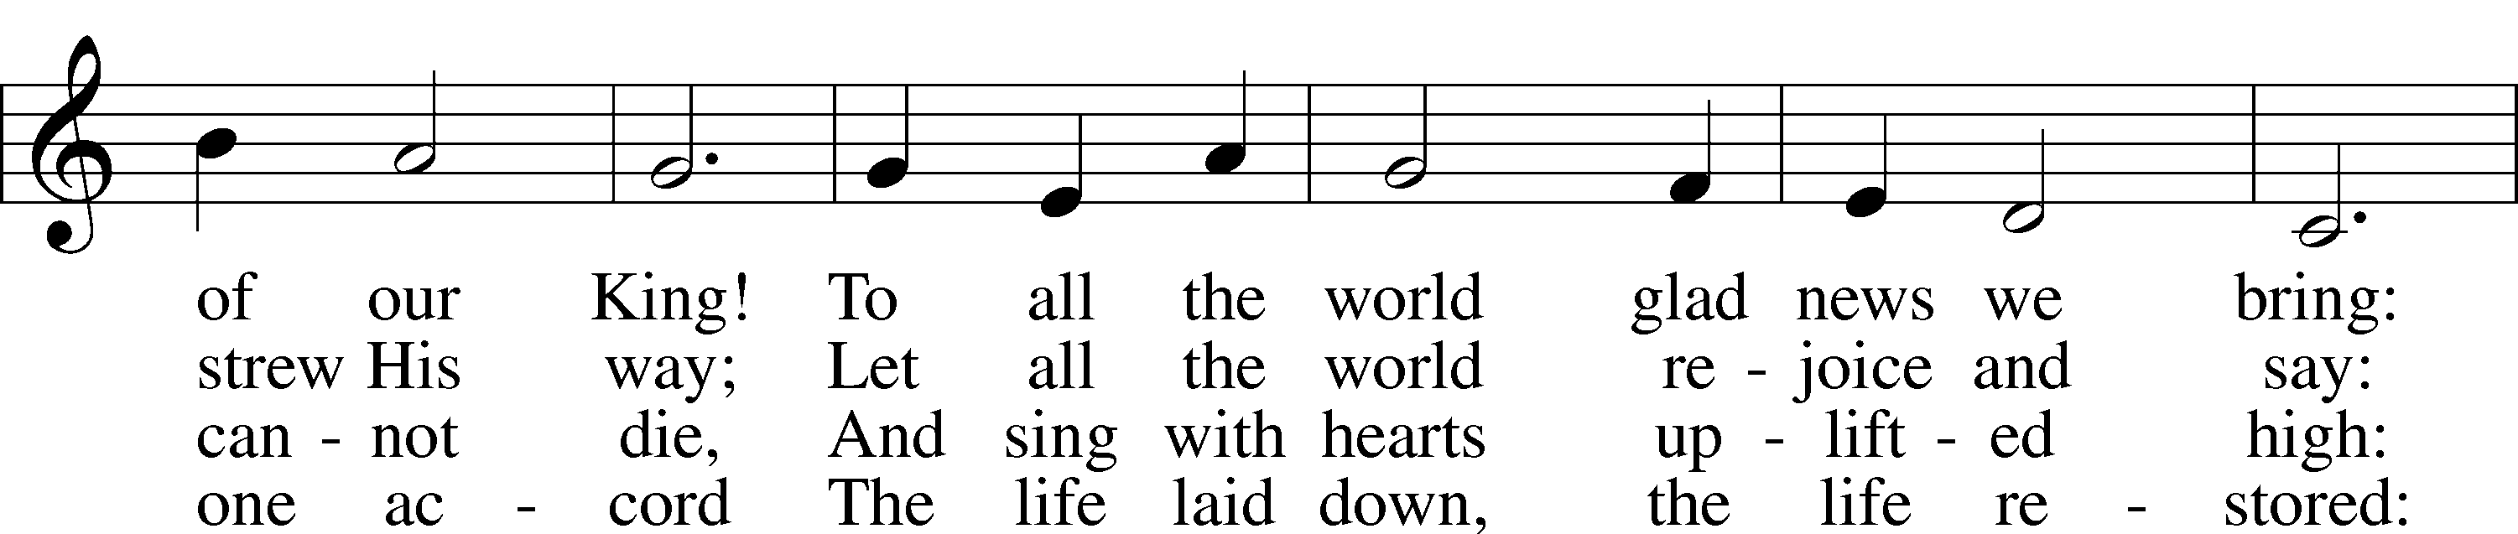

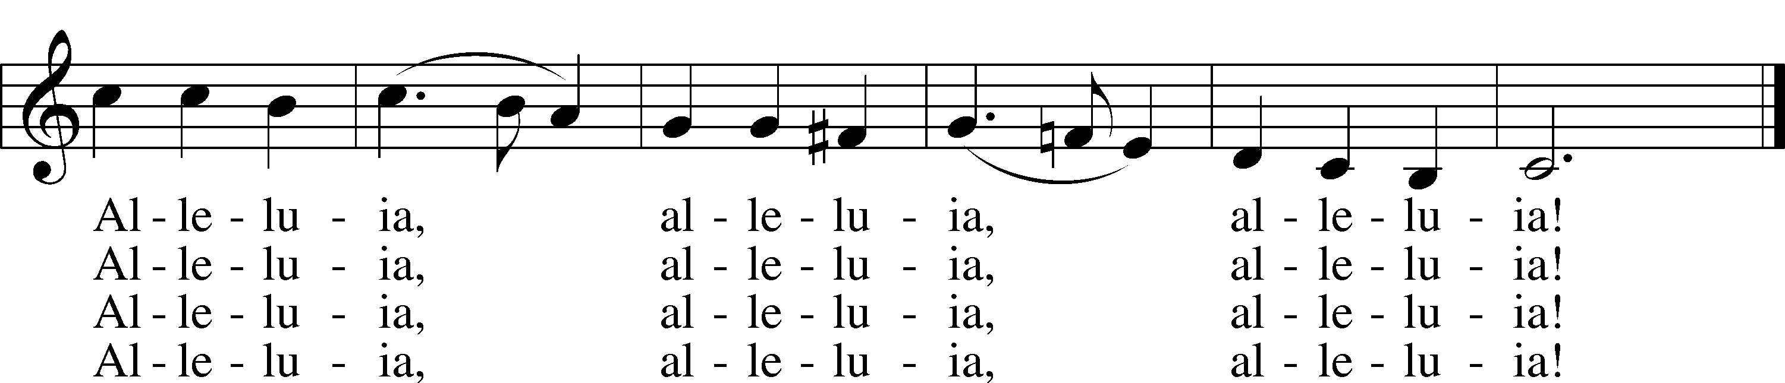

Text: Cyril A. Alington, 1872–1955, alt.  
Tune: Melchior Vulpius, c. 1570–1615  
Text: © 1958, renewed 1986 Hymns Ancient and Modern Ltd., admin. Hope Publishing Co. Used by permission: LSB Hymn License no. 110005011  
Tune: Public domain

Sermon

Stand

Prayer of the Church

Following the prayers, the people may greet one another in the name of the Lord, saying, “Peace be with you,” as a sign of reconciliation and of the unity of the Spirit in the bond of peace (Matt. 5:22–24; Eph. 4:1–3).

Sit

Offering

Hymn

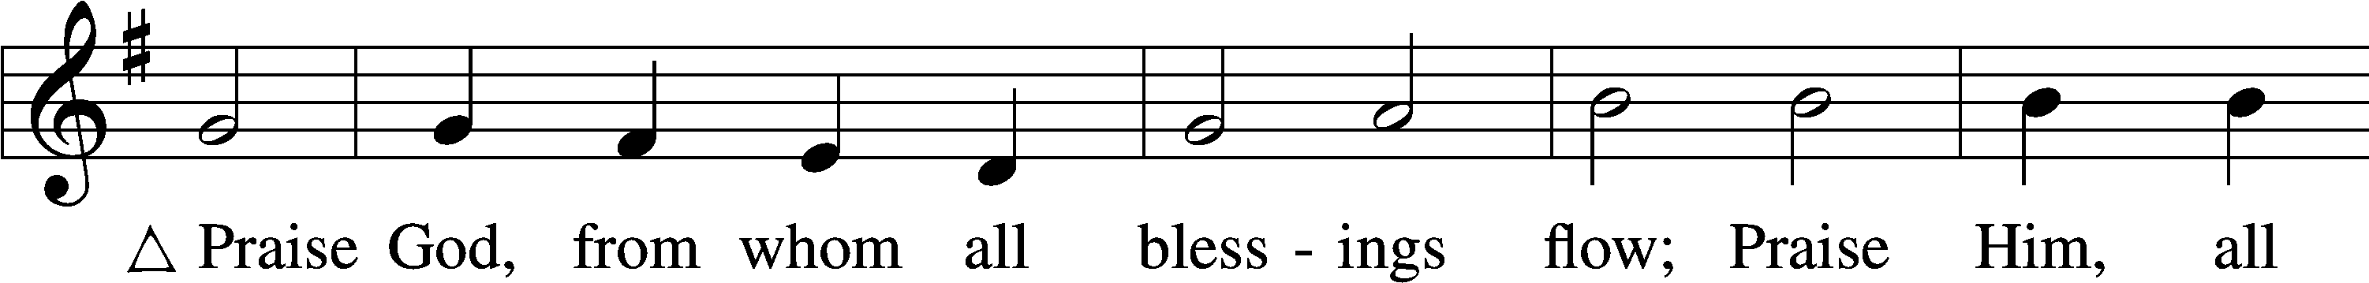

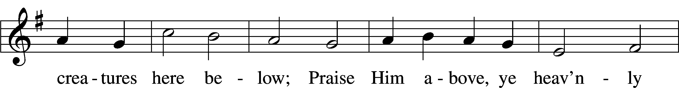

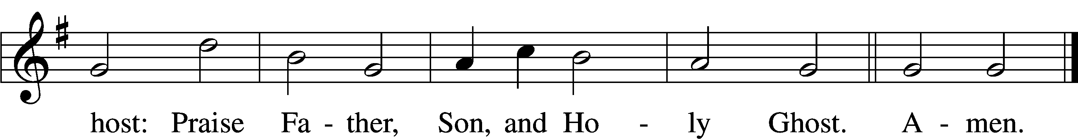

Text: Thomas Ken, 1637–1711  
Tune: Trente quatre Pseaumes de David, 1551, Geneva, ed. Louis Bourgeois  
Text and tune: Public domain

# Service of the Sacrament

Stand

Preface 2 Timothy 4:22; [Colossians 3:1]; [Psalm 136]

P The Lord be with you.

C **And also with you.**

P Lift up your hearts.

C **We lift them to the Lord.**

P Let us give thanks to the Lord our God.

C **It is right to give Him thanks and praise.**

P It is truly good, right, and salutary that we should at all times and in all places give thanks to You, O Lord, holy Father, almighty and everlasting God, for the countless blessings You so freely bestow on us and all creation. Above all, we give thanks for Your boundless love shown to us when You sent Your only-begotten Son, Jesus Christ, into our flesh and laid on Him our sin, giving Him into death that we might not die eternally. Because He is now risen from the dead and lives and reigns to all eternity, all who believe in Him will overcome sin and death and will rise again to new life. Therefore with angels and archangels and with all the company of heaven we laud and magnify Your glorious name, evermore praising You and saying:

Sanctus Isaiah 6:3; Matthew 21:9

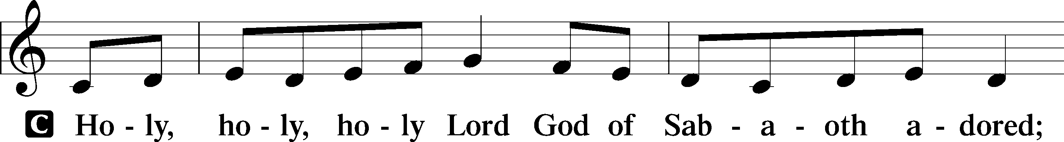

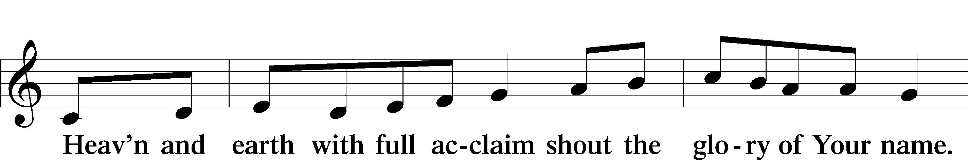

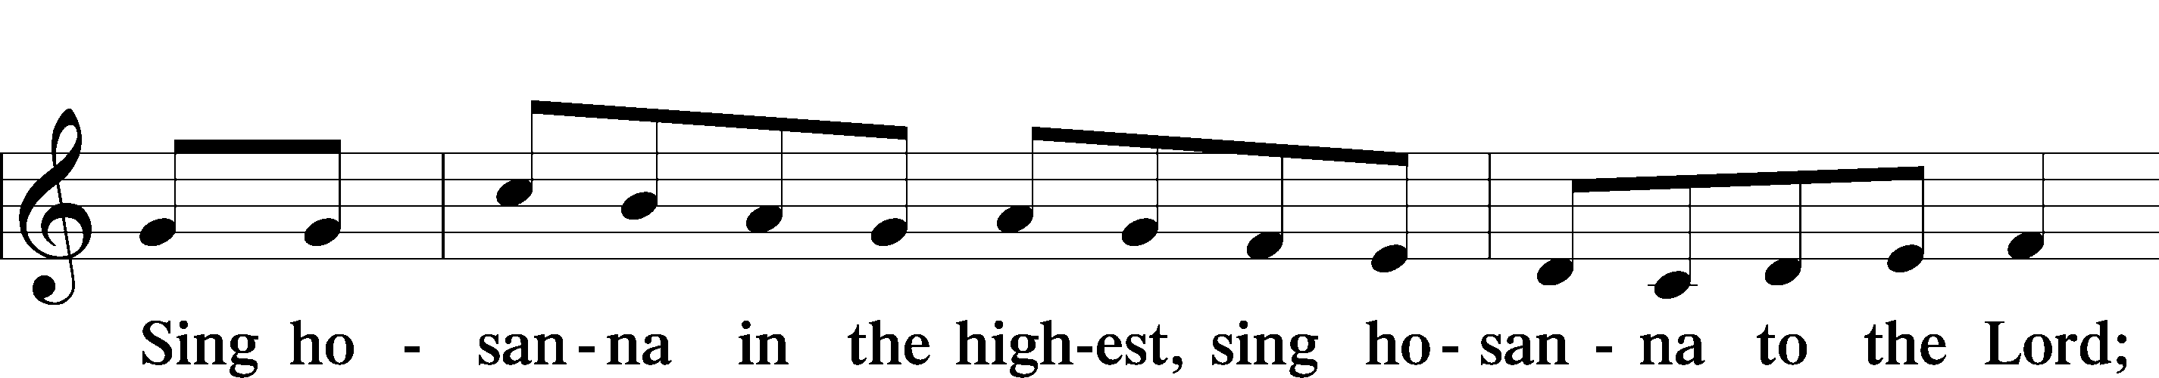

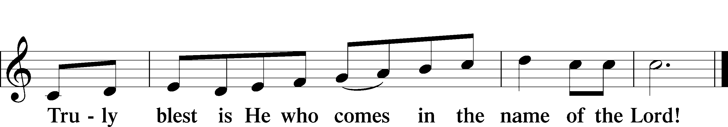

Text: Stephen P. Starke

Prayer of Thanksgiving

P Blessed are You, O Lord our God, king of all creation, for You have had mercy on us and given Your only-begotten Son that whoever believes in Him should not perish but have eternal life.

For Christ, our Passover Lamb, has been sacrificed. By His death, He has redeemed us from bondage to sin and death, and by His resurrection, He has delivered us into new life in Him.

Grant us to keep the Feast in sincerity and truth, faithfully eating His body given into death and drinking His life’s blood poured out for our salvation until we pass through death to the promised land of life eternal.

Hear us as we pray in His name and as He has taught us:

Lord’s Prayer

C **Our Father who art in heaven,**

**hallowed be Thy name,**

**Thy kingdom come,**

**Thy will be done on earth**

**as it is in heaven;**

**give us this day our daily bread;**

**and forgive us our trespasses**

**as we forgive those**

**who trespass against us;**

**and lead us not into temptation,**

**but deliver us from evil.**

**For Thine is the kingdom**

**and the power and the glory**

**forever and ever. Amen.**

The Words of Our Lord

P Our Lord Jesus Christ, on the night when He was betrayed, took bread, and when He had given thanks, He broke it and gave it to the disciples and said: “Take, eat; this is My T body, which is given for you. This do in remembrance of Me.”

In the same way also He took the cup after supper, and when He had given thanks, He gave it to them, saying: “Drink of it, all of you; this cup is the new testament in My T blood, which is shed for you for the forgiveness of sins. This do, as often as you drink it, in remembrance of Me.”

Pax Domini

P The peace of the Lord be with you always.

C **Amen.**

Agnus Dei John 1:29

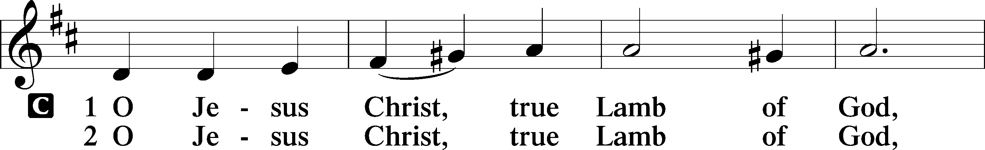

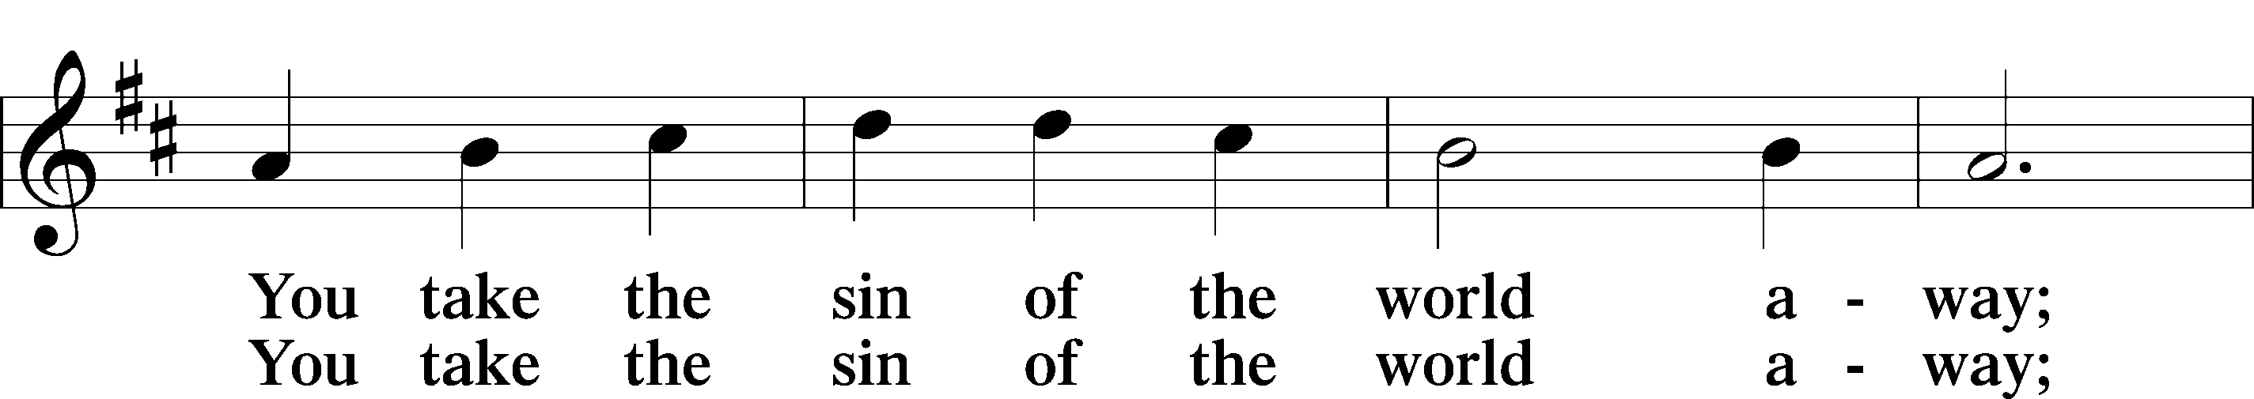

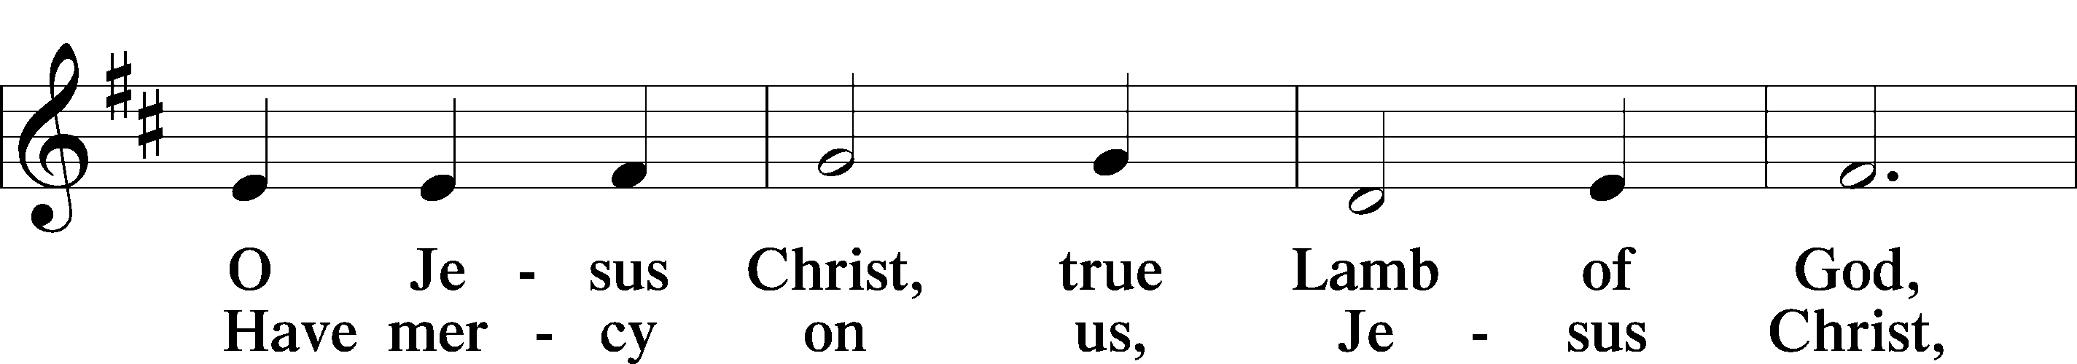

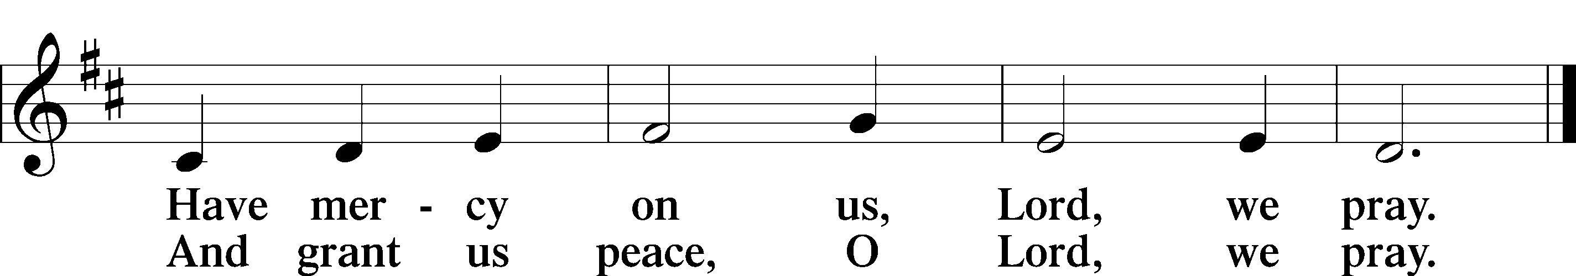

Text: Stephen P. Starke

Sit

Distribution

The pastor and those who assist him receive the body and blood of Christ first and then distribute them to those who come to receive, saying:

Take, eat; this is the true body of our Lord and Savior Jesus Christ, given into death for your sins.

**Amen.**

Take, drink; this is the true blood of our Lord and Savior Jesus Christ, shed for the forgiveness of your sins.

**Amen.**

In dismissing the communicants, the following is said:

The Dismissal

P The body and blood of our Lord Jesus Christ strengthen and preserve you in body and soul to life everlasting. Depart T in peace.

C **Amen.**

633 At the Lamb’s High Feast We Sing

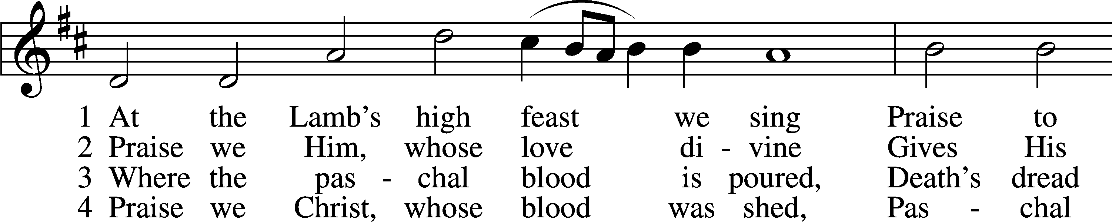

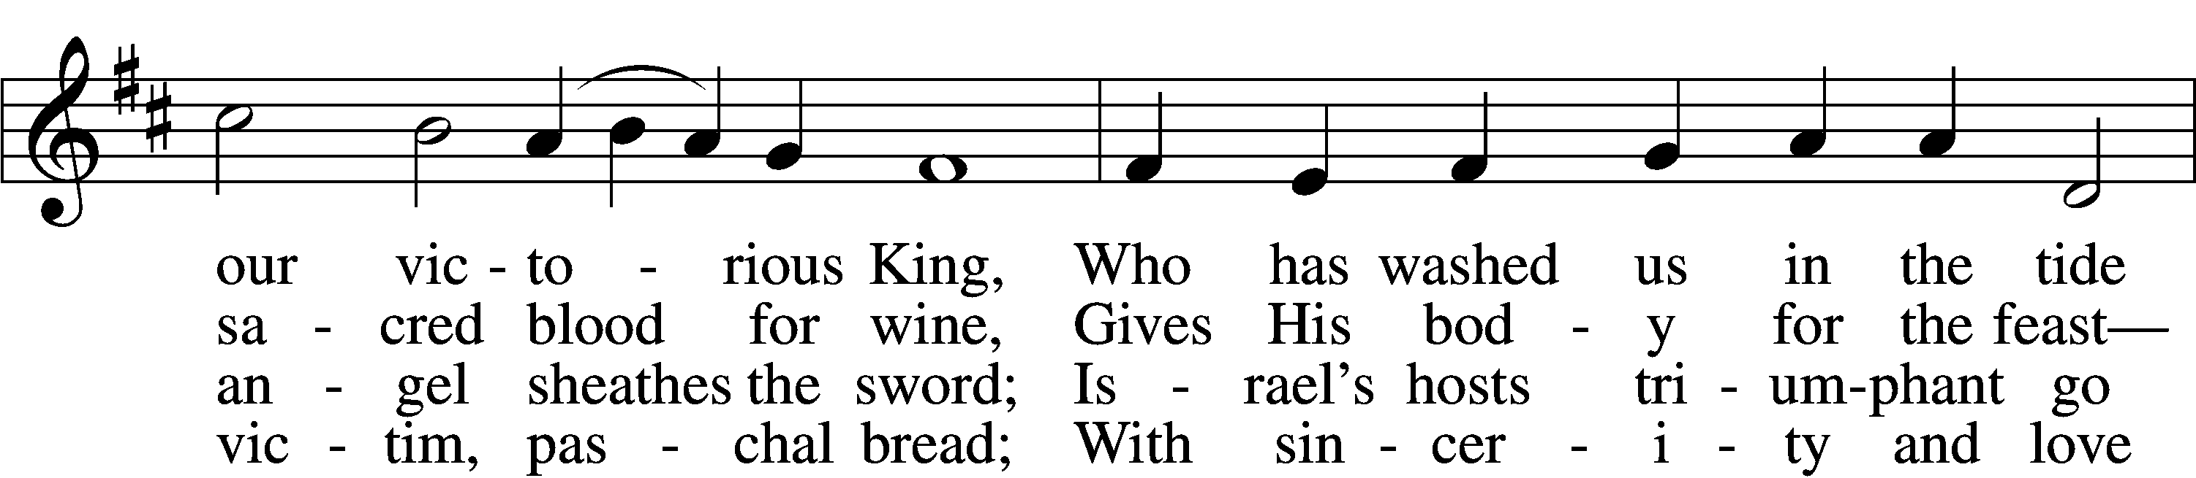

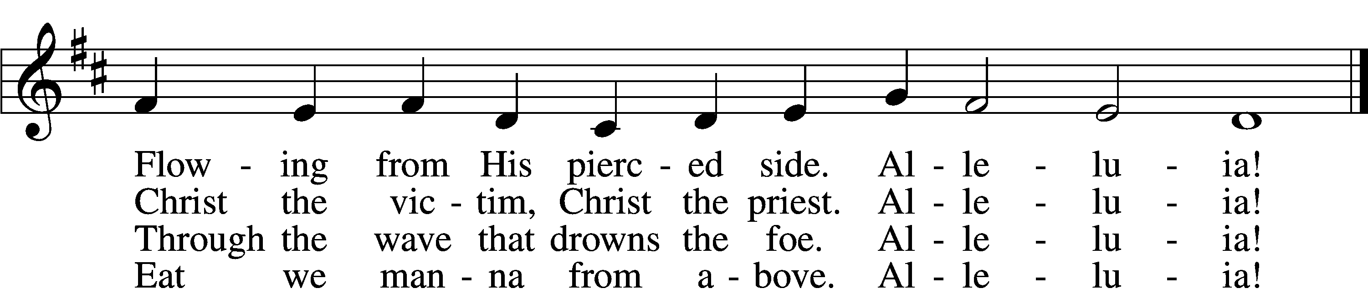

5 Mighty Victim from the sky,  
Hell’s fierce pow’rs beneath You lie;  
You have conquered in the fight,  
You have brought us life and light.  
 Alleluia!

6 Now no more can death appall,  
Now no more the grave enthrall;  
You have opened paradise,  
And Your saints in You shall rise.  
 Alleluia!

7 Easter triumph, Easter joy!  
This alone can sin destroy;  
From sin’s pow’r, Lord, set us free,  
Newborn souls in You to be.  
 Alleluia!

D 8 Father, who the crown shall give,  
Savior, by whose death we live,  
Spirit, guide through all our days:  
Three in One, Your name we praise.  
 Alleluia!

Text: Latin, c. 5th–10th cent.; tr. Robert Campbell, 1814–68, alt.  
Tune: Kirchengeseng, 1566, Ivancice  
Text and tune: Public domain

467 Awake, My Heart, with Gladness

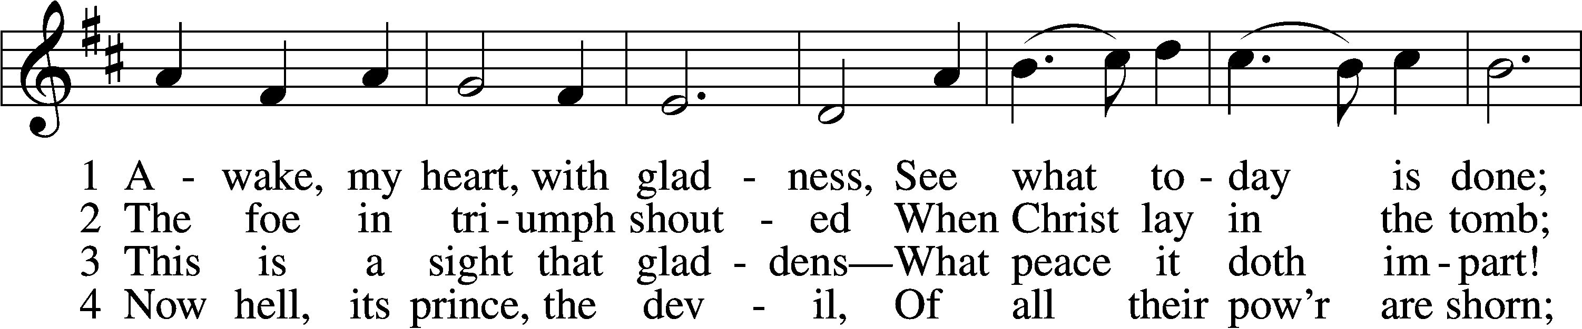

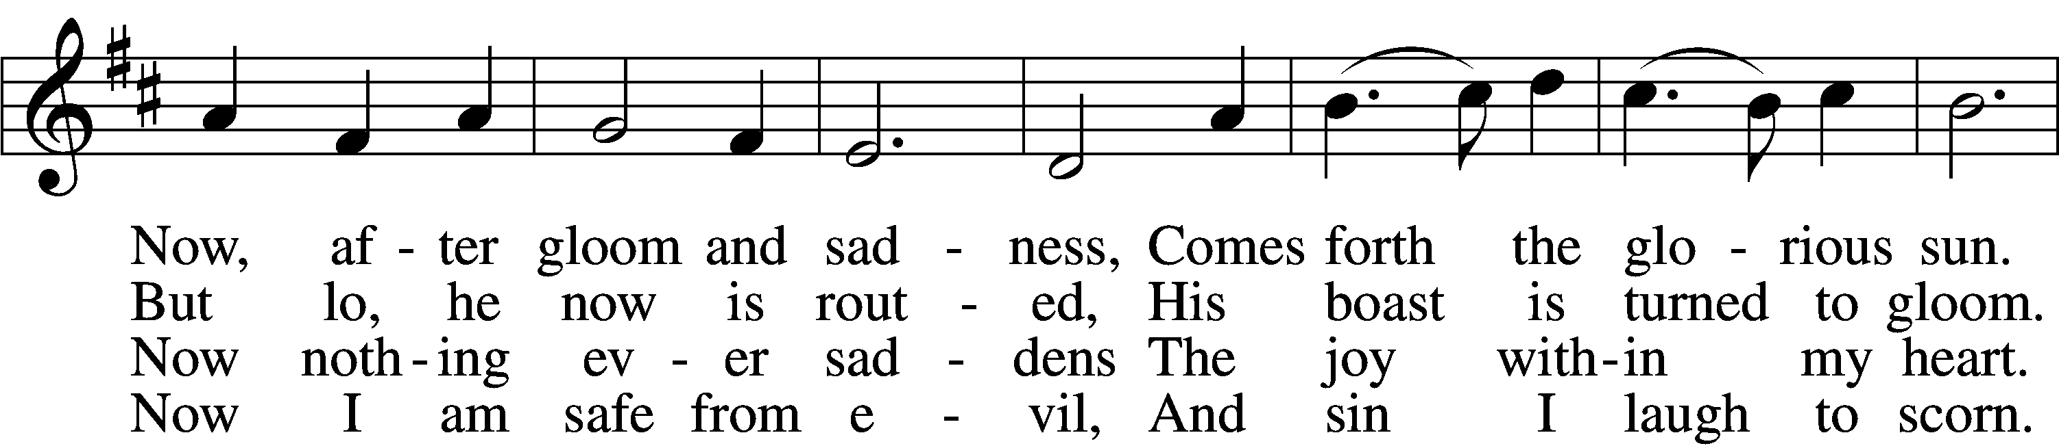

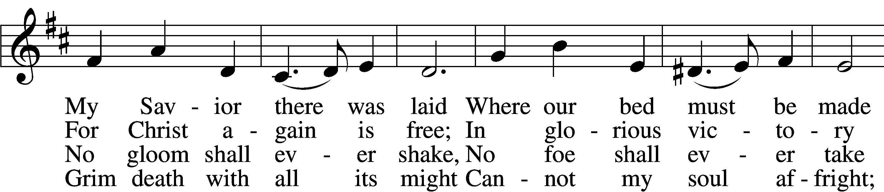

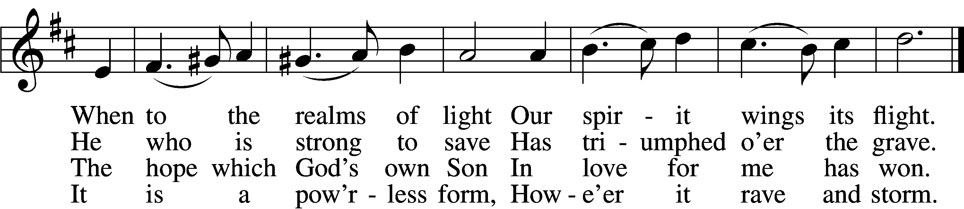

5 The world against me rages,  
 Its fury I disdain;  
Though bitter war it wages,  
 Its work is all in vain.  
My heart from care is free,  
No trouble troubles me.  
 Misfortune now is play,  
 And night is bright as day.

6 Now I will cling forever  
 To Christ, my Savior true;  
My Lord will leave me never,  
 Whate’er He passes through.  
He rends death’s iron chain;  
He breaks through sin and pain;  
 He shatters hell’s grim thrall;  
 I follow Him through all.

7 He brings me to the portal  
 That leads to bliss untold,  
Whereon this rhyme immortal  
 Is found in script of gold:  
“Who there My cross has shared  
Finds here a crown prepared;  
 Who there with Me has died  
 Shall here be glorified.”

Text: Paul Gerhardt, 1607–76; tr. John Kelly, 1833–90, alt.  
Tune: Johann Crüger, 1598–1662  
Text and tune: Public domain

465 Now All the Vault of Heaven Resounds

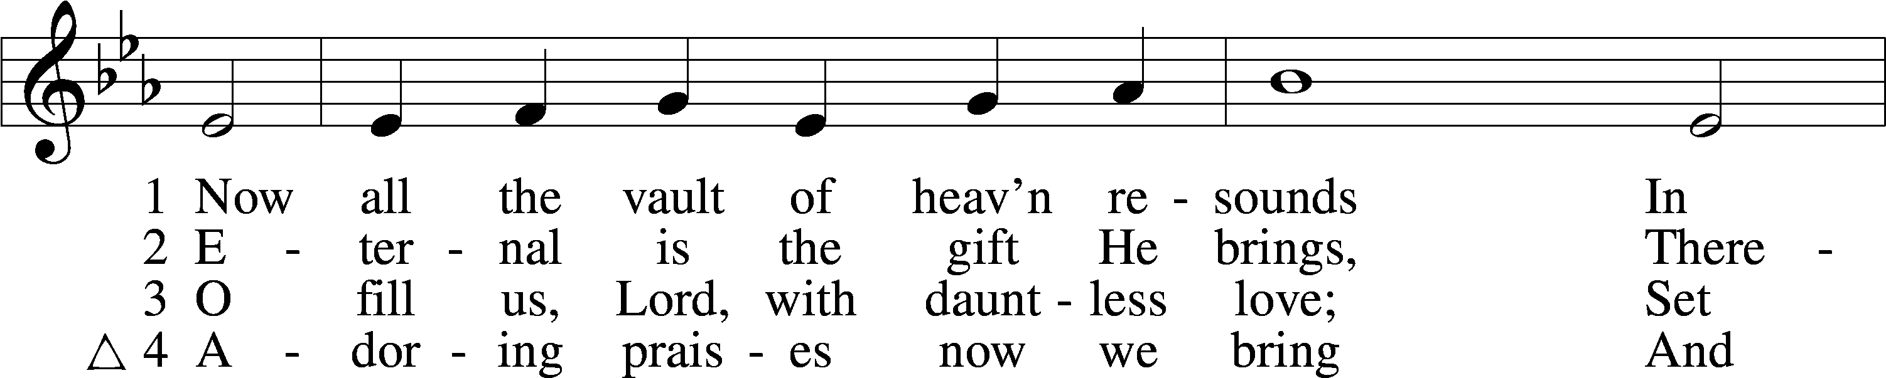

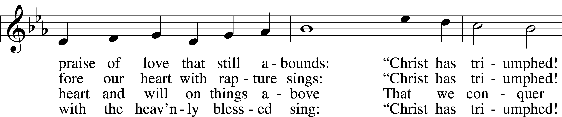

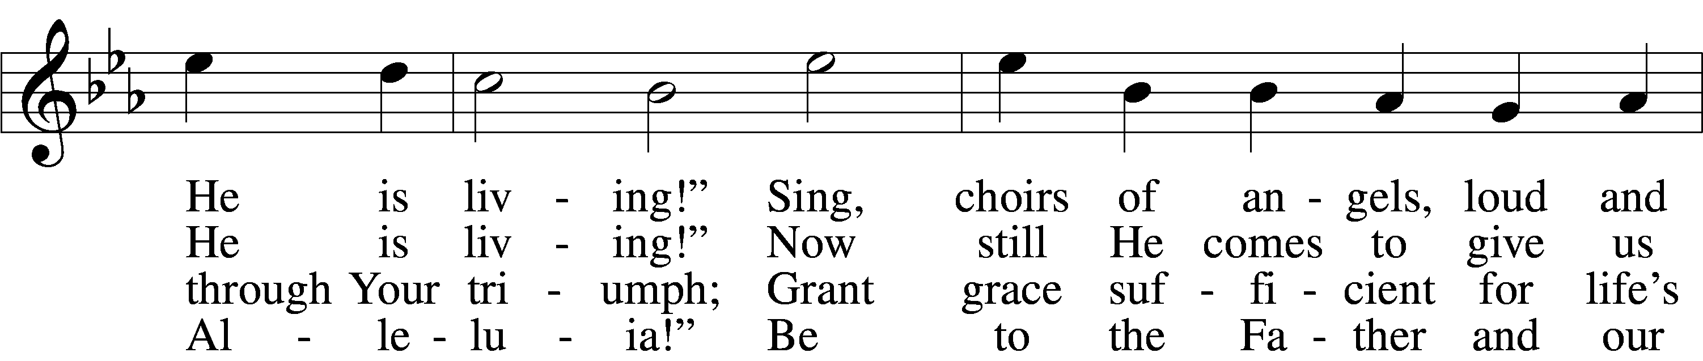

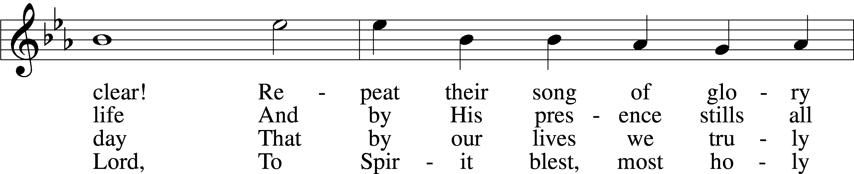

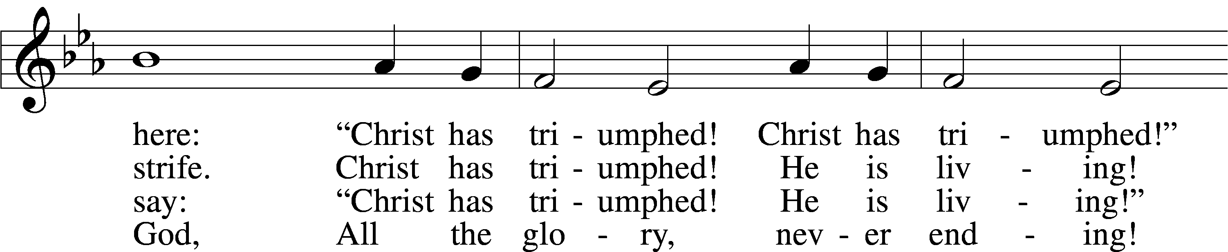

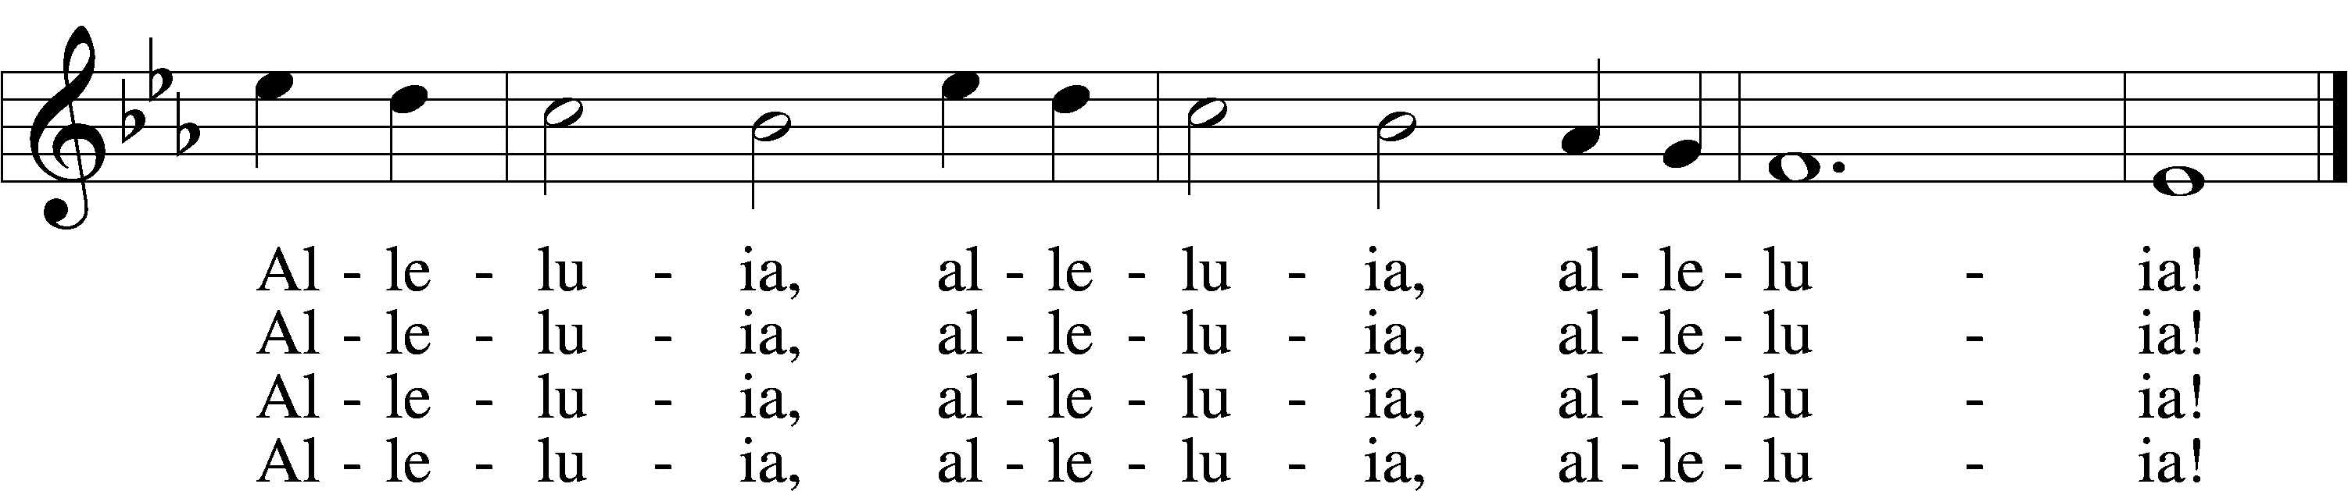

Text: Paul Z. Strodach, 1876–1947, alt.  
Tune: Geistliche Kirchengesäng, 1623, Köln  
Text: © 1958 Augsburg Publishing House. Used by permission: LSB Hymn License no. 110005011  
Tune: Public domain

461 I Know That My Redeemer Lives

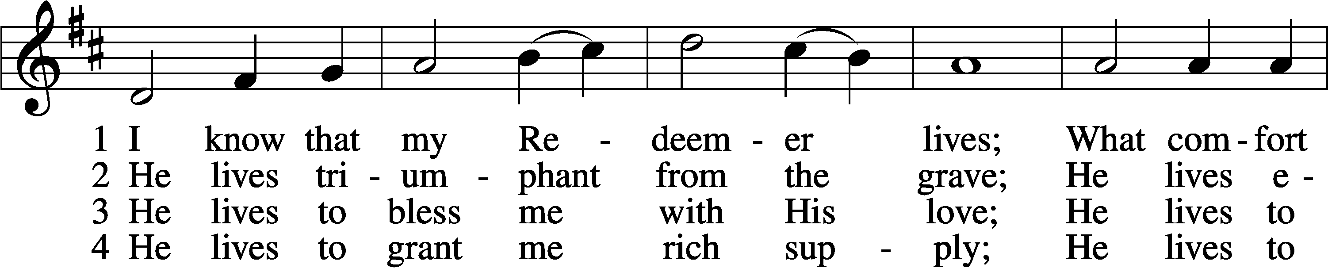

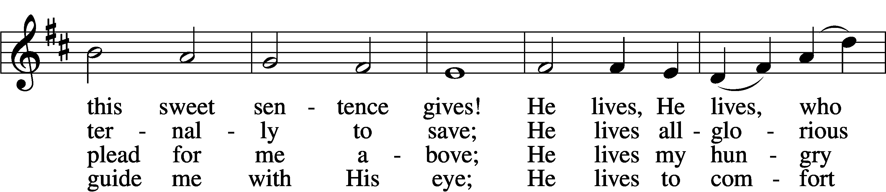

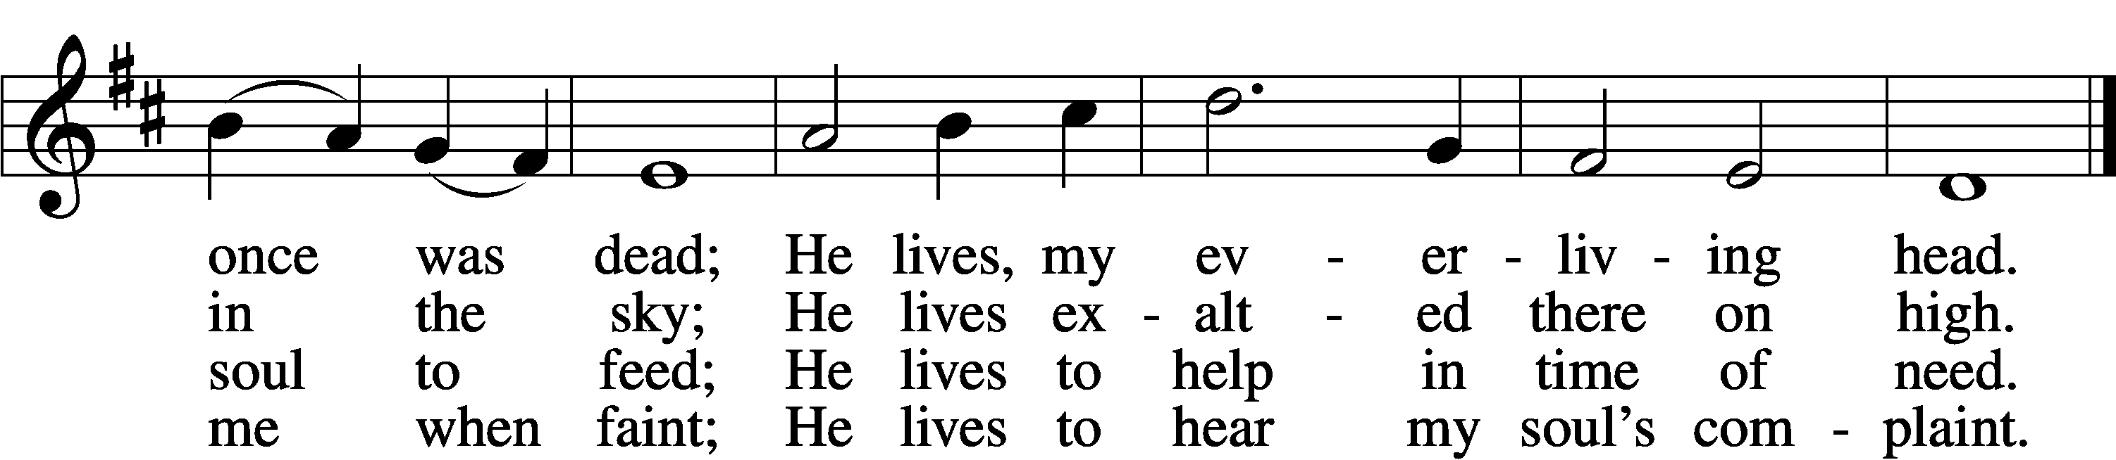

5 He lives to silence all my fears;  
He lives to wipe away my tears;  
He lives to calm my troubled heart;  
He lives all blessings to impart.

6 He lives, my kind, wise, heav’nly friend;  
He lives and loves me to the end;  
He lives, and while He lives, I’ll sing;  
He lives, my Prophet, Priest, and King.

7 He lives and grants me daily breath;  
He lives, and I shall conquer death;  
He lives my mansion to prepare;  
He lives to bring me safely there.

8 He lives, all glory to His name!  
He lives, my Jesus, still the same;  
Oh, the sweet joy this sentence gives:  
I know that my Redeemer lives!

Text: Samuel Medley, 1738–99, abr.  
Tune: attr. John C. Hatton, d. 1793  
Text and tune: Public domain

Stand

Nunc Dimittis Luke 2:29–32

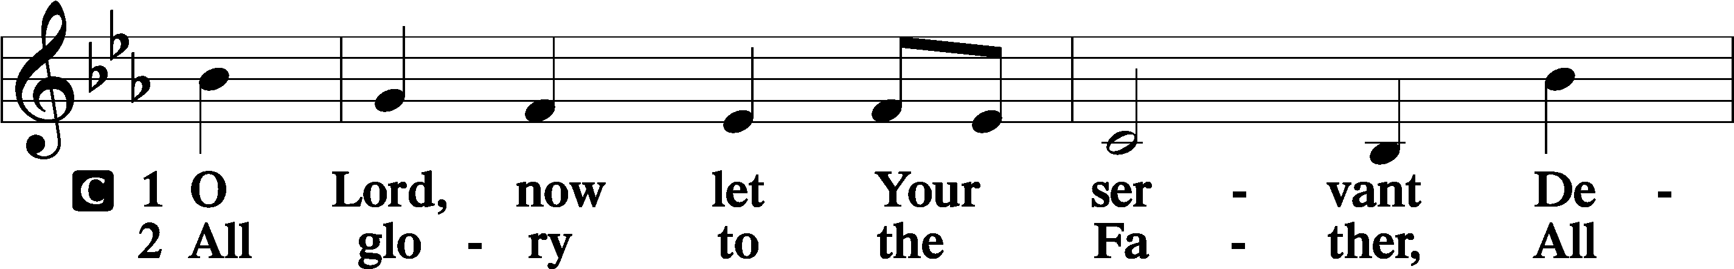

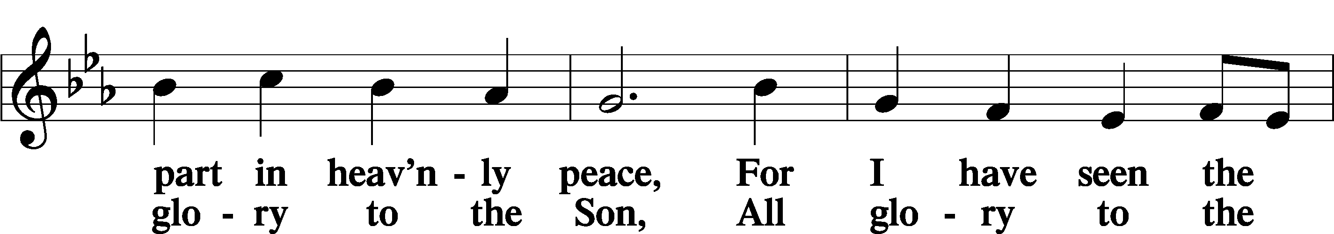

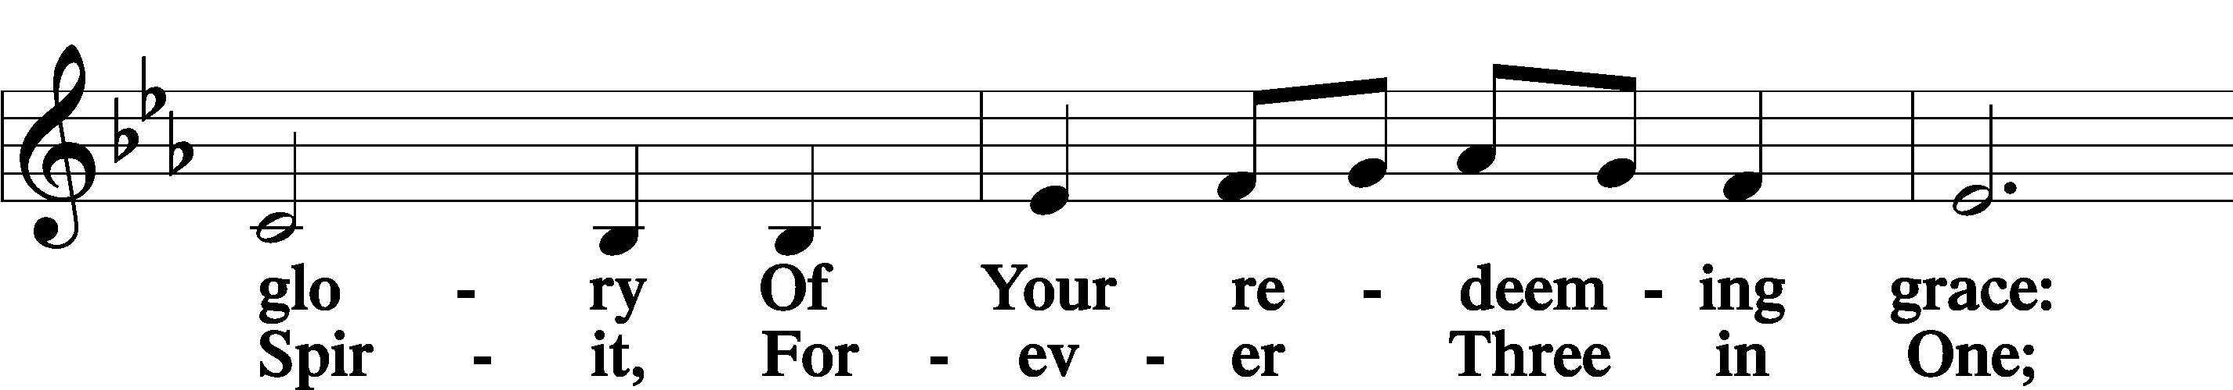

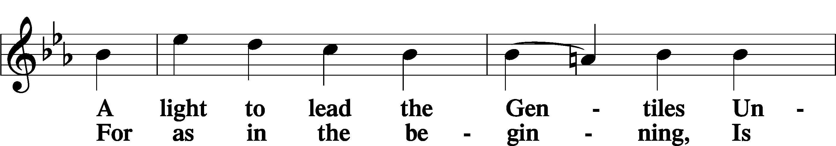

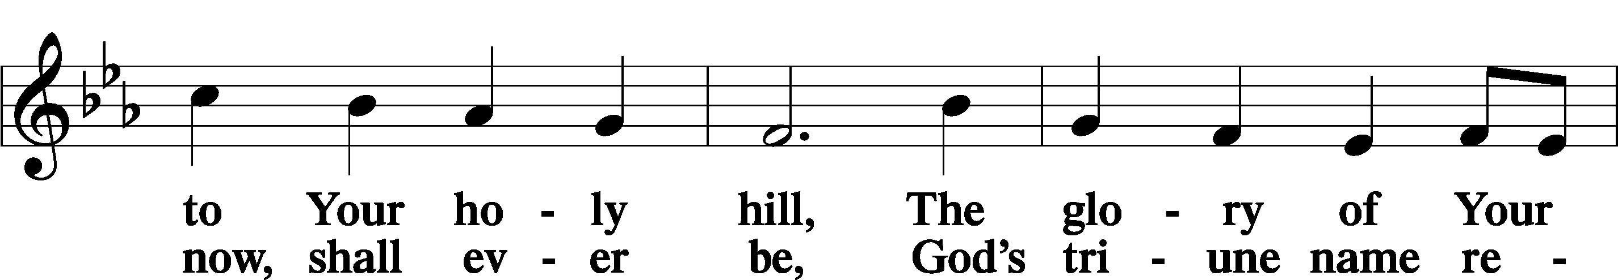

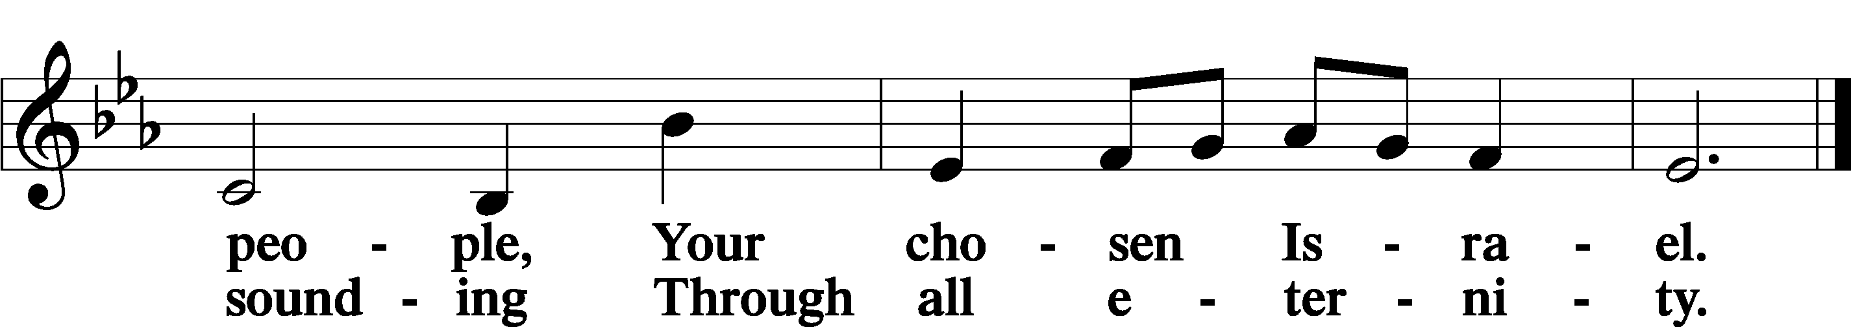

Post-Communion Collect

A Let us pray.

We give thanks to You, almighty God, that You have refreshed us through this salutary gift, and we implore You that of Your mercy You would strengthen us through the same in faith toward You and in fervent love toward one another; through Jesus Christ, Your Son, our Lord, who lives and reigns with You and the Holy Spirit, one God, now and forever.

C **Amen.**

Benedicamus Psalm 103:1

A Let us bless the Lord.

C **Thanks be to God.**

Benediction

P The Lord bless you and keep you.

The Lord make His face shine on you and be gracious to you.

The Lord look upon you with favor and T give you peace.

C **Amen.**

463 Christ the Lord Is Risen Today; Alleluia

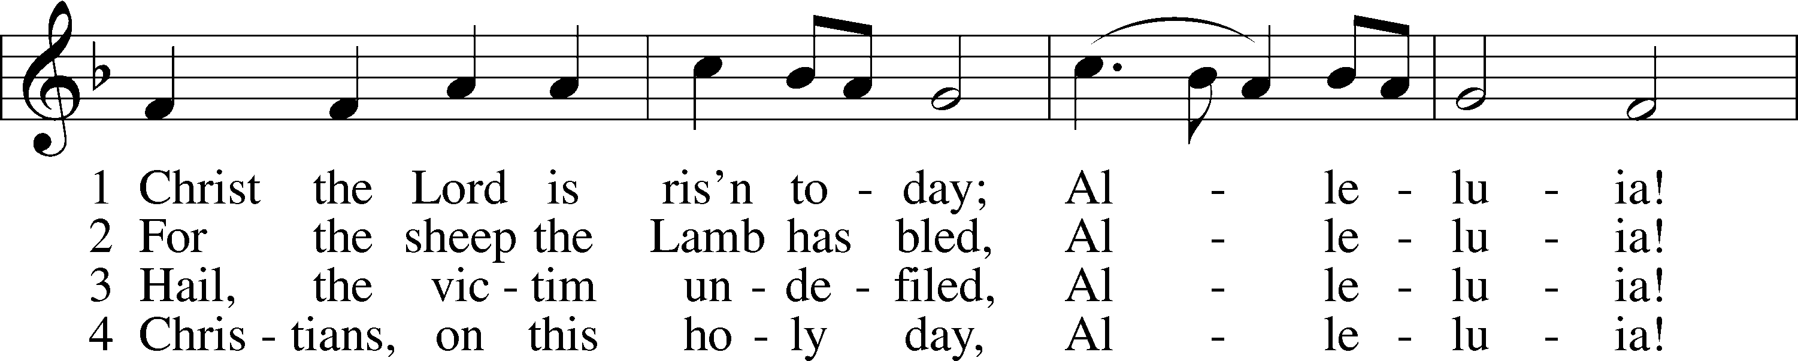

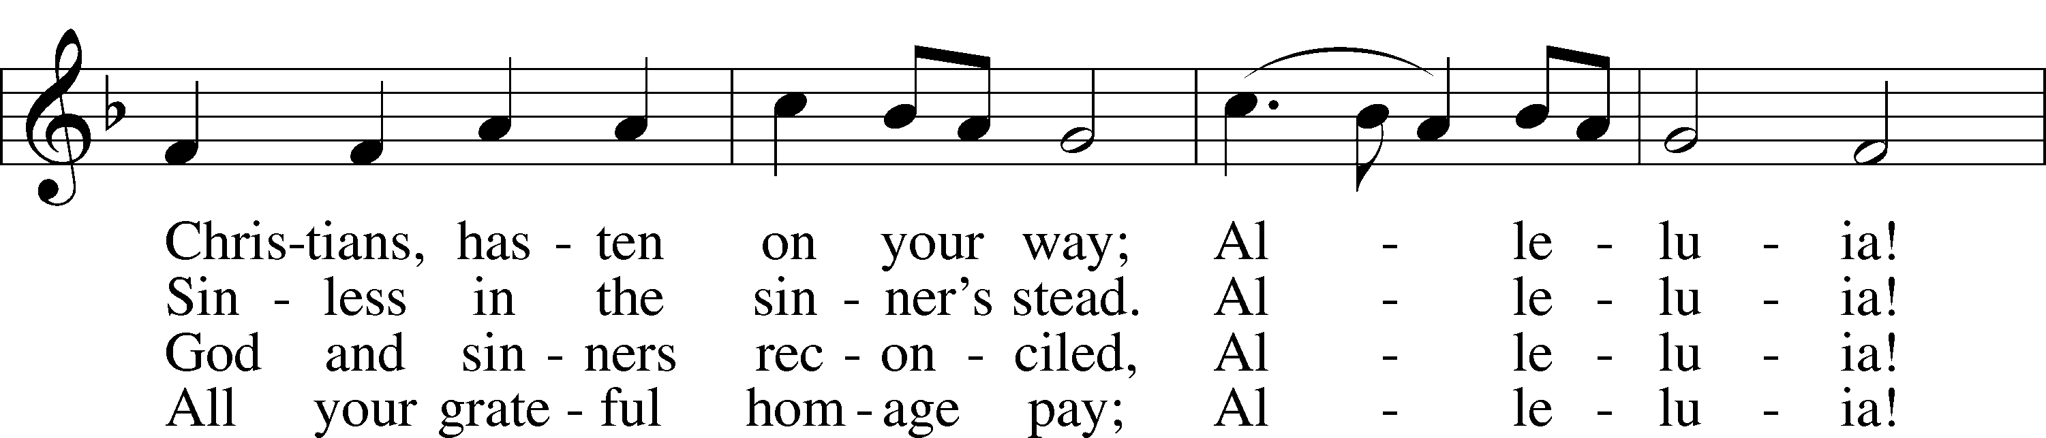

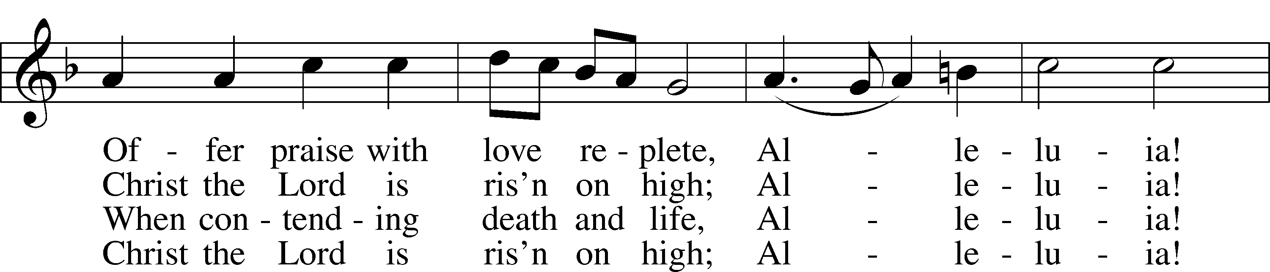

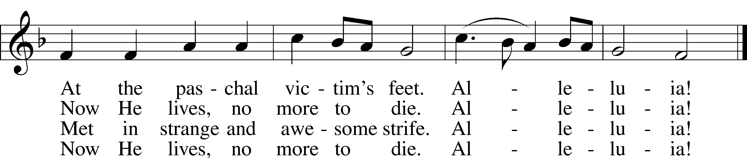

Text: attr. Wipo of Burgundy, d. c. 1050; tr. Jane E. Leeson, 1809–81, alt.  
Tune: Robert Williams, c. 1781–1821  
Text and tune: Public domain

Acknowledgments

Divine Service, Setting Four from Lutheran Service Book

Unless otherwise indicated, Scripture quotations are from the ESV® Bible (The Holy Bible, English Standard Version®), copyright © 2001 by Crossway, a publishing ministry of Good News Publishers. Used by permission. All rights reserved.

Created by Lutheran Service Builder © 2025 Concordia Publishing House.