On entering the church

P Lord, I love the habitation of Your house and the place

where Your glory dwells. In the multitude of Your tender

mercies prepare my heart that I may enter Your house to

worship and confess Your holy name; through Jesus Christ,

my God and Lord.

Before worship

C O Lord, our creator, redeemer, and comforter, as we come

together to worship You in spirit and in truth, we humbly

pray that You would open our hearts to the preaching of

Your Word so that we may repent of our sins, believe in

Jesus Christ as our only Savior, and grow in grace and

holiness. Hear us for His sake.

504 Father Most Holy

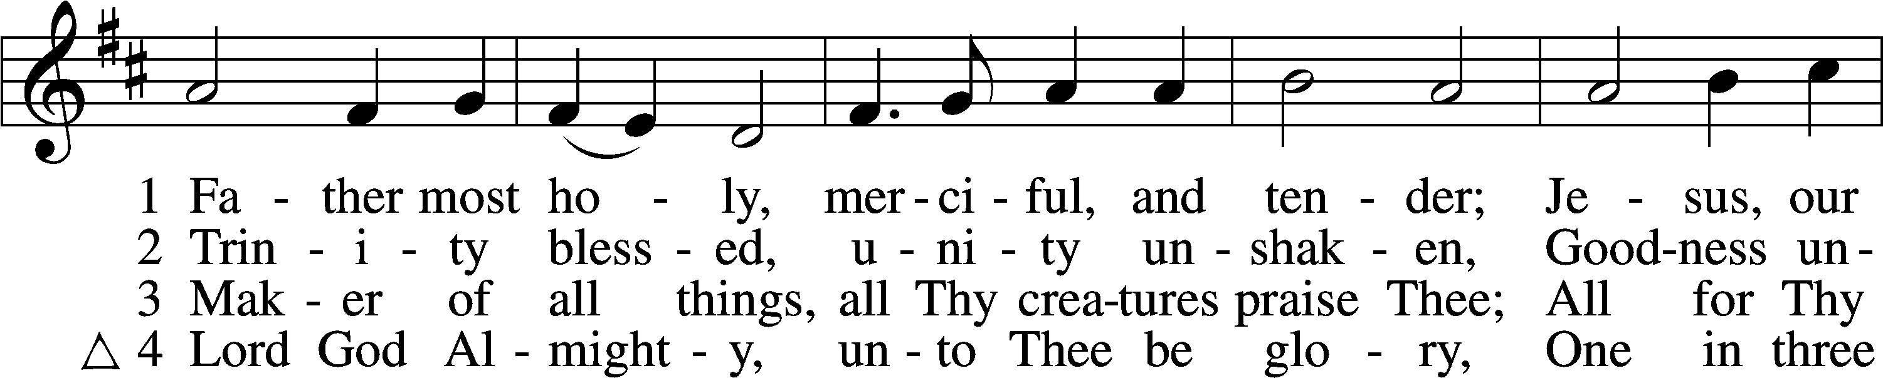

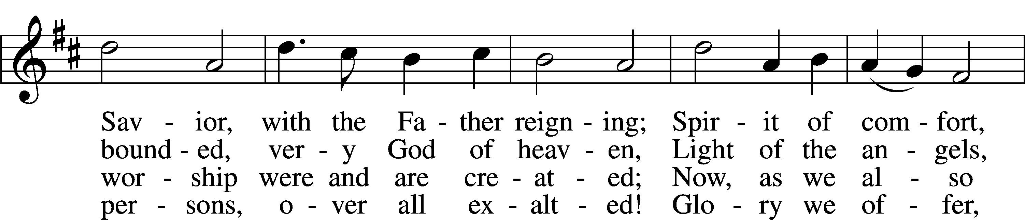

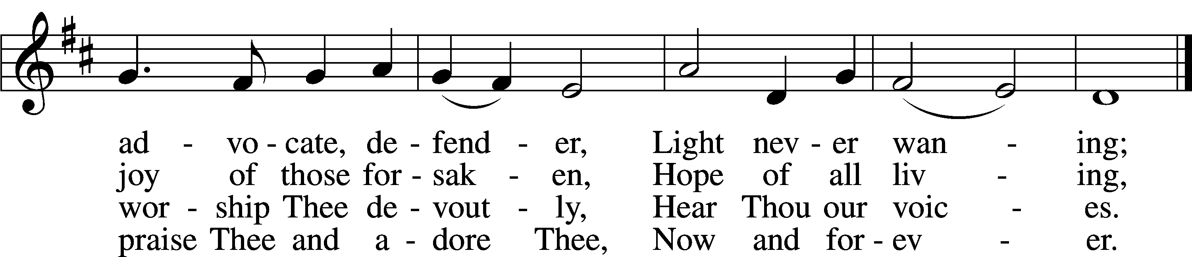

Text: Latin, c. 10th cent.; tr. Percy Dearmer, 1867–1936, alt.  
Tune: Antiphoner, 1681, Paris  
Text and tune: Public domain

# Confession and Absolution

The sign of the cross may be made by all in remembrance of their Baptism.

Invocation Matthew 28:19b; 18:20

P In the name of the Father and of the T Son and of the Holy Spirit.

C **Amen.**

Exhortation Hebrews 10:22; Psalm 124:8; Psalm 32:5

P Beloved in the Lord! Let us draw near with a true heart and confess our sins unto God our Father, beseeching Him in the name of our Lord Jesus Christ to grant us forgiveness.

P Our help is in the name of the Lord,

C **who made heaven and earth.**

P I said, I will confess my transgressions unto the Lord,

C **and You forgave the iniquity of my sin.**

Silence for reflection on God’s Word and for self-examination.

Confession of Sins

P Almighty God, our maker and redeemer, we poor sinners confess unto You that we are by nature sinful and unclean and that we have sinned against You by thought, word, and deed. Wherefore we flee for refuge to Your infinite mercy, seeking and imploring Your grace for the sake of our Lord Jesus Christ.

C **O most merciful God, who has given Your only-begotten Son to die for us, have mercy upon us and for His sake grant us remission of all our sins; and by Your Holy Spirit increase in us true knowledge of You and of Your will and true obedience to Your Word, to the end that by Your grace we may come to everlasting life; through Jesus Christ, our Lord. Amen.**

Declaration of Grace Mark 16:16; John 1:12

P Almighty God, our heavenly Father, has had mercy upon us and has given His only Son to die for us and for His sake forgives us all our sins. To those who believe on His name He gives power to become the children of God and has promised them His Holy Spirit. He that believes and is baptized shall be saved.

Grant this, Lord, unto us all.

C **Amen.**

# Service of the Word

Introit Psalm 119:145–149; antiphon: Psalm 50:15

Call upon me in the day of trouble;  
 I will deliver you, and you shall glorify me.  
**With my whole heart I cry; answer me, O Lord!  
 I will keep your statutes.**I call to you; save me,  
 that I may observe your testimonies.  
**I rise before dawn and cry for help;  
 I hope in your words.**My eyes are awake before the watches of the night,  
 that I may meditate on your promise.  
**Hear my voice according to your steadfast love;  
 O Lord, according to your justice give me life.**

Gloria Patri

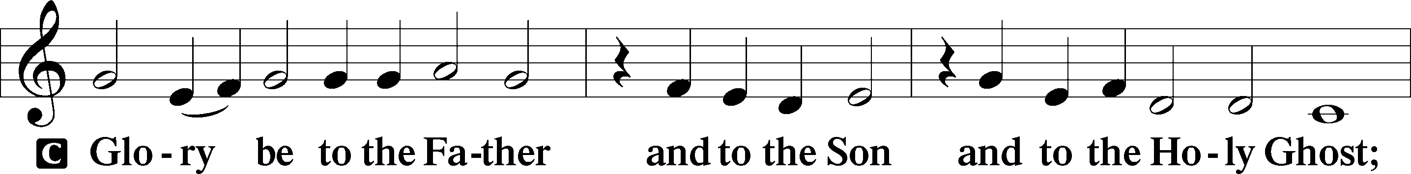

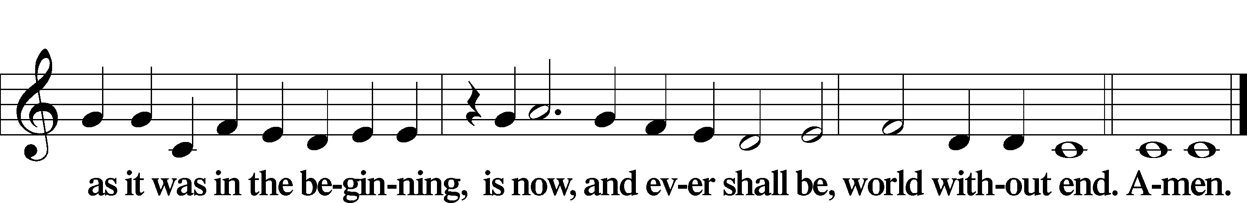

Kyrie Mark 10:47

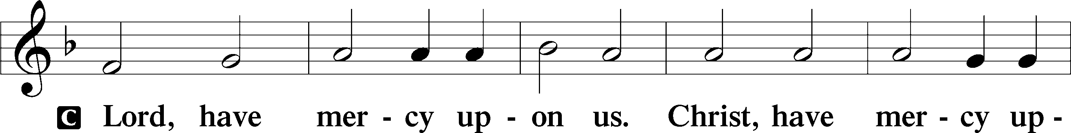

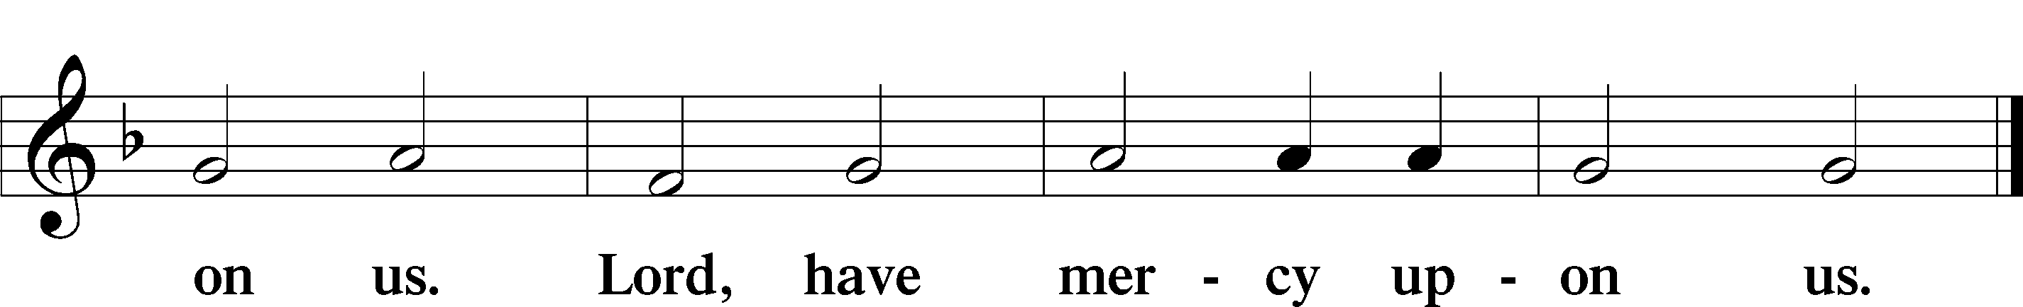

Gloria in Excelsis Luke 2:14; John 1:29

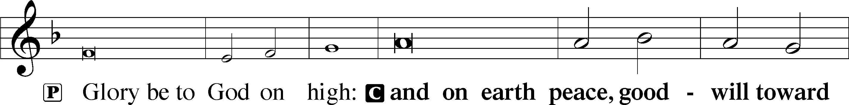

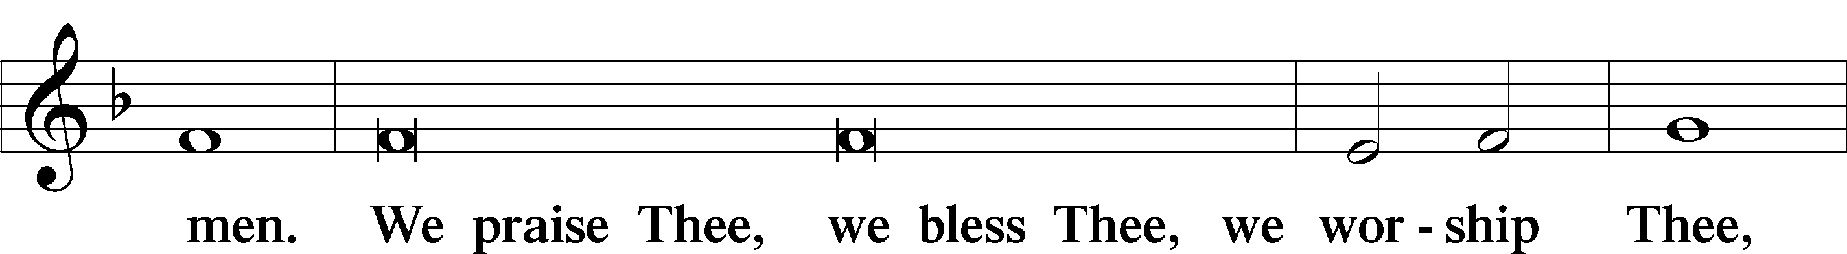

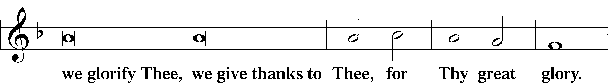

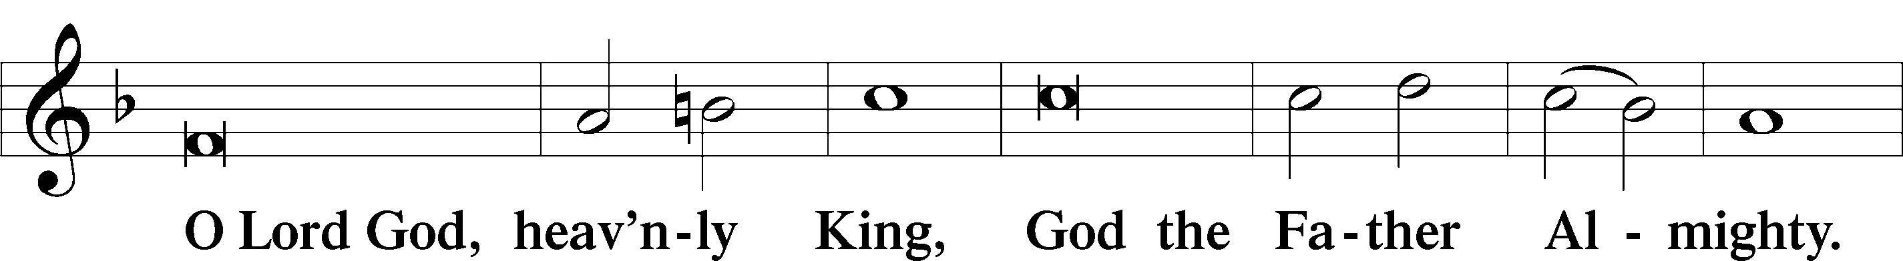

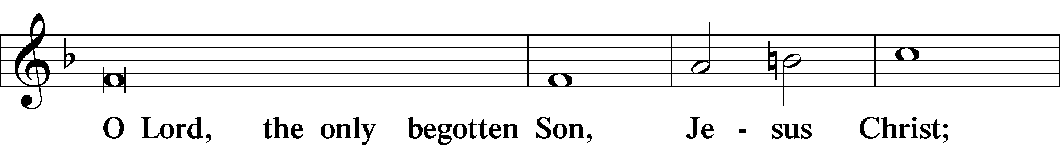

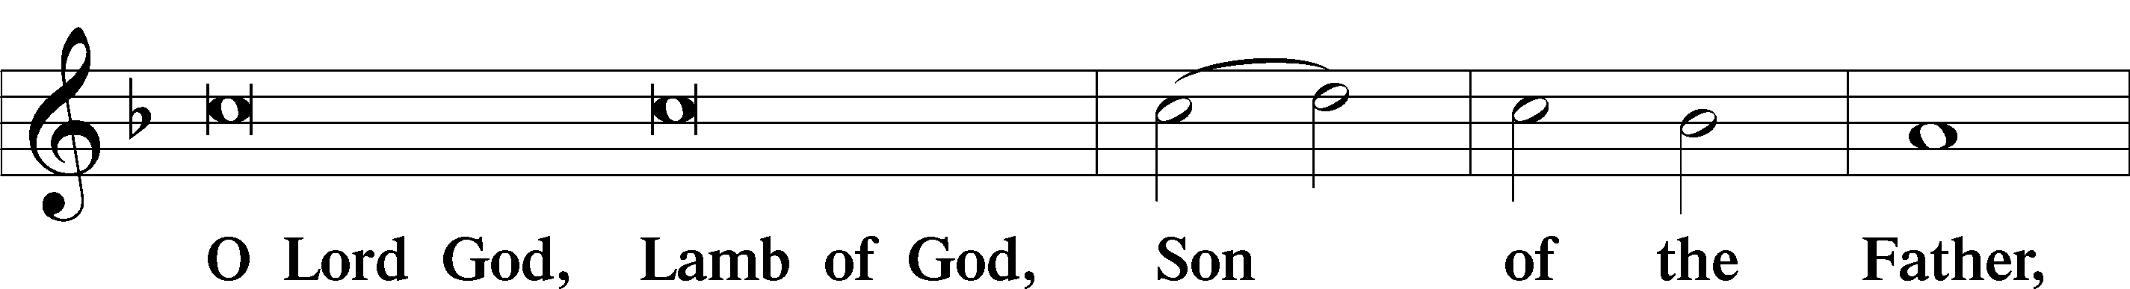

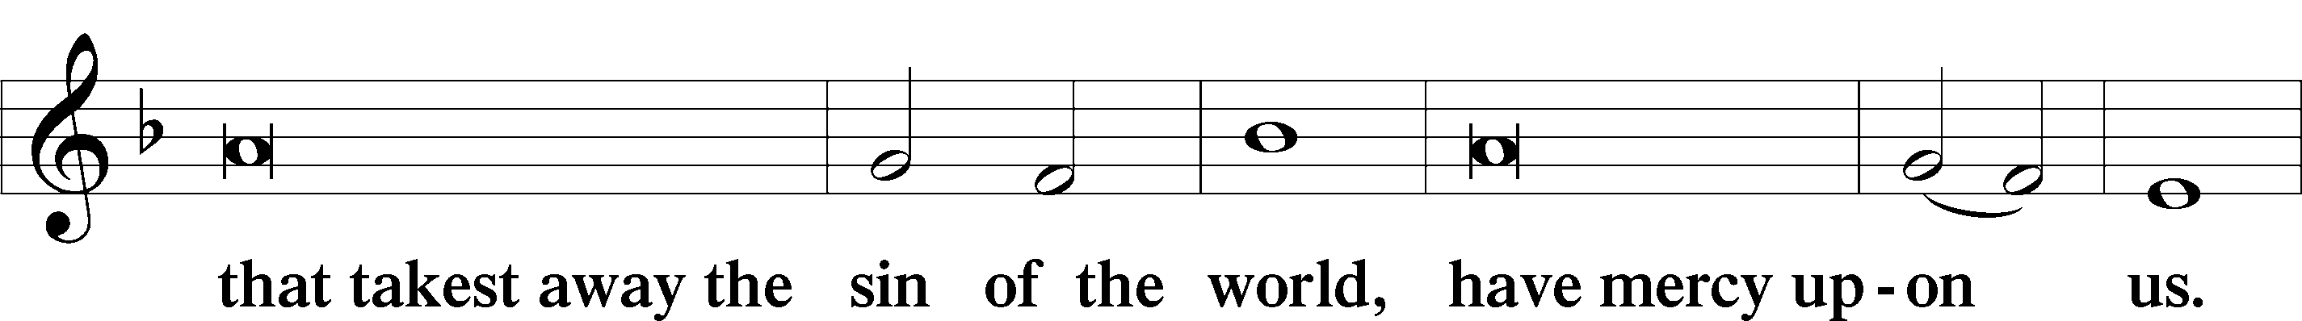

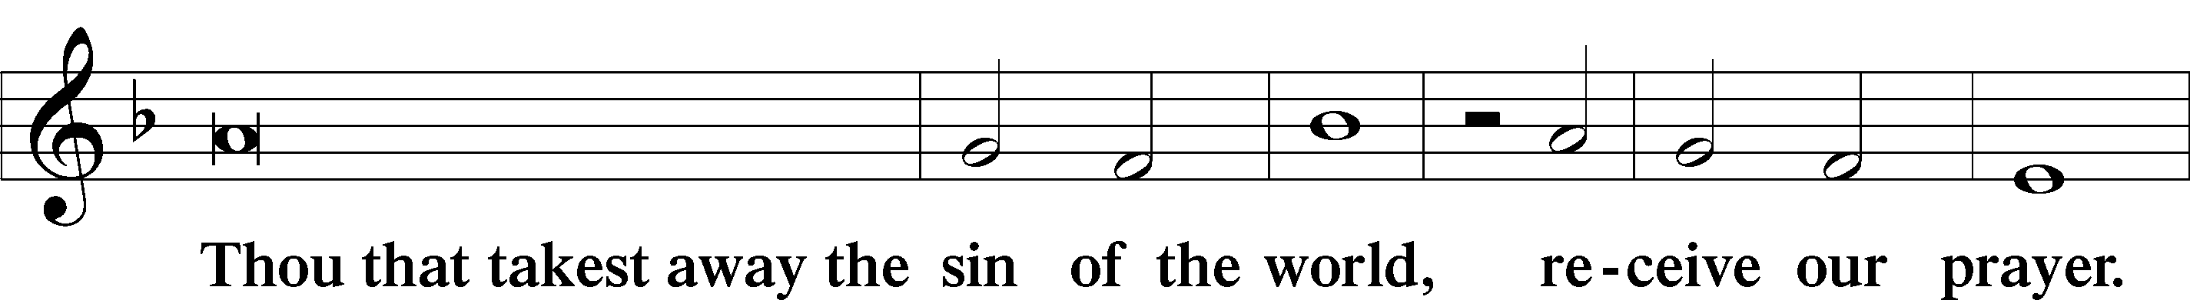

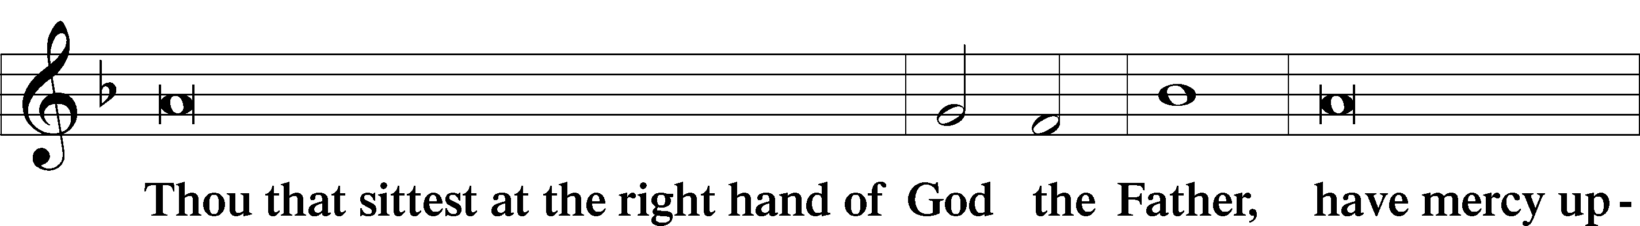

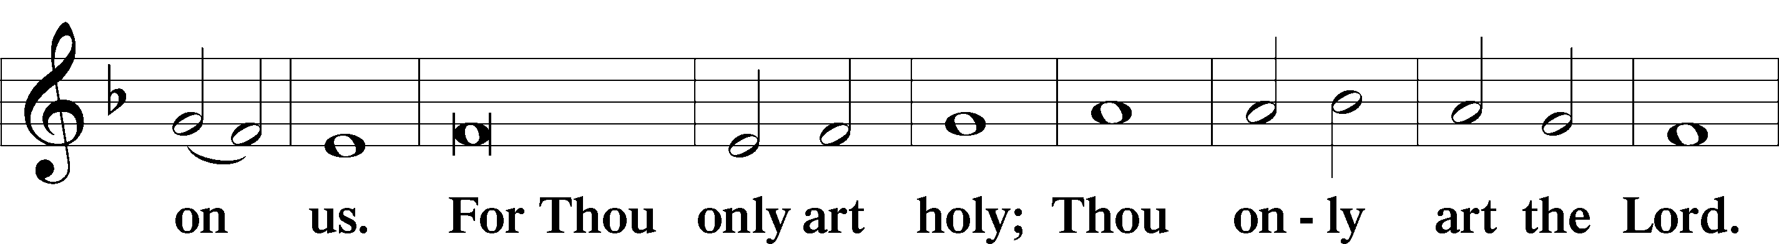

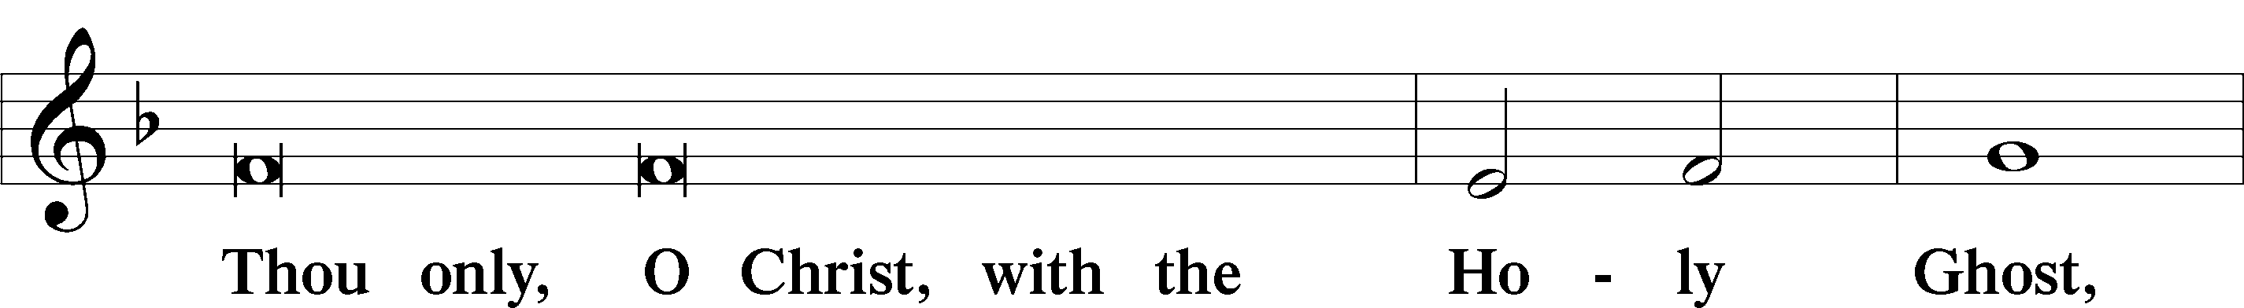

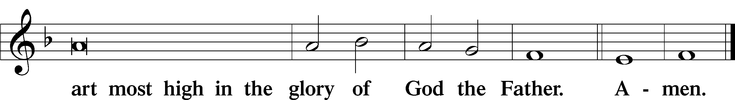

Salutation and Collect of the Day

P The Lord be with you.

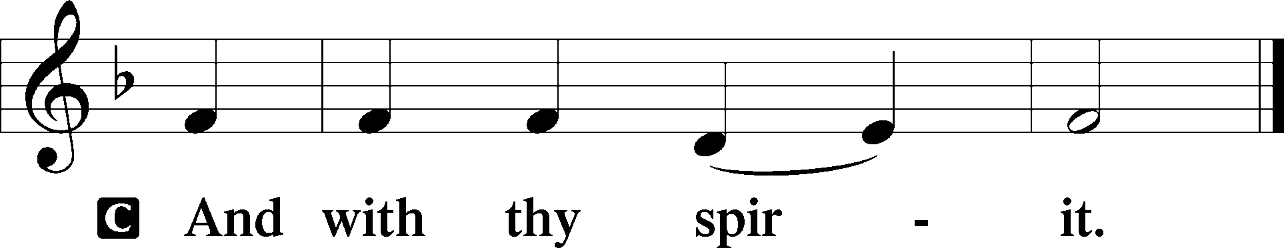

P Let us pray.

O Lord, let Your merciful ears be attentive to the prayers of Your servants, and by Your Word and Spirit teach us how to pray that our petitions may be pleasing before You; through Jesus Christ, Your Son, our Lord, who lives and reigns with You and the Holy Spirit, one God, now and forever.

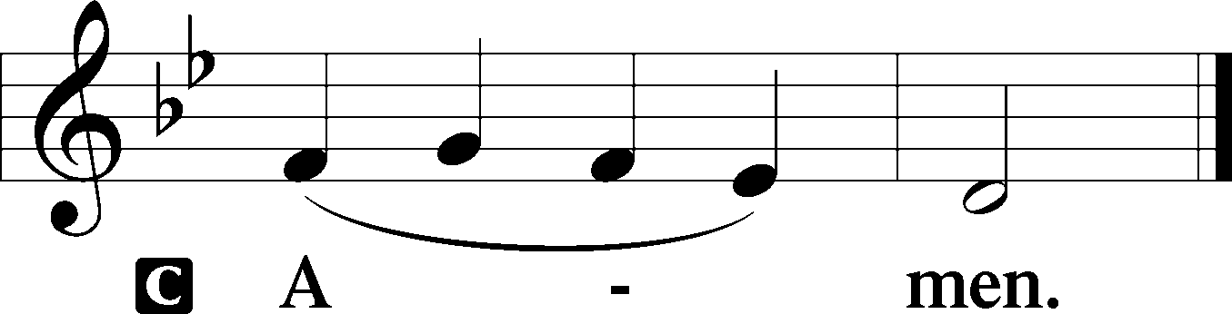

Sit

Old Testament Reading Genesis 18:20–33

20Then the Lord said, “Because the outcry against Sodom and Gomorrah is great and their sin is very grave, 21I will go down to see whether they have done altogether according to the outcry that has come to me. And if not, I will know.”

22So the men turned from there and went toward Sodom, but Abraham still stood before the Lord. 23Then Abraham drew near and said, “Will you indeed sweep away the righteous with the wicked? 24Suppose there are fifty righteous within the city. Will you then sweep away the place and not spare it for the fifty righteous who are in it? 25Far be it from you to do such a thing, to put the righteous to death with the wicked, so that the righteous fare as the wicked! Far be that from you! Shall not the Judge of all the earth do what is just?” 26And the Lord said, “If I find at Sodom fifty righteous in the city, I will spare the whole place for their sake.”

27Abraham answered and said, “Behold, I have undertaken to speak to the Lord, I who am but dust and ashes. 28Suppose five of the fifty righteous are lacking. Will you destroy the whole city for lack of five?” And he said, “I will not destroy it if I find forty-five there.” 29Again he spoke to him and said, “Suppose forty are found there.” He answered, “For the sake of forty I will not do it.” 30Then he said, “Oh let not the Lord be angry, and I will speak. Suppose thirty are found there.” He answered, “I will not do it, if I find thirty there.” 31He said, “Behold, I have undertaken to speak to the Lord. Suppose twenty are found there.” He answered, “For the sake of twenty I will not destroy it.” 32Then he said, “Oh let not the Lord be angry, and I will speak again but this once. Suppose ten are found there.” He answered, “For the sake of ten I will not destroy it.” 33And the Lord went his way, when he had finished speaking to Abraham, and Abraham returned to his place.

A This is the Word of the Lord.

C **Thanks be to God.**

Gradual Romans 10:15b, 18b; Isaiah 52:7b, alt.

How beautiful are the feet of those who preach the good news,  
 who publish peace and bring good news of salvation.  
**Their voice has gone out to all the earth,  
 and their words to the ends of the world.**

Epistle Colossians 2:6–19

6Therefore, as you received Christ Jesus the Lord, so walk in him, 7rooted and built up in him and established in the faith, just as you were taught, abounding in thanksgiving.

8See to it that no one takes you captive by philosophy and empty deceit, according to human tradition, according to the elemental spirits of the world, and not according to Christ. 9For in him the whole fullness of deity dwells bodily, 10and you have been filled in him, who is the head of all rule and authority. 11In him also you were circumcised with a circumcision made without hands, by putting off the body of the flesh, by the circumcision of Christ, 12having been buried with him in baptism, in which you were also raised with him through faith in the powerful working of God, who raised him from the dead. 13And you, who were dead in your trespasses and the uncircumcision of your flesh, God made alive together with him, having forgiven us all our trespasses, 14by canceling the record of debt that stood against us with its legal demands. This he set aside, nailing it to the cross. 15He disarmed the rulers and authorities and put them to open shame, by triumphing over them in him.

16Therefore let no one pass judgment on you in questions of food and drink, or with regard to a festival or a new moon or a Sabbath. 17These are a shadow of the things to come, but the substance belongs to Christ. 18Let no one disqualify you, insisting on asceticism and worship of angels, going on in detail about visions, puffed up without reason by his sensuous mind, 19and not holding fast to the Head, from whom the whole body, nourished and knit together through its joints and ligaments, grows with a growth that is from God.

Stand

Alleluia

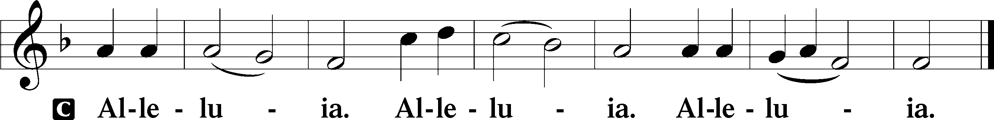

Holy Gospel Luke 11:1–13

P The Holy Gospel according to St. Luke, the eleventh chapter.

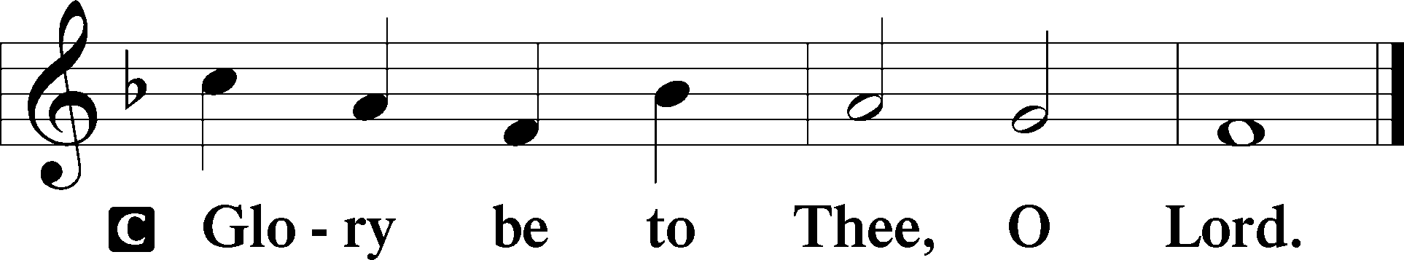

1Now Jesus was praying in a certain place, and when he finished, one of his disciples said to him, “Lord, teach us to pray, as John taught his disciples.” 2And he said to them, “When you pray, say:

“Father, hallowed be your name.  
 Your kingdom come.  
 3Give us each day our daily bread,  
 4and forgive us our sins,  
 for we ourselves forgive everyone who is indebted to us.  
 And lead us not into temptation.”

5And he said to them, “Which of you who has a friend will go to him at midnight and say to him, ‘Friend, lend me three loaves, 6for a friend of mine has arrived on a journey, and I have nothing to set before him’; 7and he will answer from within, ‘Do not bother me; the door is now shut, and my children are with me in bed. I cannot get up and give you anything’? 8I tell you, though he will not get up and give him anything because he is his friend, yet because of his impudence he will rise and give him whatever he needs. 9And I tell you, ask, and it will be given to you; seek, and you will find; knock, and it will be opened to you. 10For everyone who asks receives, and the one who seeks finds, and to the one who knocks it will be opened. 11What father among you, if his son asks for a fish, will instead of a fish give him a serpent; 12or if he asks for an egg, will give him a scorpion? 13If you then, who are evil, know how to give good gifts to your children, how much more will the heavenly Father give the Holy Spirit to those who ask him!”

P This is the Gospel of the Lord.

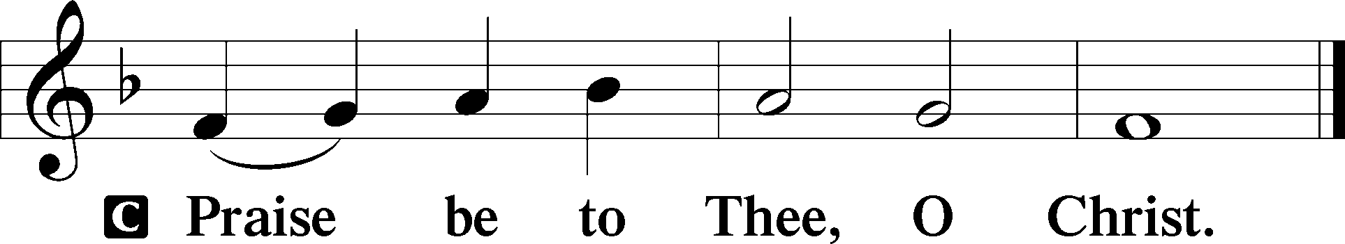

Apostles’ Creed

C **I believe in God, the Father Almighty,**

**maker of heaven and earth.**

**And in Jesus Christ, His only Son, our Lord,**

**who was conceived by the Holy Spirit,**

**born of the virgin Mary,**

**suffered under Pontius Pilate,**

**was crucified, died and was buried.**

**He descended into hell.**

**The third day He rose again from the dead.**

**He ascended into heaven**

**and sits at the right hand of God the Father Almighty.**

**From thence He will come to judge the living and the dead.**

**I believe in the Holy Spirit,**

**the holy Christian Church,**

**the communion of saints,**

**the forgiveness of sins,**

**the resurrection of the body,**

**and the life** T **everlasting. Amen.**

Sit

Children's Sermon

766 Our Father, Who from Heaven Above sts. 1–5

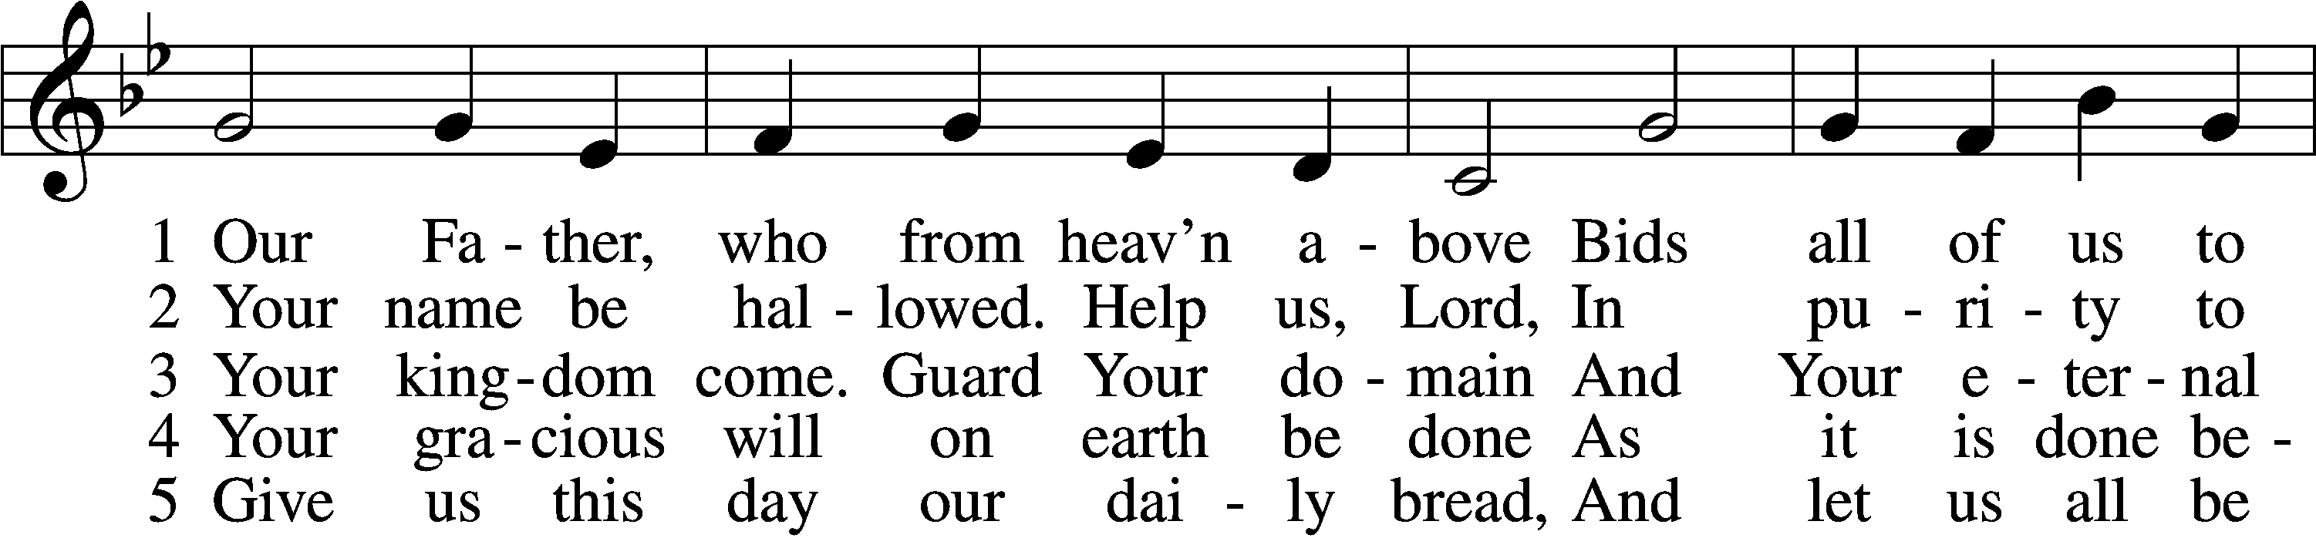

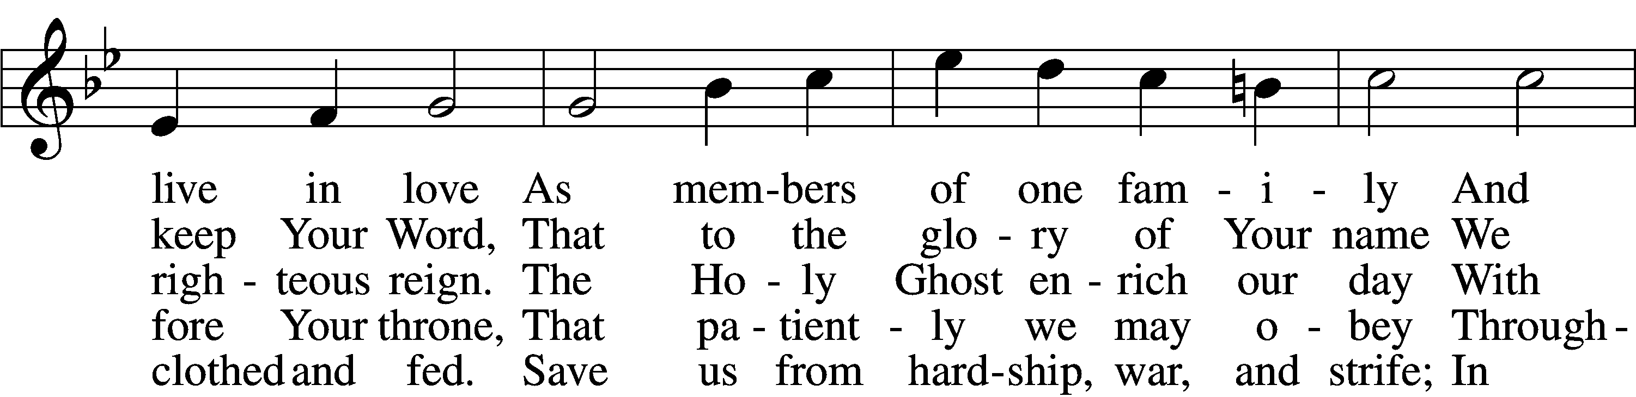

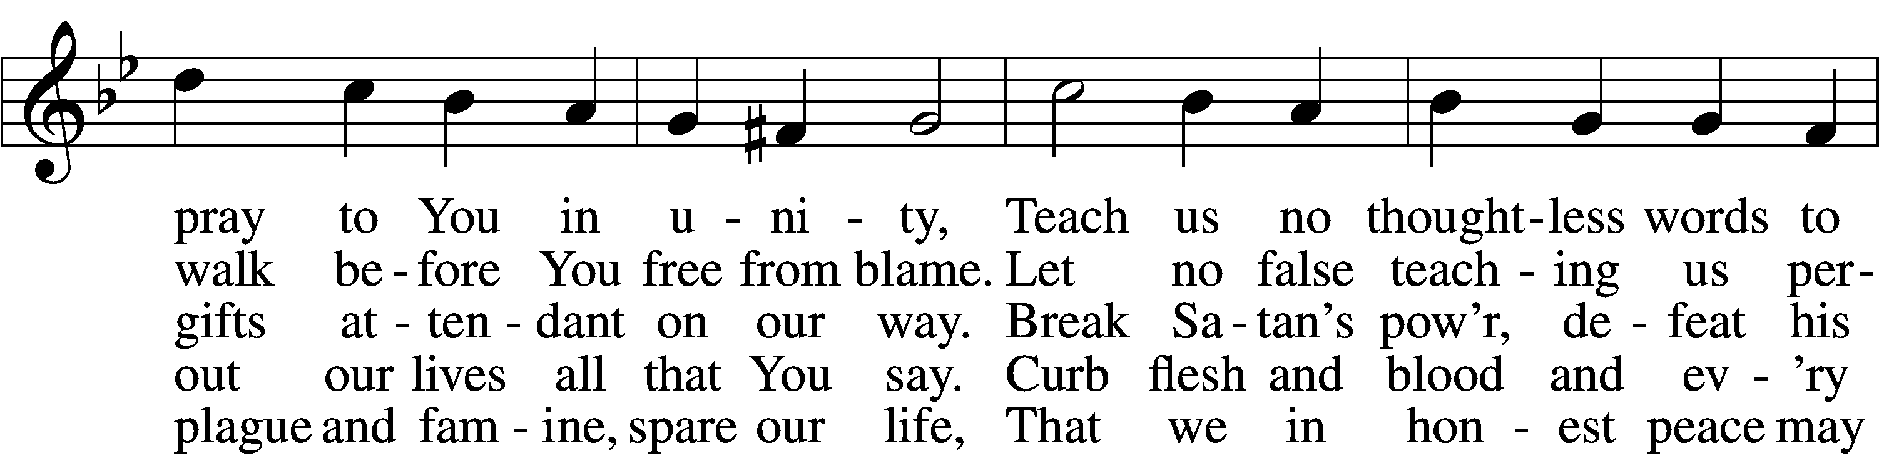

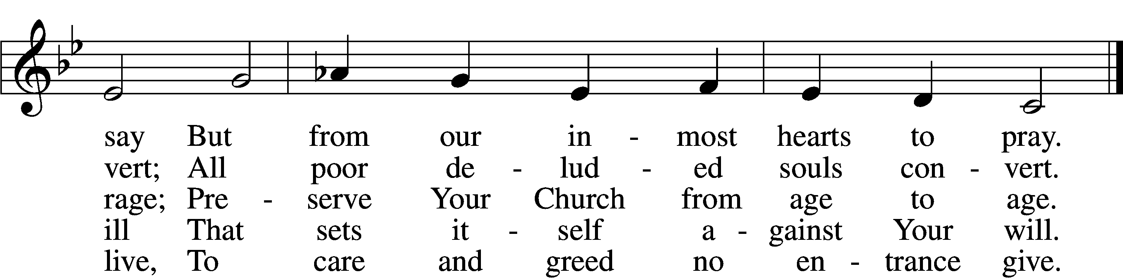

Text: Martin Luther, 1483–1546; (st. 1): tr. The Lutheran Hymnal, 1941, alt.; (sts. 2–5): tr. F. Samuel Janzow, 1913–2001, alt.  
Tune: attr. Martin Luther, 1483–1546  
Text (st. 1): Public domain  
Text (sts. 2–5): © 1980 Concordia Publishing House. Used by permission: LSB Hymn License no. 110005011  
Tune: Public domain

Sermon

766 Our Father, Who from Heaven Above sts. 6–9

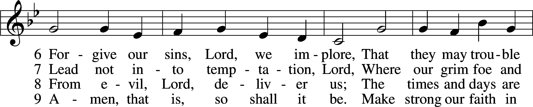

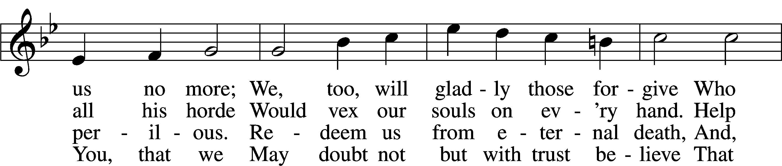

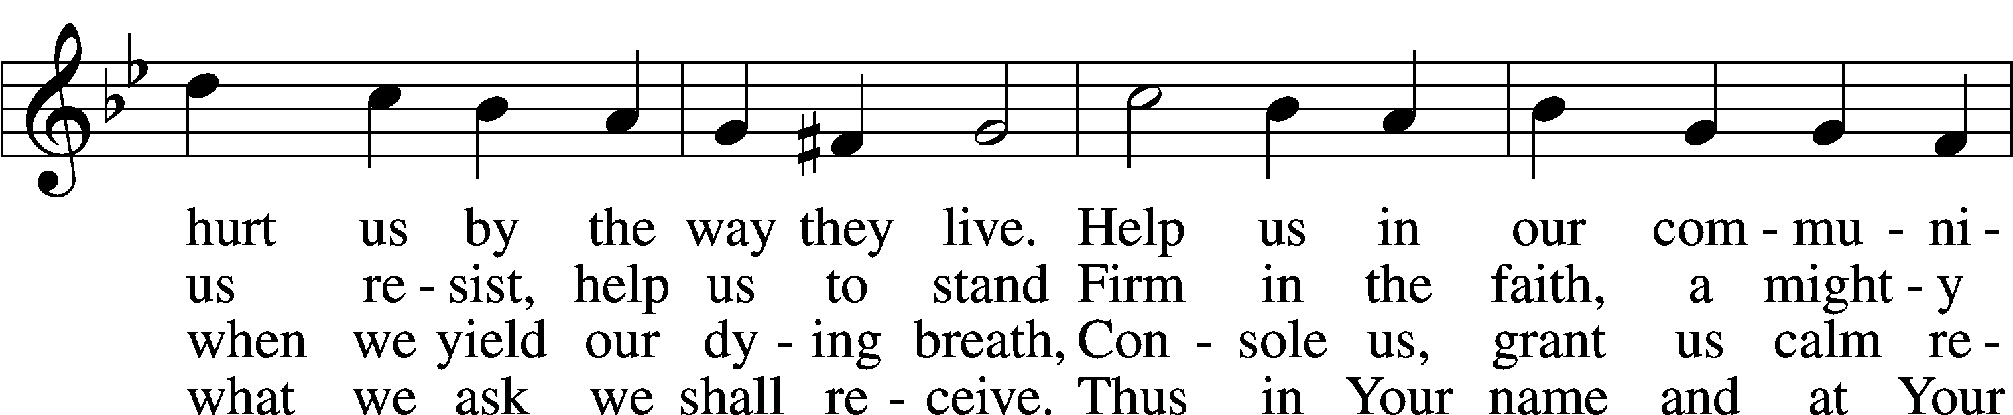

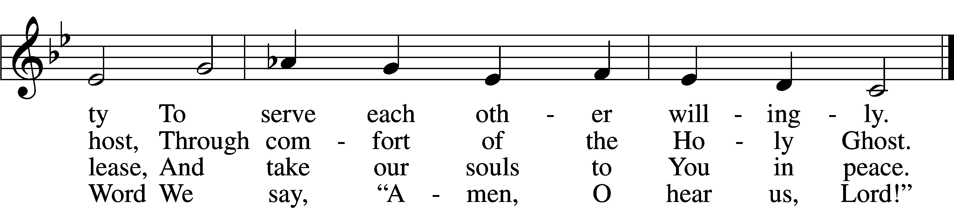

Text: Martin Luther, 1483–1546; (sts. 6, 8–9): tr. The Lutheran Hymnal, 1941, alt.; (st. 7): tr. F. Samuel Janzow, 1913–2001, alt.  
Tune: attr. Martin Luther, 1483–1546  
Text (sts. 6, 8–9): Public domain  
Text (st. 7): © 1980 Concordia Publishing House. Used by permission: LSB Hymn License no. 110005011  
Tune: Public domain

Votum

P The peace of God, which passes all understanding, keep your hearts and minds in Christ Jesus.

C **Amen.**

Stand

Offertory Psalm 51:10–12

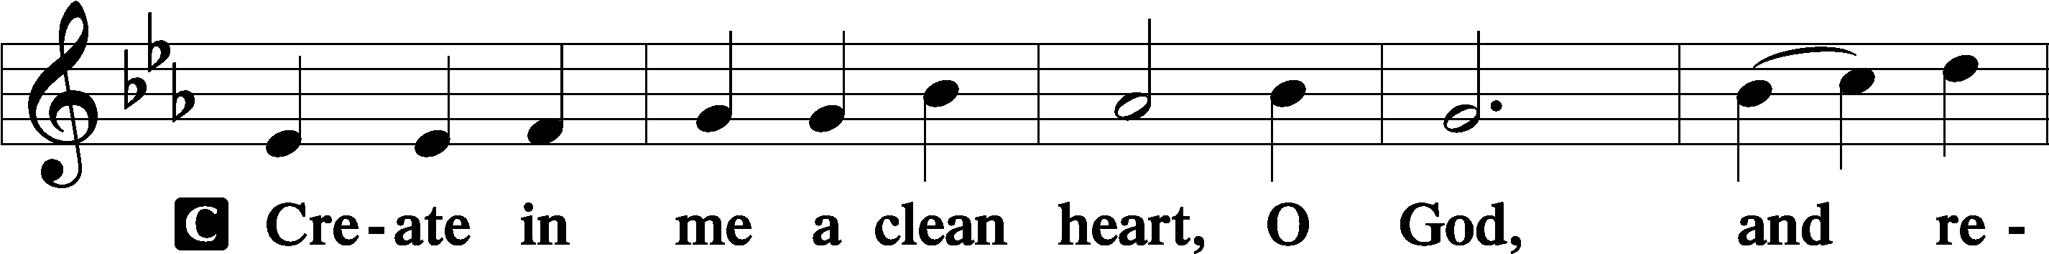

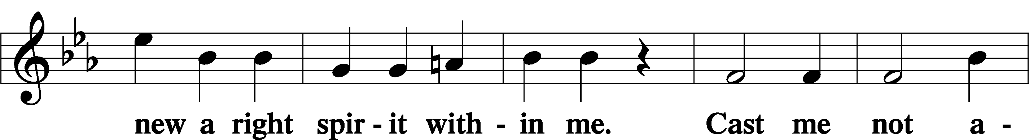

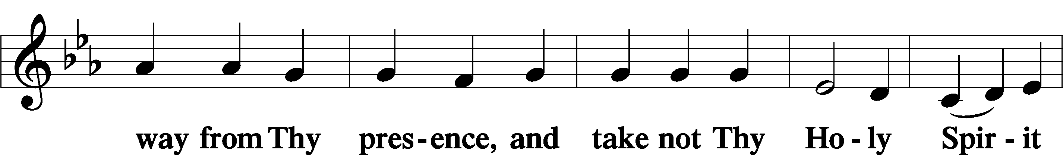

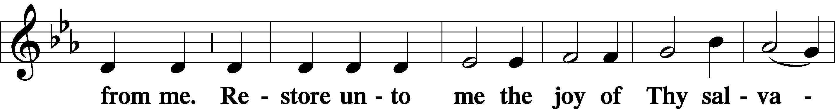

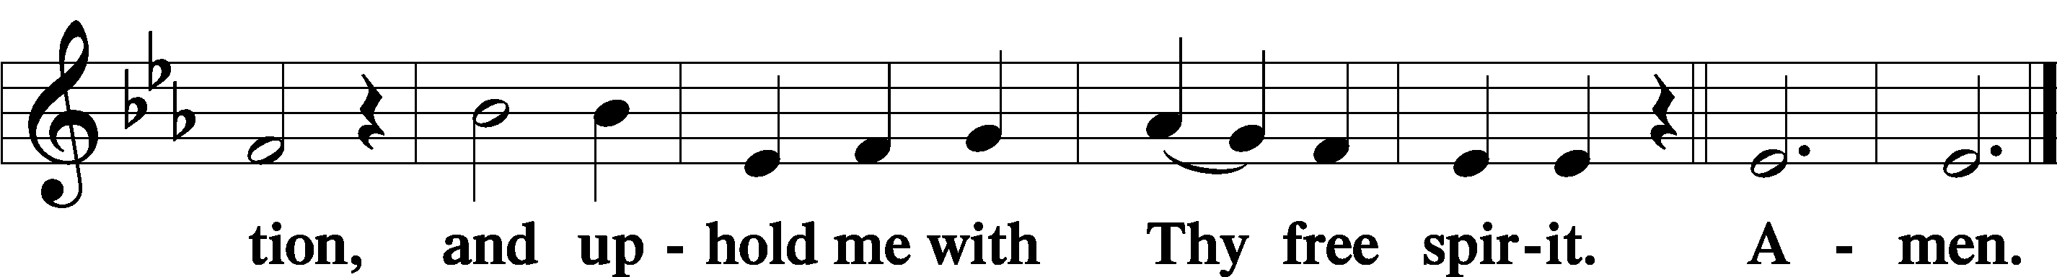

Offering

805 Praise God, from Whom All Blessings Flow

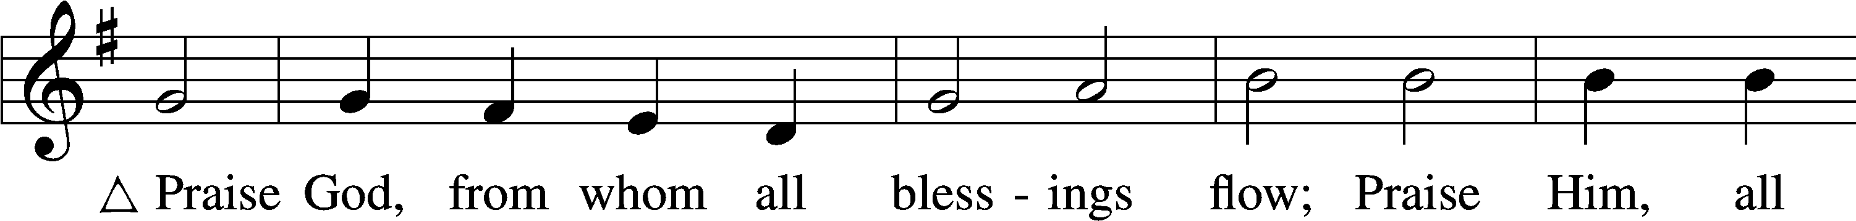

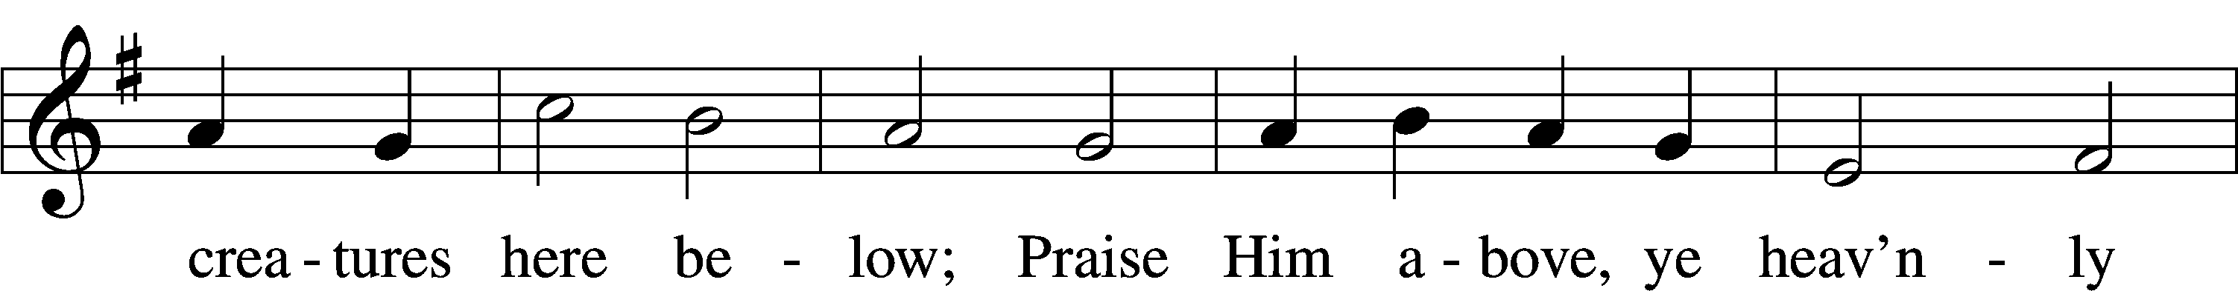

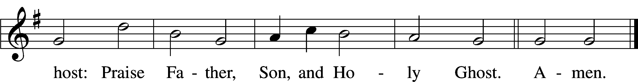

Text: Thomas Ken, 1637–1711  
Tune: Trente quatre Pseaumes de David, 1551, Geneva, ed. Louis Bourgeois  
Text and tune: Public domain

Prayer of the Church

Lord’s Prayer Matthew 6:9–13

P Lord, remember us in Your kingdom and teach us to pray:

C **Our Father who art in heaven,**

**hallowed be Thy name,**

**Thy kingdom come,**

**Thy will be done on earth**

**as it is in heaven;**

**give us this day our daily bread;**

**and forgive us our trespasses**

**as we forgive those**

**who trespass against us;**

**and lead us not into temptation,**

**but deliver us from evil.**

**For Thine is the kingdom**

**and the power and the glory**

**forever and ever. Amen.**

Collect for the Word

Blessed Lord, You have caused all Holy Scriptures to be written for our learning. Grant that we may so hear them, read, mark, learn, and inwardly digest them that, by the patience and comfort of Your holy Word, we may embrace and ever hold fast the blessed hope of everlasting life; through Jesus Christ, Your Son, our Lord, who lives and reigns with You and the Holy Spirit, one God, now and forever.

Benediction

P The Lord bless you and keep you.

The Lord make His face shine on you and be gracious to you.

The Lord look upon you with favor and T give you peace.

C **Amen.**

922 Go, My Children, with My Blessing sts. 1–4

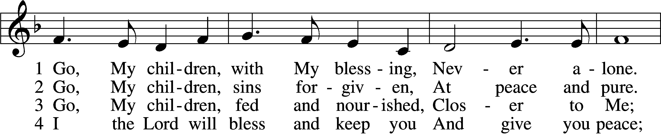

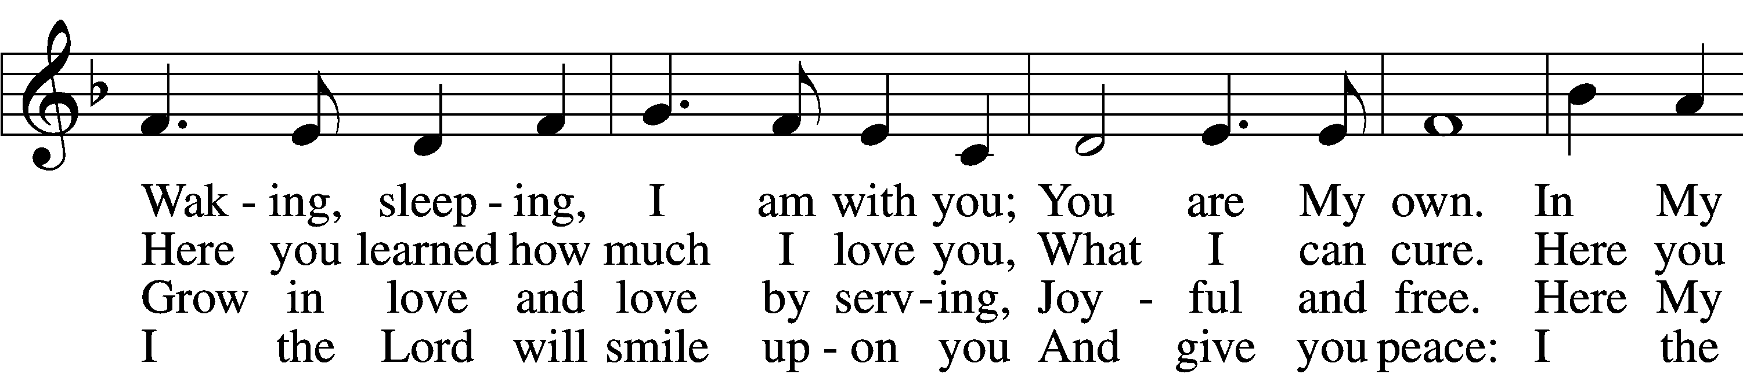

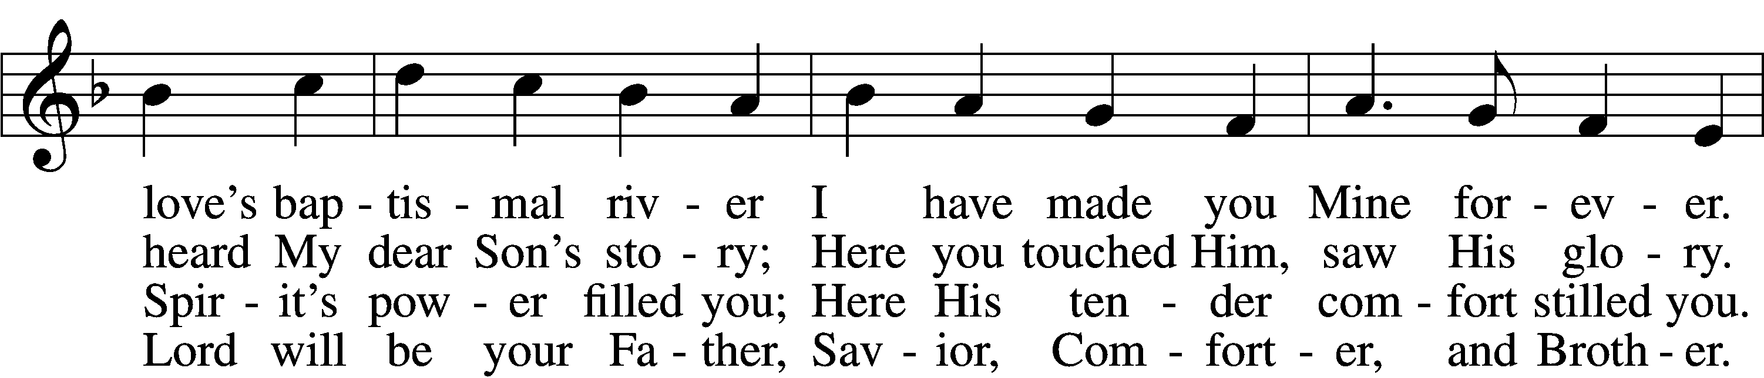

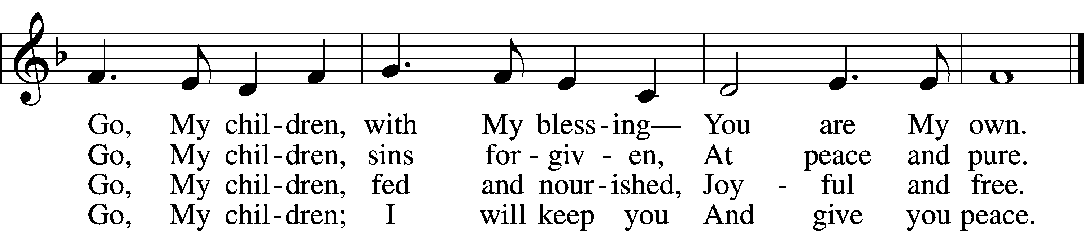

Text: Jaroslav J. Vajda, 1919–2008  
Tune: Welsh, 18th cent.  
Text: © 1983 Concordia Publishing House. Used by permission: LSB Hymn License no. 110005011  
Tune: Public domain

Acknowledgments

Unless otherwise indicated, Scripture quotations are from the ESV® Bible (The Holy Bible, English Standard Version®), copyright © 2001 by Crossway, a publishing ministry of Good News Publishers. Used by permission. All rights reserved.

Created by Lutheran Service Builder © 2025 Concordia Publishing House.