On entering the church

P Lord, I love the habitation of Your house and the place

where Your glory dwells. In the multitude of Your tender

mercies prepare my heart that I may enter Your house to

worship and confess Your holy name; through Jesus Christ,

my God and Lord.

Before worship

C O Lord, our creator, redeemer, and comforter, as we come

together to worship You in spirit and in truth, we humbly

pray that You would open our hearts to the preaching of

Your Word so that we may repent of our sins, believe in

Jesus Christ as our only Savior, and grow in grace and

holiness. Hear us for His sake.

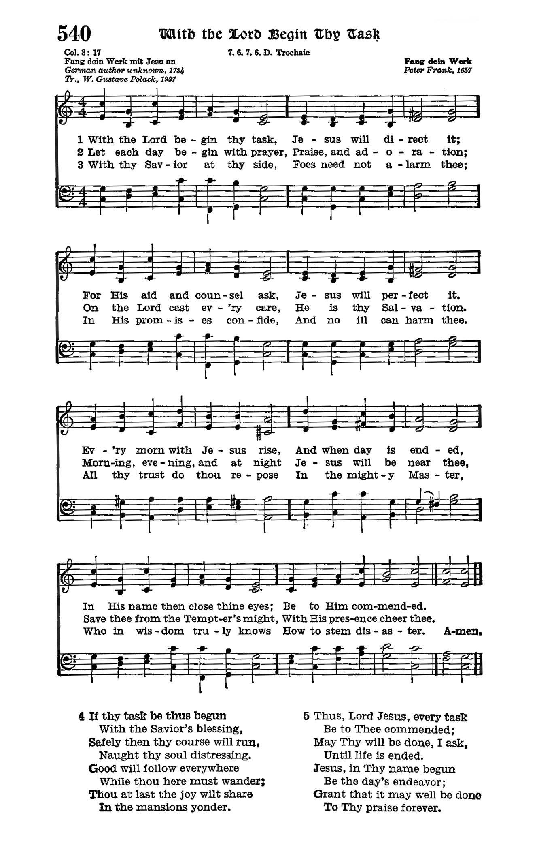

# Confession and Absolution

Stand

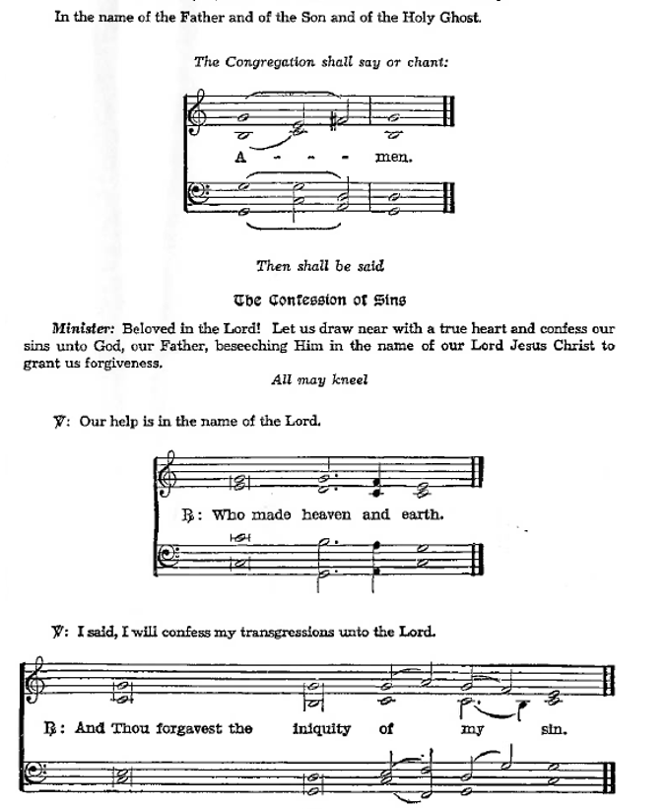Kneel/Stand

Silence for reflection on God’s Word and for self-examination.

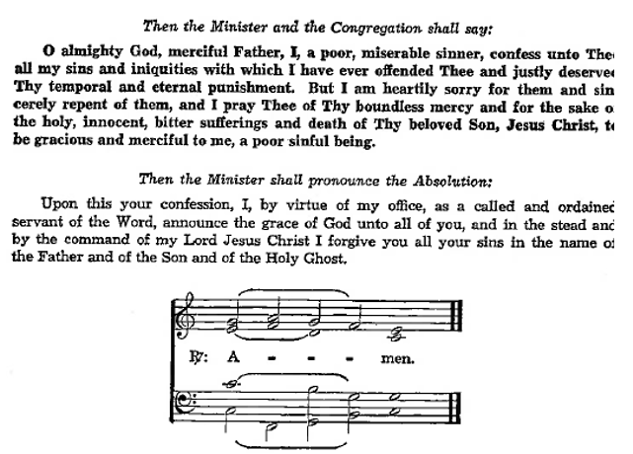

**Introit** *Psalm 75:1–2, 6, 9; antiphon: v. 7*

It is God who executes judgment,  
 putting down one and lifting up another.  
**We give thanks to you, O God; we give thanks, for your name is near.  
 We recount your wondrous deeds.**At the set time that I appoint  
 I will judge with equity.  
**For not from the east or from the west  
 and not from the wilderness comes lifting up.**But I will declare it forever;

I will sing praises to the God of Jacob.

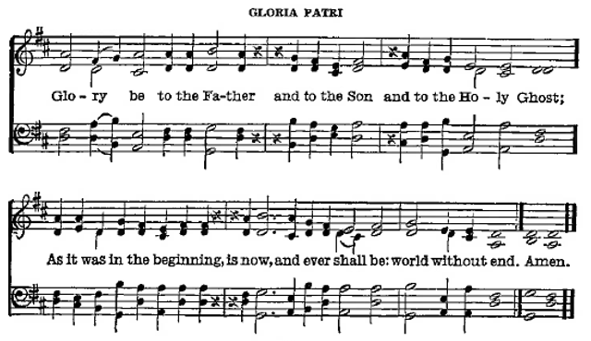

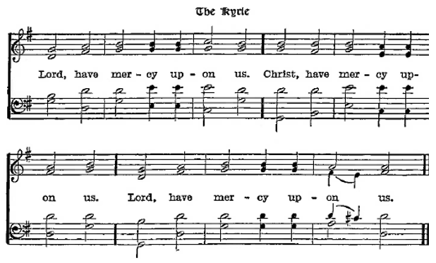

P O Lord of grace and mercy, teach us by Your Holy Spirit to follow the example of Your Son in true humility, that we may withstand the temptations of the devil and with pure hearts and minds avoid ungodly pride; through the same Jesus Christ, our Lord, who lives and reigns with You and the Holy Spirit, one God, now and forever.

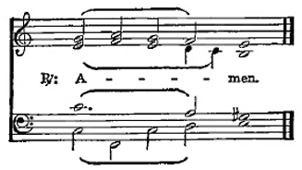

Sit

Old Testament *Proverbs 25:2–10*

2It is the glory of God to conceal things,  
 but the glory of kings is to search things out.  
3As the heavens for height, and the earth for depth,  
 so the heart of kings is unsearchable.  
4Take away the dross from the silver,  
 and the smith has material for a vessel;  
5take away the wicked from the presence of the king,  
 and his throne will be established in righteousness.  
6Do not put yourself forward in the king’s presence  
 or stand in the place of the great,  
7for it is better to be told, “Come up here,”  
 than to be put lower in the presence of a noble.  
What your eyes have seen  
 8do not hastily bring into court,  
for what will you do in the end,  
 when your neighbor puts you to shame?  
9Argue your case with your neighbor himself,  
 and do not reveal another’s secret,  
10lest he who hears you bring shame upon you,  
 and your ill repute have no end.

**Gradual** *Psalm 34:9, 19, alt.*

Fear the Lord, you his saints,  
 for those who fear him lack nothing!  
Many are the afflictions of the righteous,  
 but the Lord delivers him out of them all.

Epistle *Hebrews 13:1–17*

1Let brotherly love continue. 2Do not neglect to show hospitality to strangers, for thereby some have entertained angels unawares. 3Remember those who are in prison, as though in prison with them, and those who are mistreated, since you also are in the body. 4Let marriage be held in honor among all, and let the marriage bed be undefiled, for God will judge the sexually immoral and adulterous. 5Keep your life free from love of money, and be content with what you have, for he has said, “I will never leave you nor forsake you.” 6So we can confidently say,

“The Lord is my helper; I will not fear; what can man do to me?”

7Remember your leaders, those who spoke to you the word of God. Consider the outcome of their way of life, and imitate their faith. 8Jesus Christ is the same yesterday and today and forever. 9Do not be led away by diverse and strange teachings, for it is good for the heart to be strengthened by grace, not by foods, which have not benefited those devoted to them. 10We have an altar from which those who serve the tent have no right to eat. 11For the bodies of those animals whose blood is brought into the holy places by the high priest as a sacrifice for sin are burned outside the camp. 12So Jesus also suffered outside the gate in order to sanctify the people through his own blood. 13Therefore let us go to him outside the camp and bear the reproach he endured. 14For here we have no lasting city, but we seek the city that is to come. 15Through him then let us continually offer up a sacrifice of praise to God, that is, the fruit of lips that acknowledge his name. 16Do not neglect to do good and to share what you have, for such sacrifices are pleasing to God.

17Obey your leaders and submit to them, for they are keeping watch over your souls, as those who will have to give an account. Let them do this with joy and not with groaning, for that would be of no advantage to you.

A Here endeth the Epistle.

Stand

Holy Gospel *Luke 14:1–14*

P The Holy Gospel is written in the Fourteenth chapter of St. Luke, beginning at the first verse.

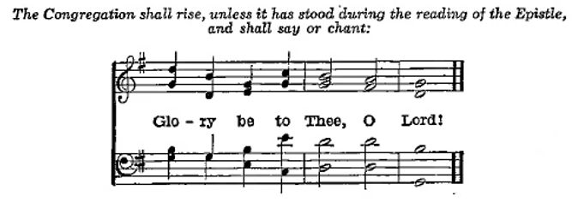

1One Sabbath, when [Jesus] went to dine at the house of a ruler of the Pharisees, they were watching him carefully. 2And behold, there was a man before him who had dropsy. 3And Jesus responded to the lawyers and Pharisees, saying, “Is it lawful to heal on the Sabbath, or not?” 4But they remained silent. Then he took him and healed him and sent him away. 5And he said to them, “Which of you, having a son or an ox that has fallen into a well on a Sabbath day, will not immediately pull him out?” 6And they could not reply to these things.

7Now he told a parable to those who were invited, when he noticed how they chose the places of honor, saying to them, 8“When you are invited by someone to a wedding feast, do not sit down in a place of honor, lest someone more distinguished than you be invited by him, 9and he who invited you both will come and say to you, ‘Give your place to this person,’ and then you will begin with shame to take the lowest place. 10But when you are invited, go and sit in the lowest place, so that when your host comes he may say to you, ‘Friend, move up higher.’ Then you will be honored in the presence of all who sit at table with you. 11For everyone who exalts himself will be humbled, and he who humbles himself will be exalted.”

12He said also to the man who had invited him, “When you give a dinner or a banquet, do not invite your friends or your brothers or your relatives or rich neighbors, lest they also invite you in return and you be repaid. 13But when you give a feast, invite the poor, the crippled, the lame, the blind, 14and you will be blessed, because they cannot repay you. You will be repaid at the resurrection of the just.”

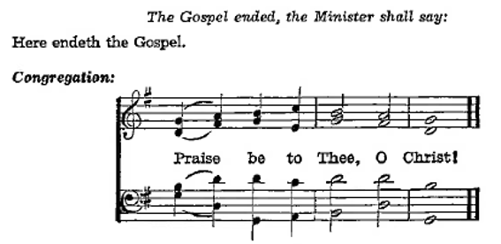

Nicene Creed

C **I believe in one God,**

**the Father Almighty,**

**maker of heaven and earth**

**and of all things visible and invisible.**

**And in one Lord Jesus Christ,**

**the only-begotten Son of God,**

**begotten of His Father before all worlds,**

**God of God, Light of Light,**

**very God of very God,**

**begotten, not made,**

**being of one substance with the Father,**

**by whom all things were made;**

**who for us men and for our salvation came down from heaven**

**and was incarnate by the Holy Ghost of the virgin Mary**

**and was made man;**

**and was crucified also for us under Pontius Pilate.**

**He suffered and was buried.**

**And the third day He rose again according to the Scriptures**

**and ascended into heaven**

**and sits at the right hand of the Father.**

**And He will come again with glory to judge both the living and the dead,**

**whose kingdom will have no end.**

**And I believe in the Holy Ghost,**

**the Lord and giver of life,**

**who proceeds from the Father and the Son,**

**who with the Father and the Son together is worshiped and glorified,**

**who spoke by the prophets.**

**And I believe in one holy Christian and apostolic Church,**

**I acknowledge one Baptism for the remission of sins,**

**and I look for the resurrection of the dead**

**and the life of the world to come. Amen.**

Sit

Children's Sermon

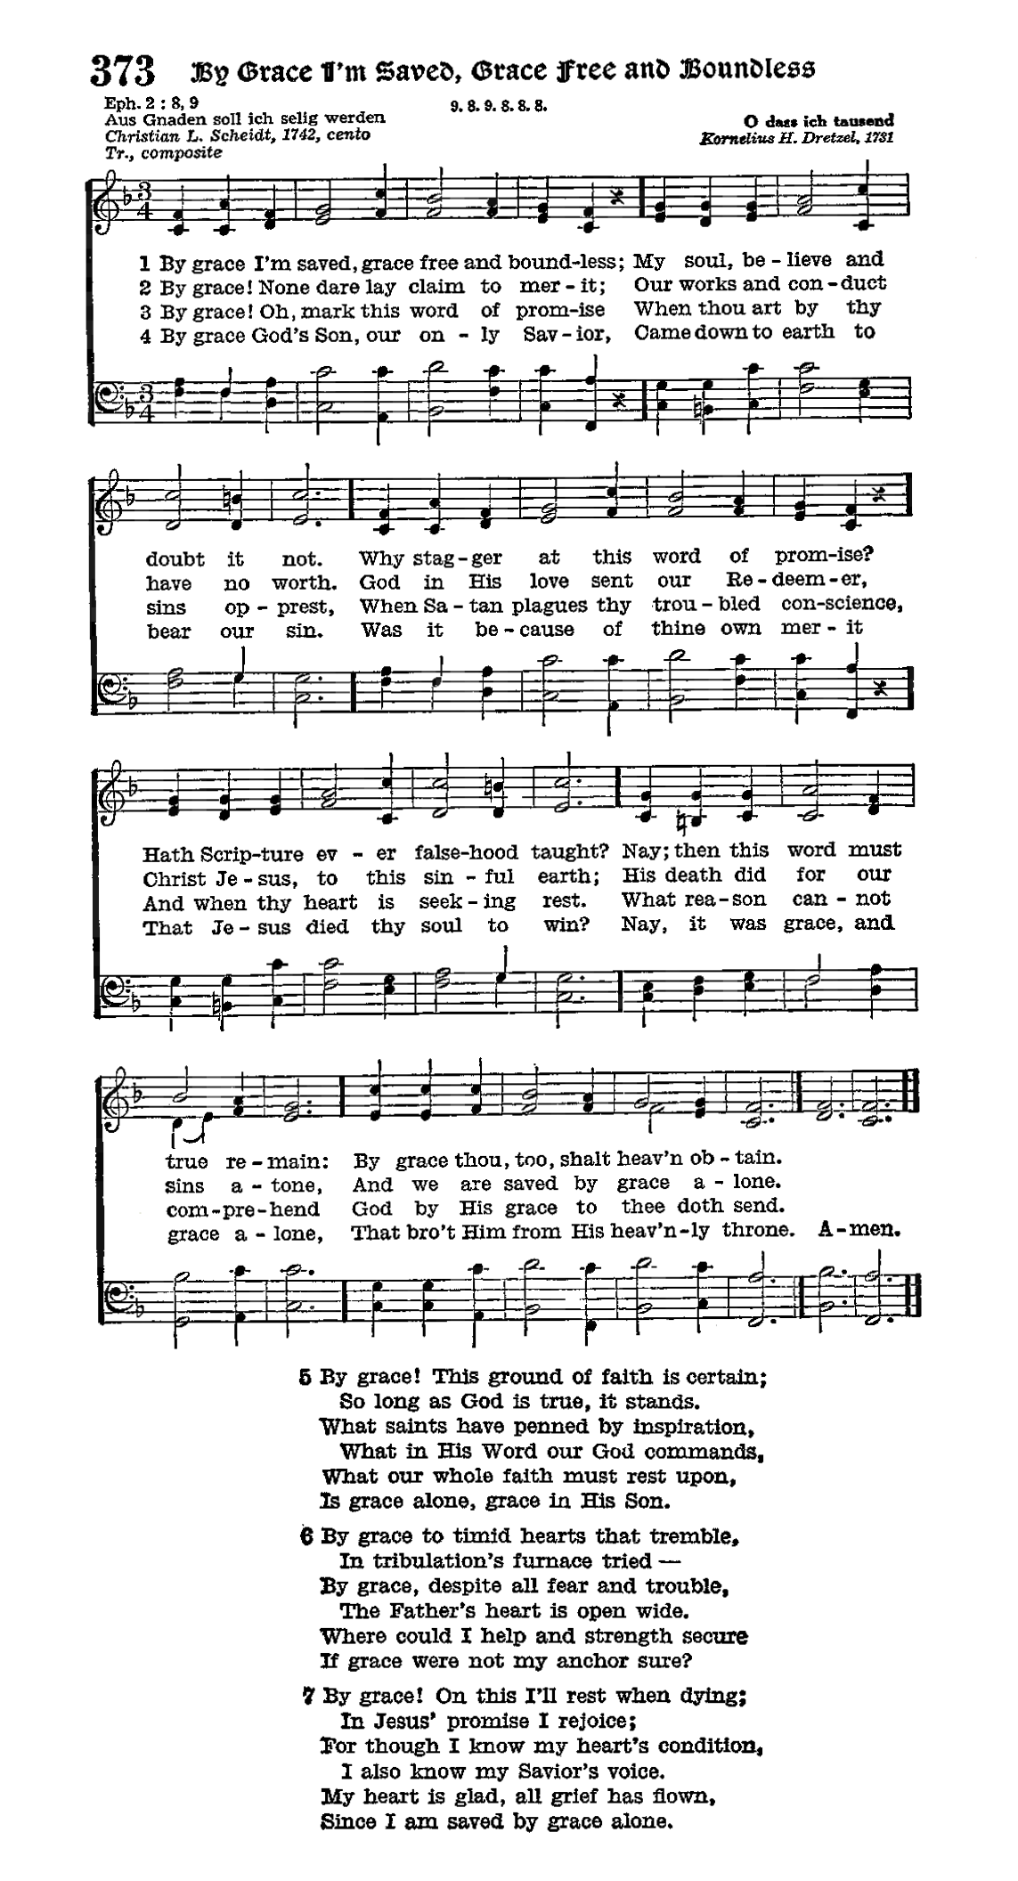

Sermon

Votum

P The peace of God, which passeth all understanding, keep your hearts and minds through Christ Jesus.

Stand

Offertory Psalm 51:10–12

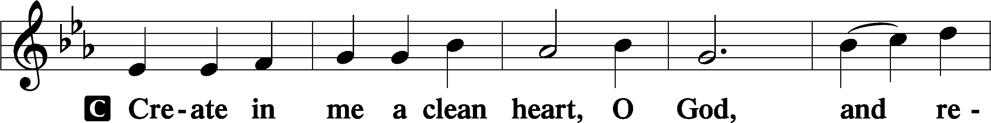

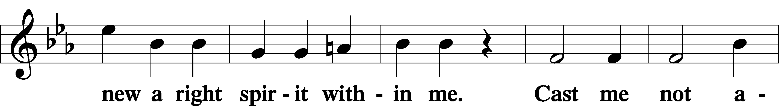

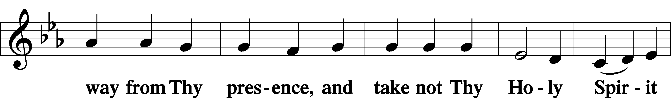

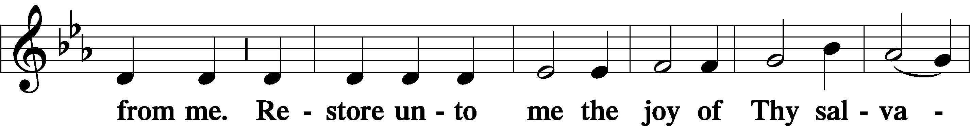

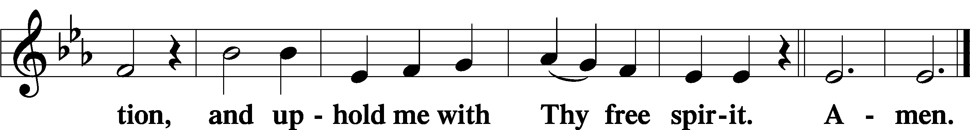

Sit

Offering

644 Praise God, from Whom All Blessings Flow

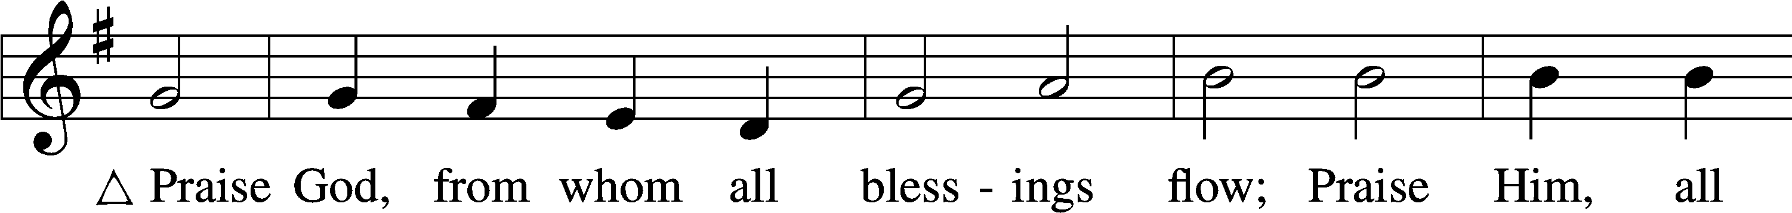

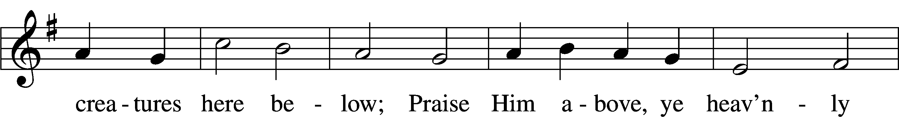

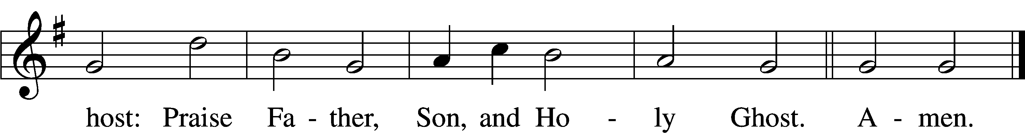

Text: Thomas Ken, 1637–1711  
Tune: Trente quatre Pseaumes de David, 1551, Geneva, ed. Louis Bourgeois  
Text and tune: Public domain

Stand

Prayer of the Church

# Service of the Sacrament

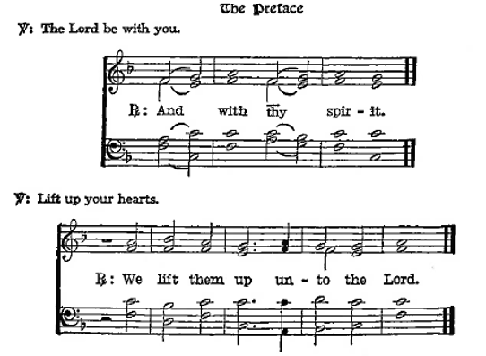

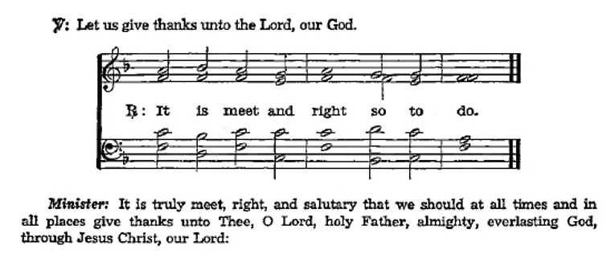

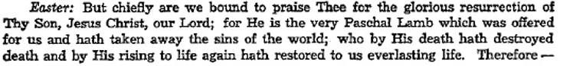

**Sanctus** Isaiah 6:3; Matthew 21:9

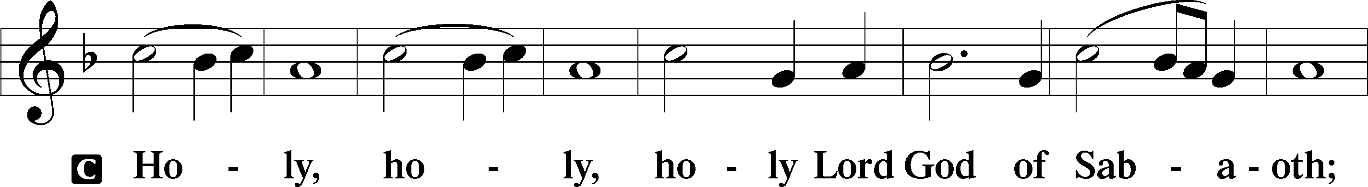

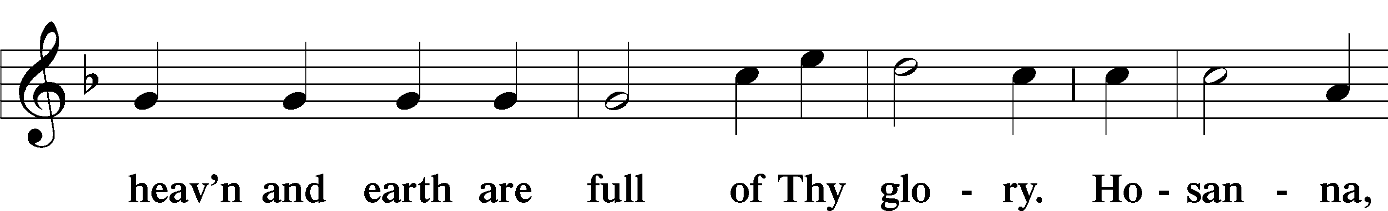

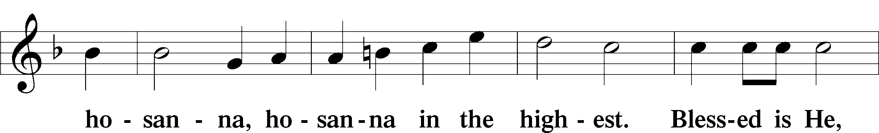

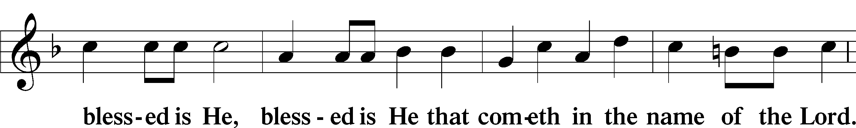

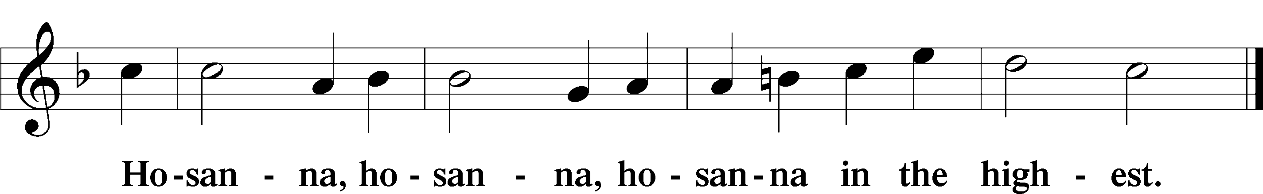

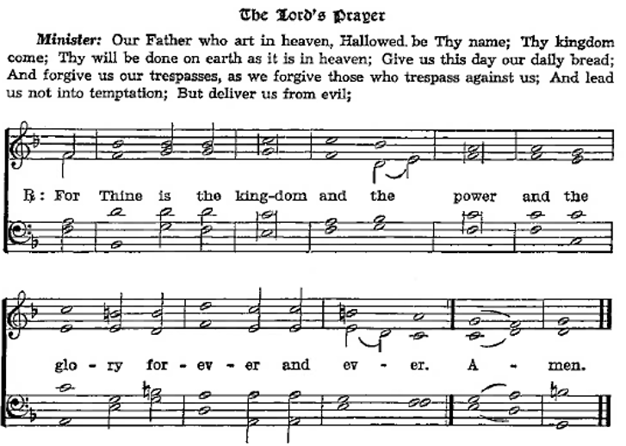

The Words of Our Lord Matthew 26:26–28; Mark 14:22–24; Luke 22:19–20; 1 Corinthians 11:23–25

P Our Lord Jesus Christ, the same night in which He was

betrayed, took bread; and when He had given thanks, He

brake it and gave it to the disciples saying, “Take, eat; this

is My body, which is given for you. This do in

remembrance of Me.”

After the same manner also He took the cup when he had supped, and when He had given thanks, He gave it to them, saying, “Drink ye all of it; this cup is the New Testament in My blood, which is shed for you for the remission of sins. This do, as oft as ye drink it, in remembrance of Me.”

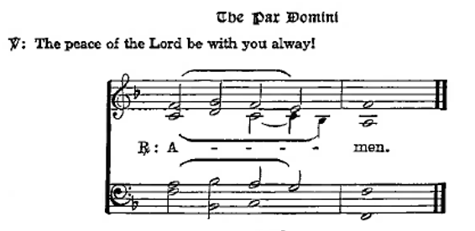Agnus Dei John 1:29

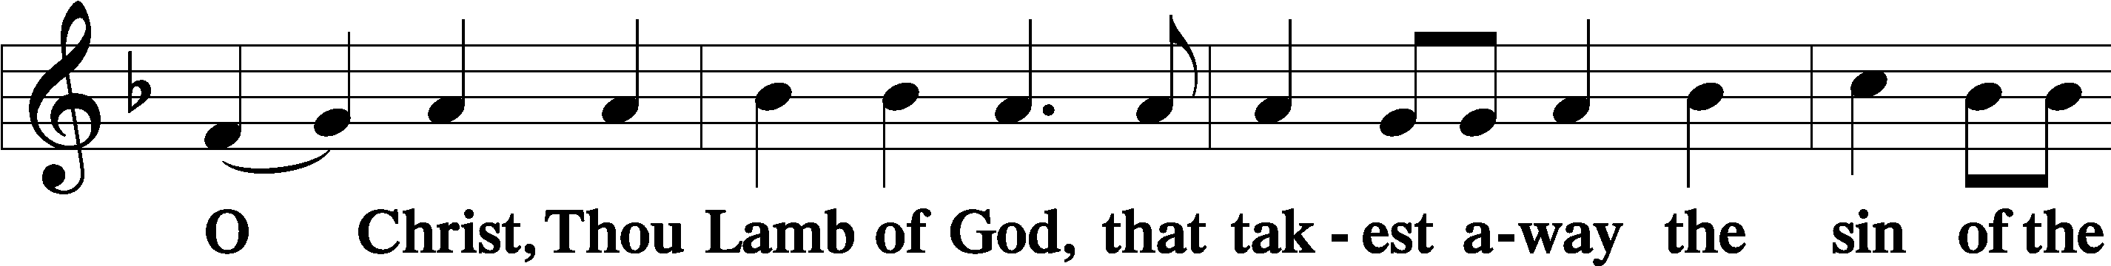

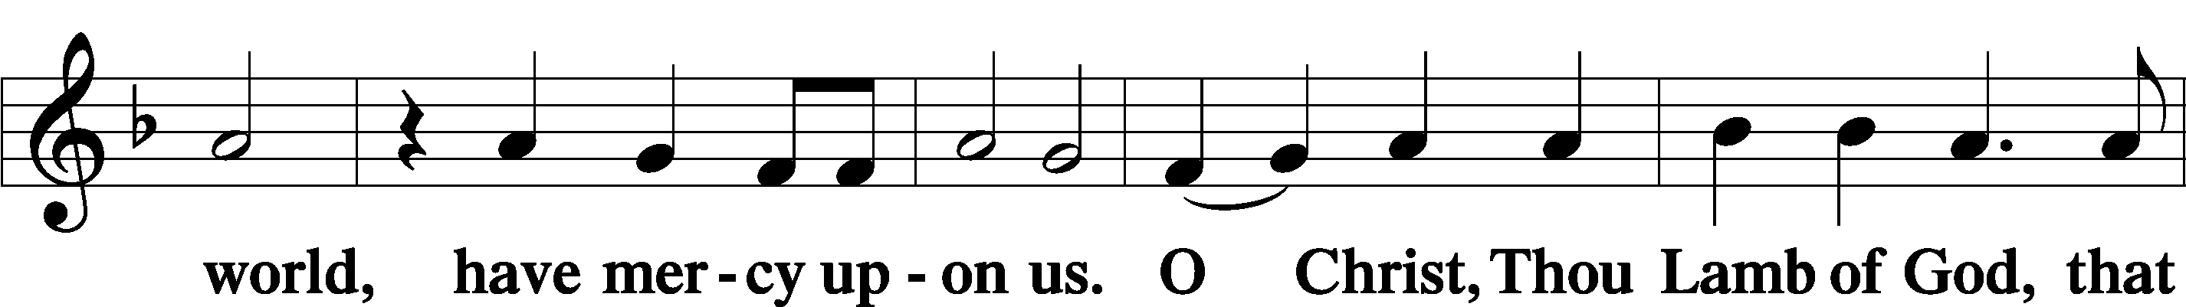

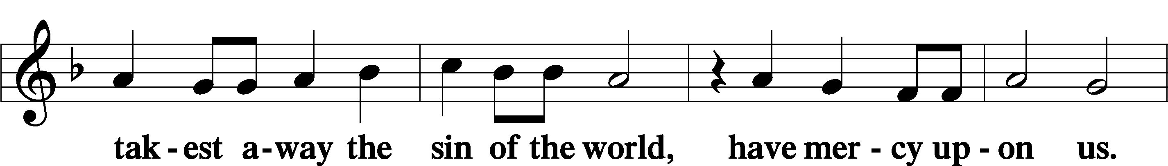

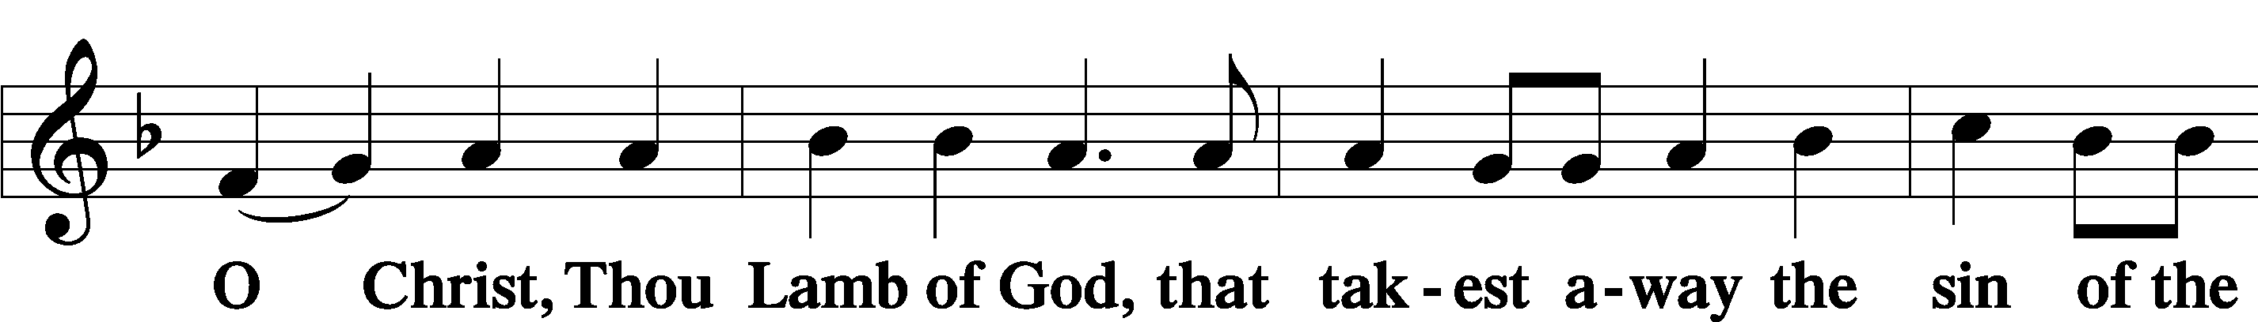

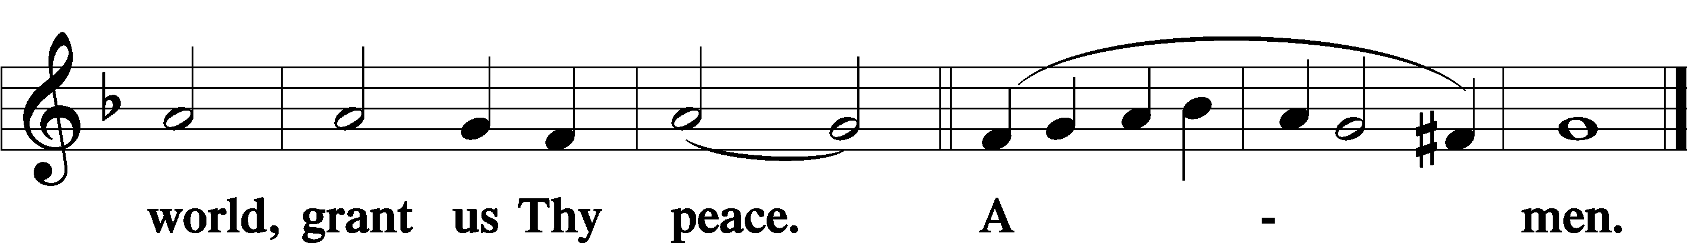

Sit

Distribution

The pastor and those who assist him receive the body and blood of Christ first and then distribute them to those who come to receive, saying:

Take, eat; this is the true body of our Lord and Savior Jesus Christ, given into death for your sins.

**Amen.**

Take, drink; this is the true blood of our Lord and Savior Jesus Christ, shed for the forgiveness of your sins.

**Amen.**

In dismissing the communicants, the following is said:

The Dismissal

P The body and blood of our Lord Jesus Christ strengthen and preserve you in the true faith unto life everlasting. Depart in peace.

C **Amen.**

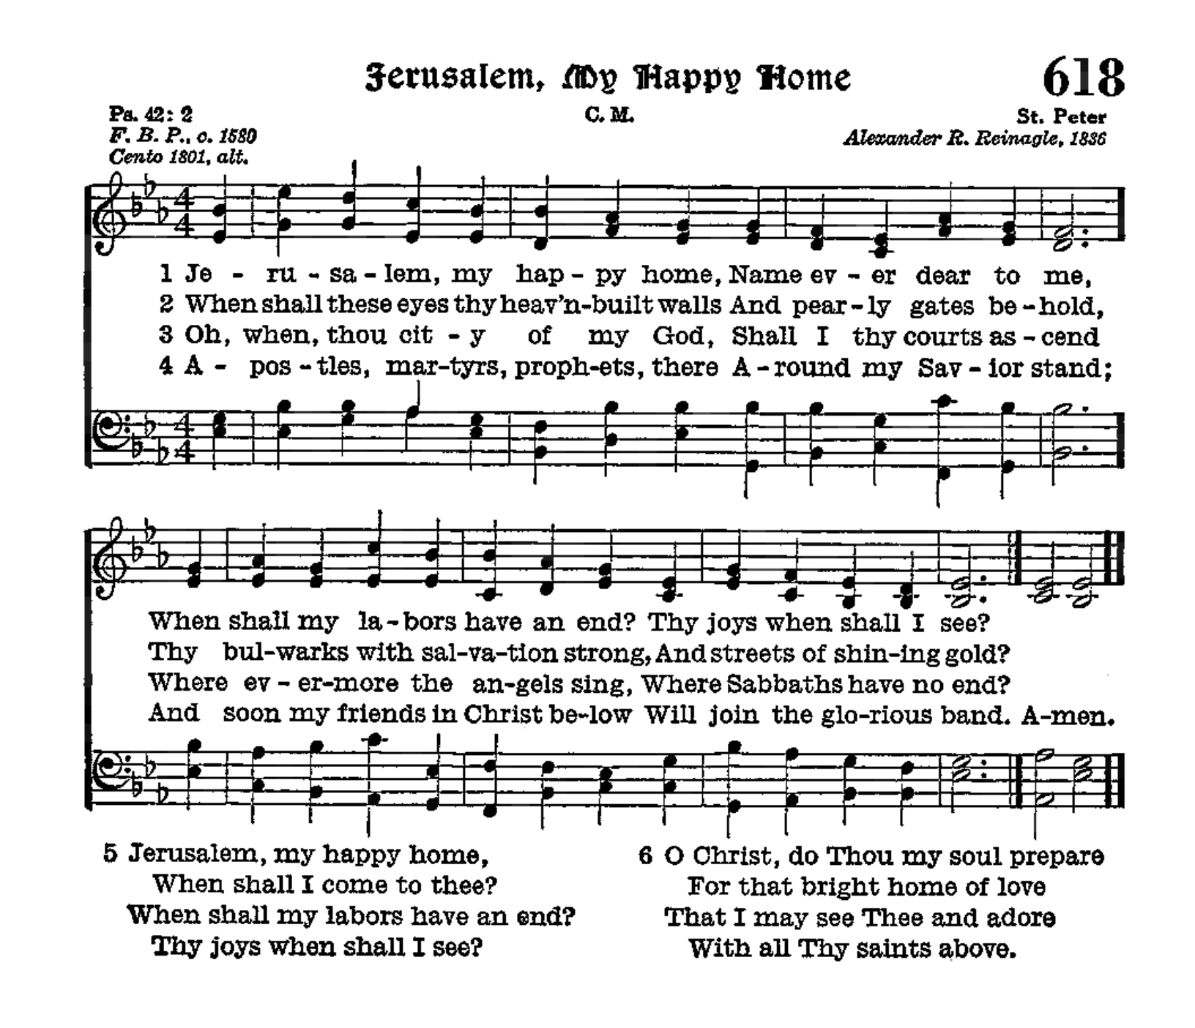

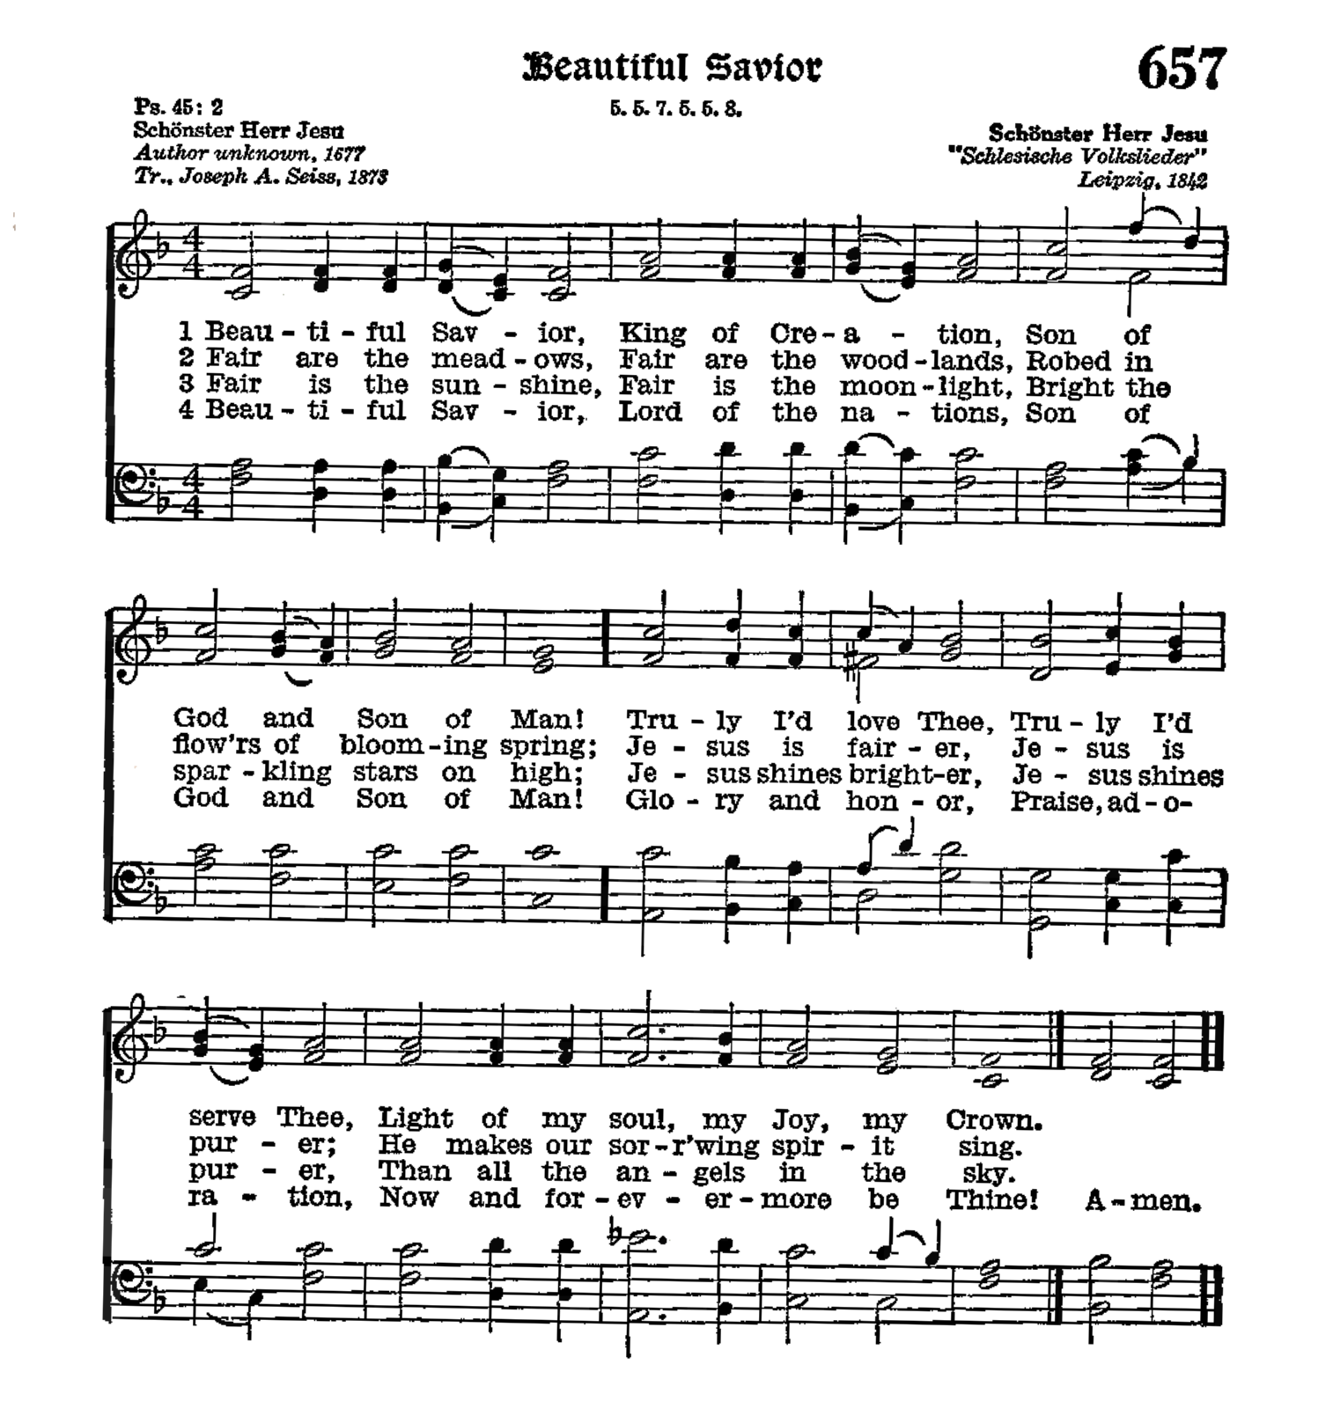

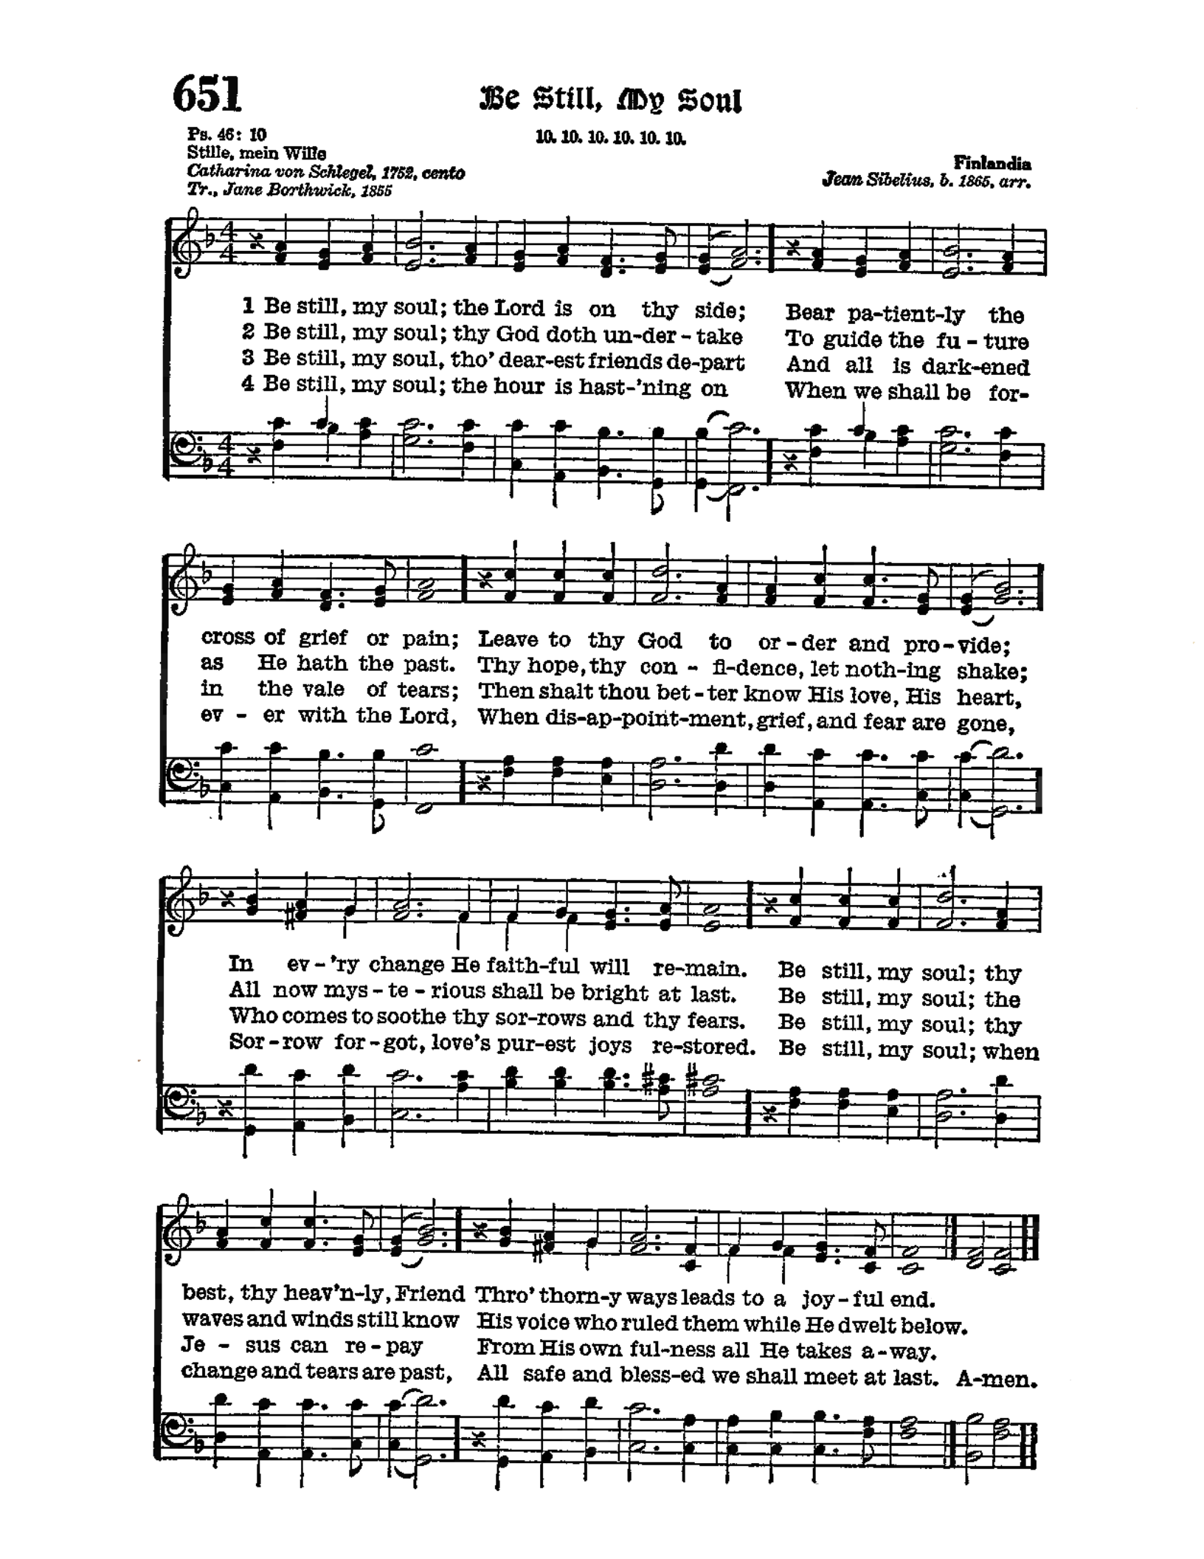

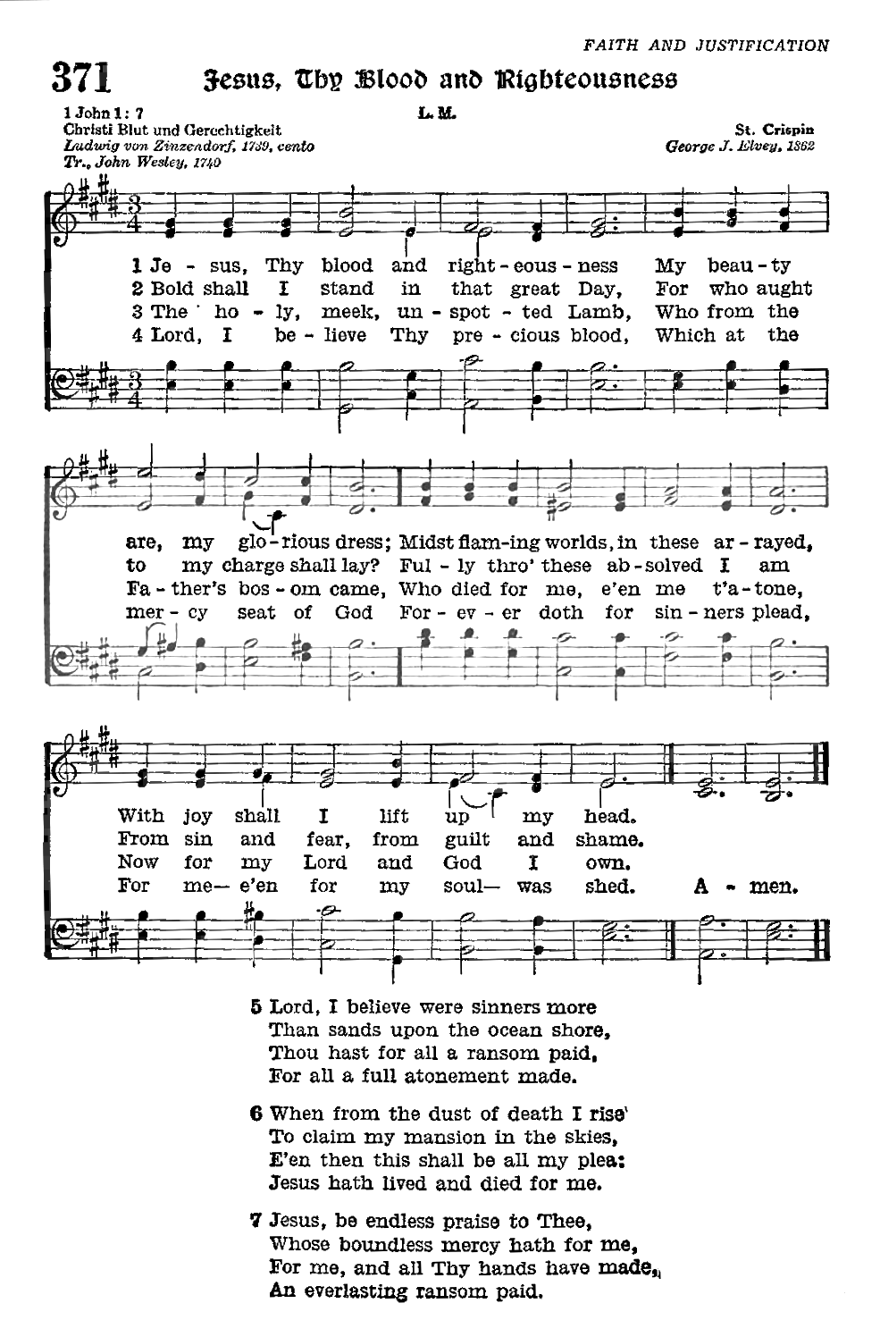

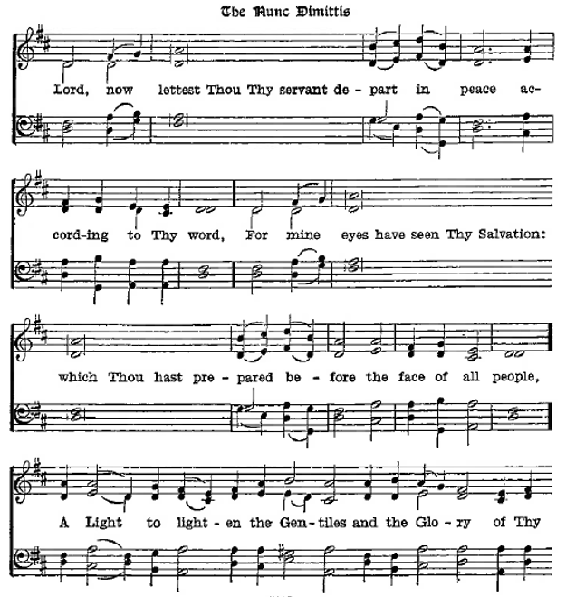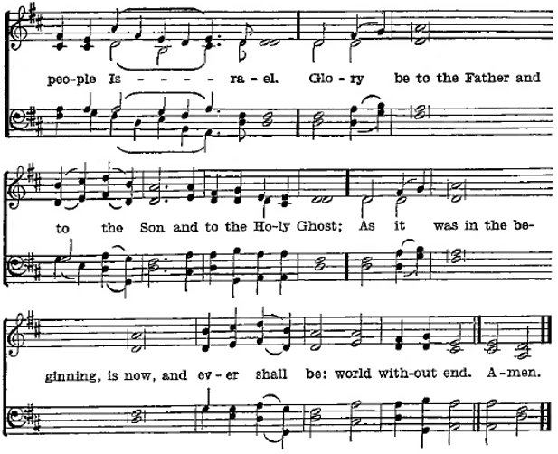

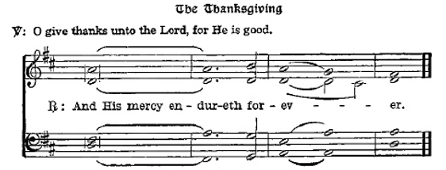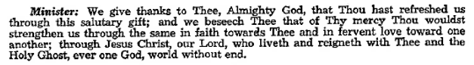

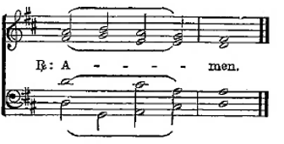

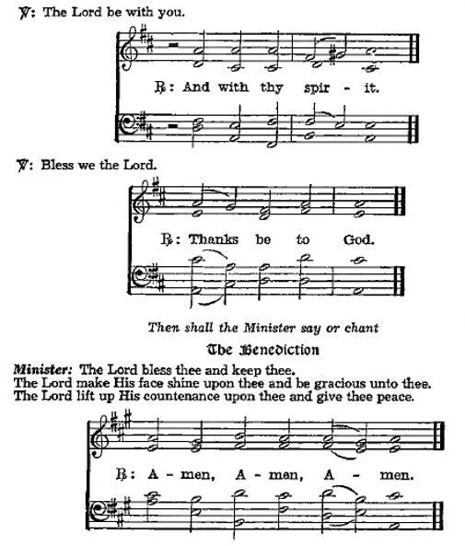

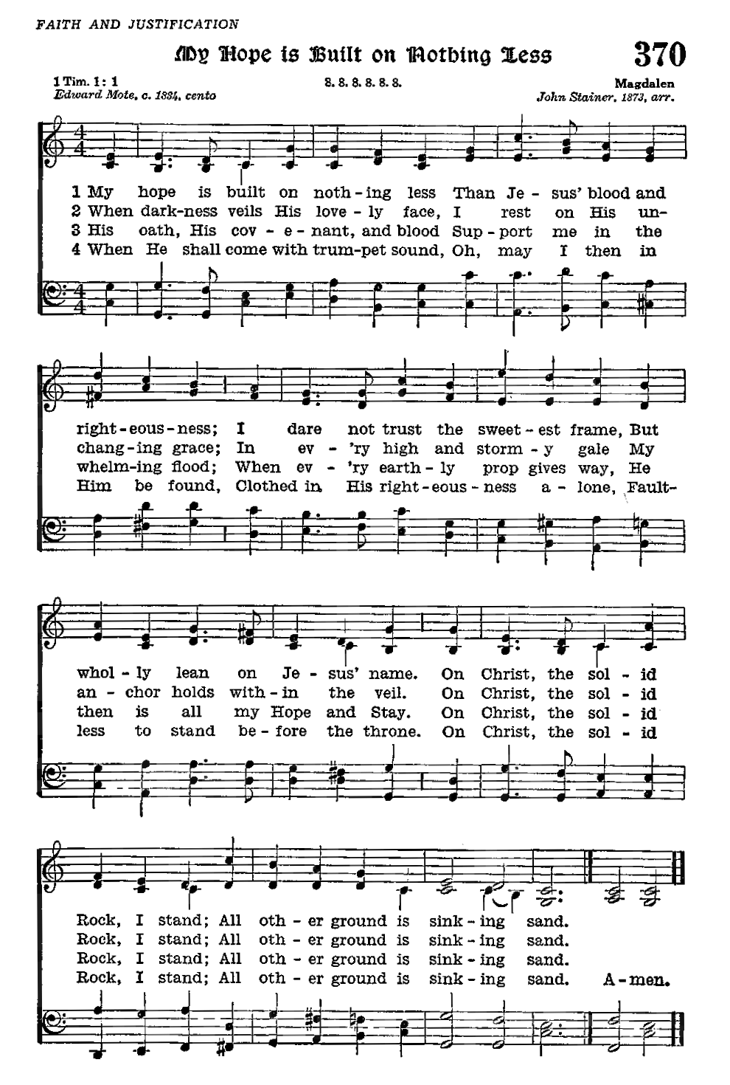

Acknowledgments

Divine Service, from The Lutheran Hymnal

Unless otherwise indicated, Scripture quotations are from the ESV® Bible (The Holy Bible, English Standard Version®), copyright © 2001 by Crossway, a publishing ministry of Good News Publishers. Used by permission. All rights reserved.

Created by Lutheran Service Builder © 2024 Concordia Publishing House.