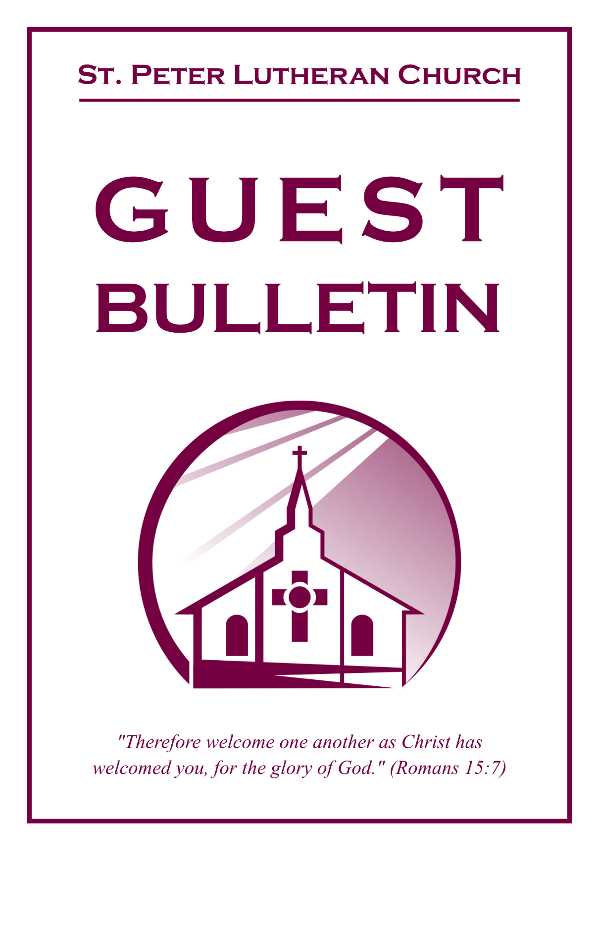

July 26, 2026



St. Peter Lutheran Church
Missouri Synod
906 Highway 59N, P.O. Box 133

Bowie, Texas 76230

Church (940) 872-1886 Fax ((940) 872-8837

Church E-mail: stpetertexscty@gmail.com
To Our Guests and Visitors:

We welcome all our friends in Christ who have come to worship with us. If you are a guest, please feel at home with us, sign our guest register, and worship with us whenever you are able. If you do not have a church home, we invite you to
consider becoming a part of our church family.

Website: www.stpetertex.com
Communion Statement:

The Lord’s Supper is celebrated at this congregation in the confession and glad confidence that, as He says, our Lord gives into our mouths not only bread and wine but His very Body and Blood to eat and drink for the forgiveness of sins and to strengthen our union with Him and one another.

Our Lord invites to His table those who trust in His words, repent of all sin, and set aside any refusal to forgive and love as He forgives and loves us, that they may show forth His death until He comes.

Because those who eat and drink our Lord’s Body and Blood unworthily do so to their great harm, and because Holy Communion is a confession of the faith, which is confessed at this altar, guests who are not confirmed members of an LCMS congregation and have not previously communed at this altar, are asked to first speak with our pastor.

If you are unable to do so before the service, it is out of Christian love and care for your souls that we ask you to refrain from communing this morning.

For further study, please see Matthew 5:23ff, 10:32ff, 18:15–35, 26:26–29; 1 Corinthians 11:17–34.

If you desire to receive a blessing for yourself or your children, please approach during
communion, cross your arms over your chest and bow your head as you kneel at the
altar rail.

Who Receives the Sacrament of the Altar Worthily?
Fasting and bodily preparation are certainly fine outward training. But that person is truly worthy and well prepared who has faith in these words: “Given and shed for you for the forgiveness of sins.” But anyone who does not believe these words or doubts them is unworthy and unprepared; for the words “for you” require all hearts to believe.
How May I Prepare?
See Dr. Luther’s self–examination questions and answers in the
LSB Hymnal on page 329

Upon entering the Sanctuary. please turn off cell phones, pagers. etc. Use the time as a quiet time for personal reflection and meditation in preparation for worship. This is a time for anyone to join in praying for the service, and for the church in general.
935 Tell Out, My Soul, the Greatness of the Lord
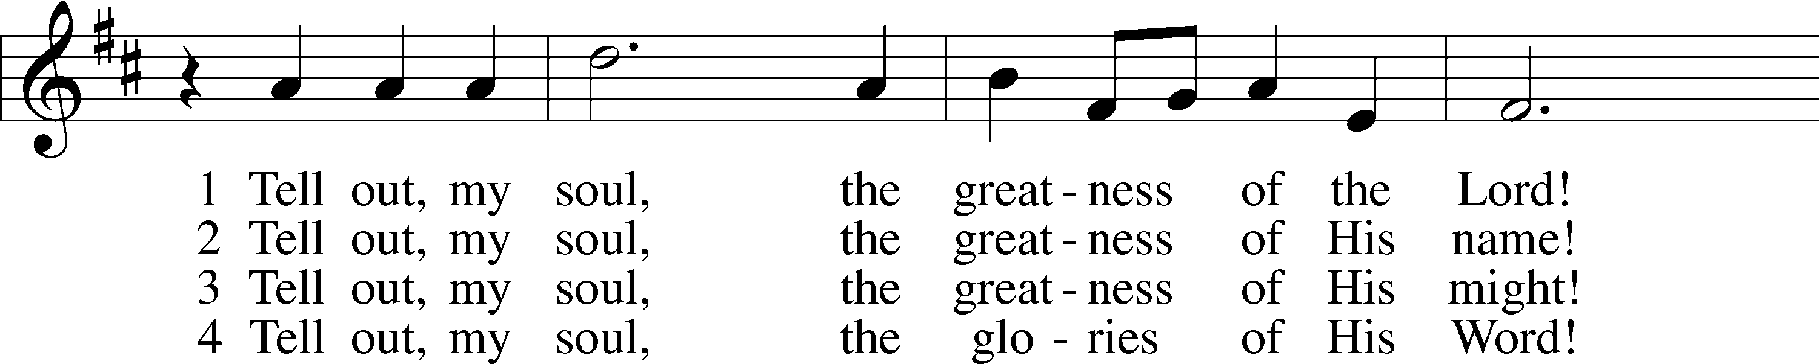
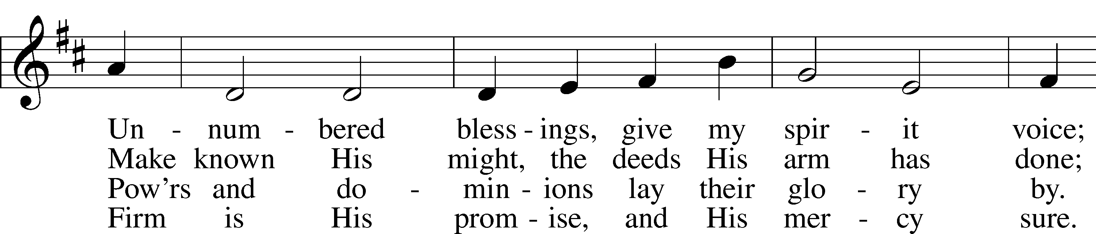
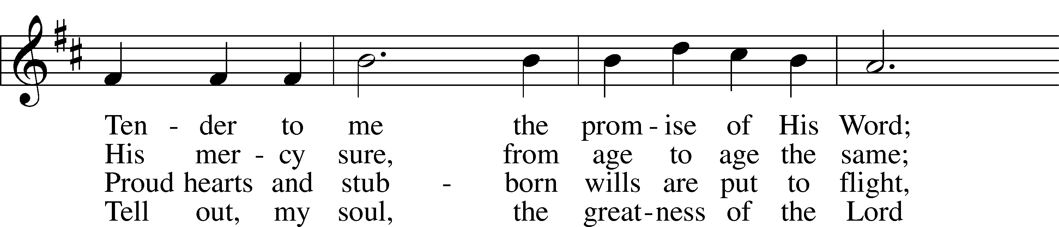
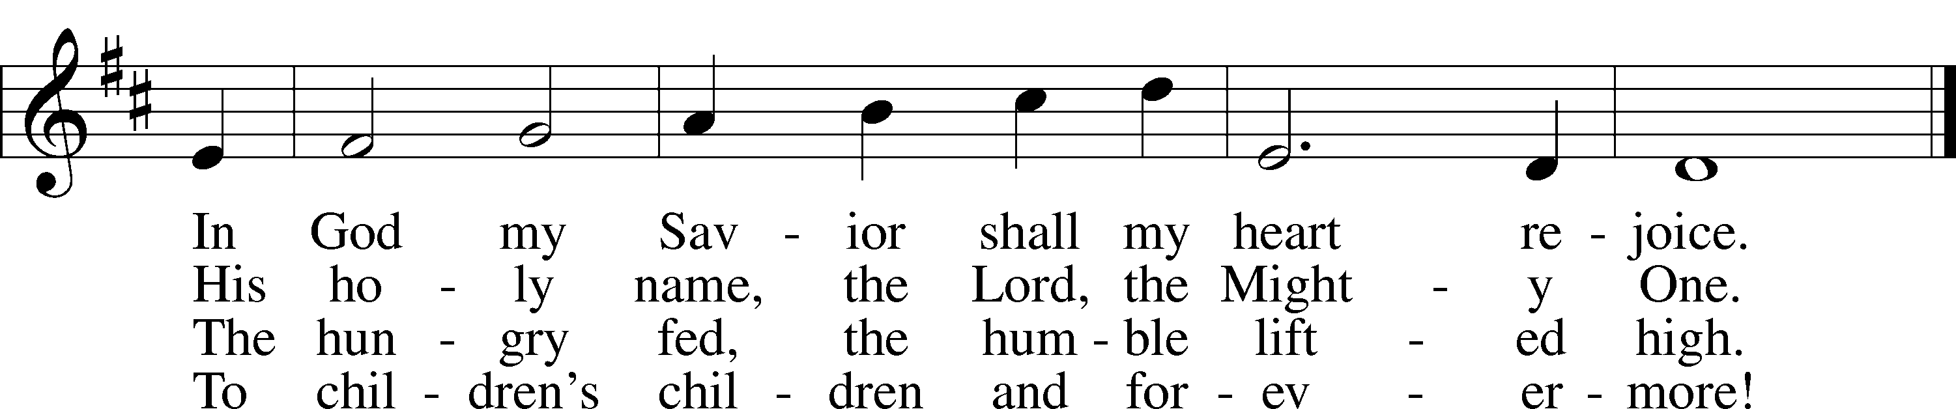
Text: Timothy Dudley-Smith, 1926–2024
Tune: Walter Greatorex, 1877–1949
Text: © 1962, renewed 1990 Hope Publishing Co. Used by permission: LSB Hymn License no. 110005011
Tune: © Oxford University Press. Used by permission: LSB Hymn License no. 110005011

Confession and Absolution

The sign of the cross may be made by all in remembrance of their Baptism.

Invocation Matthew 28:19b; 18:20
P In the name of the Father and of the T Son and of the Holy Spirit.
C Amen.

Exhortation Hebrews 10:22; Psalm 124:8; Psalm 32:5
P Beloved in the Lord! Let us draw near with a true heart and confess our sins unto God our Father, beseeching Him in the name of our Lord Jesus Christ to grant us forgiveness.

P Our help is in the name of the Lord,
C who made heaven and earth.
P I said, I will confess my transgressions unto the Lord,
C and You forgave the iniquity of my sin.

Silence for reflection on God’s Word and for self-examination.

Confession of Sins
P O almighty God, merciful Father,
C I, a poor, miserable sinner, confess unto You all my sins and iniquities with which I have ever offended You and justly deserved Your temporal and eternal punishment. But I am heartily sorry for them and sincerely repent of them, and I pray You of Your boundless mercy and for the sake of the holy, innocent, bitter sufferings and death of Your beloved Son, Jesus Christ, to be gracious and merciful to me, a poor, sinful being.

Absolution [John 20:19–23]
P Upon this your confession, I, by virtue of my office, as a called and ordained servant of the Word, announce the grace of God unto all of you, and in the stead and by the command of my Lord Jesus Christ I forgive you all your sins in the name of the Father and of the T Son and of the Holy Spirit.
C Amen.

Service of the Word

Introit Psalm 125
1Those who trust in the Lord are like Mount Zion,
which cannot be moved, but abides forever.
2As the mountains surround Jerusalem,
so the Lord surrounds his people,
from this time forth and forevermore.
3For the scepter of wickedness shall not rest
on the land allotted to the righteous,
lest the righteous stretch out
their hands to do wrong.
4Do good, O Lord, to those who are good,
and to those who are upright in their hearts!
5But those who turn aside to their crooked ways
the Lord will lead away with evildoers!
Peace be upon Israel!

Gloria Patri
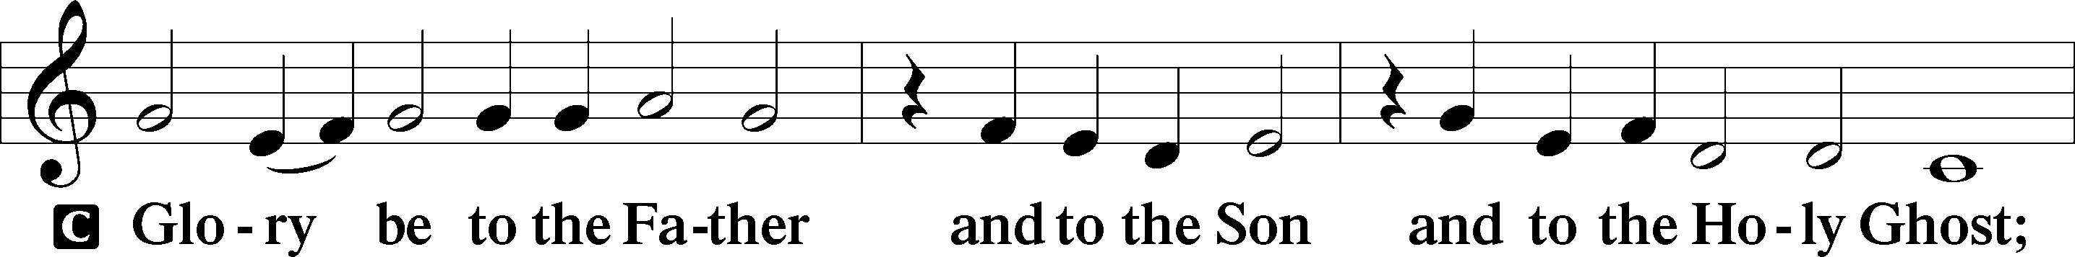
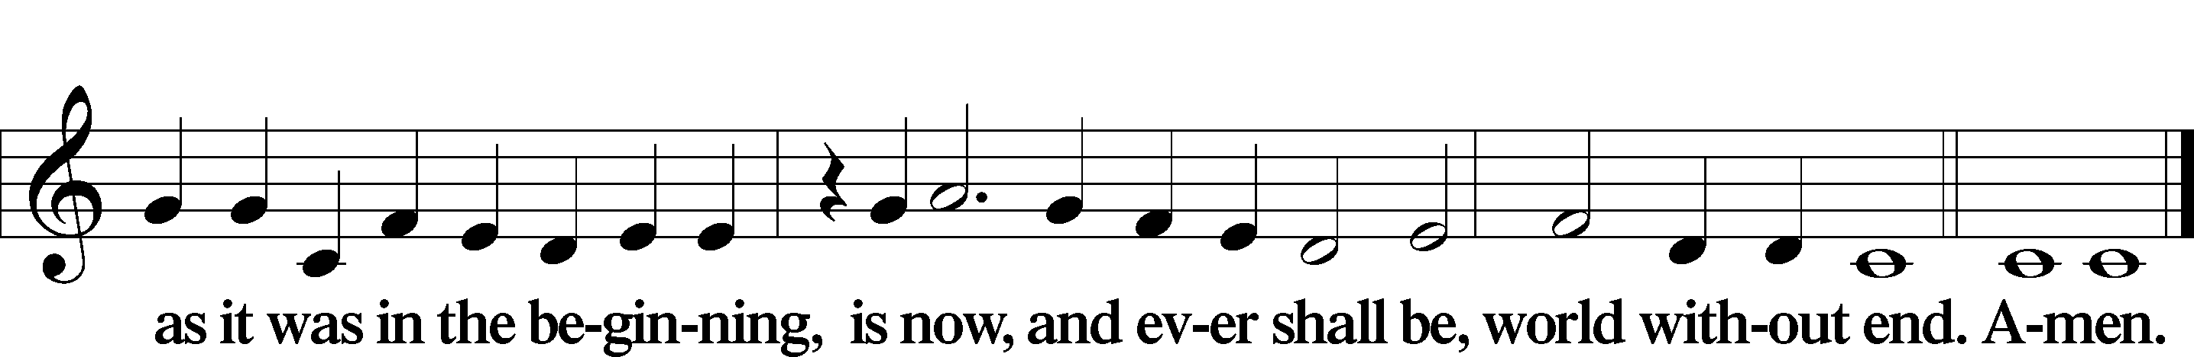

Kyrie Mark 10:47
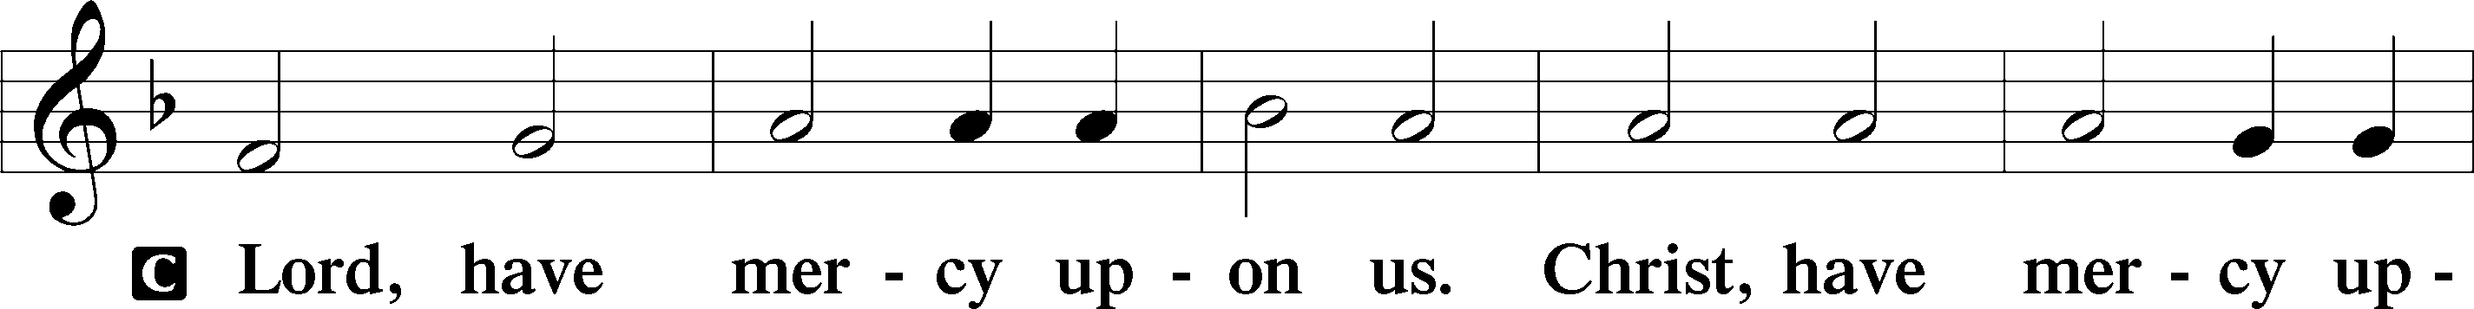
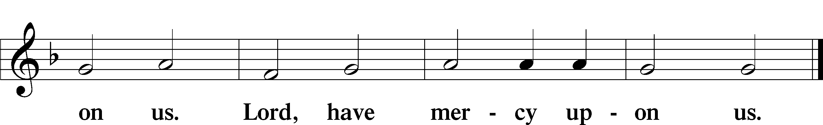

Gloria in Excelsis Luke 2:14; John 1:29
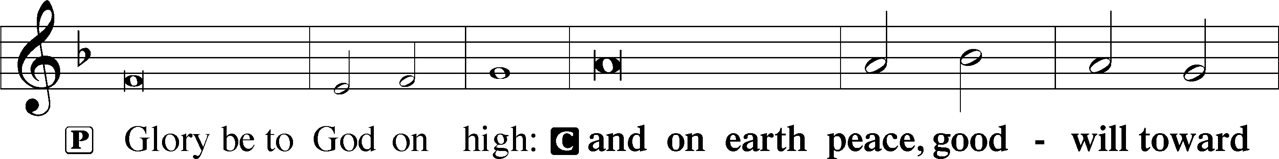
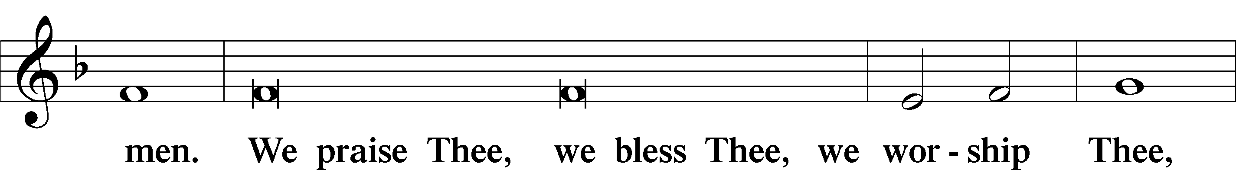
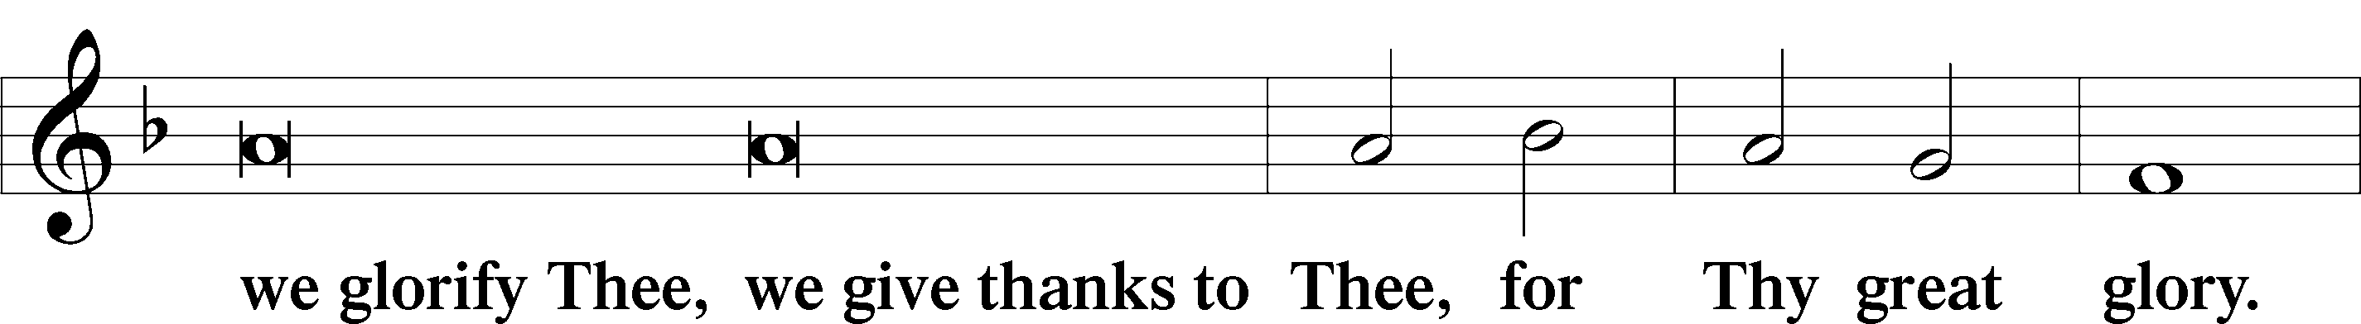
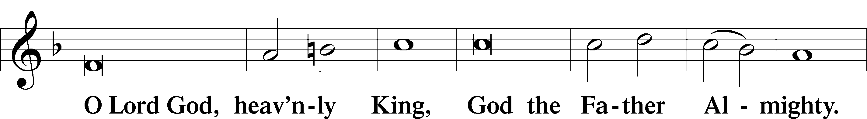
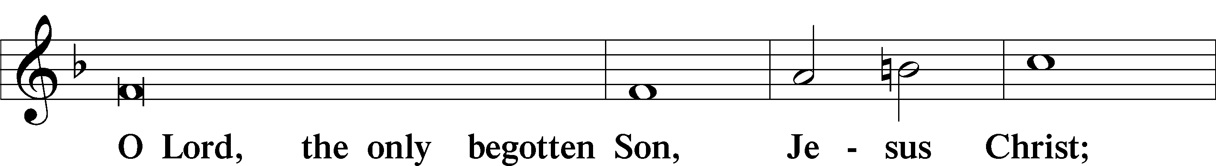
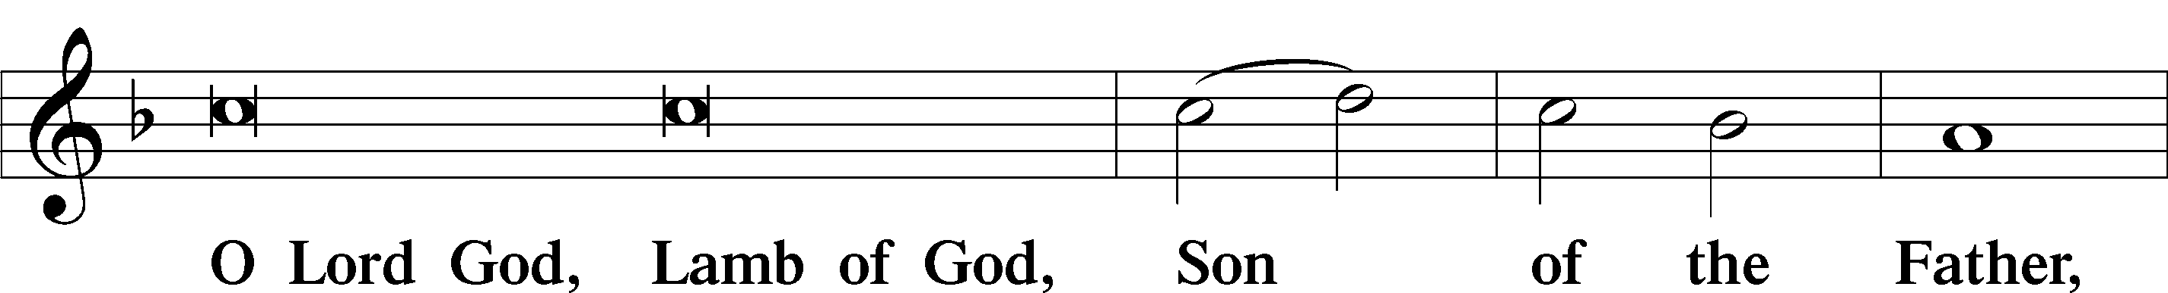
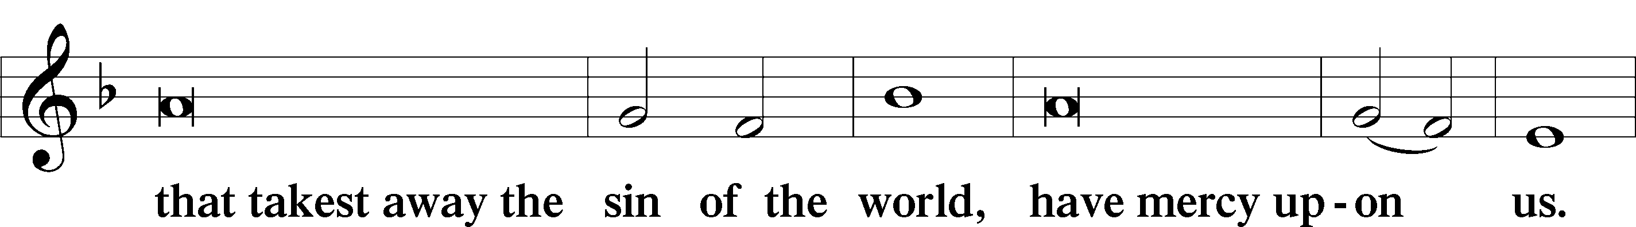
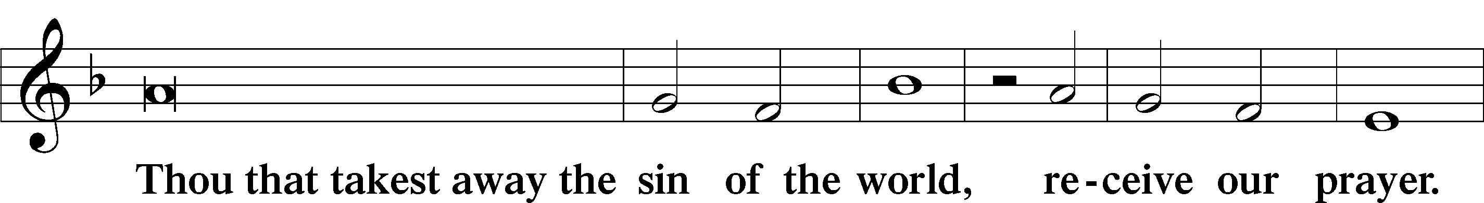
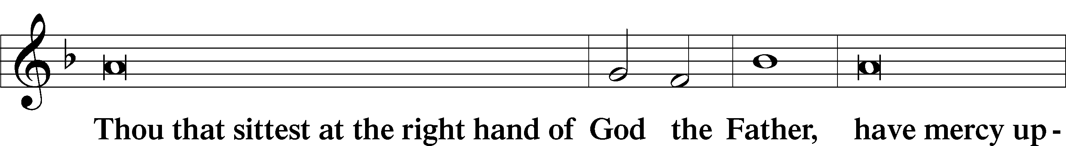
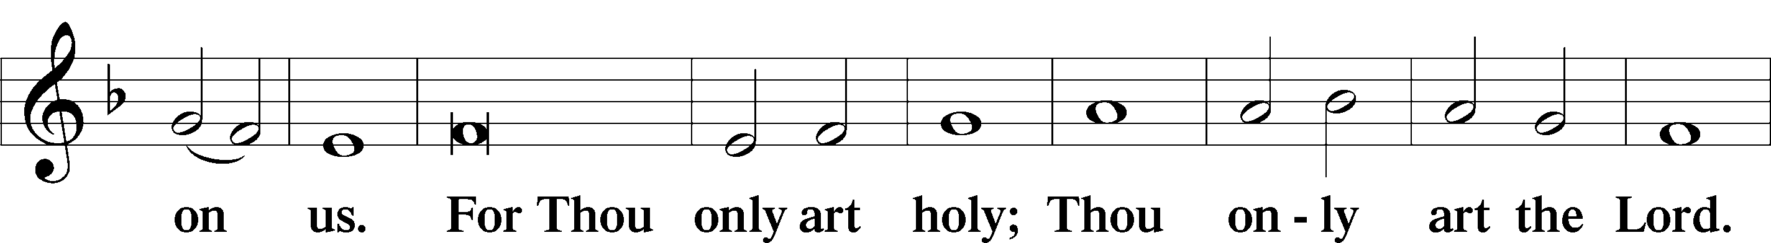
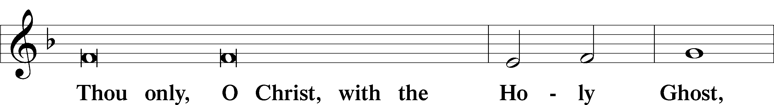
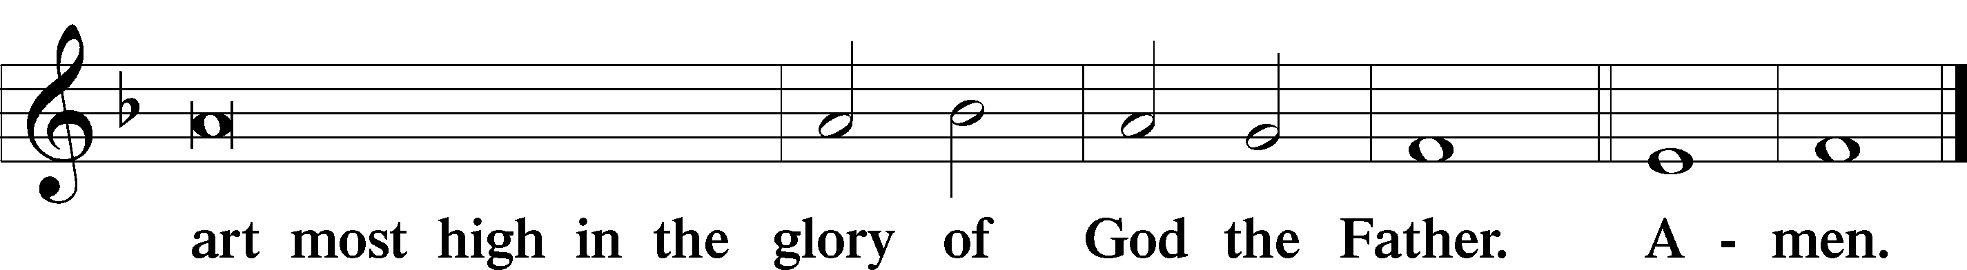

Salutation and Collect of the Day
P The Lord be with you.
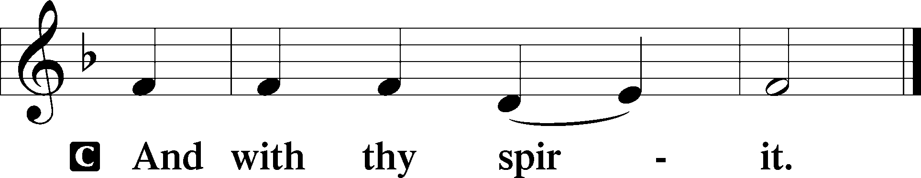

P Let us pray.
Almighty and everlasting God, give us an increase of faith, hope, and love, that, receiving what You have promised, we may love what You have commanded; through Jesus Christ, Your Son, our Lord, who lives and reigns with You and the Holy Spirit, one God, now and forever.

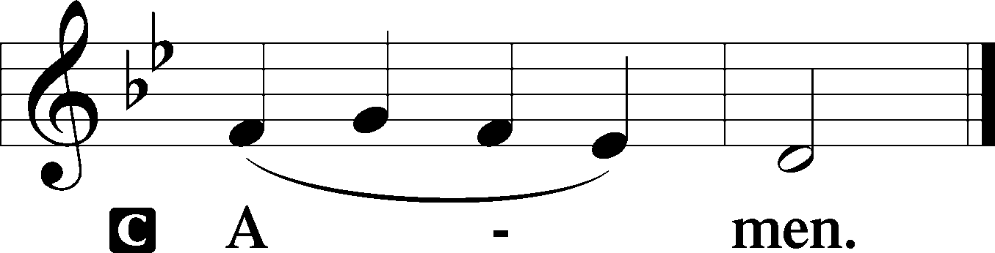

Sit
Old Testament Reading Deuteronomy 7:6–9
6“You are a people holy to the Lord your God. The Lord your God has chosen you to be a people for his treasured possession, out of all the peoples who are on the face of the earth. 7It was not because you were more in number than any other people that the Lord set his love on you and chose you, for you were the fewest of all peoples, 8but it is because the Lord loves you and is keeping the oath that he swore to your fathers, that the Lord has brought you out with a mighty hand and redeemed you from the house of slavery, from the hand of Pharaoh king of Egypt. 9Know therefore that the Lord your God is God, the faithful God who keeps covenant and steadfast love with those who love him and keep his commandments, to a thousand generations.”

A This is the Word of the Lord.
C Thanks be to God.

Gradual Romans 11:33, 36
Oh, the depth of the riches and wisdom and knowledge of God!
How unsearchable are his judgments and how inscrutable his ways!
For from him and through him and to him are all things.
To him be glory forever. Amen.

Epistle Romans 8:28–39
28We know that for those who love God all things work together for good, for those who are called according to his purpose. 29For those whom he foreknew he also predestined to be conformed to the image of his Son, in order that he might be the firstborn among many brothers. 30And those whom he predestined he also called, and those whom he called he also justified, and those whom he justified he also glorified. 31What then shall we say to these things? If God is for us, who can be against us? 32He who did not spare his own Son but gave him up for us all, how will he not also with him graciously give us all things? 33Who shall bring any charge against God’s elect? It is God who justifies. 34Who is to condemn? Christ Jesus is the one who died—more than that, who was raised—who is at the right hand of God, who indeed is interceding for us. 35Who shall separate us from the love of Christ? Shall tribulation, or distress, or persecution, or famine, or nakedness, or danger, or sword? 36As it is written, “For your sake we are being killed all the day long;
we are regarded as sheep to be slaughtered.” 37No, in all these things we are more than conquerors through him who loved us. 38For I am sure that neither death nor life, nor angels nor rulers, nor things present nor things to come, nor powers, 39nor height nor depth, nor anything else in all creation, will be able to separate us from the love of God in Christ Jesus our Lord.

Stand

Alleluia
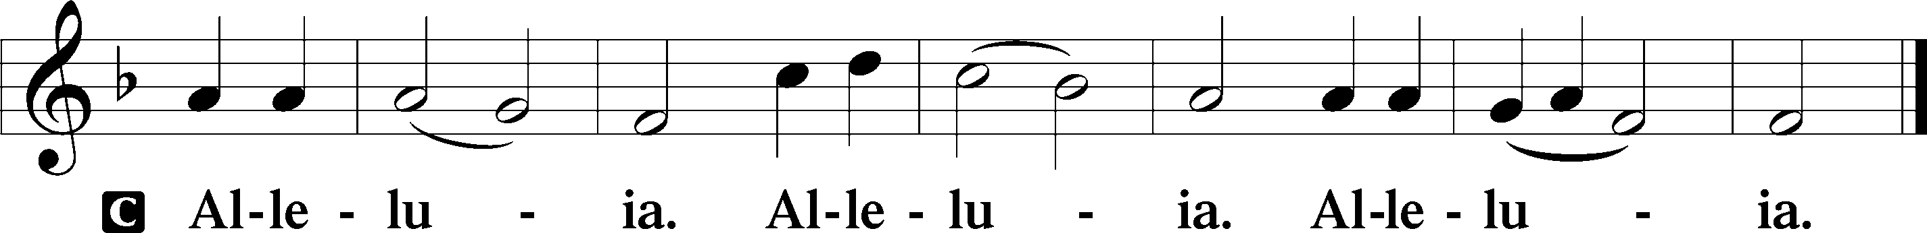

Holy Gospel Matthew 13:44–52
P The Holy Gospel according to St. Matthew, the thirteenth chapter.

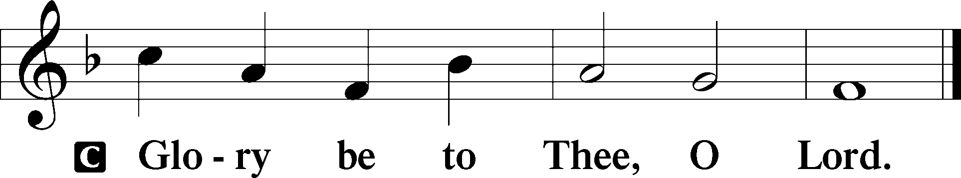

44[Jesus said:] “The kingdom of heaven is like treasure hidden in a field, which a man found and covered up. Then in his joy he goes and sells all that he has and buys that field. 45“Again, the kingdom of heaven is like a merchant in search of fine pearls, 46who, on finding one pearl of great value, went and sold all that he had and bought it. 47“Again, the kingdom of heaven is like a net that was thrown into the sea and gathered fish of every kind. 48When it was full, men drew it ashore and sat down and sorted the good into containers but threw away the bad. 49So it will be at the close of the age. The angels will come out and separate the evil from the righteous 50and throw them into the fiery furnace. In that place there will be weeping and gnashing of teeth. 51“Have you understood all these things?” They said to him, “Yes.” 52And he said to them, “Therefore every scribe who has been trained for the kingdom of heaven is like a master of a house, who brings out of his treasure what is new and what is old.”

P This is the Gospel of the Lord.

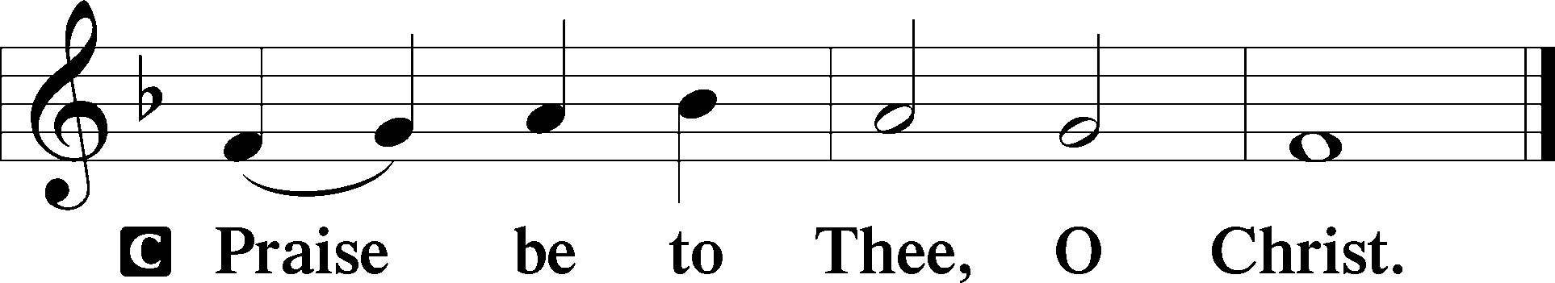

Apostles’ Creed
C I believe in God, the Father Almighty,
maker of heaven and earth.

And in Jesus Christ, His only Son, our Lord,
who was conceived by the Holy Spirit,
born of the virgin Mary,
suffered under Pontius Pilate,
was crucified, died and was buried.
He descended into hell.
The third day He rose again from the dead.
He ascended into heaven
and sits at the right hand of God the Father Almighty.
From thence He will come to judge the living and the dead.

I believe in the Holy Spirit,
the holy Christian Church,
the communion of saints,
the forgiveness of sins,
the resurrection of the body,
and the life T everlasting. Amen.

Sit

Children's Sermon

573 Lord, ’Tis Not That I Did Choose Thee
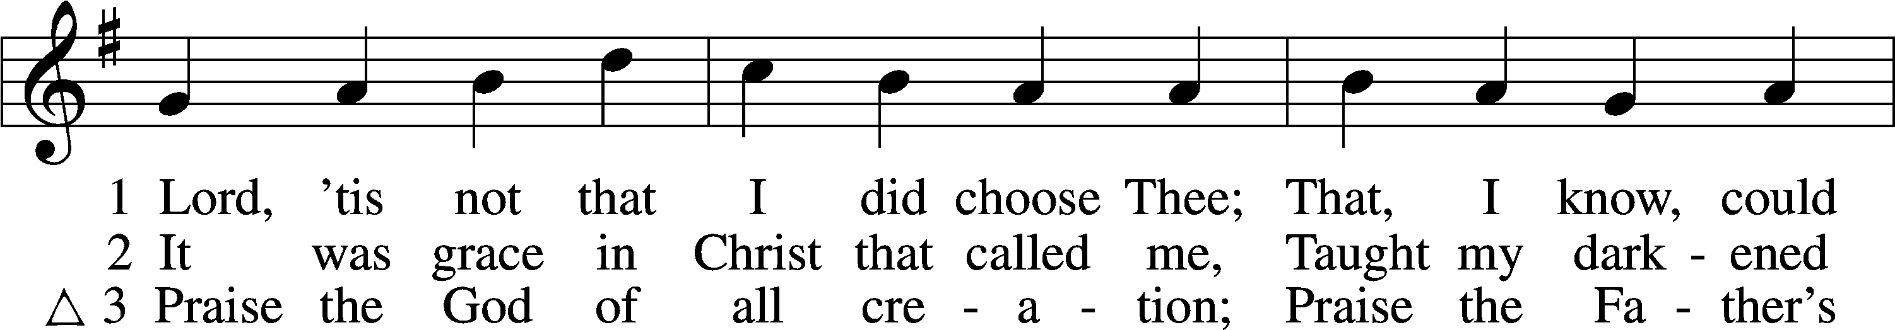
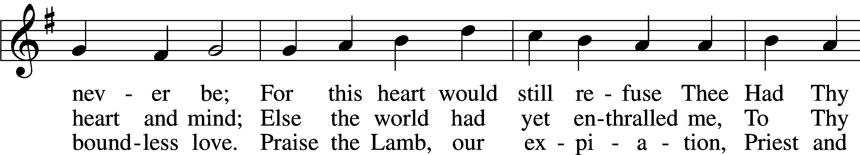
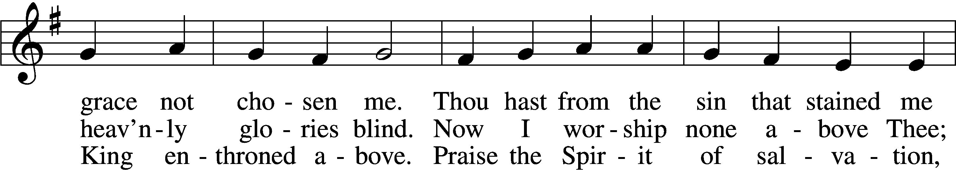
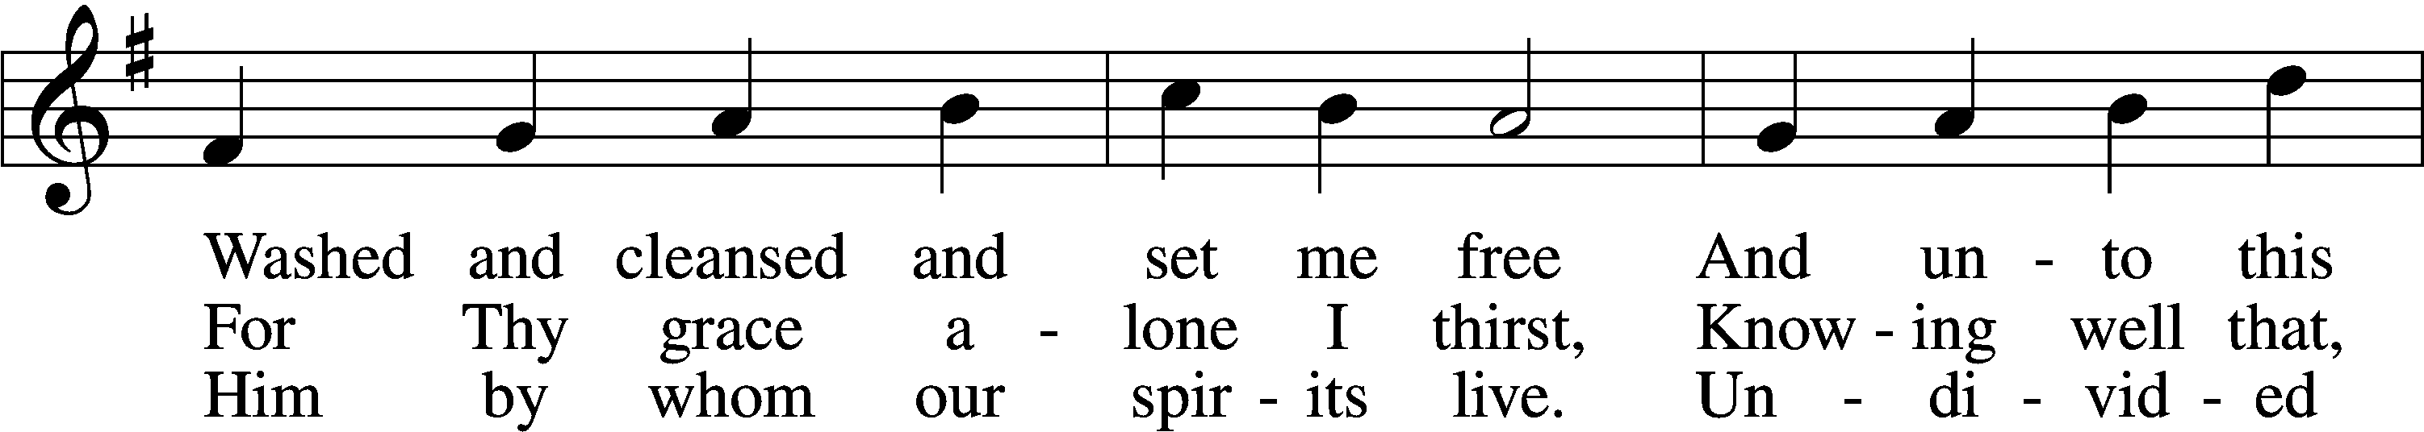
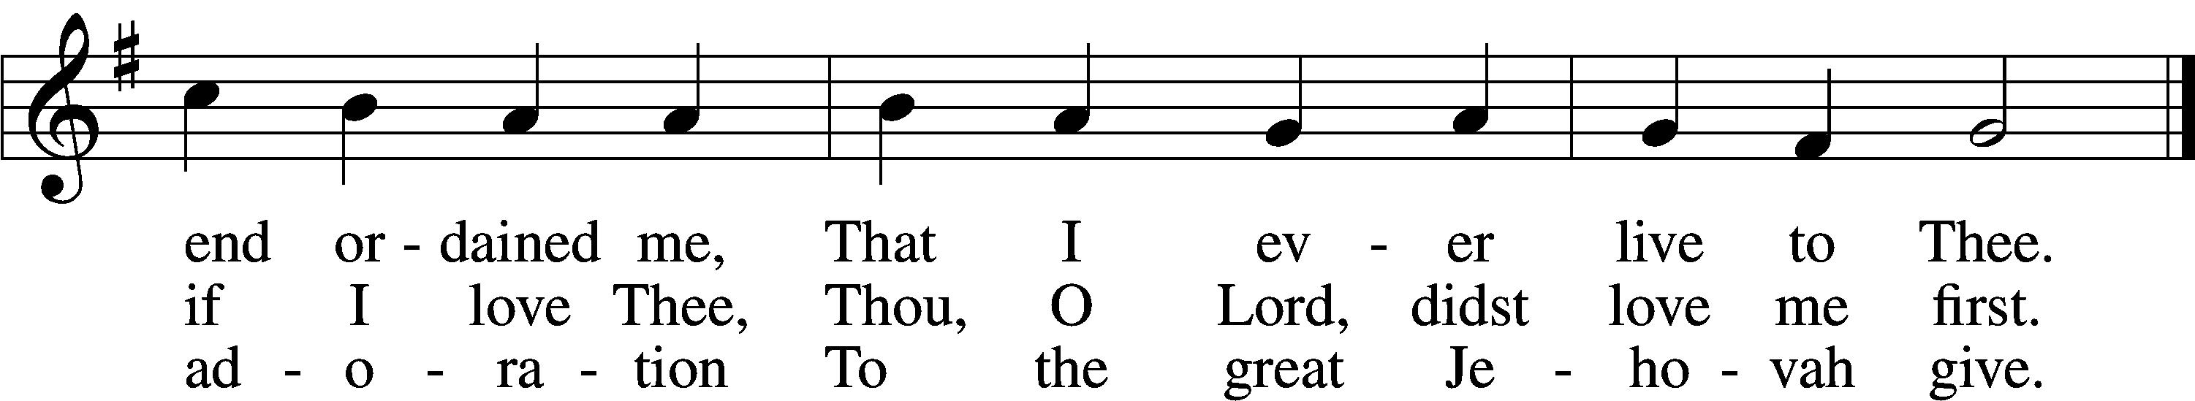
Text: Josiah Conder, 1789–1855, alt.
Tune: Erbaulicher Musicalischer Christen-Schatz, 1745, Basel
Text and tune: Public domain

Sermon

Votum
P The peace of God, which passes all understanding, keep your hearts and minds in Christ Jesus.
C Amen.

Stand

Offertory Psalm 51:10–12
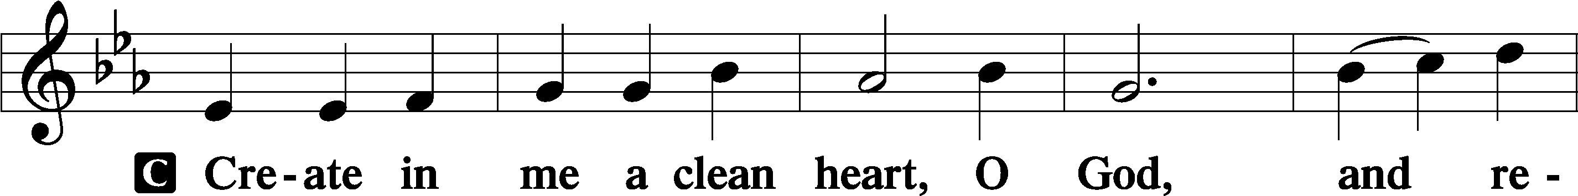
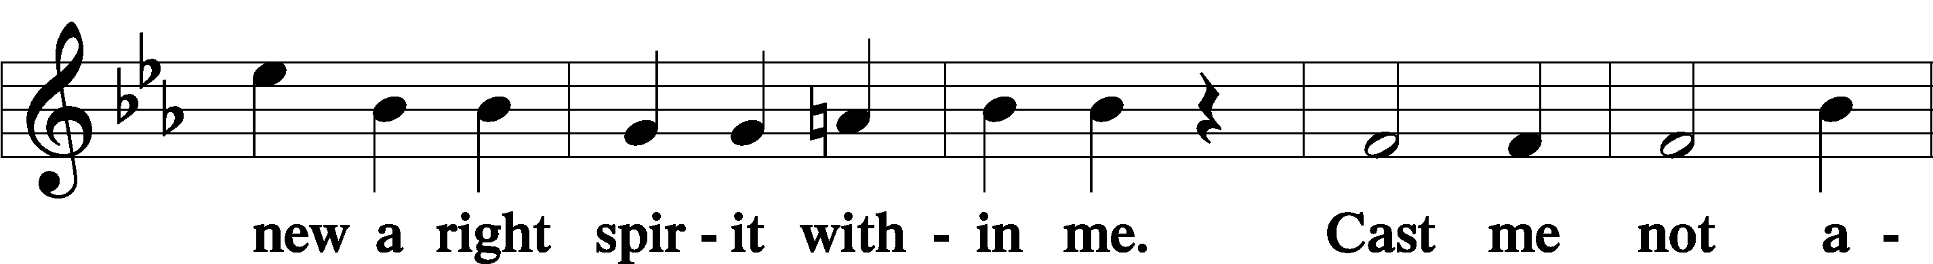
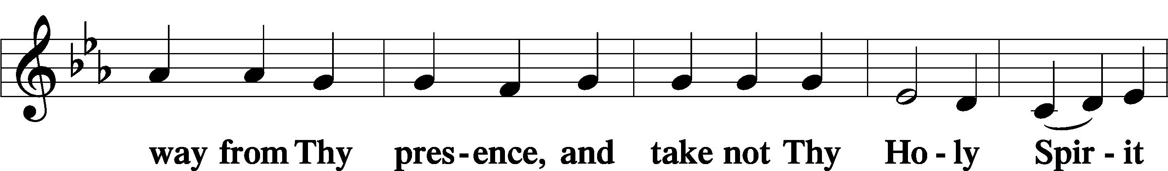
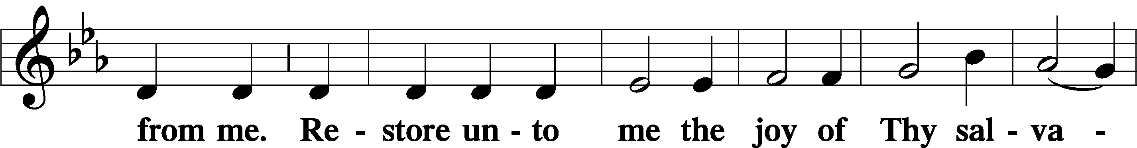
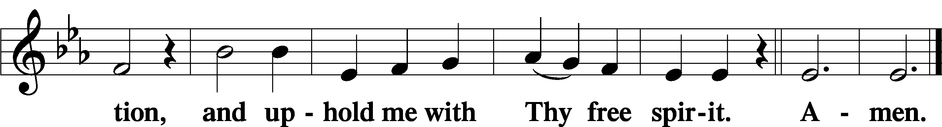

Offering

805 Praise God, from Whom All Blessings Flow
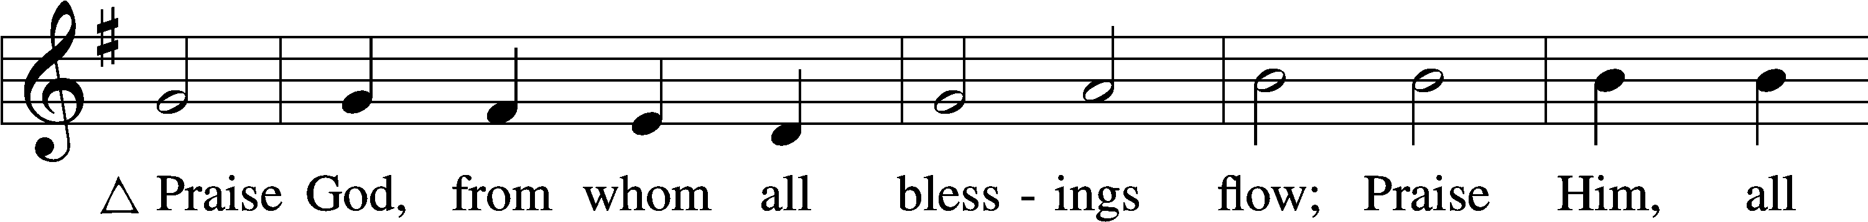
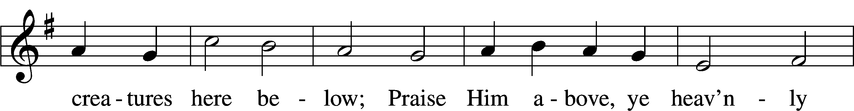
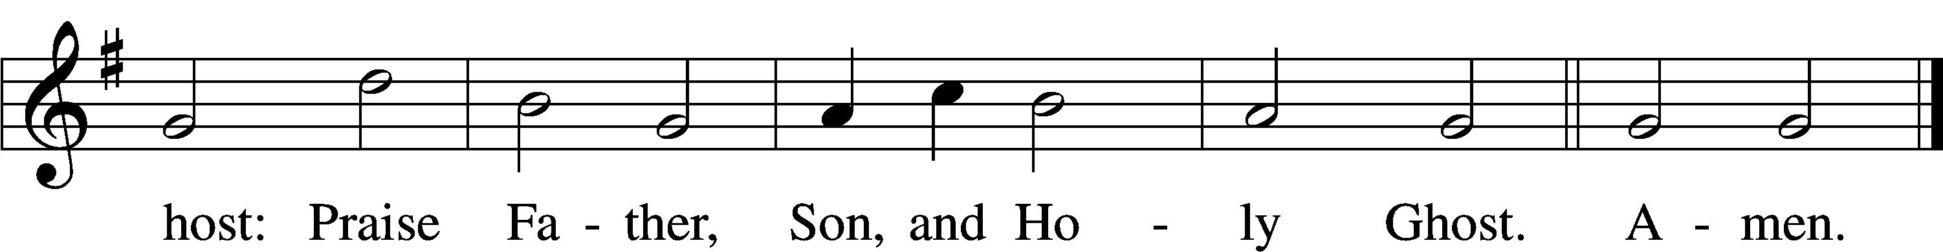
Text: Thomas Ken, 1637–1711
Tune: Trente quatre Pseaumes de David, 1551, Geneva, ed. Louis Bourgeois
Text and tune: Public domain

Prayer of the Church

Lord’s Prayer Matthew 6:9–13
P Lord, remember us in Your kingdom and teach us to pray:
C Our Father who art in heaven,
hallowed be Thy name,
Thy kingdom come,
Thy will be done on earth
as it is in heaven;
give us this day our daily bread;
and forgive us our trespasses
as we forgive those
who trespass against us;
and lead us not into temptation,
but deliver us from evil.
For Thine is the kingdom
and the power and the glory
forever and ever. Amen.

Collect for the Word

Blessed Lord, You have caused all Holy Scriptures to be written for our learning. Grant that we may so hear them, read, mark, learn, and inwardly digest them that, by the patience and comfort of Your holy Word, we may embrace and ever hold fast the blessed hope of everlasting life; through Jesus Christ, Your Son, our Lord, who lives and reigns with You and the Holy Spirit, one God, now and forever.

Benediction
P The Lord bless you and keep you.
The Lord make His face shine on you and be gracious to you.
The Lord look upon you with favor and T give you peace.
C Amen.

803 Joyful, Joyful We Adore Thee
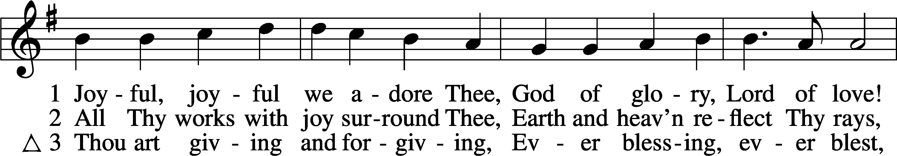
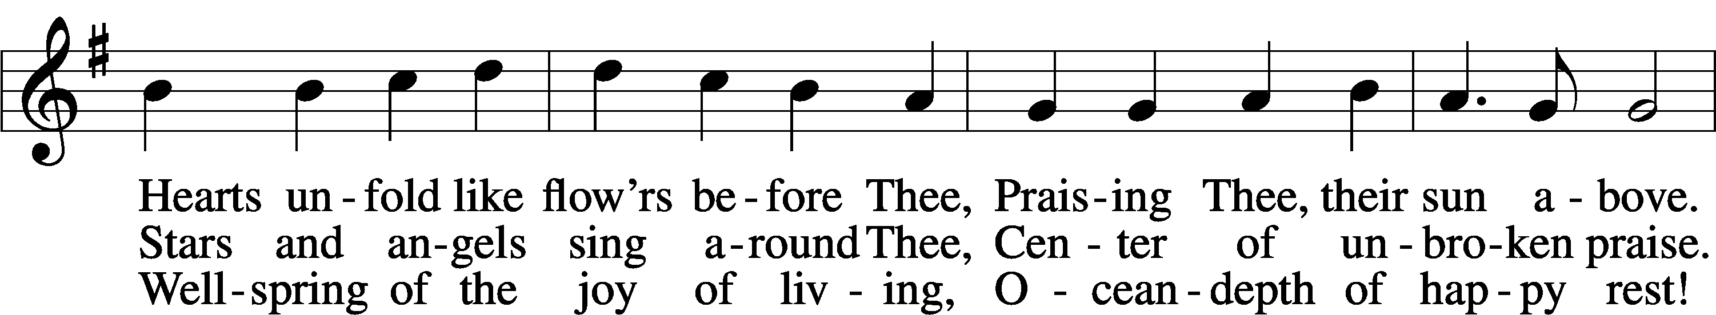
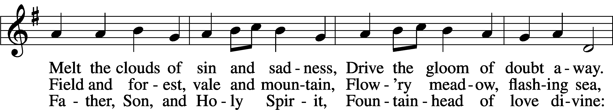
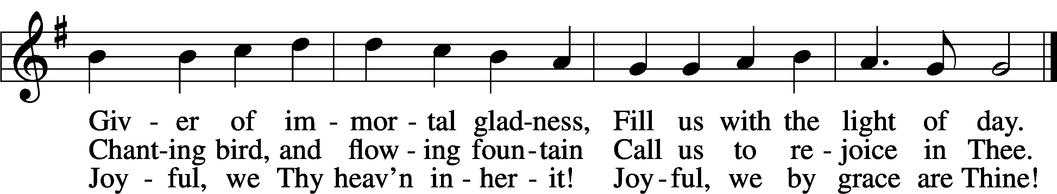
Text: Henry Van Dyke, 1852–1933, alt.
Tune: Ludwig van Beethoven, 1770–1827; adapt. Edward Hodges, 1796–1867
Text and tune: Public domain
Acknowledgments
Unless otherwise indicated, Scripture quotations are from the ESV® Bible (The Holy Bible, English Standard Version®), copyright © 2001 by Crossway, a publishing ministry of Good News Publishers. Used by permission. All rights reserved.
Created by Lutheran Service Builder © 2026 Concordia Publishing House.

