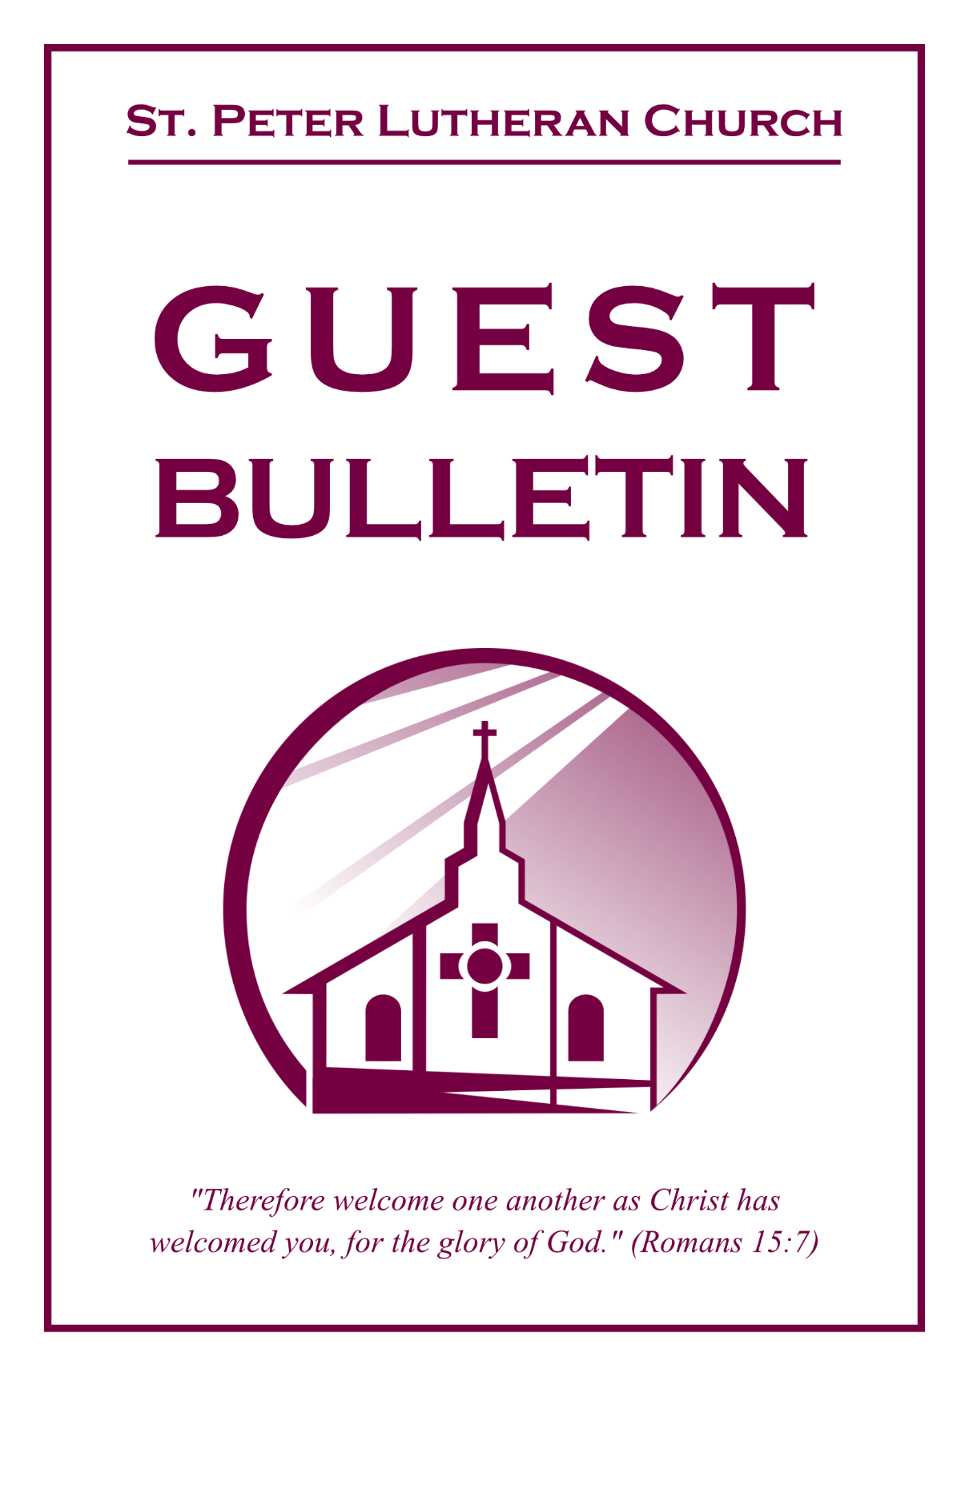

October 11, 2026



St. Peter Lutheran Church
Missouri Synod
906 Highway 59N, P.O. Box 133

Bowie, Texas 76230

Church (940) 872-1886 Fax ((940) 872-8837

Church E-mail: stpetertexscty@gmail.com
To Our Guests and Visitors:

We welcome all our friends in Christ who have come to worship with us. If you are a guest, please feel at home with us, sign our guest register, and worship with us whenever you are able. If you do not have a church home, we invite you to
consider becoming a part of our church family.

Website: www.stpetertex.com
Communion Statement:

The Lord’s Supper is celebrated at this congregation in the confession and glad confidence that, as He says, our Lord gives into our mouths not only bread and wine but His very Body and Blood to eat and drink for the forgiveness of sins and to strengthen our union with Him and one another.

Our Lord invites to His table those who trust in His words, repent of all sin, and set aside any refusal to forgive and love as He forgives and loves us, that they may show forth His death until He comes.

Because those who eat and drink our Lord’s Body and Blood unworthily do so to their great harm, and because Holy Communion is a confession of the faith, which is confessed at this altar, guests who are not confirmed members of an LCMS congregation and have not previously communed at this altar, are asked to first speak with our pastor.

If you are unable to do so before the service, it is out of Christian love and care for your souls that we ask you to refrain from communing this morning.

For further study, please see Matthew 5:23ff, 10:32ff, 18:15–35, 26:26–29; 1 Corinthians 11:17–34.

If you desire to receive a blessing for yourself or your children, please approach during
communion, cross your arms over your chest and bow your head as you kneel at the
altar rail.

Who Receives the Sacrament of the Altar Worthily?
Fasting and bodily preparation are certainly fine outward training. But that person is truly worthy and well prepared who has faith in these words: “Given and shed for you for the forgiveness of sins.” But anyone who does not believe these words or doubts them is unworthy and unprepared; for the words “for you” require all hearts to believe.
How May I Prepare?
See Dr. Luther’s self–examination questions and answers in the
LSB Hymnal on page 329

Upon entering the Sanctuary. please turn off cell phones, pagers. etc. Use the time as a quiet time for personal reflection and meditation in preparation for worship. This is a time for anyone to join in praying for the service, and for the church in general.
515 Rejoice, Rejoice, Believers
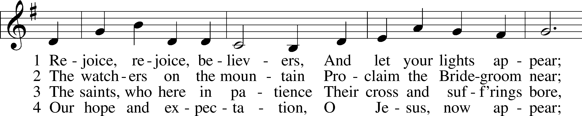
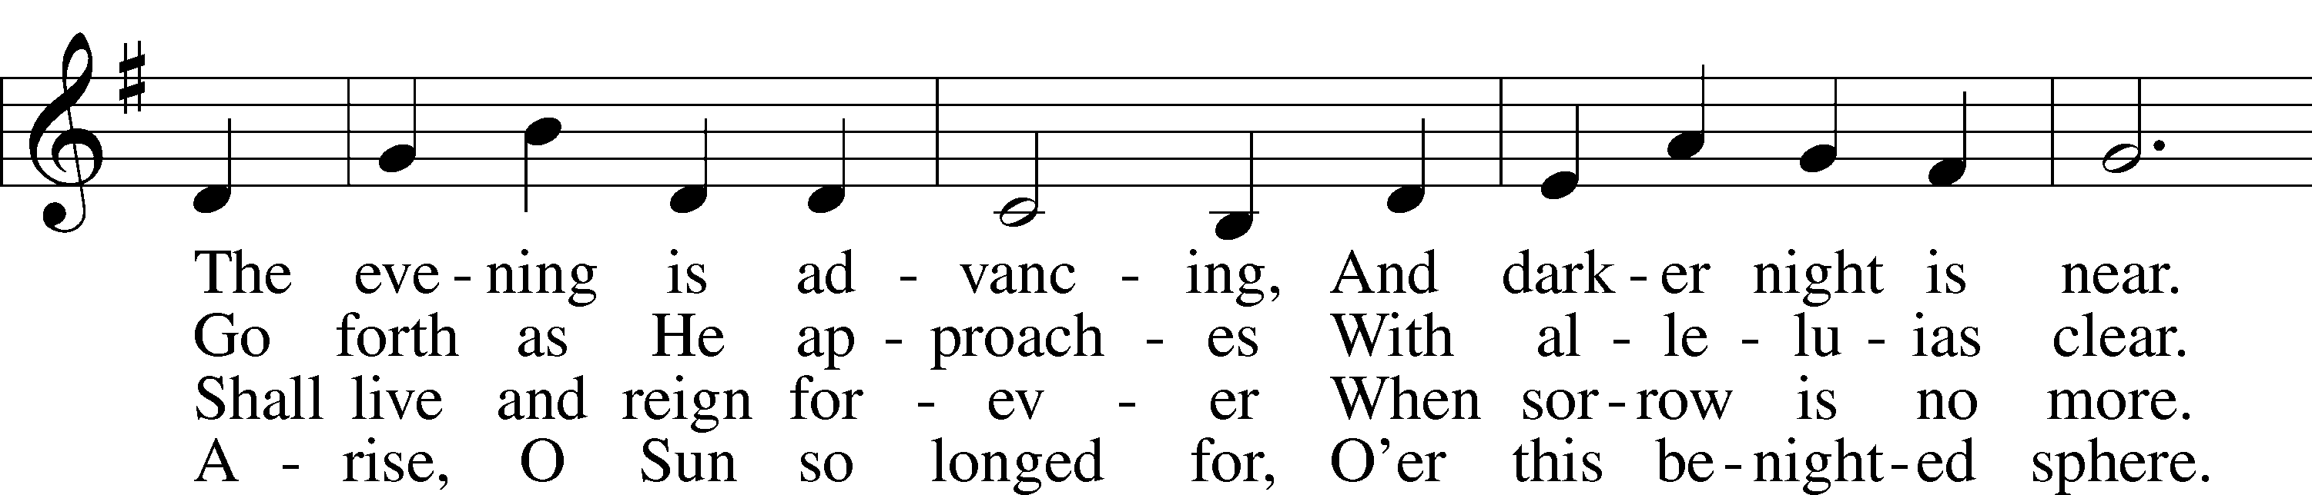
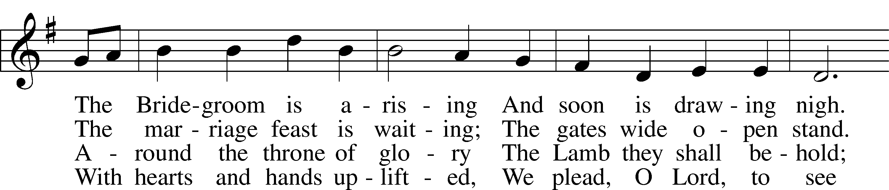
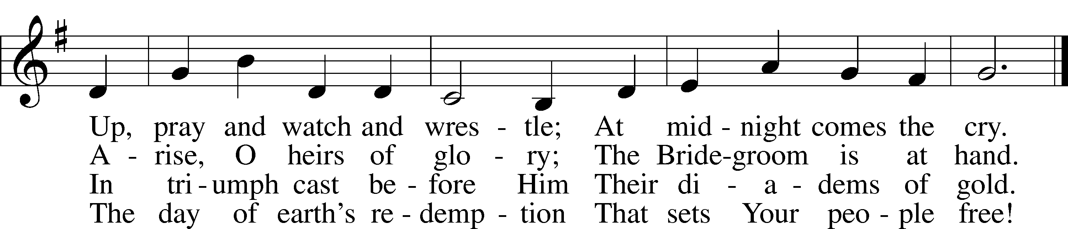
Text: Laurentius Laurenti, 1660–1722; tr. Sarah B. Findlater, 1823–1907, alt.
Tune: Swedish
Text and tune: Public domain
Confession and Absolution
The sign of the cross may be made by all in remembrance of their Baptism.

Invocation
P In the name of the Father and of the T Son and of the Holy Spirit.
C Amen.

Exhortation Hebrews 10:22; Psalm 124:8; Psalm 32:5
P Beloved in the Lord! Let us draw near with a true heart and confess our sins unto God our Father, beseeching Him in the name of our Lord Jesus Christ to grant us forgiveness.
P Our help is in the name of the Lord,
C who made heaven and earth.
P I said, I will confess my transgressions unto the Lord,
C and You forgave the iniquity of my sin.

Silence for reflection on God’s Word and for self-examination.

Confession of Sins
P Almighty God, our maker and redeemer, we poor sinners confess unto You that we are by nature sinful and unclean and that we have sinned against You by thought, word, and deed. Wherefore we flee for refuge to Your infinite mercy, seeking and imploring Your grace for the sake of our Lord Jesus Christ.
C O most merciful God, who has given Your only-begotten Son to die for us, have mercy upon us and for His sake grant us remission of all our sins; and by Your Holy Spirit increase in us true knowledge of You and of Your will and true obedience to Your Word, to the end that by Your grace we may come to everlasting life; through Jesus Christ, our Lord. Amen.

Declaration of Grace Mark 16:16; John 1:12
P Almighty God, our heavenly Father, has had mercy upon us and has given His only Son to die for us and for His sake forgives us all our sins. To those who believe on His name He gives power to become the children of God and has promised them His Holy Spirit. He that believes and is baptized shall be saved.
Grant this, Lord, unto us all.
C Amen.

Service of the Word
Introit Isaiah 61:10; antiphon: Psalm 146:2
I will praise the Lord as long as I live;
I will sing praises to my God while I have my being.
I will greatly rejoice in the Lord;
my soul shall exult in my God,
for he has clothed me with the garments of salvation;
he has covered me with the robe of righteousness,
as a bridegroom decks himself like a priest with a beautiful headdress,
and as a bride adorns herself with her jewels.

Gloria Patri
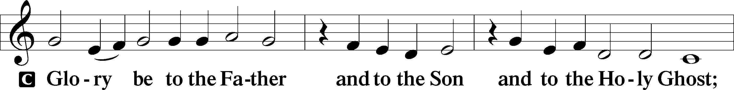
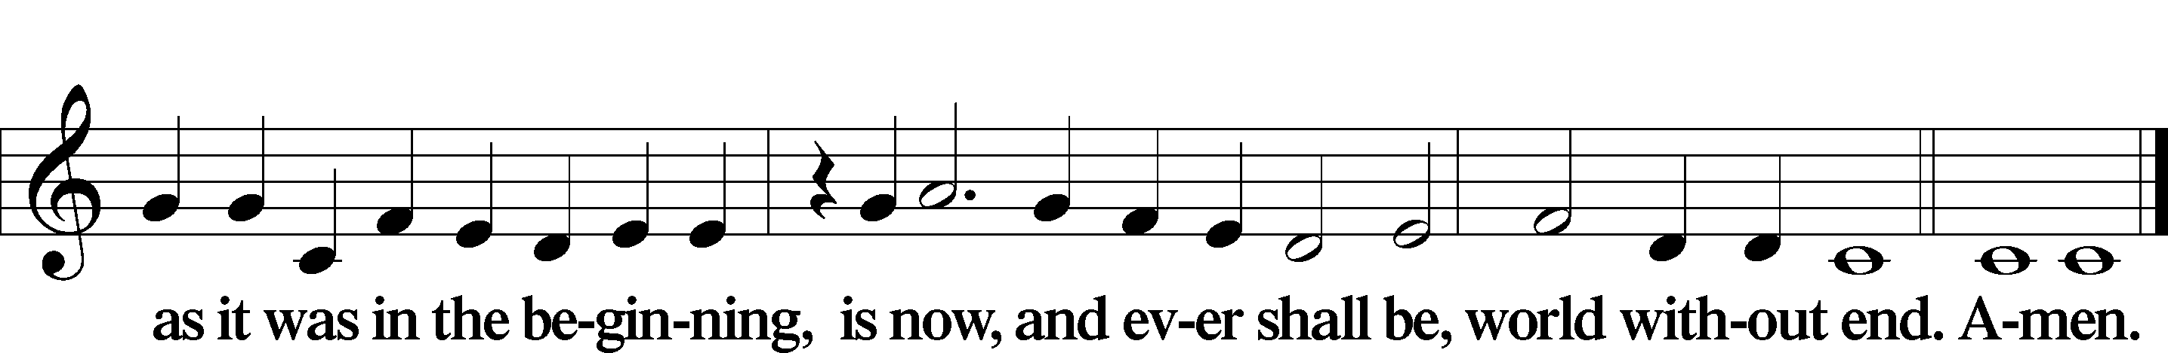

Kyrie Mark 10:47
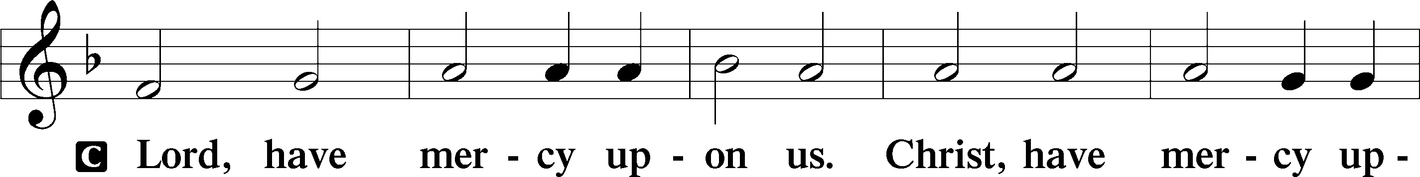
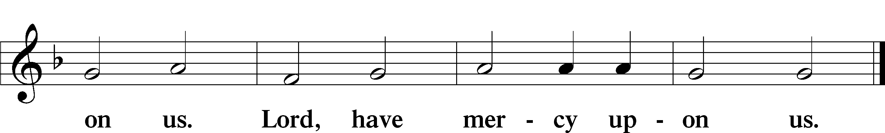

Gloria in Excelsis Luke 2:14; John 1:29
P Glory be to God on high:
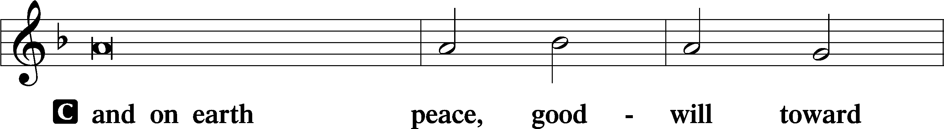
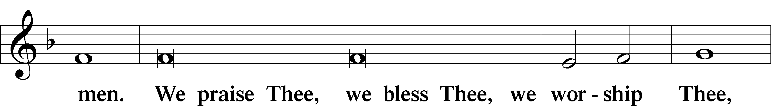
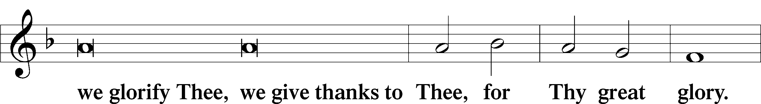
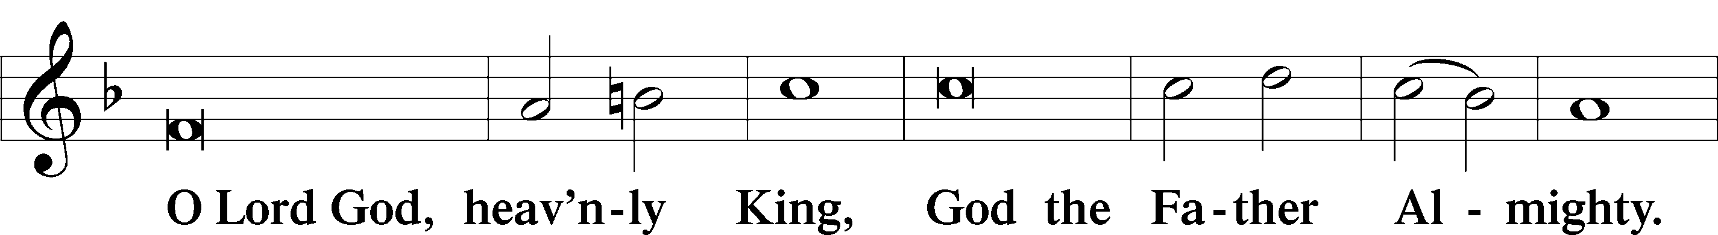
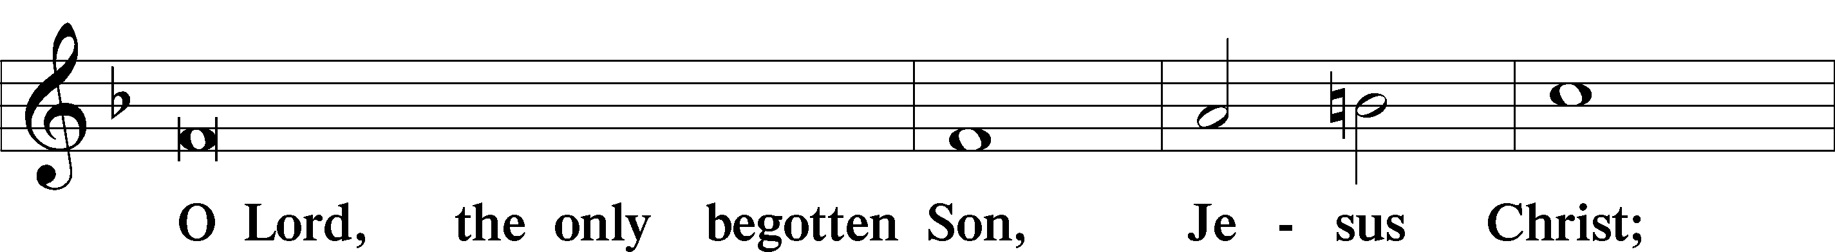
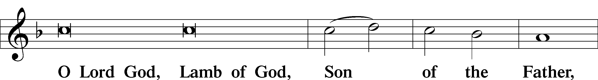
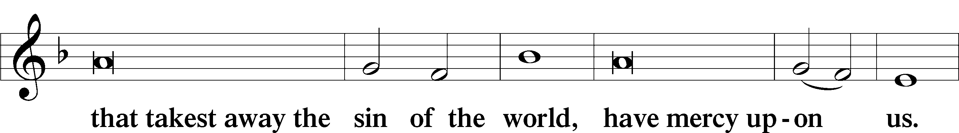
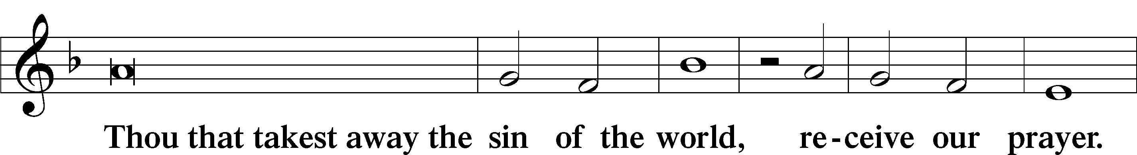
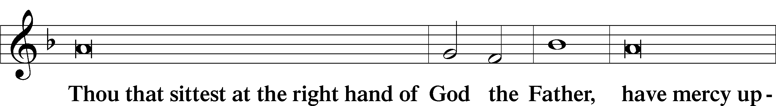
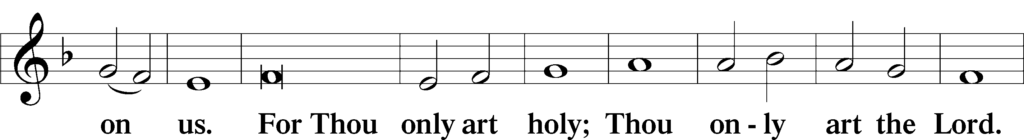
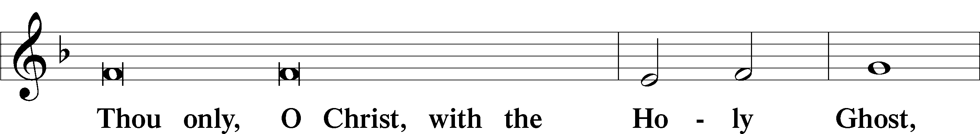
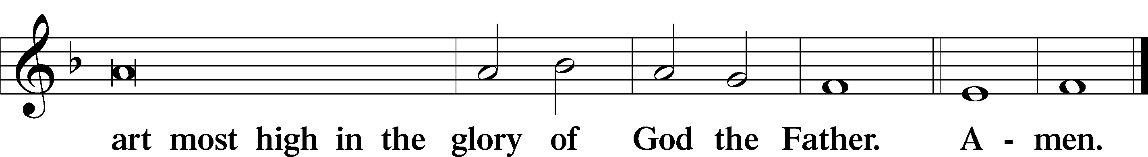

Salutation and Collect of the Day
P The Lord be with you.
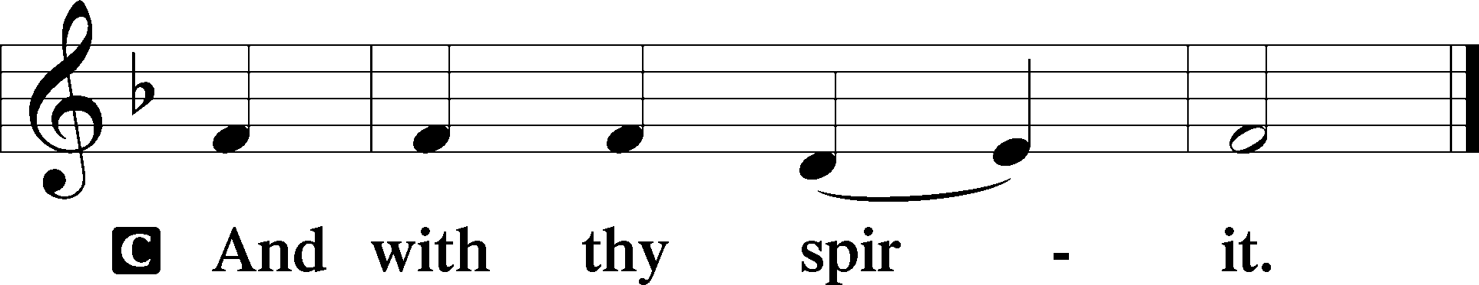

P Let us pray.
Almighty God, You invite us to trust in You for our salvation. Deal with us not in the severity of Your judgment but by the greatness of Your mercy; through Jesus Christ, Your Son, our Lord, who lives and reigns with You and the Holy Spirit, one God, now and forever.

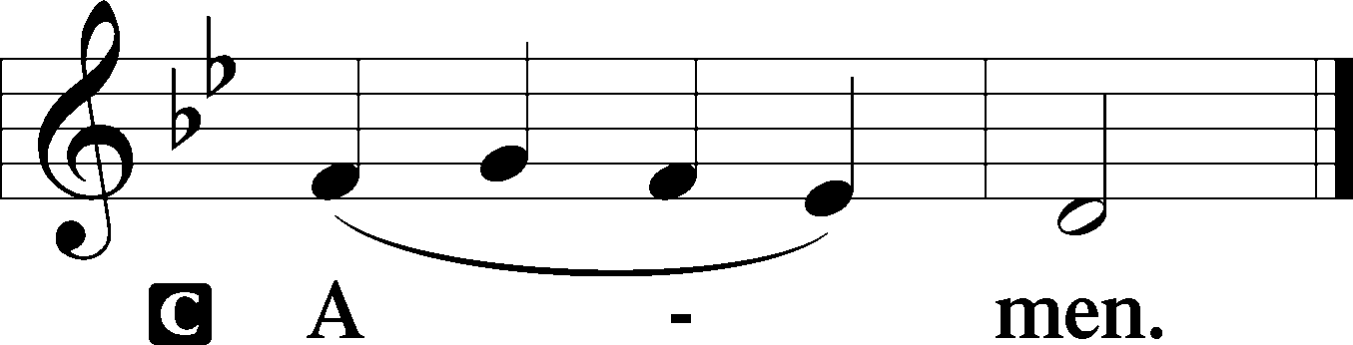

Sit

Old Testament Reading Isaiah 25:6–9
6On this mountain the Lord of hosts will make for all peoples a feast of rich food, a feast of well-aged wine, of rich food full of marrow, of aged wine well refined. 7And he will swallow up on this mountain the covering that is cast over all peoples, the veil that is spread over all nations. 8He will swallow up death forever; and the Lord God will wipe away tears from all faces, and the reproach of his people he will take away from all the earth, for the Lord has spoken. 9It will be said on that day, “Behold, this is our God; we have waited for him, that he might save us. This is the Lord; we have waited for him; let us be glad and rejoice in his salvation.”
A This is the Word of the Lord.
C Thanks be to God.

Gradual Psalm 91:11; 103:1
He will command his angels concerning you
to guard you in all your ways.
Bless the Lord, O my soul,
and all that is within me, bless his holy name!

Epistle Philippians 4:4–13
4Rejoice in the Lord always; again I will say, Rejoice. 5Let your reasonableness be known to everyone. The Lord is at hand; 6do not be anxious about anything, but in everything by prayer and supplication with thanksgiving let your requests be made known to God. 7And the peace of God, which surpasses all understanding, will guard your hearts and your minds in Christ Jesus.8Finally, brothers, whatever is true, whatever is honorable, whatever is just, whatever is pure, whatever is lovely, whatever is commendable, if there is any excellence, if there is anything worthy of praise, think about these things. 9What you have learned and received and heard and seen in me—practice these things, and the God of peace will be with you.10I rejoiced in the Lord greatly that now at length you have revived your concern for me. You were indeed concerned for me, but you had no opportunity. 11Not that I am speaking of being in need, for I have learned in whatever situation I am to be content. 12I know how to be brought low, and I know how to abound. In any and every circumstance, I have learned the secret of facing plenty and hunger, abundance and need. 13I can do all things through him who strengthens me.

Stand

Alleluia
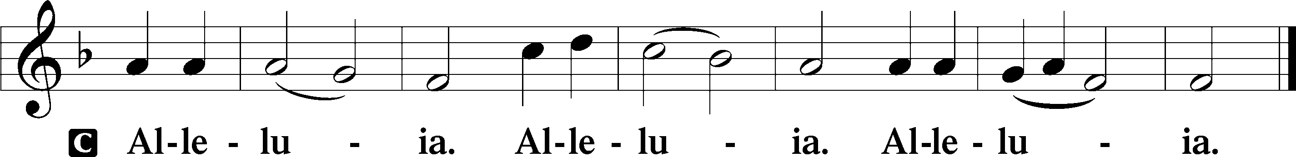

Holy Gospel Matthew 22:1–14
P The Holy Gospel according to St. Matthew, the twenty-second chapter.

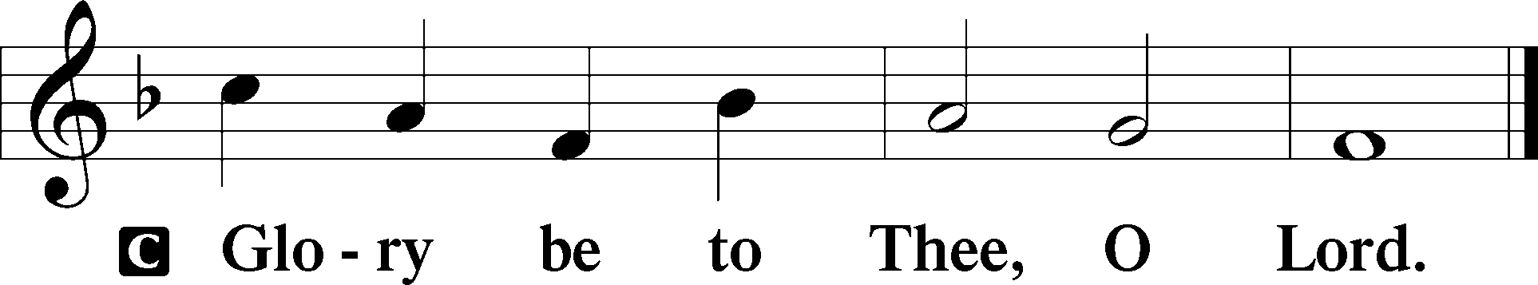

1Again Jesus spoke to them in parables, saying, 2“The kingdom of heaven may be compared to a king who gave a wedding feast for his son, 3and sent his servants to call those who were invited to the wedding feast, but they would not come. 4Again he sent other servants, saying, ‘Tell those who are invited, See, I have prepared my dinner, my oxen and my fat calves have been slaughtered, and everything is ready. Come to the wedding feast.’ 5But they paid no attention and went off, one to his farm, another to his business, 6while the rest seized his servants, treated them shamefully, and killed them. 7The king was angry, and he sent his troops and destroyed those murderers and burned their city. 8Then he said to his servants, ‘The wedding feast is ready, but those invited were not worthy. 9Go therefore to the main roads and invite to the wedding feast as many as you find.’ 10And those servants went out into the roads and gathered all whom they found, both bad and good. So the wedding hall was filled with guests. 11“But when the king came in to look at the guests, he saw there a man who had no wedding garment. 12And he said to him, ‘Friend, how did you get in here without a wedding garment?’ And he was speechless. 13Then the king said to the attendants, ‘Bind him hand and foot and cast him into the outer darkness. In that place there will be weeping and gnashing of teeth.’ 14For many are called, but few are chosen.”
P This is the Gospel of the Lord.

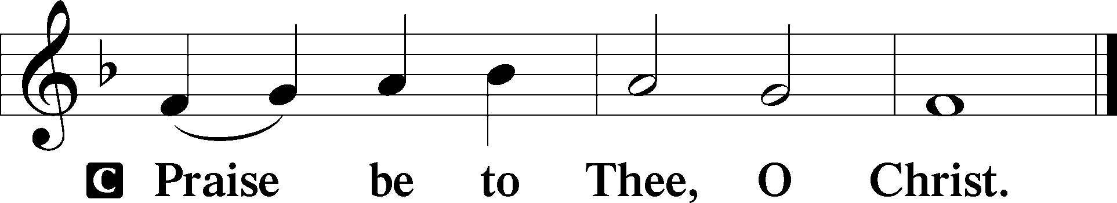

Apostles’ Creed
C I believe in God, the Father Almighty,
maker of heaven and earth.

And in Jesus Christ, His only Son, our Lord,
who was conceived by the Holy Spirit,
born of the virgin Mary,
suffered under Pontius Pilate,
was crucified, died and was buried.
He descended into hell.
The third day He rose again from the dead.
He ascended into heaven
and sits at the right hand of God the Father Almighty.
From thence He will come to judge the living and the dead.

I believe in the Holy Spirit,
the holy Christian Church,
the communion of saints,
the forgiveness of sins,
the resurrection of the body,
and the life T everlasting. Amen.

Sit

Children's Sermon

633 At the Lamb’s High Feast We Sing sts. 1–5
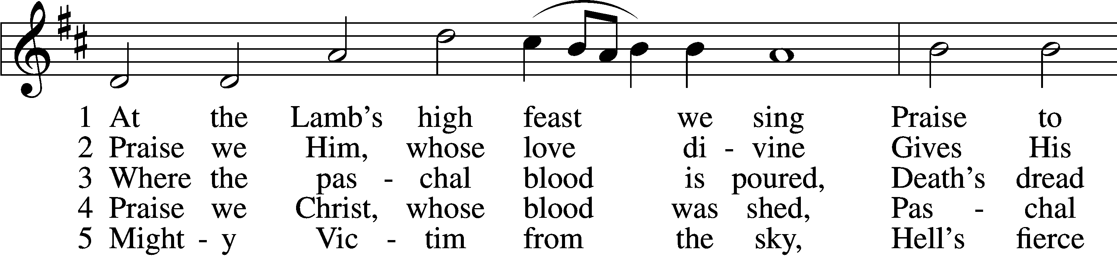
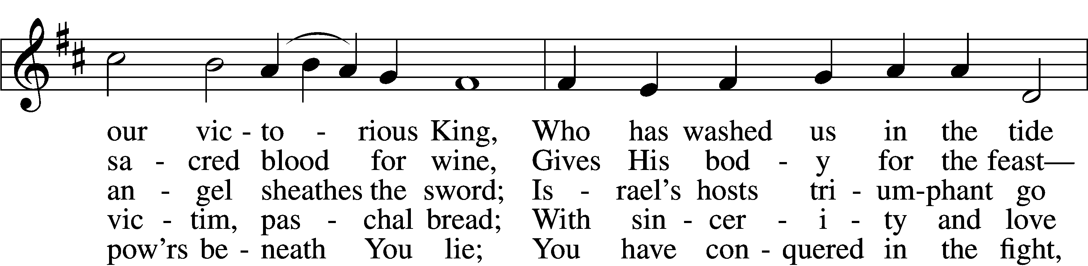
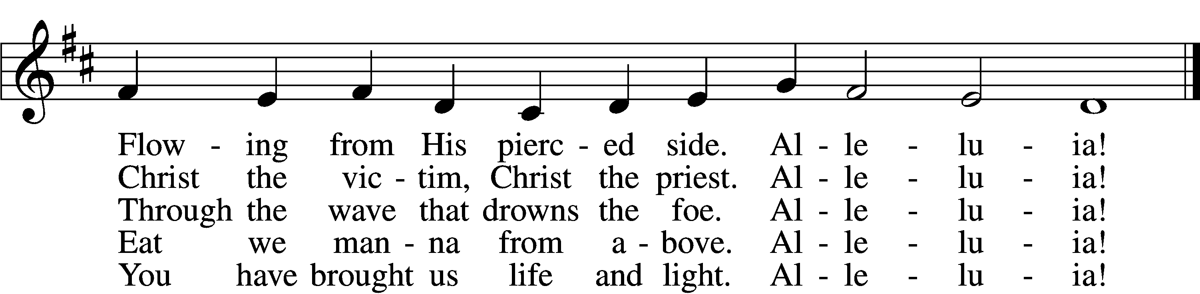
Text: Latin, c. 5th–10th cent.; tr. Robert Campbell, 1814–68, alt.
Tune: Kirchengeseng, 1566, Ivancice
Text and tune: Public domain

Sermon “Rejected Joy”

Votum
P The peace of God, which passes all understanding, keep your hearts and minds in Christ Jesus.
C Amen.

Stand

Offertory Psalm 51:10–12
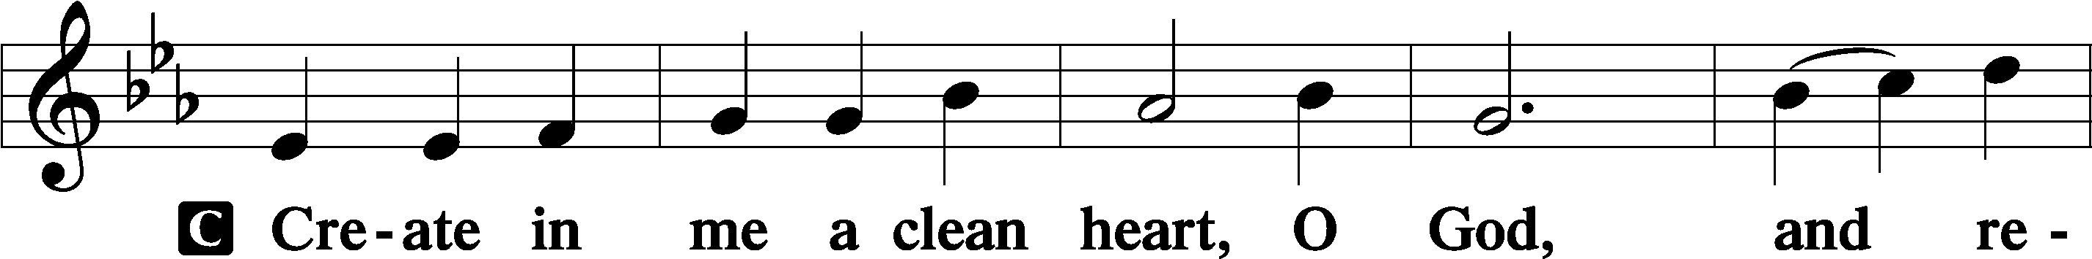
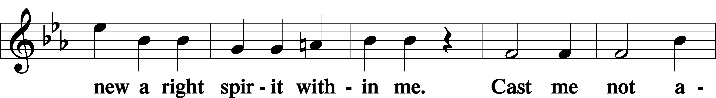
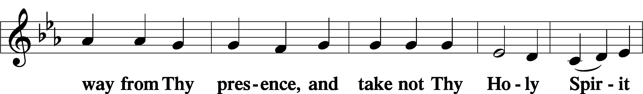
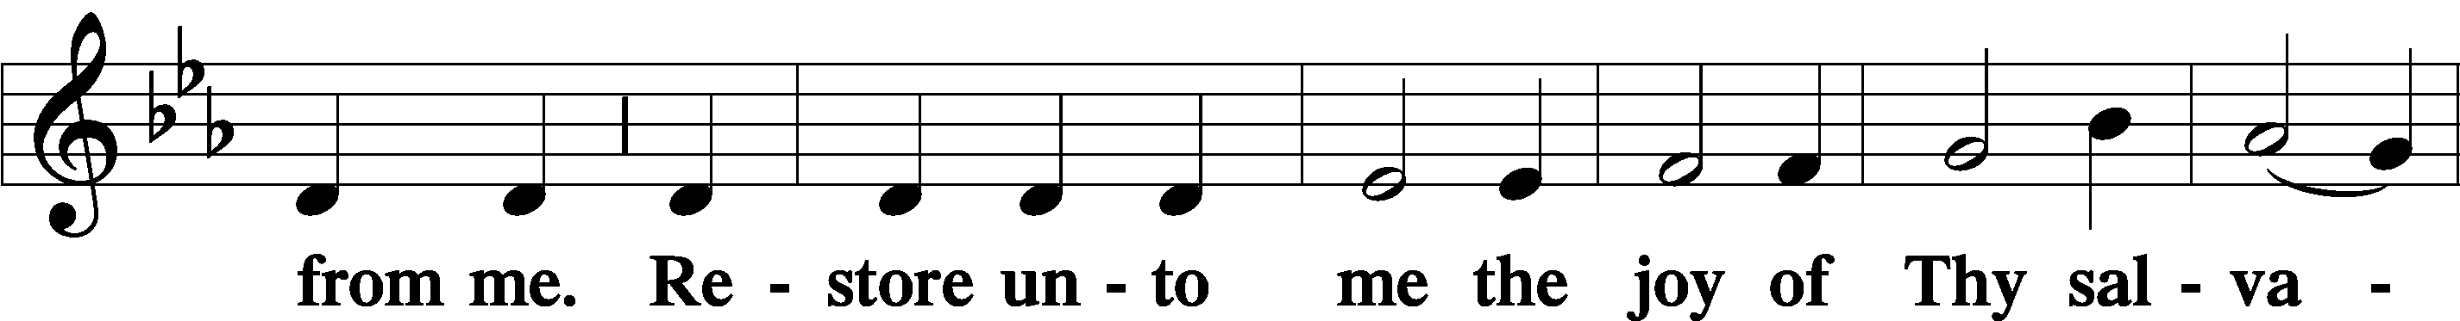
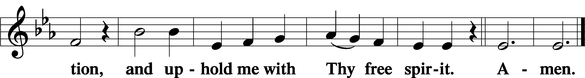

Offering

805 Praise God, from Whom All Blessings Flow
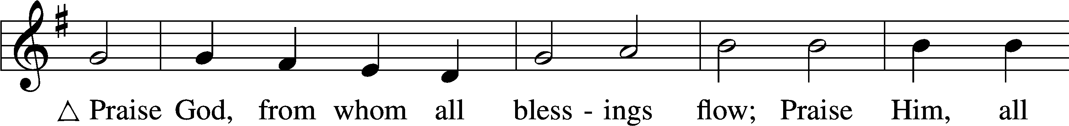
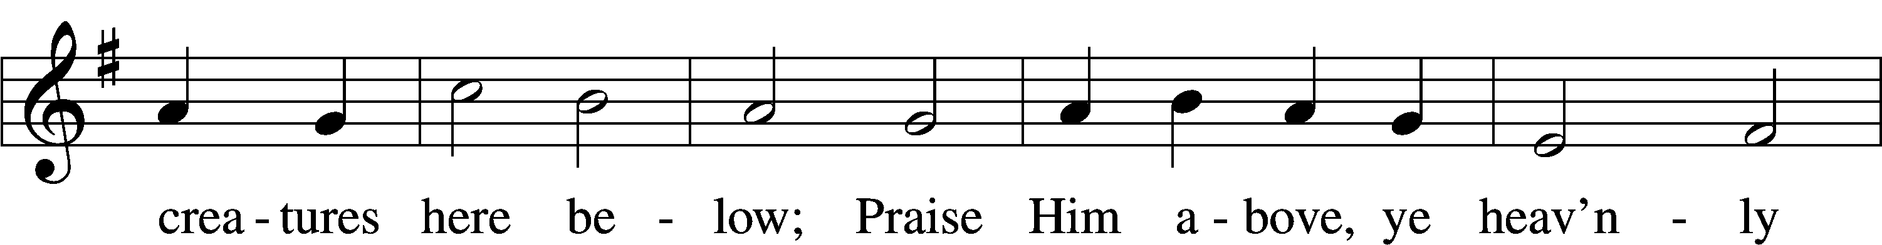
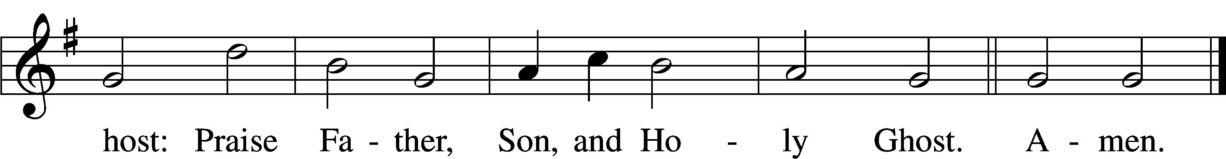
Text: Thomas Ken, 1637–1711
Tune: Trente quatre Pseaumes de David, 1551, Geneva, ed. Louis Bourgeois
Text and tune: Public domain

Prayer of the Church

Lord’s Prayer Matthew 6:9–13
P Lord, remember us in Your kingdom and teach us to pray:
C Our Father who art in heaven,
hallowed be Thy name,
Thy kingdom come,
Thy will be done on earth
as it is in heaven;
give us this day our daily bread;
and forgive us our trespasses
as we forgive those
who trespass against us;
and lead us not into temptation,
but deliver us from evil.
For Thine is the kingdom
and the power and the glory
forever and ever. Amen.

Collect for the Word

Blessed Lord, You have caused all Holy Scriptures to be written for our learning. Grant that we may so hear them, read, mark, learn, and inwardly digest them that, by the patience and comfort of Your holy Word, we may embrace and ever hold fast the blessed hope of everlasting life; through Jesus Christ, Your Son, our Lord, who lives and reigns with You and the Holy Spirit, one God, now and forever.

Benediction
P The Lord bless you and keep you.
The Lord make His face shine on you and be gracious to you.
The Lord look upon you with favor and T give you peace.
C Amen.
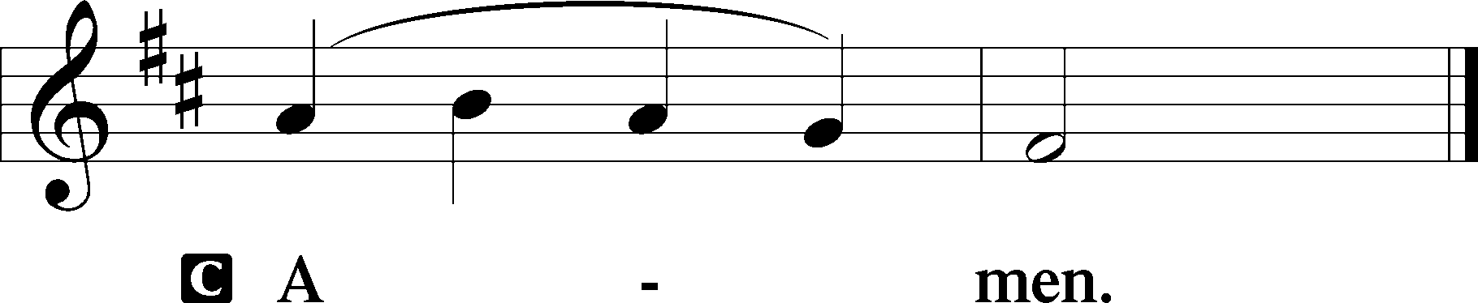

830 Spread the Reign of God the Lord
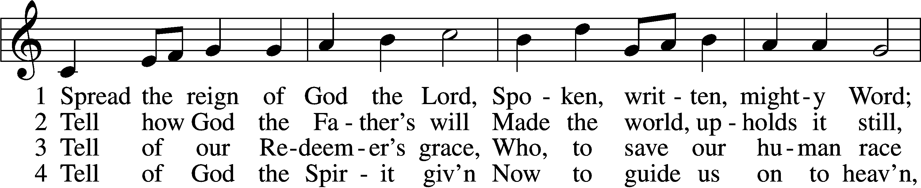
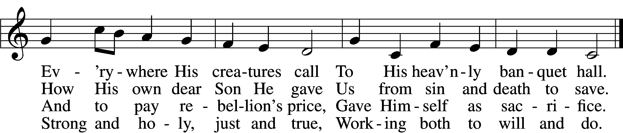

5 Enter, mighty Word, the field;
Ripe the promise of its yield.
But the reapers, oh, how few
For the work there is to do!

6 Lord of harvest, great and kind,
Rouse to action heart and mind;
Let the gath’ring nations all
See Your light and heed Your call.

Text: Jonathan Friedrich Bahnmaier, 1774–1841; tr. composite
Tune: Geist-reiches Gesang-Buch, 1704, Halle, ed. Johann A. Freylinghausen, alt.
Text and tune: Public domain
Acknowledgments
Unless otherwise indicated, Scripture quotations are from the ESV® Bible (The Holy Bible, English Standard Version®), copyright © 2001 by Crossway, a publishing ministry of Good News Publishers. Used by permission. All rights reserved.
Created by Lutheran Service Builder © 2026 Concordia Publishing House.

