
January 2026

According to Webster’s Dictionary, the word Epiphany (noun) has a few meanings:
- a Christian festival held on January 6 in commemoration of the coming of the Magi as the first manifestation of Christ to the Gentiles or in the Eastern Church in commemoration of the baptism of Christ.
- a usually sudden manifestation or perception of the essential nature or meaning of something. For example: the experience is an epiphany whereby the true essence of cooking is revealed.
- an illuminating discovery, realization, or disclosure. When a child moves from recognizing letters to decoding and comprehension, a moment of epiphany takes place and children become empowered through their knowledge.
When we Christians gather to celebrate the Epiphany of our Lord, we not only are observing the first definition (a Christian festival held on January 6), but also the second and third definitions. Also, please note that we celebrate a season of Epiphany, not just limited to January 6th. During this season, we realize how Jesus came to the earth and illuminated it with his presence. Epiphany is a time of discovery.
From the LCMS website: The Feast of the Epiphany centers in the visit of the Magi from the East. In that respect, it is a “13th day” of Christmas, and yet it also marks the beginning of a new liturgical season. Where Christmas has focused on the incarnation of our Lord, that is, on God becoming flesh, the season of Epiphany emphasizes the manifestation or self–revelation of God in that same flesh of Christ. For the Lord Himself has entered our darkness and rises upon us with the brightness of His true light (Is. 60:1–2). He does so chiefly by His Word of the Gospel, which He causes to be preached within His Church on earth, not only to the Jews but also to the Gentiles (Eph. 3:8–10). As the Magi were guided by the promises of Holy Scripture to find and worship the Christ Child with His mother in the house (Matt. 2:5–11), so does He call disciples from all nations by the preaching of His Word to find and worship Him within His Church (Is. 60:3–6).

A blessed Epiphany season to all!
— Pastor De Young

The Lutheran Church is nothing else than the Church of the Bible. It does not deviate from the Bible; it does not take away or add to it, but stands squarely on the Word of God. In all its teaching and in its practice, the Lutheran Church lives by this key principle.
- C. F. W. Walther

How foolish it is when they ridicule pure doctrine and say to us, “enough already with your pure doctrine! That can only lead to dead orthodoxy. Focus on pure living instead.” That would be like saying to a farmer, “Stop fretting about good seed! Be concerned about good fruit instead.” If you are concerned with good fruit, you will also be concerned about good seed. If you are concerned about pure doctrine, you will at the same time also be concerned about genuine Christianity and a sincere Christian life.

Just as you cannot make out of the gospel a sacrifice or a work, so you cannot make a sacrifice or a work out of this sacrament; for this sacrament is the gospel.

Each one must believe for himself, just as I must believe all the Gospels for myself. I cannot hear or believe or keep for any one else so much as a single letter of the gospel, even as I cannot be baptized for any one else. But a good work I can always do to another person and for another person. Indeed, I have to do them for somebody else or they are not good works. For example, I can pray for you, serve you, work for you, suffer for you, and so forth. There is a great difference between faith and good works, just as vast as the difference in value between the tree and the fruit. Fruits disappear and return each year, but the tree remains always. Faith also remains always, but works disappear.

No good work can free us of our sins or give us grace of life or salvation. But this sacrament does give life, grace and blessedness, for it is a fountain of life and of blessedness.
- Martin Luther



Celebrate December’s Baptism Birthdays
& their years as heirs of God’s kingdom!

Date | Name | Years
1st | Larry Pyle | 66
9th | Sarah Horton | 21
13th | Rayleigh Pace | 13
15th | Erin McComack | 37
16th | Mary Atkinson | 26
 | Nova McComack | 4
19th | Hawk Shaw | 6
20th | Kaylee McComack | 18
22nd | Avery Henry | 9
24th | Tori Lasch | 27
25th | Gaylon Rice | 11
27th | Archer Furguson | 13
 | Kegann Gilmore | 13
28th | Emma Lasch | 19
29th | Sherry Hammer | 42
 | Carla Hughes | 42

Serving in God’s House this month

Elder of the Month | William Pickett
Counters | Lee Hughes / David Geis
Altar Guild | Sherry Hamme / Jeannine Yowell
Altar Care | Ashley Keyes / Dawn Keyes
Guest Monitor | Tonda Rice & Lisa Lawson

Week | Acolytes | Reader
January 04 | Avery Henry & Bella Caswell | Lee Hughes
January 11 | Molly Gilmore & Max Gilmore | Arn Anderson
January 18 | Parker Lawson & Annallee Osbon | Bryan Roth
January 25 | Karlee Hughes & Emily Keyes | William Pickett





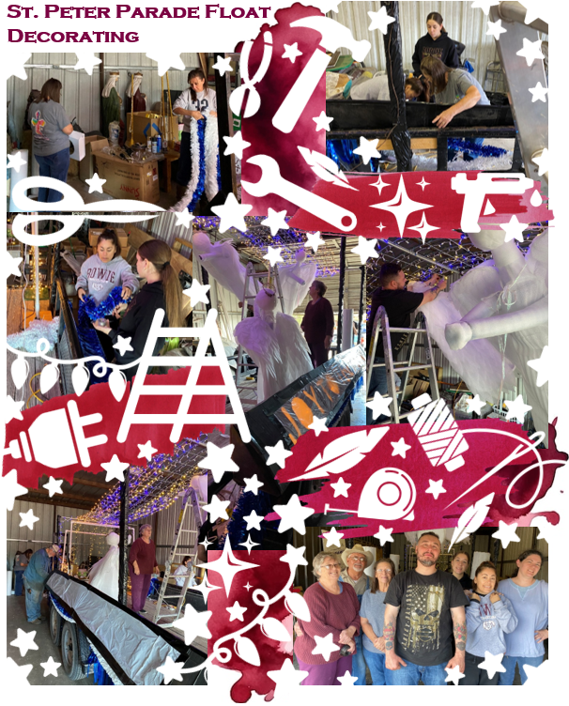

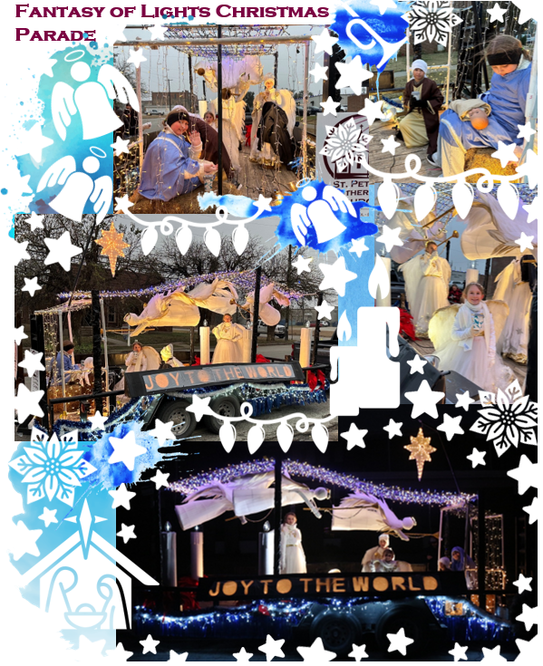



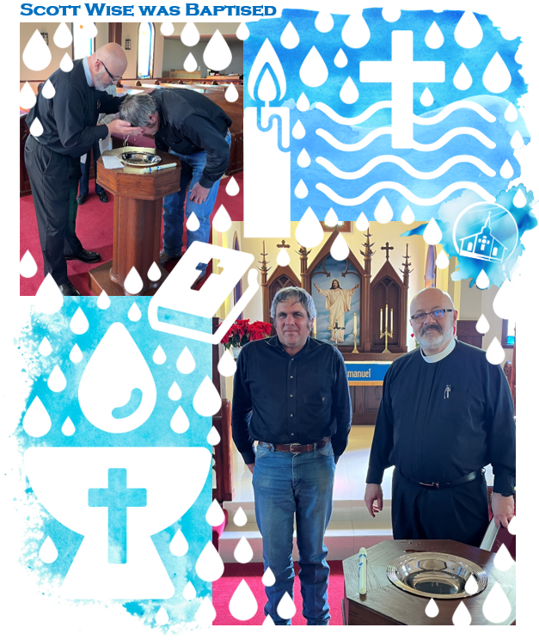





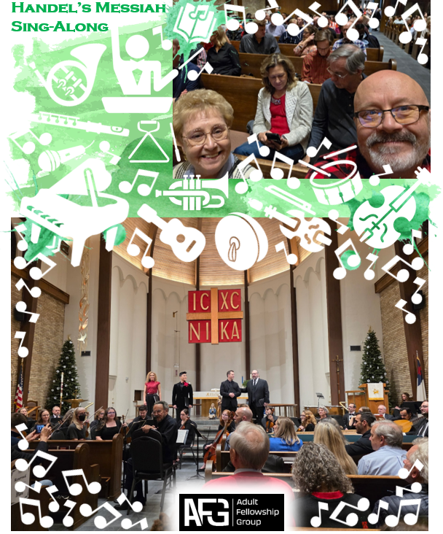

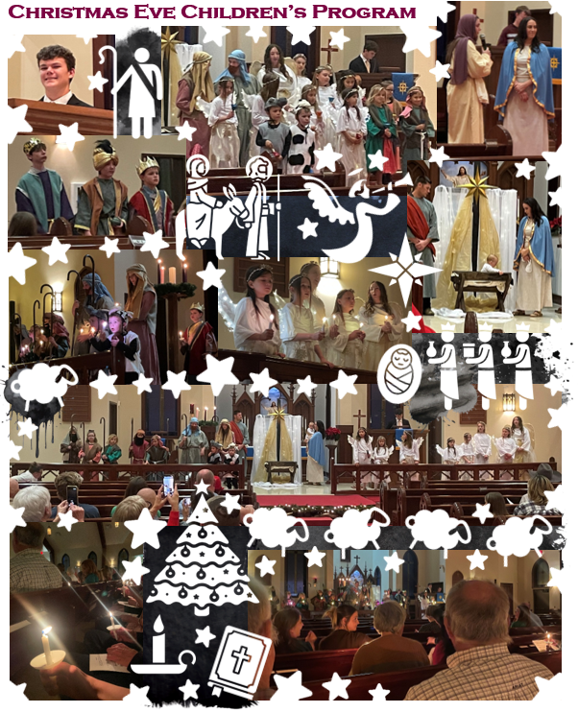

Did you know we have a Facebook & Instagram?

You can find the links to our socials on our website at: www.stpetertex.com

Follow us for important updates, verse-of-the-week posts, and more!
In case you missed December’s weekly verse posts:


