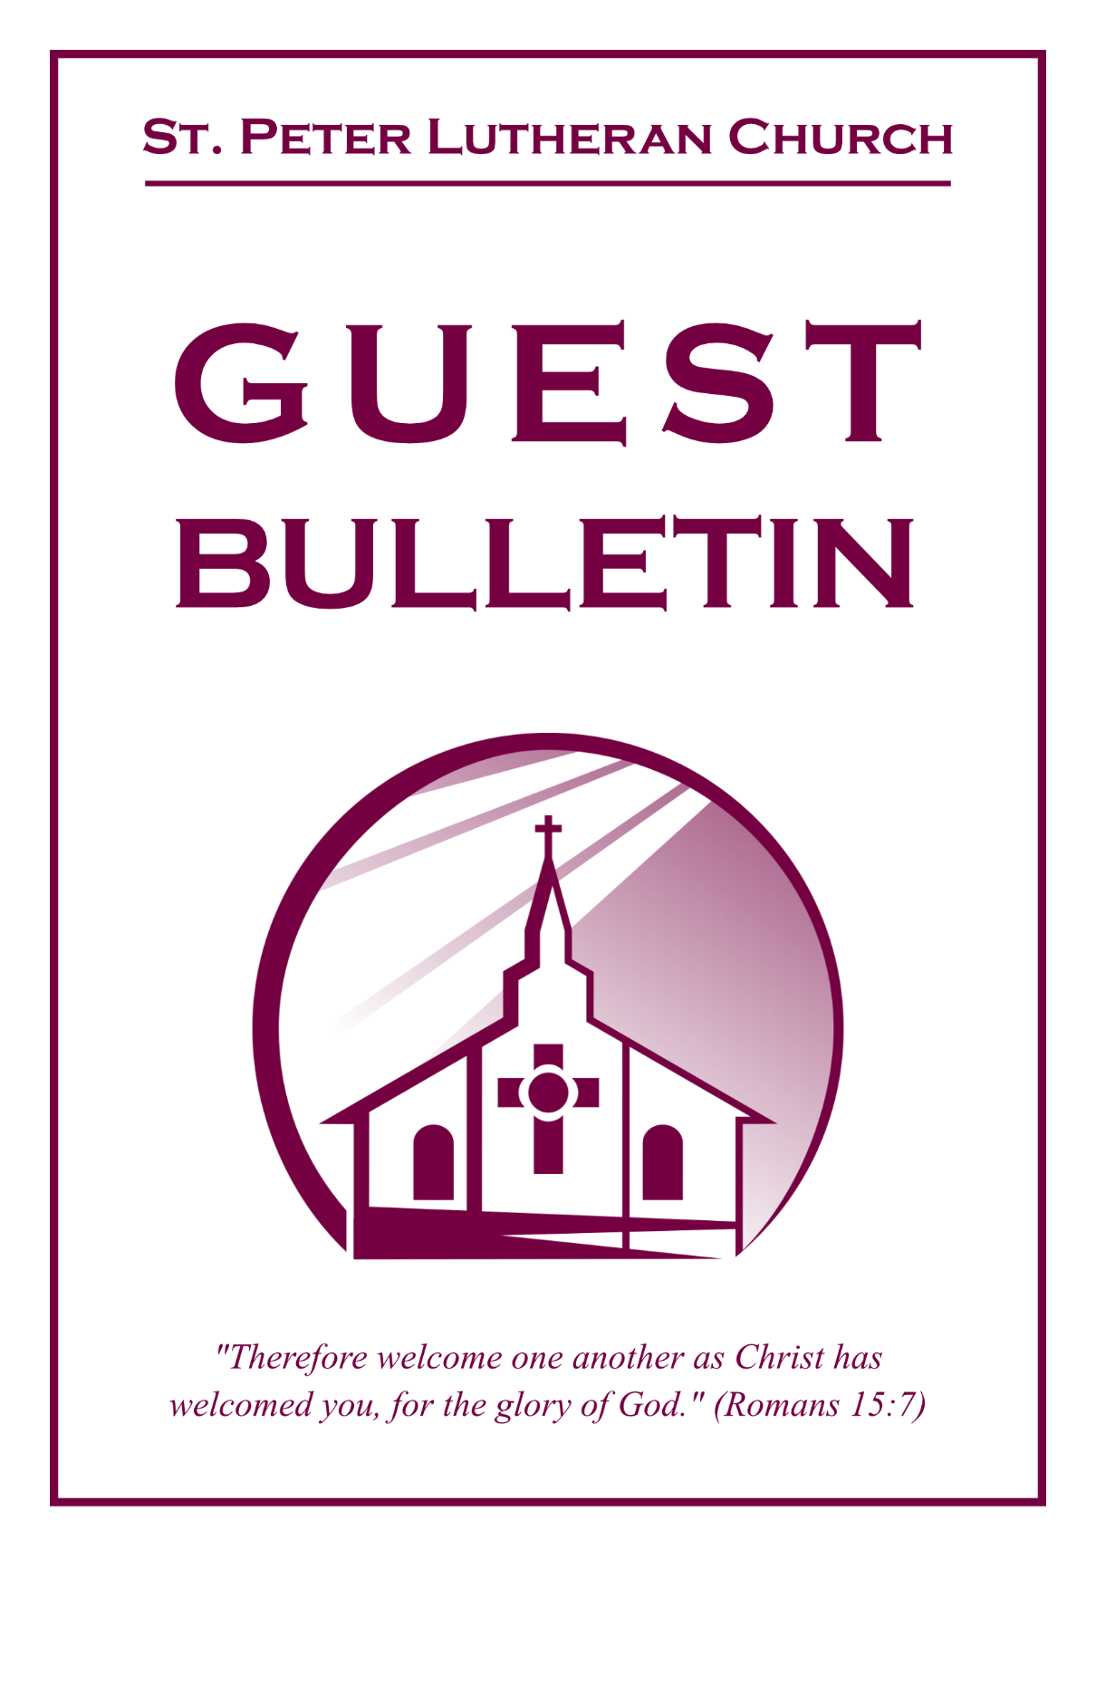

August 23, 2026



St. Peter Lutheran Church
Missouri Synod
906 Highway 59N, P.O. Box 133

Bowie, Texas 76230

Church (940) 872-1886 Fax ((940) 872-8837

Church E-mail: stpetertexscty@gmail.com
To Our Guests and Visitors:

We welcome all our friends in Christ who have come to worship with us. If you are a guest, please feel at home with us, sign our guest register, and worship with us whenever you are able. If you do not have a church home, we invite you to
consider becoming a part of our church family.

Website: www.stpetertex.com
Communion Statement:

The Lord’s Supper is celebrated at this congregation in the confession and glad confidence that, as He says, our Lord gives into our mouths not only bread and wine but His very Body and Blood to eat and drink for the forgiveness of sins and to strengthen our union with Him and one another.

Our Lord invites to His table those who trust in His words, repent of all sin, and set aside any refusal to forgive and love as He forgives and loves us, that they may show forth His death until He comes.

Because those who eat and drink our Lord’s Body and Blood unworthily do so to their great harm, and because Holy Communion is a confession of the faith, which is confessed at this altar, guests who are not confirmed members of an LCMS congregation and have not previously communed at this altar, are asked to first speak with our pastor.

If you are unable to do so before the service, it is out of Christian love and care for your souls that we ask you to refrain from communing this morning.

For further study, please see Matthew 5:23ff, 10:32ff, 18:15–35, 26:26–29; 1 Corinthians 11:17–34.

If you desire to receive a blessing for yourself or your children, please approach during
communion, cross your arms over your chest and bow your head as you kneel at the
altar rail.

Who Receives the Sacrament of the Altar Worthily?
Fasting and bodily preparation are certainly fine outward training. But that person is truly worthy and well prepared who has faith in these words: “Given and shed for you for the forgiveness of sins.” But anyone who does not believe these words or doubts them is unworthy and unprepared; for the words “for you” require all hearts to believe.
How May I Prepare?
See Dr. Luther’s self–examination questions and answers in the
LSB Hymnal on page 329

Upon entering the Sanctuary. please turn off cell phones, pagers. etc. Use the time as a quiet time for personal reflection and meditation in preparation for worship. This is a time for anyone to join in praying for the service, and for the church in general.
525 Crown Him with Many Crowns
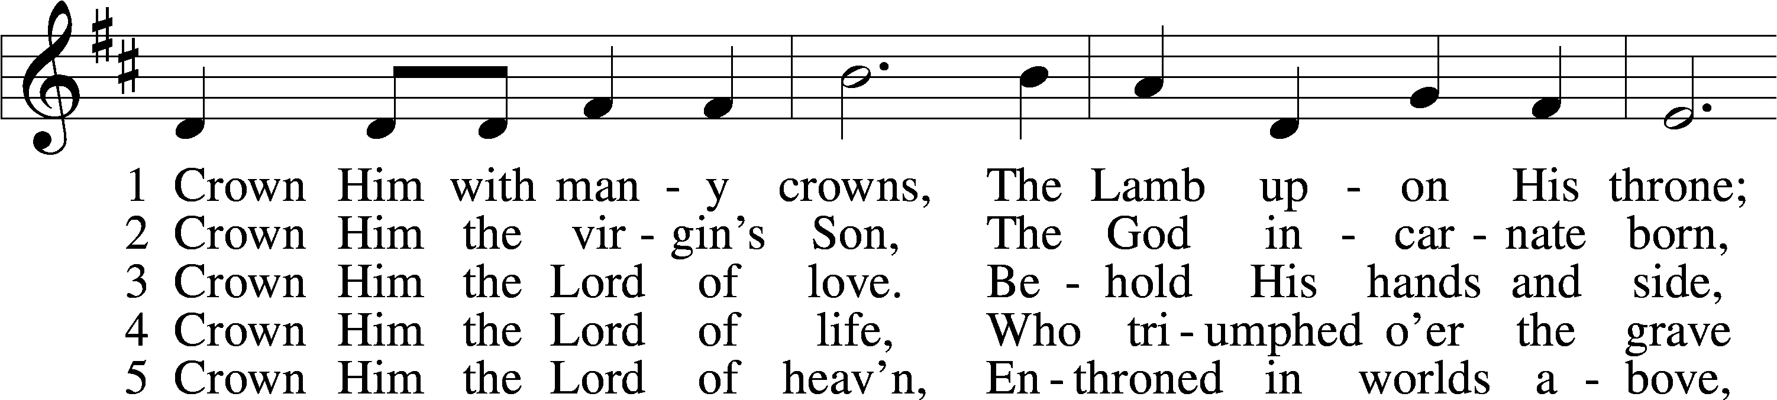
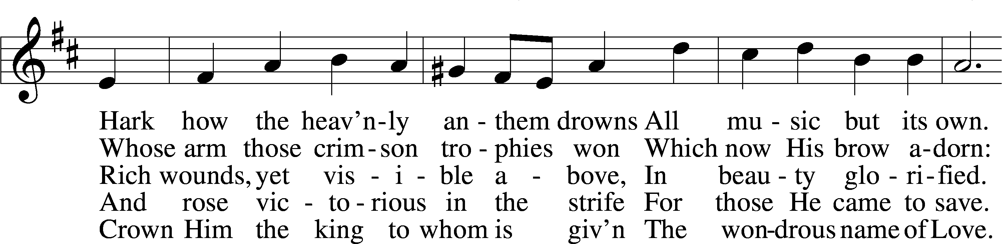
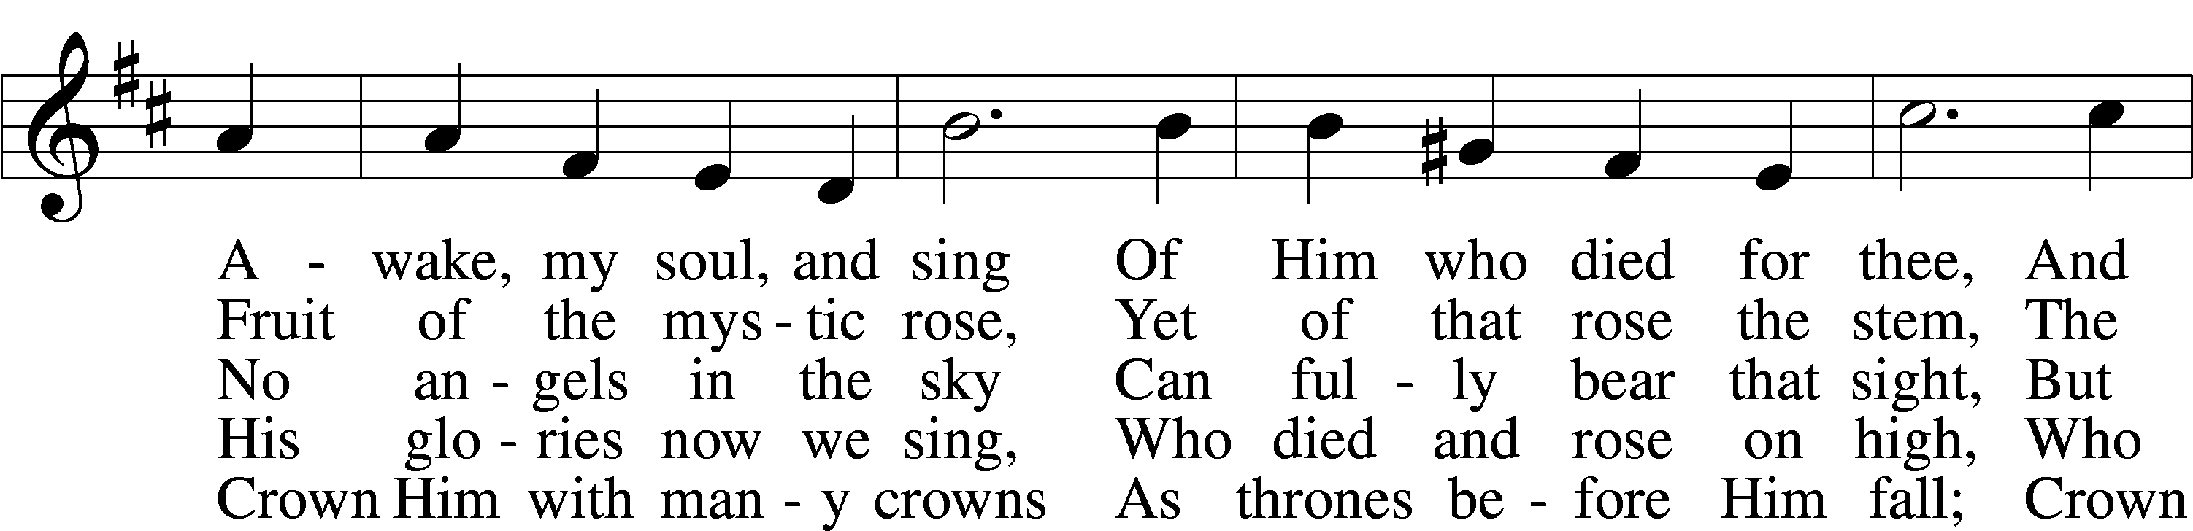
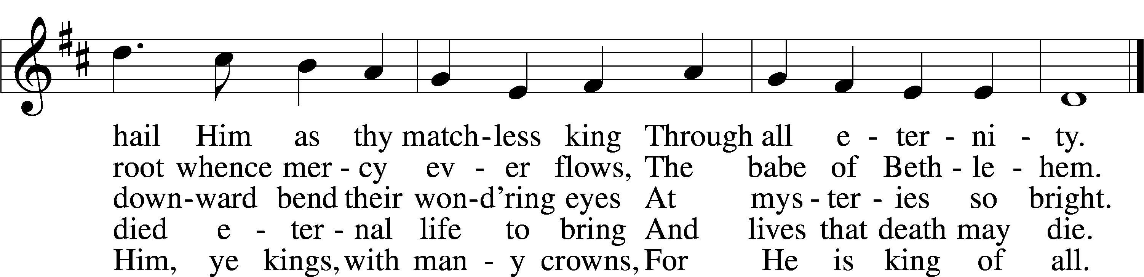
Text (sts. 1–3, 5): Matthew Bridges, 1800–94, alt.; (st. 4): Godfrey Thring, 1823–1903
Tune: George J. Elvey, 1816–93
Text and tune: Public domain

Rite of Membership

Welcoming Hymn “We Bid You Welcome”
(Tune: Renew Me, O Eternal Light)
We bid you welcome in the name,
Of Jesus, our exalted King,
Come, join with us, and work and pray,
Until Christ comes, that glorious Day.

Come, join with us and feast and sing,
Filled with the Spirit, fired with love,
Submit yourselves, with us, each day,
To God, in faith, through Christ, the Way!

Confession and Absolution
The sign of the cross may be made by all in remembrance of their Baptism.

Invocation Matthew 28:19b; 18:20
P In the name of the Father and of the T Son and of the Holy Spirit.
C Amen.

Exhortation Hebrews 10:22; Psalm 124:8; Psalm 32:5
P Beloved in the Lord! Let us draw near with a true heart and confess our sins unto God our Father, beseeching Him in the name of our Lord Jesus Christ to grant us forgiveness.

P Our help is in the name of the Lord,
C who made heaven and earth.
P I said, I will confess my transgressions unto the Lord,
C and You forgave the iniquity of my sin.

Silence for reflection on God’s Word and for self-examination.

Confession of Sins
P Almighty God, our maker and redeemer, we poor sinners confess unto You that we are by nature sinful and unclean and that we have sinned against You by thought, word, and deed. Wherefore we flee for refuge to Your infinite mercy, seeking and imploring Your grace for the sake of our Lord Jesus Christ.
C O most merciful God, who has given Your only-begotten Son to die for us, have mercy upon us and for His sake grant us remission of all our sins; and by Your Holy Spirit increase in us true knowledge of You and of Your will and true obedience to Your Word, to the end that by Your grace we may come to everlasting life; through Jesus Christ, our Lord. Amen.

Declaration of Grace Mark 16:16; John 1:12
P Almighty God, our heavenly Father, has had mercy upon us and has given His only Son to die for us and for His sake forgives us all our sins. To those who believe on His name He gives power to become the children of God and has promised them His Holy Spirit. He that believes and is baptized shall be saved.
s
Grant this, Lord, unto us all.
C Amen.

Service of the Word

Introit Psalm 2:6–7; 117; antiphon: Psalm 115:18
But we will bless the Lord
from this time forth and forevermore. Praise the Lord!
As for me, I have set my King
on Zion, my holy hill.
I will tell of the decree:
The Lord said to me, “You are my Son; today I have begotten you.”
Praise the Lord, all nations!
Extol him, all peoples!
For great is his steadfast love toward us,
and the faithfulness of the Lord endures forever. Praise the Lord!

Gloria Patri
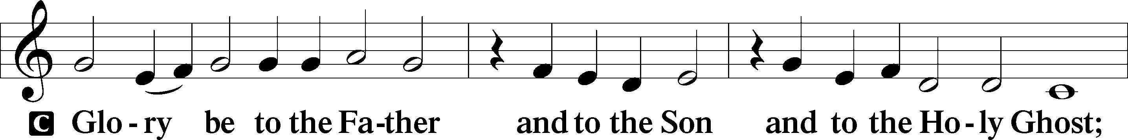
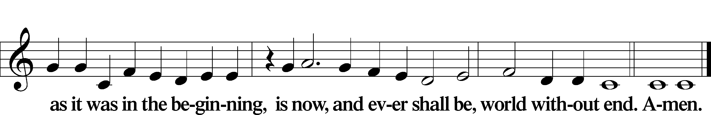

Kyrie Mark 10:47
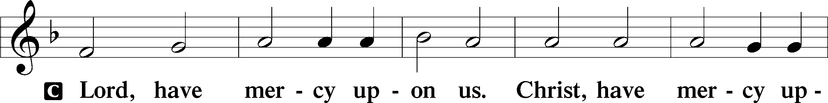
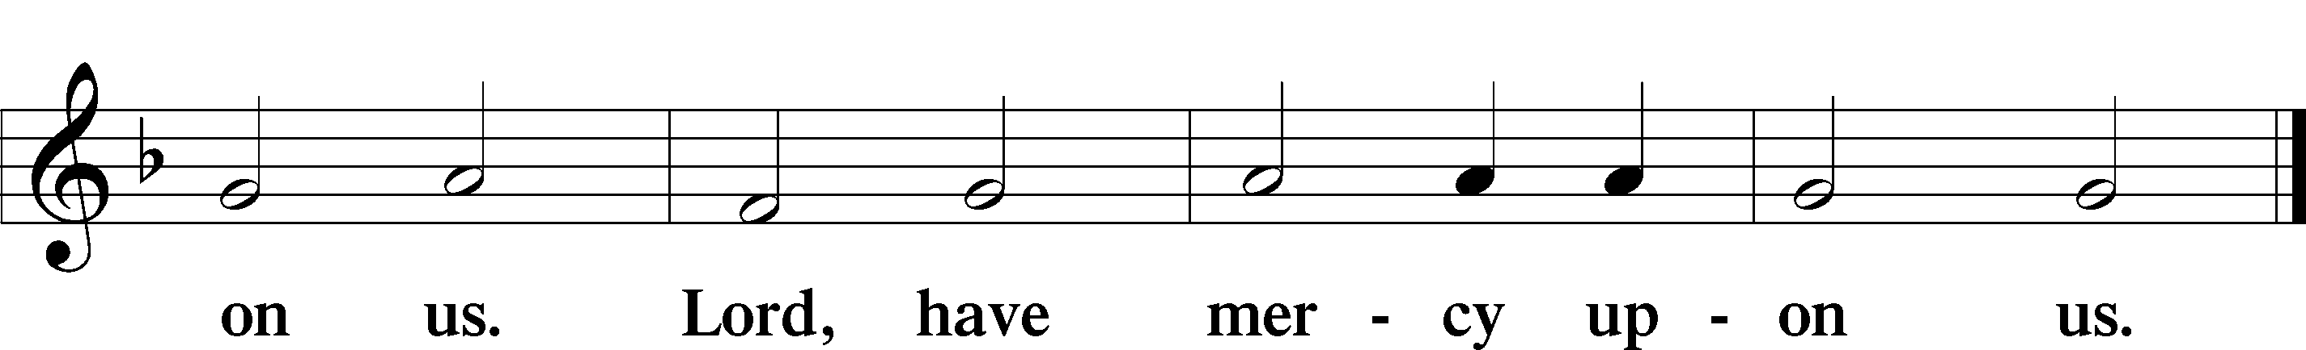

Gloria in Excelsis Luke 2:14; John 1:29
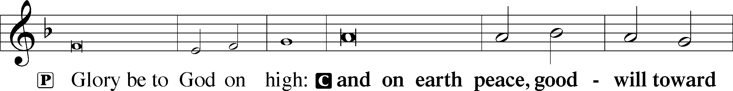
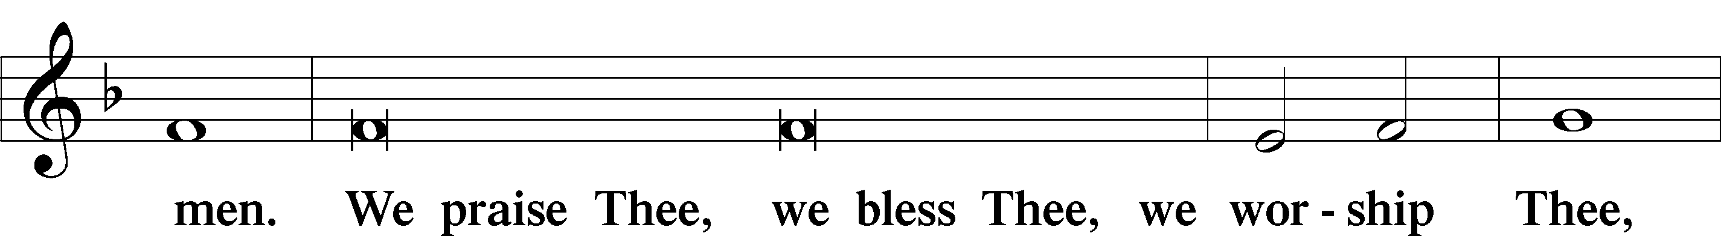
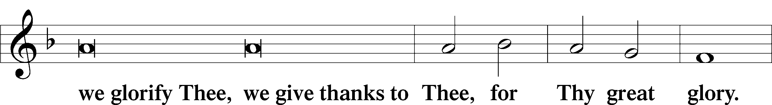
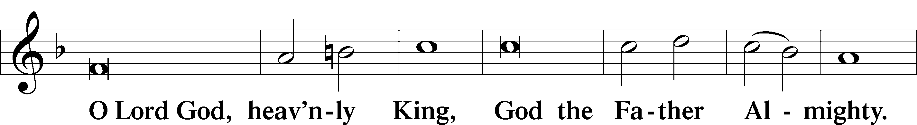
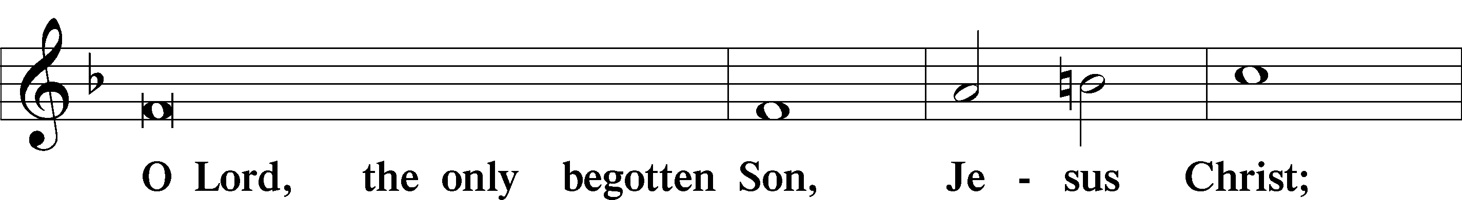
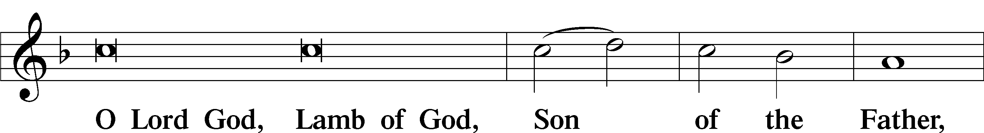
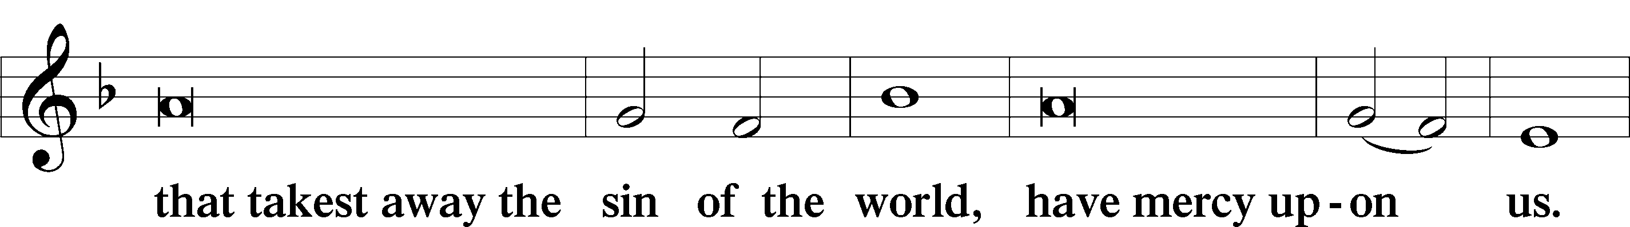
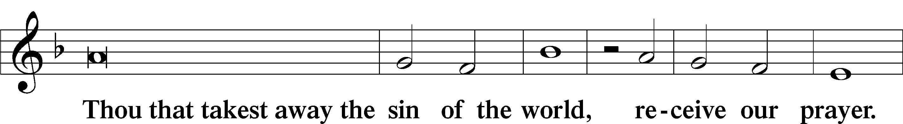
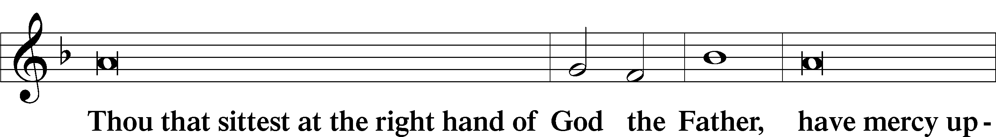
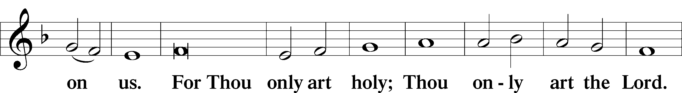
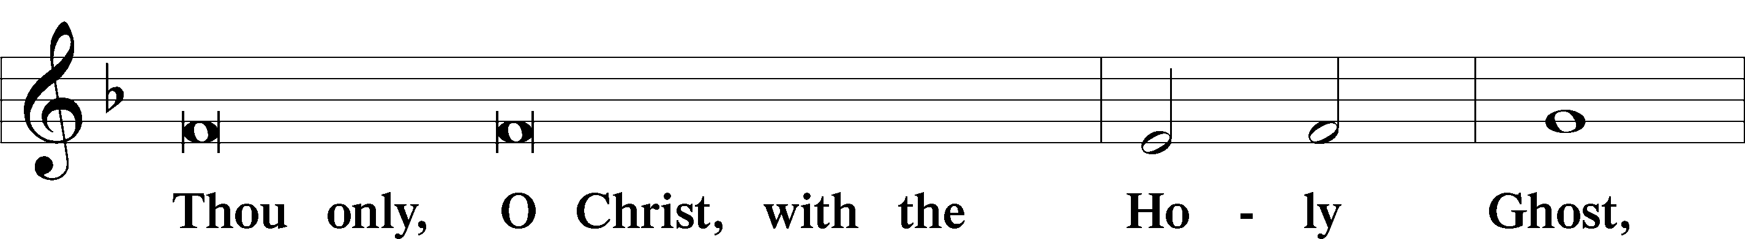
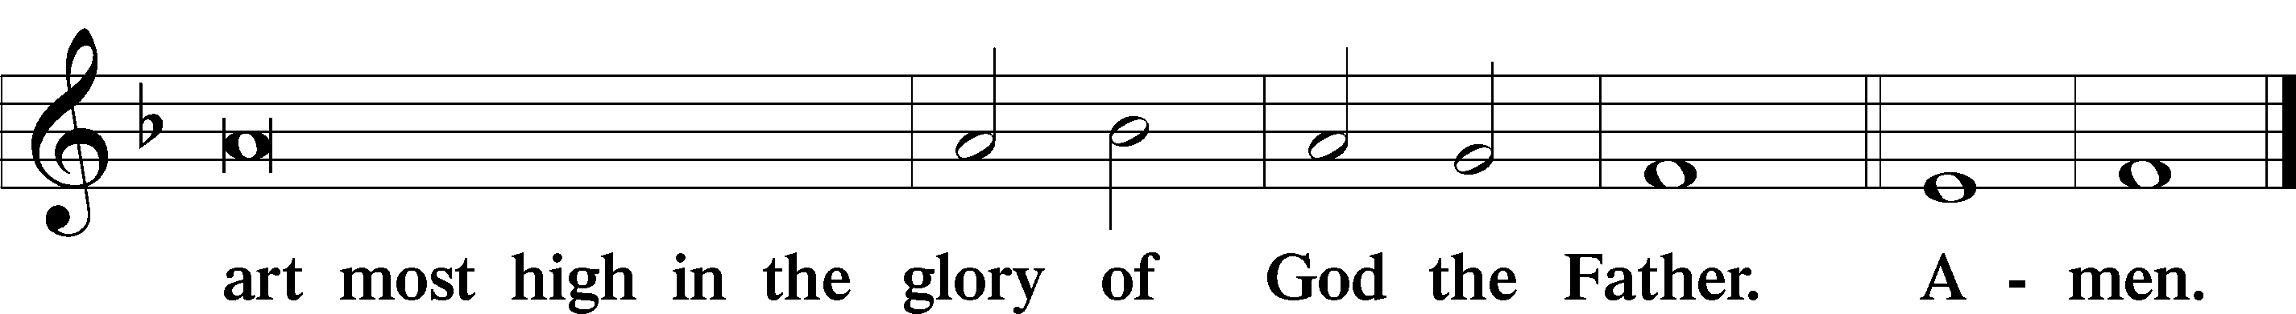

Salutation and Collect of the Day
P The Lord be with you.
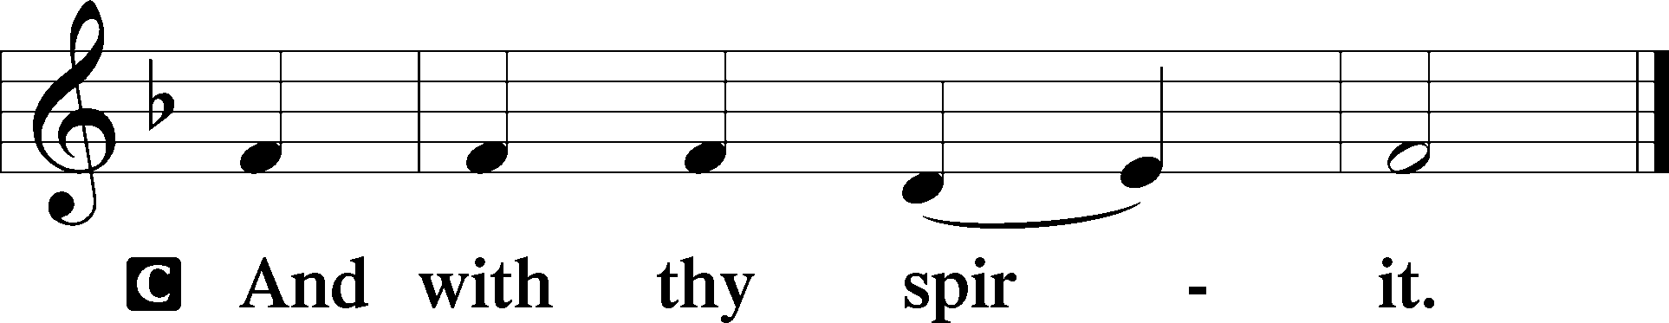

P Let us pray.
Almighty God, whom to know is everlasting life, grant us to know Your Son, Jesus, to be the way, the truth, and the life that we may boldly confess Him to be the Christ and steadfastly walk in the way that leads to life eternal; through the same Jesus Christ, our Lord, who lives and reigns with You and the Holy Spirit, one God, now and forever.

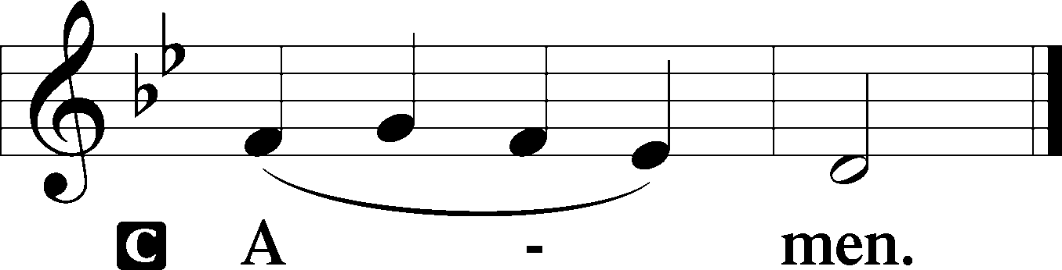

Sit

Old Testament Reading Isaiah 51:1–6
1“Listen to me, you who pursue righteousness, you who seek the Lord: look to the rock from which you were hewn, and to the quarry from which you were dug. 2Look to Abraham your father and to Sarah who bore you; for he was but one when I called him, that I might bless him and multiply him. 3For the Lord comforts Zion; he comforts all her waste places and makes her wilderness like Eden, her desert like the garden of the Lord; joy and gladness will be found in her, thanksgiving and the voice of song. 4“Give attention to me, my people, and give ear to me, my nation; for a law will go out from me, and I will set my justice for a light to the peoples. 5My righteousness draws near, my salvation has gone out, and my arms will judge the peoples; the coastlands hope for me, and for my arm they wait. 6Lift up your eyes to the heavens, and look at the earth beneath; for the heavens vanish like smoke, the earth will wear out like a garment, and they who dwell in it will die in like manner; but my salvation will be forever, and my righteousness will never be dismayed.”

A This is the Word of the Lord.
C Thanks be to God.

Gradual Psalm 34:9, 19, alt.
Fear the Lord, you his saints,
for those who fear him lack nothing!
Many are the afflictions of the righteous,
but the Lord delivers him out of them all.

Epistle Romans 11:33—12:8
33Oh, the depth of the riches and wisdom and knowledge of God! How unsearchable are his judgments and how inscrutable his ways! 34“For who has known the mind of the Lord, or who has been his counselor?” 35“Or who has given a gift to him that he might be repaid?” 36For from him and through him and to him are all things. To him be glory forever. Amen. 1I appeal to you therefore, brothers, by the mercies of God, to present your bodies as a living sacrifice, holy and acceptable to God, which is your spiritual worship. 2Do not be conformed to this world, but be transformed by the renewal of your mind, that by testing you may discern what is the will of God, what is good and acceptable and perfect. 3For by the grace given to me I say to everyone among you not to think of himself more highly than he ought to think, but to think with sober judgment, each according to the measure of faith that God has assigned. 4For as in one body we have many members, and the members do not all have the same function, 5so we, though many, are one body in Christ, and individually members one of another. 6Having gifts that differ according to the grace given to us, let us use them: if prophecy, in proportion to our faith; 7if service, in our serving; the one who teaches, in his teaching; 8the one who exhorts, in his exhortation; the one who contributes, in generosity; the one who leads, with zeal; the one who does acts of mercy, with cheerfulness.

Stand

Alleluia
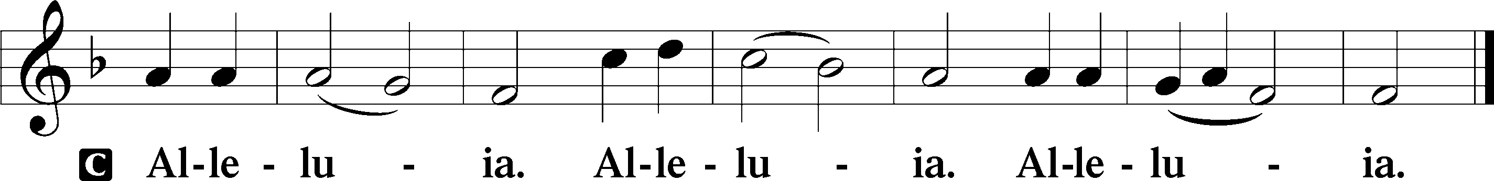

Holy Gospel Matthew 16:13–20
P The Holy Gospel according to St. Matthew, the sixteenth chapter.

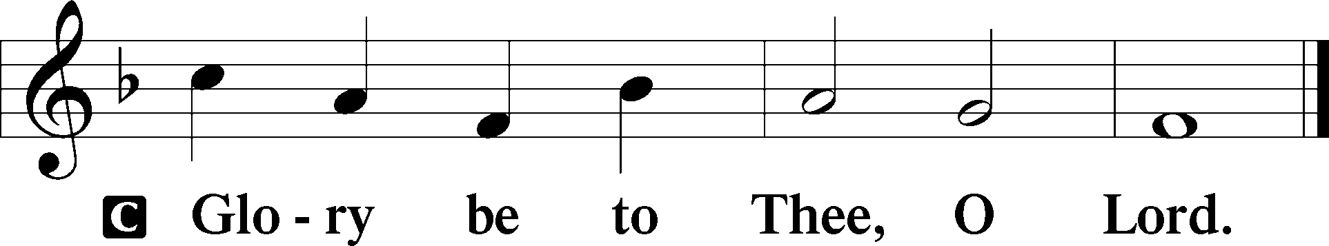

13Now when Jesus came into the district of Caesarea Philippi, he asked his disciples, “Who do people say that the Son of Man is?” 14And they said, “Some say John the Baptist, others say Elijah, and others Jeremiah or one of the prophets.” 15He said to them, “But who do you say that I am?” 16Simon Peter replied, “You are the Christ, the Son of the living God.” 17And Jesus answered him, “Blessed are you, Simon Bar-Jonah! For flesh and blood has not revealed this to you, but my Father who is in heaven. 18And I tell you, you are Peter, and on this rock I will build my church, and the gates of hell shall not prevail against it. 19I will give you the keys of the kingdom of heaven, and whatever you bind on earth shall be bound in heaven, and whatever you loose on earth shall be loosed in heaven.” 20Then he strictly charged the disciples to tell no one that he was the Christ.

P This is the Gospel of the Lord.

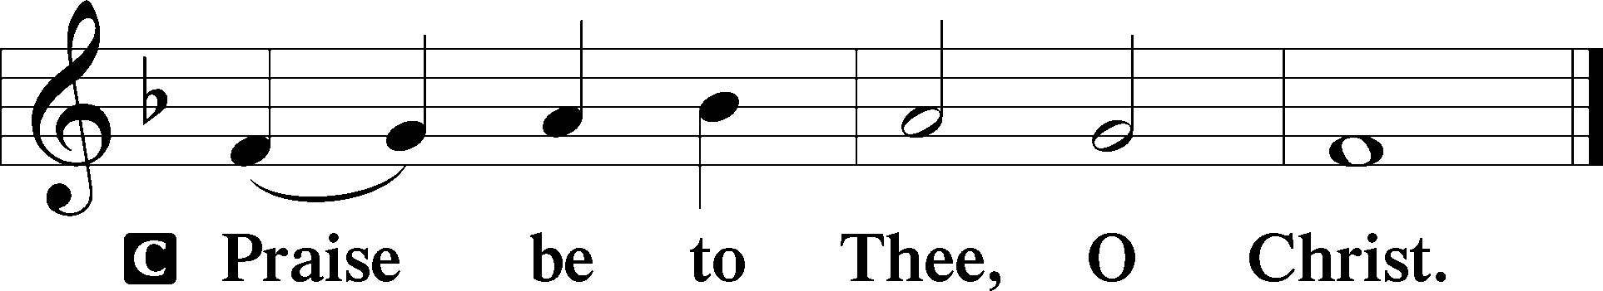

Apostles’ Creed
C I believe in God, the Father Almighty,
maker of heaven and earth.

And in Jesus Christ, His only Son, our Lord,
who was conceived by the Holy Spirit,
born of the virgin Mary,
suffered under Pontius Pilate,
was crucified, died and was buried.
He descended into hell.
The third day He rose again from the dead.
He ascended into heaven
and sits at the right hand of God the Father Almighty.
From thence He will come to judge the living and the dead.

I believe in the Holy Spirit,
the holy Christian Church,
the communion of saints,
the forgiveness of sins,
the resurrection of the body,
and the life T everlasting. Amen.

Sit

Children's Sermon

832 Jesus Shall Reign
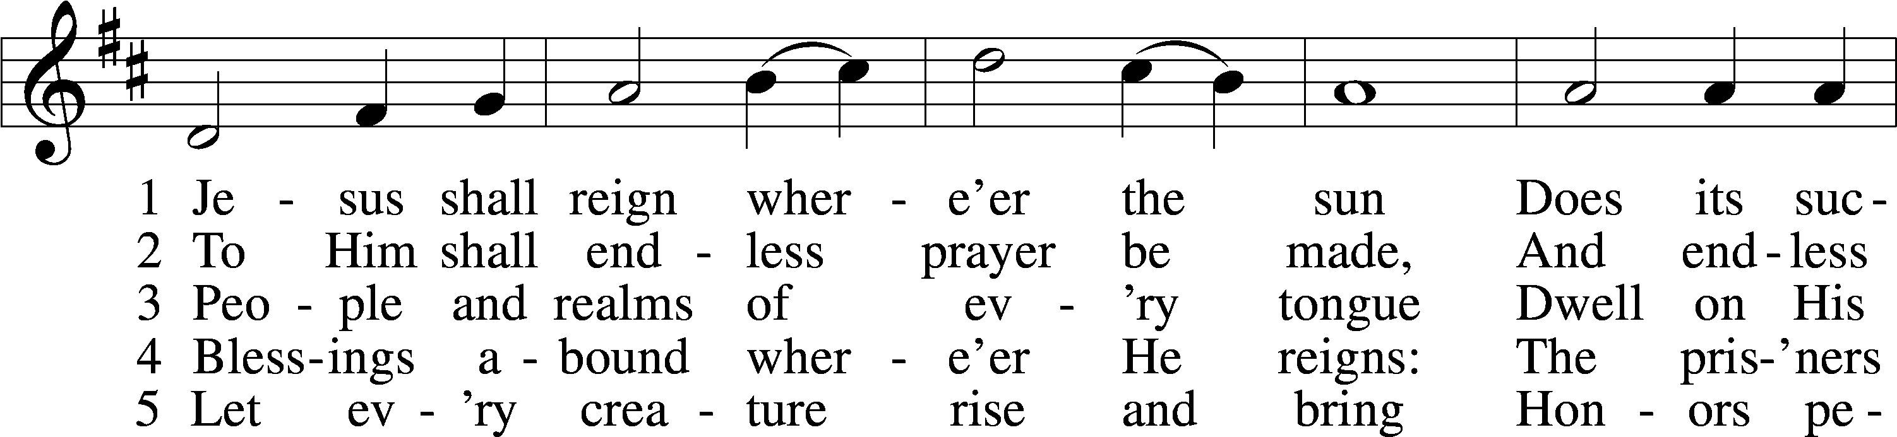
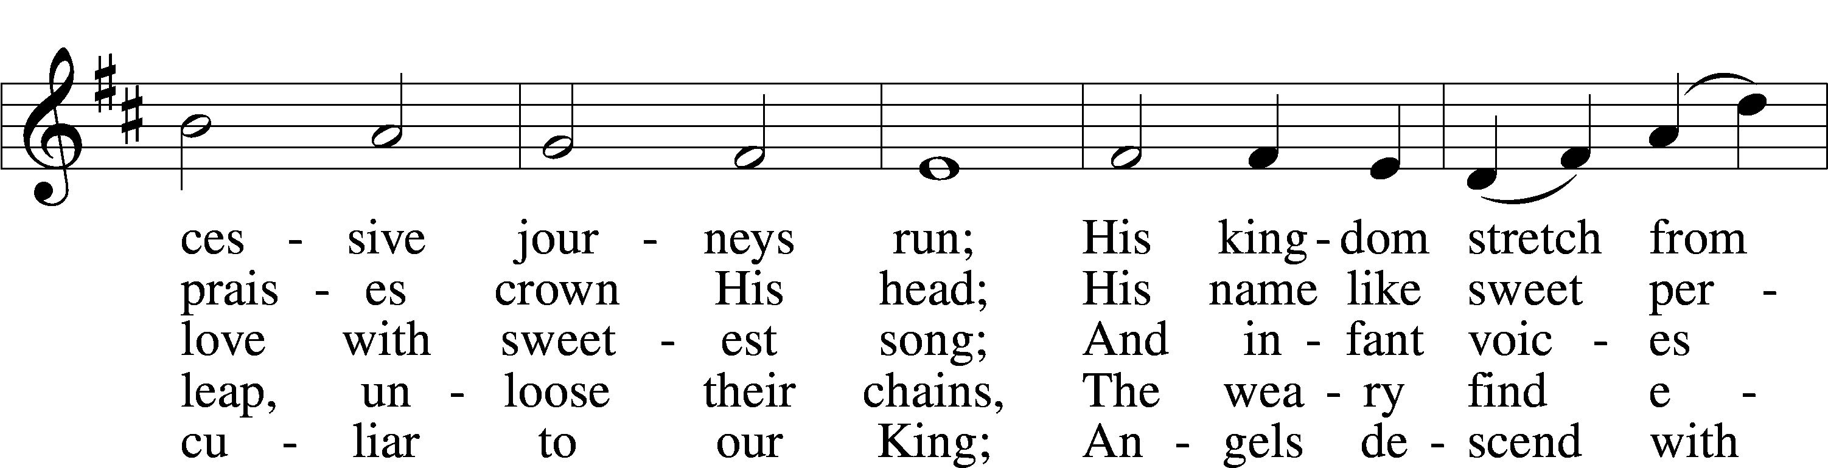
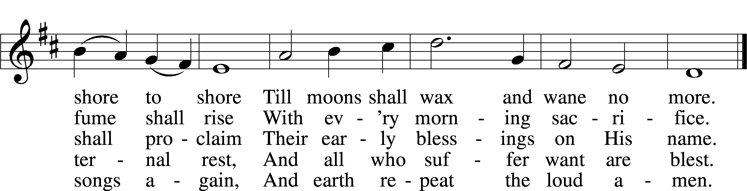
Text: Isaac Watts, 1674–1748, alt.
Tune: attr. John C. Hatton, d. 1793
Text and tune: Public domain

Sermon “And the Survey Said …”

Votum
P The peace of God, which passes all understanding, keep your hearts and minds in Christ Jesus.
C Amen.

Stand

Offertory Psalm 51:10–12
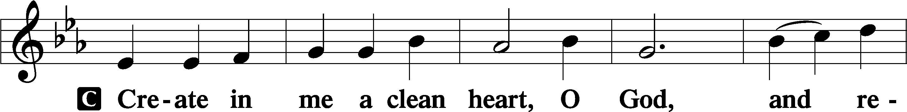
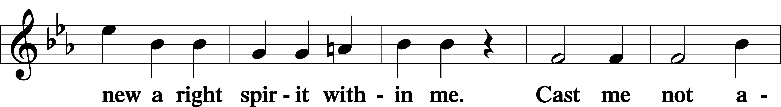
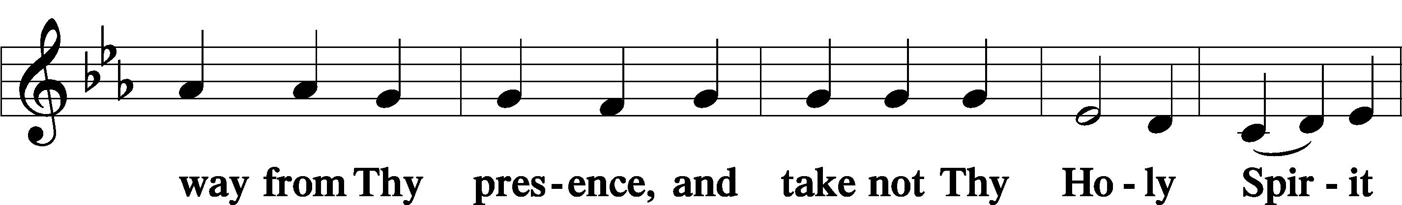
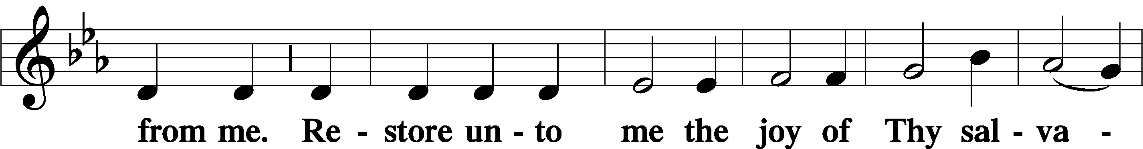
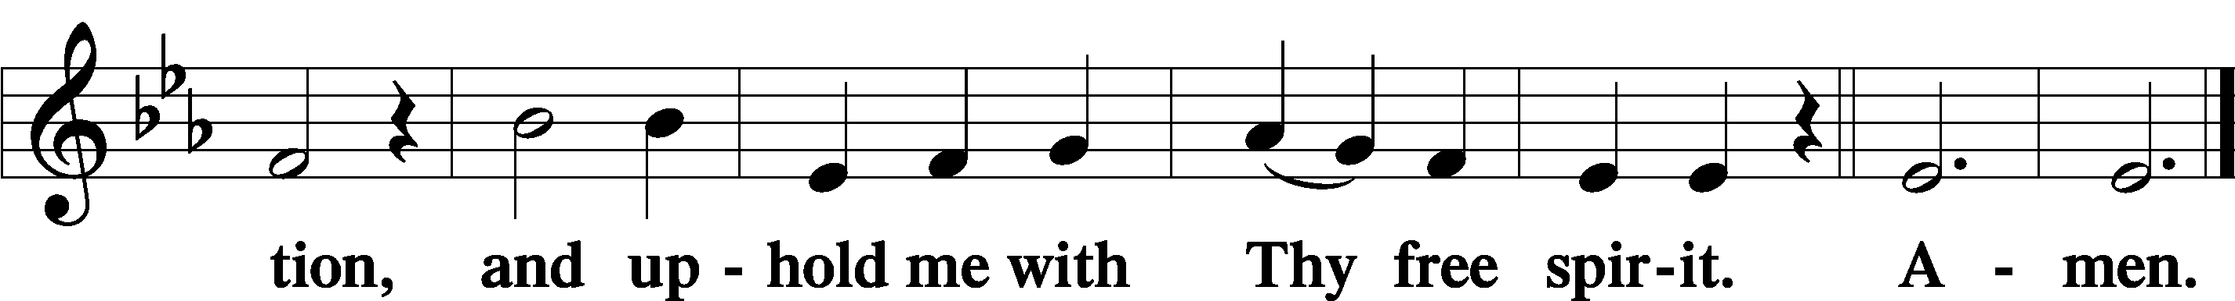

Offering

805 Praise God, from Whom All Blessings Flow
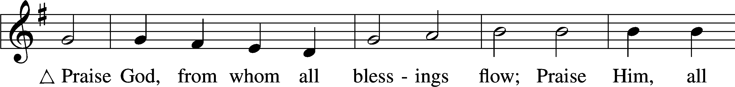
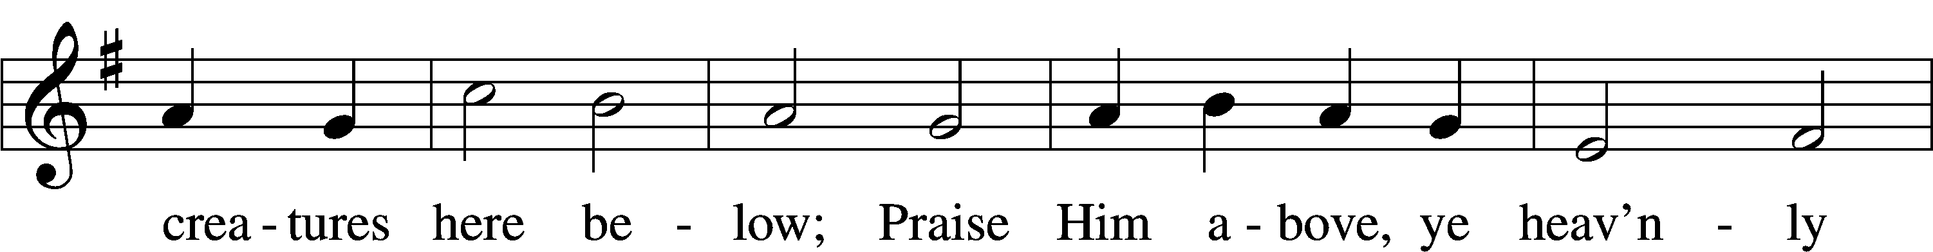
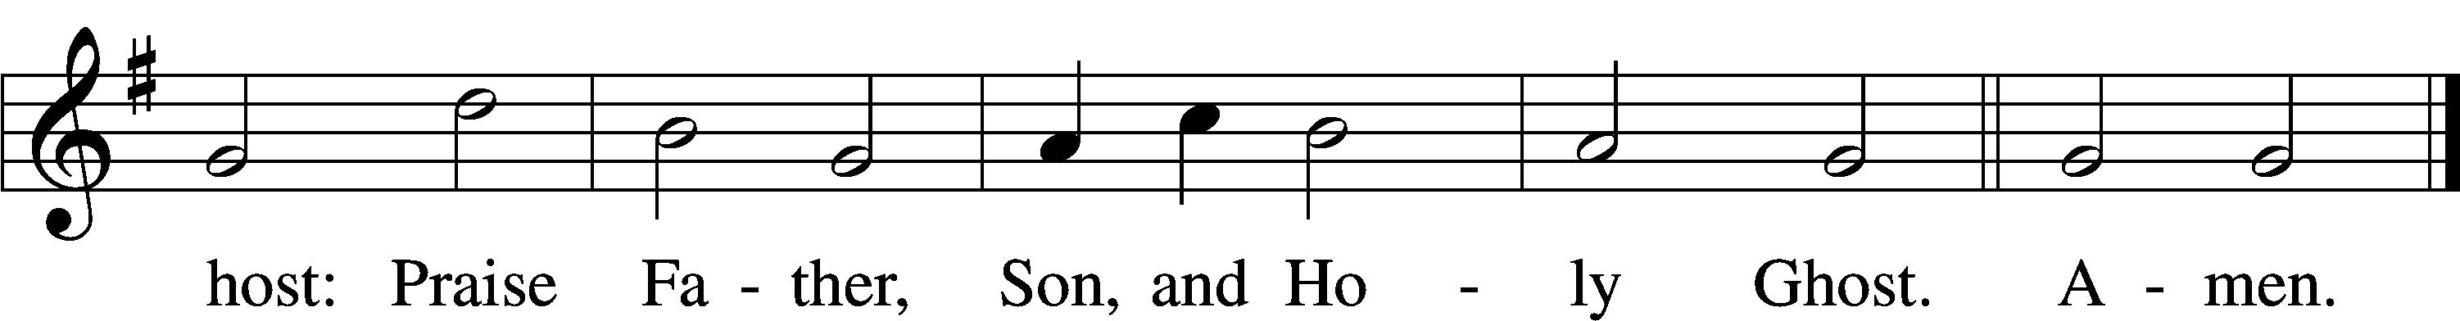
Text: Thomas Ken, 1637–1711
Tune: Trente quatre Pseaumes de David, 1551, Geneva, ed. Louis Bourgeois
Text and tune: Public domain

Prayer of the Church

Lord’s Prayer Matthew 6:9–13
P Lord, remember us in Your kingdom and teach us to pray:
C Our Father who art in heaven,
hallowed be Thy name,
Thy kingdom come,
Thy will be done on earth
as it is in heaven;
give us this day our daily bread;
and forgive us our trespasses
as we forgive those
who trespass against us;
and lead us not into temptation,
but deliver us from evil.
For Thine is the kingdom
and the power and the glory
forever and ever. Amen.

Collect for the Word

Blessed Lord, You have caused all Holy Scriptures to be written for our learning. Grant that we may so hear them, read, mark, learn, and inwardly digest them that, by the patience and comfort of Your holy Word, we may embrace and ever hold fast the blessed hope of everlasting life; through Jesus Christ, Your Son, our Lord, who lives and reigns with You and the Holy Spirit, one God, now and forever.

Benediction
P The Lord bless you and keep you.
The Lord make His face shine on you and be gracious to you.
The Lord look upon you with favor and T give you peace.
C Amen.

912 Christ Is Our Cornerstone
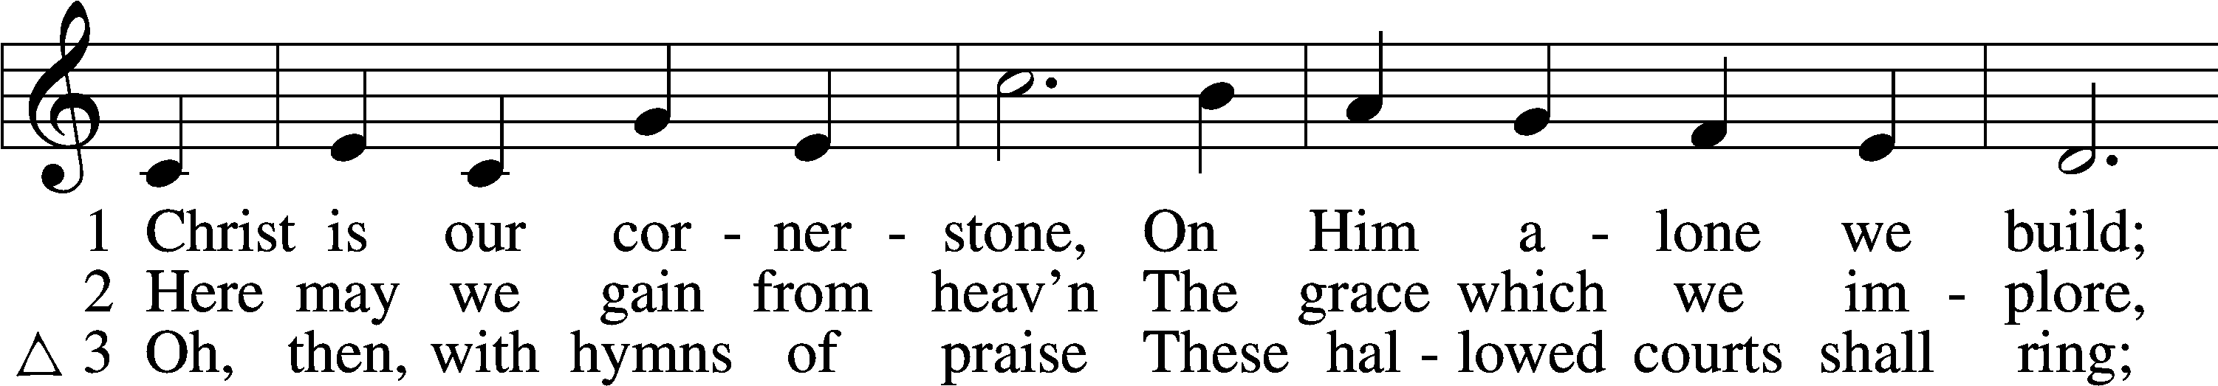
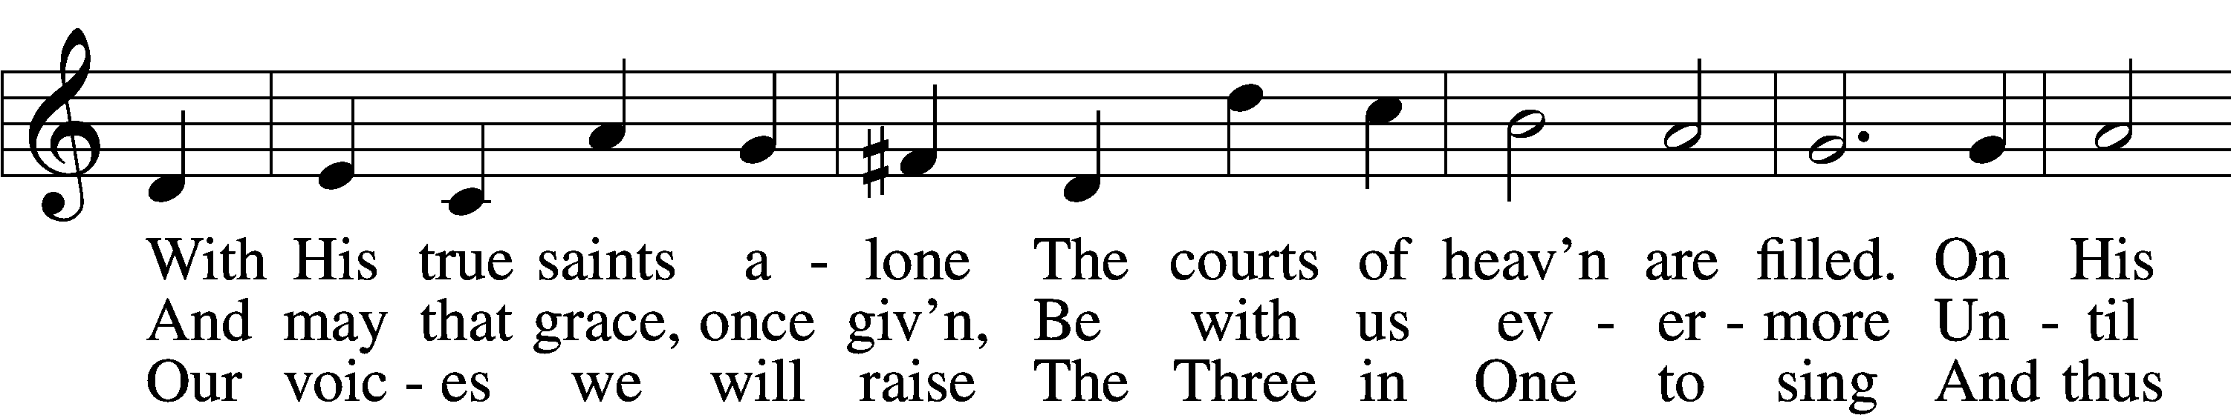
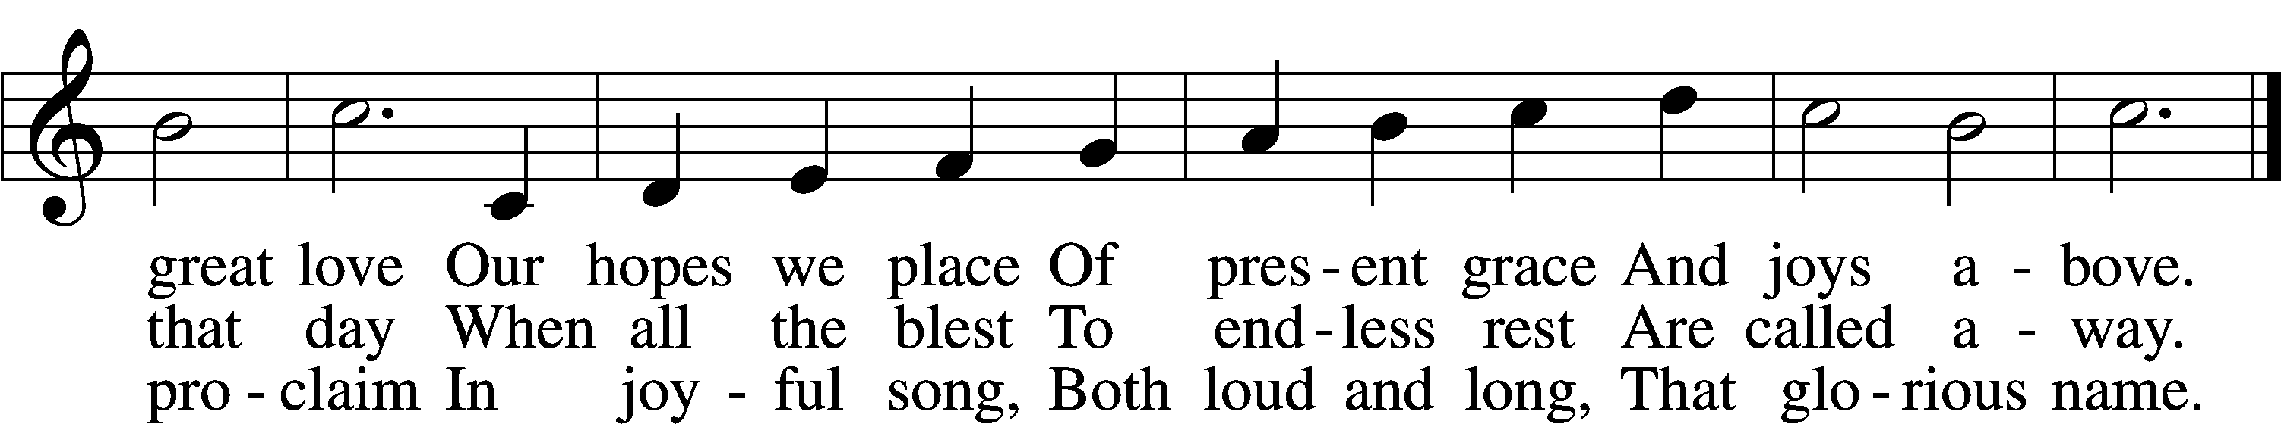
Text: Latin, c. 8th cent.; tr. John Chandler, 1806–76, alt.
Tune: John Darwall, 1731–89
Text and tune: Public domain
Acknowledgments
Unless otherwise indicated, Scripture quotations are from the ESV® Bible (The Holy Bible, English Standard Version®), copyright © 2001 by Crossway, a publishing ministry of Good News Publishers. Used by permission. All rights reserved.
Created by Lutheran Service Builder © 2026 Concordia Publishing House.

