On entering the church

P Lord, I love the habitation of Your house and the place

where Your glory dwells. In the multitude of Your tender

mercies prepare my heart that I may enter Your house to

worship and confess Your holy name; through Jesus Christ,

my God and Lord.

Before worship

C O Lord, our creator, redeemer, and comforter, as we come

together to worship You in spirit and in truth, we humbly

pray that You would open our hearts to the preaching of

Your Word so that we may repent of our sins, believe in

Jesus Christ as our only Savior, and grow in grace and

holiness. Hear us for His sake.

676 Behold a Host, Arrayed in White

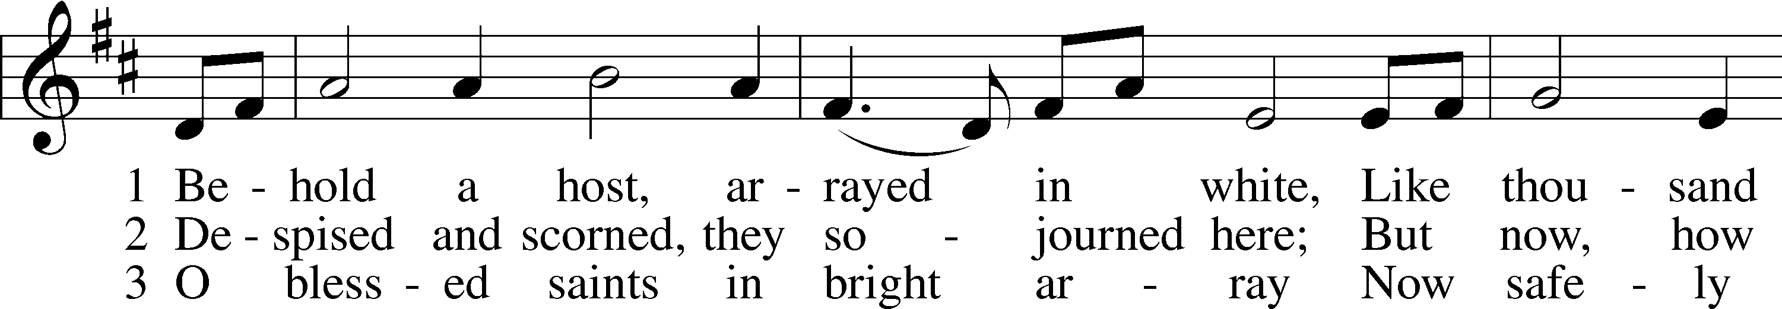

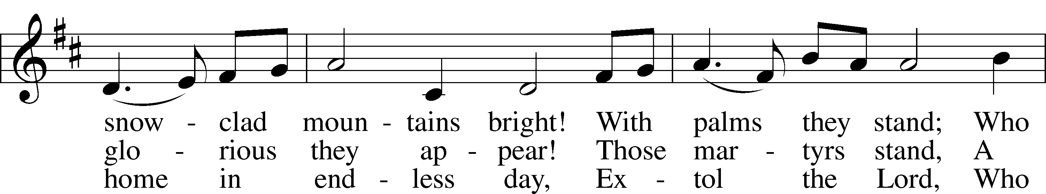

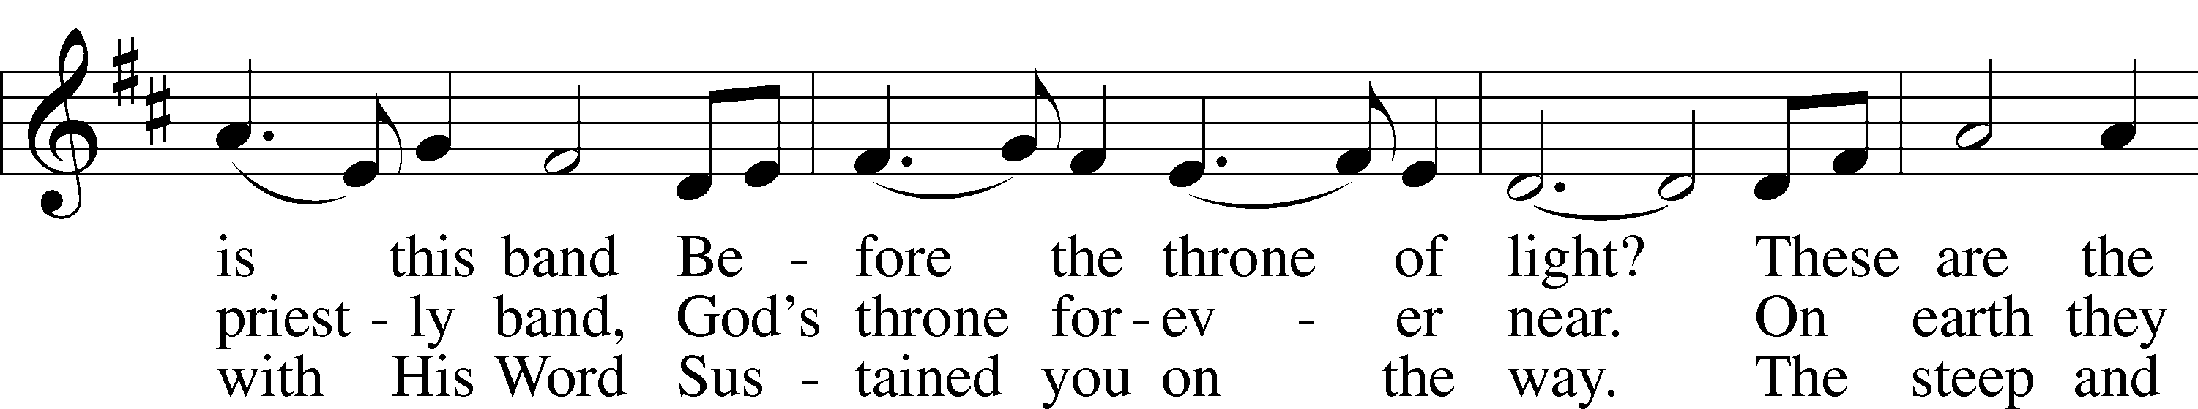

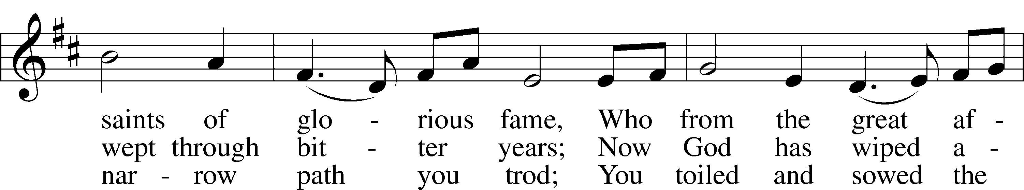

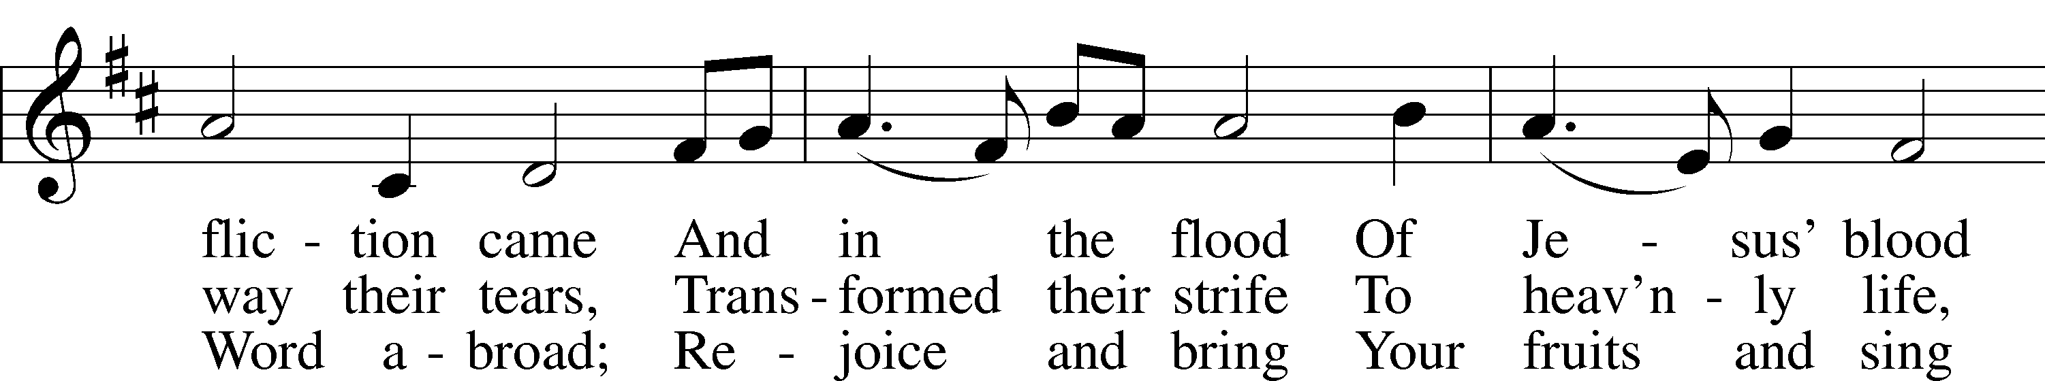

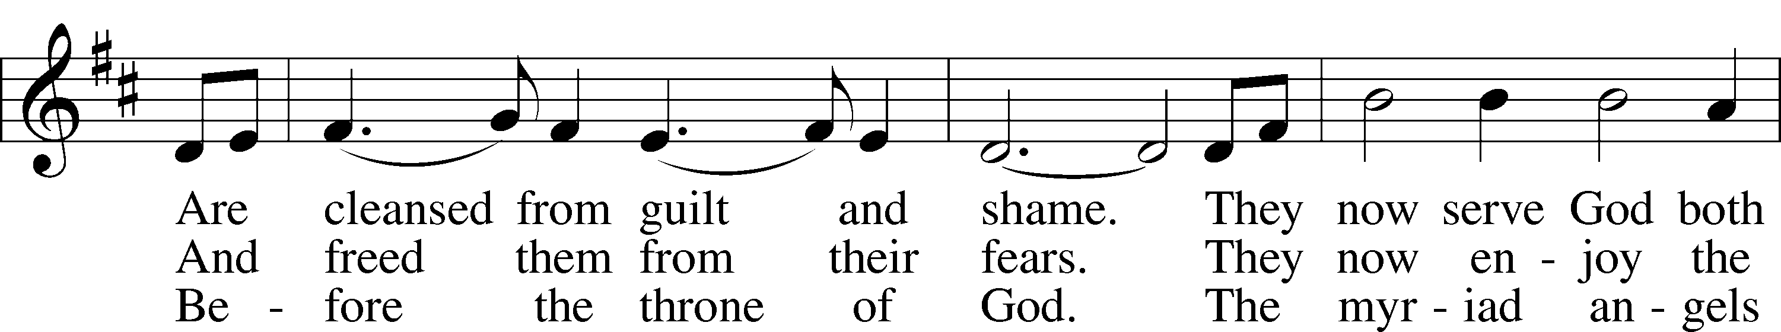

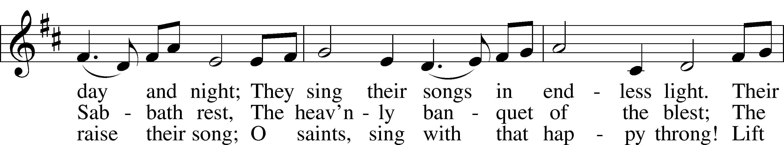

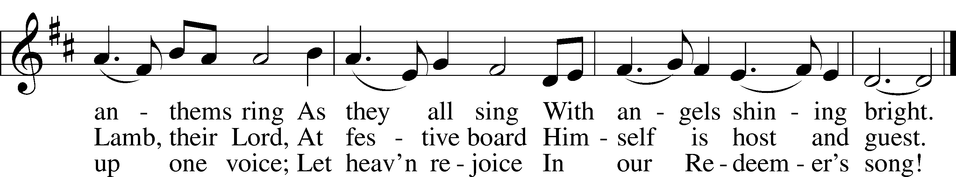

Text: Hans Adolf Brorson, 1694–1764; tr. The Lutheran Hymnal, 1941, alt.  
Tune: Norwegian, 17th cent.  
Text and tune: Public domain

# Confession and Absolution

Stand

The sign of the cross may be made by all in remembrance of their Baptism.

Invocation Matthew 28:19b; 18:20

P In the name of the Father and of the T Son and of the Holy Spirit.

C **Amen.**

Exhortation Hebrews 10:22; Psalm 124:8; Psalm 32:5

P Beloved in the Lord! Let us draw near with a true heart and confess our sins unto God our Father, beseeching Him in the name of our Lord Jesus Christ to grant us forgiveness.

P Our help is in the name of the Lord,

C **who made heaven and earth.**

P I said, I will confess my transgressions unto the Lord,

C **and You forgave the iniquity of my sin.**

Kneel/Stand

Silence for reflection on God’s Word and for self-examination.

Confession of Sins

P O almighty God, merciful Father,

C **I, a poor, miserable sinner, confess unto You all my sins and iniquities with which I have ever offended You and justly deserved Your temporal and eternal punishment. But I am heartily sorry for them and sincerely repent of them, and I pray You of Your boundless mercy and for the sake of the holy, innocent, bitter sufferings and death of Your beloved Son, Jesus Christ, to be gracious and merciful to me, a poor, sinful being.**

Absolution [John 20:19–23]

P Upon this your confession, I, by virtue of my office, as a called and ordained servant of the Word, announce the grace of God unto all of you, and in the stead and by the command of my Lord Jesus Christ I forgive you all your sins in the name of the Father and of the T Son and of the Holy Spirit.

C **Amen.**

Stand

# Service of the Word

Introit Psalm 78:70–72; 79:13; antiphon: John 10:14, 15b

I am the good shepherd.  
 I know my own and my own know me, and I lay down my life for the sheep.  
**He chose David his servant and took him from the sheepfolds;  
 from following the nursing ewes he brought him to shepherd Jacob his people, Israel his inheritance.**  
With upright heart he shepherded them  
 and guided them with his skillful hand.  
**But we your people, the sheep of your pasture, will give thanks to you forever;  
 from generation to generation we will recount your praise.**

Gloria Patri

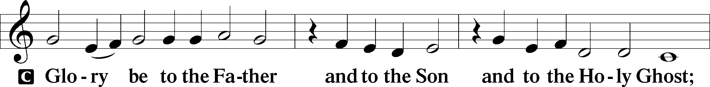

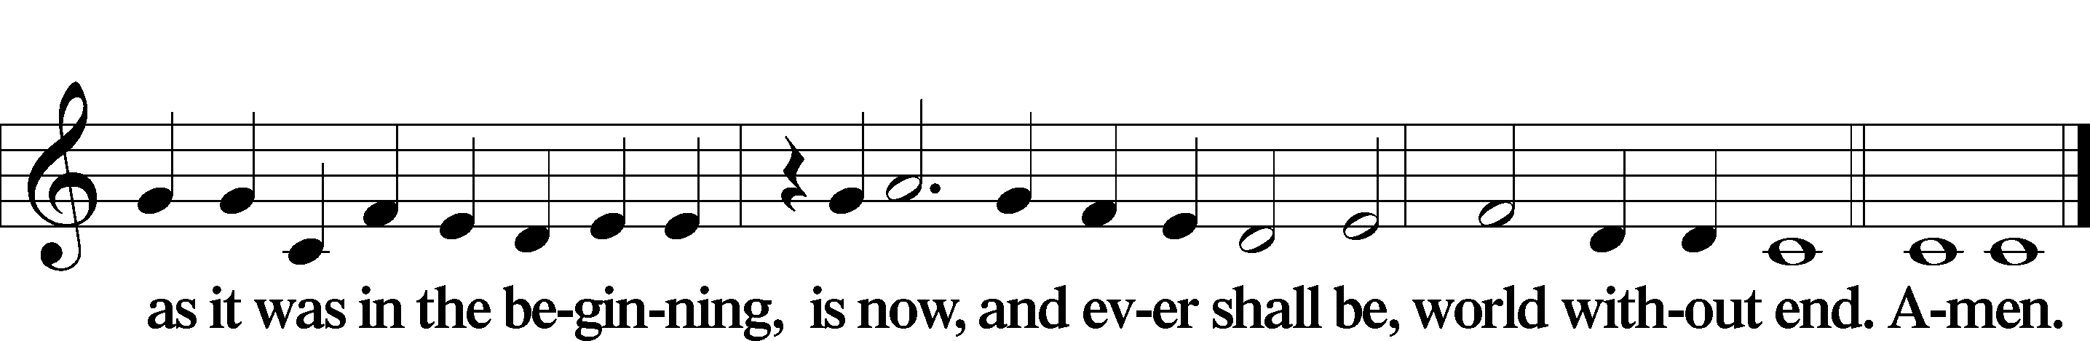

Kyrie Mark 10:47

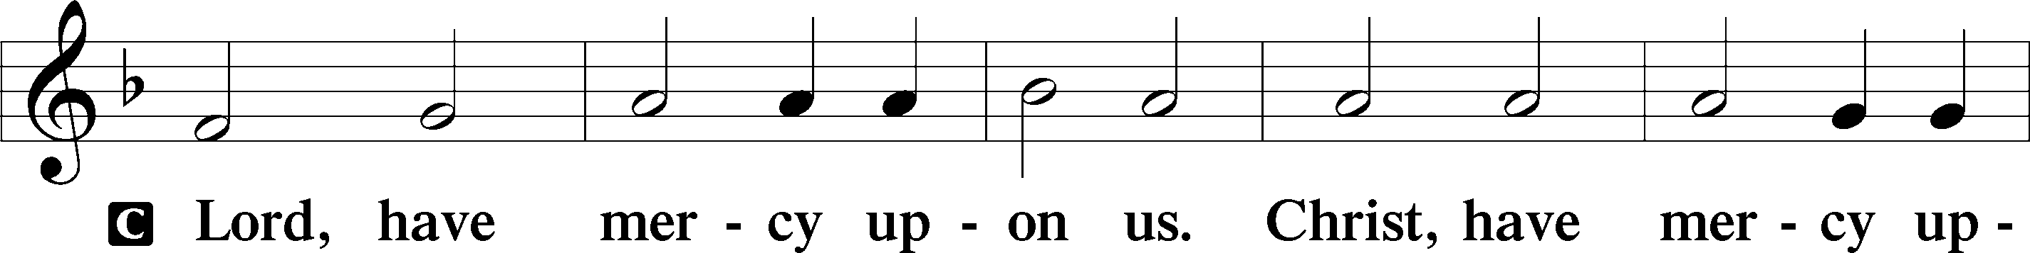

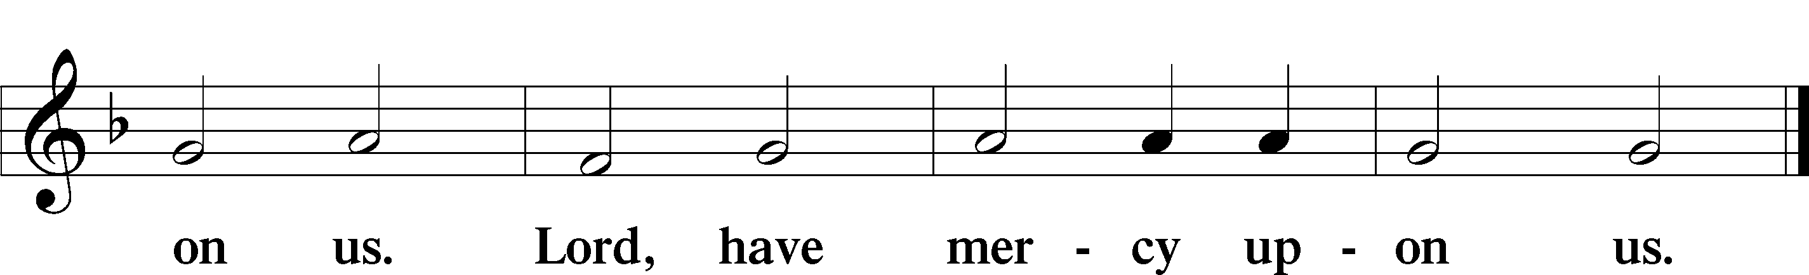

Gloria in Excelsis Luke 2:14; John 1:29

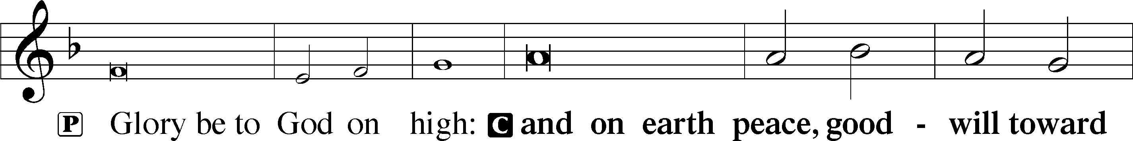

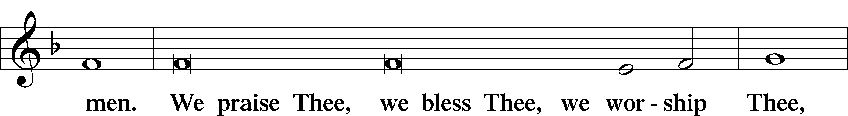

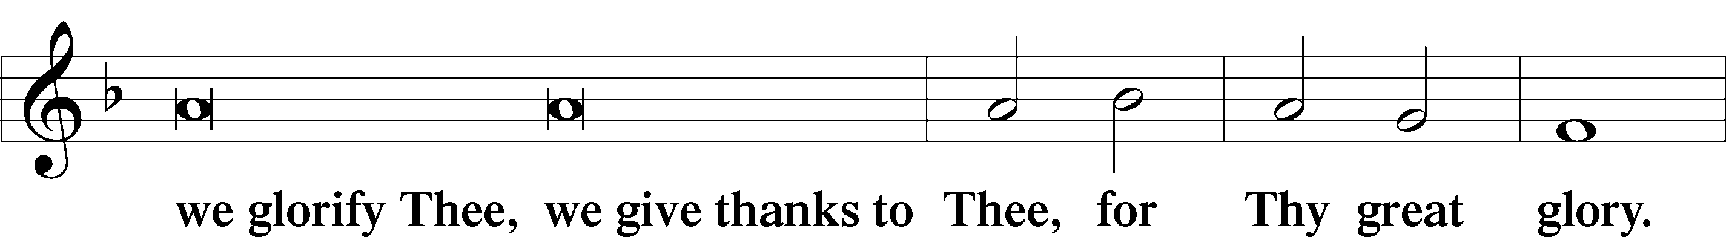

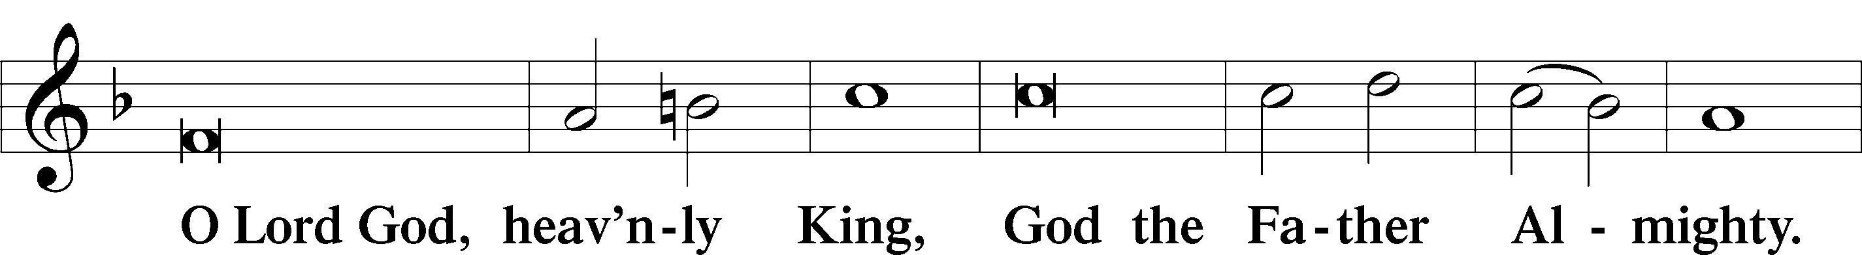

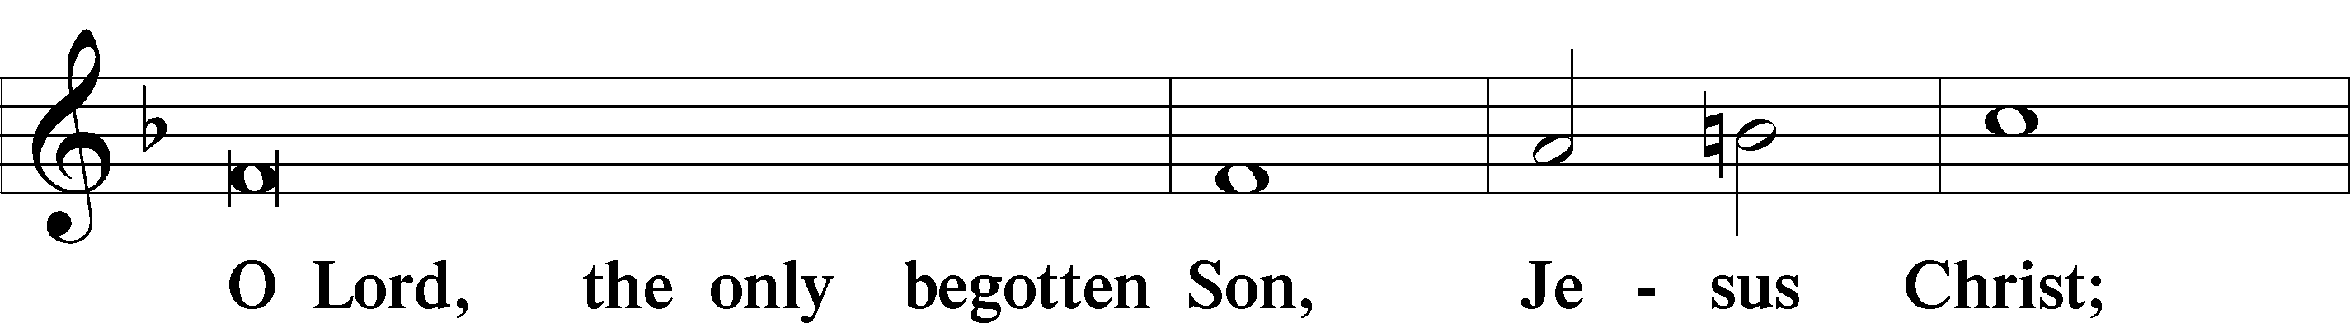

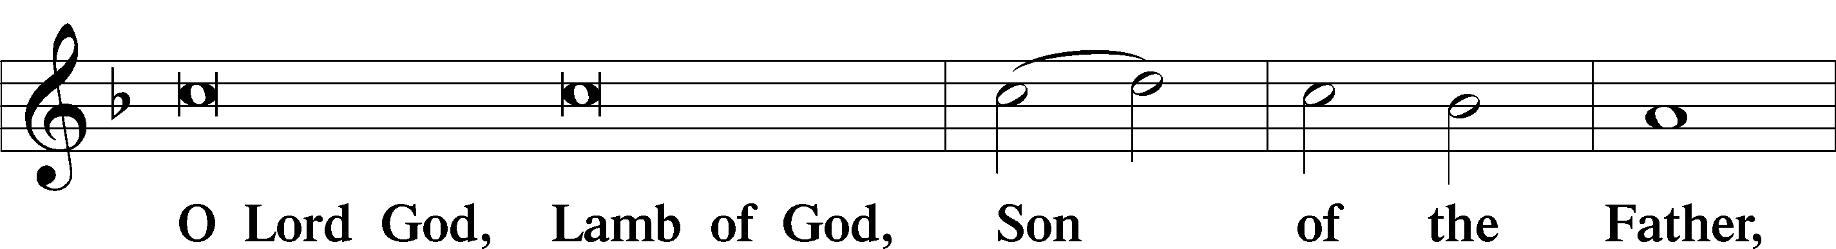

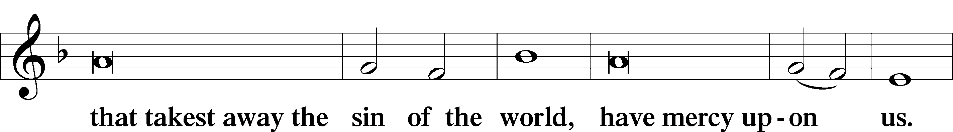

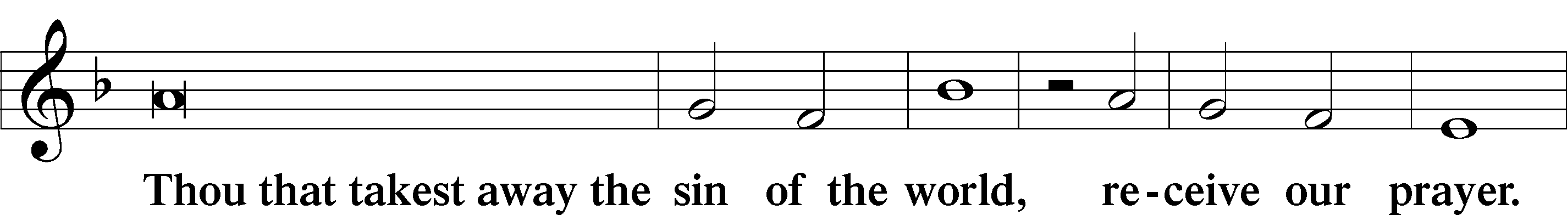

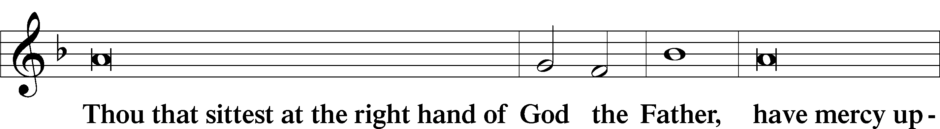

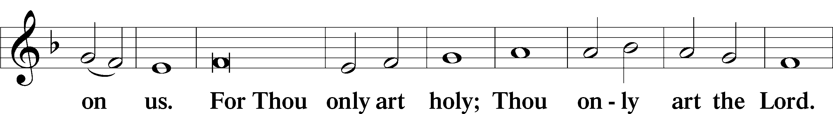

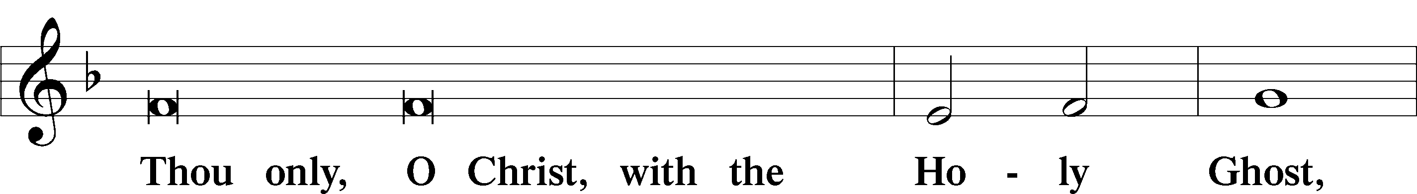

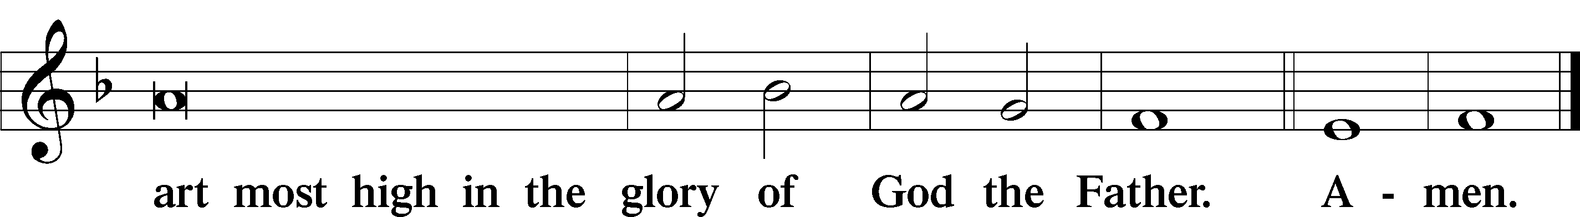

Salutation and Collect of the Day

P The Lord be with you.

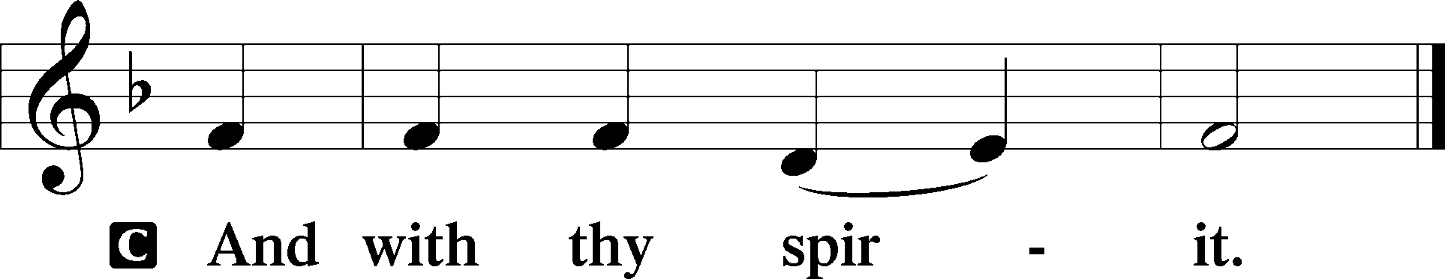

P Let us pray.

Almighty God, merciful Father, since You have wakened from death the Shepherd of Your sheep, grant us Your Holy Spirit that when we hear the voice of our Shepherd we may know Him who calls us each by name and follow where He leads; through the same Jesus Christ, Your Son, our Lord, who lives and reigns with You and the Holy Spirit, one God, now and forever.

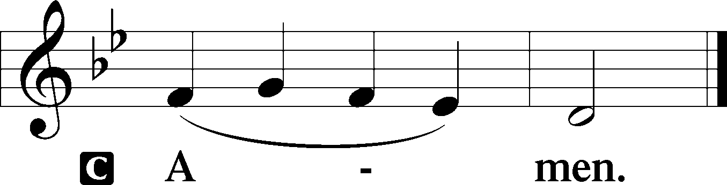

Sit

First Reading Acts 20:17–35

17Now from Miletus [Paul] sent to Ephesus and called the elders of the church to come to him. 18And when they came to him, he said to them:

“You yourselves know how I lived among you the whole time from the first day that I set foot in Asia, 19serving the Lord with all humility and with tears and with trials that happened to me through the plots of the Jews; 20how I did not shrink from declaring to you anything that was profitable, and teaching you in public and from house to house, 21testifying both to Jews and to Greeks of repentance toward God and of faith in our Lord Jesus Christ. 22And now, behold, I am going to Jerusalem, constrained by the Spirit, not knowing what will happen to me there, 23except that the Holy Spirit testifies to me in every city that imprisonment and afflictions await me. 24But I do not account my life of any value nor as precious to myself, if only I may finish my course and the ministry that I received from the Lord Jesus, to testify to the gospel of the grace of God. 25And now, behold, I know that none of you among whom I have gone about proclaiming the kingdom will see my face again. 26Therefore I testify to you this day that I am innocent of the blood of all of you, 27for I did not shrink from declaring to you the whole counsel of God. 28Pay careful attention to yourselves and to all the flock, in which the Holy Spirit has made you overseers, to care for the church of God, which he obtained with his own blood. 29I know that after my departure fierce wolves will come in among you, not sparing the flock; 30and from among your own selves will arise men speaking twisted things, to draw away the disciples after them. 31Therefore be alert, remembering that for three years I did not cease night or day to admonish everyone with tears. 32And now I commend you to God and to the word of his grace, which is able to build you up and to give you the inheritance among all those who are sanctified. 33I coveted no one’s silver or gold or apparel. 34You yourselves know that these hands ministered to my necessities and to those who were with me. 35In all things I have shown you that by working hard in this way we must help the weak and remember the words of the Lord Jesus, how he himself said, ‘It is more blessed to give than to receive.’”

A This is the Word of the Lord.

C **Thanks be to God.**

Gradual adapt. from Matthew 28:7; Hebrews 2:7; Psalm 8:6

Christ has risen from the dead.  
 [God the Father] has crowned him with glory and honor.  
**He has given him dominion over the works of his hands;  
 he has put all things under his feet.**

Epistle Revelation 7:9–17

9After this I looked, and behold, a great multitude that no one could number, from every nation, from all tribes and peoples and languages, standing before the throne and before the Lamb, clothed in white robes, with palm branches in their hands, 10and crying out with a loud voice, “Salvation belongs to our God who sits on the throne, and to the Lamb!” 11And all the angels were standing around the throne and around the elders and the four living creatures, and they fell on their faces before the throne and worshiped God, 12saying, “Amen! Blessing and glory and wisdom and thanksgiving and honor and power and might be to our God forever and ever! Amen.”

13Then one of the elders addressed me, saying, “Who are these, clothed in white robes, and from where have they come?” 14I said to him, “Sir, you know.” And he said to me, “These are the ones coming out of the great tribulation. They have washed their robes and made them white in the blood of the Lamb.

15“Therefore they are before the throne of God,  
 and serve him day and night in his temple;  
 and he who sits on the throne will shelter them with his presence.  
16They shall hunger no more, neither thirst anymore;  
 the sun shall not strike them,  
 nor any scorching heat.  
17For the Lamb in the midst of the throne will be their shepherd,  
 and he will guide them to springs of living water,  
and God will wipe away every tear from their eyes.”

A This is the Word of the Lord.

C **Thanks be to God.**

Stand

Alleluia

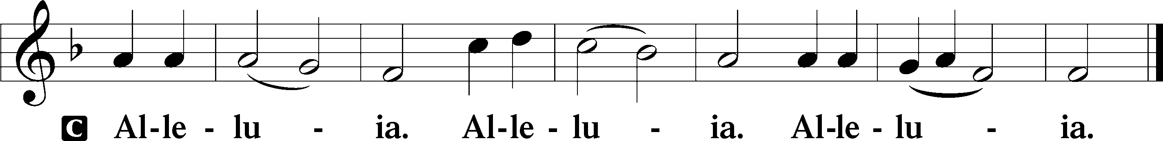

Holy Gospel John 10:22–30

P The Holy Gospel according to St. John, the tenth chapter.

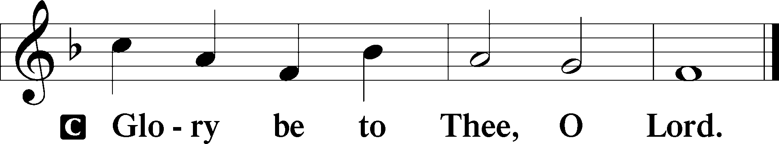

22At that time the Feast of Dedication took place at Jerusalem. It was winter, 23and Jesus was walking in the temple, in the colonnade of Solomon. 24So the Jews gathered around him and said to him, “How long will you keep us in suspense? If you are the Christ, tell us plainly.” 25Jesus answered them, “I told you, and you do not believe. The works that I do in my Father’s name bear witness about me, 26but you do not believe because you are not part of my flock. 27My sheep hear my voice, and I know them, and they follow me. 28I give them eternal life, and they will never perish, and no one will snatch them out of my hand. 29My Father, who has given them to me, is greater than all, and no one is able to snatch them out of the Father’s hand. 30I and the Father are one.”

P This is the Gospel of the Lord.

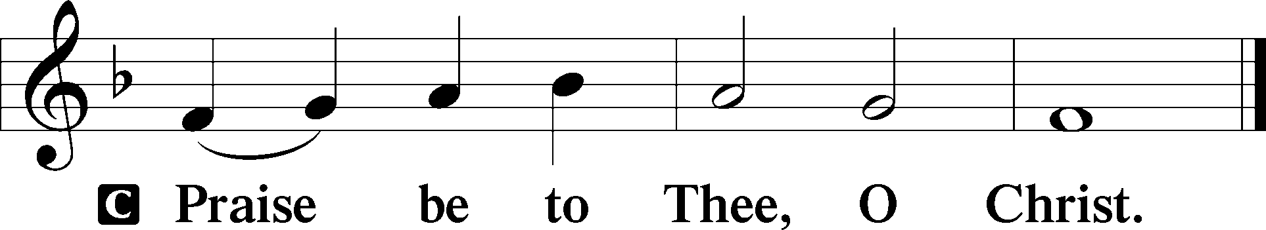

Apostles’ Creed

C **I believe in God, the Father Almighty,**

**maker of heaven and earth.**

**And in Jesus Christ, His only Son, our Lord,**

**who was conceived by the Holy Spirit,**

**born of the virgin Mary,**

**suffered under Pontius Pilate,**

**was crucified, died and was buried.**

**He descended into hell.**

**The third day He rose again from the dead.**

**He ascended into heaven**

**and sits at the right hand of God the Father Almighty.**

**From thence He will come to judge the living and the dead.**

**I believe in the Holy Spirit,**

**the holy Christian Church,**

**the communion of saints,**

**the forgiveness of sins,**

**the resurrection of the body,**

**and the life** T **everlasting. Amen.**

Sit

Children's Sermon

710 The Lord’s My Shepherd, I’ll Not Want

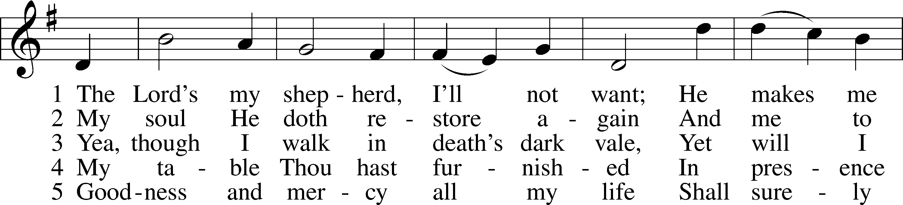

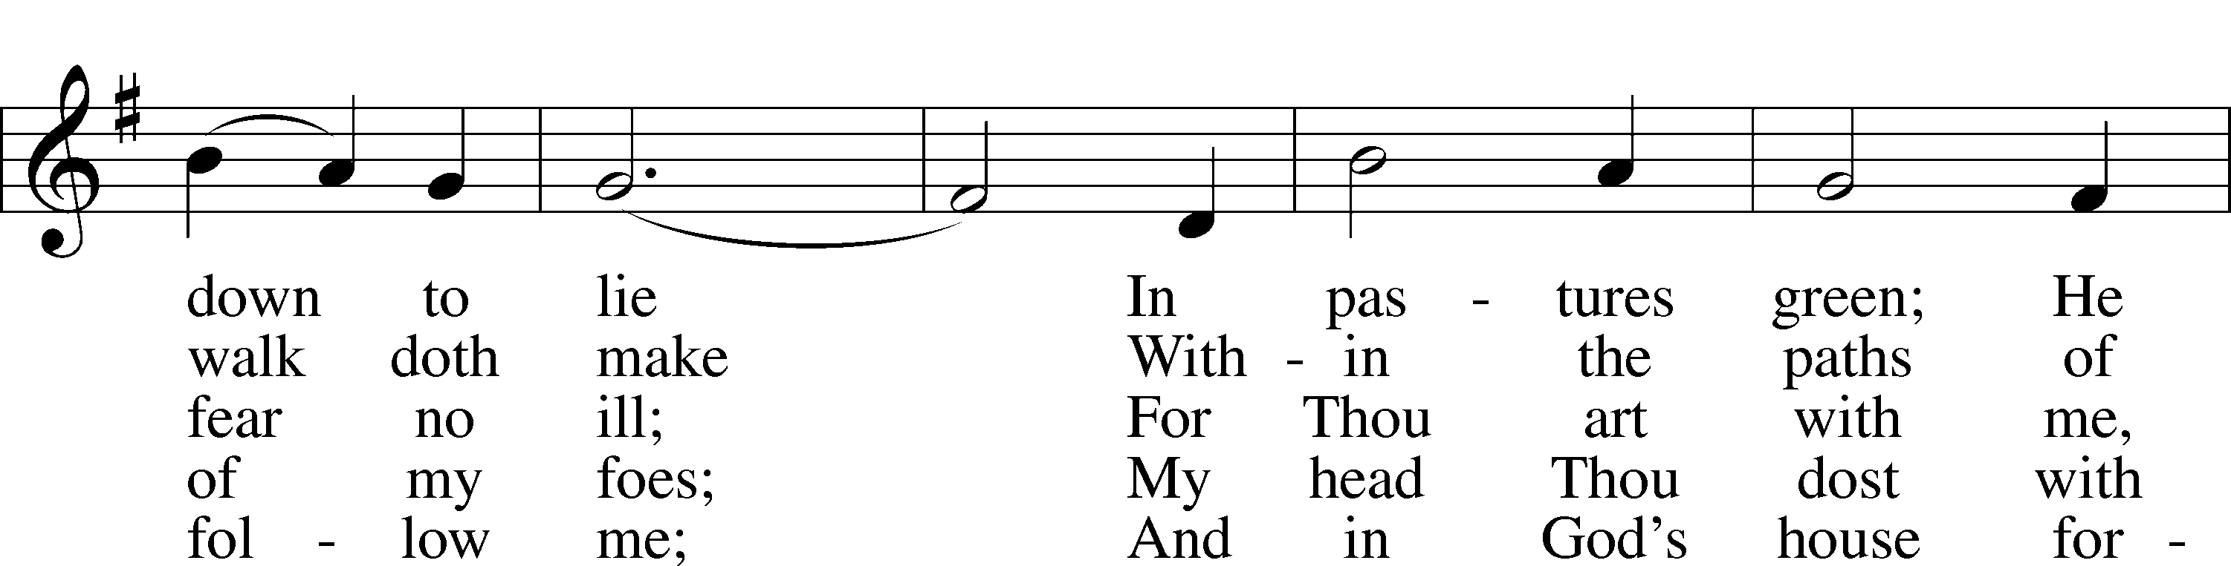

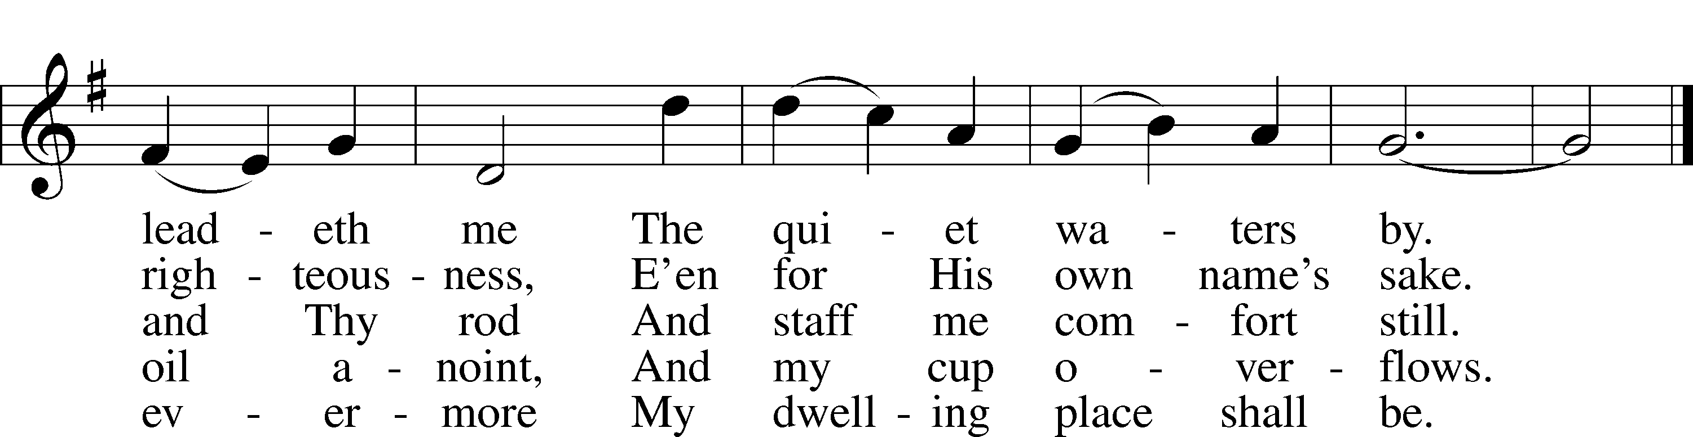

Text: The Psalms of David in Meeter, 1650, Edinburgh  
Tune: William Gardiner, 1770–1853  
Text and tune: Public domain

Sermon

Votum

P The peace of God, which passes all understanding, keep your hearts and minds in Christ Jesus.

C **Amen.**

Stand

Offertory Psalm 51:10–12

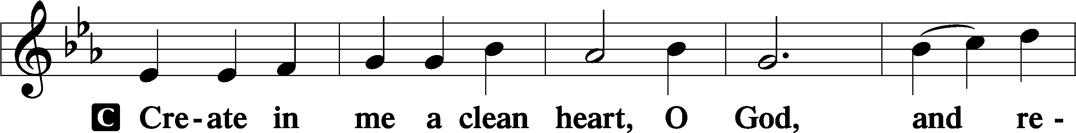

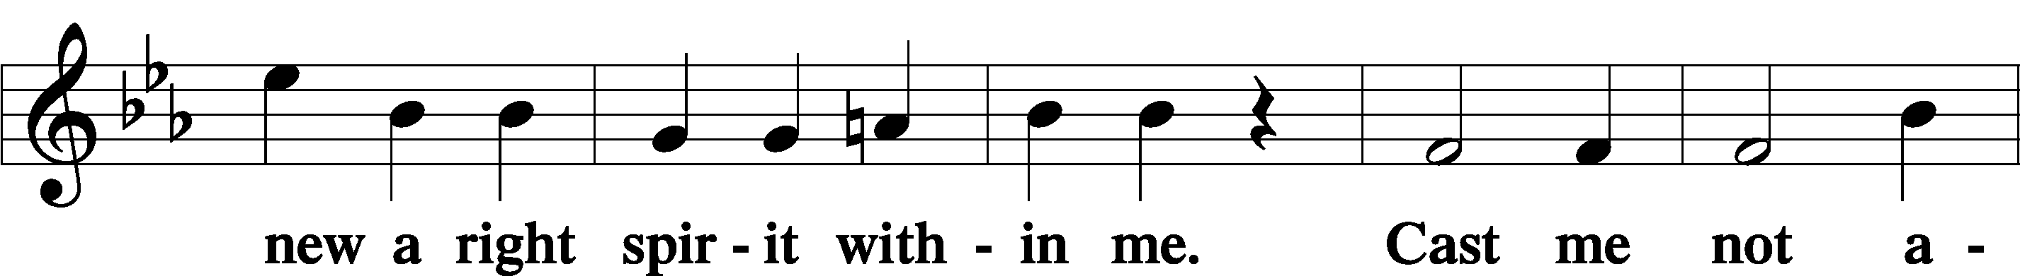

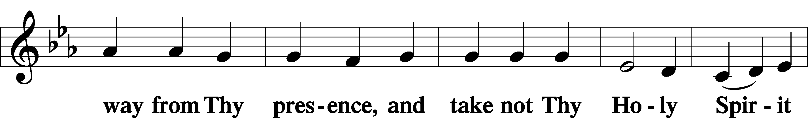

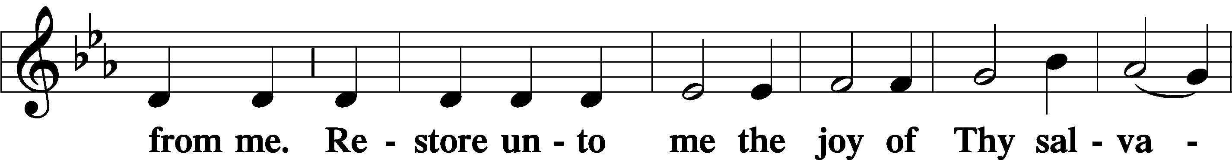

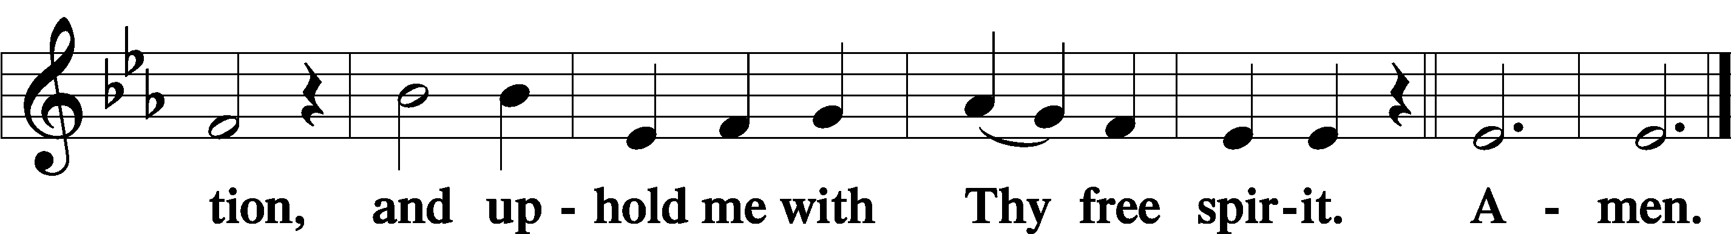

Sit

Offering

Hymn

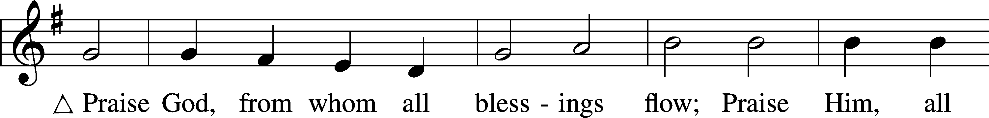

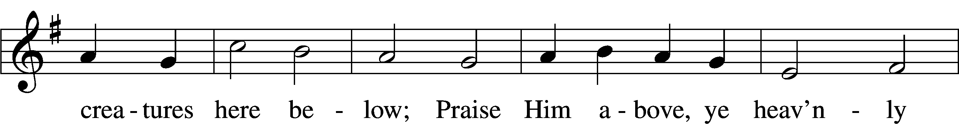

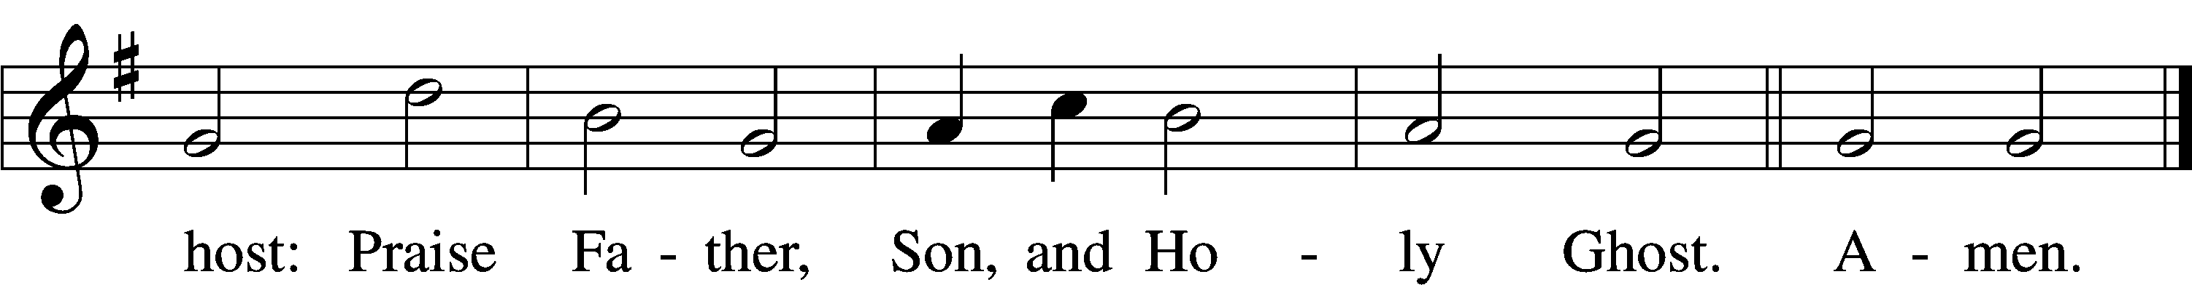

Text: Thomas Ken, 1637–1711  
Tune: Trente quatre Pseaumes de David, 1551, Geneva, ed. Louis Bourgeois  
Text and tune: Public domain

Stand

Prayer of the Church

Lord’s Prayer Matthew 6:9–13

P Lord, remember us in Your kingdom and teach us to pray:

C **Our Father who art in heaven,**

**hallowed be Thy name,**

**Thy kingdom come,**

**Thy will be done on earth**

**as it is in heaven;**

**give us this day our daily bread;**

**and forgive us our trespasses**

**as we forgive those**

**who trespass against us;**

**and lead us not into temptation,**

**but deliver us from evil.**

**For Thine is the kingdom**

**and the power and the glory**

**forever and ever. Amen.**

Collect for the Word

Blessed Lord, You have caused all Holy Scriptures to be written for our learning. Grant that we may so hear them, read, mark, learn, and inwardly digest them that, by the patience and comfort of Your holy Word, we may embrace and ever hold fast the blessed hope of everlasting life; through Jesus Christ, Your Son, our Lord, who lives and reigns with You and the Holy Spirit, one God, now and forever.

Benediction

P The Lord bless you and keep you.

The Lord make His face shine on you and be gracious to you.

The Lord look upon you with favor and T give you peace.

C **Amen.**

670 Ye Watchers and Ye Holy Ones

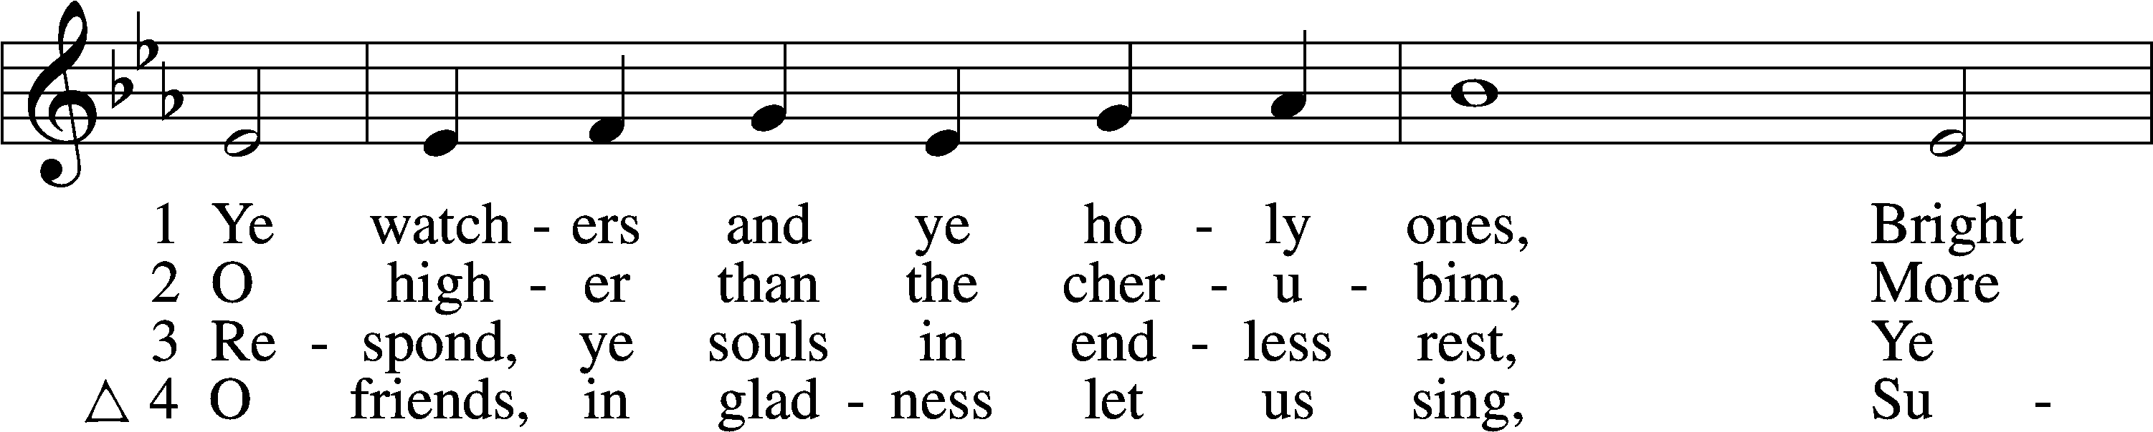

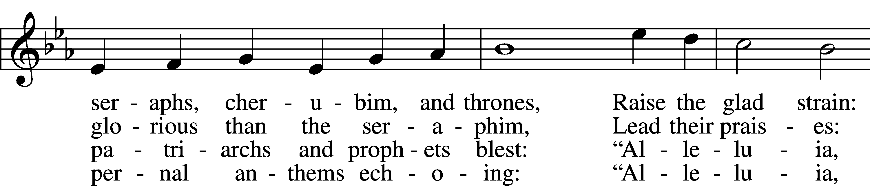

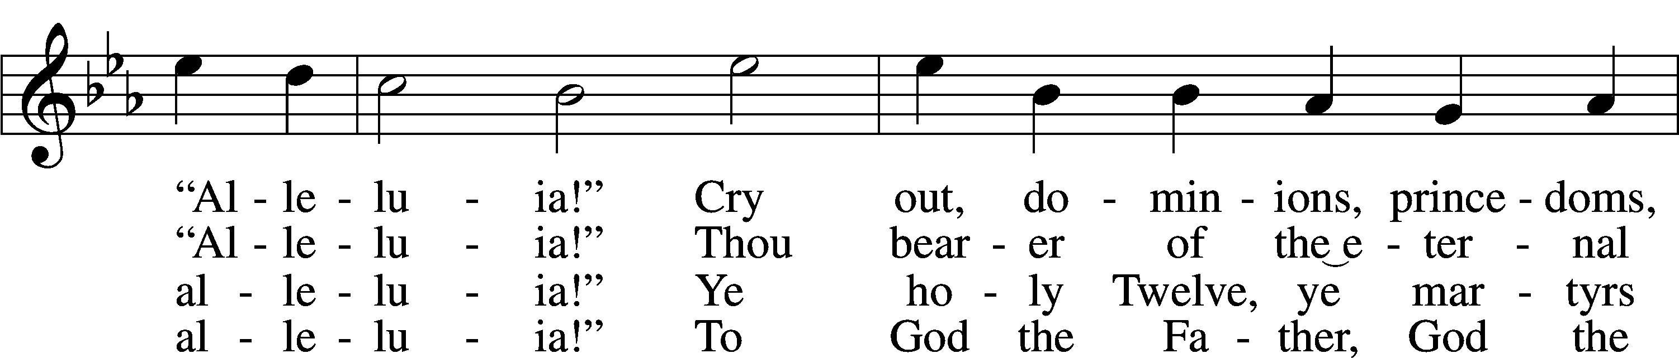

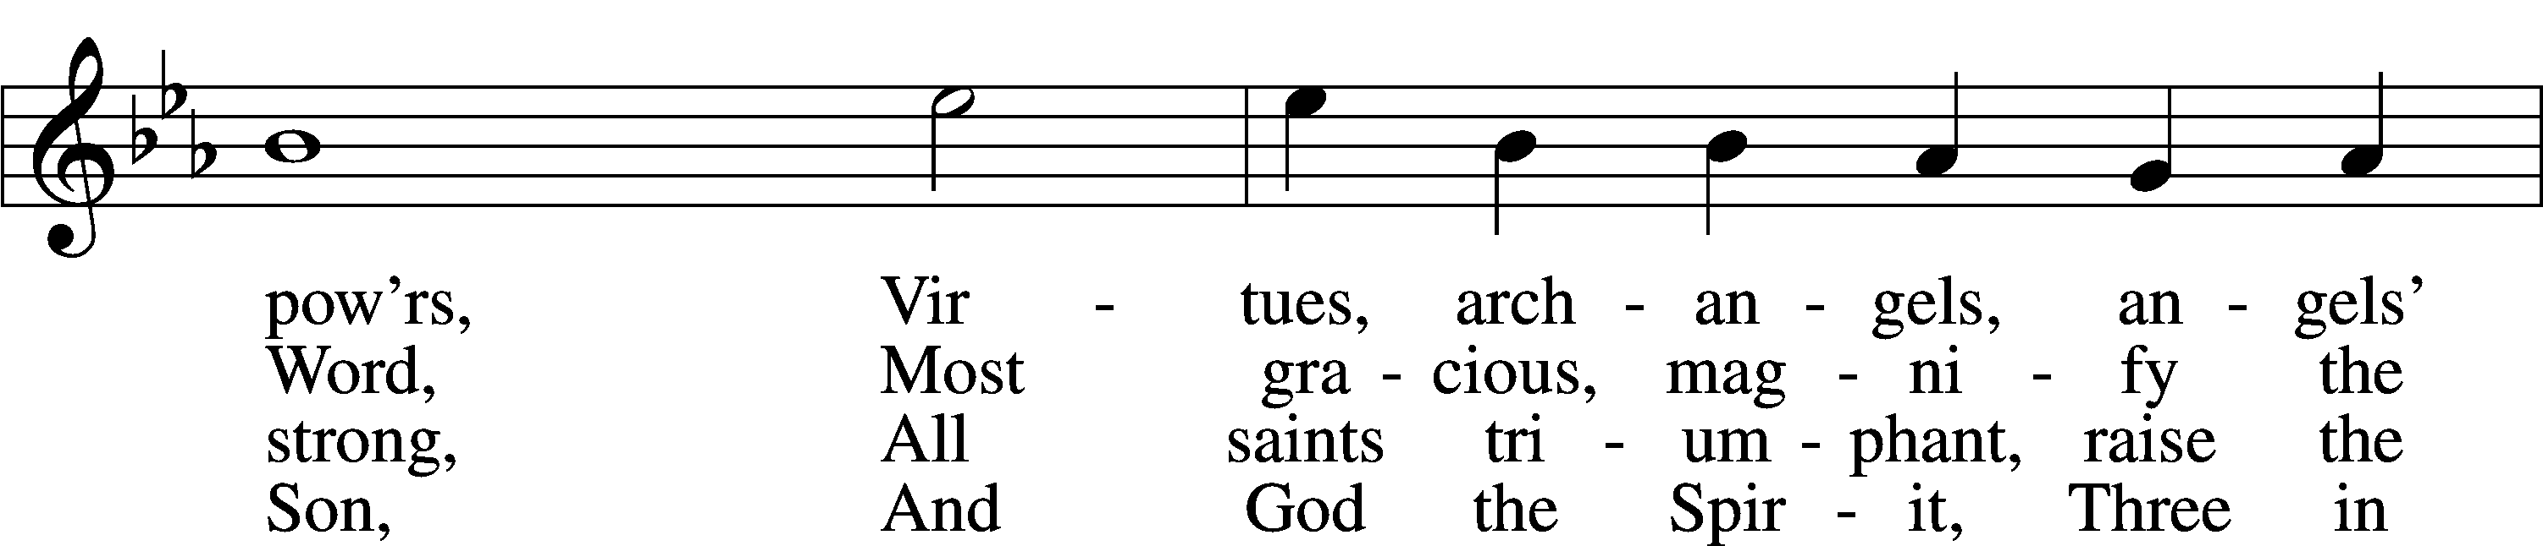

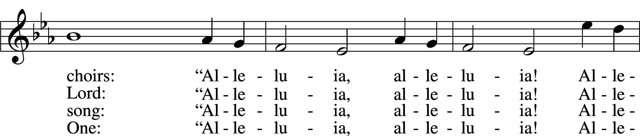

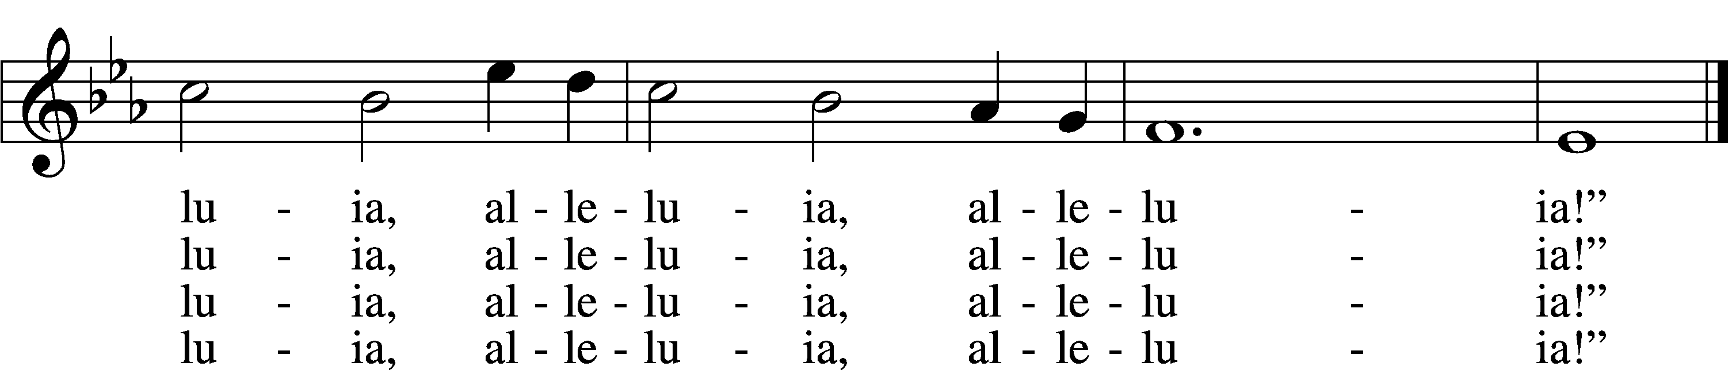

Text: J. Athelstan L. Riley, 1858–1945, alt.  
Tune: Geistliche Kirchengesäng, 1623, Köln  
Text and tune: Public domain

Acknowledgments

Divine Service, Setting Three from Lutheran Service Book

Unless otherwise indicated, Scripture quotations are from the ESV® Bible (The Holy Bible, English Standard Version®), copyright © 2001 by Crossway, a publishing ministry of Good News Publishers. Used by permission. All rights reserved.

Created by Lutheran Service Builder © 2025 Concordia Publishing House.