On entering the church

P Lord, I love the habitation of Your house and the place

where Your glory dwells. In the multitude of Your tender

mercies prepare my heart that I may enter Your house to

worship and confess Your holy name; through Jesus Christ,

my God and Lord.

Before worship

C O Lord, our creator, redeemer, and comforter, as we come

together to worship You in spirit and in truth, we humbly

pray that You would open our hearts to the preaching of

Your Word so that we may repent of our sins, believe in

Jesus Christ as our only Savior, and grow in grace and

holiness. Hear us for His sake.

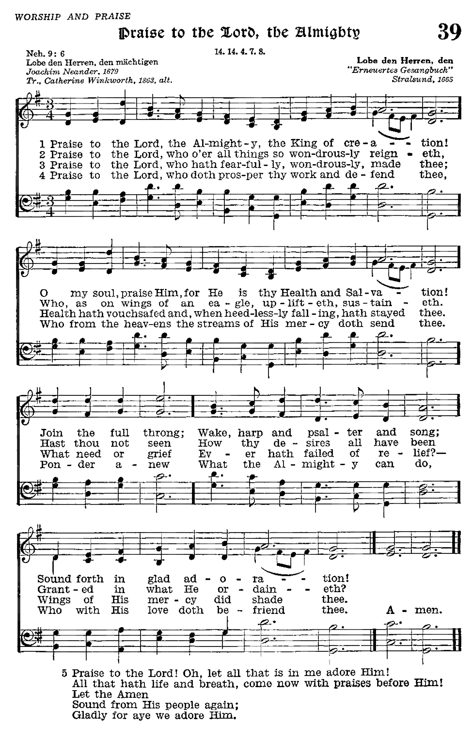

# Confession and Absolution

Stand

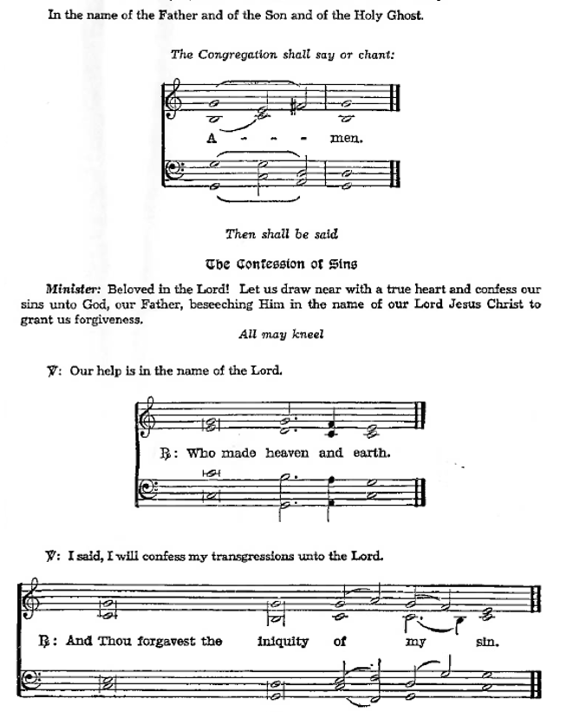Kneel/Stand

Silence for reflection on God’s Word and for self-examination.

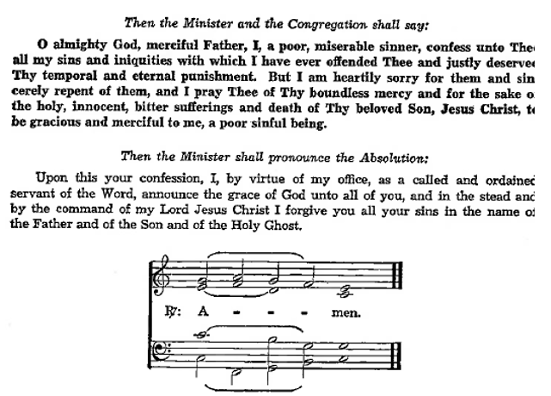

**Introit** *Psalm 85:8–10, 13; antiphon: v. 7*

Show us your steadfast love, O Lord,  
 and grant us your salvation.  
**Let me hear what God the Lord will speak,  
 for he will speak peace to his people, to his saints; but let them not turn back to folly.**Surely his salvation is near to those who fear him,  
 that glory may dwell in our land.  
**Steadfast love and faithfulness meet;  
 righteousness and peace kiss each other.**Righteousness will go before him  
 and make his footsteps a way.

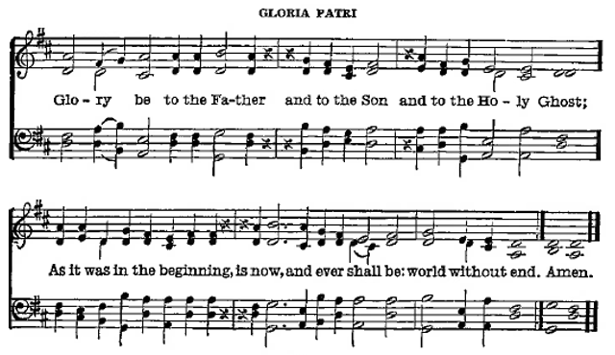

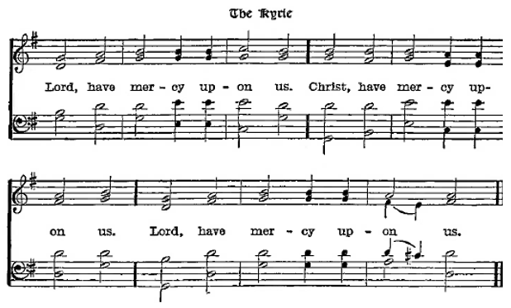

P Lord of all power and might, author and giver of all good things, graft into our hearts the love of Your name and nourish us with all goodness that we may love and serve our neighbor; through Jesus Christ, Your Son, our Lord, who lives and reigns with You and the Holy Spirit, one God, now and forever.

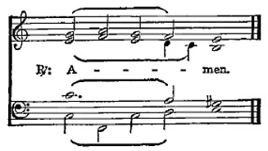

Sit

Old Testament *1 Kings 19:9b–21*

19Behold, the word of the Lord came to [Elijah], and he said to him, “What are you doing here, Elijah?” 10He said, “I have been very jealous for the Lord, the God of hosts. For the people of Israel have forsaken your covenant, thrown down your altars, and killed your prophets with the sword, and I, even I only, am left, and they seek my life, to take it away.” 11And he said, “Go out and stand on the mount before the Lord.” And behold, the Lord passed by, and a great and strong wind tore the mountains and broke in pieces the rocks before the Lord, but the Lord was not in the wind. And after the wind an earthquake, but the Lord was not in the earthquake. 12And after the earthquake a fire, but the Lord was not in the fire. And after the fire the sound of a low whisper. 13And when Elijah heard it, he wrapped his face in his cloak and went out and stood at the entrance of the cave. And behold, there came a voice to him and said, “What are you doing here, Elijah?” 14He said, “I have been very jealous for the Lord, the God of hosts. For the people of Israel have forsaken your covenant, thrown down your altars, and killed your prophets with the sword, and I, even I only, am left, and they seek my life, to take it away.” 15And the Lord said to him, “Go, return on your way to the wilderness of Damascus. And when you arrive, you shall anoint Hazael to be king over Syria. 16And Jehu the son of Nimshi you shall anoint to be king over Israel, and Elisha the son of Shaphat of Abel-meholah you shall anoint to be prophet in your place. 17And the one who escapes from the sword of Hazael shall Jehu put to death, and the one who escapes from the sword of Jehu shall Elisha put to death. 18Yet I will leave seven thousand in Israel, all the knees that have not bowed to Baal, and every mouth that has not kissed him.”

19So he departed from there and found Elisha the son of Shaphat, who was plowing with twelve yoke of oxen in front of him, and he was with the twelfth. Elijah passed by him and cast his cloak upon him. 20And he left the oxen and ran after Elijah and said, “Let me kiss my father and my mother, and then I will follow you.” And he said to him, “Go back again, for what have I done to you?” 21And he returned from following him and took the yoke of oxen and sacrificed them and boiled their flesh with the yokes of the oxen and gave it to the people, and they ate. Then he arose and went after Elijah and assisted him.

**Gradual** *Romans 10:15b, 18b; Isaiah 52:7b, alt.*

How beautiful are the feet of those who preach the good news,  
 who publish peace and bring good news of salvation.  
Their voice has gone out to all the earth,  
 and their words to the ends of the world.

Epistle *Galatians 5:1, 13–25*

1For freedom Christ has set us free; stand firm therefore, and do not submit again to a yoke of slavery. . . .

13For you were called to freedom, brothers. Only do not use your freedom as an opportunity for the flesh, but through love serve one another. 14For the whole law is fulfilled in one word: “You shall love your neighbor as yourself.” 15But if you bite and devour one another, watch out that you are not consumed by one another.

16But I say, walk by the Spirit, and you will not gratify the desires of the flesh. 17For the desires of the flesh are against the Spirit, and the desires of the Spirit are against the flesh, for these are opposed to each other, to keep you from doing the things you want to do. 18But if you are led by the Spirit, you are not under the law. 19Now the works of the flesh are evident: sexual immorality, impurity, sensuality, 20idolatry, sorcery, enmity, strife, jealousy, fits of anger, rivalries, dissensions, divisions, 21envy, drunkenness, orgies, and things like these. I warn you, as I warned you before, that those who do such things will not inherit the kingdom of God. 22But the fruit of the Spirit is love, joy, peace, patience, kindness, goodness, faithfulness, 23gentleness, self-control; against such things there is no law. 24And those who belong to Christ Jesus have crucified the flesh with its passions and desires.

25If we live by the Spirit, let us also walk by the Spirit.

A Here endeth the Epistle.

Stand

Holy Gospel *Luke 9:51–62*

P The Holy Gospel is written in the Ninth chapter of St. Luke, beginning at the fifty first verse.

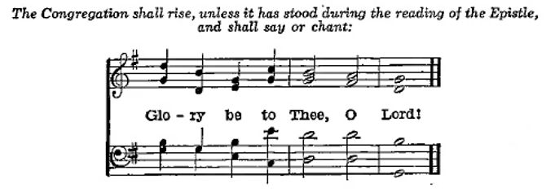

51When the days drew near for [Jesus] to be taken up, he set his face to go to Jerusalem. 52And he sent messengers ahead of him, who went and entered a village of the Samaritans, to make preparations for him. 53But the people did not receive him, because his face was set toward Jerusalem. 54And when his disciples James and John saw it, they said, “Lord, do you want us to tell fire to come down from heaven and consume them?” 55But he turned and rebuked them. 56And they went on to another village.

57As they were going along the road, someone said to him, “I will follow you wherever you go.” 58And Jesus said to him, “Foxes have holes, and birds of the air have nests, but the Son of Man has nowhere to lay his head.” 59To another he said, “Follow me.” But he said, “Lord, let me first go and bury my father.” 60And Jesus said to him, “Leave the dead to bury their own dead. But as for you, go and proclaim the kingdom of God.” 61Yet another said, “I will follow you, Lord, but let me first say farewell to those at my home.” 62Jesus said to him, “No one who puts his hand to the plow and looks back is fit for the kingdom of God.”

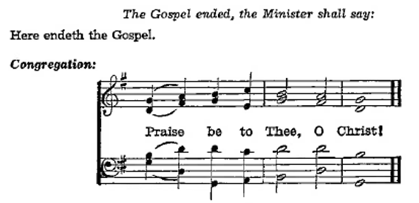

Nicene Creed

C **I believe in one God,**

**the Father Almighty,**

**maker of heaven and earth**

**and of all things visible and invisible.**

**And in one Lord Jesus Christ,**

**the only-begotten Son of God,**

**begotten of His Father before all worlds,**

**God of God, Light of Light,**

**very God of very God,**

**begotten, not made,**

**being of one substance with the Father,**

**by whom all things were made;**

**who for us men and for our salvation came down from heaven**

**and was incarnate by the Holy Ghost of the virgin Mary**

**and was made man;**

**and was crucified also for us under Pontius Pilate.**

**He suffered and was buried.**

**And the third day He rose again according to the Scriptures**

**and ascended into heaven**

**and sits at the right hand of the Father.**

**And He will come again with glory to judge both the living and the dead,**

**whose kingdom will have no end.**

**And I believe in the Holy Ghost,**

**the Lord and giver of life,**

**who proceeds from the Father and the Son,**

**who with the Father and the Son together is worshiped and glorified,**

**who spoke by the prophets.**

**And I believe in one holy Christian and apostolic Church,**

**I acknowledge one Baptism for the remission of sins,**

**and I look for the resurrection of the dead**

**and the life of the world to come. Amen.**

Sit

Children's Sermon

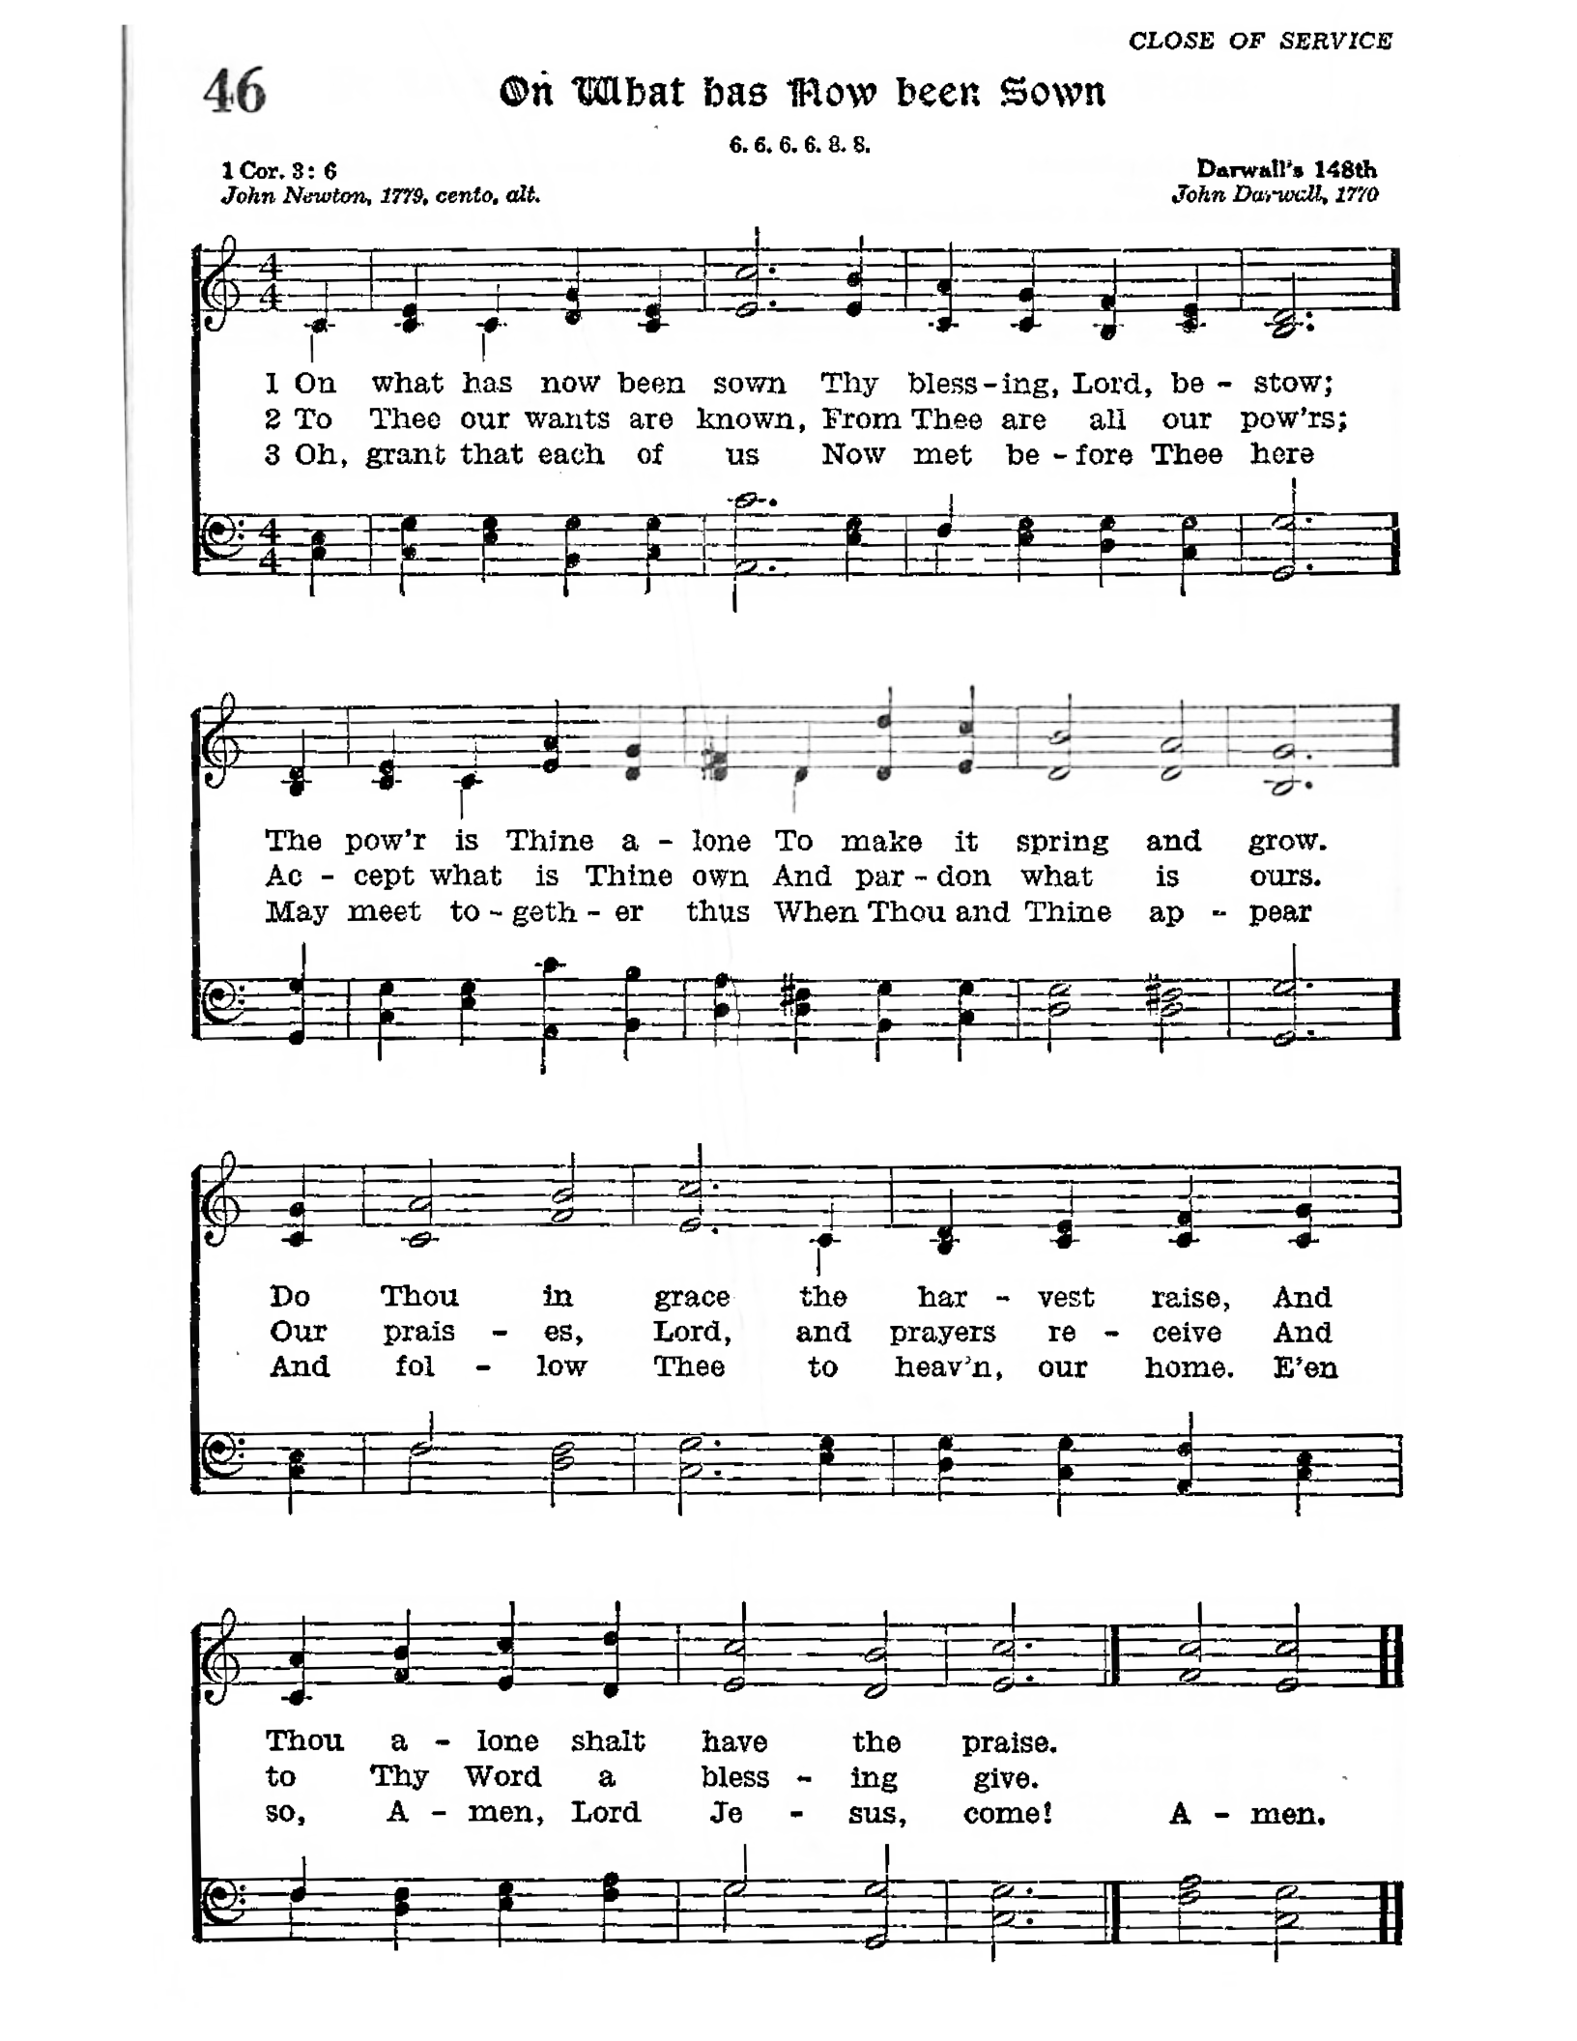

Sermon

Votum

P The peace of God, which passeth all understanding, keep your hearts and minds through Christ Jesus.

Stand

Offertory Psalm 51:10–12

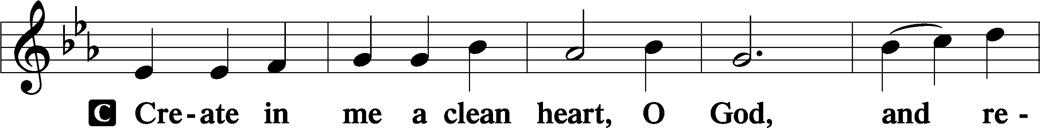

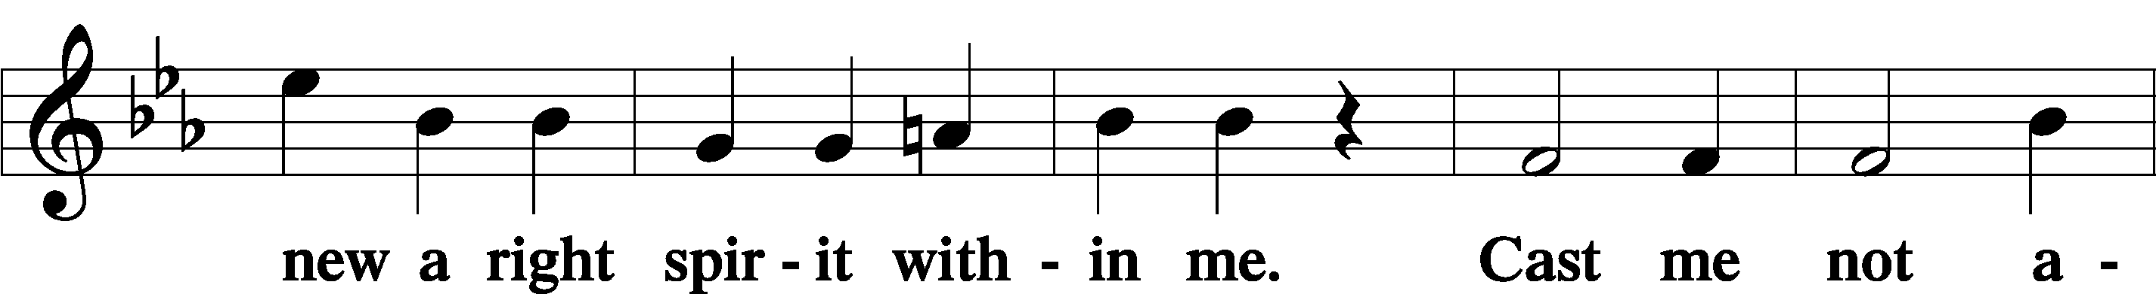

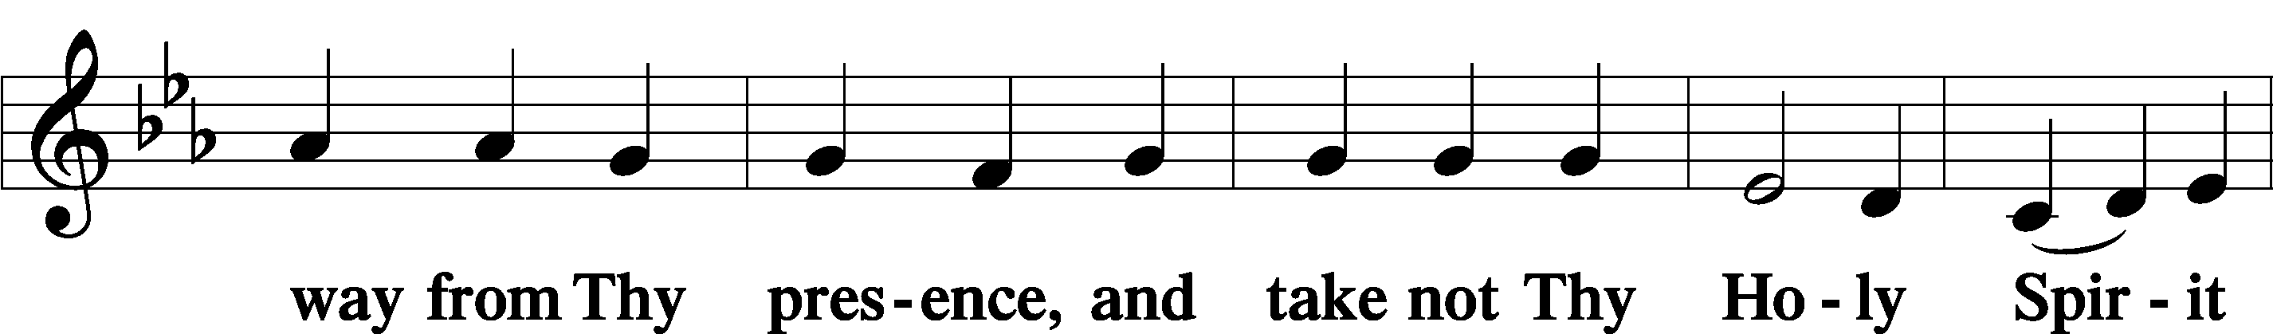

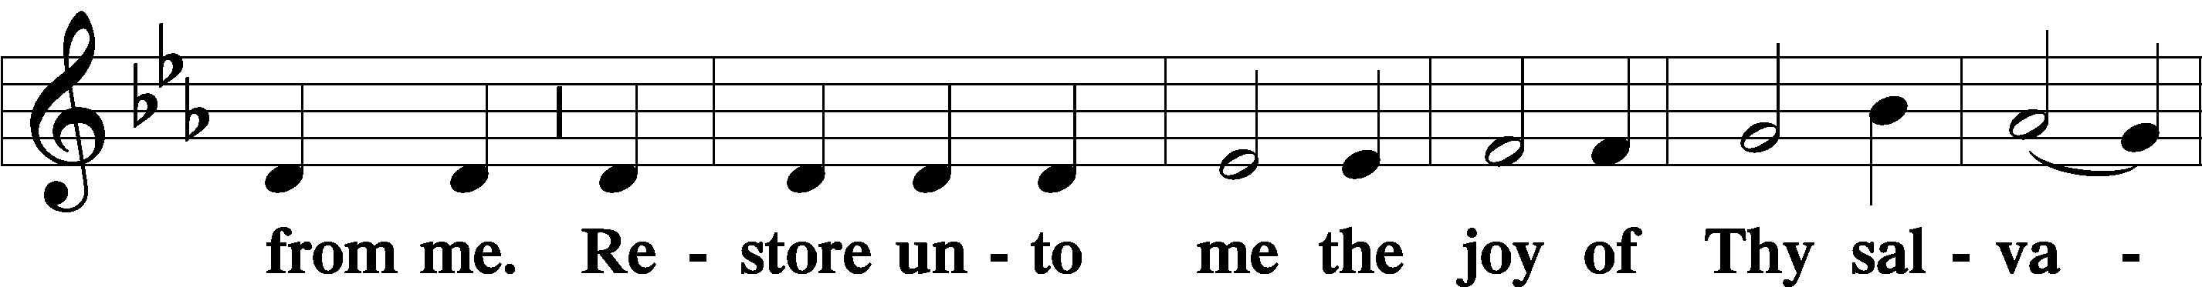

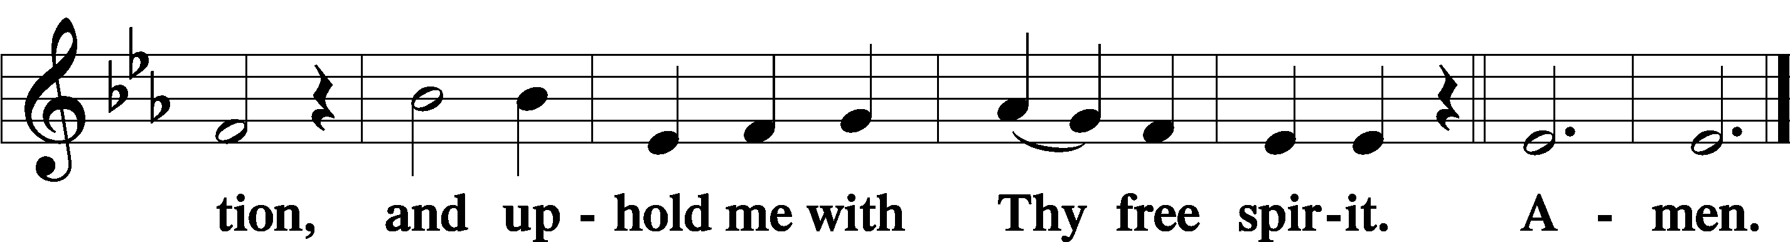

Sit

Offering

644 Praise God, from Whom All Blessings Flow

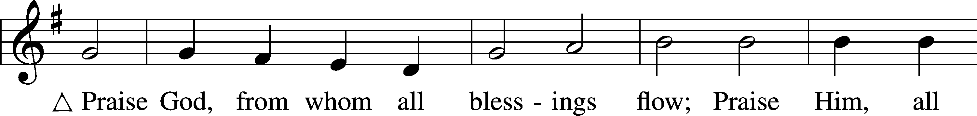

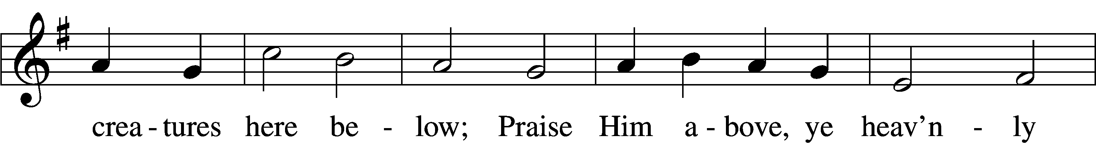

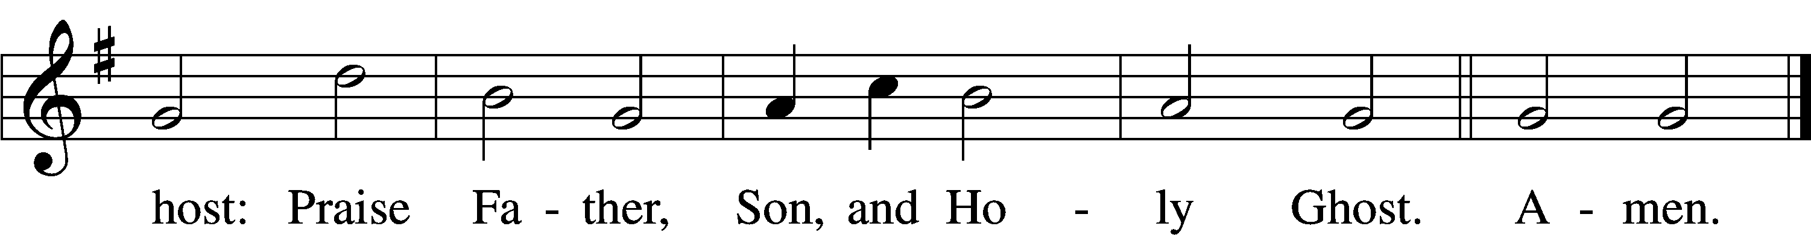

Text: Thomas Ken, 1637–1711  
Tune: Trente quatre Pseaumes de David, 1551, Geneva, ed. Louis Bourgeois  
Text and tune: Public domain

Stand

Prayer of the Church

# Service of the Sacrament

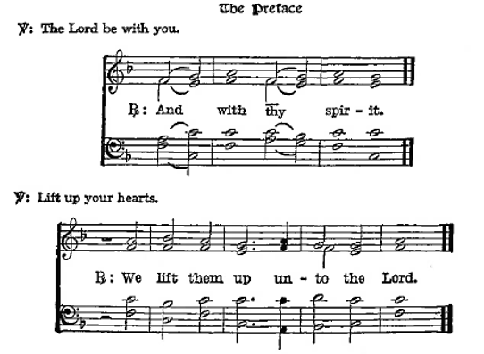

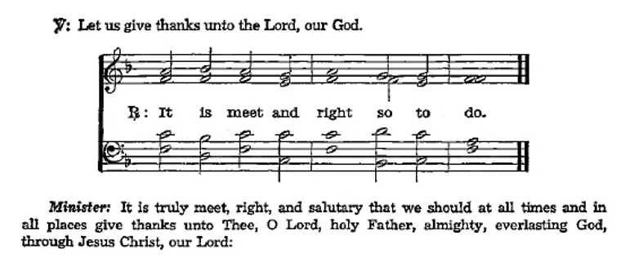

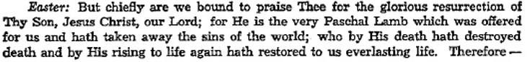

**Sanctus** Isaiah 6:3; Matthew 21:9

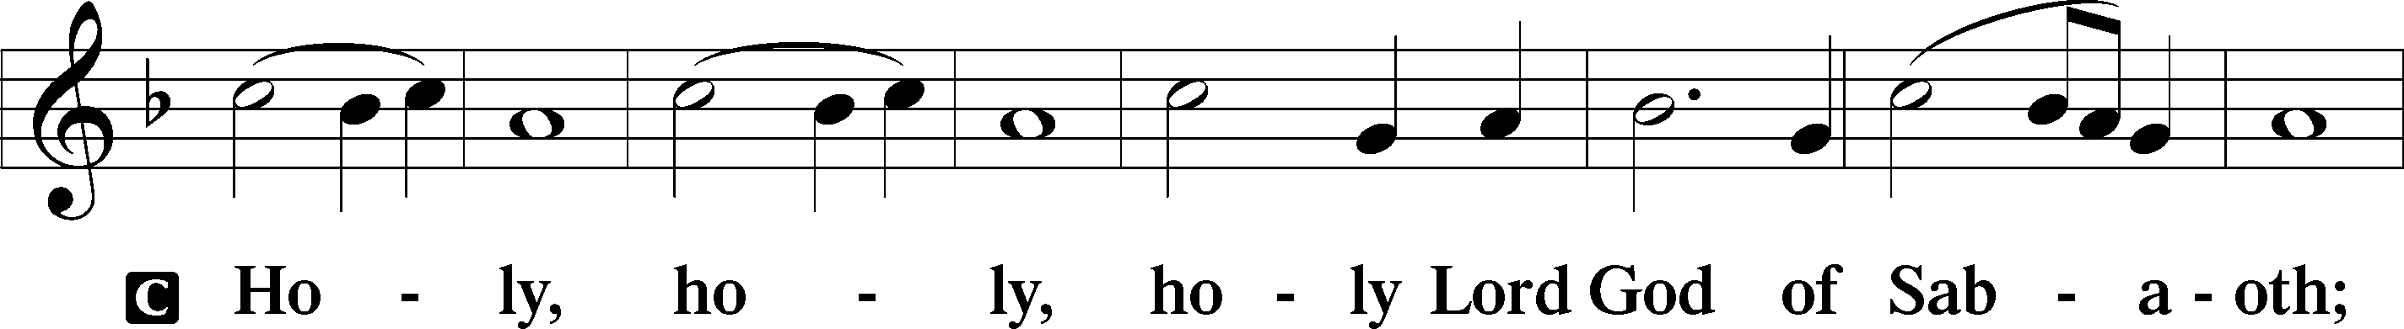

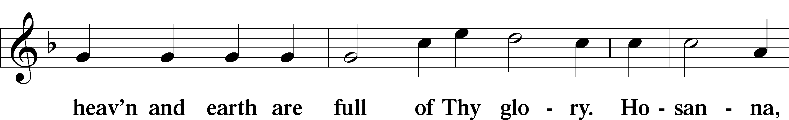

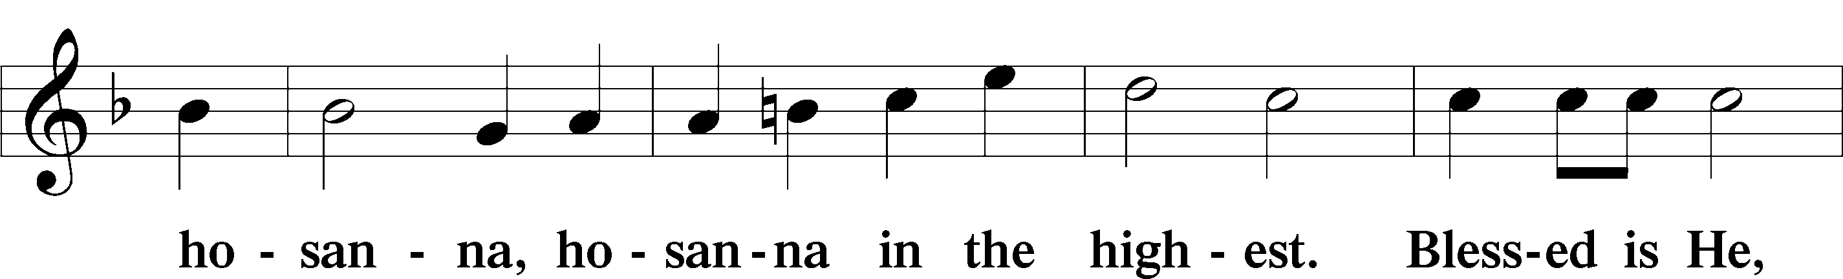

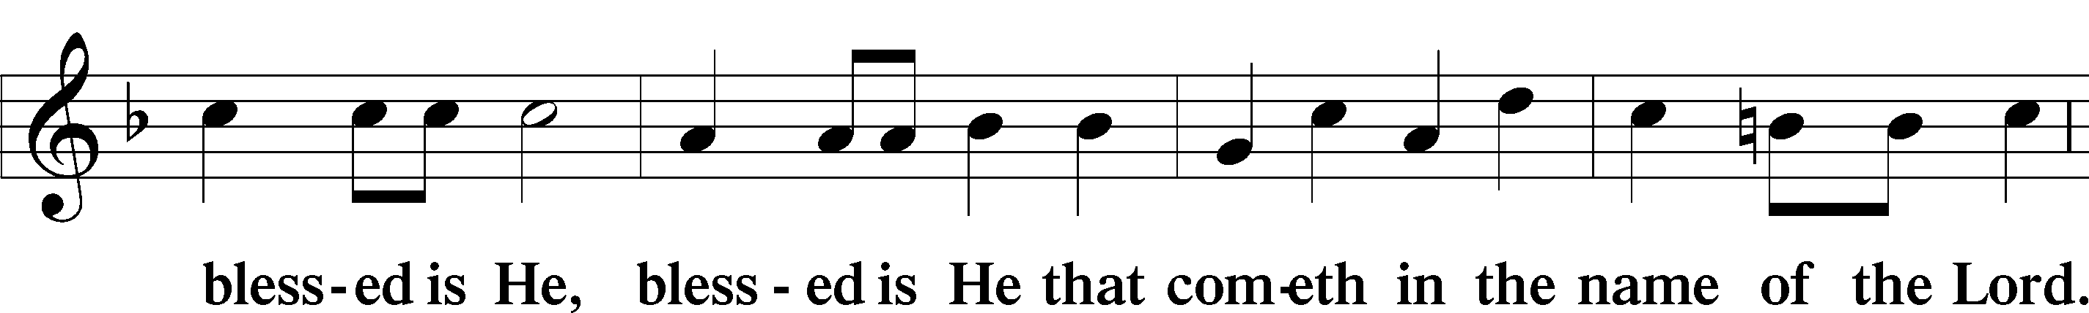

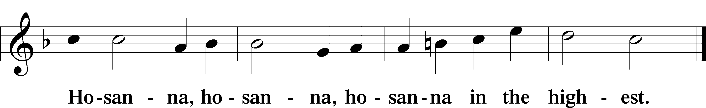

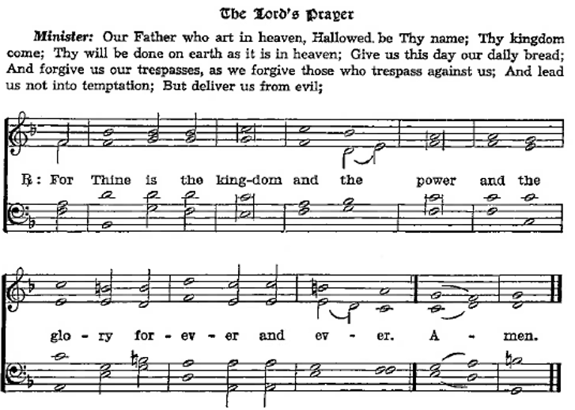

The Words of Our Lord Matthew 26:26–28; Mark 14:22–24; Luke 22:19–20; 1 Corinthians 11:23–25

P Our Lord Jesus Christ, the same night in which He was

betrayed, took bread; and when He had given thanks, He

brake it and gave it to the disciples saying, “Take, eat; this

is My body, which is given for you. This do in

remembrance of Me.”

After the same manner also He took the cup when he had supped, and when He had given thanks, He gave it to them, saying, “Drink ye all of it; this cup is the New Testament in My blood, which is shed for you for the remission of sins. This do, as oft as ye drink it, in remembrance of Me.”

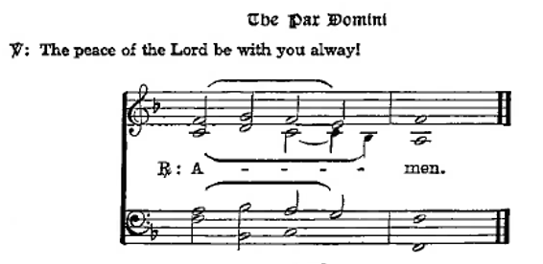Agnus Dei John 1:29

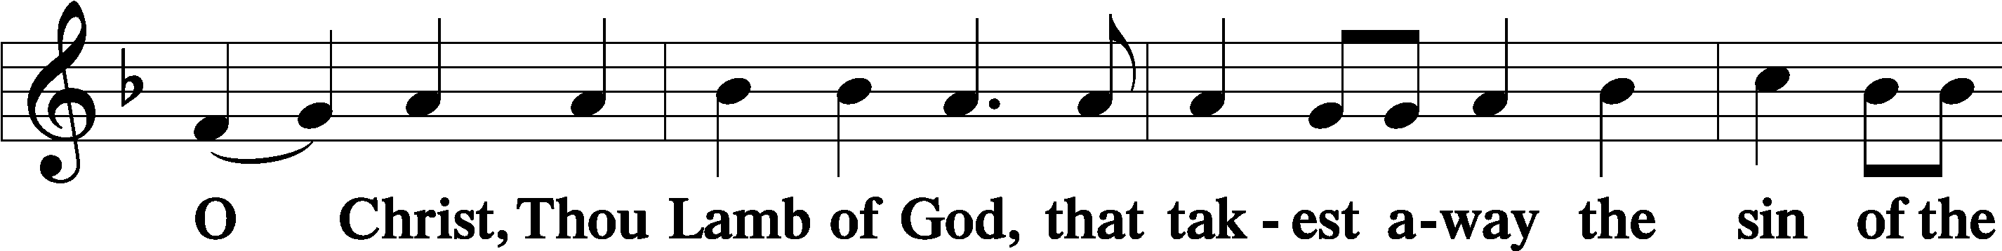

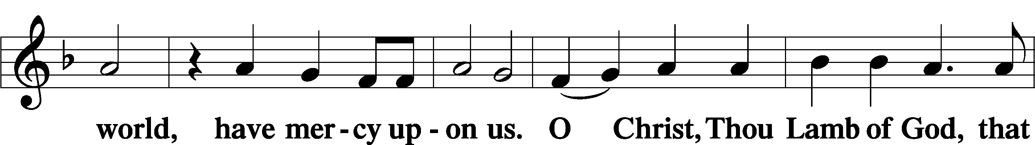

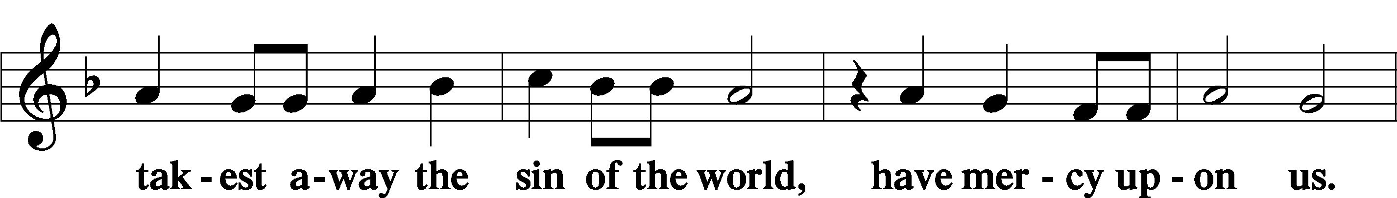

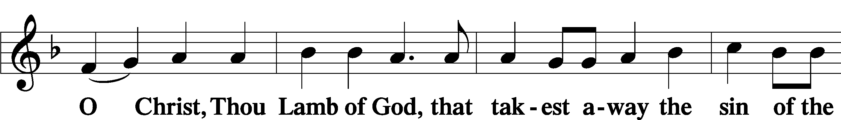

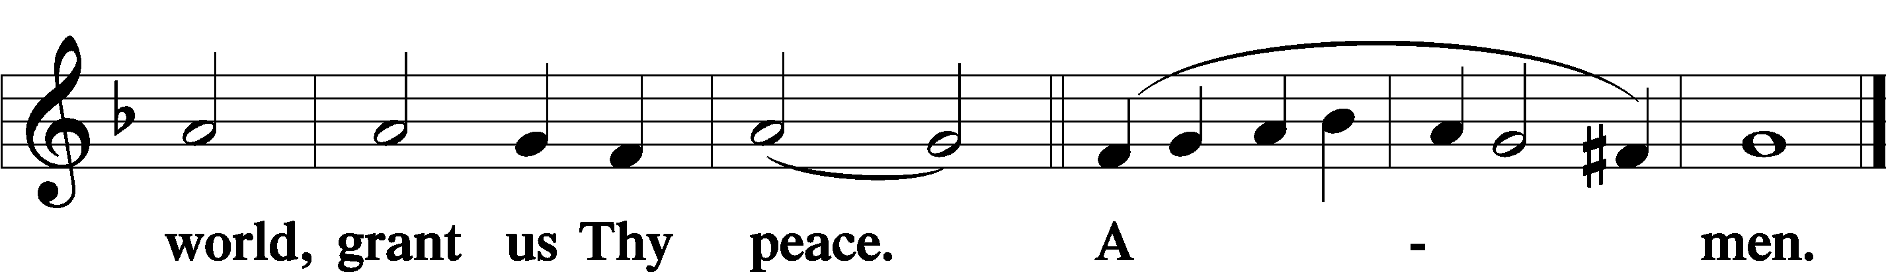

Sit

Distribution

The pastor and those who assist him receive the body and blood of Christ first and then distribute them to those who come to receive, saying:

Take, eat; this is the true body of our Lord and Savior Jesus Christ, given into death for your sins.

**Amen.**

Take, drink; this is the true blood of our Lord and Savior Jesus Christ, shed for the forgiveness of your sins.

**Amen.**

In dismissing the communicants, the following is said:

The Dismissal

P The body and blood of our Lord Jesus Christ strengthen and preserve you in the true faith unto life everlasting. Depart in peace.

C **Amen.**

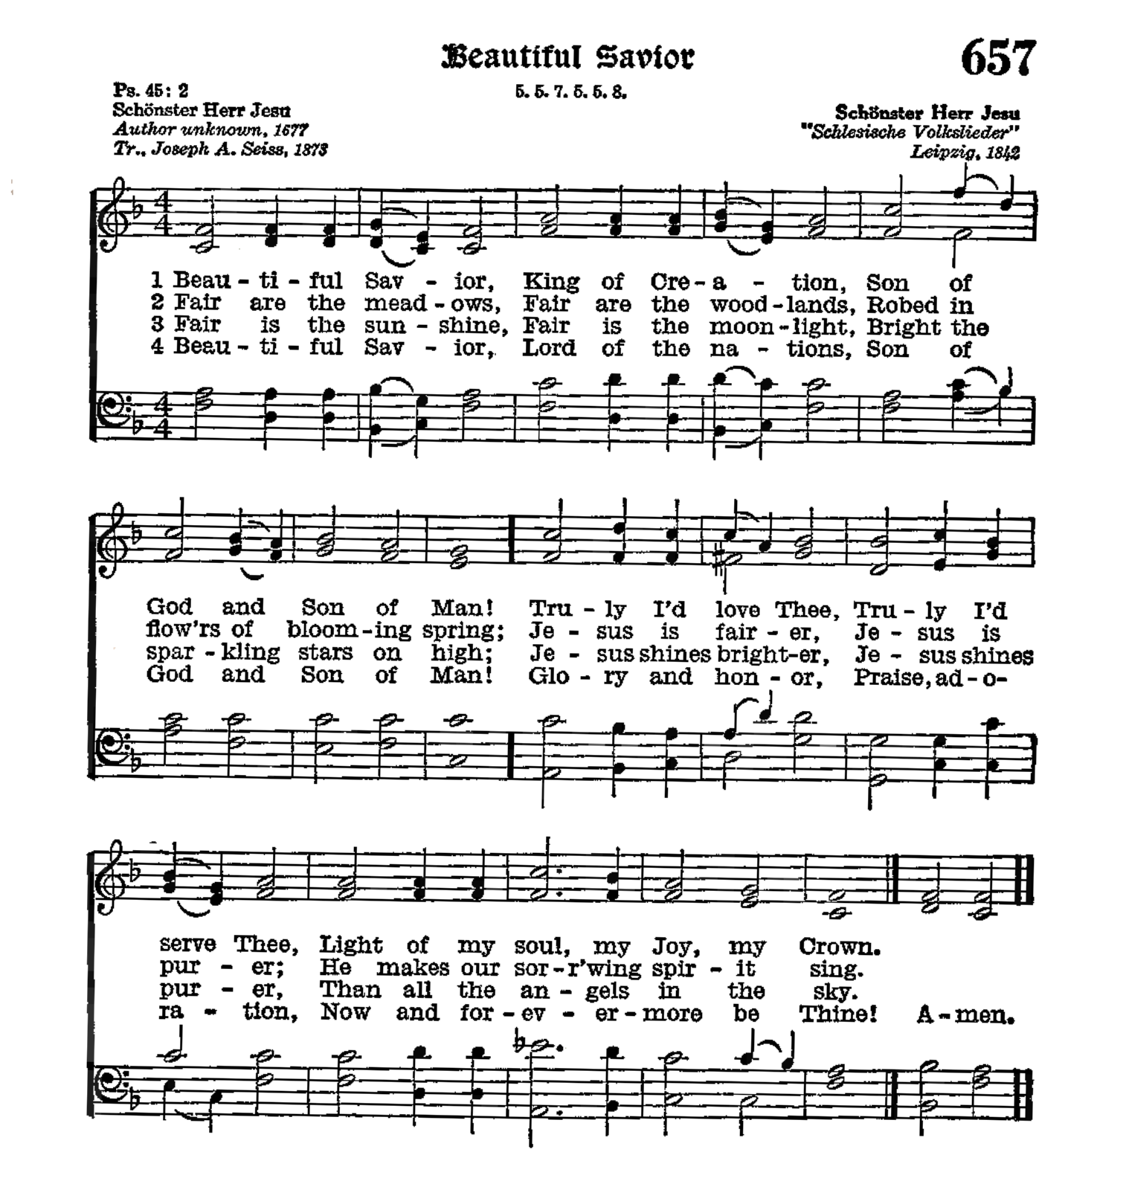

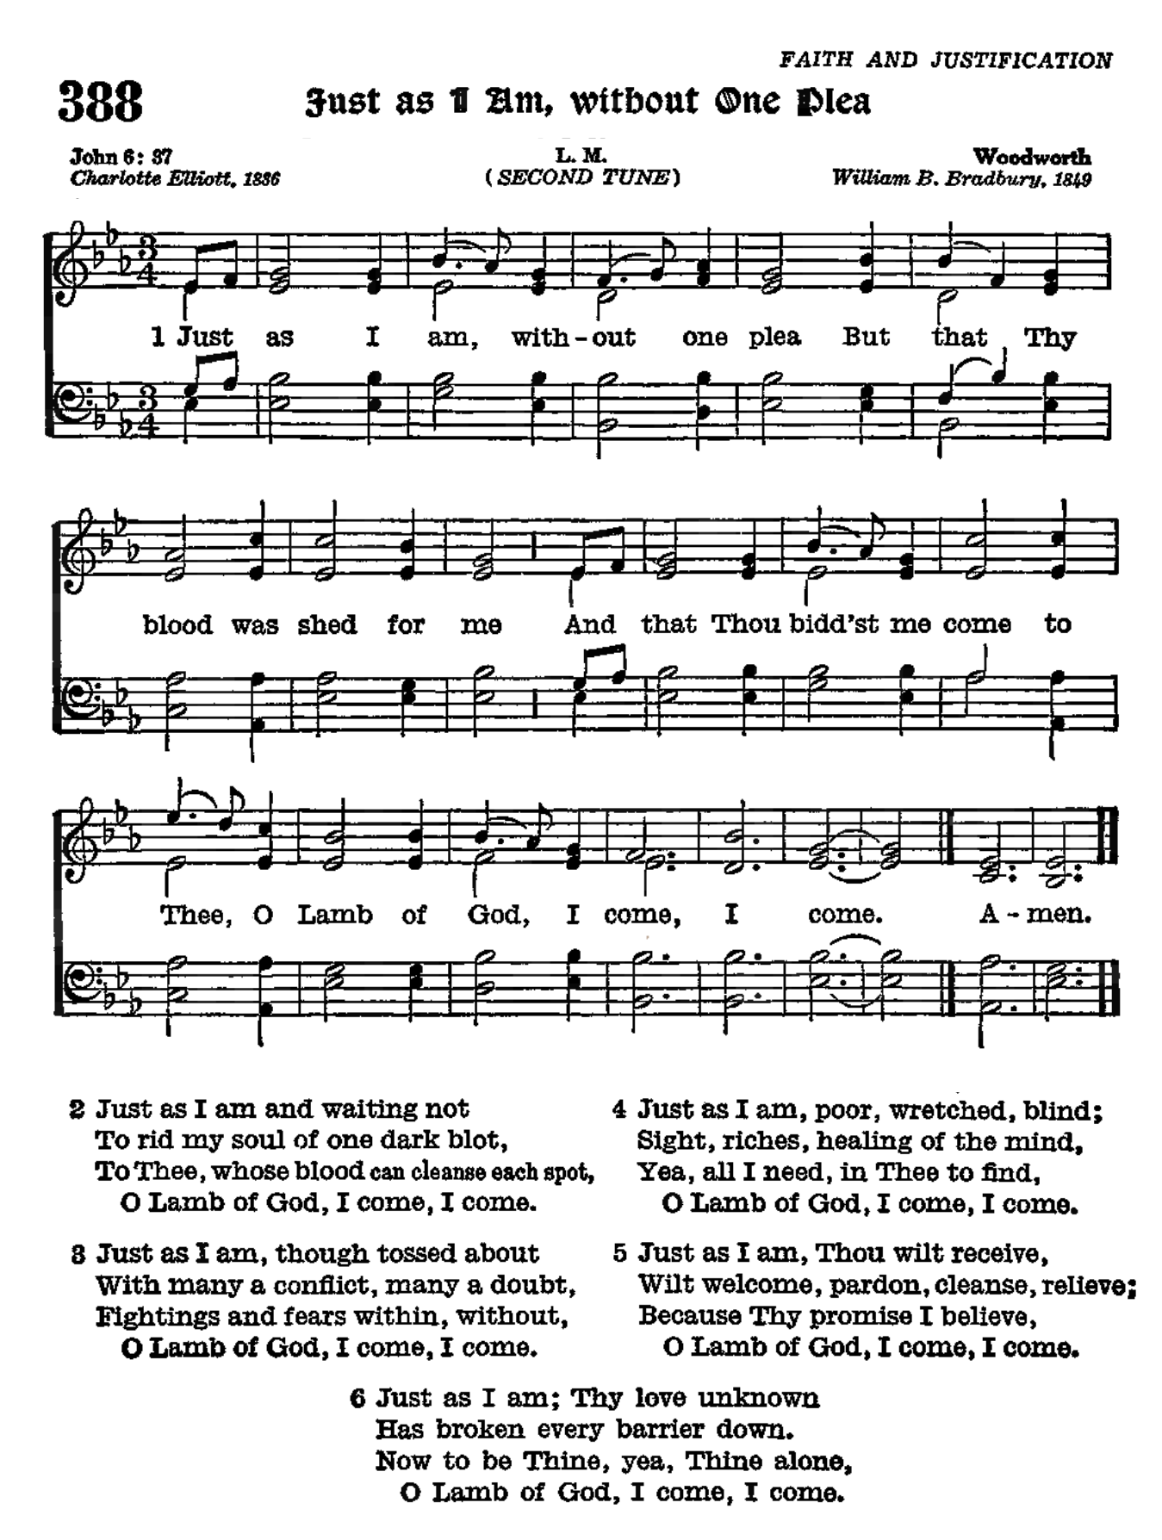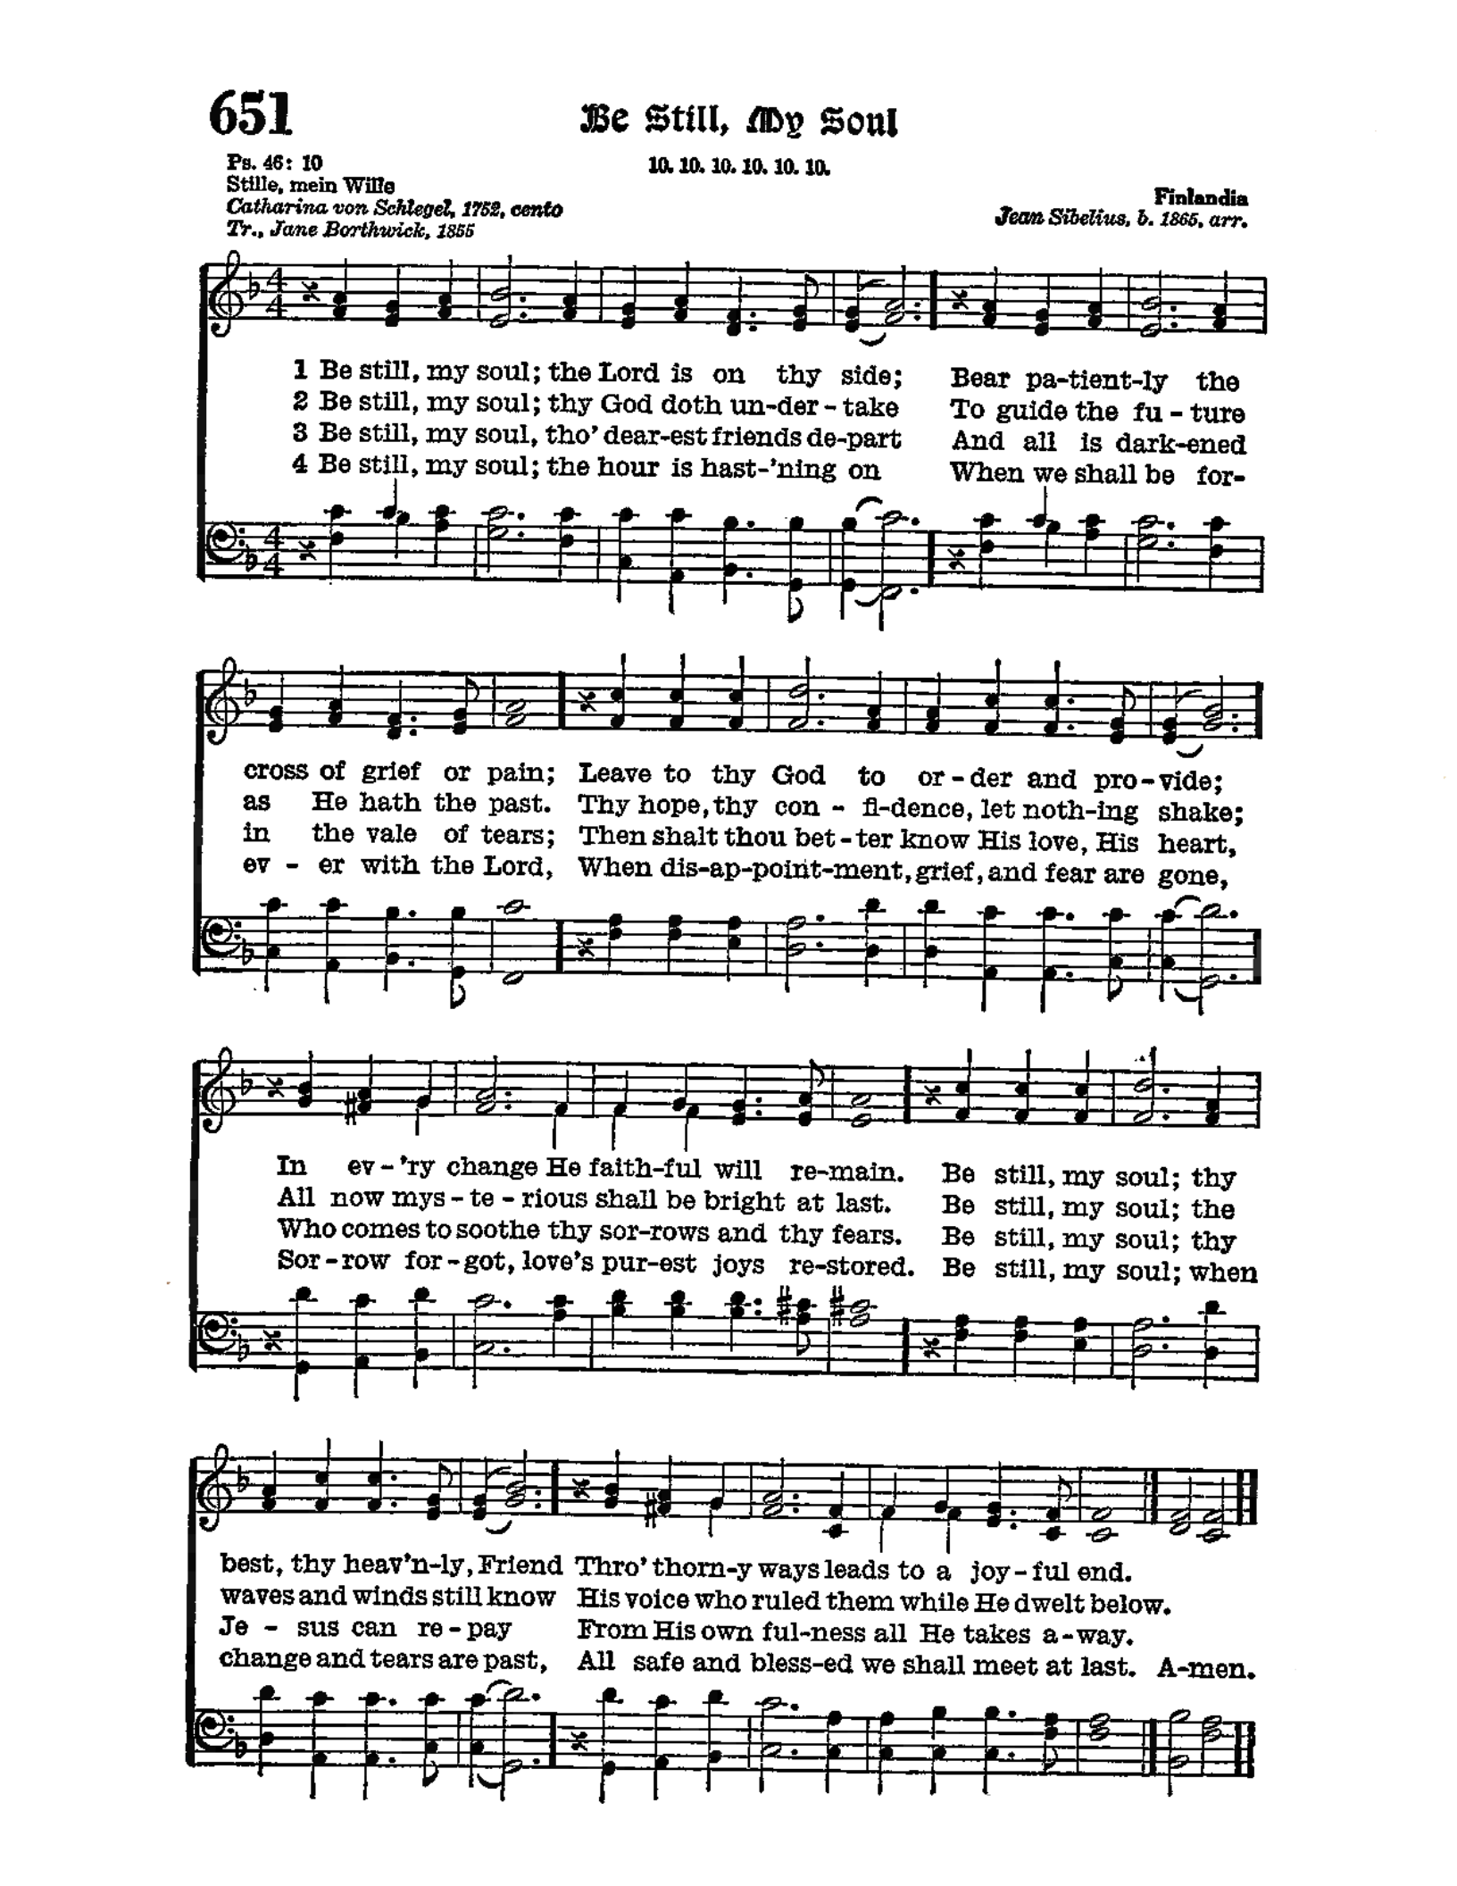

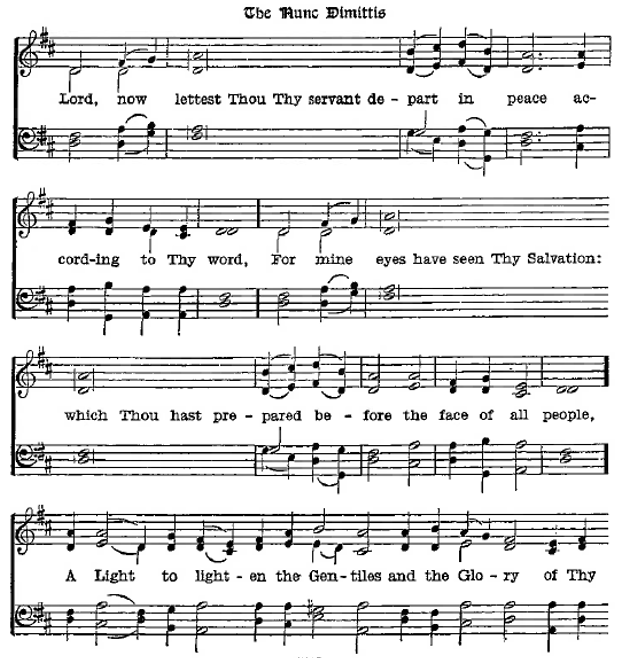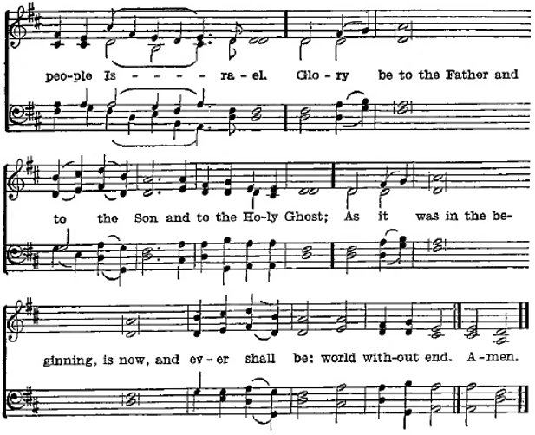

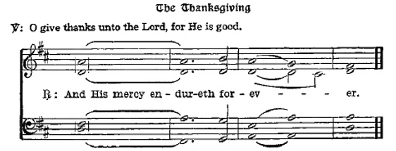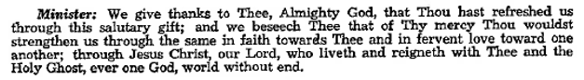

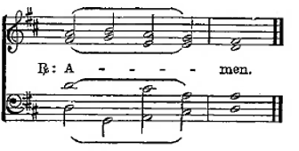

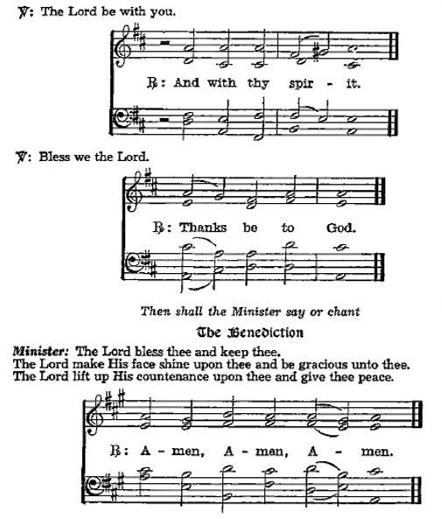

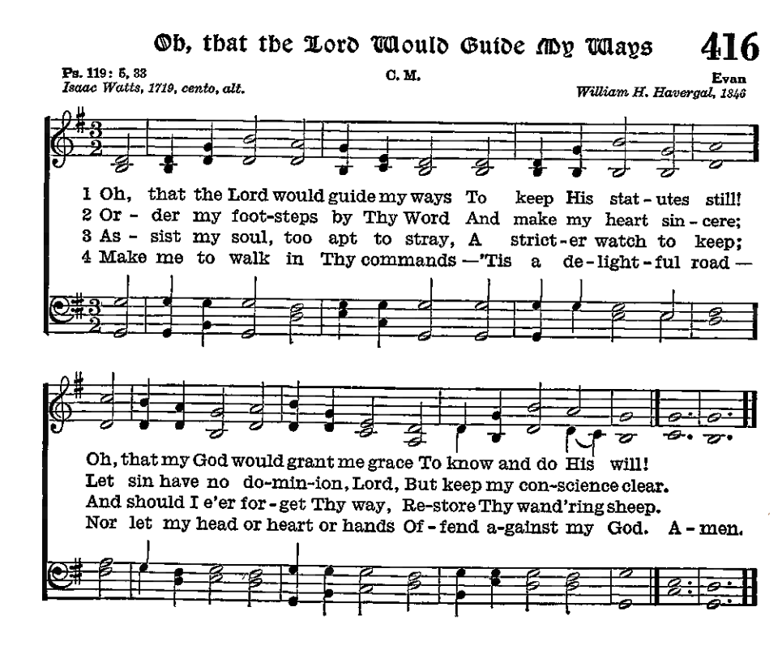

Acknowledgments

Divine Service, from The Lutheran Hymnal

Unless otherwise indicated, Scripture quotations are from the ESV® Bible (The Holy Bible, English Standard Version®), copyright © 2001 by Crossway, a publishing ministry of Good News Publishers. Used by permission. All rights reserved.

Created by Lutheran Service Builder © 2024 Concordia Publishing House.