On entering the church

P Lord, I love the habitation of Your house and the place

where Your glory dwells. In the multitude of Your tender

mercies prepare my heart that I may enter Your house to

worship and confess Your holy name; through Jesus Christ,

my God and Lord.

Before worship

C O Lord, our creator, redeemer, and comforter, as we come

together to worship You in spirit and in truth, we humbly

pray that You would open our hearts to the preaching of

Your Word so that we may repent of our sins, believe in

Jesus Christ as our only Savior, and grow in grace and

holiness. Hear us for His sake.

750 If Thou But Trust in God to Guide Thee

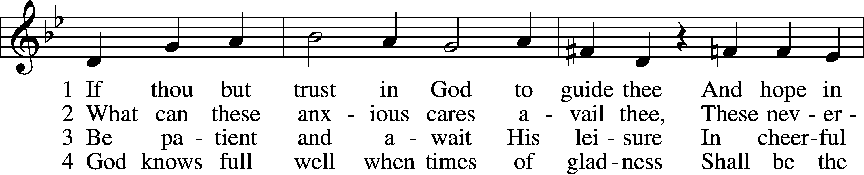

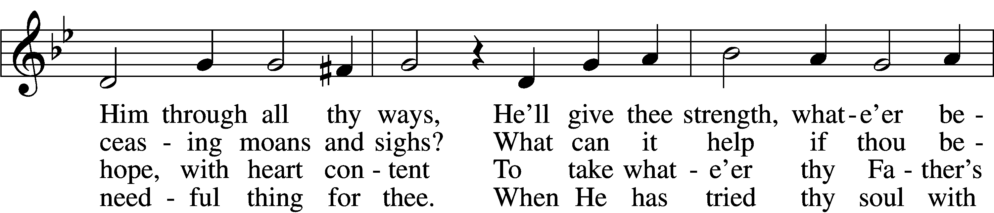

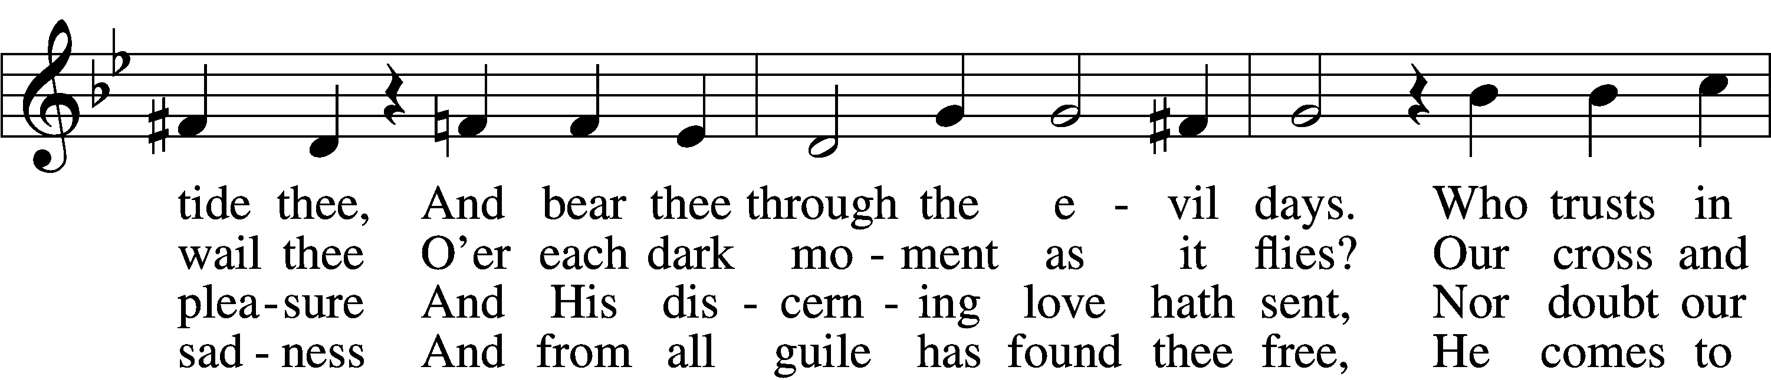

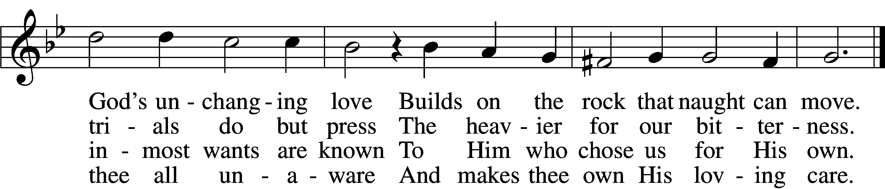

5 Nor think amid the fiery trial  
 That God hath cast thee off unheard,  
That he whose hopes meet no denial  
 Must surely be of God preferred.  
Time passes and much change doth bring  
And sets a bound to ev’rything.

6 All are alike before the Highest;  
 ’Tis easy for our God, we know,  
To raise thee up, though low thou liest,  
 To make the rich man poor and low.  
True wonders still by Him are wrought  
Who setteth up and brings to naught.

7 Sing, pray, and keep His ways unswerving,  
 Perform thy duties faithfully,  
And trust His Word; though undeserving,  
 Thou yet shalt find it true for thee.  
God never yet forsook in need  
The soul that trusted Him indeed.

Text: tr. Catherine Winkworth, 1827–78, alt.  
Text and tune: Georg Neumark, 1621–81  
Text and tune: Public domain

# Confession and Absolution

The sign of the cross may be made by all in remembrance of their Baptism.

Invocation Matthew 28:19b; 18:20

P In the name of the Father and of the T Son and of the Holy Spirit.

C **Amen.**

Exhortation Hebrews 10:22; Psalm 124:8; Psalm 32:5

P Beloved in the Lord! Let us draw near with a true heart and confess our sins unto God our Father, beseeching Him in the name of our Lord Jesus Christ to grant us forgiveness.

P Our help is in the name of the Lord,

C **who made heaven and earth.**

P I said, I will confess my transgressions unto the Lord,

C **and You forgave the iniquity of my sin.**

Silence for reflection on God’s Word and for self-examination.

Confession of Sins

P Almighty God, our maker and redeemer, we poor sinners confess unto You that we are by nature sinful and unclean and that we have sinned against You by thought, word, and deed. Wherefore we flee for refuge to Your infinite mercy, seeking and imploring Your grace for the sake of our Lord Jesus Christ.

C **O most merciful God, who has given Your only-begotten Son to die for us, have mercy upon us and for His sake grant us remission of all our sins; and by Your Holy Spirit increase in us true knowledge of You and of Your will and true obedience to Your Word, to the end that by Your grace we may come to everlasting life; through Jesus Christ, our Lord. Amen.**

Declaration of Grace Mark 16:16; John 1:12

P Almighty God, our heavenly Father, has had mercy upon us and has given His only Son to die for us and for His sake forgives us all our sins. To those who believe on His name He gives power to become the children of God and has promised them His Holy Spirit. He that believes and is baptized shall be saved.  
  
Grant this, Lord, unto us all.

C **Amen.**

# Service of the Word

Introit Psalm 147:8–11; antiphon: v. 7

Sing to the Lord with thanksgiving;  
 make melody to our God on the lyre!  
**He covers the heavens with clouds; he prepares rain for the earth;  
 he makes grass grow on the hills.**  
He gives to the beasts their food,  
 and to the young ravens that cry.  
**His delight is not in the strength of the horse,  
 nor his pleasure in the legs of a man,**but the Lord takes pleasure in those who fear him,  
 in those who hope in his steadfast love.

Gloria Patri

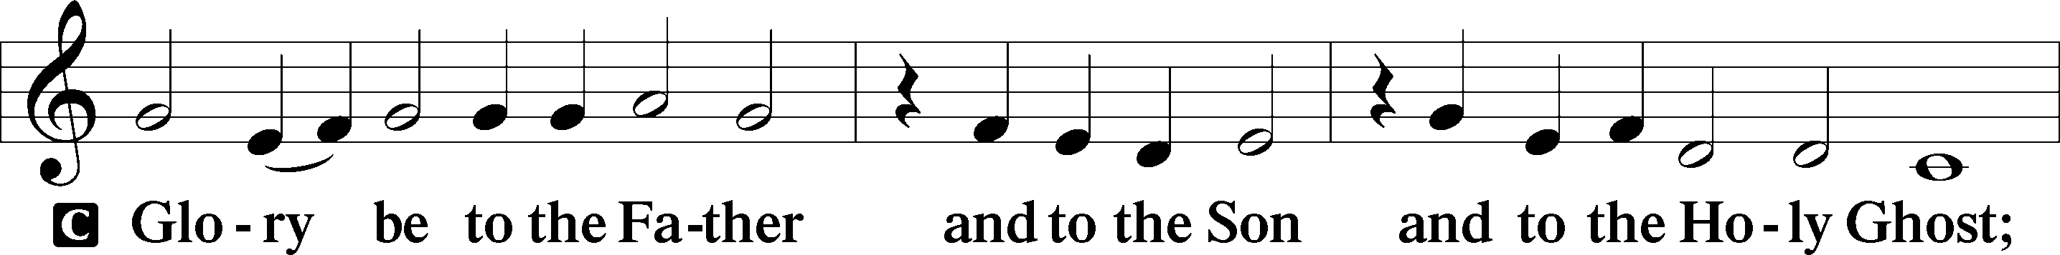

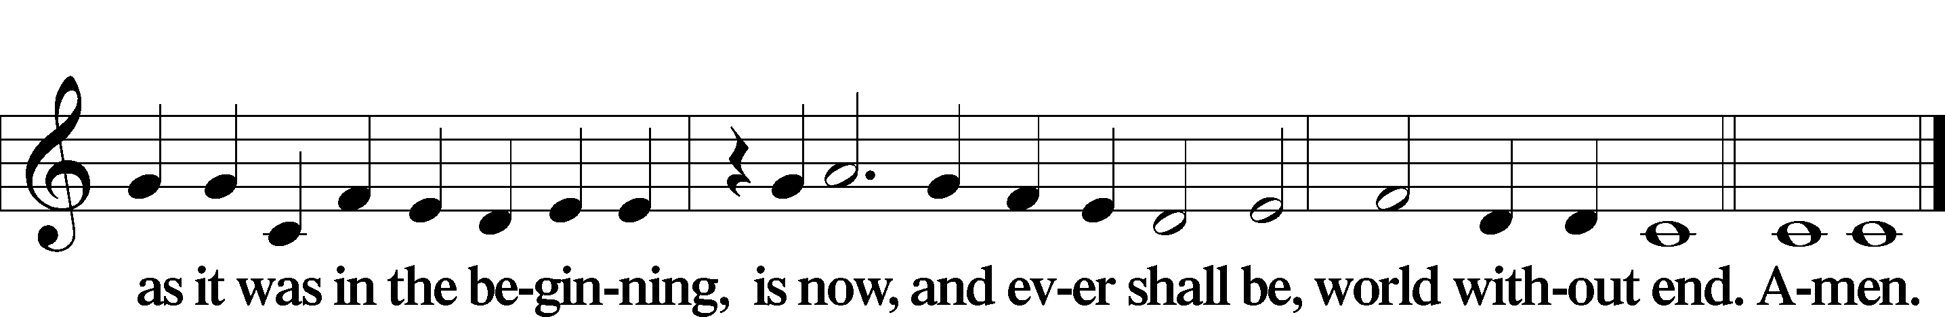

Kyrie Mark 10:47

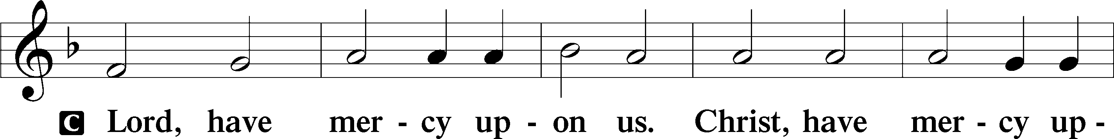

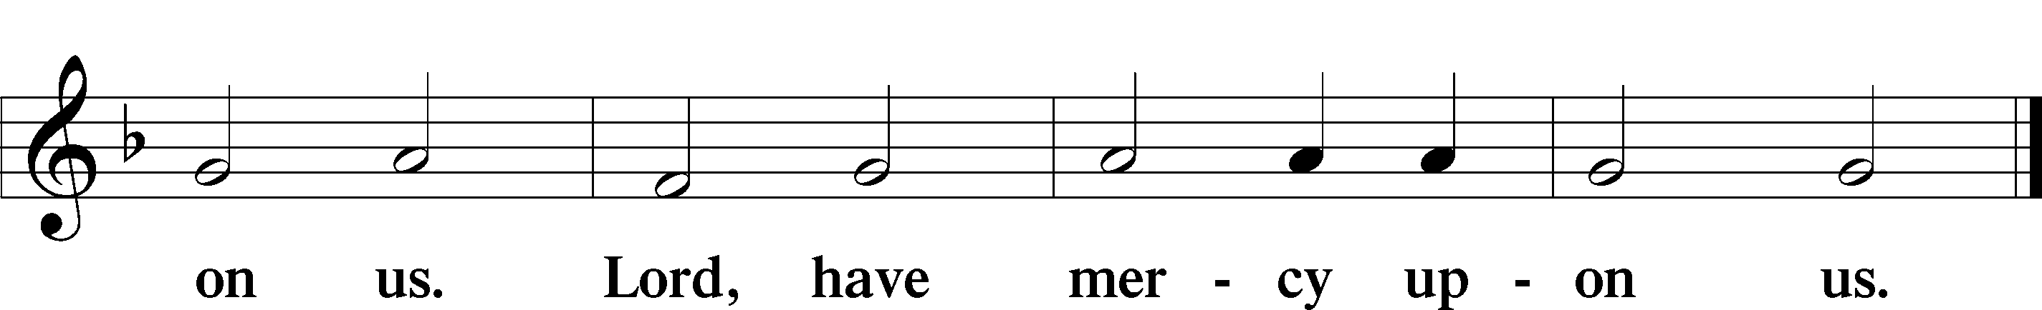

Gloria in Excelsis Luke 2:14; John 1:29

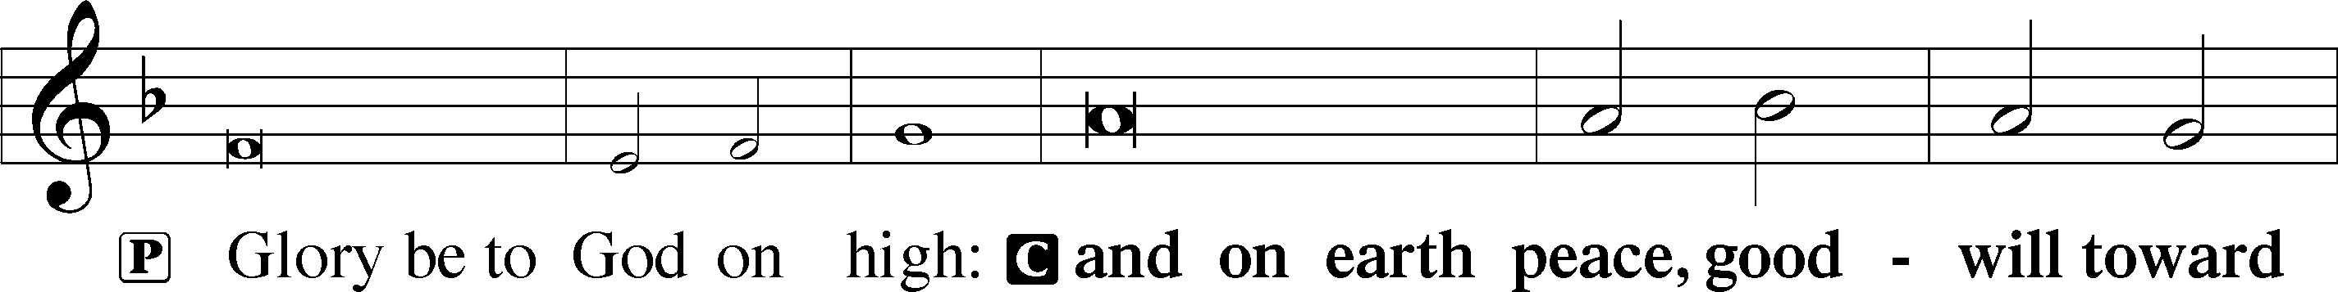

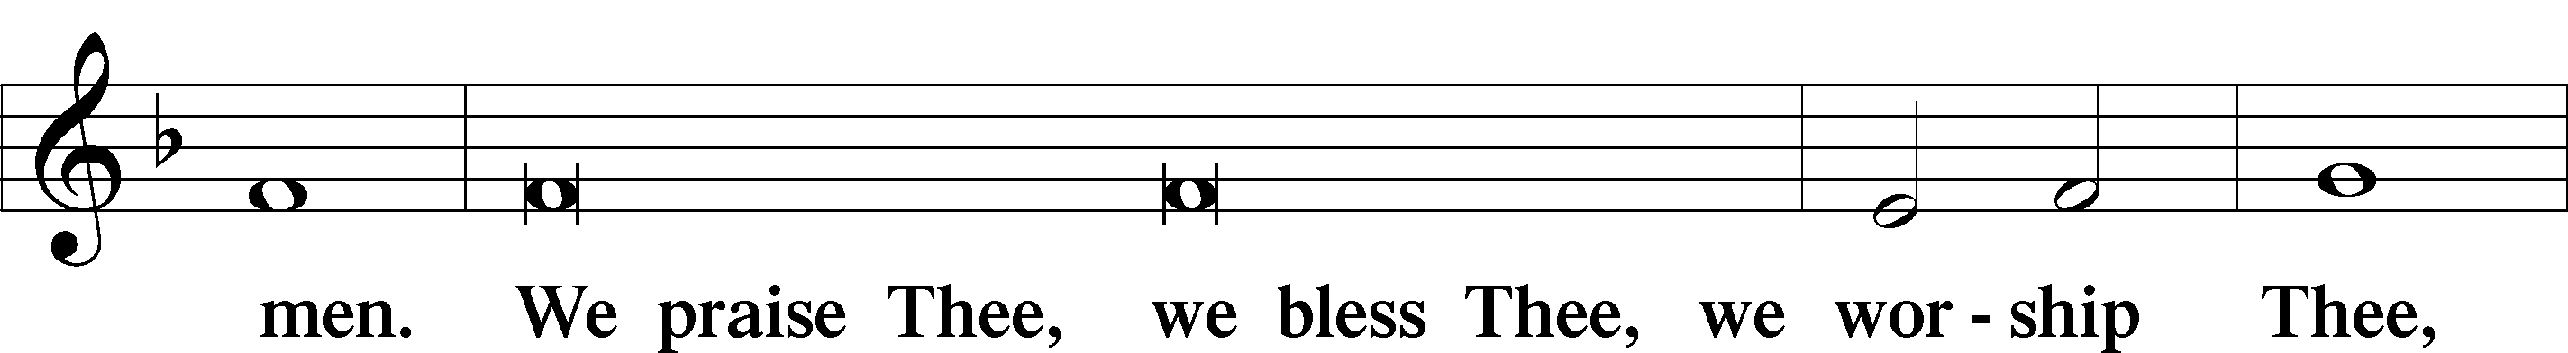

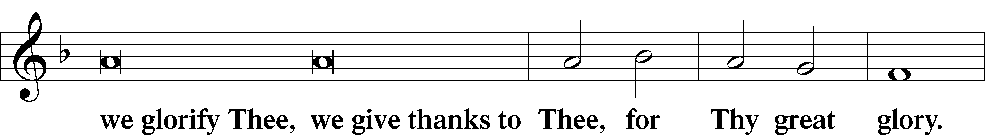

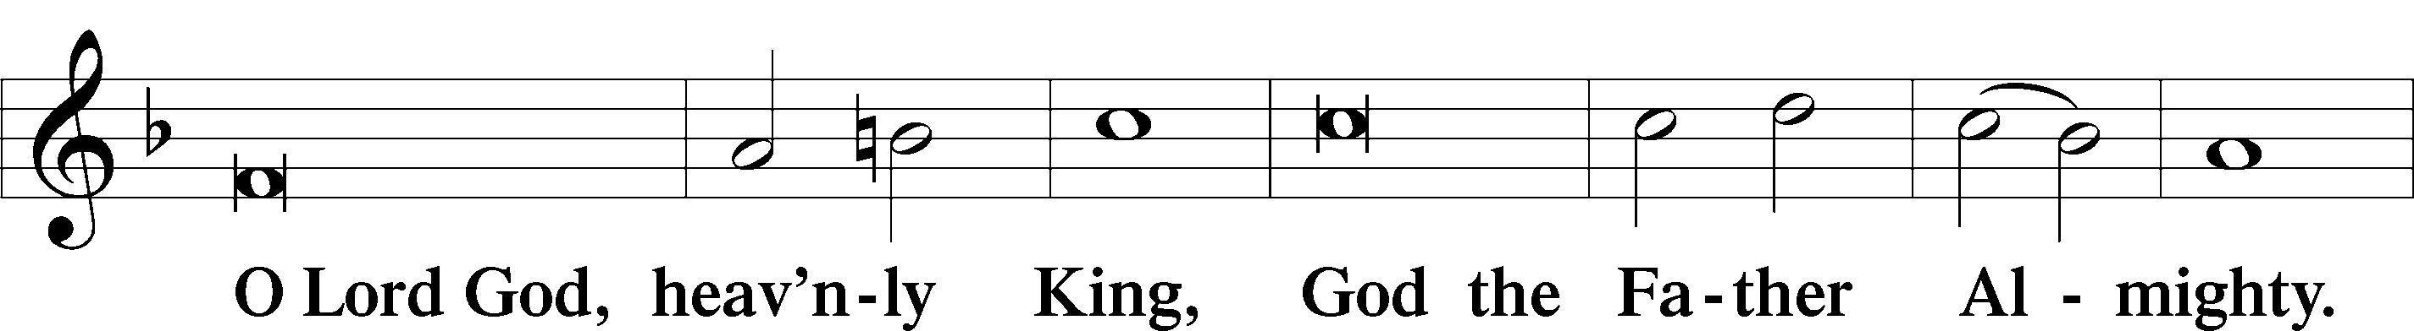

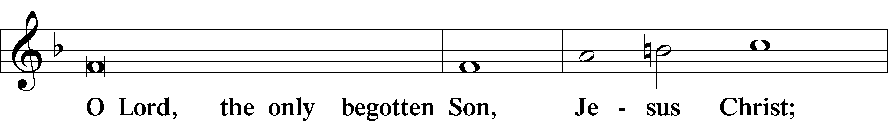

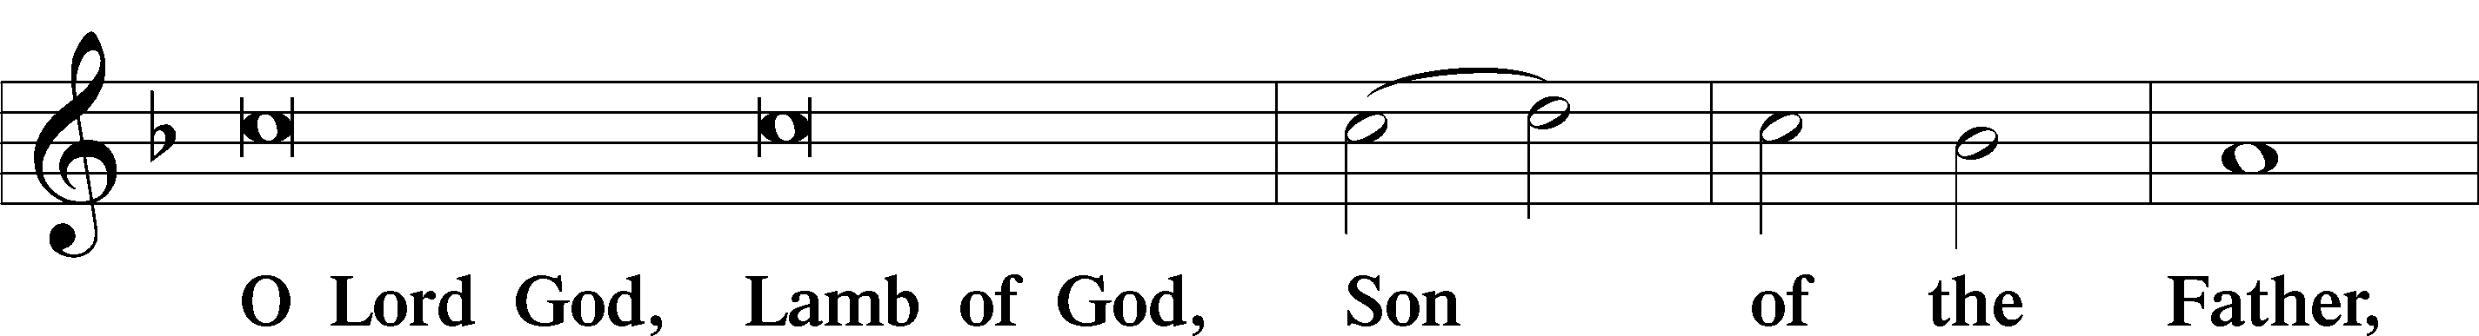

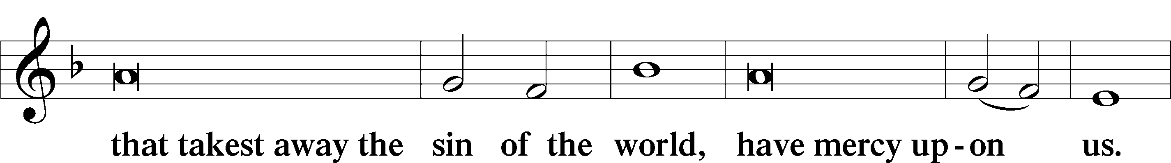

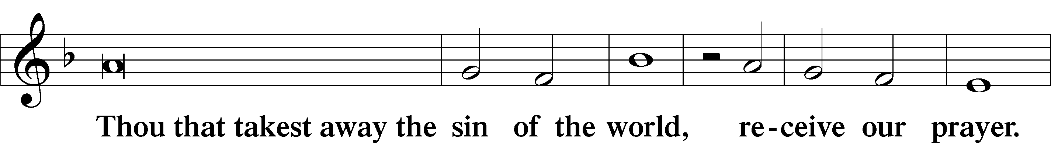

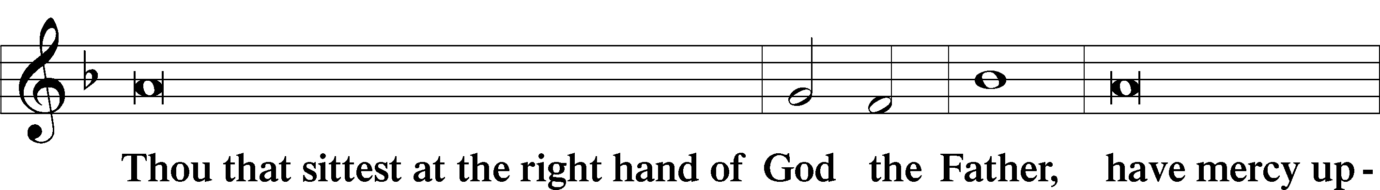

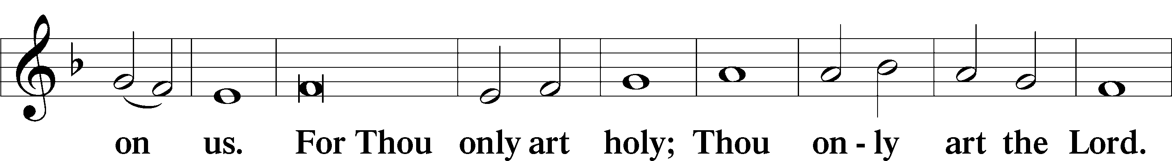

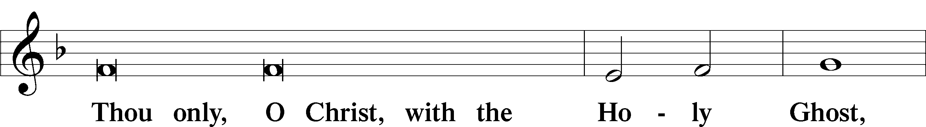

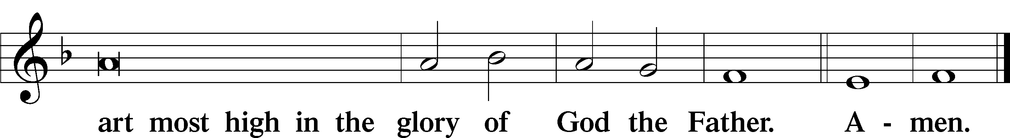

Salutation and Collect of the Day

P The Lord be with you.

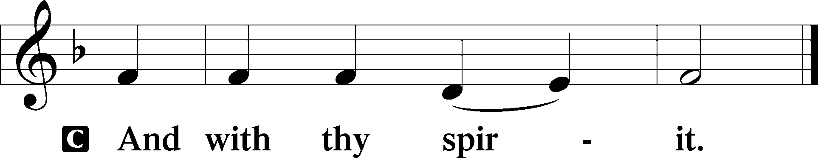

P Let us pray.

Almighty and merciful God, it is by Your grace that we live as Your people who offer acceptable service. Grant that we may walk by faith, and not by sight, in the way that leads to eternal life; through Jesus Christ, Your Son, our Lord, who lives and reigns with You and the Holy Spirit, one God, now and forever.

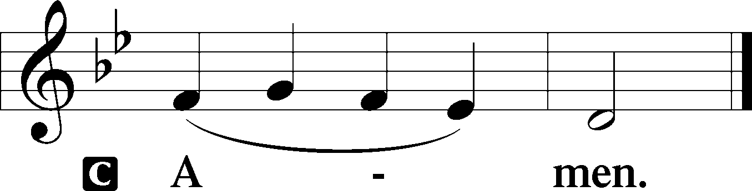

Sit

Old Testament Reading Genesis 15:1–6

1After these things the word of the Lord came to Abram in a vision: “Fear not, Abram, I am your shield; your reward shall be very great.” 2But Abram said, “O Lord God, what will you give me, for I continue childless, and the heir of my house is Eliezer of Damascus?” 3And Abram said, “Behold, you have given me no offspring, and a member of my household will be my heir.” 4And behold, the word of the Lord came to him: “This man shall not be your heir; your very own son shall be your heir.” 5And he brought him outside and said, “Look toward heaven, and number the stars, if you are able to number them.” Then he said to him, “So shall your offspring be.” 6And he believed the Lord, and he counted it to him as righteousness.

A This is the Word of the Lord.

C **Thanks be to God.**

Gradual Psalm 34:9, 19, alt.

Fear the Lord, you his saints,  
 for those who fear him lack nothing!  
**Many are the afflictions of the righteous,  
 but the Lord delivers him out of them all.**

Epistle Hebrews 11:1–16

1Now faith is the assurance of things hoped for, the conviction of things not seen. 2For by it the people of old received their commendation. 3By faith we understand that the universe was created by the word of God, so that what is seen was not made out of things that are visible.

4By faith Abel offered to God a more acceptable sacrifice than Cain, through which he was commended as righteous, God commending him by accepting his gifts. And through his faith, though he died, he still speaks. 5By faith Enoch was taken up so that he should not see death, and he was not found, because God had taken him. Now before he was taken he was commended as having pleased God. 6And without faith it is impossible to please him, for whoever would draw near to God must believe that he exists and that he rewards those who seek him. 7By faith Noah, being warned by God concerning events as yet unseen, in reverent fear constructed an ark for the saving of his household. By this he condemned the world and became an heir of the righteousness that comes by faith.

8By faith Abraham obeyed when he was called to go out to a place that he was to receive as an inheritance. And he went out, not knowing where he was going. 9By faith he went to live in the land of promise, as in a foreign land, living in tents with Isaac and Jacob, heirs with him of the same promise. 10For he was looking forward to the city that has foundations, whose designer and builder is God. 11By faith Sarah herself received power to conceive, even when she was past the age, since she considered him faithful who had promised. 12Therefore from one man, and him as good as dead, were born descendants as many as the stars of heaven and as many as the innumerable grains of sand by the seashore.

13These all died in faith, not having received the things promised, but having seen them and greeted them from afar, and having acknowledged that they were strangers and exiles on the earth. 14For people who speak thus make it clear that they are seeking a homeland. 15If they had been thinking of that land from which they had gone out, they would have had opportunity to return. 16But as it is, they desire a better country, that is, a heavenly one. Therefore God is not ashamed to be called their God, for he has prepared for them a city.

Stand

Alleluia

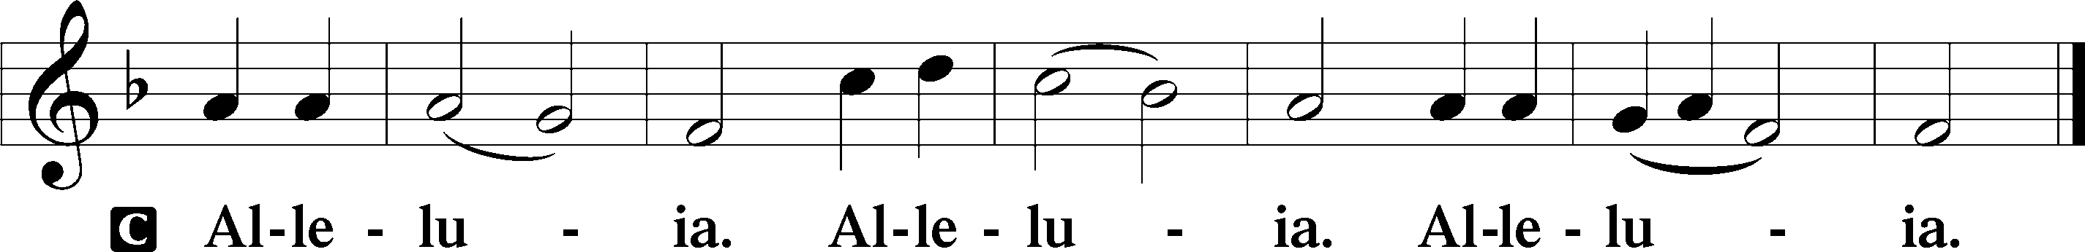

Holy Gospel Luke 12:22–34

P The Holy Gospel according to St. Luke, the twelfth chapter.

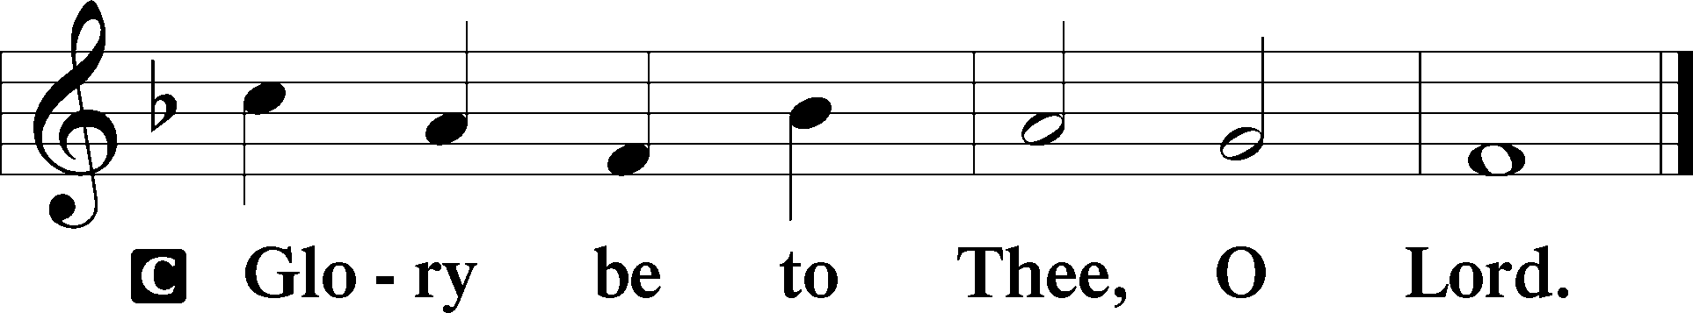

22[Jesus] said to his disciples, “Therefore I tell you, do not be anxious about your life, what you will eat, nor about your body, what you will put on. 23For life is more than food, and the body more than clothing. 24Consider the ravens: they neither sow nor reap, they have neither storehouse nor barn, and yet God feeds them. Of how much more value are you than the birds! 25And which of you by being anxious can add a single hour to his span of life? 26If then you are not able to do as small a thing as that, why are you anxious about the rest? 27Consider the lilies, how they grow: they neither toil nor spin, yet I tell you, even Solomon in all his glory was not arrayed like one of these. 28But if God so clothes the grass, which is alive in the field today, and tomorrow is thrown into the oven, how much more will he clothe you, O you of little faith! 29And do not seek what you are to eat and what you are to drink, nor be worried. 30For all the nations of the world seek after these things, and your Father knows that you need them. 31Instead, seek his kingdom, and these things will be added to you.

32“Fear not, little flock, for it is your Father’s good pleasure to give you the kingdom. 33Sell your possessions, and give to the needy. Provide yourselves with moneybags that do not grow old, with a treasure in the heavens that does not fail, where no thief approaches and no moth destroys. 34For where your treasure is, there will your heart be also.”

P This is the Gospel of the Lord.

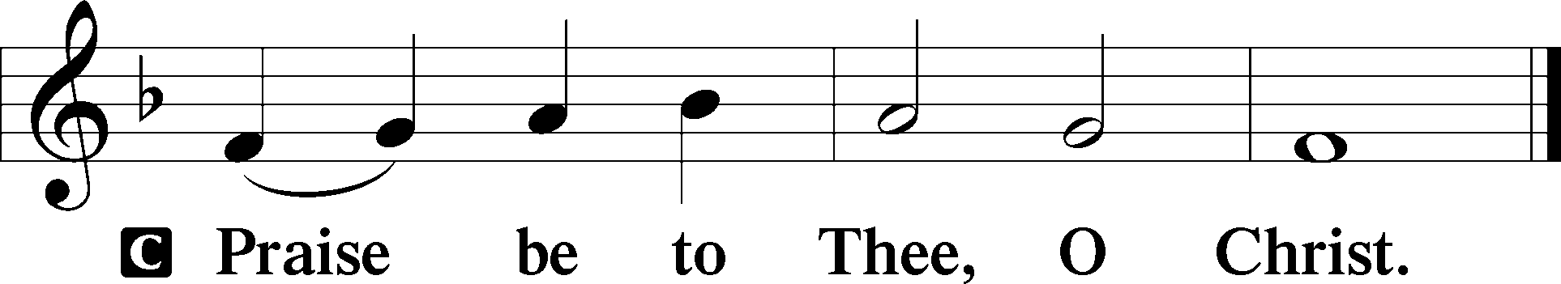

Apostles’ Creed

C **I believe in God, the Father Almighty,**

**maker of heaven and earth.**

**And in Jesus Christ, His only Son, our Lord,**

**who was conceived by the Holy Spirit,**

**born of the virgin Mary,**

**suffered under Pontius Pilate,**

**was crucified, died and was buried.**

**He descended into hell.**

**The third day He rose again from the dead.**

**He ascended into heaven**

**and sits at the right hand of God the Father Almighty.**

**From thence He will come to judge the living and the dead.**

**I believe in the Holy Spirit,**

**the holy Christian Church,**

**the communion of saints,**

**the forgiveness of sins,**

**the resurrection of the body,**

**and the life** T **everlasting. Amen.**

Sit

Children's Sermon

666 O Little Flock, Fear Not the Foe

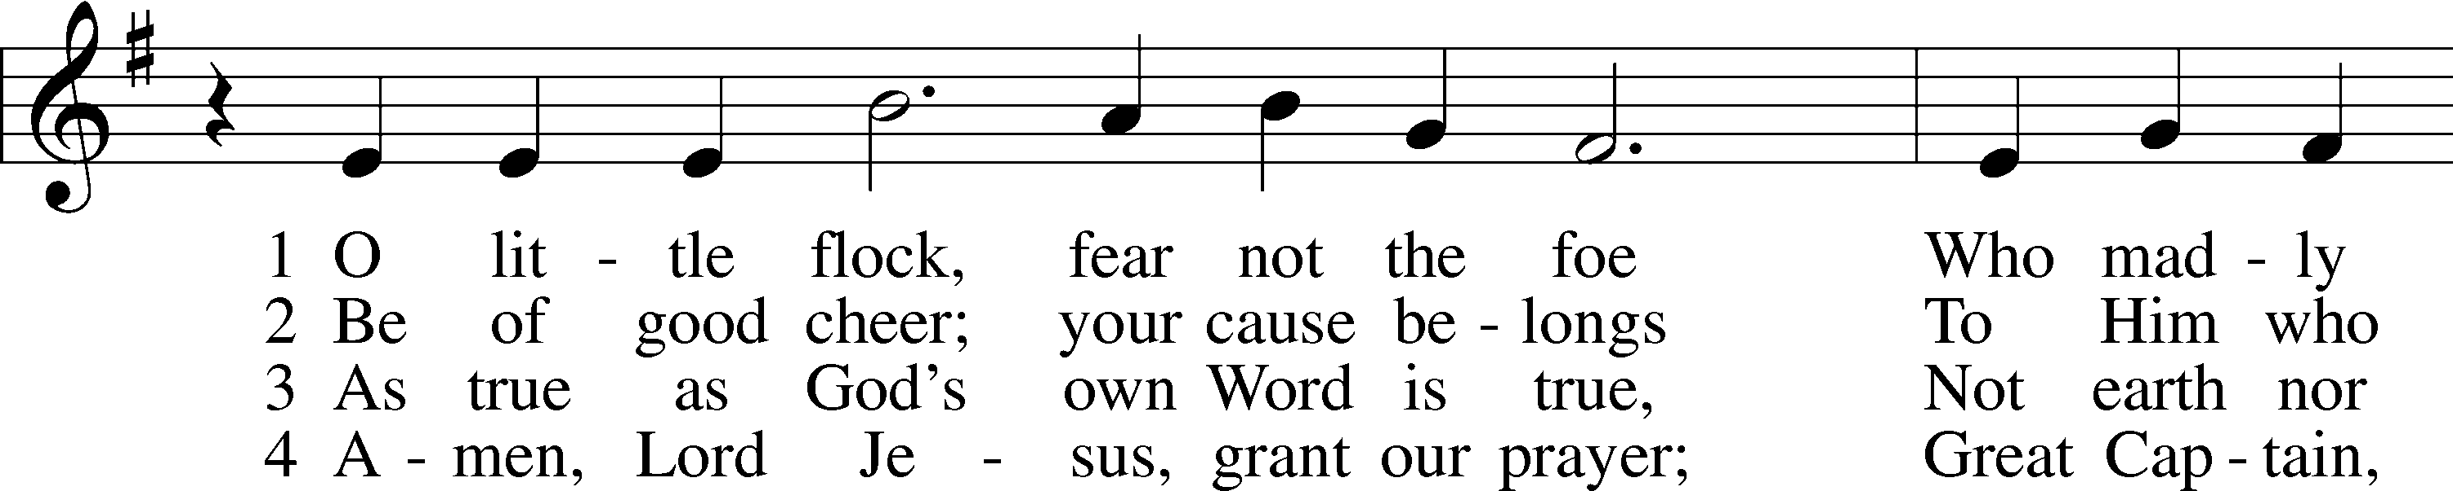

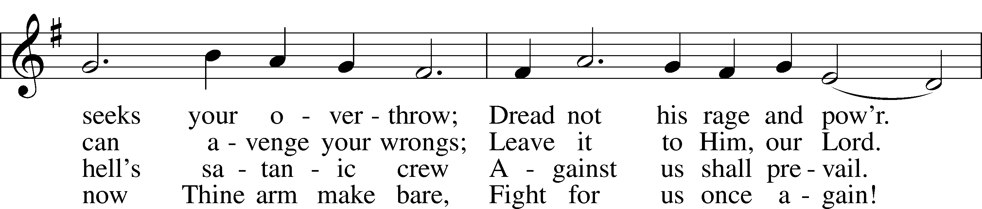

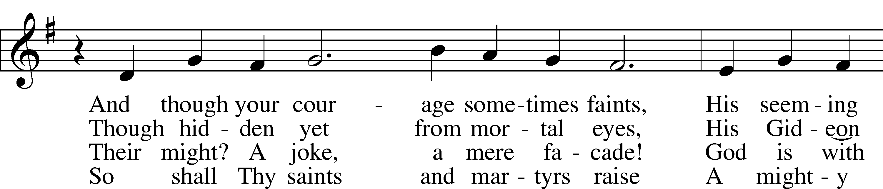

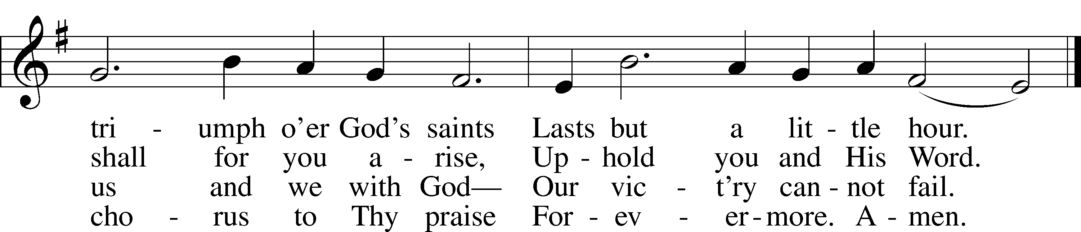

Text: Jacob Fabricius, 1593–1654; tr. Catherine Winkworth, 1827–78, alt.  
Tune: German, 1534, Nürnberg  
Text and tune: Public domain

Sermon

Votum

P The peace of God, which passes all understanding, keep your hearts and minds in Christ Jesus.

C **Amen.**

Stand

Offertory Psalm 51:10–12

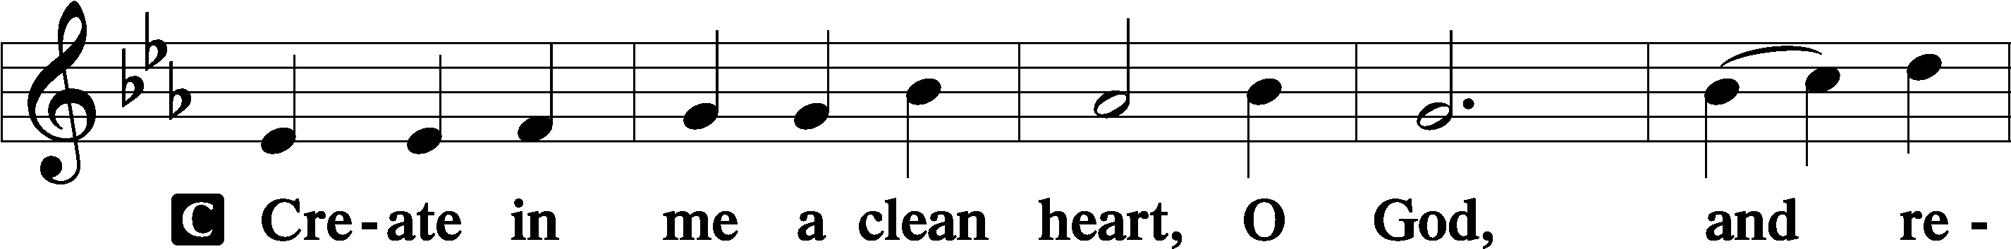

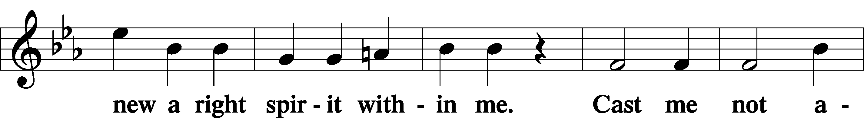

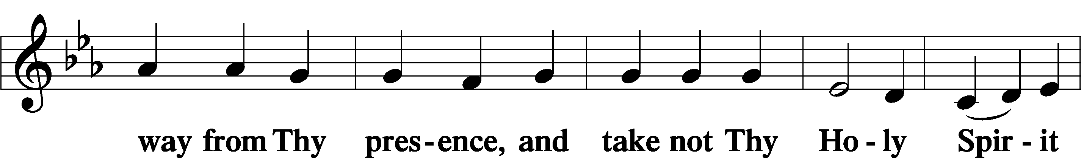

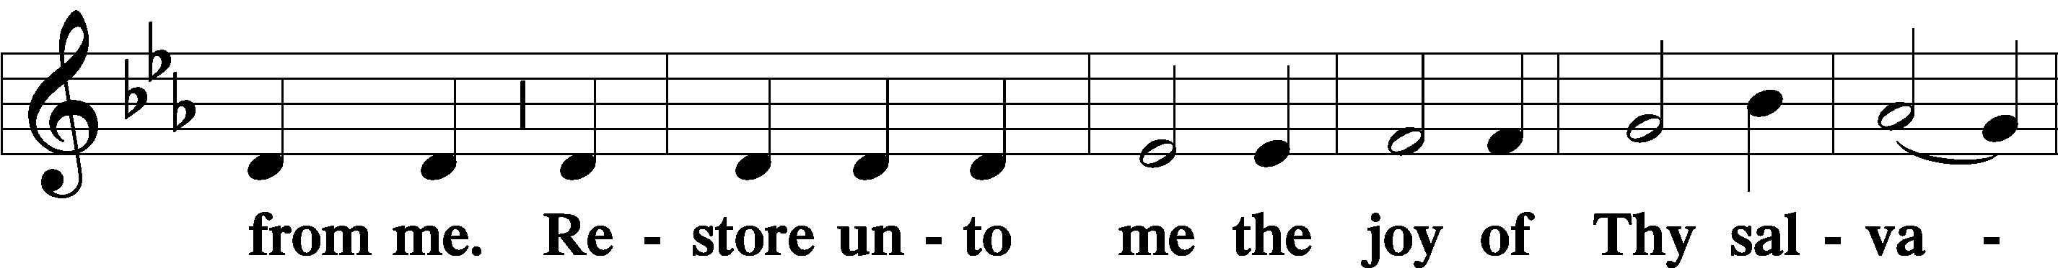

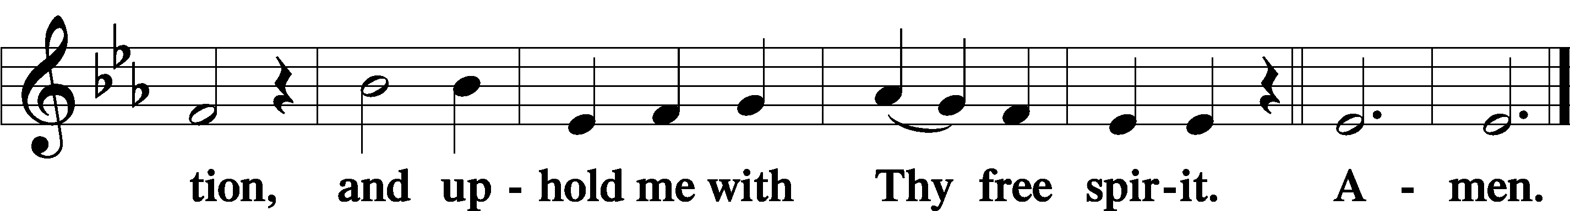

Offering

805 Praise God, from Whom All Blessings Flow

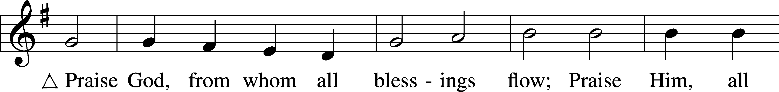

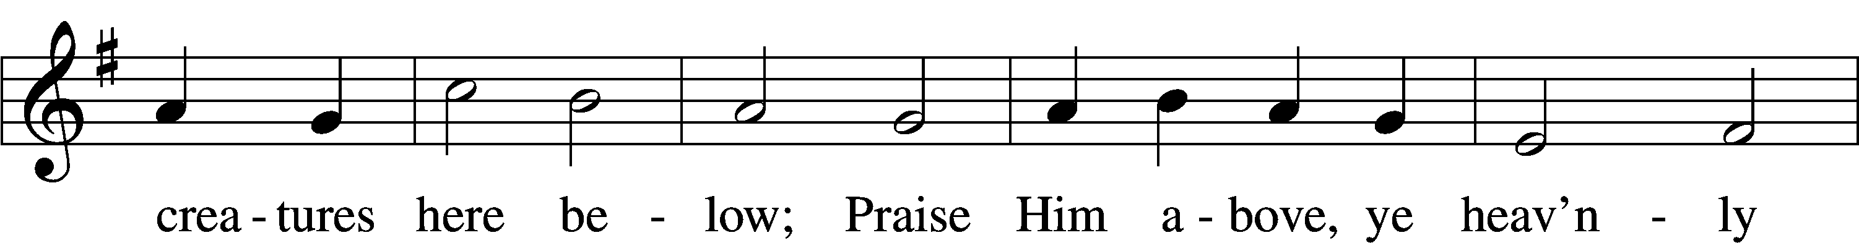

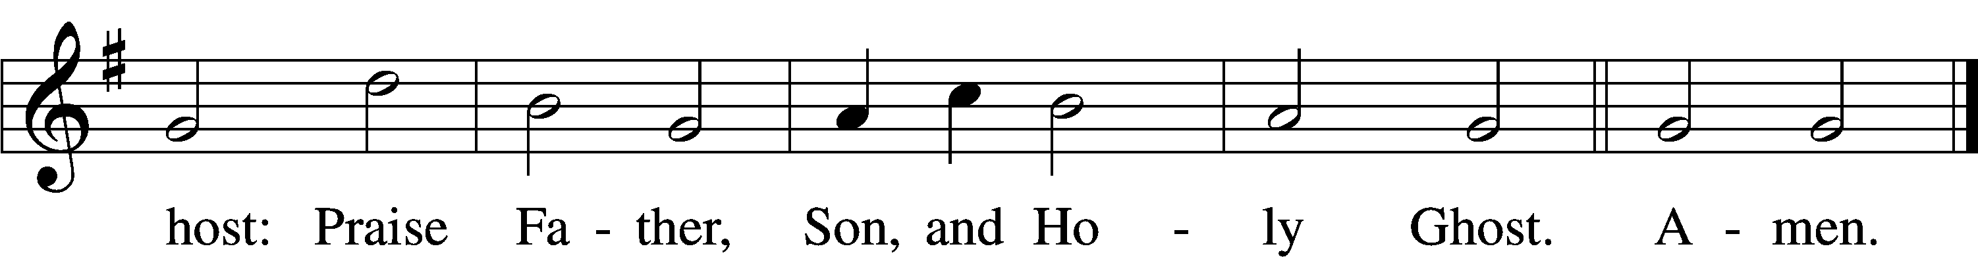

Text: Thomas Ken, 1637–1711  
Tune: Trente quatre Pseaumes de David, 1551, Geneva, ed. Louis Bourgeois  
Text and tune: Public domain

Prayer of the Church

Lord’s Prayer Matthew 6:9–13

P Lord, remember us in Your kingdom and teach us to pray:

C **Our Father who art in heaven,**

**hallowed be Thy name,**

**Thy kingdom come,**

**Thy will be done on earth**

**as it is in heaven;**

**give us this day our daily bread;**

**and forgive us our trespasses**

**as we forgive those**

**who trespass against us;**

**and lead us not into temptation,**

**but deliver us from evil.**

**For Thine is the kingdom**

**and the power and the glory**

**forever and ever. Amen.**

Collect for the Word

Blessed Lord, You have caused all Holy Scriptures to be written for our learning. Grant that we may so hear them, read, mark, learn, and inwardly digest them that, by the patience and comfort of Your holy Word, we may embrace and ever hold fast the blessed hope of everlasting life; through Jesus Christ, Your Son, our Lord, who lives and reigns with You and the Holy Spirit, one God, now and forever.

Benediction

P The Lord bless you and keep you.

The Lord make His face shine on you and be gracious to you.

The Lord look upon you with favor and T give you peace.

C **Amen.**

733 O God, Our Help in Ages Past sts. 1–6

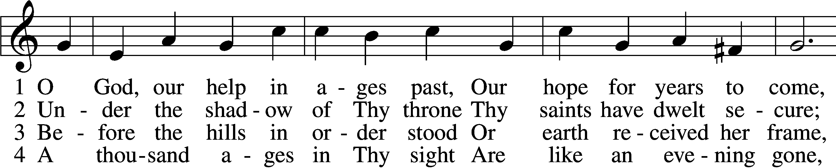

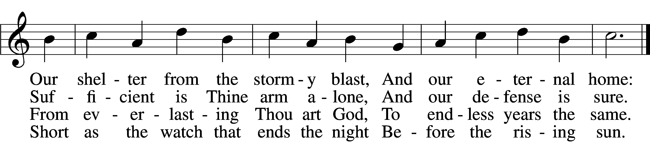

5 Time, like an ever-rolling stream,  
 Soon bears us all away;  
We fly forgotten as a dream  
 Dies at the op’ning day.

6 O God, our help in ages past,  
 Our hope for years to come,  
Be Thou our guard while troubles last  
 And our eternal home!

Text: Isaac Watts, 1674–1748, alt.  
Tune: William Croft, 1678–1727  
Text and tune: Public domain

Acknowledgments

Unless otherwise indicated, Scripture quotations are from the ESV® Bible (The Holy Bible, English Standard Version®), copyright © 2001 by Crossway, a publishing ministry of Good News Publishers. Used by permission. All rights reserved.

Created by Lutheran Service Builder © 2025 Concordia Publishing House.