478 The Day of Resurrection
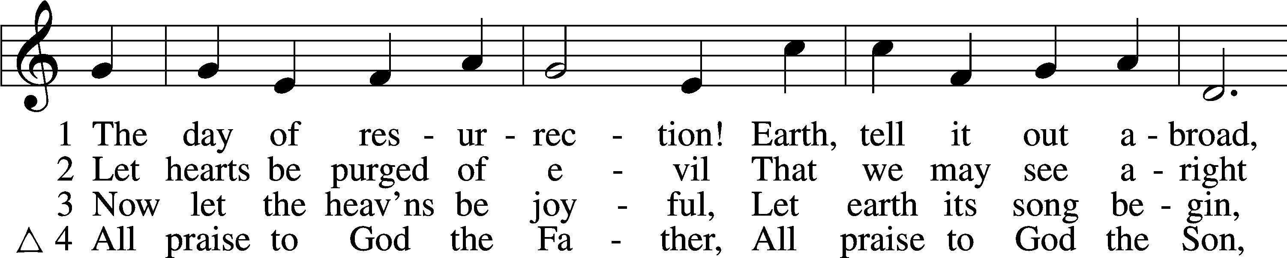
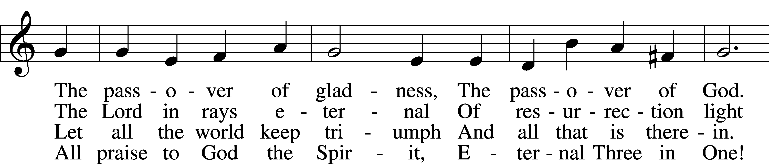
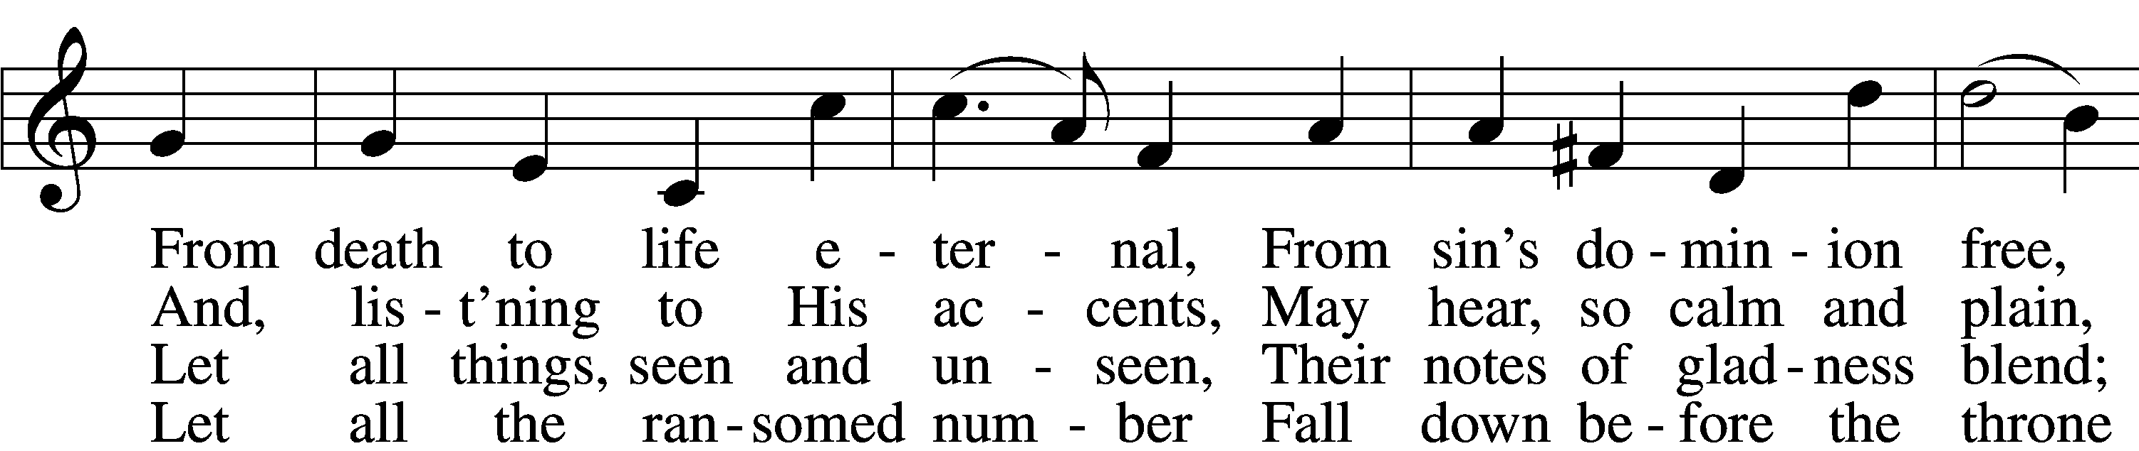
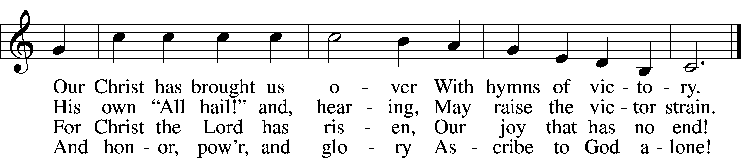
Text: John of Damascus, c. 696–c. 754; tr. John Mason Neale, 1818–66, alt.
Tune: Henry T. Smart, 1813–79
Text and tune: Public domain

Confession and Absolution

Stand

The sign of the cross may be made by all in remembrance of their Baptism.

Invocation Matthew 28:19b; 18:20
P In the name of the Father and of the T Son and of the Holy Spirit.
C Amen.

Exhortation Hebrews 10:22; Psalm 124:8; Psalm 32:5
P Beloved in the Lord! Let us draw near with a true heart and confess our sins unto God our Father, beseeching Him in the name of our Lord Jesus Christ to grant us forgiveness.

P Our help is in the name of the Lord,
C who made heaven and earth.
P I said, I will confess my transgressions unto the Lord,
C and You forgave the iniquity of my sin.

Kneel/Stand

Silence for reflection on God’s Word and for self-examination.

Confession of Sins
P O almighty God, merciful Father,
C I, a poor, miserable sinner, confess unto You all my sins and iniquities with which I have ever offended You and justly deserved Your temporal and eternal punishment. But I am heartily sorry for them and sincerely repent of them, and I pray You of Your boundless mercy and for the sake of the holy, innocent, bitter sufferings and death of Your beloved Son, Jesus Christ, to be gracious and merciful to me, a poor, sinful being.

Absolution [John 20:19–23]
P Upon this your confession, I, by virtue of my office, as a called and ordained servant of the Word, announce the grace of God unto all of you, and in the stead and by the command of my Lord Jesus Christ I forgive you all your sins in the name of the Father and of the T Son and of the Holy Spirit.
C Amen.

Stand

Service of the Word

Introit Psalm 100; antiphon: Psalm 101:1
I will sing of steadfast love and justice;
to you, O Lord, I will make music.
Make a joyful noise to the Lord, all the earth!
Serve the Lord with gladness! Come into his presence with singing!
Know that the Lord, he is God!
It is he who made us, and we are his; we are his people, and the sheep of his pasture.
Enter his gates with thanksgiving, and his courts with praise!
Give thanks to him; bless his name!
For the Lord is good; his steadfast love endures forever,
and his faithfulness to all generations.
Glory be to the Father and to the Son
and to the Holy Spirit;
as it was in the beginning,
is now, and will be forever. Amen.
I will sing of steadfast love and justice;
to you, O Lord, I will make music.

Gloria Patri
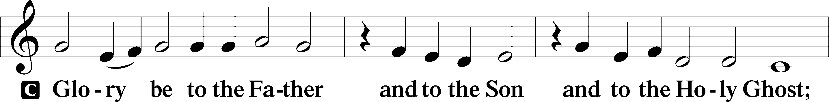
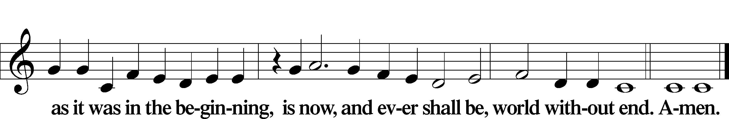

Kyrie Mark 10:47
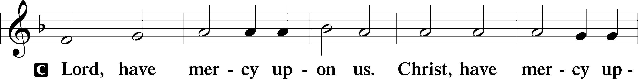
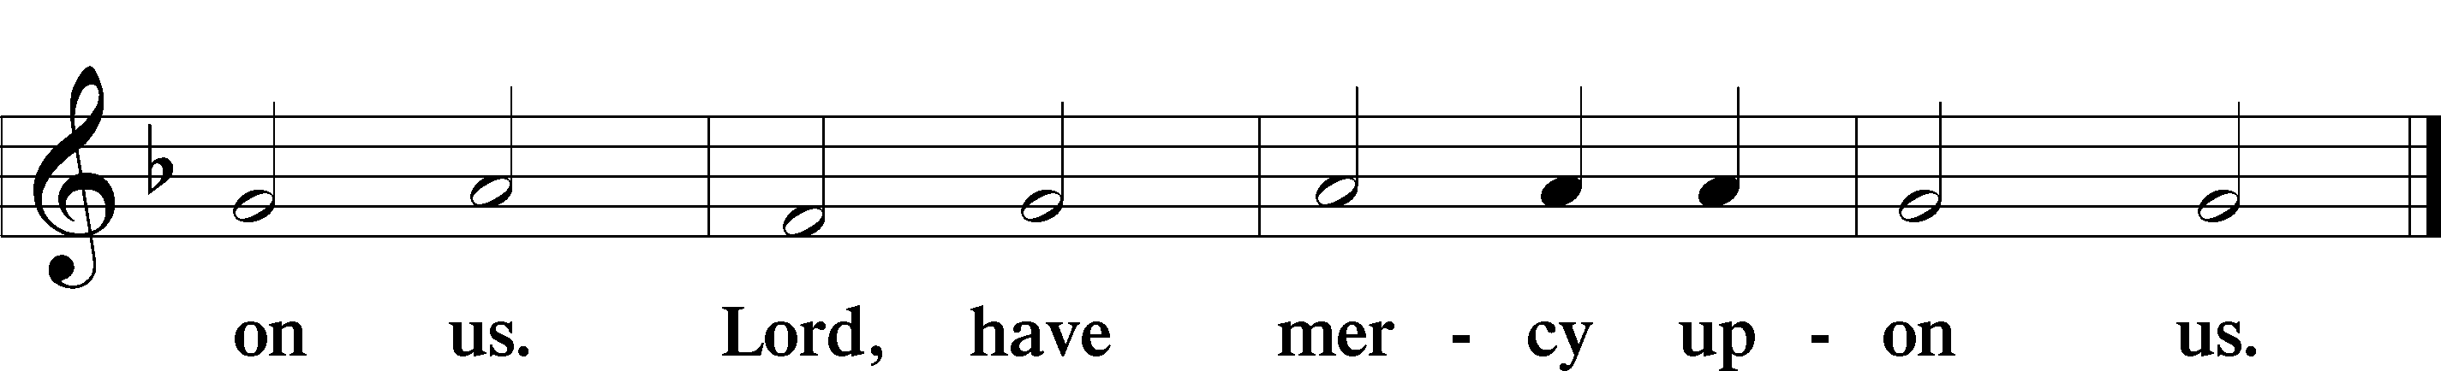

Gloria in Excelsis Luke 2:14; John 1:29
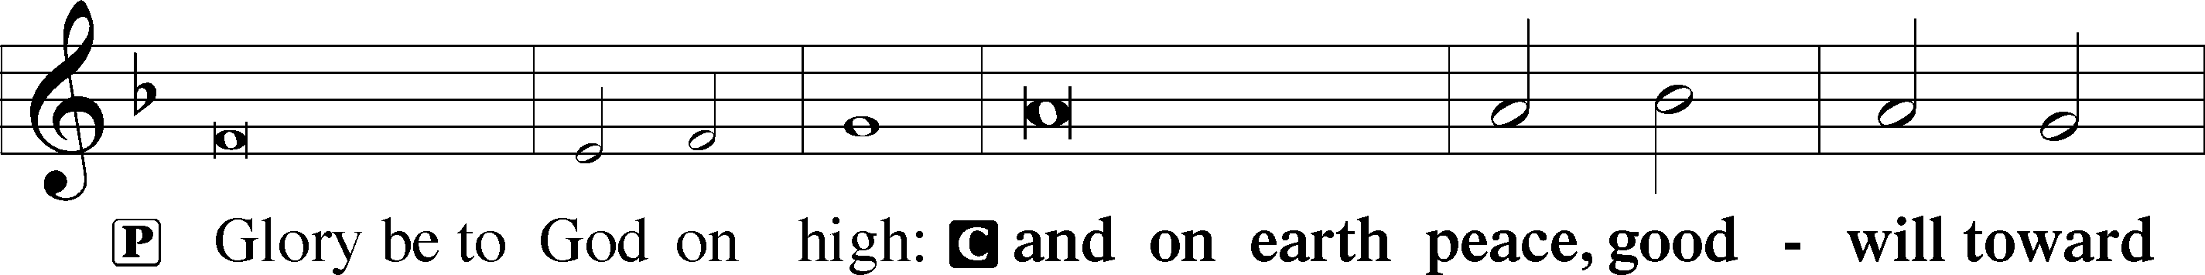
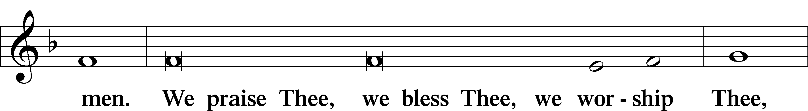
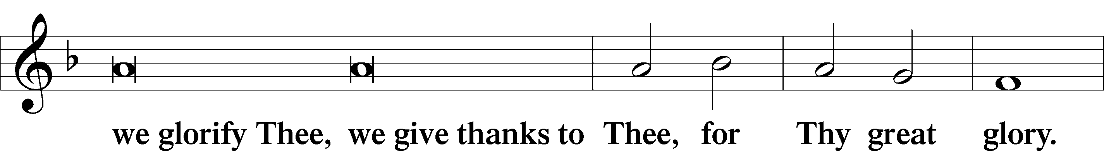
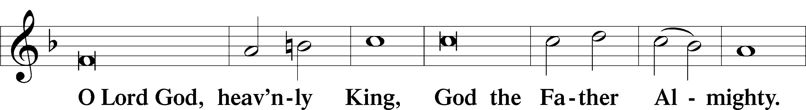
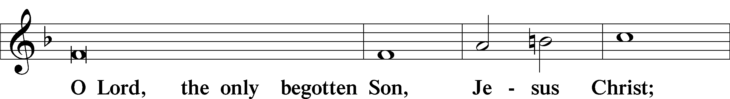
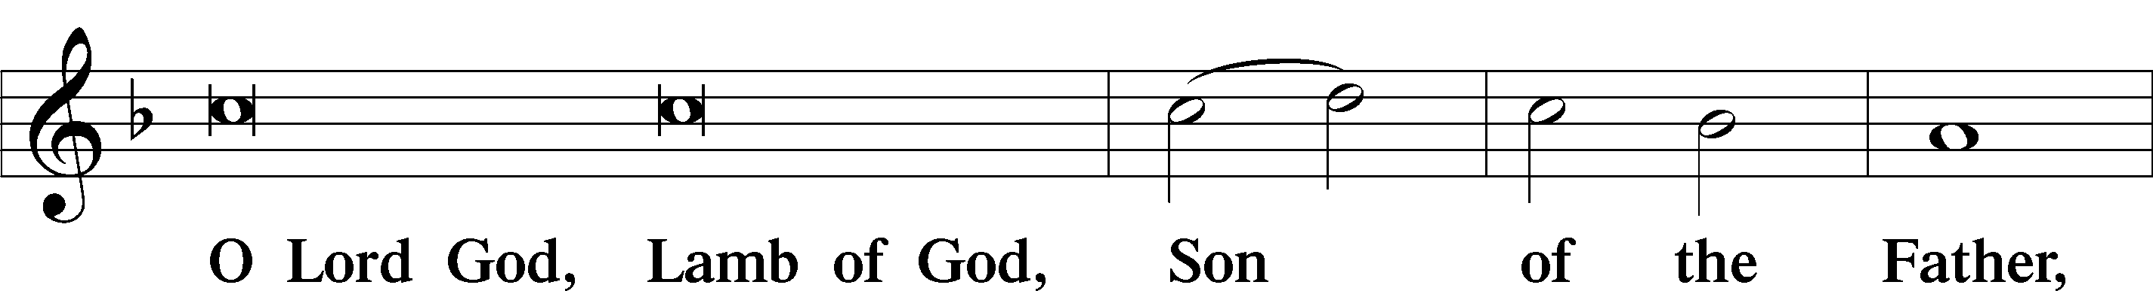
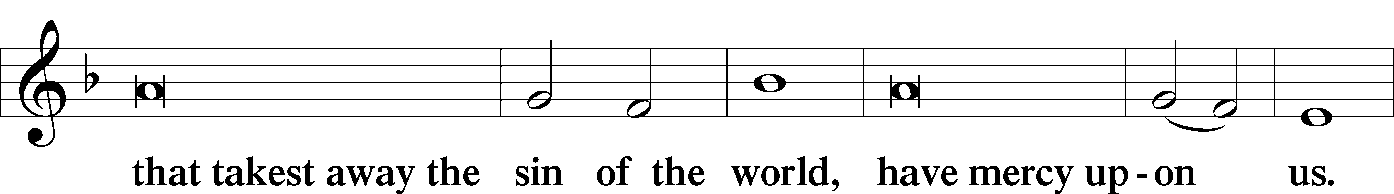
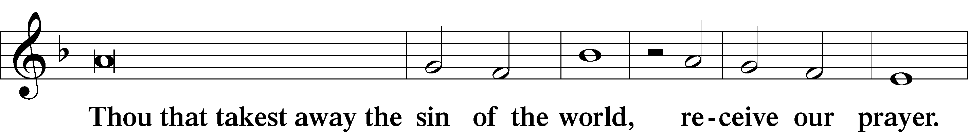
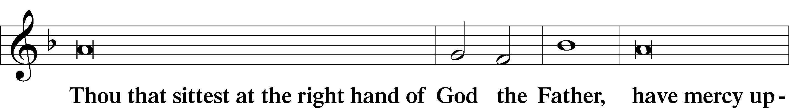
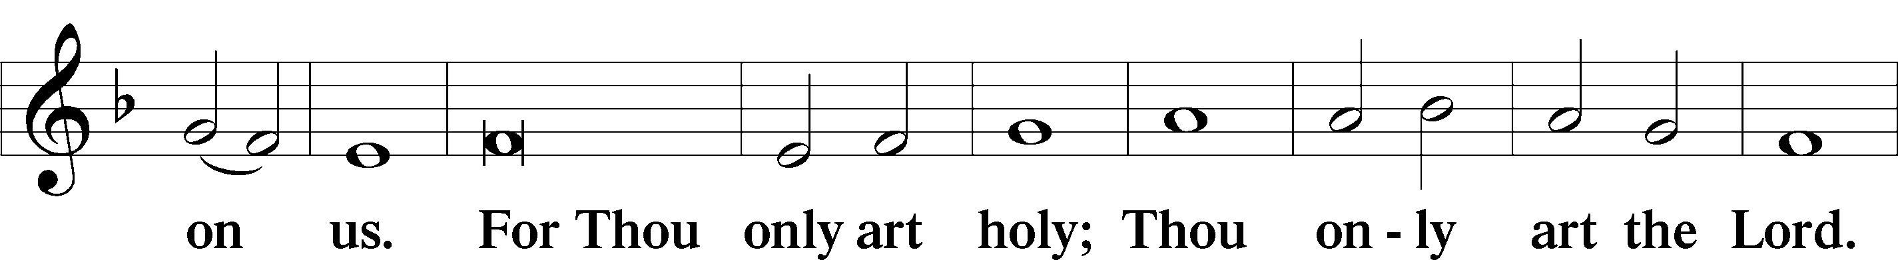
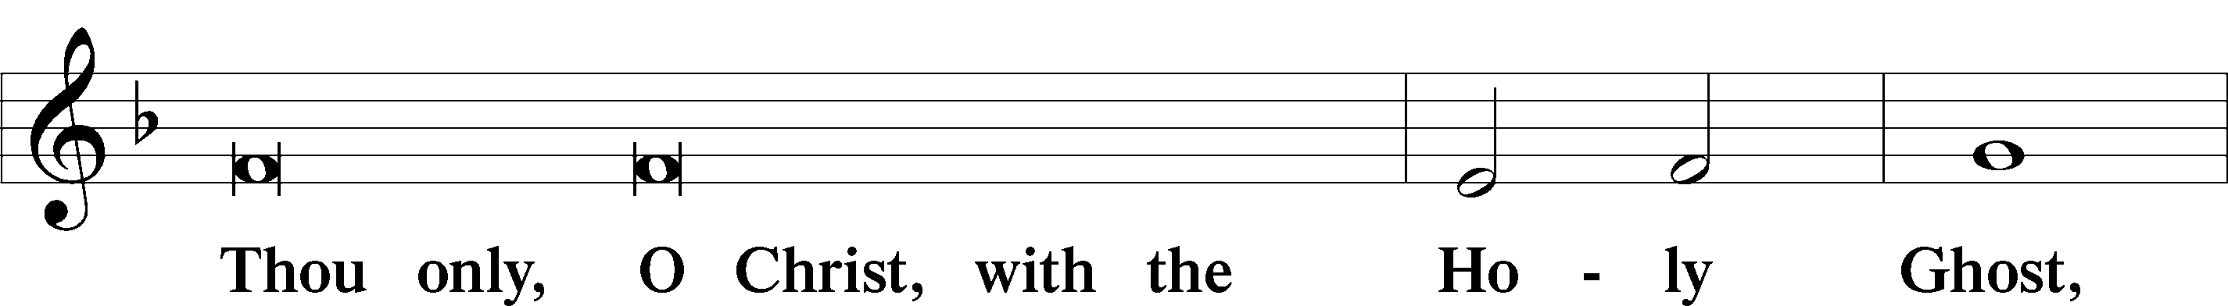
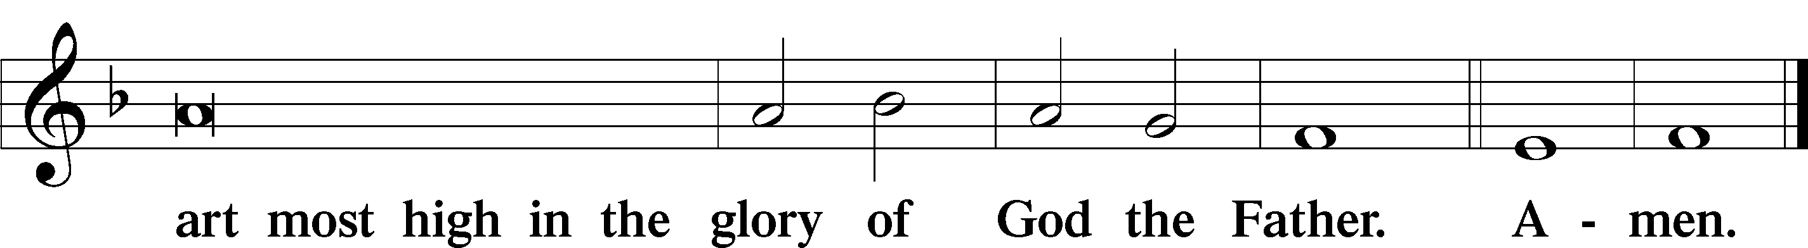

Salutation and Collect of the Day
P The Lord be with you.
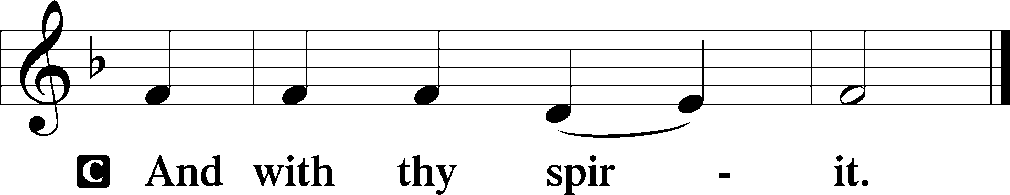

P Let us pray.
O King of glory, Lord of hosts, uplifted in triumph far above all heavens, leave us not without consolation but send us the Spirit of truth whom You promised from the Father; for You live and reign with Him and the Holy Spirit, one God, now and forever.

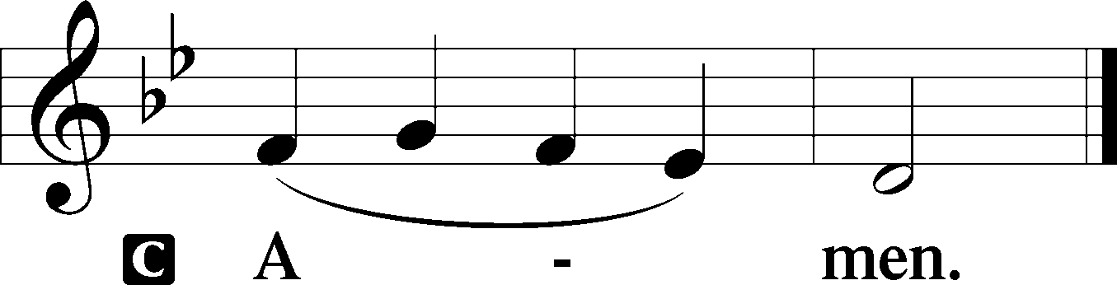

Sit

Old Testament Acts 1:12–26
12Then [the apostles] returned to Jerusalem from the mount called Olivet, which is near Jerusalem, a Sabbath day’s journey away. 13And when they had entered, they went up to the upper room, where they were staying, Peter and John and James and Andrew, Philip and Thomas, Bartholomew and Matthew, James the son of Alphaeus and Simon the Zealot and Judas the son of James. 14All these with one accord were devoting themselves to prayer, together with the women and Mary the mother of Jesus, and his brothers.
15In those days Peter stood up among the brothers (the company of persons was in all about 120) and said, 16“Brothers, the Scripture had to be fulfilled, which the Holy Spirit spoke beforehand by the mouth of David concerning Judas, who became a guide to those who arrested Jesus. 17For he was numbered among us and was allotted his share in this ministry.” 18(Now this man bought a field with the reward of his wickedness, and falling headlong he burst open in the middle and all his bowels gushed out. 19And it became known to all the inhabitants of Jerusalem, so that the field was called in their own language Akeldama, that is, Field of Blood.) 20“For it is written in the Book of Psalms,
“‘May his camp become desolate,
and let there be no one to dwell in it’;
and
“‘Let another take his office.’
21So one of the men who have accompanied us during all the time that the Lord Jesus went in and out among us, 22beginning from the baptism of John until the day when he was taken up from us—one of these men must become with us a witness to his resurrection.” 23And they put forward two, Joseph called Barsabbas, who was also called Justus, and Matthias. 24And they prayed and said, “You, Lord, who know the hearts of all, show which one of these two you have chosen 25to take the place in this ministry and apostleship from which Judas turned aside to go to his own place.” 26And they cast lots for them, and the lot fell on Matthias, and he was numbered with the eleven apostles.

A This is the Word of the Lord.
C Thanks be to God.

Gradual adapt. from Matthew 28:7; Hebrews 2:7; Psalm 8:6
Christ has risen from the dead.
[God the Father] has crowned him with glory and honor.
He has given him dominion over the works of his hands;
he has put all things under his feet.

Epistle 1 Peter 4:12–19; 5:6–11
12Beloved, do not be surprised at the fiery trial when it comes upon you to test you, as though something strange were happening to you. 13But rejoice insofar as you share Christ’s sufferings, that you may also rejoice and be glad when his glory is revealed. 14If you are insulted for the name of Christ, you are blessed, because the Spirit of glory and of God rests upon you. 15But let none of you suffer as a murderer or a thief or an evildoer or as a meddler. 16Yet if anyone suffers as a Christian, let him not be ashamed, but let him glorify God in that name. 17For it is time for judgment to begin at the household of God; and if it begins with us, what will be the outcome for those who do not obey the gospel of God? 18And
“If the righteous is scarcely saved,
what will become of the ungodly and the sinner?”
19Therefore let those who suffer according to God’s will entrust their souls to a faithful Creator while doing good. . . .
6Humble yourselves, therefore, under the mighty hand of God so that at the proper time he may exalt you, 7casting all your anxieties on him, because he cares for you. 8Be sober-minded; be watchful. Your adversary the devil prowls around like a roaring lion, seeking someone to devour. 9Resist him, firm in your faith, knowing that the same kinds of suffering are being experienced by your brotherhood throughout the world. 10And after you have suffered a little while, the God of all grace, who has called you to his eternal glory in Christ, will himself restore, confirm, strengthen, and establish you. 11To him be the dominion forever and ever. Amen.

A This is the Word of the Lord.
C Thanks be to God.

Stand

Alleluia
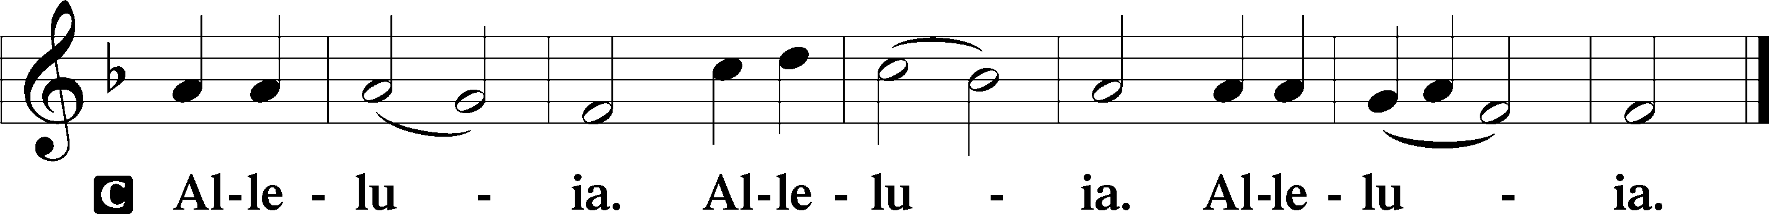

Holy Gospel John 17:1–11
P The Holy Gospel according to St. John, the seventeenth chapter.

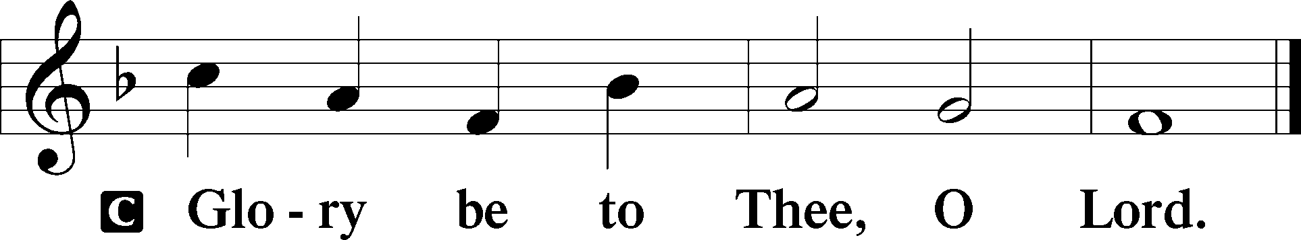

1When Jesus had spoken these words, he lifted up his eyes to heaven, and said, “Father, the hour has come; glorify your Son that the Son may glorify you, 2since you have given him authority over all flesh, to give eternal life to all whom you have given him. 3And this is eternal life, that they know you the only true God, and Jesus Christ whom you have sent. 4I glorified you on earth, having accomplished the work that you gave me to do. 5And now, Father, glorify me in your own presence with the glory that I had with you before the world existed.
6“I have manifested your name to the people whom you gave me out of the world. Yours they were, and you gave them to me, and they have kept your word. 7Now they know that everything that you have given me is from you. 8For I have given them the words that you gave me, and they have received them and have come to know in truth that I came from you; and they have believed that you sent me. 9I am praying for them. I am not praying for the world but for those whom you have given me, for they are yours. 10All mine are yours, and yours are mine, and I am glorified in them. 11And I am no longer in the world, but they are in the world, and I am coming to you. Holy Father, keep them in your name, which you have given me, that they may be one, even as we are one.”

P This is the Gospel of the Lord.

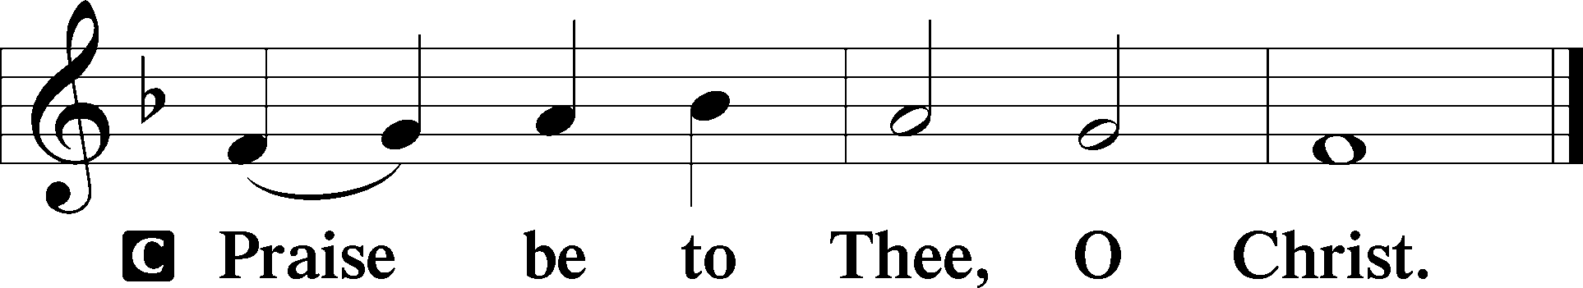

Nicene Creed
C I believe in one God,
the Father Almighty,
maker of heaven and earth
and of all things visible and invisible.

And in one Lord Jesus Christ,
the only-begotten Son of God,
begotten of His Father before all worlds,
God of God, Light of Light,
very God of very God,
begotten, not made,
being of one substance with the Father,
by whom all things were made;
who for us men and for our salvation came down from heaven
and was incarnate by the Holy Spirit of the virgin Mary
and was made man;
and was crucified also for us under Pontius Pilate.
He suffered and was buried.
And the third day He rose again according to the Scriptures
and ascended into heaven
and sits at the right hand of the Father.
And He will come again with glory to judge both the living and the dead,
whose kingdom will have no end.

And I believe in the Holy Spirit,
the Lord and giver of life,
who proceeds from the Father and the Son,
who with the Father and the Son together is worshiped and glorified,
who spoke by the prophets.
And I believe in one holy Christian and apostolic Church,
I acknowledge one Baptism for the remission of sins,
and I look for the resurrection of the dead
and the life T of the world to come. Amen.

Sit

Children's Sermon

545 Word of God, Come Down on Earth
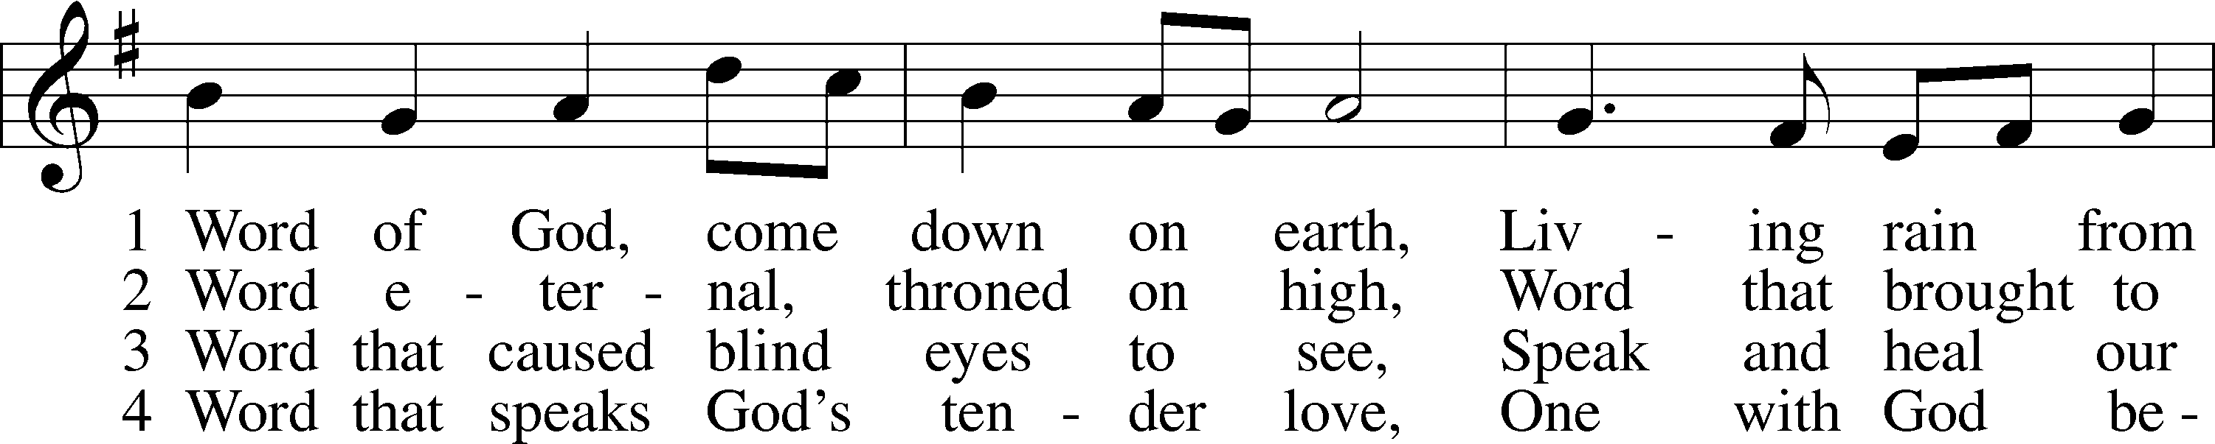
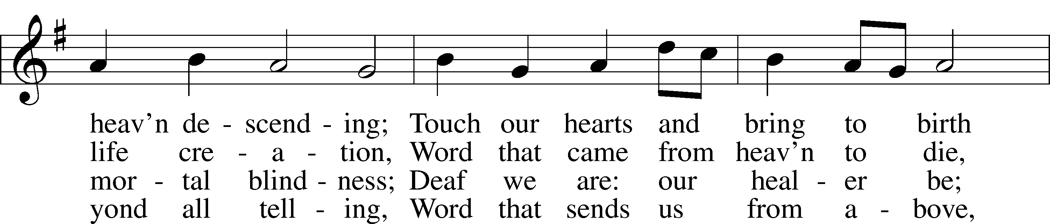
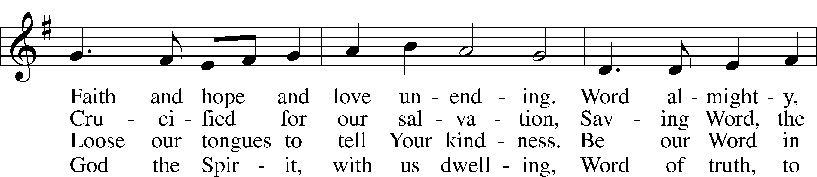
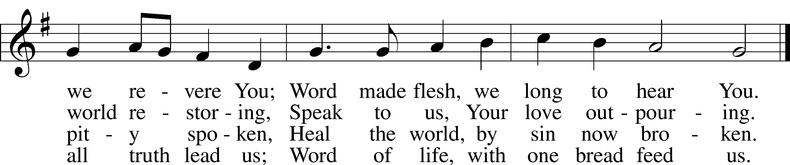
Text: James Quinn, 1919–2010
Tune: Johann Rudolph Ahle, 1625–73, alt.
Text: © 1969 OCP Publications. Used by permission: LSB Hymn License no. 110005011
Tune: Public domain

Sermon “Life Choices”

Votum
P The peace of God, which passes all understanding, keep your hearts and minds in Christ Jesus.
C Amen.

Stand

Offertory Psalm 51:10–12
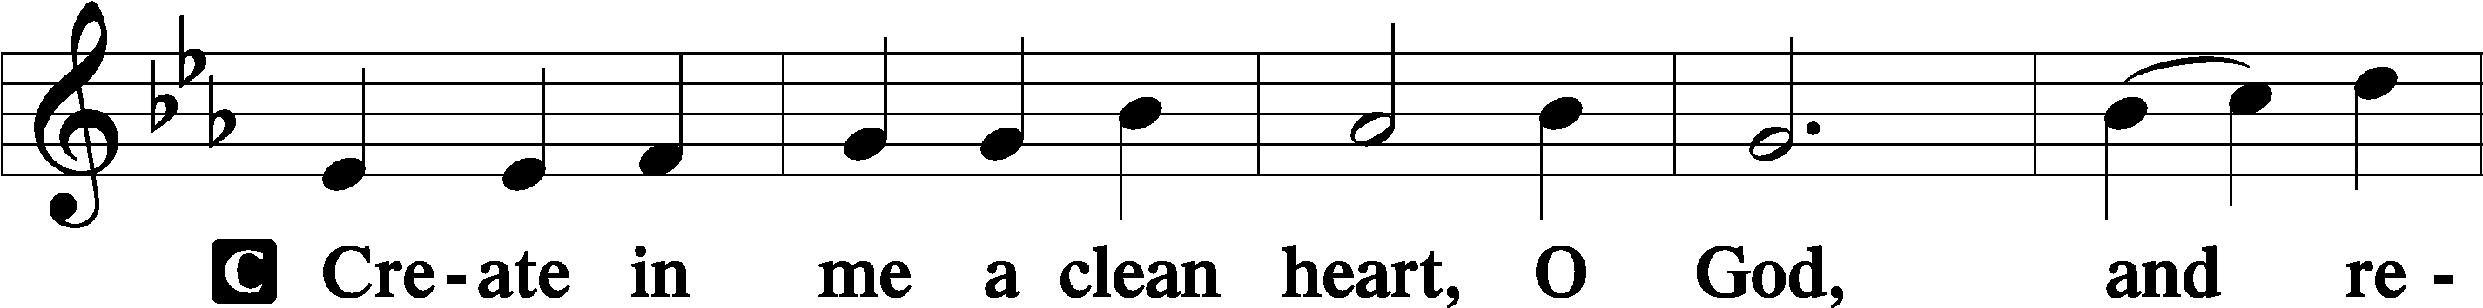
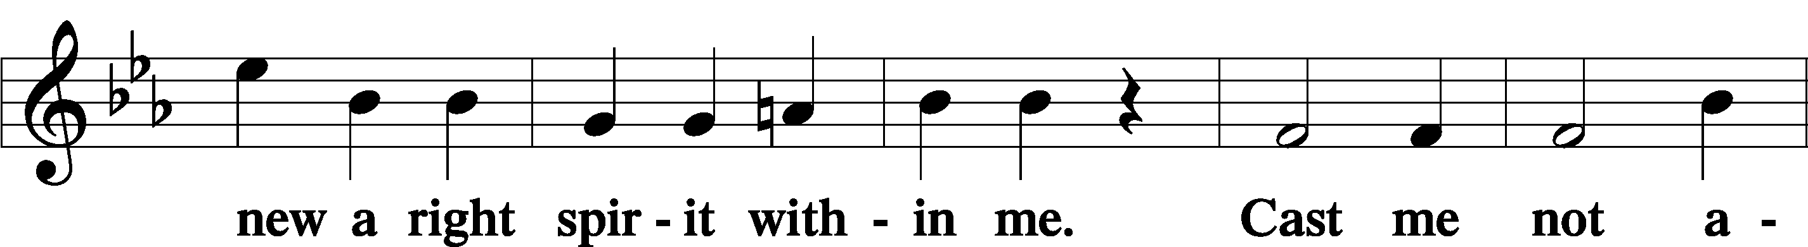
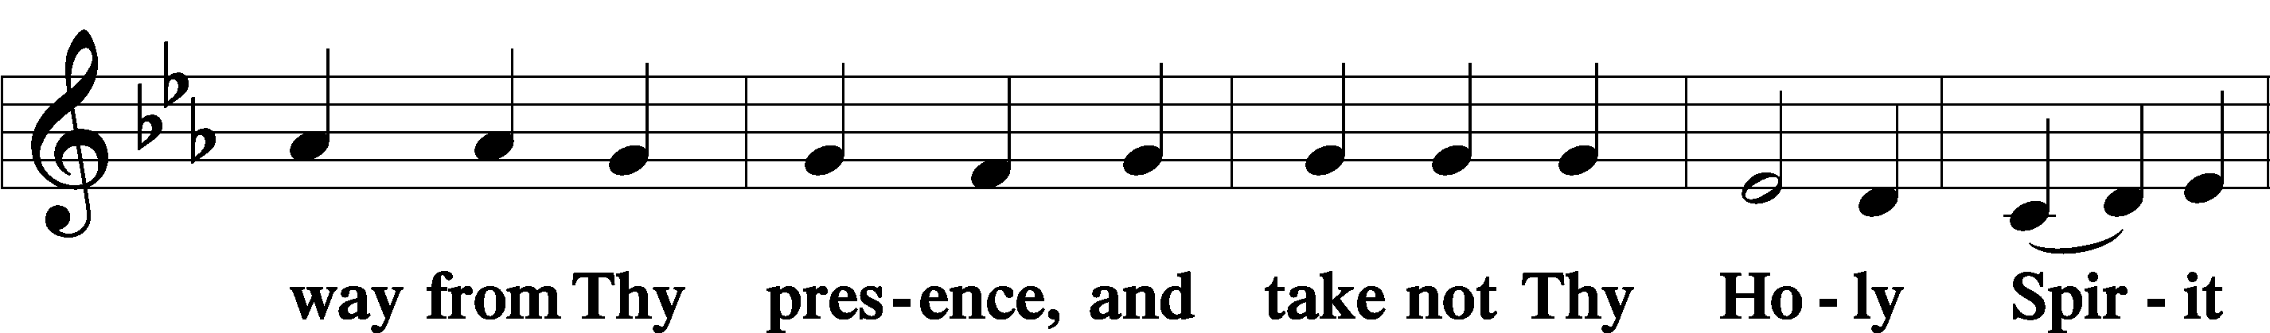
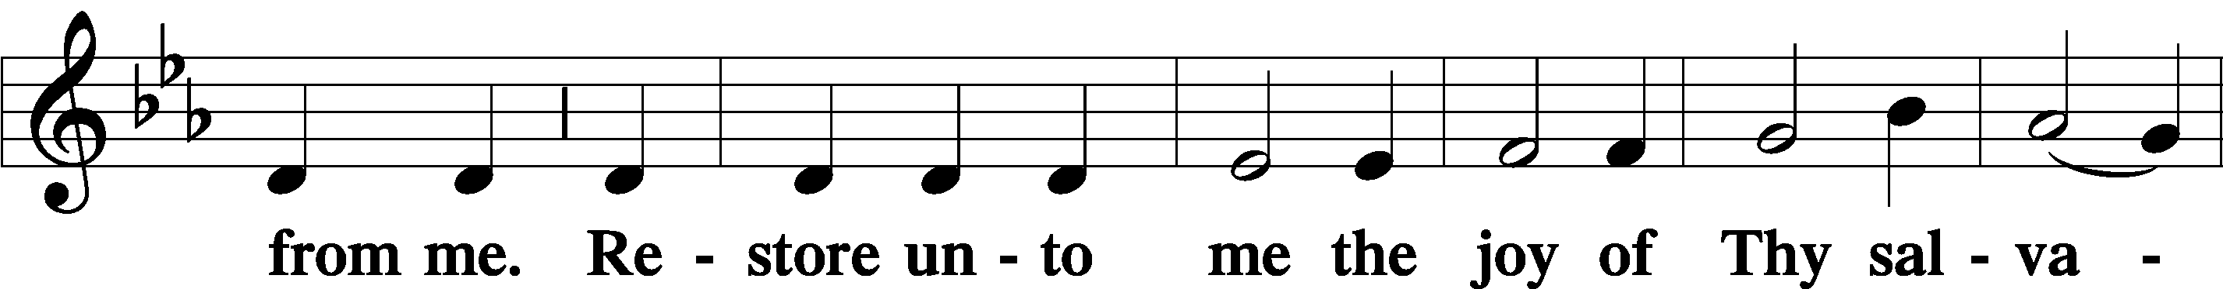
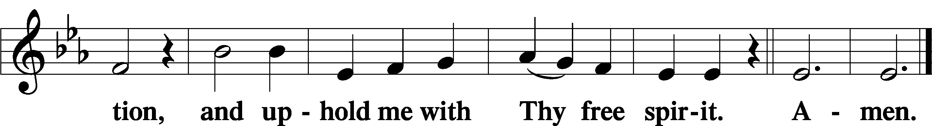

Sit

Offering

805 Praise God, from Whom All Blessings Flow
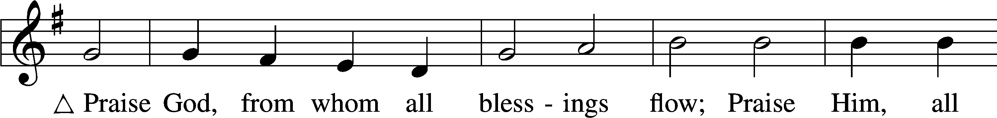
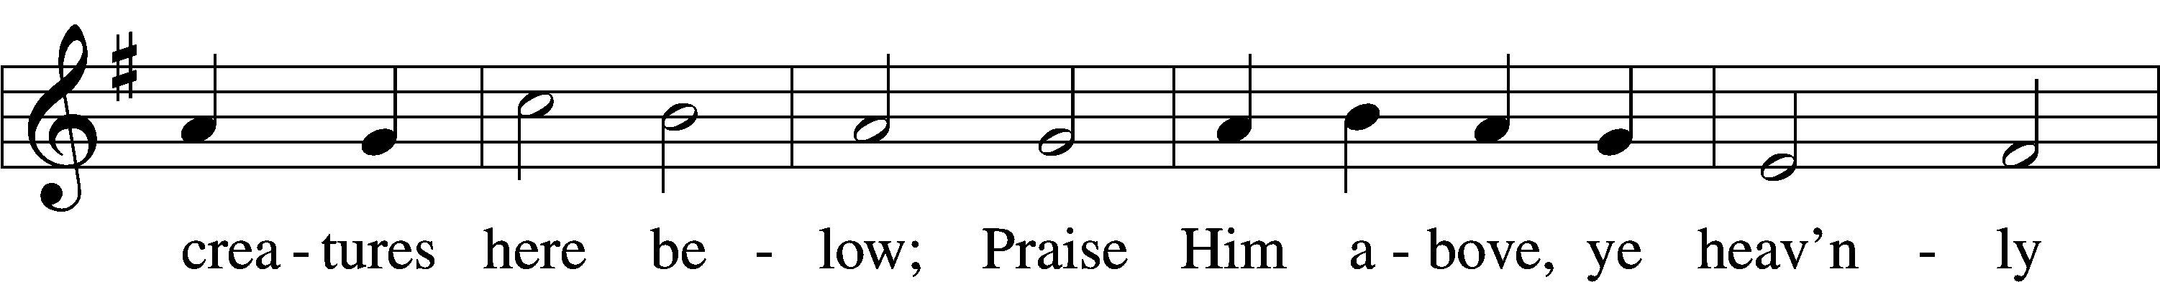
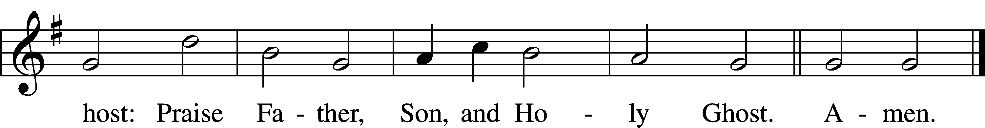
Text: Thomas Ken, 1637–1711
Tune: Trente quatre Pseaumes de David, 1551, Geneva, ed. Louis Bourgeois
Text and tune: Public domain

Stand

Prayer of the Church

Service of the Sacrament

Preface 2 Timothy 4:22; [Colossians 3:1]; [Psalm 136]
P The Lord be with you.
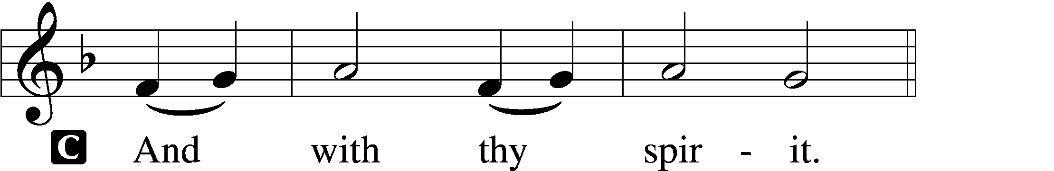

P Lift up your hearts.
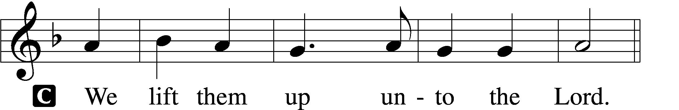

P Let us give thanks unto the Lord, our God.
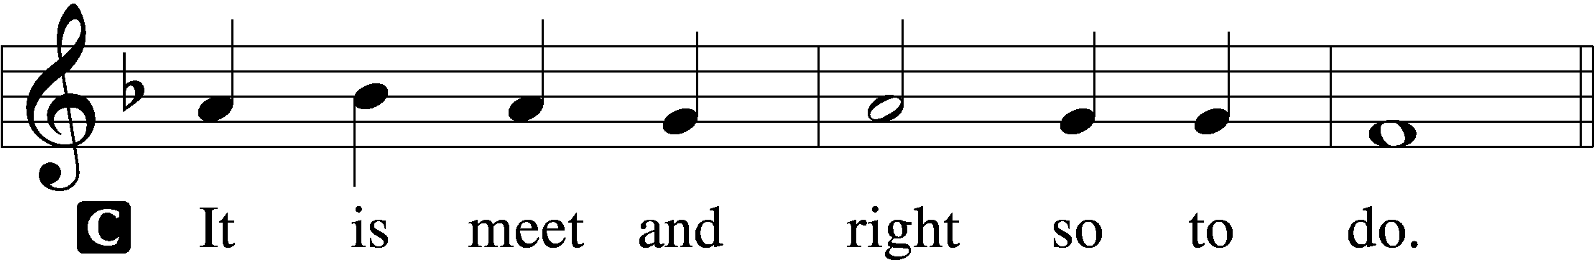

Proper Preface (Full)
P It is truly meet, right, and salutary that we should at all times and in all places give thanks to You, holy Lord, almighty Father, everlasting God, through Jesus Christ, our Lord, who after His resurrection appeared openly to all His disciples and in their sight was taken up into heaven that He might make us partakers of His divine life. Therefore with angels and archangels and with all the company of heaven we laud and magnify Your glorious name, evermore praising You and saying:

Sanctus Isaiah 6:3; Matthew 21:9
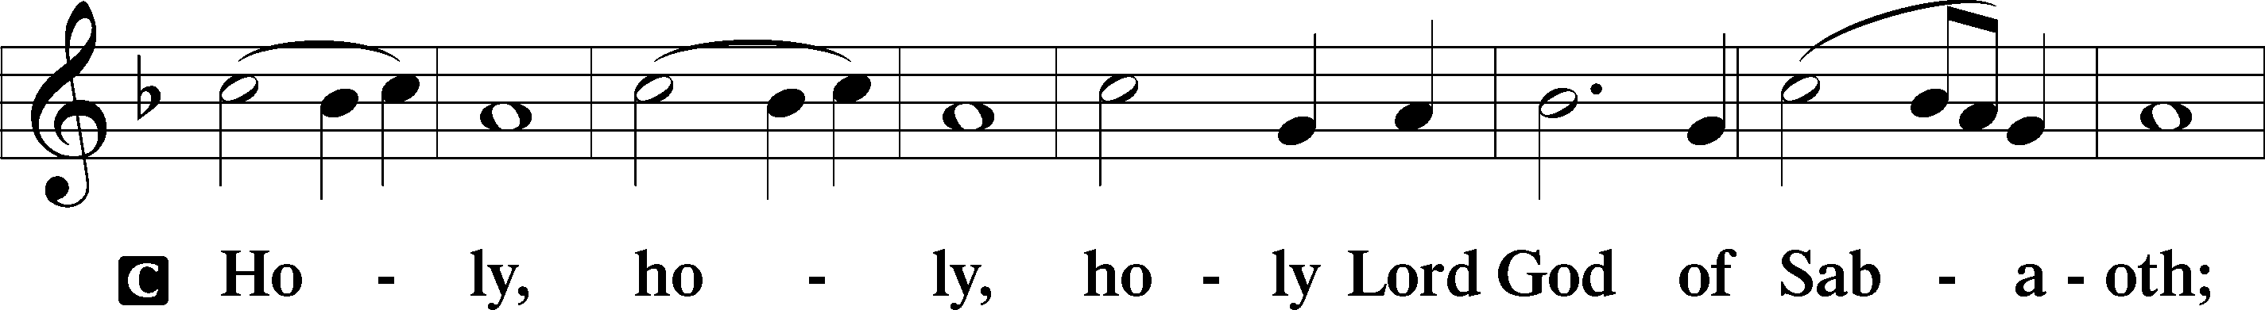
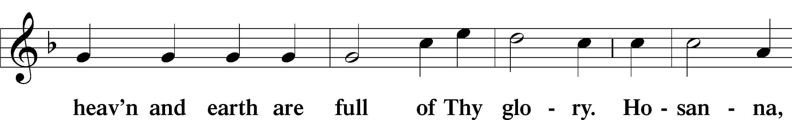
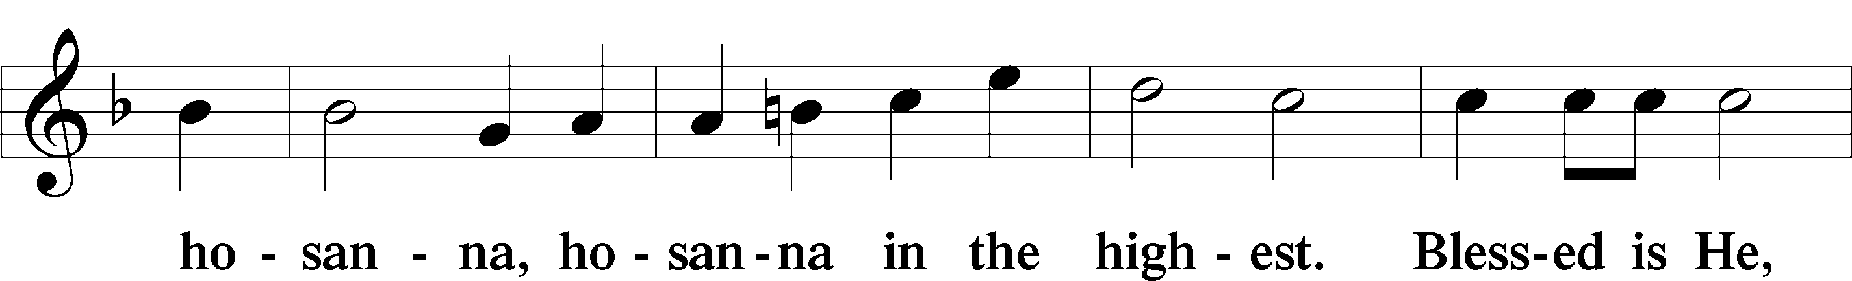
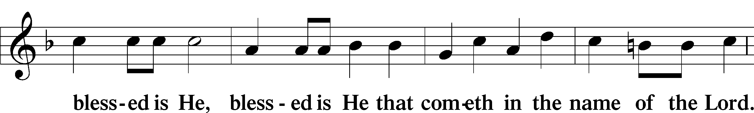
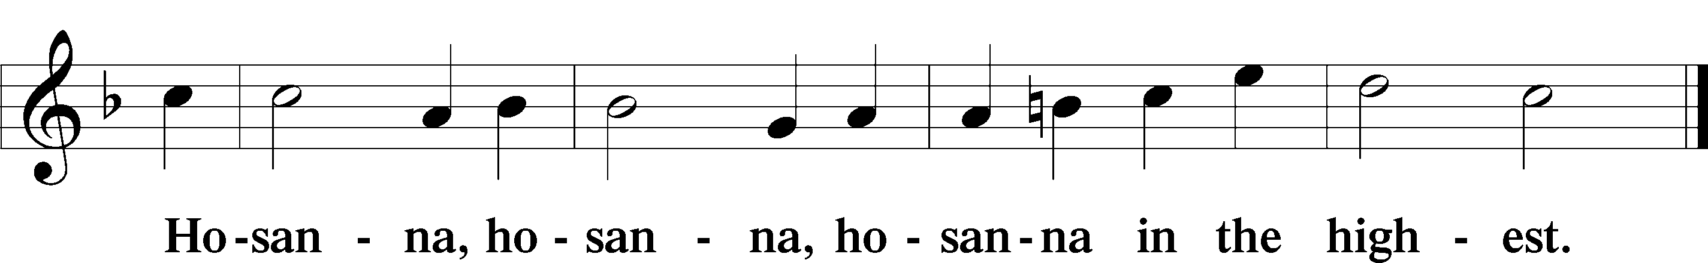

Lord’s Prayer Matthew 6:9–13
P Our Father who art in heaven,
hallowed be Thy name,
Thy kingdom come,
Thy will be done on earth as it is in heaven;
give us this day our daily bread;
and forgive us our trespasses as we forgive those who trespass against us;
and lead us not into temptation,
but deliver us from evil.
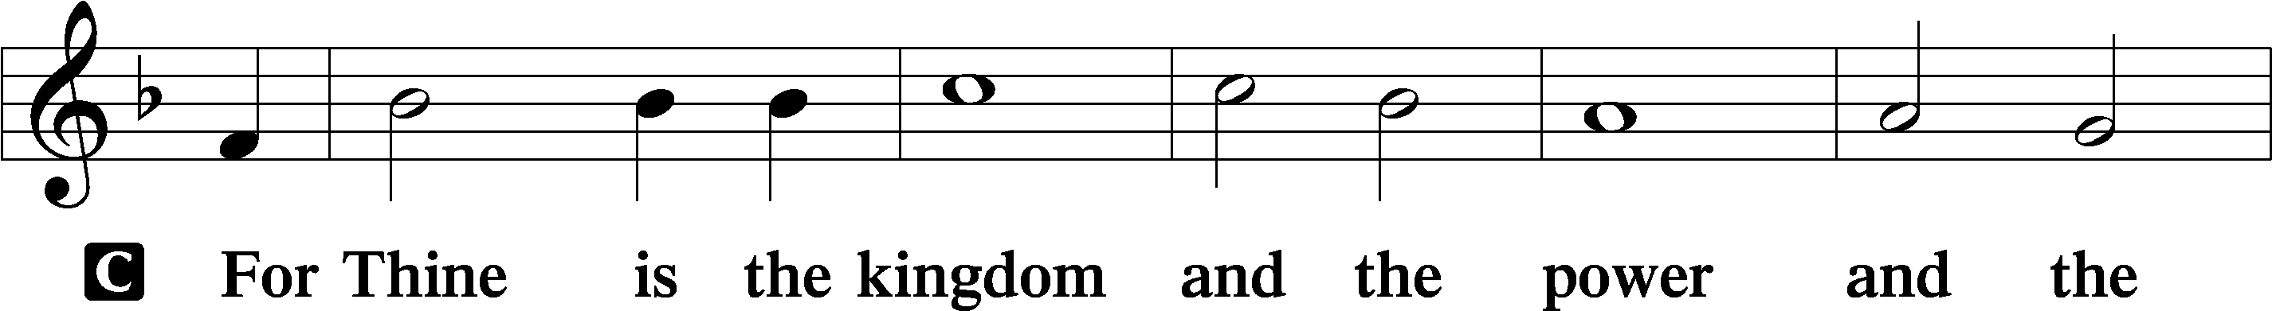
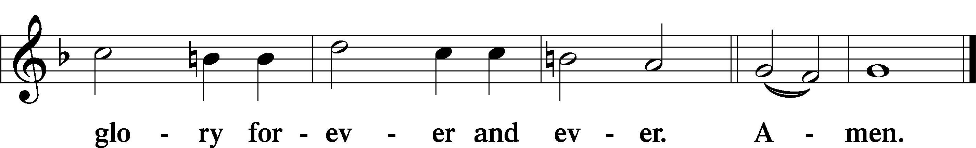

The Words of Our Lord Matthew 26:26–28; Mark 14:22–24; Luke 22:19–20; 1 Corinthians 11:23–25
P Our Lord Jesus Christ, on the night when He was betrayed, took bread, and when He had given thanks, He broke it and gave it to the disciples and said: “Take, eat; this is My T body, which is given for you. This do in remembrance of Me.”

In the same way also He took the cup after supper, and when He had given thanks, He gave it to them, saying: “Drink of it, all of you; this cup is the new testament in My T blood, which is shed for you for the forgiveness of sins. This do, as often as you drink it, in remembrance of Me.”

Pax Domini John 20:19
P The peace of the Lord be with you always.

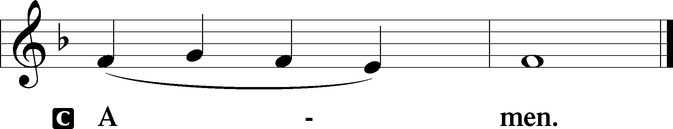

Agnus Dei John 1:29
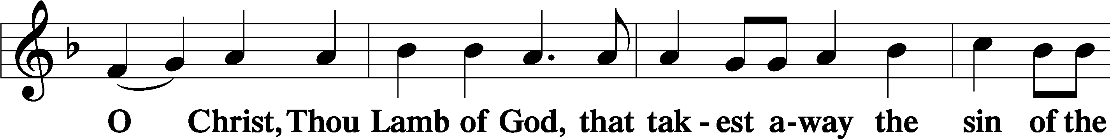
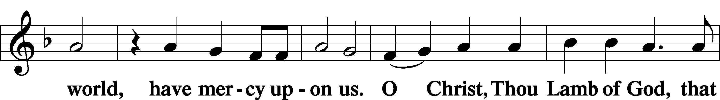
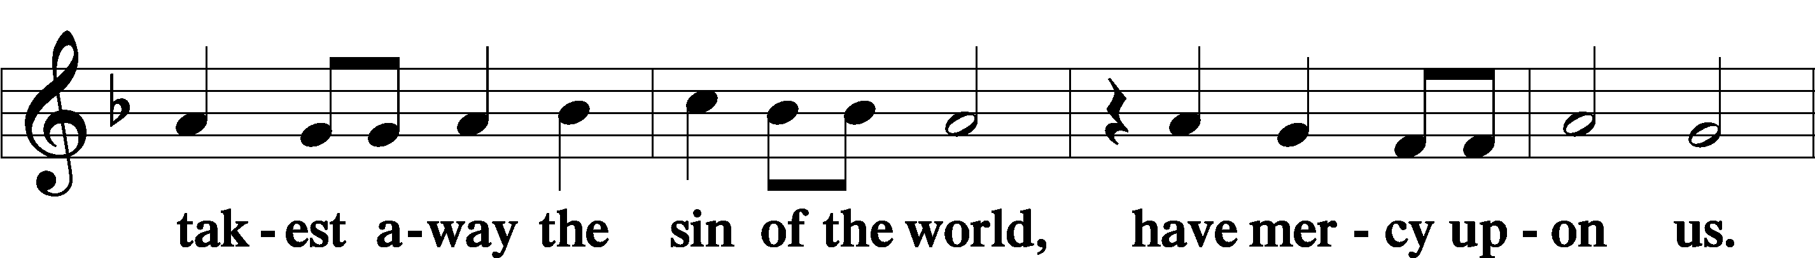
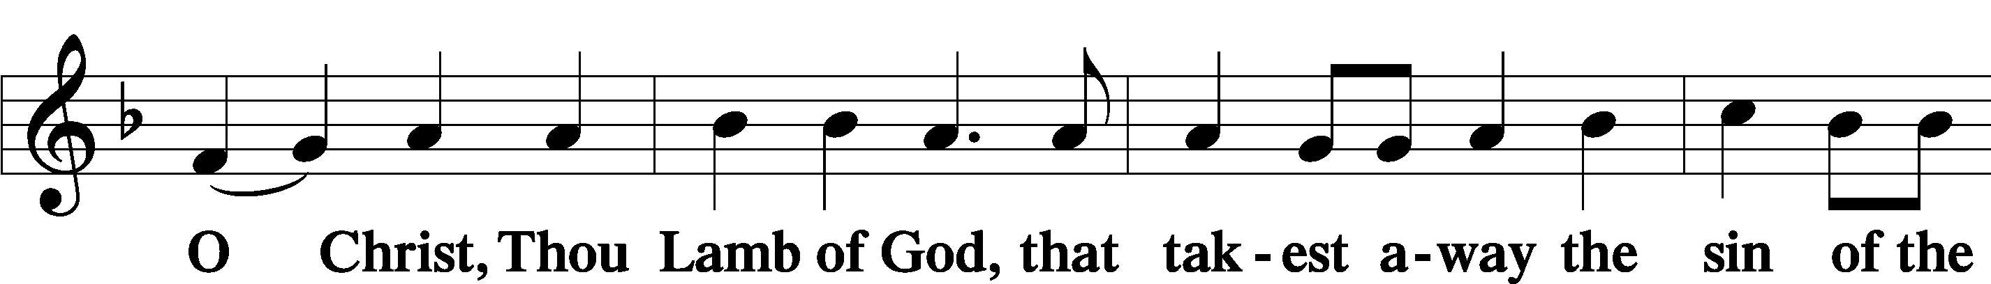
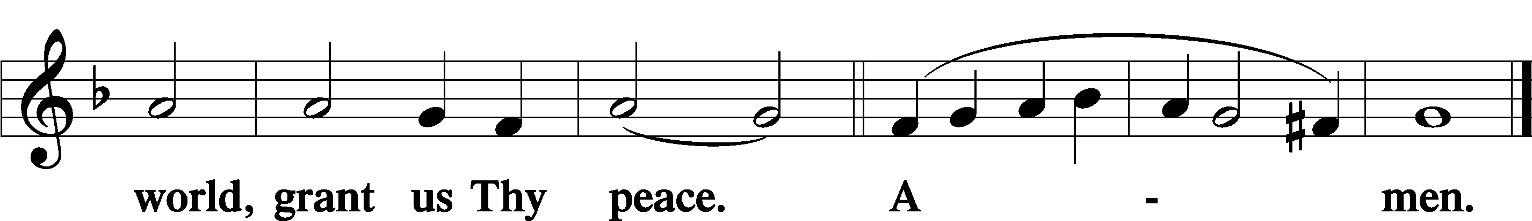

Sit

Distribution

The pastor and those who assist him receive the body and blood of Christ first and then distribute them to those who come to receive, saying:

Take, eat; this is the true body of our Lord and Savior Jesus Christ, given into death for your sins.
Amen.

Take, drink; this is the true blood of our Lord and Savior Jesus Christ, shed for the forgiveness of your sins.
Amen.

In dismissing the communicants, the following is said:

The Dismissal
P The body and blood of our Lord Jesus Christ strengthen and preserve you in body and soul to life everlasting. Depart T in peace.
C Amen.

Hymn
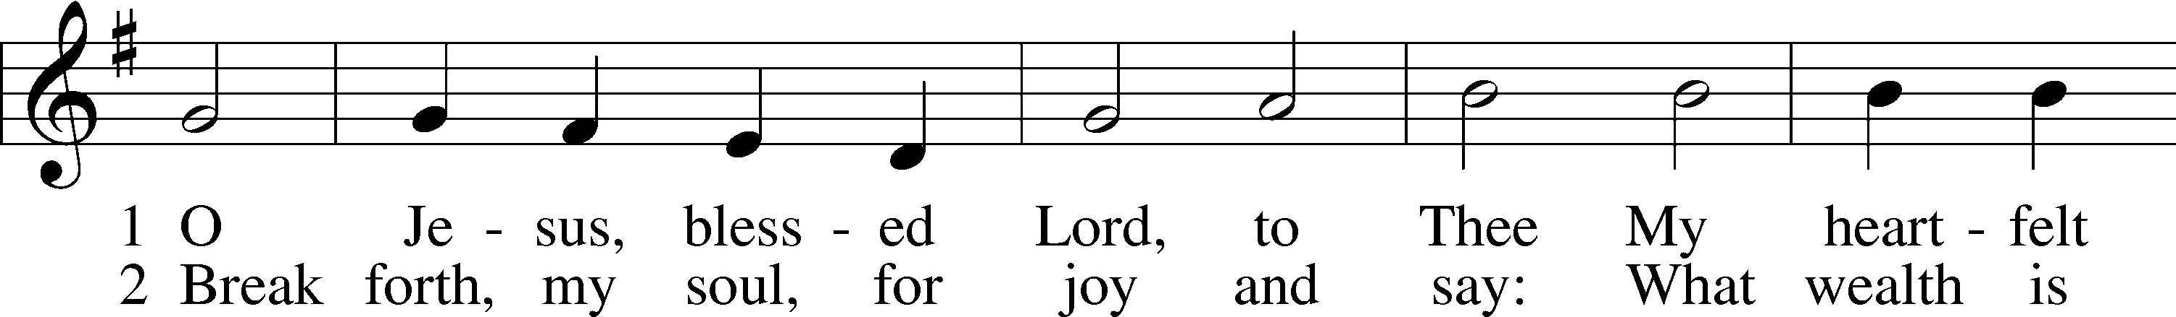
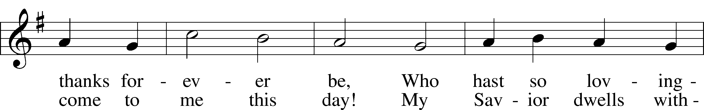
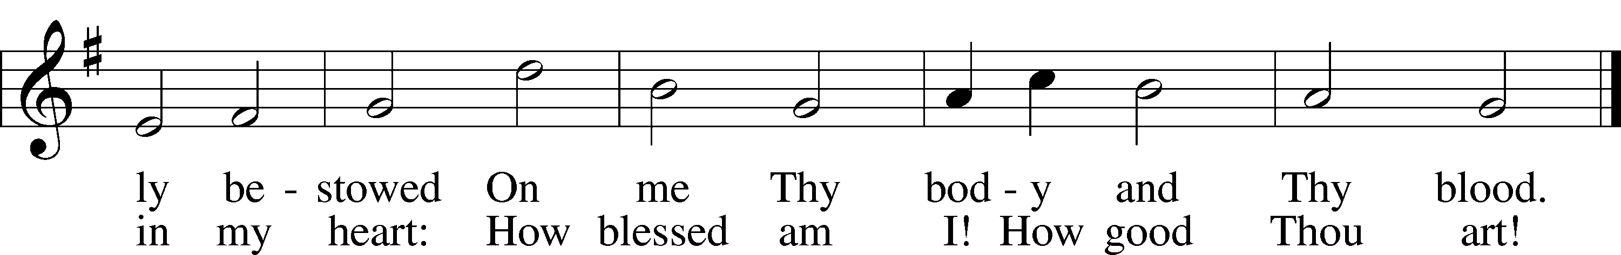
Text: Thomas Hansen Kingo, 1634–1703; tr. Arthur J. Mason, 1851–1928
Tune: Trente quatre Pseaumes de David, 1551, Geneva, ed. Louis Bourgeois
Text and tune: Public domain

754 Entrust Your Days and Burdens
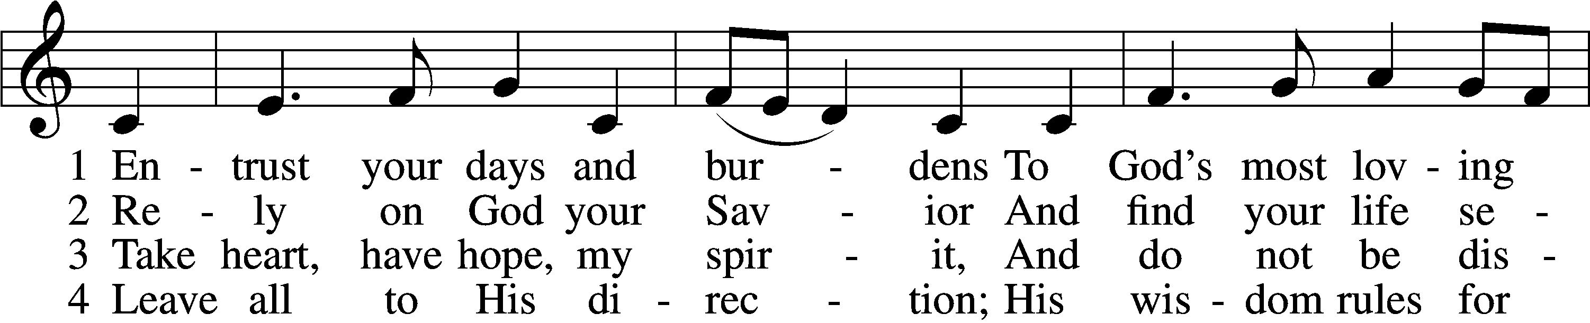
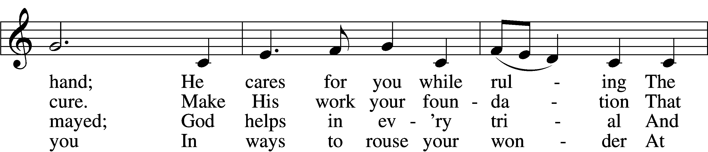
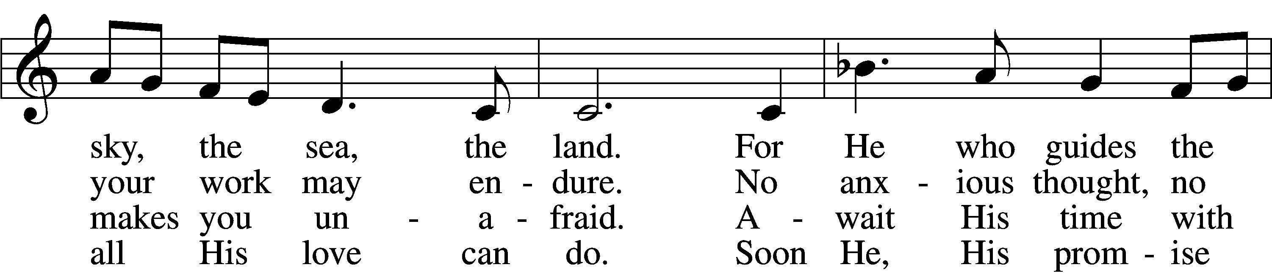
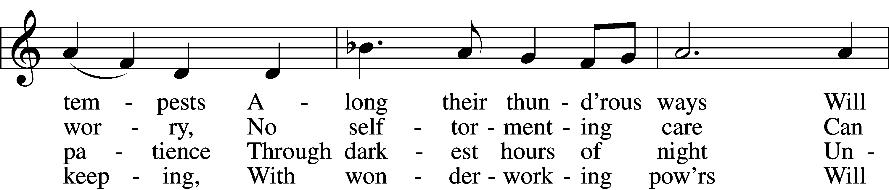
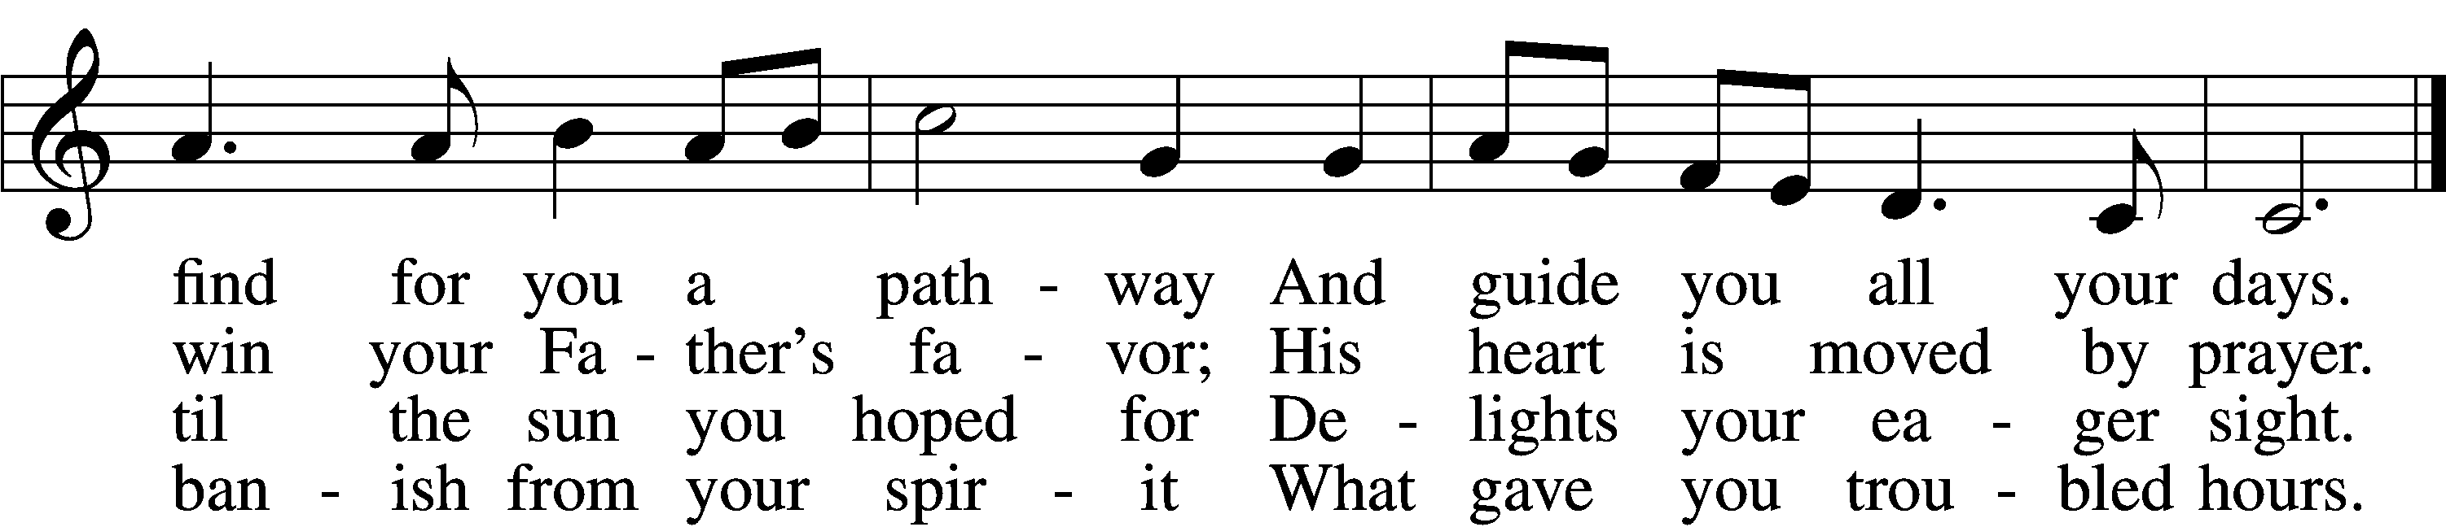

5 O blessèd heir of heaven,
You’ll hear the song resound
Of endless jubilation
When you with life are crowned.
In your right hand your maker
Will place the victor’s palm,
And you will thank Him gladly
With heaven’s joyful psalm.

6 Our hands and feet, Lord, strengthen;
With joy our spirits bless
Until we see the ending
Of all our life’s distress.
And so throughout our lifetime
Keep us within Your care
And at our end then bring us
To heav’n to praise You there.
Text: Paul Gerhardt, 1607–76; (sts. 1–5): tr. F. Samuel Janzow, 1913–2001, alt.; (st. 6): tr. Lutheran Service Book, 2006
Tune: Stephen R. Johnson, 1966
Text (sts. 1–5): © 1982 Concordia Publishing House; (st. 6): © 2006 Concordia Publishing House. Used by permission: LSB Hymn License no. 110005011
Tune: © 2002 Stephen R. Johnson. Used by permission: LSB Hymn License no. 110005011

474 Alleluia! Jesus Is Risen
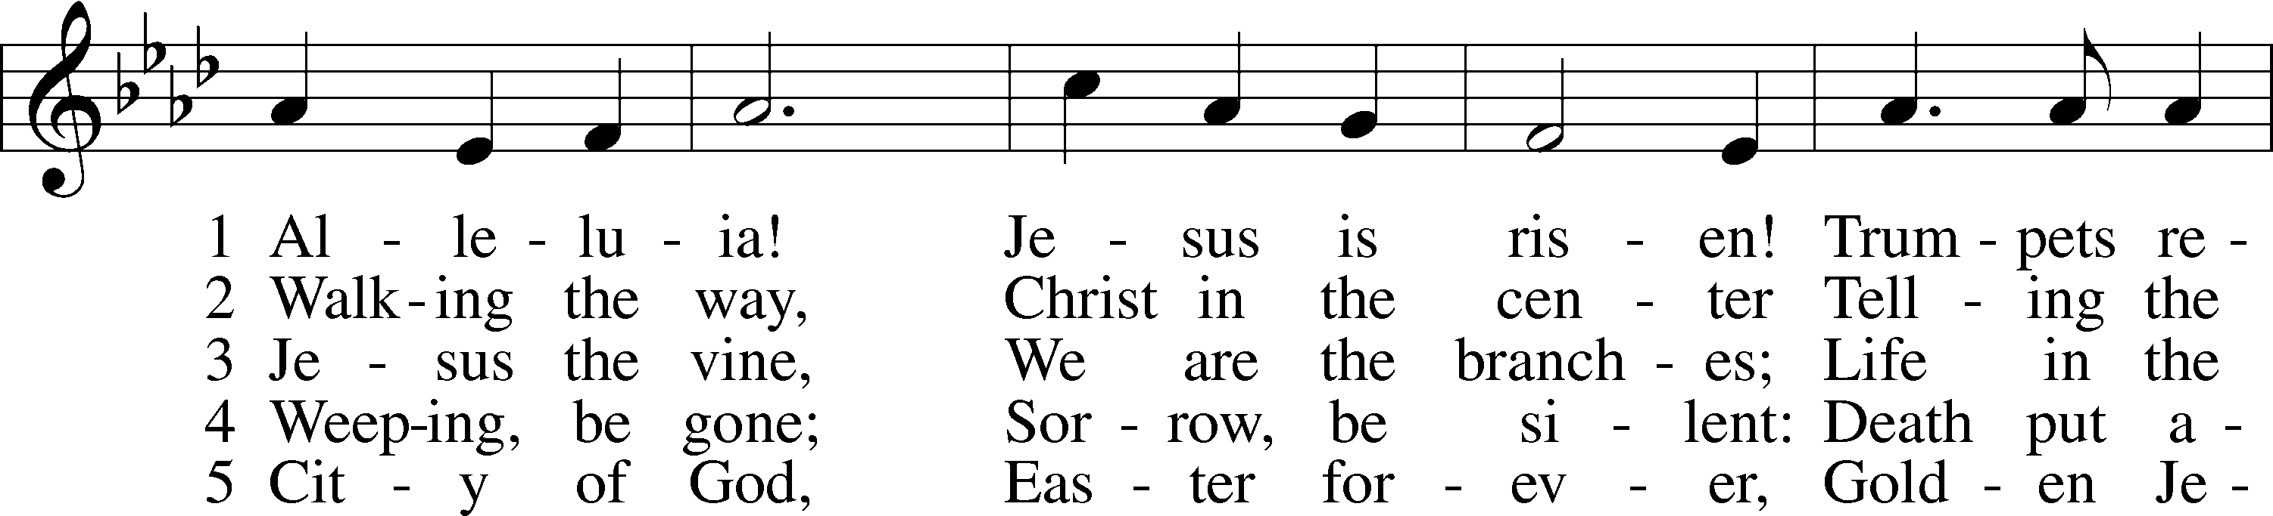
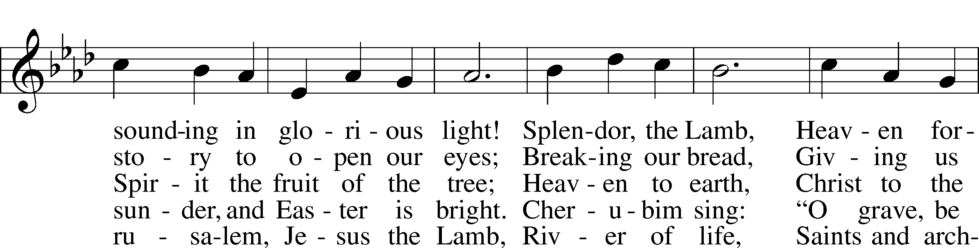
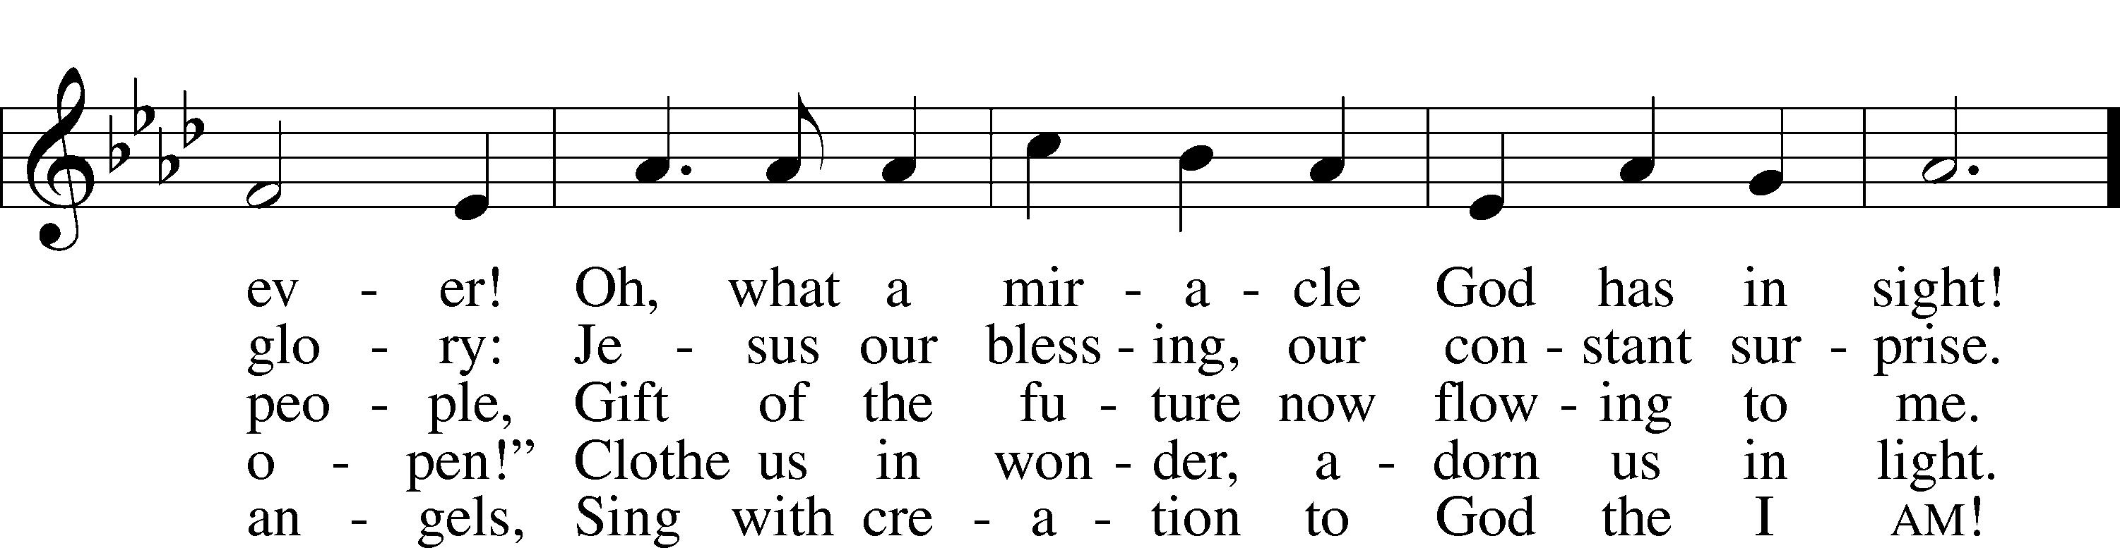
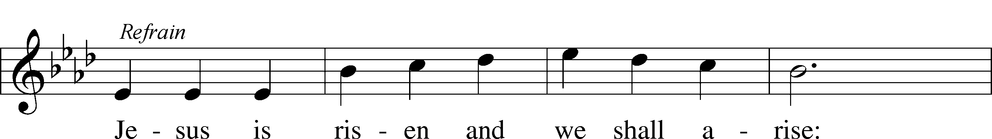
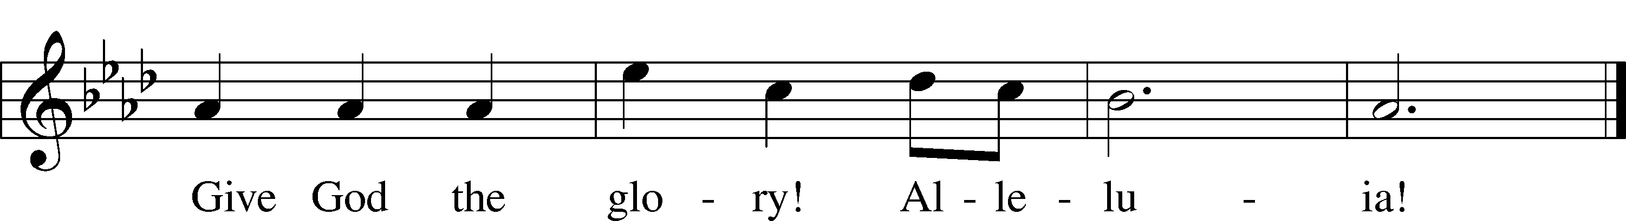
Text: Herbert F. Brokering, 1926–2009
Tune: David N. Johnson, 1922–87
Text: © 1995 Augsburg Fortress. Used by permission: LSB Hymn License no. 110005011
Tune: © 1968 Augsburg Publishing House. Used by permission: LSB Hymn License no. 110005011

623 Lord Jesus Christ, We Humbly Pray
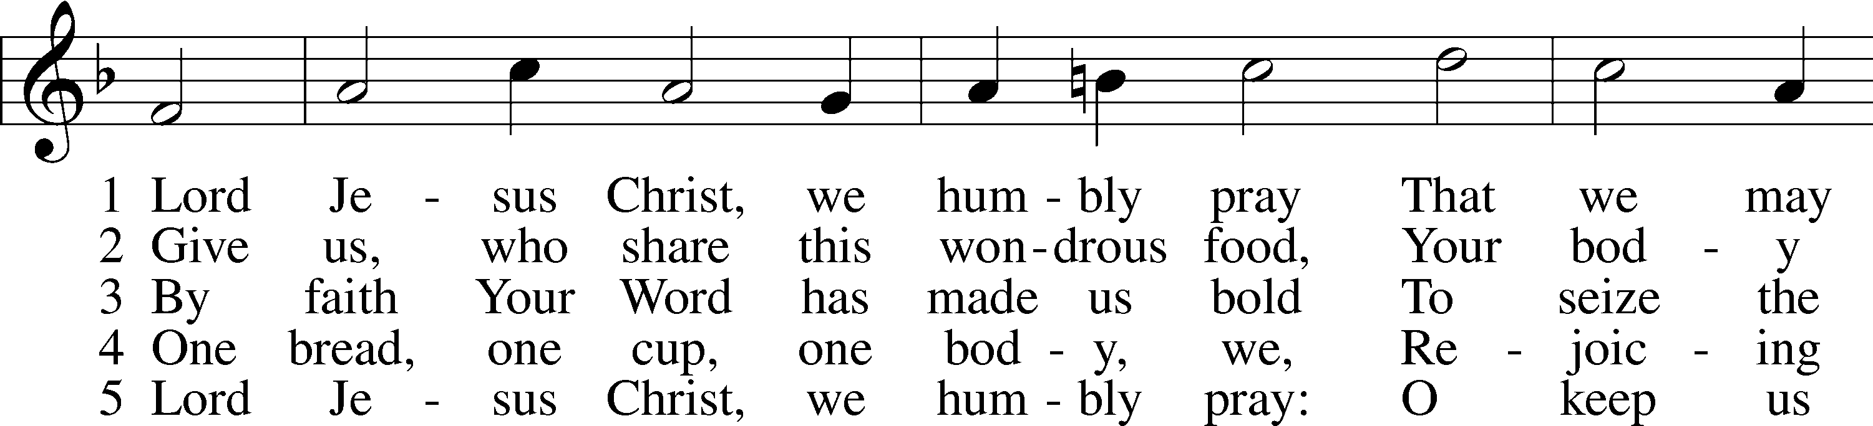
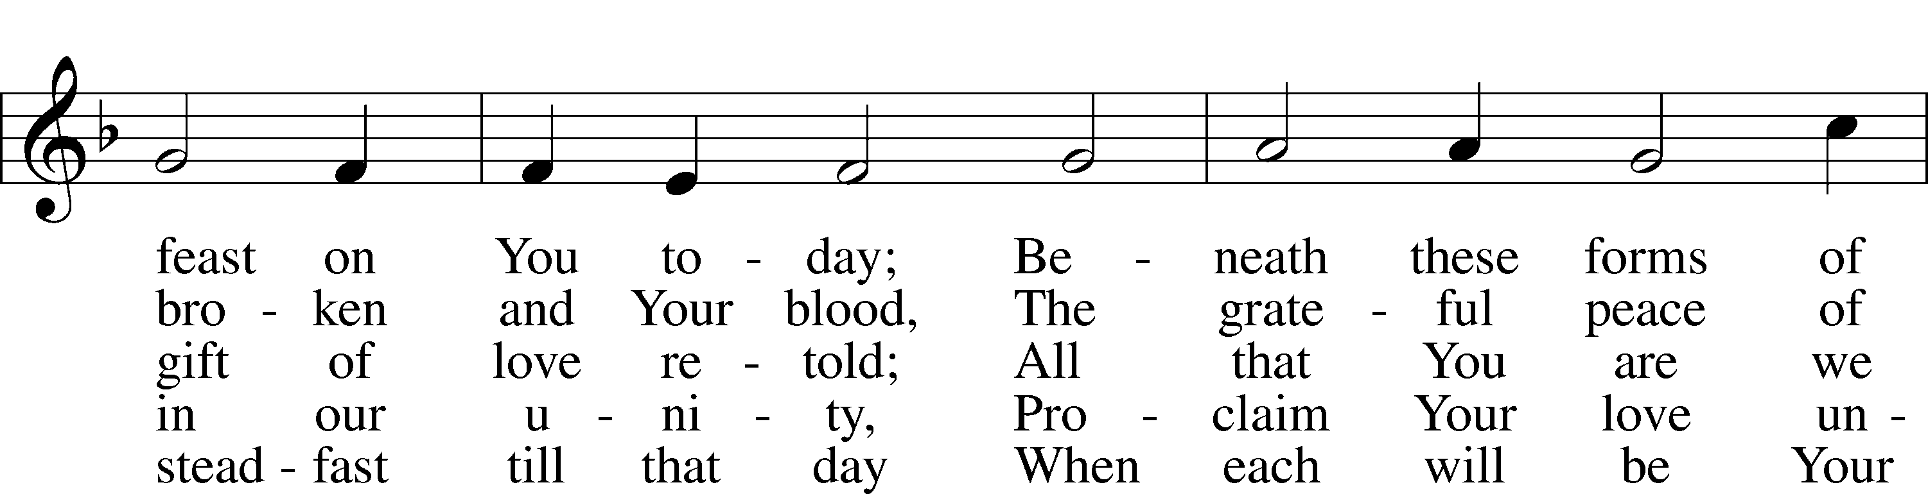
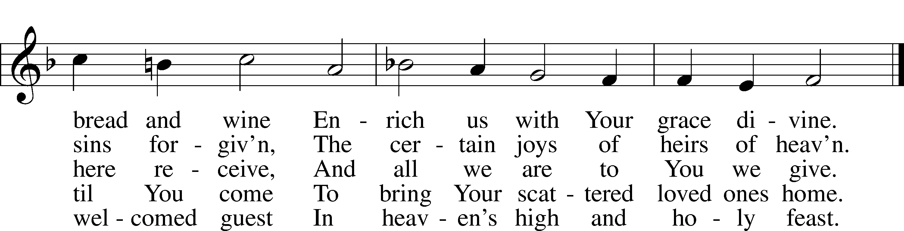
Text: Henry E. Jacobs, 1844–1932, alt.
Tune: Cantionale Germanicum, 1628, Gochsheim
Text and tune: Public domain

Stand

Nunc Dimittis Luke 2:29–32
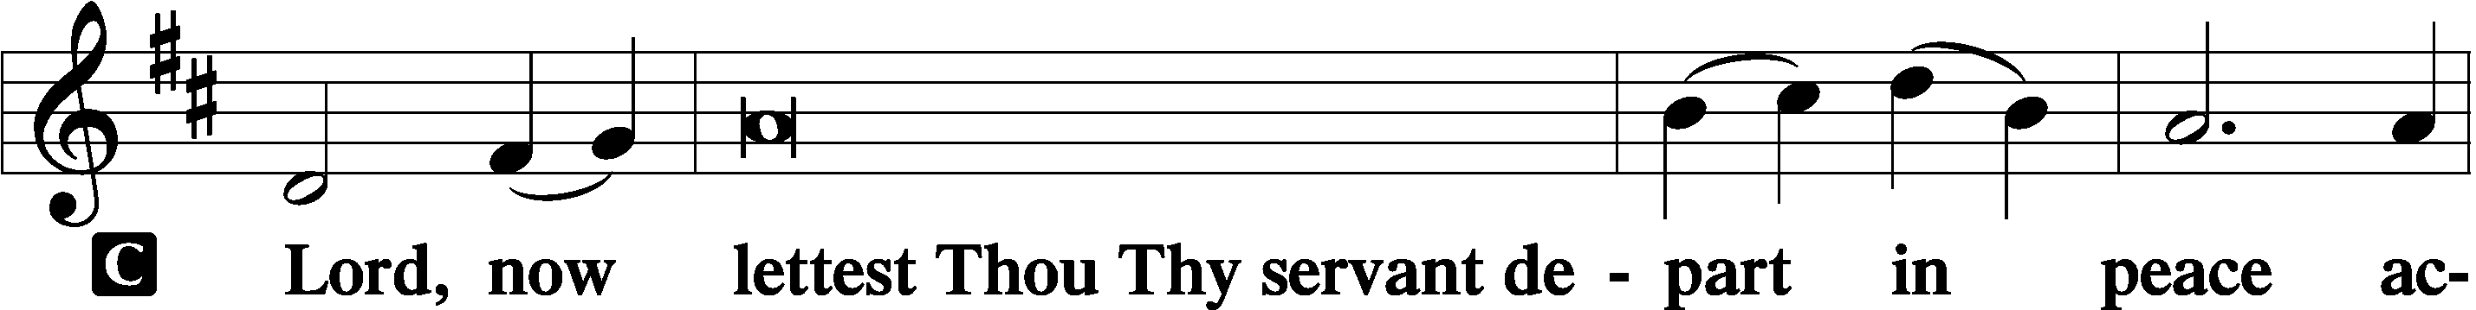

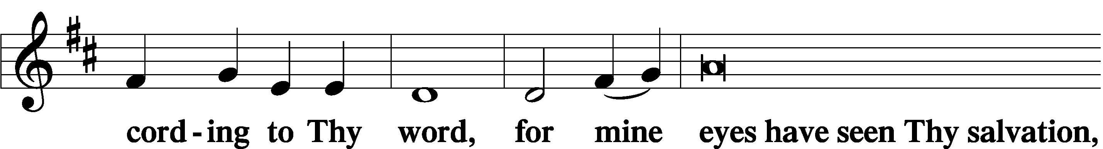

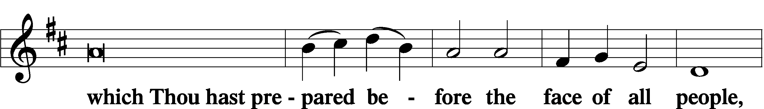

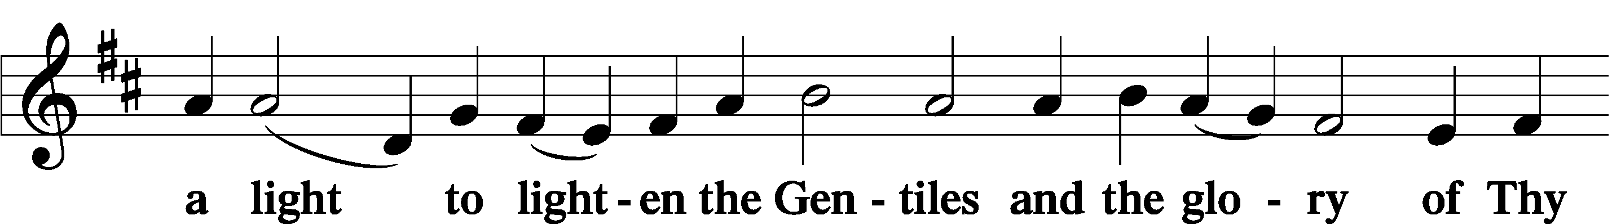

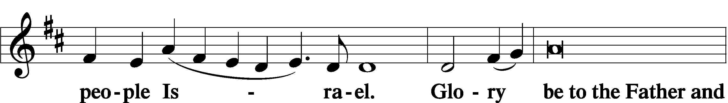

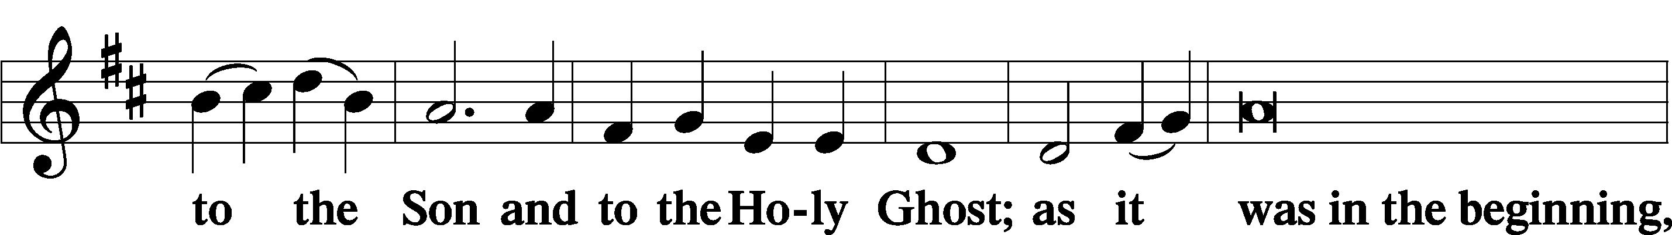

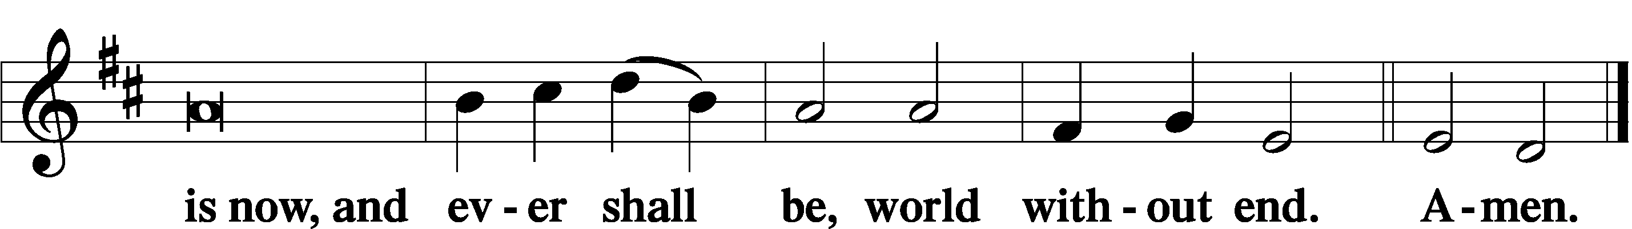

Thanksgiving Psalm 107:1
A O give thanks unto the Lord, for He is good,

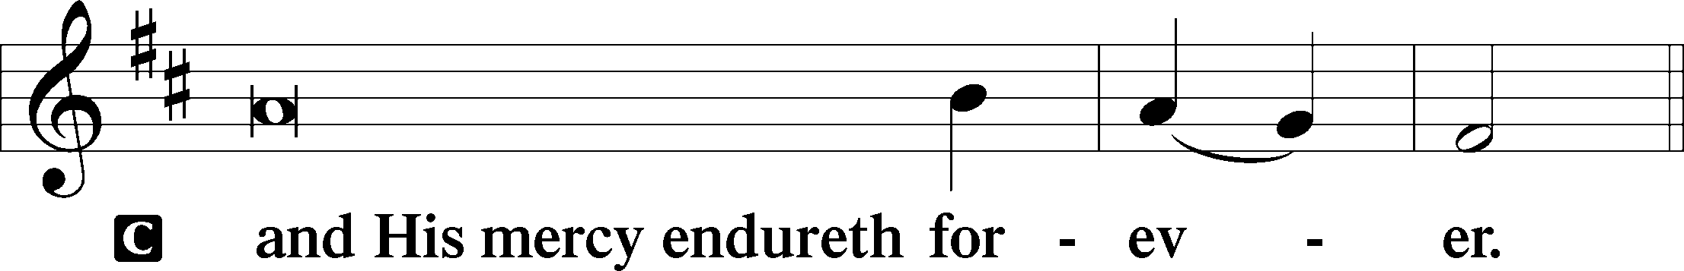

Post-Communion Collect
A Let us pray.
We give thanks to You, almighty God, that You have refreshed us through this salutary gift, and we implore You that of Your mercy You would strengthen us through the same in faith toward You and in fervent love toward one another; through Jesus Christ, Your Son, our Lord, who lives and reigns with You and the Holy Spirit, one God, now and forever.

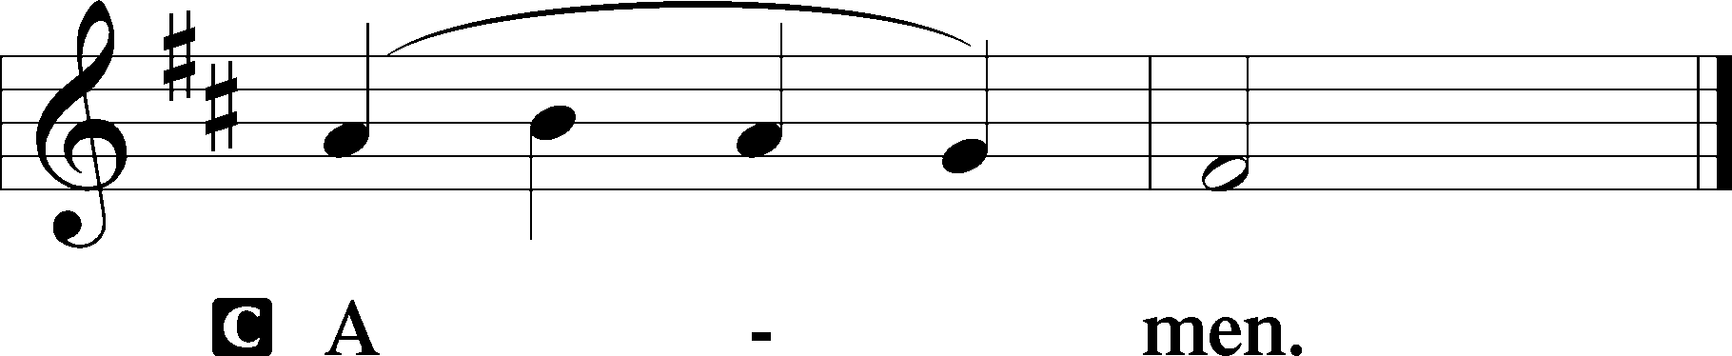

Salutation 2 Timothy 4:22
P The Lord be with you.

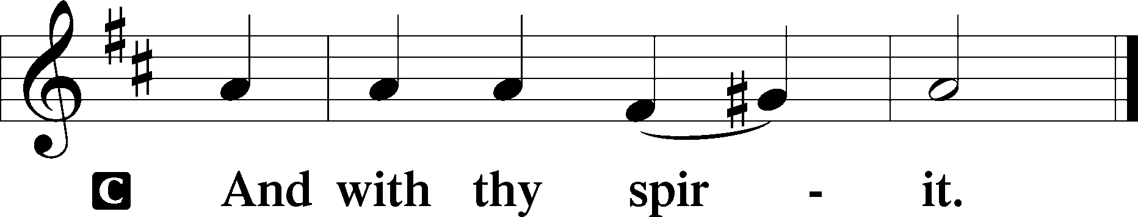

Benedicamus Psalm 103:1
A Bless we the Lord.

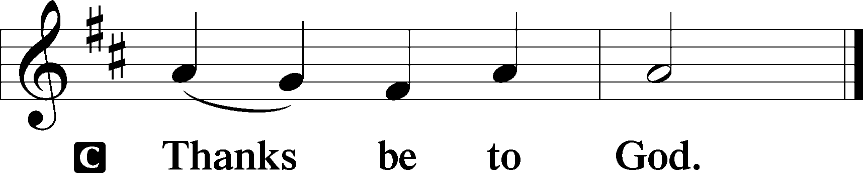

Benediction Numbers 6:24–26
P The Lord bless you and keep you.
The Lord make His face shine upon you and be gracious unto you.
The Lord lift up His countenance upon you and T give you peace.
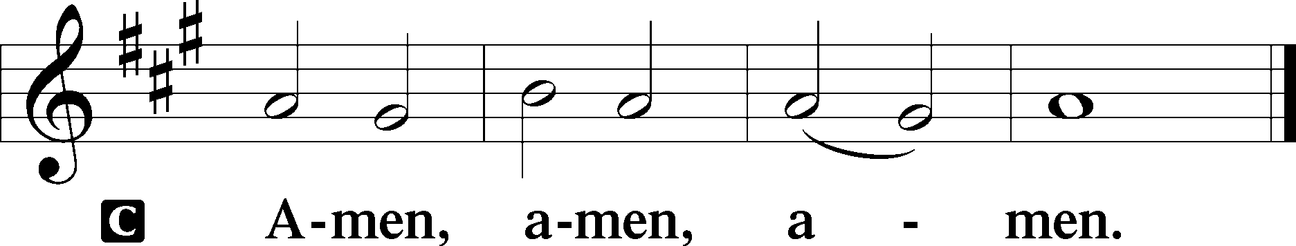

492 On Christ’s Ascension I Now Build
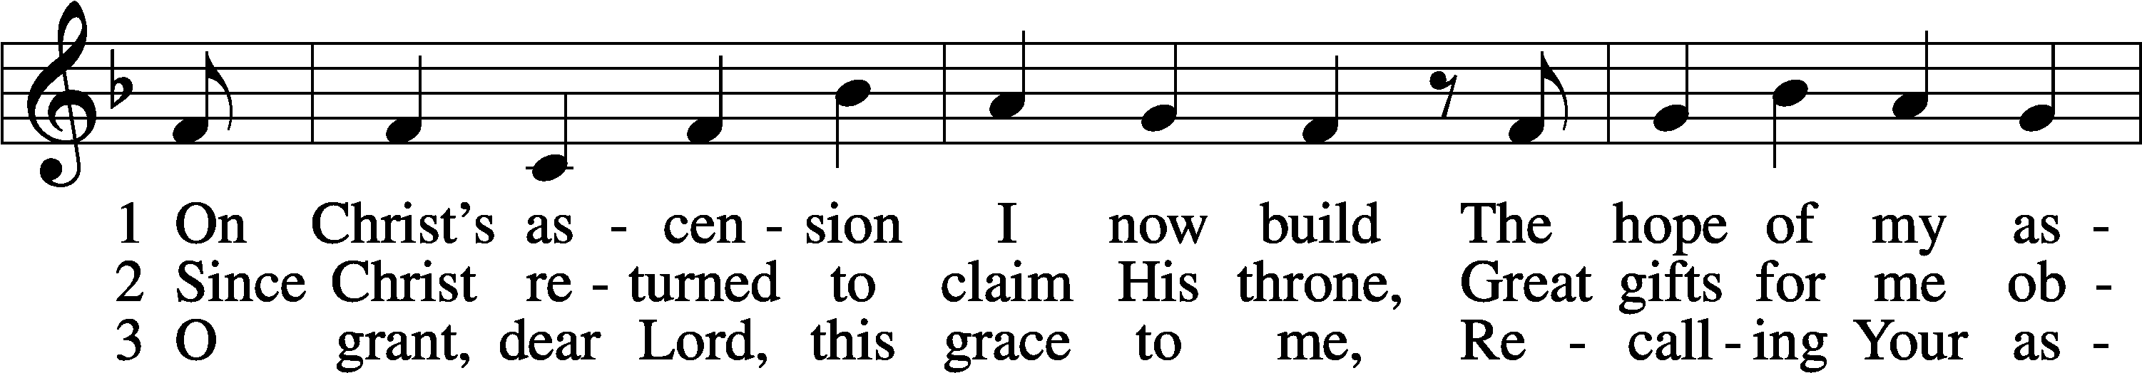
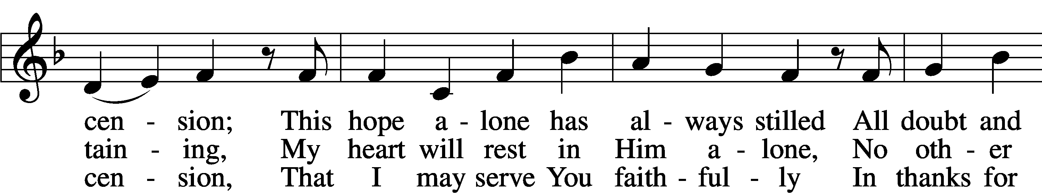
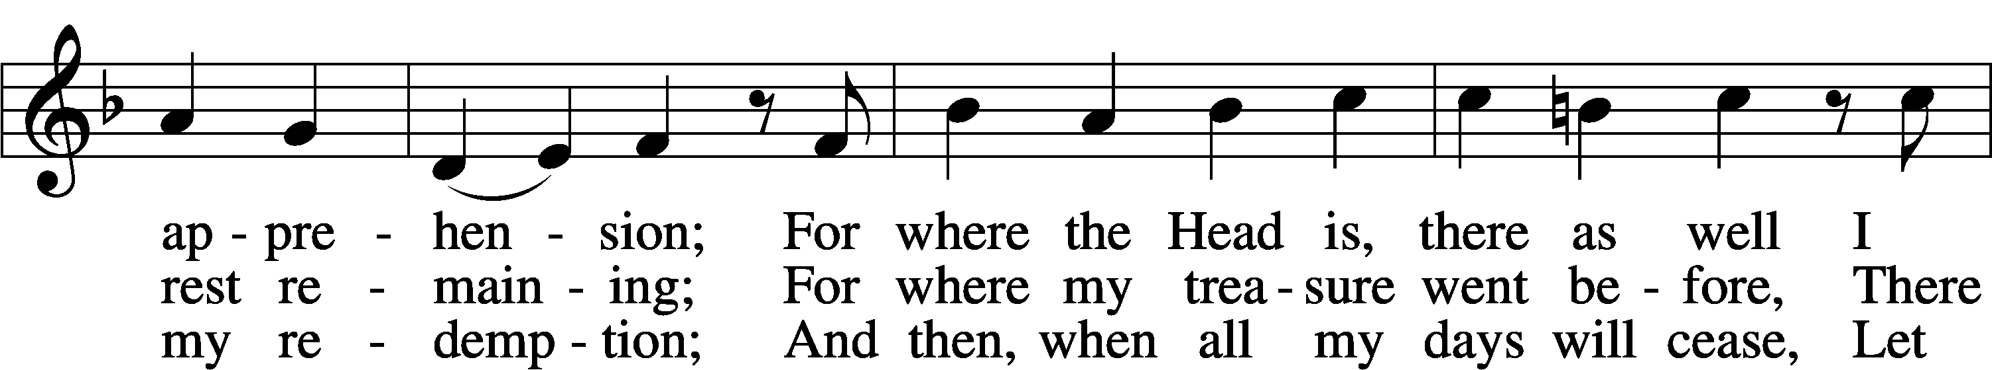
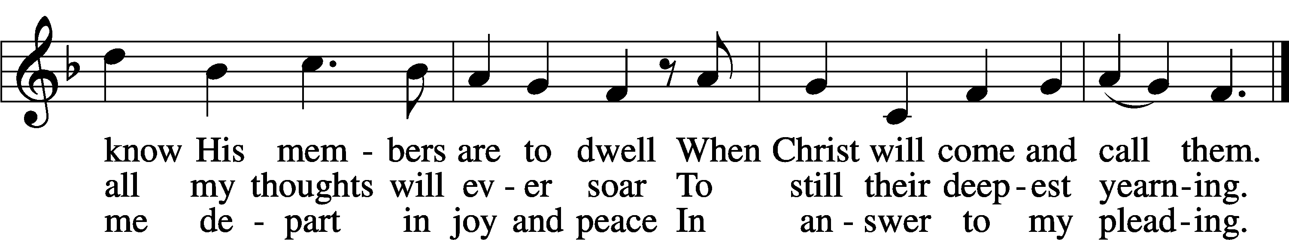
Text: Josua Wegelin, 1604–40; tr. William M. Czamanske, 1873–1964, alt.
Tune: Etlich Cristlich lider, 1524, Wittenberg
Text: © 1941 Concordia Publishing House. Used by permission: LSB Hymn License no. 110005011
Tune: Public domain

Acknowledgments
Divine Service, Setting Three from Lutheran Service Book
Unless otherwise indicated, Scripture quotations are from the ESV® Bible (The Holy Bible, English Standard Version®), copyright © 2001 by Crossway, a publishing ministry of Good News Publishers. Used by permission. All rights reserved.
Created by Lutheran Service Builder © 2026 Concordia Publishing House.

