On entering the church

P Lord, I love the habitation of Your house and the place

where Your glory dwells. In the multitude of Your tender

mercies prepare my heart that I may enter Your house to

worship and confess Your holy name; through Jesus Christ,

my God and Lord.

Before worship

C O Lord, our creator, redeemer, and comforter, as we come

together to worship You in spirit and in truth, we humbly

pray that You would open our hearts to the preaching of

Your Word so that we may repent of our sins, believe in

Jesus Christ as our only Savior, and grow in grace and

holiness. Hear us for His sake.

594 God’s Own Child, I Gladly Say It

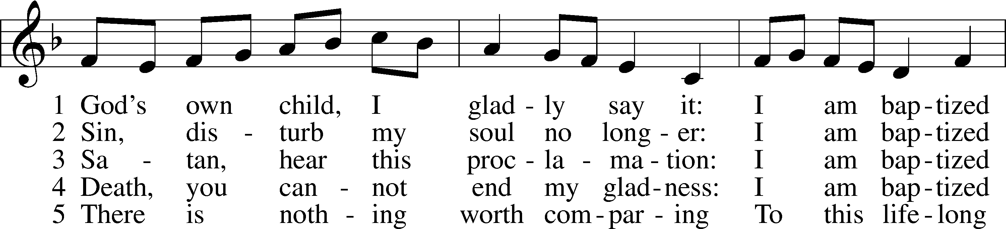

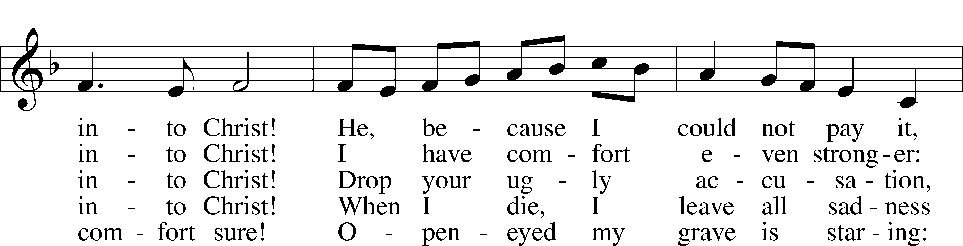

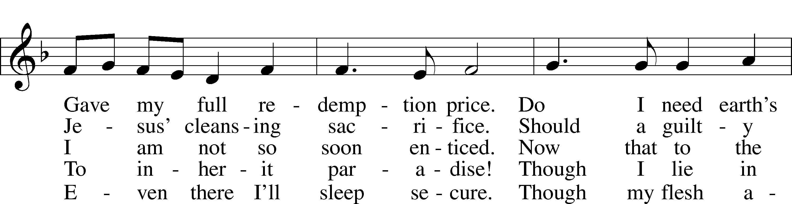

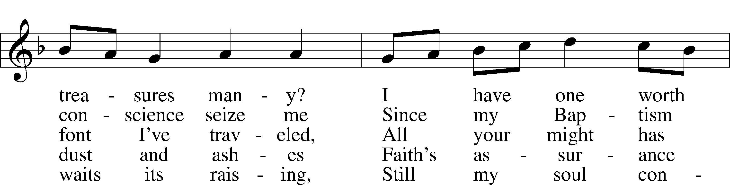

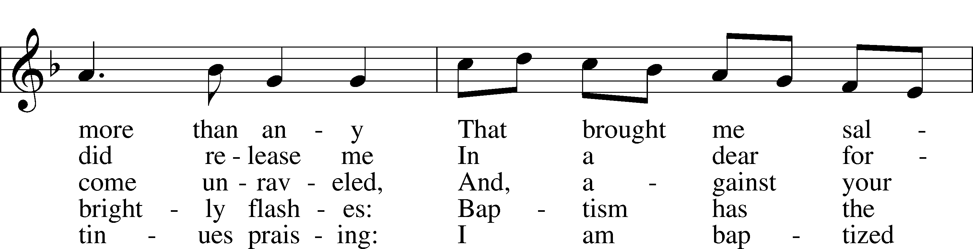

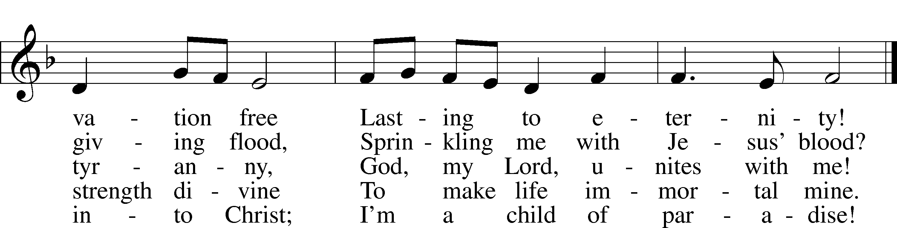

Text: Erdmann Neumeister, 1671–1756; tr. Robert E. Voelker, 1957  
Tune: Johann Caspar Bachofen, 1695–1755, alt.  
Text: © 1991 Robert E. Voelker. Used by permission: LSB Hymn License no. 110005011  
Tune: Public domain

# Confession and Absolution

The sign of the cross may be made by all in remembrance of their Baptism.

Invocation Matthew 28:19b; 18:20

P In the name of the Father and of the T Son and of the Holy Spirit.

C **Amen.**

Exhortation Hebrews 10:22; Psalm 124:8; Psalm 32:5

P Beloved in the Lord! Let us draw near with a true heart and confess our sins unto God our Father, beseeching Him in the name of our Lord Jesus Christ to grant us forgiveness.

P Our help is in the name of the Lord,

C **who made heaven and earth.**

P I said, I will confess my transgressions unto the Lord,

C **and You forgave the iniquity of my sin.**

Silence for reflection on God’s Word and for self-examination.

Confession of Sins

P O almighty God, merciful Father,

C **I, a poor, miserable sinner, confess unto You all my sins and iniquities with which I have ever offended You and justly deserved Your temporal and eternal punishment. But I am heartily sorry for them and sincerely repent of them, and I pray You of Your boundless mercy and for the sake of the holy, innocent, bitter sufferings and death of Your beloved Son, Jesus Christ, to be gracious and merciful to me, a poor, sinful being.**

Absolution [John 20:19–23]

P Upon this your confession, I, by virtue of my office, as a called and ordained servant of the Word, announce the grace of God unto all of you, and in the stead and by the command of my Lord Jesus Christ I forgive you all your sins in the name of the Father and of the T Son and of the Holy Spirit.

C **Amen.**

# Service of the Word

Introit Psalm 71:20–24; antiphon: v. 3

Be to me a rock of refuge, to which I may continually come;  
 you have given the command to save me, for you are my rock and my fortress.  
**You who have made me see many troubles and calamities will revive me again;  
 from the depths of the earth you will bring me up again.**  
You will increase my greatness  
 and comfort me again.  
**I will also praise you with the harp for your faithfulness, O my God;  
 I will sing praises to you with the lyre, O Holy One of Israel.**My lips will shout for joy, when I sing praises to you;  
 my soul also, which you have redeemed.  
**And my tongue will talk of your righteous help all the day long,  
 for they have been put to shame and disappointed who sought to do me hurt.**

Gloria Patri

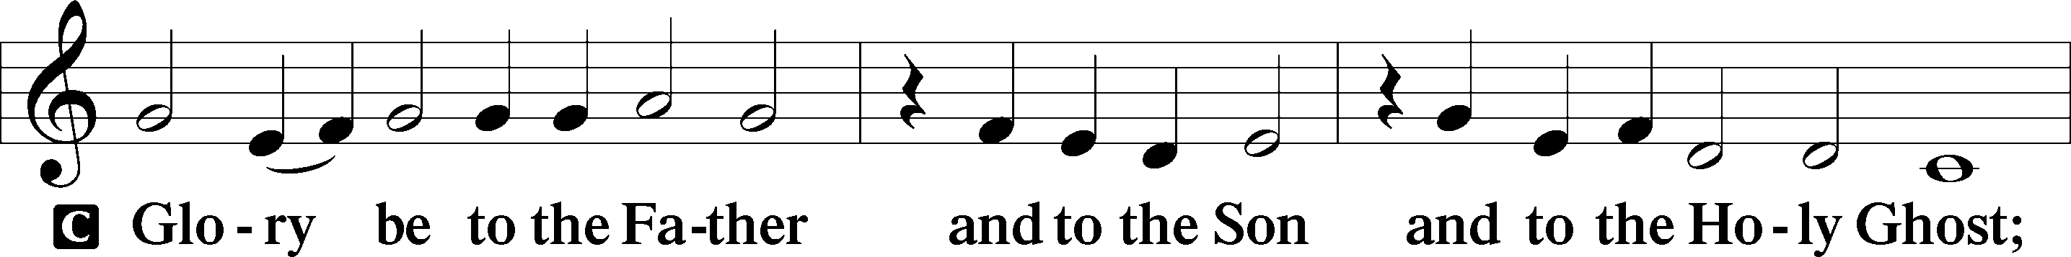

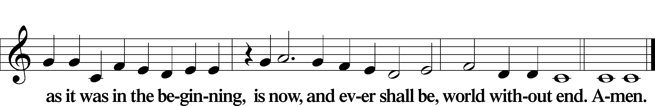

Kyrie Mark 10:47

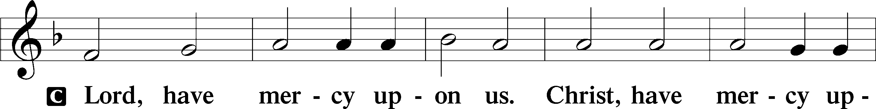

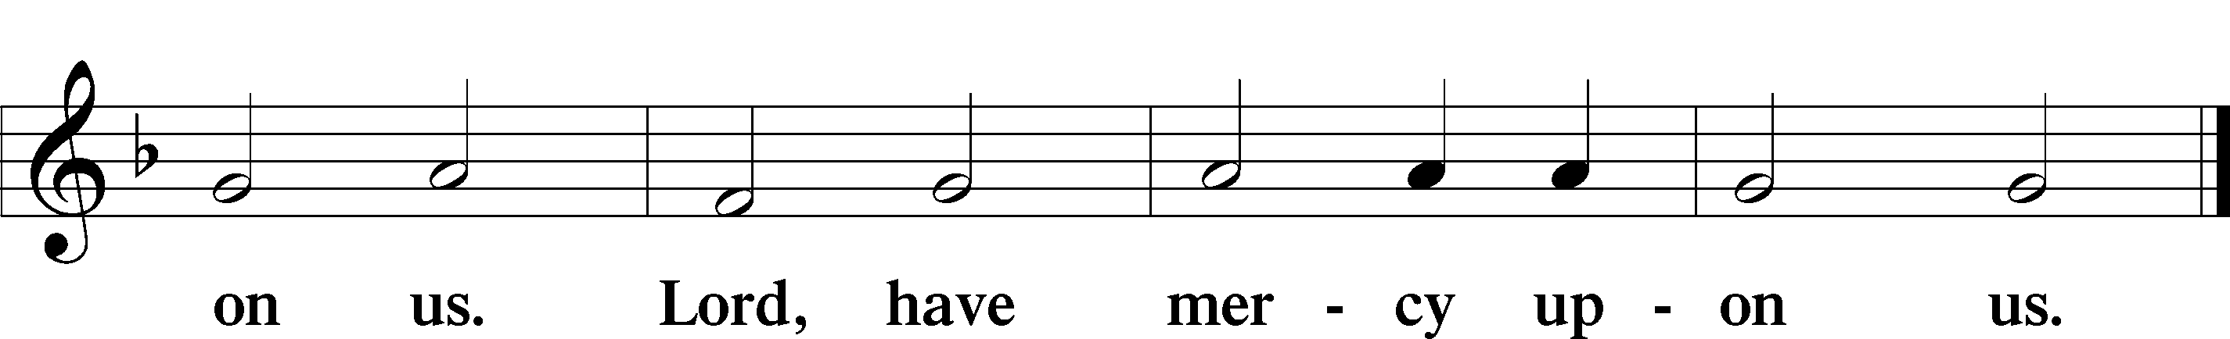

Gloria in Excelsis Luke 2:14; John 1:29

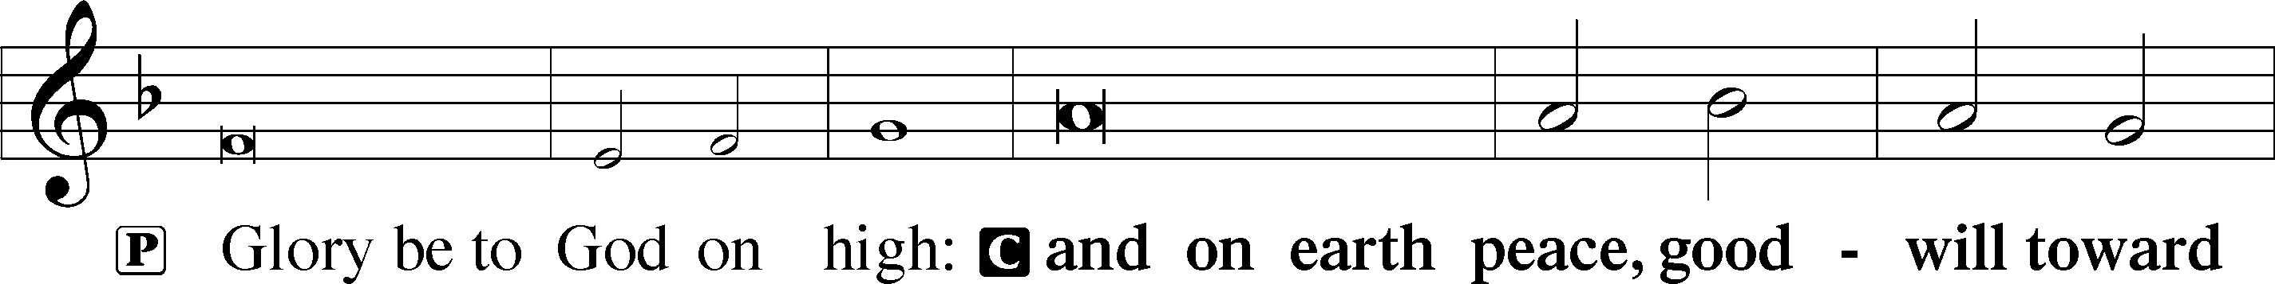

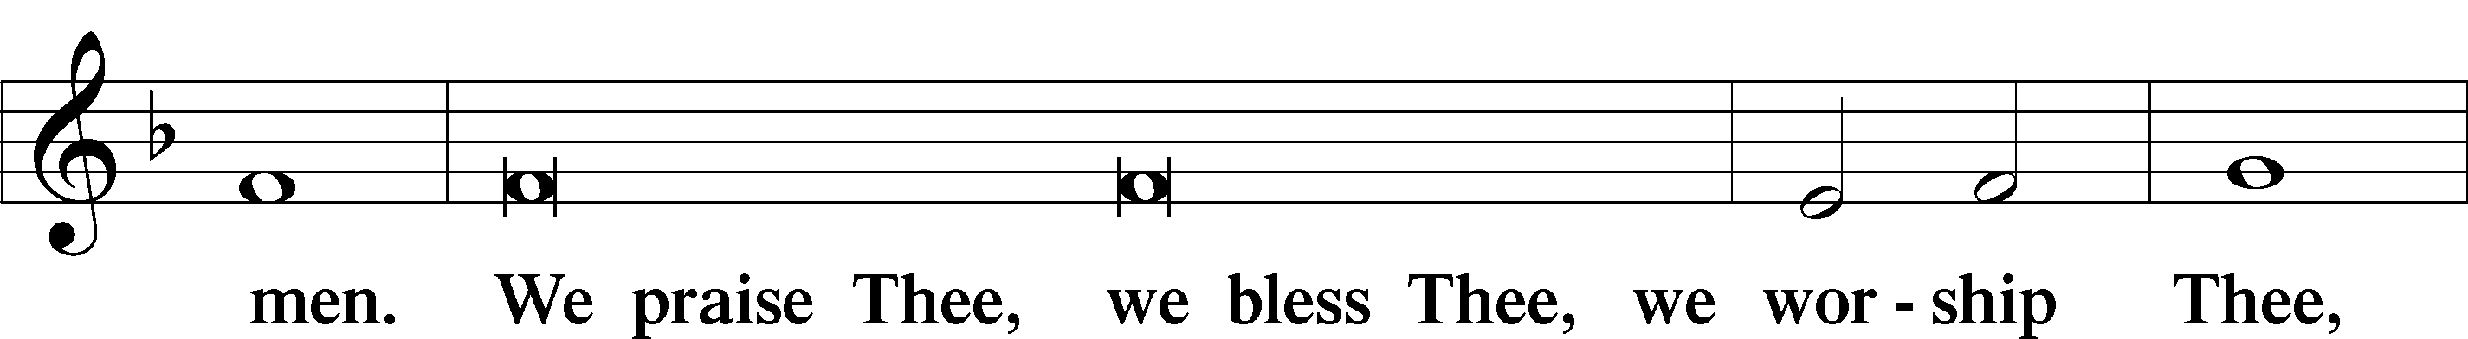

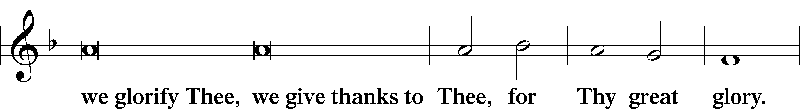

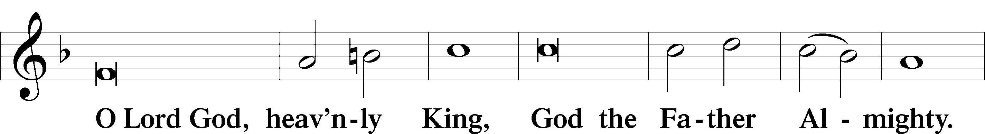

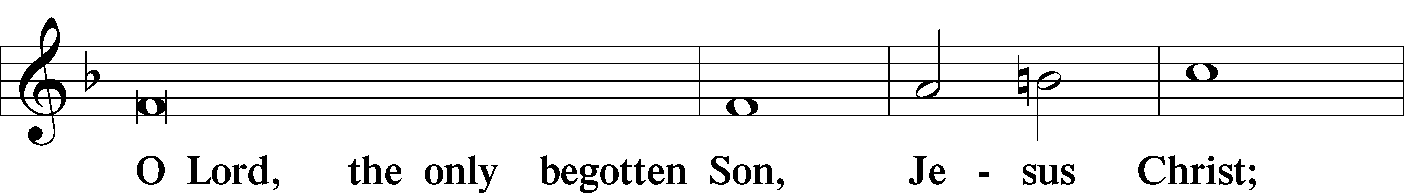

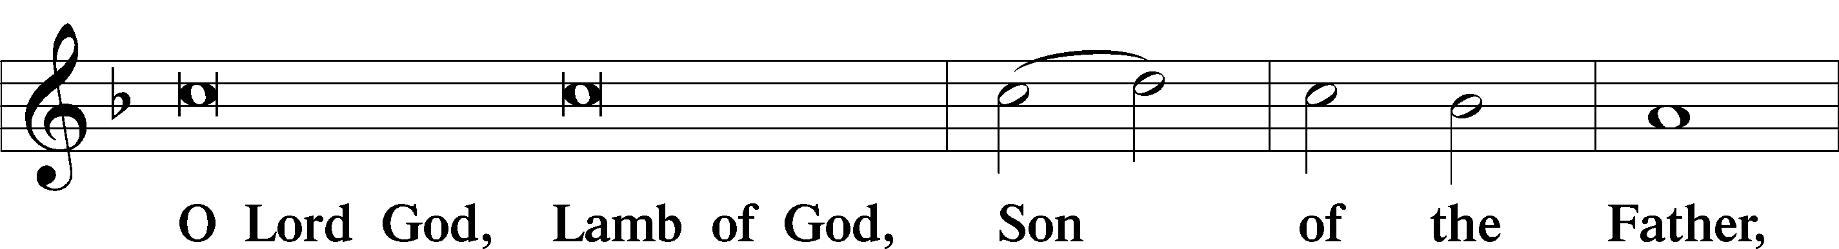

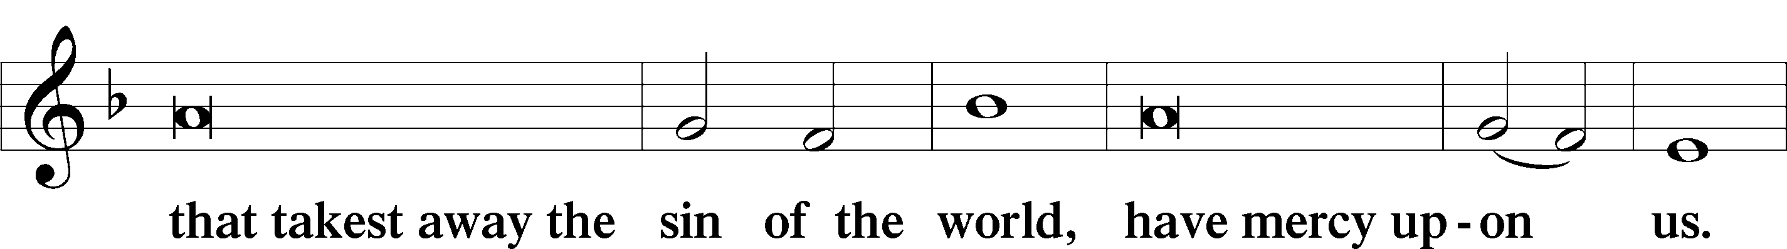

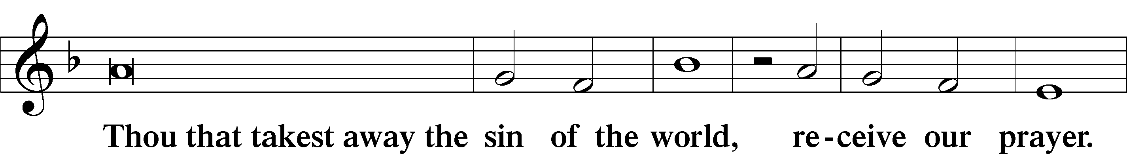

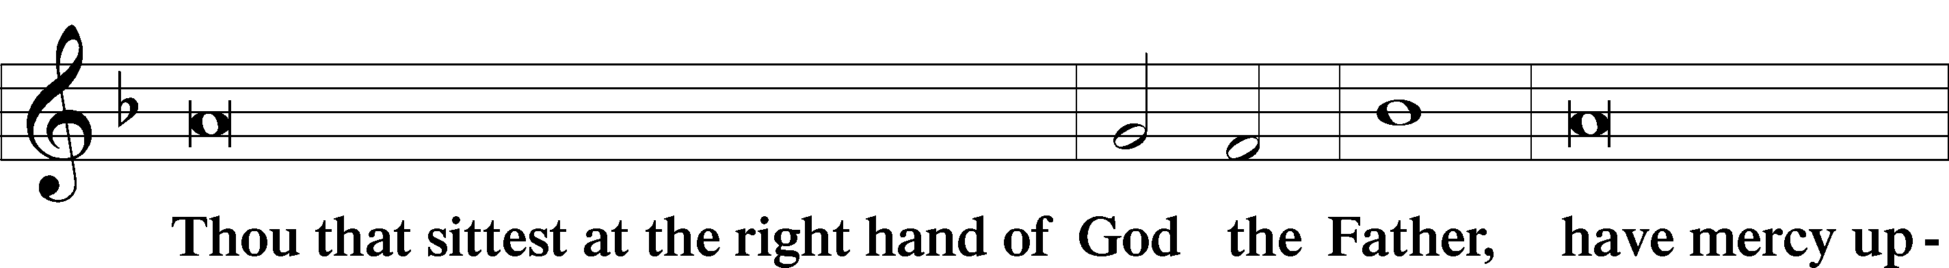

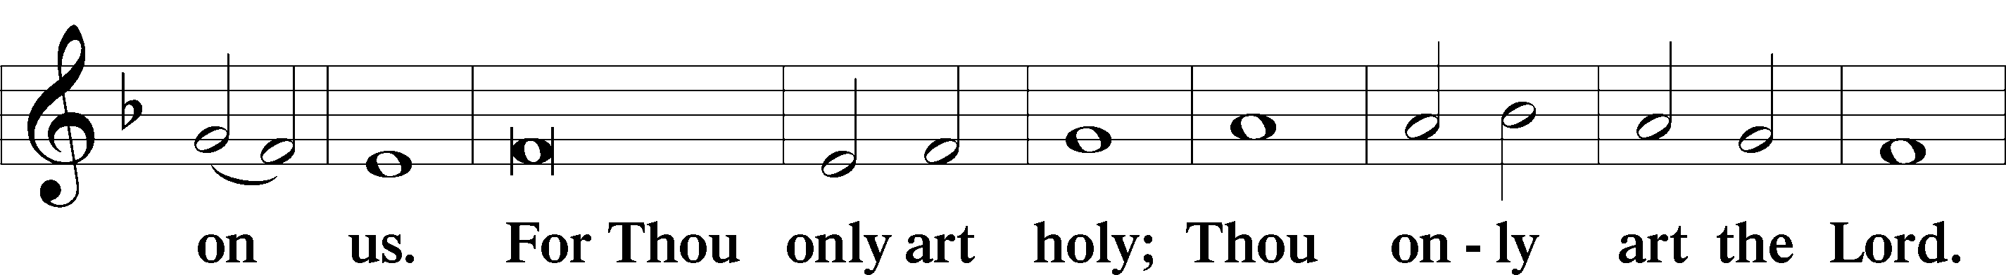

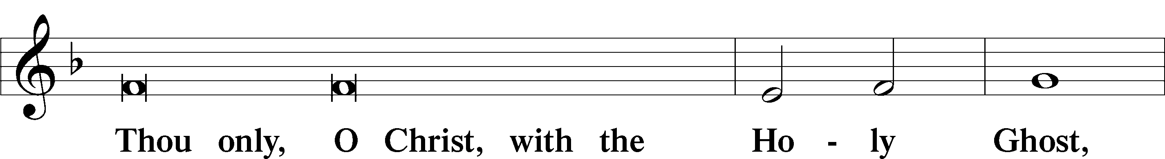

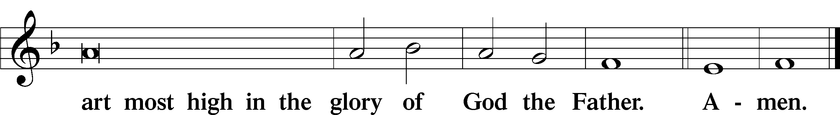

Salutation and Collect of the Day

P The Lord be with you.

C **And with thy spirit.**

P Let us pray.

O God, You have prepared for those who love You such good things as surpass our understanding. Cast out all sins and evil desires from us, and pour into our hearts Your Holy Spirit to guide us into all blessedness; through Jesus Christ, Your Son, our Lord, who lives and reigns with You and the Holy Spirit, one God, now and forever.

C **Amen.**

Sit

Old Testament Reading Isaiah 65:1–9

1I was ready to be sought by those who did not ask for me;  
 I was ready to be found by those who did not seek me.  
I said, “Here am I, here am I,”  
 to a nation that was not called by my name.  
2I spread out my hands all the day  
 to a rebellious people,  
who walk in a way that is not good,  
 following their own devices;  
3a people who provoke me  
 to my face continually,  
sacrificing in gardens  
 and making offerings on bricks;  
4who sit in tombs,  
 and spend the night in secret places;  
who eat pig’s flesh,  
 and broth of tainted meat is in their vessels;  
5who say, “Keep to yourself,  
 do not come near me, for I am too holy for you.”  
These are a smoke in my nostrils,  
 a fire that burns all the day.  
6Behold, it is written before me:  
 “I will not keep silent, but I will repay;  
I will indeed repay into their bosom  
 7both your iniquities and your fathers’ iniquities together,  
says the Lord;  
because they made offerings on the mountains  
 and insulted me on the hills,  
I will measure into their bosom  
 payment for their former deeds.”

8Thus says the Lord:  
“As the new wine is found in the cluster,  
 and they say, ‘Do not destroy it,  
 for there is a blessing in it,’  
so I will do for my servants’ sake,  
 and not destroy them all.  
9I will bring forth offspring from Jacob,  
 and from Judah possessors of my mountains;  
my chosen shall possess it,  
 and my servants shall dwell there.”

A This is the Word of the Lord.

C **Thanks be to God.**

Gradual Romans 10:8b, 10

The word is near you, in your mouth and in your heart,  
 the word of faith that we proclaim.  
**For with the heart one believes and is justified,  
 and with the mouth one confesses and is saved.**

Epistle Galatians 3:23—4:7

23Now before faith came, we were held captive under the law, imprisoned until the coming faith would be revealed. 24So then, the law was our guardian until Christ came, in order that we might be justified by faith. 25But now that faith has come, we are no longer under a guardian, 26for in Christ Jesus you are all sons of God, through faith. 27For as many of you as were baptized into Christ have put on Christ. 28There is neither Jew nor Greek, there is neither slave nor free, there is neither male nor female, for you are all one in Christ Jesus. 29And if you are Christ’s, then you are Abraham’s offspring, heirs according to promise.

1I mean that the heir, as long as he is a child, is no different from a slave, though he is the owner of everything, 2but he is under guardians and managers until the date set by his father. 3In the same way we also, when we were children, were enslaved to the elementary principles of the world. 4But when the fullness of time had come, God sent forth his Son, born of woman, born under the law, 5to redeem those who were under the law, so that we might receive adoption as sons. 6And because you are sons, God has sent the Spirit of his Son into our hearts, crying, “Abba! Father!” 7So you are no longer a slave, but a son, and if a son, then an heir through God.

Stand

Alleluia

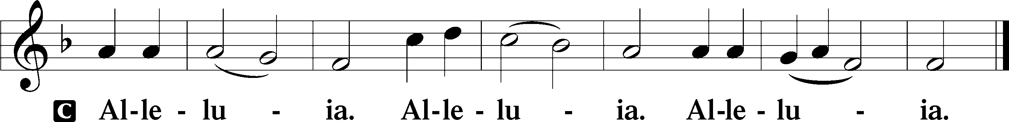

Holy Gospel Luke 8:26–39

P The Holy Gospel according to St. Luke, the eighth chapter.

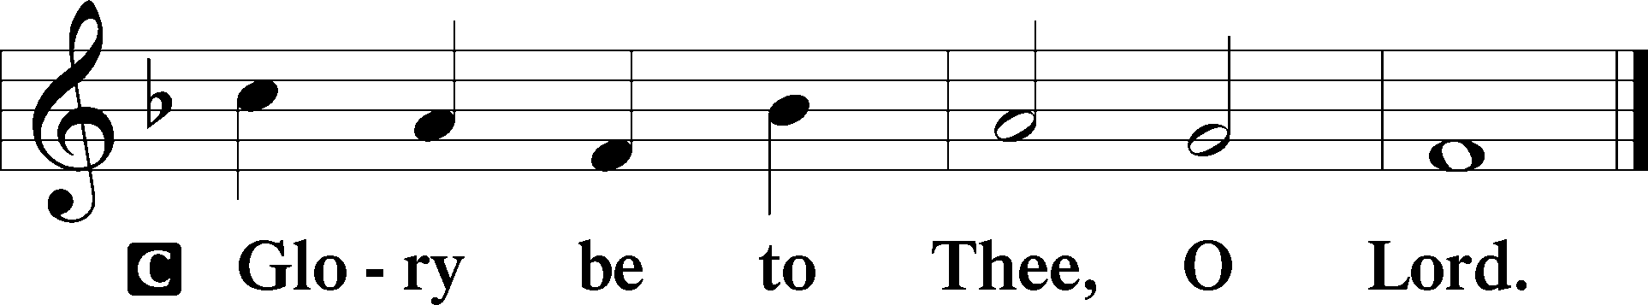

26Then they sailed to the country of the Gerasenes, which is opposite Galilee. 27When Jesus had stepped out on land, there met him a man from the city who had demons. For a long time he had worn no clothes, and he had not lived in a house but among the tombs. 28When he saw Jesus, he cried out and fell down before him and said with a loud voice, “What have you to do with me, Jesus, Son of the Most High God? I beg you, do not torment me.” 29For he had commanded the unclean spirit to come out of the man. (For many a time it had seized him. He was kept under guard and bound with chains and shackles, but he would break the bonds and be driven by the demon into the desert.) 30Jesus then asked him, “What is your name?” And he said, “Legion,” for many demons had entered him. 31And they begged him not to command them to depart into the abyss. 32Now a large herd of pigs was feeding there on the hillside, and they begged him to let them enter these. So he gave them permission. 33Then the demons came out of the man and entered the pigs, and the herd rushed down the steep bank into the lake and were drowned.

34When the herdsmen saw what had happened, they fled and told it in the city and in the country. 35Then people went out to see what had happened, and they came to Jesus and found the man from whom the demons had gone, sitting at the feet of Jesus, clothed and in his right mind, and they were afraid. 36And those who had seen it told them how the demon-possessed man had been healed. 37Then all the people of the surrounding country of the Gerasenes asked him to depart from them, for they were seized with great fear. So he got into the boat and returned. 38The man from whom the demons had gone begged that he might be with him, but Jesus sent him away, saying, 39“Return to your home, and declare how much God has done for you.” And he went away, proclaiming throughout the whole city how much Jesus had done for him.

P This is the Gospel of the Lord.

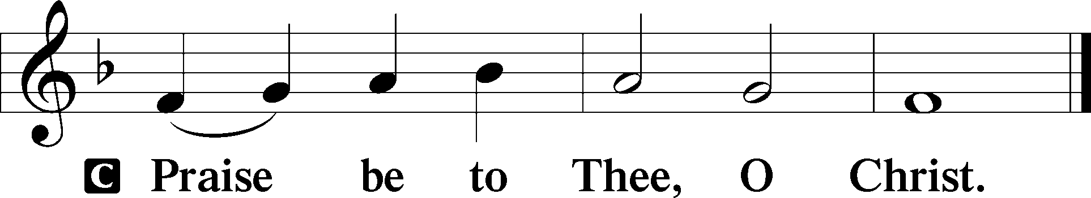

Apostles’ Creed

C **I believe in God, the Father Almighty,**

**maker of heaven and earth.**

**And in Jesus Christ, His only Son, our Lord,**

**who was conceived by the Holy Spirit,**

**born of the virgin Mary,**

**suffered under Pontius Pilate,**

**was crucified, died and was buried.**

**He descended into hell.**

**The third day He rose again from the dead.**

**He ascended into heaven**

**and sits at the right hand of God the Father Almighty.**

**From thence He will come to judge the living and the dead.**

**I believe in the Holy Spirit,**

**the holy Christian Church,**

**the communion of saints,**

**the forgiveness of sins,**

**the resurrection of the body,**

**and the life** T **everlasting. Amen.**

Sit

Children's Sermon

528 Oh, for a Thousand Tongues to Sing

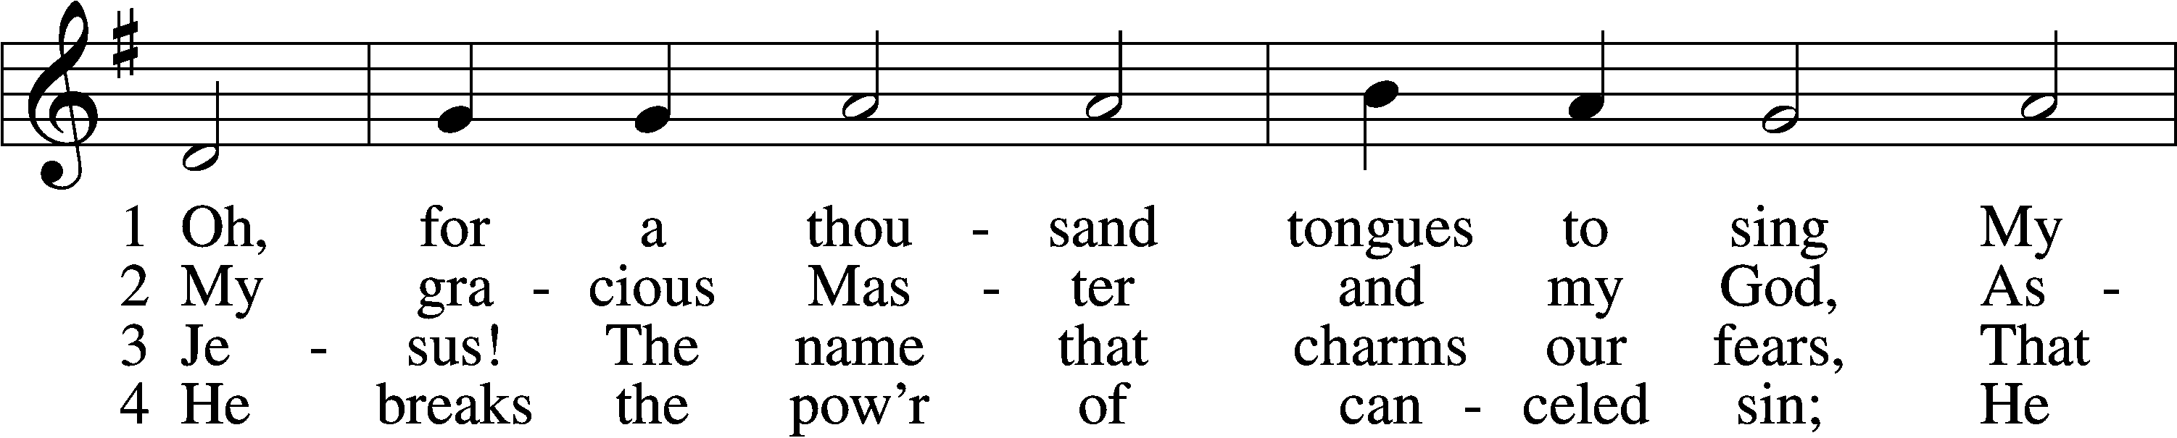

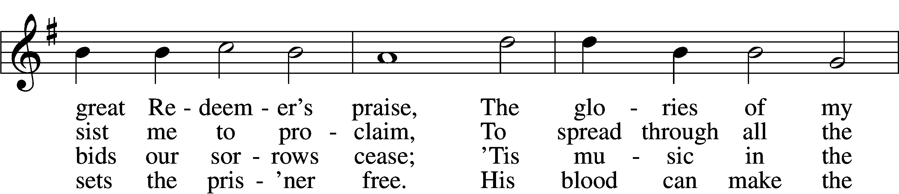

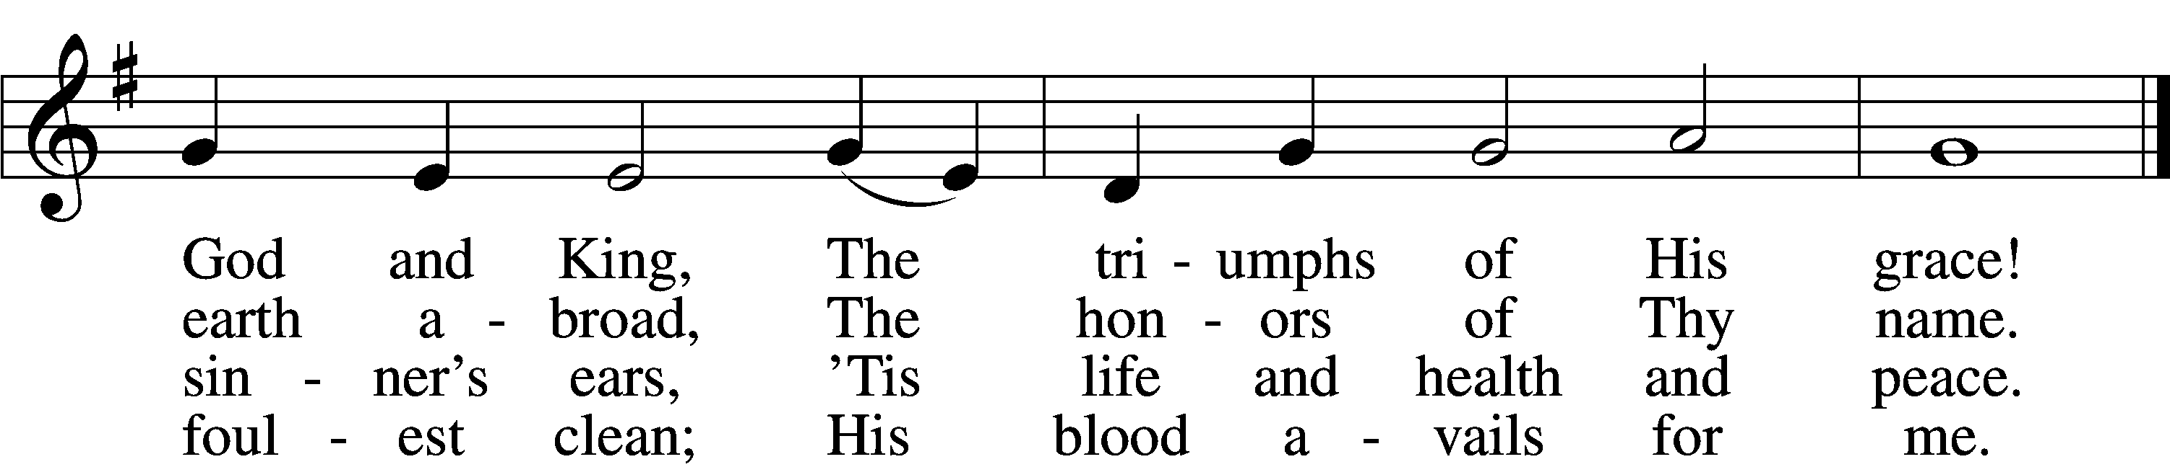

5 Look unto Him, ye nations; own  
 Your God, ye fallen race.  
Look and be saved through faith alone,  
 Be justified by grace.

6 See all your sins on Jesus laid;  
 The Lamb of God was slain.  
His soul was once an off’ring made  
 For ev’ry soul of man.

7 To God all glory, praise, and love  
 Be now and ever giv’n  
By saints below and saints above,  
 The Church in earth and heav’n.

Text: Charles Wesley, 1707–88, alt.  
Tune: Carl G. Gläser, 1784–1829  
Text and tune: Public domain

Sermon

Votum

P The peace of God, which passes all understanding, keep your hearts and minds in Christ Jesus.

C **Amen.**

Stand

Offertory Psalm 51:10–12

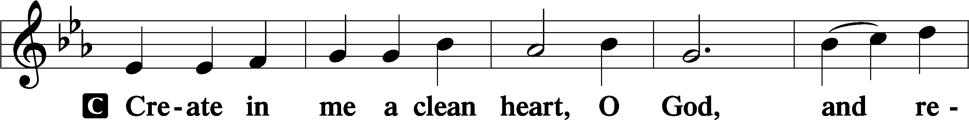

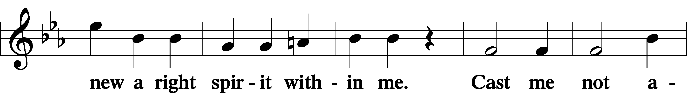

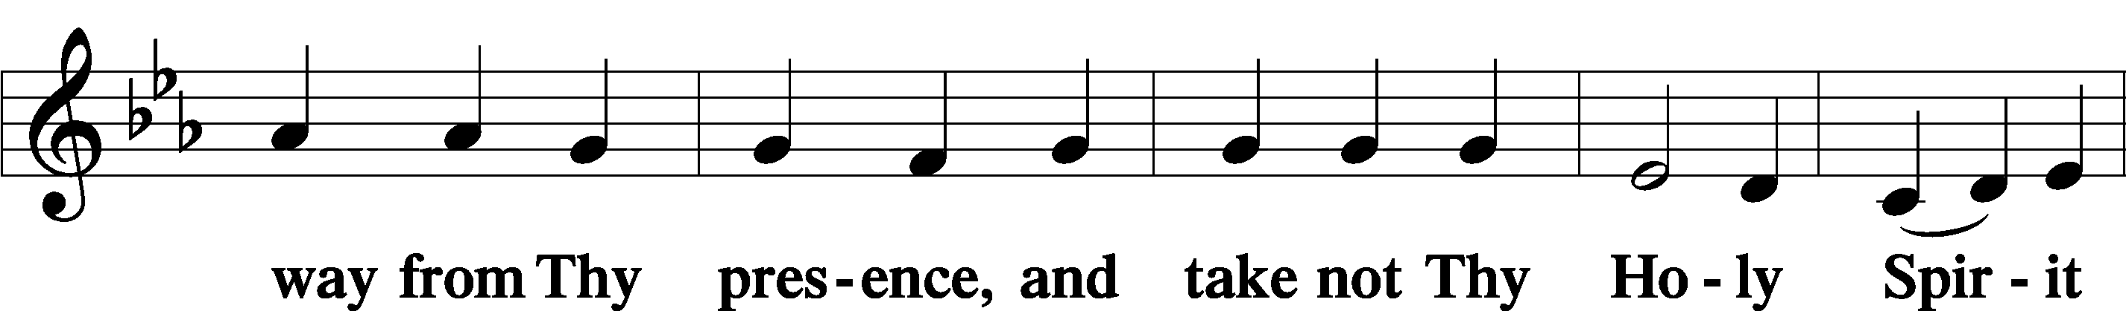

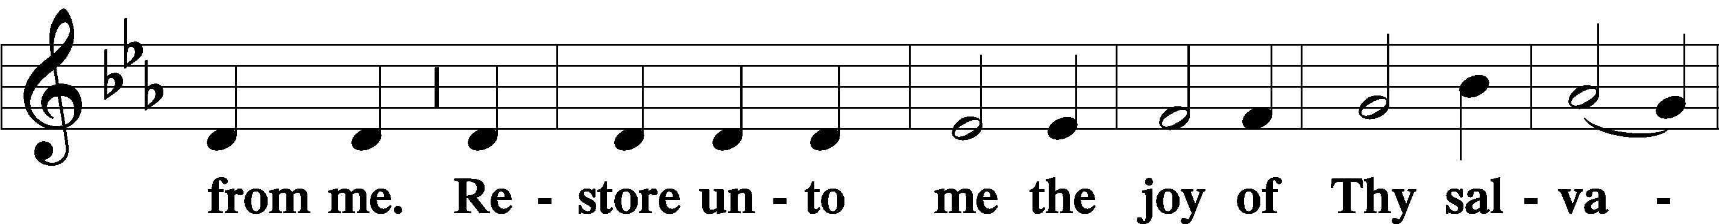

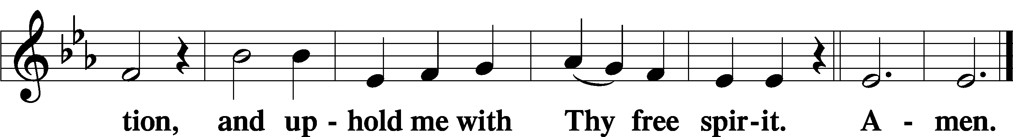

Offering

805 Praise God, from Whom All Blessings Flow

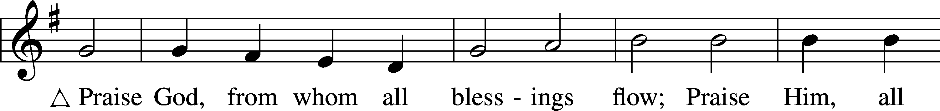

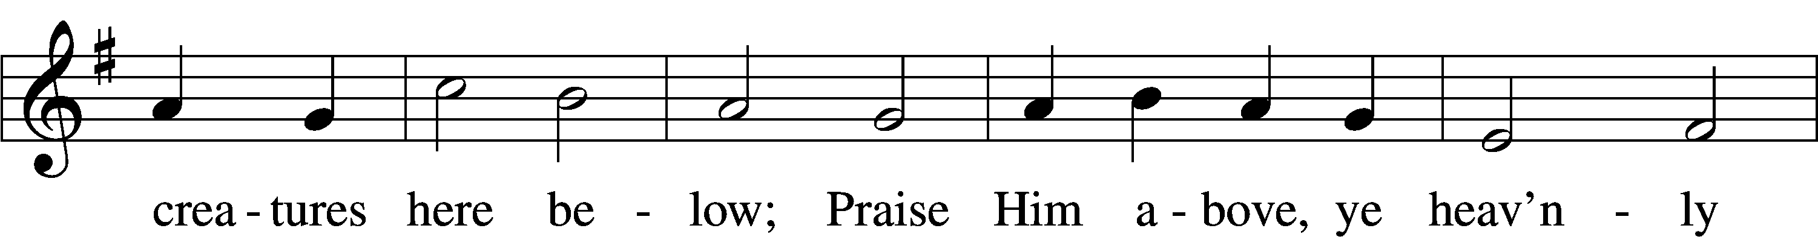

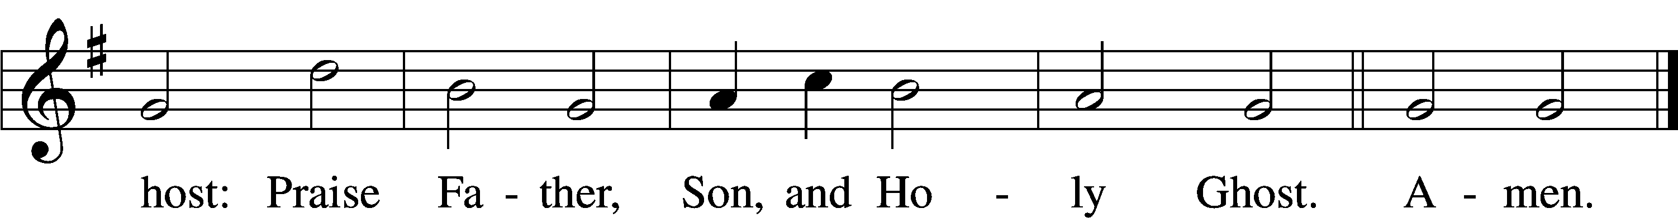

Text: Thomas Ken, 1637–1711  
Tune: Trente quatre Pseaumes de David, 1551, Geneva, ed. Louis Bourgeois  
Text and tune: Public domain

Prayer of the Church

Lord’s Prayer Matthew 6:9–13

P Lord, remember us in Your kingdom and teach us to pray:

C **Our Father who art in heaven,**

**hallowed be Thy name,**

**Thy kingdom come,**

**Thy will be done on earth**

**as it is in heaven;**

**give us this day our daily bread;**

**and forgive us our trespasses**

**as we forgive those**

**who trespass against us;**

**and lead us not into temptation,**

**but deliver us from evil.**

**For Thine is the kingdom**

**and the power and the glory**

**forever and ever. Amen.**

Collect for the Word

Blessed Lord, You have caused all Holy Scriptures to be written for our learning. Grant that we may so hear them, read, mark, learn, and inwardly digest them that, by the patience and comfort of Your holy Word, we may embrace and ever hold fast the blessed hope of everlasting life; through Jesus Christ, Your Son, our Lord, who lives and reigns with You and the Holy Spirit, one God, now and forever.

Benediction

P The Lord bless you and keep you.

The Lord make His face shine on you and be gracious to you.

The Lord look upon you with favor and T give you peace.

C **Amen.**

744 Amazing Grace sts. 1–5

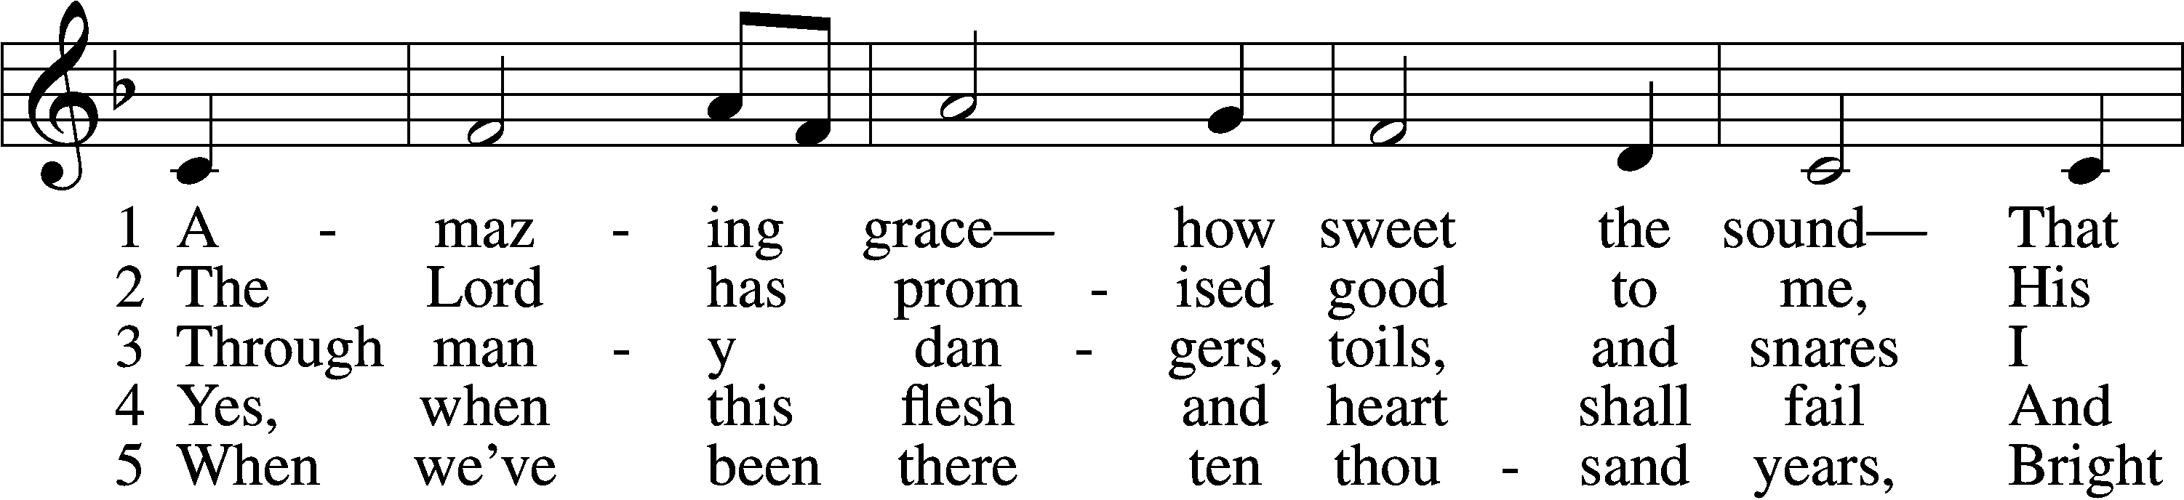

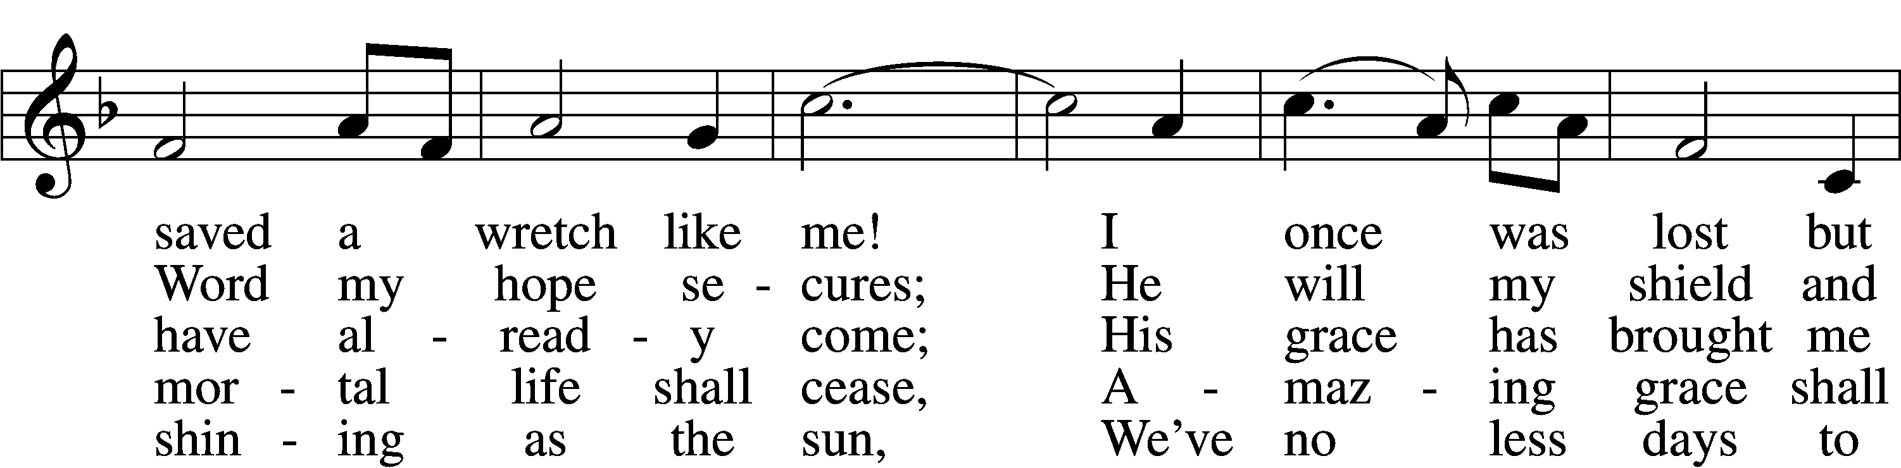

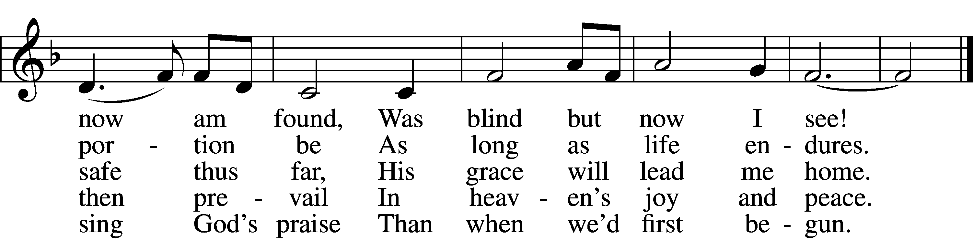

Text (sts. 1–4): John Newton, 1725–1807, alt.; (st. 5): A Collection of Sacred Ballads, 1790, Richmond  
Tune: Columbian Harmony, 1829, Cincinnati  
Text and tune: Public domain

Acknowledgments

Unless otherwise indicated, Scripture quotations are from the ESV® Bible (The Holy Bible, English Standard Version®), copyright © 2001 by Crossway, a publishing ministry of Good News Publishers. Used by permission. All rights reserved.

Created by Lutheran Service Builder © 2025 Concordia Publishing House.