On entering the church

P Lord, I love the habitation of Your house and the place

where Your glory dwells. In the multitude of Your tender

mercies prepare my heart that I may enter Your house to

worship and confess Your holy name; through Jesus Christ,

my God and Lord.

Before worship

C O Lord, our creator, redeemer, and comforter, as we come

together to worship You in spirit and in truth, we humbly

pray that You would open our hearts to the preaching of

Your Word so that we may repent of our sins, believe in

Jesus Christ as our only Savior, and grow in grace and

holiness. Hear us for His sake.

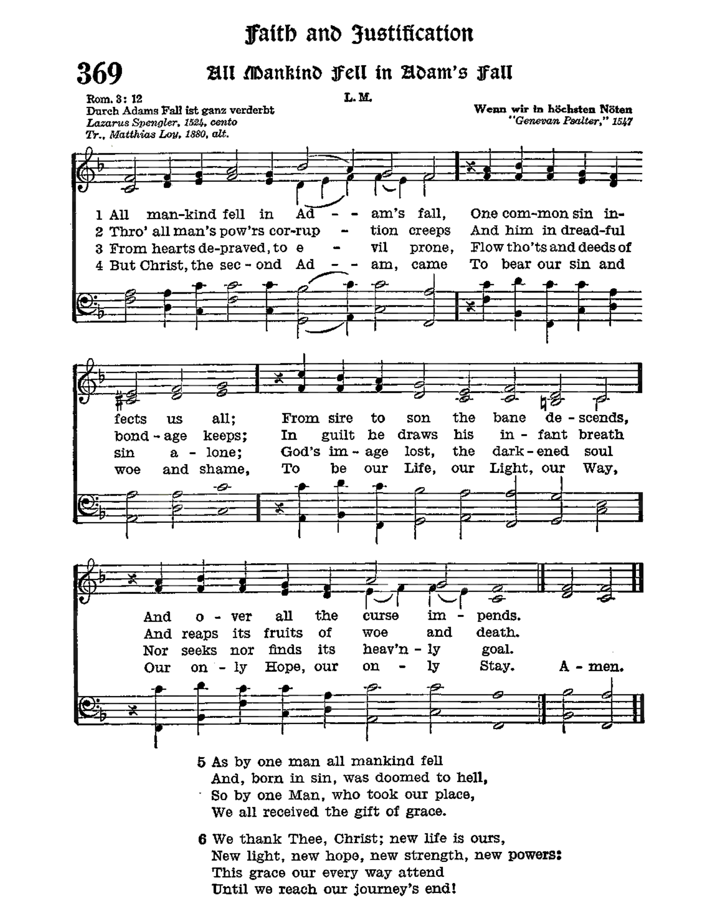

# Confession and Absolution

Stand

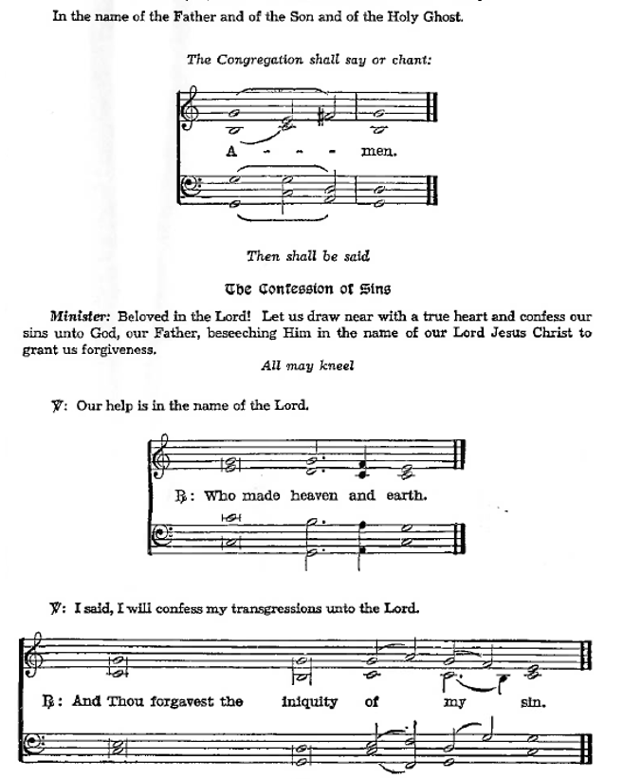Kneel/Stand

Silence for reflection on God’s Word and for self-examination.

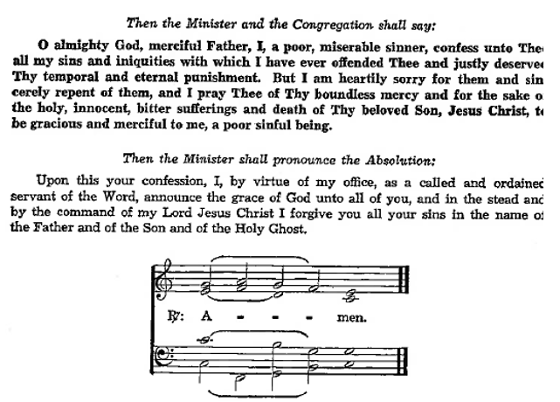

**Introit** *Psalm 51:2–6; antiphon: v. 1*

Have mercy on me, O God, according to your steadfast love;  
 according to your abundant mercy blot out my transgressions.  
**Wash me thoroughly from my iniquity,  
 and cleanse me from my sin!**For I know my transgressions,  
 and my sin is ever before me.  
**Against you, you only, have I sinned and done what is evil in your sight,  
 so that you may be justified in your words and blameless in your judgment.**Behold, I was brought forth in iniquity,  
 and in sin did my mother conceive me.  
**Behold, you delight in truth in the inward being,  
 and you teach me wisdom in the secret heart.**

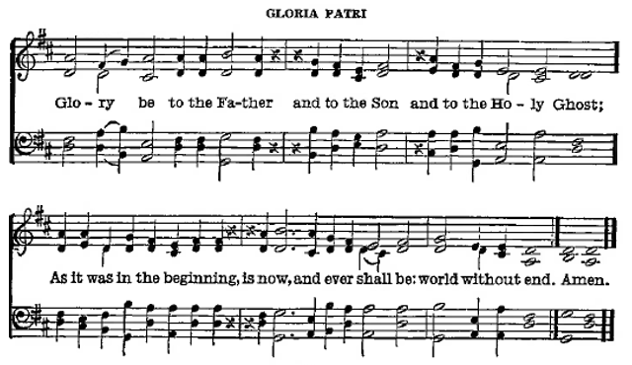

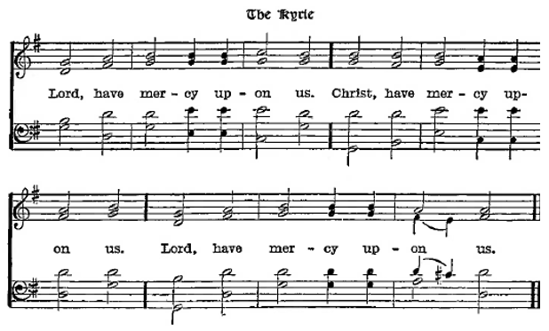

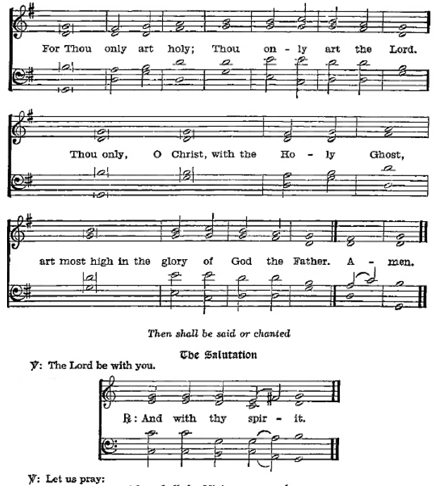

P Almighty God, our heavenly Father, Your mercies are new every morning; and though we deserve only punishment, You receive us as Your children and provide for all our needs of body and soul. Grant that we may heartily acknowledge Your merciful goodness, give thanks for all Your benefits, and serve You in willing obedience; through Jesus Christ, Your Son, our Lord, who lives and reigns with You and the Holy Spirit, one God, now and forever.

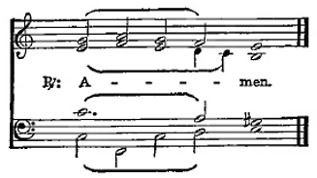

Sit

Old Testament *Isaiah 12*

1 In that day you will say:

“I will praise you, Lord.  
    Although you were angry with me,  
your anger has turned away  
    and you have comforted me.  
2Surely God is my salvation;  
    I will trust and not be afraid.  
The Lord, the Lord himself, is my strength and my defense[[a](https://www.biblegateway.com/passage/?search=Isaiah%2012&version=NIV#fen-NIV-17903a)];  
    he has become my salvation.”  
3With joy you will draw water  
    from the wells of salvation.

4In that day you will say:

“Give praise to the Lord, proclaim his name;  
    make known among the nations what he has done,  
    and proclaim that his name is exalted.  
5Sing to the Lord, for he has done glorious things;  
    let this be known to all the world.  
6Shout aloud and sing for joy, people of Zion,  
    for great is the Holy One of Israel among you.”

**Gradual** Hebrews 12:2

[O come, let us fix our eyes on] Jesus,  
 the founder and perfecter of our faith,  
who for the joy that was set before him endured the cross, despising the shame,  
 and is seated at the right hand of the throne of God.

Epistle *2 Corinthians 5:16-21*

**16**So from now on we regard no one from a worldly point of view. Though we once regarded Christ in this way, we do so no longer. **17**Therefore, if anyone is in Christ, the new creation has come: The old has gone, the new is here! **18**All this is from God, who reconciled us to himself through Christ and gave us the ministry of reconciliation: **19**that God was reconciling the world to himself in Christ, not counting people’s sins against them. And he has committed to us the message of reconciliation. **20**We are therefore Christ’s ambassadors, as though God were making his appeal through us. We implore you on Christ’s behalf: Be reconciled to God. **21**God made him who had no sin to be sin for us, so that in him we might become the righteousness of God.

A Here endeth the Epistle.

Stand

Holy Gospel *Luke 15:1-3, 11b-32*

P The Holy Gospel is written in the Fifteenth chapter of St. Luke, beginning at the first verse.

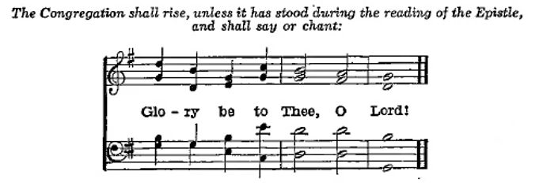

**1** Now the tax collectors and sinners were all gathering around to hear Jesus. **2** But the Pharisees and the teachers of the law muttered, “This man welcomes sinners and eats with them.”

**3** Then Jesus told them this parable:

“There was a man who had two sons. 12And the younger of them said to his father, ‘Father, give me the share of property that is coming to me.’ And he divided his property between them. 13Not many days later, the younger son gathered all he had and took a journey into a far country, and there he squandered his property in reckless living. 14And when he had spent everything, a severe famine arose in that country, and he began to be in need. 15So he went and hired himself out to one of the citizens of that country, who sent him into his fields to feed pigs. 16And he was longing to be fed with the pods that the pigs ate, and no one gave him anything.

17“But when he came to himself, he said, ‘How many of my father’s hired servants have more than enough bread, but I perish here with hunger! 18I will arise and go to my father, and I will say to him, “Father, I have sinned against heaven and before you. 19I am no longer worthy to be called your son. Treat me as one of your hired servants.”’ 20And he arose and came to his father. But while he was still a long way off, his father saw him and felt compassion, and ran and embraced him and kissed him. 21And the son said to him, ‘Father, I have sinned against heaven and before you. I am no longer worthy to be called your son.’ 22But the father said to his servants, ‘Bring quickly the best robe, and put it on him, and put a ring on his hand, and shoes on his feet. 23And bring the fattened calf and kill it, and let us eat and celebrate. 24For this my son was dead, and is alive again; he was lost, and is found.’ And they began to celebrate.

25“Now his older son was in the field, and as he came and drew near to the house, he heard music and dancing. 26And he called one of the servants and asked what these things meant. 27And he said to him, ‘Your brother has come, and your father has killed the fattened calf, because he has received him back safe and sound.’ 28But he was angry and refused to go in. His father came out and entreated him, 29but he answered his father, ‘Look, these many years I have served you, and I never disobeyed your command, yet you never gave me a young goat, that I might celebrate with my friends. 30But when this son of yours came, who has devoured your property with prostitutes, you killed the fattened calf for him!’ 31And he said to him, ‘Son, you are always with me, and all that is mine is yours. 32It was fitting to celebrate and be glad, for this your brother was dead, and is alive; he was lost, and is found.’”

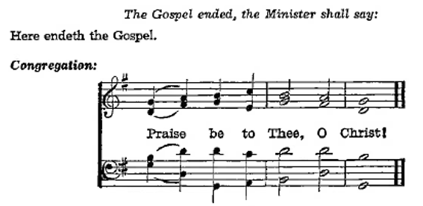

Nicene Creed

C **I believe in one God,**

**the Father Almighty,**

**maker of heaven and earth**

**and of all things visible and invisible.**

**And in one Lord Jesus Christ,**

**the only-begotten Son of God,**

**begotten of His Father before all worlds,**

**God of God, Light of Light,**

**very God of very God,**

**begotten, not made,**

**being of one substance with the Father,**

**by whom all things were made;**

**who for us men and for our salvation came down from heaven**

**and was incarnate by the Holy Ghost of the virgin Mary**

**and was made man;**

**and was crucified also for us under Pontius Pilate.**

**He suffered and was buried.**

**And the third day He rose again according to the Scriptures**

**and ascended into heaven**

**and sits at the right hand of the Father.**

**And He will come again with glory to judge both the living and the dead,**

**whose kingdom will have no end.**

**And I believe in the Holy Ghost,**

**the Lord and giver of life,**

**who proceeds from the Father and the Son,**

**who with the Father and the Son together is worshiped and glorified,**

**who spoke by the prophets.**

**And I believe in one holy Christian and apostolic Church,**

**I acknowledge one Baptism for the remission of sins,**

**and I look for the resurrection of the dead**

**and the life of the world to come. Amen.**

Sit

Children's Sermon

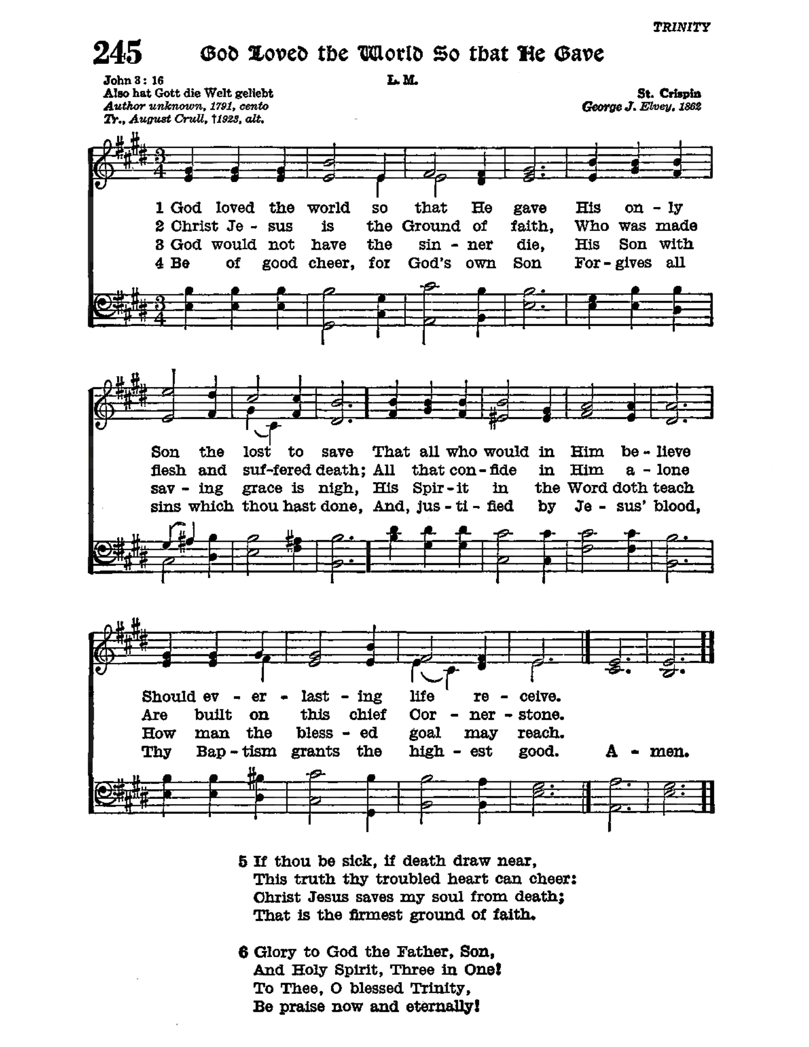

Sermon

Votum

P The peace of God, which passeth all understanding, keep your hearts and minds through Christ Jesus.

Stand

Offertory Psalm 51:10–12

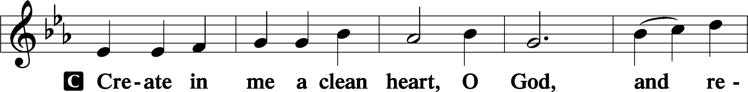

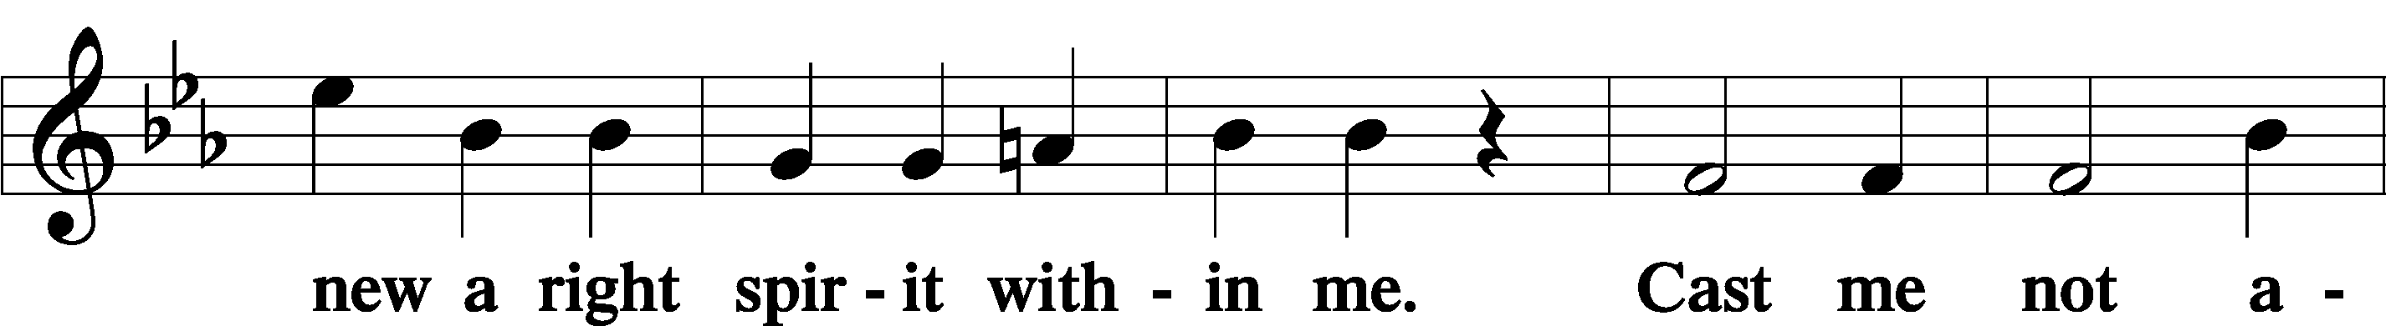

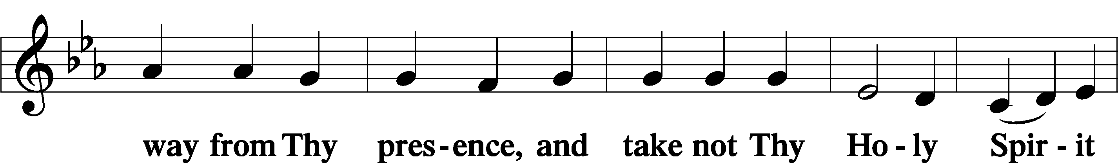

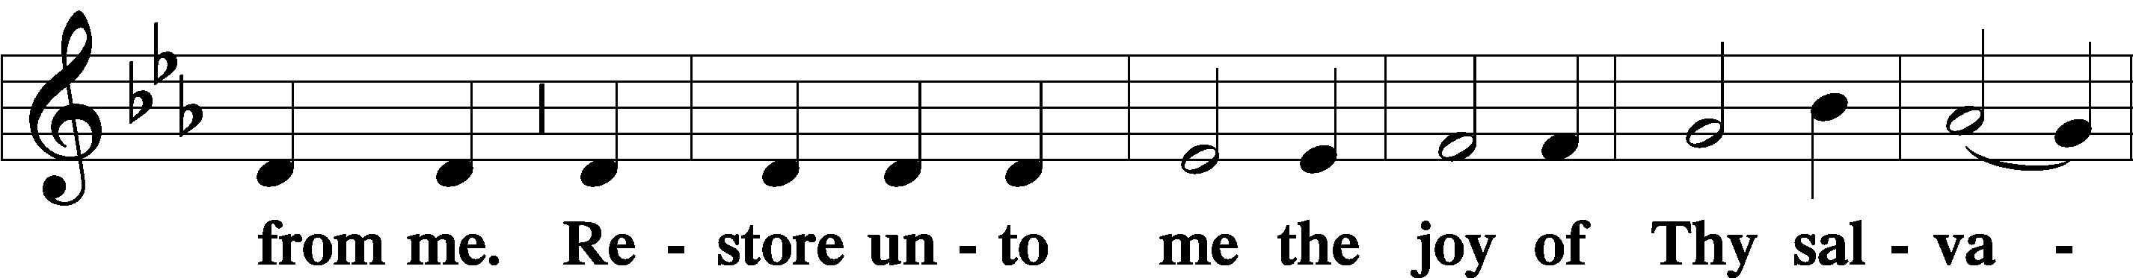

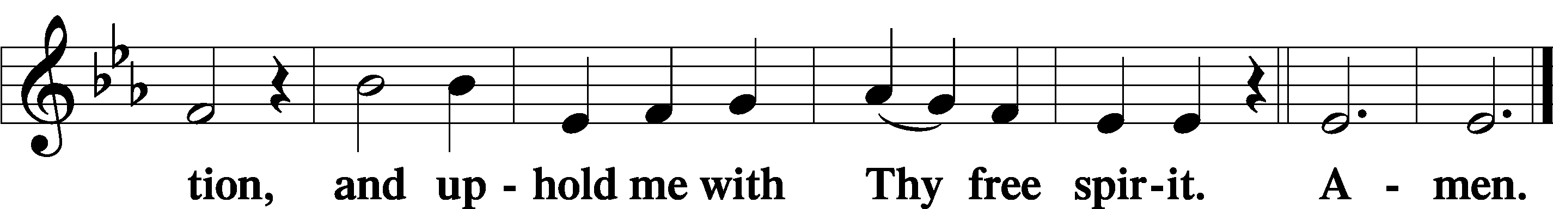

Sit

Offering

644 Praise God, from Whom All Blessings Flow

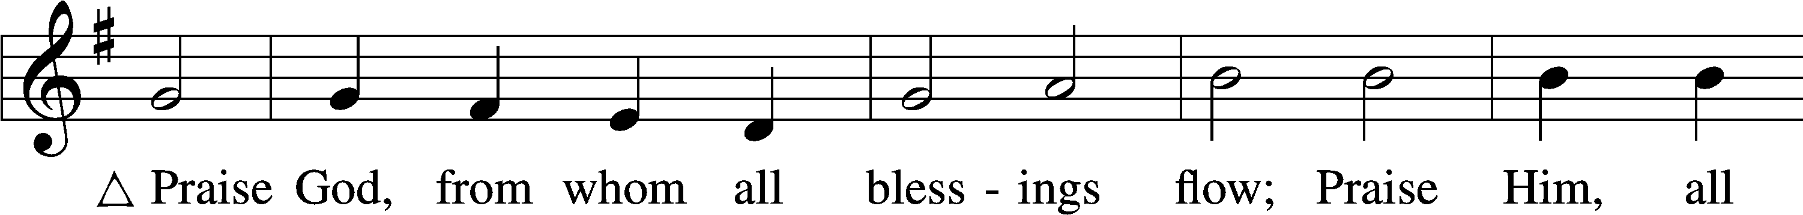

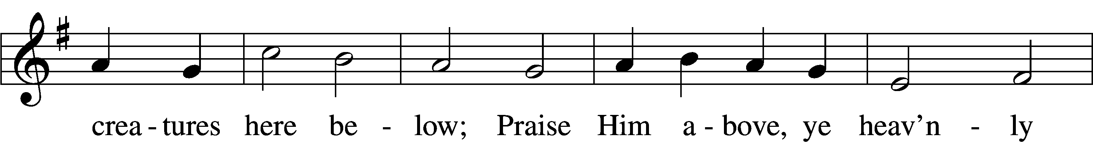

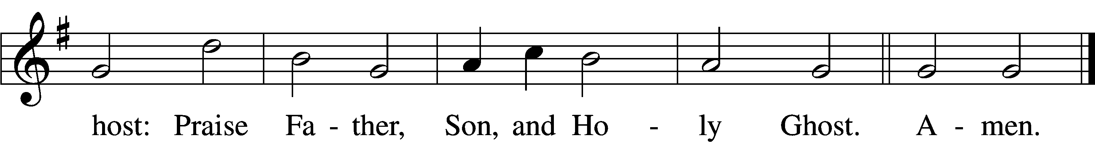

Text: Thomas Ken, 1637–1711  
Tune: Trente quatre Pseaumes de David, 1551, Geneva, ed. Louis Bourgeois  
Text and tune: Public domain

Stand

Prayer of the Church

# Service of the Sacrament

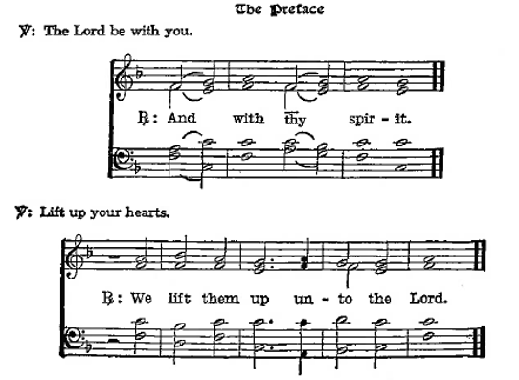

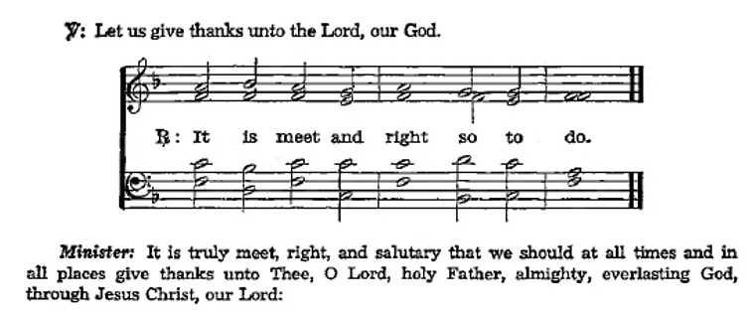

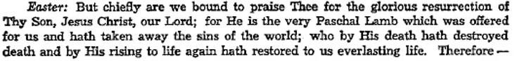

**Sanctus** Isaiah 6:3; Matthew 21:9

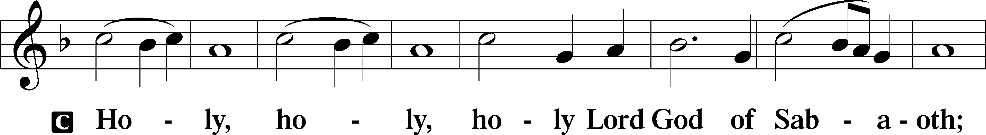

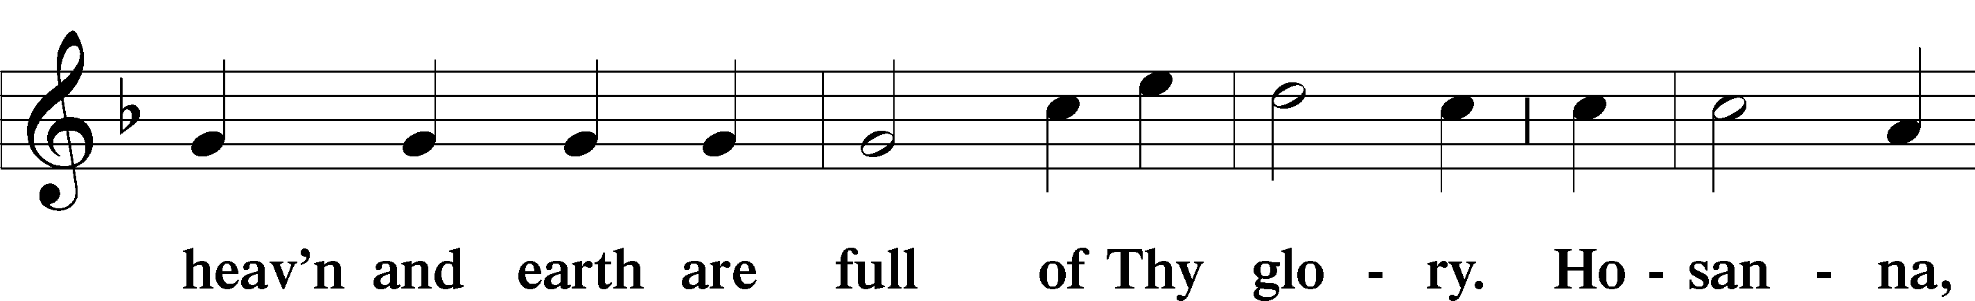

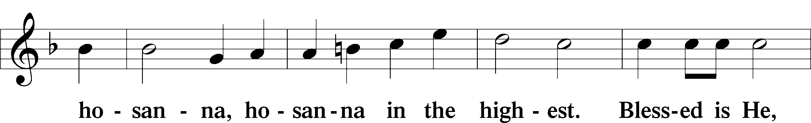

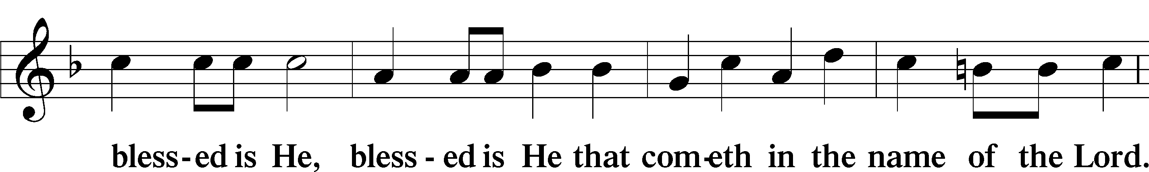

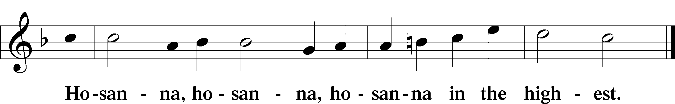

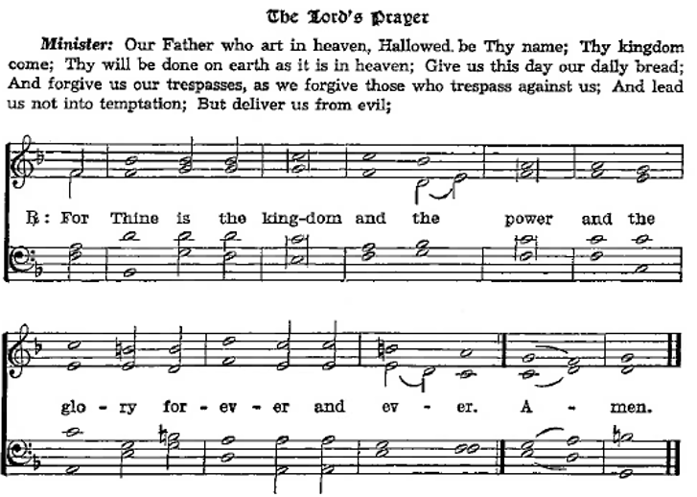

The Words of Our Lord Matthew 26:26–28; Mark 14:22–24; Luke 22:19–20; 1 Corinthians 11:23–25

P Our Lord Jesus Christ, the same night in which He was

betrayed, took bread; and when He had given thanks, He

brake it and gave it to the disciples saying, “Take, eat; this

is My body, which is given for you. This do in

remembrance of Me.”

After the same manner also He took the cup when he had supped, and when He had given thanks, He gave it to them, saying, “Drink ye all of it; this cup is the New Testament in My blood, which is shed for you for the remission of sins. This do, as oft as ye drink it, in remembrance of Me.”

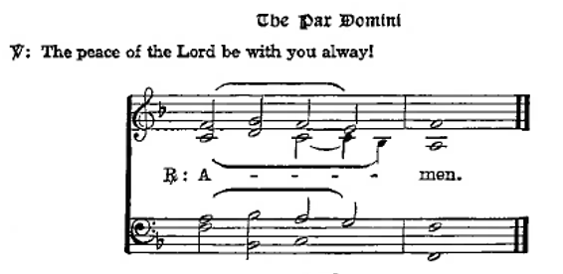Agnus Dei John 1:29

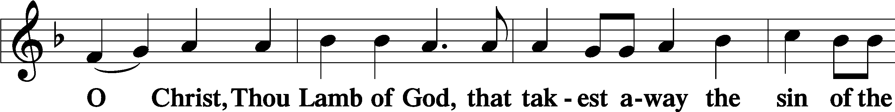

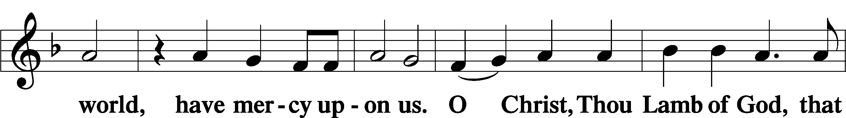

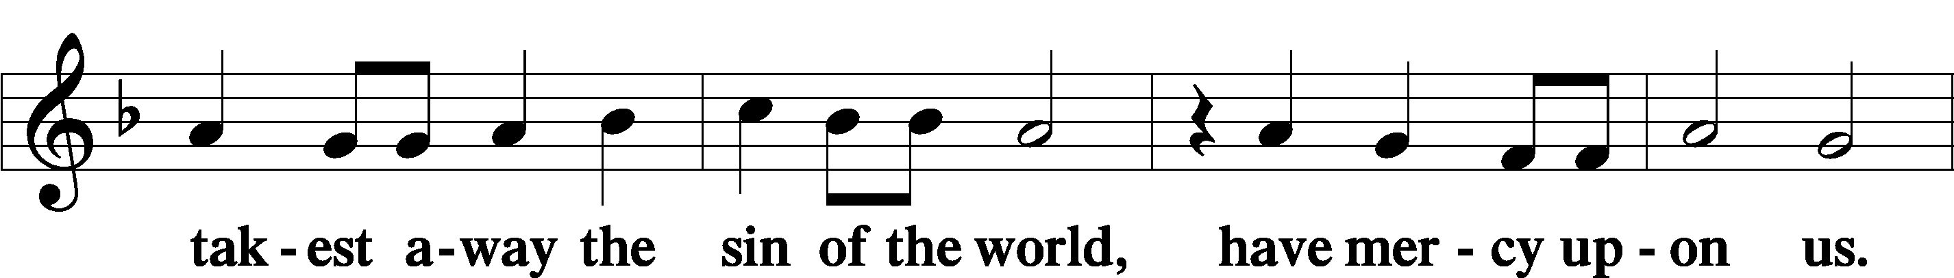

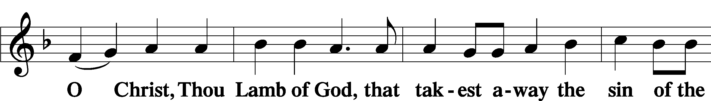



Sit

Distribution

The pastor and those who assist him receive the body and blood of Christ first and then distribute them to those who come to receive, saying:

Take, eat; this is the true body of our Lord and Savior Jesus Christ, given into death for your sins.

**Amen.**

Take, drink; this is the true blood of our Lord and Savior Jesus Christ, shed for the forgiveness of your sins.

**Amen.**

In dismissing the communicants, the following is said:

The Dismissal

P The body and blood of our Lord Jesus Christ strengthen and preserve you in the true faith unto life everlasting. Depart in peace.

C **Amen.**

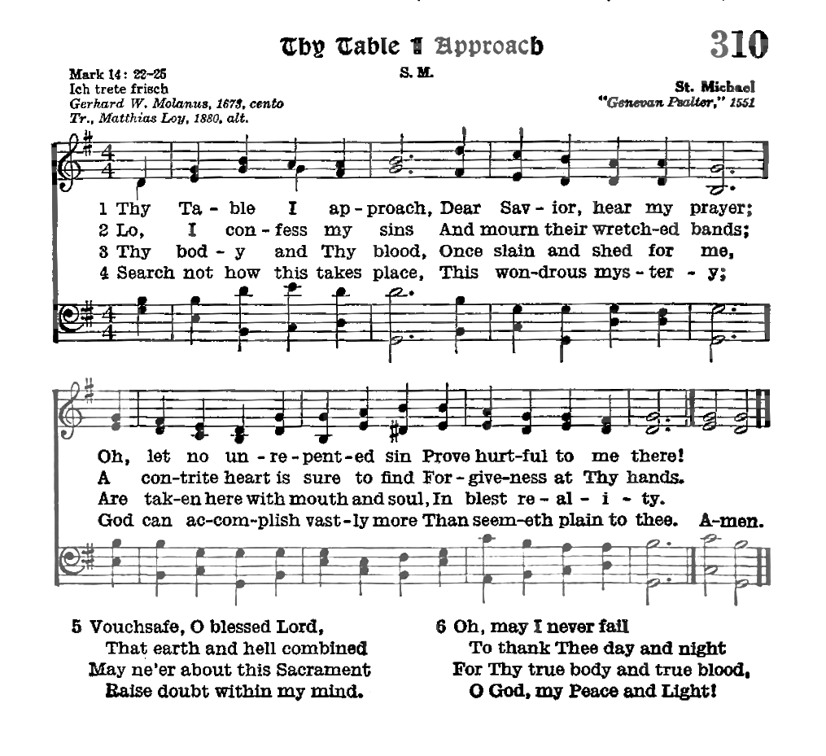

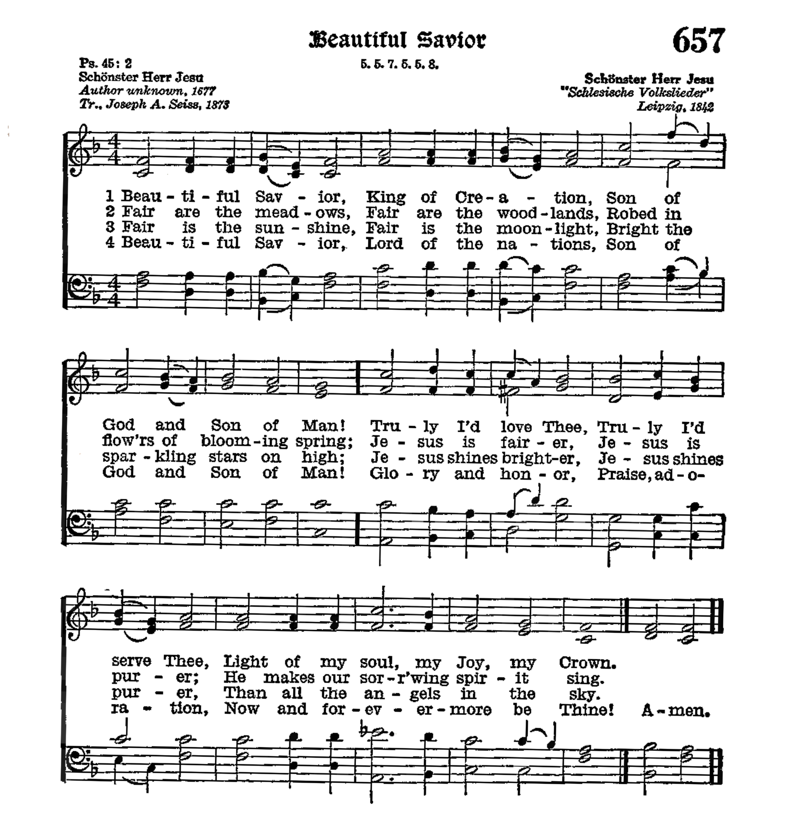

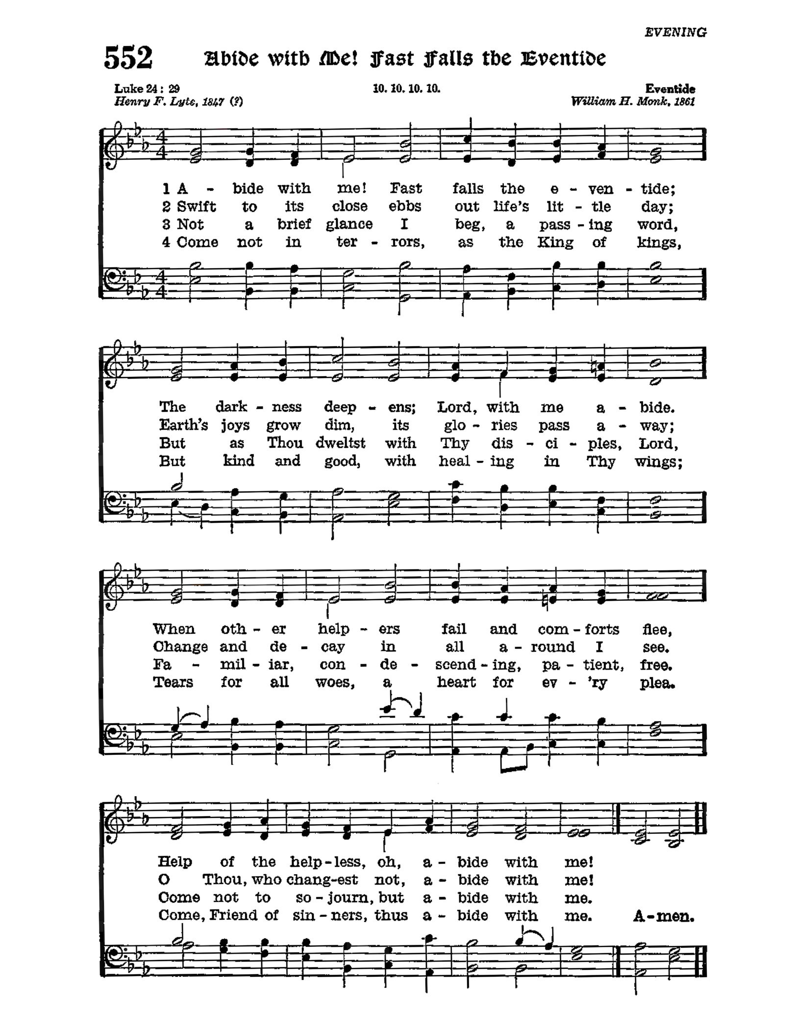

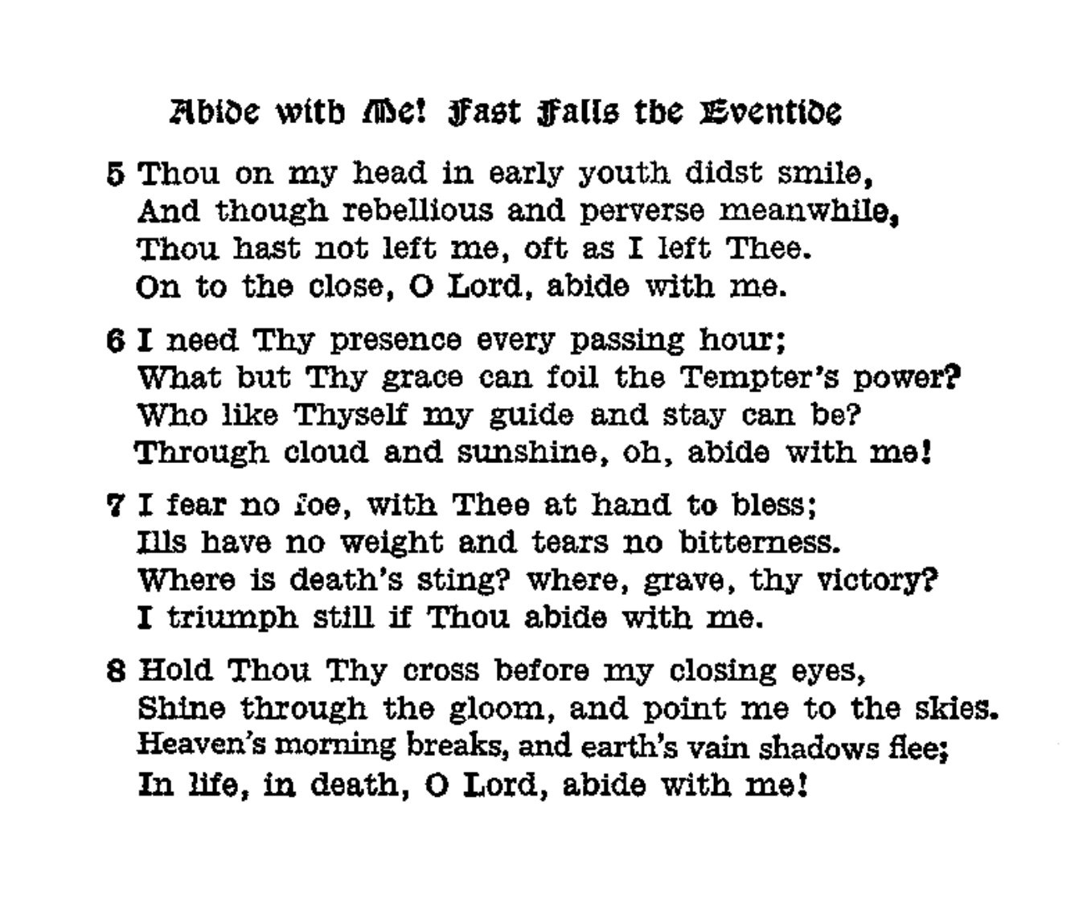

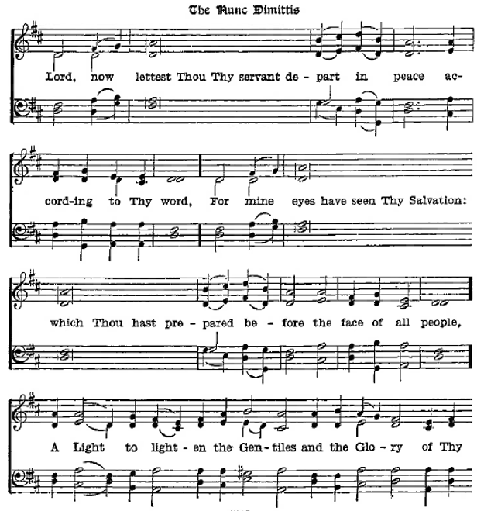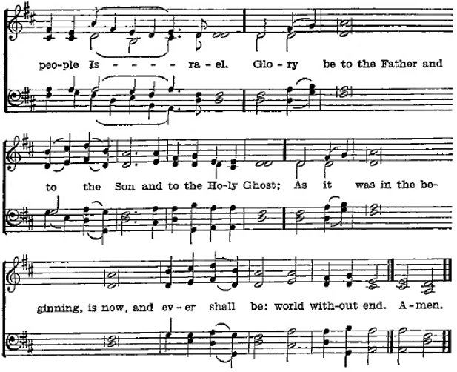

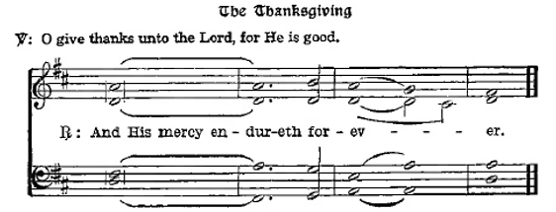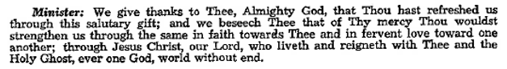

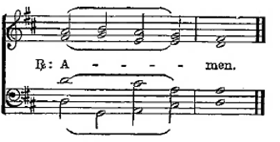

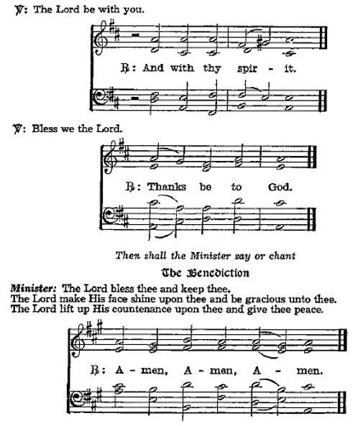

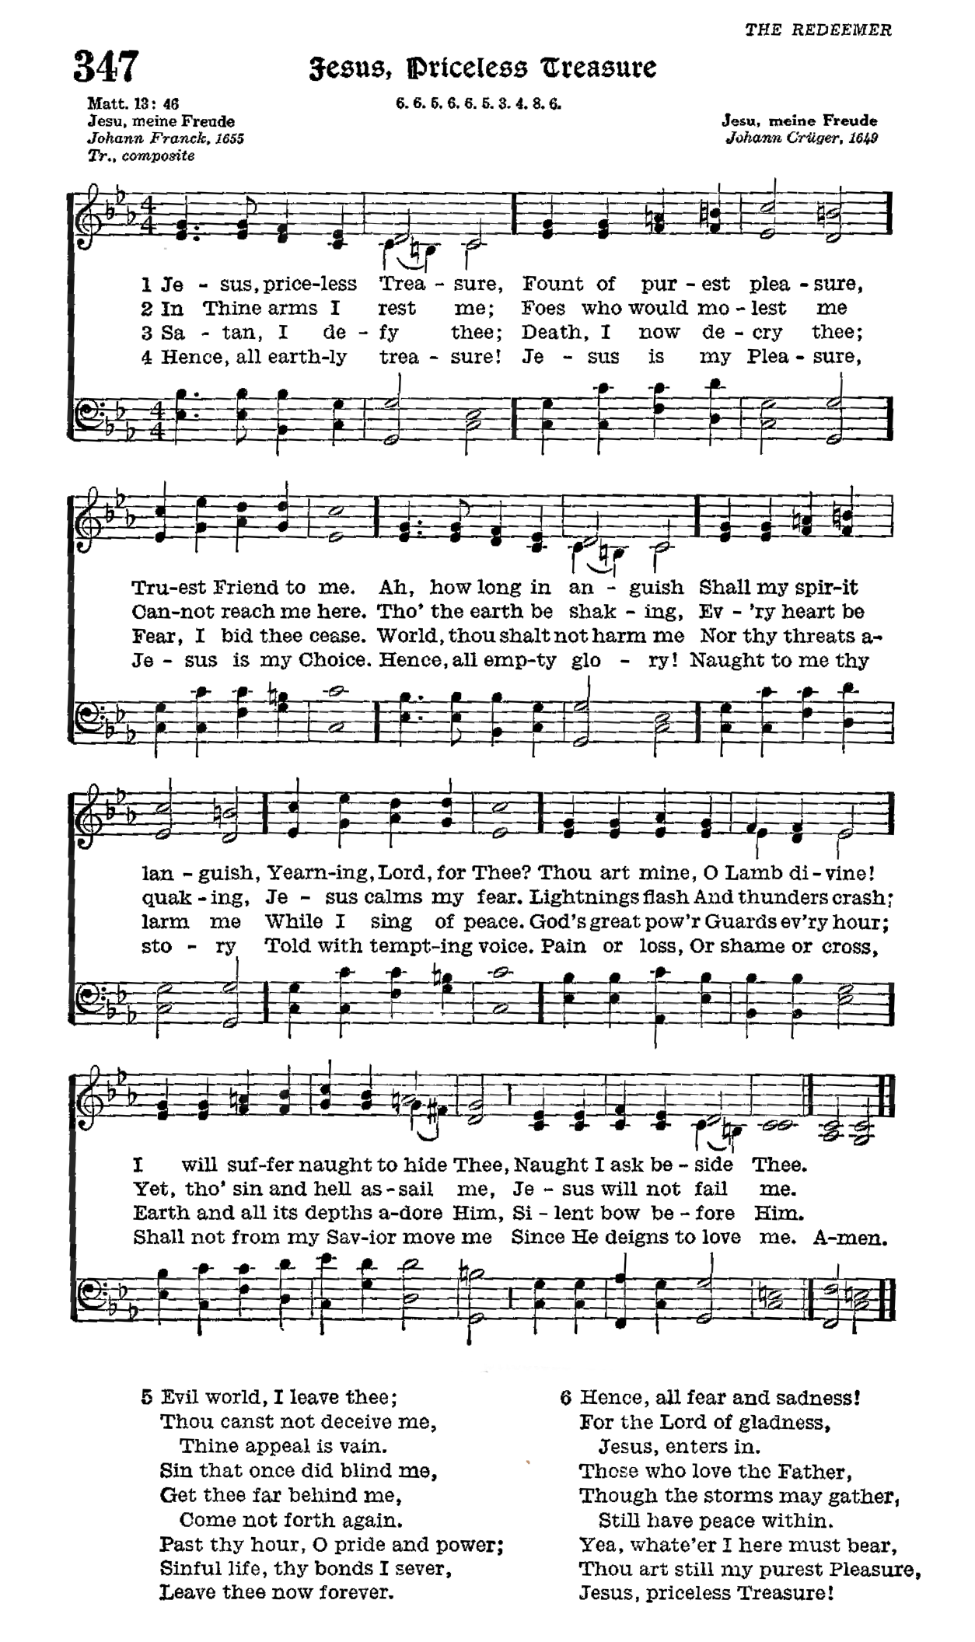

Acknowledgments

Divine Service, from The Lutheran Hymnal

Unless otherwise indicated, Scripture quotations are from the ESV® Bible (The Holy Bible, English Standard Version®), copyright © 2001 by Crossway, a publishing ministry of Good News Publishers. Used by permission. All rights reserved.

Created by Lutheran Service Builder © 2024 Concordia Publishing House.