On entering the church

P Lord, I love the habitation of Your house and the place
where Your glory dwells. In the multitude of Your tender
mercies prepare my heart that I may enter Your house to
worship and confess Your holy name; through Jesus Christ,
my God and Lord.

Before worship

C O Lord, our creator, redeemer, and comforter, as we come
together to worship You in spirit and in truth, we humbly
pray that You would open our hearts to the preaching of
Your Word so that we may repent of our sins, believe in
Jesus Christ as our only Savior, and grow in grace and
holiness. Hear us for His sake.

579 The Law of God Is Good and Wise
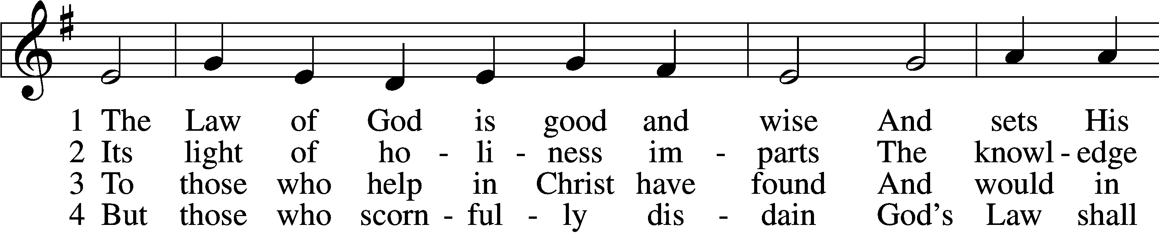
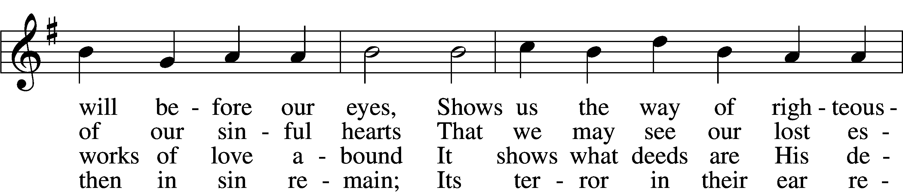
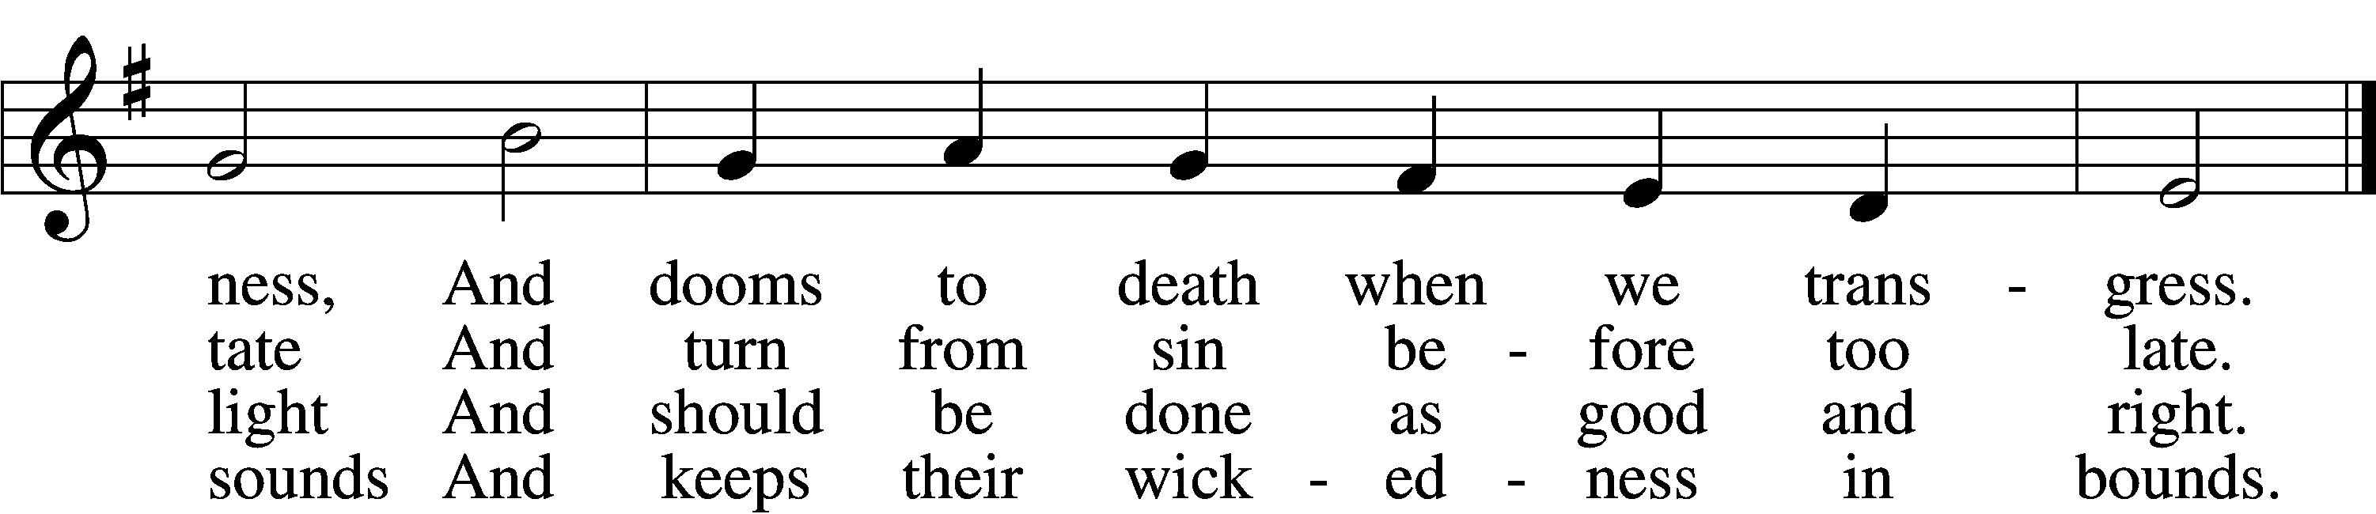

5 The Law is good; but since the fall
Its holiness condemns us all;
It dooms us for our sin to die
And has no pow’r to justify.

6 To Jesus we for refuge flee,
Who from the curse has set us free,
And humbly worship at His throne,
Saved by His grace through faith alone.
Text: Matthias Loy, 1828–1915, alt.
Tune: Geistliche Lieder auffs new gebessert, 1543, Wittenberg, ed. Joseph Klug
Text and tune: Public domain

Confession and Absolution

Stand

The sign of the cross may be made by all in remembrance of their Baptism.

Invocation Matthew 28:19b; 18:20
P In the name of the Father and of the T Son and of the Holy Spirit.
C Amen.

Exhortation Hebrews 10:22; Psalm 124:8; Psalm 32:5
P Beloved in the Lord! Let us draw near with a true heart and confess our sins unto God our Father, beseeching Him in the name of our Lord Jesus Christ to grant us forgiveness.

P Our help is in the name of the Lord,
C who made heaven and earth.
P I said, I will confess my transgressions unto the Lord,
C and You forgave the iniquity of my sin.

Kneel/Stand

Silence for reflection on God’s Word and for self-examination.

Confession of Sins
P O almighty God, merciful Father,
C I, a poor, miserable sinner, confess unto You all my sins and iniquities with which I have ever offended You and justly deserved Your temporal and eternal punishment. But I am heartily sorry for them and sincerely repent of them, and I pray You of Your boundless mercy and for the sake of the holy, innocent, bitter sufferings and death of Your beloved Son, Jesus Christ, to be gracious and merciful to me, a poor, sinful being.

Absolution [John 20:19–23]
P Upon this your confession, I, by virtue of my office, as a called and ordained servant of the Word, announce the grace of God unto all of you, and in the stead and by the command of my Lord Jesus Christ I forgive you all your sins in the name of the Father and of the T Son and of the Holy Spirit.
C Amen.

Stand

Service of the Word

Introit Psalm 25:1–2a, 7–8, 11; antiphon: vv. 6, 2b, 22
Remember your mercy, O Lord, and your steadfast love,
for they have been from of old.
Let not my enemies exult over me.
Redeem Israel, O God, out of all his troubles.
To you, O Lord, I lift up my soul.
O my God, in you I trust; let me not be put to shame.
Remember not the sins of my youth or my transgressions;
according to your steadfast love remember me, for the sake of your goodness, O Lord!
Good and upright is the Lord;
therefore he instructs sinners in the way.
For your name’s sake, O Lord,
pardon my guilt, for it is great.

Gloria Patri
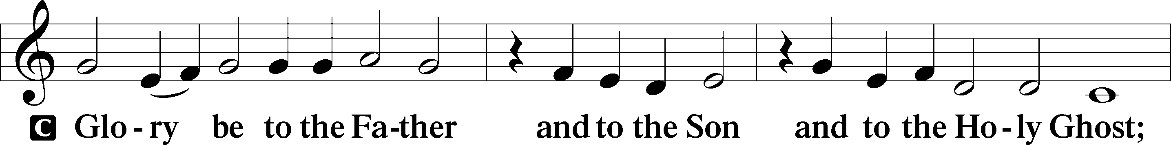
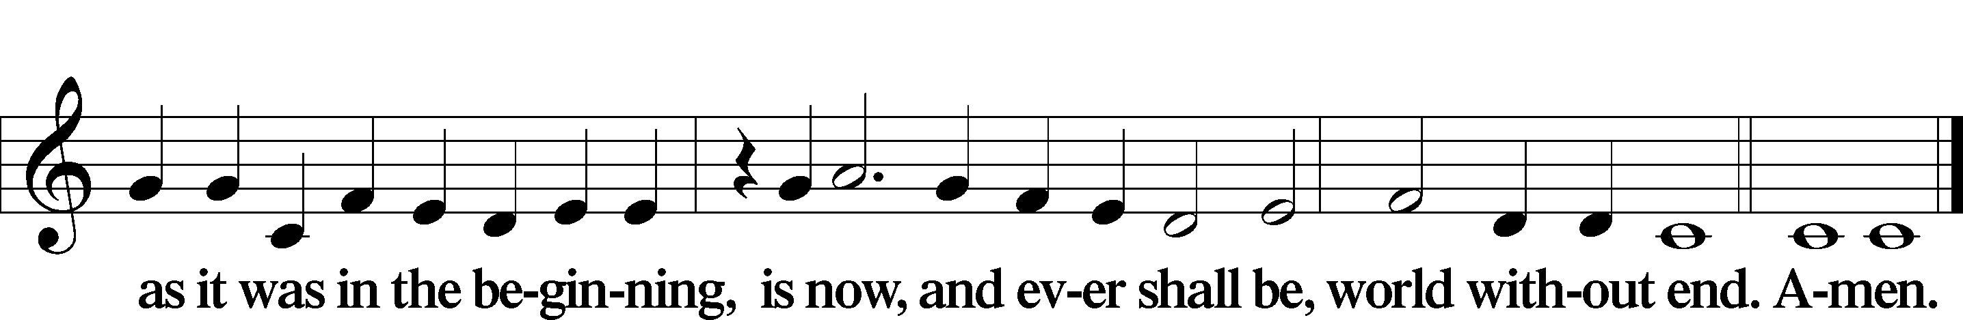

Kyrie Mark 10:47
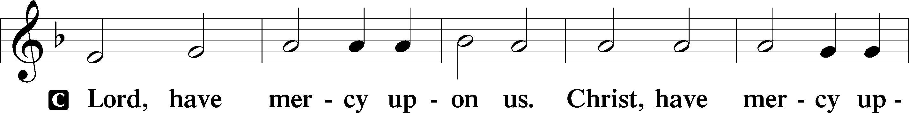
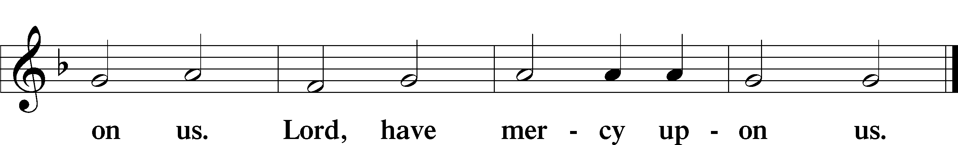

Salutation and Collect of the Day
P The Lord be with you.
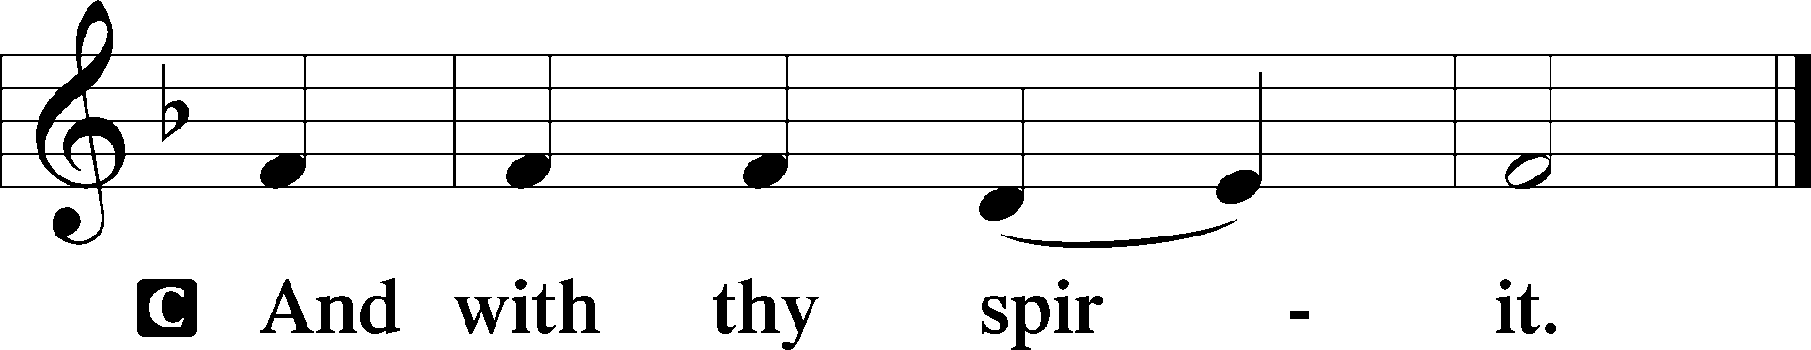

P Let us pray.
O God, You see that of ourselves we have no strength. By Your mighty power defend us from all adversities that may happen to the body and from all evil thoughts that may assault and hurt the soul; through Jesus Christ, Your Son, our Lord, who lives and reigns with You and the Holy Spirit, one God, now and forever.

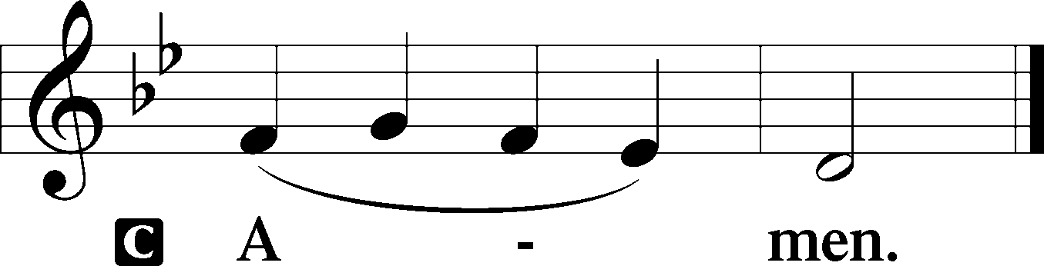

Sit

Old Testament Reading Genesis 32:22–32
22The same night he arose and took his two wives, his two female servants, and his eleven children, and crossed the ford of the Jabbok. 23He took them and sent them across the stream, and everything else that he had. 24And Jacob was left alone. And a man wrestled with him until the breaking of the day. 25When the man saw that he did not prevail against Jacob, he touched his hip socket, and Jacob’s hip was put out of joint as he wrestled with him. 26Then he said, “Let me go, for the day has broken.” But Jacob said, “I will not let you go unless you bless me.” 27And he said to him, “What is your name?” And he said, “Jacob.” 28Then he said, “Your name shall no longer be called Jacob, but Israel, for you have striven with God and with men, and have prevailed.” 29Then Jacob asked him, “Please tell me your name.” But he said, “Why is it that you ask my name?” And there he blessed him. 30So Jacob called the name of the place Peniel, saying, “For I have seen God face to face, and yet my life has been delivered.” 31The sun rose upon him as he passed Penuel, limping because of his hip. 32Therefore to this day the people of Israel do not eat the sinew of the thigh that is on the hip socket, because he touched the socket of Jacob’s hip on the sinew of the thigh.

A This is the Word of the Lord.
C Thanks be to God.

Gradual Psalm 25:17–18
The troubles of my heart are enlarged;
bring me out of my distresses.
Consider my affliction and my trouble,
and forgive all my sins.

Epistle Romans 5:1–5
1Therefore, since we have been justified by faith, we have peace with God through our Lord Jesus Christ. 2Through him we have also obtained access by faith into this grace in which we stand, and we rejoice in hope of the glory of God. 3More than that, we rejoice in our sufferings, knowing that suffering produces endurance, 4and endurance produces character, and character produces hope, 5and hope does not put us to shame, because God’s love has been poured into our hearts through the Holy Spirit who has been given to us.

A This is the Word of the Lord.
C Thanks be to God.

Stand

Holy Gospel Matthew 15:21–28
P The Holy Gospel according to St. Matthew, the fifteenth chapter.

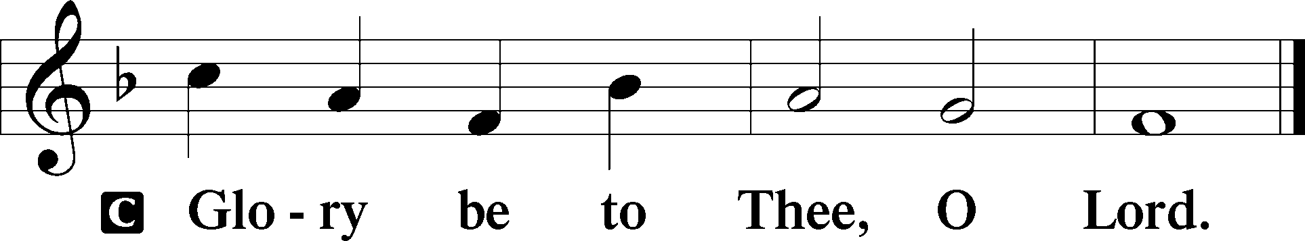

21Jesus went away from there and withdrew to the district of Tyre and Sidon. 22And behold, a Canaanite woman from that region came out and was crying, “Have mercy on me, O Lord, Son of David; my daughter is severely oppressed by a demon.” 23But he did not answer her a word. And his disciples came and begged him, saying, “Send her away, for she is crying out after us.” 24He answered, “I was sent only to the lost sheep of the house of Israel.” 25But she came and knelt before him, saying, “Lord, help me.” 26And he answered, “It is not right to take the children’s bread and throw it to the dogs.” 27She said, “Yes, Lord, yet even the dogs eat the crumbs that fall from their masters’ table.” 28Then Jesus answered her, “O woman, great is your faith! Be it done for you as you desire.” And her daughter was healed instantly.

P This is the Gospel of the Lord.

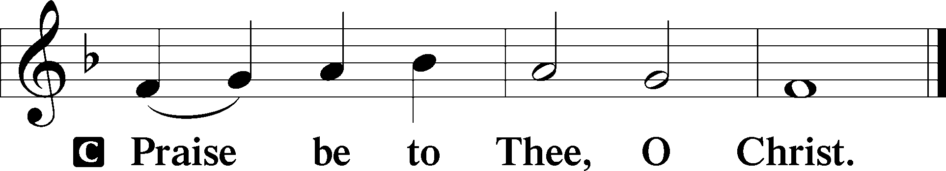

Nicene Creed
C I believe in one God,
the Father Almighty,
maker of heaven and earth
and of all things visible and invisible.

And in one Lord Jesus Christ,
the only-begotten Son of God,
begotten of His Father before all worlds,
God of God, Light of Light,
very God of very God,
begotten, not made,
being of one substance with the Father,
by whom all things were made;
who for us men and for our salvation came down from heaven
and was incarnate by the Holy Spirit of the virgin Mary
and was made man;
and was crucified also for us under Pontius Pilate.
He suffered and was buried.
And the third day He rose again according to the Scriptures
and ascended into heaven
and sits at the right hand of the Father.
And He will come again with glory to judge both the living and the dead,
whose kingdom will have no end.

And I believe in the Holy Spirit,
the Lord and giver of life,
who proceeds from the Father and the Son,
who with the Father and the Son together is worshiped and glorified,
who spoke by the prophets.
And I believe in one holy Christian and apostolic Church,
I acknowledge one Baptism for the remission of sins,
and I look for the resurrection of the dead
and the life T of the world to come. Amen.

Sit

Children's Sermon

615 When in the Hour of Deepest Need
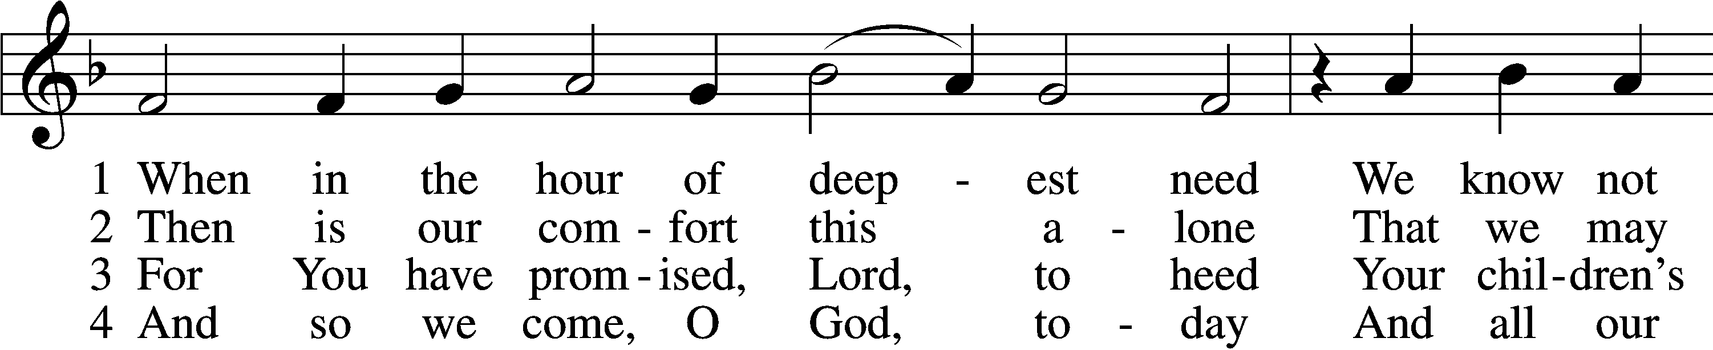
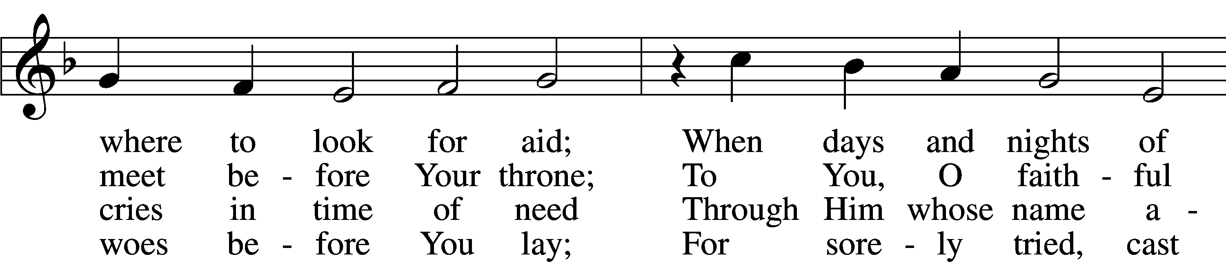
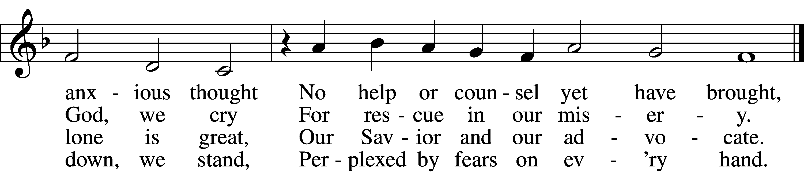

5 O from our sins, Lord, turn Your face;
Absolve us through Your boundless grace.
Be with us in our anguish still;
Free us at last from ev’ry ill.

6 So we with all our hearts each day
To You our glad thanksgiving pay,
Then walk obedient to Your Word,
And now and ever praise You, Lord.
Text: Paul Eber, 1511–69; tr. Catherine Winkworth, 1827–78, alt.
Tune: Louis Bourgeois, c. 1510–61
Text and tune: Public domain

Sermon

Votum
P The peace of God, which passes all understanding, keep your hearts and minds in Christ Jesus.
C Amen.

Stand

Offertory Psalm 51:10–12
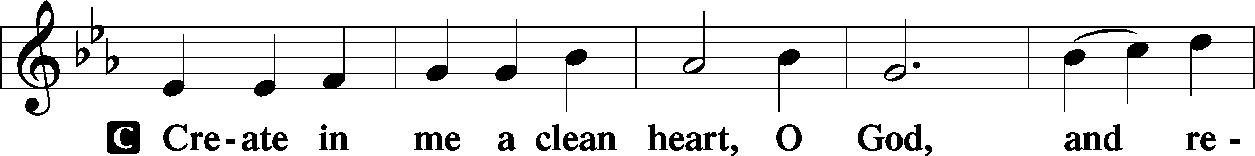
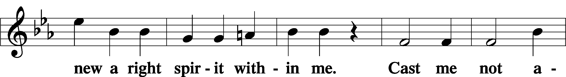
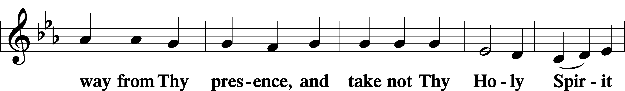
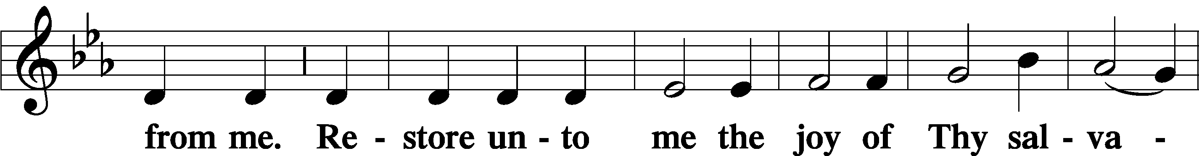
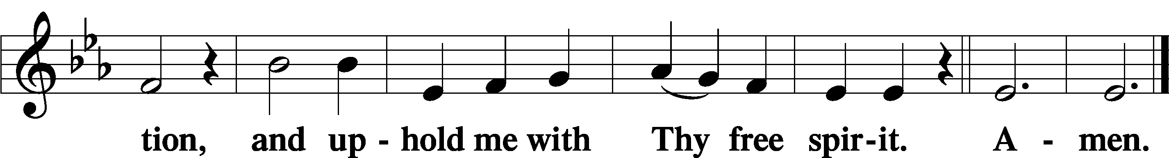

Sit

Offering

805 Praise God, from Whom All Blessings Flow
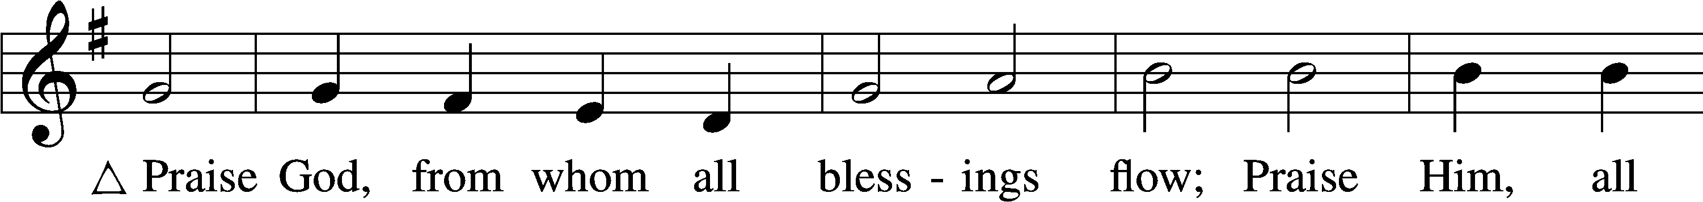
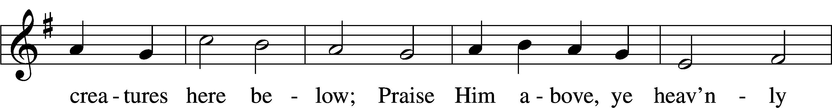
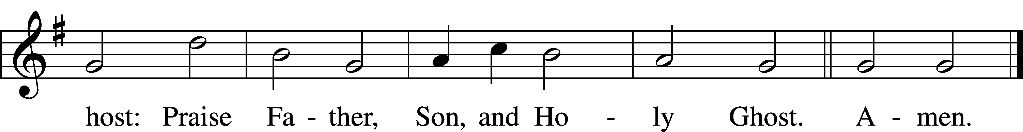
Text: Thomas Ken, 1637–1711
Tune: Trente quatre Pseaumes de David, 1551, Geneva, ed. Louis Bourgeois
Text and tune: Public domain

Stand

Prayer of the Church

Service of the Sacrament

Preface 2 Timothy 4:22; [Colossians 3:1]; [Psalm 136]
P The Lord be with you.
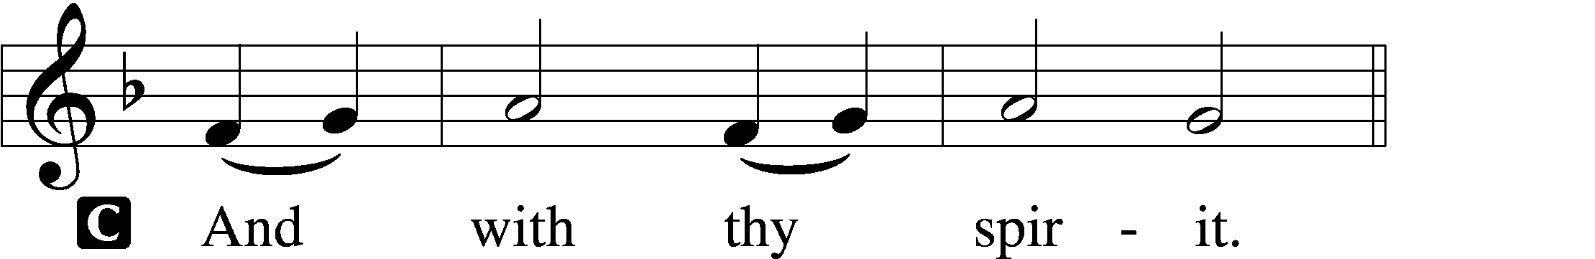

P Lift up your hearts.
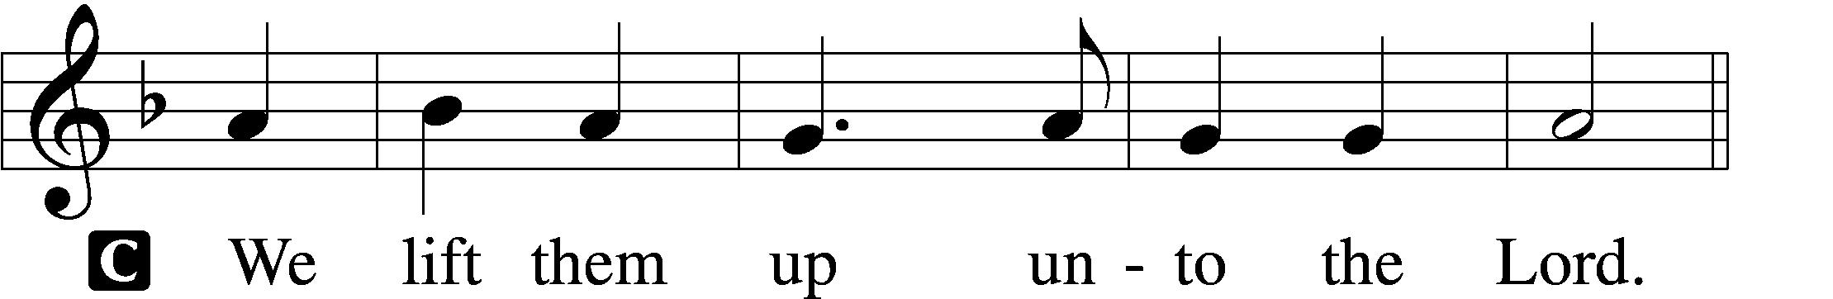

P Let us give thanks unto the Lord, our God.
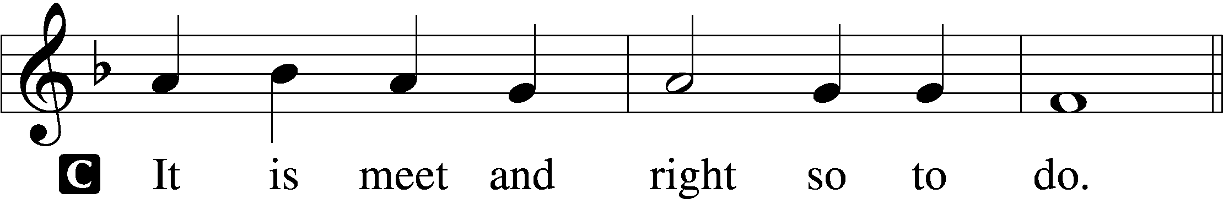

Proper Preface (Full)
P It is truly meet, right, and salutary that we should at all times and in all places give thanks to You, holy Lord, almighty Father, everlasting God, through Jesus Christ, our Lord, who overcame the assaults of the devil and gave His life as a ransom for many that with cleansed hearts we might be prepared joyfully to celebrate the paschal feast in sincerity and truth. Therefore with angels and archangels and with all the company of heaven we laud and magnify Your glorious name, evermore praising You and saying:

Sanctus Isaiah 6:3; Matthew 21:9
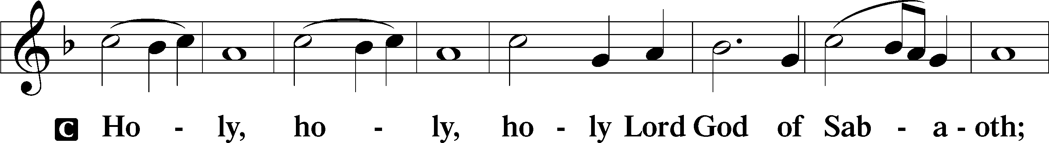
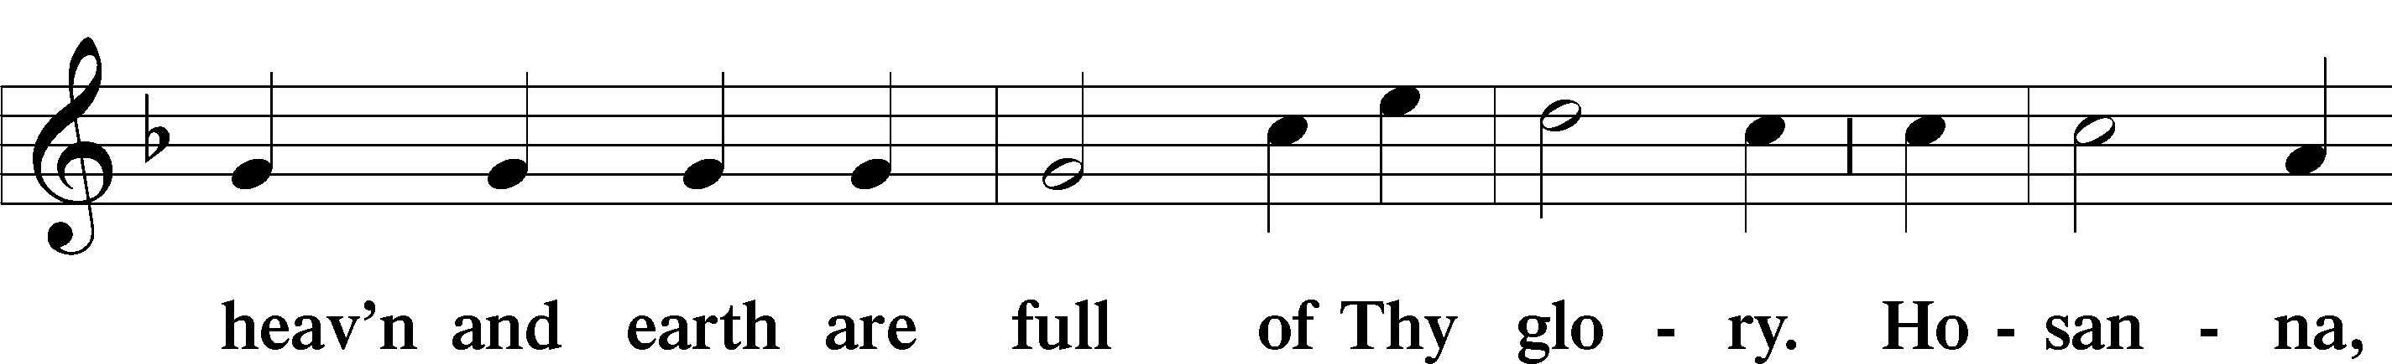
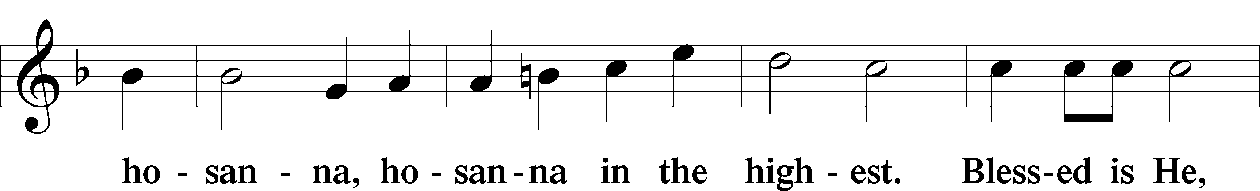
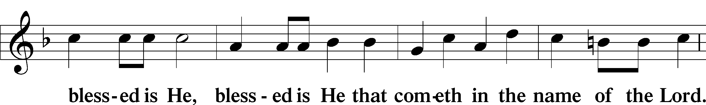
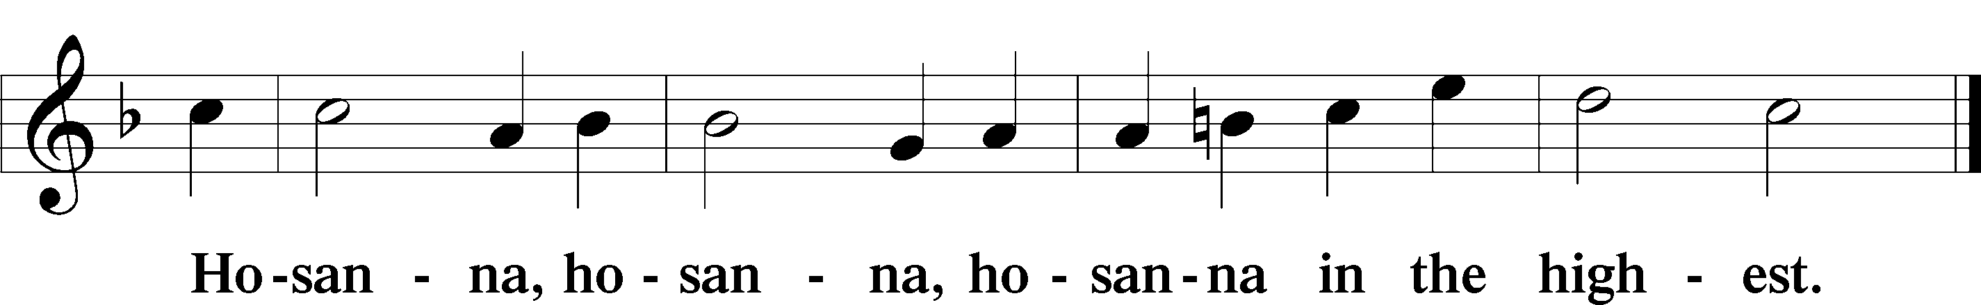

Lord’s Prayer Matthew 6:9–13
P Our Father who art in heaven,
hallowed be Thy name,
Thy kingdom come,
Thy will be done on earth as it is in heaven;
give us this day our daily bread;
and forgive us our trespasses as we forgive those who trespass against us;
and lead us not into temptation,
but deliver us from evil.
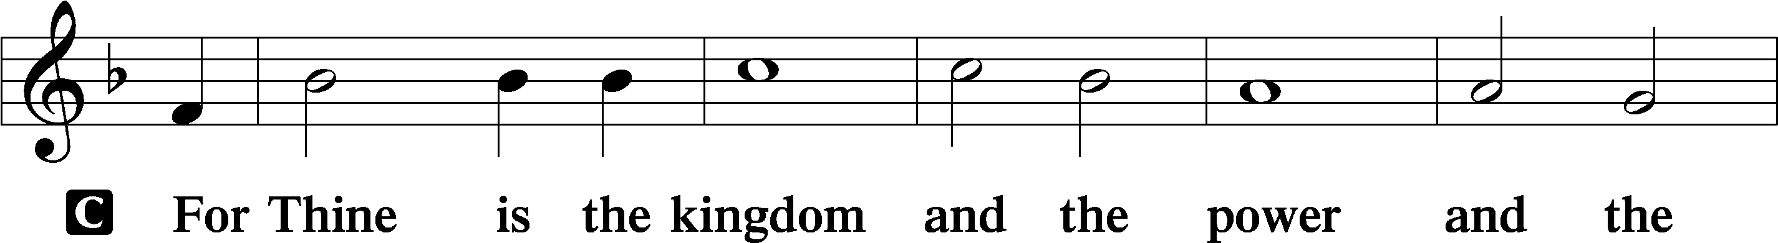
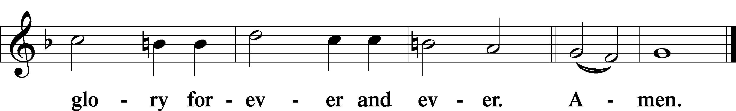

The Words of Our Lord Matthew 26:26–28; Mark 14:22–24; Luke 22:19–20; 1 Corinthians 11:23–25
P Our Lord Jesus Christ, on the night when He was betrayed, took bread, and when He had given thanks, He broke it and gave it to the disciples and said: “Take, eat; this is My T body, which is given for you. This do in remembrance of Me.”

In the same way also He took the cup after supper, and when He had given thanks, He gave it to them, saying: “Drink of it, all of you; this cup is the new testament in My T blood, which is shed for you for the forgiveness of sins. This do, as often as you drink it, in remembrance of Me.”

Pax Domini John 20:19
P The peace of the Lord be with you always.

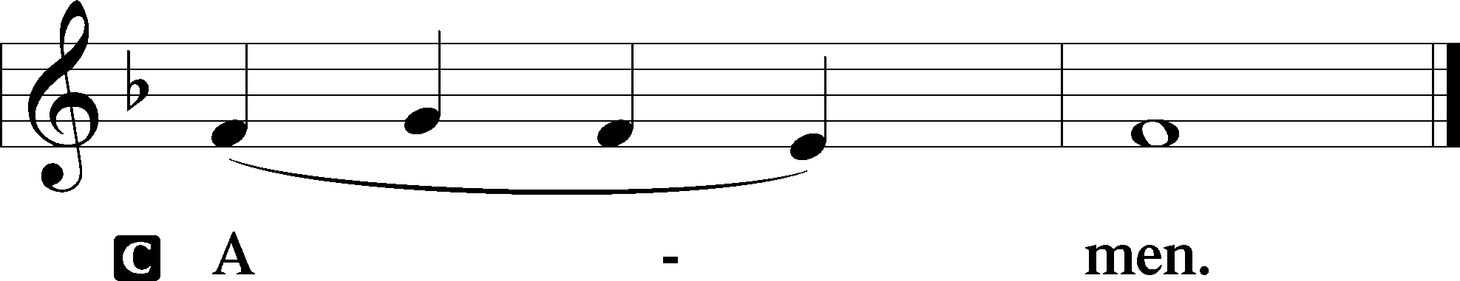

Agnus Dei John 1:29
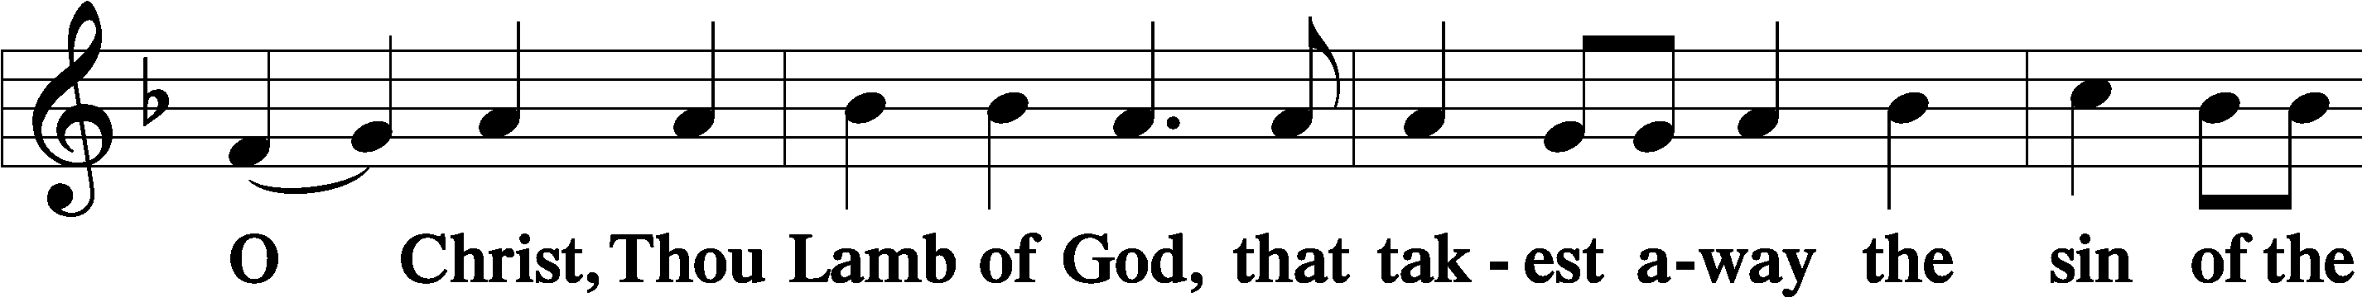
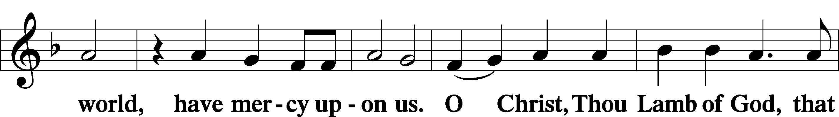
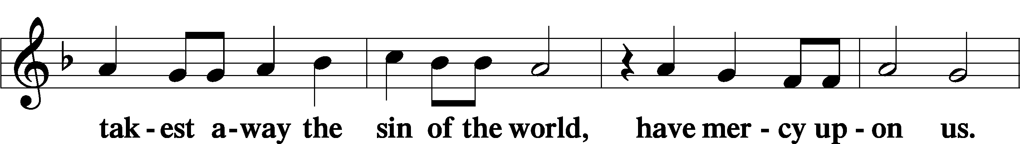
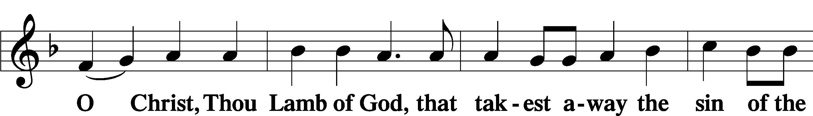
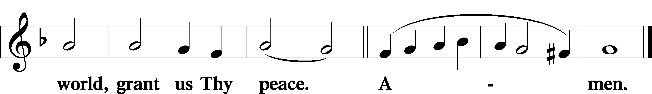

Sit

Distribution

The pastor and those who assist him receive the body and blood of Christ first and then distribute them to those who come to receive, saying:

Take, eat; this is the true body of our Lord and Savior Jesus Christ, given into death for your sins.
Amen.

Take, drink; this is the true blood of our Lord and Savior Jesus Christ, shed for the forgiveness of your sins.
Amen.

In dismissing the communicants, the following is said:

The Dismissal
P The body and blood of our Lord Jesus Christ strengthen and preserve you in body and soul to life everlasting. Depart T in peace.
C Amen.

621 Let All Mortal Flesh Keep Silence
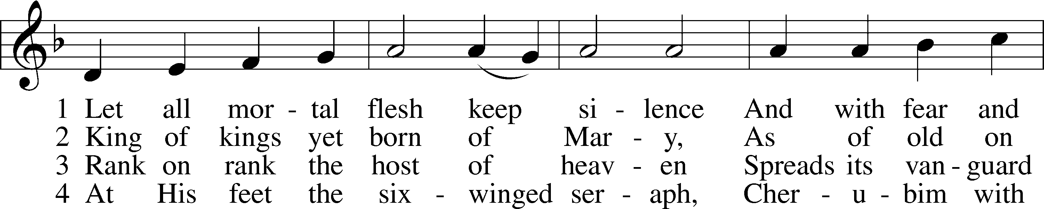
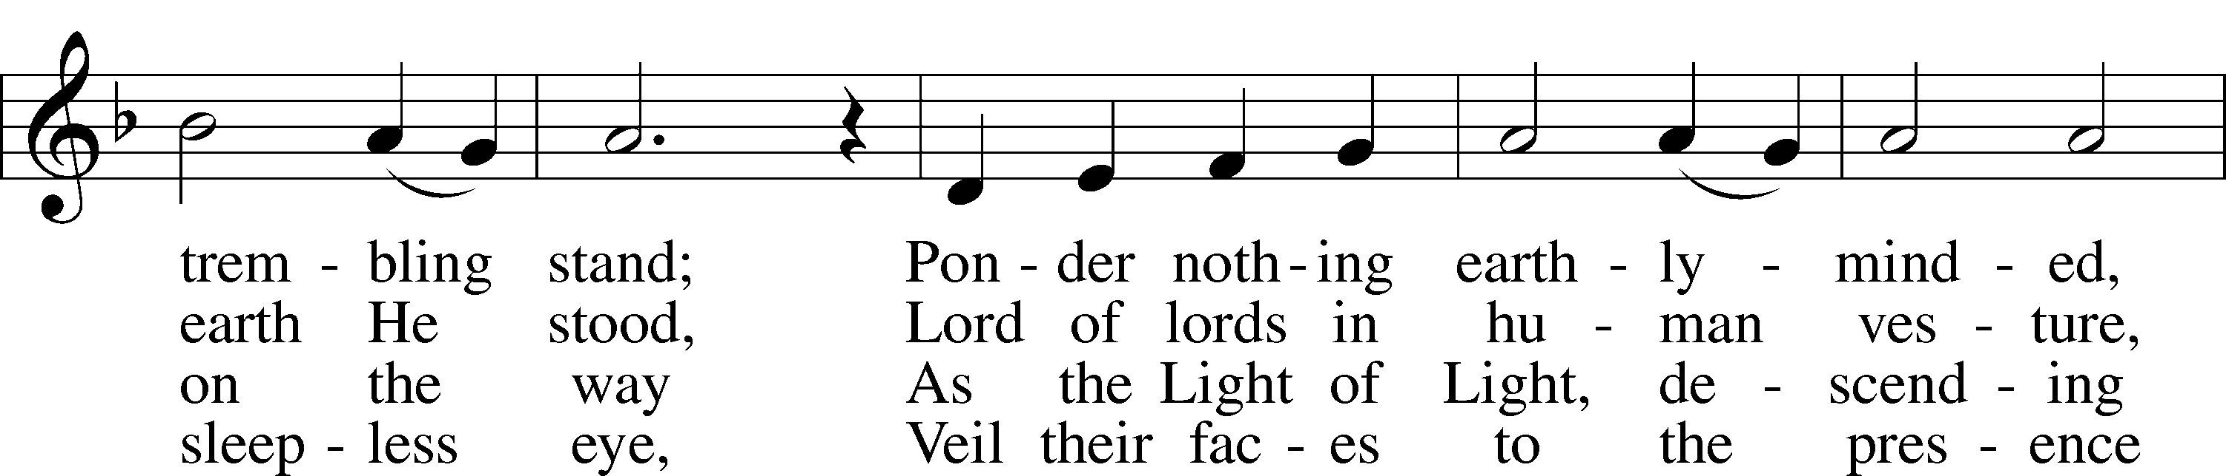
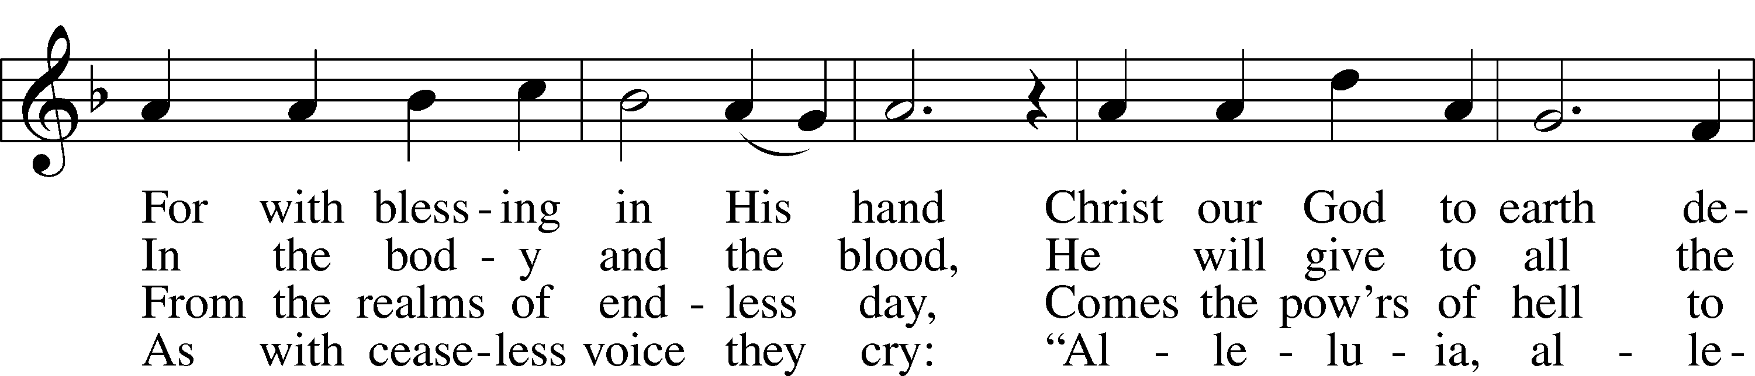
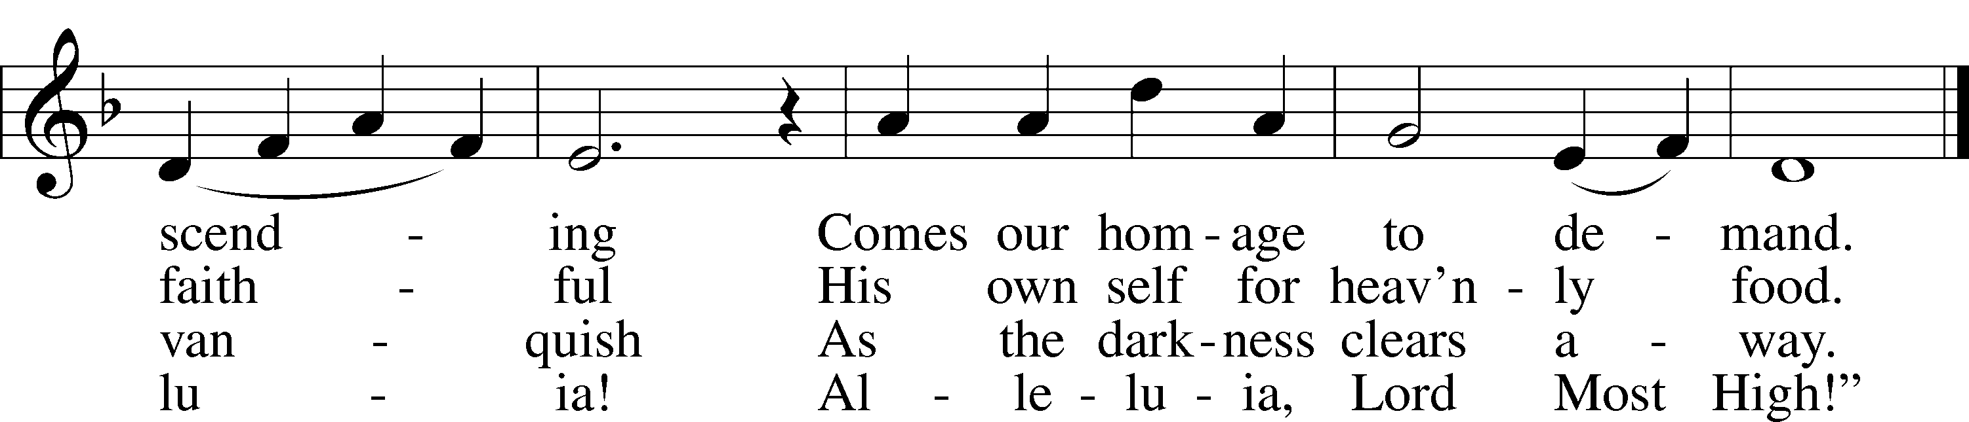
Text: Liturgy of St. James, 5th cent.; tr. Gerard Moultrie, 1829–85, alt.
Tune: French, 17th cent.
Text and tune: Public domain

623 Lord Jesus Christ, We Humbly Pray
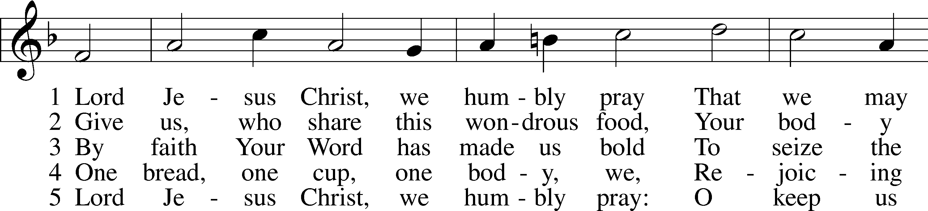
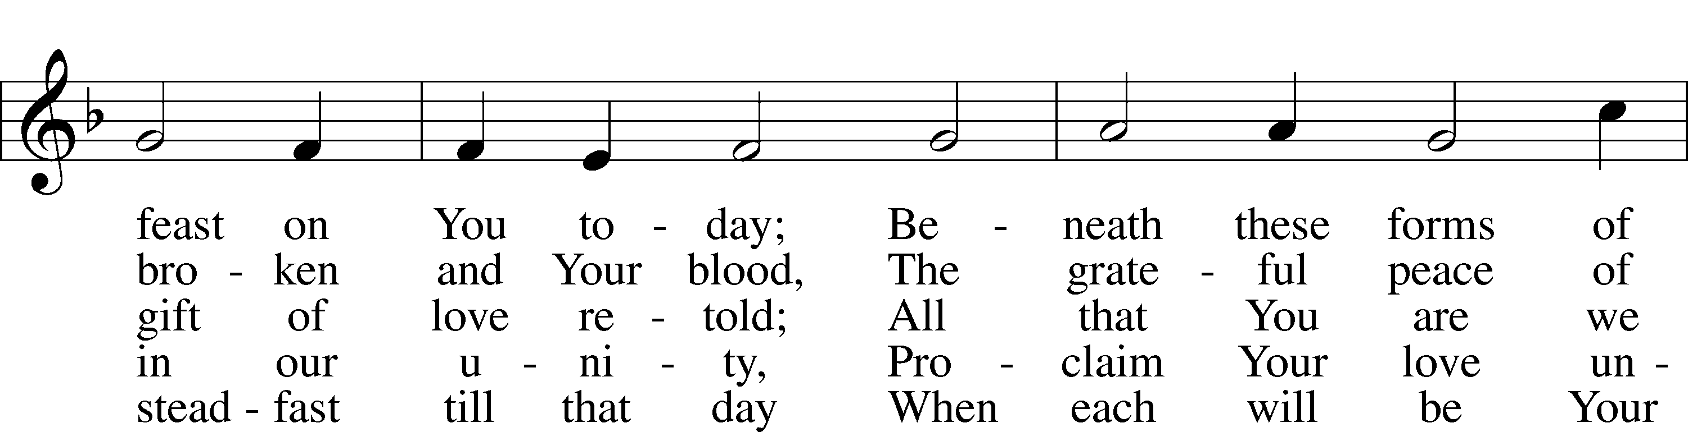
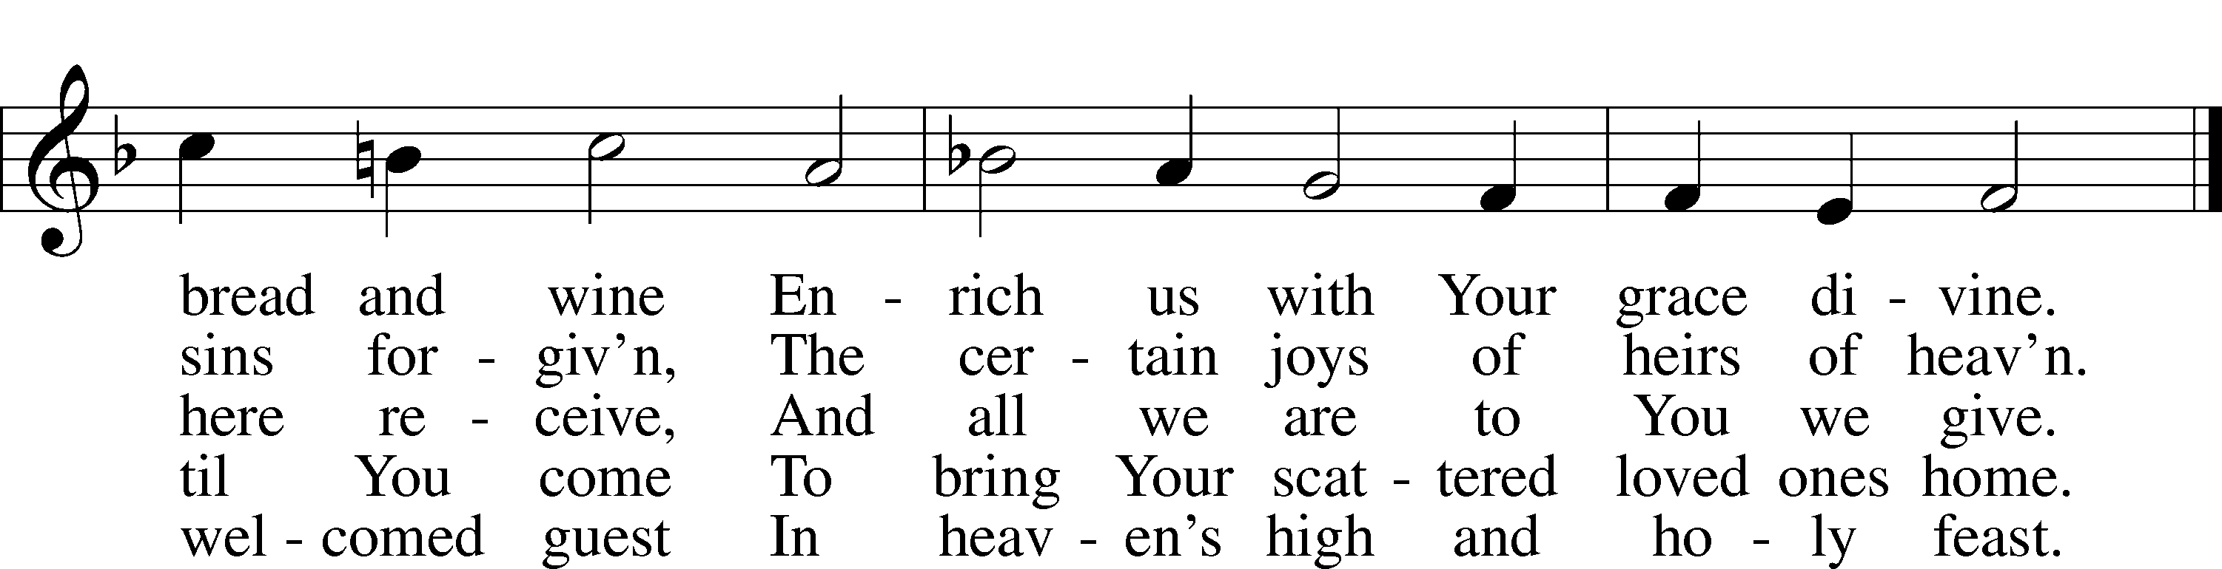
Text: Henry E. Jacobs, 1844–1932, alt.
Tune: Cantionale Germanicum, 1628, Gochsheim
Text and tune: Public domain

628 Your Table I Approach
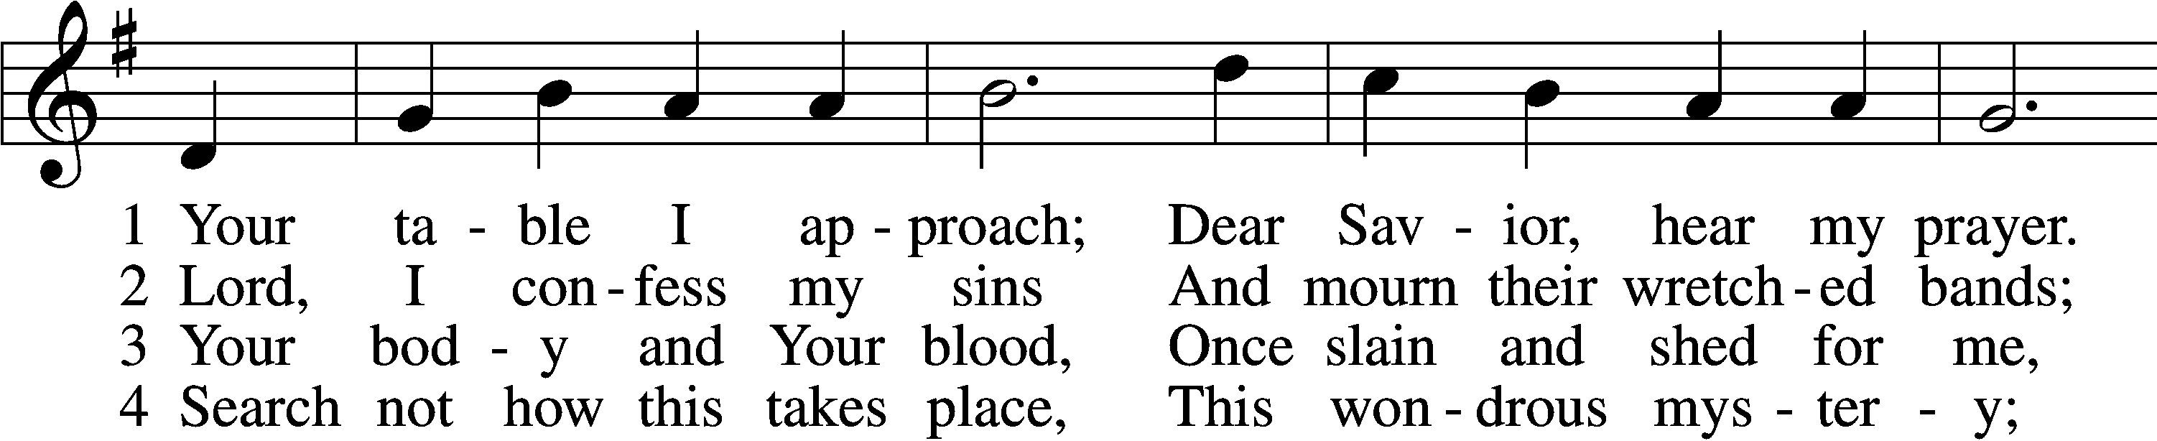
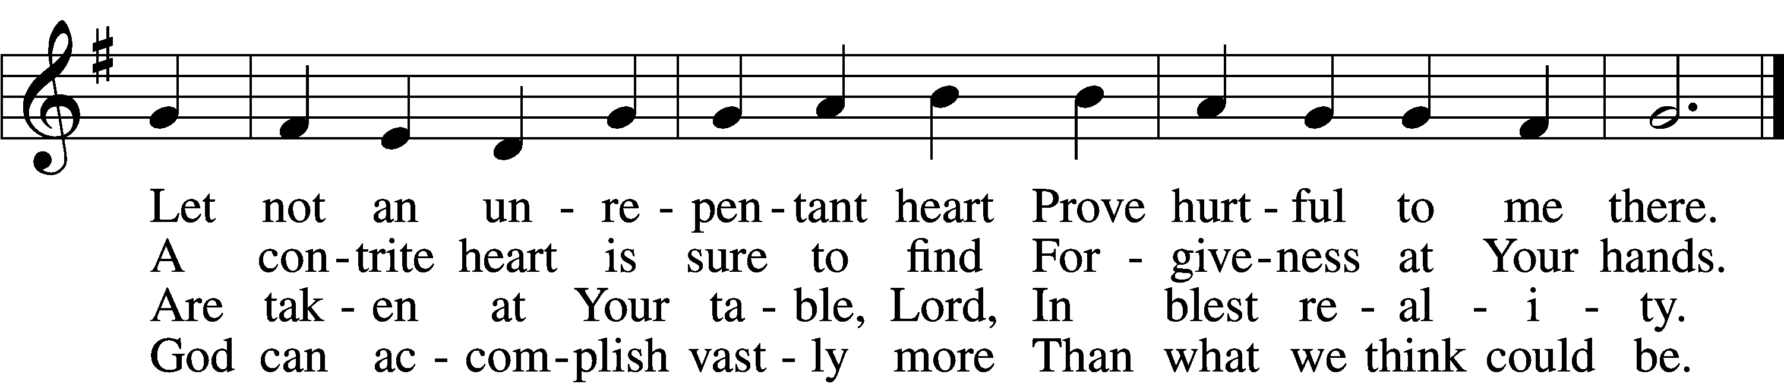

5 O grant, most blessèd Lord,
That earth and hell combined
May not about this sacrament
Raise doubt within my mind.

6 Oh, may I never fail
To thank You day and night
For Your true body and true blood,
O God, my peace and light.
Text: Gerhard Wolter Molanus, 1633–1722; tr. Matthias Loy, 1828–1915, alt.
Tune: Trente quatre Pseaumes de David, 1551, Geneva, ed. Louis Bourgeois
Text and tune: Public domain

619 Thy Body, Given for Me, O Savior
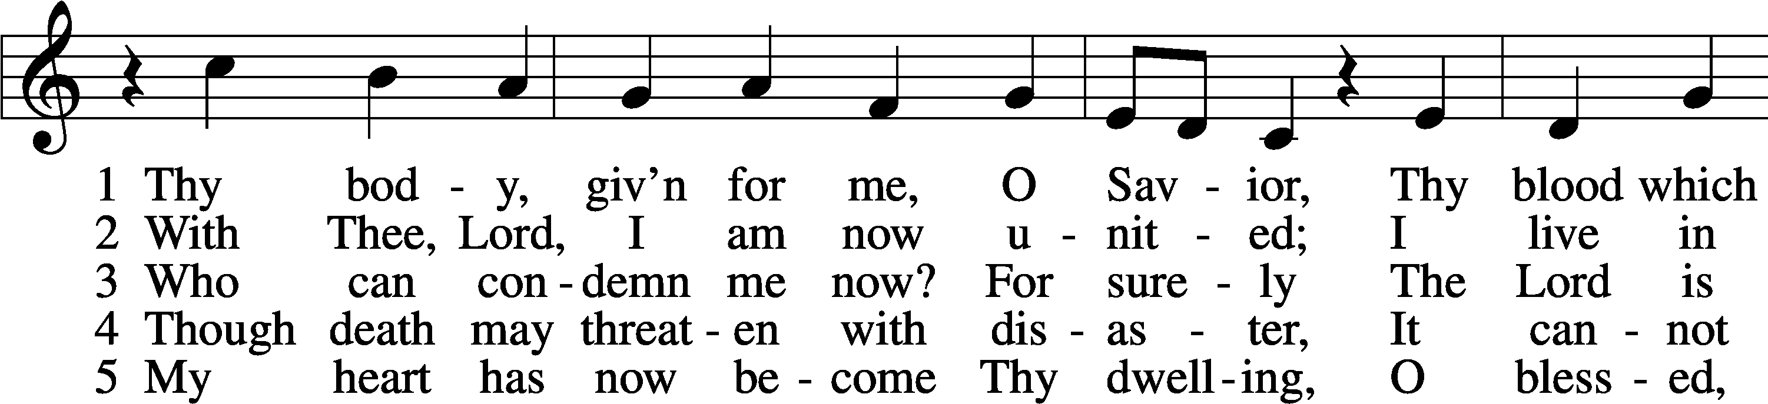
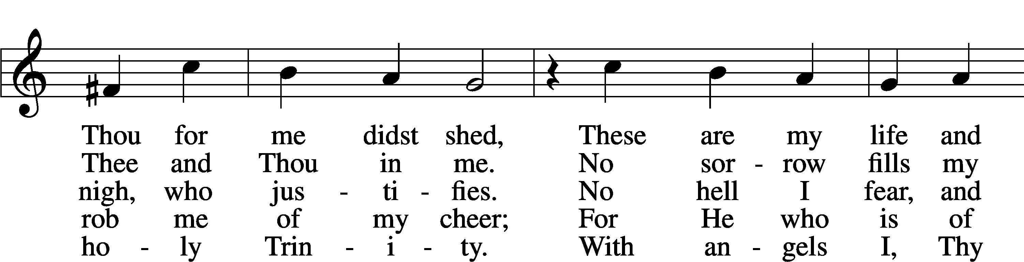
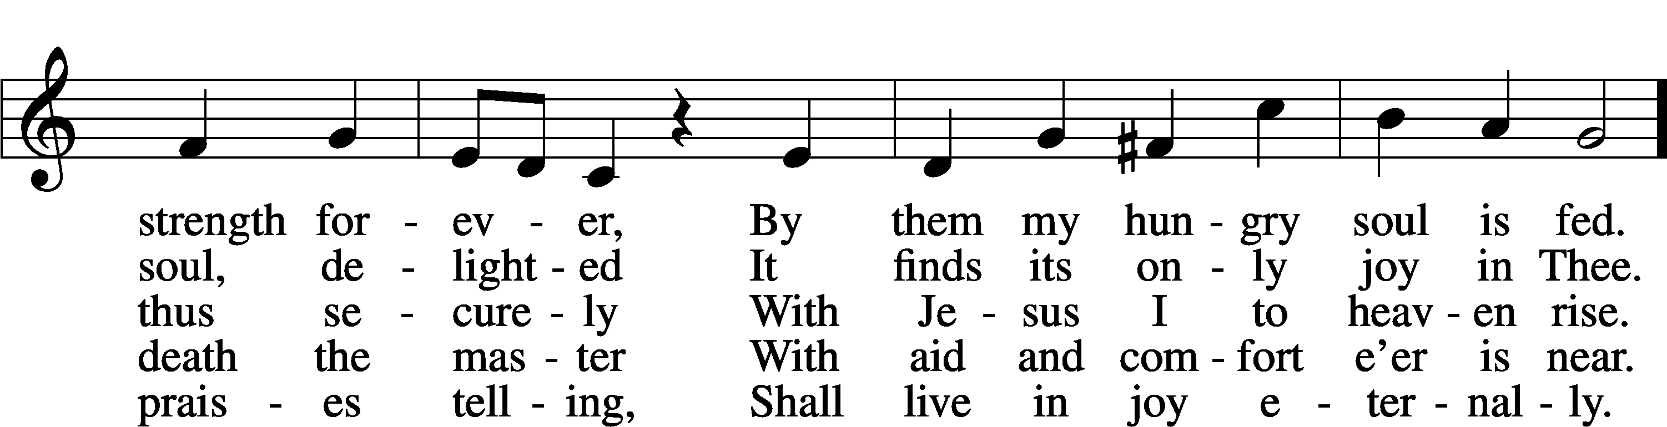
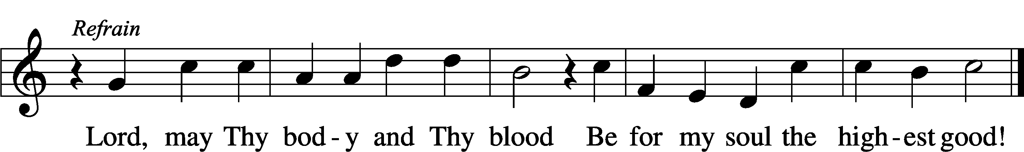
Text: Friedrich Christian Heyder, 1677–1754; tr. The Lutheran Hymnal, 1941, abr.
Tune: Emskirchner Choral-Buch, 1756, Leipzig
Text: © 1941 Concordia Publishing House. Used by permission: LSB Hymn License no. 110005011
Tune: Public domain

Stand

Nunc Dimittis Luke 2:29–32
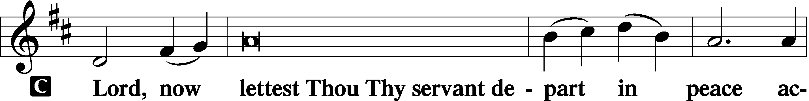

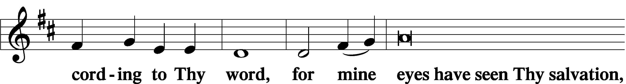

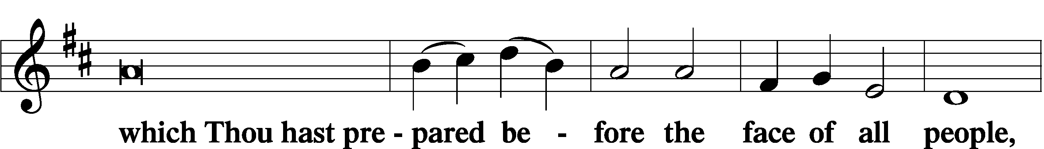

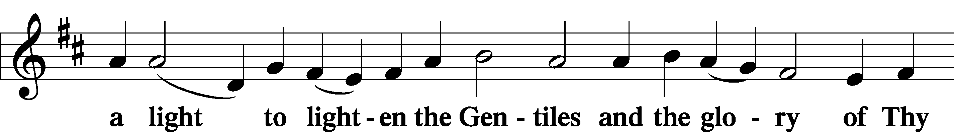

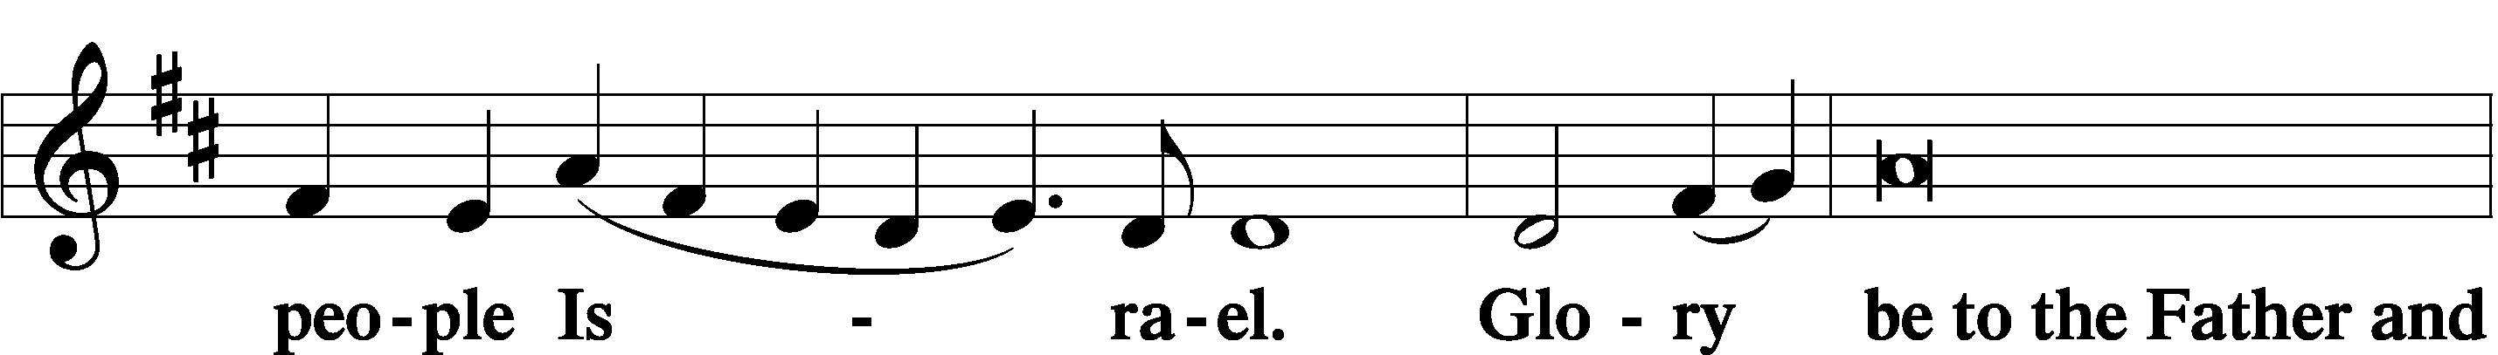

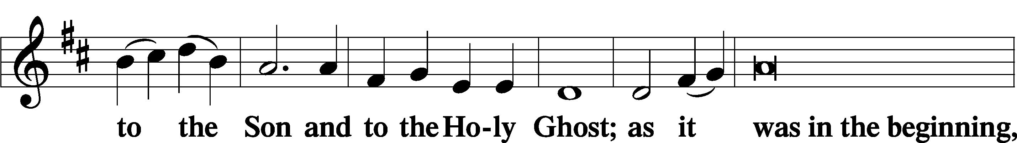

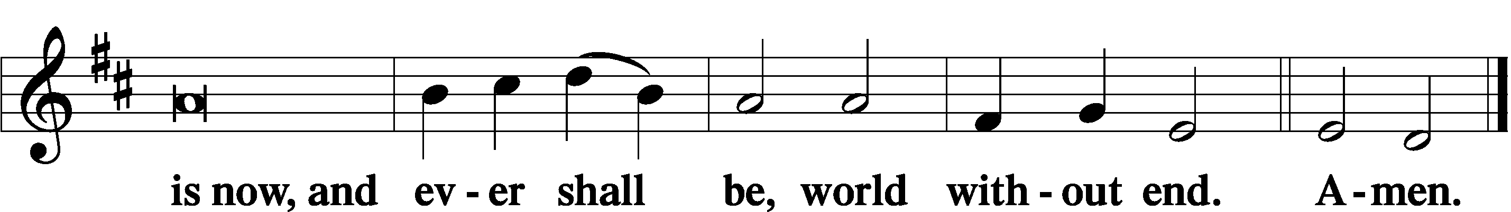

Thanksgiving Psalm 107:1
A O give thanks unto the Lord, for He is good,

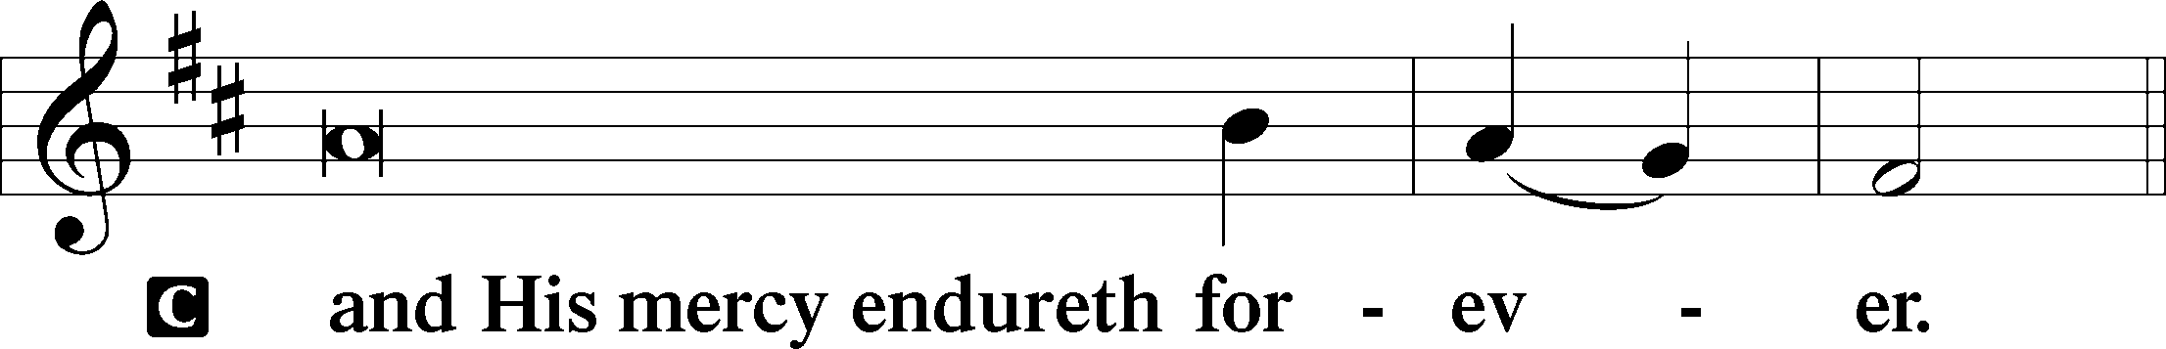

Post-Communion Collect
A Let us pray.
We give thanks to You, almighty God, that You have refreshed us through this salutary gift, and we implore You that of Your mercy You would strengthen us through the same in faith toward You and in fervent love toward one another; through Jesus Christ, Your Son, our Lord, who lives and reigns with You and the Holy Spirit, one God, now and forever.

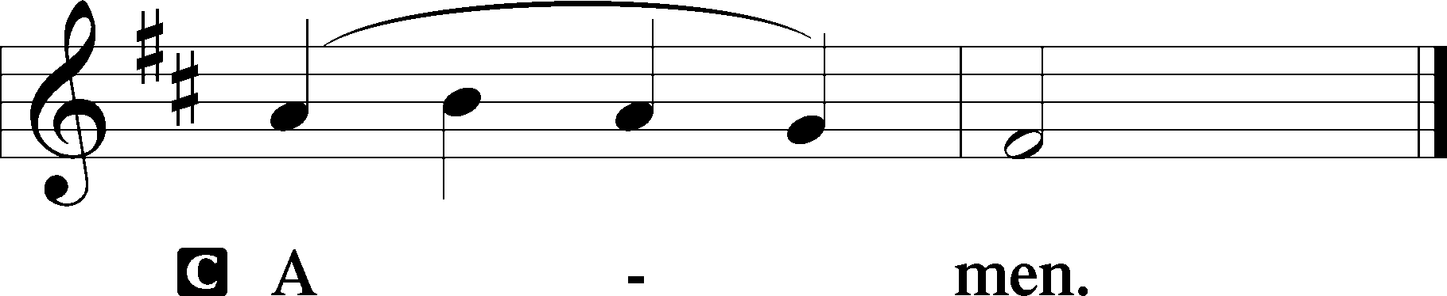

Salutation 2 Timothy 4:22
P The Lord be with you.

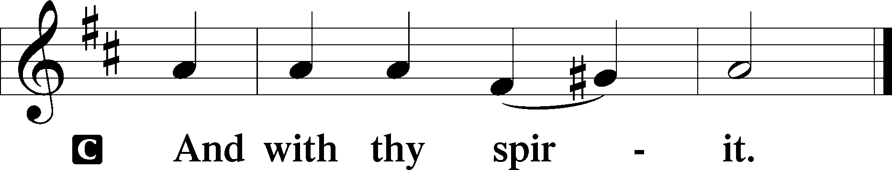

Benedicamus Psalm 103:1
A Bless we the Lord.

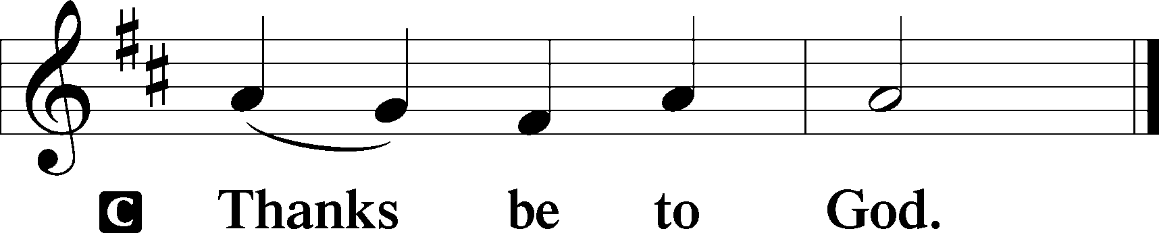

Benediction Numbers 6:24–26
P The Lord bless you and keep you.
The Lord make His face shine upon you and be gracious unto you.
The Lord lift up His countenance upon you and T give you peace.
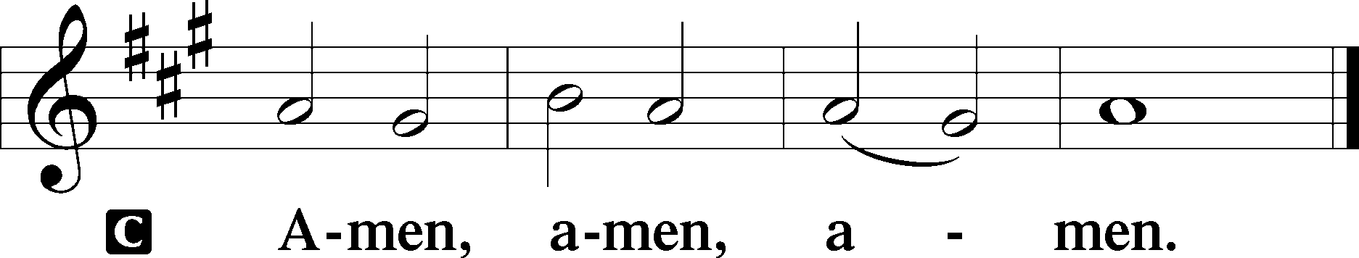

693 O Holy Spirit, Grant Us Grace
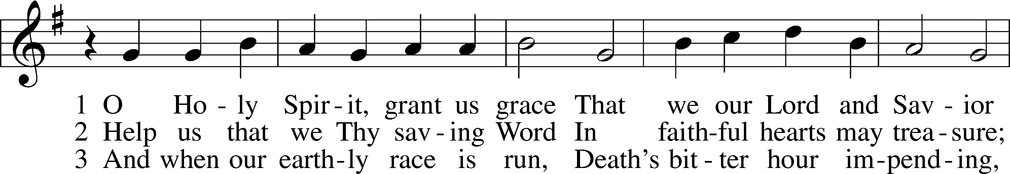
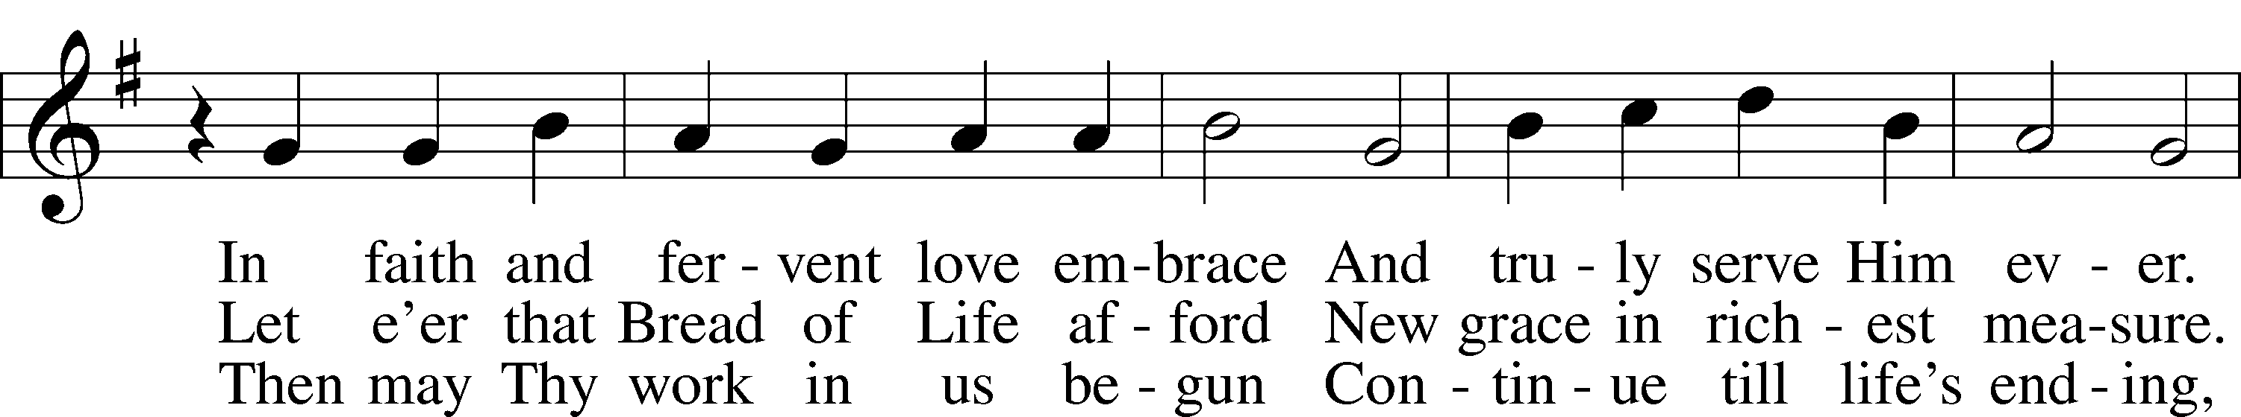
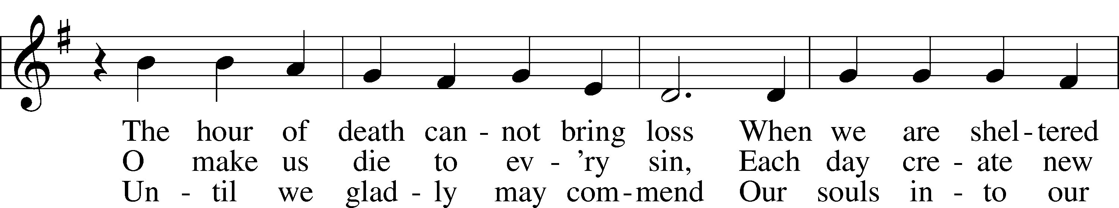
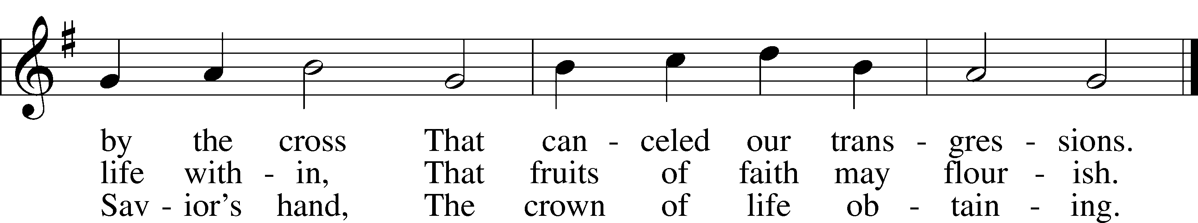
Text: Bartholomäus Ringwaldt, 1532–99; tr. Oluf H. Smeby, 1851–1929, alt.
Tune: Geistliche Lieder auffs new gebessert, 1535, Wittenberg, ed. Joseph Klug
Text and tune: Public domain

Acknowledgments
Divine Service, Setting Three from Lutheran Service Book
Unless otherwise indicated, Scripture quotations are from the ESV® Bible (The Holy Bible, English Standard Version®), copyright © 2001 by Crossway, a publishing ministry of Good News Publishers. Used by permission. All rights reserved.
Created by Lutheran Service Builder © 2026 Concordia Publishing House.

