On entering the church

P Lord, I love the habitation of Your house and the place
where Your glory dwells. In the multitude of Your tender
mercies prepare my heart that I may enter Your house to
worship and confess Your holy name; through Jesus Christ,
my God and Lord.

Before worship

C O Lord, our creator, redeemer, and comforter, as we come
together to worship You in spirit and in truth, we humbly
pray that You would open our hearts to the preaching of
Your Word so that we may repent of our sins, believe in
Jesus Christ as our only Savior, and grow in grace and
holiness. Hear us for His sake.

344 On Jordan’s Bank the Baptist’s Cry
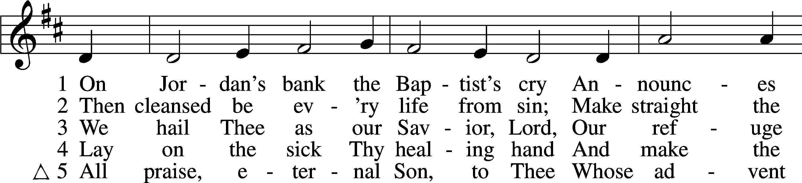
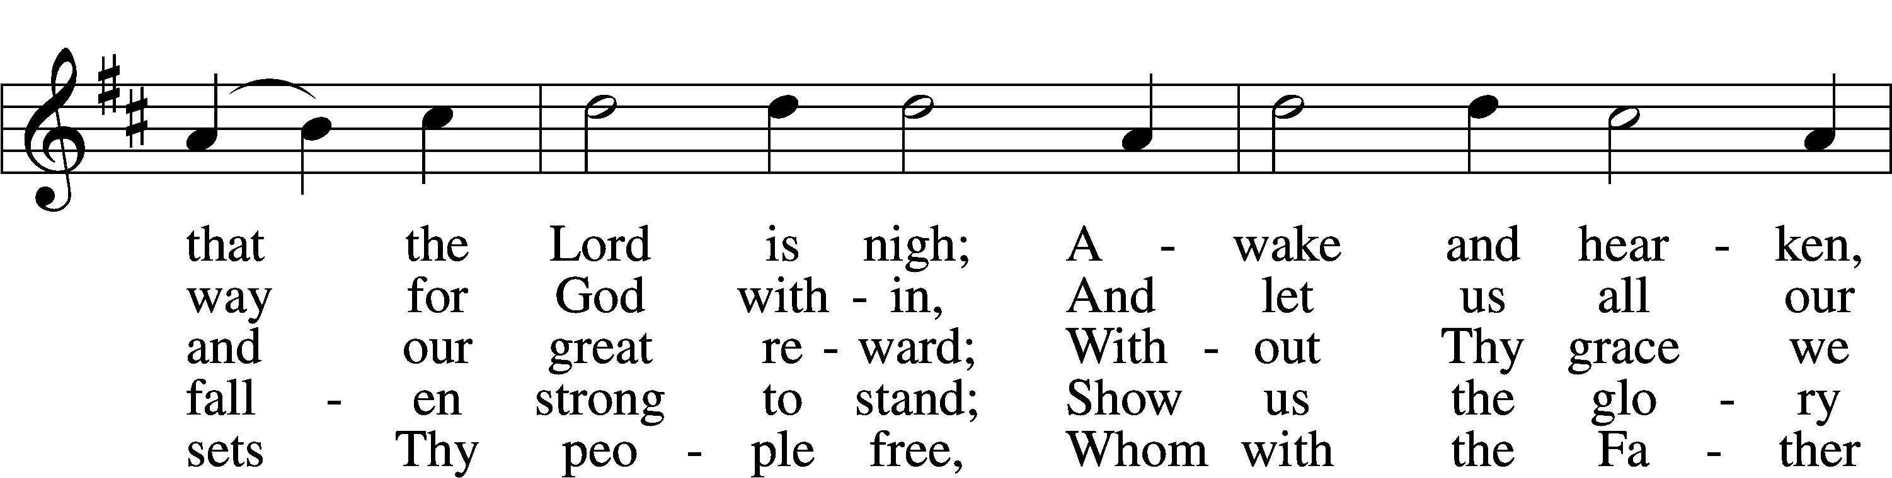
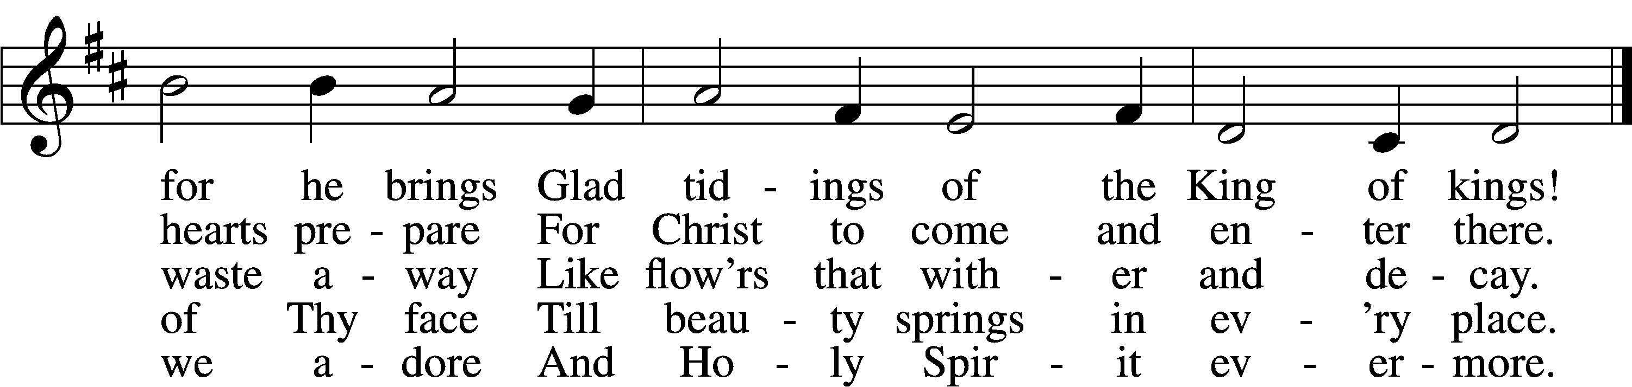
Text: Charles Coffin, 1676–1749; tr. composite
Tune: adapt. Michael Praetorius, 1571–1621
Text and tune: Public domain

Confession and Absolution

The sign of the cross may be made by all in remembrance of their Baptism.

Invocation Matthew 28:19b; 18:20
P In the name of the Father and of the T Son and of the Holy Spirit.
C Amen.

Exhortation Hebrews 10:22; Psalm 124:8; Psalm 32:5
P Beloved in the Lord! Let us draw near with a true heart and confess our sins unto God our Father, beseeching Him in the name of our Lord Jesus Christ to grant us forgiveness.

P Our help is in the name of the Lord,
C who made heaven and earth.
P I said, I will confess my transgressions unto the Lord,
C and You forgave the iniquity of my sin.

Silence for reflection on God’s Word and for self-examination.

Confession of Sins
P Almighty God, our maker and redeemer, we poor sinners confess unto You that we are by nature sinful and unclean and that we have sinned against You by thought, word, and deed. Wherefore we flee for refuge to Your infinite mercy, seeking and imploring Your grace for the sake of our Lord Jesus Christ.
C O most merciful God, who has given Your only-begotten Son to die for us, have mercy upon us and for His sake grant us remission of all our sins; and by Your Holy Spirit increase in us true knowledge of You and of Your will and true obedience to Your Word, to the end that by Your grace we may come to everlasting life; through Jesus Christ, our Lord. Amen.

Declaration of Grace Mark 16:16; John 1:12
P Almighty God, our heavenly Father, has had mercy upon us and has given His only Son to die for us and for His sake forgives us all our sins. To those who believe on His name He gives power to become the children of God and has promised them His Holy Spirit. He that believes and is baptized shall be saved.
Grant this, Lord, unto us all.
C Amen.

Service of the Word

Introit Psalm 85:1–2, 6, 8; antiphon: Philippians 4:4–5
Rejoice in the Lord always;
again I will say, Rejoice.
Let your reasonableness be known to everyone.
The Lord is at hand.
Lord, you were favorable to your land;
you restored the fortunes of Jacob.
You forgave the iniquity of your people;
you covered all their sin.
Will you not revive us again,
that your people may rejoice in you?
Let me hear what God the Lord will speak,
for he will speak peace to his people, to his saints; but let them not turn back to folly.

Gloria Patri
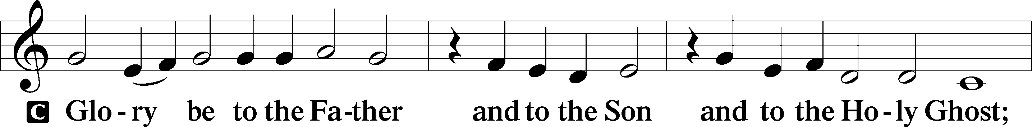
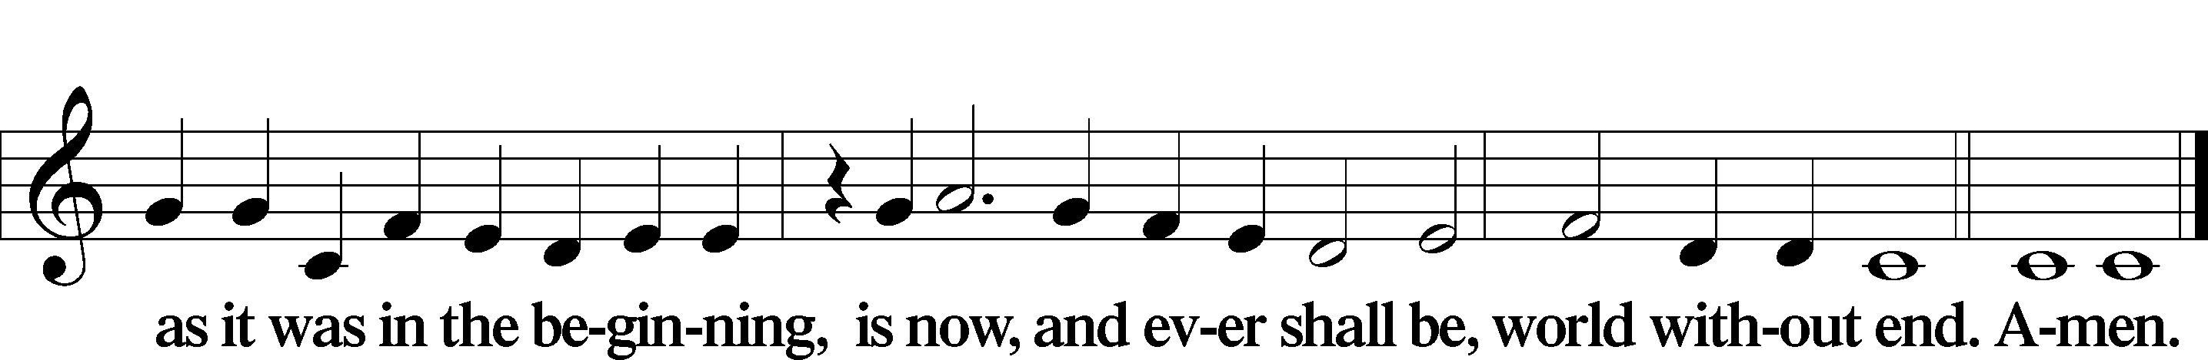

Kyrie Mark 10:47
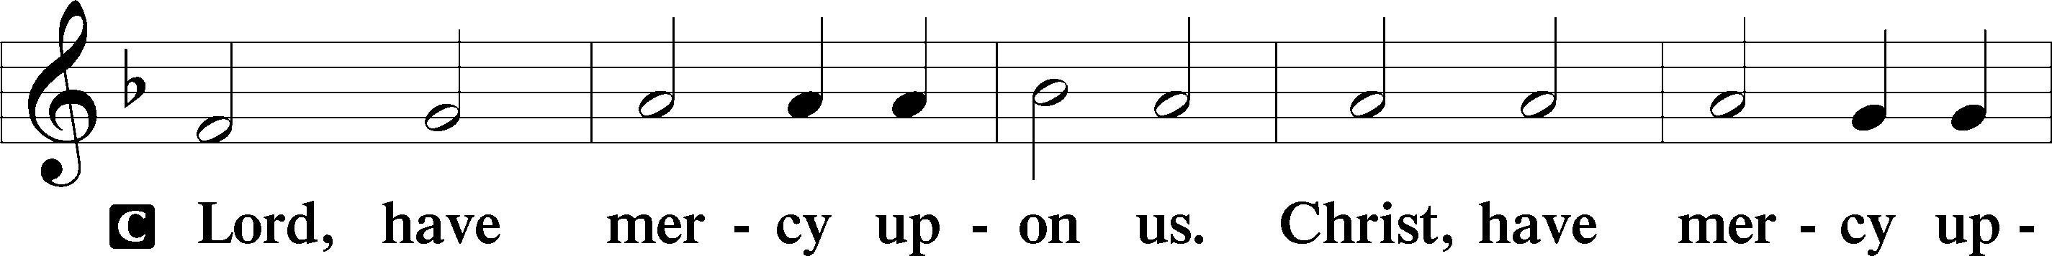
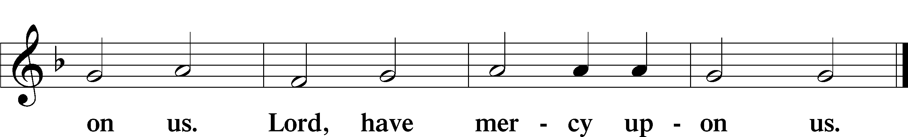

Salutation and Collect of the Day
P The Lord be with you.
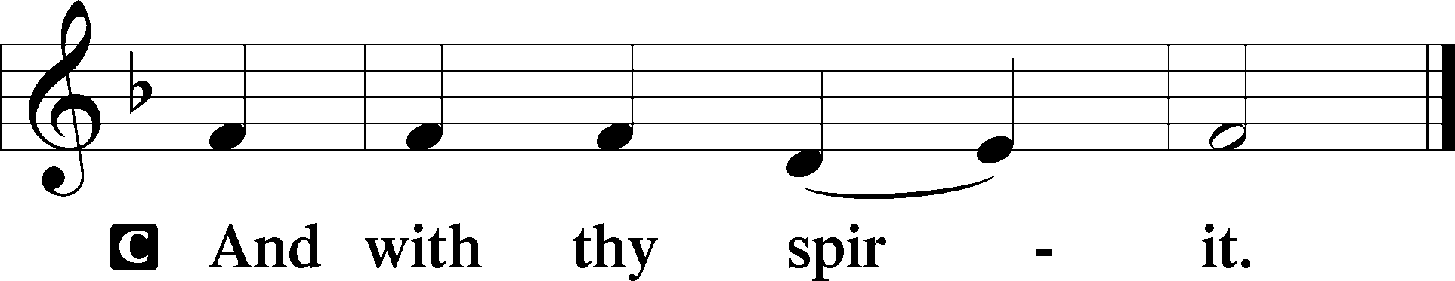

P Let us pray.
Lord Jesus Christ, we implore You to hear our prayers and to lighten the darkness of our hearts by Your gracious visitation; for You live and reign with the Father and the Holy Spirit, one God, now and forever.

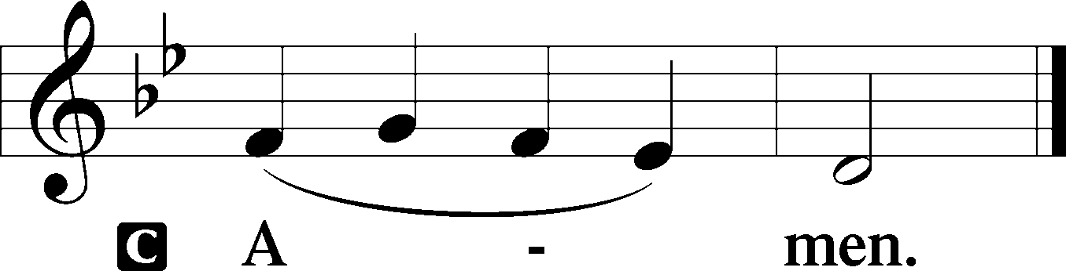

Sit

Old Testament Reading Isaiah 40:1–11
1Comfort, comfort my people, says your God.
2Speak tenderly to Jerusalem,
and cry to her
that her warfare is ended,
that her iniquity is pardoned,
that she has received from the Lord’s hand
double for all her sins.
3A voice cries:
“In the wilderness prepare the way of the Lord;
make straight in the desert a highway for our God.
4Every valley shall be lifted up,
and every mountain and hill be made low;
the uneven ground shall become level,
and the rough places a plain.
5And the glory of the Lord shall be revealed,
and all flesh shall see it together,
for the mouth of the Lord has spoken.”
6A voice says, “Cry!”
And I said, “What shall I cry?”
All flesh is grass,
and all its beauty is like the flower of the field.
7The grass withers, the flower fades
when the breath of the Lord blows on it;
surely the people are grass.
8The grass withers, the flower fades,
but the word of our God will stand forever.
9Get you up to a high mountain,
O Zion, herald of good news;
lift up your voice with strength,
O Jerusalem, herald of good news;
lift it up, fear not;
say to the cities of Judah,
“Behold your God!”
10Behold, the Lord God comes with might,
and his arm rules for him;
behold, his reward is with him,
and his recompense before him.
11He will tend his flock like a shepherd;
he will gather the lambs in his arms;
he will carry them in his bosom,
and gently lead those that are with young.

A This is the Word of the Lord.
C Thanks be to God.

Gradual Psalm 80:1–2
You who are enthroned upon the cherubim, shine forth.
Stir up your might and come to save us!
Give ear, O Shepherd of Israel,
you who lead Joseph like a flock!

Epistle 1 Corinthians 4:1–5
1This is how one should regard us, as servants of Christ and stewards of the mysteries of God. 2Moreover, it is required of stewards that they be found trustworthy. 3But with me it is a very small thing that I should be judged by you or by any human court. In fact, I do not even judge myself. 4I am not aware of anything against myself, but I am not thereby acquitted. It is the Lord who judges me. 5Therefore do not pronounce judgment before the time, before the Lord comes, who will bring to light the things now hidden in darkness and will disclose the purposes of the heart. Then each one will receive his commendation from God.

Stand

Alleluia
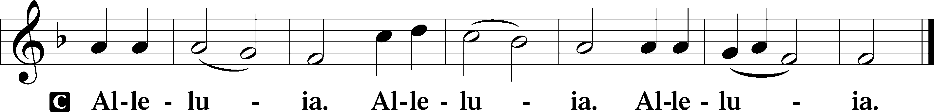

Holy Gospel Matthew 11:2–11
P The Holy Gospel according to St. Matthew, the eleventh chapter.

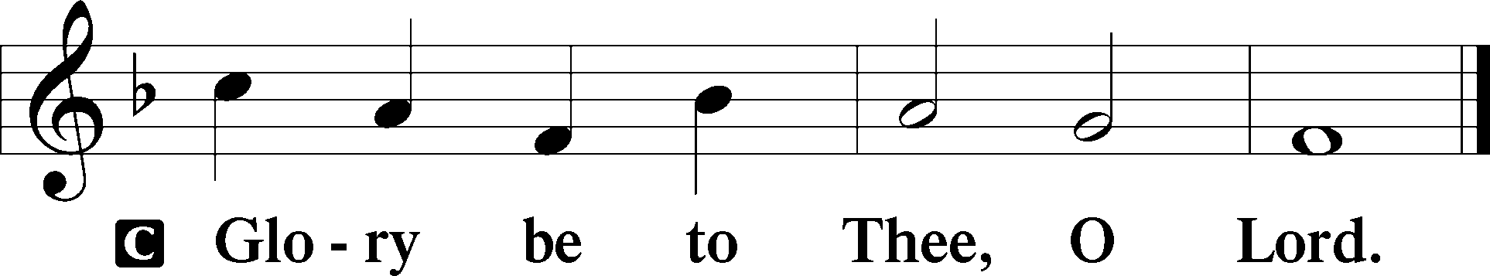

2When John heard in prison about the deeds of the Christ, he sent word by his disciples 3and said to him, “Are you the one who is to come, or shall we look for another?” 4And Jesus answered them, “Go and tell John what you hear and see: 5the blind receive their sight and the lame walk, lepers are cleansed and the deaf hear, and the dead are raised up, and the poor have good news preached to them. 6And blessed is the one who is not offended by me.”
7As they went away, Jesus began to speak to the crowds concerning John: “What did you go out into the wilderness to see? A reed shaken by the wind? 8What then did you go out to see? A man dressed in soft clothing? Behold, those who wear soft clothing are in kings’ houses. 9What then did you go out to see? A prophet? Yes, I tell you, and more than a prophet. 10This is he of whom it is written,
“‘Behold, I send my messenger before your face,
who will prepare your way before you.’
11Truly, I say to you, among those born of women there has arisen no one greater than John the Baptist. Yet the one who is least in the kingdom of heaven is greater than he.”

P This is the Gospel of the Lord.

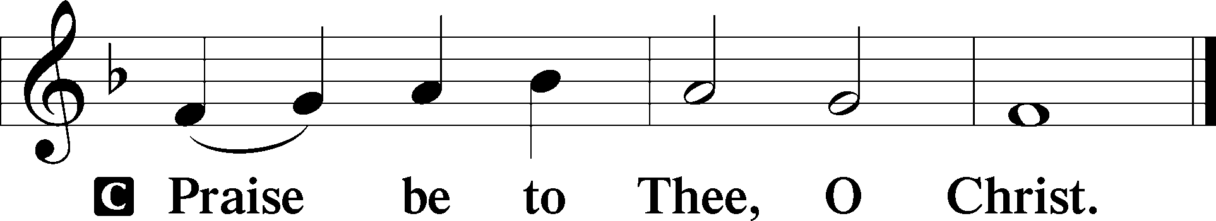

Apostles’ Creed
C I believe in God, the Father Almighty,
maker of heaven and earth.

And in Jesus Christ, His only Son, our Lord,
who was conceived by the Holy Spirit,
born of the virgin Mary,
suffered under Pontius Pilate,
was crucified, died and was buried.
He descended into hell.
The third day He rose again from the dead.
He ascended into heaven
and sits at the right hand of God the Father Almighty.
From thence He will come to judge the living and the dead.

I believe in the Holy Spirit,
the holy Christian Church,
the communion of saints,
the forgiveness of sins,
the resurrection of the body,
and the life T everlasting. Amen.

Sit

Children's Sermon

345 Hark! A Thrilling Voice Is Sounding
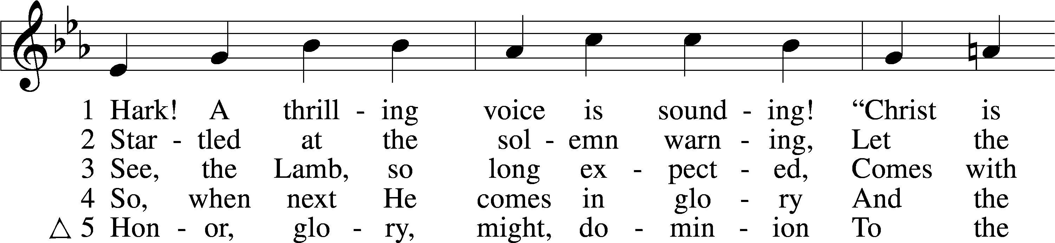
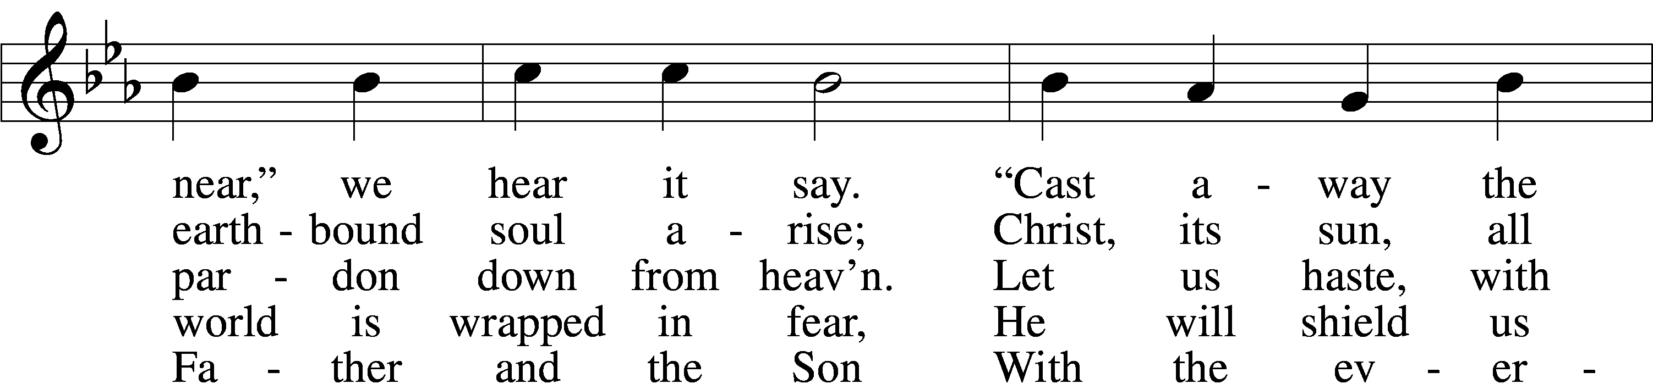
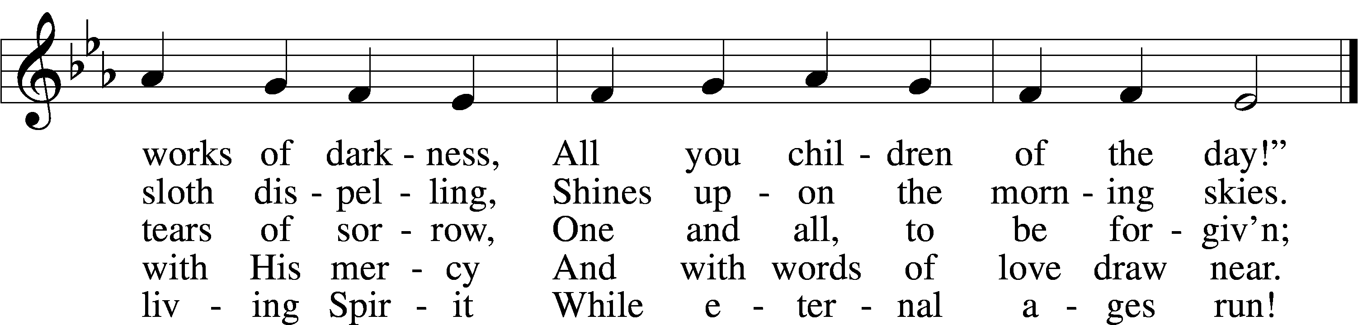
Text: Latin, c. 5th–10th cent.; tr. Edward Caswall, 1814–78, alt.
Tune: William H. Monk, 1823–89
Text and tune: Public domain

Sermon

Votum
P The peace of God, which passes all understanding, keep your hearts and minds in Christ Jesus.
C Amen.

Stand

Offertory Psalm 51:10–12
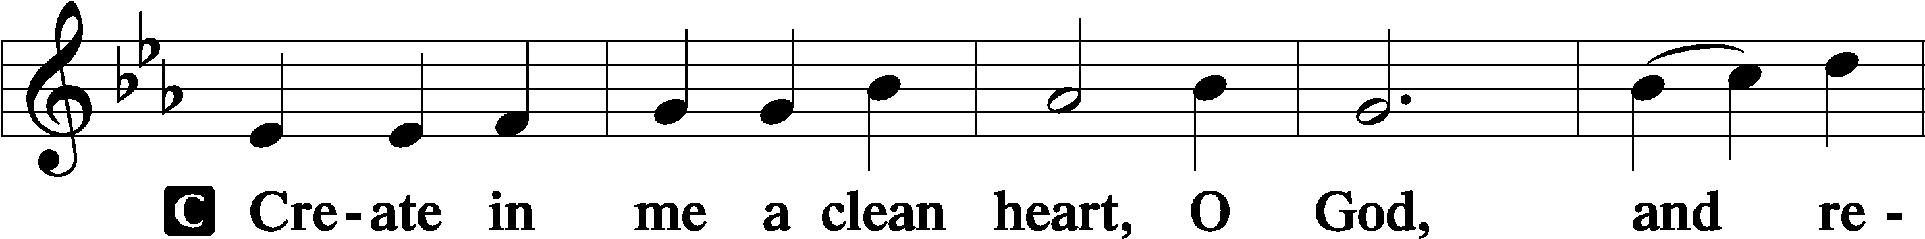
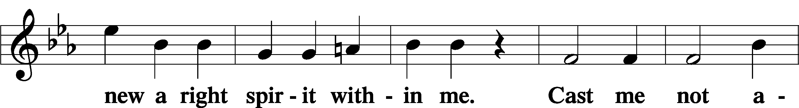
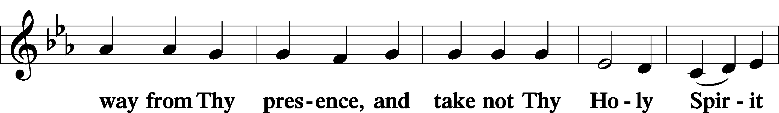
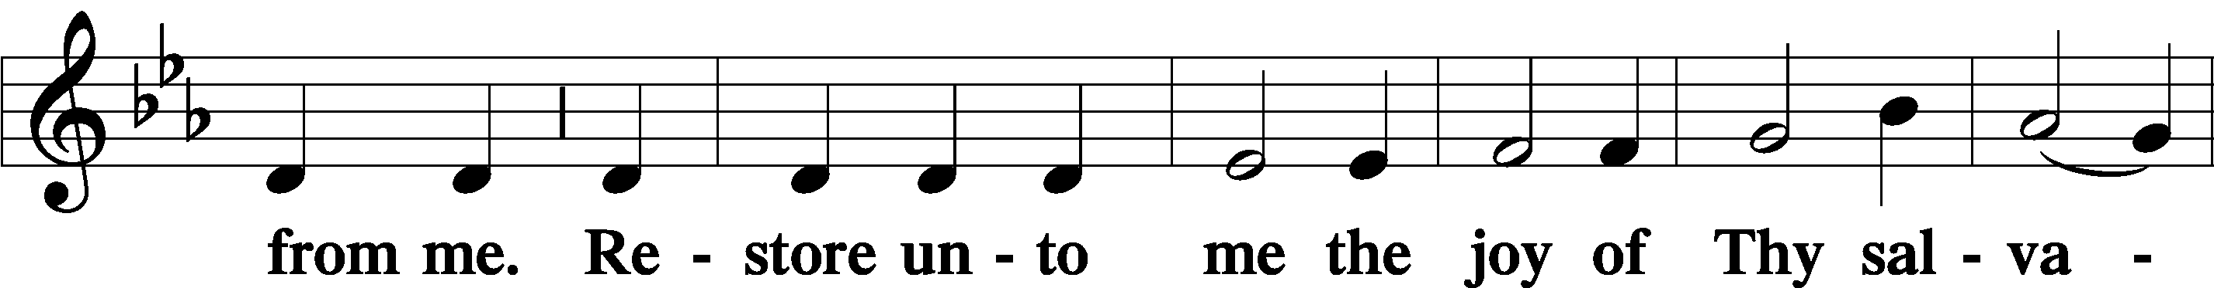
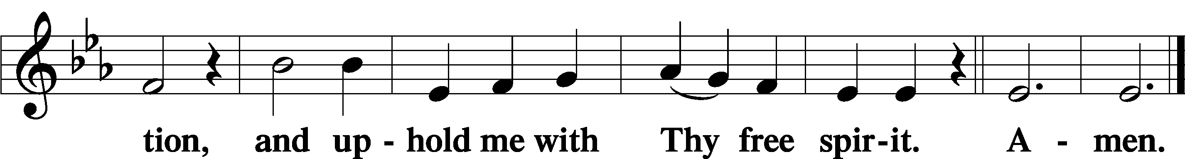

Offering

805 Praise God, from Whom All Blessings Flow
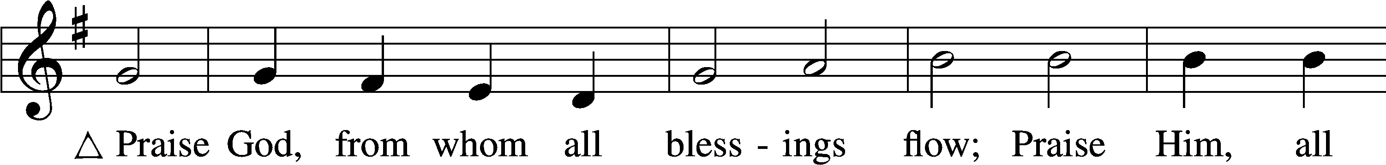
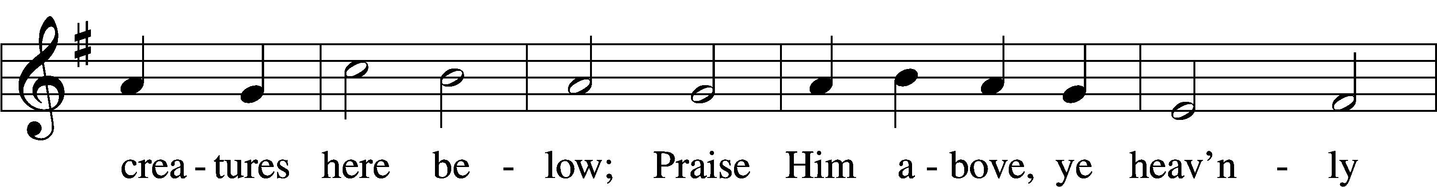
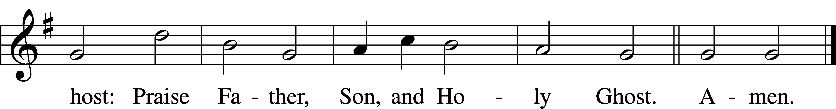
Text: Thomas Ken, 1637–1711
Tune: Trente quatre Pseaumes de David, 1551, Geneva, ed. Louis Bourgeois
Text and tune: Public domain

Prayer of the Church

Lord’s Prayer Matthew 6:9–13
P Lord, remember us in Your kingdom and teach us to pray:
C Our Father who art in heaven,
hallowed be Thy name,
Thy kingdom come,
Thy will be done on earth
as it is in heaven;
give us this day our daily bread;
and forgive us our trespasses
as we forgive those
who trespass against us;
and lead us not into temptation,
but deliver us from evil.
For Thine is the kingdom
and the power and the glory
forever and ever. Amen.

Collect for the Word

Blessed Lord, You have caused all Holy Scriptures to be written for our learning. Grant that we may so hear them, read, mark, learn, and inwardly digest them that, by the patience and comfort of Your holy Word, we may embrace and ever hold fast the blessed hope of everlasting life; through Jesus Christ, Your Son, our Lord, who lives and reigns with You and the Holy Spirit, one God, now and forever.

Benediction
P The Lord bless you and keep you.
The Lord make His face shine on you and be gracious to you.
The Lord look upon you with favor and T give you peace.
C Amen.

349 Hark the Glad Sound
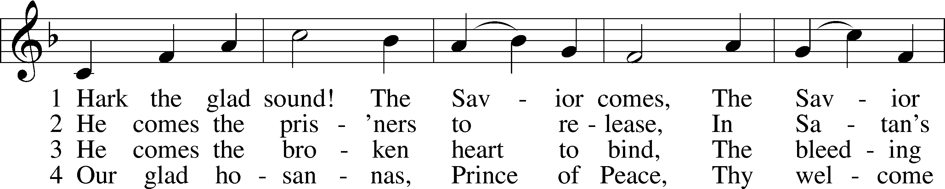
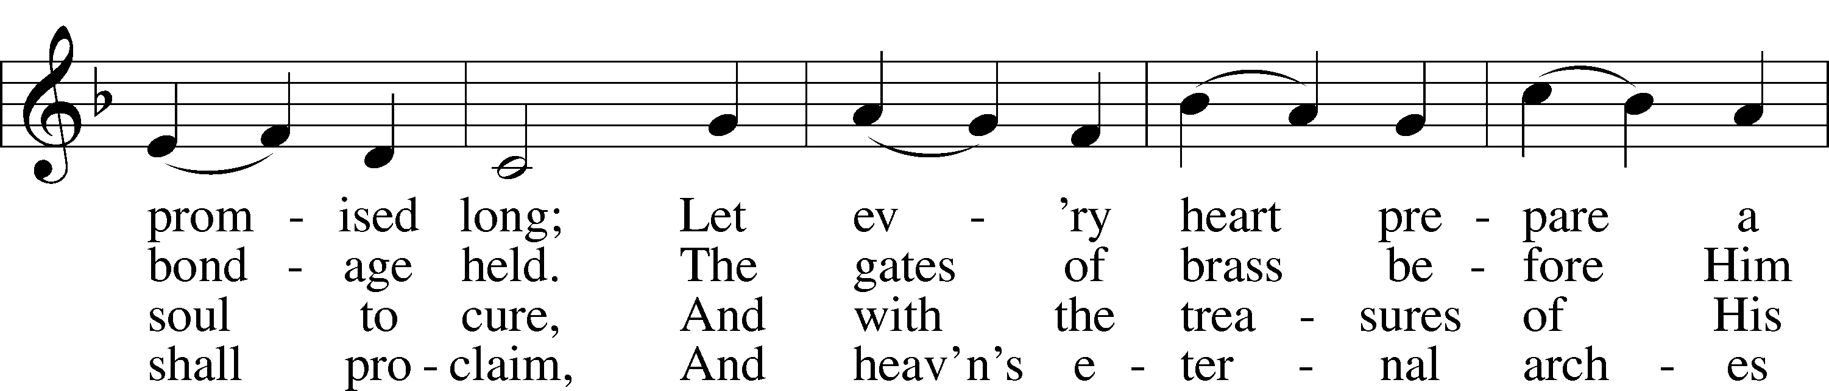
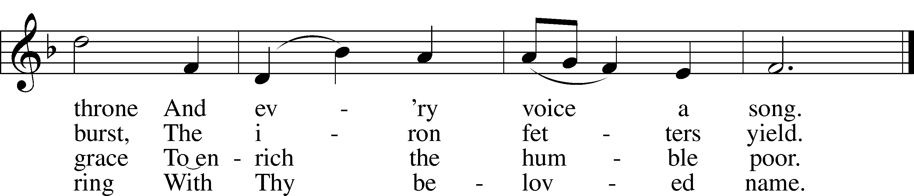
Text: Philip Doddridge, 1702–51
Tune: Thomas Haweis, 1734–1820
Text and tune: Public domain

Acknowledgments
Unless otherwise indicated, Scripture quotations are from the ESV® Bible (The Holy Bible, English Standard Version®), copyright © 2001 by Crossway, a publishing ministry of Good News Publishers. Used by permission. All rights reserved.
Created by Lutheran Service Builder © 2025 Concordia Publishing House.

