On entering the church

P Lord, I love the habitation of Your house and the place

where Your glory dwells. In the multitude of Your tender

mercies prepare my heart that I may enter Your house to

worship and confess Your holy name; through Jesus Christ,

my God and Lord.

Before worship

C O Lord, our creator, redeemer, and comforter, as we come

together to worship You in spirit and in truth, we humbly

pray that You would open our hearts to the preaching of

Your Word so that we may repent of our sins, believe in

Jesus Christ as our only Savior, and grow in grace and

holiness. Hear us for His sake.

442 All Glory, Laud, and Honor

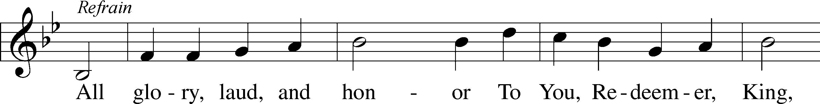

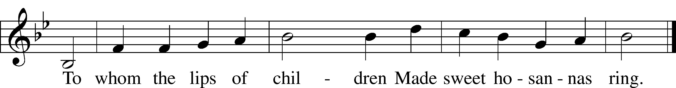

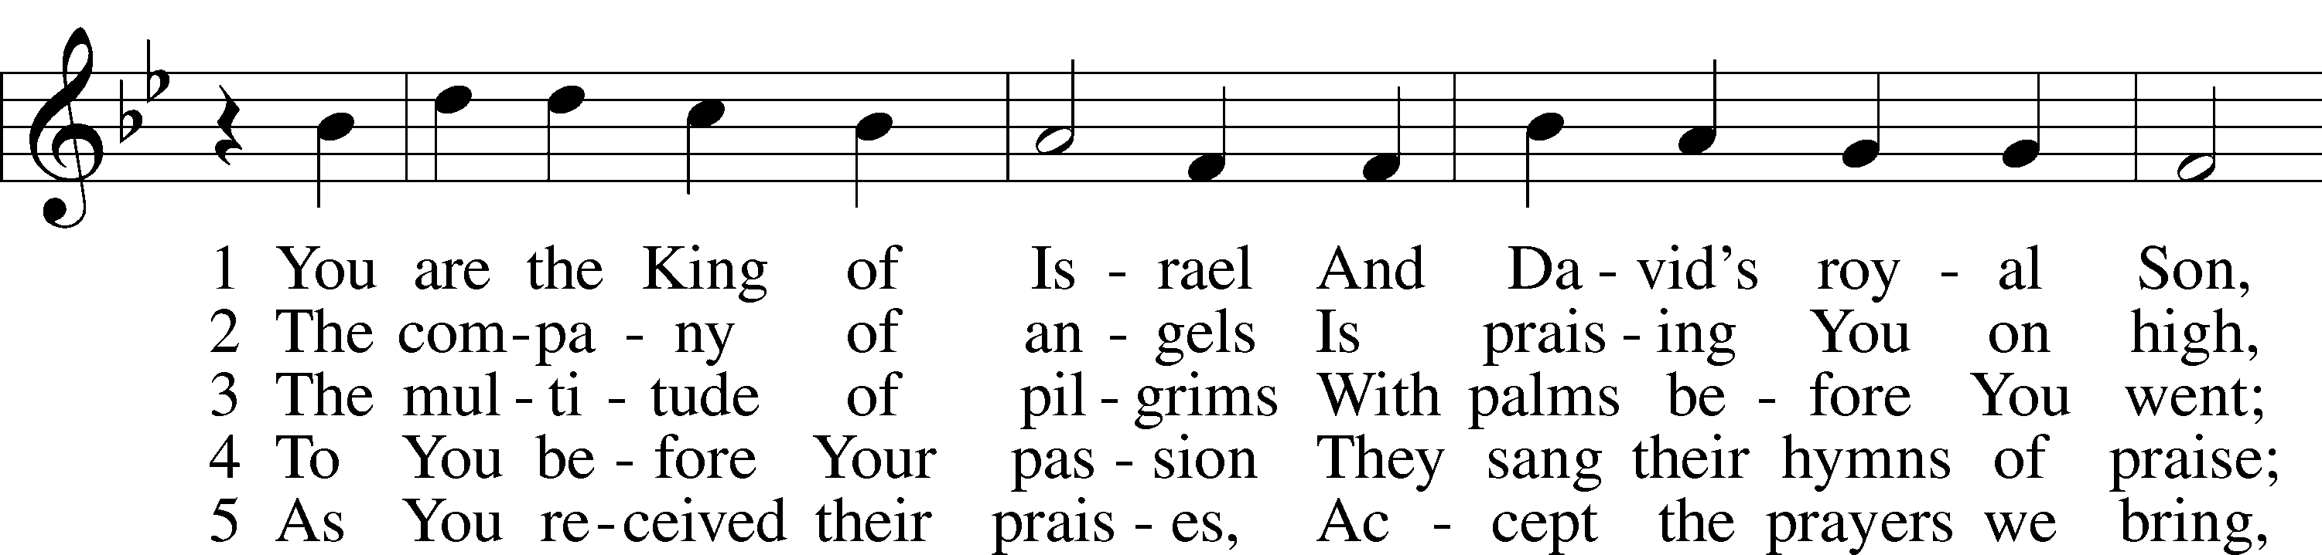

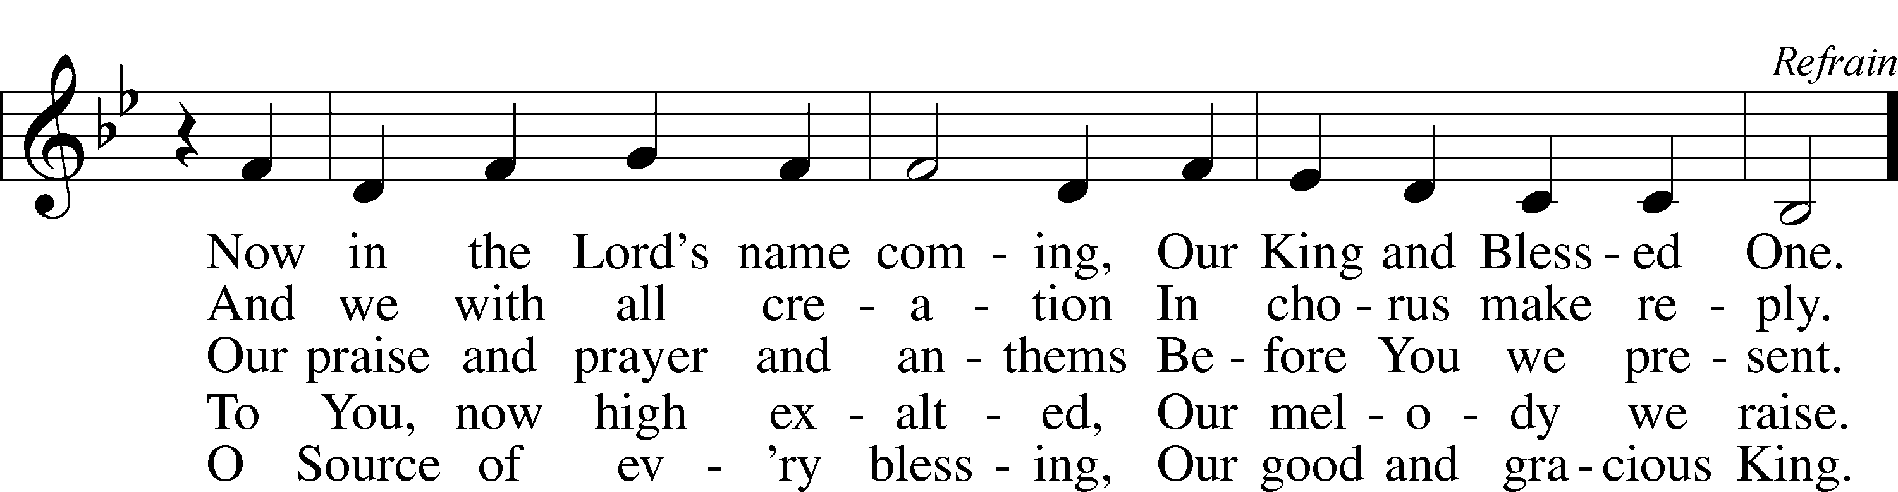

Text: Theodulf of Orléans, c. 762–821; tr. John Mason Neale, 1818–66, alt.  
Tune: Melchior Teschner, 1584–1635, alt.  
Text and tune: Public domain

# Confession and Absolution

The sign of the cross may be made by all in remembrance of their Baptism.

Invocation Matthew 28:19b; 18:20

P In the name of the Father and of the T Son and of the Holy Spirit.

C **Amen.**

Exhortation Hebrews 10:22; Psalm 124:8; Psalm 32:5

P Beloved in the Lord! Let us draw near with a true heart and confess our sins unto God our Father, beseeching Him in the name of our Lord Jesus Christ to grant us forgiveness.

P Our help is in the name of the Lord,

C **who made heaven and earth.**

P I said, I will confess my transgressions unto the Lord,

C **and You forgave the iniquity of my sin.**

Silence for reflection on God’s Word and for self-examination.

Confession of Sins

P Almighty God, our maker and redeemer, we poor sinners confess unto You that we are by nature sinful and unclean and that we have sinned against You by thought, word, and deed. Wherefore we flee for refuge to Your infinite mercy, seeking and imploring Your grace for the sake of our Lord Jesus Christ.

C **O most merciful God, who has given Your only-begotten Son to die for us, have mercy upon us and for His sake grant us remission of all our sins; and by Your Holy Spirit increase in us true knowledge of You and of Your will and true obedience to Your Word, to the end that by Your grace we may come to everlasting life; through Jesus Christ, our Lord. Amen.**

Declaration of Grace Mark 16:16; John 1:12

P Almighty God, our heavenly Father, has had mercy upon us and has given His only Son to die for us and for His sake forgives us all our sins. To those who believe on His name He gives power to become the children of God and has promised them His Holy Spirit. He that believes and is baptized shall be saved.  
  
Grant this, Lord, unto us all.

C **Amen.**

# Service of the Word

Introit Psalm 24:7–10; antiphon: Psalm 118:26

Blessèd is he who comes in the name of the Lord!  
 We bless you from the house of the Lord.  
**Lift up your heads, O gates! And be lifted up, O ancient doors,  
 that the King of glory may come in.**  
Who is this King of glory?  
 The Lord, strong and mighty, the Lord, mighty in battle!  
**Lift up your heads, O gates! And lift them up, O ancient doors,  
 that the King of glory may come in.**  
Who is this King of glory?  
 The Lord of hosts, he is the King of glory!  
**Blessèd is he who comes in the name of the Lord!  
 We bless you from the house of the Lord.**

Gloria Patri

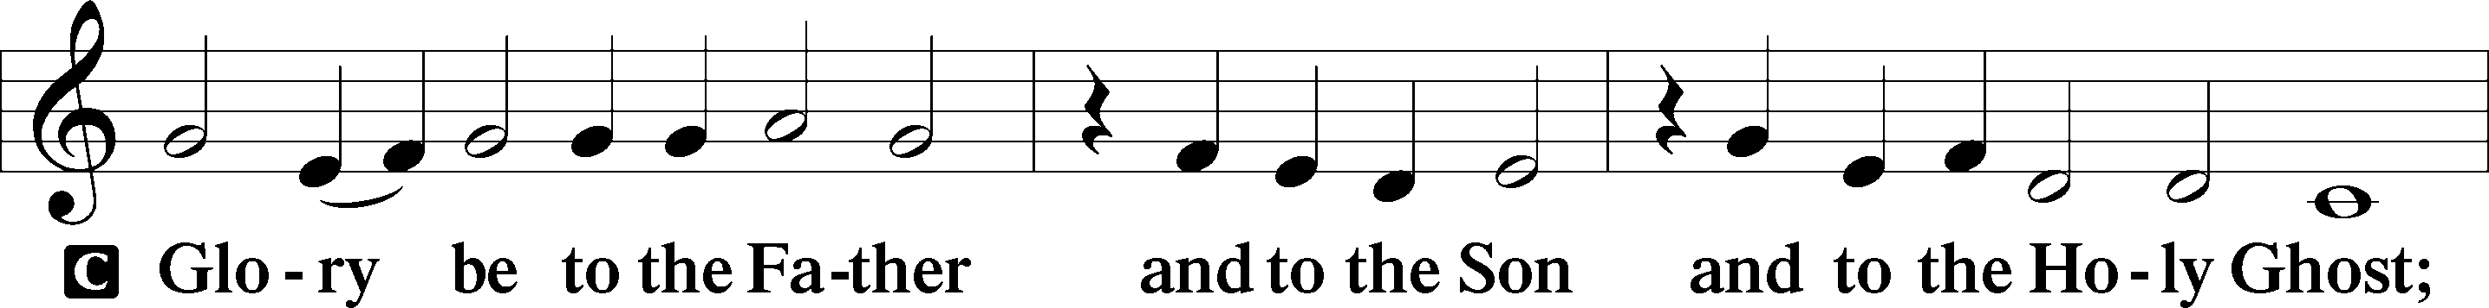

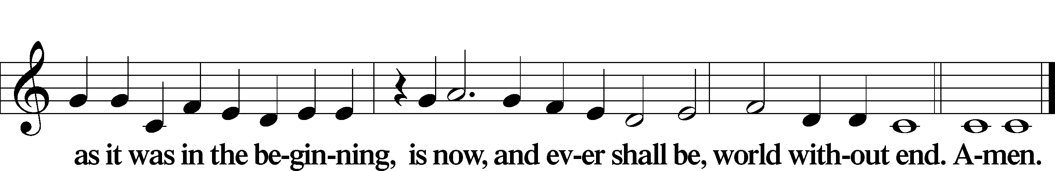

Kyrie Mark 10:47

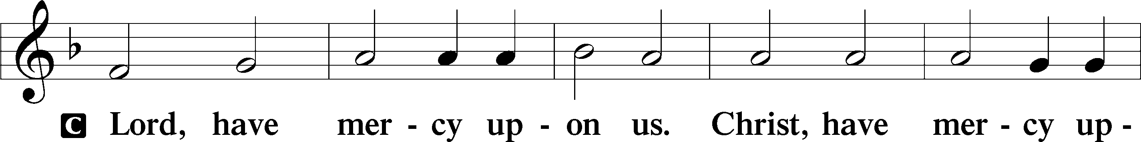

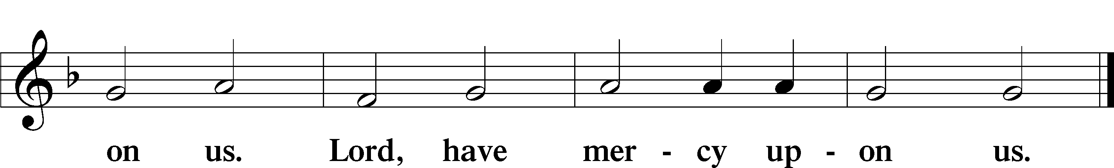

Salutation and Collect of the Day

P The Lord be with you.

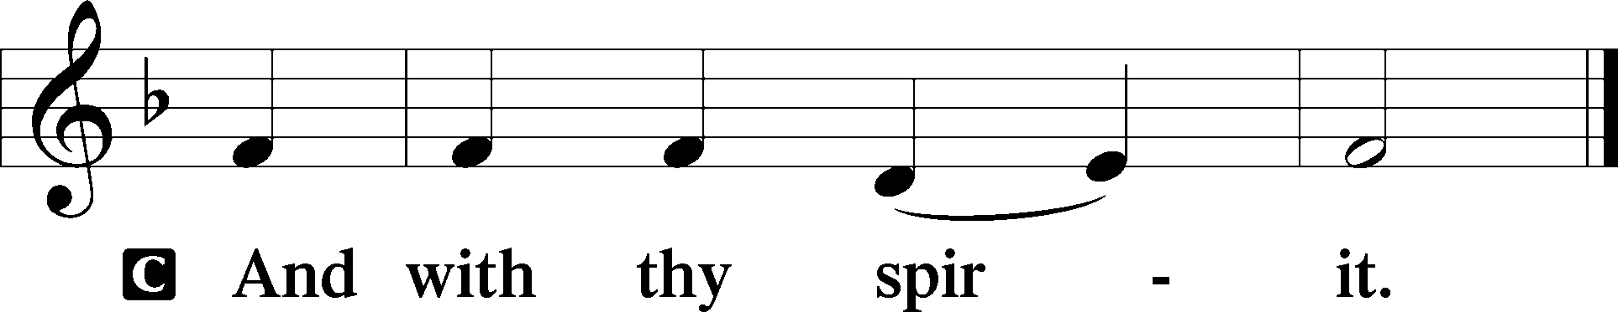

P Let us pray.

Almighty and everlasting God, You sent Your Son, our Savior Jesus Christ, to take upon Himself our flesh and to suffer death upon the cross. Mercifully grant that we may follow the example of His great humility and patience and be made partakers of His resurrection; through the same Jesus Christ, our Lord, who lives and reigns with You and the Holy Spirit, one God, now and forever.

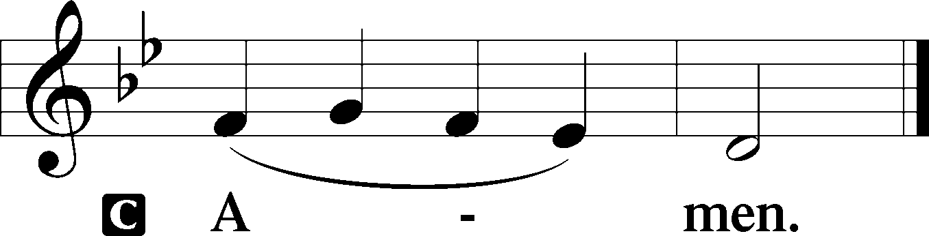

Sit

Old Testament Reading Deuteronomy 32:36–39

36 The Lord will vindicate his people  
 and have compassion on his servants,  
when he sees that their power is gone  
 and there is none remaining, bond or free.  
37Then he will say, “Where are their gods,  
 the rock in which they took refuge,  
38who ate the fat of their sacrifices  
 and drank the wine of their drink offering?  
Let them rise up and help you;  
 let them be your protection!

39“See now that I, even I, am he,  
 and there is no god beside me;  
I kill and I make alive;  
 I wound and I heal;  
 and there is none that can deliver out of my hand.”

A This is the Word of the Lord.

C **Thanks be to God.**

Gradual Hebrews 9:12a, c, 15a; Psalm 111:9a

[Christ] entered once for all into the holy places, by means of his own blood,  
 thus securing an eternal redemption.  
**Therefore he is the mediator of a new covenant,  
 so that those who are called may receive the promised eternal inheritance.**He sent redemption to his people;  
 he has commanded his covenant forever.

Epistle Philippians 2:5–11

5Have this mind among yourselves, which is yours in Christ Jesus, 6who, though he was in the form of God, did not count equality with God a thing to be grasped, 7but made himself nothing, taking the form of a servant, being born in the likeness of men. 8And being found in human form, he humbled himself by becoming obedient to the point of death, even death on a cross. 9Therefore God has highly exalted him and bestowed on him the name that is above every name, 10so that at the name of Jesus every knee should bow, in heaven and on earth and under the earth, 11and every tongue confess that Jesus Christ is Lord, to the glory of God the Father.

Stand

Holy Gospel Luke 19:28–40

P The Holy Gospel according to St. Luke, the nineteenth chapter.

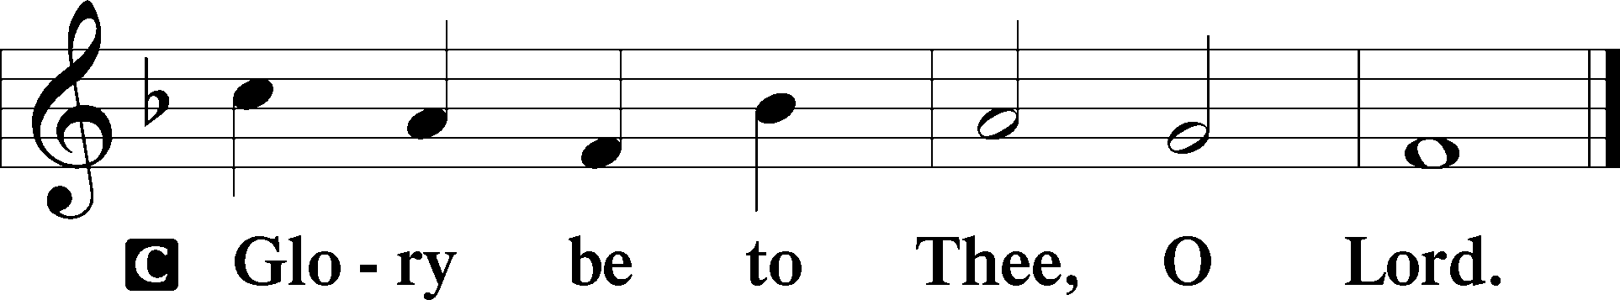

28When [Jesus] had said these things, he went on ahead, going up to Jerusalem. 29When he drew near to Bethphage and Bethany, at the mount that is called Olivet, he sent two of the disciples, 30saying, “Go into the village in front of you, where on entering you will find a colt tied, on which no one has ever yet sat. Untie it and bring it here. 31If anyone asks you, ‘Why are you untying it?’ you shall say this: ‘The Lord has need of it.’” 32So those who were sent went away and found it just as he had told them. 33And as they were untying the colt, its owners said to them, “Why are you untying the colt?” 34And they said, “The Lord has need of it.” 35And they brought it to Jesus, and throwing their cloaks on the colt, they set Jesus on it. 36And as he rode along, they spread their cloaks on the road. 37As he was drawing near—already on the way down the Mount of Olives—the whole multitude of his disciples began to rejoice and praise God with a loud voice for all the mighty works that they had seen, 38saying, “Blessed is the King who comes in the name of the Lord! Peace in heaven and glory in the highest!” 39And some of the Pharisees in the crowd said to him, “Teacher, rebuke your disciples.” 40He answered, “I tell you, if these were silent, the very stones would cry out.”

P This is the Gospel of the Lord.

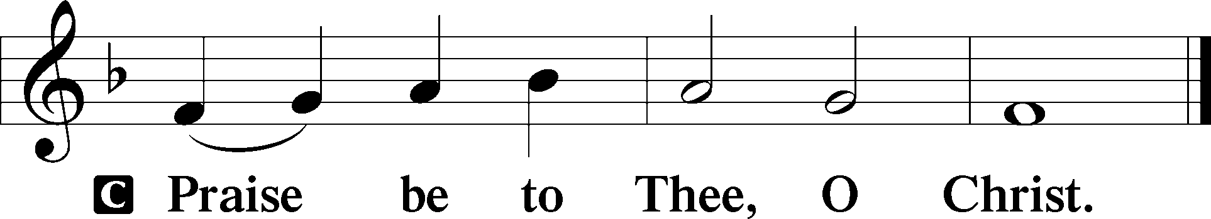

Apostles’ Creed

C **I believe in God, the Father Almighty,**

**maker of heaven and earth.**

**And in Jesus Christ, His only Son, our Lord,**

**who was conceived by the Holy Spirit,**

**born of the virgin Mary,**

**suffered under Pontius Pilate,**

**was crucified, died and was buried.**

**He descended into hell.**

**The third day He rose again from the dead.**

**He ascended into heaven**

**and sits at the right hand of God the Father Almighty.**

**From thence He will come to judge the living and the dead.**

**I believe in the Holy Spirit,**

**the holy Christian Church,**

**the communion of saints,**

**the forgiveness of sins,**

**the resurrection of the body,**

**and the life** T **everlasting. Amen.**

Sit

Children's Sermon

559 Oh, How Great Is Your Compassion

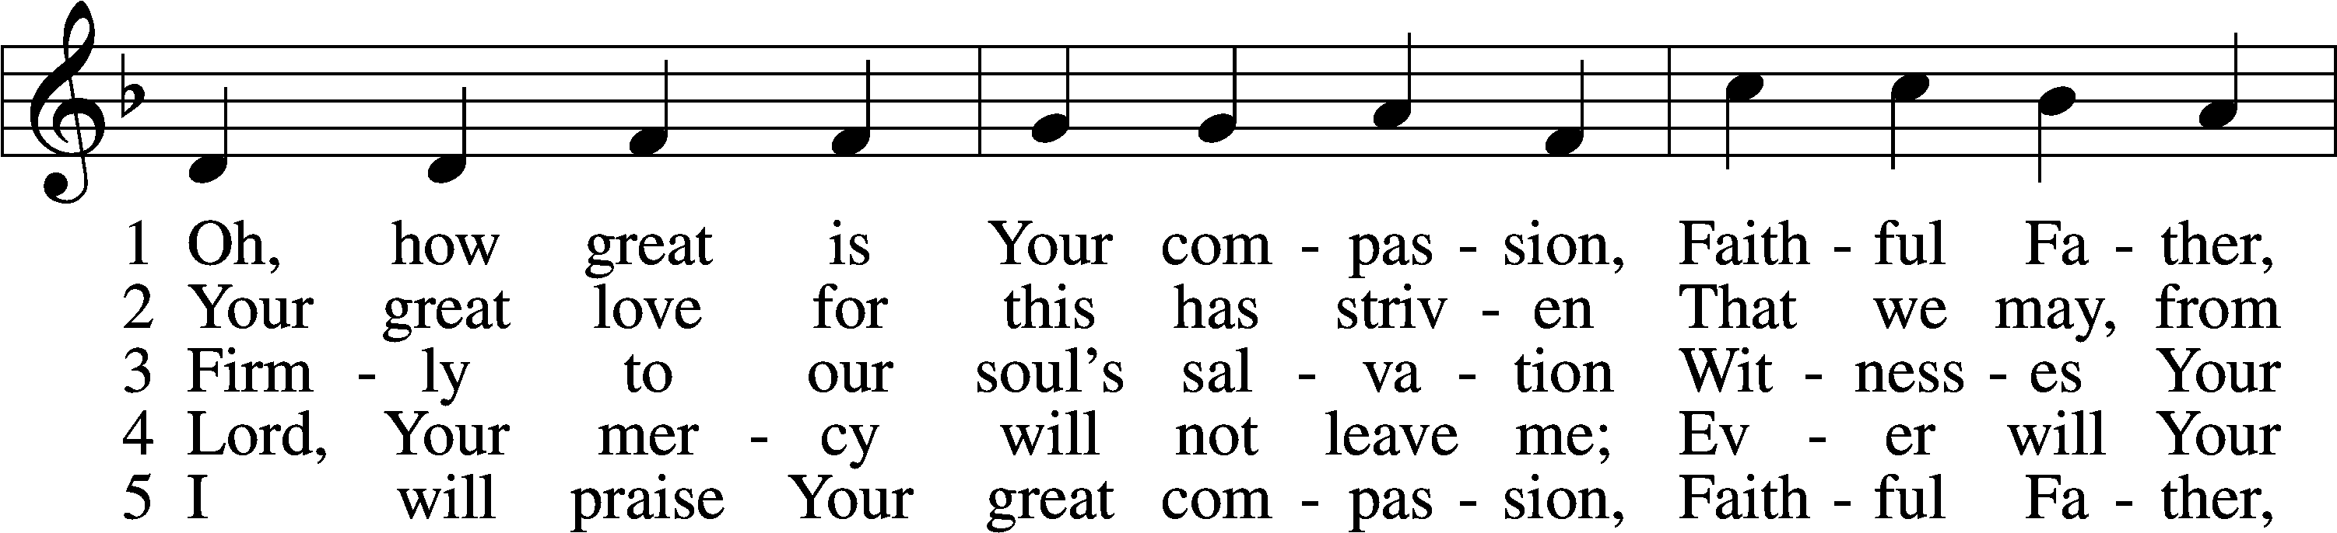

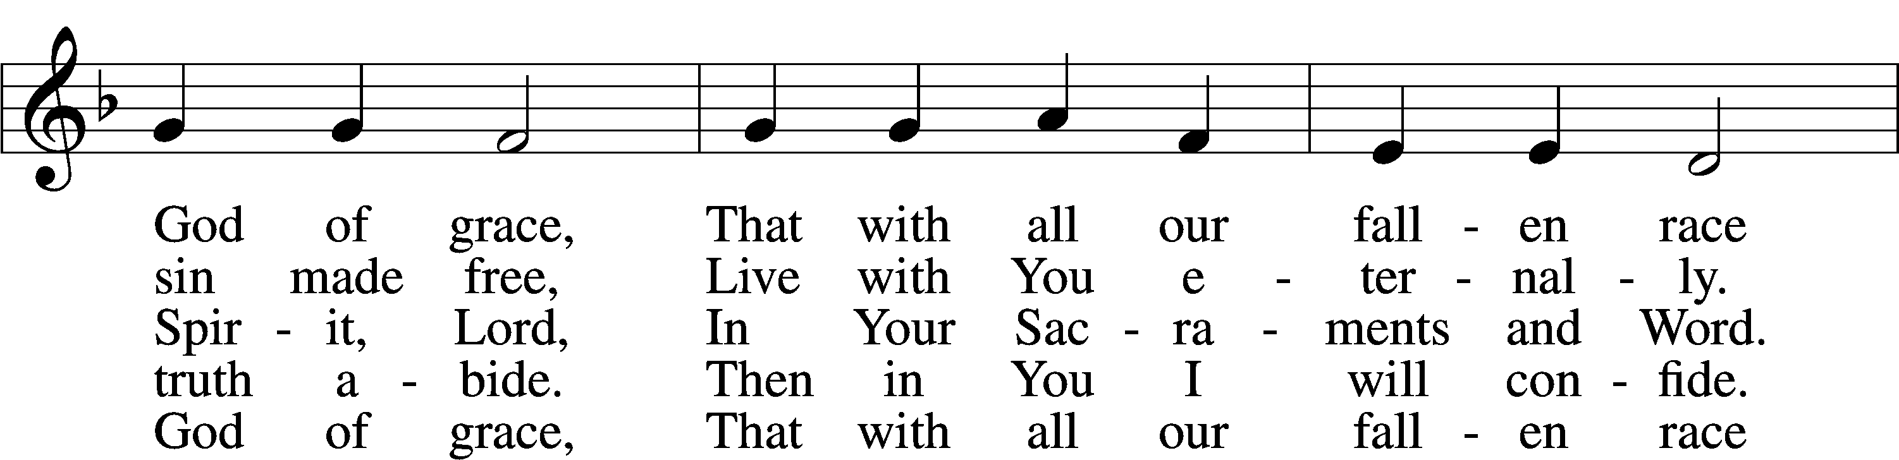

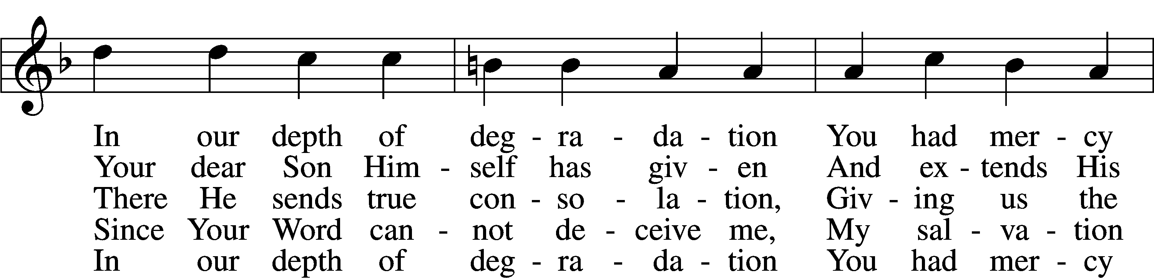

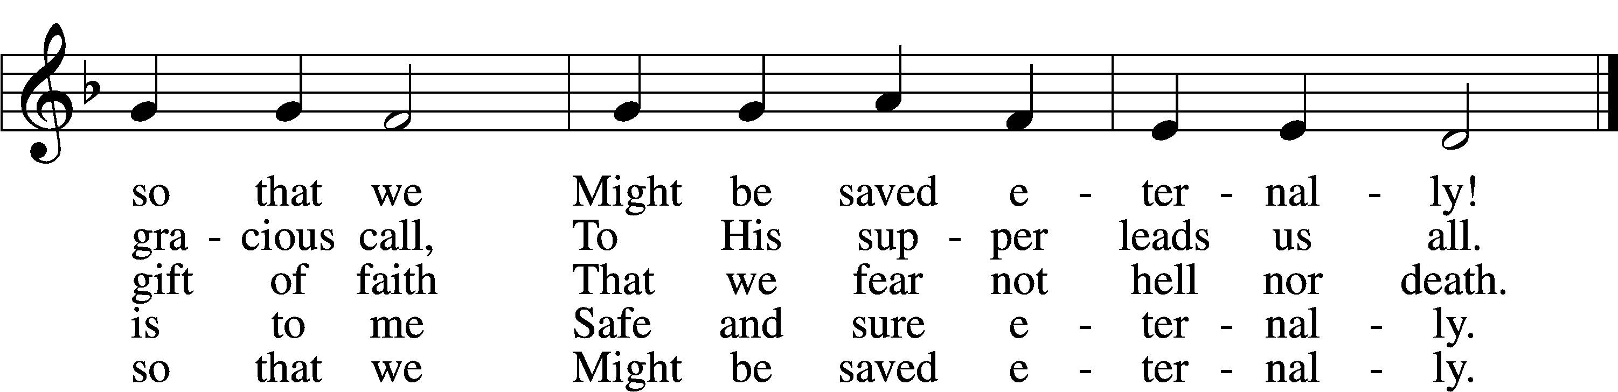

Text: Johann Olearius, 1611–84; tr. August Crull, 1845–1923, alt.  
Tune: Schäffer-Belustigung . . . Hirthen-Lieder, 1653, Altdorf  
Text and tune: Public domain

Sermon

Votum

P The peace of God, which passes all understanding, keep your hearts and minds in Christ Jesus.

C **Amen.**

Stand

Offertory Psalm 51:10–12

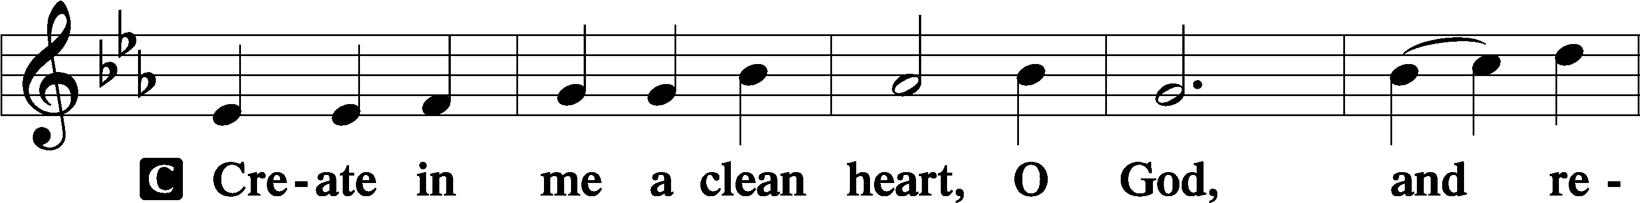

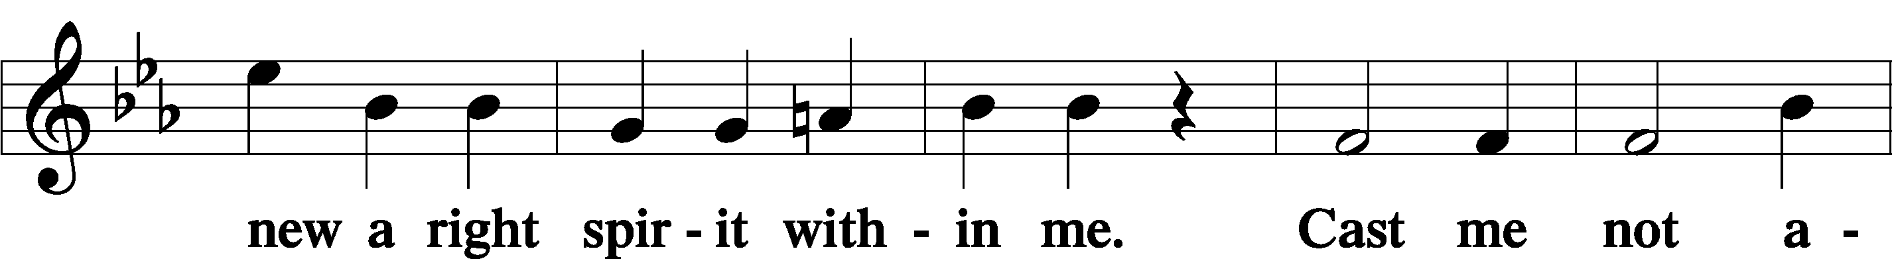

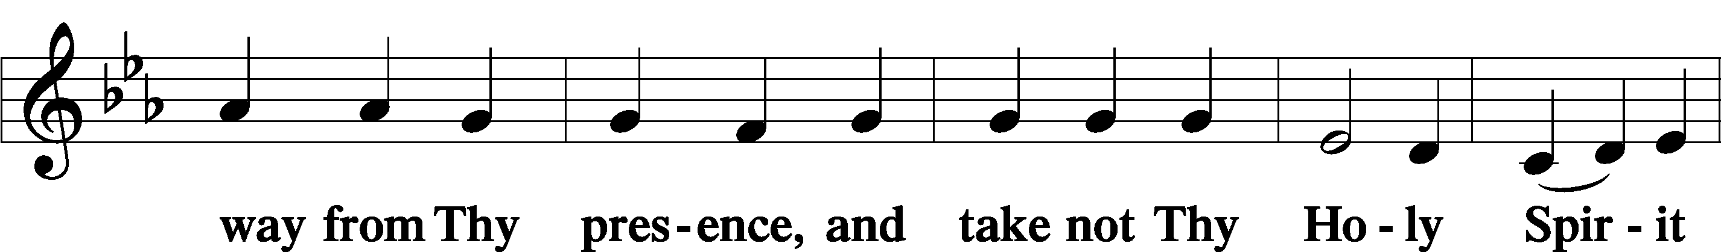

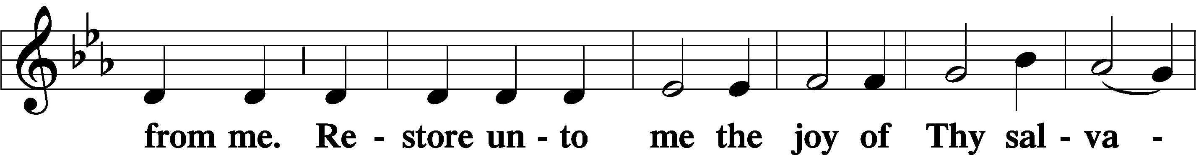

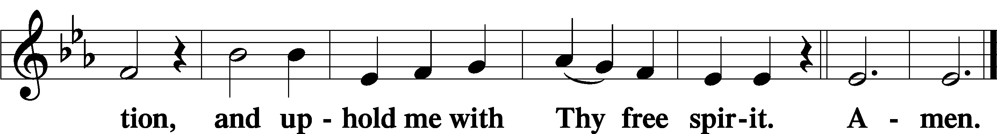

Offering

805 Praise God, from Whom All Blessings Flow

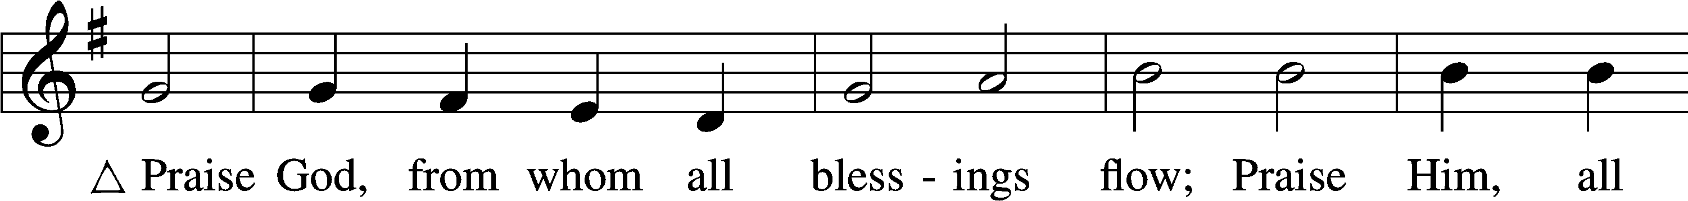

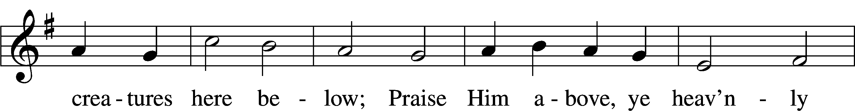

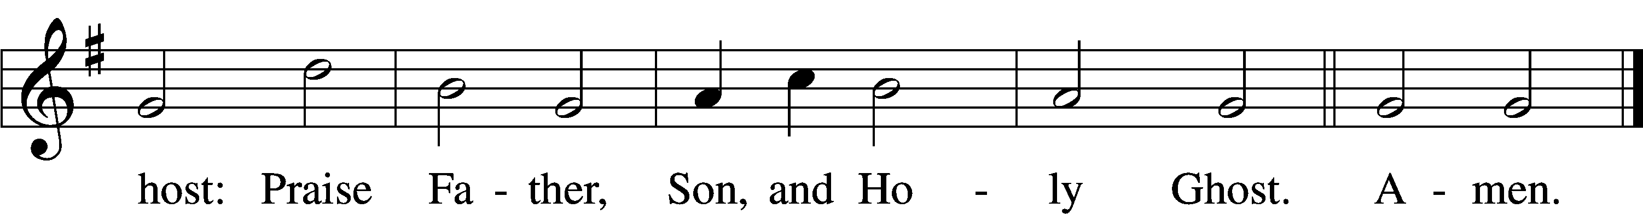

Text: Thomas Ken, 1637–1711  
Tune: Trente quatre Pseaumes de David, 1551, Geneva, ed. Louis Bourgeois  
Text and tune: Public domain

Prayer of the Church

Lord’s Prayer Matthew 6:9–13

P Lord, remember us in Your kingdom and teach us to pray:

C **Our Father who art in heaven,**

**hallowed be Thy name,**

**Thy kingdom come,**

**Thy will be done on earth**

**as it is in heaven;**

**give us this day our daily bread;**

**and forgive us our trespasses**

**as we forgive those**

**who trespass against us;**

**and lead us not into temptation,**

**but deliver us from evil.**

**For Thine is the kingdom**

**and the power and the glory**

**forever and ever. Amen.**

Collect for the Word

Blessed Lord, You have caused all Holy Scriptures to be written for our learning. Grant that we may so hear them, read, mark, learn, and inwardly digest them that, by the patience and comfort of Your holy Word, we may embrace and ever hold fast the blessed hope of everlasting life; through Jesus Christ, Your Son, our Lord, who lives and reigns with You and the Holy Spirit, one God, now and forever.

Benediction

P The Lord bless you and keep you.

The Lord make His face shine on you and be gracious to you.

The Lord look upon you with favor and T give you peace.

C **Amen.**

420 Christ, the Life of All the Living

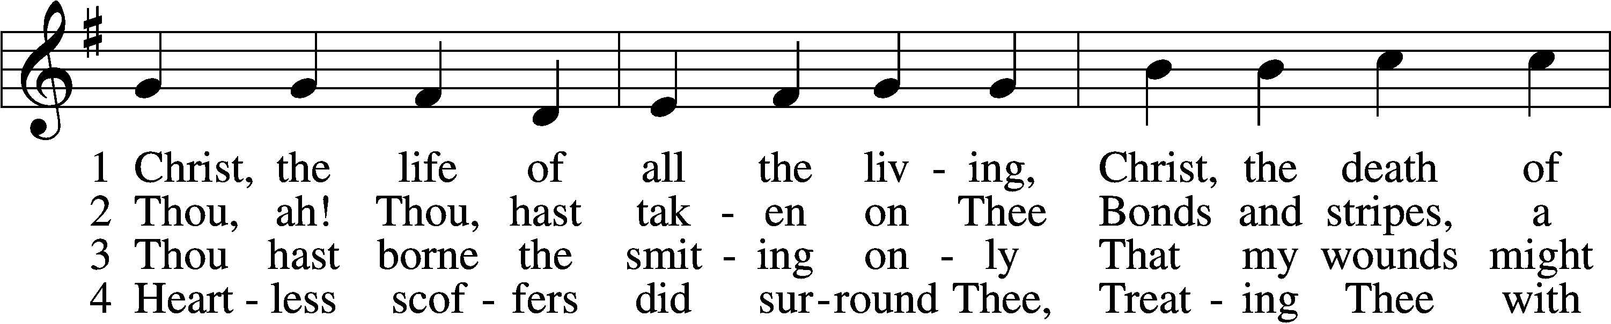

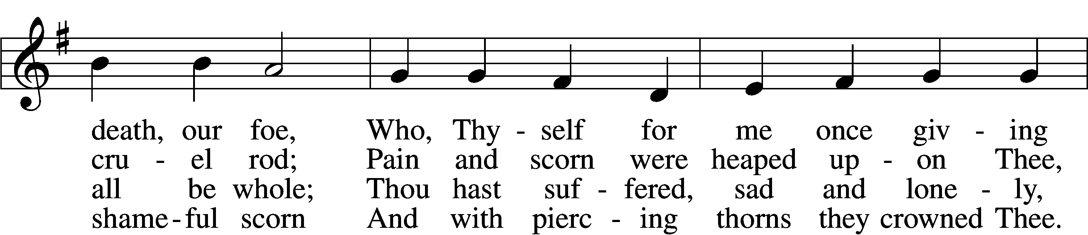

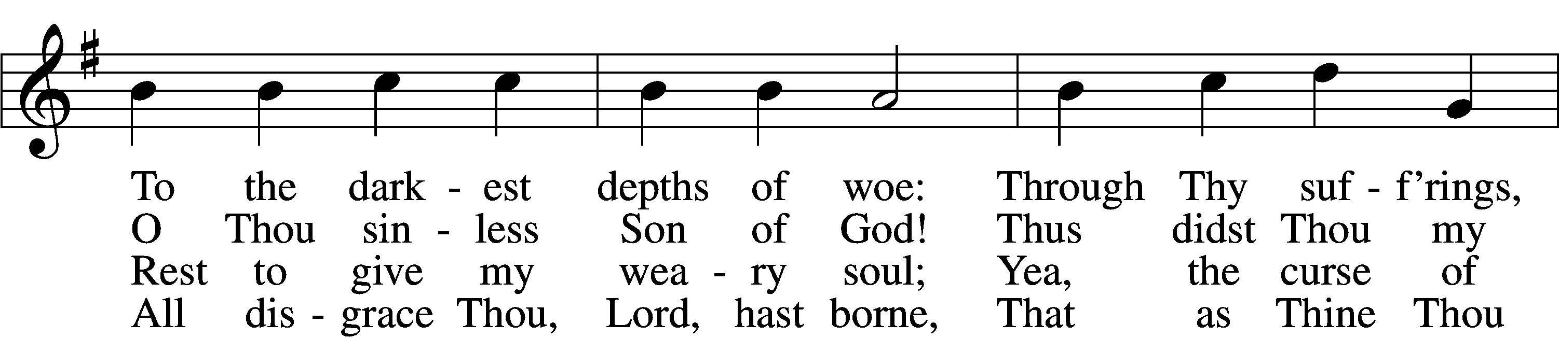

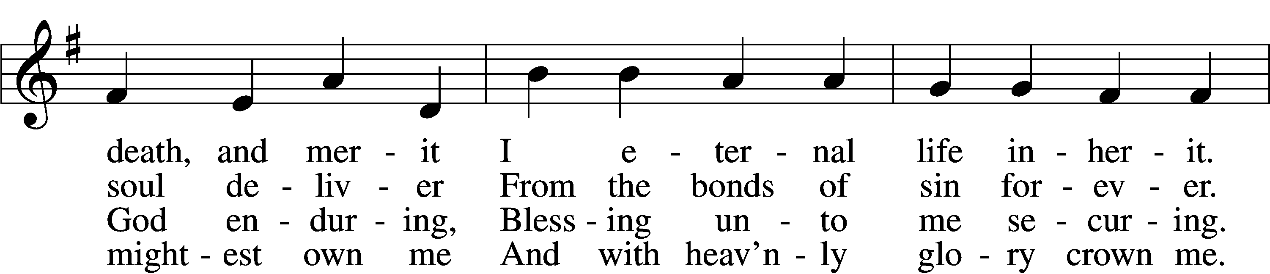

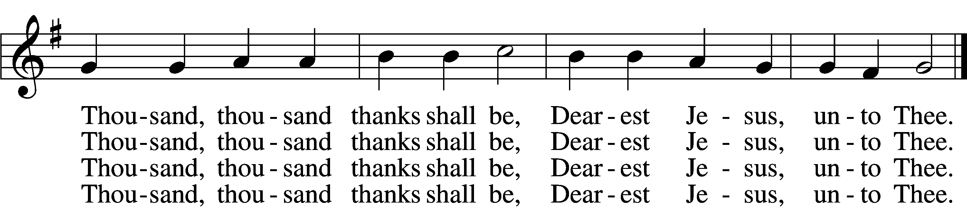

5 Thou hast suffered men to bruise Thee,  
 That from pain I might be free;  
Falsely did Thy foes accuse Thee:  
 Thence I gain security;  
Comfortless Thy soul did languish  
Me to comfort in my anguish.  
 Thousand, thousand thanks shall be,  
 Dearest Jesus, unto Thee.

6 Thou hast suffered great affliction  
 And hast borne it patiently,  
Even death by crucifixion,  
 Fully to atone for me;  
Thou didst choose to be tormented  
That my doom should be prevented.  
 Thousand, thousand thanks shall be,  
 Dearest Jesus, unto Thee.

7 Then, for all that wrought my pardon,  
 For Thy sorrows deep and sore,  
For Thine anguish in the Garden,  
 I will thank Thee evermore,  
Thank Thee for Thy groaning, sighing,  
For Thy bleeding and Thy dying,  
 For that last triumphant cry,  
 And shall praise Thee, Lord, on high.

Text: Ernst Christoph Homburg, 1605–81; (sts. 1–2, 5, 7): tr. Catherine Winkworth, 1827–78, alt.; (sts. 3–4, 6): tr. Evangelical Lutheran Hymn-Book, 1912, St. Louis  
Tune: Das grosse Cantional, 1687, Darmstadt  
Text and tune: Public domain

Acknowledgments

Unless otherwise indicated, Scripture quotations are from the ESV® Bible (The Holy Bible, English Standard Version®), copyright © 2001 by Crossway, a publishing ministry of Good News Publishers. Used by permission. All rights reserved.

Created by Lutheran Service Builder © 2025 Concordia Publishing House.