On entering the church

P Lord, I love the habitation of Your house and the place

where Your glory dwells. In the multitude of Your tender

mercies prepare my heart that I may enter Your house to

worship and confess Your holy name; through Jesus Christ,

my God and Lord.

Before worship

C O Lord, our creator, redeemer, and comforter, as we come

together to worship You in spirit and in truth, we humbly

pray that You would open our hearts to the preaching of

Your Word so that we may repent of our sins, believe in

Jesus Christ as our only Savior, and grow in grace and

holiness. Hear us for His sake.

579 The Law of God Is Good and Wise

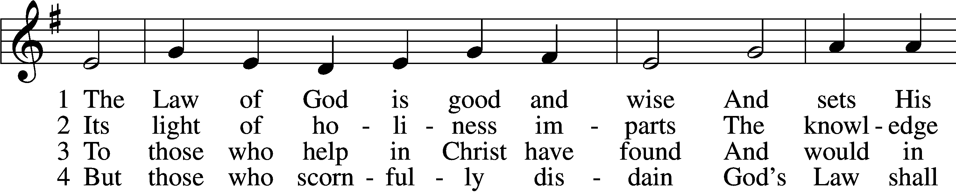

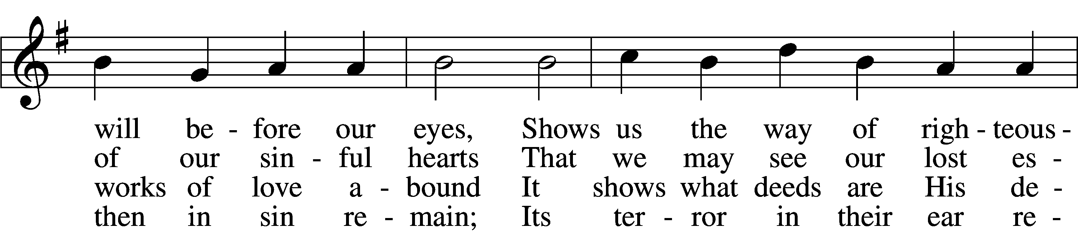

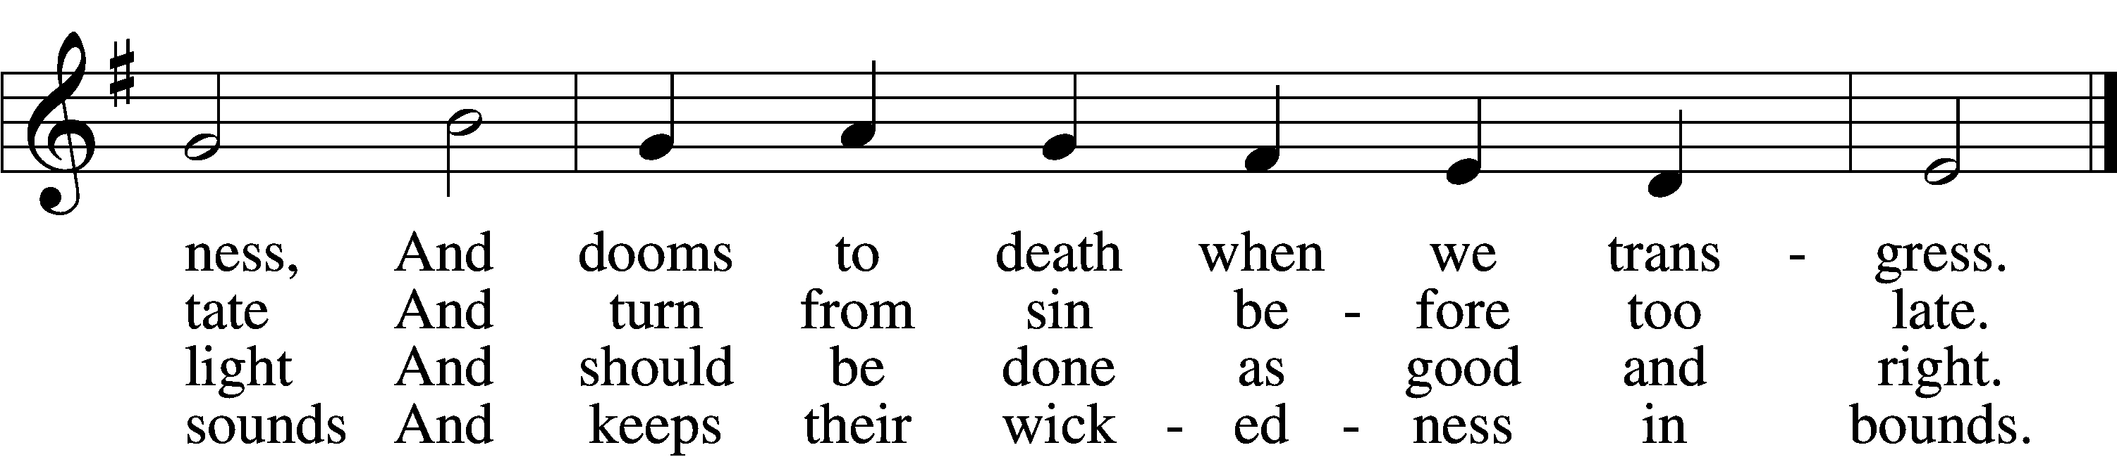

5 The Law is good; but since the fall  
Its holiness condemns us all;  
It dooms us for our sin to die  
And has no pow’r to justify.

6 To Jesus we for refuge flee,  
Who from the curse has set us free,  
And humbly worship at His throne,  
Saved by His grace through faith alone.

Text: Matthias Loy, 1828–1915, alt.  
Tune: Geistliche Lieder auffs new gebessert, 1543, Wittenberg, ed. Joseph Klug  
Text and tune: Public domain

# Confession and Absolution

The sign of the cross may be made by all in remembrance of their Baptism.

Invocation Matthew 28:19b; 18:20

P In the name of the Father and of the T Son and of the Holy Spirit.

C **Amen.**

Exhortation Hebrews 10:22; Psalm 124:8; Psalm 32:5

P Beloved in the Lord! Let us draw near with a true heart and confess our sins unto God our Father, beseeching Him in the name of our Lord Jesus Christ to grant us forgiveness.

P Our help is in the name of the Lord,

C **who made heaven and earth.**

P I said, I will confess my transgressions unto the Lord,

C **and You forgave the iniquity of my sin.**

Silence for reflection on God’s Word and for self-examination.

Confession of Sins

P Almighty God, our maker and redeemer, we poor sinners confess unto You that we are by nature sinful and unclean and that we have sinned against You by thought, word, and deed. Wherefore we flee for refuge to Your infinite mercy, seeking and imploring Your grace for the sake of our Lord Jesus Christ.

C **O most merciful God, who has given Your only-begotten Son to die for us, have mercy upon us and for His sake grant us remission of all our sins; and by Your Holy Spirit increase in us true knowledge of You and of Your will and true obedience to Your Word, to the end that by Your grace we may come to everlasting life; through Jesus Christ, our Lord. Amen.**

Declaration of Grace Mark 16:16; John 1:12

P Almighty God, our heavenly Father, has had mercy upon us and has given His only Son to die for us and for His sake forgives us all our sins. To those who believe on His name He gives power to become the children of God and has promised them His Holy Spirit. He that believes and is baptized shall be saved.  
  
Grant this, Lord, unto us all.

C **Amen.**

# Service of the Word

Introit Psalm 30:2–5; antiphon: vv. 11a, 12b

You have turned for me my mourning into dancing;  
 O Lord my God, I will give thanks to you forever!  
**O Lord my God, I cried to you for help,  
 and you have healed me.**  
O Lord, you have brought up my soul from Sheol;  
 you restored me to life from among those who go down to the pit.  
**Sing praises to the Lord, O you his saints,  
 and give thanks to his holy name.**For his anger is but for a moment, and his favor is for a lifetime.  
 Weeping may tarry for the night, but joy comes with the morning.

Gloria Patri

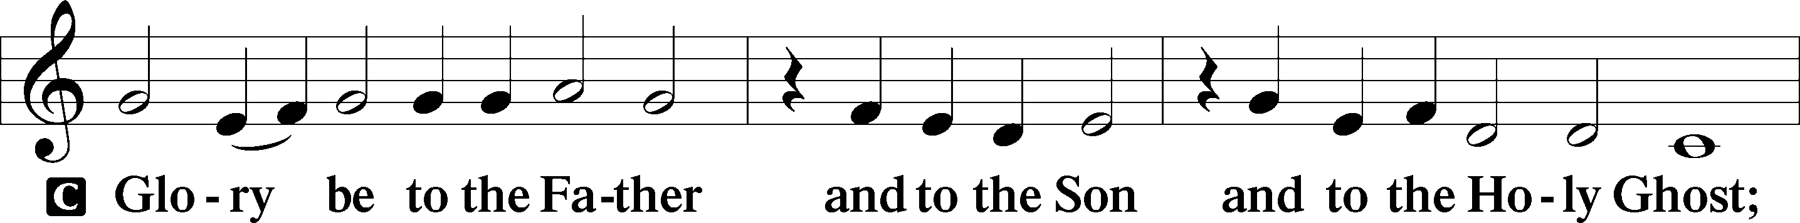

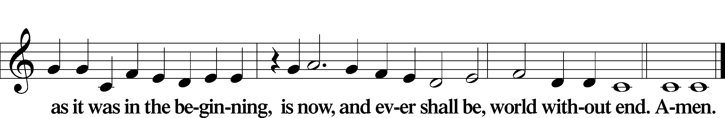

Kyrie Mark 10:47

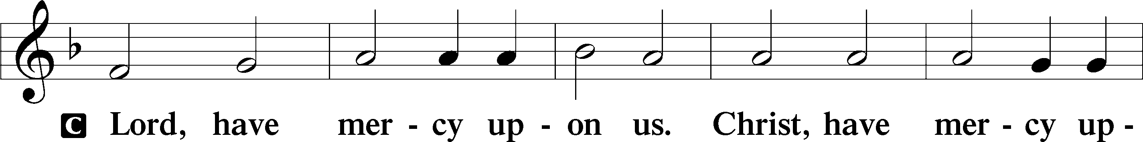

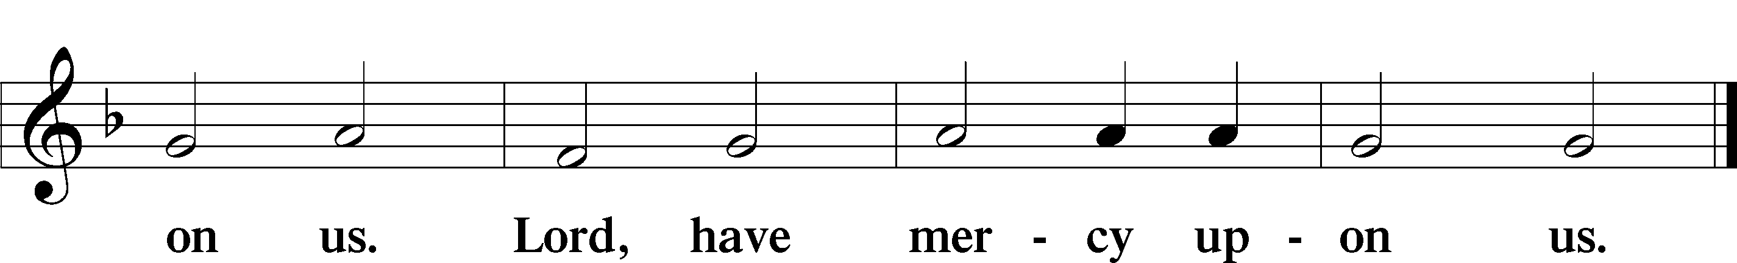

Gloria in Excelsis Luke 2:14; John 1:29

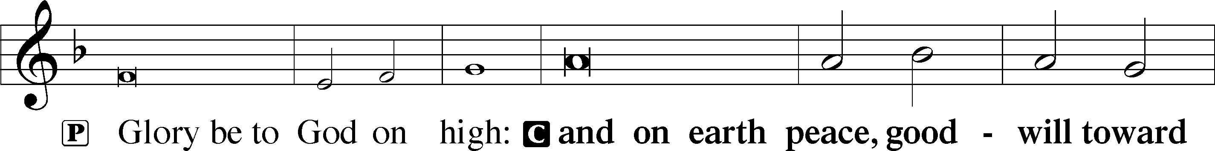

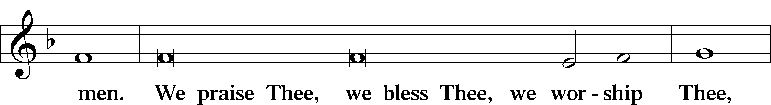

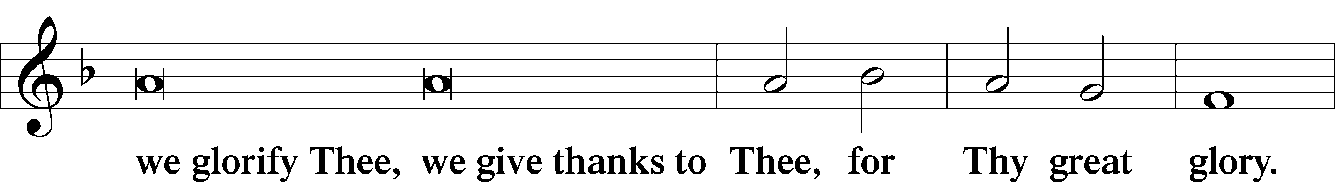

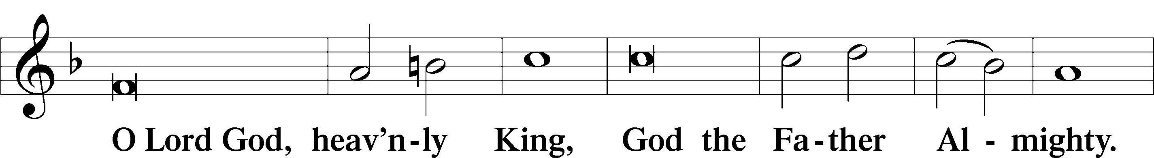

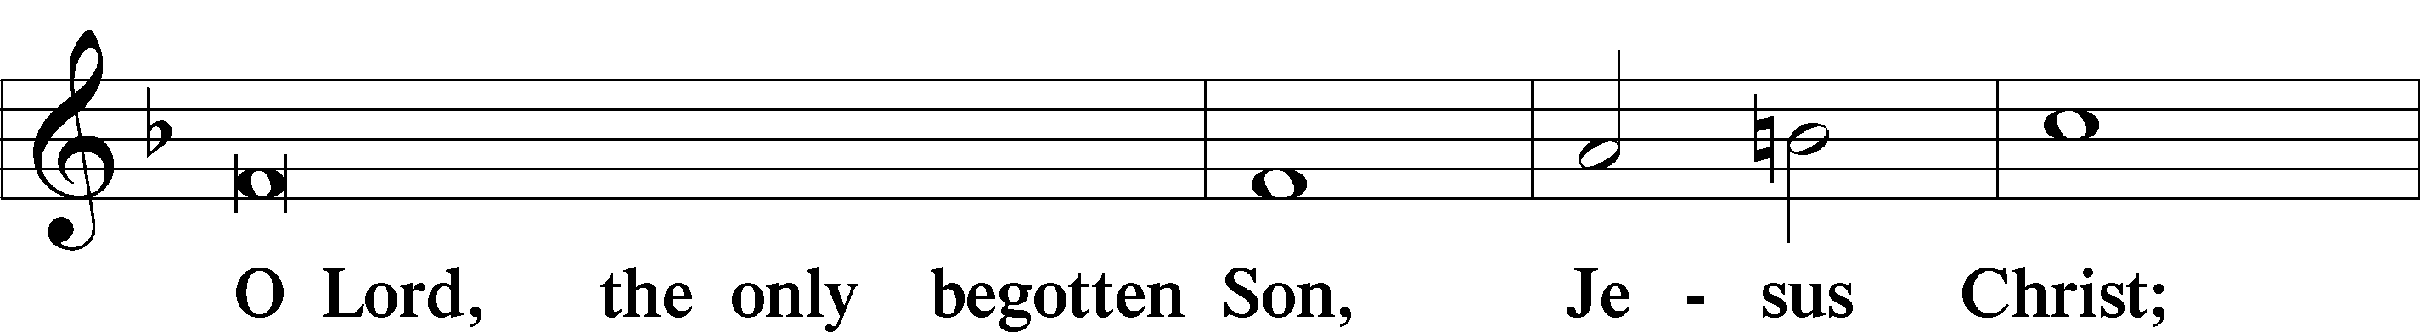

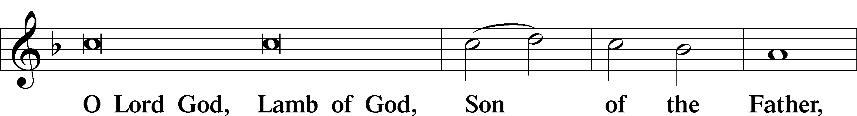

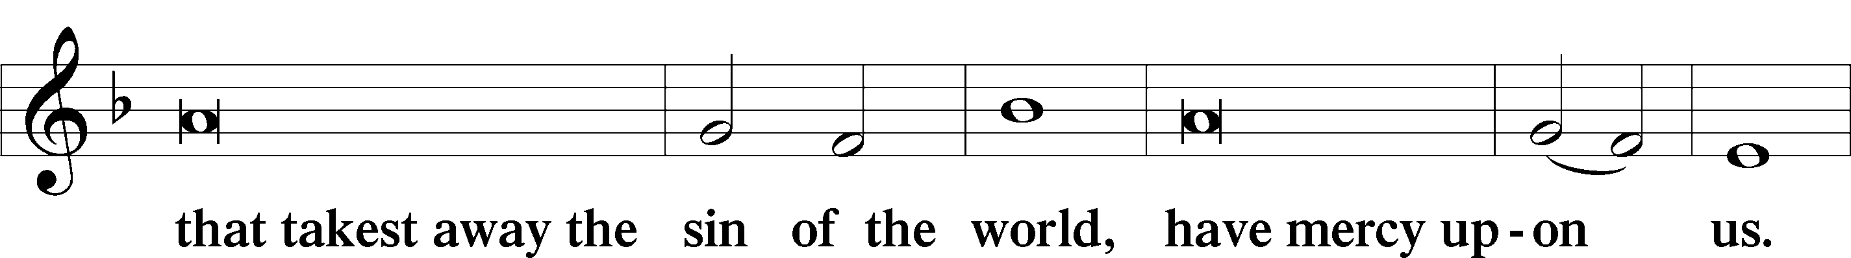

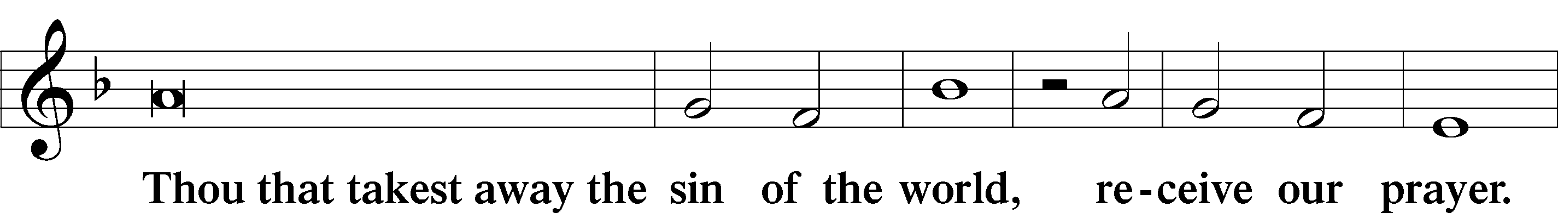

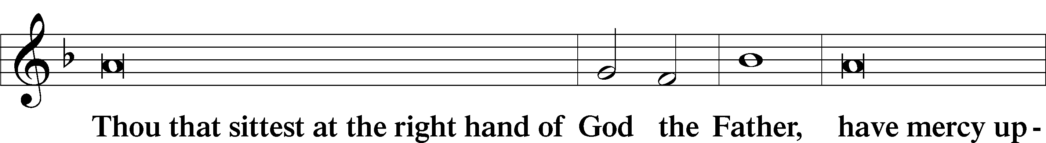

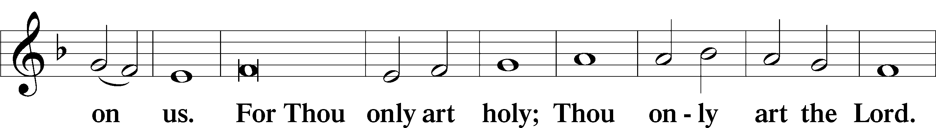

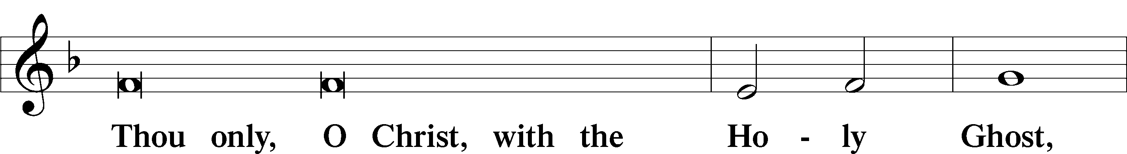

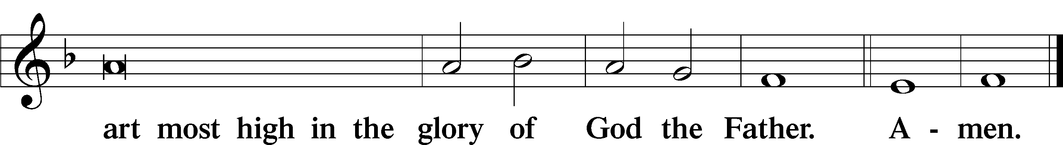

Salutation and Collect of the Day

P The Lord be with you.

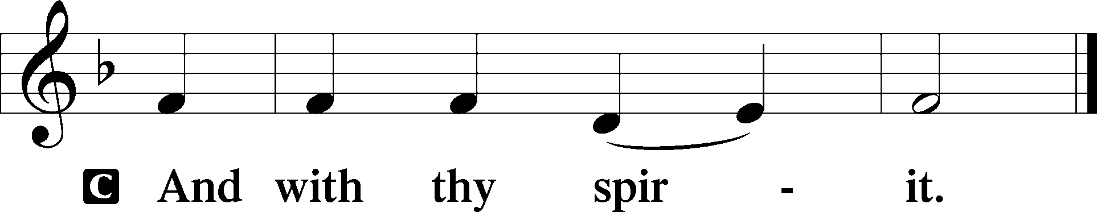

P Let us pray.

Lord Jesus, You are the Good Shepherd, without whom nothing is secure. Rescue and preserve us that we may not be lost forever but follow You, rejoicing in the way that leads to eternal life; for You live and reign with the Father and the Holy Spirit, one God, now and forever.

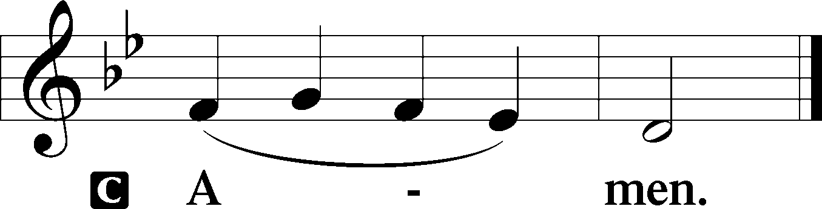

Sit

Old Testament Reading Ezekiel 34:11–24

11“For thus says the Lord God: Behold, I, I myself will search for my sheep and will seek them out. 12As a shepherd seeks out his flock when he is among his sheep that have been scattered, so will I seek out my sheep, and I will rescue them from all places where they have been scattered on a day of clouds and thick darkness. 13And I will bring them out from the peoples and gather them from the countries, and will bring them into their own land. And I will feed them on the mountains of Israel, by the ravines, and in all the inhabited places of the country. 14I will feed them with good pasture, and on the mountain heights of Israel shall be their grazing land. There they shall lie down in good grazing land, and on rich pasture they shall feed on the mountains of Israel. 15I myself will be the shepherd of my sheep, and I myself will make them lie down, declares the Lord God. 16I will seek the lost, and I will bring back the strayed, and I will bind up the injured, and I will strengthen the weak, and the fat and the strong I will destroy. I will feed them in justice.

17“As for you, my flock, thus says the Lord God: Behold, I judge between sheep and sheep, between rams and male goats. 18Is it not enough for you to feed on the good pasture, that you must tread down with your feet the rest of your pasture; and to drink of clear water, that you must muddy the rest of the water with your feet? 19And must my sheep eat what you have trodden with your feet, and drink what you have muddied with your feet?

20“Therefore, thus says the Lord God to them: Behold, I, I myself will judge between the fat sheep and the lean sheep. 21Because you push with side and shoulder, and thrust at all the weak with your horns, till you have scattered them abroad, 22I will rescue my flock; they shall no longer be a prey. And I will judge between sheep and sheep. 23And I will set up over them one shepherd, my servant David, and he shall feed them: he shall feed them and be their shepherd. 24And I, the Lord, will be their God, and my servant David shall be prince among them. I am the Lord; I have spoken.”

A This is the Word of the Lord.

C **Thanks be to God.**

Gradual Psalm 34:9, 19, alt.

Fear the Lord, you his saints,  
 for those who fear him lack nothing!  
**Many are the afflictions of the righteous,  
 but the Lord delivers him out of them all.**

Epistle 1 Timothy 1:12–17

12I thank him who has given me strength, Christ Jesus our Lord, because he judged me faithful, appointing me to his service, 13though formerly I was a blasphemer, persecutor, and insolent opponent. But I received mercy because I had acted ignorantly in unbelief, 14and the grace of our Lord overflowed for me with the faith and love that are in Christ Jesus. 15The saying is trustworthy and deserving of full acceptance, that Christ Jesus came into the world to save sinners, of whom I am the foremost. 16But I received mercy for this reason, that in me, as the foremost, Jesus Christ might display his perfect patience as an example to those who were to believe in him for eternal life. 17To the King of ages, immortal, invisible, the only God, be honor and glory forever and ever. Amen.

Stand

Alleluia

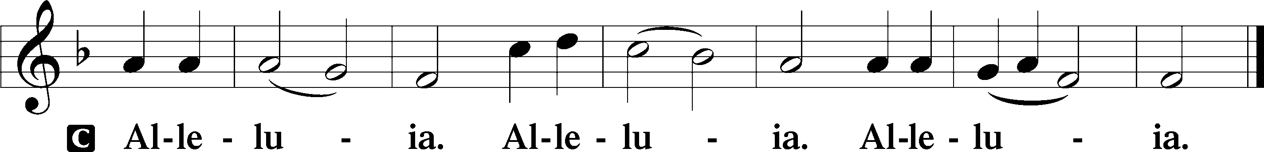

Holy Gospel Luke 15:1–10

P The Holy Gospel according to St. Luke, the fifteenth chapter.

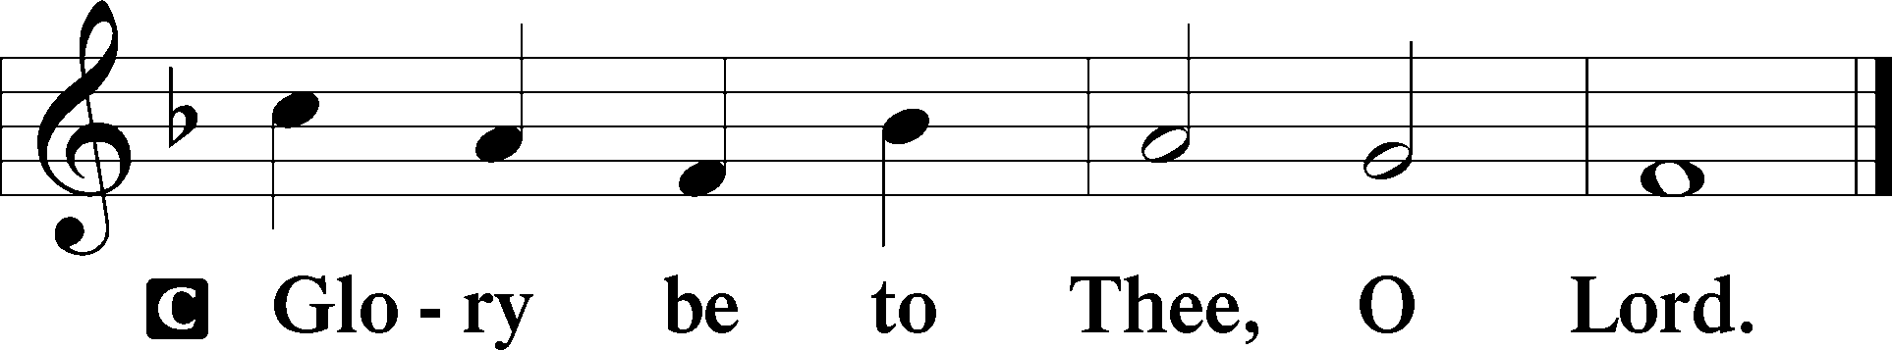

1Now the tax collectors and sinners were all drawing near to hear [Jesus]. 2And the Pharisees and the scribes grumbled, saying, “This man receives sinners and eats with them.”

3So he told them this parable: 4“What man of you, having a hundred sheep, if he has lost one of them, does not leave the ninety-nine in the open country, and go after the one that is lost, until he finds it? 5And when he has found it, he lays it on his shoulders, rejoicing. 6And when he comes home, he calls together his friends and his neighbors, saying to them, ‘Rejoice with me, for I have found my sheep that was lost.’ 7Just so, I tell you, there will be more joy in heaven over one sinner who repents than over ninety-nine righteous persons who need no repentance.

8“Or what woman, having ten silver coins, if she loses one coin, does not light a lamp and sweep the house and seek diligently until she finds it? 9And when she has found it, she calls together her friends and neighbors, saying, ‘Rejoice with me, for I have found the coin that I had lost.’ 10Just so, I tell you, there is joy before the angels of God over one sinner who repents.”

P This is the Gospel of the Lord.

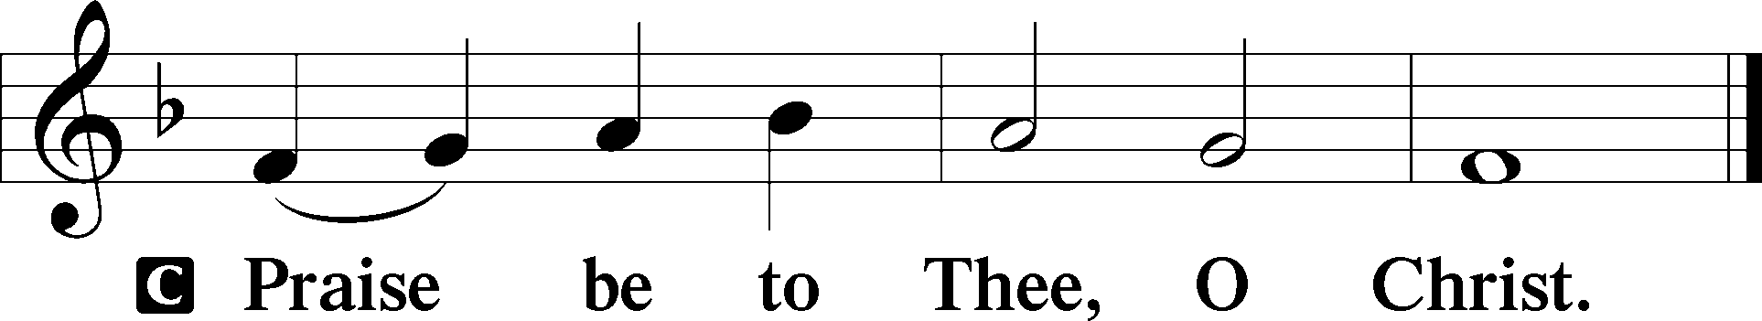

Apostles’ Creed

C **I believe in God, the Father Almighty,**

**maker of heaven and earth.**

**And in Jesus Christ, His only Son, our Lord,**

**who was conceived by the Holy Spirit,**

**born of the virgin Mary,**

**suffered under Pontius Pilate,**

**was crucified, died and was buried.**

**He descended into hell.**

**The third day He rose again from the dead.**

**He ascended into heaven**

**and sits at the right hand of God the Father Almighty.**

**From thence He will come to judge the living and the dead.**

**I believe in the Holy Spirit,**

**the holy Christian Church,**

**the communion of saints,**

**the forgiveness of sins,**

**the resurrection of the body,**

**and the life** T **everlasting. Amen.**

Sit

Children's Sermon

710 The Lord’s My Shepherd, I’ll Not Want

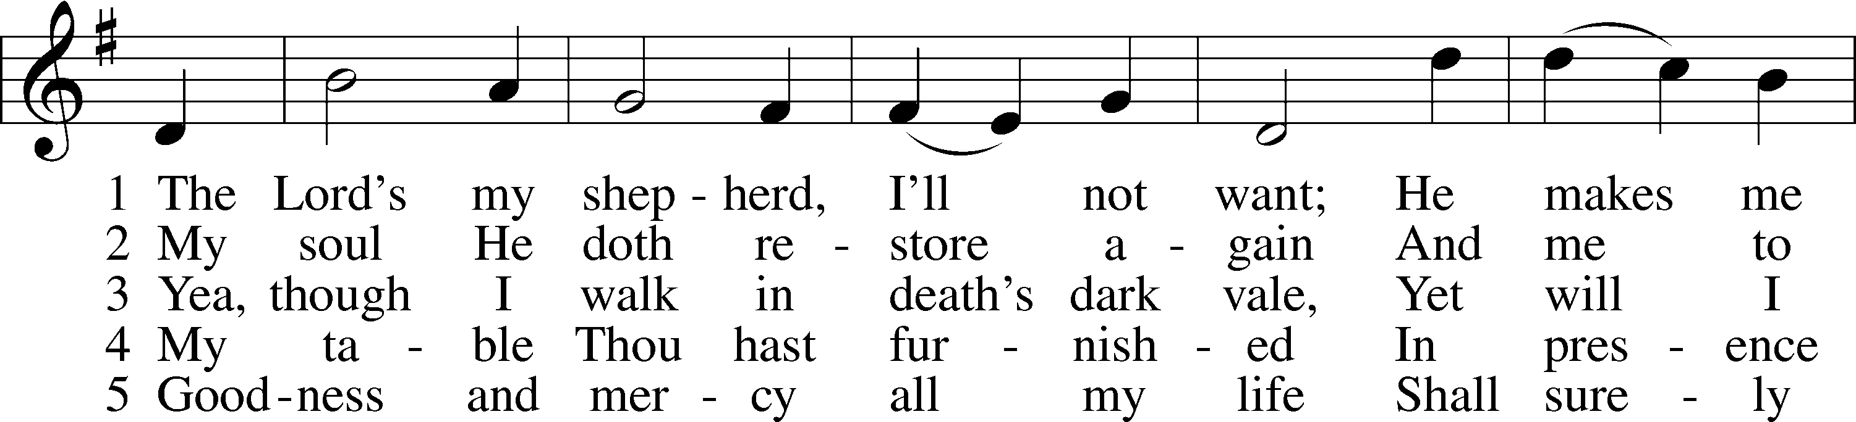

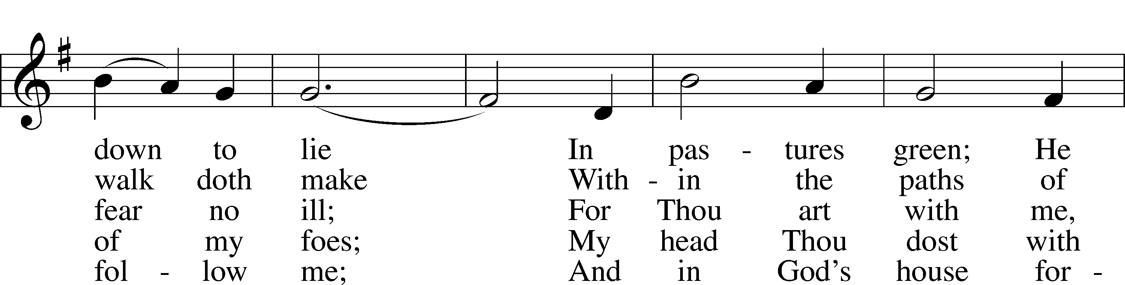

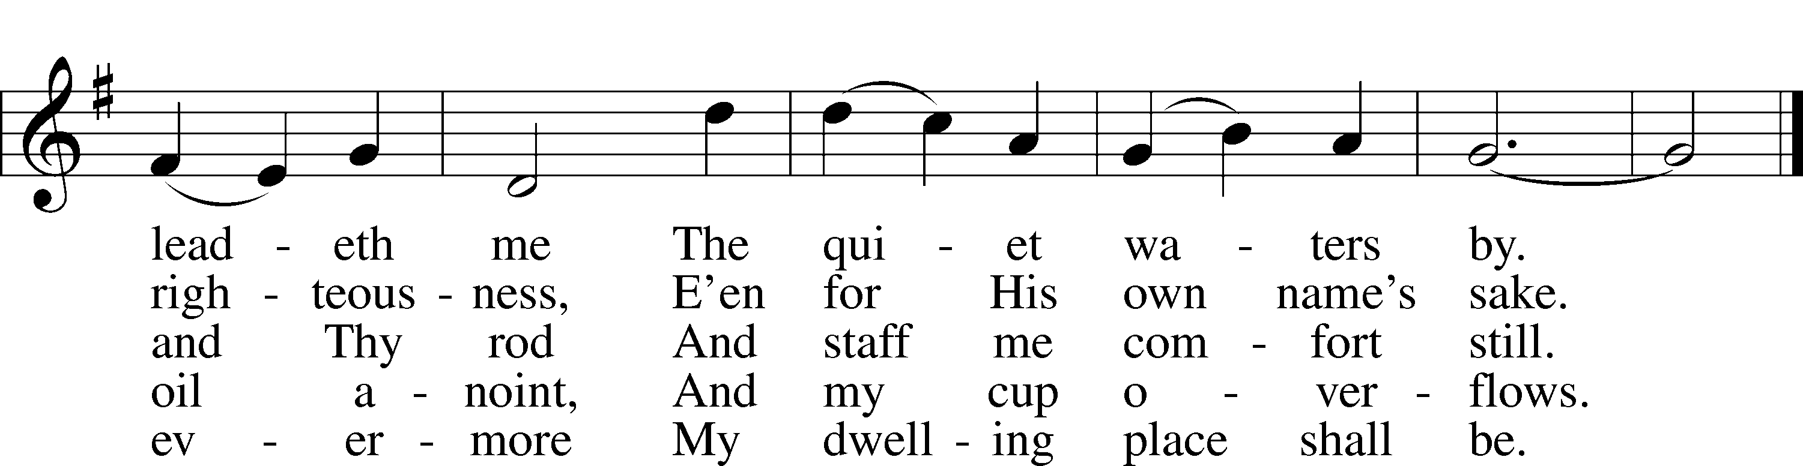

Text: The Psalms of David in Meeter, 1650, Edinburgh  
Tune: William Gardiner, 1770–1853  
Text and tune: Public domain

Sermon

Votum

P The peace of God, which passes all understanding, keep your hearts and minds in Christ Jesus.

C **Amen.**

Stand

Offertory Psalm 51:10–12

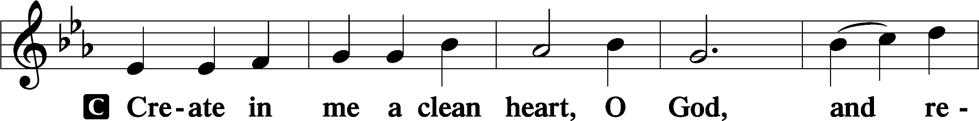

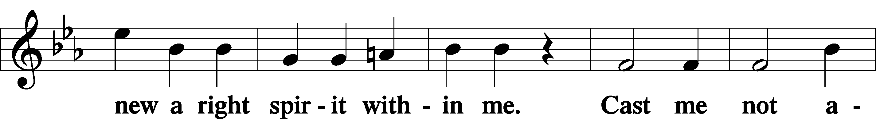

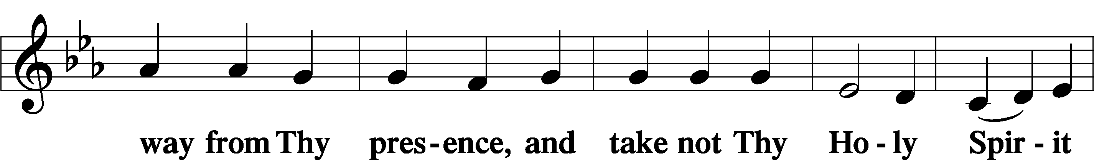

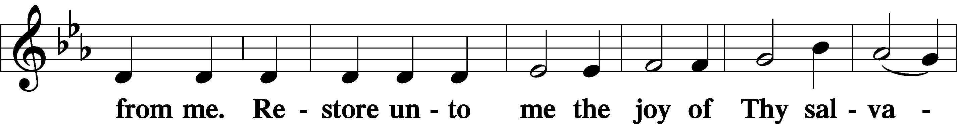

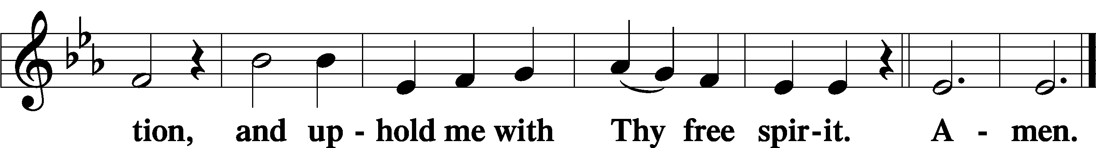

Offering

805 Praise God, from Whom All Blessings Flow

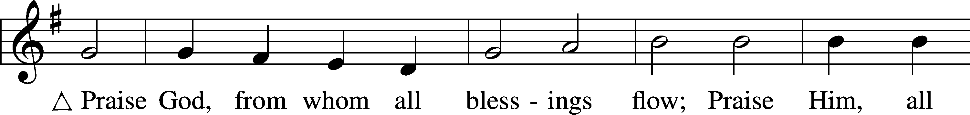

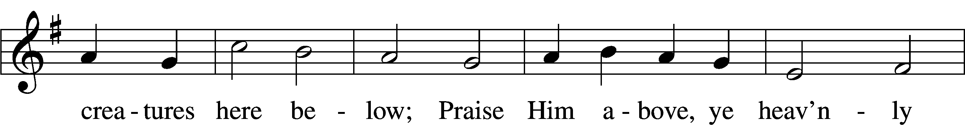

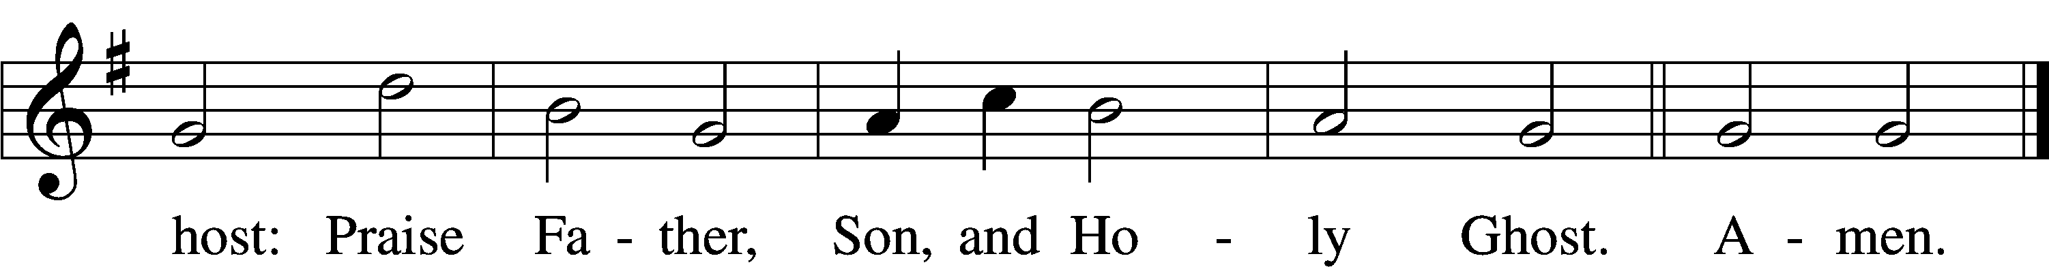

Text: Thomas Ken, 1637–1711  
Tune: Trente quatre Pseaumes de David, 1551, Geneva, ed. Louis Bourgeois  
Text and tune: Public domain

Prayer of the Church

Lord’s Prayer Matthew 6:9–13

P Lord, remember us in Your kingdom and teach us to pray:

C **Our Father who art in heaven,**

**hallowed be Thy name,**

**Thy kingdom come,**

**Thy will be done on earth**

**as it is in heaven;**

**give us this day our daily bread;**

**and forgive us our trespasses**

**as we forgive those**

**who trespass against us;**

**and lead us not into temptation,**

**but deliver us from evil.**

**For Thine is the kingdom**

**and the power and the glory**

**forever and ever. Amen.**

Collect for the Word

Blessed Lord, You have caused all Holy Scriptures to be written for our learning. Grant that we may so hear them, read, mark, learn, and inwardly digest them that, by the patience and comfort of Your holy Word, we may embrace and ever hold fast the blessed hope of everlasting life; through Jesus Christ, Your Son, our Lord, who lives and reigns with You and the Holy Spirit, one God, now and forever.

Benediction

P The Lord bless you and keep you.

The Lord make His face shine on you and be gracious to you.

The Lord look upon you with favor and T give you peace.

C **Amen.**

609 Jesus Sinners Doth Receive

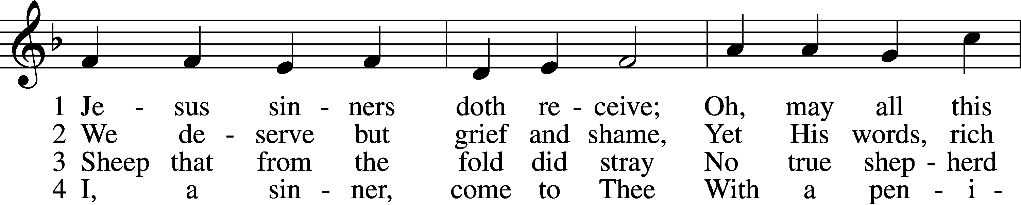

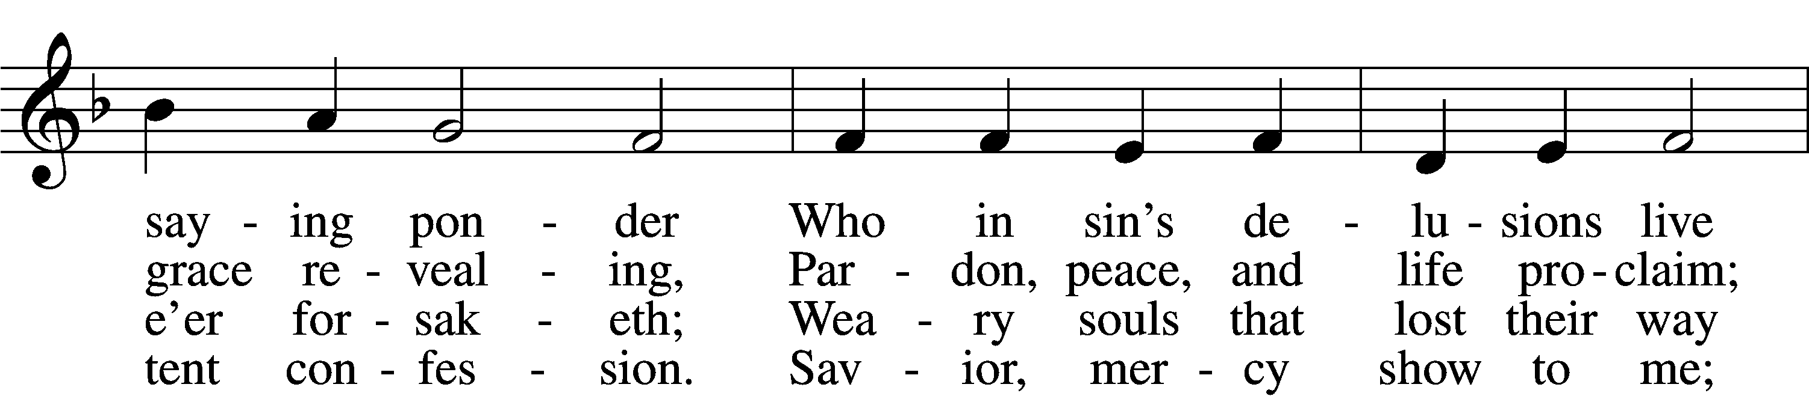

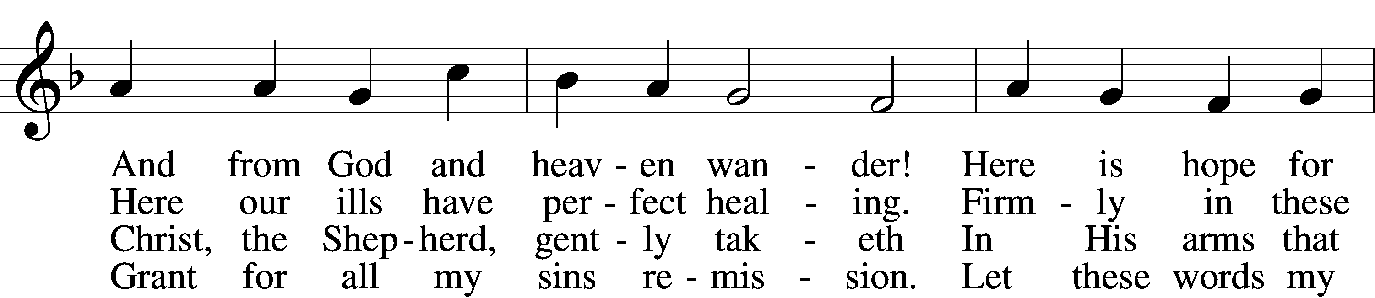

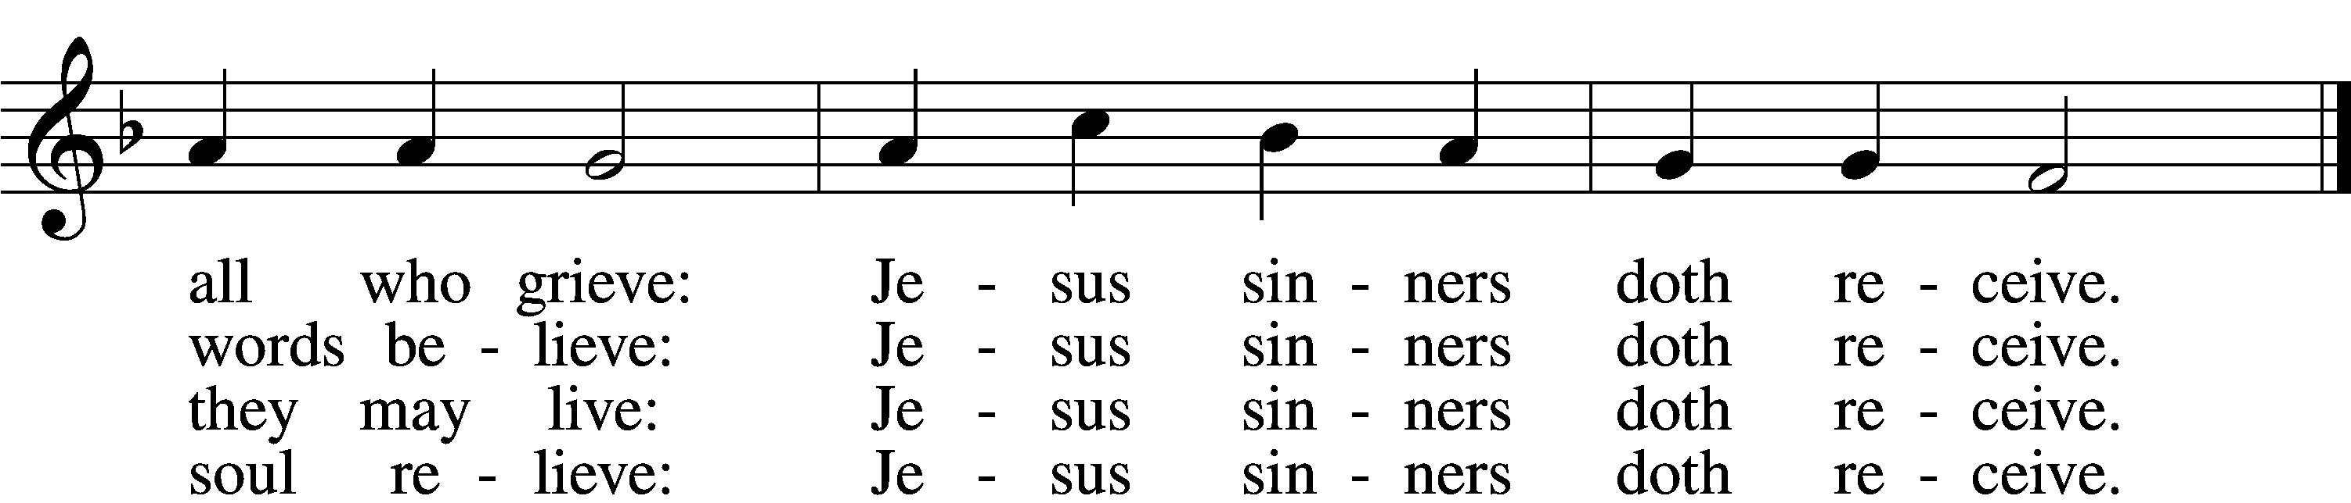

5 Oh, how blest it is to know:  
 Were as scarlet my transgression,  
It shall be as white as snow  
 By Thy blood and bitter passion;  
For these words I now believe:  
Jesus sinners doth receive.

6 Now my conscience is at peace;  
 From the Law I stand acquitted.  
Christ hath purchased my release  
 And my ev’ry sin remitted.  
Naught remains my soul to grieve:  
Jesus sinners doth receive.

7 Jesus sinners doth receive;  
 Also I have been forgiven;  
And when I this earth must leave,  
 I shall find an open heaven.  
Dying, still to Him I cleave:  
Jesus sinners doth receive.

Text: tr. The Lutheran Hymnal, 1941, alt.; Erdmann Neumeister, 1671–1756  
Tune: Neu-verfertigtes Darmstädtisches Gesang-Buch, 1699, Darmstadt  
Text and tune: Public domain

Acknowledgments

Unless otherwise indicated, Scripture quotations are from the ESV® Bible (The Holy Bible, English Standard Version®), copyright © 2001 by Crossway, a publishing ministry of Good News Publishers. Used by permission. All rights reserved.

Created by Lutheran Service Builder © 2025 Concordia Publishing House.