On entering the church

P Lord, I love the habitation of Your house and the place
where Your glory dwells. In the multitude of Your tender
mercies prepare my heart that I may enter Your house to
worship and confess Your holy name; through Jesus Christ,
my God and Lord.

Before worship

C O Lord, our creator, redeemer, and comforter, as we come
together to worship You in spirit and in truth, we humbly
pray that You would open our hearts to the preaching of
Your Word so that we may repent of our sins, believe in
Jesus Christ as our only Savior, and grow in grace and
holiness. Hear us for His sake.

Holy Baptism

594 God’s Own Child, I Gladly Say It
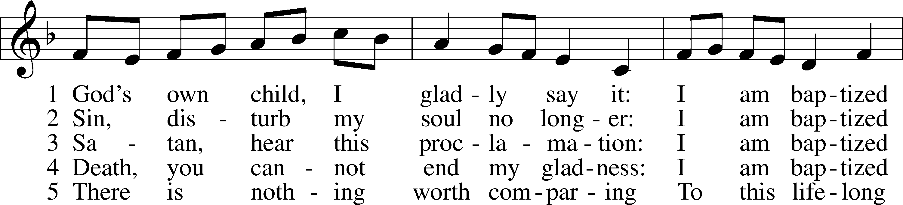
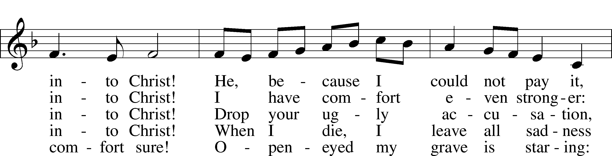
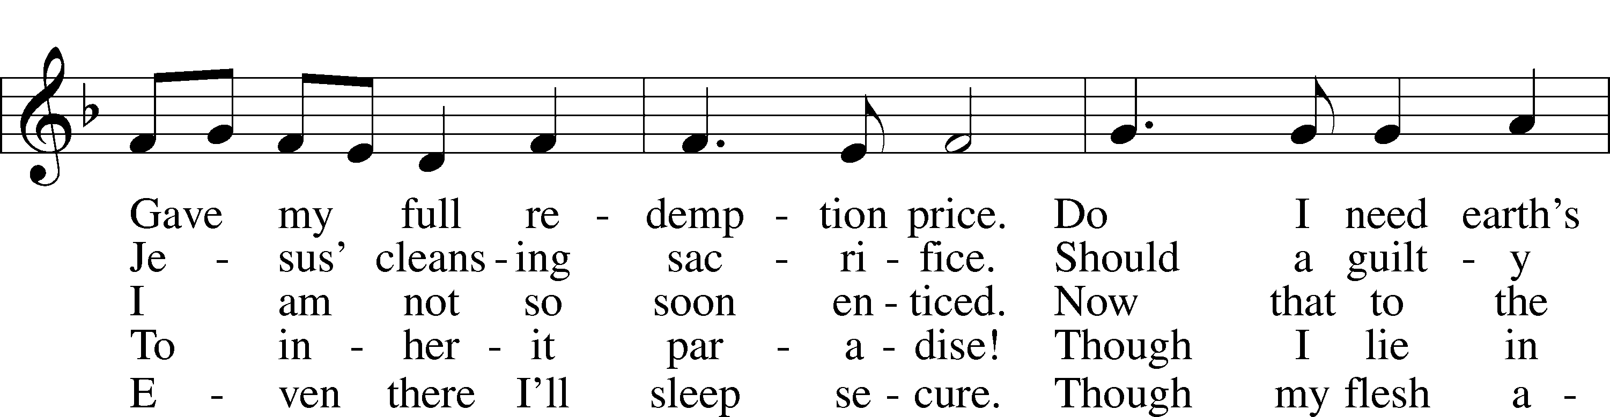
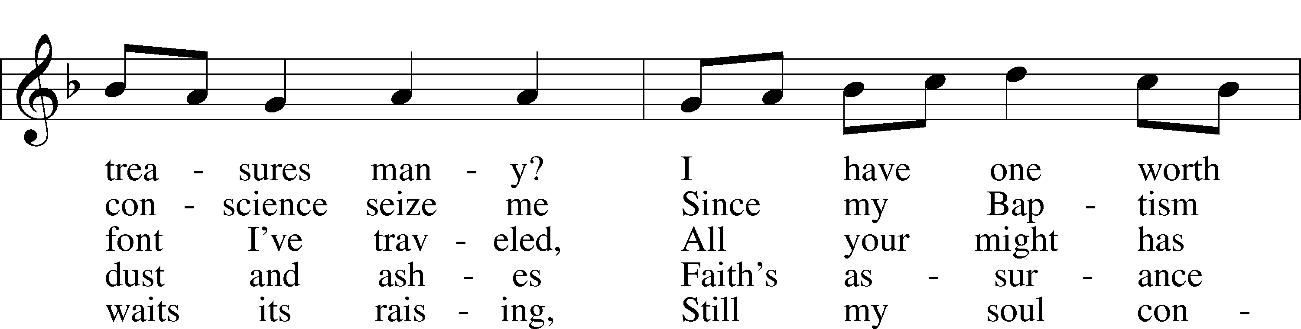
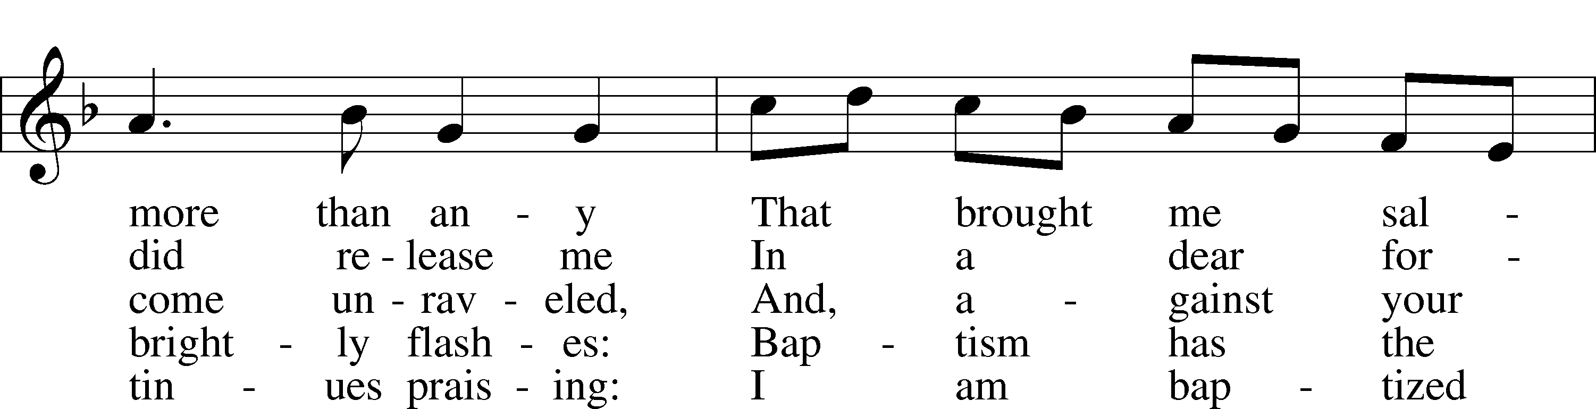
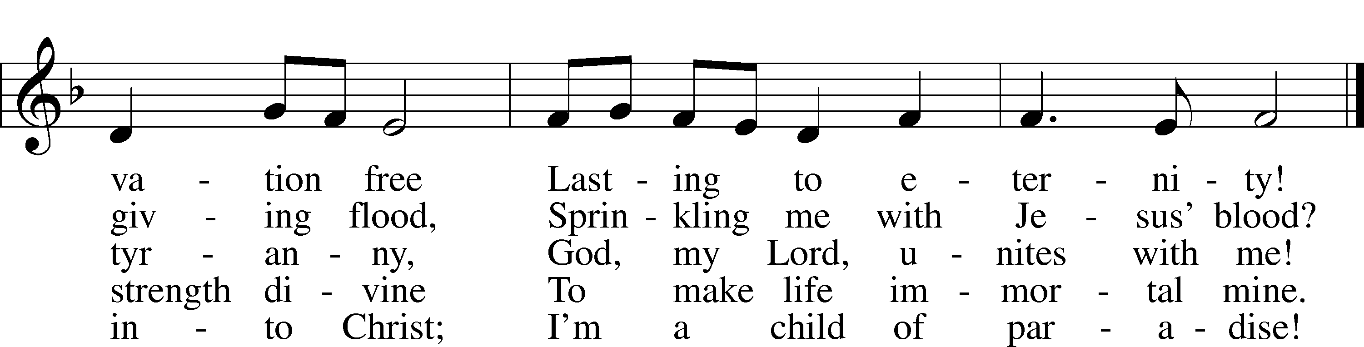
Text: Erdmann Neumeister, 1671–1756; tr. Robert E. Voelker, 1957
Tune: Johann Caspar Bachofen, 1695–1755, alt.
Text: © 1991 Robert E. Voelker. Used by permission: LSB Hymn License no. 110005011
Tune: Public domain
Confession and Absolution

The sign of the cross may be made by all in remembrance of their Baptism.

Invocation Matthew 28:19b; 18:20
P In the name of the Father and of the T Son and of the Holy Spirit.
C Amen.

Exhortation Hebrews 10:22; Psalm 124:8; Psalm 32:5
P Beloved in the Lord! Let us draw near with a true heart and confess our sins unto God our Father, beseeching Him in the name of our Lord Jesus Christ to grant us forgiveness.

P Our help is in the name of the Lord,
C who made heaven and earth.
P I said, I will confess my transgressions unto the Lord,
C and You forgave the iniquity of my sin.

Silence for reflection on God’s Word and for self-examination.

Confession of Sins
P Almighty God, our maker and redeemer, we poor sinners confess unto You that we are by nature sinful and unclean and that we have sinned against You by thought, word, and deed. Wherefore we flee for refuge to Your infinite mercy, seeking and imploring Your grace for the sake of our Lord Jesus Christ.
C O most merciful God, who has given Your only-begotten Son to die for us, have mercy upon us and for His sake grant us remission of all our sins; and by Your Holy Spirit increase in us true knowledge of You and of Your will and true obedience to Your Word, to the end that by Your grace we may come to everlasting life; through Jesus Christ, our Lord. Amen.

Declaration of Grace Mark 16:16; John 1:12
P Almighty God, our heavenly Father, has had mercy upon us and has given His only Son to die for us and for His sake forgives us all our sins. To those who believe on His name He gives power to become the children of God and has promised them His Holy Spirit. He that believes and is baptized shall be saved.
Grant this, Lord, unto us all.
C Amen.

Service of the Word

Introit Psalm 44:1–2, 7–8; antiphon: vv. 23, 25a, 26a
Awake! Why are you sleeping, O Lord?
Rouse yourself! Do not reject us forever!
For our soul is bowed down to the dust.
Rise up; come to our help!
O God, we have heard with our ears, our fathers have told us,
what deeds you performed in their days, in the days of old:
you with your own hand drove out the nations, but them you planted;
you afflicted the peoples, but them you set free.
But you have saved us from our foes
and have put to shame those who hate us.
In God we have boasted continually,
and we will give thanks to your name forever.

Gloria Patri
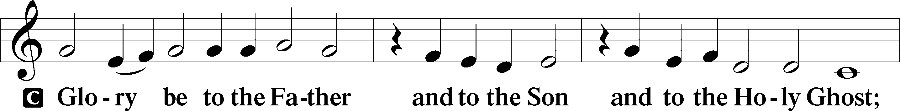
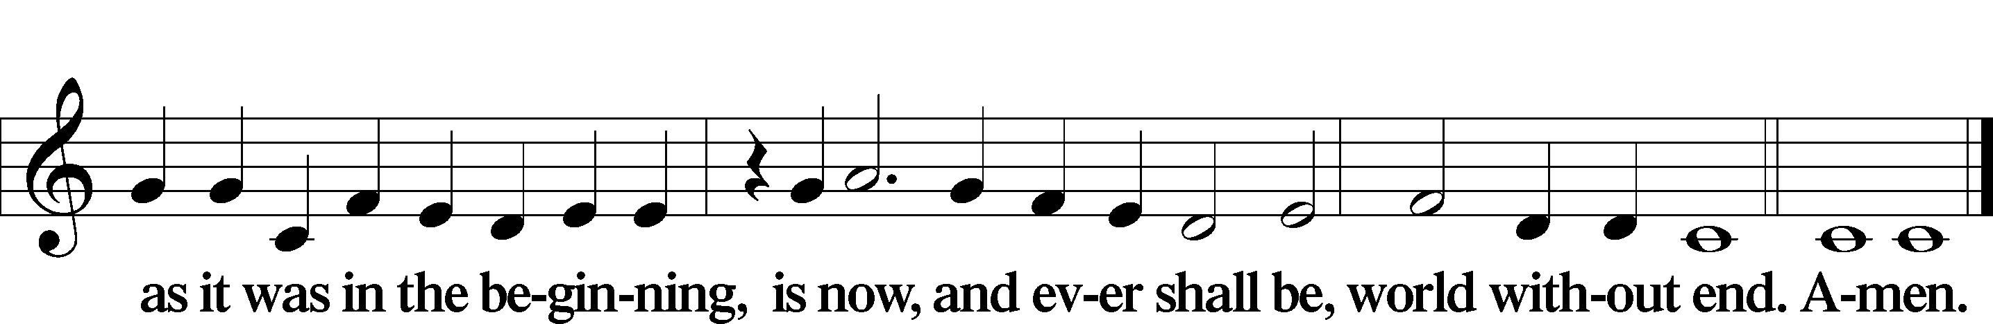

Kyrie Mark 10:47
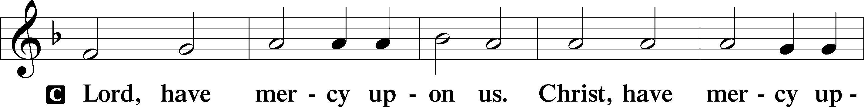
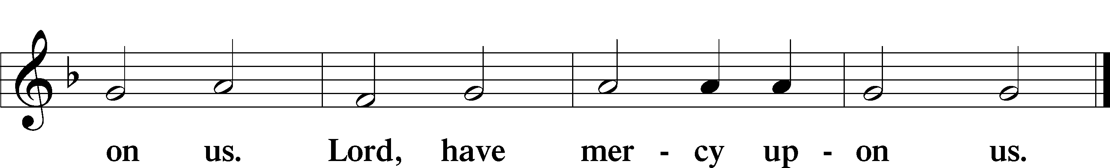

Salutation and Collect of the Day
P The Lord be with you.
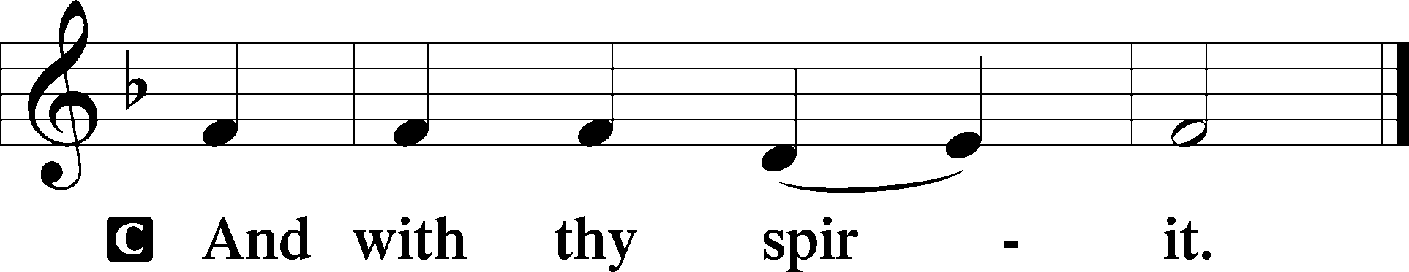

P Let us pray.
O God, the strength of all who put their trust in You, mercifully grant that by Your power we may be defended against all adversity; through Jesus Christ, Your Son, our Lord, who lives and reigns with You and the Holy Spirit, one God, now and forever.

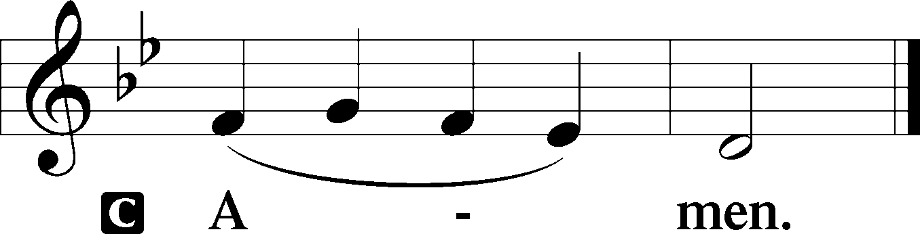

Sit

Old Testament Reading Isaiah 55:10–13
10“For as the rain and the snow come down from heaven
and do not return there but water the earth,
making it bring forth and sprout,
giving seed to the sower and bread to the eater,
11so shall my word be that goes out from my mouth;
it shall not return to me empty,
but it shall accomplish that which I purpose,
and shall succeed in the thing for which I sent it.
12“For you shall go out in joy
and be led forth in peace;
the mountains and the hills before you
shall break forth into singing,
and all the trees of the field shall clap their hands.
13Instead of the thorn shall come up the cypress;
instead of the brier shall come up the myrtle;
and it shall make a name for the Lord,
an everlasting sign that shall not be cut off.”

A This is the Word of the Lord.
C Thanks be to God.

Gradual Psalm 83:18, 13
[Let your enemies] know that you alone, whose name is the Lord,
are the Most High over all the earth.
O my God, make them like whirling dust,
like chaff before the wind.

Epistle 2 Corinthians 11:19—12:9
19For you gladly bear with fools, being wise yourselves! 20For you bear it if someone makes slaves of you, or devours you, or takes advantage of you, or puts on airs, or strikes you in the face. 21To my shame, I must say, we were too weak for that!
But whatever anyone else dares to boast of—I am speaking as a fool—I also dare to boast of that. 22Are they Hebrews? So am I. Are they Israelites? So am I. Are they offspring of Abraham? So am I. 23Are they servants of Christ? I am a better one—I am talking like a madman—with far greater labors, far more imprisonments, with countless beatings, and often near death. 24Five times I received at the hands of the Jews the forty lashes less one. 25Three times I was beaten with rods. Once I was stoned. Three times I was shipwrecked; a night and a day I was adrift at sea; 26on frequent journeys, in danger from rivers, danger from robbers, danger from my own people, danger from Gentiles, danger in the city, danger in the wilderness, danger at sea, danger from false brothers; 27in toil and hardship, through many a sleepless night, in hunger and thirst, often without food, in cold and exposure. 28And, apart from other things, there is the daily pressure on me of my anxiety for all the churches. 29Who is weak, and I am not weak? Who is made to fall, and I am not indignant?
30If I must boast, I will boast of the things that show my weakness. 31The God and Father of the Lord Jesus, he who is blessed forever, knows that I am not lying. 32At Damascus, the governor under King Aretas was guarding the city of Damascus in order to seize me, 33but I was let down in a basket through a window in the wall and escaped his hands.
1I must go on boasting. Though there is nothing to be gained by it, I will go on to visions and revelations of the Lord. 2I know a man in Christ who fourteen years ago was caught up to the third heaven—whether in the body or out of the body I do not know, God knows. 3And I know that this man was caught up into paradise—whether in the body or out of the body I do not know, God knows— 4and he heard things that cannot be told, which man may not utter. 5On behalf of this man I will boast, but on my own behalf I will not boast, except of my weaknesses. 6Though if I should wish to boast, I would not be a fool, for I would be speaking the truth. But I refrain from it, so that no one may think more of me than he sees in me or hears from me. 7So to keep me from being too elated by the surpassing greatness of the revelations, a thorn was given me in the flesh, a messenger of Satan to harass me, to keep me from being too elated. 8Three times I pleaded with the Lord about this, that it should leave me. 9But he said to me, “My grace is sufficient for you, for my power is made perfect in weakness.” Therefore I will boast all the more gladly of my weaknesses, so that the power of Christ may rest upon me.

Stand

Holy Gospel Luke 8:4–15
P The Holy Gospel according to St. Luke, the eighth chapter.

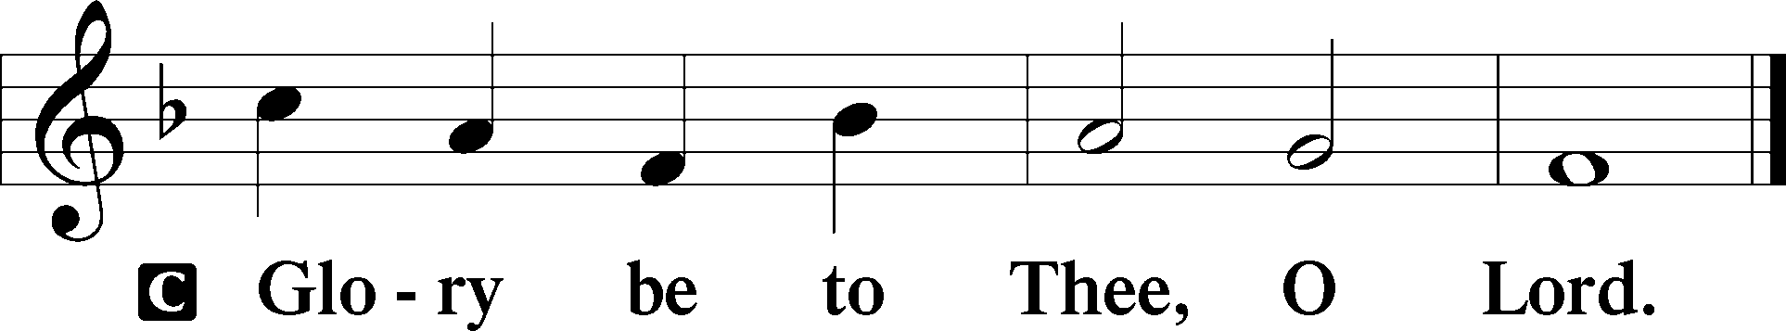

4When a great crowd was gathering and people from town after town came to [Jesus], he said in a parable: 5“A sower went out to sow his seed. And as he sowed, some fell along the path and was trampled underfoot, and the birds of the air devoured it. 6And some fell on the rock, and as it grew up, it withered away, because it had no moisture. 7And some fell among thorns, and the thorns grew up with it and choked it. 8And some fell into good soil and grew and yielded a hundredfold.” As he said these things, he called out, “He who has ears to hear, let him hear.”
9And when his disciples asked him what this parable meant, 10he said, “To you it has been given to know the secrets of the kingdom of God, but for others they are in parables, so that ‘seeing they may not see, and hearing they may not understand.’ 11Now the parable is this: The seed is the word of God. 12The ones along the path are those who have heard. Then the devil comes and takes away the word from their hearts, so that they may not believe and be saved. 13And the ones on the rock are those who, when they hear the word, receive it with joy. But these have no root; they believe for a while, and in time of testing fall away. 14And as for what fell among the thorns, they are those who hear, but as they go on their way they are choked by the cares and riches and pleasures of life, and their fruit does not mature. 15As for that in the good soil, they are those who, hearing the word, hold it fast in an honest and good heart, and bear fruit with patience.”

P This is the Gospel of the Lord.

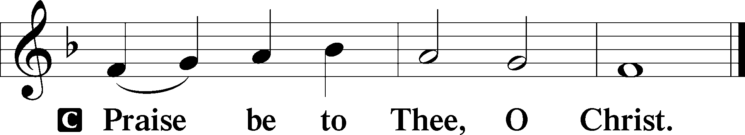

Apostles’ Creed
C I believe in God, the Father Almighty,
maker of heaven and earth.

And in Jesus Christ, His only Son, our Lord,
who was conceived by the Holy Spirit,
born of the virgin Mary,
suffered under Pontius Pilate,
was crucified, died and was buried.
He descended into hell.
The third day He rose again from the dead.
He ascended into heaven
and sits at the right hand of God the Father Almighty.
From thence He will come to judge the living and the dead.

I believe in the Holy Spirit,
the holy Christian Church,
the communion of saints,
the forgiveness of sins,
the resurrection of the body,
and the life T everlasting. Amen.

Sit

Children's Sermon

826 Hark, the Voice of Jesus Crying
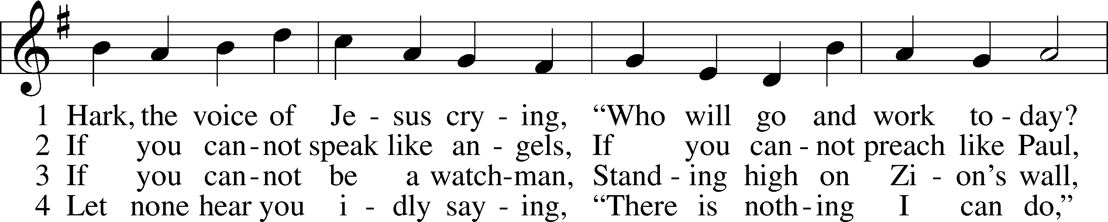
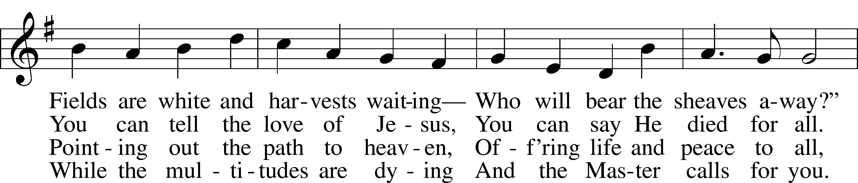
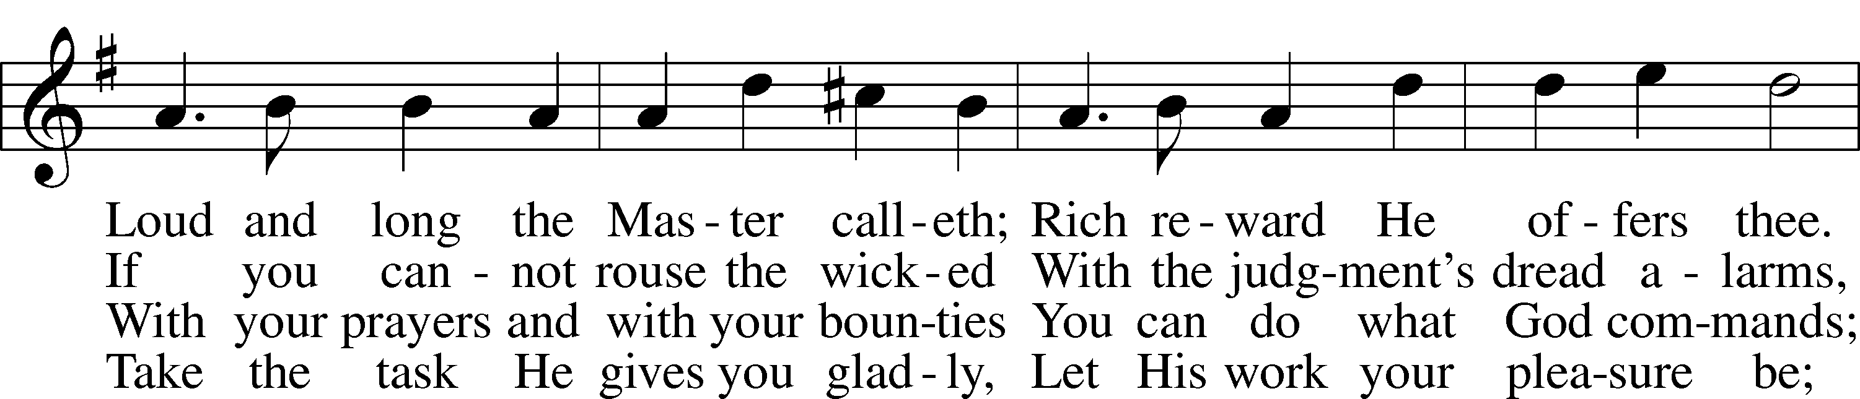
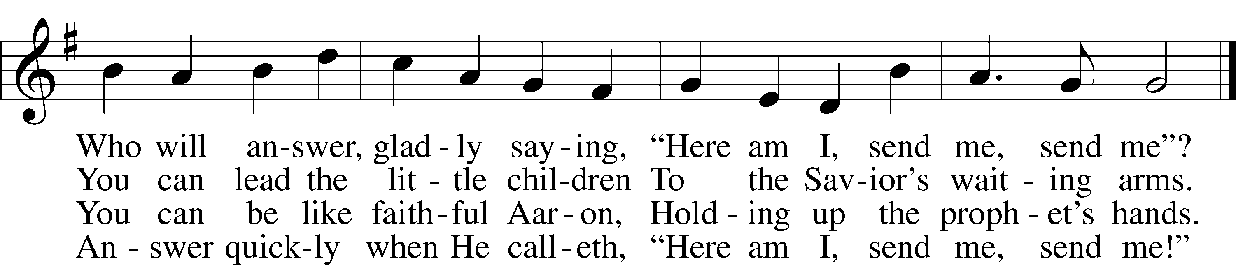
Text (sts. 1–2, 4): Daniel March, 1816–1909, alt.; (st. 3): unknown, alt.
Tune: Joseph Barnby, 1838–96
Text and tune: Public domain

Sermon

Votum
P The peace of God, which passes all understanding, keep your hearts and minds in Christ Jesus.
C Amen.

Stand

Offertory Psalm 51:10–12
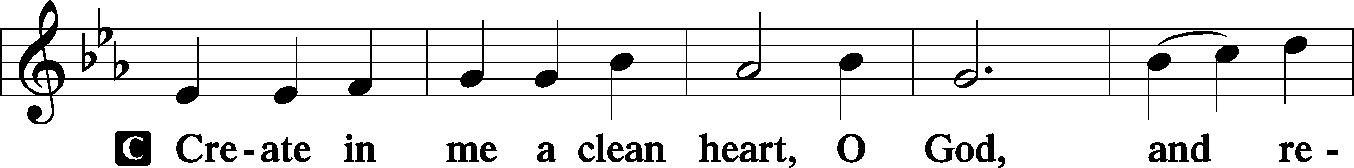
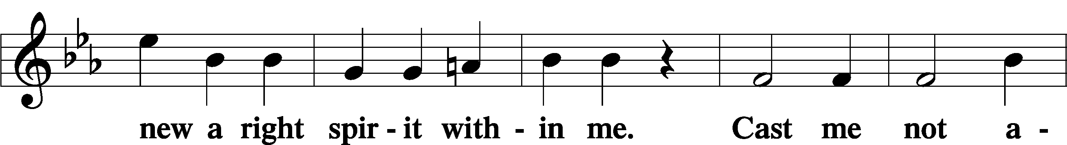
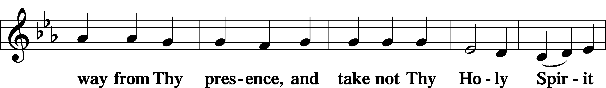
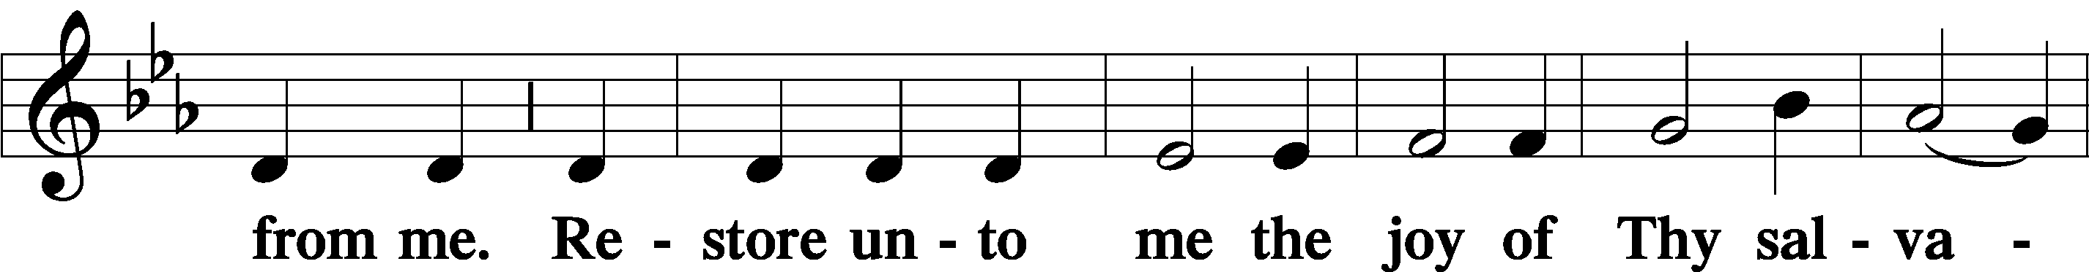
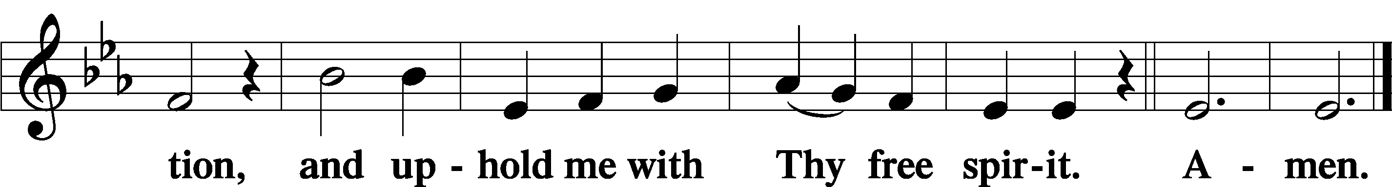

Offering

805 Praise God, from Whom All Blessings Flow
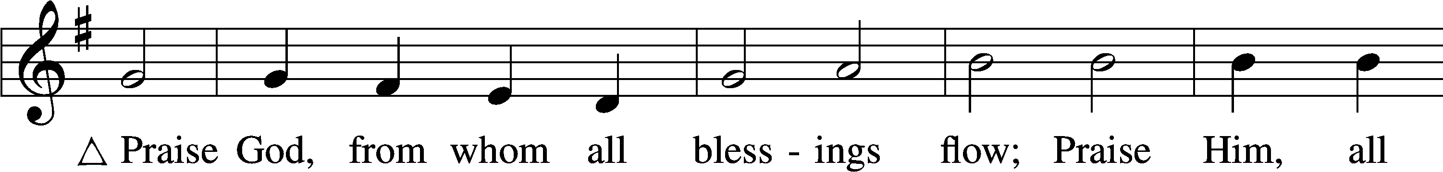
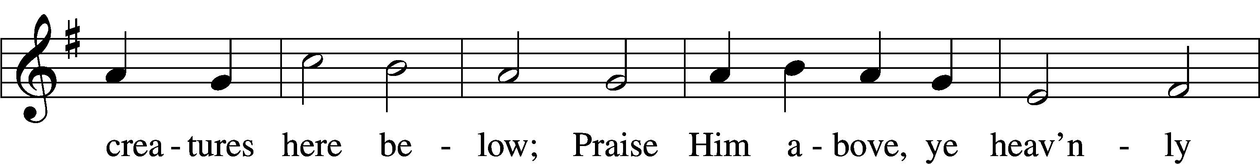
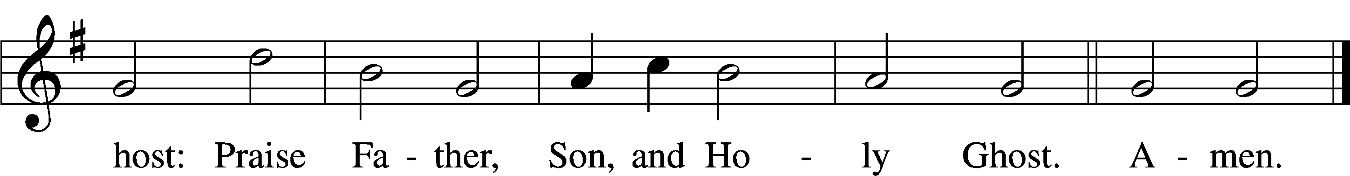
Text: Thomas Ken, 1637–1711
Tune: Trente quatre Pseaumes de David, 1551, Geneva, ed. Louis Bourgeois
Text and tune: Public domain

Prayer of the Church

Lord’s Prayer Matthew 6:9–13
P Lord, remember us in Your kingdom and teach us to pray:
C Our Father who art in heaven,
hallowed be Thy name,
Thy kingdom come,
Thy will be done on earth
as it is in heaven;
give us this day our daily bread;
and forgive us our trespasses
as we forgive those
who trespass against us;
and lead us not into temptation,
but deliver us from evil.
For Thine is the kingdom
and the power and the glory
forever and ever. Amen.

Collect for the Word

Blessed Lord, You have caused all Holy Scriptures to be written for our learning. Grant that we may so hear them, read, mark, learn, and inwardly digest them that, by the patience and comfort of Your holy Word, we may embrace and ever hold fast the blessed hope of everlasting life; through Jesus Christ, Your Son, our Lord, who lives and reigns with You and the Holy Spirit, one God, now and forever.

Benediction
P The Lord bless you and keep you.
The Lord make His face shine on you and be gracious to you.
The Lord look upon you with favor and T give you peace.
C Amen.

921 On What Has Now Been Sown
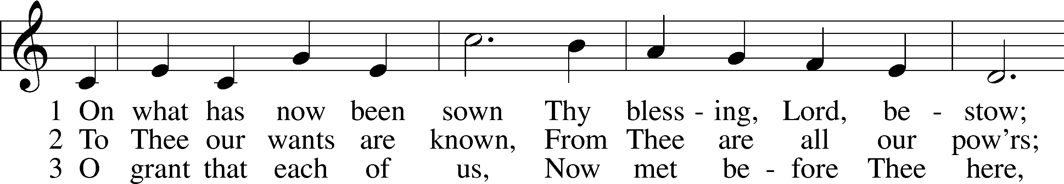
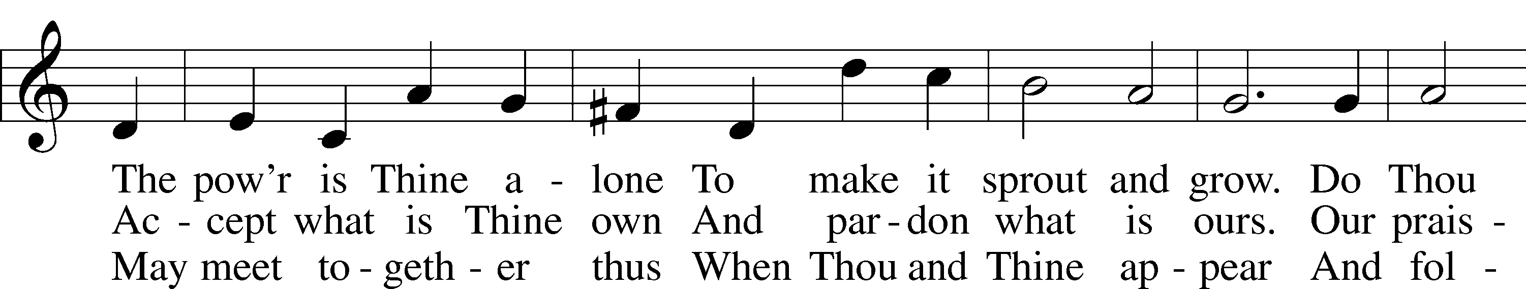
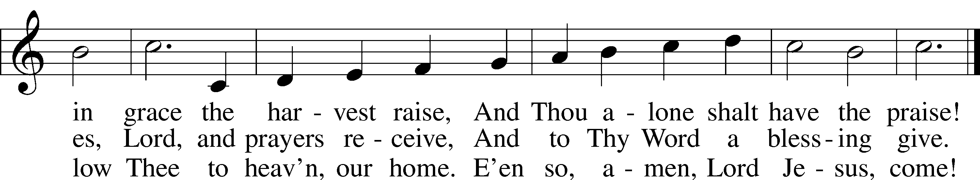
Text: John Newton, 1725–1807, alt.
Tune: John Darwall, 1731–89
Text and tune: Public domain

Acknowledgments
Unless otherwise indicated, Scripture quotations are from the ESV® Bible (The Holy Bible, English Standard Version®), copyright © 2001 by Crossway, a publishing ministry of Good News Publishers. Used by permission. All rights reserved.
Created by Lutheran Service Builder © 2026 Concordia Publishing House.

