On entering the church

P Lord, I love the habitation of Your house and the place
where Your glory dwells. In the multitude of Your tender
mercies prepare my heart that I may enter Your house to
worship and confess Your holy name; through Jesus Christ,
my God and Lord.

Before worship

C O Lord, our creator, redeemer, and comforter, as we come
together to worship You in spirit and in truth, we humbly
pray that You would open our hearts to the preaching of
Your Word so that we may repent of our sins, believe in
Jesus Christ as our only Savior, and grow in grace and
holiness. Hear us for His sake.

515 Rejoice, Rejoice, Believers
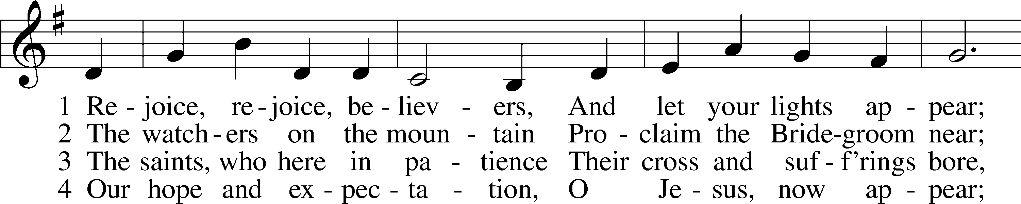
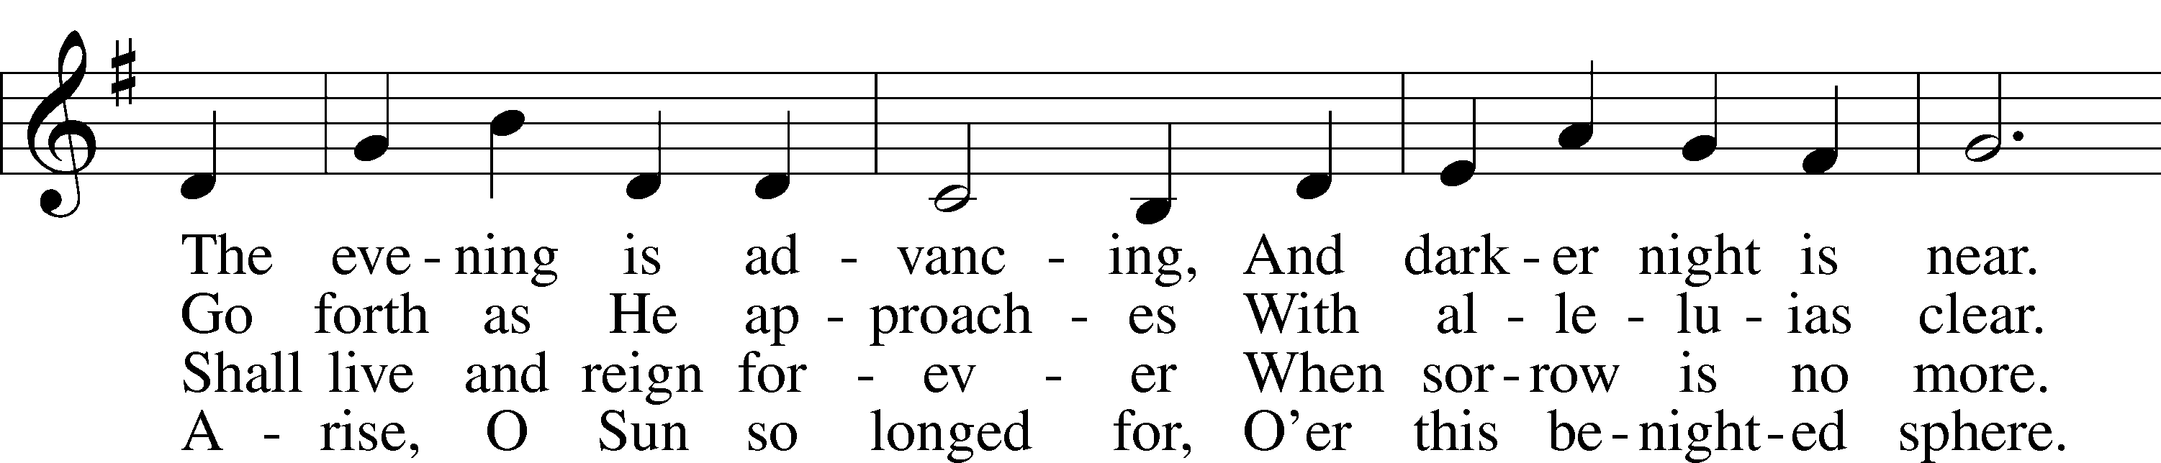
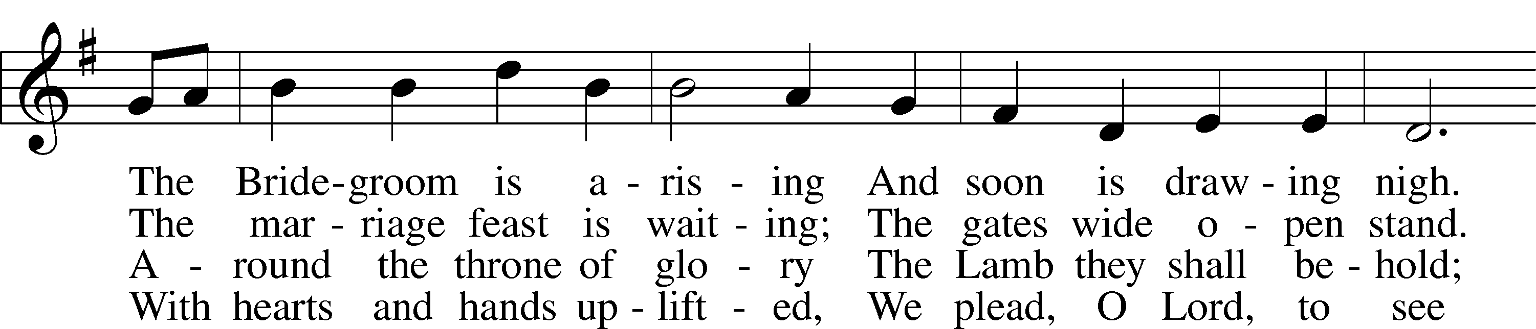
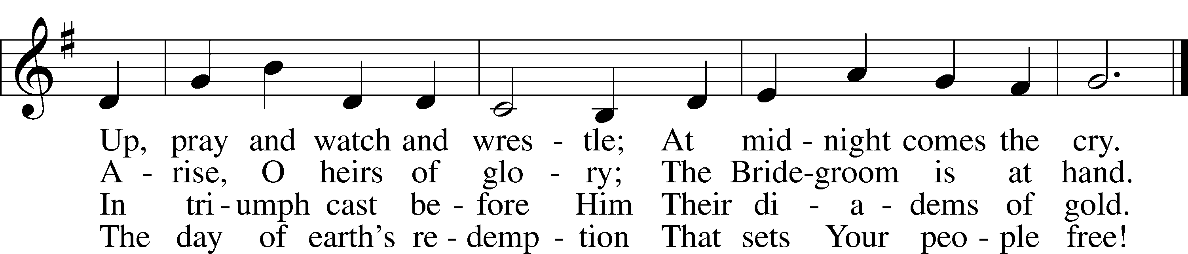
Text: Laurentius Laurenti, 1660–1722; tr. Sarah B. Findlater, 1823–1907, alt.
Tune: Swedish
Text and tune: Public domain
Confession and Absolution

The sign of the cross may be made by all in remembrance of their Baptism.

Invocation Matthew 28:19b; 18:20
P In the name of the Father and of the T Son and of the Holy Spirit.
C Amen.

Exhortation Hebrews 10:22; Psalm 124:8; Psalm 32:5
P Beloved in the Lord! Let us draw near with a true heart and confess our sins unto God our Father, beseeching Him in the name of our Lord Jesus Christ to grant us forgiveness.

P Our help is in the name of the Lord,
C who made heaven and earth.
P I said, I will confess my transgressions unto the Lord,
C and You forgave the iniquity of my sin.

Silence for reflection on God’s Word and for self-examination.

Confession of Sins
P Almighty God, our maker and redeemer, we poor sinners confess unto You that we are by nature sinful and unclean and that we have sinned against You by thought, word, and deed. Wherefore we flee for refuge to Your infinite mercy, seeking and imploring Your grace for the sake of our Lord Jesus Christ.
C O most merciful God, who has given Your only-begotten Son to die for us, have mercy upon us and for His sake grant us remission of all our sins; and by Your Holy Spirit increase in us true knowledge of You and of Your will and true obedience to Your Word, to the end that by Your grace we may come to everlasting life; through Jesus Christ, our Lord. Amen.

Declaration of Grace Mark 16:16; John 1:12
P Almighty God, our heavenly Father, has had mercy upon us and has given His only Son to die for us and for His sake forgives us all our sins. To those who believe on His name He gives power to become the children of God and has promised them His Holy Spirit. He that believes and is baptized shall be saved.
Grant this, Lord, unto us all.
C Amen.

Service of the Word
Introit Psalm 115:2–4, 8, 17–18; antiphon: v. 11
You who fear the Lord, trust in the Lord!
He is their help and their shield.
Why should the nations say,
“Where is their God?”
Our God is in the heavens;
he does all that he pleases.
Their idols are silver and gold,
the work of human hands.
Those who make them become like them;
so do all who trust in them.
The dead do not praise the Lord,
nor do any who go down into silence.
But we will bless the Lord
from this time forth and forevermore. Praise the Lord!

Gloria Patri
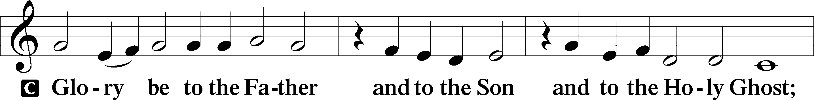
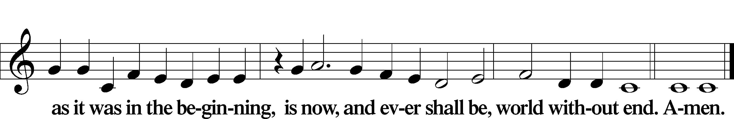

Kyrie Mark 10:47
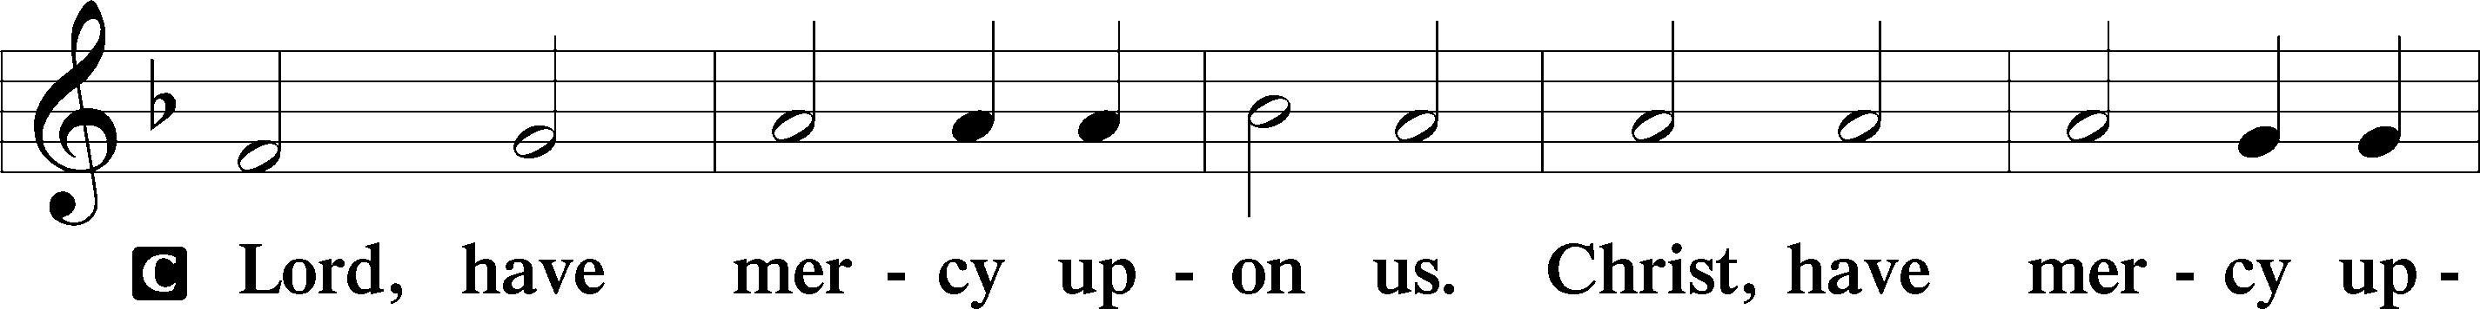
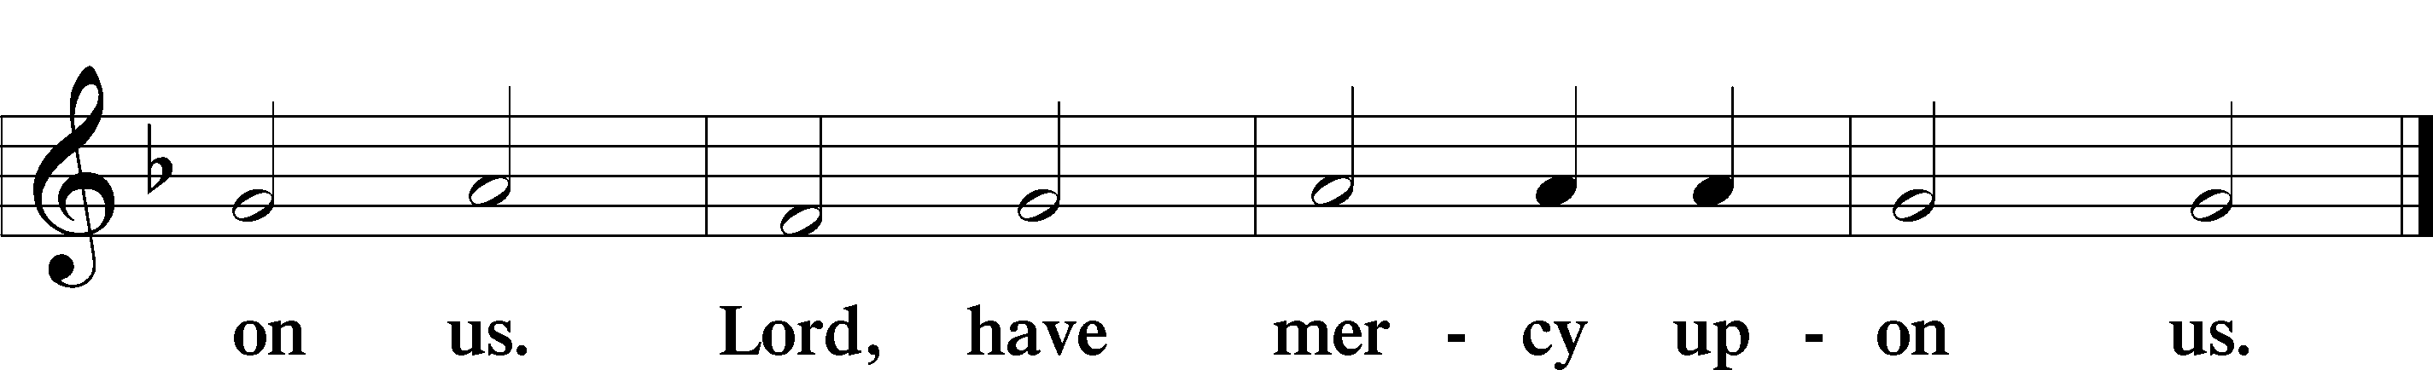

Gloria in Excelsis Luke 2:14; John 1:29
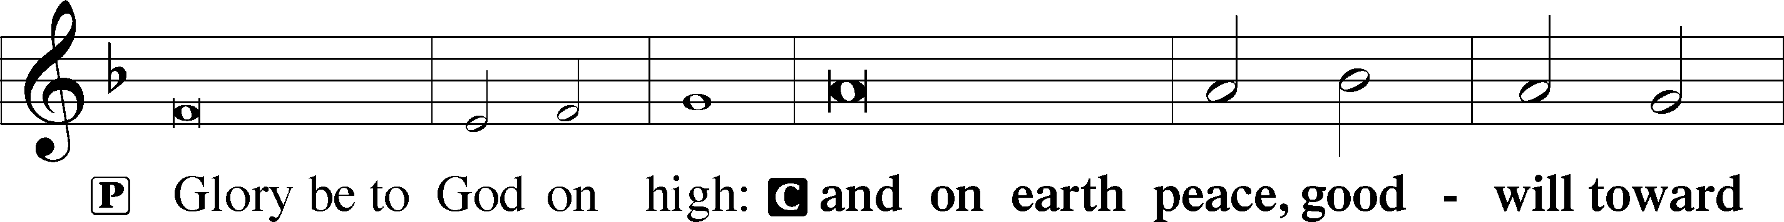
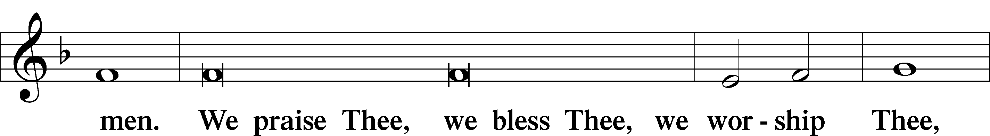
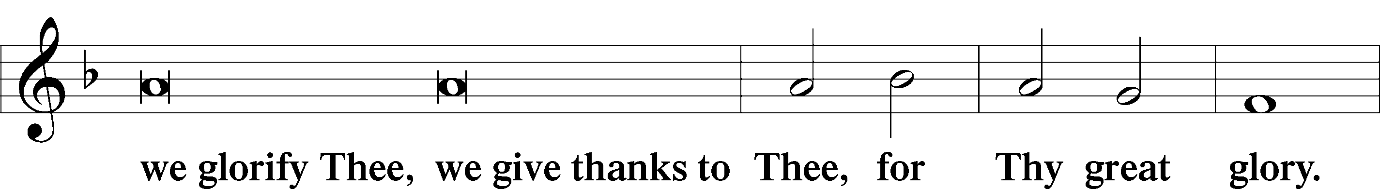
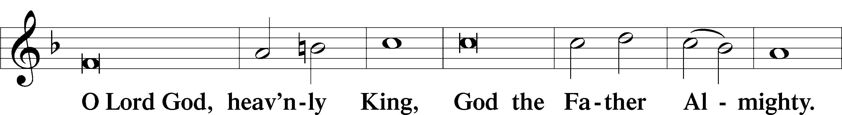
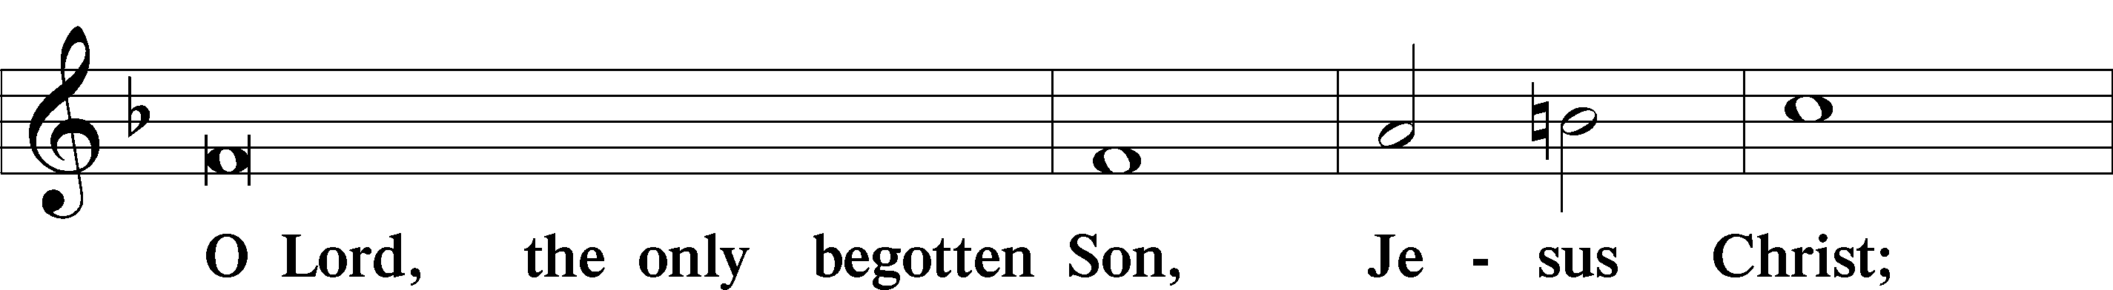
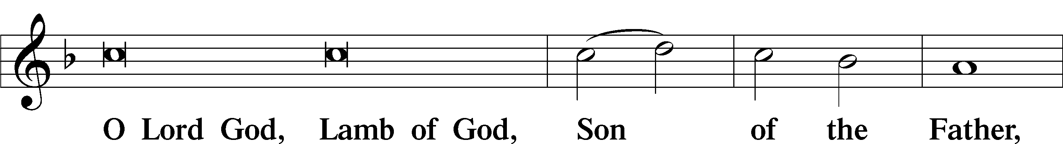
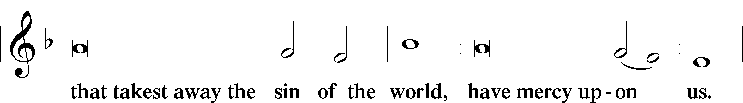
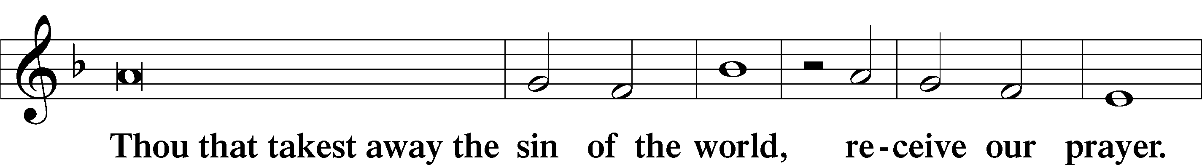
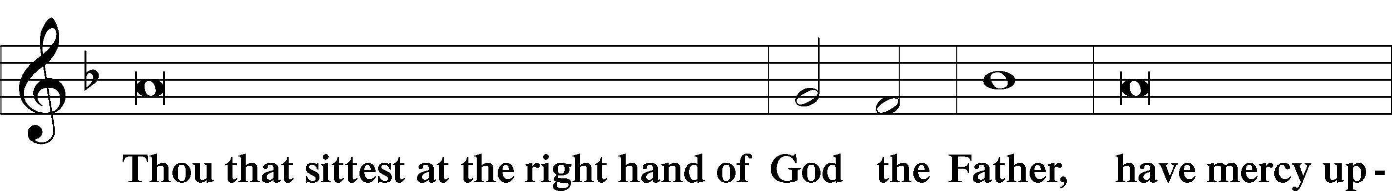
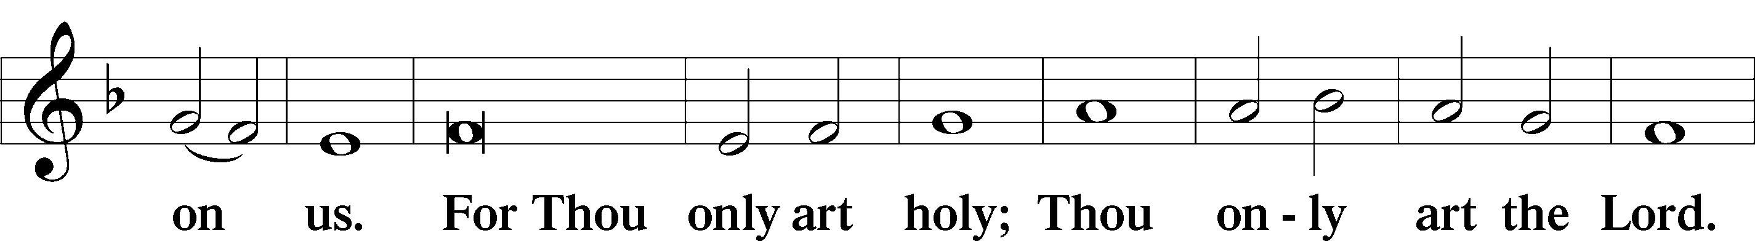
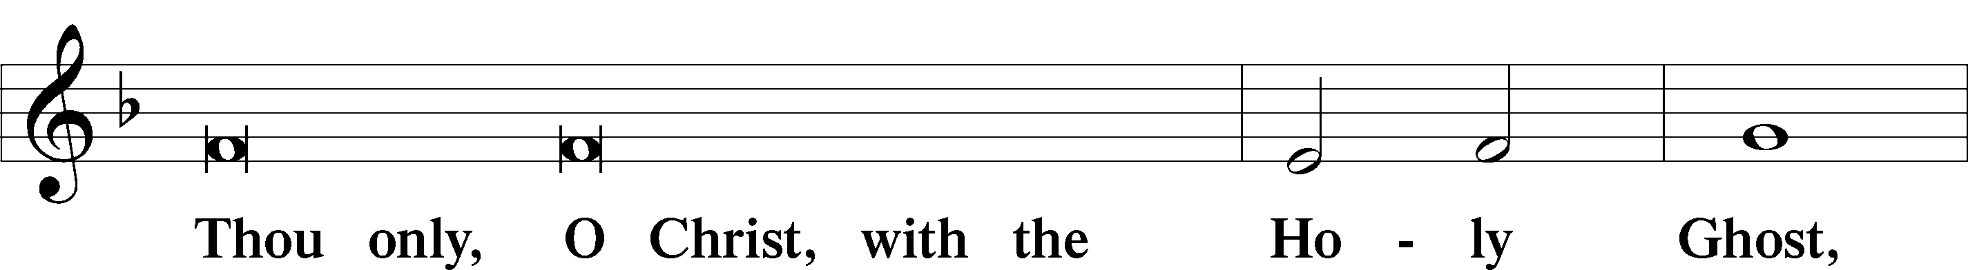
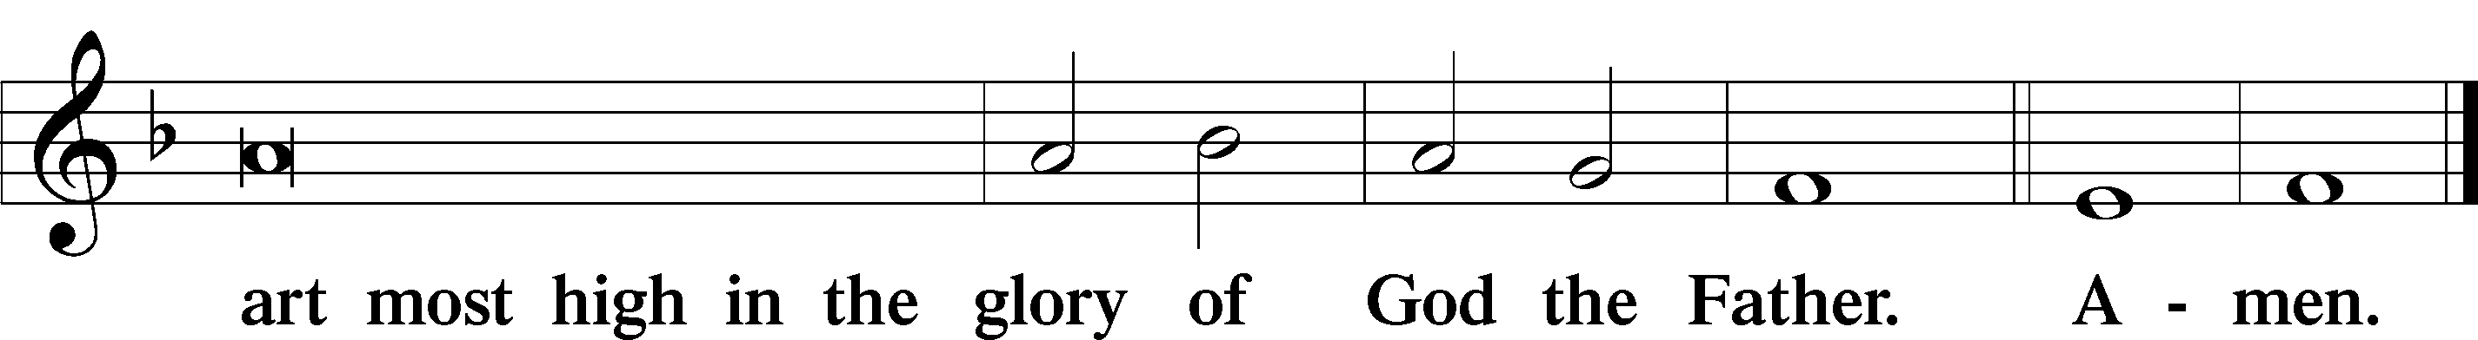

Salutation and Collect of the Day
P The Lord be with you.
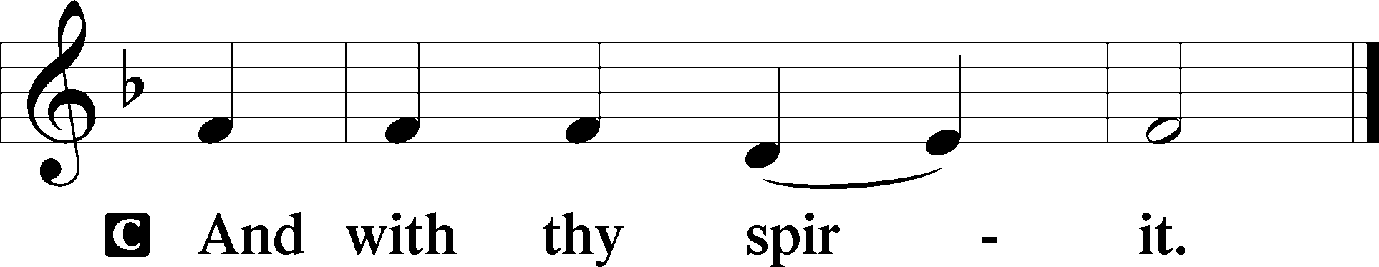

P Let us pray.
Living God, Your almighty power is made known chiefly in showing mercy and pity. Grant us the fullness of Your grace to lay hold of Your promises and live forever in Your presence; through Jesus Christ, Your Son, our Lord, who lives and reigns with You and the Holy Spirit, one God, now and forever.

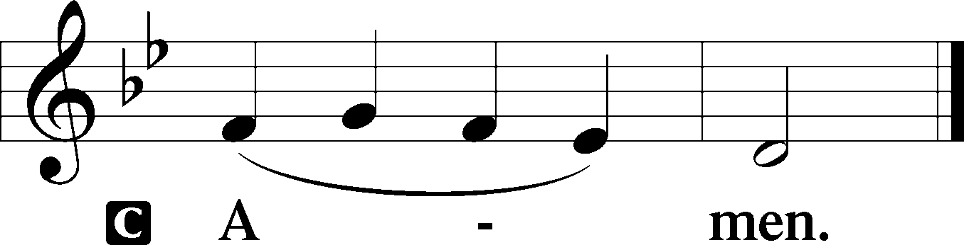

Sit

Old Testament Reading Exodus 3:1–15
1Now Moses was keeping the flock of his father-in-law, Jethro, the priest of Midian, and he led his flock to the west side of the wilderness and came to Horeb, the mountain of God. 2And the angel of the Lord appeared to him in a flame of fire out of the midst of a bush. He looked, and behold, the bush was burning, yet it was not consumed. 3And Moses said, “I will turn aside to see this great sight, why the bush is not burned.” 4When the Lord saw that he turned aside to see, God called to him out of the bush, “Moses, Moses!” And he said, “Here I am.” 5Then he said, “Do not come near; take your sandals off your feet, for the place on which you are standing is holy ground.” 6And he said, “I am the God of your father, the God of Abraham, the God of Isaac, and the God of Jacob.” And Moses hid his face, for he was afraid to look at God.
7Then the Lord said, “I have surely seen the affliction of my people who are in Egypt and have heard their cry because of their taskmasters. I know their sufferings, 8and I have come down to deliver them out of the hand of the Egyptians and to bring them up out of that land to a good and broad land, a land flowing with milk and honey, to the place of the Canaanites, the Hittites, the Amorites, the Perizzites, the Hivites, and the Jebusites. 9And now, behold, the cry of the people of Israel has come to me, and I have also seen the oppression with which the Egyptians oppress them. 10Come, I will send you to Pharaoh that you may bring my people, the children of Israel, out of Egypt.” 11But Moses said to God, “Who am I that I should go to Pharaoh and bring the children of Israel out of Egypt?” 12He said, “But I will be with you, and this shall be the sign for you, that I have sent you: when you have brought the people out of Egypt, you shall serve God on this mountain.”
13Then Moses said to God, “If I come to the people of Israel and say to them, ‘The God of your fathers has sent me to you,’ and they ask me, ‘What is his name?’ what shall I say to them?” 14God said to Moses, “I am who I am.” And he said, “Say this to the people of Israel, ‘I am has sent me to you.’” 15God also said to Moses, “Say this to the people of Israel, ‘The Lord, the God of your fathers, the God of Abraham, the God of Isaac, and the God of Jacob, has sent me to you.’ This is my name forever, and thus I am to be remembered throughout all generations.”

A This is the Word of the Lord.
C Thanks be to God.

Gradual Revelation 7:14b; Psalm 84:5
These are the ones coming out of the great tribulation.
They have washed their robes and made them white in the blood of the Lamb.
Blessèd are those whose strength is in you,
in whose heart are the highways to Zion.

Epistle 2 Thessalonians 2:1–8, 13–17
1Now concerning the coming of our Lord Jesus Christ and our being gathered together to him, we ask you, brothers, 2not to be quickly shaken in mind or alarmed, either by a spirit or a spoken word, or a letter seeming to be from us, to the effect that the day of the Lord has come. 3Let no one deceive you in any way. For that day will not come, unless the rebellion comes first, and the man of lawlessness is revealed, the son of destruction, 4who opposes and exalts himself against every so-called god or object of worship, so that he takes his seat in the temple of God, proclaiming himself to be God. 5Do you not remember that when I was still with you I told you these things? 6And you know what is restraining him now so that he may be revealed in his time. 7For the mystery of lawlessness is already at work. Only he who now restrains it will do so until he is out of the way. 8And then the lawless one will be revealed, whom the Lord Jesus will kill with the breath of his mouth and bring to nothing by the appearance of his coming. . . .
13But we ought always to give thanks to God for you, brothers beloved by the Lord, because God chose you as the firstfruits to be saved, through sanctification by the Spirit and belief in the truth. 14To this he called you through our gospel, so that you may obtain the glory of our Lord Jesus Christ. 15So then, brothers, stand firm and hold to the traditions that you were taught by us, either by our spoken word or by our letter.
16Now may our Lord Jesus Christ himself, and God our Father, who loved us and gave us eternal comfort and good hope through grace, 17comfort your hearts and establish them in every good work and word.

Stand

Alleluia
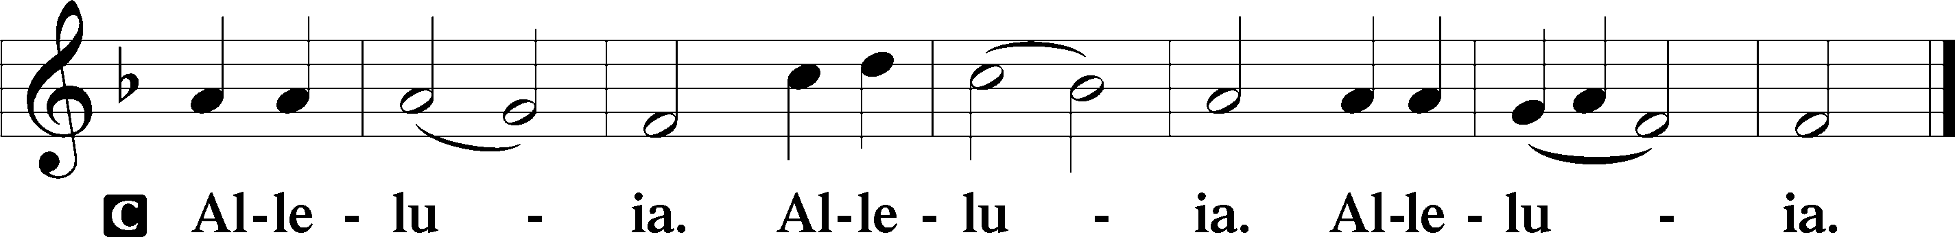

Holy Gospel Luke 20:27–40
P The Holy Gospel according to St. Luke, the twentieth chapter.

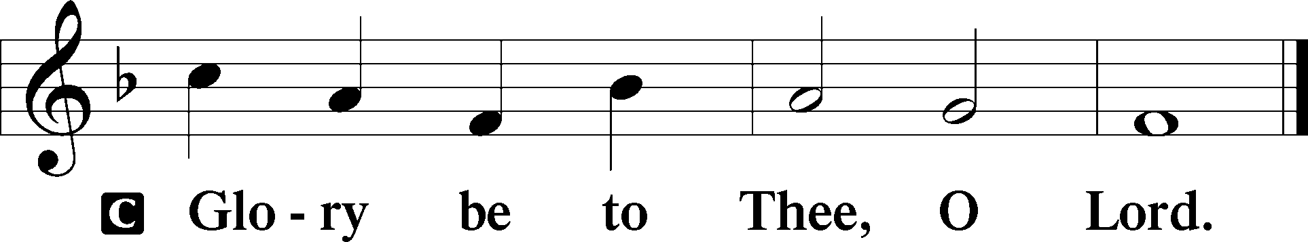

27There came to [Jesus] some Sadducees, those who deny that there is a resurrection, 28and they asked him a question, saying, “Teacher, Moses wrote for us that if a man’s brother dies, having a wife but no children, the man must take the widow and raise up offspring for his brother. 29Now there were seven brothers. The first took a wife, and died without children. 30And the second 31and the third took her, and likewise all seven left no children and died. 32Afterward the woman also died. 33In the resurrection, therefore, whose wife will the woman be? For the seven had her as wife.”
34And Jesus said to them, “The sons of this age marry and are given in marriage, 35but those who are considered worthy to attain to that age and to the resurrection from the dead neither marry nor are given in marriage, 36for they cannot die anymore, because they are equal to angels and are sons of God, being sons of the resurrection. 37But that the dead are raised, even Moses showed, in the passage about the bush, where he calls the Lord the God of Abraham and the God of Isaac and the God of Jacob. 38Now he is not God of the dead, but of the living, for all live to him.” 39Then some of the scribes answered, “Teacher, you have spoken well.” 40For they no longer dared to ask him any question.

P This is the Gospel of the Lord.

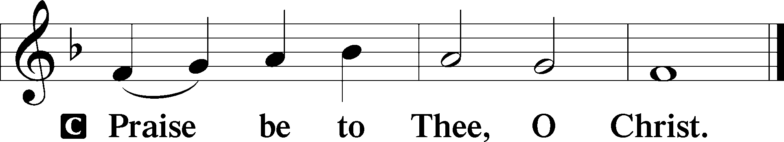

Apostles’ Creed
C I believe in God, the Father Almighty,
maker of heaven and earth.
And in Jesus Christ, His only Son, our Lord,
who was conceived by the Holy Spirit,
born of the virgin Mary,
suffered under Pontius Pilate,
was crucified, died and was buried.
He descended into hell.
The third day He rose again from the dead.
He ascended into heaven
and sits at the right hand of God the Father Almighty.
From thence He will come to judge the living and the dead.
I believe in the Holy Spirit,
the holy Christian Church,
the communion of saints,
the forgiveness of sins,
the resurrection of the body,
and the life T everlasting. Amen.

Sit

Children's Sermon

741 Jesus Christ, My Sure Defense sts. 1–4
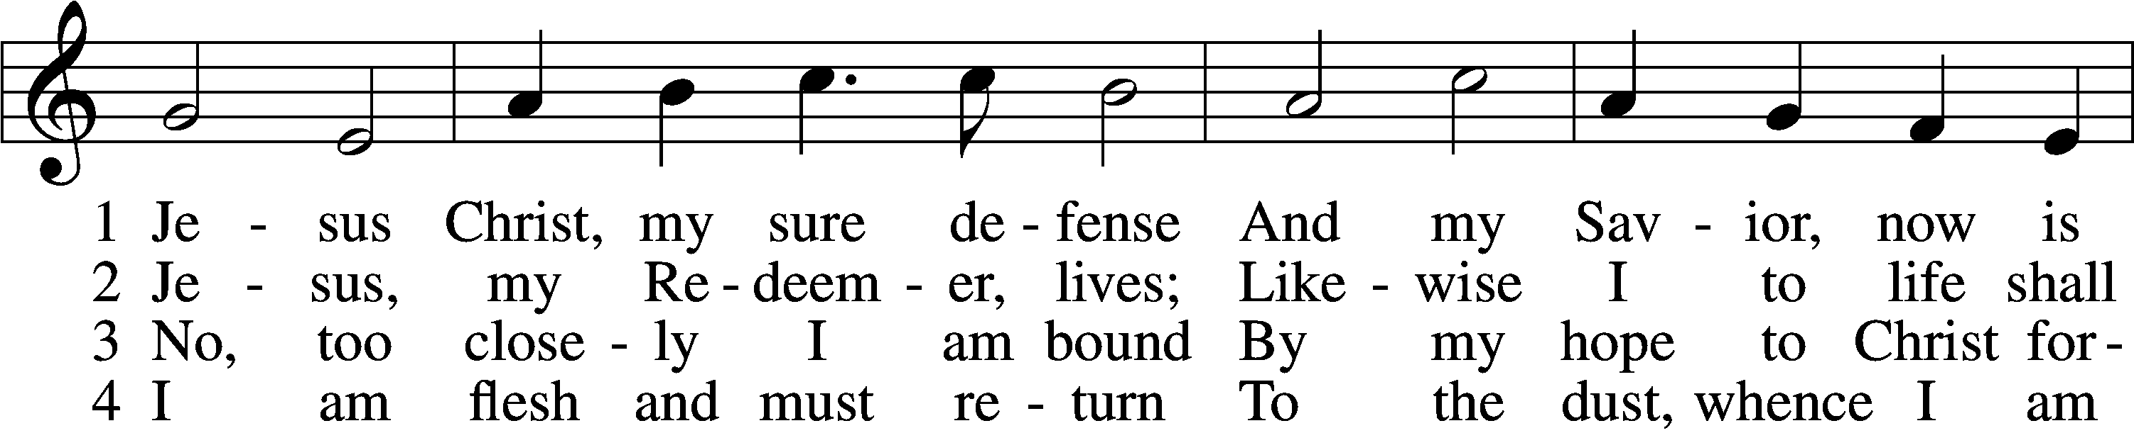
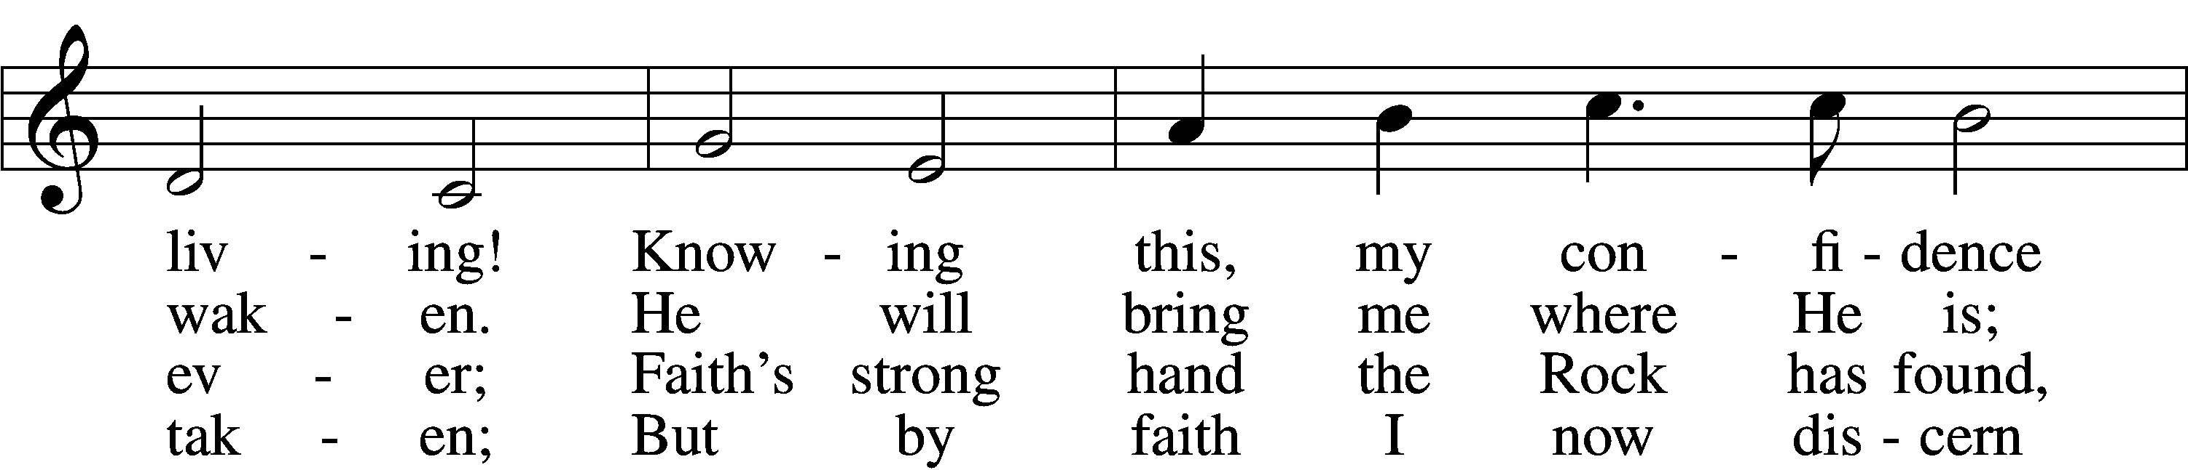
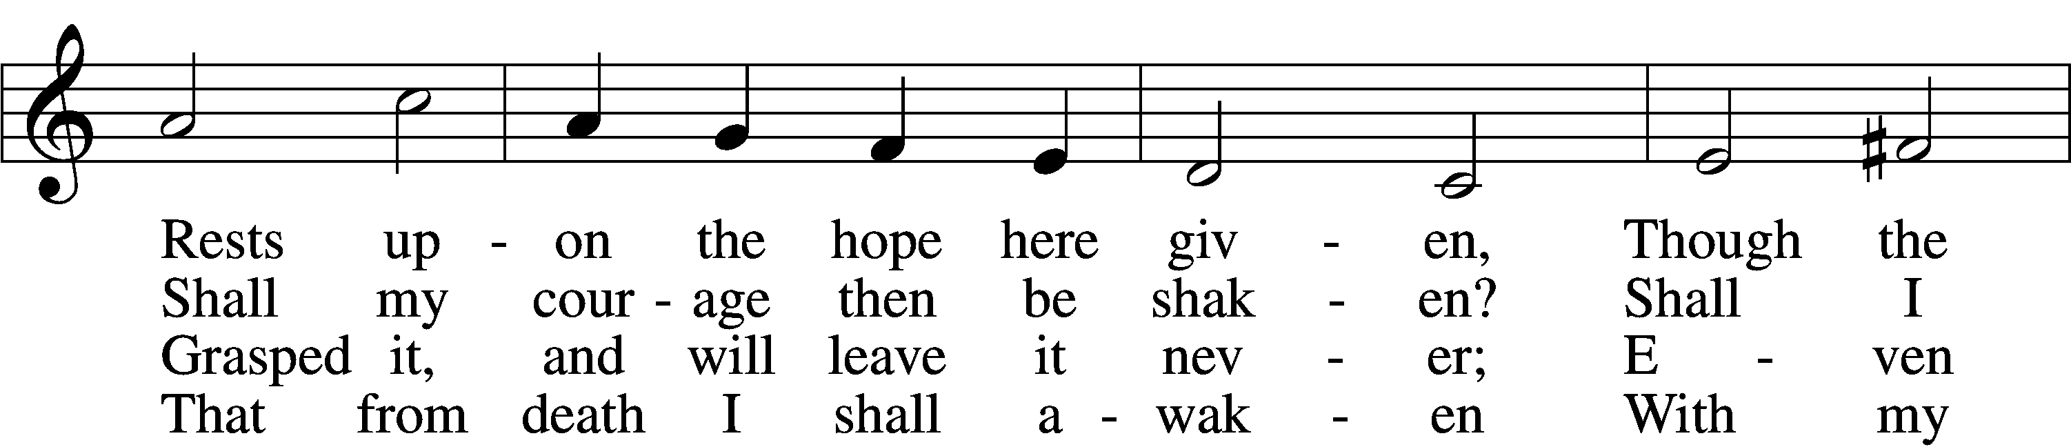
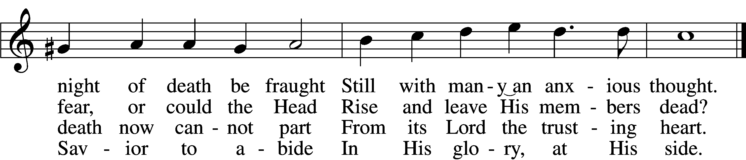
Text: Otto von Schwerin, 1616–79; tr. Catherine Winkworth, 1827–78, alt.
Tune: Johann Crüger, 1598–1662
Text and tune: Public domain

Sermon

741 Jesus Christ, My Sure Defense sts. 5–8
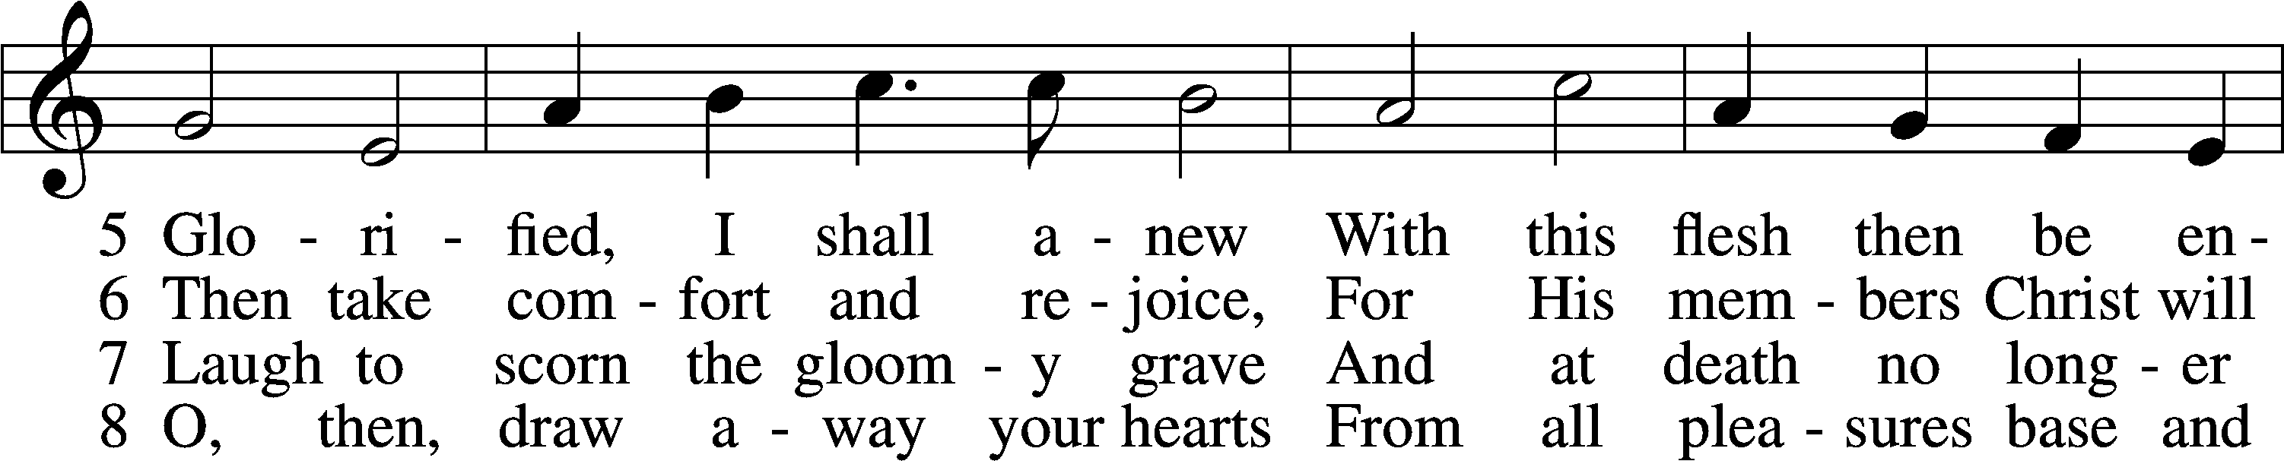
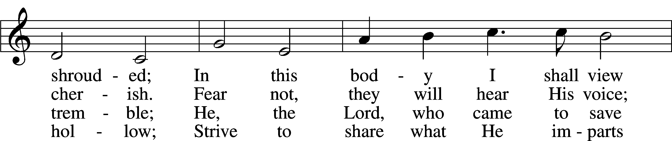
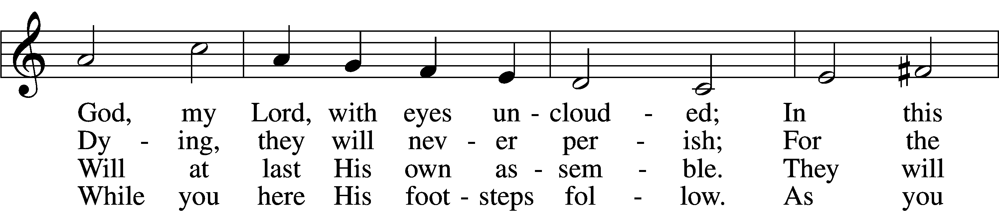
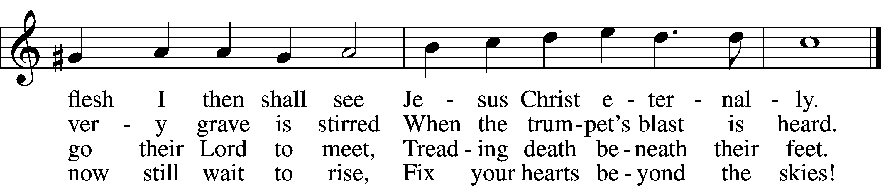
Text: Otto von Schwerin, 1616–79; tr. Catherine Winkworth, 1827–78, alt.
Tune: Johann Crüger, 1598–1662
Text and tune: Public domain

Votum
P The peace of God, which passes all understanding, keep your hearts and minds in Christ Jesus.
C Amen.

Stand

Offertory Psalm 51:10–12
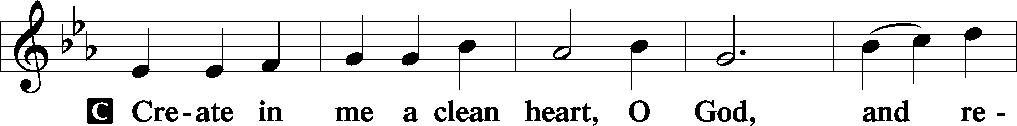
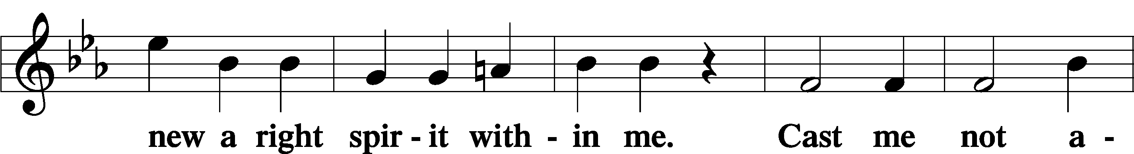
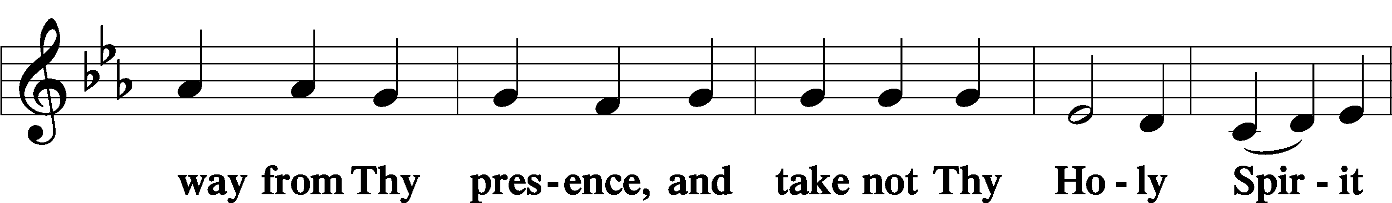
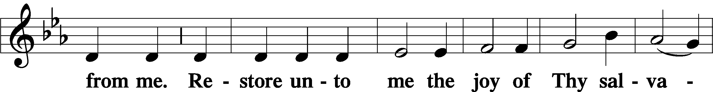
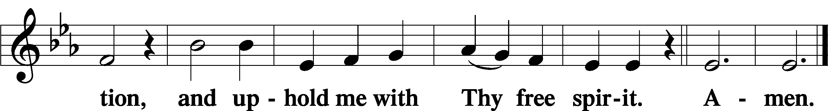

805 Praise God, from Whom All Blessings Flow
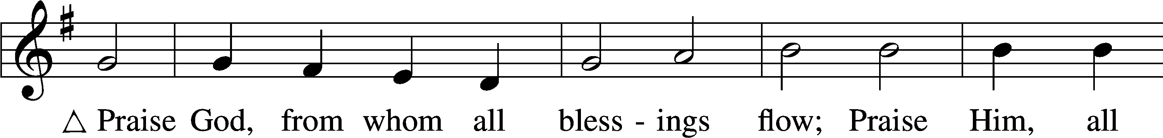
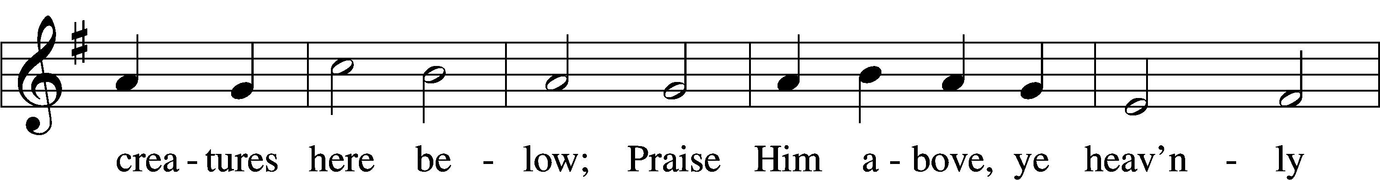
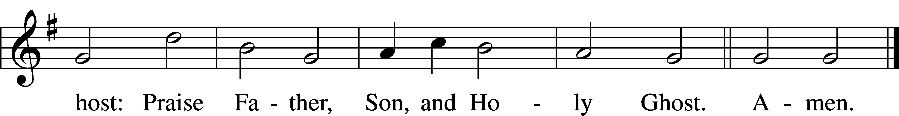
Text: Thomas Ken, 1637–1711
Tune: Trente quatre Pseaumes de David, 1551, Geneva, ed. Louis Bourgeois
Text and tune: Public domain

Offering

Prayer of the Church

Lord’s Prayer Matthew 6:9–13
P Lord, remember us in Your kingdom and teach us to pray:
C Our Father who art in heaven,
hallowed be Thy name,
Thy kingdom come,
Thy will be done on earth
as it is in heaven;
give us this day our daily bread;
and forgive us our trespasses
as we forgive those
who trespass against us;
and lead us not into temptation,
but deliver us from evil.
For Thine is the kingdom
and the power and the glory
forever and ever. Amen.

Collect for the Word

Blessed Lord, You have caused all Holy Scriptures to be written for our learning. Grant that we may so hear them, read, mark, learn, and inwardly digest them that, by the patience and comfort of Your holy Word, we may embrace and ever hold fast the blessed hope of everlasting life; through Jesus Christ, Your Son, our Lord, who lives and reigns with You and the Holy Spirit, one God, now and forever.

Benediction
P The Lord bless you and keep you.
The Lord make His face shine on you and be gracious to you.
The Lord look upon you with favor and T give you peace.
C Amen.

802 Immortal, Invisible, God Only Wise
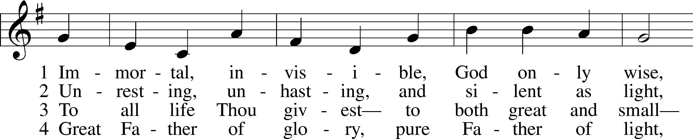
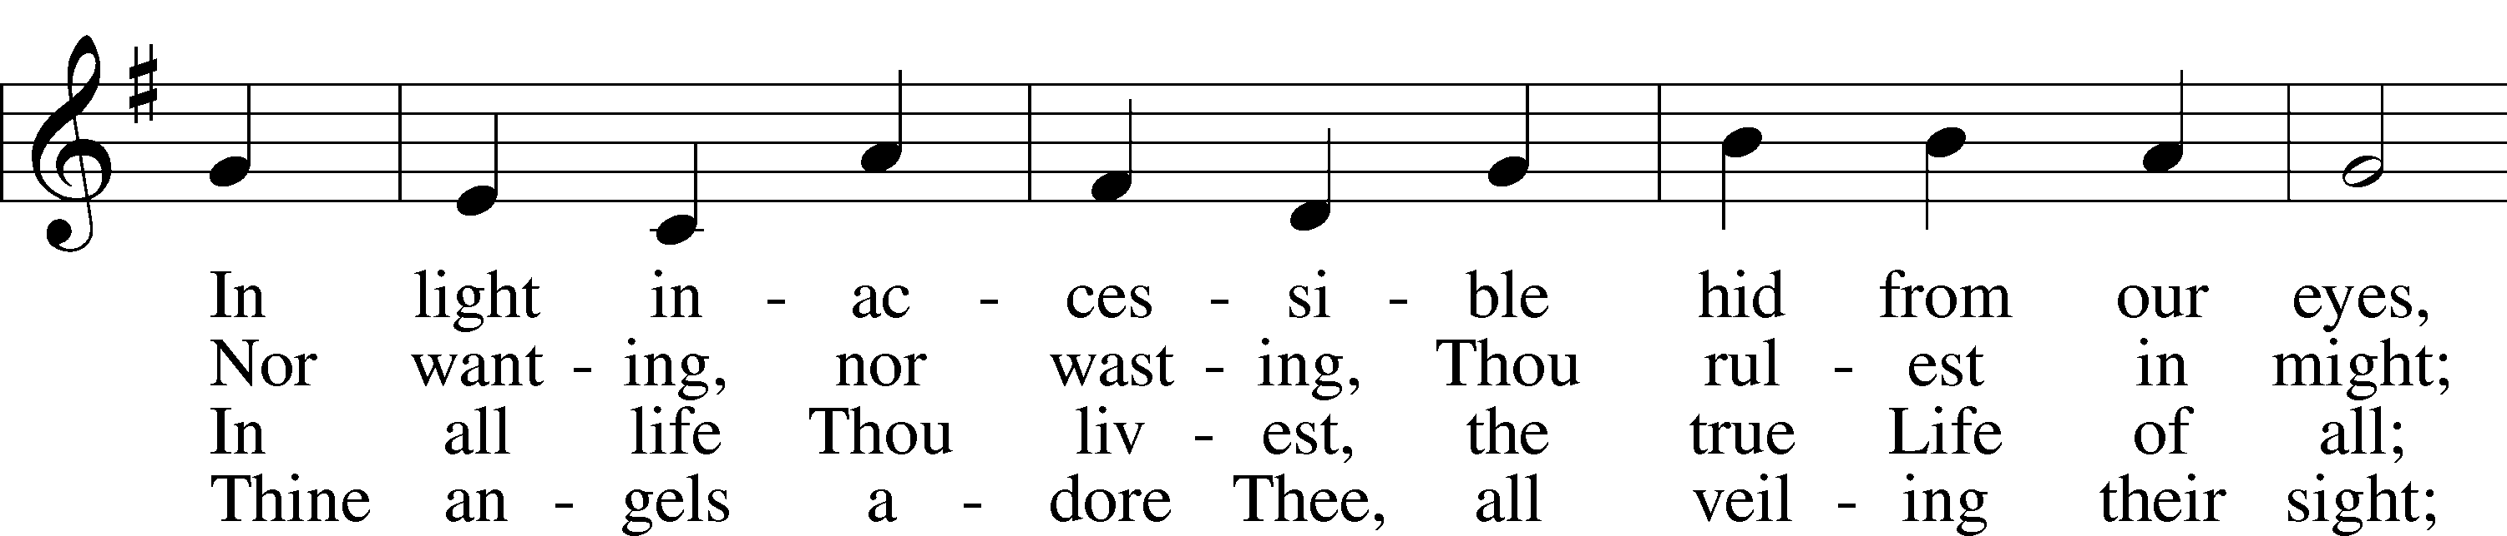
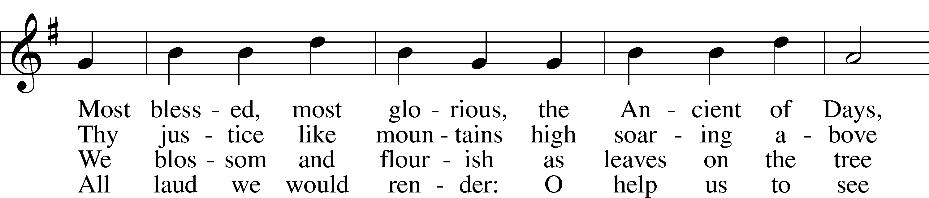
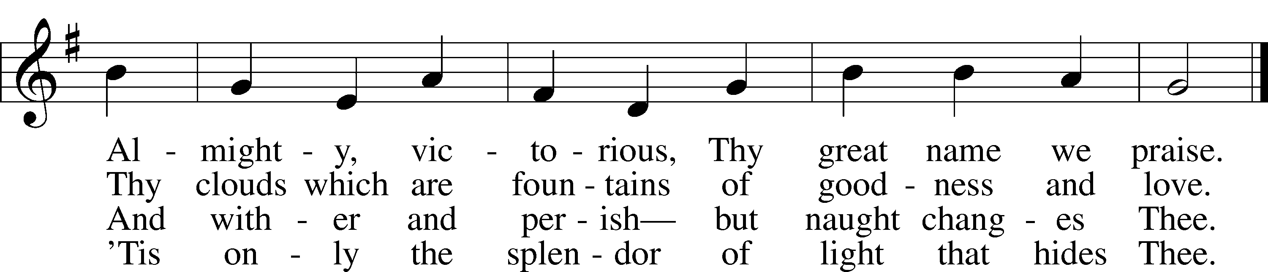
Text: W. Chalmers Smith, 1824–1908, alt.
Tune: Welsh
Text and tune: Public domain
Acknowledgments
Unless otherwise indicated, Scripture quotations are from the ESV® Bible (The Holy Bible, English Standard Version®), copyright © 2001 by Crossway, a publishing ministry of Good News Publishers. Used by permission. All rights reserved.
Created by Lutheran Service Builder © 2025 Concordia Publishing House.

