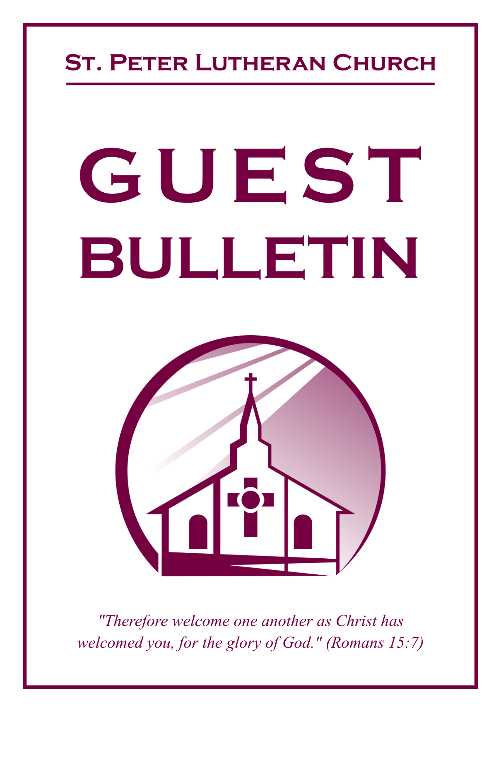

September 13, 2026



St. Peter Lutheran Church
Missouri Synod
906 Highway 59N, P.O. Box 133

Bowie, Texas 76230

Church (940) 872-1886 Fax ((940) 872-8837

Church E-mail: stpetertexscty@gmail.com
To Our Guests and Visitors:

We welcome all our friends in Christ who have come to worship with us. If you are a guest, please feel at home with us, sign our guest register, and worship with us whenever you are able. If you do not have a church home, we invite you to
consider becoming a part of our church family.

Website: www.stpetertex.com
Communion Statement:

The Lord’s Supper is celebrated at this congregation in the confession and glad confidence that, as He says, our Lord gives into our mouths not only bread and wine but His very Body and Blood to eat and drink for the forgiveness of sins and to strengthen our union with Him and one another.

Our Lord invites to His table those who trust in His words, repent of all sin, and set aside any refusal to forgive and love as He forgives and loves us, that they may show forth His death until He comes.

Because those who eat and drink our Lord’s Body and Blood unworthily do so to their great harm, and because Holy Communion is a confession of the faith, which is confessed at this altar, guests who are not confirmed members of an LCMS congregation and have not previously communed at this altar, are asked to first speak with our pastor.

If you are unable to do so before the service, it is out of Christian love and care for your souls that we ask you to refrain from communing this morning.

For further study, please see Matthew 5:23ff, 10:32ff, 18:15–35, 26:26–29; 1 Corinthians 11:17–34.

If you desire to receive a blessing for yourself or your children, please approach during
communion, cross your arms over your chest and bow your head as you kneel at the
altar rail.

Who Receives the Sacrament of the Altar Worthily?
Fasting and bodily preparation are certainly fine outward training. But that person is truly worthy and well prepared who has faith in these words: “Given and shed for you for the forgiveness of sins.” But anyone who does not believe these words or doubts them is unworthy and unprepared; for the words “for you” require all hearts to believe.
How May I Prepare?
See Dr. Luther’s self–examination questions and answers in the
LSB Hymnal on page 329

Upon entering the Sanctuary. please turn off cell phones, pagers. etc. Use the time as a quiet time for personal reflection and meditation in preparation for worship. This is a time for anyone to join in praying for the service, and for the church in general.
765 God Moves in a Mysterious Way
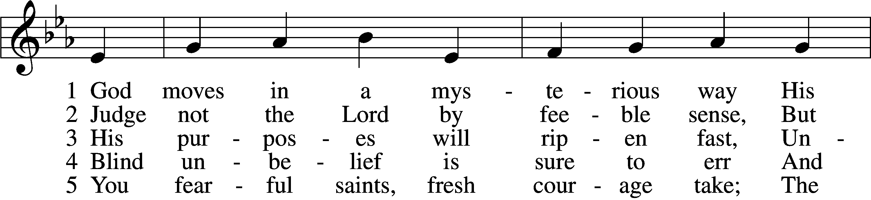
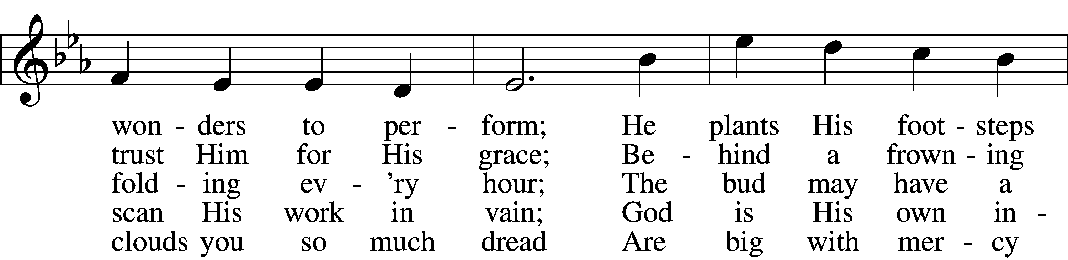
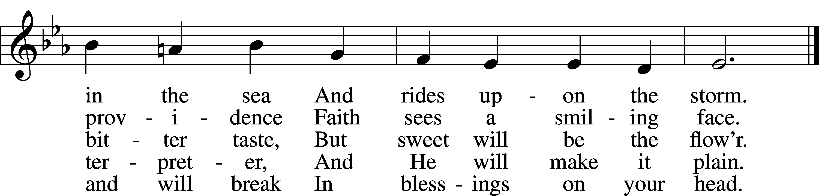
Text: William Cowper, 1731–1800, alt.
Tune: The CL Psalmes of David, 1615, Edinburgh
Text and tune: Public domain
Confession and Absolution

The sign of the cross may be made by all in remembrance of their Baptism.

Invocation Matthew 28:19b; 18:20
P In the name of the Father and of the T Son and of the Holy Spirit.
C Amen.

Exhortation Hebrews 10:22; Psalm 124:8; Psalm 32:5
P Beloved in the Lord! Let us draw near with a true heart and confess our sins unto God our Father, beseeching Him in the name of our Lord Jesus Christ to grant us forgiveness.

P Our help is in the name of the Lord,
C who made heaven and earth.
P I said, I will confess my transgressions unto the Lord,
C and You forgave the iniquity of my sin.

Silence for reflection on God’s Word and for self-examination.
Confession of Sins
P Almighty God, our maker and redeemer, we poor sinners confess unto You that we are by nature sinful and unclean and that we have sinned against You by thought, word, and deed. Wherefore we flee for refuge to Your infinite mercy, seeking and imploring Your grace for the sake of our Lord Jesus Christ.
C O most merciful God, who has given Your only-begotten Son to die for us, have mercy upon us and for His sake grant us remission of all our sins; and by Your Holy Spirit increase in us true knowledge of You and of Your will and true obedience to Your Word, to the end that by Your grace we may come to everlasting life; through Jesus Christ, our Lord. Amen.

Declaration of Grace Mark 16:16; John 1:12
P Almighty God, our heavenly Father, has had mercy upon us and has given His only Son to die for us and for His sake forgives us all our sins. To those who believe on His name He gives power to become the children of God and has promised them His Holy Spirit. He that believes and is baptized shall be saved.
Grant this, Lord, unto us all.
C Amen.

Service of the Word

Introit Psalm 143:1–2; antiphon: v. 9
Deliver me from my enemies, O Lord!
I have fled to you for refuge!
Hear my prayer, O Lord; give ear to my pleas for mercy!
In your faithfulness answer me, in your righteousness!
Enter not into judgment with your servant,
for no one living is righteous before you.
Gloria Patri
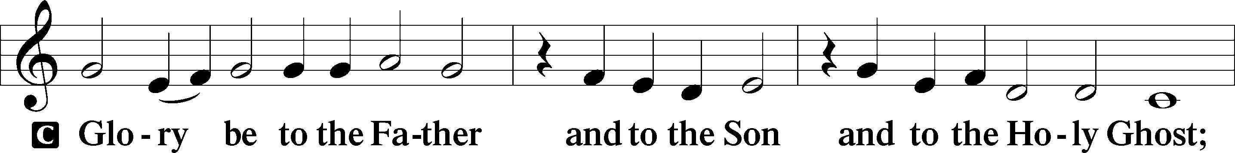
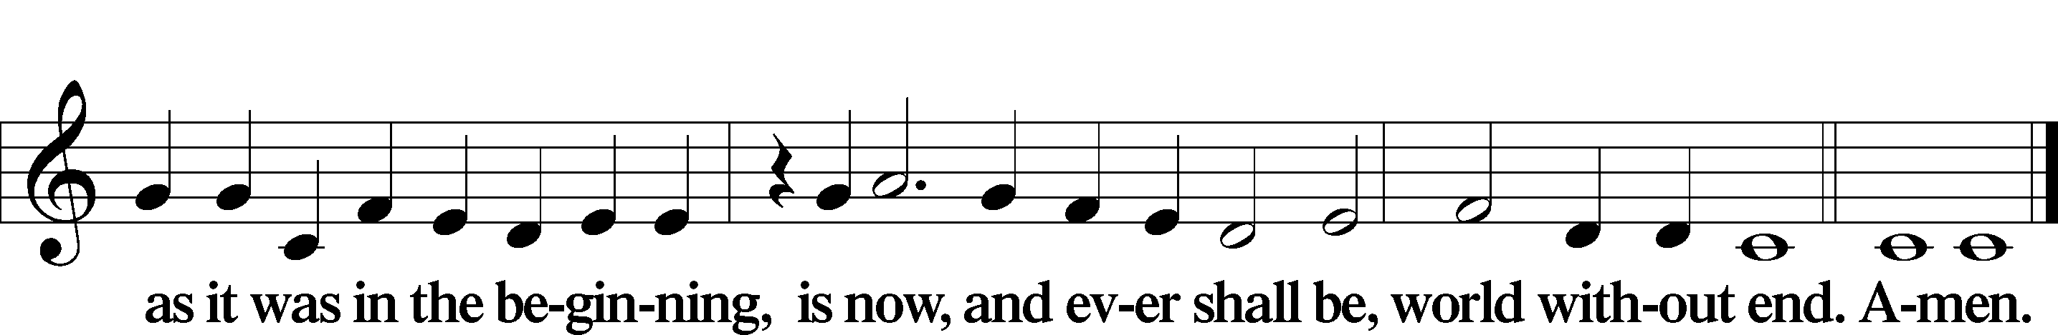

Kyrie Mark 10:47
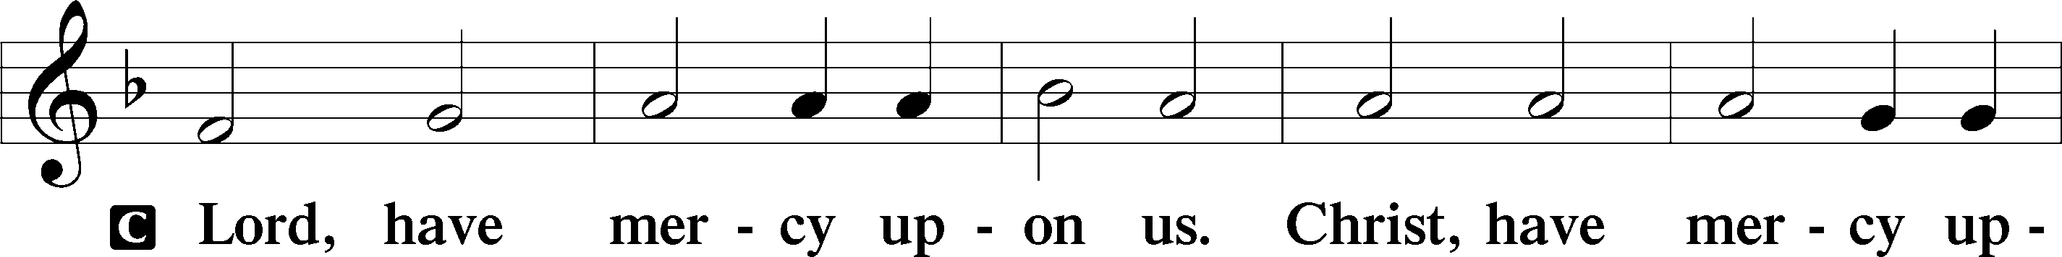
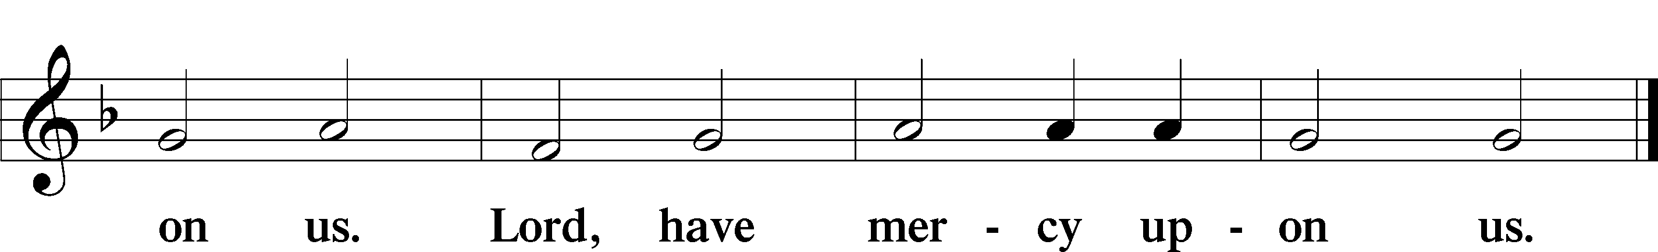

Gloria in Excelsis Luke 2:14; John 1:29
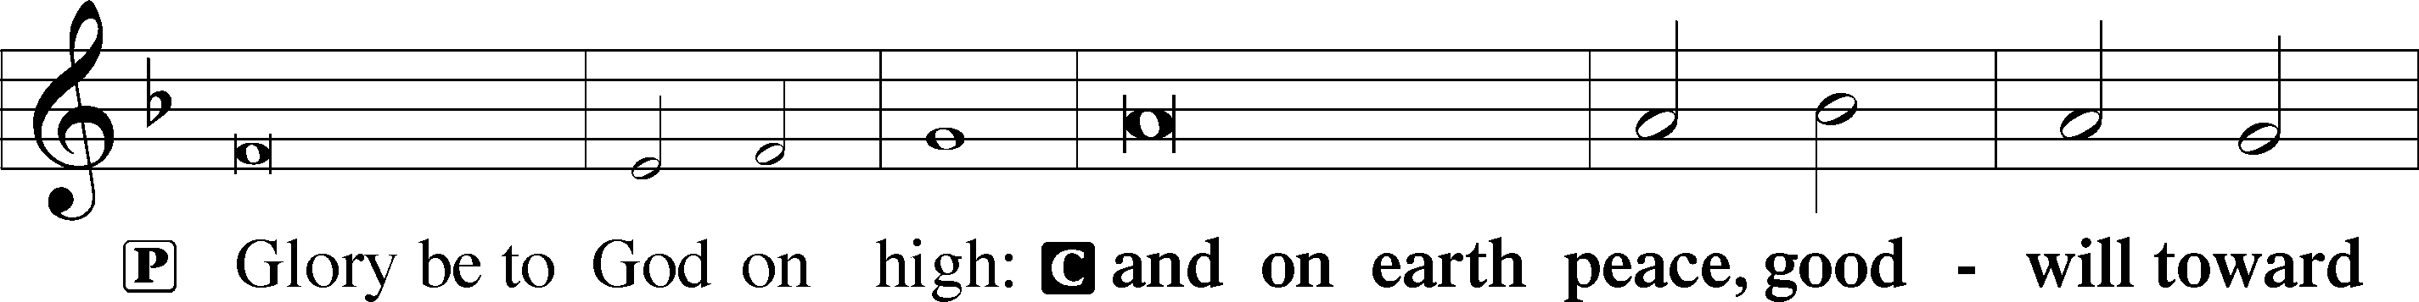
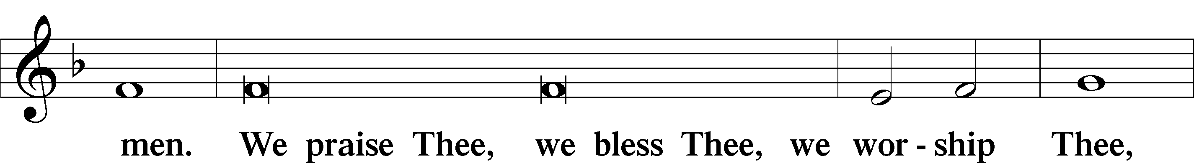
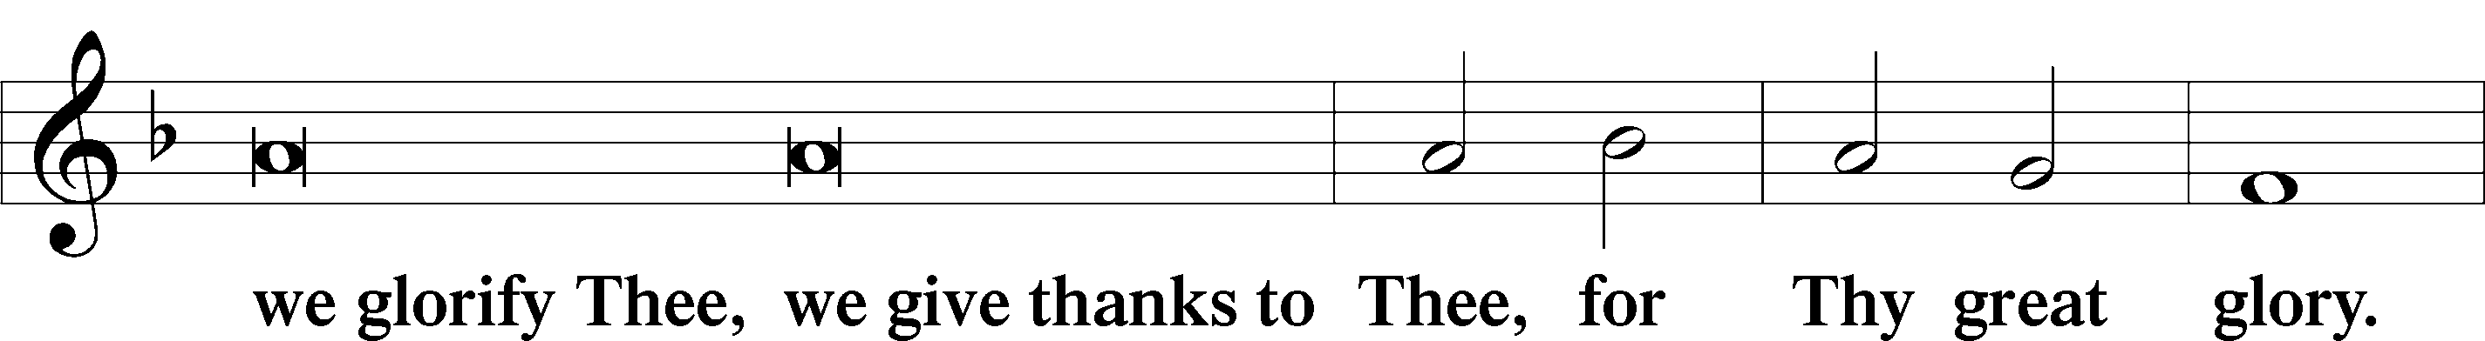
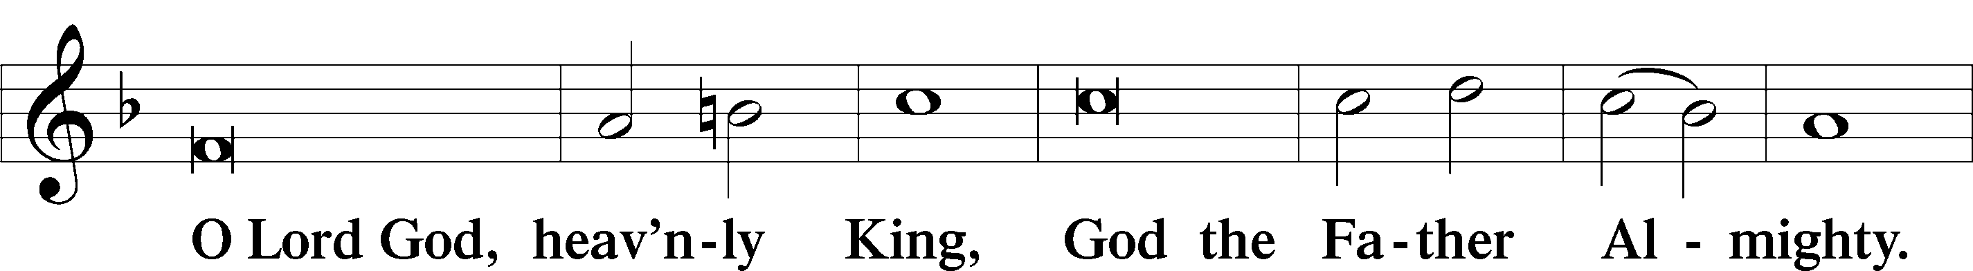
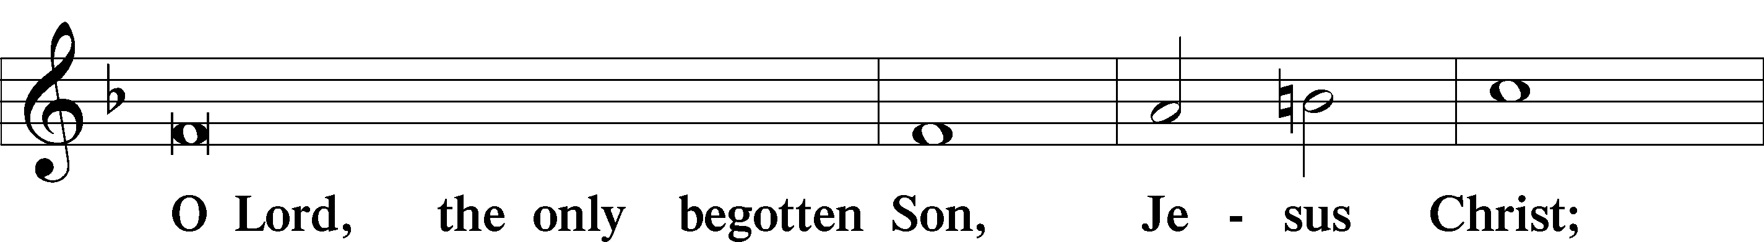
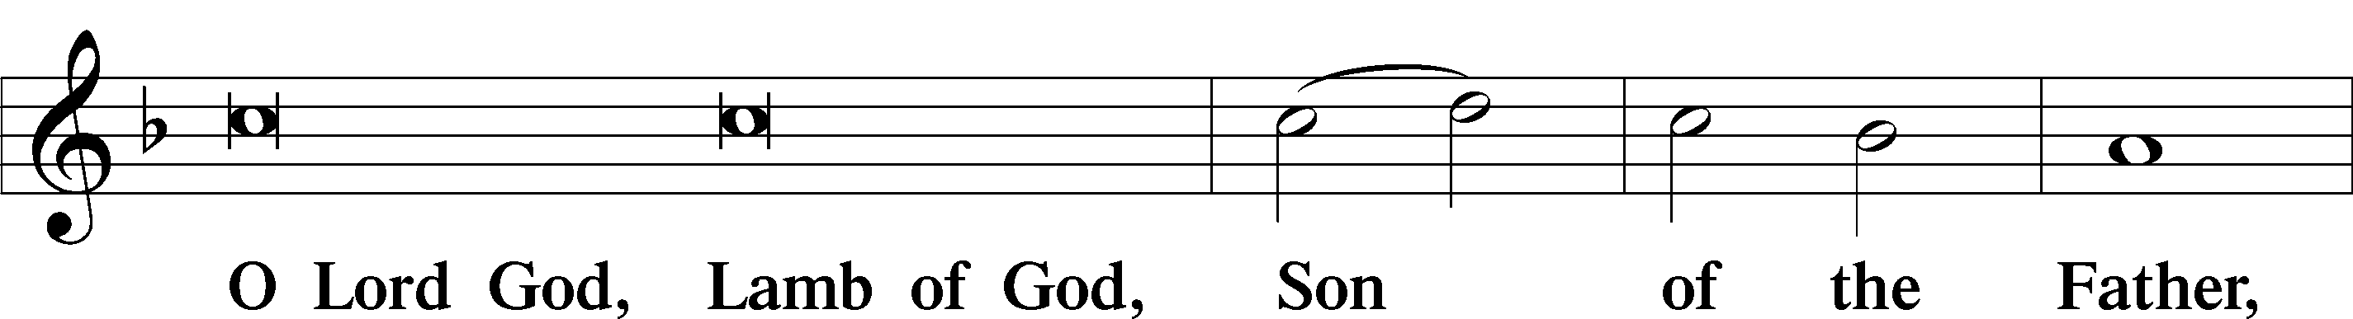
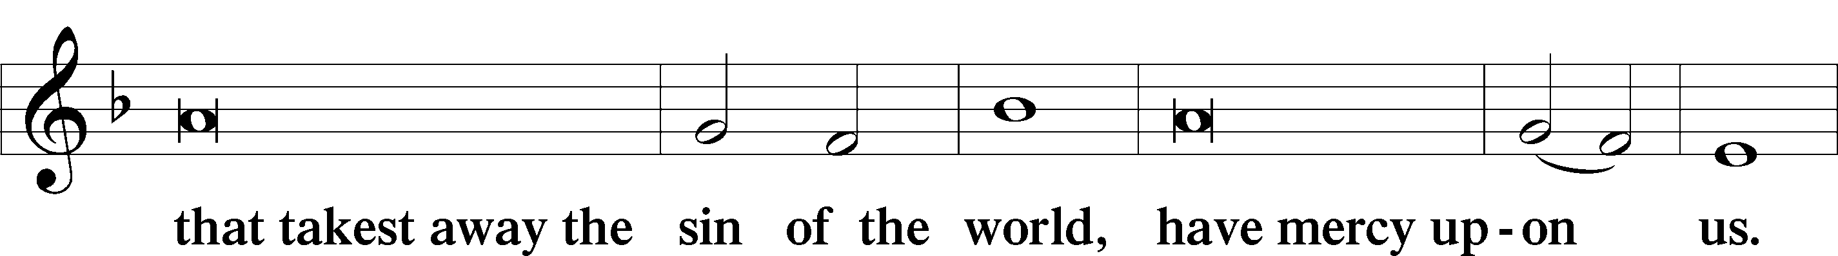
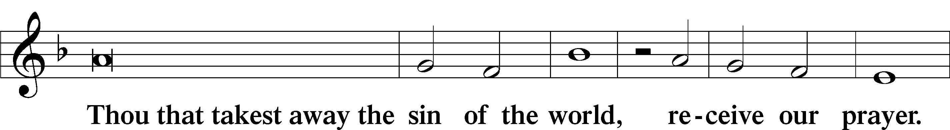
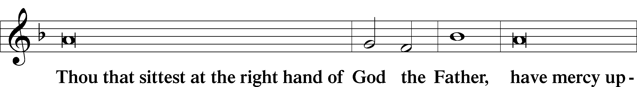
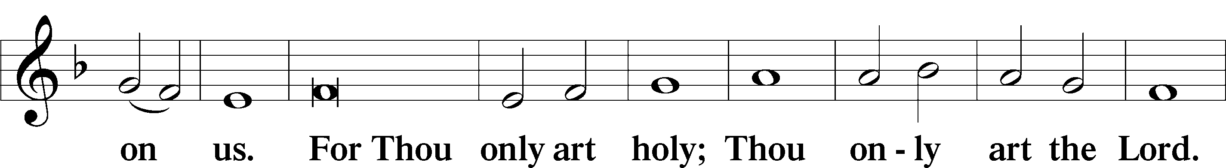
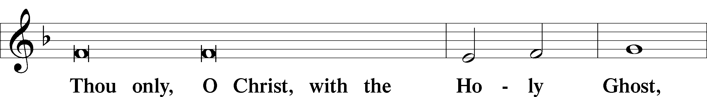
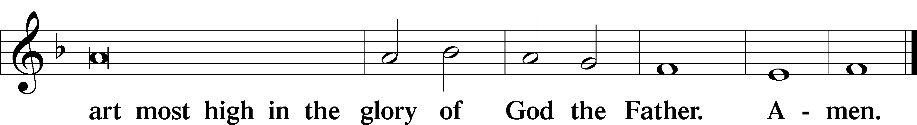

Salutation and Collect of the Day
P The Lord be with you.
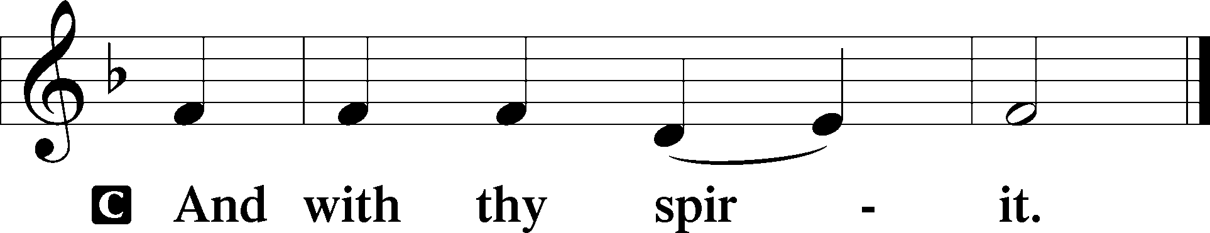

P Let us pray.
O God, our refuge and strength, the author of all godliness, hear the devout prayers of Your Church, especially in times of persecution, and grant that what we ask in faith we may obtain; through Jesus Christ, our Lord, who lives and reigns with You and the Holy Spirit, one God, now and forever.

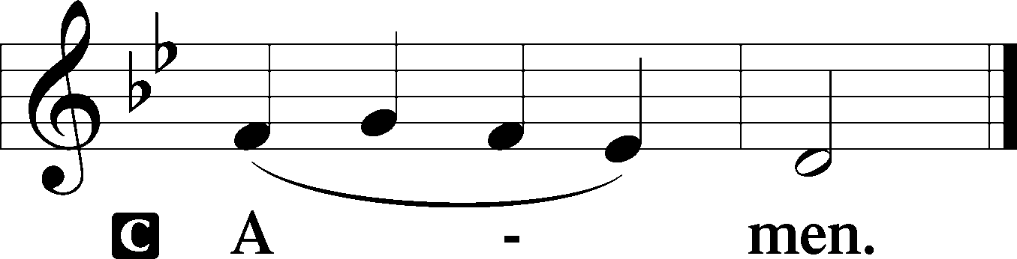

Sit

Old Testament Reading Genesis 50:15–21
15When Joseph’s brothers saw that their father was dead, they said, “It may be that Joseph will hate us and pay us back for all the evil that we did to him.” 16So they sent a message to Joseph, saying, “Your father gave this command before he died, 17‘Say to Joseph, Please forgive the transgression of your brothers and their sin, because they did evil to you.’ And now, please forgive the transgression of the servants of the God of your father.” Joseph wept when they spoke to him. 18His brothers also came and fell down before him and said, “Behold, we are your servants.” 19But Joseph said to them, “Do not fear, for am I in the place of God? 20As for you, you meant evil against me, but God meant it for good, to bring it about that many people should be kept alive, as they are today. 21So do not fear; I will provide for you and your little ones.” Thus he comforted them and spoke kindly to them.

A This is the Word of the Lord.
C Thanks be to God.

Gradual Psalm 34:9, 19, alt.
Fear the Lord, you his saints,
for those who fear him lack nothing!
Many are the afflictions of the righteous,
but the Lord delivers him out of them all.

Epistle Romans 14:1–12
1As for the one who is weak in faith, welcome him, but not to quarrel over opinions. 2One person believes he may eat anything, while the weak person eats only vegetables. 3Let not the one who eats despise the one who abstains, and let not the one who abstains pass judgment on the one who eats, for God has welcomed him. 4Who are you to pass judgment on the servant of another? It is before his own master that he stands or falls. And he will be upheld, for the Lord is able to make him stand. 5One person esteems one day as better than another, while another esteems all days alike. Each one should be fully convinced in his own mind. 6The one who observes the day, observes it in honor of the Lord. The one who eats, eats in honor of the Lord, since he gives thanks to God, while the one who abstains, abstains in honor of the Lord and gives thanks to God. 7For none of us lives to himself, and none of us dies to himself. 8If we live, we live to the Lord, and if we die, we die to the Lord. So then, whether we live or whether we die, we are the Lord’s. 9For to this end Christ died and lived again, that he might be Lord both of the dead and of the living. 10Why do you pass judgment on your brother? Or you, why do you despise your brother? For we will all stand before the judgment seat of God; 11for it is written, “As I live, says the Lord, every knee shall bow to me, and every tongue shall confess to God.” 12So then each of us will give an account of himself to God.

Stand

Alleluia
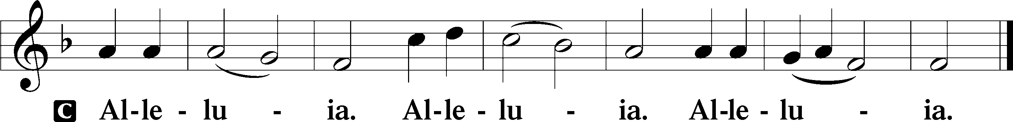

Holy Gospel Matthew 18:21–35
P The Holy Gospel according to St. Matthew, the eighteenth chapter.

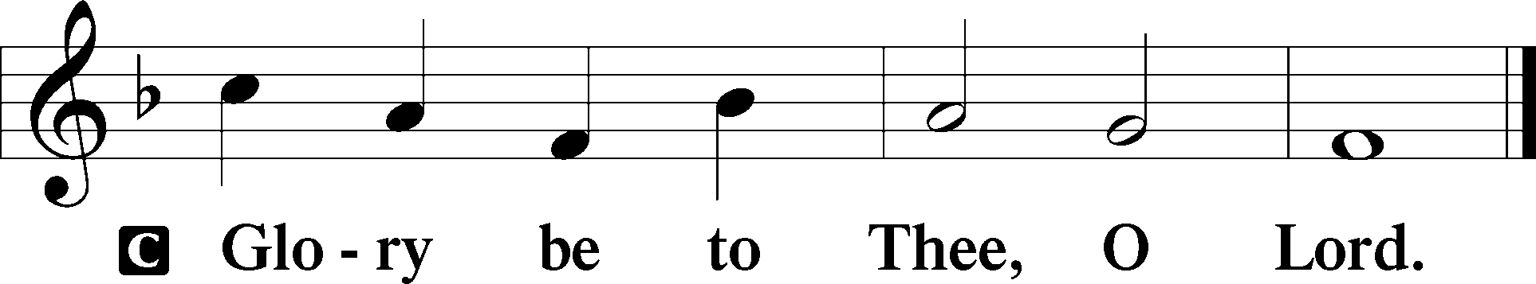

21Peter came up and said to [Jesus], “Lord, how often will my brother sin against me, and I forgive him? As many as seven times?” 22Jesus said to him, “I do not say to you seven times, but seventy times seven. 23“Therefore the kingdom of heaven may be compared to a king who wished to settle accounts with his servants. 24When he began to settle, one was brought to him who owed him ten thousand talents. 25And since he could not pay, his master ordered him to be sold, with his wife and children and all that he had, and payment to be made. 26So the servant fell on his knees, imploring him, ‘Have patience with me, and I will pay you everything.’ 27And out of pity for him, the master of that servant released him and forgave him the debt. 28But when that same servant went out, he found one of his fellow servants who owed him a hundred denarii, and seizing him, he began to choke him, saying, ‘Pay what you owe.’ 29So his fellow servant fell down and pleaded with him, ‘Have patience with me, and I will pay you.’ 30He refused and went and put him in prison until he should pay the debt. 31When his fellow servants saw what had taken place, they were greatly distressed, and they went and reported to their master all that had taken place. 32Then his master summoned him and said to him, ‘You wicked servant! I forgave you all that debt because you pleaded with me. 33And should not you have had mercy on your fellow servant, as I had mercy on you?’ 34And in anger his master delivered him to the jailers, until he should pay all his debt. 35So also my heavenly Father will do to every one of you, if you do not forgive your brother from your heart.”

P This is the Gospel of the Lord.
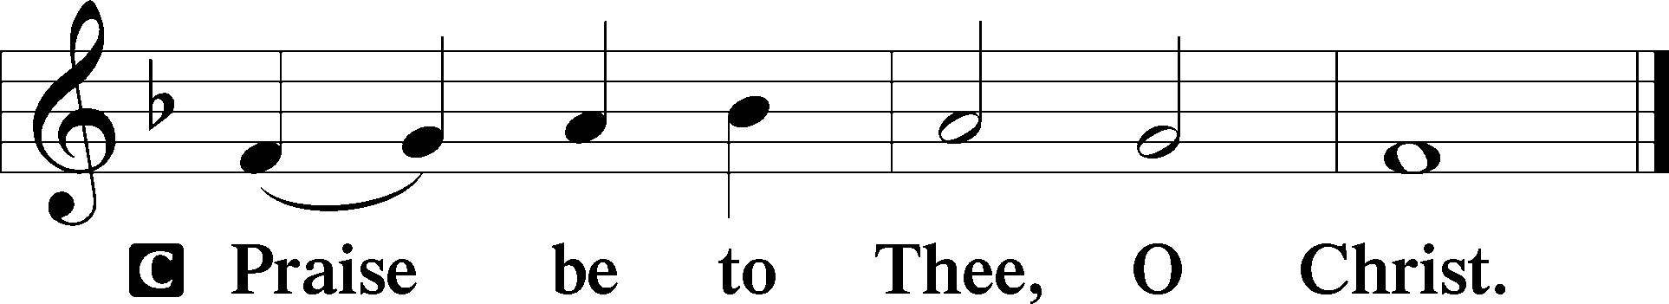

Apostles’ Creed
C I believe in God, the Father Almighty,
maker of heaven and earth.

And in Jesus Christ, His only Son, our Lord,
who was conceived by the Holy Spirit,
born of the virgin Mary,
suffered under Pontius Pilate,
was crucified, died and was buried.
He descended into hell.
The third day He rose again from the dead.
He ascended into heaven
and sits at the right hand of God the Father Almighty.
From thence He will come to judge the living and the dead.

I believe in the Holy Spirit,
the holy Christian Church,
the communion of saints,
the forgiveness of sins,
the resurrection of the body,
and the life T everlasting. Amen.

Sit

Children's Sermon

611 Chief of Sinners Though I Be
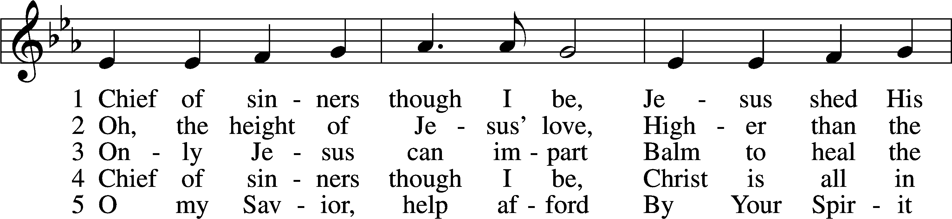
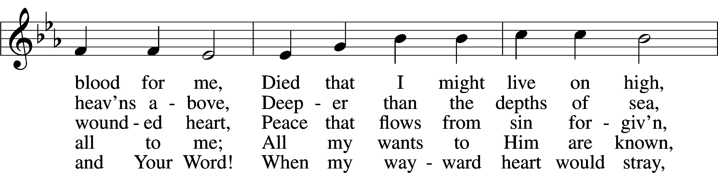
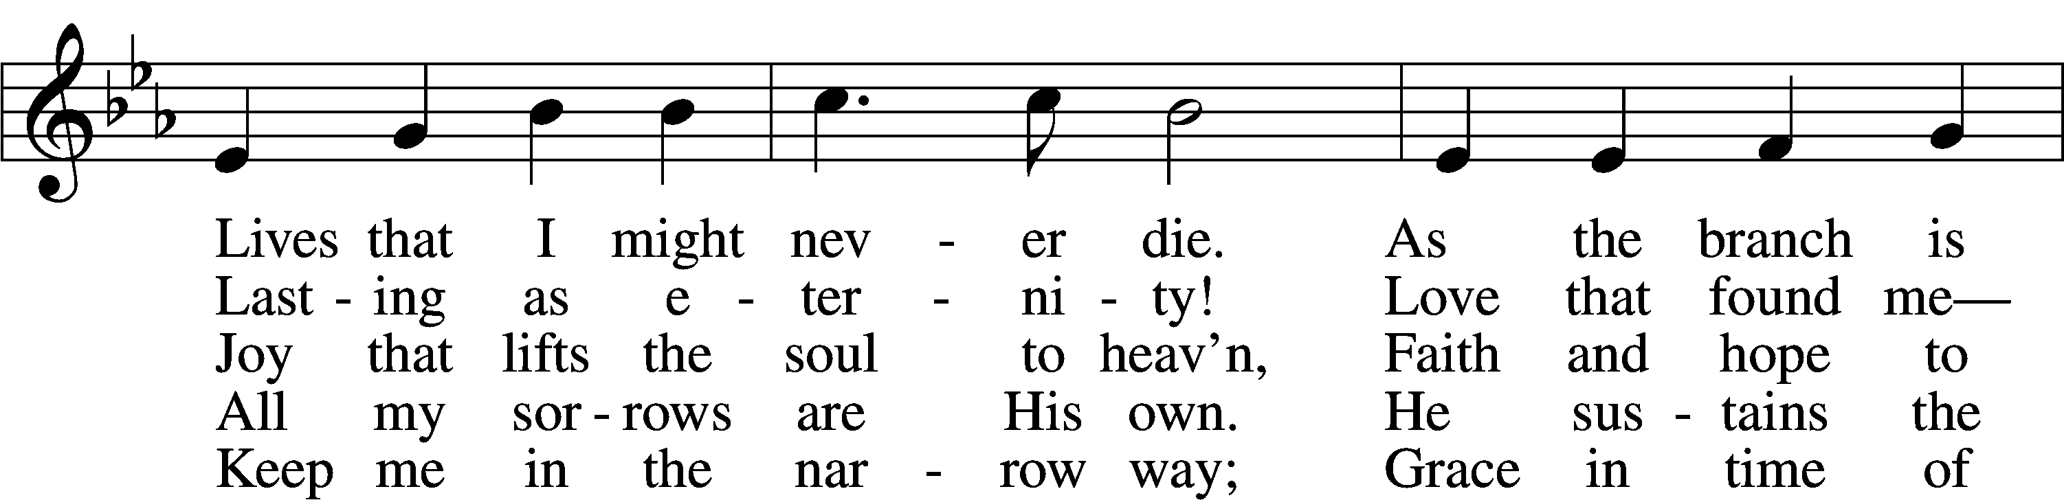
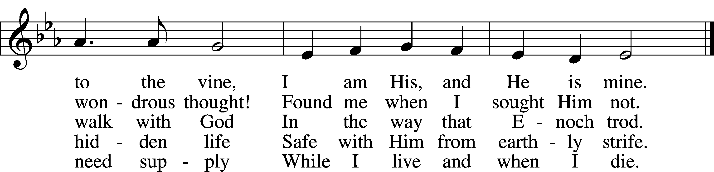
Text: William McComb, 1793–1873, alt.
Tune: Richard Redhead, 1820–1901
Text and tune: Public domain

Sermon “Forgive?”

Votum
P The peace of God, which passes all understanding, keep your hearts and minds in Christ Jesus.
C Amen.

Stand

Offertory Psalm 51:10–12
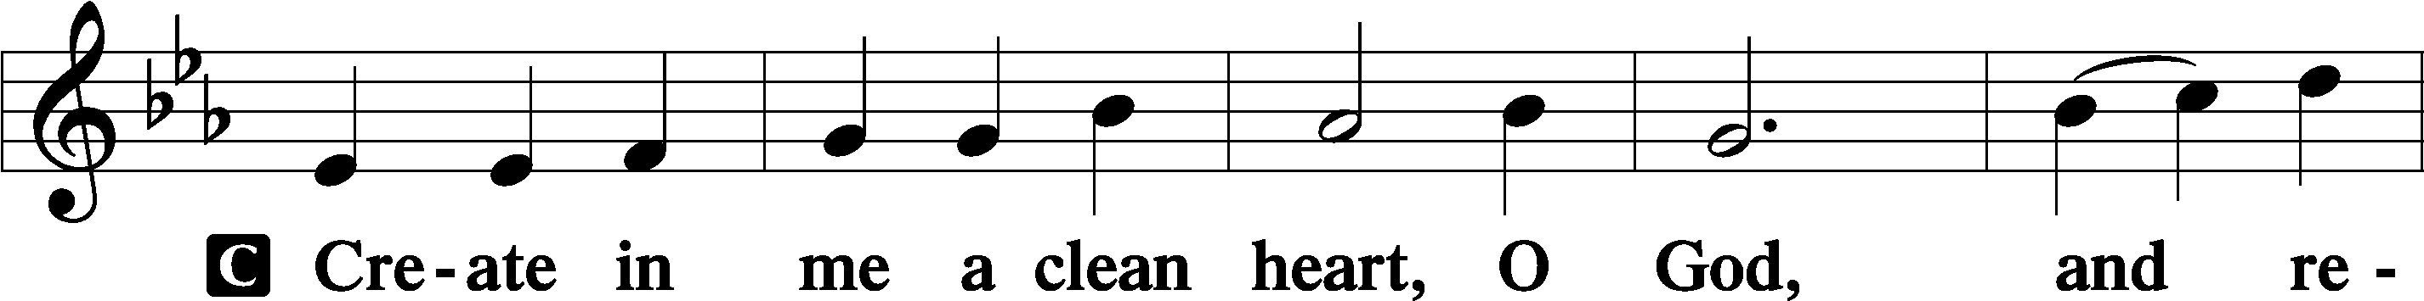
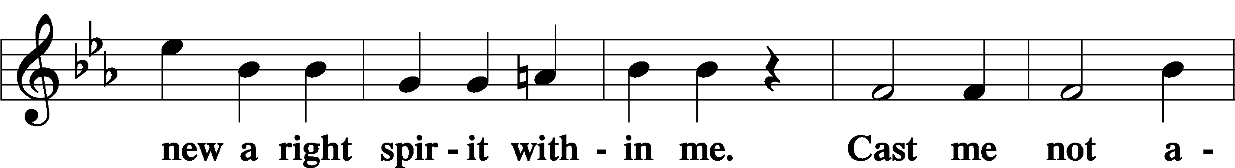
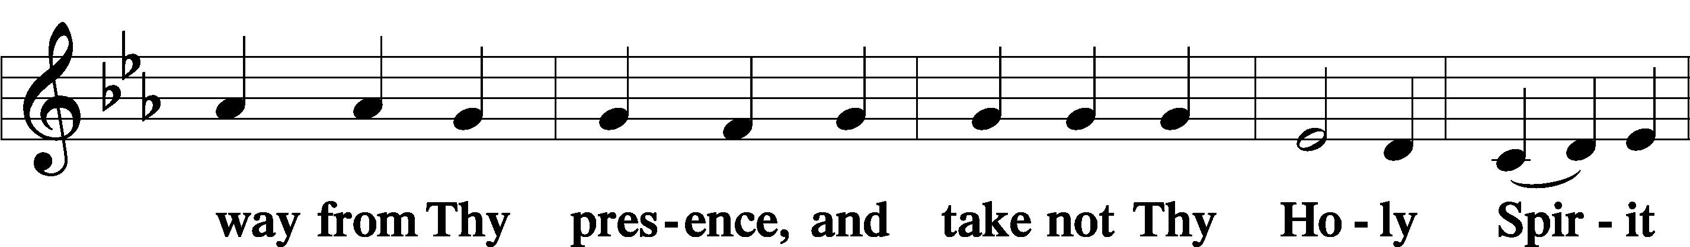
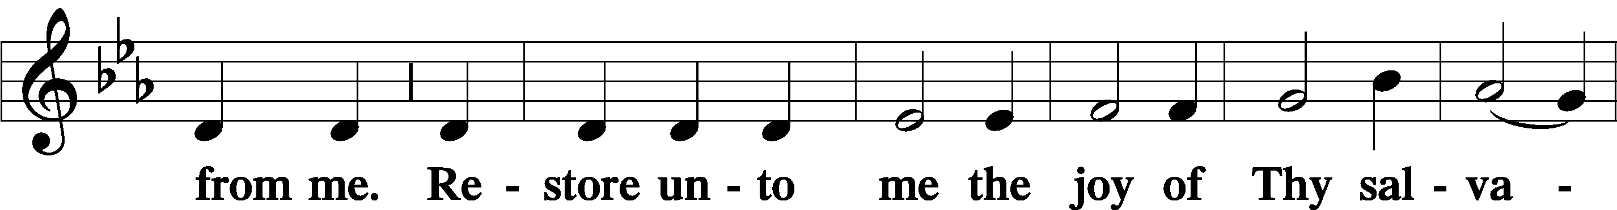
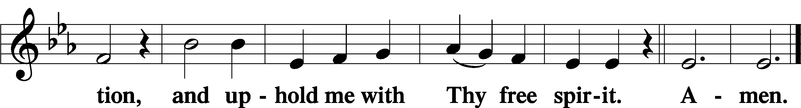

Offering

805 Praise God, from Whom All Blessings Flow
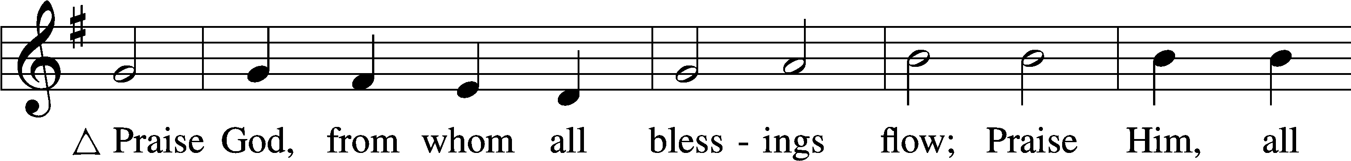
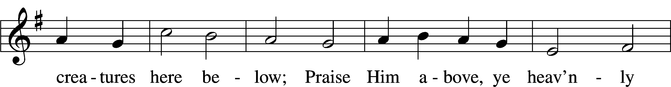
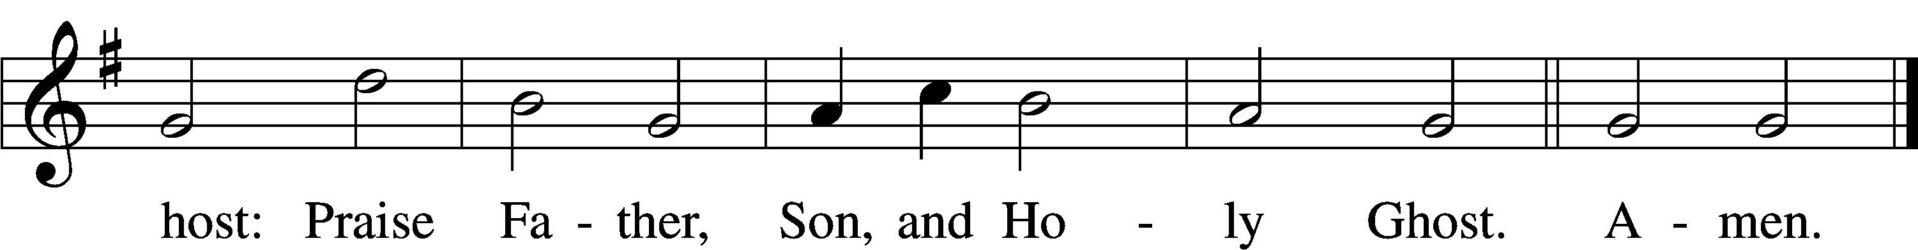
Text: Thomas Ken, 1637–1711
Tune: Trente quatre Pseaumes de David, 1551, Geneva, ed. Louis Bourgeois
Text and tune: Public domain

Prayer of the Church

Lord’s Prayer Matthew 6:9–13
P Lord, remember us in Your kingdom and teach us to pray:
C Our Father who art in heaven,
hallowed be Thy name,
Thy kingdom come,
Thy will be done on earth
as it is in heaven;
give us this day our daily bread;
and forgive us our trespasses
as we forgive those
who trespass against us;
and lead us not into temptation,
but deliver us from evil.
For Thine is the kingdom
and the power and the glory
forever and ever. Amen.

Collect for the Word

Blessed Lord, You have caused all Holy Scriptures to be written for our learning. Grant that we may so hear them, read, mark, learn, and inwardly digest them that, by the patience and comfort of Your holy Word, we may embrace and ever hold fast the blessed hope of everlasting life; through Jesus Christ, Your Son, our Lord, who lives and reigns with You and the Holy Spirit, one God, now and forever.

Benediction
P The Lord bless you and keep you.
The Lord make His face shine on you and be gracious to you.
The Lord look upon you with favor and T give you peace.
C Amen.

790 Praise to the Lord, the Almighty
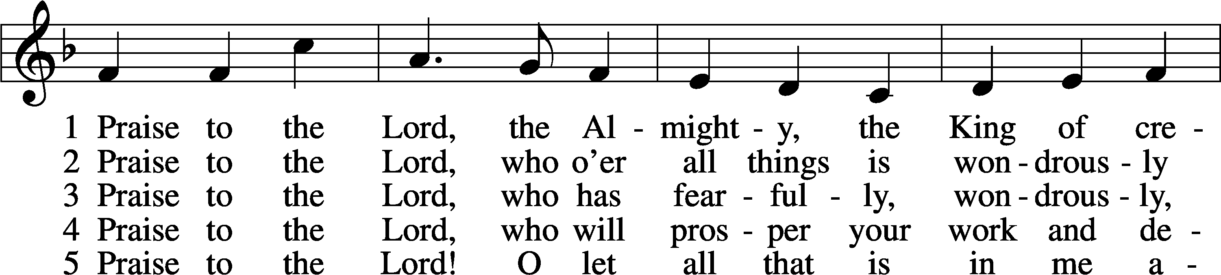
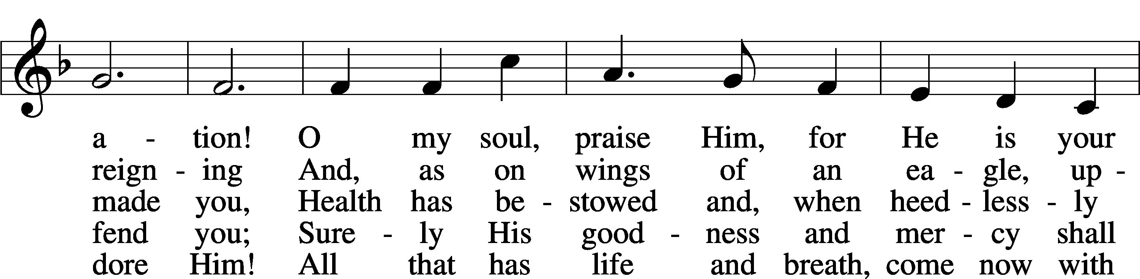
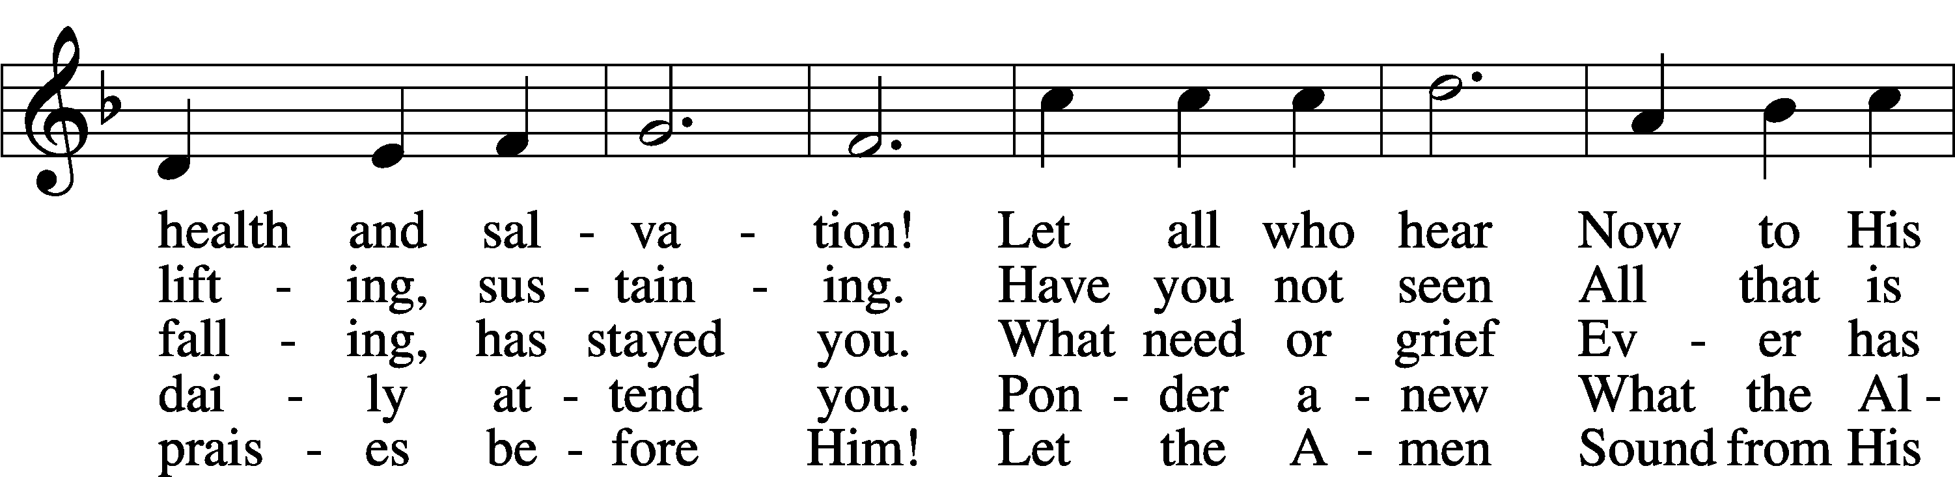
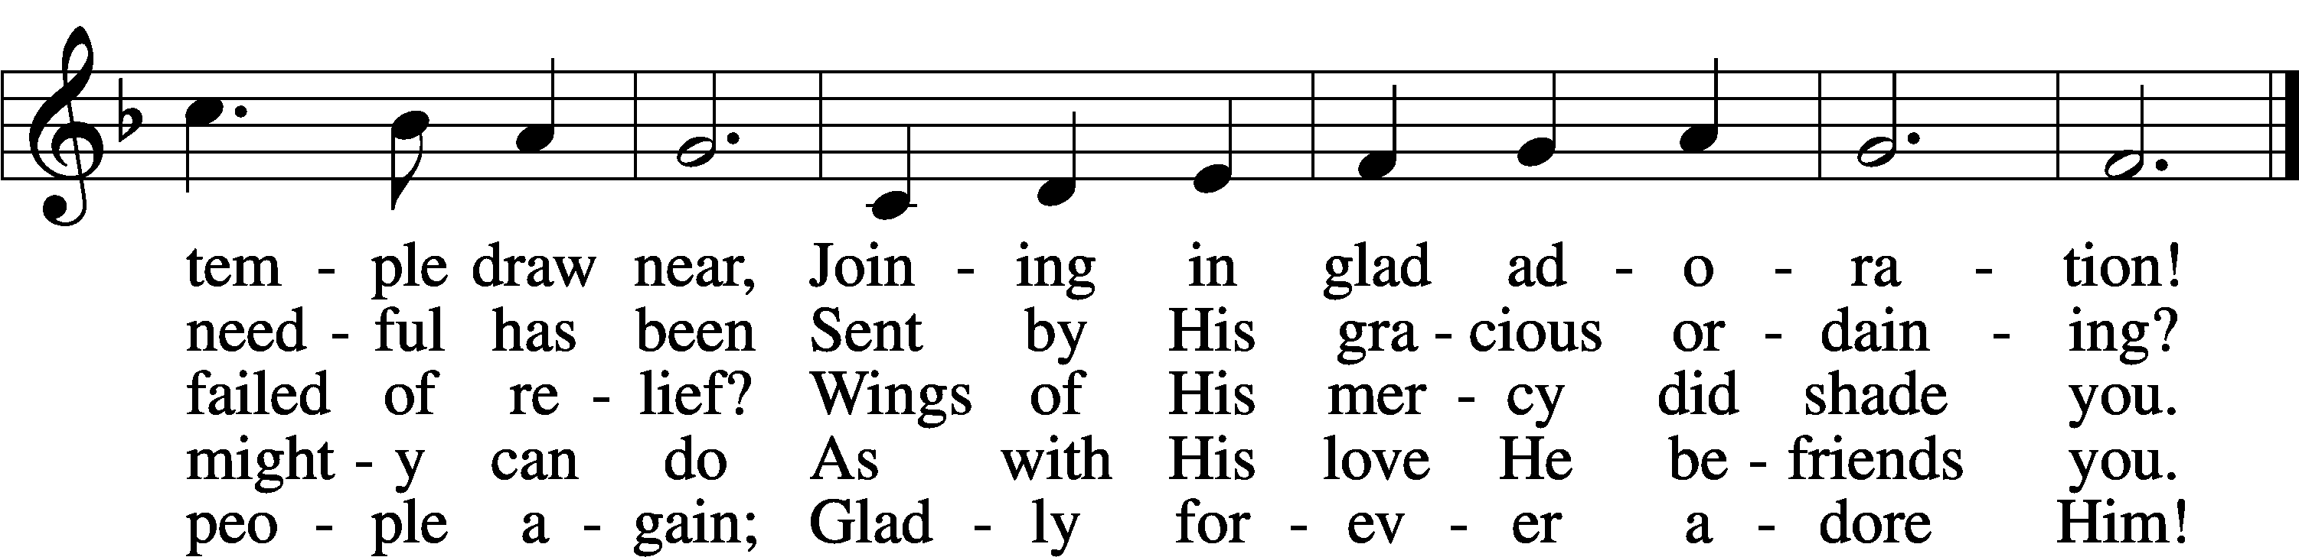
Text: Joachim Neander, 1650–80; tr. Catherine Winkworth, 1827–78, alt.
Tune: Ander Theil Des Erneuerten Gesang-Buchs, 1665, Stralsund
Text and tune: Public domain
Acknowledgments
Unless otherwise indicated, Scripture quotations are from the ESV® Bible (The Holy Bible, English Standard Version®), copyright © 2001 by Crossway, a publishing ministry of Good News Publishers. Used by permission. All rights reserved.
Created by Lutheran Service Builder © 2026 Concordia Publishing House.

