On entering the church

P Lord, I love the habitation of Your house and the place

where Your glory dwells. In the multitude of Your tender

mercies prepare my heart that I may enter Your house to

worship and confess Your holy name; through Jesus Christ,

my God and Lord.

Before worship

C O Lord, our creator, redeemer, and comforter, as we come

together to worship You in spirit and in truth, we humbly

pray that You would open our hearts to the preaching of

Your Word so that we may repent of our sins, believe in

Jesus Christ as our only Savior, and grow in grace and

holiness. Hear us for His sake.

696 O God, My Faithful God

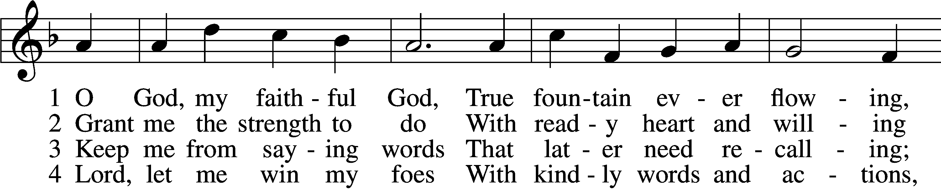

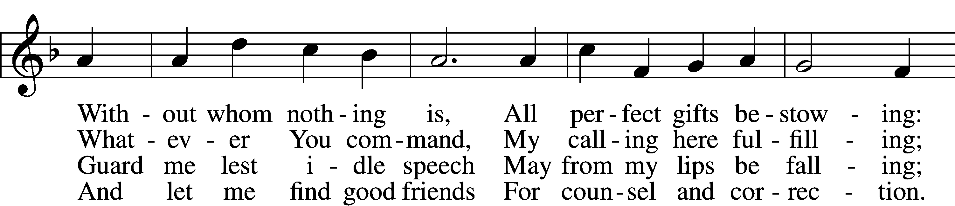

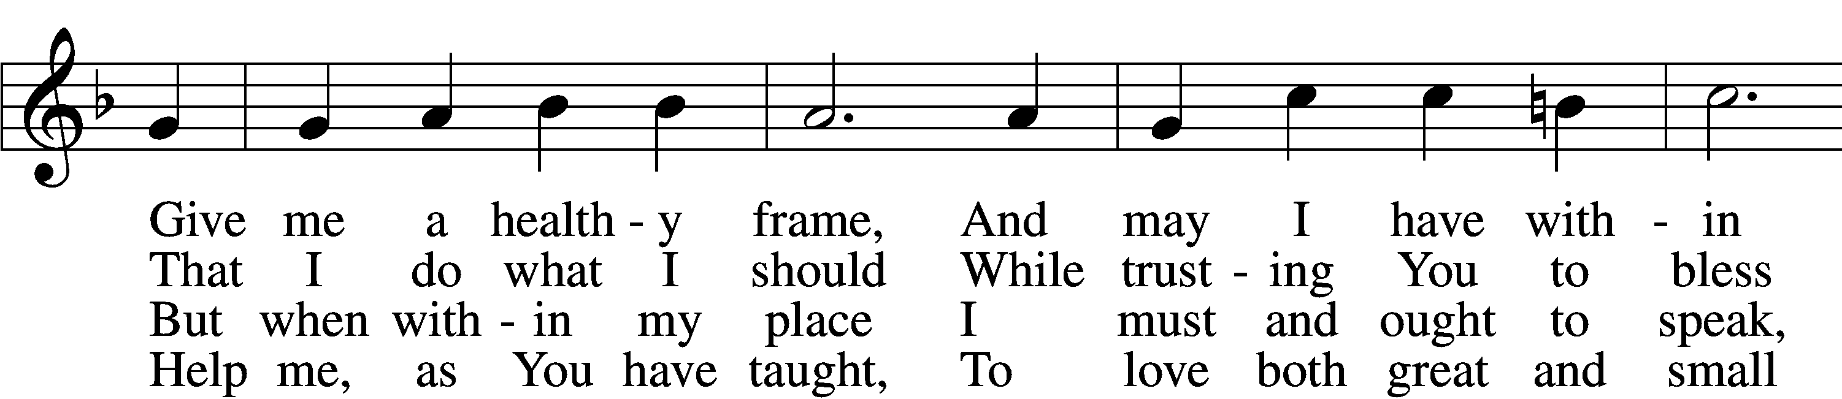

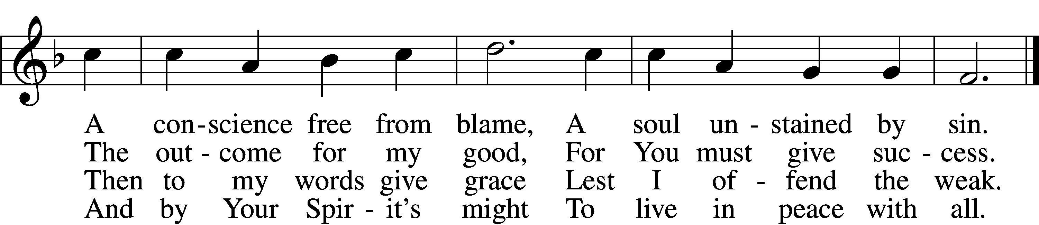

5 Let me depart this life  
 Confiding in my Savior;  
By grace receive my soul  
 That it may live forever;  
And let my body have  
 A quiet resting place  
Within a Christian grave;  
 And let it sleep in peace.

6 And on that final day  
 When all the dead are waking,  
Stretch out Your mighty hand,  
 My deathly slumber breaking.  
Then let me hear Your voice,  
 Redeem this earthly frame,  
And bid me to rejoice  
 With those who love Your name.

Text: Johann Heermann, 1585–1647; tr. Catherine Winkworth, 1827–78, alt.  
Tune: Neu-vermehrtes . . . Gesangbuch, 1693, 3rd ed., Meiningen  
Text and tune: Public domain

# Confession and Absolution

Stand

The sign of the cross may be made by all in remembrance of their Baptism.

Invocation Matthew 28:19b; 18:20

P In the name of the Father and of the T Son and of the Holy Spirit.

C **Amen.**

Exhortation Hebrews 10:22; Psalm 124:8; Psalm 32:5

P Beloved in the Lord! Let us draw near with a true heart and confess our sins unto God our Father, beseeching Him in the name of our Lord Jesus Christ to grant us forgiveness.

P Our help is in the name of the Lord,

C **who made heaven and earth.**

P I said, I will confess my transgressions unto the Lord,

C **and You forgave the iniquity of my sin.**

Kneel/Stand

Silence for reflection on God’s Word and for self-examination.

Confession of Sins

P O almighty God, merciful Father,

C **I, a poor, miserable sinner, confess unto You all my sins and iniquities with which I have ever offended You and justly deserved Your temporal and eternal punishment. But I am heartily sorry for them and sincerely repent of them, and I pray You of Your boundless mercy and for the sake of the holy, innocent, bitter sufferings and death of Your beloved Son, Jesus Christ, to be gracious and merciful to me, a poor, sinful being.**

Absolution [John 20:19–23]

P Upon this your confession, I, by virtue of my office, as a called and ordained servant of the Word, announce the grace of God unto all of you, and in the stead and by the command of my Lord Jesus Christ I forgive you all your sins in the name of the Father and of the T Son and of the Holy Spirit.

C **Amen.**

Stand

# Service of the Word

Introit Psalm 49:7–8, 13–14a, 15; antiphon: vv. 1–2

Hear this, all peoples!  
 Give ear, all inhabitants of the world,  
**both low and high,  
 rich and poor together!**Truly no man can ransom another,  
 or give to God the price of his life,  
**for the ransom of their life is costly  
 and can never suffice.**This is the path of those who have foolish confidence;  
 yet after them people approve of their boasts.  
**Like sheep they are appointed for Sheol;  
 death shall be their shepherd.**But God will ransom my soul from the power of Sheol,  
 for he will receive me.

Gloria Patri

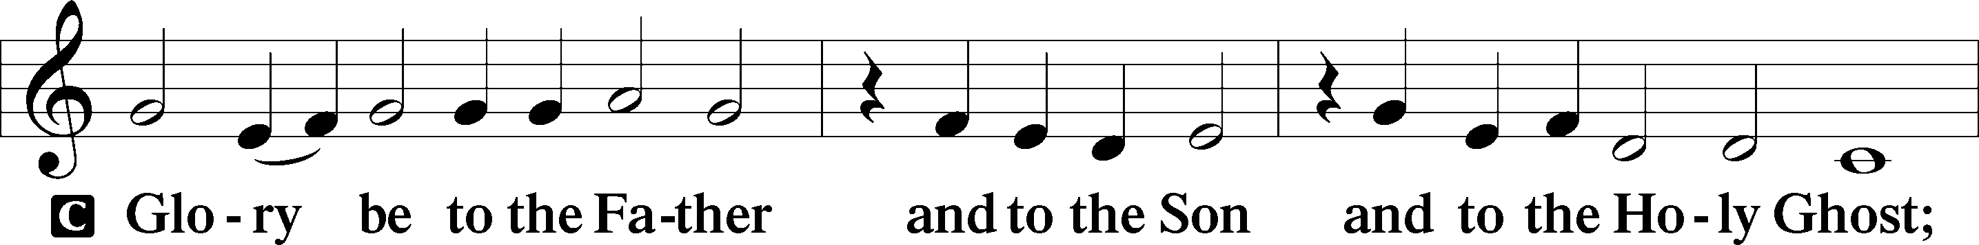

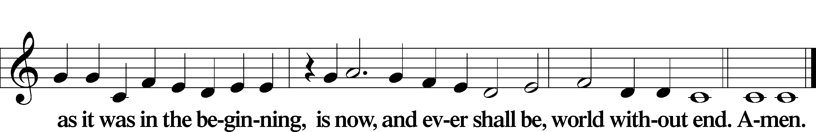

Kyrie Mark 10:47

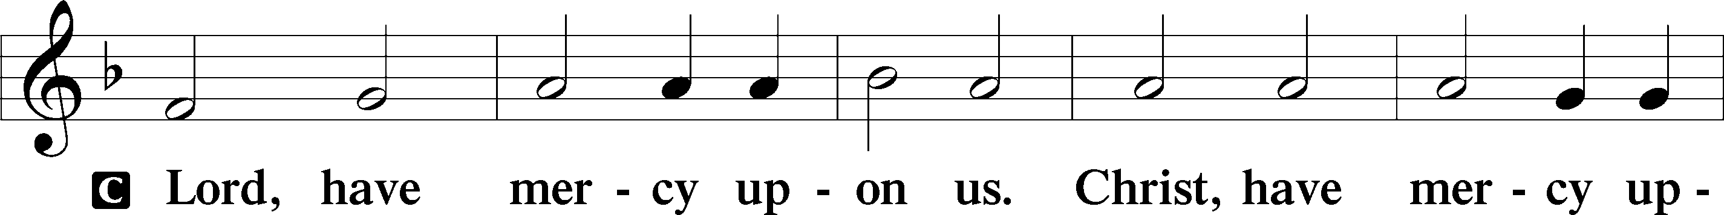

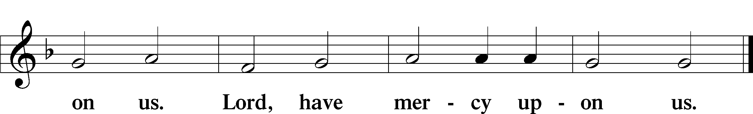

Gloria in Excelsis Luke 2:14; John 1:29

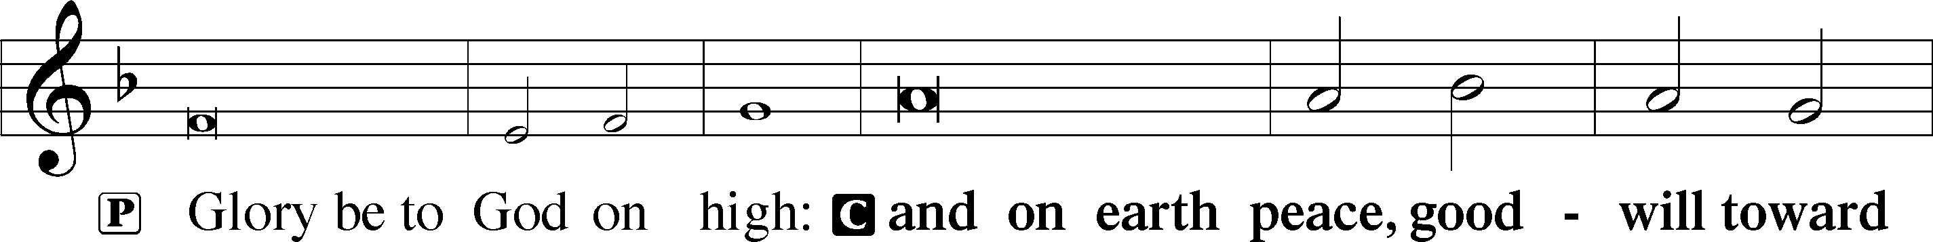

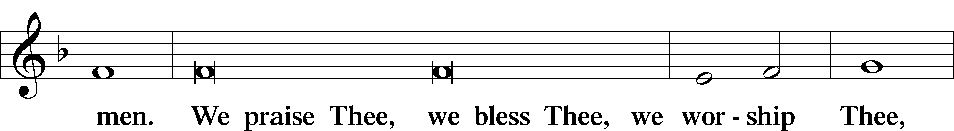

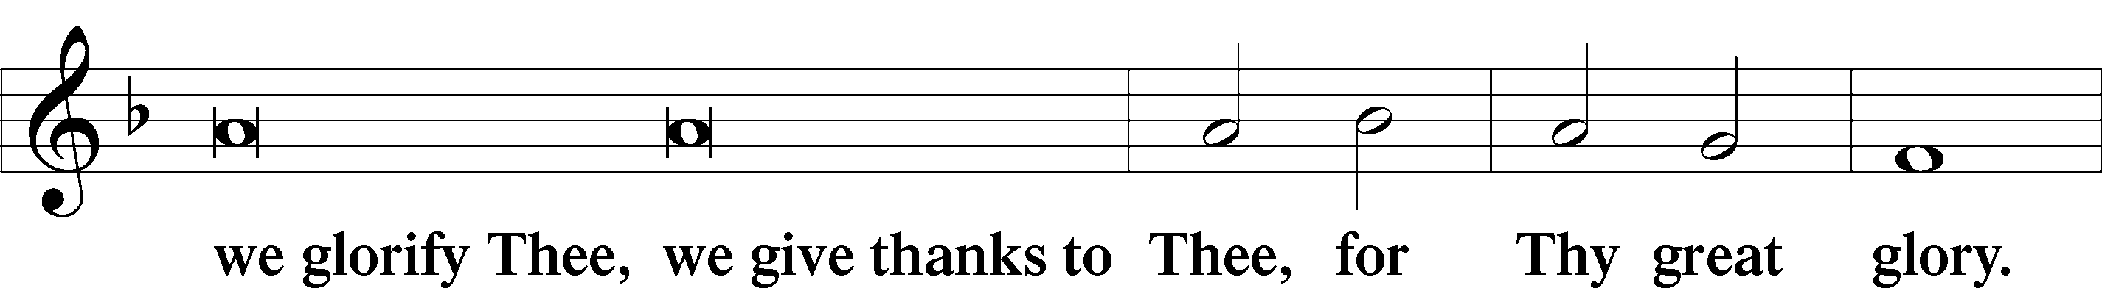

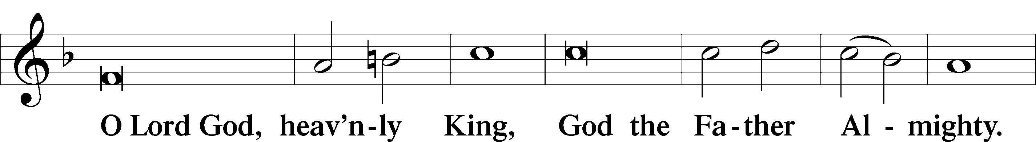

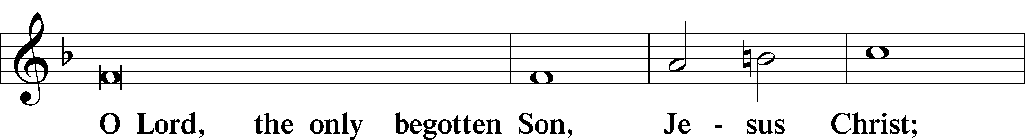

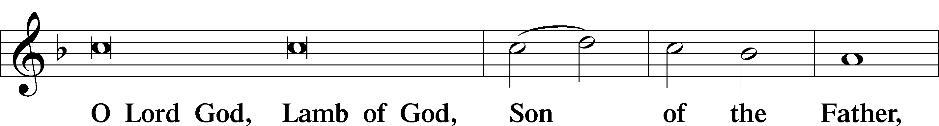

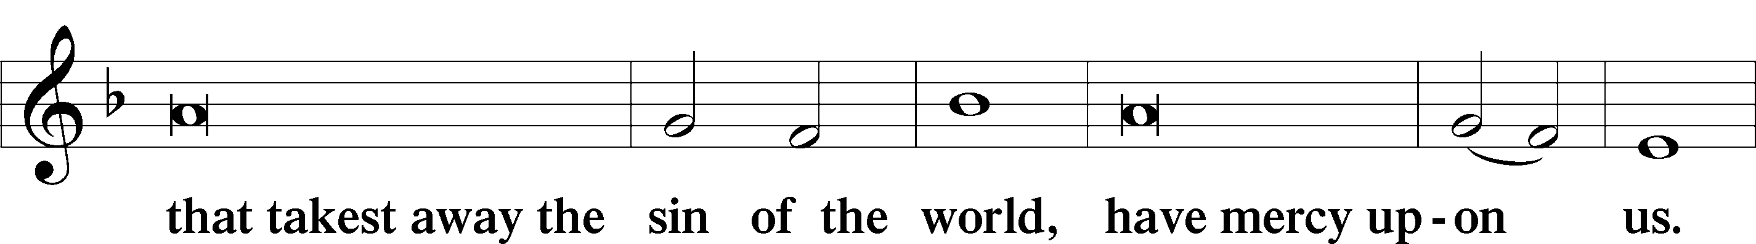

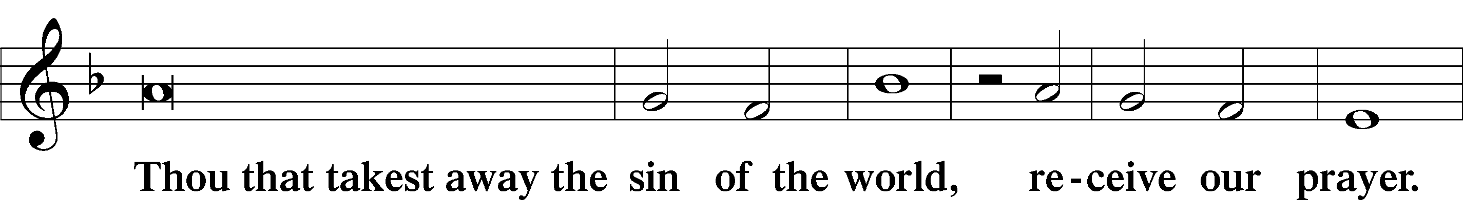

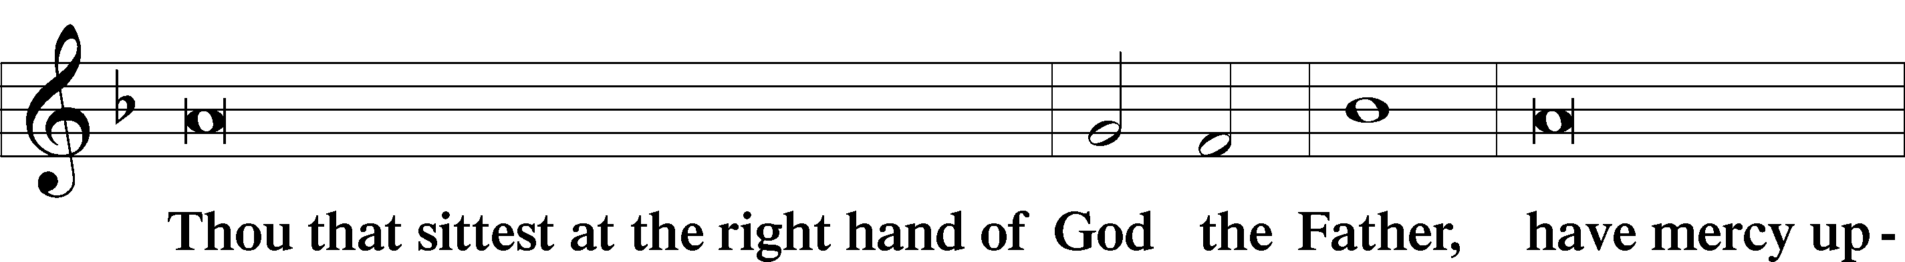

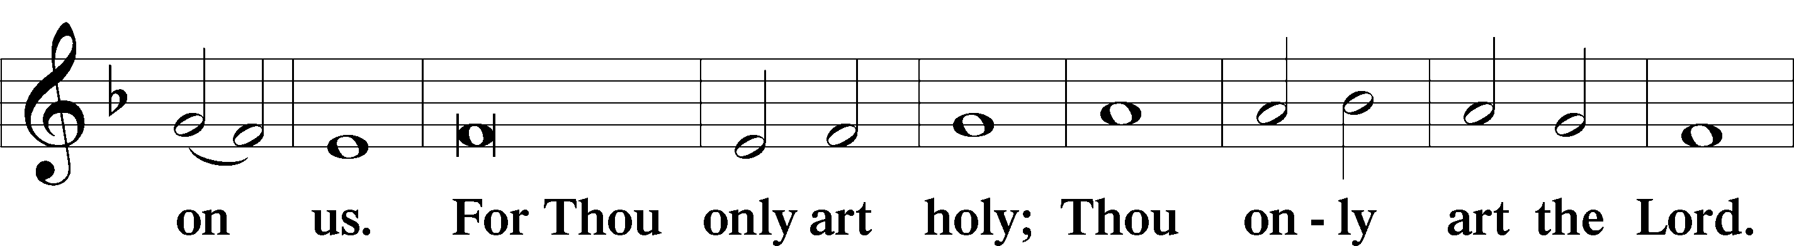

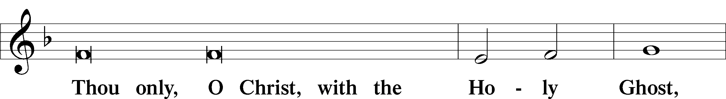

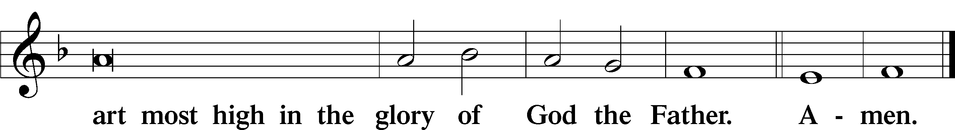

Salutation and Collect of the Day

P The Lord be with you.

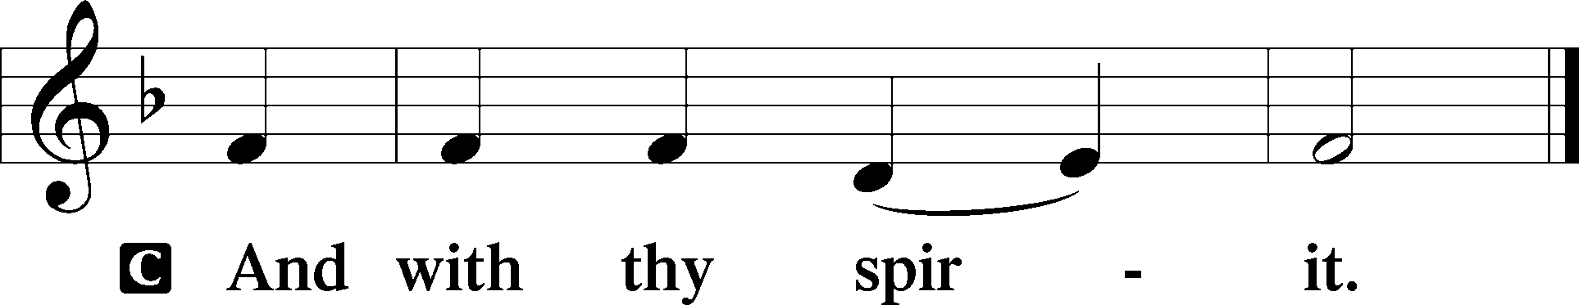

P Let us pray.

O Lord, grant us wisdom to recognize the treasures You have stored up for us in heaven, that we may never despair but always rejoice and be thankful for the riches of Your grace; through Jesus Christ, Your Son, our Lord, who lives and reigns with You and the Holy Spirit, one God, now and forever.

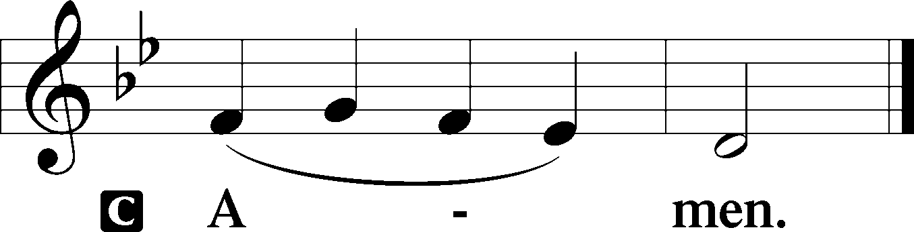

Sit

Old Testament Reading Ecclesiastes 1:2, 12–14; 2:18–26

2Vanity of vanities, says the Preacher,  
 vanity of vanities! All is vanity. . . .

12I the Preacher have been king over Israel in Jerusalem. 13And I applied my heart to seek and to search out by wisdom all that is done under heaven. It is an unhappy business that God has given to the children of man to be busy with. 14I have seen everything that is done under the sun, and behold, all is vanity and a striving after wind. . . .

18I hated all my toil in which I toil under the sun, seeing that I must leave it to the man who will come after me, 19and who knows whether he will be wise or a fool? Yet he will be master of all for which I toiled and used my wisdom under the sun. This also is vanity. 20So I turned about and gave my heart up to despair over all the toil of my labors under the sun, 21because sometimes a person who has toiled with wisdom and knowledge and skill must leave everything to be enjoyed by someone who did not toil for it. This also is vanity and a great evil. 22What has a man from all the toil and striving of heart with which he toils beneath the sun? 23For all his days are full of sorrow, and his work is a vexation. Even in the night his heart does not rest. This also is vanity.

24There is nothing better for a person than that he should eat and drink and find enjoyment in his toil. This also, I saw, is from the hand of God, 25for apart from him who can eat or who can have enjoyment? 26For to the one who pleases him God has given wisdom and knowledge and joy, but to the sinner he has given the business of gathering and collecting, only to give to one who pleases God. This also is vanity and a striving after wind.

A This is the Word of the Lord.

C **Thanks be to God.**

Gradual Romans 10:15b, 18b; Isaiah 52:7b, alt.

How beautiful are the feet of those who preach the good news,  
 who publish peace and bring good news of salvation.  
**Their voice has gone out to all the earth,  
 and their words to the ends of the world.**

Epistle Colossians 3:1–11

1If then you have been raised with Christ, seek the things that are above, where Christ is, seated at the right hand of God. 2Set your minds on things that are above, not on things that are on earth. 3For you have died, and your life is hidden with Christ in God. 4When Christ who is your life appears, then you also will appear with him in glory.

5Put to death therefore what is earthly in you: sexual immorality, impurity, passion, evil desire, and covetousness, which is idolatry. 6On account of these the wrath of God is coming. 7In these you too once walked, when you were living in them. 8But now you must put them all away: anger, wrath, malice, slander, and obscene talk from your mouth. 9Do not lie to one another, seeing that you have put off the old self with its practices 10and have put on the new self, which is being renewed in knowledge after the image of its creator. 11Here there is not Greek and Jew, circumcised and uncircumcised, barbarian, Scythian, slave, free; but Christ is all, and in all.

A This is the Word of the Lord.

C **Thanks be to God.**

Stand

Alleluia

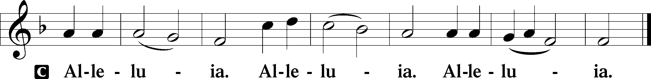

Holy Gospel Luke 12:13–21

P The Holy Gospel according to St. Luke, the twelfth chapter.

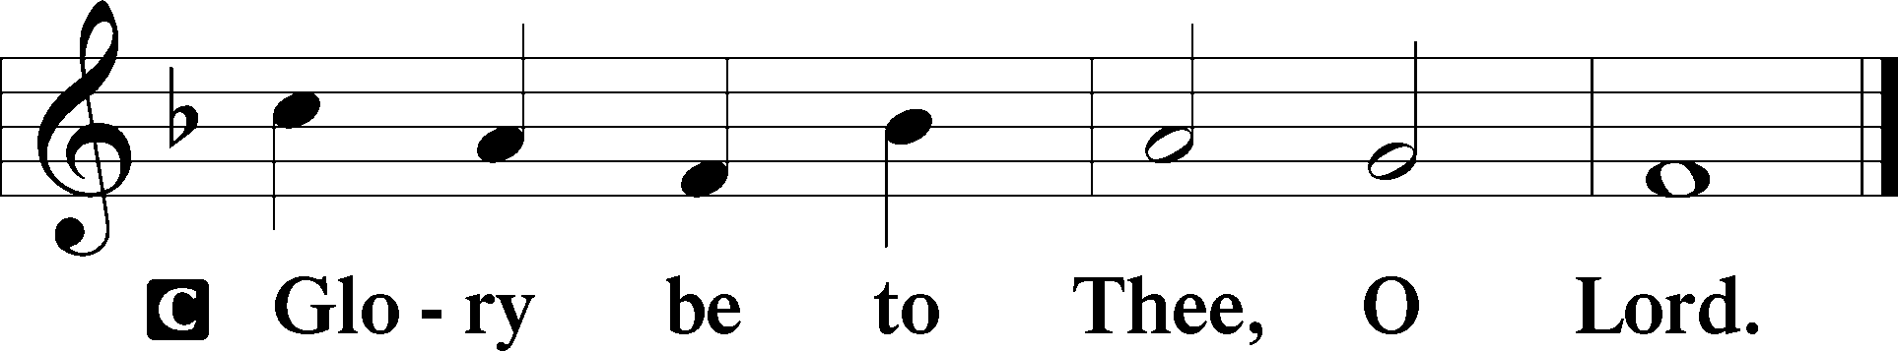

13Someone in the crowd said to [Jesus], “Teacher, tell my brother to divide the inheritance with me.” 14But he said to him, “Man, who made me a judge or arbitrator over you?” 15And he said to them, “Take care, and be on your guard against all covetousness, for one’s life does not consist in the abundance of his possessions.” 16And he told them a parable, saying, “The land of a rich man produced plentifully, 17and he thought to himself, ‘What shall I do, for I have nowhere to store my crops?’ 18And he said, ‘I will do this: I will tear down my barns and build larger ones, and there I will store all my grain and my goods. 19And I will say to my soul, Soul, you have ample goods laid up for many years; relax, eat, drink, be merry.’ 20But God said to him, ‘Fool! This night your soul is required of you, and the things you have prepared, whose will they be?’ 21So is the one who lays up treasure for himself and is not rich toward God.”

P This is the Gospel of the Lord.

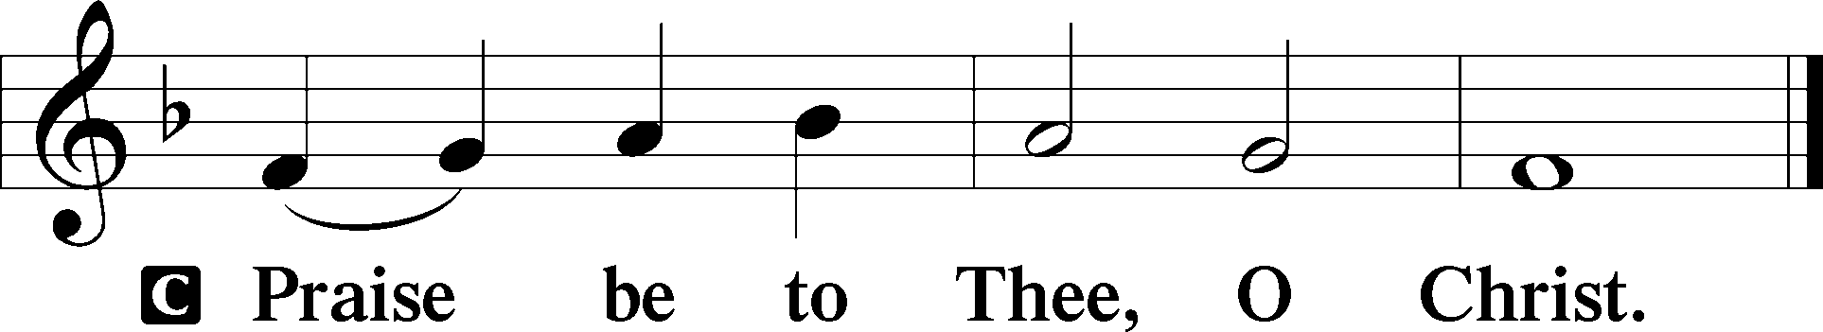

Nicene Creed

C **I believe in one God,**

**the Father Almighty,**

**maker of heaven and earth**

**and of all things visible and invisible.**

**And in one Lord Jesus Christ,**

**the only-begotten Son of God,**

**begotten of His Father before all worlds,**

**God of God, Light of Light,**

**very God of very God,**

**begotten, not made,**

**being of one substance with the Father,**

**by whom all things were made;**

**who for us men and for our salvation came down from heaven**

**and was incarnate by the Holy Spirit of the virgin Mary**

**and was made man;**

**and was crucified also for us under Pontius Pilate.**

**He suffered and was buried.**

**And the third day He rose again according to the Scriptures**

**and ascended into heaven**

**and sits at the right hand of the Father.**

**And He will come again with glory to judge both the living and the dead,**

**whose kingdom will have no end.**

**And I believe in the Holy Spirit,**

**the Lord and giver of life,**

**who proceeds from the Father and the Son,**

**who with the Father and the Son together is worshiped and glorified,**

**who spoke by the prophets.**

**And I believe in one holy Christian and apostolic Church,**

**I acknowledge one Baptism for the remission of sins,**

**and I look for the resurrection of the dead**

**and the life** T **of the world to come. Amen.**

Sit

Children's Sermon

611 Chief of Sinners Though I Be

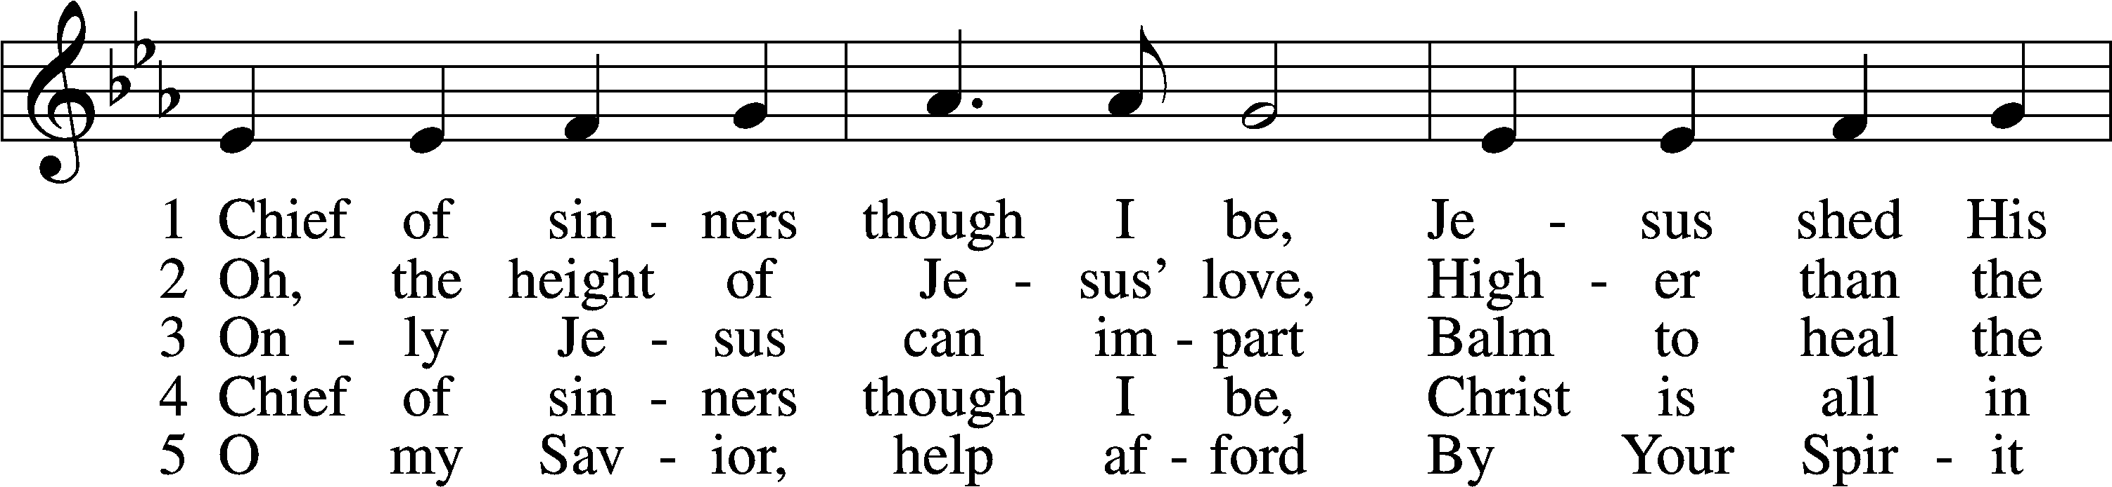

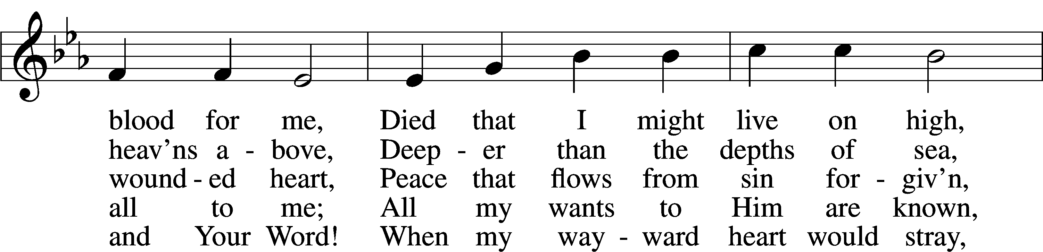

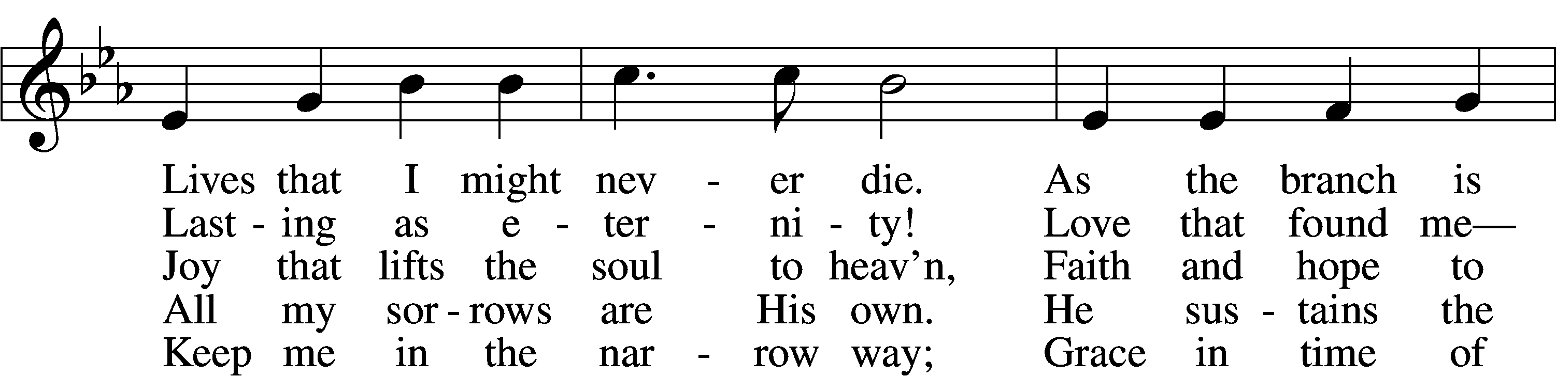

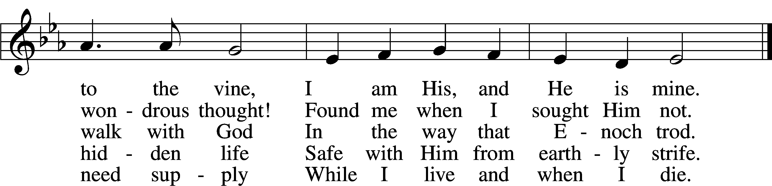

Text: William McComb, 1793–1873, alt.  
Tune: Richard Redhead, 1820–1901  
Text and tune: Public domain

Sermon

Votum

P The peace of God, which passes all understanding, keep your hearts and minds in Christ Jesus.

C **Amen.**

Stand

Offertory Psalm 51:10–12

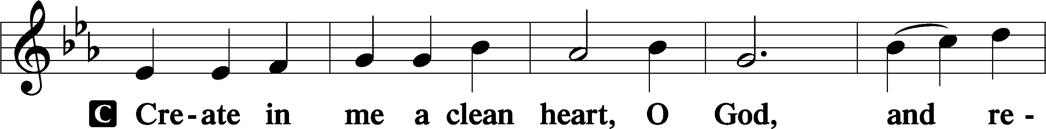

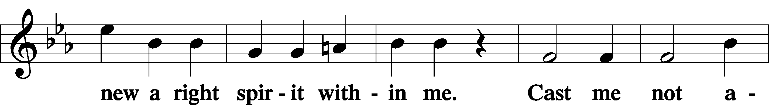

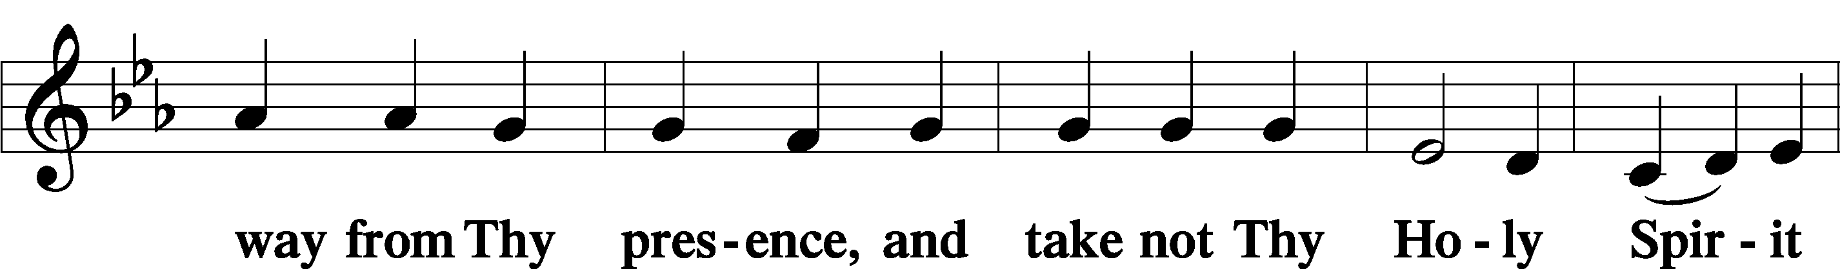

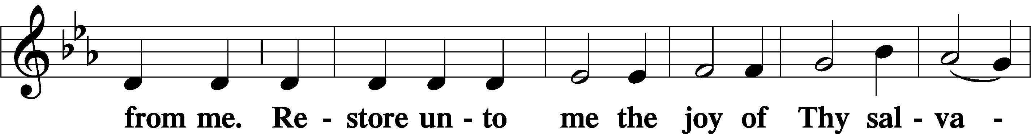

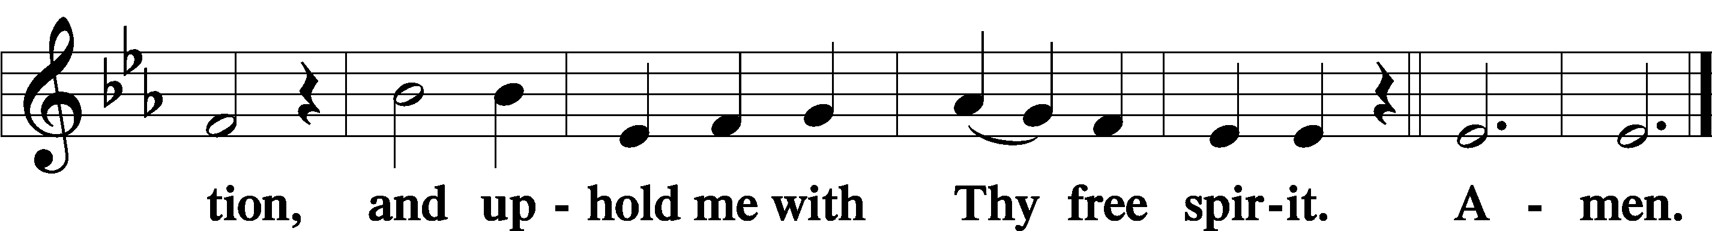

Sit

Offering

805 Praise God, from Whom All Blessings Flow

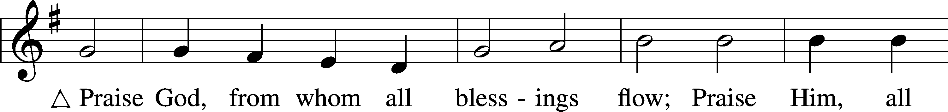

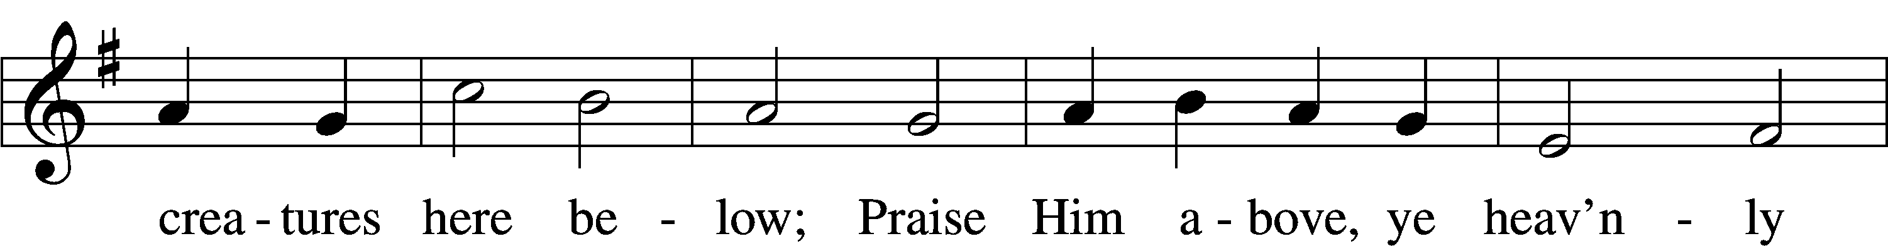

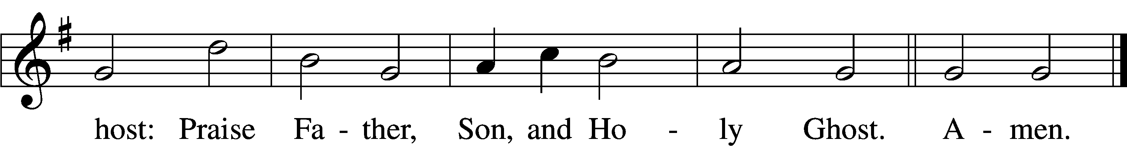

Text: Thomas Ken, 1637–1711  
Tune: Trente quatre Pseaumes de David, 1551, Geneva, ed. Louis Bourgeois  
Text and tune: Public domain

Stand

Prayer of the Church

# Service of the Sacrament

Preface 2 Timothy 4:22; [Colossians 3:1]; [Psalm 136]

P The Lord be with you.

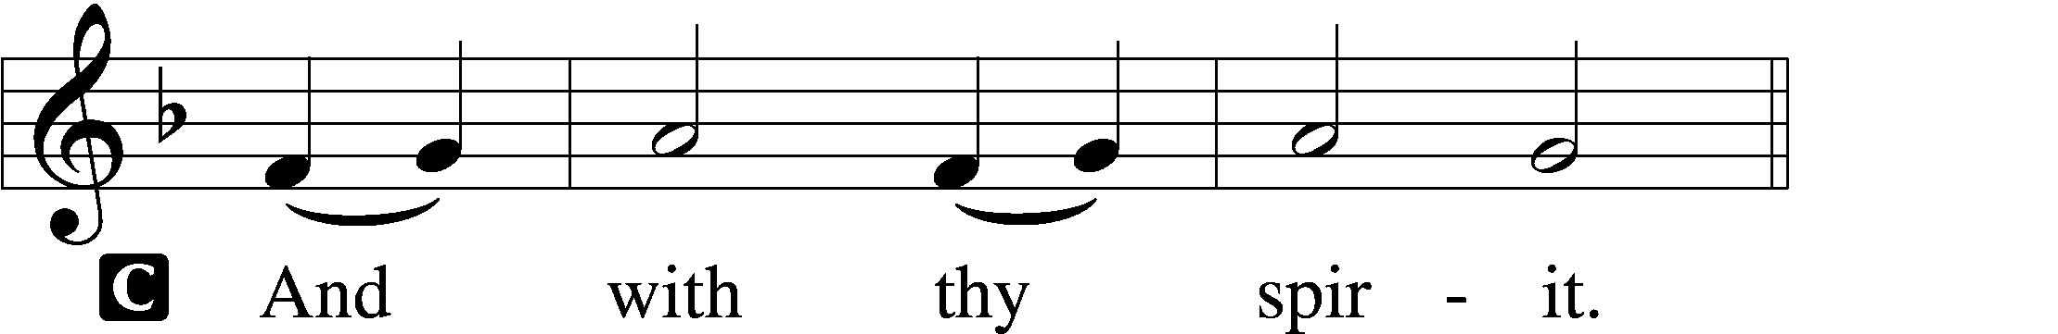

P Lift up your hearts.

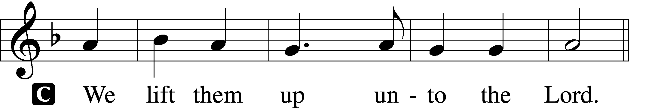

P Let us give thanks unto the Lord, our God.

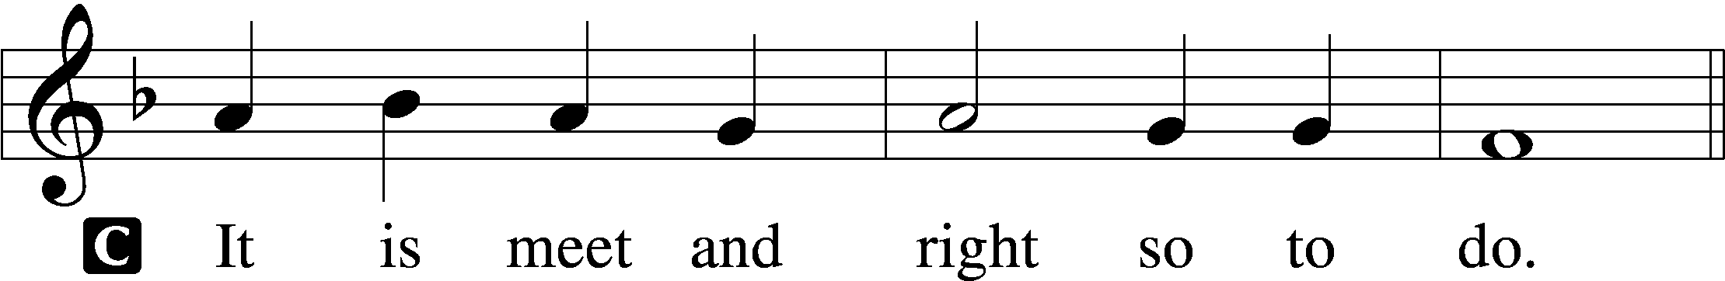

Proper Preface (Full)

P It is truly meet, right, and salutary that we should at all times and in all places give thanks to You, holy Lord, almighty Father, everlasting God, through Jesus Christ, our Lord, who, out of love for His fallen creation, humbled Himself by taking on the form of a servant, becoming obedient unto death, even death upon a cross. Risen from the dead, He has freed us from eternal death and given us life everlasting. Therefore with angels and archangels and with all the company of heaven we laud and magnify Your glorious name, evermore praising You and saying:

Sanctus Isaiah 6:3; Matthew 21:9

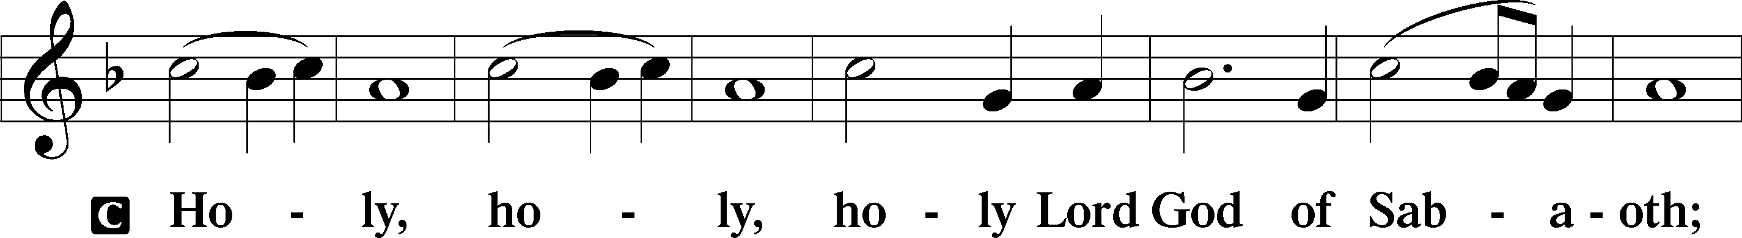

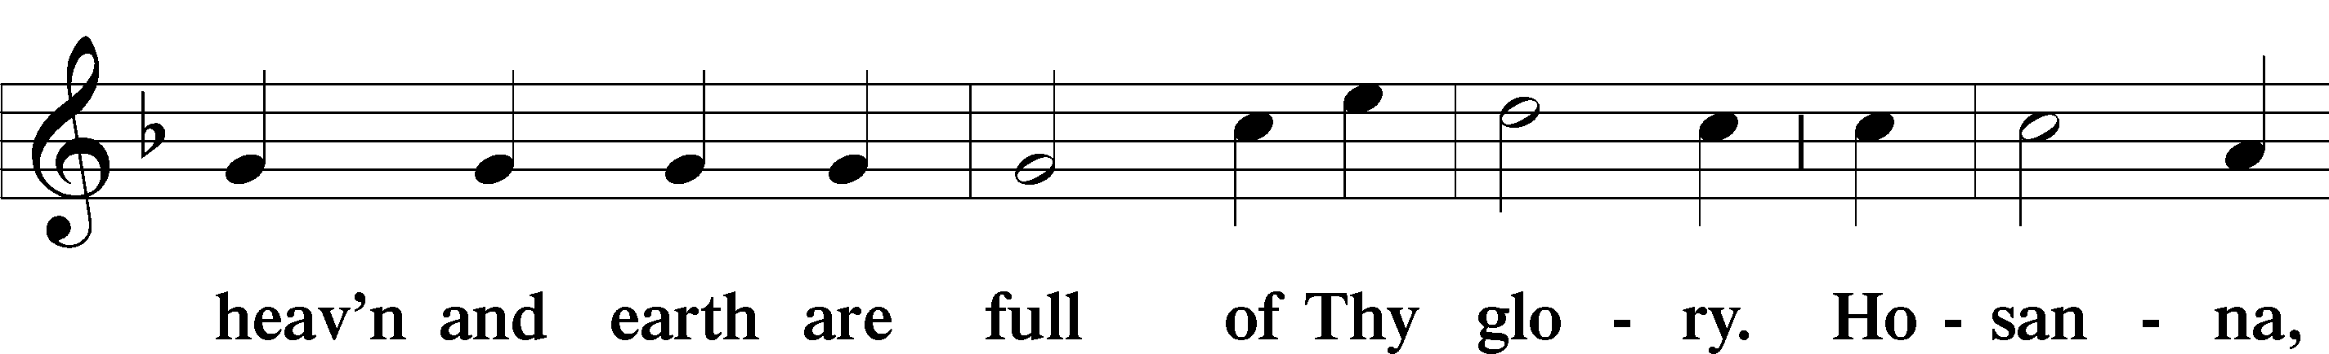

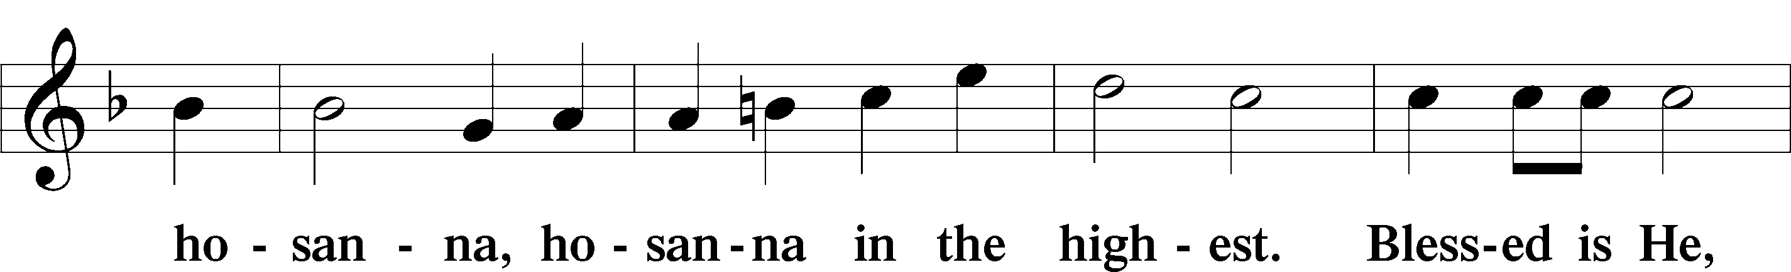

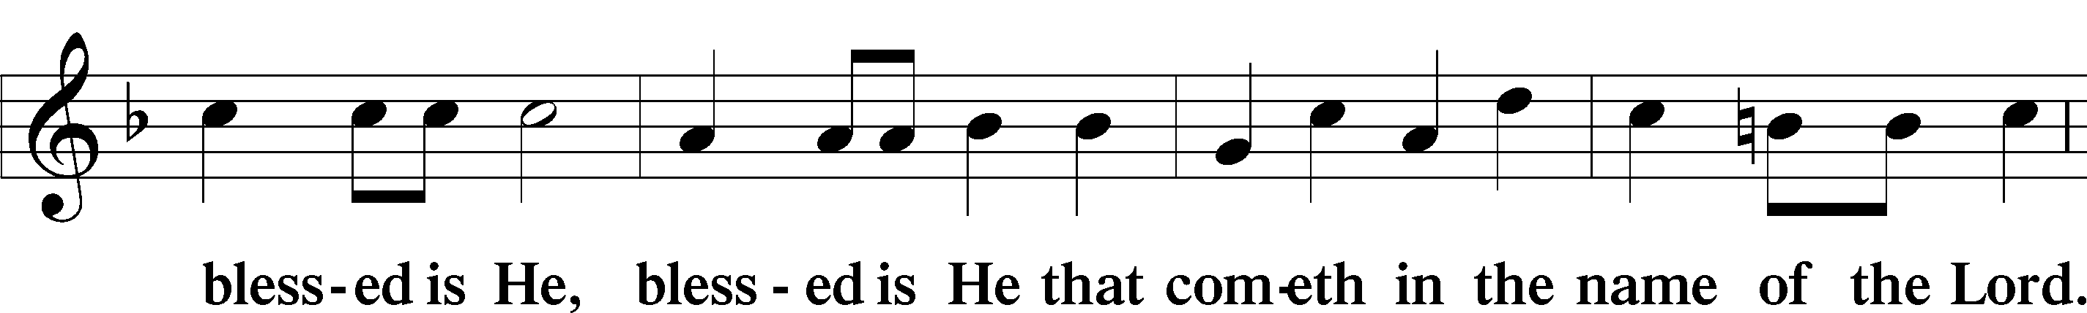

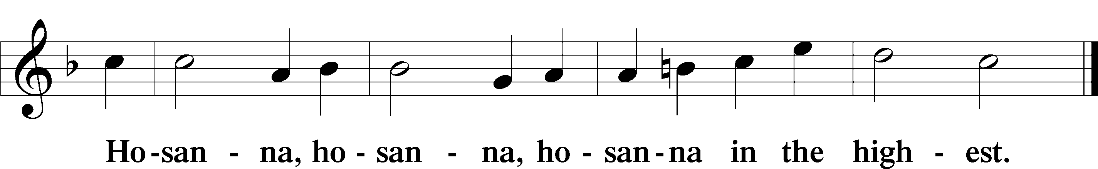

Lord’s Prayer Matthew 6:9–13

P Our Father who art in heaven,

hallowed be Thy name,

Thy kingdom come,

Thy will be done on earth as it is in heaven;

give us this day our daily bread;

and forgive us our trespasses as we forgive those who trespass against us;

and lead us not into temptation,

but deliver us from evil.

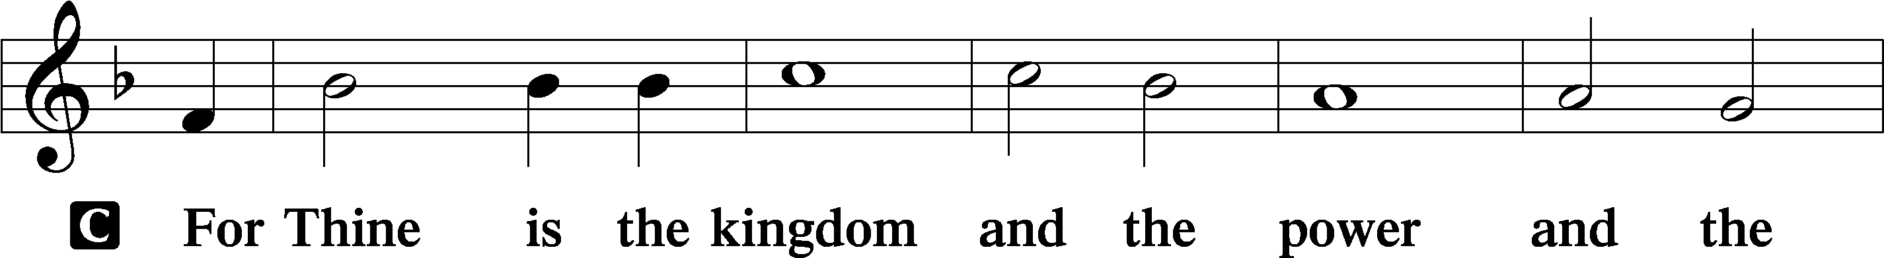

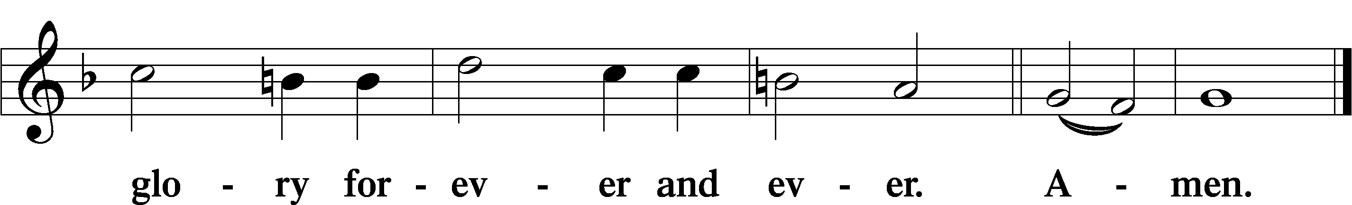

The Words of Our Lord Matthew 26:26–28; Mark 14:22–24; Luke 22:19–20; 1 Corinthians 11:23–25

P Our Lord Jesus Christ, on the night when He was betrayed, took bread, and when He had given thanks, He broke it and gave it to the disciples and said: “Take, eat; this is My T body, which is given for you. This do in remembrance of Me.”

In the same way also He took the cup after supper, and when He had given thanks, He gave it to them, saying: “Drink of it, all of you; this cup is the new testament in My T blood, which is shed for you for the forgiveness of sins. This do, as often as you drink it, in remembrance of Me.”

Pax Domini John 20:19

P The peace of the Lord be with you always.

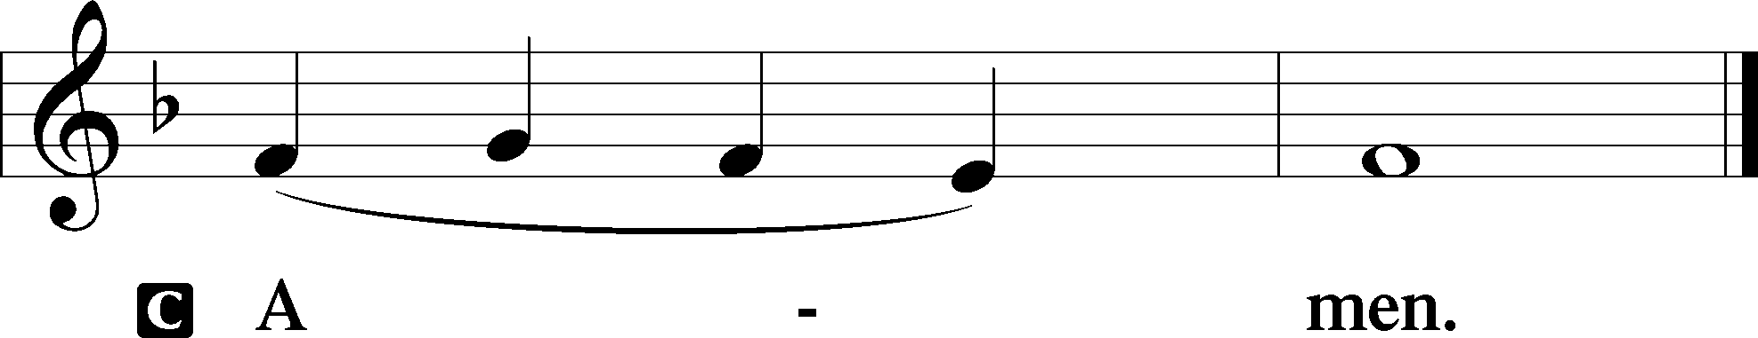

Agnus Dei John 1:29

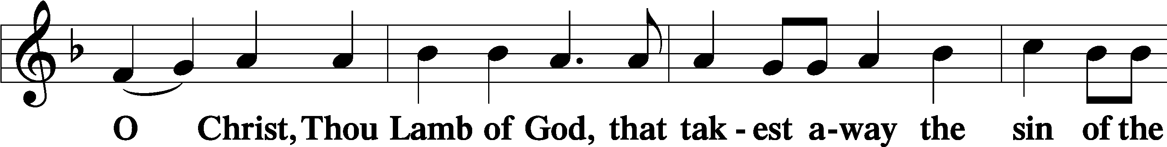

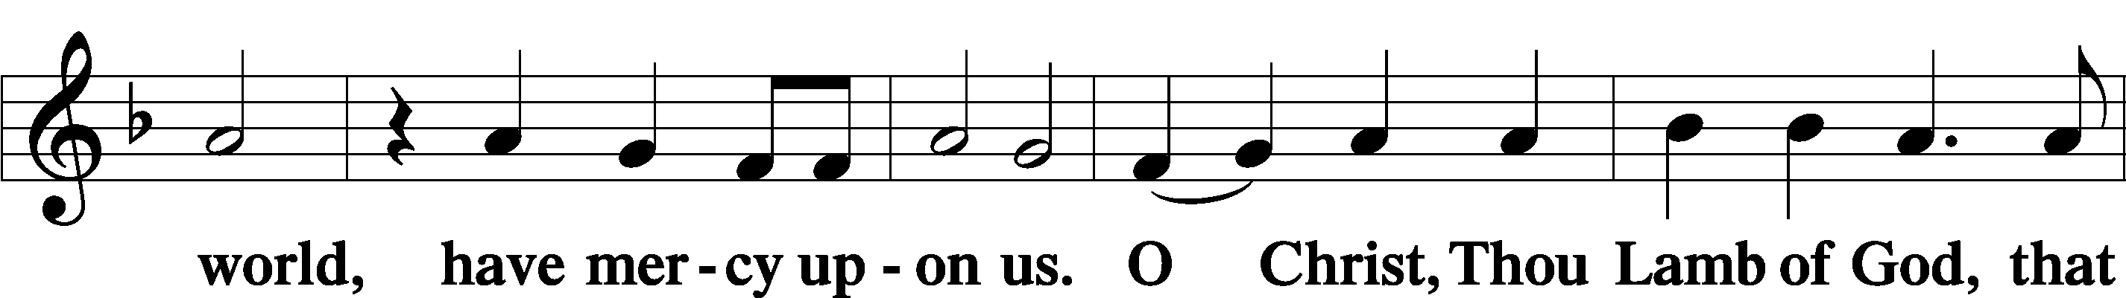

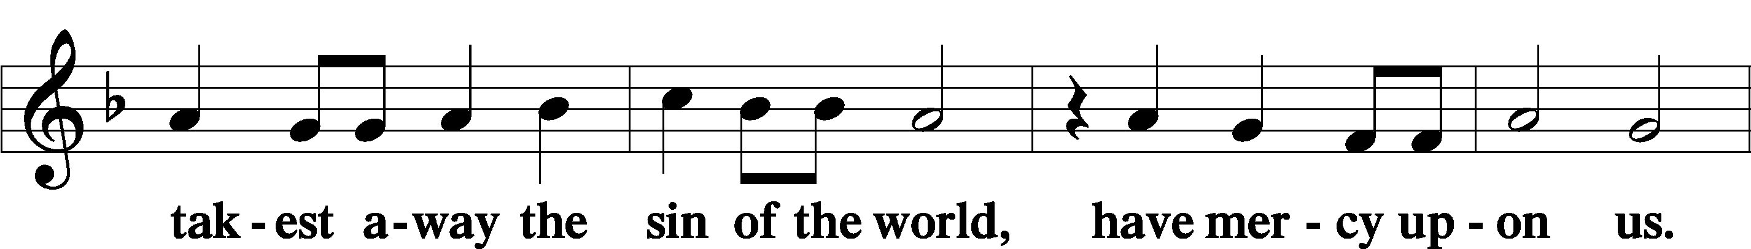

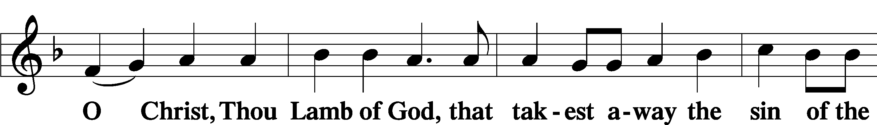

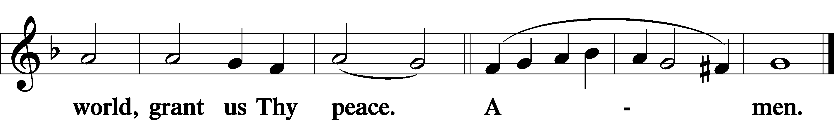

Sit

Distribution

The pastor and those who assist him receive the body and blood of Christ first and then distribute them to those who come to receive, saying:

Take, eat; this is the true body of our Lord and Savior Jesus Christ, given into death for your sins.

**Amen.**

Take, drink; this is the true blood of our Lord and Savior Jesus Christ, shed for the forgiveness of your sins.

**Amen.**

In dismissing the communicants, the following is said:

The Dismissal

P The body and blood of our Lord Jesus Christ strengthen and preserve you in body and soul to life everlasting. Depart T in peace.

C **Amen.**

554 O Jesus, King Most Wonderful

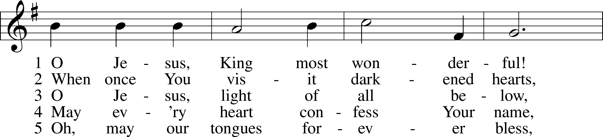

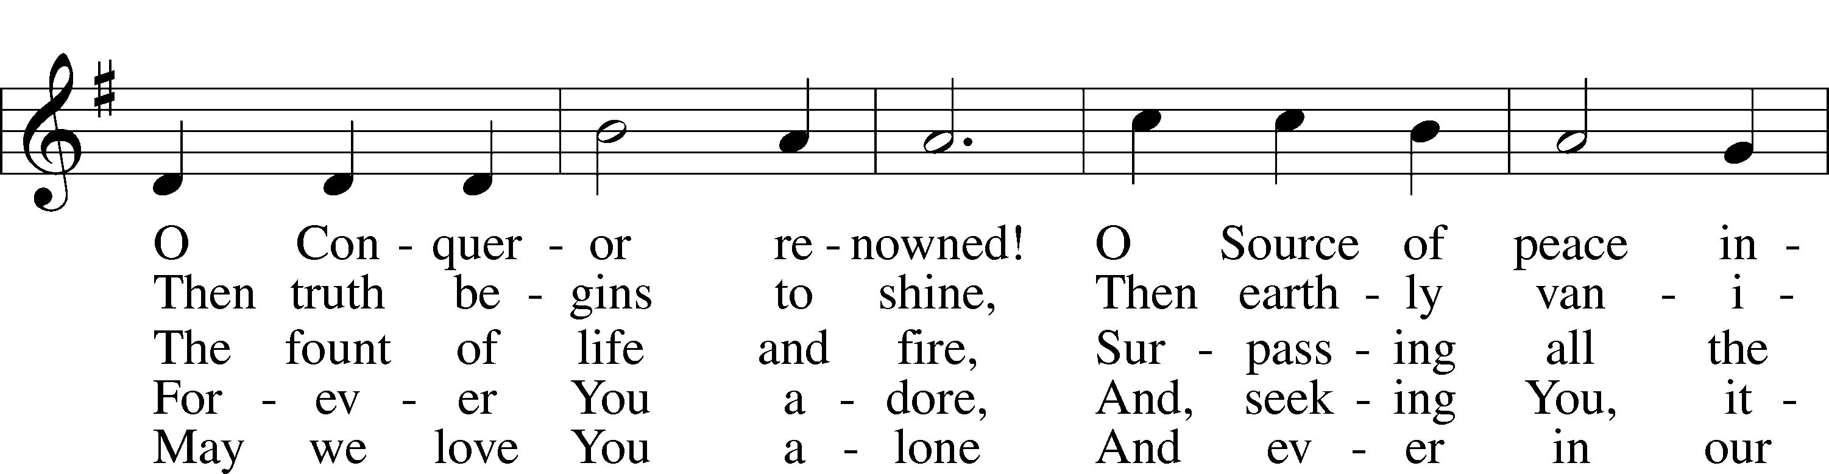

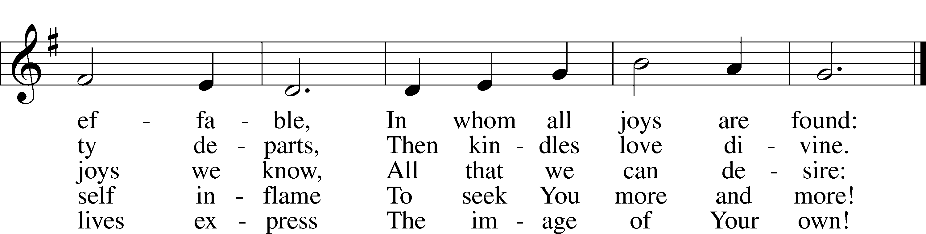

Text: attr. Bernard of Clairvaux, 1091–1153; tr. Edward Caswall, 1814–78, alt.  
Tune: John B. Dykes, 1823–76  
Text and tune: Public domain

732 All Depends on Our Possessing

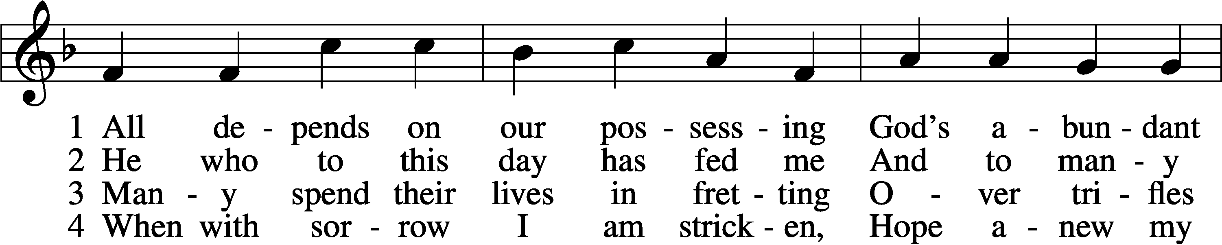

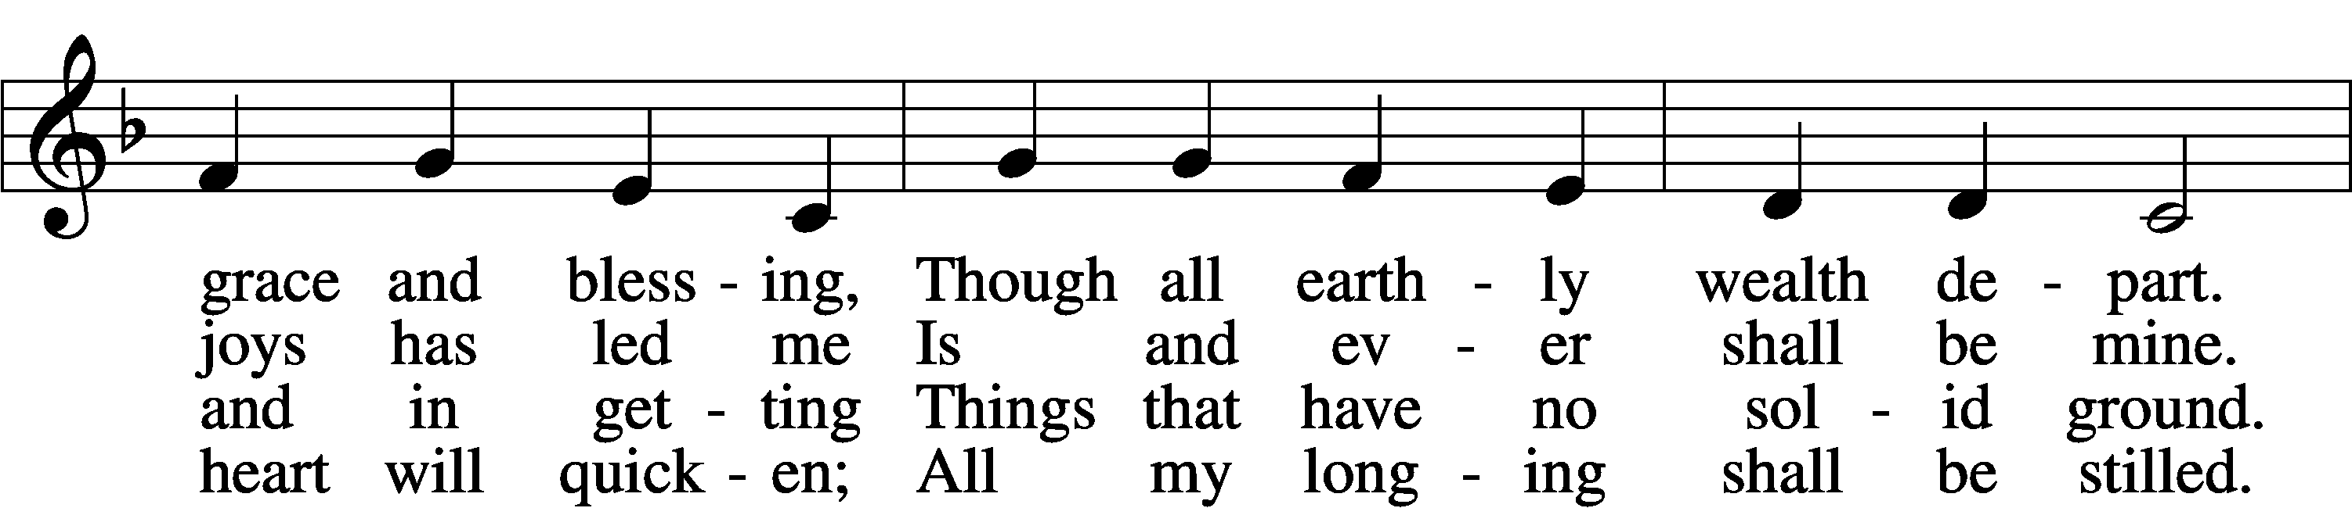

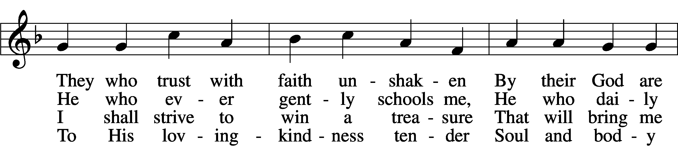

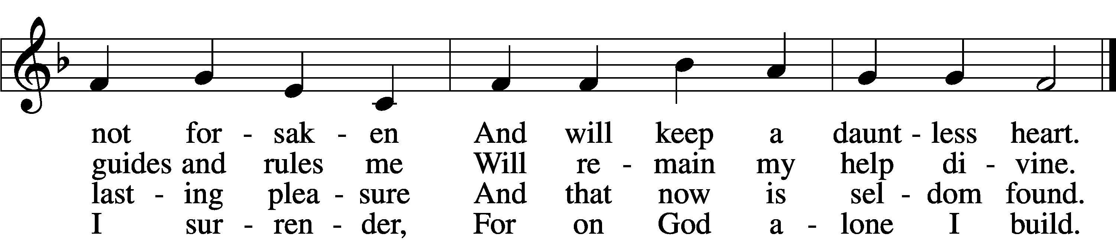

5 Well He knows what best to grant me;  
All the longing hopes that haunt me,  
 Joy and sorrow, have their day.  
I shall doubt His wisdom never;  
As God wills, so be it ever;  
 I commit to Him my way.

6 If my days on earth He lengthen,  
God my weary soul will strengthen;  
 All my trust in Him I place.  
Earthly wealth is not abiding,  
Like a stream away is gliding;  
 Safe I anchor in His grace.

Text: Andächtige Haus-Kirche, 1676, Nürnberg; tr. Catherine Winkworth, 1827–78, alt.  
Tune: Johann Löhner, 1645–1705; adapt. Johann Balthasar König, 1691–1758  
Text and tune: Public domain

707 Oh, That the Lord Would Guide My Ways

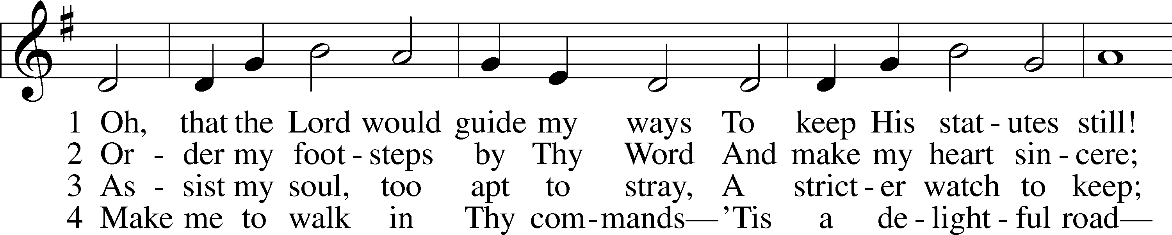

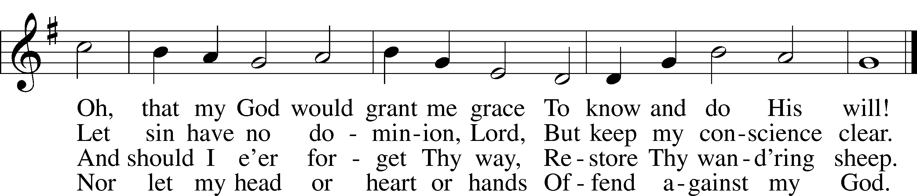

Text: Isaac Watts, 1674–1748, alt.  
Tune: William H. Havergal, 1793–1870  
Text and tune: Public domain

781 We Give Thee But Thine Own

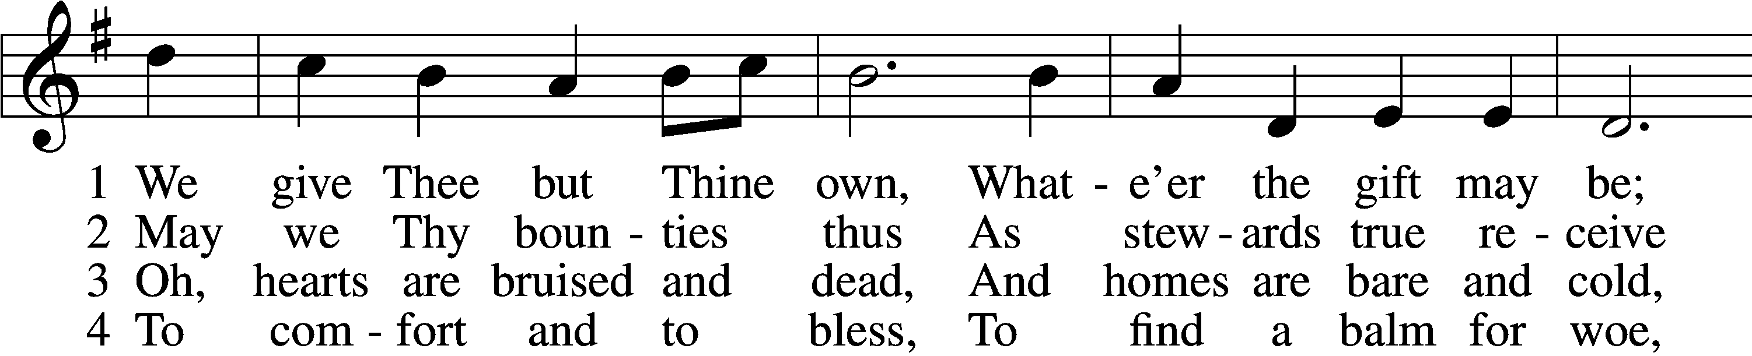

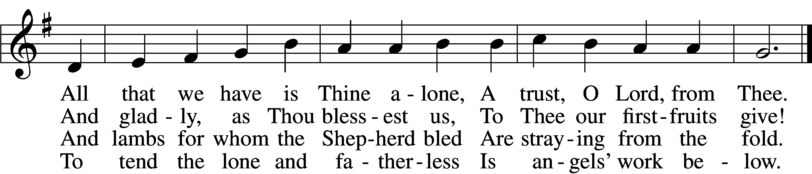

5 The captive to release,  
 To God the lost to bring,  
To teach the way of life and peace,  
 It is a Christ-like thing.

6 And we believe Thy Word,  
 Though dim our faith may be:  
Whate’er for Thine we do, O Lord,  
 We do it unto Thee.

Text: William W. How, 1823–97  
Tune: William H. Monk, 1823–89  
Text and tune: Public domain

Stand

Nunc Dimittis Luke 2:29–32

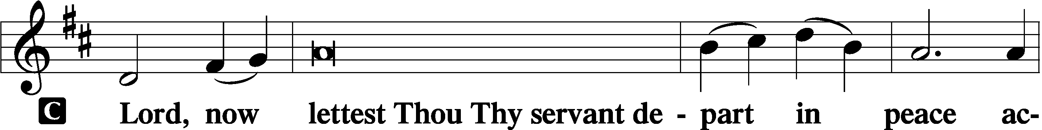

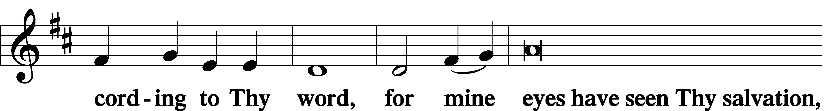

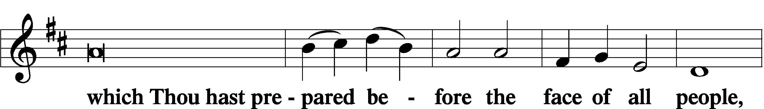

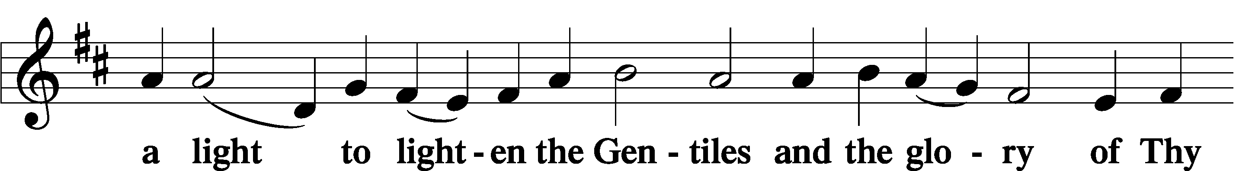

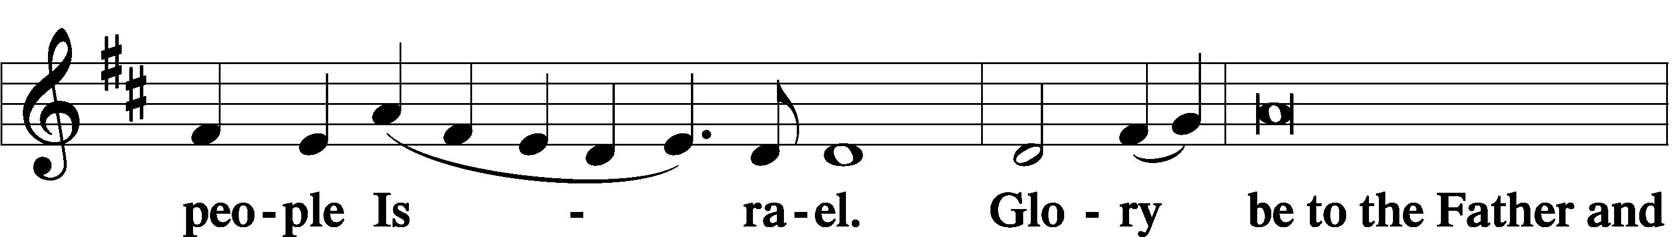

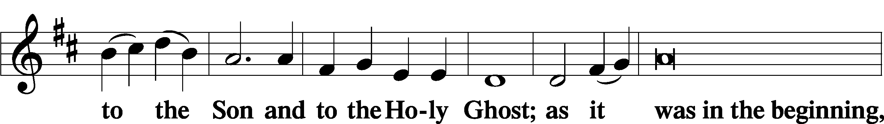

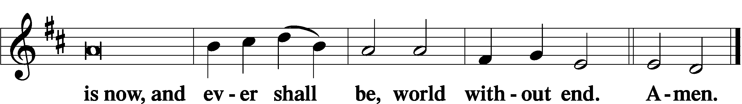

Thanksgiving Psalm 107:1

A O give thanks unto the Lord, for He is good,

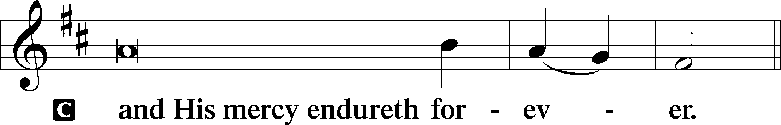

Post-Communion Collect

A Let us pray.

We give thanks to You, almighty God, that You have refreshed us through this salutary gift, and we implore You that of Your mercy You would strengthen us through the same in faith toward You and in fervent love toward one another; through Jesus Christ, Your Son, our Lord, who lives and reigns with You and the Holy Spirit, one God, now and forever.

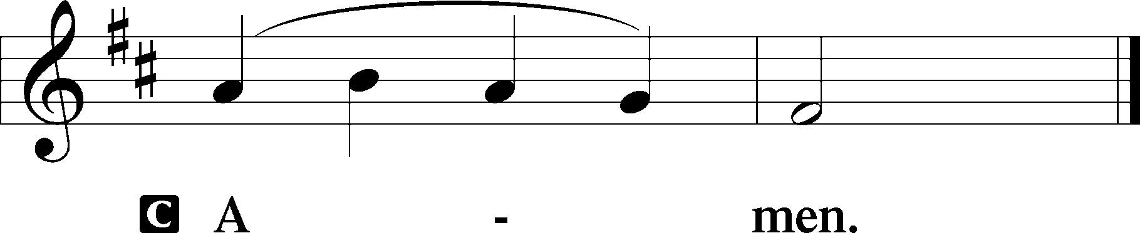

Salutation 2 Timothy 4:22

P The Lord be with you.

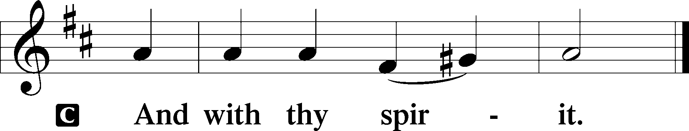

Benedicamus Psalm 103:1

A Bless we the Lord.

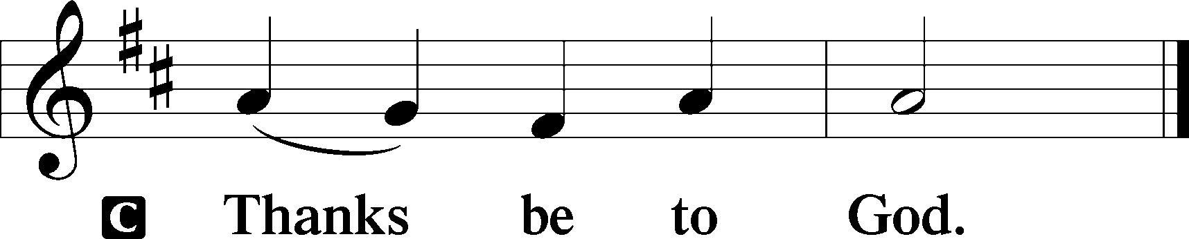

Benediction Numbers 6:24–26

P The Lord bless you and keep you.

The Lord make His face shine upon you and be gracious unto you.

The Lord lift up His countenance upon you and T give you peace.

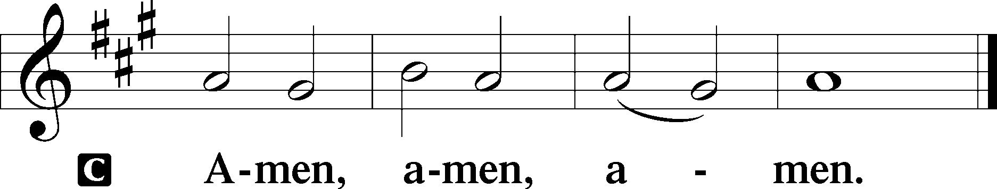

698 May We Thy Precepts, Lord, Fulfill

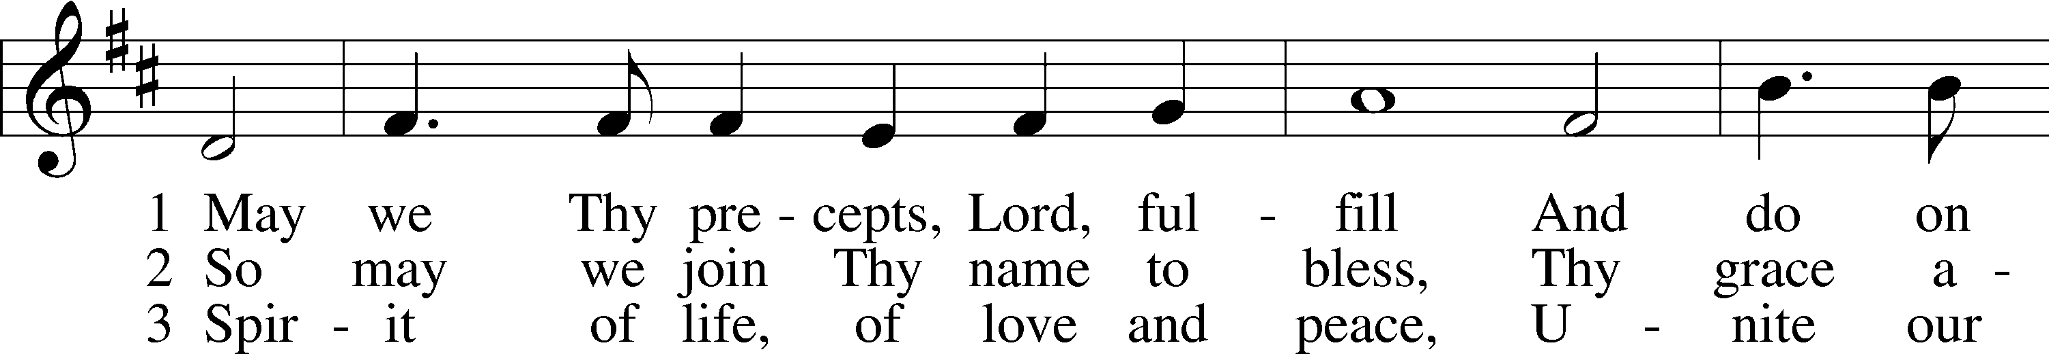

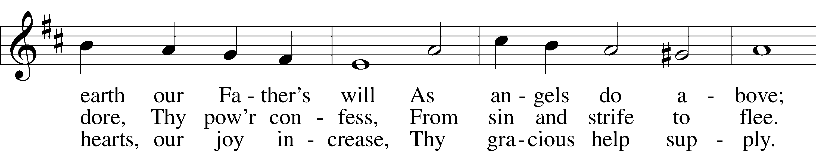

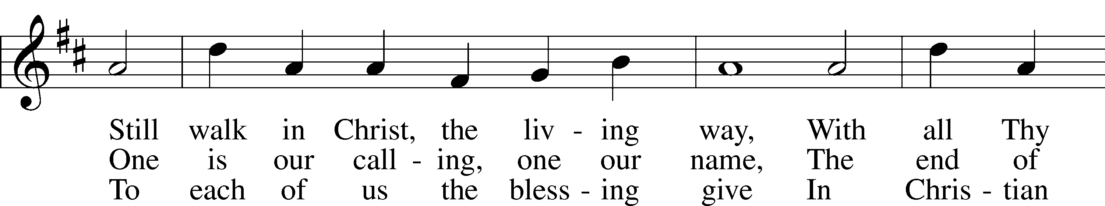

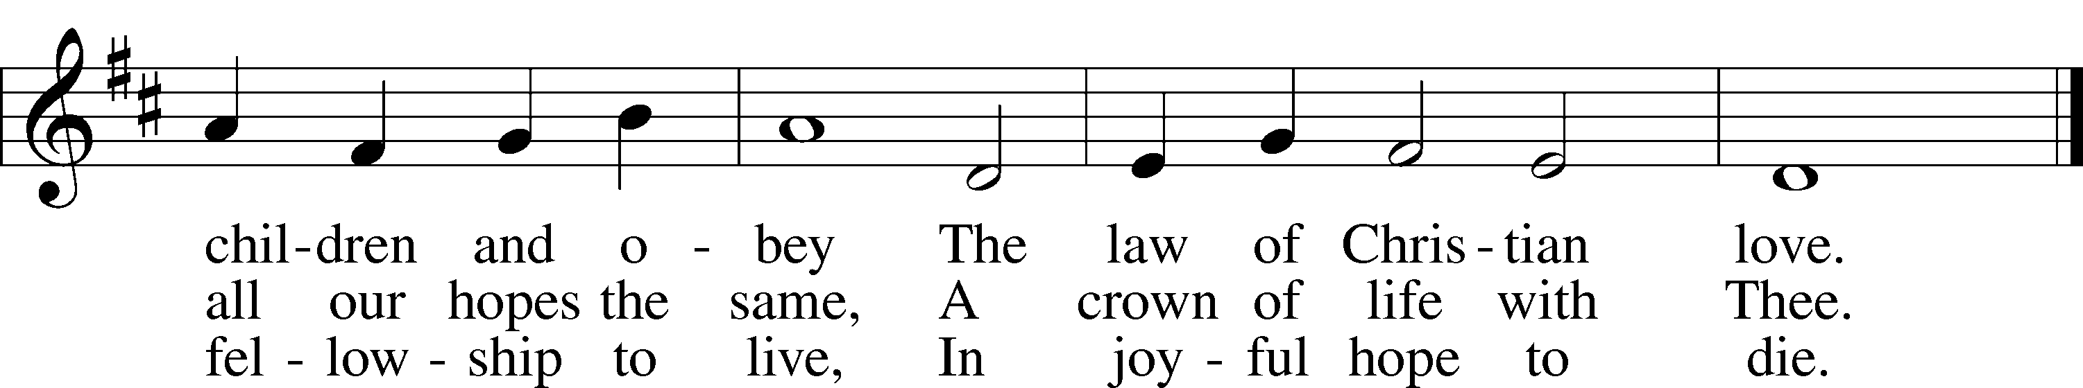

Text: Edward Osler, 1798–1863, alt.  
Tune: Lowell Mason, 1792–1872  
Text and tune: Public domain

Acknowledgments

Divine Service, Setting Three from Lutheran Service Book

Unless otherwise indicated, Scripture quotations are from the ESV® Bible (The Holy Bible, English Standard Version®), copyright © 2001 by Crossway, a publishing ministry of Good News Publishers. Used by permission. All rights reserved.

Created by Lutheran Service Builder © 2025 Concordia Publishing House.