On entering the church

P Lord, I love the habitation of Your house and the place

where Your glory dwells. In the multitude of Your tender

mercies prepare my heart that I may enter Your house to

worship and confess Your holy name; through Jesus Christ,

my God and Lord.

Before worship

C O Lord, our creator, redeemer, and comforter, as we come

together to worship You in spirit and in truth, we humbly

pray that You would open our hearts to the preaching of

Your Word so that we may repent of our sins, believe in

Jesus Christ as our only Savior, and grow in grace and

holiness. Hear us for His sake.

857 Lord, Help Us Walk Your Servant Way

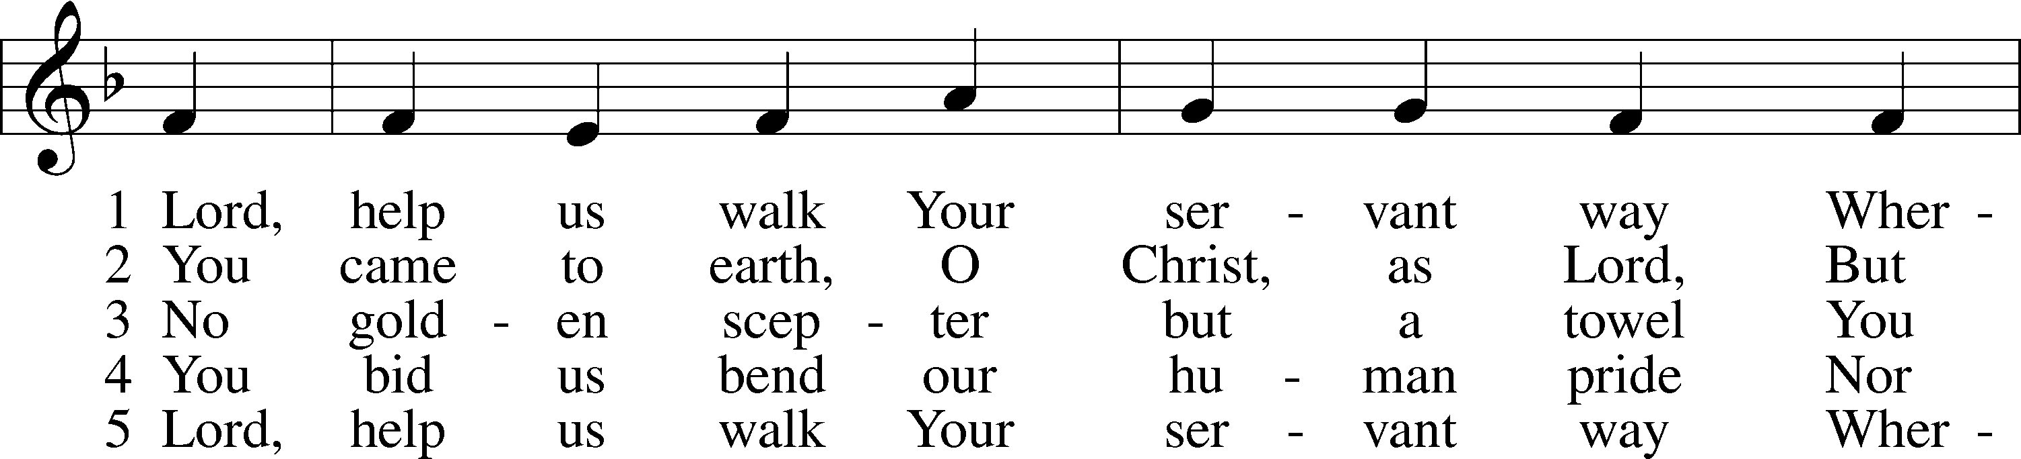

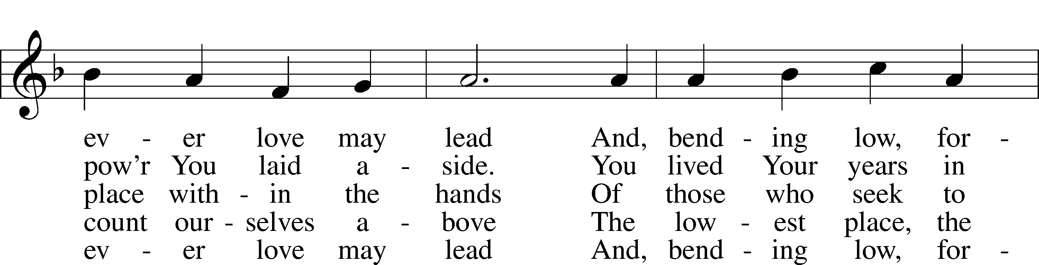

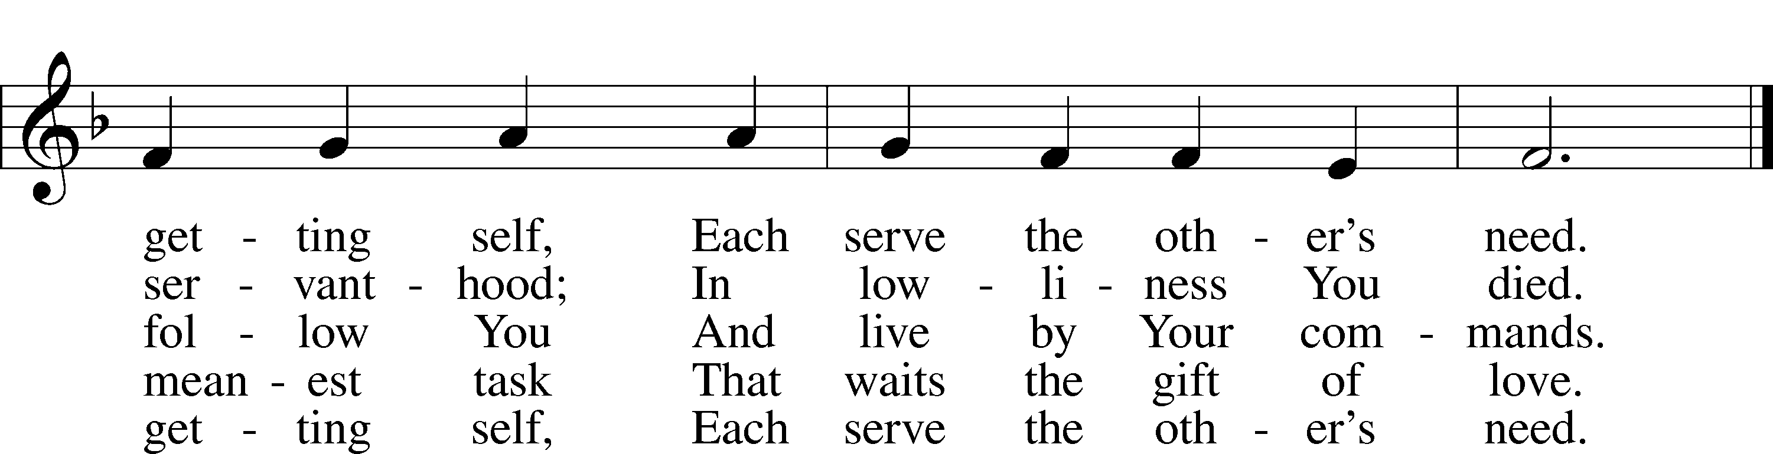

Text: Herman G. Stuempfle, Jr., 1923–2007  
Tune: The Whole Booke of Psalmes, 1562, London  
Text: © 1997 GIA Publications, Inc. Used by permission: LSB Hymn License no. 110005011  
Tune: Public domain

# Confession and Absolution

Stand

The sign of the cross may be made by all in remembrance of their Baptism.

Invocation Matthew 28:19b; 18:20

P In the name of the Father and of the T Son and of the Holy Spirit.

C **Amen.**

Exhortation Hebrews 10:22; Psalm 124:8; Psalm 32:5

P Beloved in the Lord! Let us draw near with a true heart and confess our sins unto God our Father, beseeching Him in the name of our Lord Jesus Christ to grant us forgiveness.

P Our help is in the name of the Lord,

C **who made heaven and earth.**

P I said, I will confess my transgressions unto the Lord,

C **and You forgave the iniquity of my sin.**

Kneel/Stand

Silence for reflection on God’s Word and for self-examination.

Confession of Sins

P O almighty God, merciful Father,

C **I, a poor, miserable sinner, confess unto You all my sins and iniquities with which I have ever offended You and justly deserved Your temporal and eternal punishment. But I am heartily sorry for them and sincerely repent of them, and I pray You of Your boundless mercy and for the sake of the holy, innocent, bitter sufferings and death of Your beloved Son, Jesus Christ, to be gracious and merciful to me, a poor, sinful being.**

Absolution [John 20:19–23]

P Upon this your confession, I, by virtue of my office, as a called and ordained servant of the Word, announce the grace of God unto all of you, and in the stead and by the command of my Lord Jesus Christ I forgive you all your sins in the name of the Father and of the T Son and of the Holy Spirit.

C **Amen.**

Stand

# Service of the Word

Introit Psalm 119:162, 164–165, 167; antiphon: v. 166

I hope for your salvation, O Lord,  
 and I do your commandments.  
**I rejoice at your word  
 like one who finds great spoil.**Seven times a day I praise you  
 for your just and righteous decrees.  
**Great peace have those who love your law;  
 nothing can make them stumble.**My soul keeps your testimonies;  
 I love them exceedingly.

Gloria Patri

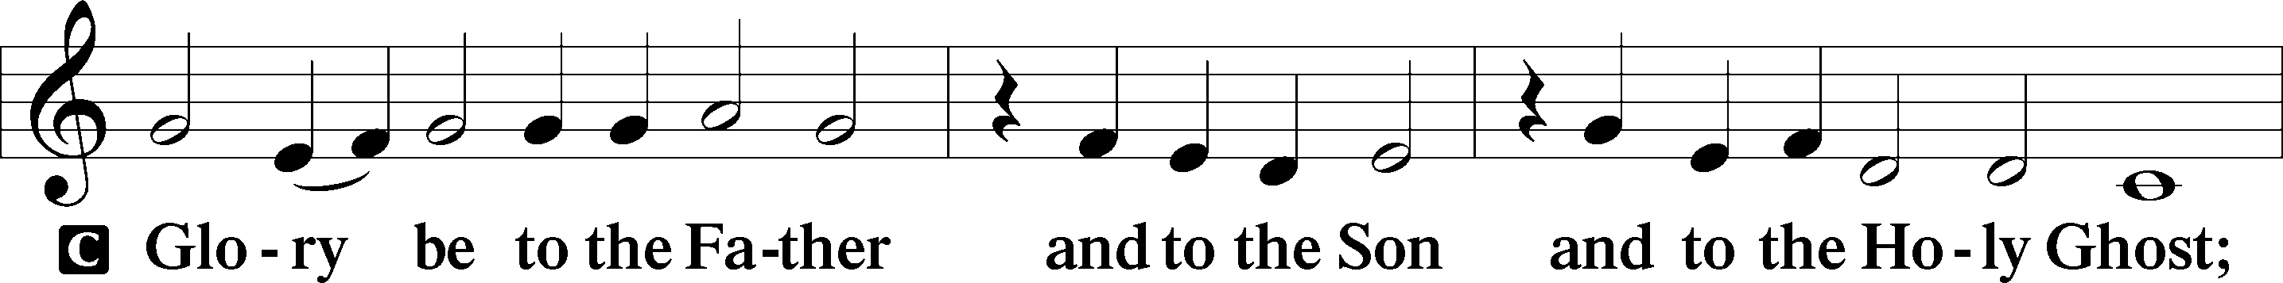

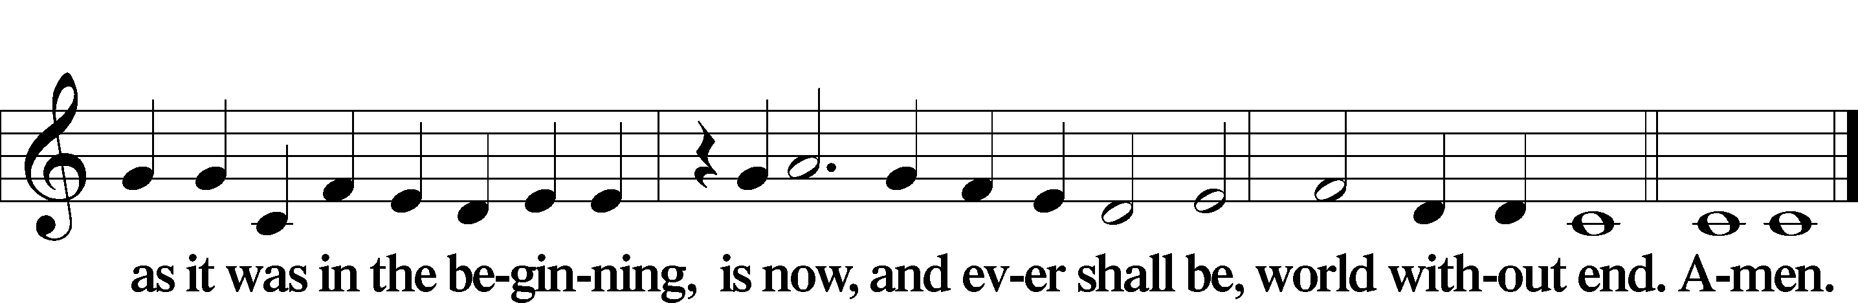

Kyrie Mark 10:47

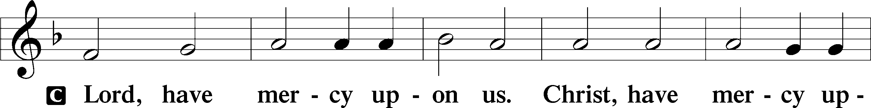

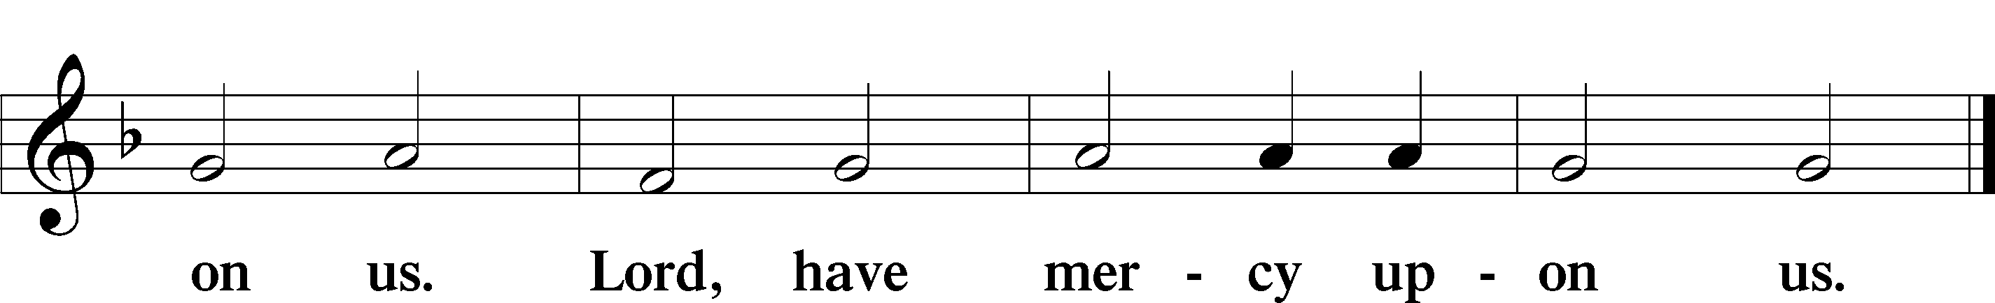

Gloria in Excelsis Luke 2:14; John 1:29

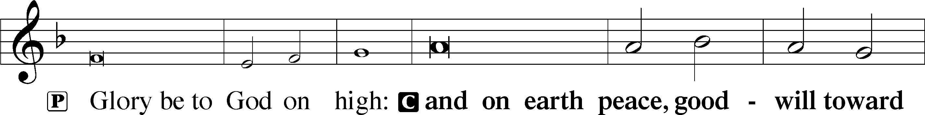

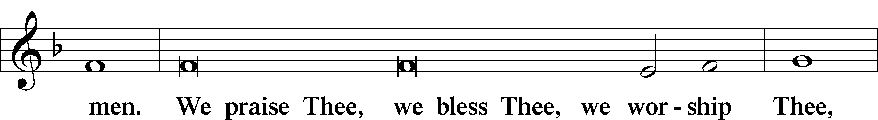

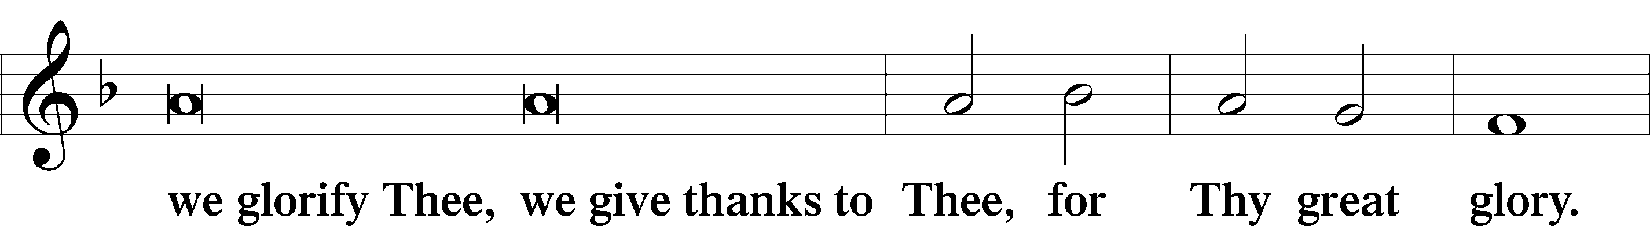

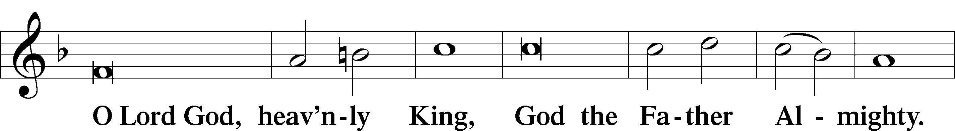

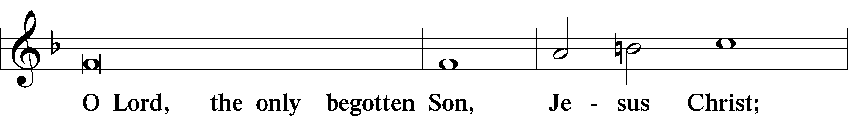

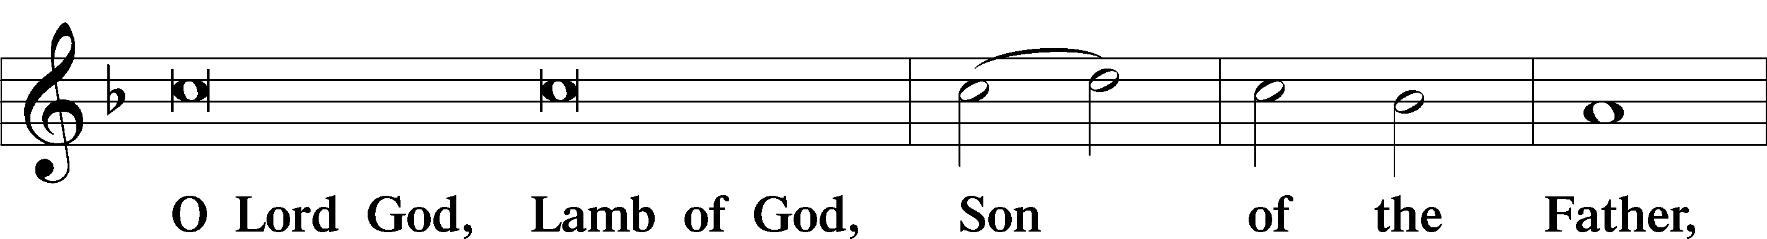

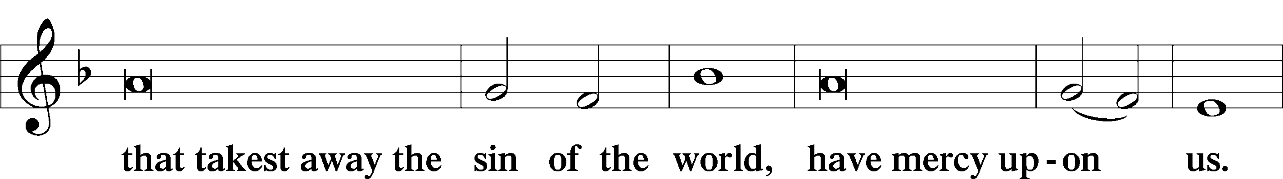

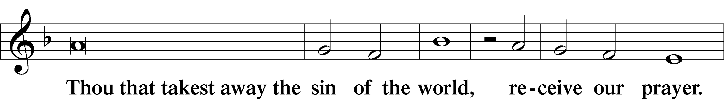

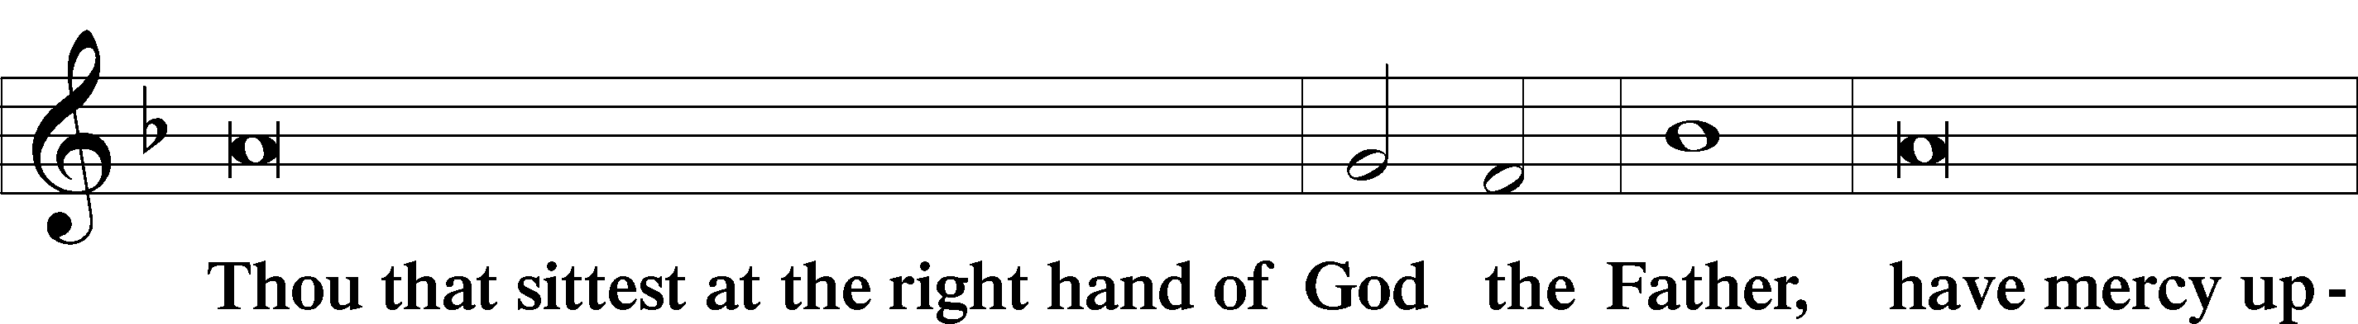

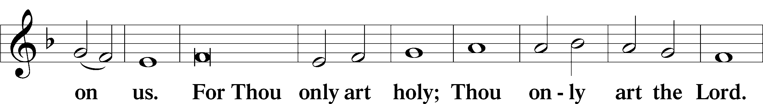

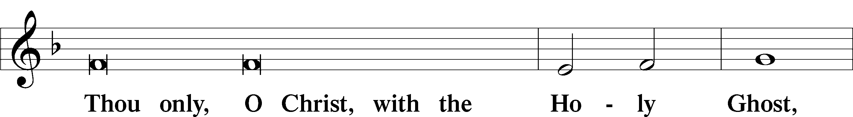

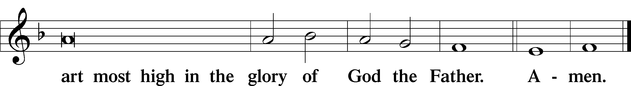

Salutation and Collect of the Day

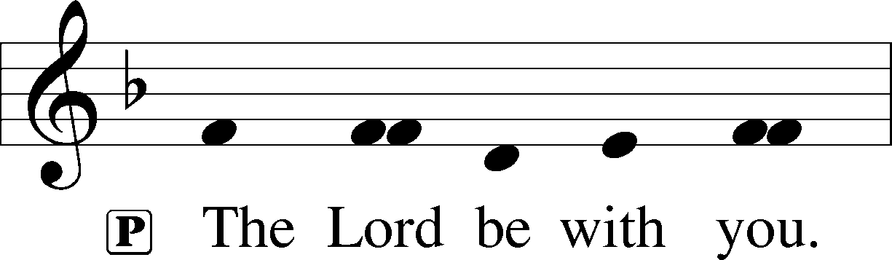

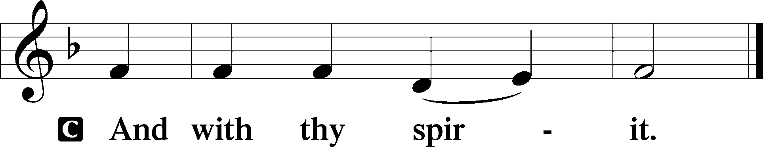

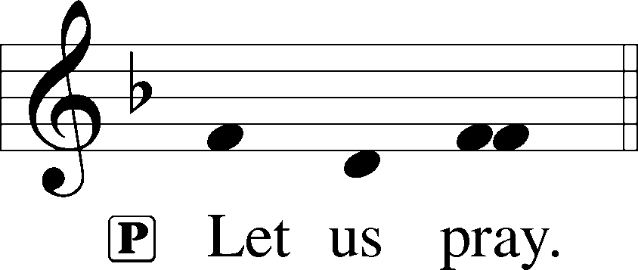

P O God, our refuge and strength, the author of all godliness, by Your grace hear the prayers of Your Church. Grant that those things which we ask in faith we may receive through Your bountiful mercy; through Jesus Christ, Your Son, our Lord, who lives and reigns with You and the Holy Spirit, one God, now and forever.

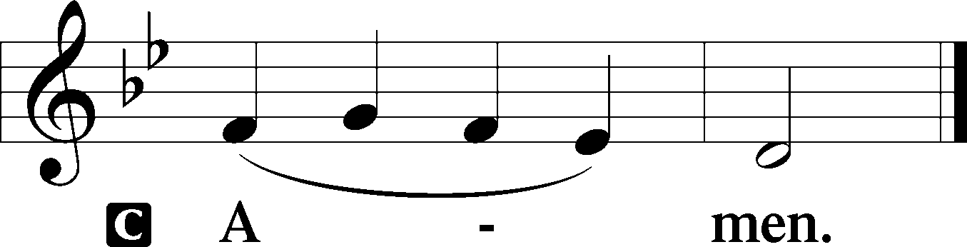

Sit

Old Testament Reading Habakkuk 1:1–4; 2:1–4

1The oracle that Habakkuk the prophet saw.

2O Lord, how long shall I cry for help,  
 and you will not hear?  
Or cry to you “Violence!”  
 and you will not save?  
3Why do you make me see iniquity,  
 and why do you idly look at wrong?  
Destruction and violence are before me;  
 strife and contention arise.  
4So the law is paralyzed,  
 and justice never goes forth.  
For the wicked surround the righteous;  
 so justice goes forth perverted.

1I will take my stand at my watchpost  
 and station myself on the tower,  
and look out to see what he will say to me,  
 and what I will answer concerning my complaint.

2And the Lord answered me:  
“Write the vision;  
 make it plain on tablets,  
 so he may run who reads it.  
3For still the vision awaits its appointed time;  
 it hastens to the end—it will not lie.  
If it seems slow, wait for it;  
 it will surely come; it will not delay.

4“Behold, his soul is puffed up; it is not upright within him,  
 but the righteous shall live by his faith.”

A This is the Word of the Lord.

C **Thanks be to God.**

Gradual Psalm 91:11; 103:1

He will command his angels concerning you  
 to guard you in all your ways.  
**Bless the Lord, O my soul,  
 and all that is within me, bless his holy name!**

Epistle 2 Timothy 1:1–14

1Paul, an apostle of Christ Jesus by the will of God according to the promise of the life that is in Christ Jesus,

2To Timothy, my beloved child:

Grace, mercy, and peace from God the Father and Christ Jesus our Lord.

3I thank God whom I serve, as did my ancestors, with a clear conscience, as I remember you constantly in my prayers night and day. 4As I remember your tears, I long to see you, that I may be filled with joy. 5I am reminded of your sincere faith, a faith that dwelt first in your grandmother Lois and your mother Eunice and now, I am sure, dwells in you as well. 6For this reason I remind you to fan into flame the gift of God, which is in you through the laying on of my hands, 7for God gave us a spirit not of fear but of power and love and self-control.

8Therefore do not be ashamed of the testimony about our Lord, nor of me his prisoner, but share in suffering for the gospel by the power of God, 9who saved us and called us to a holy calling, not because of our works but because of his own purpose and grace, which he gave us in Christ Jesus before the ages began, 10and which now has been manifested through the appearing of our Savior Christ Jesus, who abolished death and brought life and immortality to light through the gospel, 11for which I was appointed a preacher and apostle and teacher, 12which is why I suffer as I do. But I am not ashamed, for I know whom I have believed, and I am convinced that he is able to guard until that Day what has been entrusted to me. 13Follow the pattern of the sound words that you have heard from me, in the faith and love that are in Christ Jesus. 14By the Holy Spirit who dwells within us, guard the good deposit entrusted to you.

A This is the Word of the Lord.

C **Thanks be to God.**

Stand

Alleluia

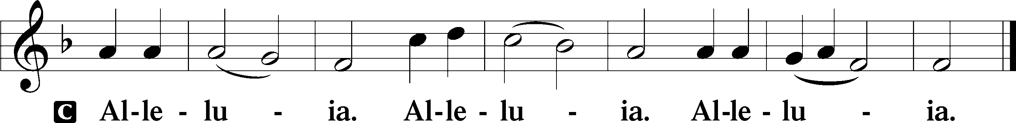

Holy Gospel Luke 17:1–10

P The Holy Gospel according to St. Luke, the seventeenth chapter.

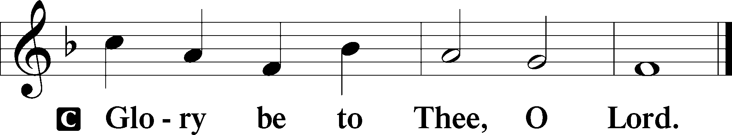

1[Jesus] said to his disciples, “Temptations to sin are sure to come, but woe to the one through whom they come! 2It would be better for him if a millstone were hung around his neck and he were cast into the sea than that he should cause one of these little ones to sin. 3Pay attention to yourselves! If your brother sins, rebuke him, and if he repents, forgive him, 4and if he sins against you seven times in the day, and turns to you seven times, saying, ‘I repent,’ you must forgive him.”

5The apostles said to the Lord, “Increase our faith!” 6And the Lord said, “If you had faith like a grain of mustard seed, you could say to this mulberry tree, ‘Be uprooted and planted in the sea,’ and it would obey you.

7“Will any one of you who has a servant plowing or keeping sheep say to him when he has come in from the field, ‘Come at once and recline at table’? 8Will he not rather say to him, ‘Prepare supper for me, and dress properly, and serve me while I eat and drink, and afterward you will eat and drink’? 9Does he thank the servant because he did what was commanded? 10So you also, when you have done all that you were commanded, say, ‘We are unworthy servants; we have only done what was our duty.’”

P This is the Gospel of the Lord.

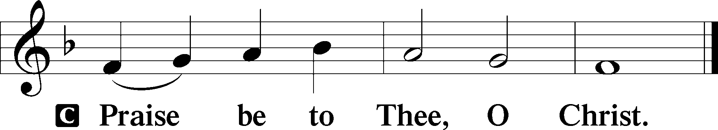

Nicene Creed

C **I believe in one God,**

**the Father Almighty,**

**maker of heaven and earth**

**and of all things visible and invisible.**

**And in one Lord Jesus Christ,**

**the only-begotten Son of God,**

**begotten of His Father before all worlds,**

**God of God, Light of Light,**

**very God of very God,**

**begotten, not made,**

**being of one substance with the Father,**

**by whom all things were made;**

**who for us men and for our salvation came down from heaven**

**and was incarnate by the Holy Spirit of the virgin Mary**

**and was made man;**

**and was crucified also for us under Pontius Pilate.**

**He suffered and was buried.**

**And the third day He rose again according to the Scriptures**

**and ascended into heaven**

**and sits at the right hand of the Father.**

**And He will come again with glory to judge both the living and the dead,**

**whose kingdom will have no end.**

**And I believe in the Holy Spirit,**

**the Lord and giver of life,**

**who proceeds from the Father and the Son,**

**who with the Father and the Son together is worshiped and glorified,**

**who spoke by the prophets.**

**And I believe in one holy Christian and apostolic Church,**

**I acknowledge one Baptism for the remission of sins,**

**and I look for the resurrection of the dead**

**and the life** T **of the world to come. Amen.**

Sit

Children's Sermon

566 By Grace I’m Saved

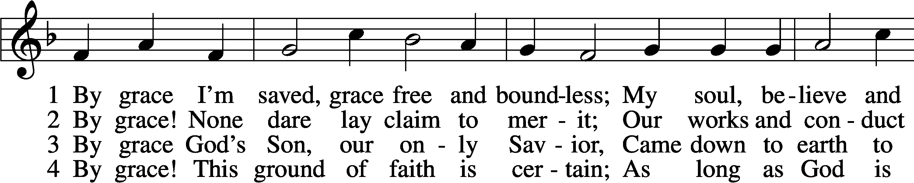

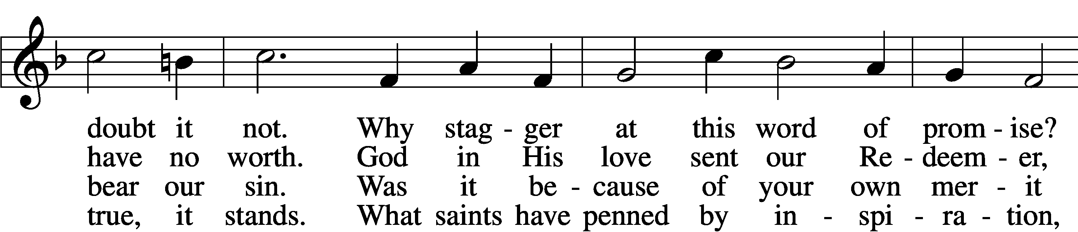

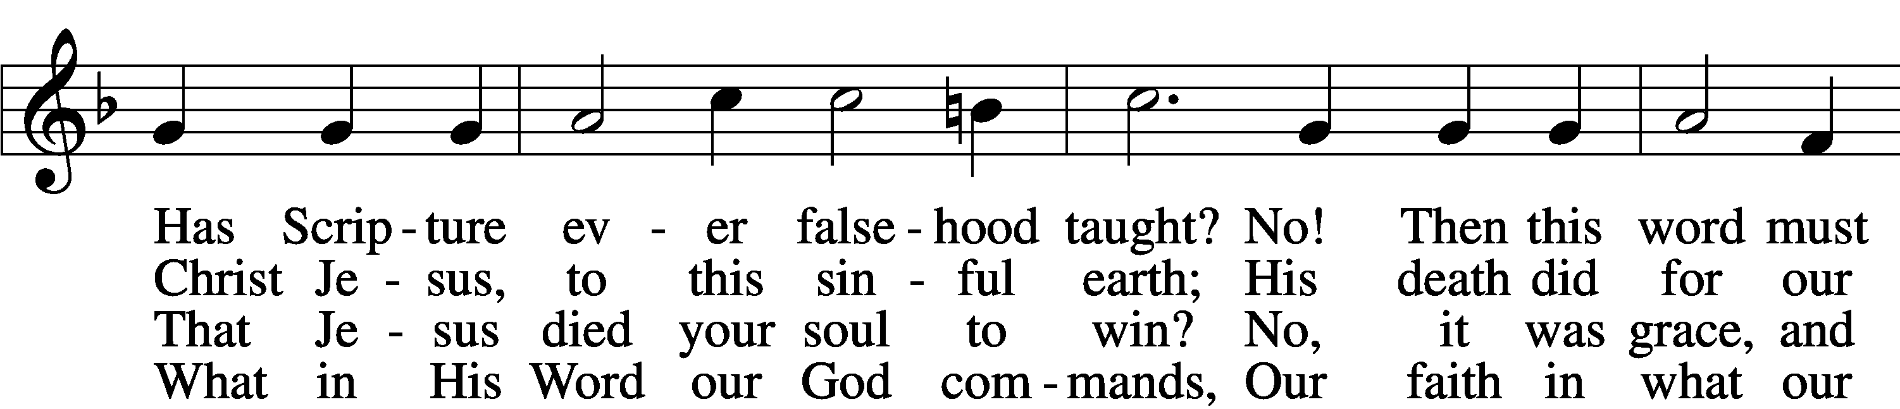

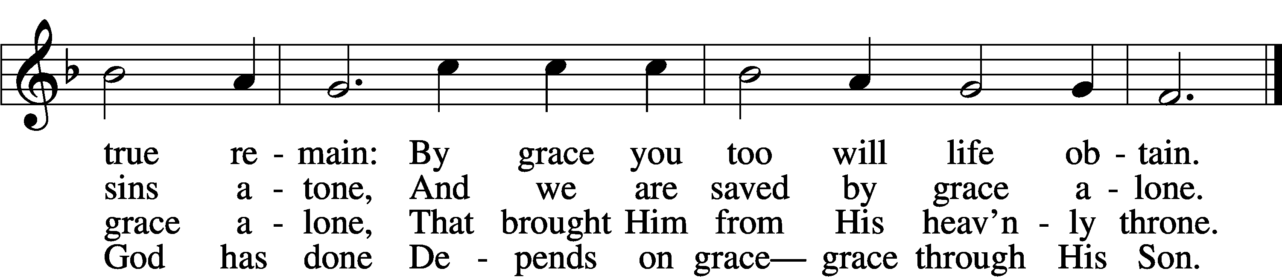

5 By grace to timid hearts that tremble,  
 In tribulation’s furnace tried,  
By grace, in spite of fear and trouble,  
 The Father’s heart is open wide.  
Where could I help and strength secure  
If grace were not my anchor sure?

6 By grace! On this I’ll rest when dying;  
 In Jesus’ promise I rejoice;  
For though I know my heart’s condition,  
 I also know my Savior’s voice.  
My heart is glad, all grief has flown  
Since I am saved by grace alone.

Text: Christian Ludwig Scheidt, 1709–61; tr. The Lutheran Hymnal, 1941, alt.  
Tune: Cornelius Heinrich Dretzel, 1697–1775  
Text and tune: Public domain

Sermon

Votum

P The peace of God, which passes all understanding, keep your hearts and minds in Christ Jesus.

C **Amen.**

Stand

Offertory Psalm 51:10–12

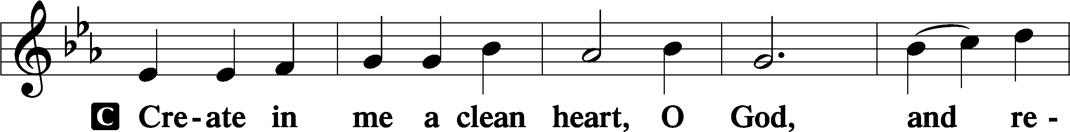

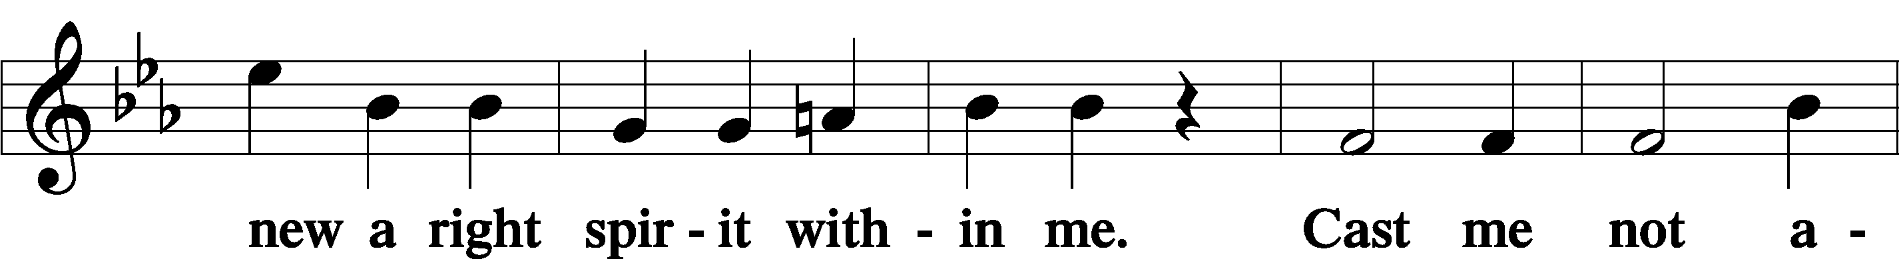

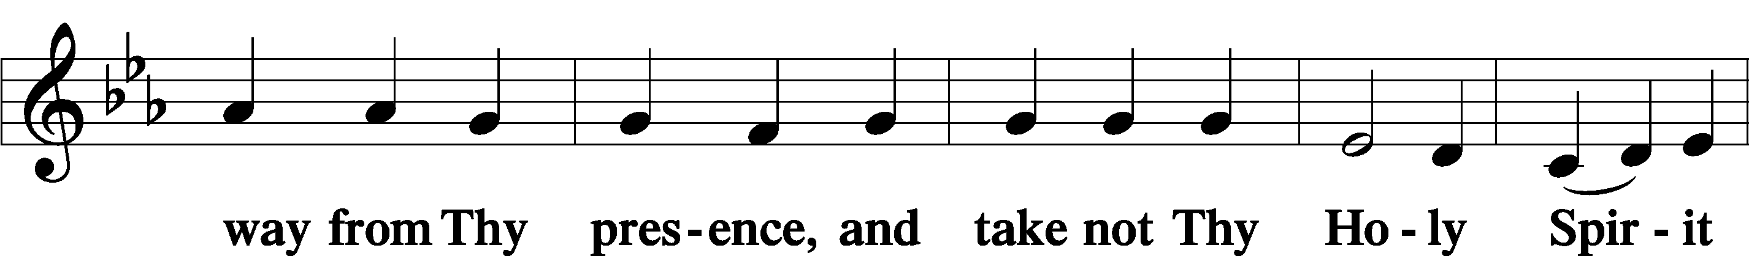

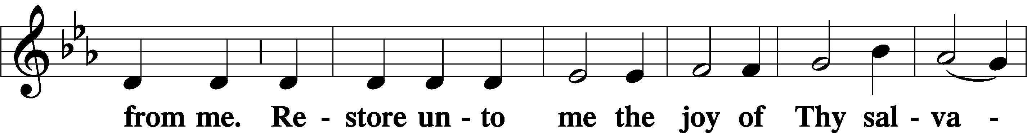

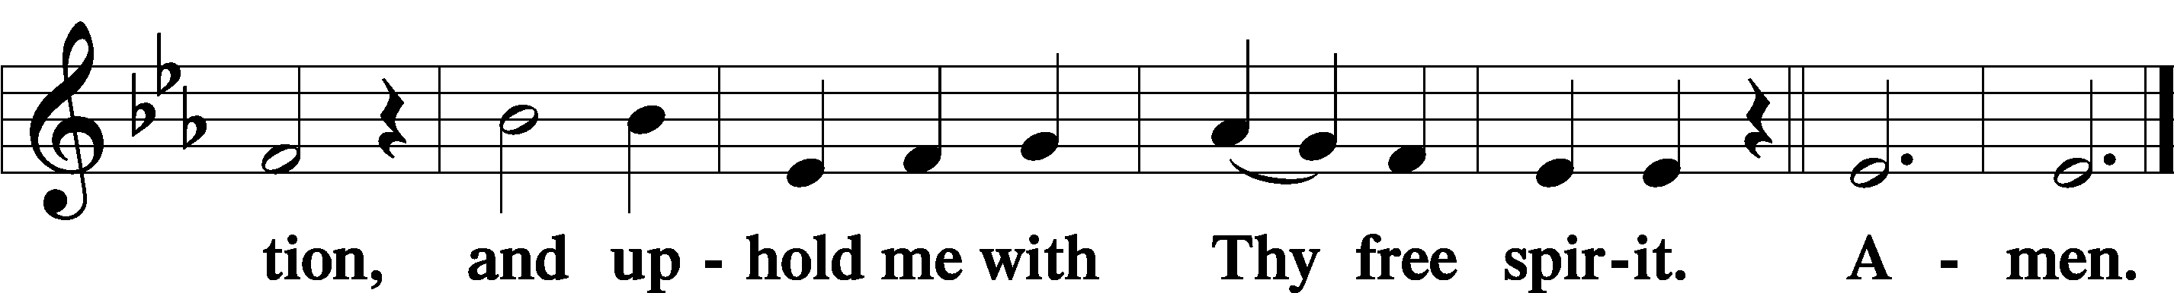

Sit

Offering

Hymn

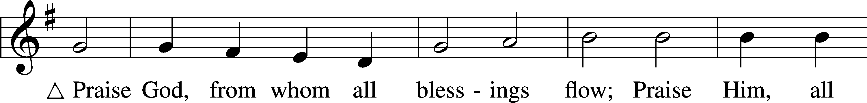

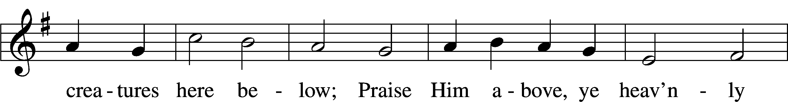

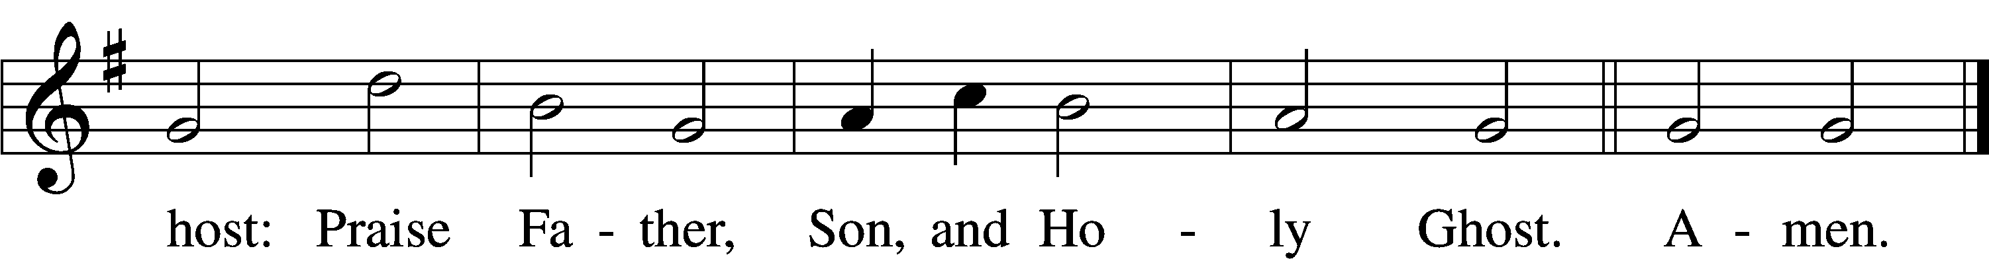

Text: Thomas Ken, 1637–1711  
Tune: Trente quatre Pseaumes de David, 1551, Geneva, ed. Louis Bourgeois  
Text and tune: Public domain

Stand

Prayer of the Church

# Service of the Sacrament

Preface 2 Timothy 4:22; [Colossians 3:1]; [Psalm 136]

P The Lord be with you.

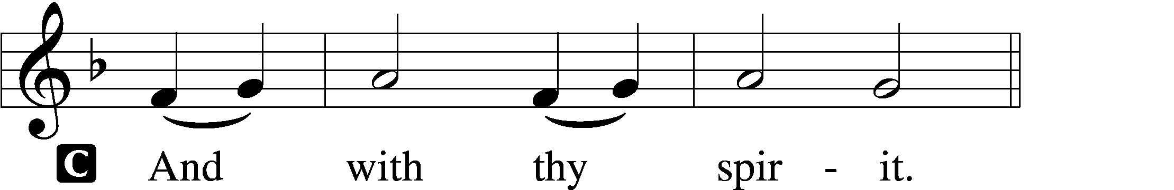

P Lift up your hearts.

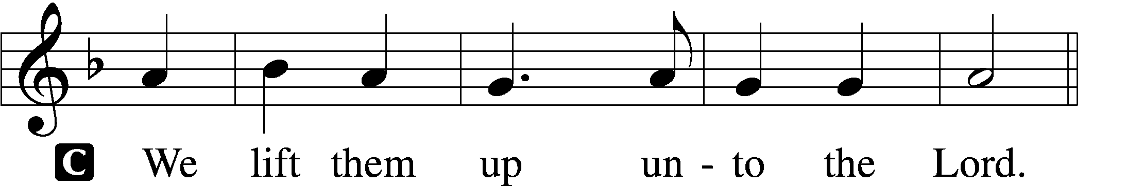

P Let us give thanks unto the Lord, our God.

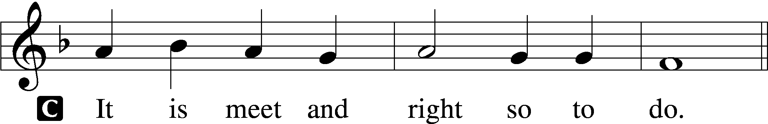

Proper Preface (Full)

P It is truly meet, right, and salutary that we should at all times and in all places give thanks to You, holy Lord, almighty Father, everlasting God, through Jesus Christ, our Lord, who, out of love for His fallen creation, humbled Himself by taking on the form of a servant, becoming obedient unto death, even death upon a cross. Risen from the dead, He has freed us from eternal death and given us life everlasting. Therefore with angels and archangels and with all the company of heaven we laud and magnify Your glorious name, evermore praising You and saying:

Sanctus Isaiah 6:3; Matthew 21:9

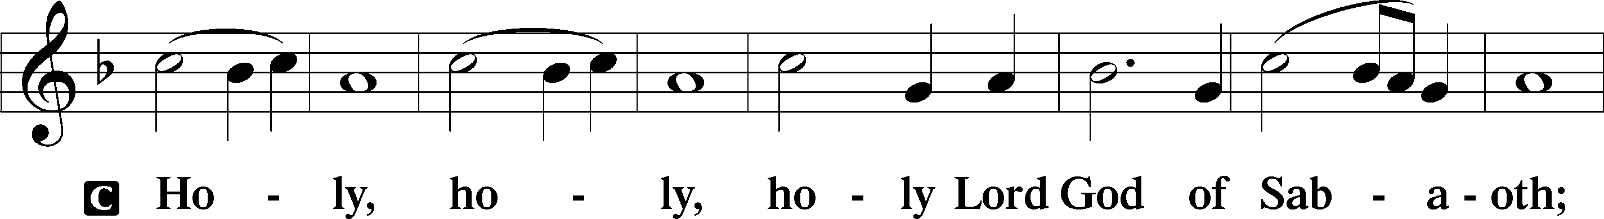

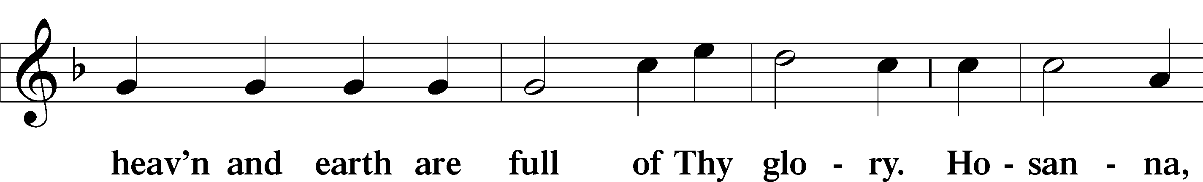

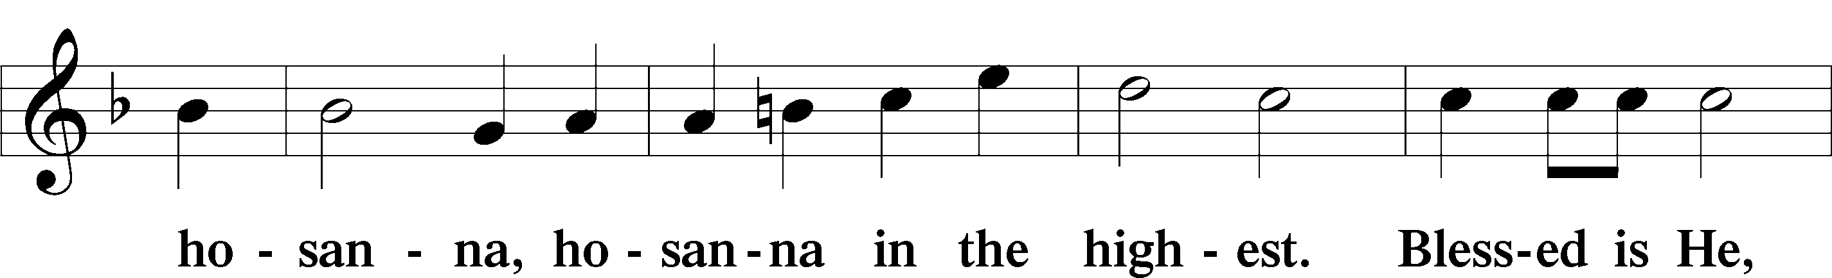

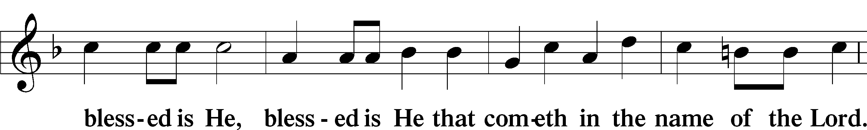

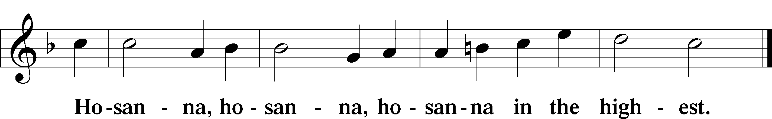

Lord’s Prayer Matthew 6:9–13

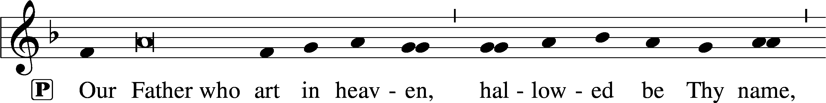

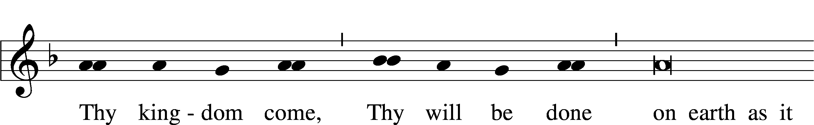

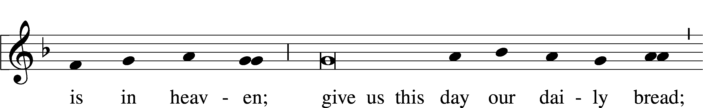

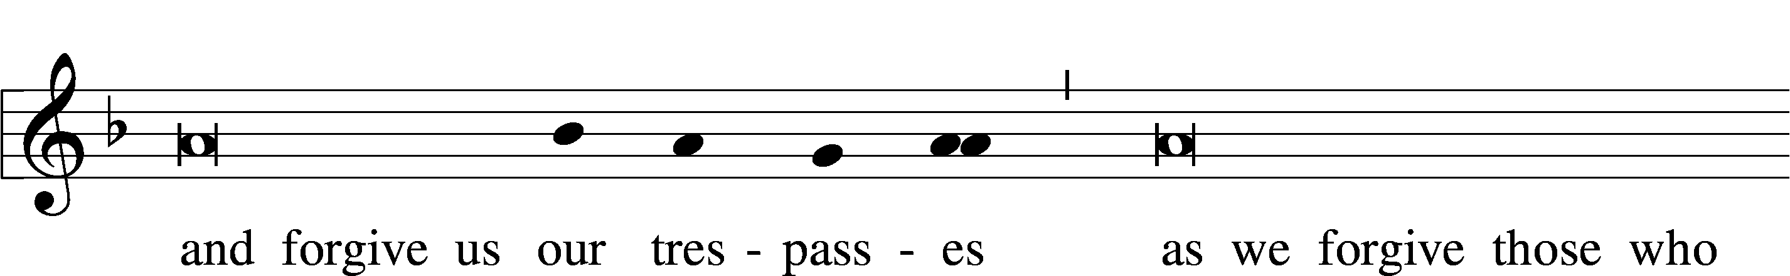

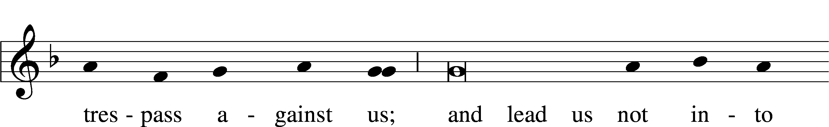

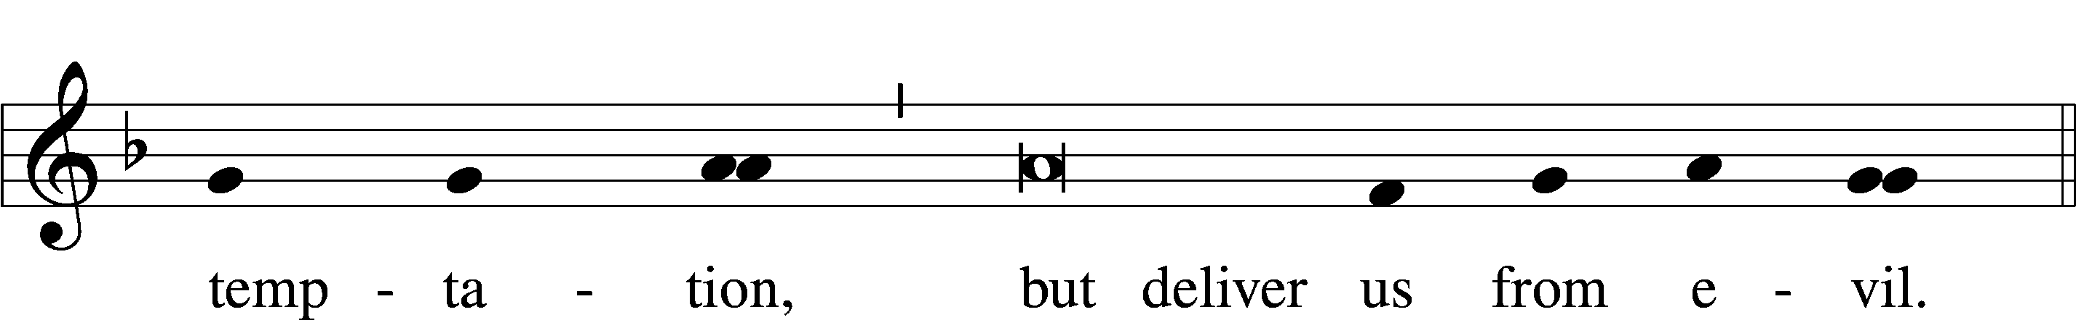

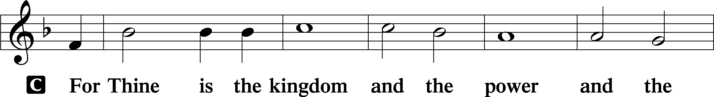

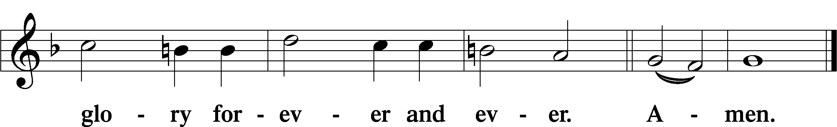

The Words of Our Lord Matthew 26:26–28; Mark 14:22–24; Luke 22:19–20; 1 Corinthians 11:23–25

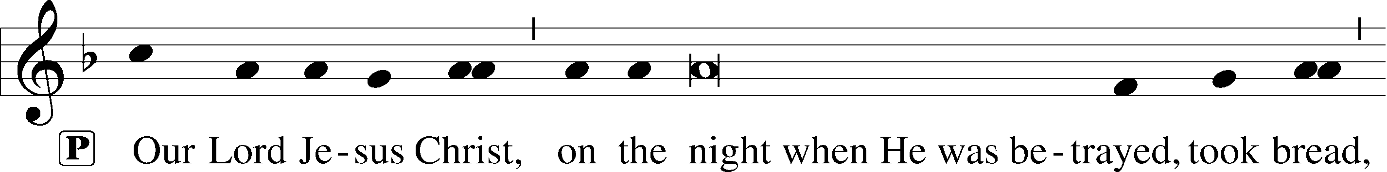

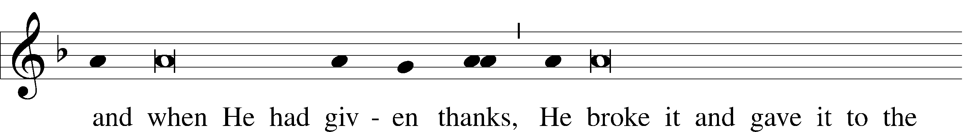

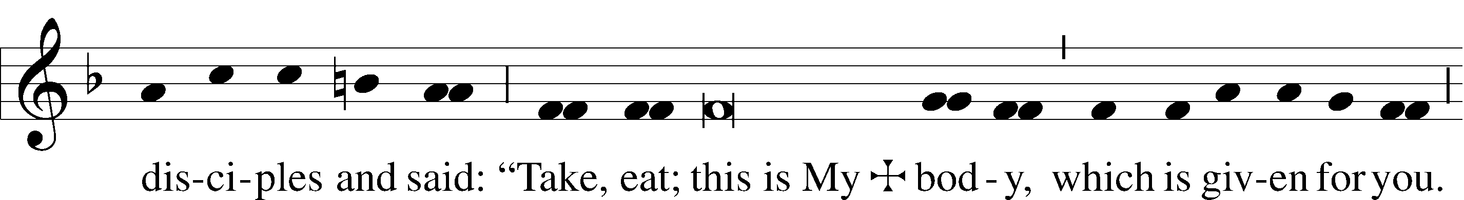

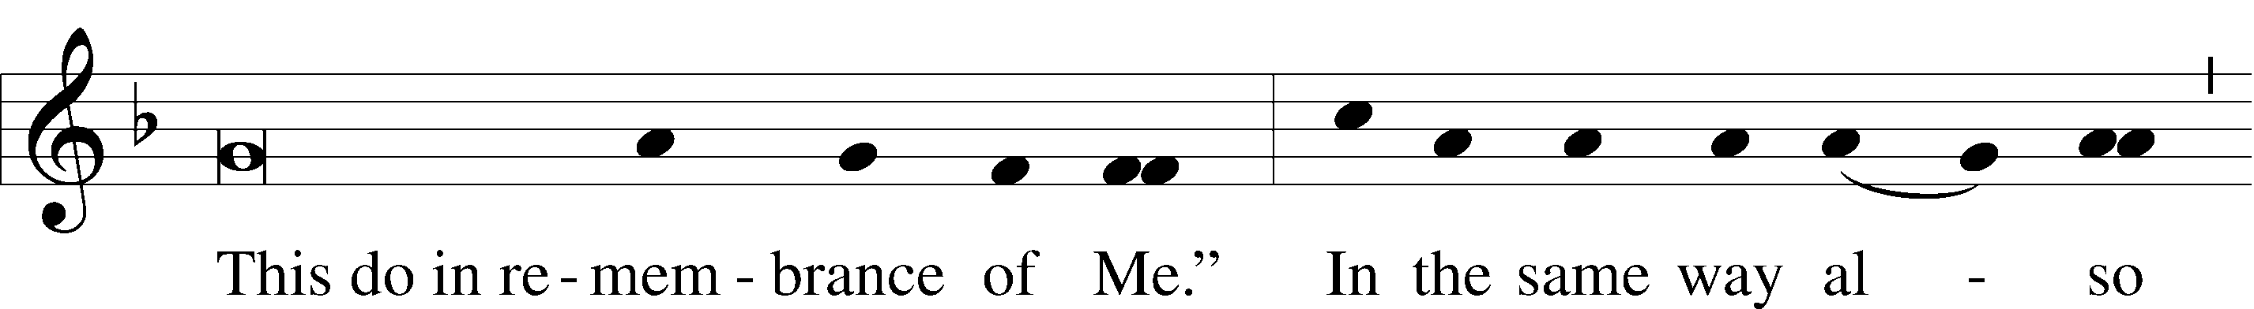

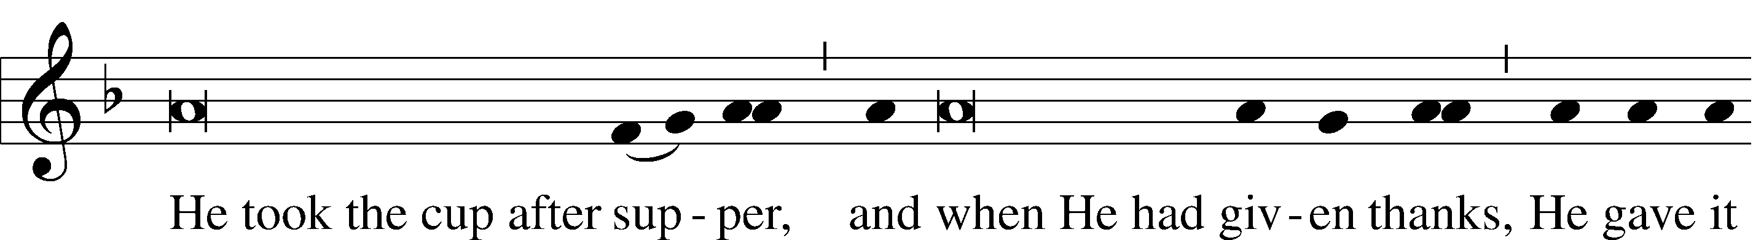

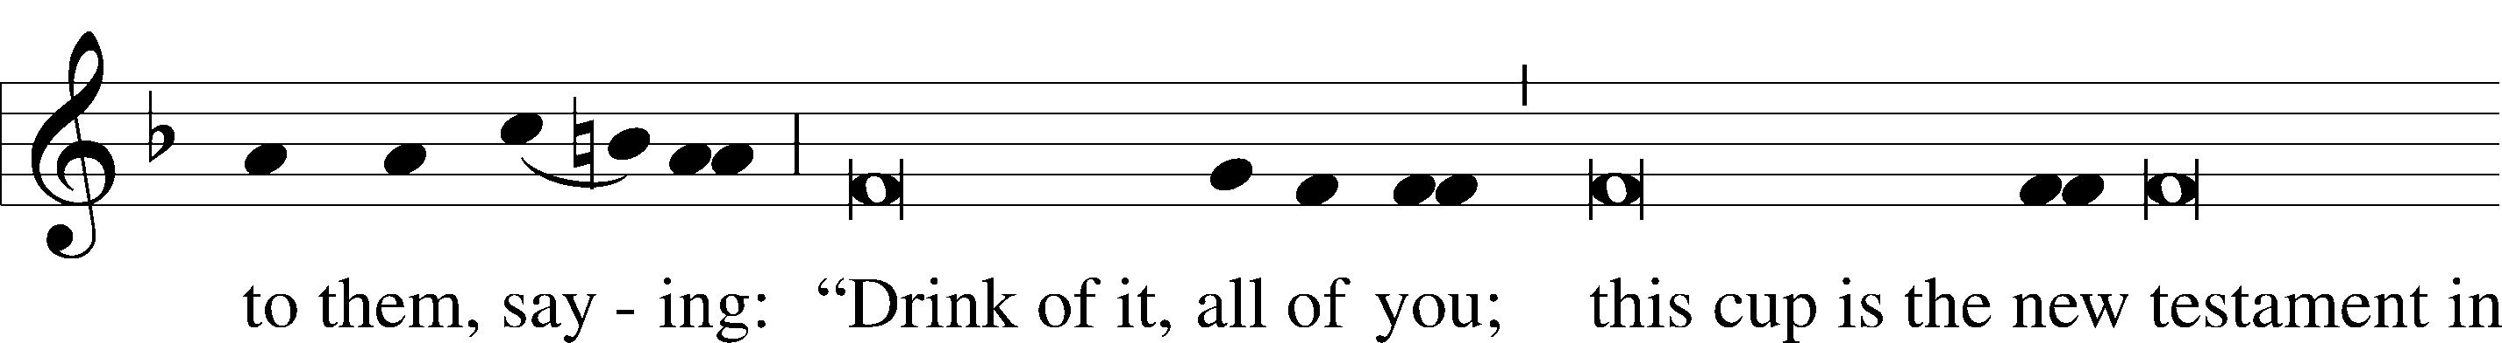

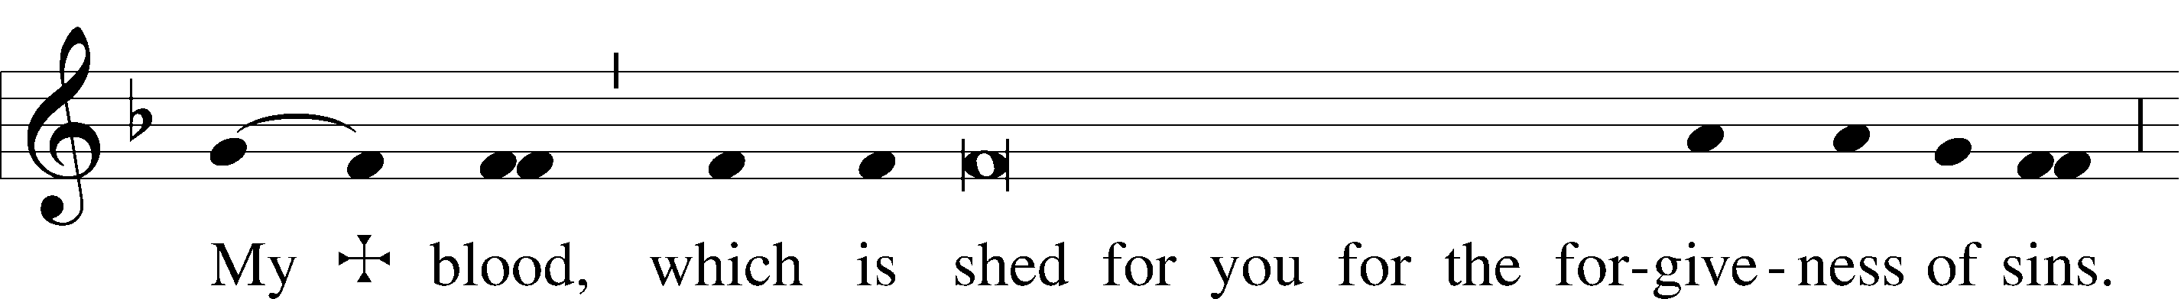

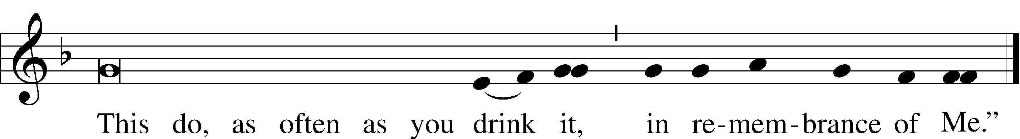

Pax Domini John 20:19

P The peace of the Lord be with you always.

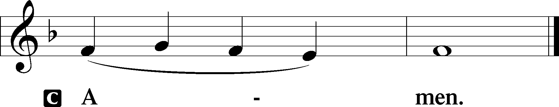

Agnus Dei John 1:29

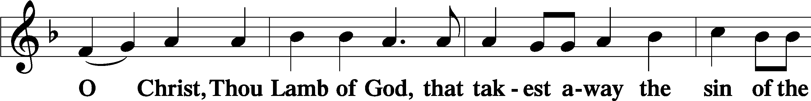

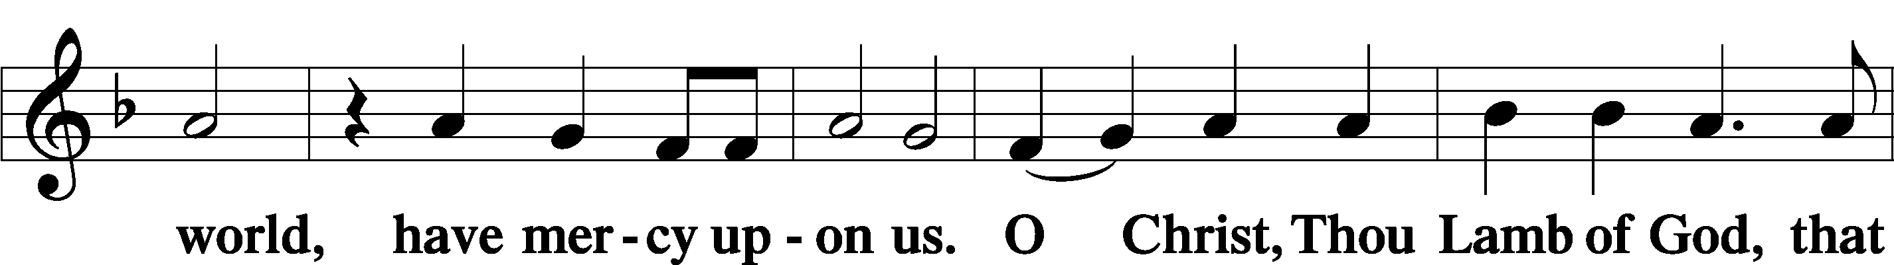

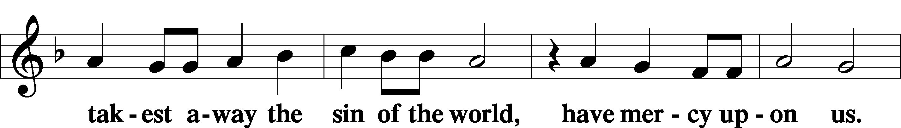

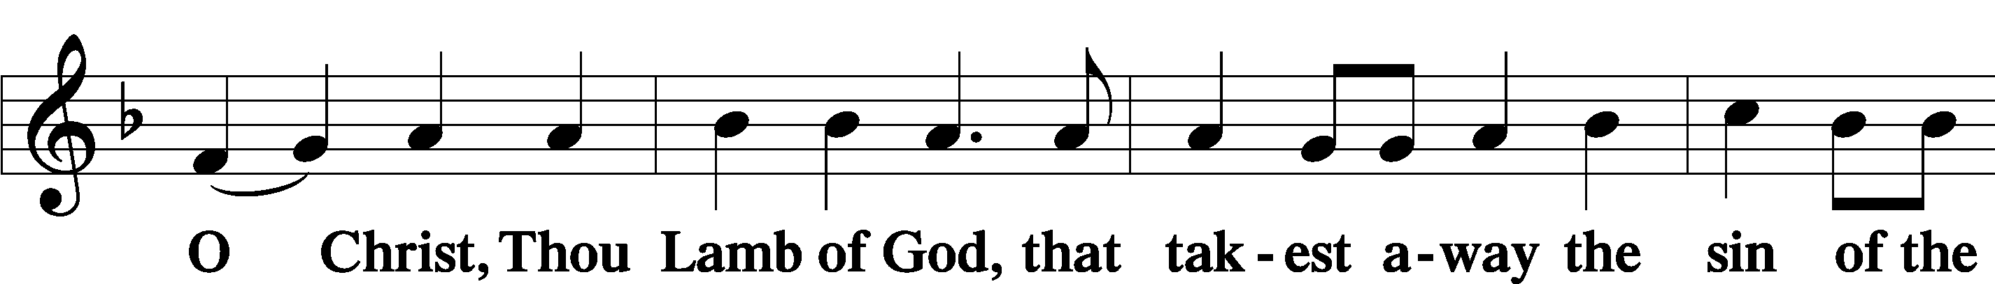

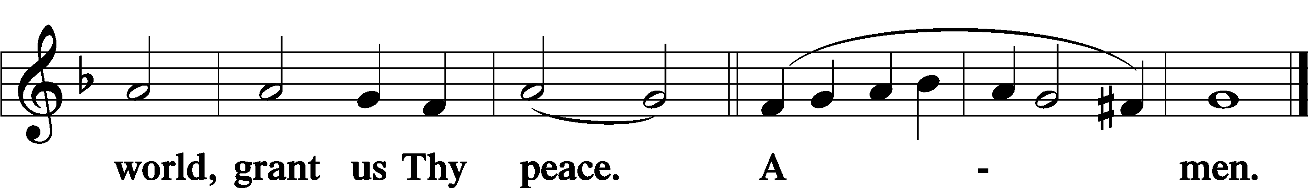

Sit

Distribution

The pastor and those who assist him receive the body and blood of Christ first and then distribute them to those who come to receive, saying:

Take, eat; this is the true body of our Lord and Savior Jesus Christ, given into death for your sins.

**Amen.**

Take, drink; this is the true blood of our Lord and Savior Jesus Christ, shed for the forgiveness of your sins.

**Amen.**

In dismissing the communicants, the following is said:

The Dismissal

P The body and blood of our Lord Jesus Christ strengthen and preserve you in body and soul to life everlasting. Depart T in peace.

C **Amen.**

565 Thy Works, Not Mine, O Christ

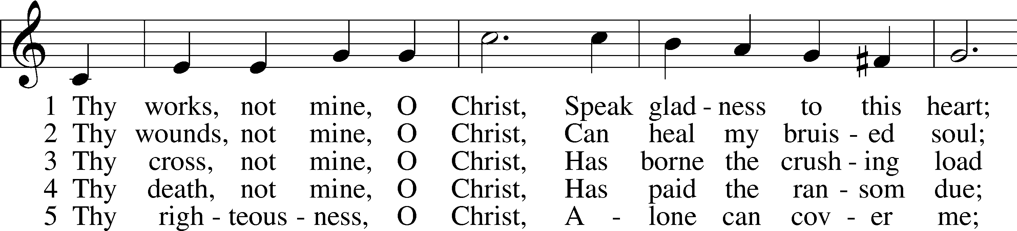

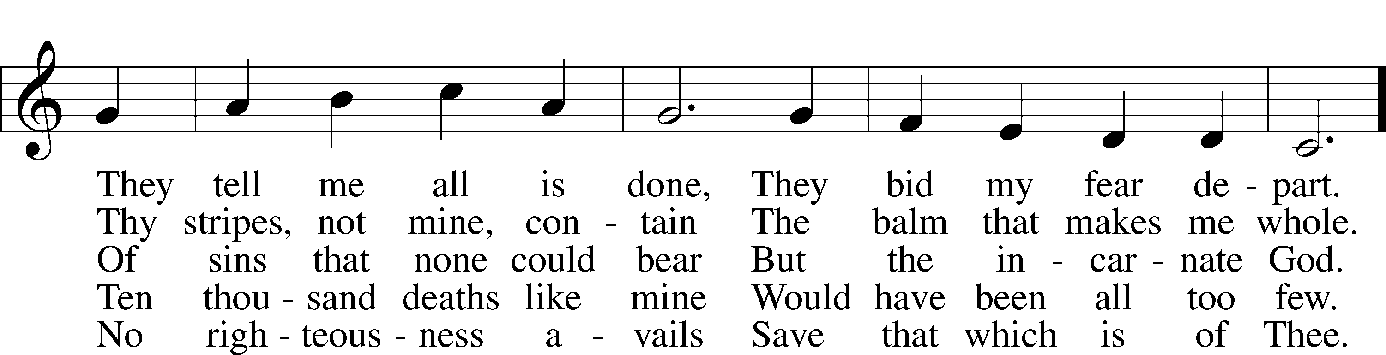

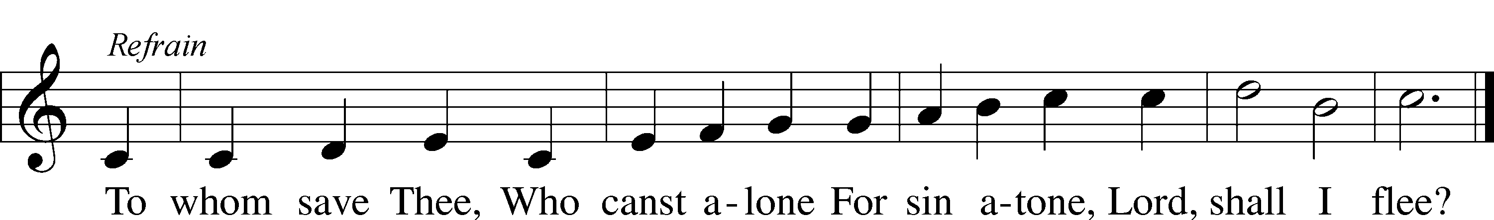

Text: Horatius Bonar, 1808–89, alt.  
Tune: The Parish Choir, 1850, London  
Text and tune: Public domain

693 O Holy Spirit, Grant Us Grace

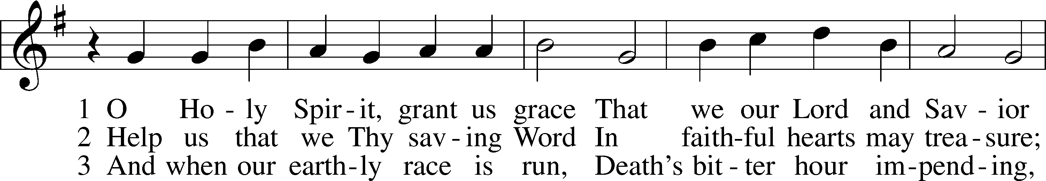

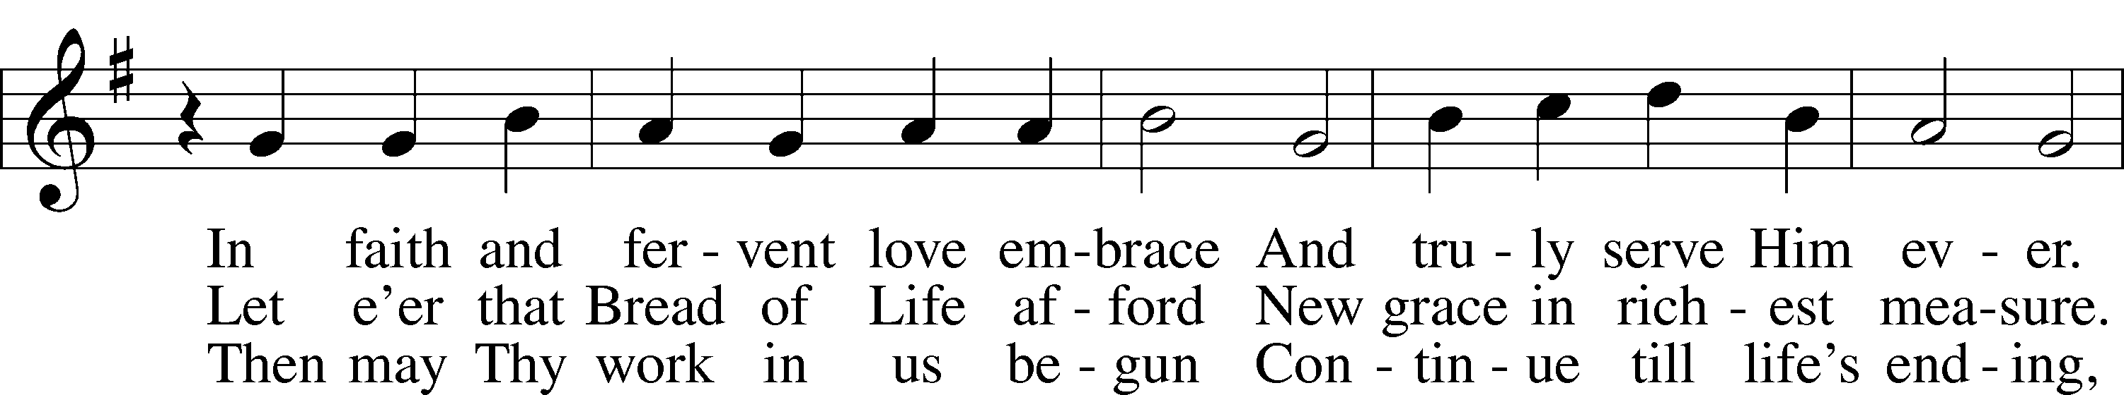

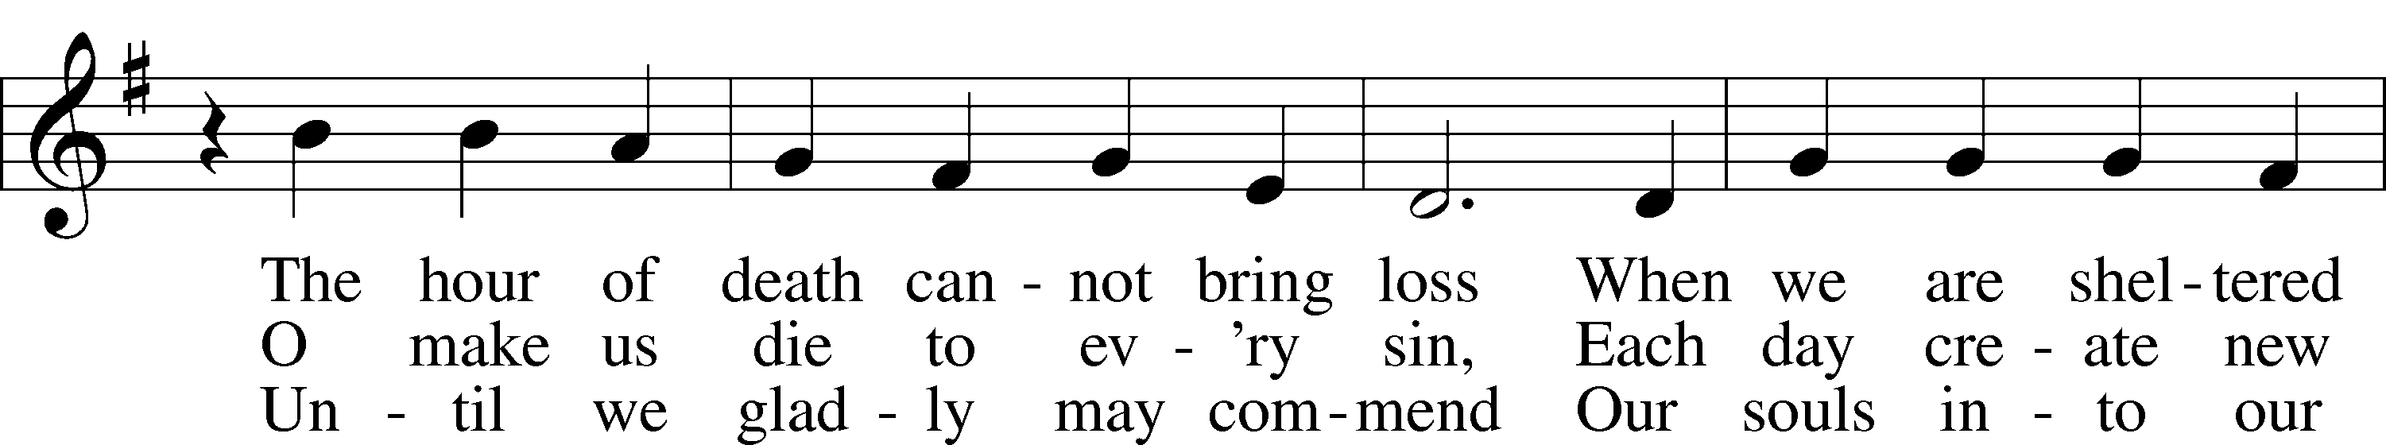

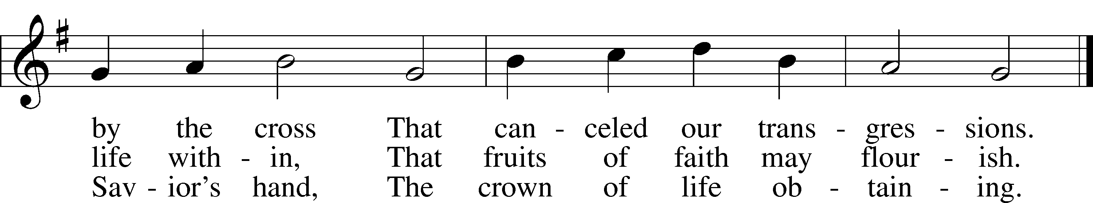

Text: Bartholomäus Ringwaldt, 1532–99; tr. Oluf H. Smeby, 1851–1929, alt.  
Tune: Geistliche Lieder auffs new gebessert, 1535, Wittenberg, ed. Joseph Klug  
Text and tune: Public domain

392 God Loves Me Dearly

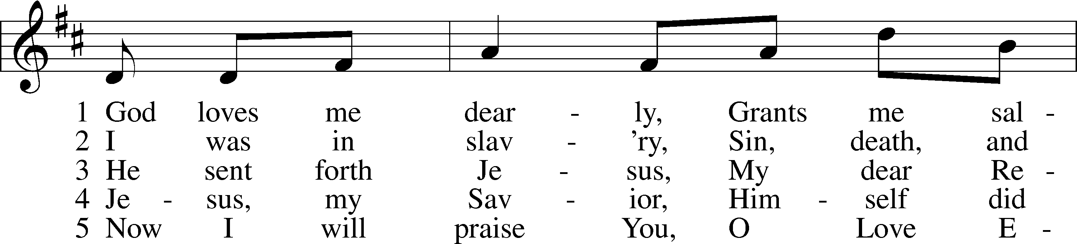

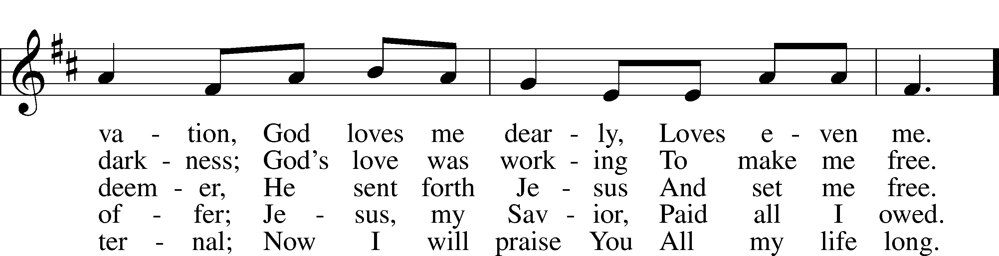

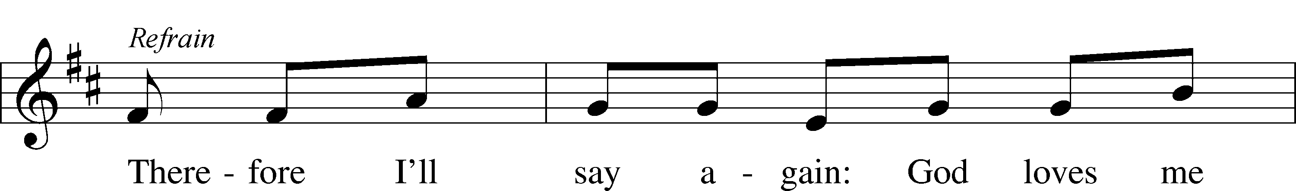

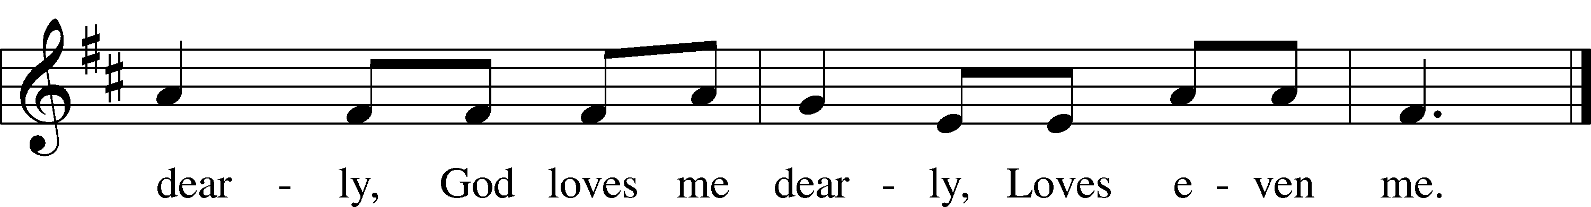

Text: August Rische, 1819–1906; tr. composite  
Tune: German  
Text and tune: Public domain

645 Built on the Rock

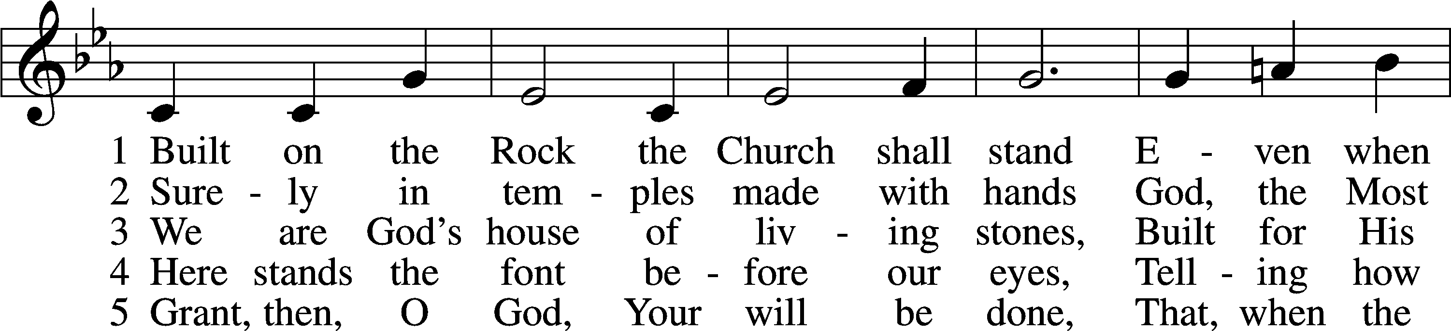

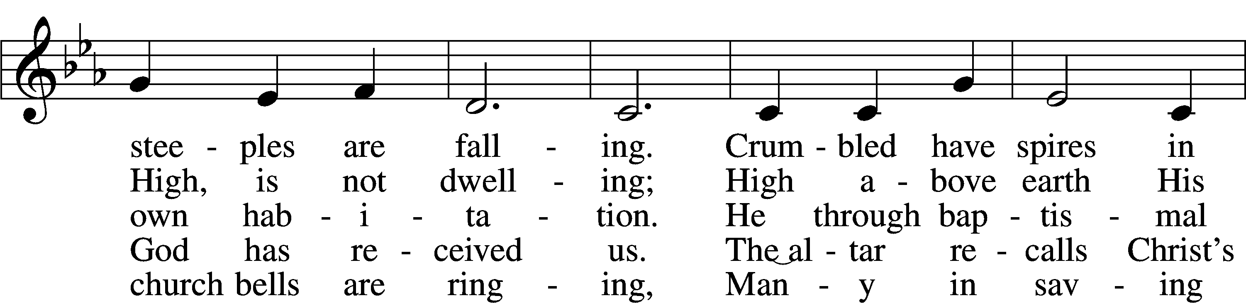

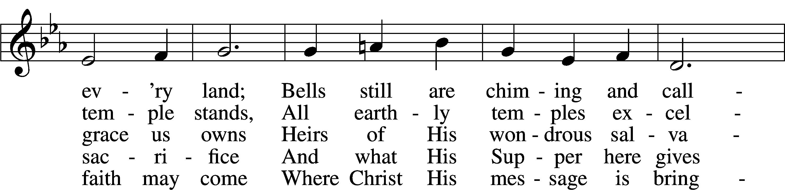

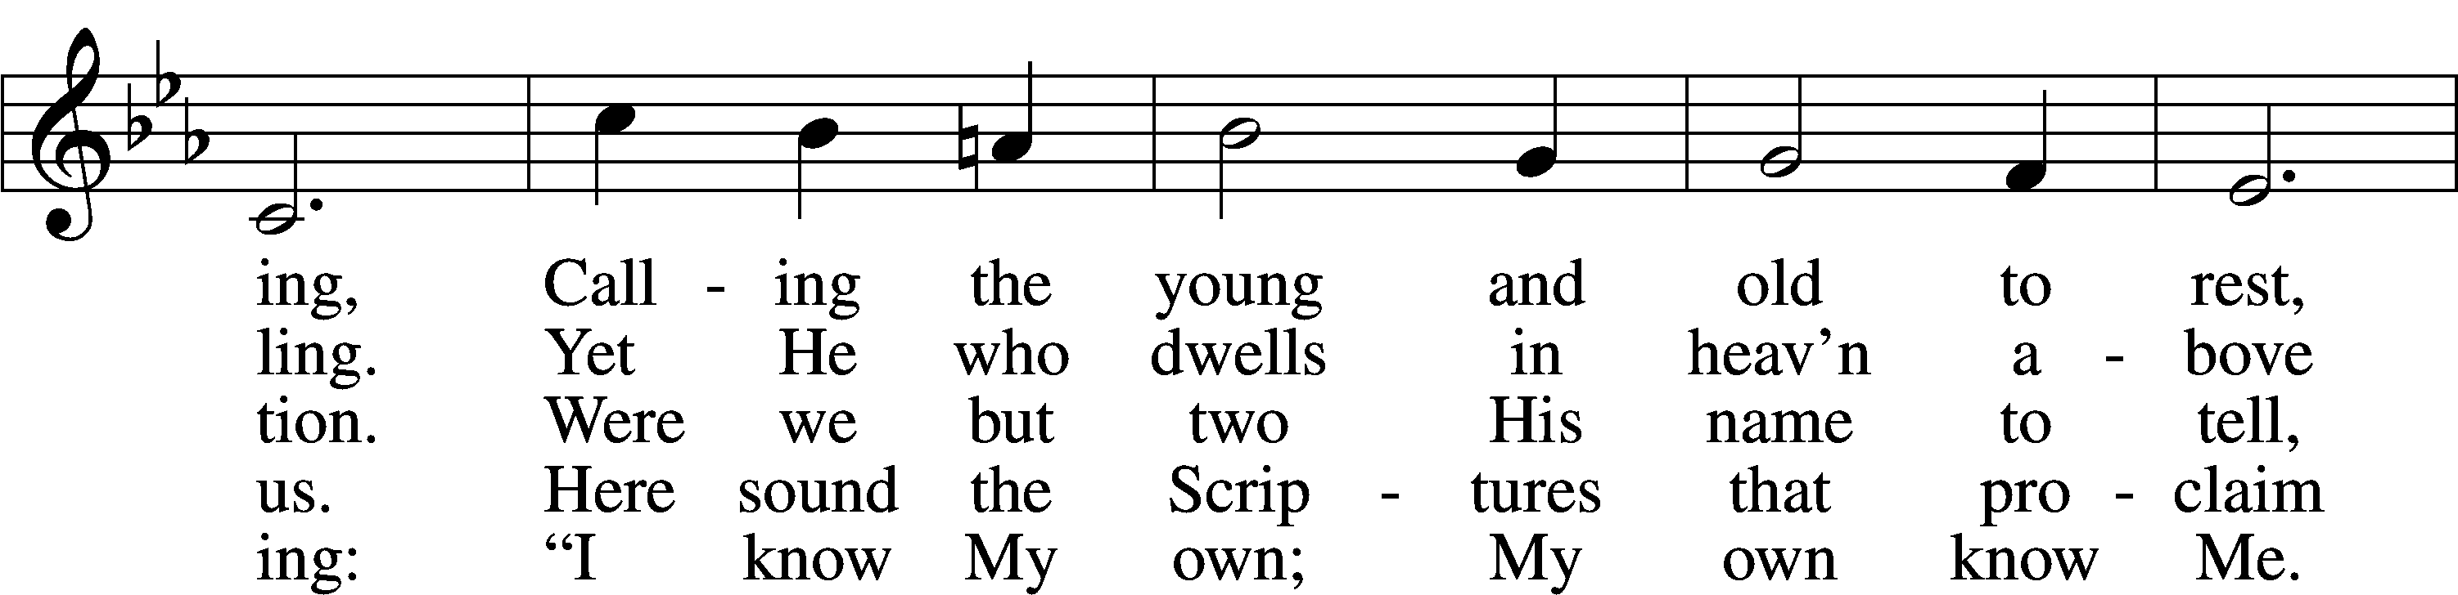

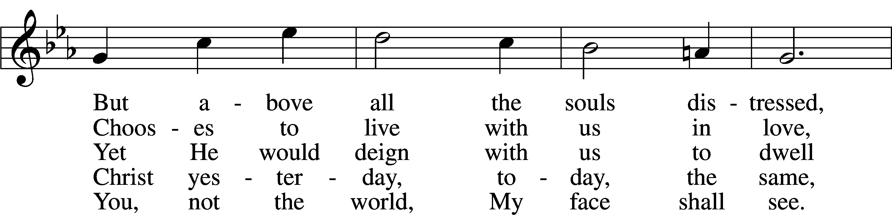

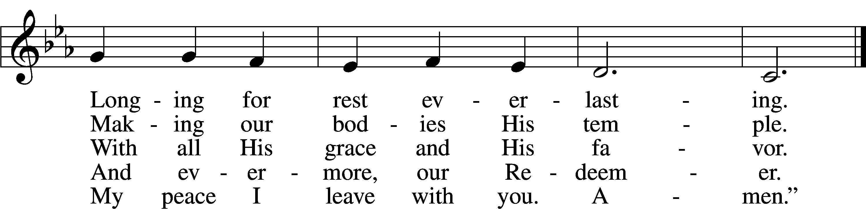

Text: Nikolai Fredrik Severin Grundtvig, 1783–1872, abr.; tr. Carl Döving, 1867–1937, alt.  
Tune: Ludvig M. Lindeman, 1812–87  
Text and tune: Public domain

Stand

Nunc Dimittis Luke 2:29–32

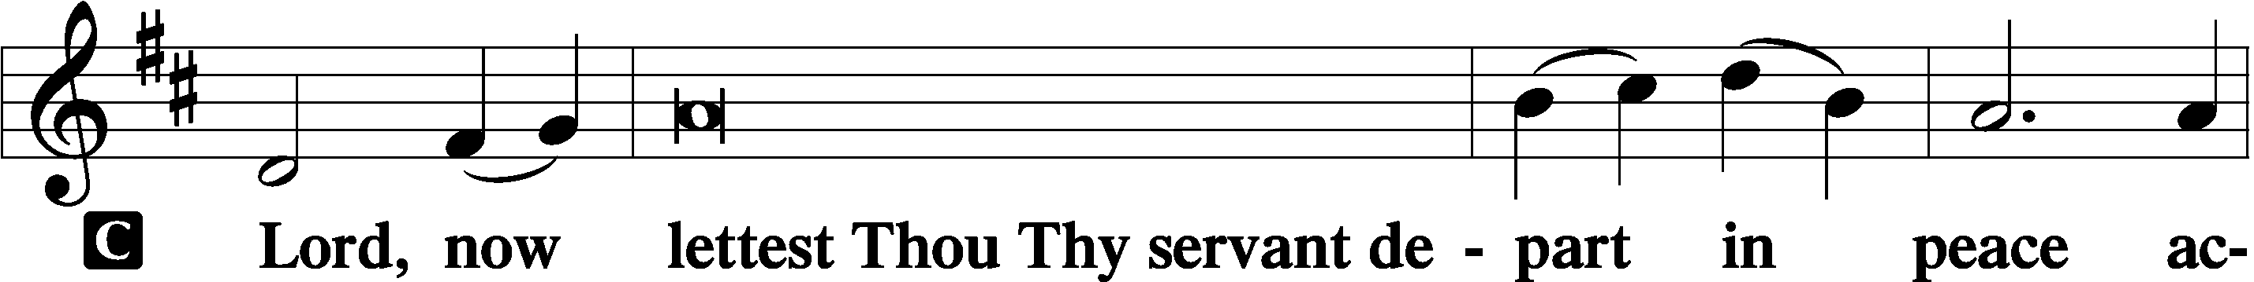

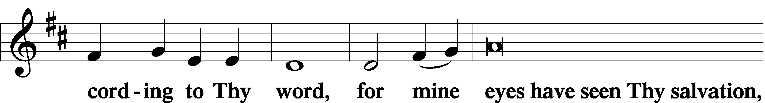

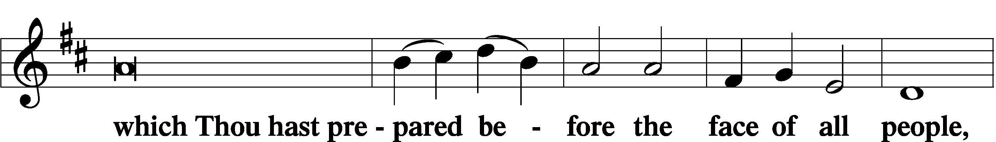

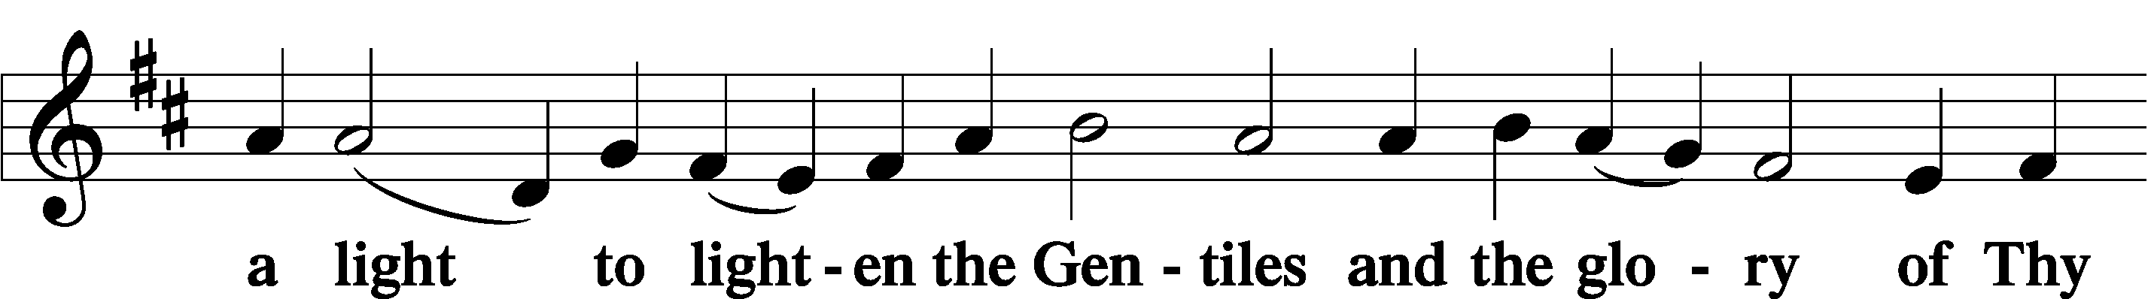

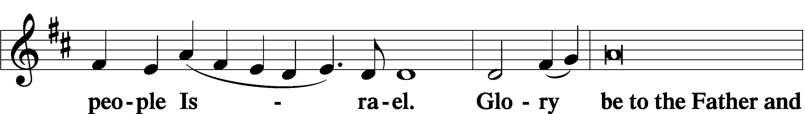

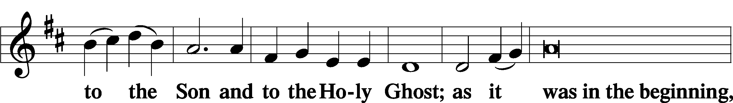

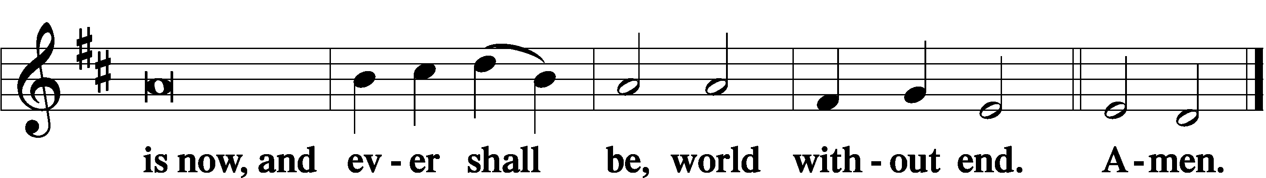

Thanksgiving Psalm 107:1

A O give thanks unto the Lord, for He is good,

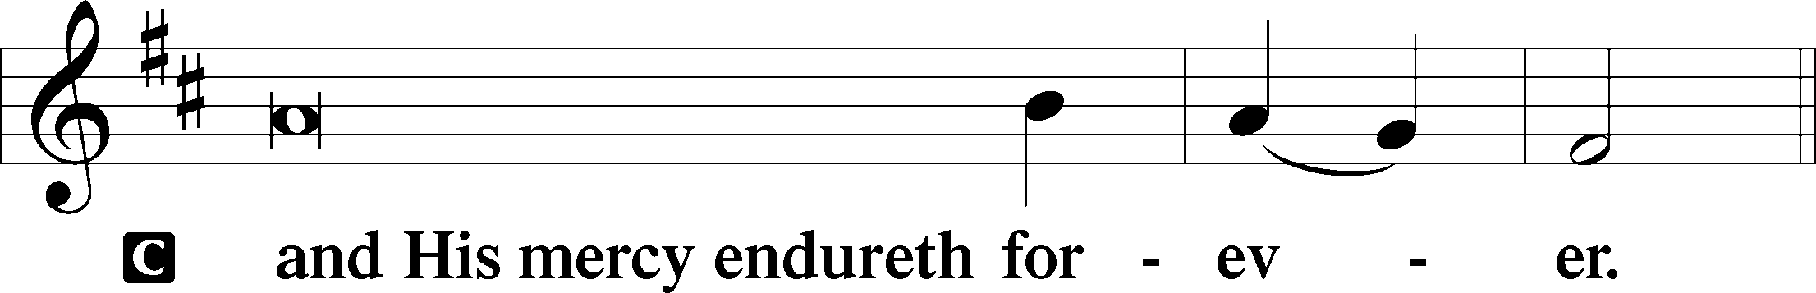

Post-Communion Collect

A Let us pray.

We give thanks to You, almighty God, that You have refreshed us through this salutary gift, and we implore You that of Your mercy You would strengthen us through the same in faith toward You and in fervent love toward one another; through Jesus Christ, Your Son, our Lord, who lives and reigns with You and the Holy Spirit, one God, now and forever.

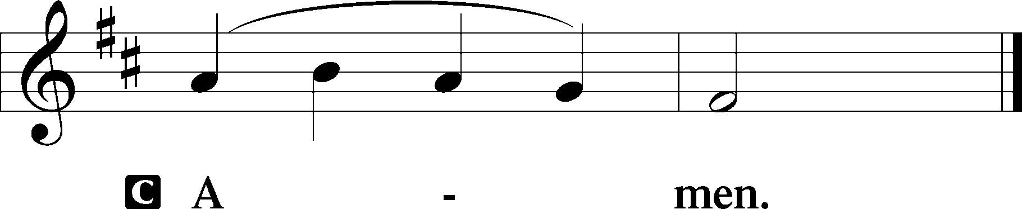

Salutation 2 Timothy 4:22

P The Lord be with you.

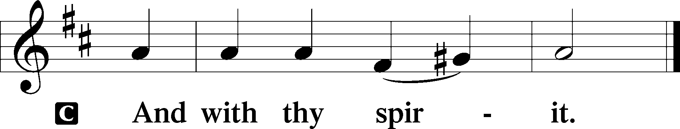

Benedicamus Psalm 103:1

A Bless we the Lord.

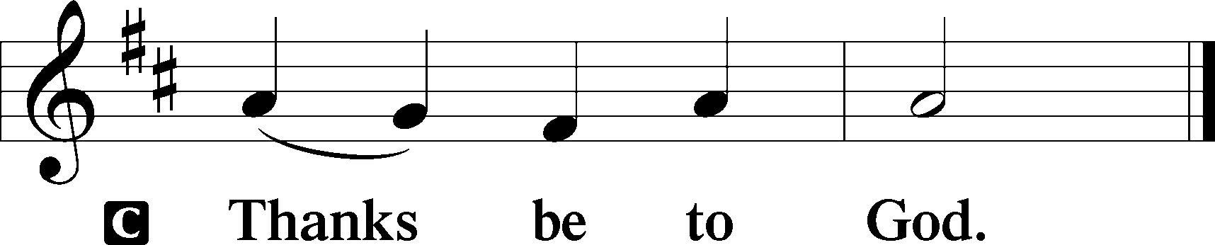

Benediction Numbers 6:24–26

P The Lord bless you and keep you.

The Lord make His face shine upon you and be gracious unto you.

The Lord lift up His countenance upon you and T give you peace.

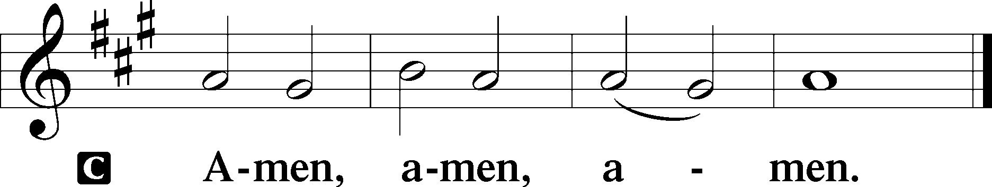

655 Lord, Keep Us Steadfast in Your Word

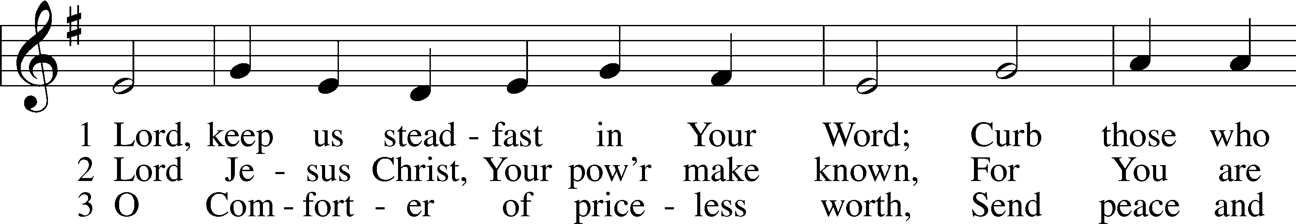

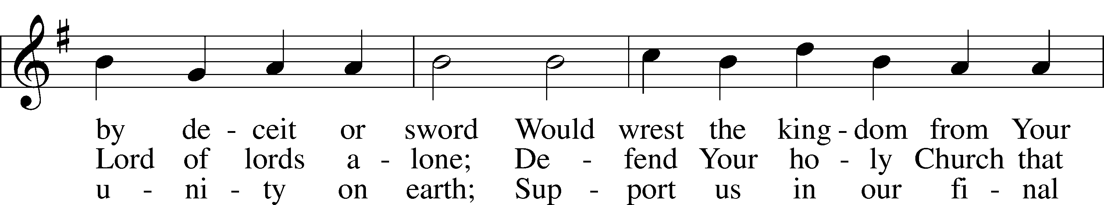

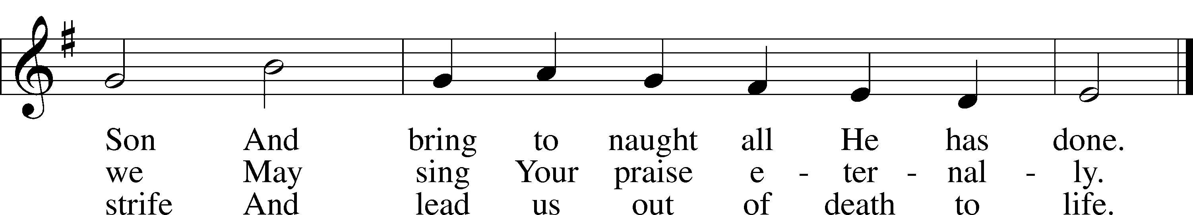

Text: Martin Luther, 1483–1546; tr. Catherine Winkworth, 1827–78, alt.  
Tune: Geistliche Lieder auffs new gebessert, 1543, Wittenberg, ed. Joseph Klug  
Text and tune: Public domain

Acknowledgments

Divine Service, Setting Three from Lutheran Service Book

Unless otherwise indicated, Scripture quotations are from the ESV® Bible (The Holy Bible, English Standard Version®), copyright © 2001 by Crossway, a publishing ministry of Good News Publishers. Used by permission. All rights reserved.

Created by Lutheran Service Builder © 2025 Concordia Publishing House.