

**October 2024**

**The Times are Getting Exciting**

School started, homecoming has come and gone for the Jackrabbits and we are entering autumn. Growing up, we had vast areas of trees which had leaves that changed colors to reds, yellows, oranges, browns, and the evergreen trees in between. It was beautiful to the beholder.

I am writing this before the Tasting Bee takes place, and I am anticipating that this will be another successful Tasting Bee. Along with that, the Adult Fellowship Group will be going to the military museum in St. Jo this Saturday.

In the following weeks, the Adult Fellowship Group will be attending the Muenster Okotberfest and also enjoying a cookout at the airport. Other activities include the Fall Festival and Trunk or Treat.

As we always do, the last Sunday of October we celebrate Reformation Sunday. We are reminded of the efforts Martin Luther made to reform the Roman Catholic church, only to be tossed out.

Luther’s famous quote: *“Unless I am convinced by the testimony of the Scriptures and by clear reason (for I do not trust in the pope or councils alone, since it is well known that they have often erred and contradicted themselves), I am bound by the Scriptures I have quoted. My conscience is captive to the Word of God. I cannot and I will not retract anything, since it is neither safe nor right to go against conscience. May God help me. Amen.”*

* Pastor De Young

“*Hier stehe ich. Ich kann nicht anders. Gott helfe mir. Amen.”*

**From the Pastor:**

**In our divine service, there are many parts of the liturgy (order of service) that should be explained. Over the next series of newsletters, we will be including an explanation of what is happening during each of these parts of the service (these explanations are found on the LCMS website).**

**About Lutheran Worship 🡪 Parts of the Liturgy**

**Distribution**

Try for a moment to picture the heavenly throng standing before the throne of God on the Last Day. The numbers will be staggering.

And yet, united as we all are to Christ, the Bridegroom, we will be one — his elect Bride. As the faithful make their way to the altar to feast on the Bread of Life in the distribution, they are given a glimpse of that holy Bride.

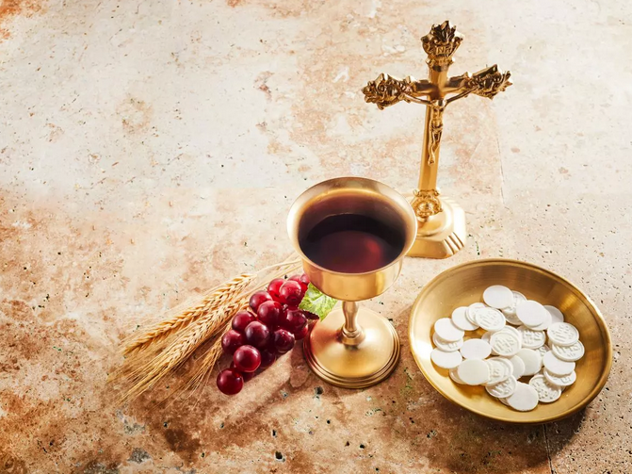Oh yes, we see all of her warts and blemishes: the petty bickering over trivial matters, the deep disagreements on more weighty issues, and the painful ways in which we sometimes treat one another.

Yet, by our common confession of the truth, we are one in Christ. As Christ gives himself to us in this holy meal, he strengthens that unity and bids us love one another with a deep and abiding love. How can it be any other way, as we are sent from the table with the blessing to depart in peace?



Celebrate October’s Baptism Birthdays

& their years as heirs of God’s kingdom!

|  |  |  |
| --- | --- | --- |
| **Date** | **Name** | **Years** |
| 1st | Mike Jones | 64 |
|  | Rebecca Pickett | 34 |
| 10th | Billy Lee | 50 |
| 18th | Aiden Henry | 15 |
| 28th | Logan McCarty | 34 |
| 29th | John Belcher | 52 |
|  | Jo Osbon | 1 |
|  | Annellee Osbon | 1 |
| 31st | Kenneth Geis | 59 |
|  | Jana Gilmore | 42 |
|  | Craig Roth | 31 |
|  |  |  |
|  |  |  |
|  |  |  |
|  |  |  |
|  |  |  |
|  |  |  |

**Serving in God’s House this month**

|  |  |
| --- | --- |
| **Elder of the Month** | Arn Anderson |
| **Counters** | Lee Hughes / David Geis |
| **Altar Guild** | Lisa Lawson / Jeannine Yowell |
| **Altar Care** | Molly Atkinson / Amanda Gilmore / Karen George |

|  |  |  |
| --- | --- | --- |
| **Week** | **Acolytes** | **Reader** |
| October 06 | Max Gilmore & Davin George | Lee Hughes |
| October 13 | Parker Lawson & Rayleigh Pace | Arn Anderson |
| October 20 | Karlee Hughes & Charlie Pace | Bryan Roth |
| October 27 | Emily Keyes & Annellee Osbon | William Pickett |

**Grace George struck a pose**

**in the Watermelon Pagent**



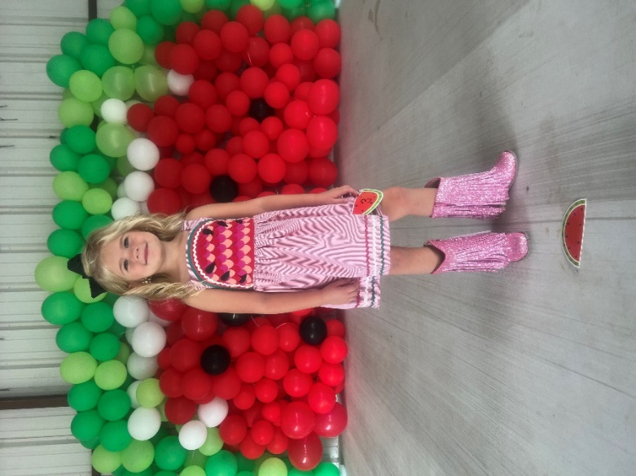

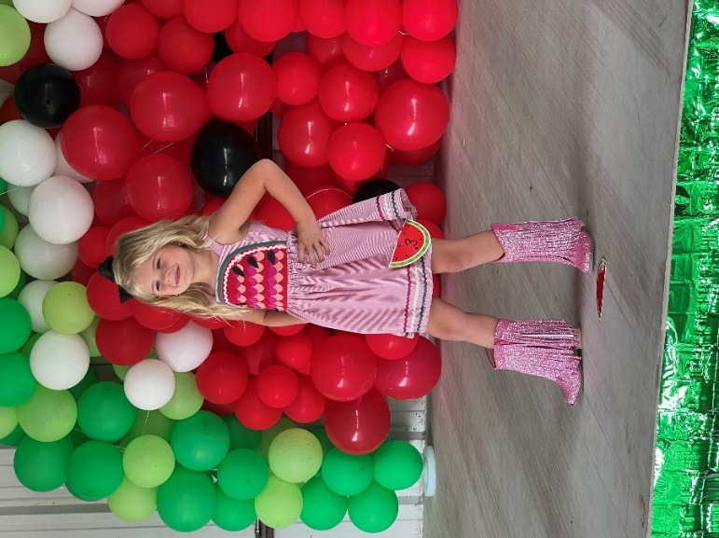

**Isabella Caswell of BHS makes**

**1st Place in JV Cross Country**



LWML Annual Tasting Bee

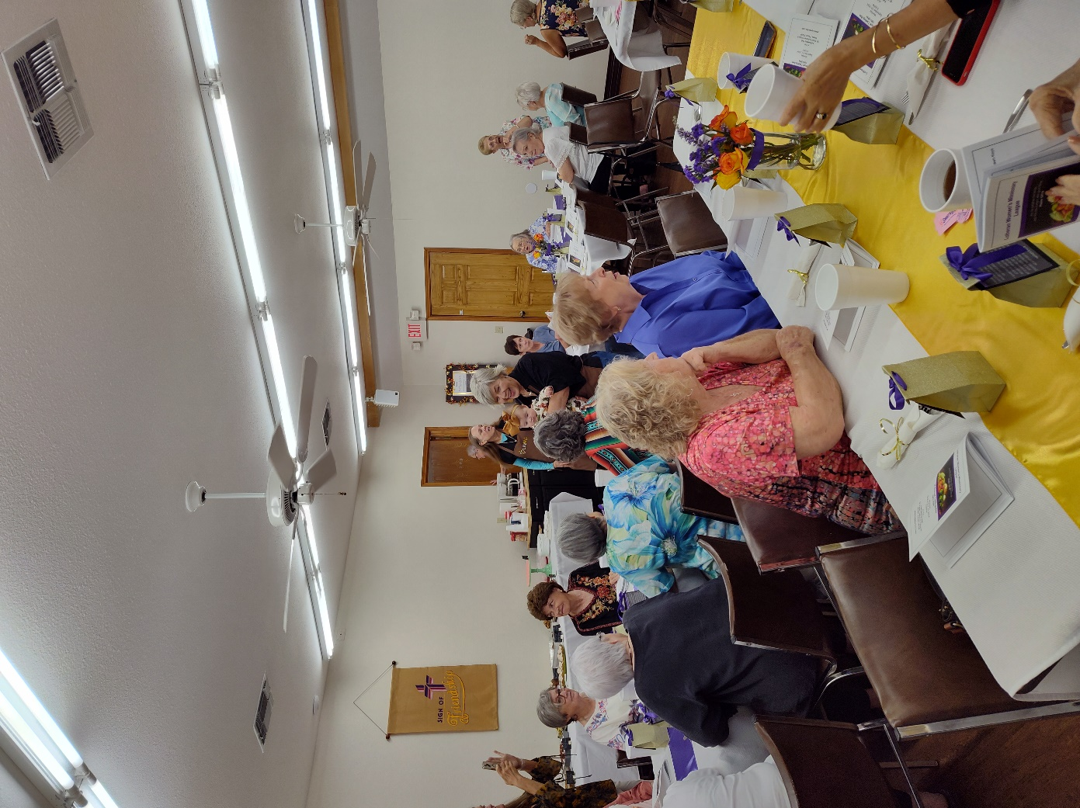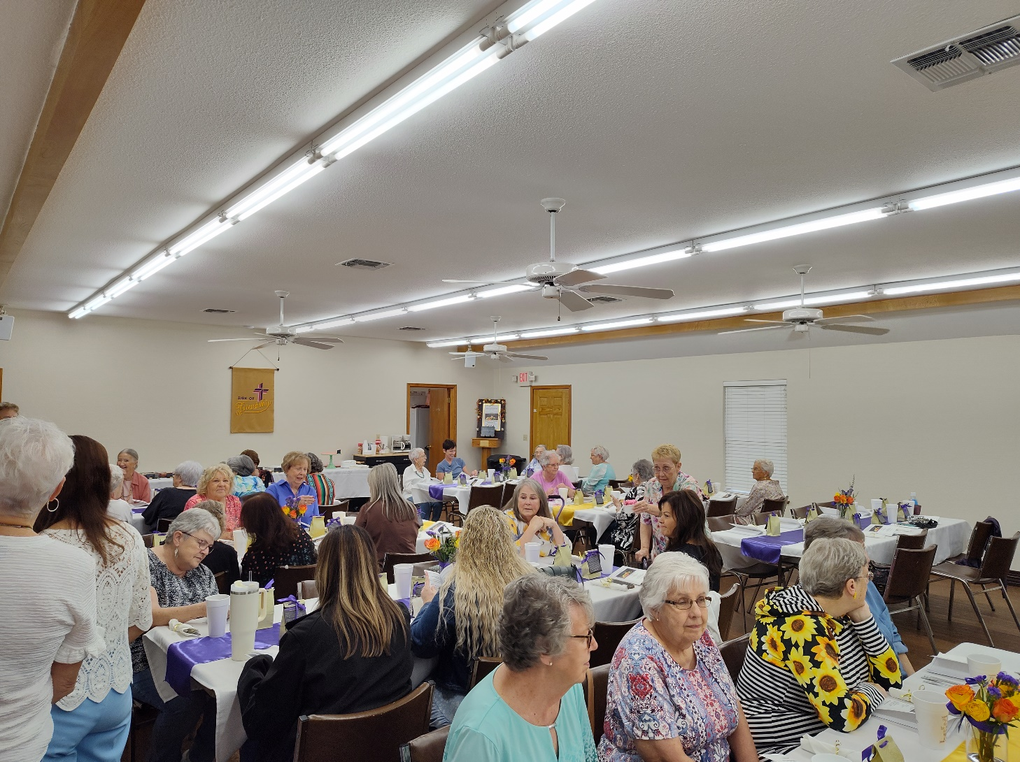had a big turnout





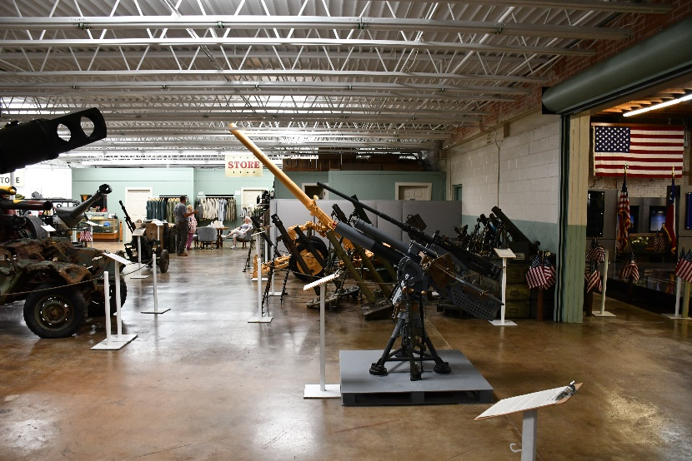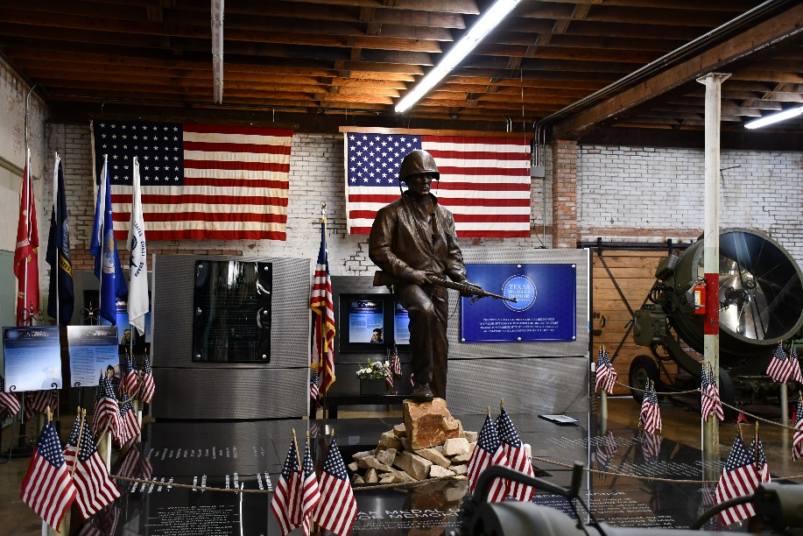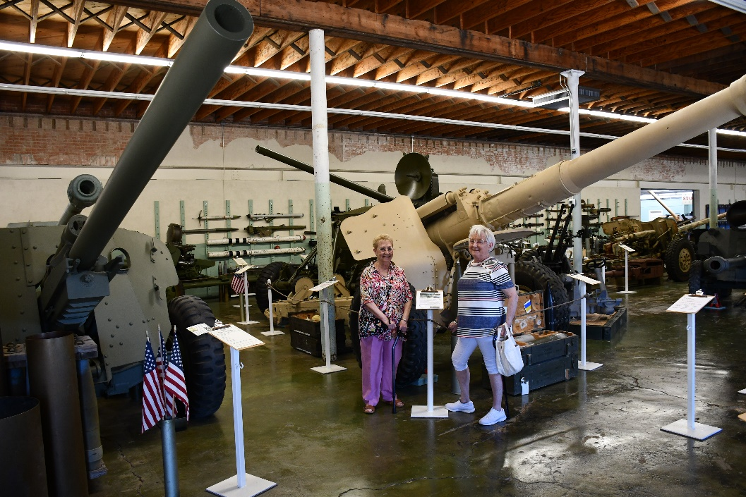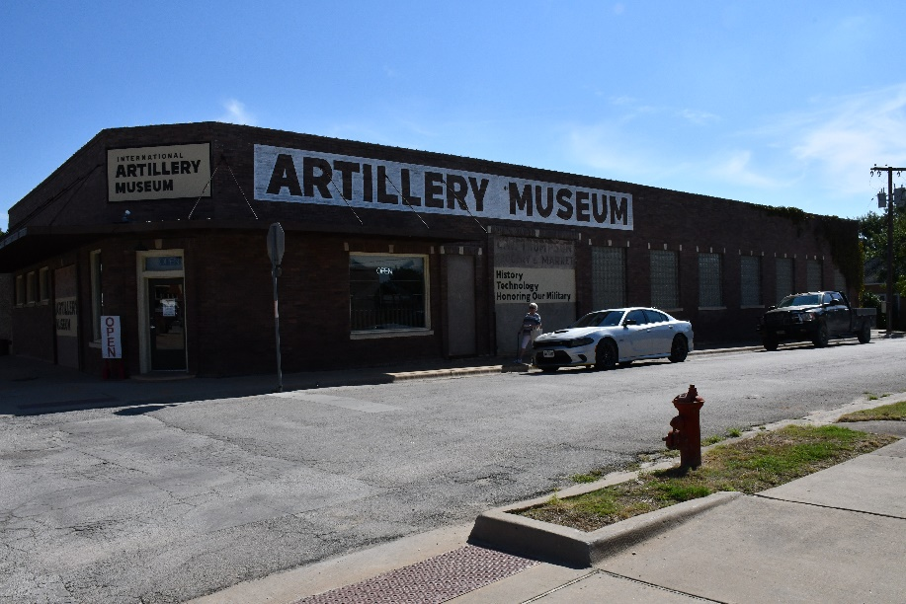the Adult Fellowship Group visited a Military Museum

The Youth Group picked pears

