On entering the church

P Lord, I love the habitation of Your house and the place
where Your glory dwells. In the multitude of Your tender
mercies prepare my heart that I may enter Your house to
worship and confess Your holy name; through Jesus Christ,
my God and Lord.

Before worship

C O Lord, our creator, redeemer, and comforter, as we come
together to worship You in spirit and in truth, we humbly
pray that You would open our hearts to the preaching of
Your Word so that we may repent of our sins, believe in
Jesus Christ as our only Savior, and grow in grace and
holiness. Hear us for His sake.

Holy Baptism

543 What Wondrous Love Is This
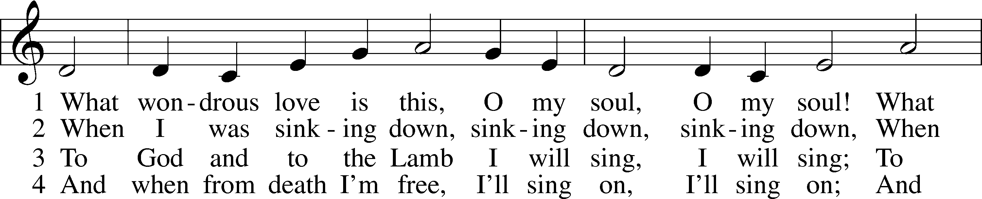
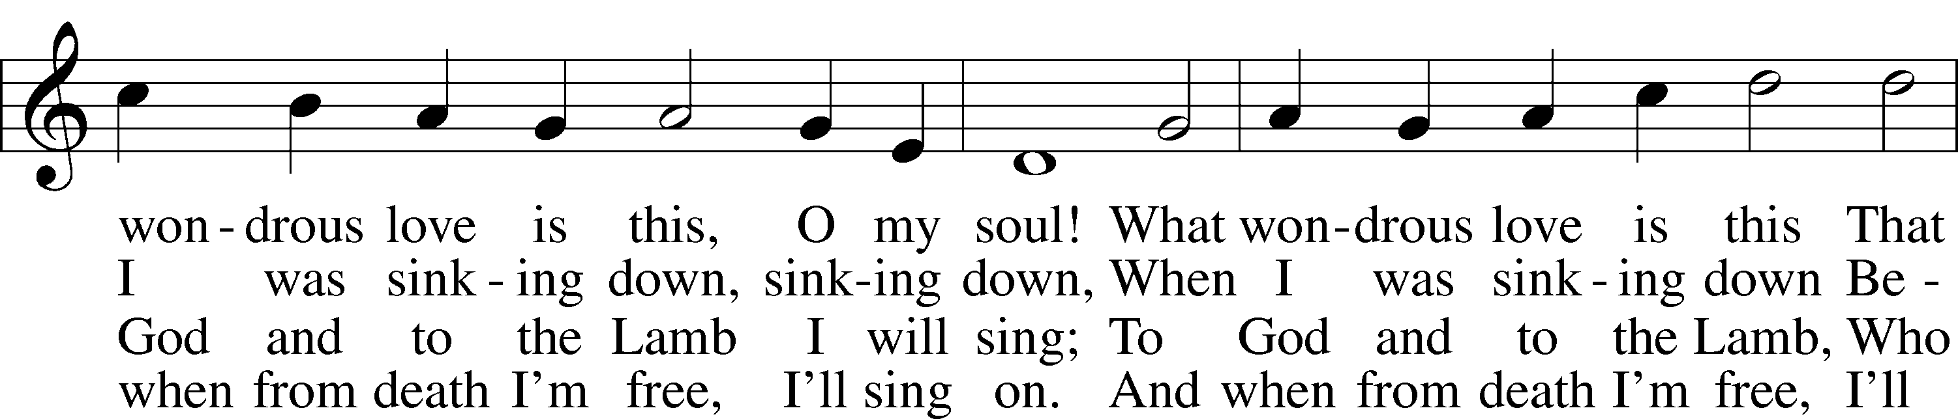
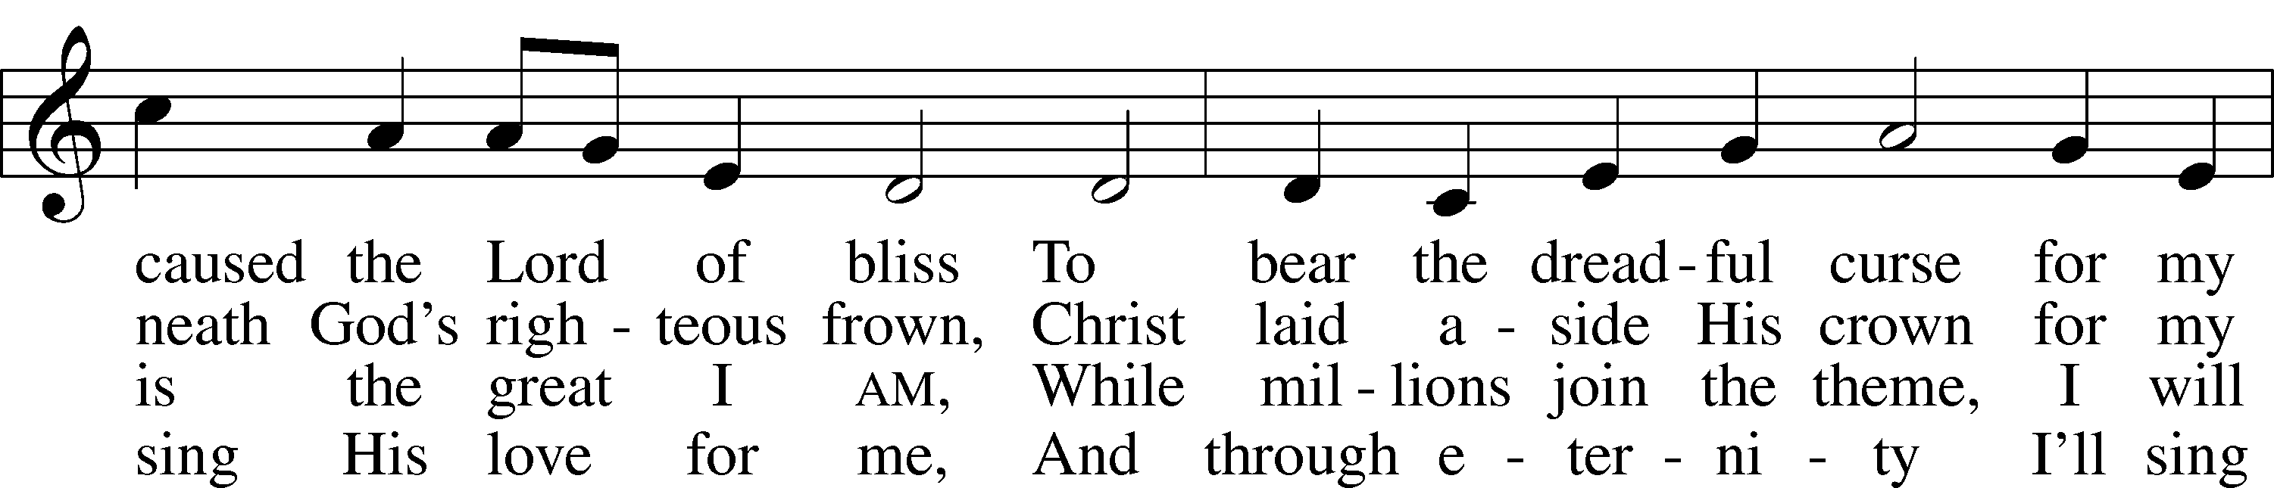
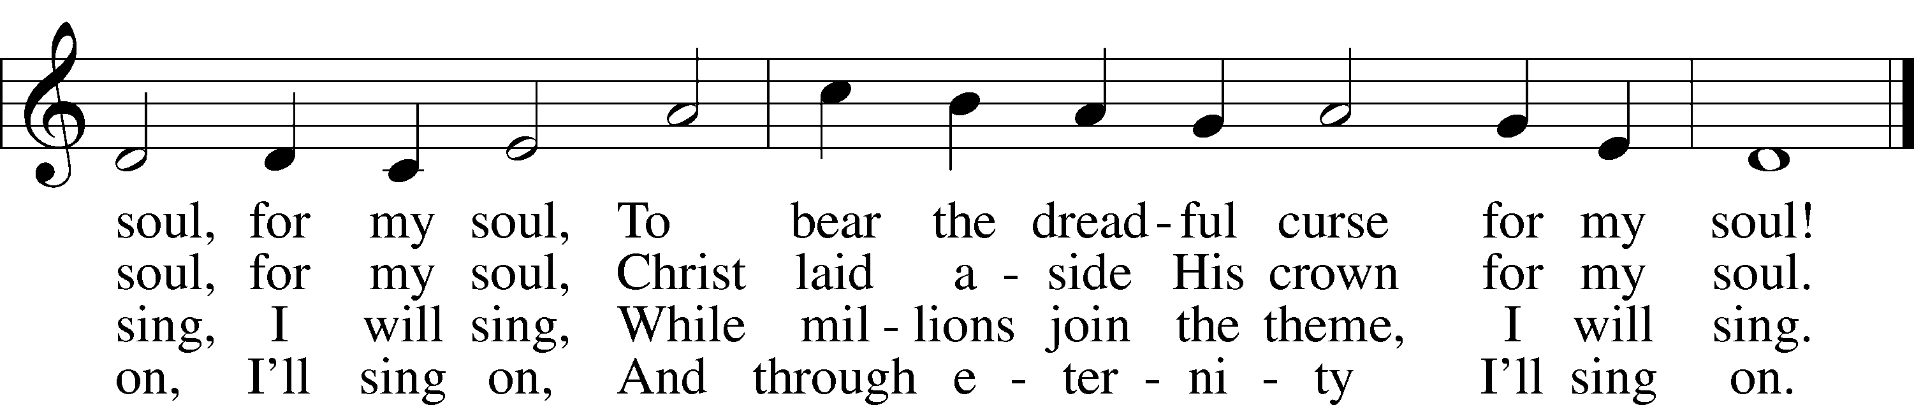
Text: A General Selection of . . . Hymns and Spiritual Songs, 1811, Lynchburg, alt.
Tune: Southern Harmony, 1835, New Haven
Text and tune: Public domain
Confession and Absolution

The sign of the cross may be made by all in remembrance of their Baptism.

Invocation Matthew 28:19b; 18:20
P In the name of the Father and of the T Son and of the Holy Spirit.
C Amen.

Exhortation Hebrews 10:22; Psalm 124:8; Psalm 32:5
P Beloved in the Lord! Let us draw near with a true heart and confess our sins unto God our Father, beseeching Him in the name of our Lord Jesus Christ to grant us forgiveness.

P Our help is in the name of the Lord,
C who made heaven and earth.
P I said, I will confess my transgressions unto the Lord,
C and You forgave the iniquity of my sin.

Silence for reflection on God’s Word and for self-examination.

Confession of Sins
P Almighty God, our maker and redeemer, we poor sinners confess unto You that we are by nature sinful and unclean and that we have sinned against You by thought, word, and deed. Wherefore we flee for refuge to Your infinite mercy, seeking and imploring Your grace for the sake of our Lord Jesus Christ.
C O most merciful God, who has given Your only-begotten Son to die for us, have mercy upon us and for His sake grant us remission of all our sins; and by Your Holy Spirit increase in us true knowledge of You and of Your will and true obedience to Your Word, to the end that by Your grace we may come to everlasting life; through Jesus Christ, our Lord. Amen.

Declaration of Grace Mark 16:16; John 1:12
P Almighty God, our heavenly Father, has had mercy upon us and has given His only Son to die for us and for His sake forgives us all our sins. To those who believe on His name He gives power to become the children of God and has promised them His Holy Spirit. He that believes and is baptized shall be saved.
Grant this, Lord, unto us all.
C Amen.

Service of the Word

Psalm Psalm 95:1–9
1Oh come, let us sing to the Lord;
let us make a joyful noise to the rock of our salvation!
2Let us come into his presence with thanksgiving;
let us make a joyful noise to him with songs of praise!
3For the Lord is a great God,
and a great King above all gods.
4In his hand are the depths of the earth;
the heights of the mountains are his also.
5The sea is his, for he made it,
and his hands formed the dry land.
6Oh come, let us worship and bow down;
let us kneel before the Lord, our Maker!
7For he is our God,
and we are the people of his pasture,
and the sheep of his hand.
Today, if you hear his voice,
8do not harden your hearts, as at Meribah,
as on the day at Massah in the wilderness,
9when your fathers put me to the test
and put me to the proof, though they had seen my work.

Gloria Patri
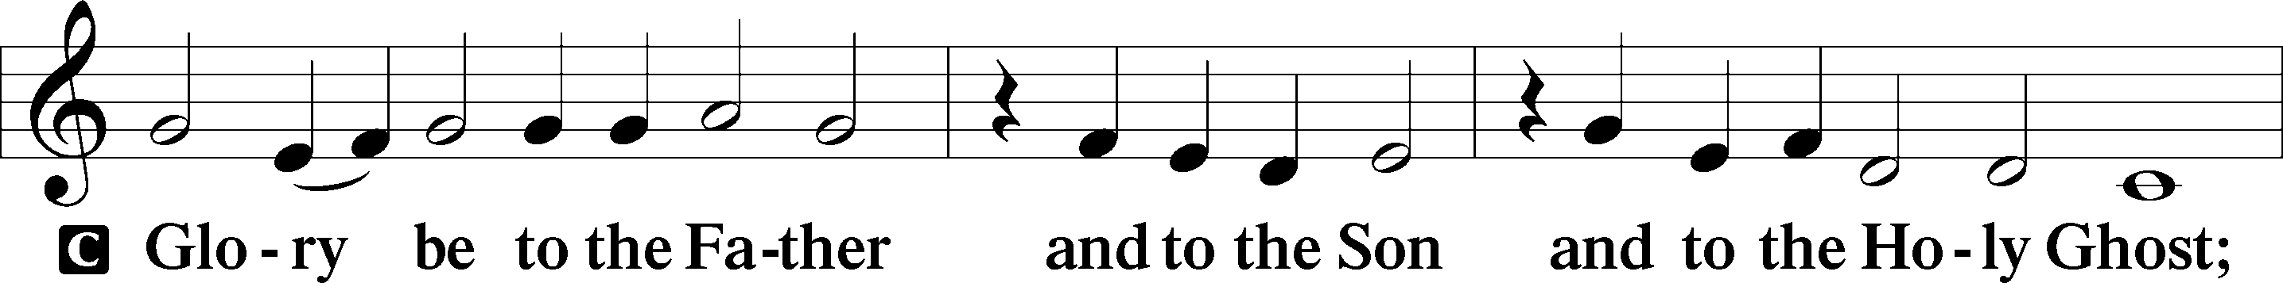
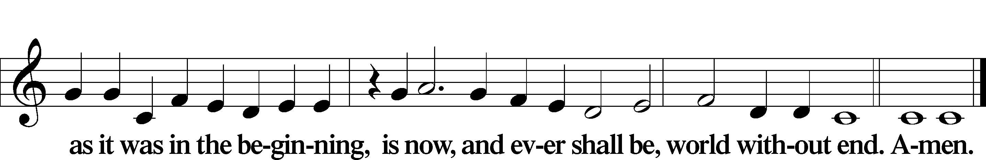

Kyrie Mark 10:47
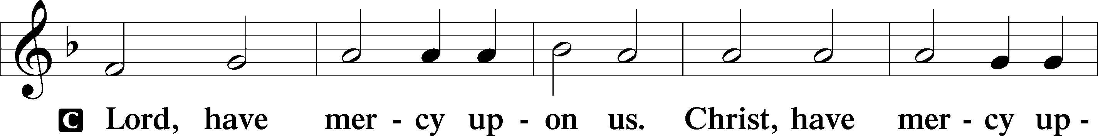
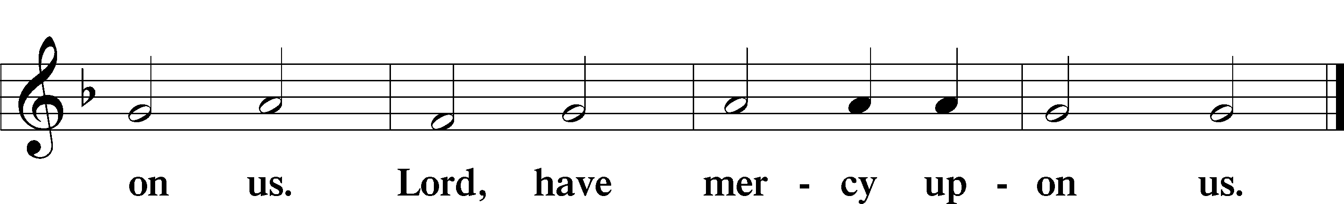

Salutation and Collect of the Day
P The Lord be with you.
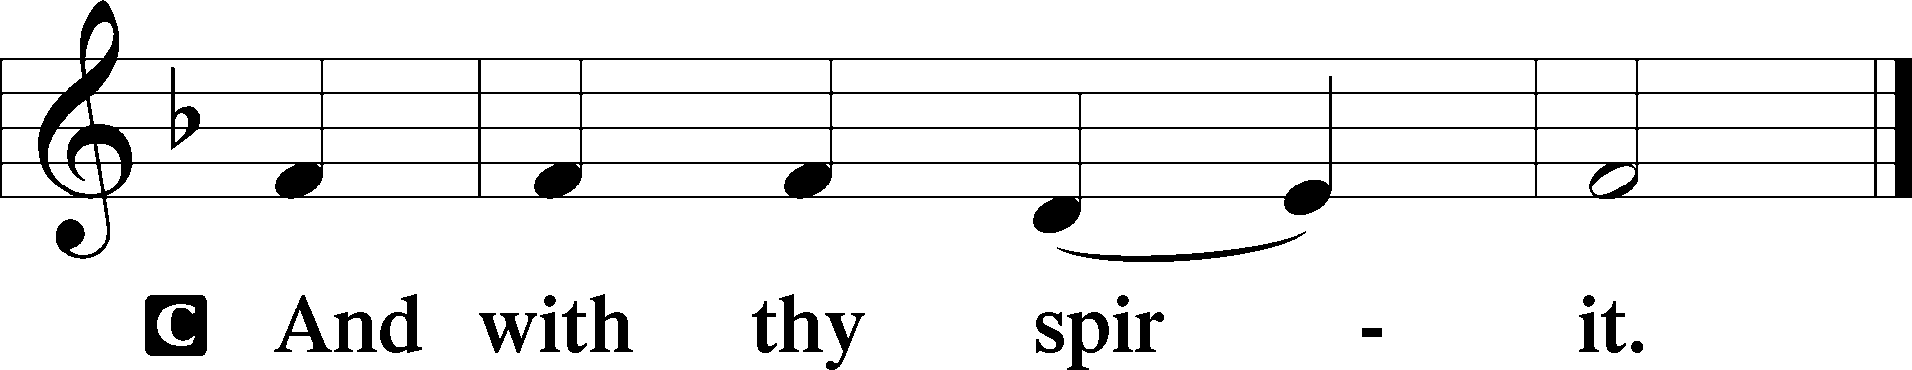

P Let us pray.
O God, whose glory it is always to have mercy, be gracious to all who have gone astray from Your ways and bring them again with penitent hearts and steadfast faith to embrace and hold fast the unchangeable truth of Your Word; through Jesus Christ, Your Son, our Lord, who lives and reigns with You and the Holy Spirit, one God, now and forever.

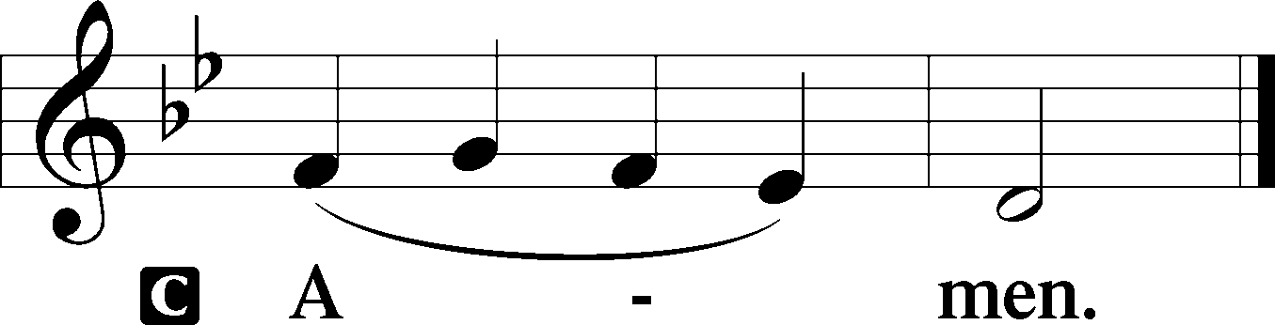

Sit

Old Testament Reading Romans 5:1–8
1Therefore, since we have been justified by faith, we have peace with God through our Lord Jesus Christ. 2Through him we have also obtained access by faith into this grace in which we stand, and we rejoice in hope of the glory of God. 3More than that, we rejoice in our sufferings, knowing that suffering produces endurance, 4and endurance produces character, and character produces hope, 5and hope does not put us to shame, because God’s love has been poured into our hearts through the Holy Spirit who has been given to us.
6For while we were still weak, at the right time Christ died for the ungodly. 7For one will scarcely die for a righteous person—though perhaps for a good person one would dare even to die— 8but God shows his love for us in that while we were still sinners, Christ died for us.

A This is the Word of the Lord.
C Thanks be to God.

Gradual Hebrews 12:2
[O come, let us fix our eyes on] Jesus,
the founder and perfecter of our faith,
who for the joy that was set before him endured the cross, despising the shame,
and is seated at the right hand of the throne of God.

Epistle Exodus 17:1–7
1All the congregation of the people of Israel moved on from the wilderness of Sin by stages, according to the commandment of the Lord, and camped at Rephidim, but there was no water for the people to drink. 2Therefore the people quarreled with Moses and said, “Give us water to drink.” And Moses said to them, “Why do you quarrel with me? Why do you test the Lord?” 3But the people thirsted there for water, and the people grumbled against Moses and said, “Why did you bring us up out of Egypt, to kill us and our children and our livestock with thirst?” 4So Moses cried to the Lord, “What shall I do with this people? They are almost ready to stone me.” 5And the Lord said to Moses, “Pass on before the people, taking with you some of the elders of Israel, and take in your hand the staff with which you struck the Nile, and go. 6Behold, I will stand before you there on the rock at Horeb, and you shall strike the rock, and water shall come out of it, and the people will drink.” And Moses did so, in the sight of the elders of Israel. 7And he called the name of the place Massah and Meribah, because of the quarreling of the people of Israel, and because they tested the Lord by saying, “Is the Lord among us or not?”

A This is the Word of the Lord.
C Thanks be to God.

Stand

Holy Gospel John 4:5–26
P The Holy Gospel according to St. John, the fourth chapter.

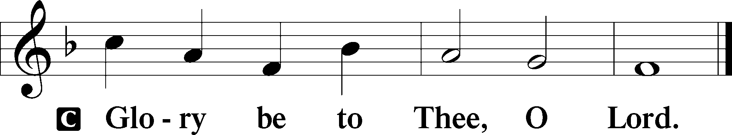

5[Jesus] came to a town of Samaria called Sychar, near the field that Jacob had given to his son Joseph. 6Jacob’s well was there; so Jesus, wearied as he was from his journey, was sitting beside the well. It was about the sixth hour.
7There came a woman of Samaria to draw water. Jesus said to her, “Give me a drink.” 8(For his disciples had gone away into the city to buy food.) 9The Samaritan woman said to him, “How is it that you, a Jew, ask for a drink from me, a woman of Samaria?” (For Jews have no dealings with Samaritans.) 10Jesus answered her, “If you knew the gift of God, and who it is that is saying to you, ‘Give me a drink,’ you would have asked him, and he would have given you living water.” 11The woman said to him, “Sir, you have nothing to draw water with, and the well is deep. Where do you get that living water? 12Are you greater than our father Jacob? He gave us the well and drank from it himself, as did his sons and his livestock.” 13Jesus said to her, “Everyone who drinks of this water will be thirsty again, 14but whoever drinks of the water that I will give him will never be thirsty forever. The water that I will give him will become in him a spring of water welling up to eternal life.” 15The woman said to him, “Sir, give me this water, so that I will not be thirsty or have to come here to draw water.”
16Jesus said to her, “Go, call your husband, and come here.” 17The woman answered him, “I have no husband.” Jesus said to her, “You are right in saying, ‘I have no husband’; 18for you have had five husbands, and the one you now have is not your husband. What you have said is true.” 19The woman said to him, “Sir, I perceive that you are a prophet. 20Our fathers worshiped on this mountain, but you say that in Jerusalem is the place where people ought to worship.” 21Jesus said to her, “Woman, believe me, the hour is coming when neither on this mountain nor in Jerusalem will you worship the Father. 22You worship what you do not know; we worship what we know, for salvation is from the Jews. 23But the hour is coming, and is now here, when the true worshipers will worship the Father in spirit and truth, for the Father is seeking such people to worship him. 24God is spirit, and those who worship him must worship in spirit and truth.” 25The woman said to him, “I know that Messiah is coming (he who is called Christ). When he comes, he will tell us all things.” 26Jesus said to her, “I who speak to you am he.”

P This is the Gospel of the Lord.

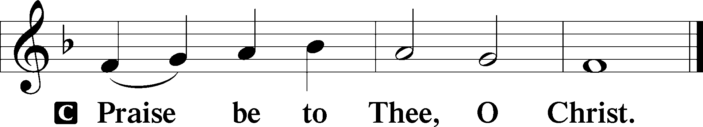

Apostles’ Creed
C I believe in God, the Father Almighty,
maker of heaven and earth.

And in Jesus Christ, His only Son, our Lord,
who was conceived by the Holy Spirit,
born of the virgin Mary,
suffered under Pontius Pilate,
was crucified, died and was buried.
He descended into hell.
The third day He rose again from the dead.
He ascended into heaven
and sits at the right hand of God the Father Almighty.
From thence He will come to judge the living and the dead.

I believe in the Holy Spirit,
the holy Christian Church,
the communion of saints,
the forgiveness of sins,
the resurrection of the body,
and the life T everlasting. Amen.

Sit

Children's Sermon

430 My Song Is Love Unknown
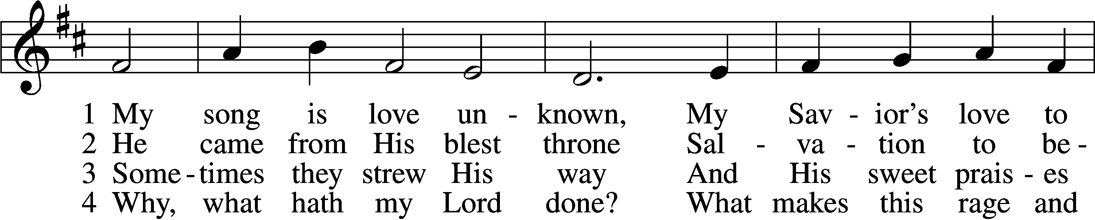
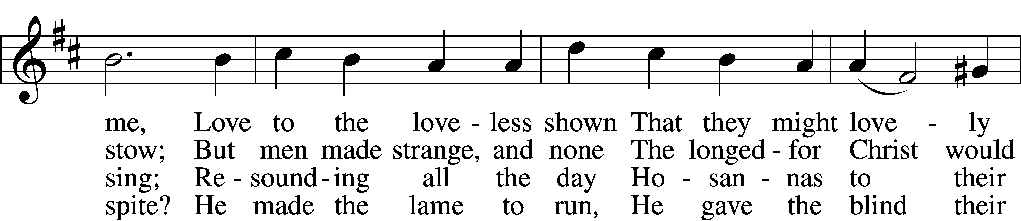
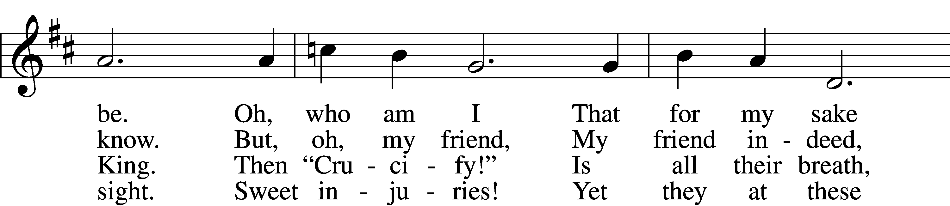
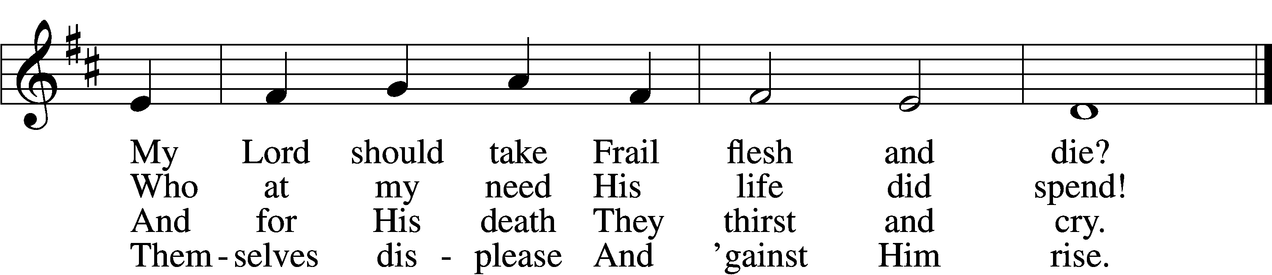

5 They rise and needs will have
My dear Lord made away;
A murderer they save,
The Prince of Life they slay.
Yet cheerful He
To suff’ring goes
That He His foes
From thence might free.

6 In life no house, no home
My Lord on earth might have;
In death no friendly tomb
But what a stranger gave.
What may I say?
Heav’n was His home
But mine the tomb
Wherein He lay.

7 Here might I stay and sing,
No story so divine!
Never was love, dear King,
Never was grief like Thine.
This is my friend,
In whose sweet praise
I all my days
Could gladly spend!
Text: Samuel Crossman, c. 1624–1683
Tune: John N. Ireland, 1879–1962
Text: Public domain
Tune: © John Ireland Trust. Used by permission: LSB Hymn License no. 110005011

Sermon

Votum
P The peace of God, which passes all understanding, keep your hearts and minds in Christ Jesus.
C Amen.

Stand

Offertory Psalm 51:10–12
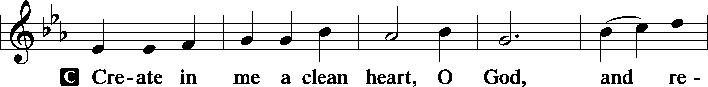
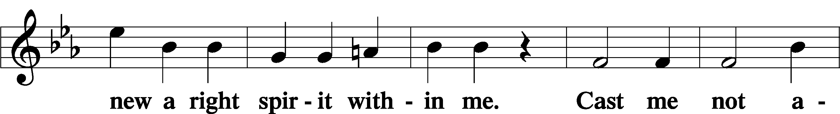
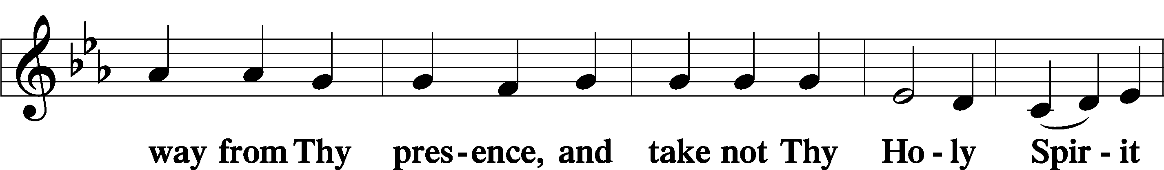
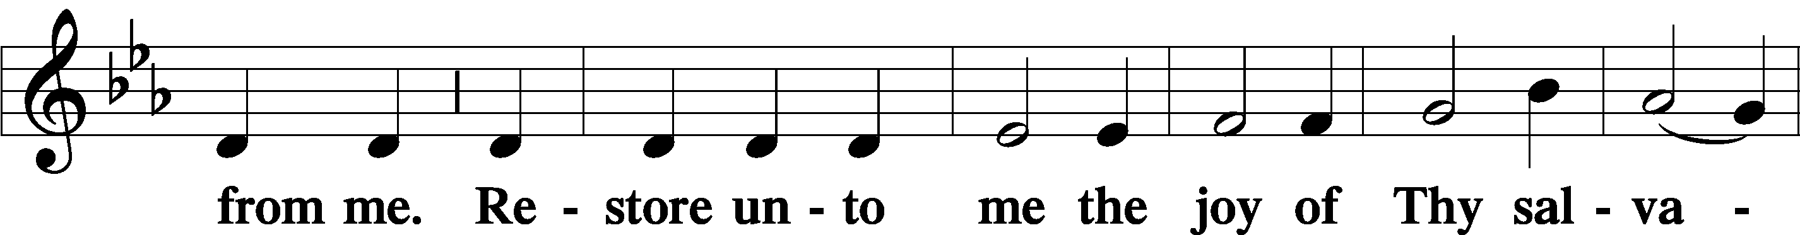
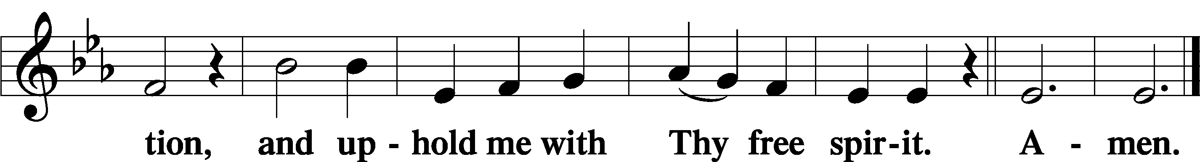

Offering

805 Praise God, from Whom All Blessings Flow
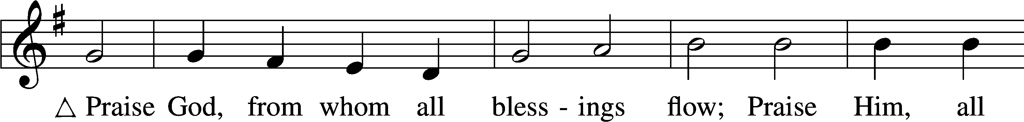
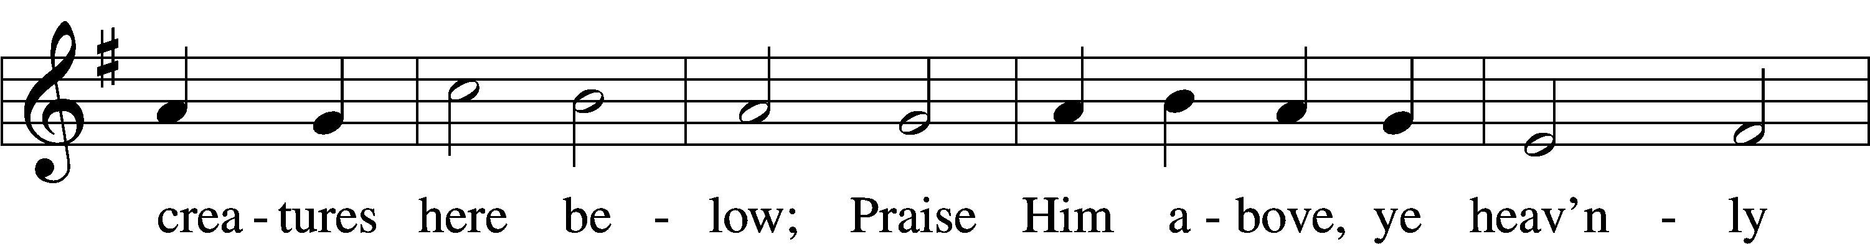
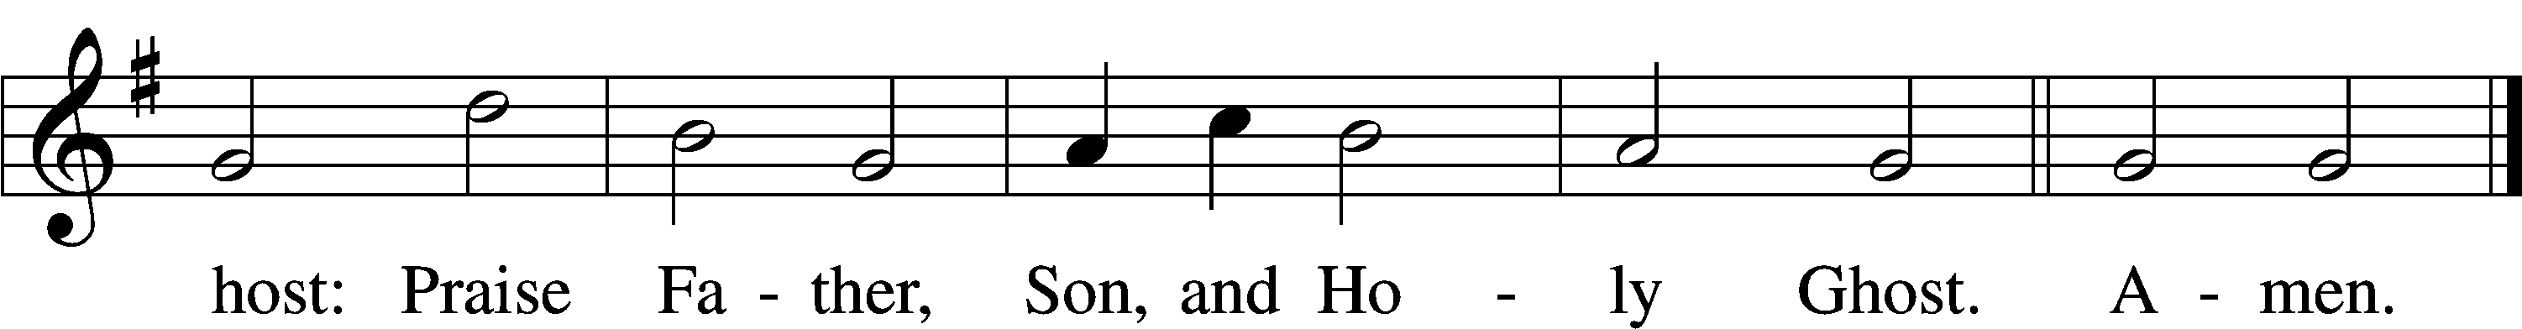
Text: Thomas Ken, 1637–1711
Tune: Trente quatre Pseaumes de David, 1551, Geneva, ed. Louis Bourgeois
Text and tune: Public domain

Prayer of the Church

Lord’s Prayer Matthew 6:9–13
P Lord, remember us in Your kingdom and teach us to pray:
C Our Father who art in heaven,
hallowed be Thy name,
Thy kingdom come,
Thy will be done on earth
as it is in heaven;
give us this day our daily bread;
and forgive us our trespasses
as we forgive those
who trespass against us;
and lead us not into temptation,
but deliver us from evil.
For Thine is the kingdom
and the power and the glory
forever and ever. Amen.

Collect for the Word

Blessed Lord, You have caused all Holy Scriptures to be written for our learning. Grant that we may so hear them, read, mark, learn, and inwardly digest them that, by the patience and comfort of Your holy Word, we may embrace and ever hold fast the blessed hope of everlasting life; through Jesus Christ, Your Son, our Lord, who lives and reigns with You and the Holy Spirit, one God, now and forever.

Benediction
P The Lord bless you and keep you.
The Lord make His face shine on you and be gracious to you.
The Lord look upon you with favor and T give you peace.
C Amen.

763 When Peace, like a River
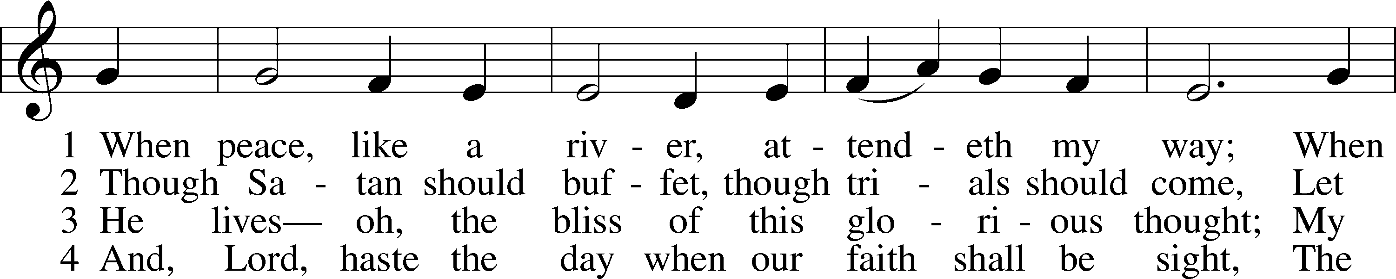
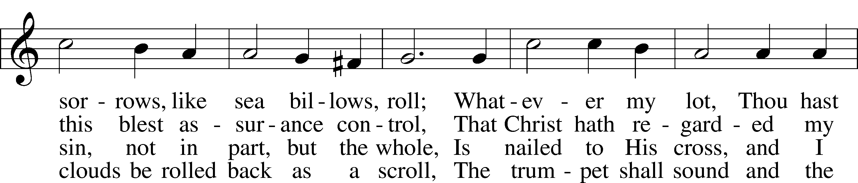
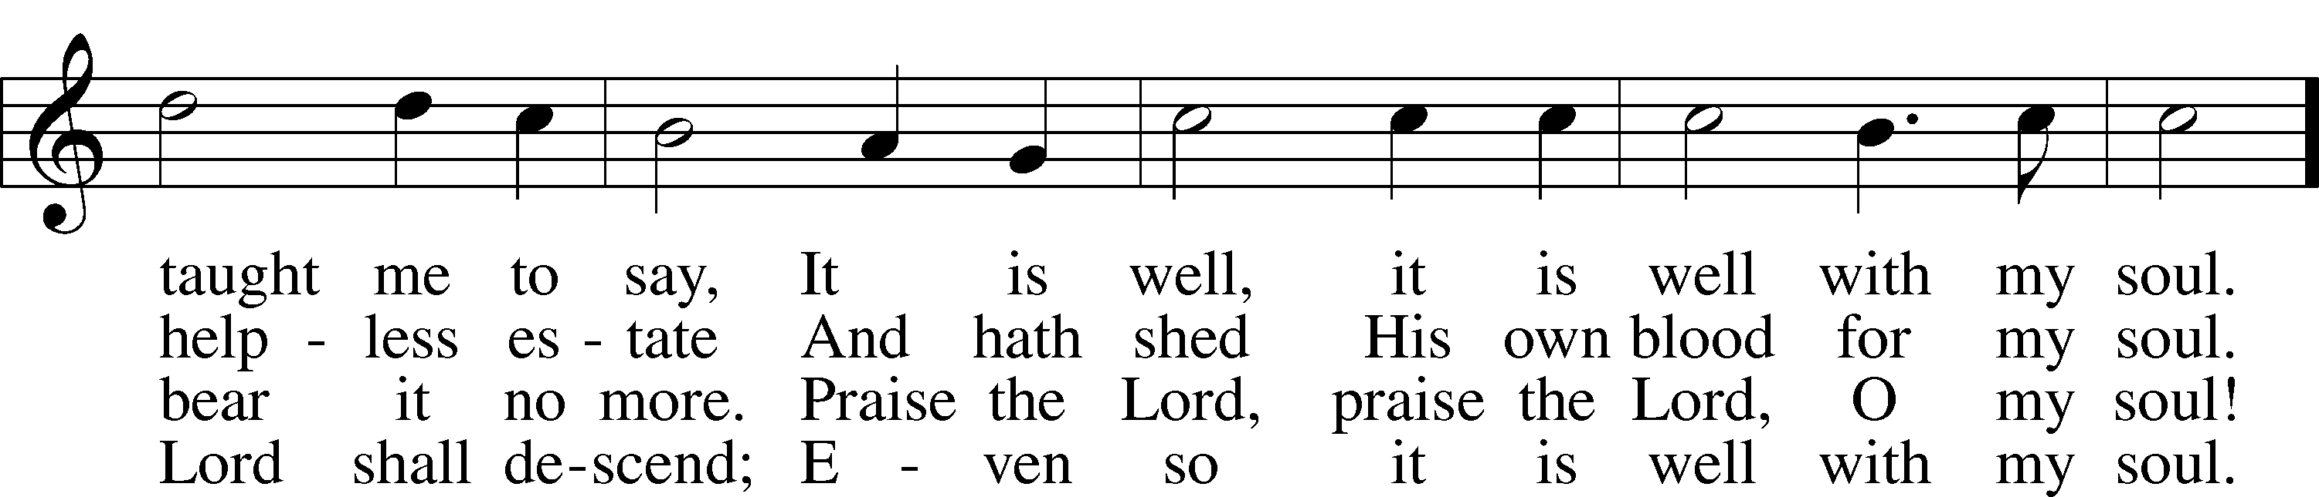
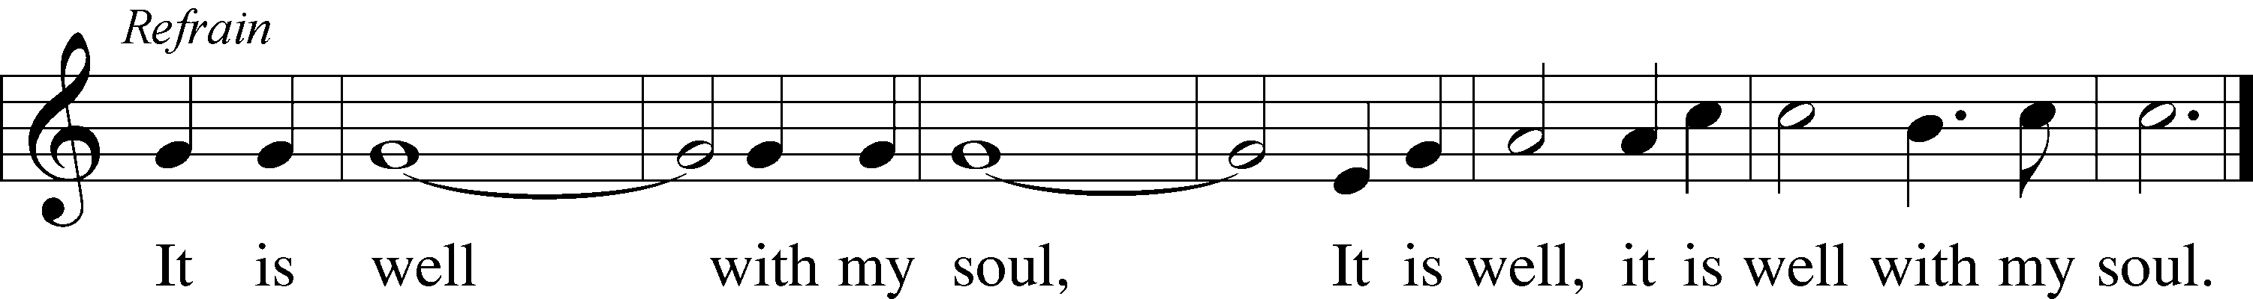
Text: Horatio G. Spafford, 1828–88, alt.
Tune: Philip P. Bliss, 1838–76
Text and tune: Public domain

Acknowledgments
Unless otherwise indicated, Scripture quotations are from the ESV® Bible (The Holy Bible, English Standard Version®), copyright © 2001 by Crossway, a publishing ministry of Good News Publishers. Used by permission. All rights reserved.
Created by Lutheran Service Builder © 2026 Concordia Publishing House.

