On entering the church

P Lord, I love the habitation of Your house and the place

where Your glory dwells. In the multitude of Your tender

mercies prepare my heart that I may enter Your house to

worship and confess Your holy name; through Jesus Christ,

my God and Lord.

Before worship

C O Lord, our creator, redeemer, and comforter, as we come

together to worship You in spirit and in truth, we humbly

pray that You would open our hearts to the preaching of

Your Word so that we may repent of our sins, believe in

Jesus Christ as our only Savior, and grow in grace and

holiness. Hear us for His sake.

842 Son of God, Eternal Savior

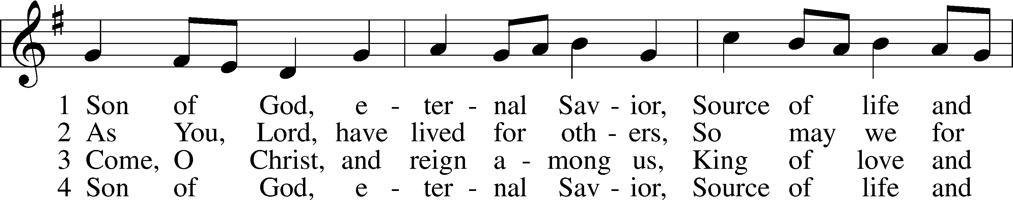

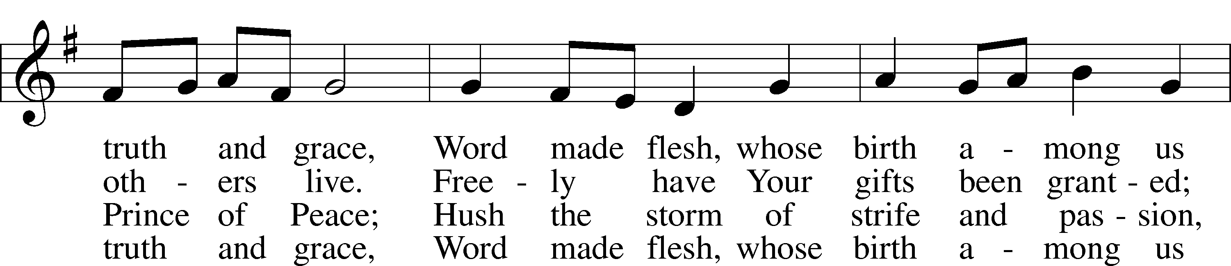

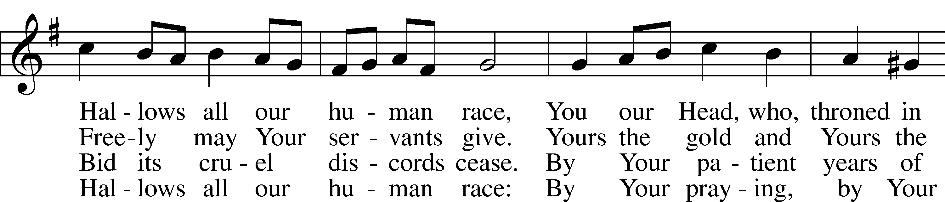

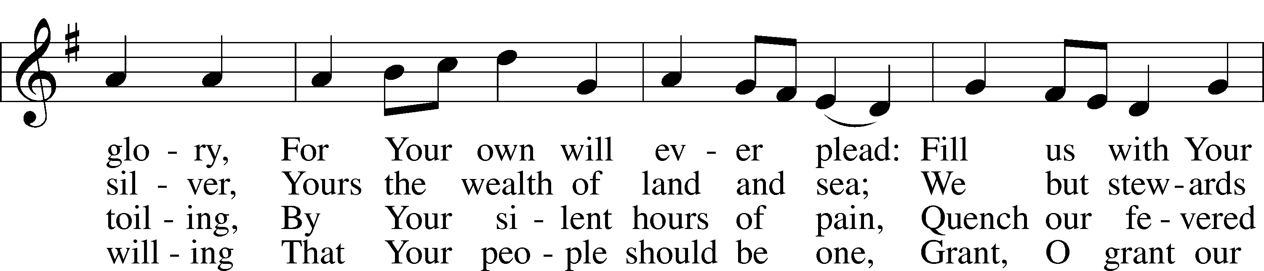

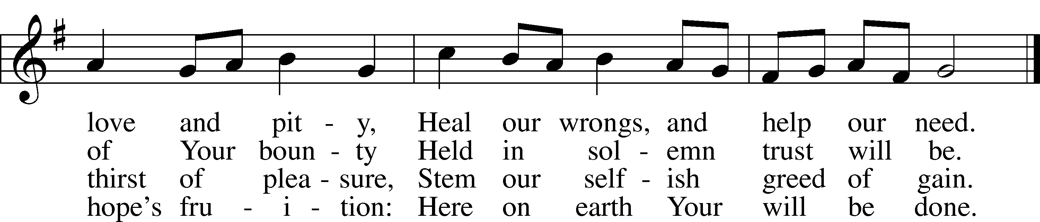

Text: Somerset T. C. Lowry, 1855–1932, alt.  
Tune: Oude en Nieuwe Hollantse . . . Contredansen, c. 1710, Amsterdam  
Text and tune: Public domain

# Confession and Absolution

The sign of the cross may be made by all in remembrance of their Baptism.

Invocation Matthew 28:19b; 18:20

P In the name of the Father and of the T Son and of the Holy Spirit.

C **Amen.**

Exhortation Hebrews 10:22; Psalm 124:8; Psalm 32:5

P Beloved in the Lord! Let us draw near with a true heart and confess our sins unto God our Father, beseeching Him in the name of our Lord Jesus Christ to grant us forgiveness.

P Our help is in the name of the Lord,

C **who made heaven and earth.**

P I said, I will confess my transgressions unto the Lord,

C **and You forgave the iniquity of my sin.**

Silence for reflection on God’s Word and for self-examination.

Confession of Sins

P Almighty God, our maker and redeemer, we poor sinners confess unto You that we are by nature sinful and unclean and that we have sinned against You by thought, word, and deed. Wherefore we flee for refuge to Your infinite mercy, seeking and imploring Your grace for the sake of our Lord Jesus Christ.

C **O most merciful God, who has given Your only-begotten Son to die for us, have mercy upon us and for His sake grant us remission of all our sins; and by Your Holy Spirit increase in us true knowledge of You and of Your will and true obedience to Your Word, to the end that by Your grace we may come to everlasting life; through Jesus Christ, our Lord. Amen.**

Declaration of Grace Mark 16:16; John 1:12

P Almighty God, our heavenly Father, has had mercy upon us and has given His only Son to die for us and for His sake forgives us all our sins. To those who believe on His name He gives power to become the children of God and has promised them His Holy Spirit. He that believes and is baptized shall be saved.  
  
Grant this, Lord, unto us all.

C **Amen.**

# Service of the Word

Introit Psalm 136:23–26; antiphon: v. 1

Give thanks to the Lord, for he is good,  
 for his steadfast love endures forever.  
**It is he who remembered us in our low estate,  
 for his steadfast love endures forever;**and rescued us from our foes,  
 for his steadfast love endures forever;  
**he who gives food to all flesh,  
 for his steadfast love endures forever.**Give thanks to the God of heaven,  
 for his steadfast love endures forever.

Gloria Patri

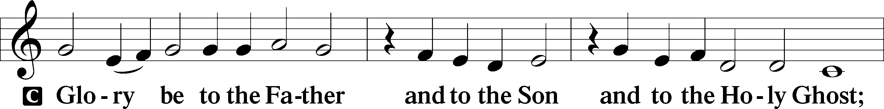

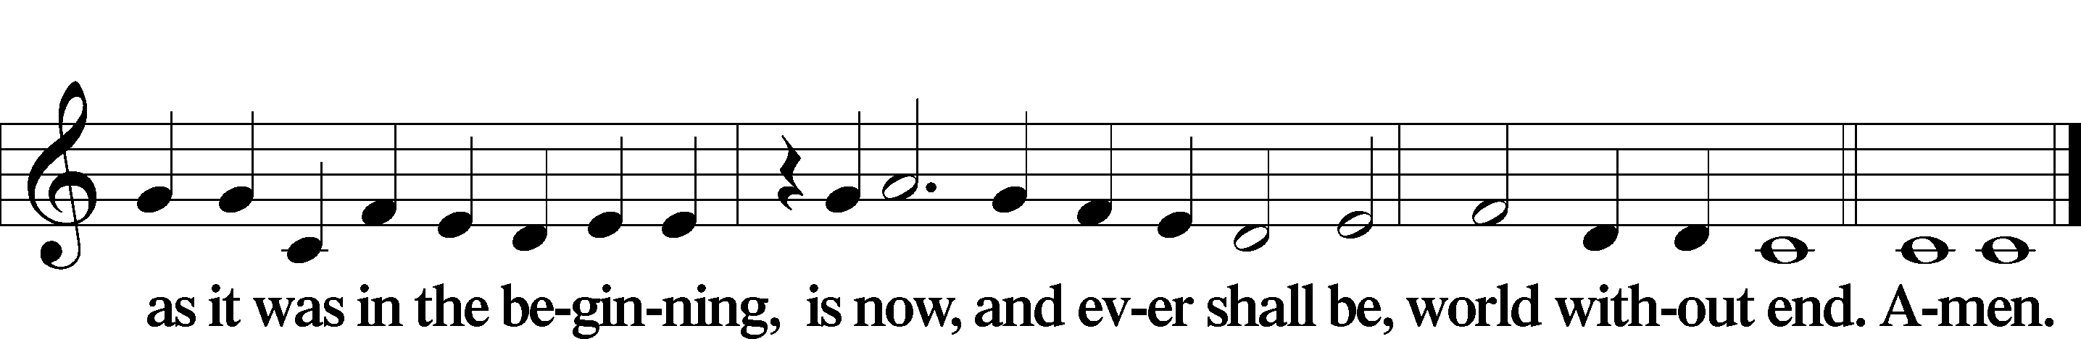

Kyrie Mark 10:47

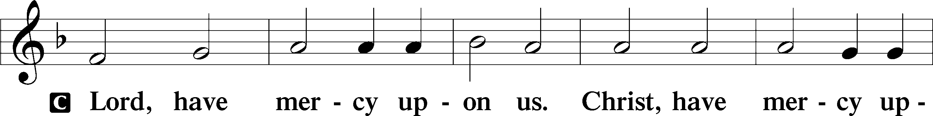

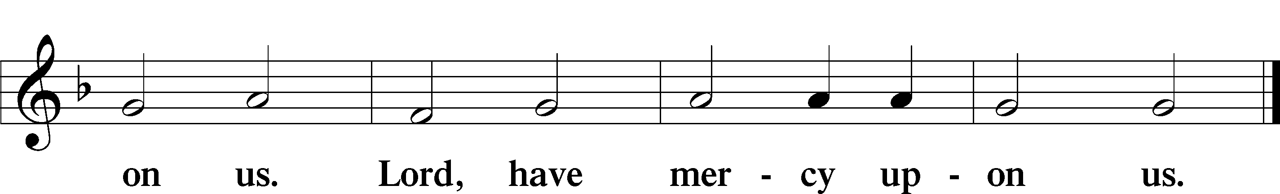

Gloria in Excelsis Luke 2:14; John 1:29

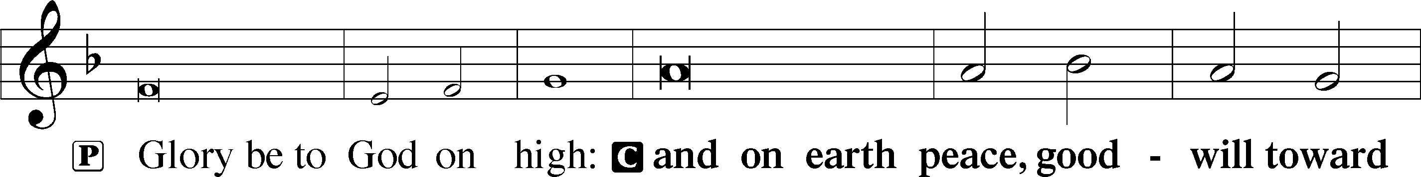

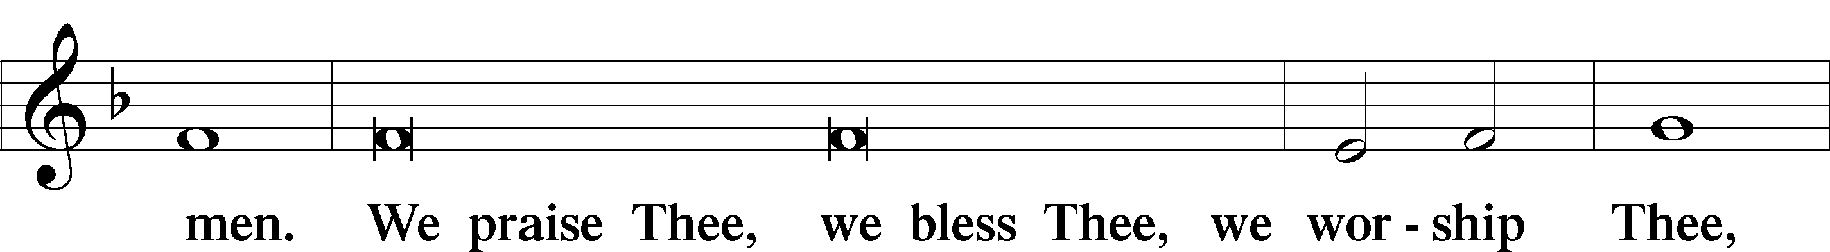

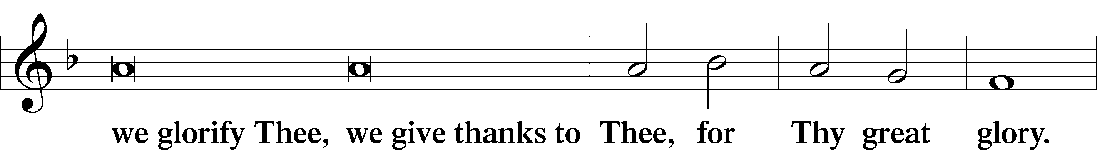

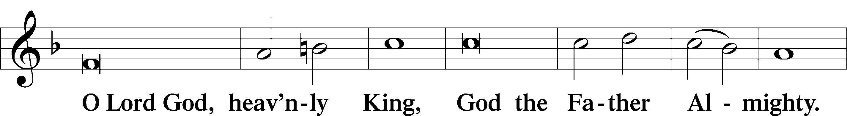

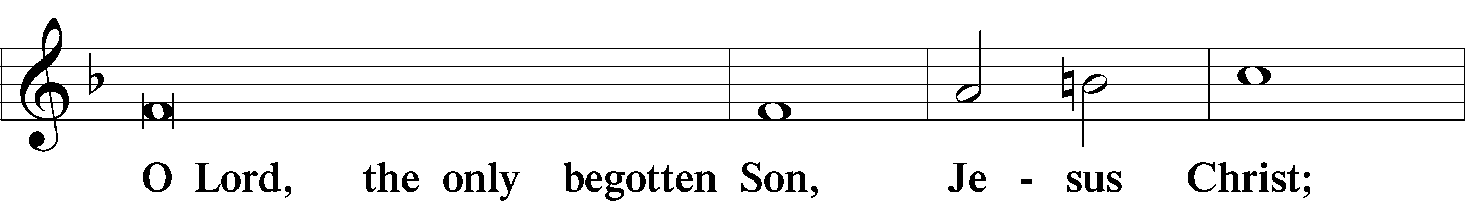

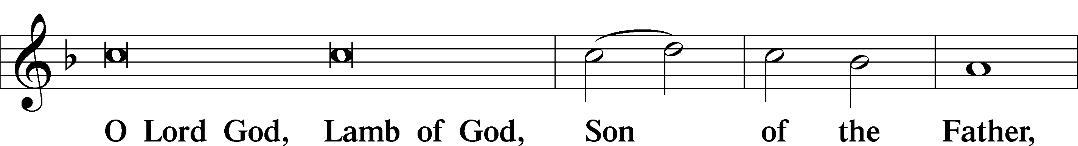

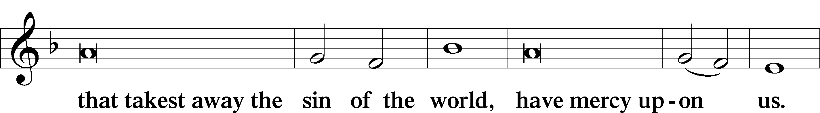

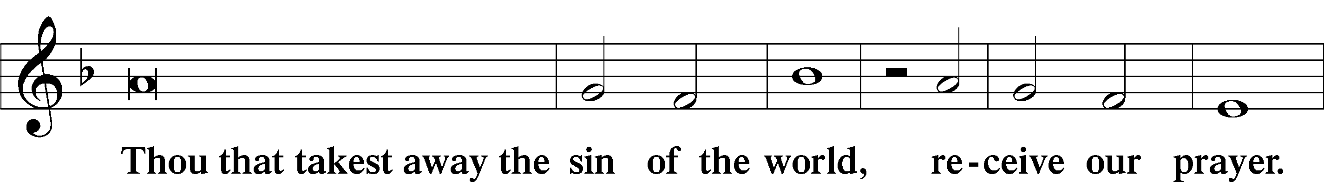

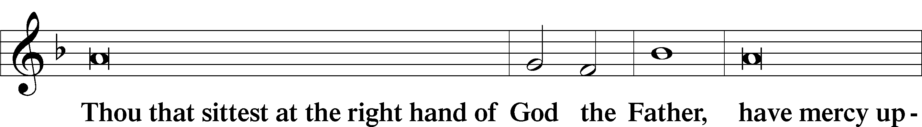

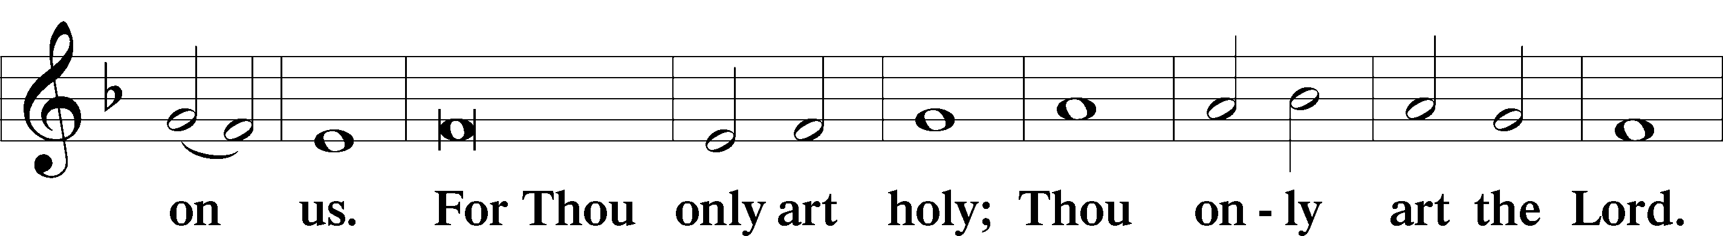

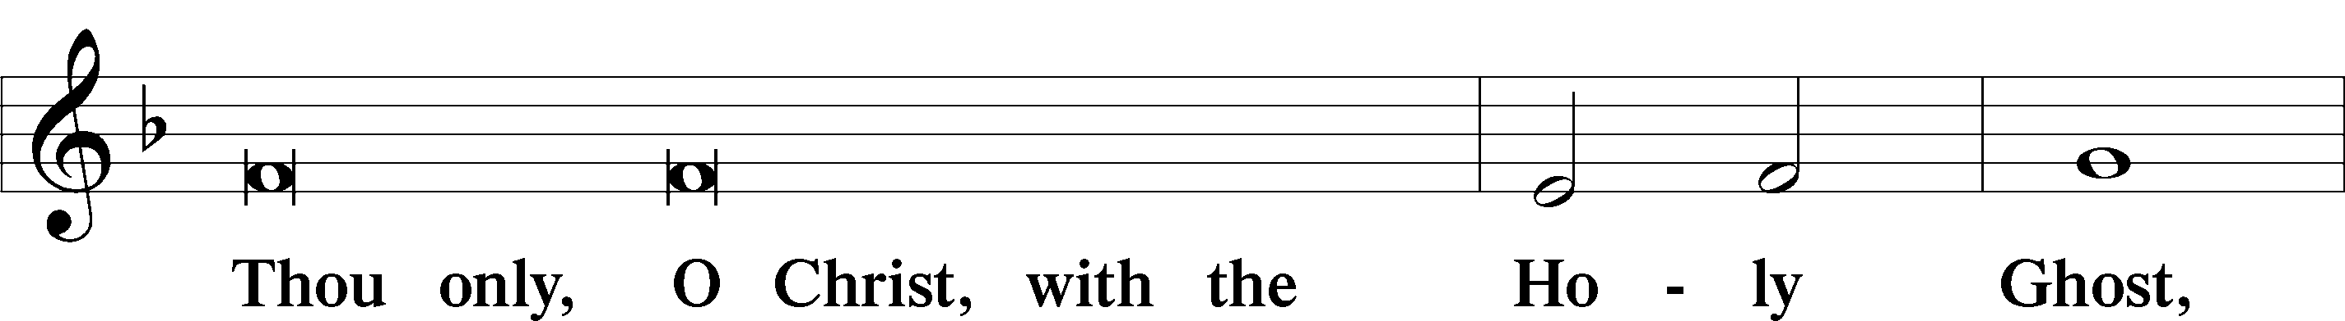

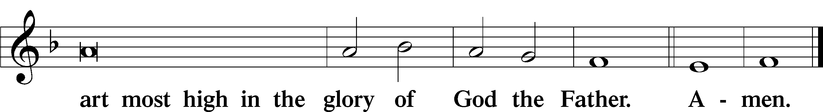

Salutation and Collect of the Day

P The Lord be with you.

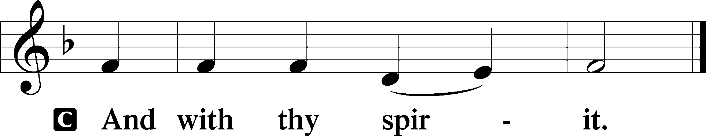

P Let us pray.

Lord Jesus Christ, in Your deep compassion You rescue us from whatever may hurt us. Teach us to love You above all things and to love our neighbors as ourselves; for You live and reign with the Father and the Holy Spirit, one God, now and forever.

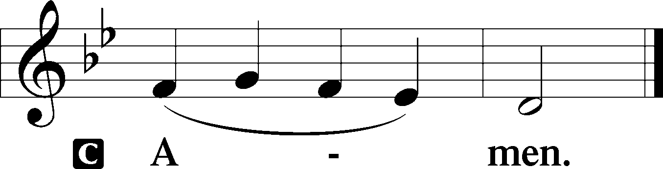

Sit

Old Testament Reading Leviticus 18:1–5; 19:9–18

1 The Lord spoke to Moses, saying, 2“Speak to the people of Israel and say to them, I am the Lord your God. 3You shall not do as they do in the land of Egypt, where you lived, and you shall not do as they do in the land of Canaan, to which I am bringing you. You shall not walk in their statutes. 4You shall follow my rules and keep my statutes and walk in them. I am the Lord your God. 5You shall therefore keep my statutes and my rules; if a person does them, he shall live by them: I am the Lord. . . .

9“When you reap the harvest of your land, you shall not reap your field right up to its edge, neither shall you gather the gleanings after your harvest. 10And you shall not strip your vineyard bare, neither shall you gather the fallen grapes of your vineyard. You shall leave them for the poor and for the sojourner: I am the Lord your God.

11“You shall not steal; you shall not deal falsely; you shall not lie to one another. 12You shall not swear by my name falsely, and so profane the name of your God: I am the Lord.

13“You shall not oppress your neighbor or rob him. The wages of a hired servant shall not remain with you all night until the morning. 14You shall not curse the deaf or put a stumbling block before the blind, but you shall fear your God: I am the Lord.

15“You shall do no injustice in court. You shall not be partial to the poor or defer to the great, but in righteousness shall you judge your neighbor. 16You shall not go around as a slanderer among your people, and you shall not stand up against the life of your neighbor: I am the Lord.

17“You shall not hate your brother in your heart, but you shall reason frankly with your neighbor, lest you incur sin because of him. 18You shall not take vengeance or bear a grudge against the sons of your own people, but you shall love your neighbor as yourself: I am the Lord.”

A This is the Word of the Lord.

C **Thanks be to God.**

Gradual Romans 10:15b, 18b; Isaiah 52:7b, alt.

How beautiful are the feet of those who preach the good news,  
 who publish peace and bring good news of salvation.  
**Their voice has gone out to all the earth,  
 and their words to the ends of the world.**

Epistle Colossians 1:1–14

1Paul, an apostle of Christ Jesus by the will of God, and Timothy our brother,

2To the saints and faithful brothers in Christ at Colossae:

Grace to you and peace from God our Father.

3We always thank God, the Father of our Lord Jesus Christ, when we pray for you, 4since we heard of your faith in Christ Jesus and of the love that you have for all the saints, 5because of the hope laid up for you in heaven. Of this you have heard before in the word of the truth, the gospel, 6which has come to you, as indeed in the whole world it is bearing fruit and growing—as it also does among you, since the day you heard it and understood the grace of God in truth, 7just as you learned it from Epaphras our beloved fellow servant. He is a faithful minister of Christ on your behalf 8and has made known to us your love in the Spirit.

9And so, from the day we heard, we have not ceased to pray for you, asking that you may be filled with the knowledge of his will in all spiritual wisdom and understanding, 10so as to walk in a manner worthy of the Lord, fully pleasing to him, bearing fruit in every good work and increasing in the knowledge of God. 11May you be strengthened with all power, according to his glorious might, for all endurance and patience with joy, 12giving thanks to the Father, who has qualified you to share in the inheritance of the saints in light. 13He has delivered us from the domain of darkness and transferred us to the kingdom of his beloved Son, 14in whom we have redemption, the forgiveness of sins.

Stand

Alleluia

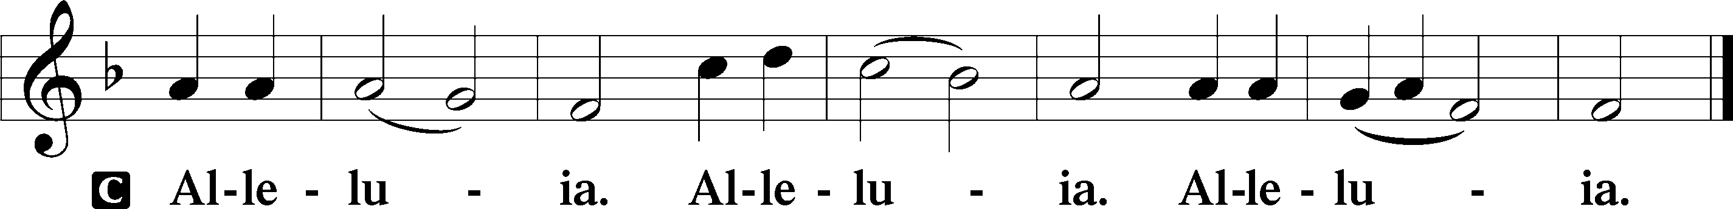

Holy Gospel Luke 10:25–37

P The Holy Gospel according to St. Luke, the tenth chapter.

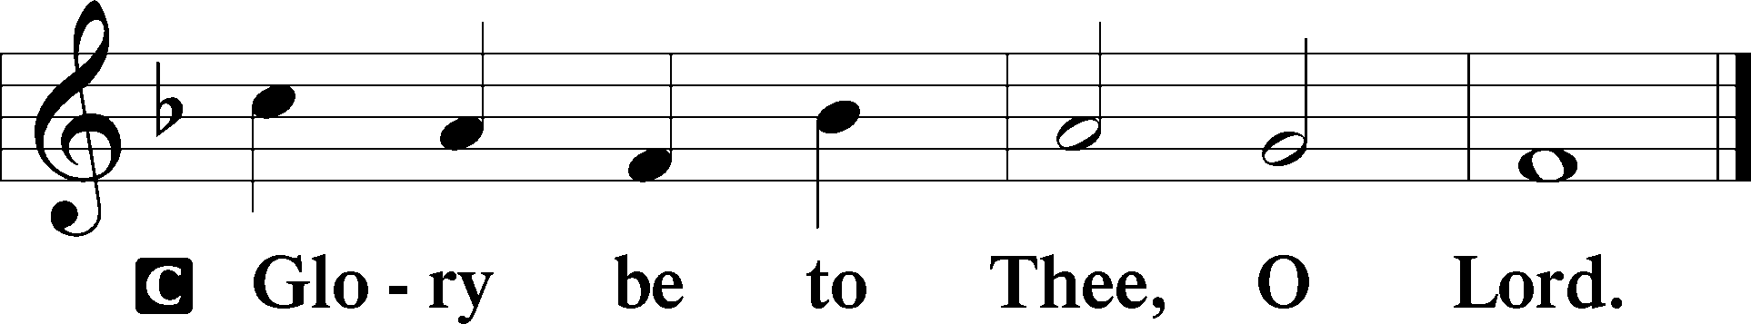

25Behold, a lawyer stood up to put [Jesus] to the test, saying, “Teacher, what shall I do to inherit eternal life?” 26He said to him, “What is written in the Law? How do you read it?” 27And he answered, “You shall love the Lord your God with all your heart and with all your soul and with all your strength and with all your mind, and your neighbor as yourself.” 28And he said to him, “You have answered correctly; do this, and you will live.”

29But he, desiring to justify himself, said to Jesus, “And who is my neighbor?” 30Jesus replied, “A man was going down from Jerusalem to Jericho, and he fell among robbers, who stripped him and beat him and departed, leaving him half dead. 31Now by chance a priest was going down that road, and when he saw him he passed by on the other side. 32So likewise a Levite, when he came to the place and saw him, passed by on the other side. 33But a Samaritan, as he journeyed, came to where he was, and when he saw him, he had compassion. 34He went to him and bound up his wounds, pouring on oil and wine. Then he set him on his own animal and brought him to an inn and took care of him. 35And the next day he took out two denarii and gave them to the innkeeper, saying, ‘Take care of him, and whatever more you spend, I will repay you when I come back.’ 36Which of these three, do you think, proved to be a neighbor to the man who fell among the robbers?” 37He said, “The one who showed him mercy.” And Jesus said to him, “You go, and do likewise.”

P This is the Gospel of the Lord.

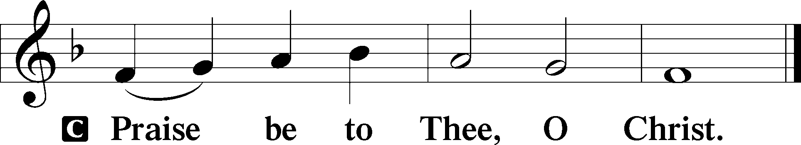

Apostles’ Creed

C **I believe in God, the Father Almighty,**

**maker of heaven and earth.**

**And in Jesus Christ, His only Son, our Lord,**

**who was conceived by the Holy Spirit,**

**born of the virgin Mary,**

**suffered under Pontius Pilate,**

**was crucified, died and was buried.**

**He descended into hell.**

**The third day He rose again from the dead.**

**He ascended into heaven**

**and sits at the right hand of God the Father Almighty.**

**From thence He will come to judge the living and the dead.**

**I believe in the Holy Spirit,**

**the holy Christian Church,**

**the communion of saints,**

**the forgiveness of sins,**

**the resurrection of the body,**

**and the life** T **everlasting. Amen.**

Sit

Children's Sermon

869 With the Lord Begin Your Task

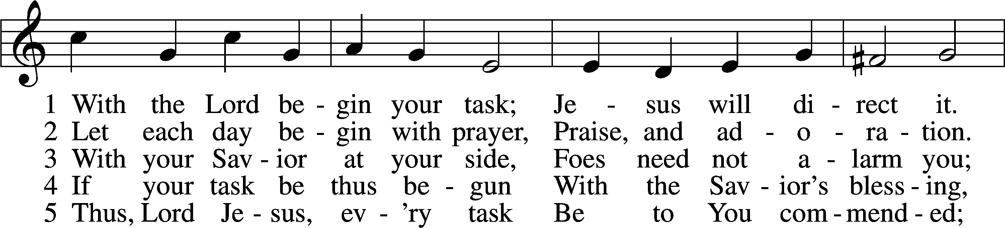

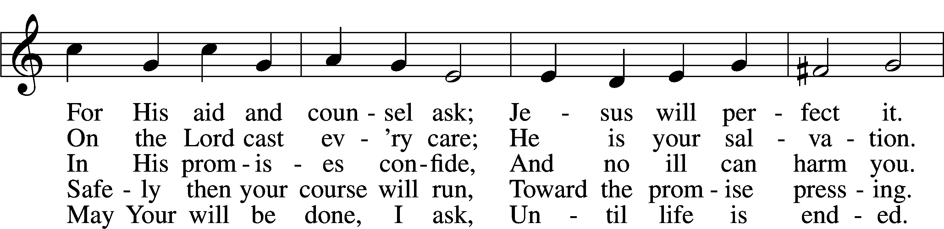

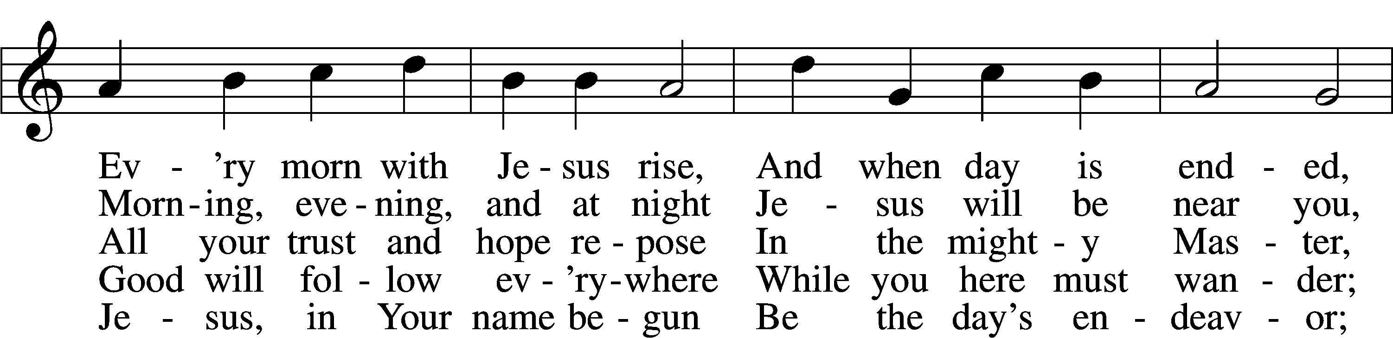

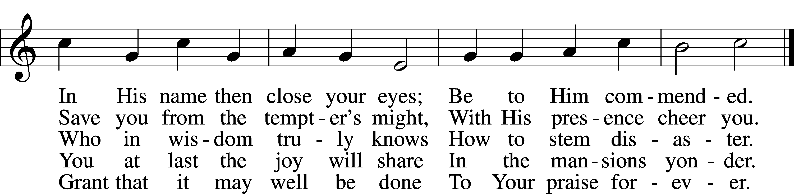

Text: Morgen- und Abend-segen, 1734, Waldenburg; tr. W. Gustave Polack, 1890–1950, alt.  
Tune: Peter Frank, 1616–75  
Text: © 1941 Concordia Publishing House. Used by permission: LSB Hymn License no. 110005011  
Tune: Public domain

Sermon

Votum

P The peace of God, which passes all understanding, keep your hearts and minds in Christ Jesus.

C **Amen.**

Stand

Offertory Psalm 51:10–12

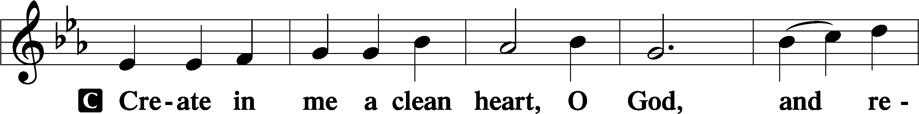

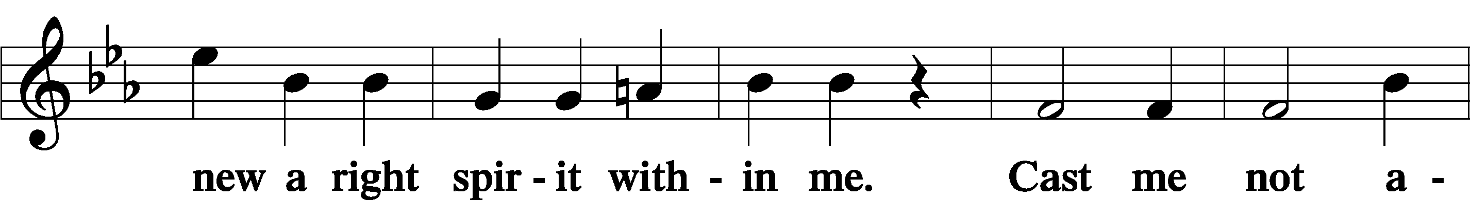

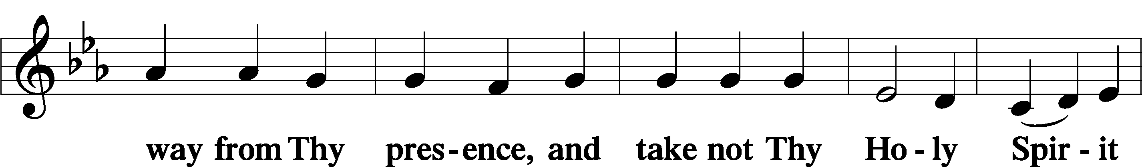

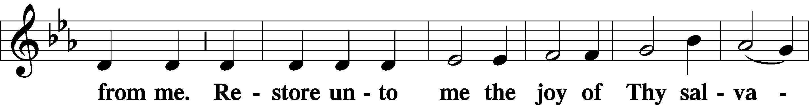

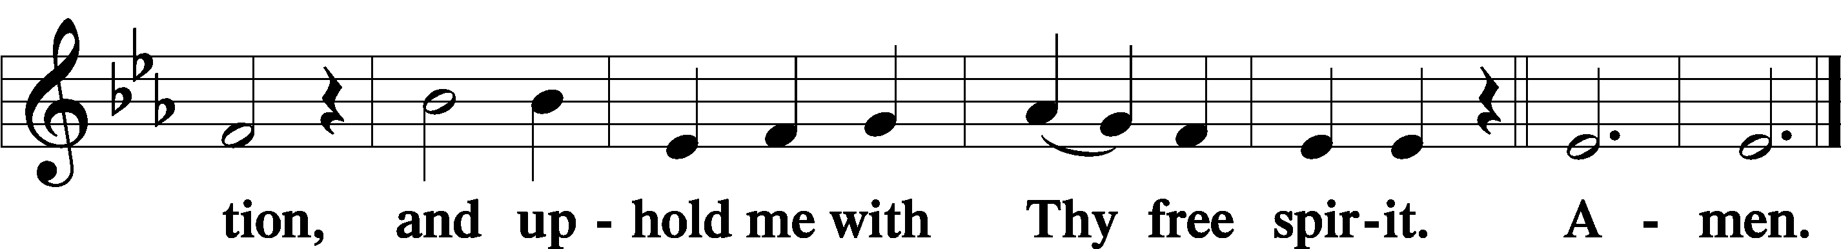

Offering

805 Praise God, from Whom All Blessings Flow

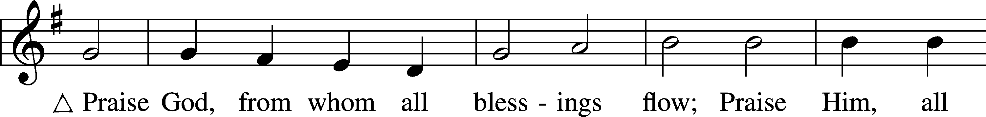

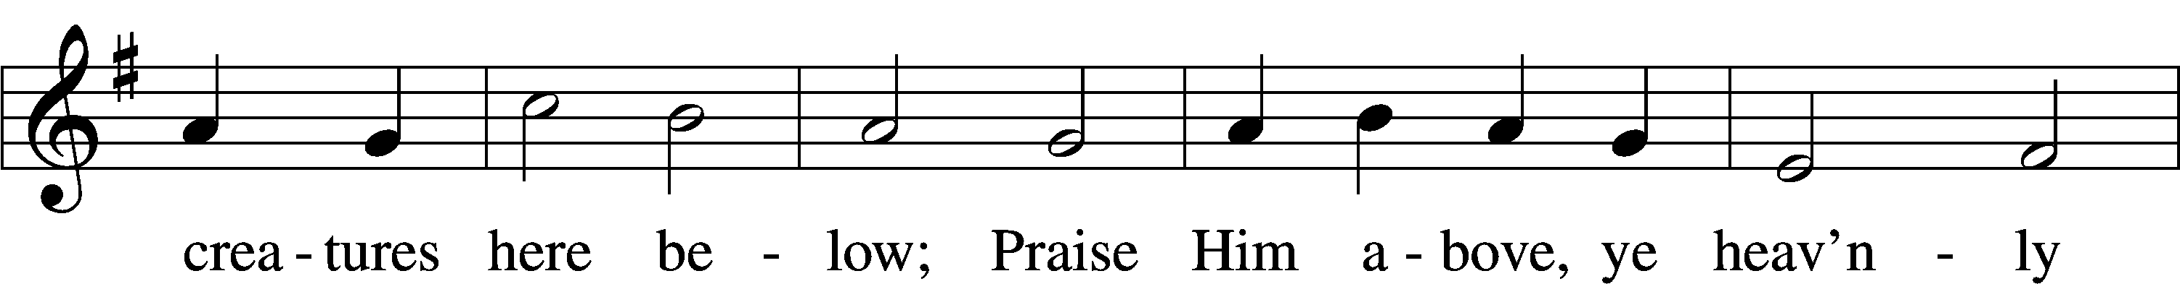

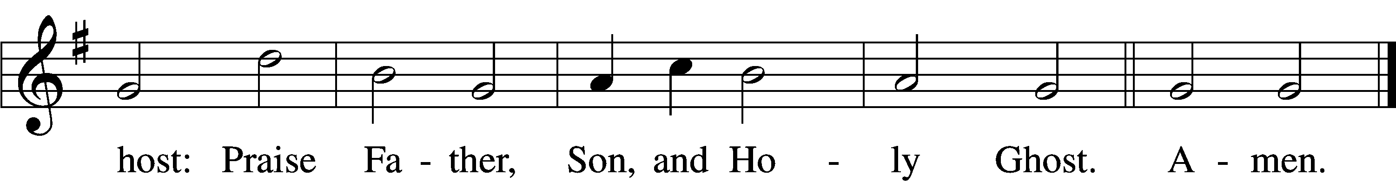

Text: Thomas Ken, 1637–1711  
Tune: Trente quatre Pseaumes de David, 1551, Geneva, ed. Louis Bourgeois  
Text and tune: Public domain

Prayer of the Church

Lord’s Prayer Matthew 6:9–13

P Lord, remember us in Your kingdom and teach us to pray:

C **Our Father who art in heaven,**

**hallowed be Thy name,**

**Thy kingdom come,**

**Thy will be done on earth**

**as it is in heaven;**

**give us this day our daily bread;**

**and forgive us our trespasses**

**as we forgive those**

**who trespass against us;**

**and lead us not into temptation,**

**but deliver us from evil.**

**For Thine is the kingdom**

**and the power and the glory**

**forever and ever. Amen.**

Collect for the Word

Blessed Lord, You have caused all Holy Scriptures to be written for our learning. Grant that we may so hear them, read, mark, learn, and inwardly digest them that, by the patience and comfort of Your holy Word, we may embrace and ever hold fast the blessed hope of everlasting life; through Jesus Christ, Your Son, our Lord, who lives and reigns with You and the Holy Spirit, one God, now and forever.

Benediction

P The Lord bless you and keep you.

The Lord make His face shine on you and be gracious to you.

The Lord look upon you with favor and T give you peace.

C **Amen.**

549 All Hail the Power of Jesus’ Name

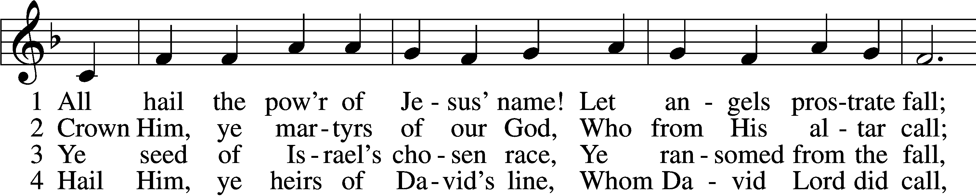

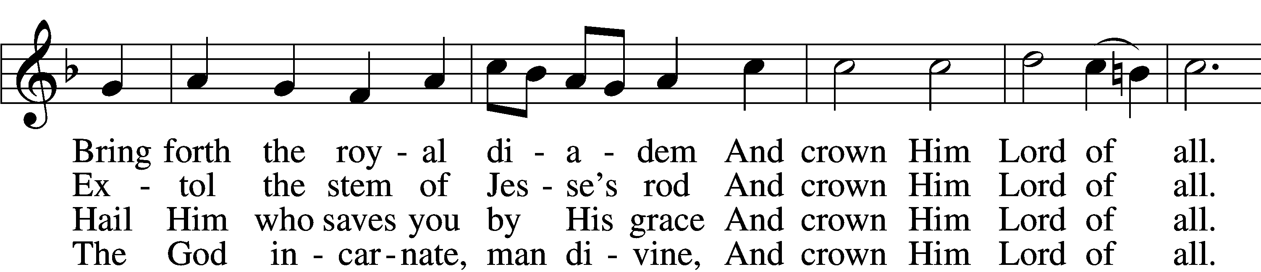

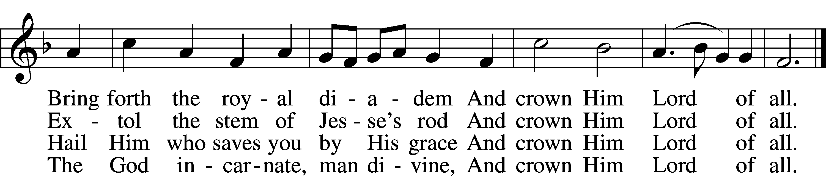

5 Sinners, whose love can ne’er forget  
 The wormwood and the gall,  
Go, spread your trophies at His feet  
 And crown Him Lord of all.  
Go, spread your trophies at His feet  
 And crown Him Lord of all.

6 Let ev’ry kindred, ev’ry tribe,  
 On this terrestrial ball  
To Him all majesty ascribe  
 And crown Him Lord of all.  
To Him all majesty ascribe  
 And crown Him Lord of all.

7 Oh, that with yonder sacred throng  
 We at His feet may fall!  
We’ll join the everlasting song  
 And crown Him Lord of all.  
We’ll join the everlasting song  
 And crown Him Lord of all.

Text (sts. 1–5): Edward Perronet, 1726–92, alt.; (sts. 6–7): A Selection of Hymns, 1787, London, alt.  
Tune: Oliver Holden, 1765–1844  
Text and tune: Public domain

Acknowledgments

Unless otherwise indicated, Scripture quotations are from the ESV® Bible (The Holy Bible, English Standard Version®), copyright © 2001 by Crossway, a publishing ministry of Good News Publishers. Used by permission. All rights reserved.

Created by Lutheran Service Builder © 2025 Concordia Publishing House.