On entering the church

P Lord, I love the habitation of Your house and the place
where Your glory dwells. In the multitude of Your tender
mercies prepare my heart that I may enter Your house to
worship and confess Your holy name; through Jesus Christ,
my God and Lord.

Before worship

C O Lord, our creator, redeemer, and comforter, as we come
together to worship You in spirit and in truth, we humbly
pray that You would open our hearts to the preaching of
Your Word so that we may repent of our sins, believe in
Jesus Christ as our only Savior, and grow in grace and
holiness. Hear us for His sake.

664 Fight the Good Fight
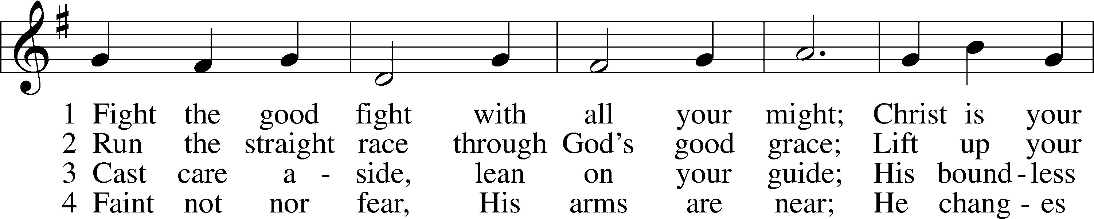
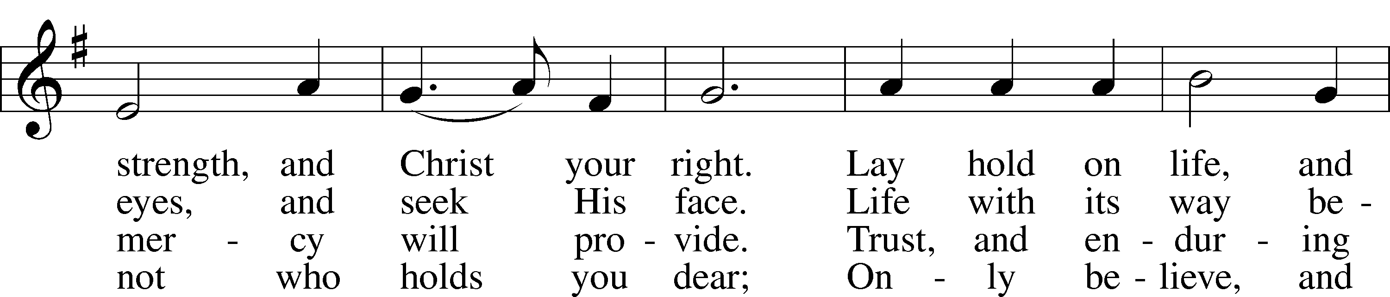
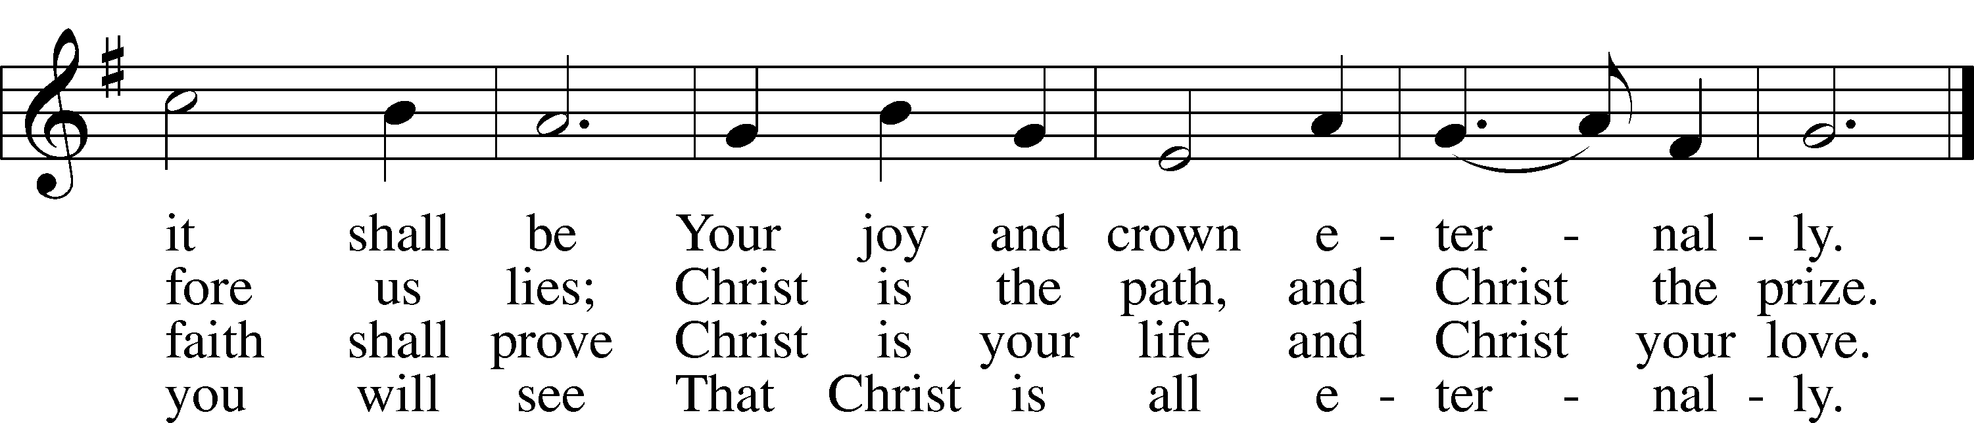
Text: John S. B. Monsell, 1811–75, alt.
Tune: The Methodist Harmonist, 1821, New York
Text and tune: Public domain
Confession and Absolution

Stand

The sign of the cross may be made by all in remembrance of their Baptism.

Invocation Matthew 28:19b; 18:20
P In the name of the Father and of the T Son and of the Holy Spirit.
C Amen.

Exhortation Hebrews 10:22; Psalm 124:8; Psalm 32:5
P Beloved in the Lord! Let us draw near with a true heart and confess our sins unto God our Father, beseeching Him in the name of our Lord Jesus Christ to grant us forgiveness.

P Our help is in the name of the Lord,
C who made heaven and earth.
P I said, I will confess my transgressions unto the Lord,
C and You forgave the iniquity of my sin.

Kneel/Stand

Silence for reflection on God’s Word and for self-examination.

Confession of Sins
P O almighty God, merciful Father,
C I, a poor, miserable sinner, confess unto You all my sins and iniquities with which I have ever offended You and justly deserved Your temporal and eternal punishment. But I am heartily sorry for them and sincerely repent of them, and I pray You of Your boundless mercy and for the sake of the holy, innocent, bitter sufferings and death of Your beloved Son, Jesus Christ, to be gracious and merciful to me, a poor, sinful being.

Absolution [John 20:19–23]
P Upon this your confession, I, by virtue of my office, as a called and ordained servant of the Word, announce the grace of God unto all of you, and in the stead and by the command of my Lord Jesus Christ I forgive you all your sins in the name of the Father and of the T Son and of the Holy Spirit.
C Amen.

Stand

Service of the Word
Introit Psalm 18:1–2a, 27, 32, 49; antiphon: vv. 5–6a
The cords of Sheol entangled me;
the snares of death confronted me.
In my distress I called upon the Lord.
From his temple he heard my voice.
I love you, O Lord, my strength.
The Lord is my rock and my fortress and my deliverer.
For you save a humble people,
but the haughty eyes you bring down.
[You have] equipped me with strength
and made my way blameless.
For this I will praise you, O Lord, among the nations,
and sing to your name.

Gloria Patri
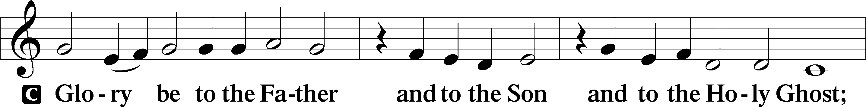
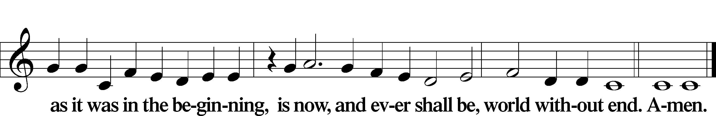

Kyrie Mark 10:47
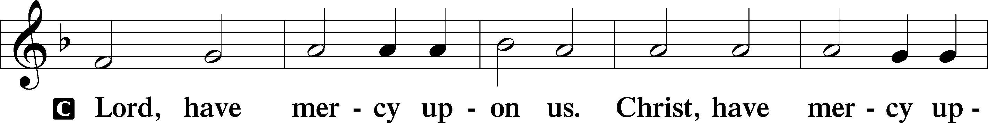
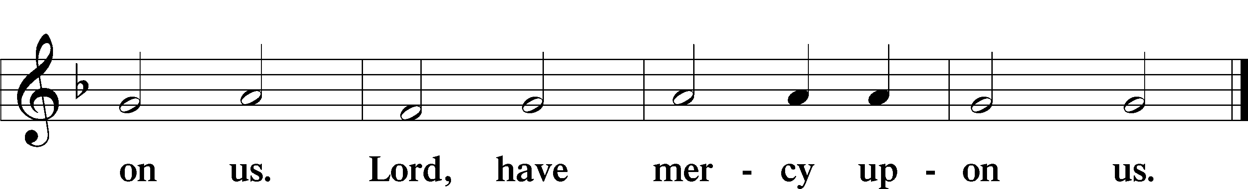

Salutation and Collect of the Day
P The Lord be with you.
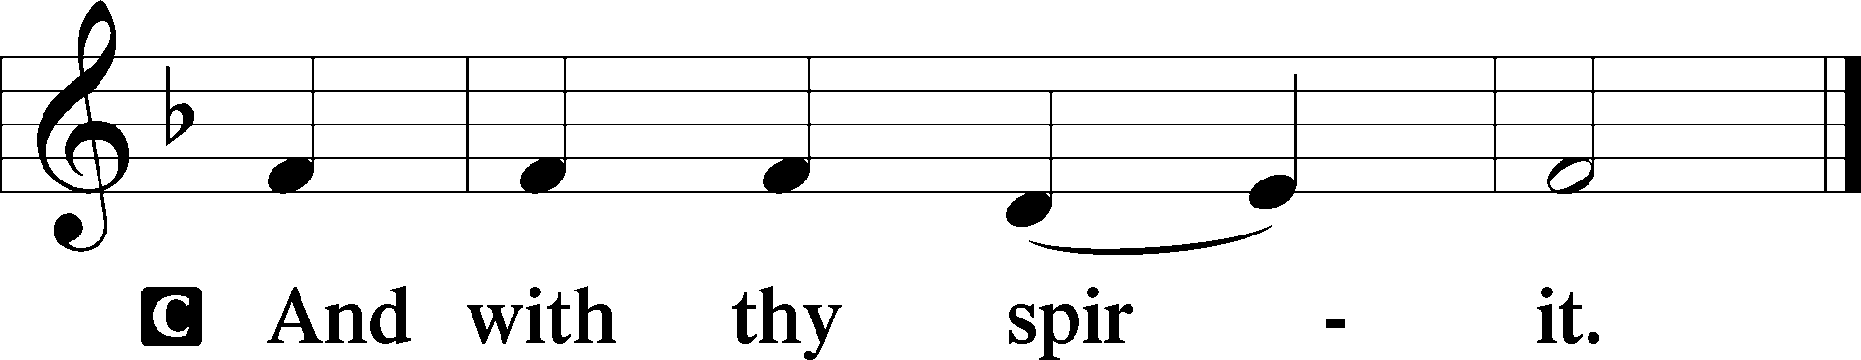

P Let us pray.
O Lord, graciously hear the prayers of Your people that we who justly suffer the consequence of our sin may be mercifully delivered by Your goodness to the glory of Your name; through Jesus Christ, Your Son, our Lord, who lives and reigns with You and the Holy Spirit, one God, now and forever.

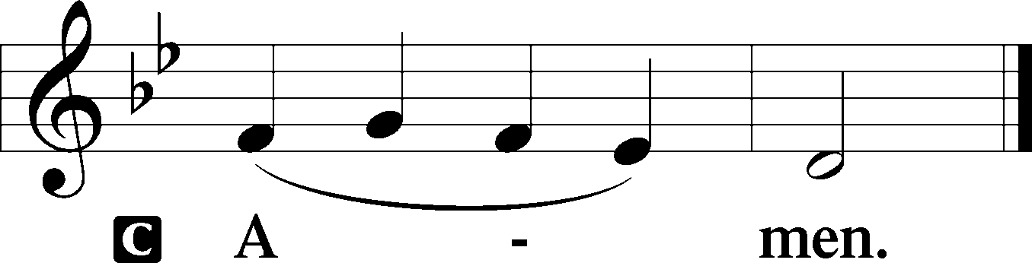

Sit

Old Testament Reading Exodus 17:1–7
1All the congregation of the people of Israel moved on from the wilderness of Sin by stages, according to the commandment of the Lord, and camped at Rephidim, but there was no water for the people to drink. 2Therefore the people quarreled with Moses and said, “Give us water to drink.” And Moses said to them, “Why do you quarrel with me? Why do you test the Lord?” 3But the people thirsted there for water, and the people grumbled against Moses and said, “Why did you bring us up out of Egypt, to kill us and our children and our livestock with thirst?” 4So Moses cried to the Lord, “What shall I do with this people? They are almost ready to stone me.” 5And the Lord said to Moses, “Pass on before the people, taking with you some of the elders of Israel, and take in your hand the staff with which you struck the Nile, and go. 6Behold, I will stand before you there on the rock at Horeb, and you shall strike the rock, and water shall come out of it, and the people will drink.” And Moses did so, in the sight of the elders of Israel. 7And he called the name of the place Massah and Meribah, because of the quarreling of the people of Israel, and because they tested the Lord by saying, “Is the Lord among us or not?”

A This is the Word of the Lord.
C Thanks be to God.

Gradual Psalm 9:9–10, 18–19a
The Lord is a stronghold for the oppressed,
a stronghold in times of trouble.
And those who know your name put their trust in you,
for you, O Lord, have not forsaken those who seek you.
For the needy shall not always be forgotten,
and the hope of the poor shall not perish forever.
Arise, O Lord!
Let not man prevail.

Epistle 1 Corinthians 9:24—10:5
24Do you not know that in a race all the runners compete, but only one receives the prize? So run that you may obtain it. 25Every athlete exercises self-control in all things. They do it to receive a perishable wreath, but we an imperishable. 26So I do not run aimlessly; I do not box as one beating the air. 27But I discipline my body and keep it under control, lest after preaching to others I myself should be disqualified.
1I want you to know, brothers, that our fathers were all under the cloud, and all passed through the sea, 2and all were baptized into Moses in the cloud and in the sea, 3and all ate the same spiritual food, 4and all drank the same spiritual drink. For they drank from the spiritual Rock that followed them, and the Rock was Christ. 5Nevertheless, with most of them God was not pleased, for they were overthrown in the wilderness.

A This is the Word of the Lord.
C Thanks be to God.

Stand

Holy Gospel Matthew 20:1–16
P The Holy Gospel according to St. Matthew, the twentieth chapter.

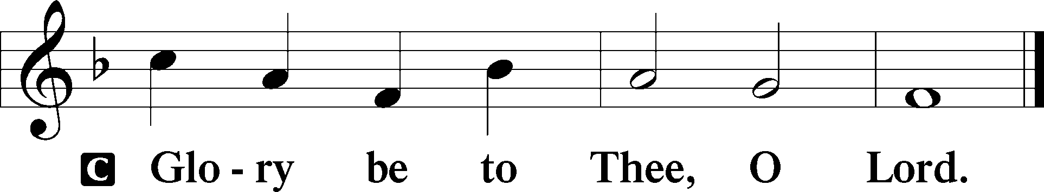

1[Jesus said:] “The kingdom of heaven is like a master of a house who went out early in the morning to hire laborers for his vineyard. 2After agreeing with the laborers for a denarius a day, he sent them into his vineyard. 3And going out about the third hour he saw others standing idle in the marketplace, 4and to them he said, ‘You go into the vineyard too, and whatever is right I will give you.’ 5So they went. Going out again about the sixth hour and the ninth hour, he did the same. 6And about the eleventh hour he went out and found others standing. And he said to them, ‘Why do you stand here idle all day?’ 7They said to him, ‘Because no one has hired us.’ He said to them, ‘You go into the vineyard too.’ 8And when evening came, the owner of the vineyard said to his foreman, ‘Call the laborers and pay them their wages, beginning with the last, up to the first.’ 9And when those hired about the eleventh hour came, each of them received a denarius. 10Now when those hired first came, they thought they would receive more, but each of them also received a denarius. 11And on receiving it they grumbled at the master of the house, 12saying, ‘These last worked only one hour, and you have made them equal to us who have borne the burden of the day and the scorching heat.’ 13But he replied to one of them, ‘Friend, I am doing you no wrong. Did you not agree with me for a denarius? 14Take what belongs to you and go. I choose to give to this last worker as I give to you. 15Am I not allowed to do what I choose with what belongs to me? Or do you begrudge my generosity?’ 16So the last will be first, and the first last.”

P This is the Gospel of the Lord.

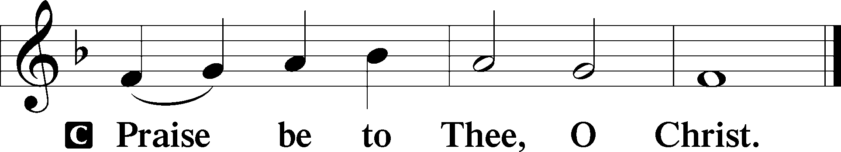

Nicene Creed
C I believe in one God,
the Father Almighty,
maker of heaven and earth
and of all things visible and invisible.

And in one Lord Jesus Christ,
the only-begotten Son of God,
begotten of His Father before all worlds,
God of God, Light of Light,
very God of very God,
begotten, not made,
being of one substance with the Father,
by whom all things were made;
who for us men and for our salvation came down from heaven
and was incarnate by the Holy Spirit of the virgin Mary
and was made man;
and was crucified also for us under Pontius Pilate.
He suffered and was buried.
And the third day He rose again according to the Scriptures
and ascended into heaven
and sits at the right hand of the Father.
And He will come again with glory to judge both the living and the dead,
whose kingdom will have no end.

And I believe in the Holy Spirit,
the Lord and giver of life,
who proceeds from the Father and the Son,
who with the Father and the Son together is worshiped and glorified,
who spoke by the prophets.
And I believe in one holy Christian and apostolic Church,
I acknowledge one Baptism for the remission of sins,
and I look for the resurrection of the dead
and the life T of the world to come. Amen.

Sit

Children's Sermon

648 Glorious Things of You Are Spoken
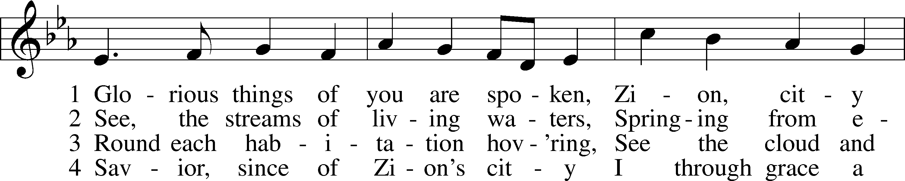
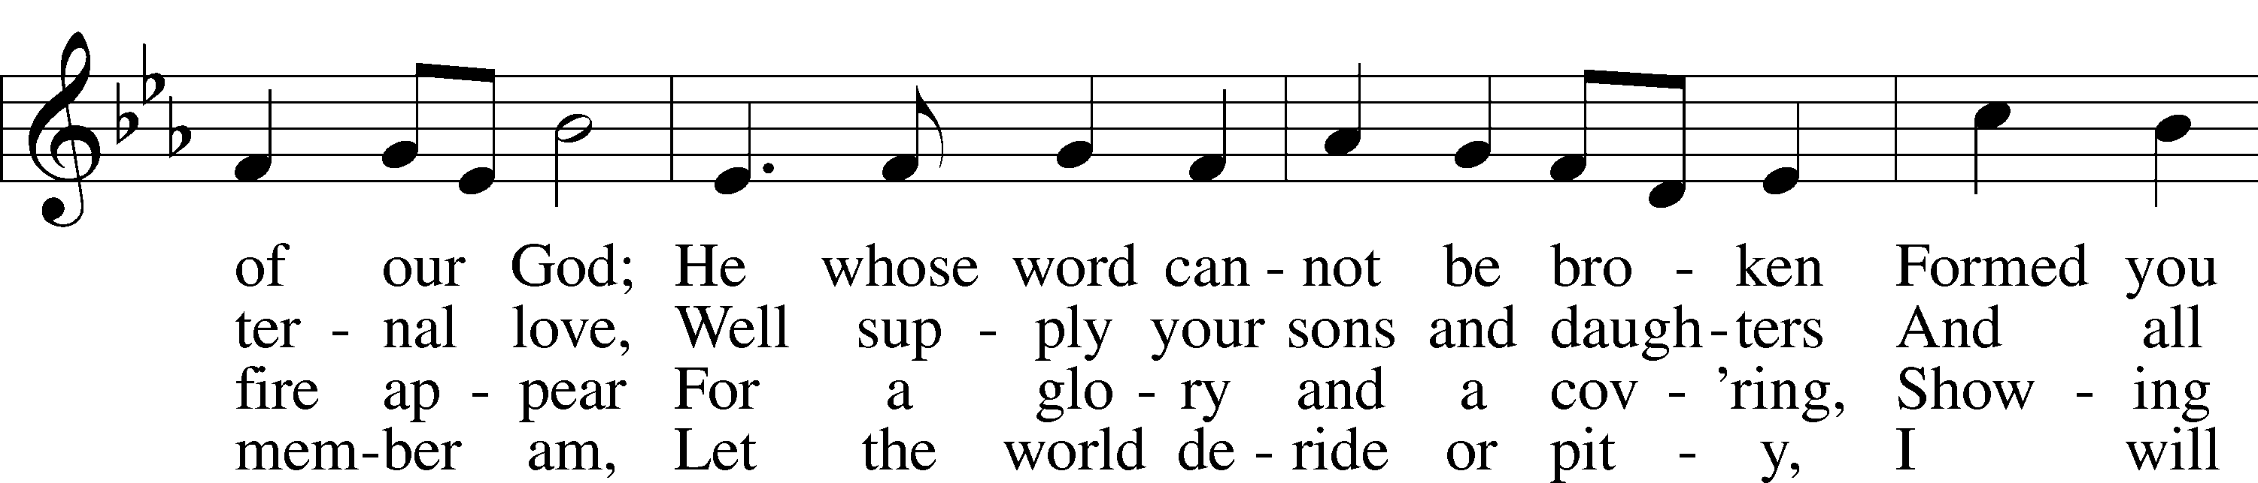
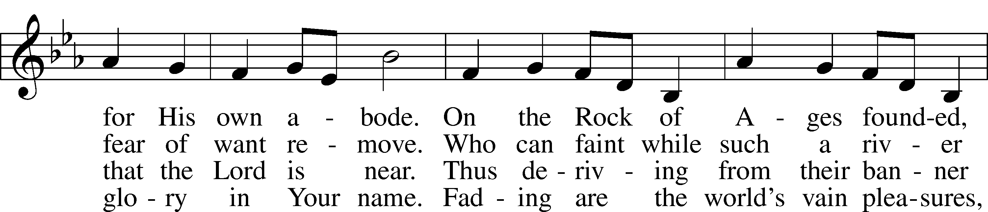
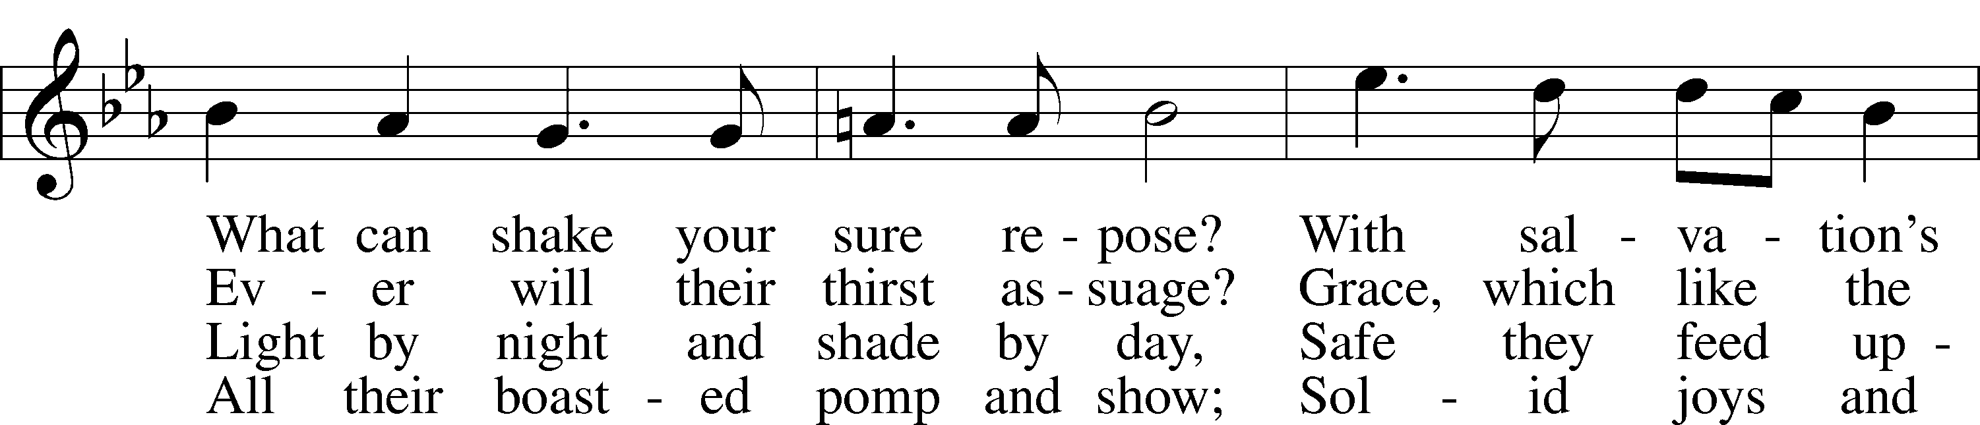
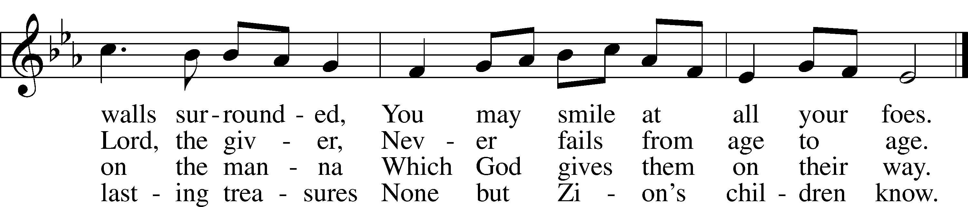
Text: John Newton, 1725–1807, alt.
Tune: Franz Joseph Haydn, 1732–1809
Text and tune: Public domain

Sermon

Votum
P The peace of God, which passes all understanding, keep your hearts and minds in Christ Jesus.
C Amen.

Stand

Offertory Psalm 51:10–12
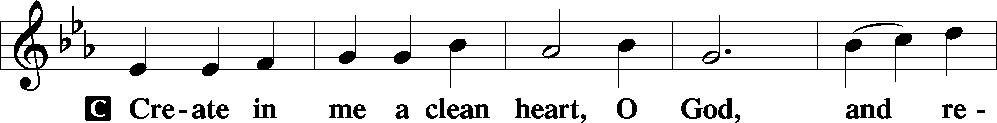
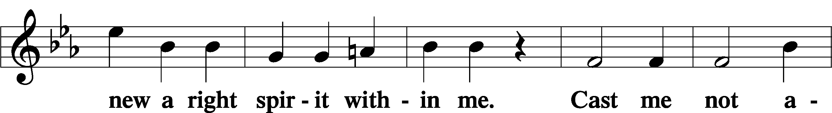
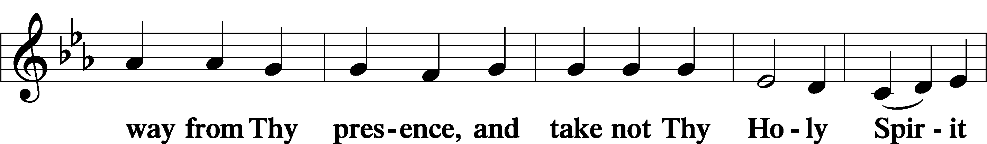
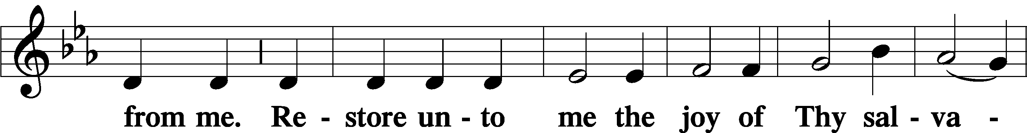
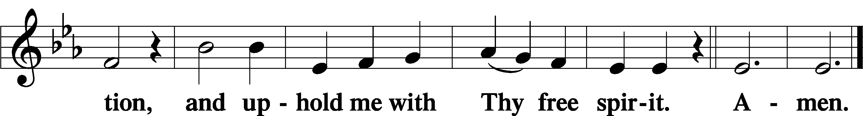

Sit

Offering

805 Praise God, from Whom All Blessings Flow
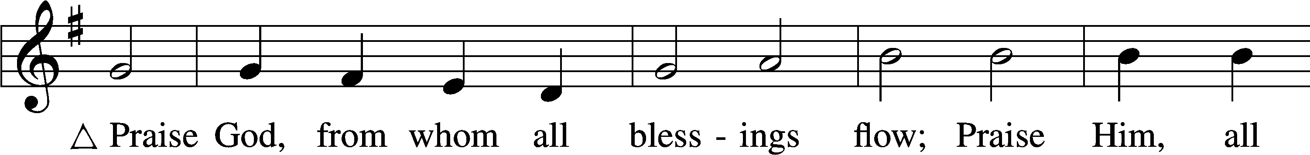
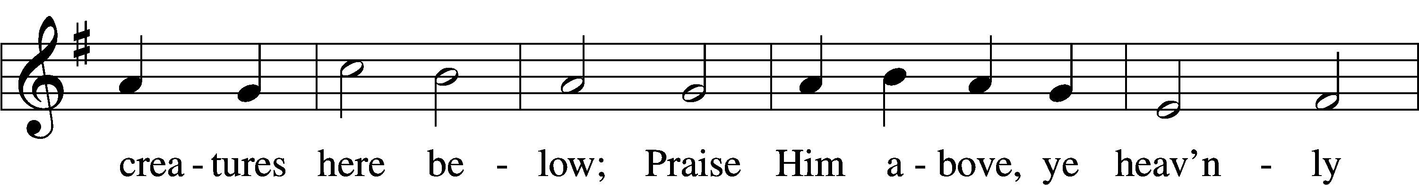
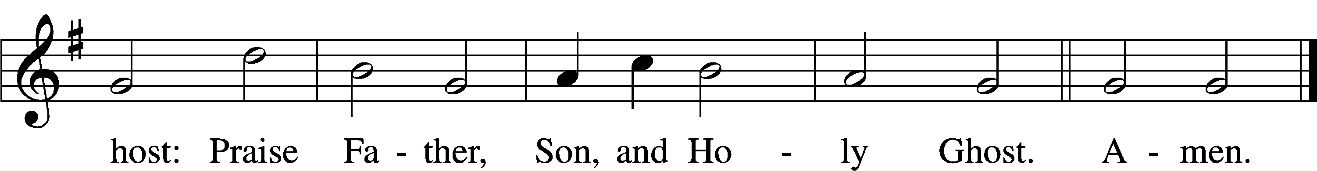
Text: Thomas Ken, 1637–1711
Tune: Trente quatre Pseaumes de David, 1551, Geneva, ed. Louis Bourgeois
Text and tune: Public domain

Stand

Prayer of the Church

Service of the Sacrament

Preface 2 Timothy 4:22; [Colossians 3:1]; [Psalm 136]
P The Lord be with you.
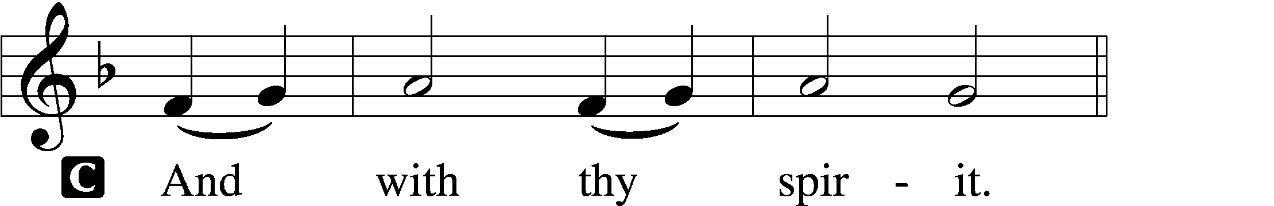

P Lift up your hearts.
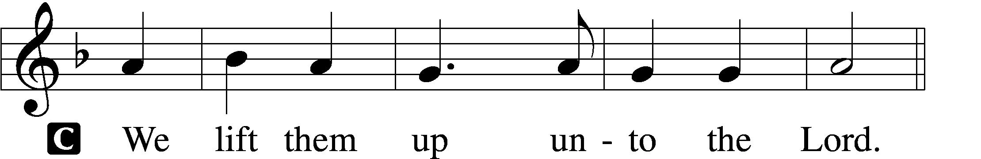

P Let us give thanks unto the Lord, our God.
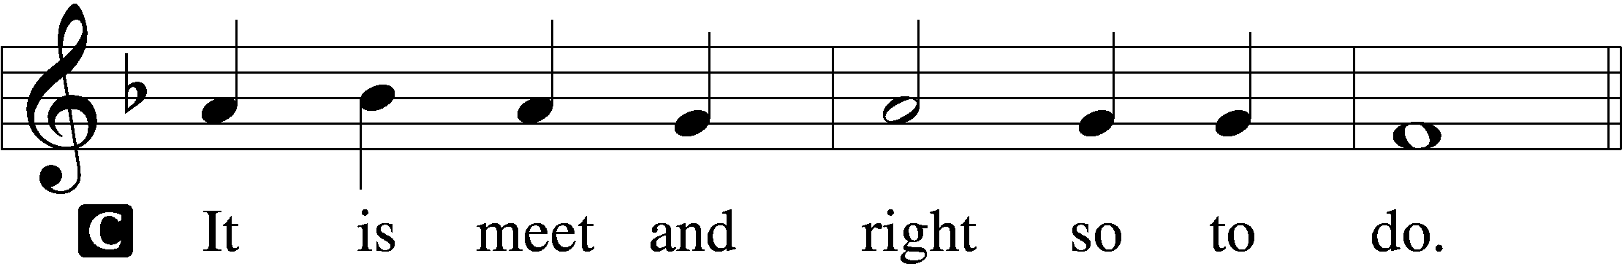

Proper Preface (Full)
P It is truly meet, right, and salutary that we should at all times and in all places give thanks to You, holy Lord, almighty Father, everlasting God, through Jesus Christ, our Lord; for what had been hidden from before the foundation of the world You have made known to the nations in Your Son. In Him, being found in the substance of our mortal nature, You have manifested the fullness of Your glory. Therefore with angels and archangels and with all the company of heaven we laud and magnify Your glorious name, evermore praising You and saying:

Sanctus Isaiah 6:3; Matthew 21:9
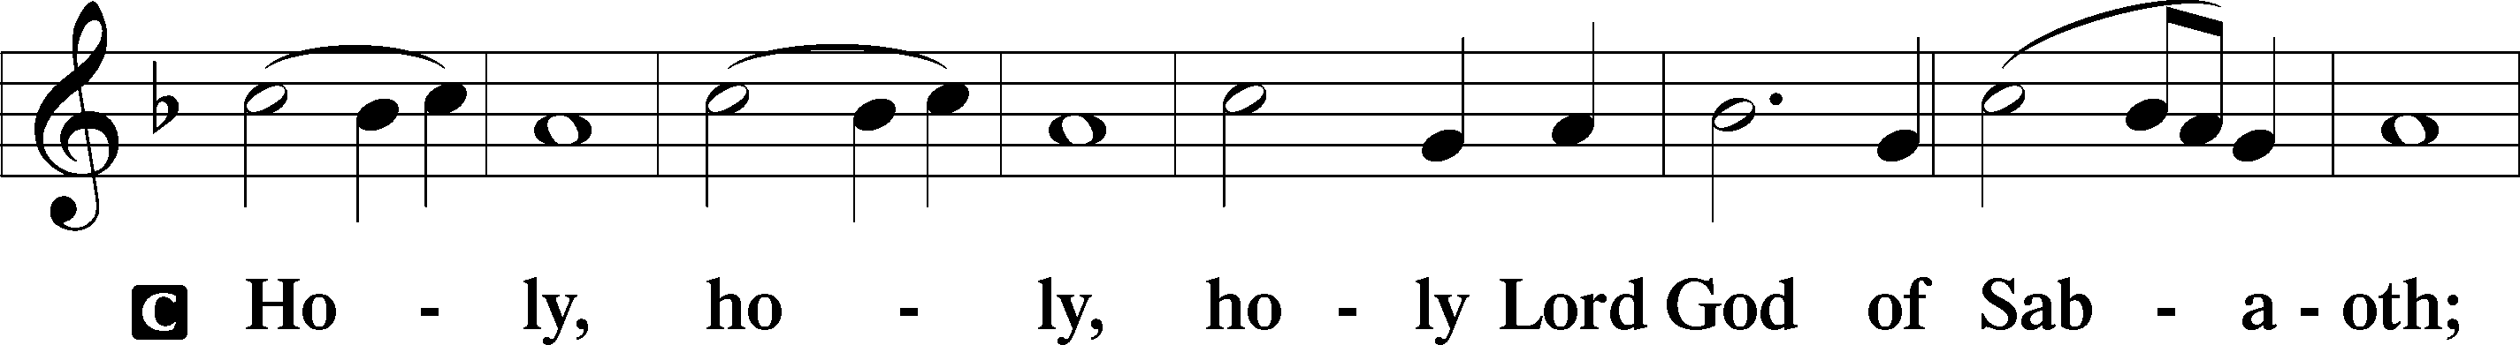
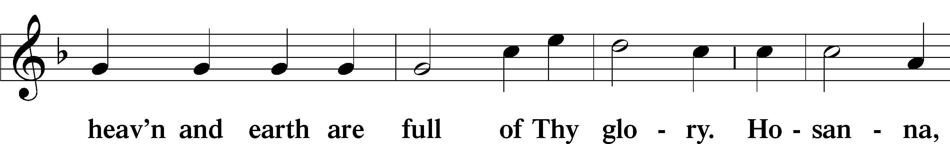
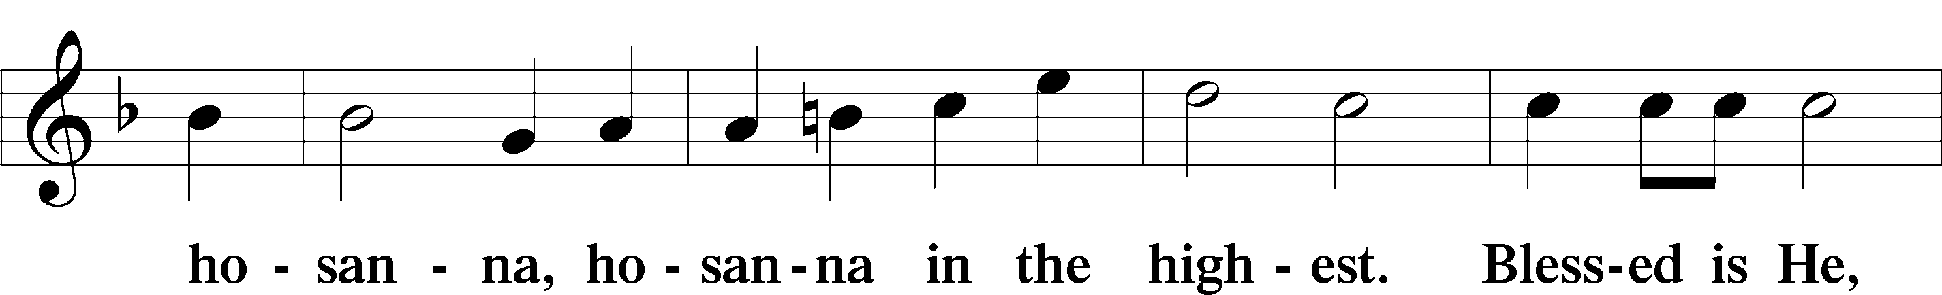
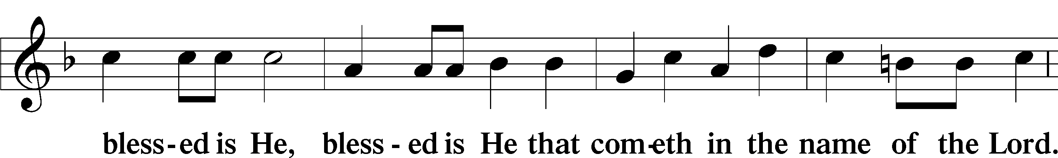
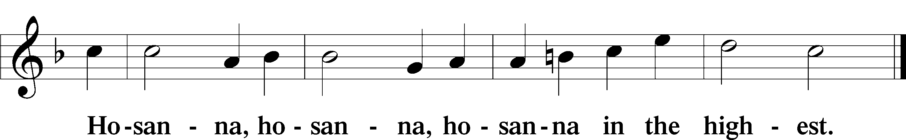

Lord’s Prayer Matthew 6:9–13
P Our Father who art in heaven,
hallowed be Thy name,
Thy kingdom come,
Thy will be done on earth as it is in heaven;
give us this day our daily bread;
and forgive us our trespasses as we forgive those who trespass against us;
and lead us not into temptation,
but deliver us from evil.
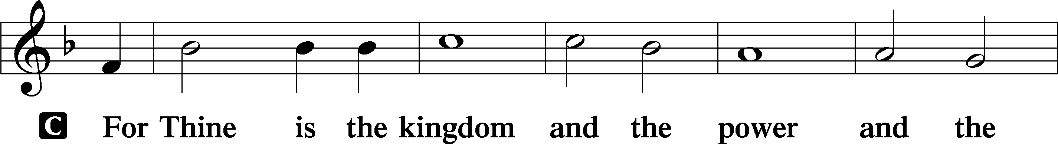
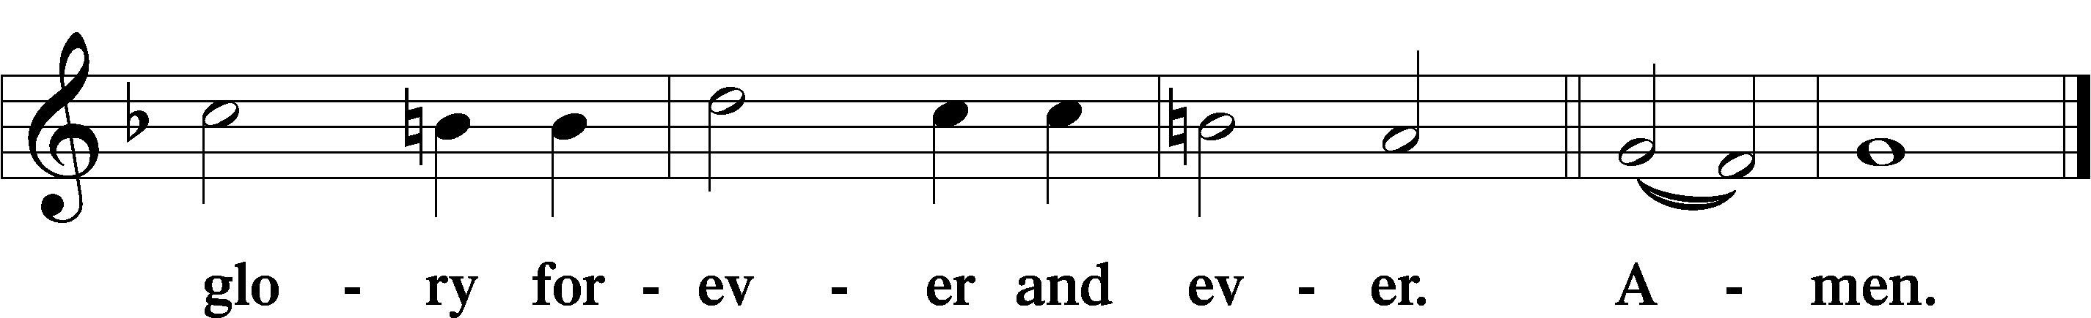

The Words of Our Lord Matthew 26:26–28; Mark 14:22–24; Luke 22:19–20; 1 Corinthians 11:23–25
P Our Lord Jesus Christ, on the night when He was betrayed, took bread, and when He had given thanks, He broke it and gave it to the disciples and said: “Take, eat; this is My T body, which is given for you. This do in remembrance of Me.”

In the same way also He took the cup after supper, and when He had given thanks, He gave it to them, saying: “Drink of it, all of you; this cup is the new testament in My T blood, which is shed for you for the forgiveness of sins. This do, as often as you drink it, in remembrance of Me.”

Pax Domini John 20:19
P The peace of the Lord be with you always.

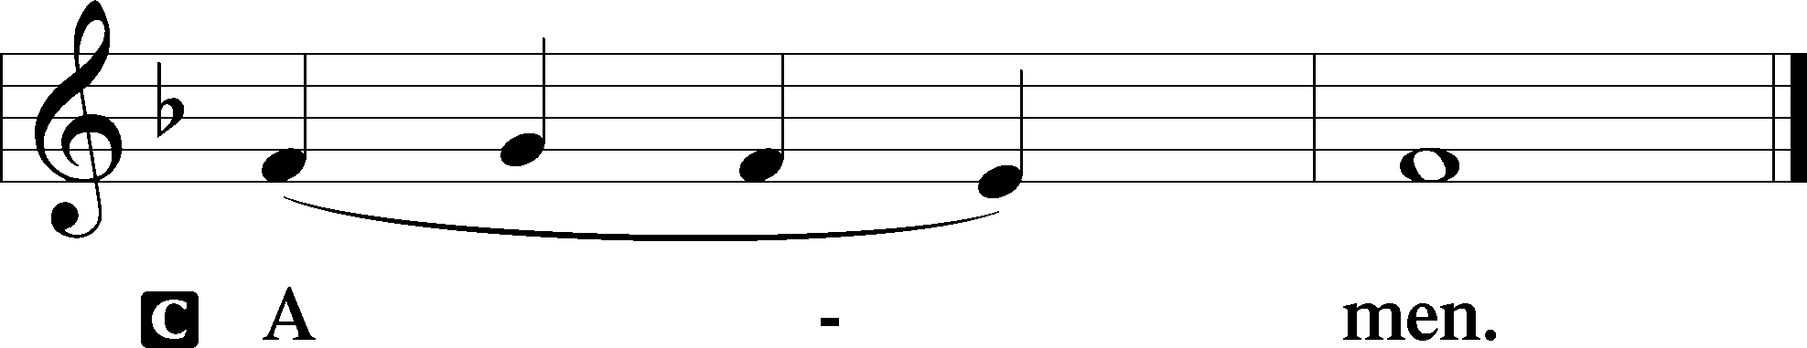

Agnus Dei John 1:29
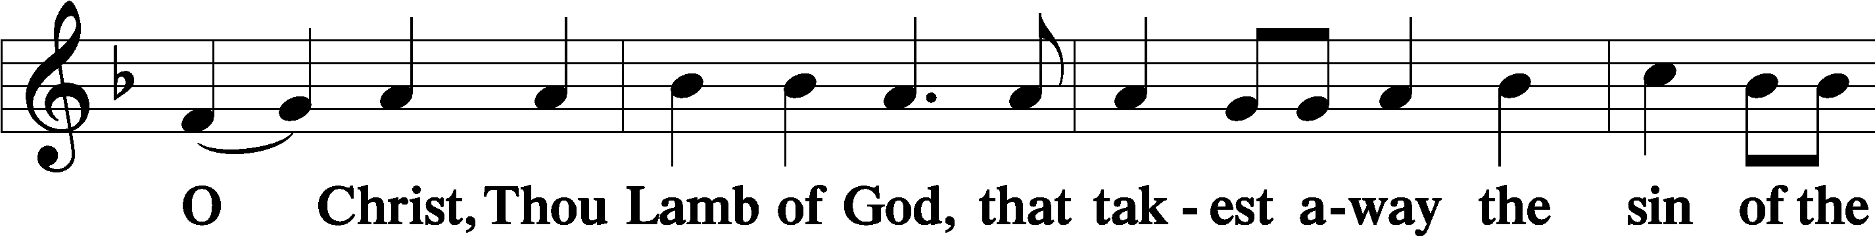
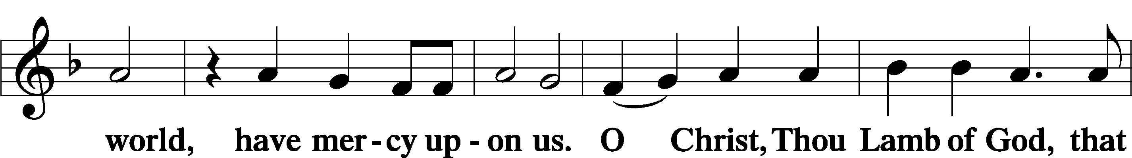
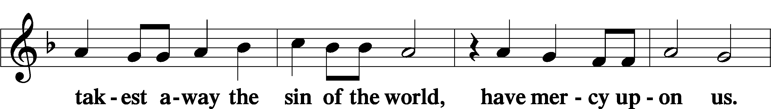
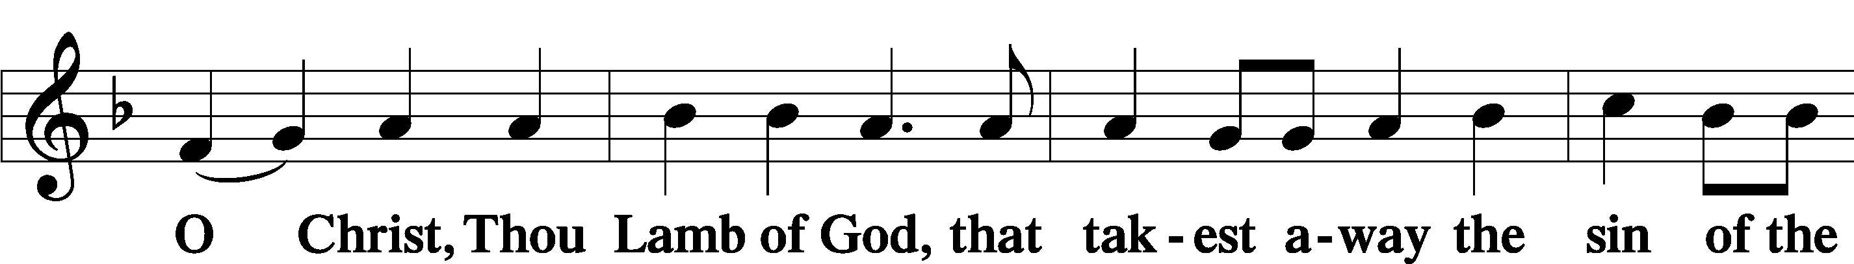
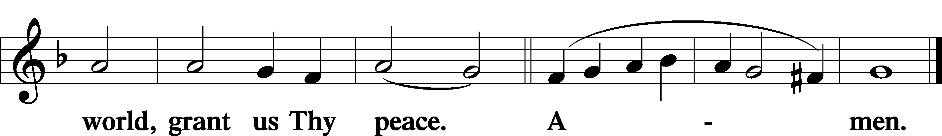

Sit

Distribution

The pastor and those who assist him receive the body and blood of Christ first and then distribute them to those who come to receive, saying:

Take, eat; this is the true body of our Lord and Savior Jesus Christ, given into death for your sins.
Amen.

Take, drink; this is the true blood of our Lord and Savior Jesus Christ, shed for the forgiveness of your sins.
Amen.

In dismissing the communicants, the following is said:

The Dismissal
P The body and blood of our Lord Jesus Christ strengthen and preserve you in body and soul to life everlasting. Depart T in peace.
C Amen.

826 Hark, the Voice of Jesus Crying
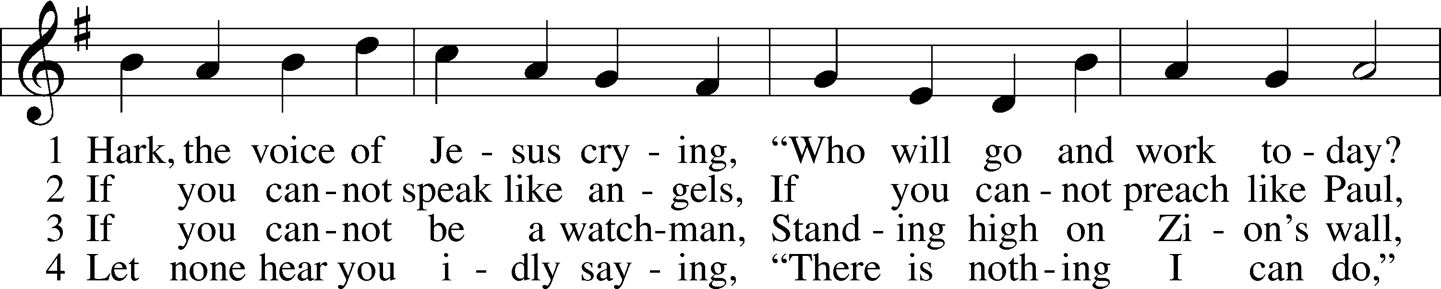
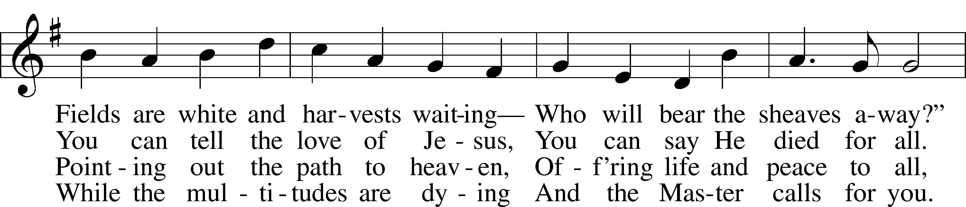
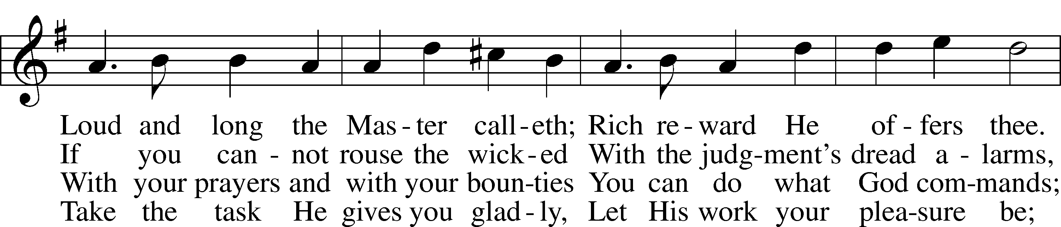
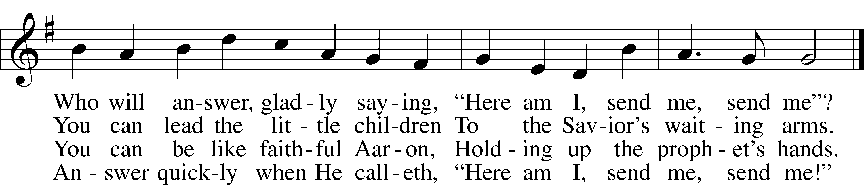
Text (sts. 1–2, 4): Daniel March, 1816–1909, alt.; (st. 3): unknown, alt.
Tune: Joseph Barnby, 1838–96
Text and tune: Public domain

628 Your Table I Approach
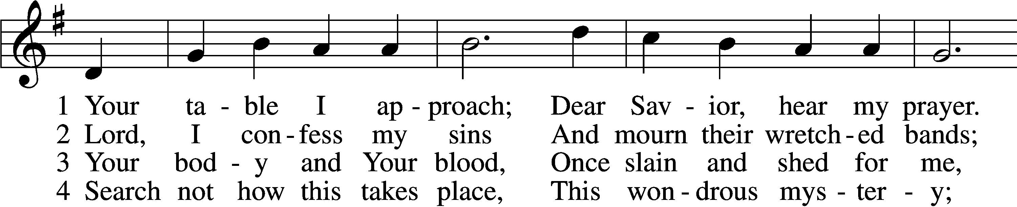
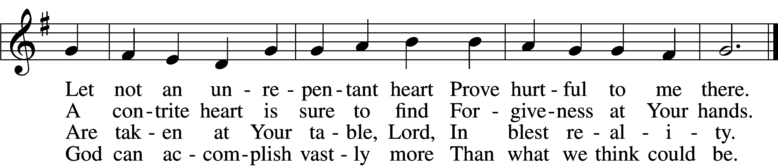

5 O grant, most blessèd Lord,
That earth and hell combined
May not about this sacrament
Raise doubt within my mind.

6 Oh, may I never fail
To thank You day and night
For Your true body and true blood,
O God, my peace and light.
Text: Gerhard Wolter Molanus, 1633–1722; tr. Matthias Loy, 1828–1915, alt.
Tune: Trente quatre Pseaumes de David, 1551, Geneva, ed. Louis Bourgeois
Text and tune: Public domain

633 At the Lamb’s High Feast We Sing
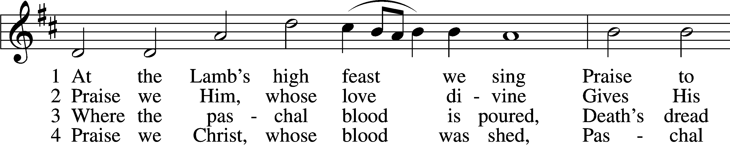
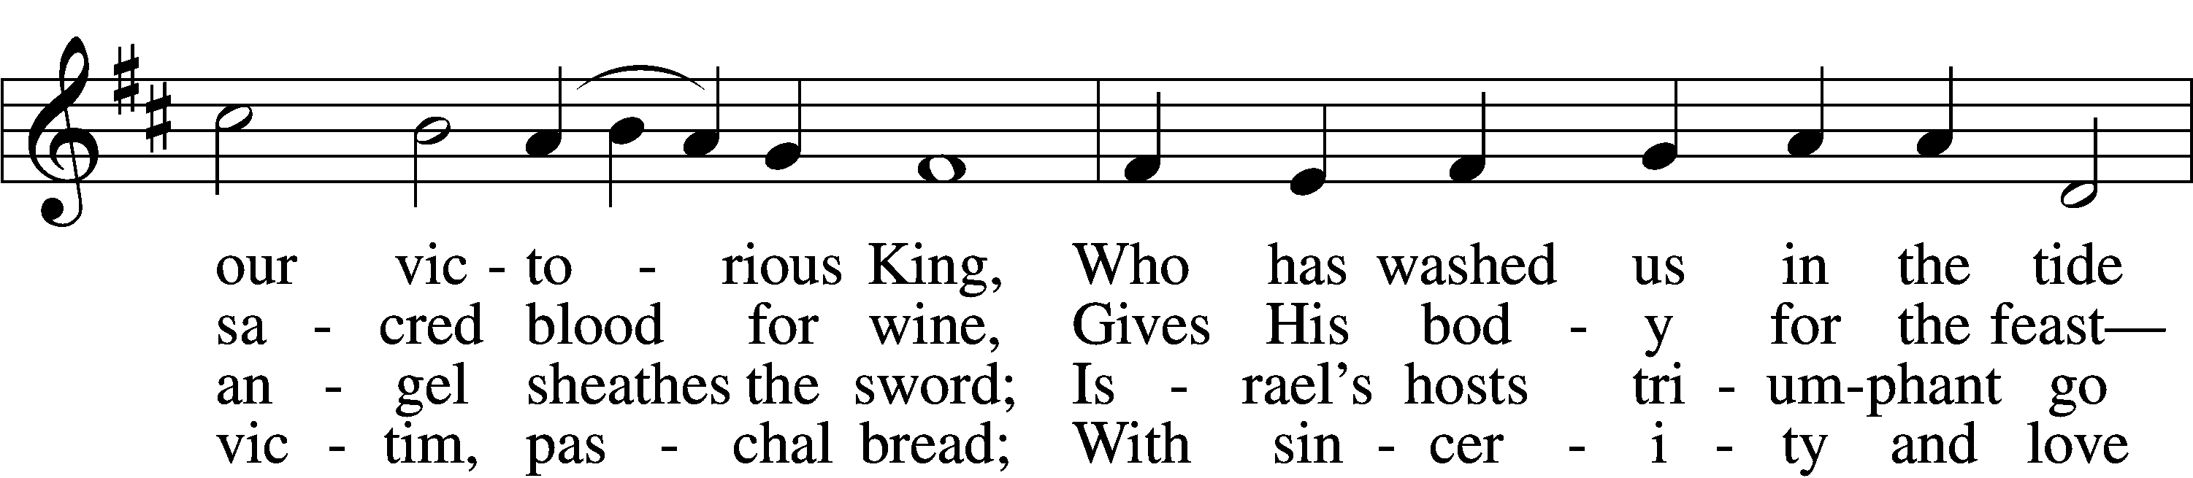
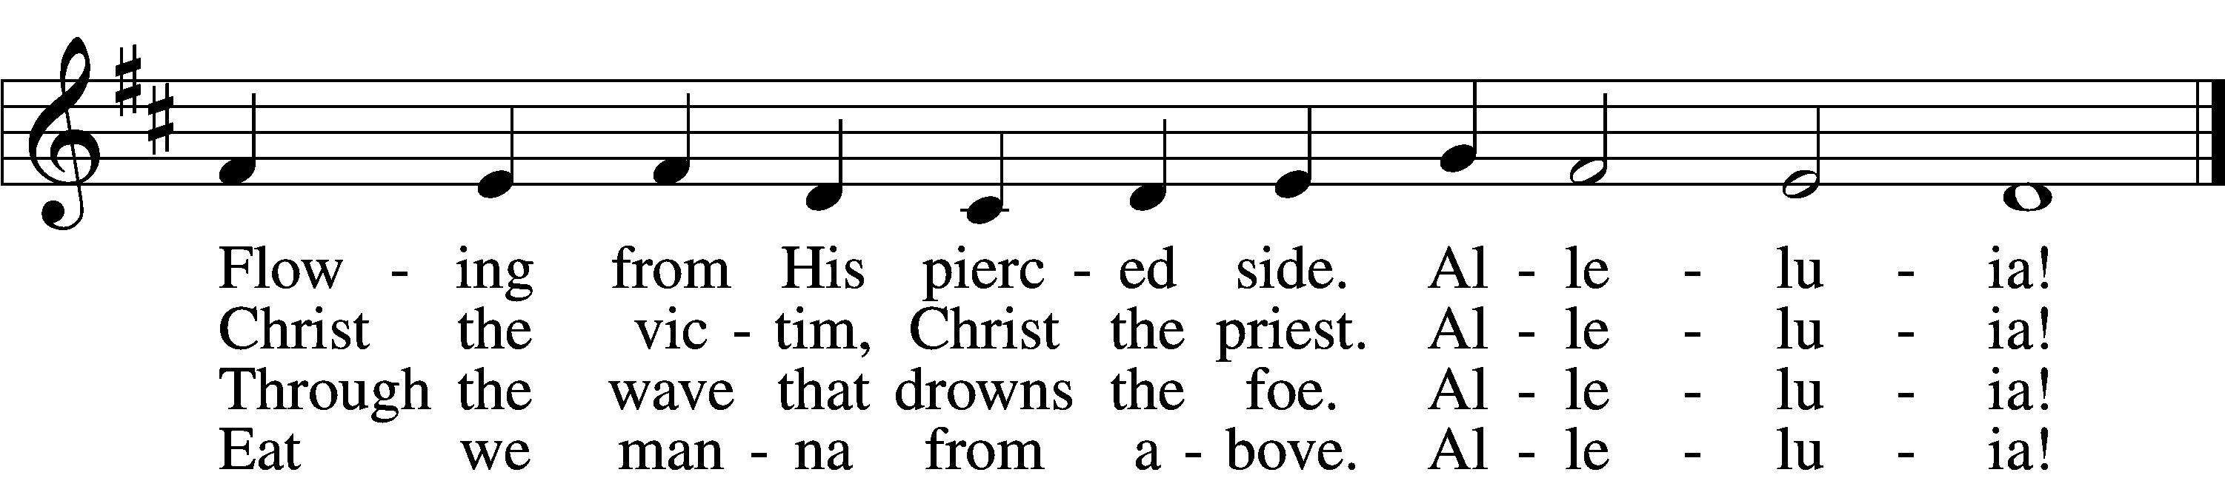

5 Mighty Victim from the sky,
Hell’s fierce pow’rs beneath You lie;
You have conquered in the fight,
You have brought us life and light.
Alleluia!

6 Now no more can death appall,
Now no more the grave enthrall;
You have opened paradise,
And Your saints in You shall rise.
Alleluia!

7 Easter triumph, Easter joy!
This alone can sin destroy;
From sin’s pow’r, Lord, set us free,
Newborn souls in You to be.
Alleluia!

D 8 Father, who the crown shall give,
Savior, by whose death we live,
Spirit, guide through all our days:
Three in One, Your name we praise.
Alleluia!
Text: Latin, c. 5th–10th cent.; tr. Robert Campbell, 1814–68, alt.
Tune: Kirchengeseng, 1566, Ivancice
Text and tune: Public domain

643 Sent Forth by God’s Blessing
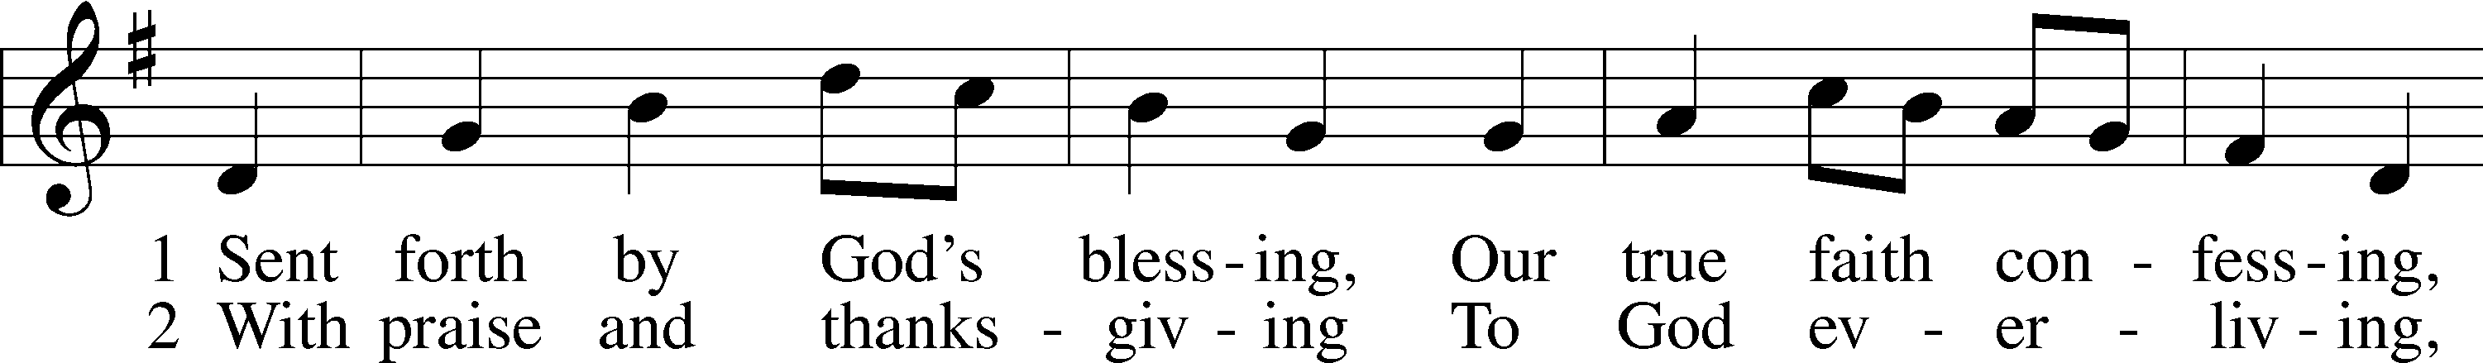
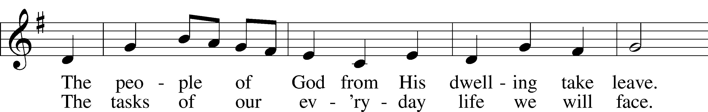
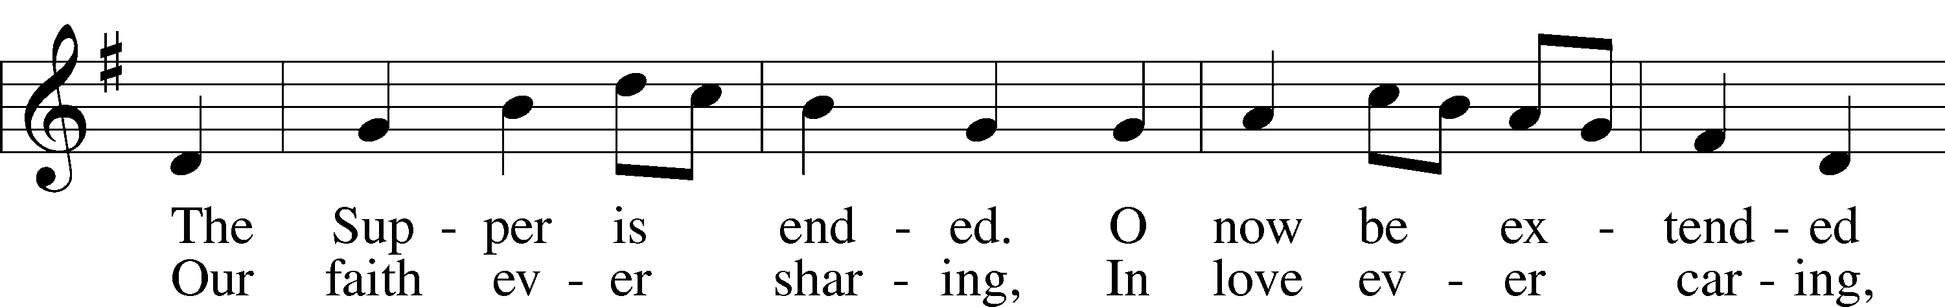
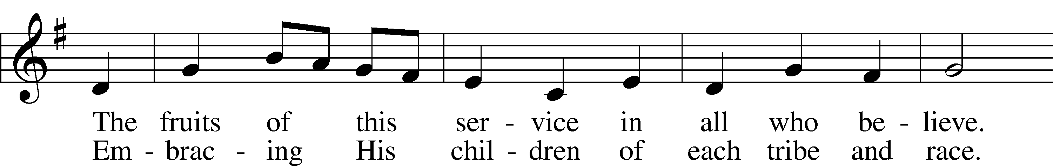
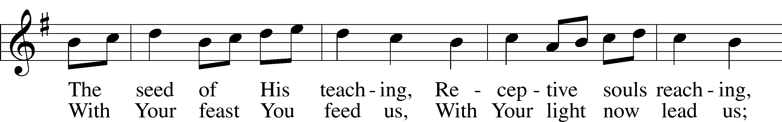
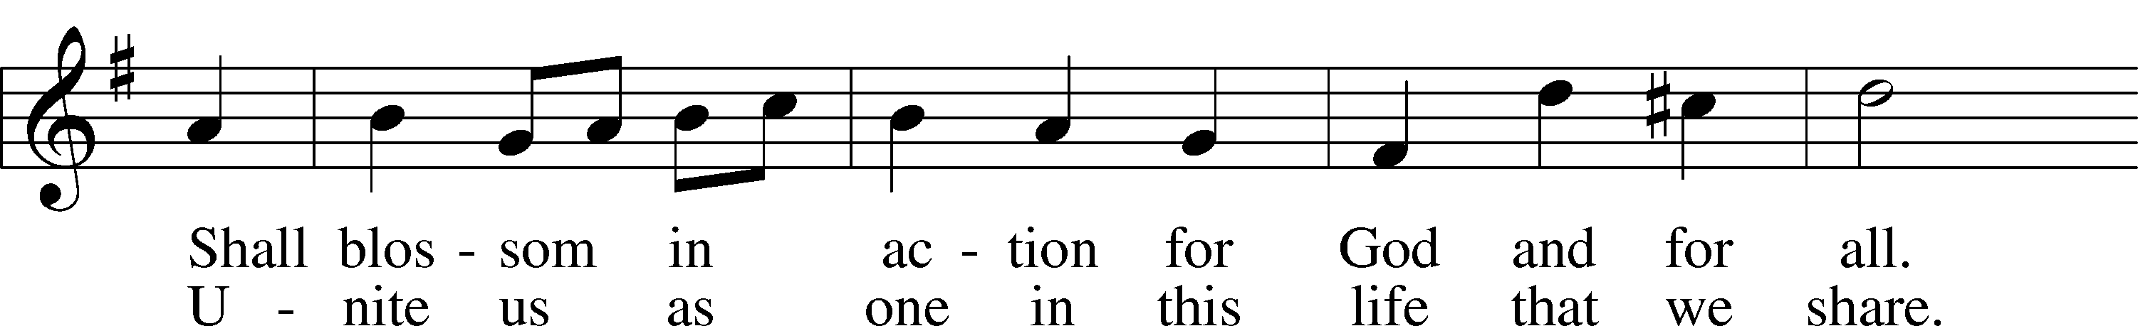
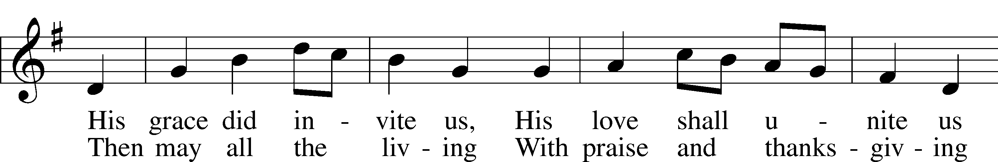
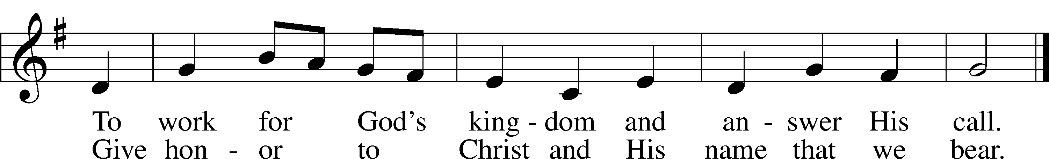
Text: Omer E. Westendorf, 1916–97, alt.
Tune: Welsh
Text: © 1964 World Library Publications. Used by permission: LSB Hymn License no. 110005011
Tune: Public domain

Stand

Nunc Dimittis Luke 2:29–32
C Lord, now lettest Thou Thy servant depart in peace according to Thy word,
for mine eyes have seen Thy salvation, which Thou hast prepared before the face of all people,
a light to lighten the Gentiles and the glory of Thy people Israel.
Glory be to the Father and to the Son and to the Holy Ghost;
as it was in the beginning, is now, and ever shall be, world without end. Amen.

Thanksgiving Psalm 107:1
A O give thanks unto the Lord, for He is good,

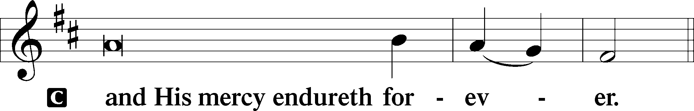

Post-Communion Collect
A Let us pray.
We give thanks to You, almighty God, that You have refreshed us through this salutary gift, and we implore You that of Your mercy You would strengthen us through the same in faith toward You and in fervent love toward one another; through Jesus Christ, Your Son, our Lord, who lives and reigns with You and the Holy Spirit, one God, now and forever.

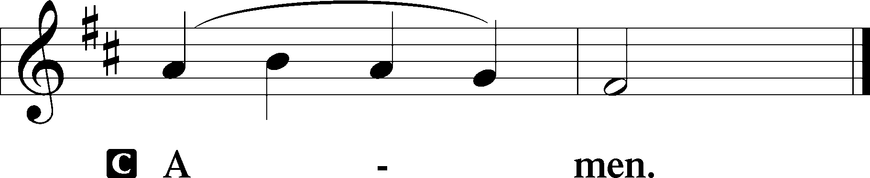

Salutation 2 Timothy 4:22
P The Lord be with you.

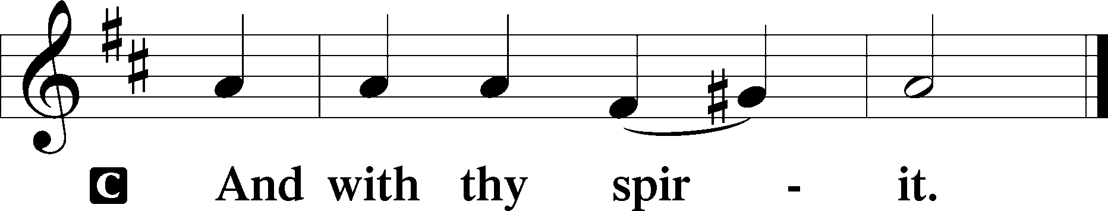

Benedicamus Psalm 103:1
A Bless we the Lord.

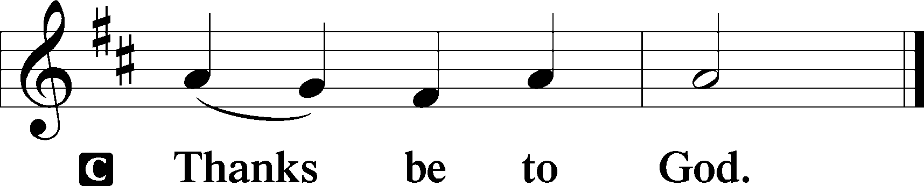

Benediction Numbers 6:24–26
P The Lord bless you and keep you.
The Lord make His face shine upon you and be gracious unto you.
The Lord lift up His countenance upon you and T give you peace.
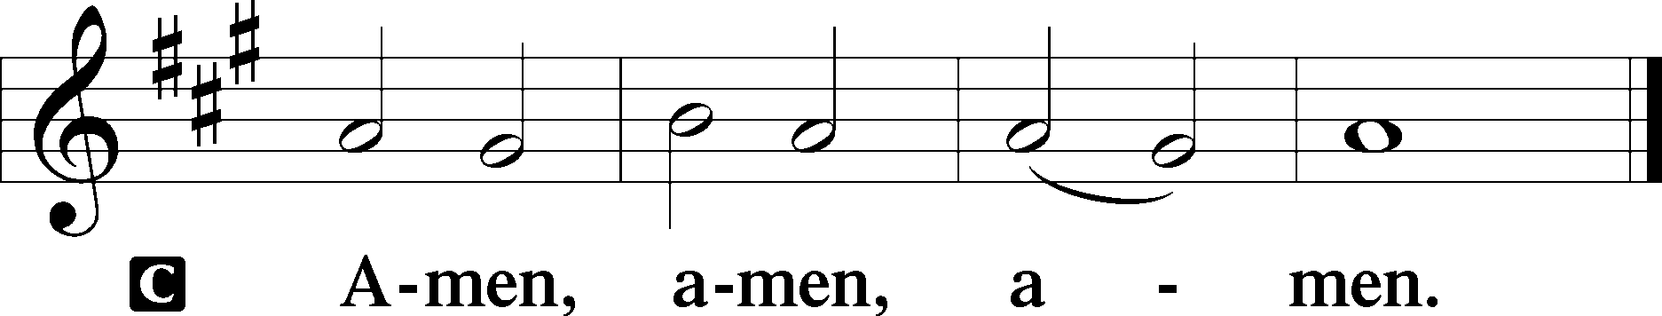

924 Lord, Dismiss Us with Your Blessing
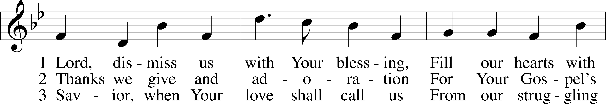
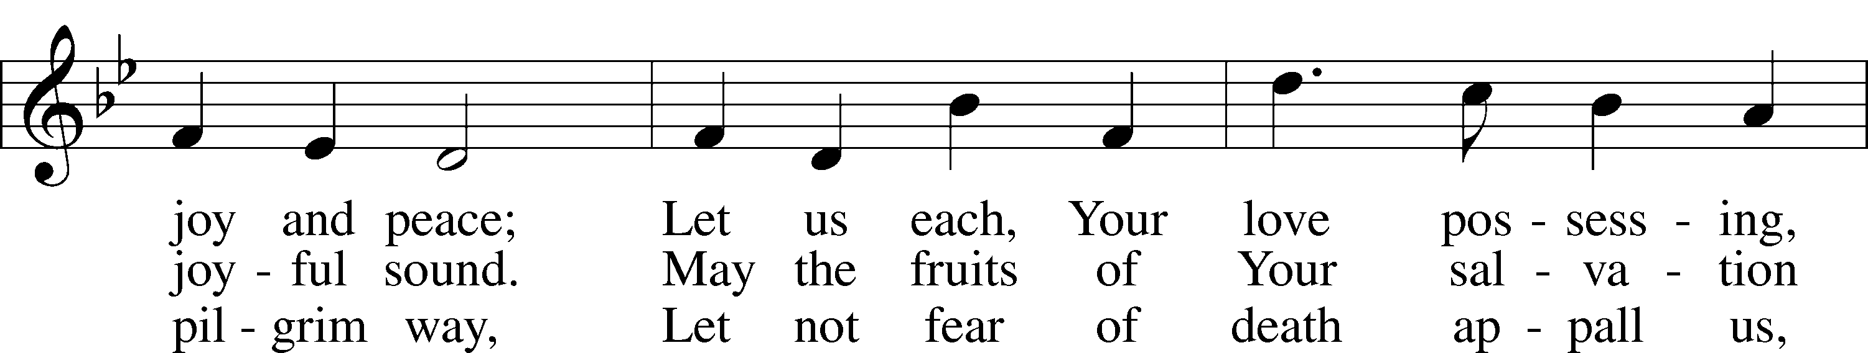
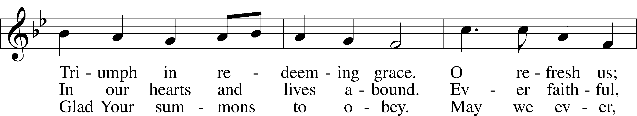
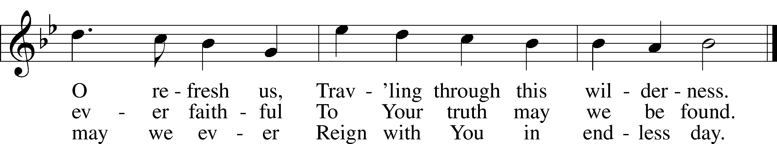
Text (sts. 1–2): attr. John Fawcett, 1740–1817, alt.; (st. 3): Godfrey Thring, 1823–1903, alt.
Tune: Henry T. Smart, 1813–79
Text and tune: Public domain
Acknowledgments
Divine Service, Setting Three from Lutheran Service Book
Unless otherwise indicated, Scripture quotations are from the ESV® Bible (The Holy Bible, English Standard Version®), copyright © 2001 by Crossway, a publishing ministry of Good News Publishers. Used by permission. All rights reserved.
Created by Lutheran Service Builder © 2026 Concordia Publishing House.

